Prairie View A&M University

September Birthdays
• • •
Takeya Scott: 9/3
Bryce Peterson: 9/7
Chinwendu Ejimadu: 9/11
Kijan Walker: 9/23
Alexandra Cromer: 9/24
Ana Hernandez: 9/29

Miss UMA
• • •

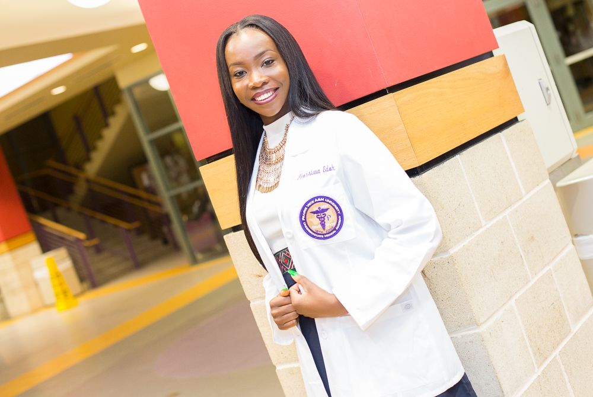

Akossiwa B. Edoh

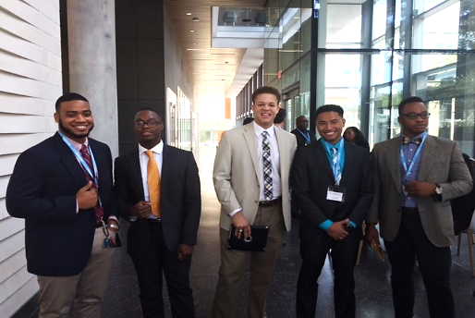

This Month in the UMA…
Undergraduate Medical Academy
Newsletter

Students traveled to Austin, Texas to visit the brand new Dell Medical School. They were opportune to speak with cardio thoracic surgeon, Dr. Reginald Baptiste.
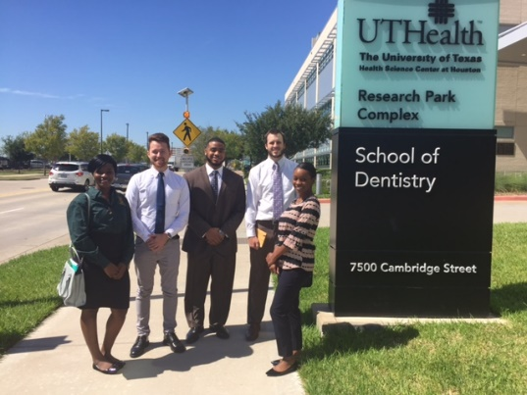
UMA pre-medical and pre-dental students also visited the University of Texas Health Science Center in Houston, Texas.
The UMA students elected this year’s E-Board members as well as Mr. and Miss UMA, who will represent the UMA at the Homecoming parade in October.
Also, Leadership and Ethics Workshops with Dr. Daniels or Ms. Jefferson as well and Study Skills with Mrs. Straker began this month.

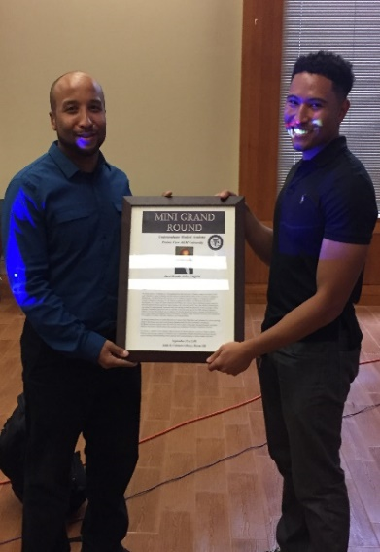
Mini-Grand Round

Mr. UMA
• • •

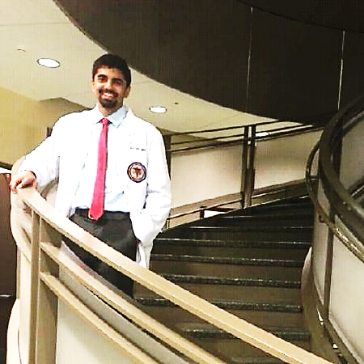

Shahryar Syed

E-board Members

• • •
President: Jessica Hawkins
Vice President: Nnaemeka Okorie
Secretary: Jazmin Villegas
Historian: Pauline Ighofose
Chaplain: Chiz Diribe
Sgt. at Arms: Roderick Emmanuel
Treasurer: Cid’Ni Wilkerson
Community Service: Vanessa Smith
Activities & Fundraiser: Takeya Scott
Class Representatives:
- Sydney Gore
- John Benefield
- Alexandra Cromer
- Faduma Hassan

UMA Students had the pleasure of meeting Dr. Jacel Brooks, who specializes in sports medicine. Dr. Brooks presented some insight on how to prepare for medical school and how to study for the MCAT and tips on specializing.

UMA Public Health Committee
The UMA Public Health Committee held a school supply drive for the Pre-K students at Eastside Elementary School. UMA Students successfully donated a ton of supplies such as crayons, markers, paint, glue sticks, construction paper, and so much more.

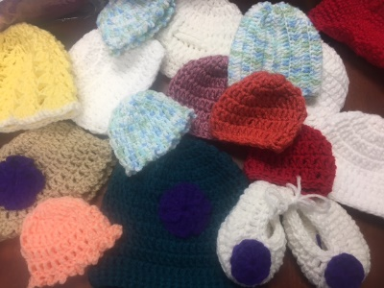
Crochet Club
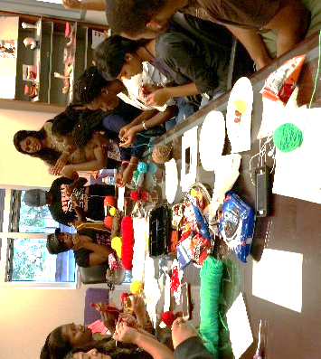
UMA Students will be crocheting hats and scarves for children in a local hospital. This is great opportunity to earn community service hours while learning a new hobby. All UMA students are welcome to join. The meetings are every Friday from 11 A.M. to 1 P.M.

Upcoming Events:
- Mini-Grand Round: October 5th
- Homecoming Parade and Game: October 8th
- Mid-Semester Exams: October 13th – 14th
- Community Service Hours due: October 21st
- UMA White Coat Ceremony: October 22nd
“Success is no accident. It is hard work, perseverance, learning, studying, sacrifice and most of all, love of what you are doing or learning to do.”
-Pele

