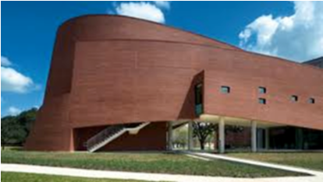
SCHOLARSHIP APPLICATION: FACULTY RECOMMENDATION:

Application submitted for: | Summer 2018 | Fall 2018 |  | Spring 2019
Major:
Architecture Construction Science Double Major (Architecture & Construction Science)
Digital Media Arts Community Development
STUDENT:
Last Name: | First Name: |  | Middle Initial: | Student ID#
Faculty Name:
RATING OF THE APPLICANT:
Category: | Likert Scale |  | Notes:
- Professionalism/conduct: Is this student a good representative of his/her major and the School of Architecture> | Low High
- Classroom engagement: Is this student meeting the learning objectives of your course/s? | Low High
- Participation: Is this student participating in student organizations and/or other areas within the School of Architecture? | Low High
Comments:
_________________________________________ ____/____/2018
Faculty Signature Date

Received by SOA Scholarship Committee: ____/____/2018
Date

