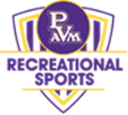

Prairie View A&M University
Department of Recreational Sports
Aquatics Department
Policies and Procedures
Effective August 24, 2020
Yolanda Y. Thomas, M.S., M.Ed., RCLGI, RCWSI, L.A.T.
Aquatics & Outdoor Pursuits Coordinator

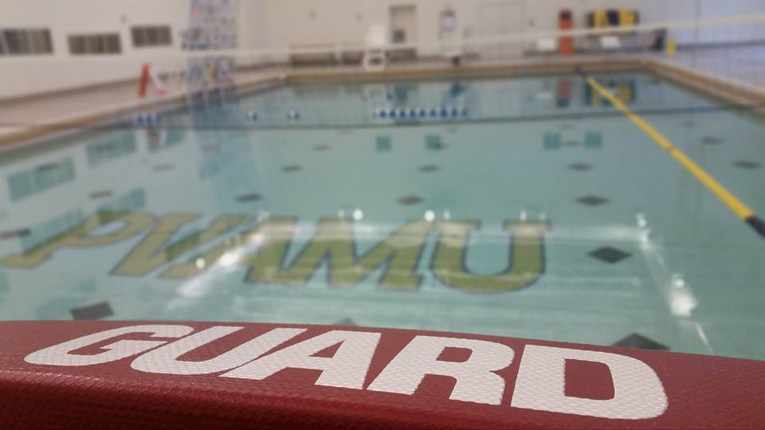

Rec Center Reopening Procedures

Aquatics Program Area
- Social distancing protocols during rescue of a swimmer.
- Social distancing between patrons and staff.
- Lifeguard Staff will be required to come in 30 minutes prior to opening to wash aquatic equipment, wipe down surfaces and major touch points.
- Lifeguard Staff will be required to stay 30 minutes after pool closing to finish washing and cleaning any dirty equipment that has not been cleaned and stowed away properly.
- Lifeguard staff will clean and disinfect common touch points, enforce policies, engage in patron surveillance, and provide customer service.

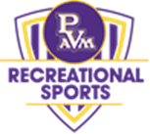

- Wipe down all Aquatic equipment (e.g., kickboards, noodles, water weights, water belts etc.) with a Bleach Solution.
- Aquatic staff will closely monitor pool chemicals to ensure safety of participants.
- All lifeguards will wear facemasks EXCEPT when a lifeguard is in a chair on surveillance as part of their uniform.
- Due to safety concerns, the Aqua Climb and Diving Board will not be available during the re-opening.
- Lap swimming or water walking/exercising will be allowed during pool hours.
- Lap Swimming will be limited to one swimmer per lane with every other lane closed to ensure social distancing.
- Patrons will not have access to locker rooms. Patrons are encouraged to wear their swimsuits in and out of the building.
- Swimming will be limited to one swimmer per lane with every other lane closed to ensure social distancing. The maximum occupancy of the pool is currently limited to 15 (25% of normal max capacity (60).
- Water Aerobics maximum occupancy of the pool is currently limited to 8 (25% of normal max capacity (30).
- Open/Lap Swimming will not occur at the same time as Water Aerobics
- Water Based Group Exercise - Will only be permitted once the Water Aerobics program resumes.
- Aquatic equipment (e.g., kickboards, noodles, water weights, water belts etc.) - Laundry baskets will be placed at the end of each lane for equipment to be returned. All equipment will be wiped down with disinfectant upon return.
- Lifeguard Office - Clean regularly with disinfectant. Social distancing will be mandated along with wearing PPE.
- Lifeguard Stands - Equipment will be wiped down with disinfectant at every rotation.
- Lifeguards In Person, In-Service Trainings can only resume once the 6ft social distancing requirement is lifted.
- Lifeguards Virtual In-Service Trainings will continue weekly
- Groups should stay 6 feet apart at all times.
- Each group should consist of either 1) only people who live together, or 2) up to 5 individuals.
- Swimmers should be advised to self-screen for any potential Covid-19 symptoms prior to entering the pool.
- The maximum occupancy of each pool is currently limited to 25% of normal max capacity.

