Managing Your Time Off

Overview
This job aid outlines the process for an Employee to request Time Off, cancel a Time Off request and correct a Time Off request that was approved or sent back by the Manager
Prerequisites: N/A
Important Information:
Time offs can only be requested for the current and prior fiscal year. Please contact your Absence Partner for any adjustments needed prior to the start of last fiscal year
FMLA Qualified Absences
- Do you have any paid time off you are eligible to take?
  - YES: Do you have enough days off to cover the entirety of the absence?
    - YES: Request Time Off twice for the same date range – once with the Type Paid Time Off and once with the Type Time Off FMLA
    - NO: Request Time Off twice for the number of paid days you have accrued – once with the Type Paid Time Off and once with the Type Time Off FMLA. Then enter a Leave of Absence for the remaining time you will be out if it is longer than 30 days. If the remaining Time Off is under 30 days, enter FMLA Time Off with Unpaid Time Off.
  - NO: Request a Leave of Absence (FMLA) if over 30 days. If under 30 days, Unpaid Time Off should be used in conjunction with FMLA Time Off
- If you want to view Time Off and Leaves of Absence on the same page, open the Absence Calendar view

Steps

Request Time Off
From the Workday Home page:
- Click the Time Off worklet
- Under Request, click Time Off

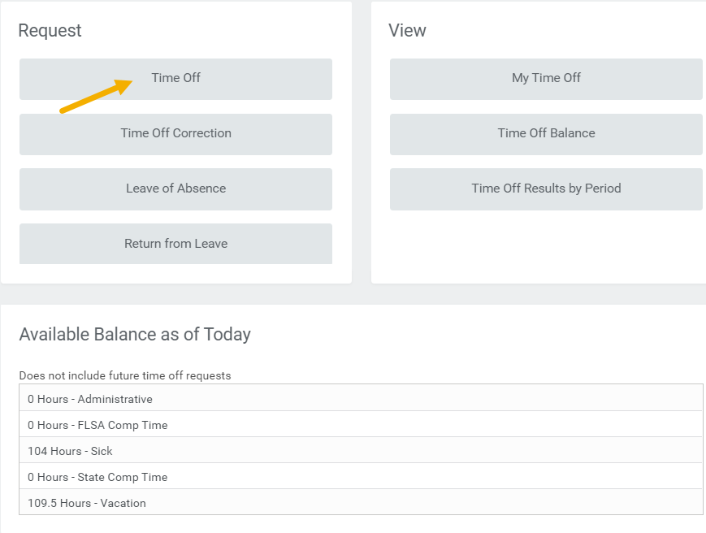
Note: You will be able to see your available balances listed below the set of Request links
The Time Off Calendar page will display
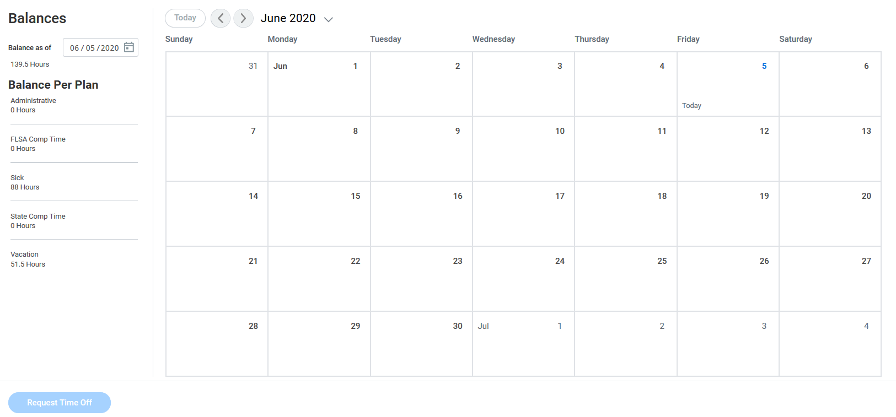
- Select a date in the left column to see your Time Off Balance as of that date (Optional)
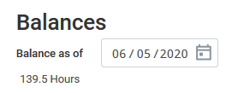
- Click the day(s) you will be out. If the time you will be out on each day varies, you will need to do separate requests for the different time frames
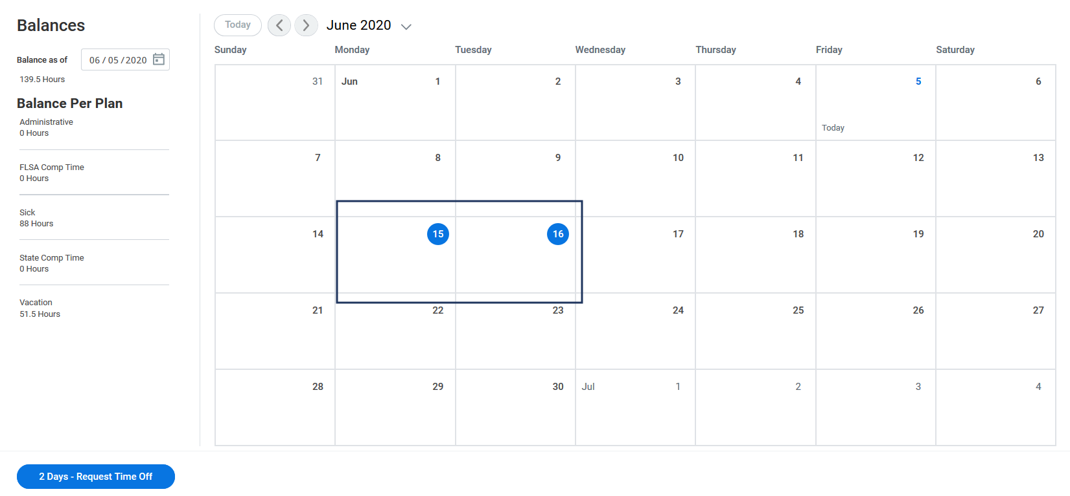
- Click the Request Time Off button
- In the pop-up window that displays, complete the following fields:
  - Time Off Type. Only Types for which you are eligible will appear (e.g. Sick)
  - Daily Quantity. This will automatically populate with the number of hours according to your assigned work schedule but can be updated. IMPORTANT: This is not the total hours but the hours per day you will be out
  - Reason (Required for certain Time Off Types)
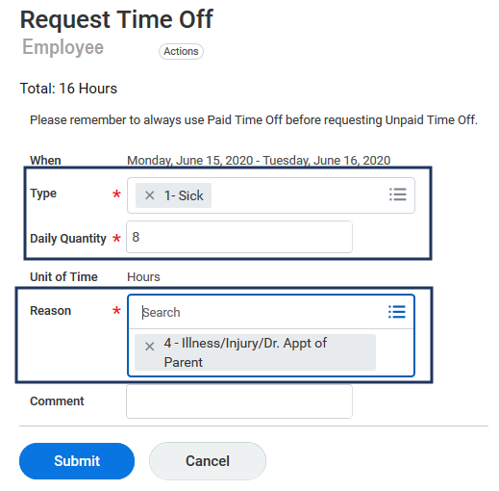
Notes:
  - Daily Quantity allows you to enter in a partial day off if necessary
  - Reason options will appear based on the Type selected
- Enter comments for your Manager as needed. Remember not to include private information in the comments section
- Click Submit
You will see the calendar updated to show what you requested
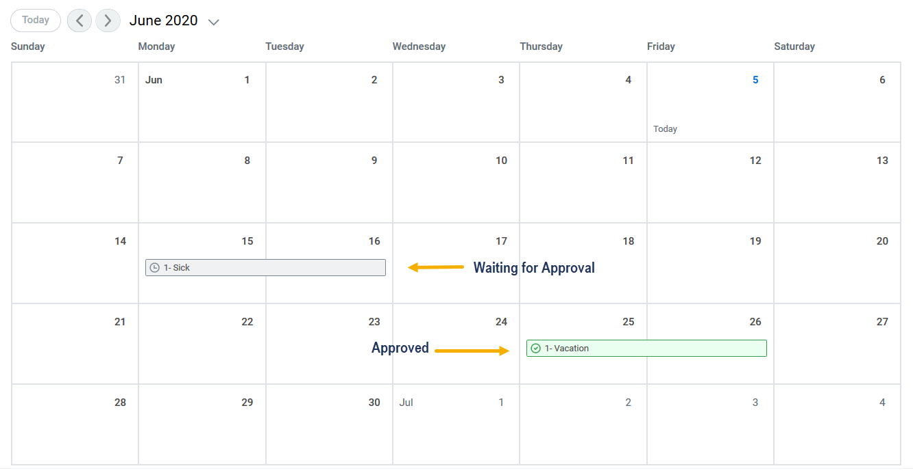
Note: Requests waiting for approval are marked in grey. Approved requests will be marked in green and display a green check mark
You have completed the Request Time Off business process

Up Next
Your Manager will receive an inbox item to take action on your request. Your request can be approved, sent back, denied or canceled.
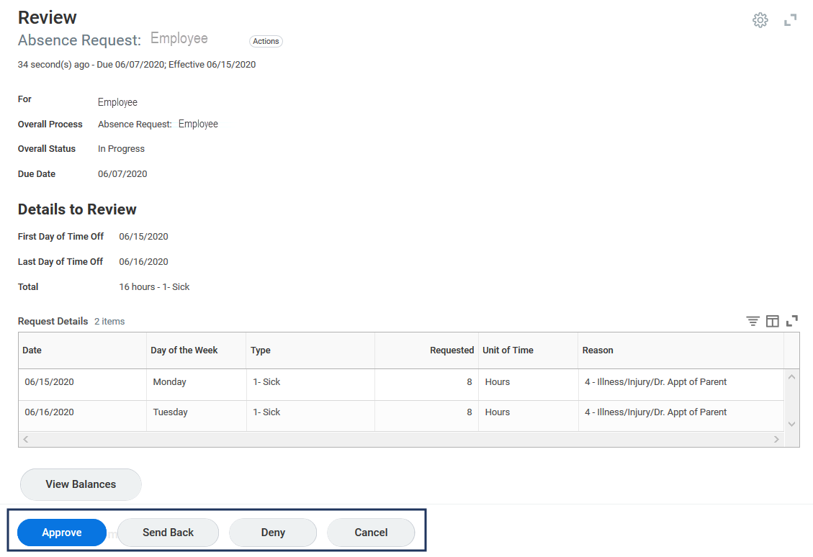
Note: Any requests involving FMLA, Parental or Emergency time offs will also route to your Absence Partner for approval once the request is approved by your Manager

Cancel Time Off Requested
IMPORTANT: You can only cancel the request if your Manager has not yet taken action. If you want to change the request, you can ask your Manager to click Send Back or you can wait until it is approved and then use the Correct a Time Off Request process described later in this job aid.
From the Workday Home page:
- Click the Time Off Worklet
- Under Request, click Time Off Correction
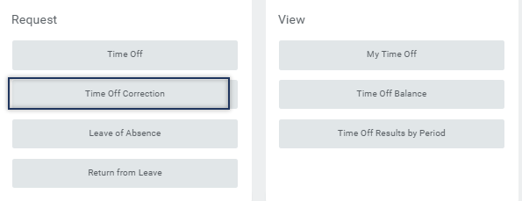
- Click the time period for which you requested an absence
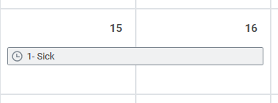
Note: The request is not yet approved because there is no green check mark. This means it is eligible for you to cancel the request
- Click Cancel this Request
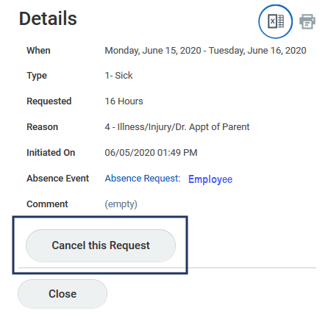
Note: This will cancel the entire request.
- Enter comments for your Manager
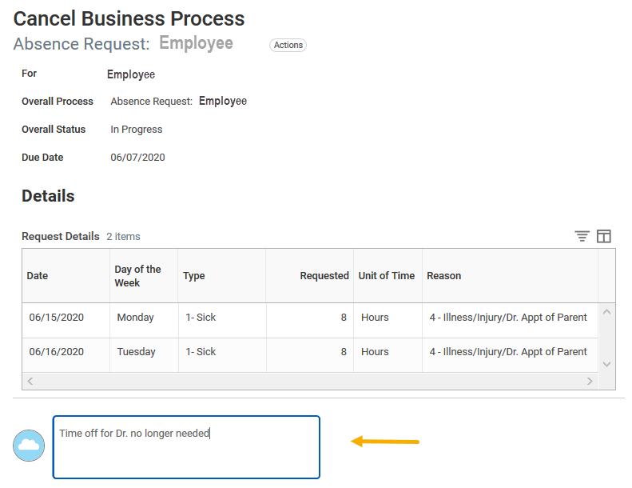
- Click Submit
- You will receive a confirmation message:
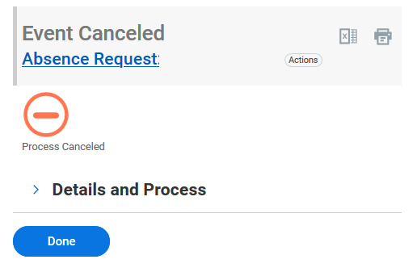
You have successfully canceled your Time Off request. No approval is required

Correct a Time Off Request
IMPORTANT: You can only initiate a Time Off Correction after it has been approved. Otherwise, you can ask your Manager to Send Back the request and then make necessary changes without cancelling the process
From the Workday Home page:
- Click the Time Off Worklet
- Click Time Off Correction
- Select the date(s) that need correction
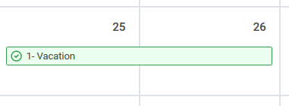
- Select the specific date(s) you need to correct and adjust the type or hours as needed or click the minus (-) sign to delete a row
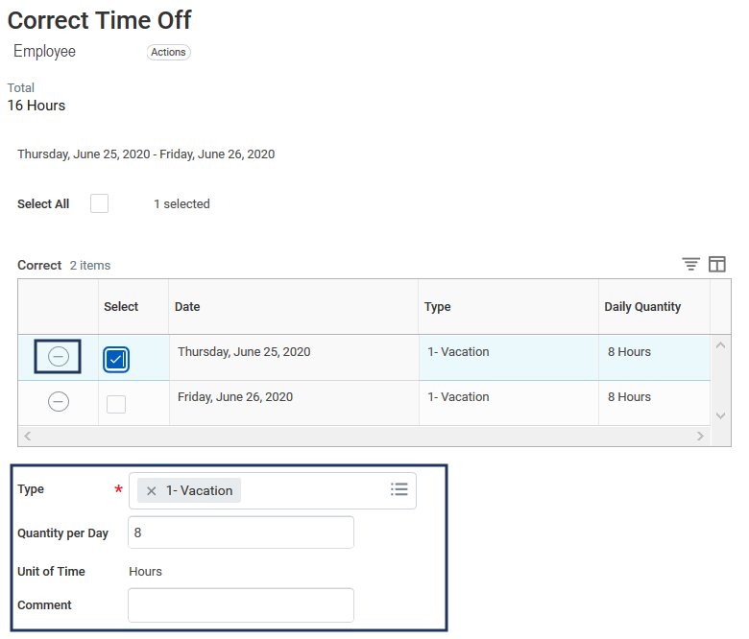
Note: Here the first day was selected and changes can be made for the Type, Quantity and Reason
- Enter comments for your Manager
- Click Submit

Up Next
  - Your Manager will receive an inbox item to approve these changes
  - Your Absence Partner will receive an inbox item to take action on any request involving FMLA, Parental or Emergency time offs, as well as unpaid time offs for faculty and staff
You have completed the initiation of the Correct a Time Off Request process

