Managing Your Bank Accounts

Overview
This job aid outlines the activities for an Employee to add an additional bank account for use when electing direct deposit for payment and how to edit existing bank accounts in Workday
Prerequisites: There is at least one bank account existing in the payment elections
Important Information:
- Payment Elections is the term used by Workday to refer to your preferences for receiving earnings (Payroll) and reimbursement (Expense)
- Bank accounts you would like to have available as options for direct deposit must first be added in the Accounts section of your payment elections in Workday
- You can distribute funds across multiple bank accounts (up to 5)

Steps

Add New Bank Account Option
- Click the Pay worklet
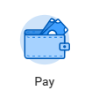
- Select Payment Elections
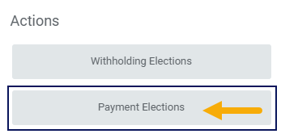
- Click Add under the Accounts section
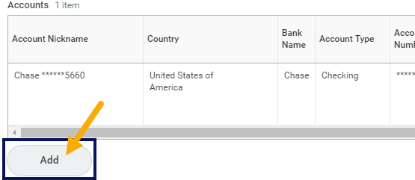
- In the Account Information section, add information including:
- Account Nickname. Workday Services recommends you use this to distinguish between accounts
- Routing Transit Number. This is a 9 digit number found on a check, deposit slip or in your banking information online
- Bank Name. This is the name of your Bank (e.g. Bank of America)
- Account Type. Select Checking or Savings
- Account Number. The is located on a check, deposit slip or in your banking information online
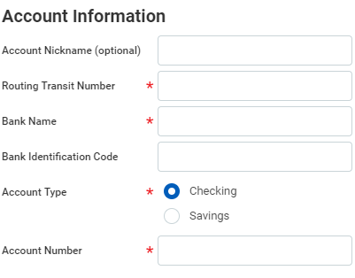
Note: The Bank Identification Code field will not be used at this time
- Click OK. The new bank account now appears in the Accounts section
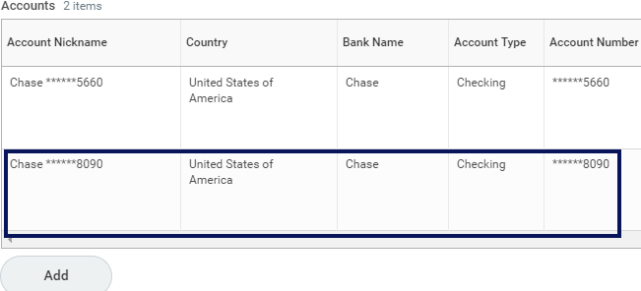

Add Bank Account to Payment Election
You are now going to take steps to deposit funds into this new account and specify how much money will be deposited
- In the Payment Elections section, click Edit to make changes. In this example we will add another account for Payroll
Payment Elections section with account listed and the edit button highlighted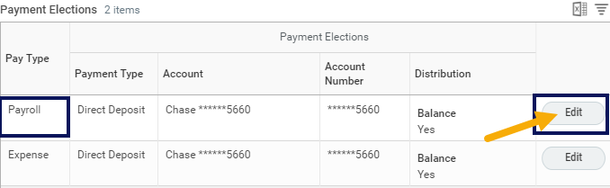
- Click the Plus icon to add the new bank account
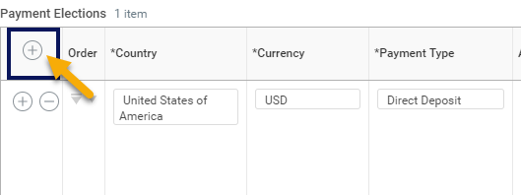
Note: you can also click the Minus icon next to any existing accounts to remove them
- You will be prompted to enter the following:
- Country. Select United States of America
- Payment Type. Select Direct Deposit
- Account. Select the new account
- Distribution Type. When using multiple bank accounts you must select an amount or percentage to be deposited into these accounts
  - Balance. Only One account can have a Balance distribution. This means whatever amount or percent of funds not already assigned to another account will be deposited into the account marked as Balance
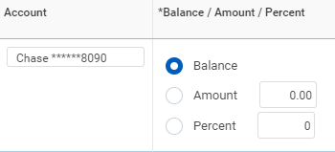
  - Amount. You can select an amount to be deposited into an account. In this example we are specifying $2000 to be deposited into one account and $5000 into another account
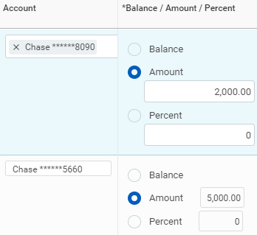
  - Percent You can select a percentage of your payment to be deposited into an account. In this example we are specifying 30% of the paycheck to be deposited in one account and 70% into another account
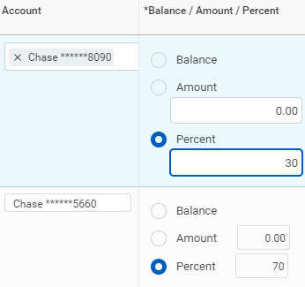
- Click OK
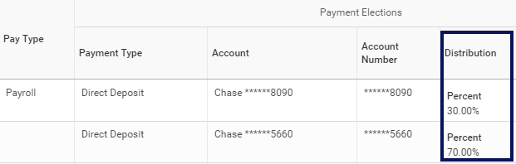
Note: You can also edit the Expense row for any reimbursements you receive using these instructions

Editing Existing Bank Accounts
Editing your current bank account details is simple. You will navigate to your Payment Elections as described earlier
- Click the Pay worklet
- Select Payment Elections
- Click the Edit button for the account you want to edit
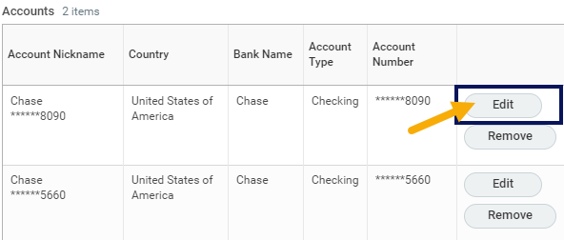
Note: You can also select Remove to delete an account
- Make changes as needed to the Account information
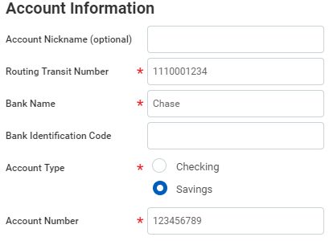
- Click OK
This completes the overview of Managing Your Bank Accounts

