Manage Your Personal Information

Overview
This job aid outlines the process for Employees, Retirees and Contingent Workers to manage personal information in Workday such as Gender, Date of Birth, Race / Ethnicity, Citizenship Status and Nationality
Prerequisites: N/A
Important Information:
- The Nationality in the Personal Information is required
- You cannot edit the Military Status field. Military Status, if populated, was pulled in based on prior selections on the old Military Status form
- To enter or update Veteran Status in Workday, go to Worker Profile > Actions > Personal Data > Change my Veteran Status Identification

Steps

- From the Workday Home page, click the Personal Information worklet
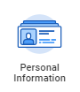
- In the Change section, click Personal Information
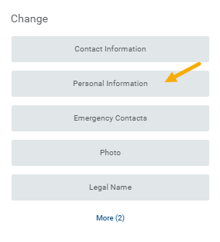
Your personal information will be displayed for Gender, Date of Birth, Race/ Ethnicity, Citizenship Status, Nationality and Military Service.
- Edit sections as needed
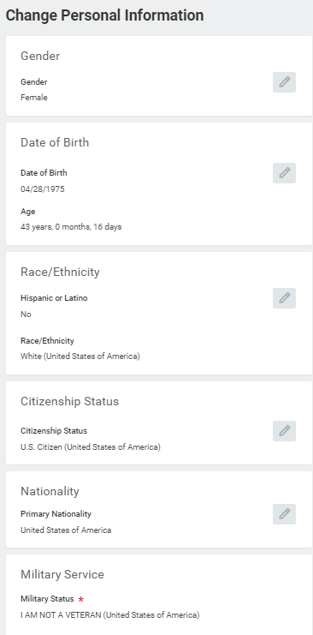
Note: Nationality is a required field and must be completed
- Enter any comments as needed
- Click Submit
Notes:
  - Some changes require supporting documentation to be provided to your HR Staff
  - Do not upload a copy of any government documents unless asked to do so
If you have any questions, you should contact your HR Contact for your department
This completes the Manage Personal Information business process

