Enter Time

Overview
This job aid outlines the process for an Employee to enter time in Workday
Prerequisites: N/A
Important Information:
  - Time can be entered by hourly employees and salaried employees tracking time on projects. Hours entered by salaried employees are for record keeping only and do not feed to payroll
  - Time entry policies vary by member. Please note that some members will enter time with the number of hours worked and others will enter time with the exact times worked

Steps
- Click the Time worklet on your Workday Home page
- Under Enter Time, click This Week
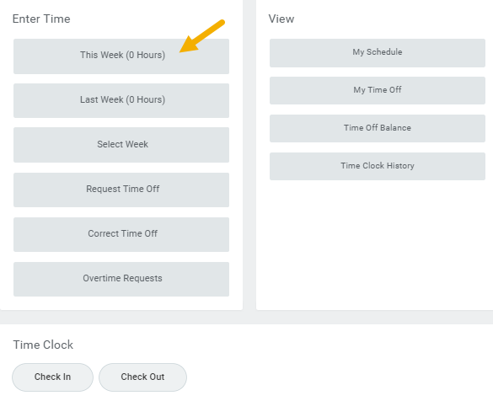
The Time Calendar will display
Notes:
  - The number of hours already entered for the week will also display
  - You may see previous time periods locked for payroll
  - Any pay dates for the week will also display within the week
  - Alternatively, you can click the previous or next arrows to navigate to a time frame other than the current week
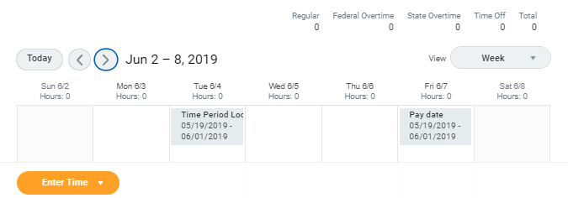
- Click on the Day / Date for which you need to enter time worked. A blue Enter Time box should appear, and then a pop-up will display
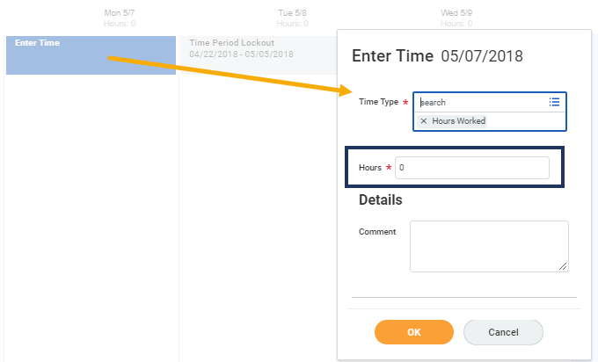
- Click Time Type
- Select Time Entry Codes and select the appropriate code
- Enter the number of Hours worked for that date
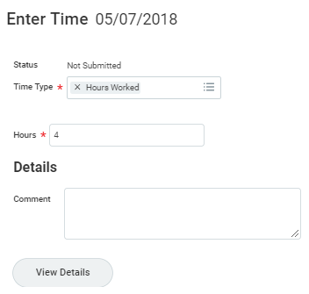
Note: Some members will enter exact times rather than the number of hours for each day
- Click OK. You will see that the time has been added to the calendar
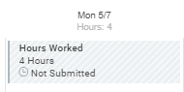
Note: You can click Enter Time at the bottom of the page to view a drop-down list of options. From there, you can select various options pertaining to time entry
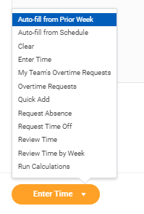
- Click Submit when you have populated all your entries for the week. The Submit Time summary page will display. Review the time entered
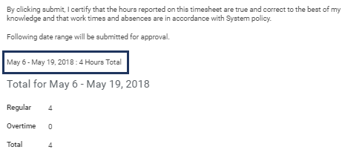
- Enter any comments, as needed
- Click Submit
The request will be routed to your Manager for approval
This completes the Enter Time process for Employees

