Edit Payment Elections

Overview
This job aid outlines the process for an Employee to set up and / or edit payment elections outside of the onboarding process
Prerequisites: The individual must be an existing employee, not going through the Onboarding process
Important Information:
  - Payment Elections are separated into Payroll and Expense. Payroll represents the employee’s paycheck. Expense represents reimbursement payments made to the employee
  - Employees working for the Texas A&M University System during conversion to Workday, and enrolled in direct deposit for expenses, will have “check” displayed in the expense section of their payment elections. These individuals are still enrolled in direct deposit for these payments
    - The process described in this job aid can be used to update what is displayed in Workday under expense to match an employee’s enrollment in direct deposit for expense
    - Employees who do not update this information and move to another member within the System would receive their first expense payment as check, and those thereafter, unless this election information is updated in Workday
  - This job aid is divided into two sections. The first section is for editing payment elections soon after conversion to Workday. The second section explains editing payment elections in general

Steps

From the Workday Home page:
- Click the Pay worklet
- Under Actions tab, click Payment Elections
- Scroll down to the Payment Elections section of the page
Note: Initially, you will likely see a section called Payment Elections Requiring Setup that shows your elections for expense
- Click Add in the far right hand column of Expense to set up this payment election
Note: If you are currently set up for direct deposit for these reimbursements, you are still enrolled. However, it has defaulted to “Check” in Workday
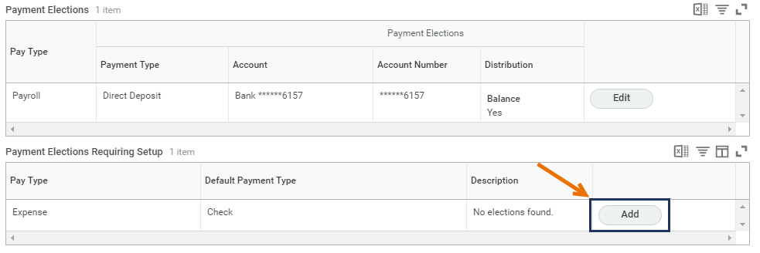
- In the Payment Elections section fill out the following information:
  - Country (currency will automatically populate)
  - Payment type (Direct Deposit or Check)
  - Account
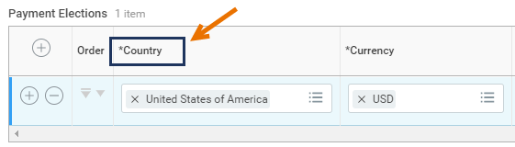
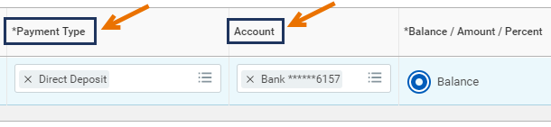
- Click the radio button for Balance
- Click OK

Changing Payment Elections
From the Workday Home page:
- Click the Pay worklet
- Under Actions tab, click Payment Elections
- Scroll down to the Payment Elections section of the page
- Click Change Election for either Payroll or Expense, depending on the change you want to make
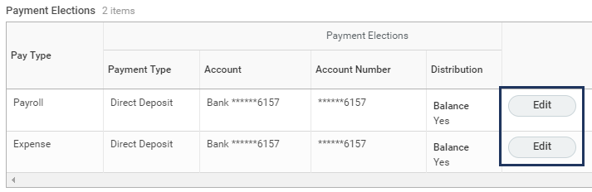
- In the Payment Elections section fill out the following information:
  - Country (currency will automatically populate)
  - Payment type (Direct Deposit or Check)
  - Bank Account
Notes:
  - If you do not currently have a bank account associated with your payment elections (e.g. you are not enrolled in direct deposit) you must add a bank account to the Accounts section of this page to add a direct deposit election
  - If you need to use multiple bank accounts, be sure all accounts are listed in the Accounts section of the page. To add an account, click Add Account
- Click the radio button for Balance
- Click OK
This completes Edit Payment Elections

