Change Your Photo

Overview
This job aid outlines the process for an Employee or Contingent Worker to change his / her photo in Workday
Prerequisites: N/A
Important Information: The photo needs to be work appropriate and approved by the employee’s Primary Manager

Steps

From the Workday Home page:
- Click the Personal Information worklet
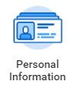
- In the Change section, click Photo
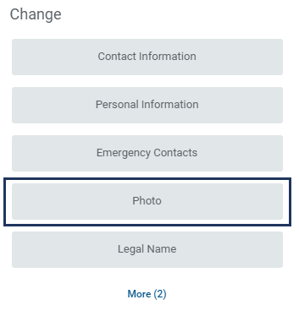
- Drag or upload a file from your computer by dragging the file into the box or clicking the Select files button
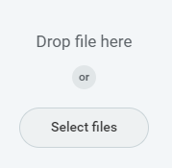
- Use the cropping tool to zoom in / out, as needed
- Click OK
- Enter any comments as needed
- Click Submit
The request will be routed to your Manager for approval
This completes the Change Photo process

