Access the Workday Mobile App for Android devices

Overview
This job aid outlines the process for an Employee to install Workday’s mobile app on an Android mobile device and provides a brief navigation overview
Prerequisites: Employee has a mobile device that uses Android (e.g. Samsung phone or tablet)
Important Information: N/A

Steps

Installing the Workday Mobile App
From your mobile device:
- Navigate to the Play Store icon
- Search for the Workday App and install
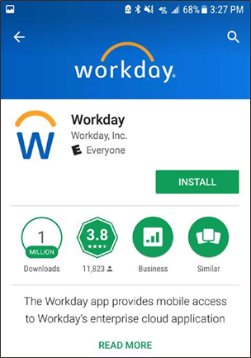
- Tap Open once installation is complete
- Tap Log in at the bottom
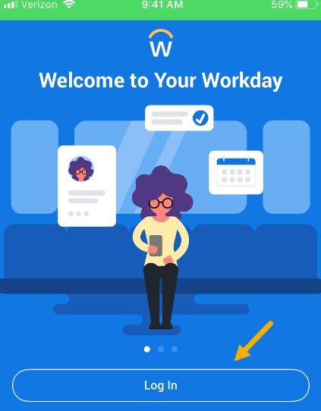
- Enter TAMUS when prompted to enter or scan your Organizational ID
- Tap the right arrow to continue
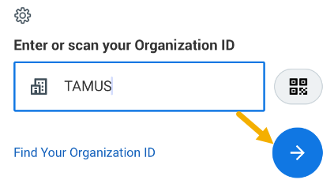
- Enter your UIN and Password
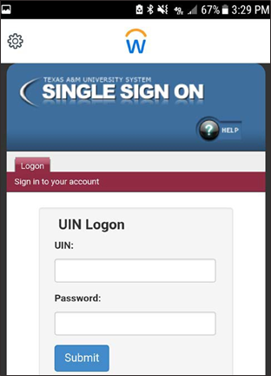
- Tap Submit
Note: You will be asked to do a multi-factor authentication with Duo. When this occurs, complete the Duo process as usual

Navigating in Mobile
This is a sample of your Workday Home page
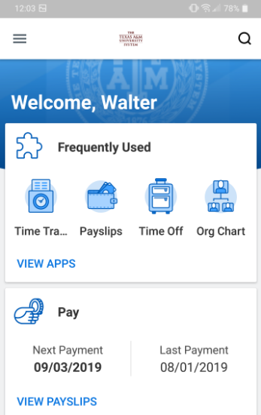
Note: Worklets are available depending on your security roles
From the Workday Home page:
- Tap the Menu icon to open the menu
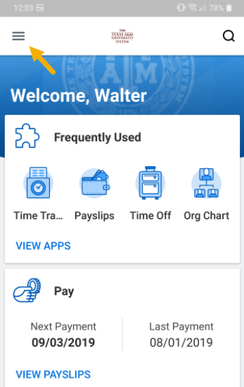
This is a sample of your Menu options:
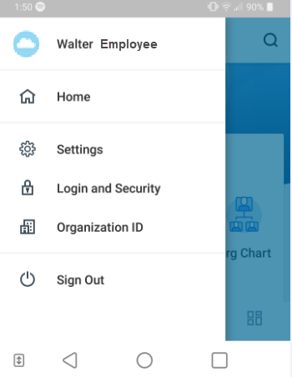
Notes:
- Employee Profile. From this link you can access your worker profile and related actions
- Home. Selecting this link takes you back to the Workday Home page
- Settings. This is used to view global settings
- Login and Security. You can manage your login and security options if your organization has made it available to you
- Organizational ID. Information on your organizational ID is provided here

Accessing Your Profile and Actions
- Tap the Menu icon to open the menu and tap on your name. Your Worker Profile displays
- Tap the Related Actions icon to display the related actions menu

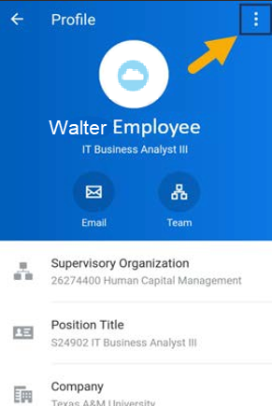
- Select the Category of the action you wish to take
Note: Not all information can be edited from the mobile app. If you cannot edit information, open Workday on your desktop to complete the action
- Tap Personal Data
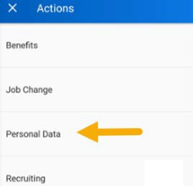
- Tap Change Contact Information
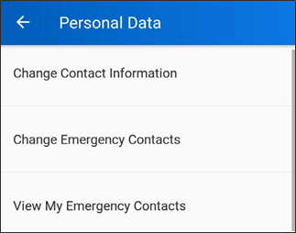

- Tap Edit to change the information if necessary and tap the check mark to save.
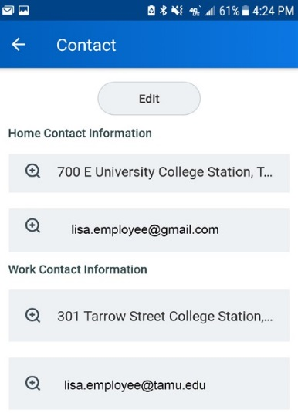
- Review the information and tap Submit
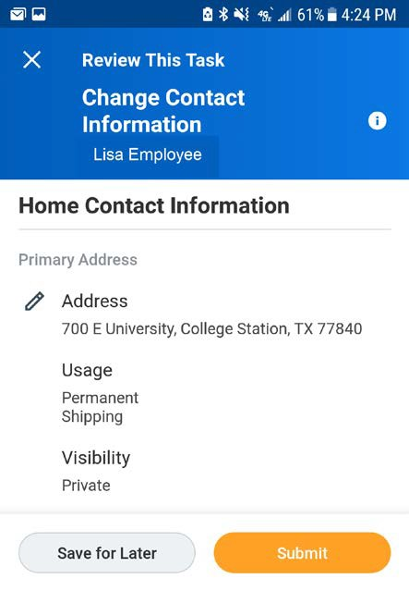
A confirmation message will be displayed
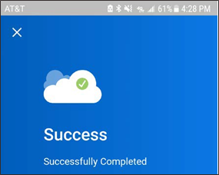

Your Inbox Worklet on Mobile

From the Workday Home page:
- Tap the Inbox icon at the bottom of the home page
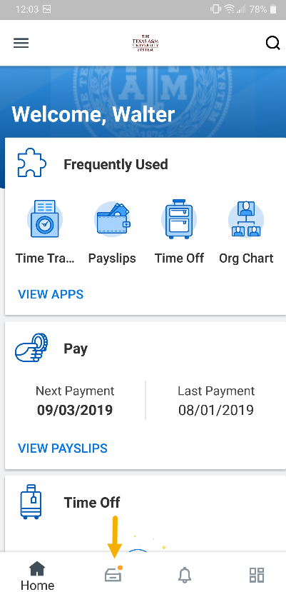
- Tap the Actions or Archive tab to access the corresponding information
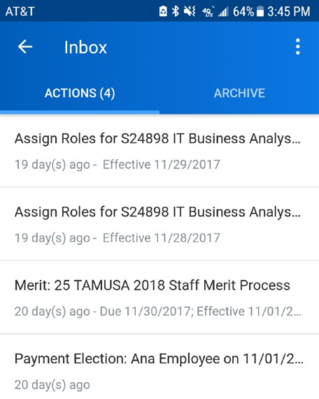
- Select an item to view more details
Note: You can see all Inbox items on mobile, but you cannot take action on every item. For items not configured for mobile, you would go to the web browser version of Workday on your mobile device to complete those action items or open Workday on your desktop
This completes the overview of Accessing the Workday Mobile App on an Android device

