PRAIRIE VIEW A&M UNIVERSITY
ROY G. PERRY COLLEGE OF ENGINEERING




INTELLIGENT FACE MASK DETECTION SYSTEM
Using Deep Learning

ELEG 4482 – Y01: Senior Design & Professionalism II

Topic: Final Report

Team Number: 8

Submitted by:
Kobi Tioro (Team Lead)
Samuel Ikefuna
Michael Stephenson
Brychan Johnson-Jackson
Ibrahim Ouedraogo

Course Facilitator: Professor Turner
Faculty Sponsor: Dr. Qian Lijun

Date of Submission: April 25th, 2021

PROJECT EXECUTIVE SUMMARY
Mission Statement
Our mission is to design and implement an intelligent Face Mask Detection System and Alarm System to reduce regulation violations and the spread of COVID-19 on campus. In return this system will slow down the spread of Covid-19 by reducing the amount of mask violations on the Prairie View A&M campus.

Problem Statement
According to the Center for Disease Control and Prevention (CDC), there have been a total of 6 million confirmed Covid-19 cases paired with over 180,000 deaths as of September 2020. Due to how easily the virus can be passed from host to host Covid-19 has become one of the worst pandemics in history. Our goal is to reduce regulation violations and the spread of COVID-19 on campus.

Target Audience
Our target audience is the schools, small businesses and hospitals.

Proposed Deliverables
- The Embedded System will consist of an edge Computing System, video camera sensor, alarm, and a screen.
- The Deep Learning Model will provide Image classification, object detection, a data Set
- Our Facemask Detection System will be installed in a safe location where it will be able to scan faces . The system alarm will sound when an individual who doesn’t have a mask is scanned.

Budget
- Project budget given was $600 and the amount spent was $289.49.
- The amount of items required is less than the given amount of $600 budget.

Customer requirements and Engineering solutions
- System will detect in real time faces with and without face masks.
- System will be highly accurate in regards to face mask detection.
- System will have an alarm system that sounds when it scans a face with no mask..
- System will be lightweight and compact due to the size of the microcontroller being relatively small.
- The system will be cost efficient. Our system should be affordable under $300.

Major Constraints
- Deep learning models can only be trained and tested on three team members.
- Only two team members are allowed to work in the lab due to the social distancing,
- Lab hours are very limited.
- Team needs to be familiar with machine learning algorithms.
- Team cannot ensure the 100% accuracy of ML applications.

Benefits
- Economical: The aim of this project is to allow businesses and public institutions to stay in business by helping them monitor people coming in their property, make sure people wear masks to avoid potential spread of the virus.
- Safety: With the implementation of our Face Mask Detection System, we will be able to decrease the spread of Covid-19 by reducing the number of mask violations.
- Social: To help stop the spread of COVID-19 and allow social events to continue through our implementation of this project.
- Technological: Our goal is to develop a product under $300 with a face mask detection failure rate less than 20%.

Recommendations
The Nvidia Jetson Nano Developer Kit will serve as a communication interface for the camera, the screen, and the speaker. Also, the kit will serve as a computer able to run a deep learning model that has been pretrained. Furthermore, the embedded system will be programmed using a dataset to train the deep learning model to ensure the accuracy of face mask detection. The system can easily be installed in all entrances and walkways across campus and as well as any other places outside the campus where wearing masks is enforced. Additional features like a temperature sensor can seamlessly be configured into the system.

Conclusion
Our Intelligent Face Mask Detection and Alarm System is designed to detect whether people are wearing masks or not. This device will allow not only campuses but most businesses to keep monitoring people that are coming into their facilities to make sure they are following the guidelines by wearing masks. The implementation of our system will reduce regulation violations and the spread of COVID-19 by impacting businesses and public institutions.

TABLE OF CONTENTS
Project Executive Summary ……………………………………………………….………….… ii – iv
Table of Contents …………………………………………………………………………..…........... v
List of Figures ……………………………………………………………………………...……...... vi
List of Tables and Graphs ……………………………………………………………....………….. vii
List of Team Members and Roles ………………………………………………………..………... viii

1. PROJECT SCOPE ……………………………………………………………………........ 1
1.1 Problem Statement ………………………………………………………………............ 2
1.2 Client Identification and Recognition of Need ……………………………………........3-4
1.3 Project Goal and Objectives ………………………………………………………....….. 4
1.4 Contemporary Issues Relevant to Project …………………………………………...........5
1.5 Potential Impact of Project on Society ……………………………………………….. 6– 7
(Safety, Environment, Technical, Economical)
  - Initial Project Constraints ………………………………………………………………. .8

2. PROJECT PLANNING AND TASK DEFINITION ……………………………………..9
2.1 Task Identification ……………………………………………………………………... 10
2.2 Gantt Chart ………………………………………………………………………………11

3. LITERATURE REVIEW ………………………………………………………………….12
3.1 List of all sources of information………………………………………………….…..... 13
3.2 Statement of Learning from each source……………………………………...................14

4. PRELIMINARY DESIGN ……………………………………………………………….. 15
4.1 Concept Generation …………………………………………………………………..... 16
4.2 Concept Evaluation and Selection …………………………………………………. 16-17
4.3 Design Constraints and Application Codes and Standards ………………………… 17-19
  - Preliminary Analysis ………………………………………………………………...20-22
  - Preliminary Design …………………………………………………………….…….23-24

5. DETAILED SYSTEM DESIGN ………………………………………………………..... 25
5.1 Project Part Summary …..………………………………………………………………26
5.2 Engineering Analysis and Simulation …………………………………………..……27-30
5.3 Layout/Detailed Drawings/Equipment Selection and Specifications …………….. ...31-32
5.4 Application of Engineering Codes and Standards ………………………………….….. 33
  - Economic Analysis …………………………………………………………………. 34-35
  - Final Design …………………………………………………………………. ……...36-38

6. RESULTS & DISCUSSION …………………………………………………………….... 39
6.1 Summary of Goals and Objectives ……………………………………………………... 40
6.2 Summary of Constraints and Codes met by Design …………………………………40-41
  - Discussion of Results …………………………………………………………………... 42

7. CONCLUSIONS AND RECOMMENDATIONS …………………………..……... 43 – 44

LIST OF REFERENCES ………………………………………………………………………..... 45

APPENDIX ……………………………………………………………………………..…….. 46 – 49

LIST OF FIGURES

Figure 1 Business Closure Rate by Category………………….. ………………..……….. 7
Figure 2 Detailed Timeline in Gantt chart………………….... ………………........…….. 11
Figure 3 Engineering Design Methodology….………………………………………....... 20
Figure 4 Preliminary Design Concept………………………………….... ……………….24
Figure 5 Projects Parts Summary ……………………………………………….. ……….23
Figure 6 Workflow for developing an AI-based face mask detector ……………………. 26
Figure 7 TLT Workflow from Nvidia.…………………………………………………… 29
Figure 8 Code for Alarm System….. ………………………………………………….... 30
Figure 9 Partial Code on Python….. ………………………………………………….... 49
Figure 10 No face detected screenshot….. …………………………………….……….... 36
Figure 11 Face detected without mask screenshot……………………………………...... 37
Figure 12 Face detected with mask screenshot…………………………………….... …..38

LIST OF TABLES AND GRAPHS

Table 5.1 Equipment List …………………………………………………....................31-32
Table 5.2 Detailed Economic Analysis………………………………………………….... 34
Table 5.3 Detailed Project comparison………………………………………………….... 35

LIST OF TEAM MEMBERS AND ROLES

- Kobi Tioro …………………………… Team Lead & Machine Learning Developer
- Michael Stephenson ……………………Secretary & Embedded System Developer
- Ibrahim Ouedraogo ……………………Data Analyst & Embedded System Developer
- Samuel Ikefuna ………………….Presentation Manager & Machine Learning Developer
- Brychan Johnson-Jackson …………………Accountant & Machine Learning Developer

Section 1 - Project Scope

1.1 Problem Statement
According to the Center for disease Control and Prevention (CDC), there have been a total of 32 million confirmed Covid-19 cases paired with over 570,000 deaths as of April 2021. Due to how easily the virus can be passed from host to host Covid-19 has become one of the worst pandemics in history. The goal of this project is to design an intelligent Face Mask Detection System and Alarm System to reduce regulation violations and the spread of COVID-19 on campus.

Business Objective:
The purpose of this project is to design and implement an intelligent face mask detection and alarm system. In return this system will slow down the spread of Covid-19 by reducing the amount of mask violations on the Prairie View A&M campus. To achieve our goal of a functional face mask detection system we will use deep learning with detailed configuration settings.

Target Audience:
The target audience for the Facemask Detection System includes but is not limited to schools, businesses, hospitals etc. The Facemask Detection System can be set up anywhere there is a need to detect whether people have on masks or not in order to keep the spread of Covid-19 as minimal as possible.

1.2 Client Identification and Recognition of Need
The project requirements are broken up into two different categories, which are the marketing requirements and user analysis.
- Marketing Requirements
    - Real time detection of faces with and without face masks.
    - Highly accurate face mask detection.
    - Alarm system through sound.
    - Easy to implement and use.
    - Screen showing face mask detection.
    - Lightweight and compact system design.
    - Cost efficient.
- User Analysis
  - Nonfunctional Requirements
    - Usability - The system will be easy to set up and implement.
    - Efficiency - The system will provide accurate and reliable image classification and object detection.
    - Portability - The system is lightweight (70 x 45 mm dimension and 8.8 ounces weight), therefore it will be easily portable.
    - Cost Efficient - The price for the system will not exceed $400 making it more affordable than most products in its market.
    - Easily Implementable - The system will come with a user manual with clear instructions on the system implementation.

1.2 Client Identification and Recognition of Need (Continued)
  - Functional Requirements
    - Alarm System- The system will produce sounds from a range of 5dB to 70dB which will be triggered when system detects a user without a face mask.
    - Facemask Detection - The system will come with a trained deep learning model for high facemask detection accuracy.
    - User-End Interface - The system will have a physical screen showing a green rectangle for people with a mask and a red rectangle for people without a mask.

1.3 Project Goals and Objectives
The goal of this project is to design an intelligent Face Mask Detection System and Alarm System to reduce regulation violations and the spread of COVID-19 on campus. In return this system will slow down the spread of Covid-19 by reducing the amount of mask violations on the Prairie View A&M campus. To achieve our goal of a functional face mask detection system we will use deep learning with detailed configuration settings. The system will be able to scan and detect whether an individual has on a facemask or not. If the scanned user does not have on a mask, the system will put a red rectangle around the user's face (which will be reflected on the system's screen), and sound an alarm. If the user does have on a facemask the system will put a green rectangle on the users face.

1.4 Contemporary Issues Relevant to Project
Since the beginning of the pandemic there has been a total of 32 million Covid-19 cases in the U.S, according to the CDC (Centers for Disease Control and Prevention). Out of those 32 million cases there has been a total of over 500,000 deaths. The immediate reason for those extremely high numbers is due to how easily the virus can be spread from host to host. The best way to prevent the spread of the virus is to utilize a facemask when in public or at this point of the pandemic, getting vaccinated.
The contemporary issue relevant to our project revolves around some individuals not feeling the need to wear masks. If everyone understood the importance of wearing a mask there would be far less cases and deaths due to the virus. Many people still don’t even believe the virus is real, some even feel like they are immune to the virus. These types of delusional mindsets are what further brought the number of cases and deaths of the virus so high. Our device will help slow down the spread of Covid-19 by reducing the amount of mask violations on the Prairie View A&M campus. Students will be prompted to put on a facemask when they walk into a building with the Facemask Detection System.

1.5 Potential Impact of Project on Society (Safety, Technical, Economical)
Safety Impact

- According to research by HACEY, the transmission probability for a Covid-19 carrier with no mask to a healthy person with a mask is 65% higher than the transmission probability for a Covid-19 carrier with a mask to a healthy person without a mask, and 68.5% higher for a Covid-19 carrier wearing a mask to a healthy person wearing a mask.
- With the implementation of our Face Mask Detection System, we will be able to decrease the spread of Covid-19 by reducing the number of mask violations.

Technical Impact

- Face mask detection is the first and most important line of defense in any back-to-work or public access COVID-19 protection strategy according to some corporate executives.
- According to the NIST Interagency Report published in july 2020, the most accurate algorithms fail to authenticate a person about 0.3% of the time using unmasked images .
- Masked images raised these top algorithms’ failure rate to about 5%, while many others competent algorithms failed between 20% to 50% of the time.
- Our goal is to develop a product under $300 with a face mask detection failure rate less than 20%.
Economic Impact

- This graph shows the percentage of local businesses by category being closed due to the pandemic.
- Businesses were hit hard by the pandemic. We can notice that in the graph businesses have been closing and losing wages dramatically up to 89%.

1.5 Potential Impact of Project on Society (Safety, Technical, Economical)
Safety Impact(Continued)

- People are staying home which is making businesses to lose their income and force them to close.
- The aim of this project is to help businesses monitor people coming in their property, making sure they wear masks to avoid potential spread of the virus which allows them to stay in business.
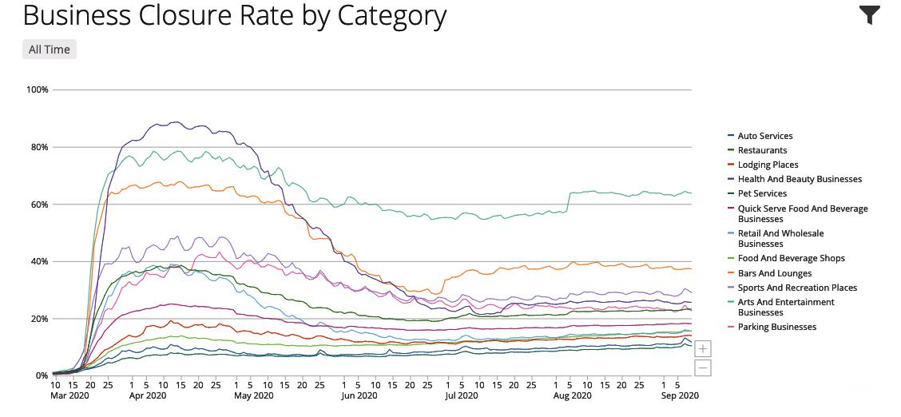
Figure 1: Business Closure Rate by Category

1.6 Initial Project Constraints
- Due to covid 19 we have a limited dataset and test population. We can only train and test the deep learning model on the team members.
- Not having a lab open at usual hours to working on implementing the design of our project. Lab hours are very limited.
- Our total budget for the project could not exceed over $600 in total expenses.
- We are not familiar with machine learning algorithms.
- We cannot ensure the 100% accuracy of ML applications.

Section 2: Project Planning and Task Definition

2.1 Task Identification
As a team we discussed the skills we are equipped with and what areas we need to strengthen to ensure we will meet our project deadlines. We used our project planning and previous experience together to successfully meet our project deadlines. To complete our project, we masterminded our projects requirements and researched face mask detection systems on the market at the time.
As we researched all the possible face mask detection systems available on the market, we were only able to find one. The Green Extreme Face Recognition & Temperature Measurement. This system however, is only able to scan one face at a time. We instantly saw an issue with that and knew scanning multiple faces would give our product one of the most competitive advantages. With that in mind we then focused on accurate face mask detection and developing an algorithm that scans multiple faces at a time. As we did more in depth research on machine learning algorithms and learned about Transfer Learning and Data Fine-tuning.
After doing our preliminary research, we decided to design and implement The Intelligent Face Mask Detection and Alarm System that will accurately detect whether or not patrons are wearing a face mask. To achieve our goal of a functional face mask detection system we will use deep learning with detailed configuration settings. As a team we consulted with our advisor Dr. Quian to make sure our Face mask detection system is attainable and meets all marketing and engineering requirements. We wanted to create a device that will slow down the spread of Covid-19 by reducing the amount of mask violations on the Prairie View A&M campus. In the end, we have finished our product and will present this project.

2.3 Gantt Chart

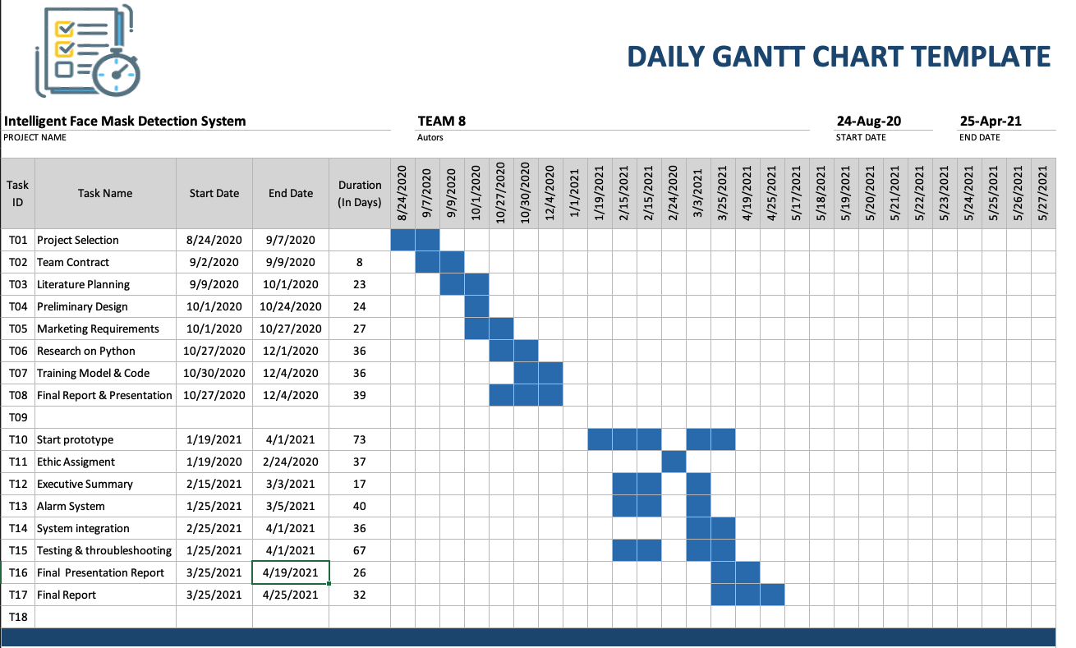
Figure 2: Detailed Timeline in Gantt chart.

Section 3 - Literature Review

3.1: List of all sources of information
[1]A. Kulkarni et al., "Implementing a Real-time, AI-Based, Face Mask Detector Application for COVID-19 | NVIDIA Developer Blog", NVIDIA Developer Blog, 2020. [Online]. Available: https://developer.nvidia.com/blog/implementing-a-real-time-ai-based-face-mask-detector-application-for-covid-19/. [Accessed: 06- Oct- 2020].
[2]"Coronavirus Disease 2019 (COVID-19) in the U.S.", Centers for Disease Control and Prevention, 2020. [Online]. Available: https://covid.cdc.gov/covid-data-tracker/#cases_casesinlast7days. [Accessed: 06- Oct- 2020].
[3]"NIST Launches Studies into Masks’ Effect on Face Recognition Software", NIST, 2020. [Online]. Available: https://www.nist.gov/news-events/news/2020/07/nist-launches-studies-masks-effect-face-recognition-software. [Accessed: 06- Oct- 2020].
[4]"Report: How many local businesses have had to close due to COVID-19? | Womply", Womply helps small businesses thrive in a digital world, 2020. [Online]. Available: https://www.womply.com/blog/report-how-many-local-businesses-have-had-to-close-due-to-covid-19/. [Accessed: 06- Oct- 2020].
[5]C. Deb, “chandrikadeb7/Face-Mask-Detection,” GitHub, 2020. [Online]. Available: https://github.com/chandrikadeb7/Face-Mask-Detection. [Accessed: 24-Nov-2020].

3.2: Statement of Learning from each source
To complete this project, We have researched several different articles to reach our goal to reduce the spread of covid 19 on Campus.
For the first article, we have learned the process on how to implement a Real-time, AI-Based, Face Mask Detector Application for COVID-19. We have also learned how to do the transfer learning to have the accuracy of our model.
For the second article, we have learned the data provided by the Center for Disease Control and Prevention how this project could impact the world and how worse this pandemic is impacting the world
For the third article, we have learned the article provided by the National Institute of Standards and Technology how the detection of people wearing masks could be challenging since a lot of top software algorithms are failing.
For the fourth article, we have learned the article provided by the website provided by womply.com how businesses have been impacted by the covid 19.
For the fifth article, we have learned the article provided by the github repository how the python code is designed.

Section 4 - Preliminary Design

4.1 Concept Generation
In the beginning phase of our project, the proposed concept was based on the idea of an
“ Ïntelligent Face Mask Detection System.” We would then develop a system that would be easy to implement and helpful during the pandemic. As a team we researched products within the market to consider design options. We wanted to develop a system that would have the capability to scan multiple faces as people enter the building, display the live feed, and an alert system through sound. Our product would be able to help reduce face mask regulation violations, and assist in decreasing the spread of COVID-19 on campus.
Initially we considered including an alert system through LED and a warning message through sound as well. By including an alert system through LED it would get the attention of anyone who may be deaf or hard of hearing. Although we decided not to include these features, our system can be upgraded to include both features.

4.2 Concept Evaluation and Selection
Initially we considered including an alert system through LED and a warning message through sound as well. By including an alert system through LED it would get the attention of anyone who may be deaf or hard of hearing. Although we decided not to include these features, our system can be upgraded to include both features. Due to the time constraint, we decided to focus on our system being able to accurately detect and classify face masks, easy to implement, display live camera feed and mask detection, lightweight and compact design, and cost efficient.. We focused on these requirements to ensure we would deliver our product before or on our project deadline.

4.2 Concept Evaluation and Selection(Continued)
Considering our requirements, we decided as a team our Intelligent Face Mask Detection System would consist of an embedded system and deep learning model. The embedded system consists of the Nvidia Jetson Nano Developer Kit, a camera, a screen, and a speaker. The Nvidia Jetson Nano Developer Kit will first serve as a communication interface for the camera, the screen, and the speaker. Secondly, the kit will serve a computer able to run a deep learning model. Using deep learning, the images obtained from the camera will be used to classify people wearing masks or people not wearing masks. In order to deliver this deep learning model, large data sets will be collected from the public domain to train a deep learning model to perform the task. These large data sets will help reduce face mask detection failure rate to have a reliable system in terms of accuracy.

4.3 Design Constraints and Applicable Codes and Standards Used in the Design
- Design Constraints:
  - For our design, the constraints will be listed from most to least critical. The most challenging constraint was as a team we were not familiar with machine learning algorithms. With this constraint the team decided to develop our machine learning algorithm skills by taking online courses to become more familiar with them. Another design constraint we came across was we had a limited dataset and test population. Initially this was due to only being able to train and test the deep learning model on the team members due to Covid-19. We overcame this constraint by applying knowledge we learned from the online courses. We instead used Transfer Learning, where we used a previous model developed for face mask detection as our starting point. We then applied another technique we learned called Data fine-tuning by adding members of the team to the dataset used to train the deep learning model. Our next design constraint is we cannot ensure the 100% accuracy of ML applications but the goal was to have an 80% accuracy rate on the facemask detection deep learning algorithm. The actual accuracy was 82% which is better than our expected accuracy rate. The fourth constraint is our total budget for the project could not exceed over $600 in total expenses. Our fifth design constraint is only two of our team members are allowed to work in the lab due to the social distancing. The sixth design constraint is not having a lab open at usual hours to work on implementing the design of our project. The lab hours are very limited due to Covid-19. Our fifth and sixth design constraint was initially seen as major constraints but they did not affect our project as we did not need lab space.

4.3 Design Constraints and Applicable Codes and Standards Used in the Design (Continued)
- Applicable Codes and Standards Used in the Design
  - IEEE Code of Ethics:
    - Implemented throughout the duration of our project to ensure the team adheres to the highest ethical and professional conduct.
  - IEEE P802E:
    - Specifies a privacy threat model for IEEE 802 technologies and provides recommendations on how to protect against privacy threats.
  - IEEE 7.6: IEEE Protection of the Public:
    - To maintain public safety with the creation of our engineering devices
  - IEEE Std 982.1-1988:
    - IEEE Standard Dictionary of Measures to Produce Reliable Software - implemented to determine the reliability of the system.
  - IEEE 610.12 - Standard Glossary of Software Engineering Terminology
    - This standard identifies terms currently in use in the field of Software Engineering when programming.
  - National Electrical Safety Code (NESC)
    - Implemented to make sure that the electrical components of the are not exposed and create any harm.
  - IEEE 829-2008: IEEE Standard for Software and System Test Documentation
    - Used as the guidelines in order to perform the test of the system

4.4 Preliminary Analysis
To arrive at our proposed solution, our team used the methodology in figure. First we started with the problem definition where we asked questions about the problem, especially what it is and why it is important to solve it. Then, our team completed our literature review, we had a deeper understanding of how to design and implement our system to meet our marketing and engineering requirements. I pursuance of the marketing and engineering requirements, we applied our knowledge gained from both academic courses and online machine learning courses.
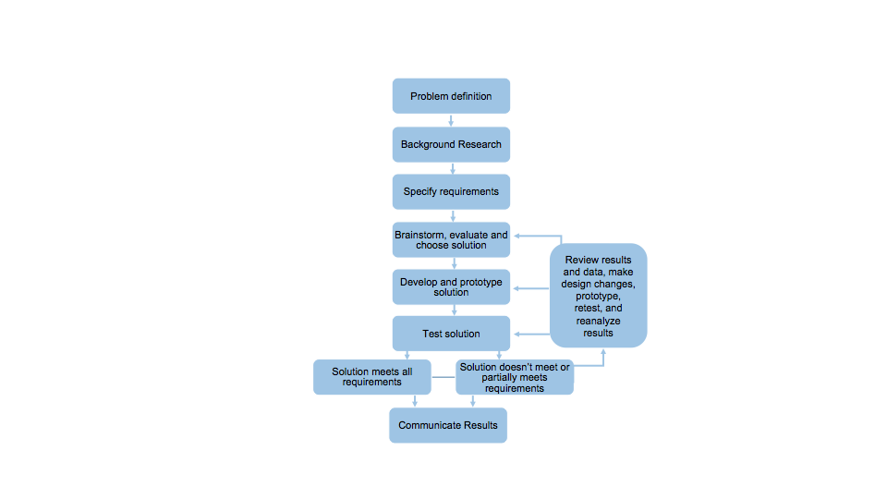
Figure 3: Engineering Design Methodology

4.4 Preliminary Analysis (Continued)
The academic courses consisted of Computer Science I & II, Data Structures, Electrical Engineering labs, Speech, Project Management, and Computer Interfacing and Communication. The Computer Science courses helped the team to understand and rewrite the code of the pre-trained deep learning model which is written in Python Programming language. The electrical engineering lab courses such as Network Theory Lab and Electronics I Lab helped the team be able to assemble our prototype with Nvidia Jetson Nano, the camera, the speaker and the screen. The knowledge from Computer Interfacing and Communication assisted the team in choosing the Nvidia Jetson Nano as our edge computing system for our design. Speech developed our public speaking and presentation skills. Which ensured we effectively present our project to our classmates and our instructor during presentation days. The Project Management course assisted in managing the overall structure of the project, each task required for each deliverable, the timeline, and who will be working on each task.
As a team, we developed and signed contracts for each semester to ensure we would deliver a successful product that meets all marketing and engineering requirements in the time given. In order to meet all requirements on schedule we decided it was necessary we meet a minimum of 4 hours a week outside of our Senior Design class. In order to have a successful product we had to obtain new skill sets. This included learning Python to program the software, how to use machine learning algorithms to train the deep learning model, and how to use Linux to.

4.4 Preliminary Analysis (Continued)
Compared to other products in the market, the major advantage of our device is our product is more cost effective. One key analysis that we researched was the Nvidia Jetson Nano also gives our Intelligent Face Mask Detection System the capability to scan multiple people at a time and display it in real time. As a result of this feature, our product has a great societal impact on the world because it can be implemented in public areas with low, medium, and high traffic. That includes locations such as schools, shopping malls, stadiums, hospitals, grocery stores, and airports unlike other products on the market. Another competitive advantage is our Intelligent Face Mask Detection System can support a dataset of 27,000 images which is almost 5,000 images more than products on the market at this time.

4.5 Preliminary Design
The process of our preliminary design is:
- An unknown face will be detected by the camera.
- The camera sends the live feed to the Nvidia Jetson Nano.
- The deep learning model will process the feed and determine whether or not the unknown face is wearing a mask.
- While the system is going through this process the live feed is being displayed on the monitoring screen.
- If the unknown face is wearing a mask the screen will display a green rectangle around the face and there will NOT be an alert through sound.
- If the unknown face is NOT wearing a mask the screen will display a red rectangle around the face and there will be an alert through sound.

4.5 Preliminary Design(Continued)

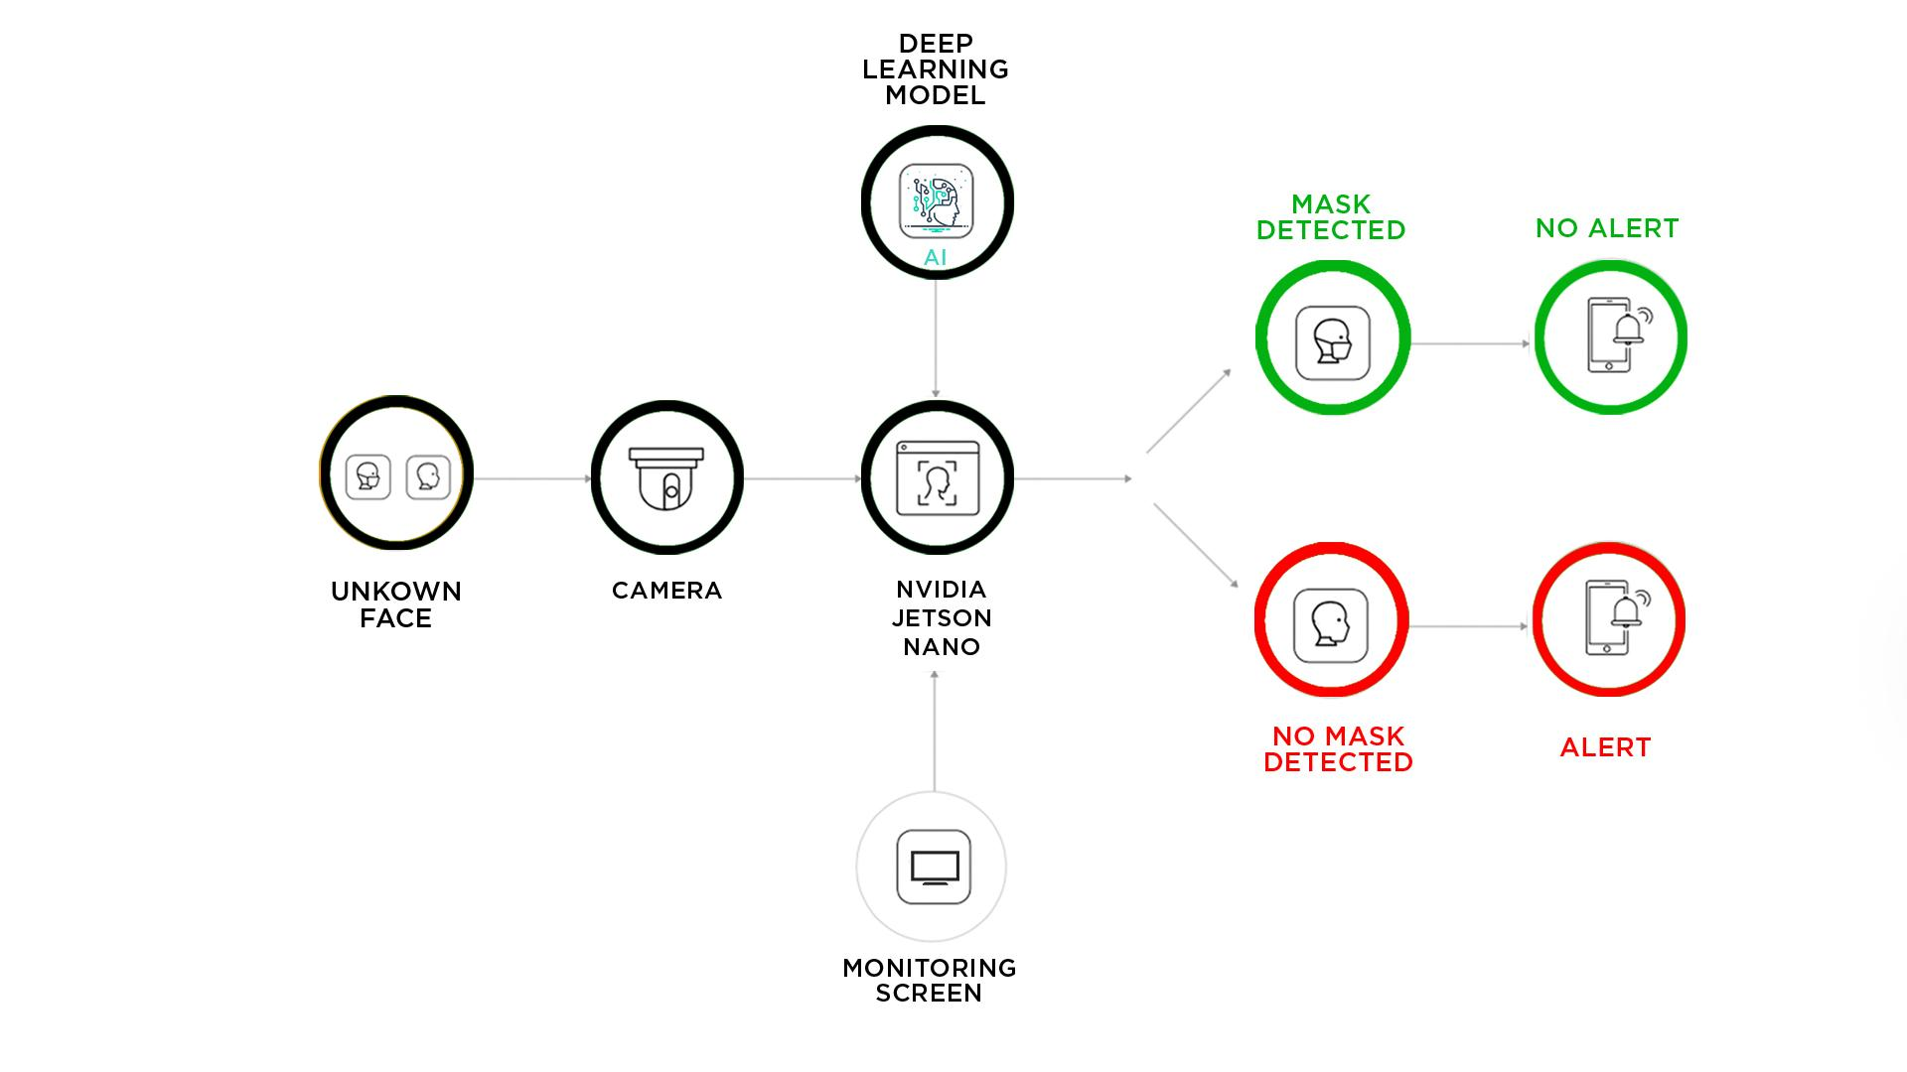
Figure 4: Preliminary Design Concept

Section 5 - Detailed System Design

5.1 Project Parts Summary
The hardware parts used in the following:
- The NVIDIA Jetson Nano Developer Kit 2GB
- The e-CAM30_CUNANO Camera Sensor
- The Mini External USB Stereo Speaker ADAFRUIT speaker
- The IPS Capacitive Touch Screen Display
- The Intel Realsense D435 depth
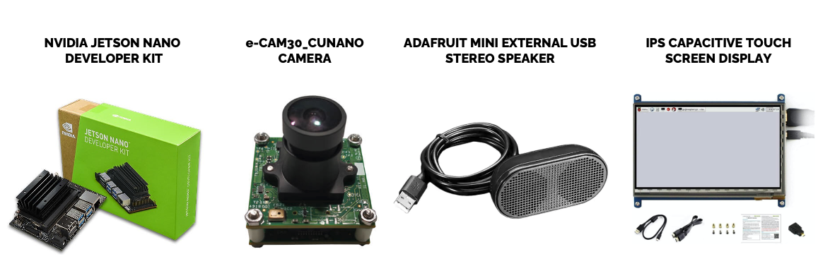
Figure 5: Projects Parts Summary

5.2 Engineering Analysis and/or Simulation
- Hardware Component

1. Setting up the Jetson Nano with Jetpack 4.5.1:

JetPack is compatible with NVIDIA’s world-leading AI platform for training and deploying AI software, reducing complexity and effort for developers including this following component:

● L4T Kernel / BSP ● CUDA Toolkit ● cuDNN
● TensorRT ● OpenCV ● VisionWorks
● Multimedia API's

The jetpack is installed by following these steps:
- Download, install, and launch Etcher on Mac OS
- Flash the Jetpack 4.5 image file into the Micro SD.
- Insert the flashed Micro SD into the Jetson Nano
- Boot the system by powering the Jetson Nano
2. Installing Tensorflow on the Jetson Nano

TensorFlow is an open-source software library for numerical computation using data flow graphs. This flexible architecture lets you deploy computation to one or more CPUs or GPUs in a desktop, server, or mobile device without rewriting code.
The TensorFlow Library can be installed by executing the following commands:
$ sudo apt-get install libhdf5-serial-dev hdf5-tools libhdf5-dev zlib1g-dev zip libjpeg8-dev liblapack-dev libblas-dev gfortran
$ sudo apt-get install python3-pip
$ sudo pip3 install -U pip testresources setuptools==49.6.0
$ sudo pip3 install -U numpy==1.16.1 future==0.18.2 mock==3.0.5 h5py==2.10.0 keras_preprocessing==1.1.1 keras_applications==1.0.8 gast==0.2.2 futures protobuf pybind11
# TF-2.x
$ sudo pip3 install --pre --extra-index-url https://developer.download.nvidia.com/compute/redist/jp/v45 tensorflow
# TF-1.15
$ sudo pip3 install --pre --extra-index-url https://developer.download.nvidia.com/compute/redist/jp/v45 ‘tensorflow<2’

5.2 Engineering Analysis and/or Simulation(Continued)

3. Setting up the Camera:
To do this a project was built from the source, below is a condensed form of the commands to download, build, and install the project:

$ git clone https://github.com/jetsonhacks/installRealSenseSDK
$ cd installRealSense/
$ ./installLibrealsense.sh

- Software Component

4. AI-based face mask detection

We have used the pretrained model provided by the company Nvidia to build our software.
The picture shows the high-level workflow of downloading the pretrained model and downloading and converting datasets to the KITTI format to use with TLT. The quantized TLT model is then deployed using DeepStream SDK to detect masked and no-mask faces.

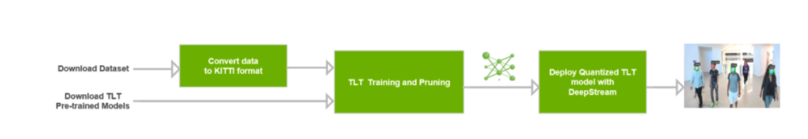
Figure 6: Workflow for developing an AI-based face mask detector

5.2 Engineering Analysis and/or Simulation(Continued)
The following picture shows the effect of pruning on the overall throughput of the face mask detection application.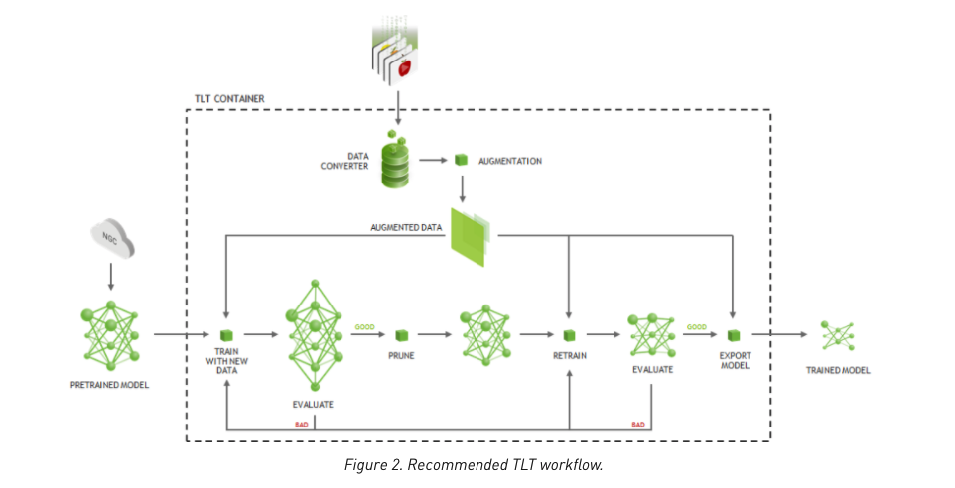
Figure 7: TLT Workflow from Nvidia

5. Alarm system
For our alarm system, we have used a library called playsound. That library eased the way to implement the alarm system.
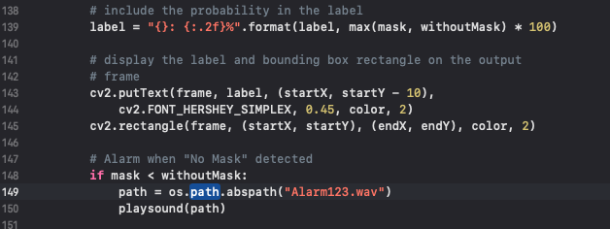
Figure 8: Code for Alarm System

5.3 Layout/Detailed Drawings/Equipment Selection and Specifications

Description | Specifications | Image
Jetson Nano Developer Kit | GPU 128-core Maxwell  CPU Quad-core ARM A57 @ 1.43 GHz  Memory 4 GB 64-bit LPDDR4 25.6 GB/s  Storage microSD (not included)  Video Encode 4K @ 30 | 4x 1080p @ 30 | 9x 720p @ 30 (H.264/H.265)  Video Decode 4K @ 60 | 2x 4K @ 30 | 8x 1080p @ 30 | 18x 720p @ 30 (H.264/H.265)  Camera 2x MIPI CSI-2 DPHY lanes  Connectivity Gigabit Ethernet, M.2 Key E  Display HDMI and display port  USB 4x USB 3.0, USB 2.0 Micro-B | 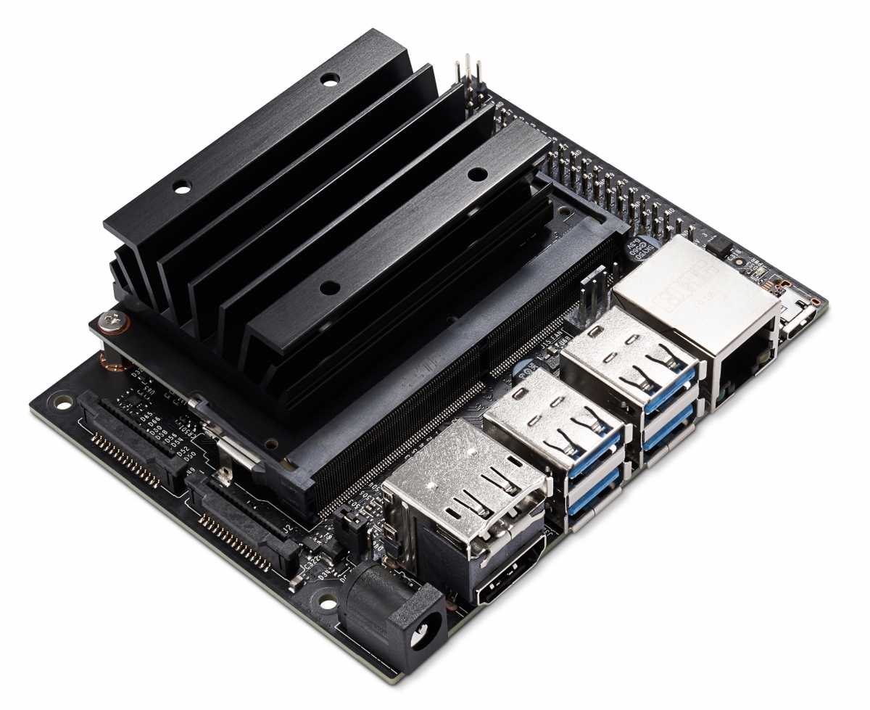
Adafruit mini external usb stereo speaker | Voltage: 5V  Total power: 2 x 2W  SNR: 60dB  Impedance: 4 ohm  Cable Length: 1,168mm / 46"  Product Dimensions: 84.0mm x 43.0mm x 32.0mm / 3.3" x 1.7" x 1.3" | 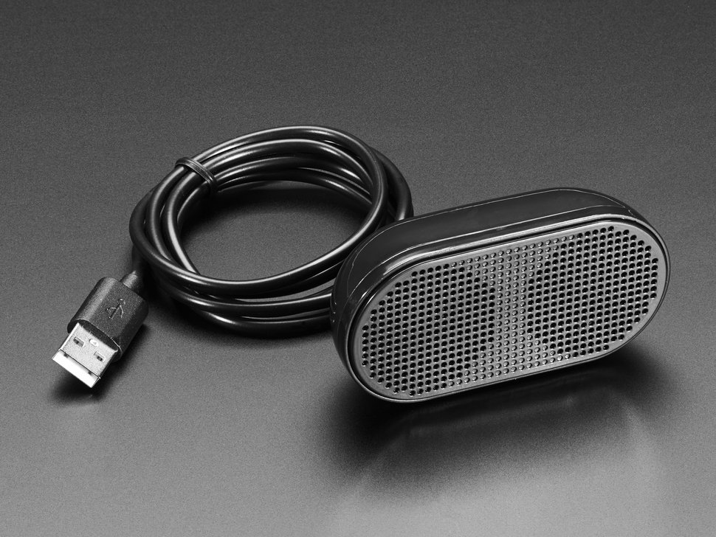
1024x600 IPS Capacitive Touch Screen LCD Display HDMI | Capacitive Touchscreen LCD HDMI interface,1024x600 hardware resolution, configurable by software (up to 1920x1080)  Supports popular mini PCs such as Raspberry Pi 4 3/2/1 B+ B A+, Jetson Nano,BB Black, Banana Pi, | 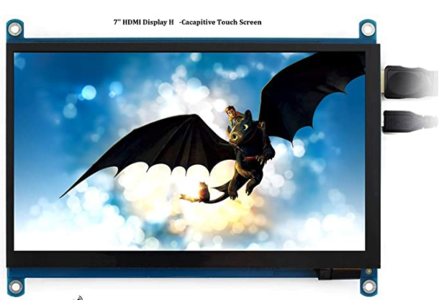
Intel® RealSense™ D435 | RGB frame resolution:  1920 × 1080, RGB frame rate: 30 fps  RGB sensor technology:  Rolling ShutterRGB sensor  RGB sensor resolution:  2 MP | 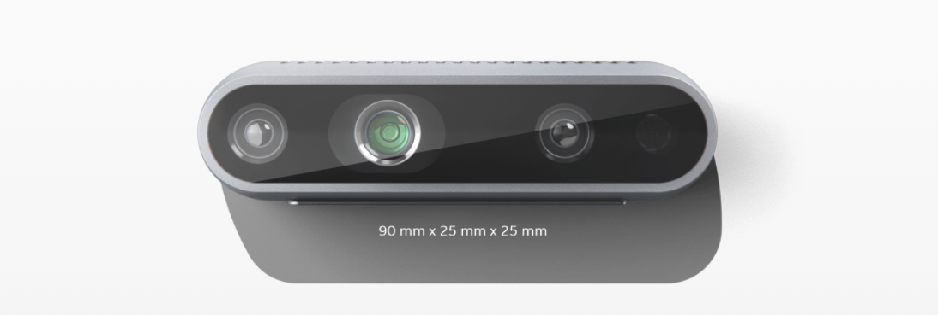

Table 5.1 : Equipment list

5.4 Application of Engineering Codes and Standards
IEEE Code of Ethics: Implemented throughout the duration of this project to ensure our group adheres to the highest ethical and professional conduct.This project allowed for us to gain valuable knowledge pertaining to database systems and Python coding
IEEE P802E: Specifies a privacy threat model for IEEE 802 technologies and provides recommendations on how to protect against privacy threats. This allows us to do this project by making people's pictures private.
IEEE 7.6: IEEE Protection of the Public: To maintain public safety with the creation of our engineering devices. The project is directly related to the public safety and we are trying to reduce the spread of covid 19.
IEEE Std 982.1-1988: IEEE Standard Dictionary of Measures to Produce Reliable Software - implemented to determine the reliability of the system.
National Electrical Safety Code (NESC)- Implemented to make sure that the electrical components of the are not exposed and create any harm.
IEEE 829-2008: IEEE Standard for Software and System Test Documentation - Used as the guidelines in order to perform the test of the system

5.5 Economic Analysis
This project was within the allocated budget of $600. Our total spending ended up at
$289.49. Our project is to create hardware and software devices to reduce the spread of covid-19 on campus.
Item Name | Description | Quantity | Total
Nvidia Jetson Nano Kit | Developer Kit | 1 | $99.00
Accessories for Jetson  Nano Developer Kit AI  Development | 7inch IPS capacitive touch display, IMX219-77 camera board, 64GB class 10 TF card, and the power adapter | 1 | $79.99
Mini External USB  Stereo Speaker | Speaker | 1 | $12.5
STEEReoCAM® - 2MP Stereo Camera for NVIDIA® Jetson | Camera | 1 | $13.50
Total for Project: |  |  | $289.49
Table 5.2: Detailed Economic Analysis

Product | Picture | Estimated Cost | Pros | Cons | Final Decision
Green Extreme Face Recognition & Temperature Measurement | 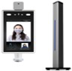 | Sale: $699 (Regular price: $1,295) | Scans an individual every 1-2 seconds.  IR body temperature detector  Database of up to 22,400 faces & 100,000 records. | Scans one person at a time.  Over budget.  Low societal impact | Not Selected
Intelligent Face Mask Detection System | 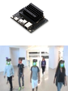 | $300 | Affordable  Already have a key component.  27,000 images  Scans multiple people at a time.  Social impact  User friendly. | Doesn’t measure temperature By this feature could be added | Selected

Table 5.2: Detailed Project comparison

5.6 Final Design cases
- No Face detected Case
When there is none passing in the front of the device, there is no face recognition. The device is not detecting any face therefore no actions

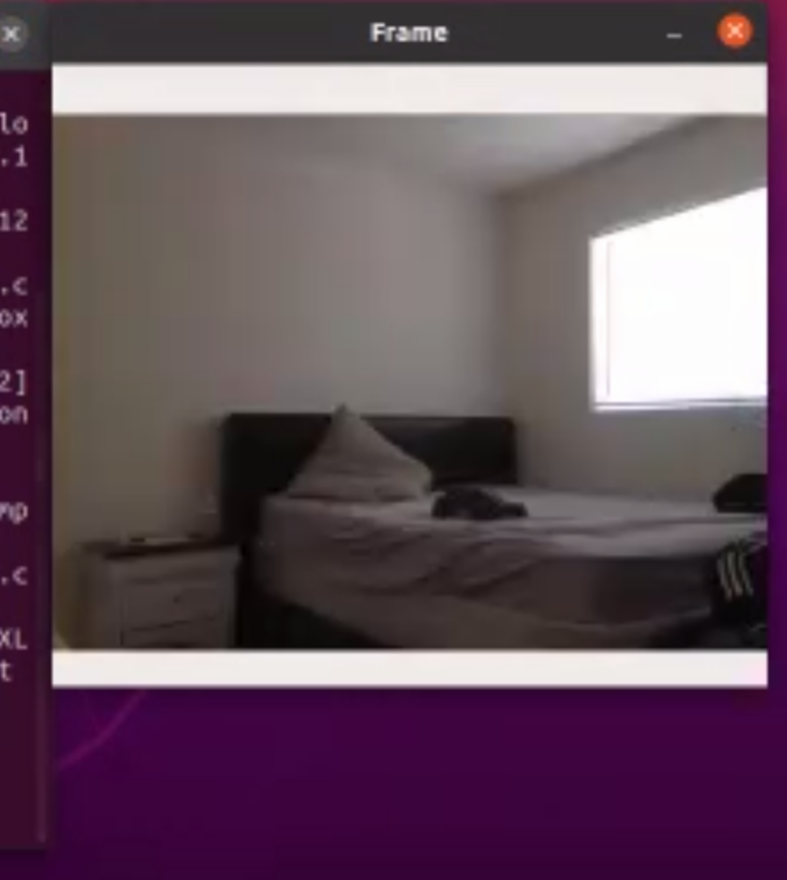
Figure 10: No face detected screenshot

- Face without mask detected Case
The device detected a human face without a mask. A red rectangle is shown with the words”No mask” with a prediction rate of 100% detection on the screen. An alarm is then sounding to let the person know to wear a mask
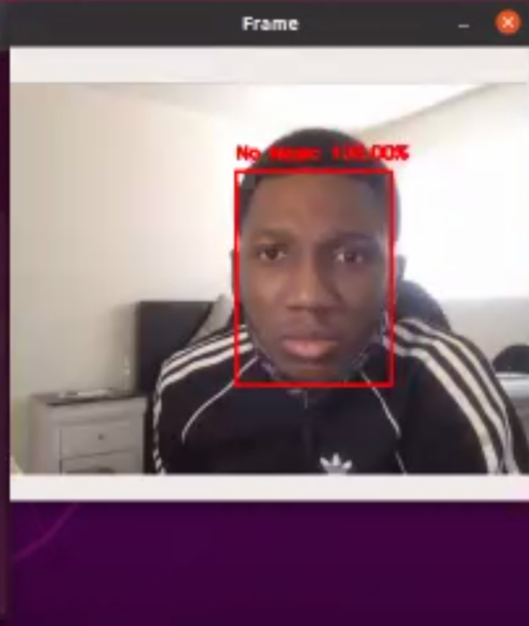
Figure 11: face detected without mask:

- Face detected with a mask on:
The device detected a human face with a mask on. The screen is showing a green rectangle with the word “Mask” with a prediction of 99.20% detection. There is no alarm sound and the person is good to go.

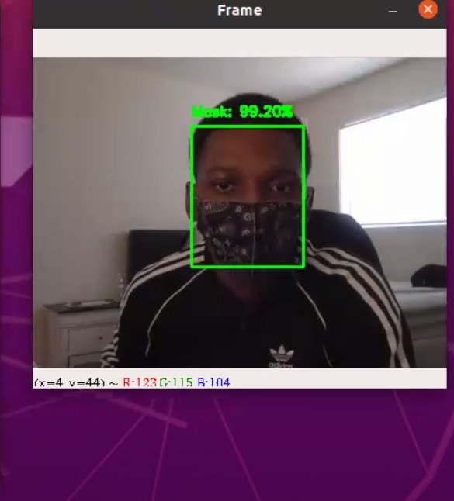

Figure 12: face detected with mask:

Section 6 - Results & Discussion

6.1 Summary of Goals and Objectives
As part of our goal, we are developing a smart and efficient device that not only keeps track of people entering a building with or without a mask, but it also helps prevent people from entering inside a building without a mask due to our designed alarm system. The goal of our project is to design an intelligent Face Mask Detection System and Alarm System to reduce regulation violations and the spread of COVID-19 on campus by creating a system that can scan the users face with a camera and processing the image through our deep learning model to alert users via alarm sound to wear a mask before entering a building.

6.2 Summary of Constraints and Codes met by Design
- Summary of Constraints
Our system had many constraints, first being the limited budget of $600 to restrict us from purchasing more up to date parts for better efficiency. Another constraint is our physical ability to attend the laboratory due to COVID-19 restrictions. Not having a lab open at usual hours to working on implementing the design of our project. When we can get lab time we could allow two of our team members inside to work. Lastly, the limited time in creating the code for the system. We only have 8-9 months to work on having the project completely done. During the 8-9 months the team could meet for 6-8 hours every week.

- Codes met by Design
- IEEE Code of Ethics: Implemented throughout the duration of our project to ensure the team adheres to the highest ethical and professional conduct.
- IEEE P802E - Specifies a privacy threat model for IEEE 802 technologies and provides recommendations on how to protect against privacy threats.
- IEEE 7.6: IEEE Protection of the Public - To maintain public safety with the creation of our engineering devices
- IEEE Std 982.1-1988: IEEE Standard Dictionary of Measures to Produce Reliable Software - implemented to determine the reliability of the system.
- IEEE 829-2008: IEEE Standard for Software and System Test Documentation - Used as the guidelines in order to perform the test of the system.
- National Electrical Safety Code (NESC)- Implemented to make sure that the electrical components of the are not exposed and create any harm.

6.3 Discussion of Results
In the end, we were able to create a feasible project that will track a person’s faces to detect if the person is wearing a mask or not. When the camera scans the users faces the image is then processed through the Nvidia Jetson Nano. Once processed through the Jetson Nano with the integration of the Deep Learning Model, the system will detect if the user approaching the camera walkway is wearing a mask or not. If the user is wearing a mask the system will display a green box around the users face on a monitor. The system will not alert the user because the user is not violating any violations. Now if the user is not wearing a mask, then the system will display a red box around the users face and alert the user via speaker with an alert sound to warn the user to wear a mask before entering a pathway.
With the physical build, we were able to make a design that can be stored easily and very simple and seamless to set up at any door entrance or walkways. We were only able to make the physical build with wired connections. We did go through many preliminary designs of the physical build, but in the end were able to create a device that has a small physical build to be easy to transport and also a user-friendly interaction with the large display screen.

Section 7 - Conclusions and Recommendations

7.1 Conclusion
Our Intelligent Face Mask Detection and Alarm System is designed to detect whether people are wearing masks or not. This device will allow not only campuses but most businesses to keep monitoring people that are coming into their facilities to make sure they are following the guidelines by wearing masks. The implementation of our system will reduce regulation violations and the spread of COVID-19 by impacting businesses and public institutions.

7. 2 Recommendations
The Nvidia Jetson Nano Developer Kit will serve as a communication interface for the camera, the screen, and the speaker. Also, the kit will serve as a computer able to run a deep learning model that has been pretrained. Furthermore, the embedded system will be programmed using a dataset to train the deep learning model to ensure the accuracy of face mask detection. The system can easily be installed in all entrances and walkways across campus and as well as any other places outside the campus where wearing masks is enforced. Additional features like a temperature sensor can seamlessly be configured into the system.

List of References
[1]A. Kulkarni et al., "Implementing a Real-time, AI-Based, Face Mask Detector Application for COVID-19 | NVIDIA Developer Blog", NVIDIA Developer Blog, 2020. [Online]. Available: https://developer.nvidia.com/blog/implementing-a-real-time-ai-based-face-mask-detector-application-for-covid-19/. [Accessed: 06- Oct- 2020].
[2]"Coronavirus Disease 2019 (COVID-19) in the U.S.", Centers for Disease Control and Prevention, 2020. [Online]. Available: https://covid.cdc.gov/covid-data-tracker/#cases_casesinlast7days. [Accessed: 06- Oct- 2020].
[3]"NIST Launches Studies into Masks’ Effect on Face Recognition Software", NIST, 2020. [Online]. Available: https://www.nist.gov/news-events/news/2020/07/nist-launches-studies-masks-effect-face-recognition-software. [Accessed: 06- Oct- 2020].
[4]"Report: How many local businesses have had to close due to COVID-19? | Womply", Womply helps small businesses thrive in a digital world, 2020. [Online]. Available: https://www.womply.com/blog/report-how-many-local-businesses-have-had-to-close-due-to-covid-19/. [Accessed: 06- Oct- 2020].
[5]C. Deb, “chandrikadeb7/Face-Mask-Detection,” GitHub, 2020. [Online]. Available: https://github.com/chandrikadeb7/Face-Mask-Detection. [Accessed: 24-Nov-2020].

Appendix

As part of our appendix, we wanted to show you how the code of the face mask detector system works. Bellow are the following functions:
- The detect_and_predict_mask function is used to predict and detect if there is someone wearing a mask or not from the image received from the camera sensor.
- The function is based on the trained model .
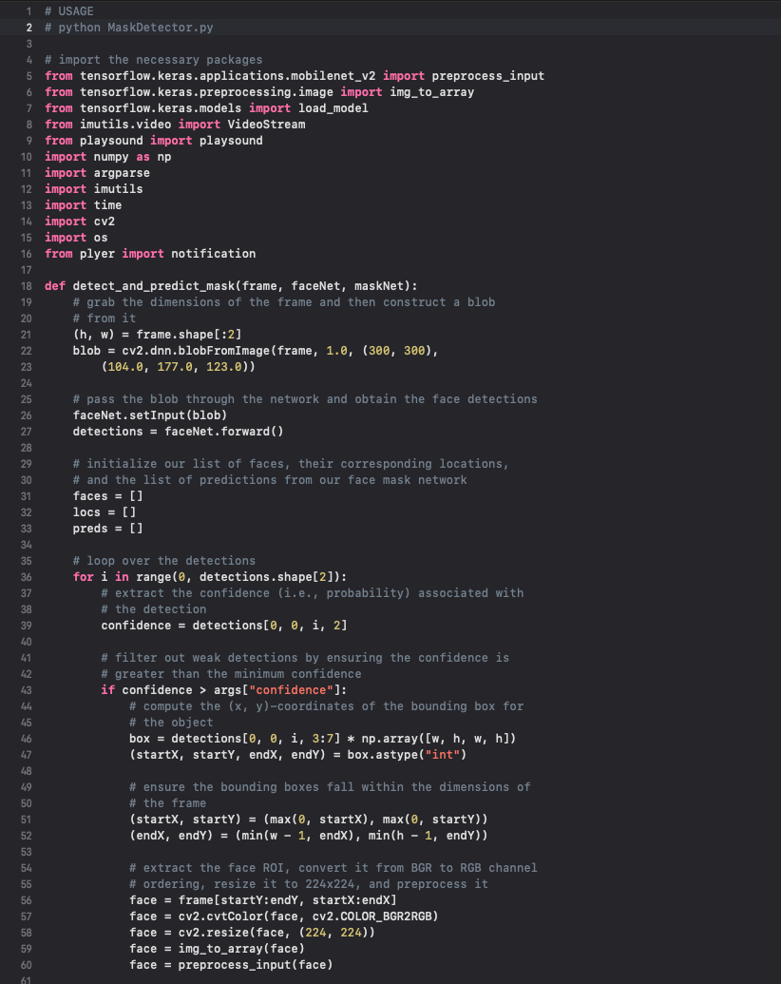

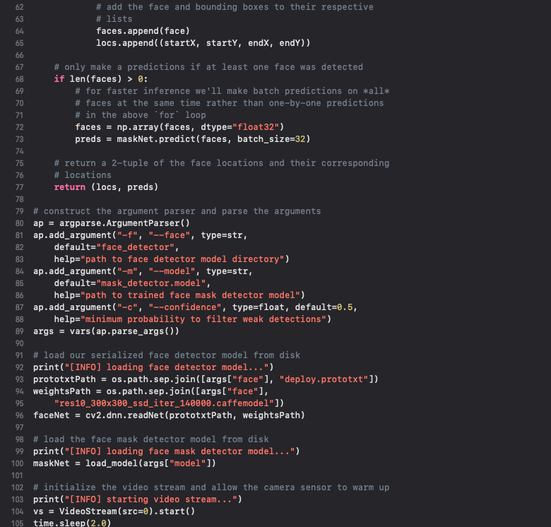

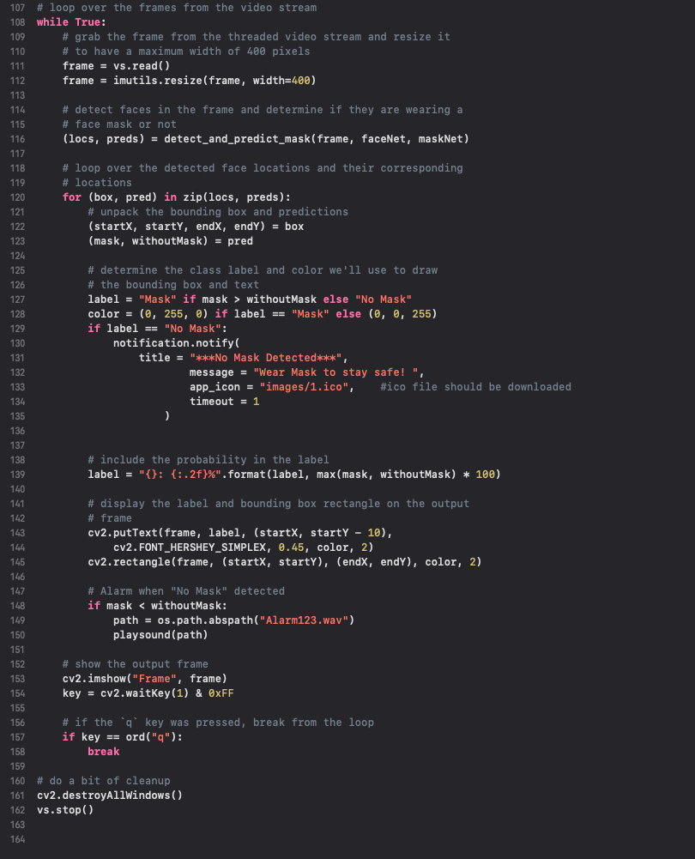
Figure 9 : Partial Code on Python:

