PRAIRIE VIEW A&M UNIVERSITY
ROY G. PERRY COLLEGE OF ENGINEERING



Parking Lot Detection System

Senior Design & Professionalism II
ELEG 4248

Topic: Final Exam Report

Team 8
Abel Mendoza
Alfredo Hurtado
Hillel Lands
Juwan Byers
Oluwadamilola Oboye
Ryan Johnson
Instructor: Professor Turner
Date of Submission: 05/01/2022

Project Executive Summary
Mission Statement:
To design a parking lot detection network that uses Long Range Wide Area Network (LoRaWan) technology in order to transmit communication signals and mitigate attacks.
Problem Statement:
Unfortunately, at present times, Internet of Things (IOT) devices are easily exploited by attackers, and they present many new challenges for security including system constraints, scalability, and enlarged attack surfaces
Proposed Deliverables:
- Check the security of LoRa OTA (Over the Air) activation using (SYTHER) a formal security analysis tool and focuses on the key exchange portion.
- Send messages along the bandwidth
- Create a functioning parking detection device
Target Audience:
Any end user of an Internet of Things (IoT) device
Budget:
Project Budget: $600
Amount Spent: $375
Customer requirements and Engineering Solutions:
- Analyze security vulnerabilities of Lora WAN and detect the security risks
- Develop new solutions to mitigate major security risks in the LoRa platform
- Use different codes to strengthen the security of the Lora
- Make sure stronger security key sets can be established when completing the over-the-air communications.
Major constraints:
- Using LoRa on college campus may raise potential connectivity problems
- The team has limited knowledge of computer coding
- The team has limited knowledge of 3-D printing operations
Project Impacts
This project impacted four aspects in today's world. The first being environmental, the second being economic and social, the third being public health and safety and lastly, technical.
Environmental:
By implementing our project, we will be a part of assisting the next generation of percentage drop in emissions from 2021 to 2030 by reducing driving time among drivers.
Economic & Social:
The goal of this project is to decrease the money and time spent on finding parking. Commuter students and faculty will know how many open spaces are left beforehand instead of driving around to find parking. Creates the opportunity to arrive on time for a class or meeting. Faculty and Employees can avoid being late to work with the time saved.
Public Health & Safety:
Implementing a parking space detector can greatly reduce emissions and stress levels for everyday drivers. By reducing the driving time of the population, the percentage of carbon monoxide emissions will be reduced. Lowering global greenhouse gas emissions will slow climate change and prevent millions of premature deaths due to air pollution over the next decades. People that use parking garages or campus parking lots will benefit from reduced stress levels because they will no longer have to deal with uncertainty and hassle of planning ahead to arrive extra early.
Technical:
LoRaWan has been the go-to network for IoT devices, especially in the industrial setup. These are devices that can reliably send very small data packets, from temperature to humidity. Lora devices are ideal to send small packets of data over a long range that does not include images or video.

Recommendation
- When setting up the environment make sure the script is correct
- Do thorough research on what security verification protocol would be the best to use
- Use as much time as possible on every security measure

Conclusion
Testing the security environment of the LoRa takes a lot of trial and error. Revision of the code is fundamental. As a team we will make sure to work as a team and continue to troubleshoot frequently.

Table of Contents
Project Executive Summary.………………………............ ii-iv
Table of Contents ……………………………………… v
List of Figures …………………………………………. vi
List of Tables and Graphs ……………………………. vii
List of Team Members and Roles ………….………. viii
1. PROJECT SCOPE
1.1 Problem Statement, Business Objective and Target Audience of your Project…2
1.2 Client identification and recognition of need 3-4
1.3 Project goals and objectives 5
1.4 Contemporary issues relevant to project 6
1.5 Potential impact of project on society (Safety, Env, Tech, Eco) 7-8
1.6 Initial Project constraints 9
2. PROJECT PLANNING AND TASK DEFINITION
2.1 Task identification 11
2.2 Gantt chart 12

3. LITERATURE REVIEW
3.1 List of all sources of information 15-16
3.2 Statement of Learning from each source 17-18

4. PRELIMINARY DESIGN
4.1 Concept generation 20-21
4.2 Concept Evaluation and selection 22
4.3 Design Constraints and Applicable Codes and standards 23
4.4 Preliminary Analysis - must show the science/math 24
4.5 Preliminary Design 25

5. DETAILED SYSTEM DESIGN
5.1 Project Parts Summary 27-28
5.2 Engineering Analysis and/or Simulation 29-33
5.3 Hardware Layout/Detailed Drawings/Equipment selection and specifications 34-40
5.3.1 Show Overview of Code Developed to Support 5.3 41-44
5.4 Application of Engineering Codes and Standards used in Final Design 45
5.5 Economic Analysis 46
5.6 Final Design – show pictures or other examples of working design 47
6. RESULTS & DISCUSSION
  - Summary of Goals and Objectives 49
6.2 Summary of Constraints and Codes met by Design elaborate 50
6.3 Discussion of Results and Other Use Cases 51

7. CONCLUSIONS AND RECOMMENDATIONS 53

LIST OF REFERENCES 55-57

APPENDIX (Include user manual or coding documentation if appropriate) 59-62

List of Figures
- Initial Team schedule…………………………………………………………………..12
- High level schedule…………………………………………………………………...13
- Gantt chart……………………………………………………………………………13
- Sensor Comparison……………………………………………………………………18
- Engineering design methodology……………………………………………………..20
- Preliminary design…………………………………………………………………….25
- Project parts summary……………………………………………………………… 27
- Ultrasonic sensor operation………………………………………………………….29
- Arduino UNO………………………………………………………………………..30
- LoRa Transmitter……………………………………………………………………..32
- Ultrasonic sensor and LED connection layout………………………………………34
- 1st iteration layout (green LED)………………………………………………………35
- 1st iteration layout (red LED)…………………………………………………………35
- 2nd iteration Ultrasonic sensor and LED connection layout………………………….36
- Ultrasonic sensor and LDC operation…………………………………………………37
- Design component Dimensions……………………………………………………….38
- Base of Parking Lot sensor enclosure…………………………………………………39
- Top Lid of Parking Lot sensor enclosure……………………………………………..39
- Arduino code developed to operate sensor and LED’s……………………………… ..41
- Code developed to configure Heltec LoRa transmitters……………………………….43
- Final parking detection device…………………………………………………………47

List of Tables and Graphs
- Engineering matrix …………..............................................................................................4
- Parts comparison ……………………………………………………………………...46

List of Team Members and Roles
Abel Mendoza……………………………………………………………………. Test Lead
Alfredo Hurtado…………....……………………………………………. Presentation Leader
Hillel Lands……....…………………………………………………...Procurement Manager
Juwan Byers………………………………………………………………………Team Lead
Oluwadamilola Oboye………………………………………Secondary Presentation Leader
Ryan Johnson……….................………………………………………Secondary Test Lead

SECTION 1 – PROJECT SCOPE

1.1 Problem Statement, Business Objective and Target Audience of your Project
Low Power Wide Area Networks (LPWAN) protocols such as LoRa are receiving increased attention from industry and academia to offer accessibility for Internet of Things (IoT) connected end devices. The popularity has exposed that there are many known security vulnerabilities. Analyze and assess the vulnerabilities of LoRaWan v1.1 and security risks of the Internet-of-Things network. The target audience of the project is any place that would like to implement LoRa communication into their communication network.

1.2 Client identification and recognition of need
- The first marketing requirement is to make the network secure and difficult to hack. To solve this, we will trouble shoot the existing code and develop secure access.
- The second marketing requirement is to have long-range access to the data. To solve this, we will use a Long-Range Wide Area (LoRaWan) module which is designed for long range data transfer.
- The third marketing requirement is to accurately detect threats to the network. To solve this, we will use a trustworthy (LoRaWan) join server with access to the root keys. This will enable verification and authentication testing prior to access.
- The fourth marketing requirement is that the device must be able to perform with minimal maintenance. To solve this, we will use an Arduino microcontroller that is powered by a 9-volt battery.
- The fifth marketing requirement is that the device must be low maintenance using an inexpensive sensing network. To solve this, we will use a battery powered sensor with a minimum of at least 1 year of battery life to send data back to the network. The cost to set up the network can be affordable when used in a large area.
- The sixth and last marketing requirement is that the components need to be enclosed to prevent environmental damage. To solve this, we will prepare a 3D rigid case designed for the parameters of the device which will minimize possible damage if any to the sensitive components within.
Marketing Requirement | Engineering requirements | Justification
Secure and make it difficult to hack network | Troubleshoot the existing code and develop secure access. | All sensitive information is kept safe
Having long-range access to the data | Use a LoRa module | This is a device that is designed for long range data transfer
Accurately detects threat to network | Use trustworthy LoRaWan join server with access to the root keys | Enables verification and authentication testing
Able to perform with minimal maintenance | Use Arduino microcontroller operated by 9V battery | Devices will not have to be maintained and replaced
Low maintenance and inexpensive sensing network. | Battery operated sensor, with a minimum 1 year+ battery life will be used to send data back to network | The cost to set up a network can be affordable in a large area
Prevent components exposure to the environment | 3D print a rigid case to protect the components | This will minimize the damage if any to the sensitive components within

Table #1 Engineering Matrix

1.3 Project goals and objectives
The goal of the project is to design a parking lot detection network that uses Long Range Wide Area Network (LoRaWan) technology in order to transmit communication signals and mitigate attacks. The objective was to be able to build a secure network that could send messages along radio frequency. Our network will be able to send signals and not have the messages interfered with by any outside noise.

1.4 Contemporary issues relevant to project
The main issue when dealing with radio frequencies is that there has to be a Wi-Fi client that is used and, on the campus, there have been previous cyber security attacks that would block attempts to connect to the network. The two-factor authentication provides a bridge that cannot be crossed and interfered with connecting to the LoRa network.

‘

1.5 Potential impact of project on society
Our project had impacts in Public Health, Safety, and Welfare, Social, Environmental, Economic, and Technical.
Environmental:
As indicated by the United States Environmental Protection Agency (EPA), motor vehicles listed from the years 1980-2020 indicate the percentage change in emissions. Our project will be a part of assisting the next generation of the percentage drop in emissions from 2021 to 2030.
Economic:
In this implemented scenario, our project will decrease the money and time spent on finding parking. INRIX is a SAAS (software as a service) and DAAS (data as a service) company which provides a variety of internet services and mobile applications pertaining to road, traffic and driver services. The chart describes the economic expenses that each driver will use to find parking. This project will be able to minimize those expenses by showing available parking spaces.
Social:
Commuter students will never be late to class again. Our project will be able to determine how many spaces are left in the parking lot, instead of those students or professors wasting time and gas. Our project can be further implemented into society at local grocery stores, retail stores, and apartments located in Waller County. Utilizing this project can also reduce stress levels for everyday drives. Individuals who plan to use parking lots on campus will benefit from reduced
1.5 Potential impact of project on society (continued)
stress levels. They will no longer have to deal with the uncertainty or hassle of planning ahead to arrive early.
Public Health, Safety, and Welfare:
Implementing a parking space detector can greatly reduce emissions and stress levels for everyday drivers. By reducing the driving time of the population, the percentage of carbon monoxide emissions will be reduced. Lowering global greenhouse gas emissions will slow climate change and prevent millions of premature deaths due to air pollution over the next decades. People that use parking garages or campus parking lots will benefit from reduced stress levels because they will no longer have to deal with uncertainty and hassle of planning ahead to arrive extra early
Technical:
LoRaWan has been the go-to network for IoT devices, especially in the industrial setup. These are devices that can reliably send very small data packets, from temperature to humidity. Lora devices are ideal to send small packets of data over a long range that does not include images or video.

1.6 Initial Project constraints
The initial project constraints are as follows:
- Arduino UNO only operates with sensors
- The 3D printed enclosure must be low enough for vehicles to park through
- LoRaWan network only transfers low data rates
- Bandwidth of frequency must be low in order to travel long distances

SECTION 2 -PROJECT PLANNING AND TASK DEFINITION

2.1 Task identification
The first part of the task was to figure out what LoRaWan was and how we would go about connecting to the network. We made sure to investigate different journals or printed lab work that would be beneficial to educating us on the entire project. The LoRa is new technology that can be used to send small packet sizes along a connected radio frequency network. The hype has a lot of professionals and those that are curious to look and see how well the network can be used for different applications such as a tracking device, security system, or even to track the temperature within a facility. There are different hotspots that can be used such as Helium or even The Things Network. According to MarketWatch, “In 2022, the global LoRa Chipsets market is projected to expand at a CAGR of 28.5%. The growing use of LoRa Chipsets in recycling processes across a variety of sectors is driving up market demand. As a result, the market is expected to reach USD 1139.8 Mn in 2028.”

2.2 Gantt Chart
The schedule was made so that the work could be divided for the strengths of the individual. We made sure to handle this as a team so that we could make sure to have the best delivery possible. Once it was completed, we began to handle the research that was required for the completion of the project and broke it up into different parts. First, we had to make sure that we had the parking lot sensor created and then we had to use the LoRa gateway network.

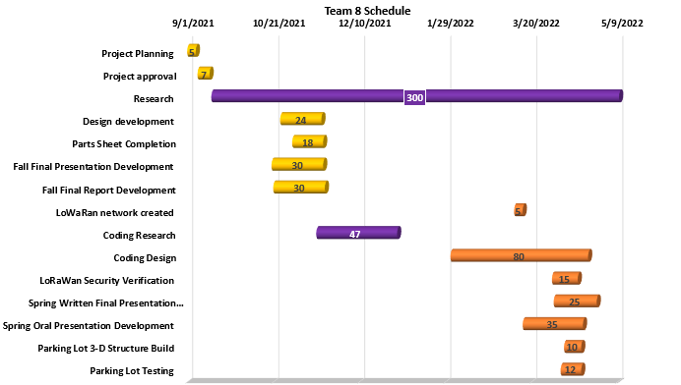
Figure #1 Initial team schedule

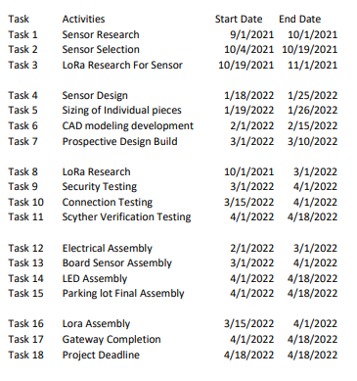
Figure #2 High Level Schedule

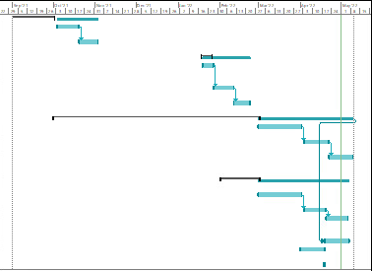
Figure #3 GANTT CHART

Section 3 - LITERATURE REVIEW

3.1 List of all Sources of Information
The list of Resources were used for composite of things such as finding the appropriate sensor for the design and for the proper LoRa gateway and end node device to receive for completion of the project. For the sensor portion of the project we used a couple resources to figure what would be the most appropriate. We had to choose between three different types: radar, infrared, and ultrasonic:
Radar: The radar sensor is able to detect through wood, plastic, or even thin walls, as well as, it works in all directions. The negative that we had was that it could only work at a minimum of four meters.
HW-MS03 high performance motion sensor board 2.4GHz to 5.8ghz microwave ... (2021,
November 11). Retrieved November 20, 2021, from https://www.amazon.com/HW-
MS03-Performance- Motion-Microwave-Arduino/dp/B09LMVCNY7
Infrared: The Infrared sensor is able to work between 2-12V. It works in temperatures ranging from 20-60 degrees Celsius which translates to 68 to 140 degrees Fahrenheit. However, it works at a minimum distance of 3 meters.
Amazon.com: Weewooday 10 pieces AM312 mini human sensor module IR ... Weewooday 10
Pieces AM312 Mini Human Sensor Module IR Pyroelectric Infrared PIR Motion Sensor
Detector Modules DC 2.7V to 12V, Working Temperature Minus 20 Degrees Celsius to
60 Degrees Celsius. (2020, December 7). Retrieved November 15, 2021, from

3.1 List of all Sources of Information(continued)
https://www.amazon.com/Weewooday-Pyroelectric-Infrared-Detector-
Temperature/dp/B08PVB7VHQ
Ultrasonic Sensor: It works at 5V and has a range of 2cm and goes up to 4 meters. The negative that we are able to work with is that is cannot work at less than 5V.
Ultrasonic distance sensor - HC-SR04. SEN-15569 - SparkFun Electronics. (n.d.). Retrieved
November 15, 2021, from https://www.sparkfun.com/products/15569

3.2 Statement of Learning from each source
In designing the parking lot system, we put a priority on the sensor that was used because it would have to fit into a small structure that would be built. The structure we envisioned building had to be able to fit into a parking lot and go into the cement. The standard dimensions of a parking lot is 9 feet by 18 feet. The correct placement would be decided later if the project was continued but being that this was the demo we wanted to make sure that we had a working device built that could fit well within these dimensions. From our first source we learned that the radar sensor is able to detect through wood, plastic, or even thin walls, as well as, it works in all directions. The negative that we had was that it could only work at a minimum of four meters. From the second source, The Infrared sensor is able to work between 2-12V. It works in temperatures ranging from 20-60 degrees Celsius which translates to 68 to 140 degrees Fahrenheit. However, it works at a minimum distance of 3 meters. From the third source, It works at 5V and has a range of 2cm and goes up to 4 meters. The negative that we are able to work with is that is cannot work at less than 5V. The ultrasonic sensor was our best choice because we could

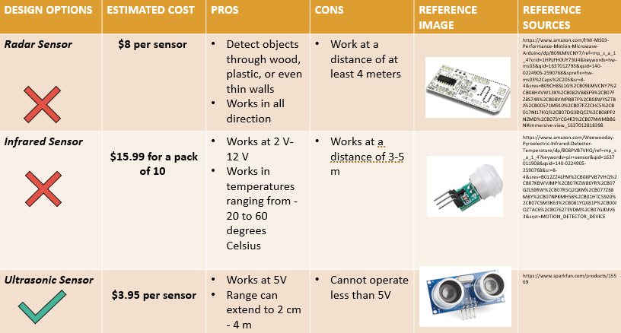
Figure #4 Sensor comparison

SECTION 4-PRELIMINARY DESIGN

4.1 Concept Generation
To start our concept generation, the team had to first come up with a methodology to solve our problem by using proper online sources. We used the information we gathered to develop our design methodology shown below.

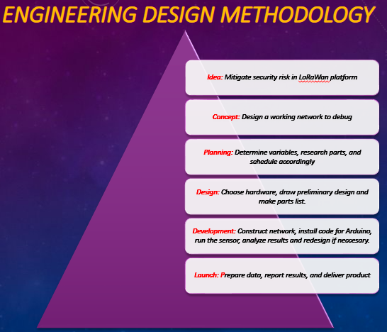
Figure #5 Engineering Design Methodology

4.1 Concept Generation (Continued)
According to Figure #5, the team started with an idea on how we could solve our problem. Moving down the pyramid, we decided on a concept for our project. The next step in
our methodology is planning and this stage is important because this is when we will define our criteria for our project. This step also includes researching the different parts we will use and this will help us make sure we stay within the budget we are given. Moving on to the design, the team starts to draw our preliminary design making sure it meets our criteria and researching the parts we will need. Once we finish with our design, we will go straight into the development stage. It is at this stage where the team will start to build our prototype, and upon completion will check if it meets our requirements. If not, we will research ways to improve our design. We will stay in this stage until our design meets our requirements. When the design is complete the last step is to report our results and deliver the product.

4.2 Concept Evaluation and Speculation
With timing being a major concern, our team chose to focus on the various sensors that are compatible with an Arduino Uno microcontroller. Determining the range, we wanted our sensor to detect vehicles, which is zero to fifty centimeters. The team agreed that the ultrasonic sensor was the best sensor for our product because we could adjust the range of detection down to a centimeter. After further research, we discovered the data that is collected from the sensors could be transferred to the Internet of Things cloud by using a Lora gateway. Using an ultrasonic sensor and gateway we would be able to minimize the amount of power consumption of our product to 5 V while still being able to communicate with a server up to two miles.

4.3 Design Constraints and Applicable Codes and Standards Used in the Preliminary Design
- Arduino uno only operates with sensors
- The 3D printed enclosure must be low enough for vehicles to park through.
- LoRaWan network only transfers low data rates
- Bandwidth of frequency must be low in order to travel long distances.
While working on different engineering design projects, it is important to stay in compliance with electrical codes, rules, and regulations. Our group consists of five electrical engineers and one computer engineer. As the electrical engineering students for this project, we focused on the electrical components and systems we implemented. We had to keep in mind the rules and regulations of IEEE Codes and Standards.
- IEEE 802.5 Standards for token ring access and for communications between LANs and MANs
- IEEE 802.6 Standards for information exchange between systems
- IEEE 802.7 Standards for broadband LAN
- IEEE 802.10 Standards for LAN/MAN security
- IEEE 802.11 Wireless Networking - "Wi-Fi"

4.4 Preliminary Analysis
After doing the necessary research the team had a better understanding of the market for the parking lot monitoring system and sensors being implemented in the systems. We discovered that most of the systems in use still use automated gates to determine the number of cars in a parking lot. We decided this is a very inefficient way to monitor a parking lot. We decided to use a sensor to detect when a vehicle is occupying a parking space. The ultrasonic sensor was the best choice compared to the other sensors in the market. An ultrasonic sensor uses a transducer to send and receive ultrasonic pulses that relay back information about an object’s proximity. High-frequency sound waves reflect from boundaries to produce distinct echo patterns. The transducer of the sensor acts as a microphone to receive and send the ultrasonic sound. Our ultrasonic sensors, like many others, use a single transducer to send a pulse and to receive the echo. The sensor determines the distance to a target by measuring time lapses between the sending and receiving of the ultrasonic pulse.

4.5 Preliminary Design
Upon completion of the concept evaluation and after much research we had a better understanding of our deliverables. We utilized the knowledge we gained from our electronics courses to properly attach our ultrasonic sensor onto our Arduino board. The knowledge we gained from our micro-processing courses helps us to communicate between our microcontroller and our network.

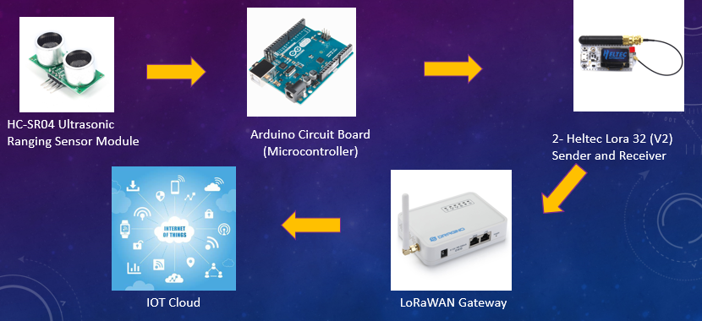
Figure #6 Preliminary Design

SECTION 5 - DETAILED SYSTEM DESIGN

5.1 Project Parts Summary

Figure #7 Parts summary
In figure #7, we can see all the parts that were essential to assemble our parking lot detection system. These parts were chosen because they met our budget requirements and were more than capable of meeting our task. We began our parts list by deciding which kind of sensor we were going to use in order to detect vehicles. This led us to research and obtain the Hc-sr04 ultrasonic sensor. This sensor was an excellent choice due to how inexpensive it was compared to other sensors on the market. It would also meet our requirements of car detection because it can accurately detect the proximity of solid objects. Furthermore, in order to operate the sensor, we needed to have a microcontroller to control all and operation and act as the (brain) of our device. For this area we chose the Arduino UNO microcontroller. This Microcontroller was a perfect option because it fulfilled the requirements that we needed such as user-friendly programmability and considerably inexpensive. This then led us to research 2 identical Lora
5.1 Project Parts Summary (continued)
transmitters, which were going to transmit data signals back and forth among themselves. For this task we chose the Heltec Lora 32 transmitter. This product was good for our project due to the fact that it had Arduino interface programmability which was already going to be necessary for the microcontroller. Lastly, in order to upload our obtained data from our devices we needed to obtain a Gateway, which is a device that serves a bridgeway from Lora Devices and the Internet of Things (IOT) cloud. So, for this reason we chose the Dragino Lora Wan Gateway.

5.2 Engineering Analysis and/or Simulation
After determining out parts necessary for our project we began the research implementation on how all these individual components would come together. In order to make our ultrasonic sensor work, we knew that we had to download the Arduino IDE program. This programming is specific to our Arduino UNO microcontroller and would be the interface that we would need in order to program our Ultrasonic sensor to work properly. This is a program that was user friendly and had many support modules that helped the team code appropriately. This part of the learning and analysis was crucial because it was imperative that our team learn this program.

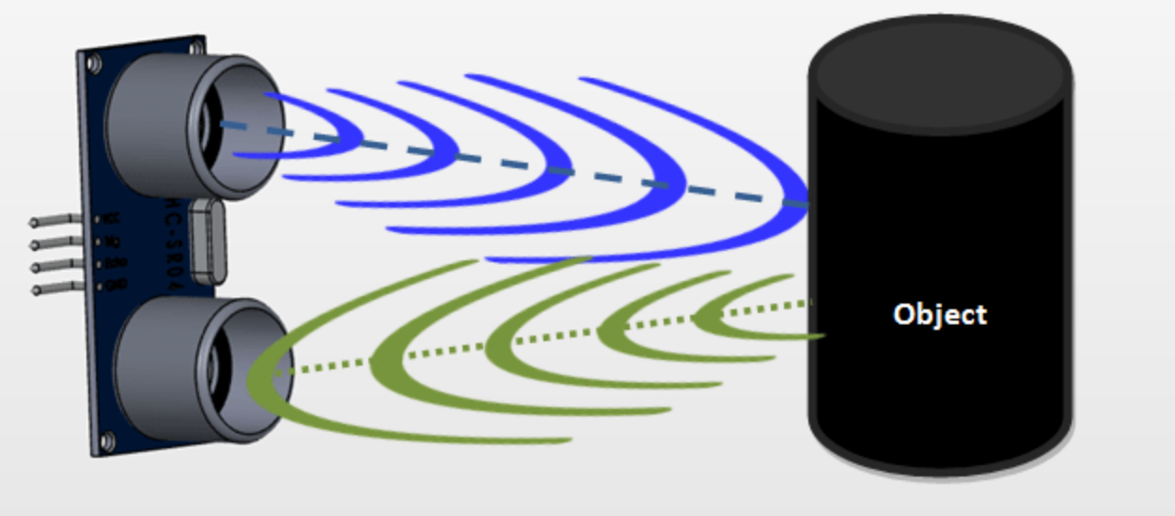
Source: https://robu.in/ultrasonic-sensor-working-principle
Figure #8 Ultrasonic sensor operation

5.2 Engineering Analysis and/or Simulation (continued)
In figure #8 we give a visual representation of how our Ultrasonic sensor operates. This working principle was important to understand in order to determine why our sensor was ideal for car detection. The Ultrasonic sensor emits short, high-frequency sound pulses at frequent intervals through the emitter side as seen by the blue wave in figure #8. These frequencies travel the air at the velocity of sound. Whenever they hit an object, then the sound waves are reflected back as an echo signal to the sensor as seen from the green wave in figure #8. This information then allows the microcontroller itself to compute the distance to the target based on the timespan between emitting the signal and receiving the echo. Ultrasonic sensors are excellent at suppressing background interference and will detect signals from any material that reflects sound.
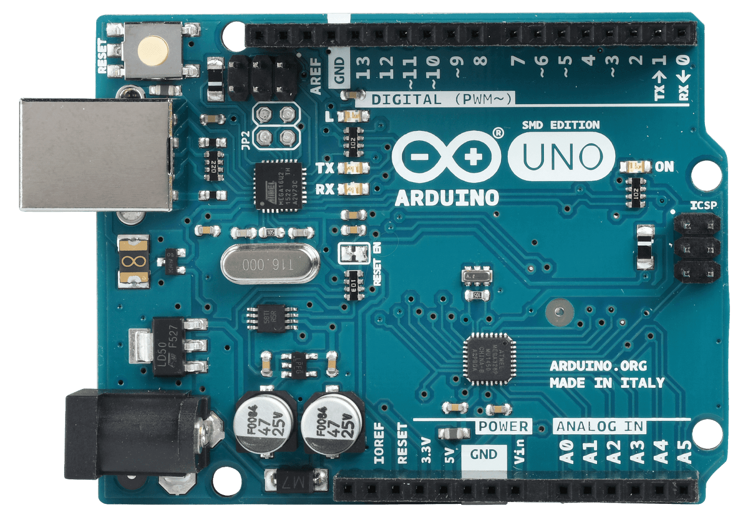
Figure #9 Arduino UNO

5.2 Engineering Analysis and/or Simulation (continued)
In order to integrate our components together we first researched the pin layout of the Arduino UNO and the different functions for each specific pin. The Arduino UNO features AVR microcontroller Atmega328, 6 analog input pins, and 14 digital IN/OUT pins out of which 6 are used as pulse width modulation (PWM) output. We determined that we would use the following pin sections for our project:
ATmega328: This is the brain of the board in which the program is stored.
Ground Pin: there are several ground pins incorporated on the board.
PWM: the board contains 6 PWM pins. PWM stands for Pulse Width Modulation, using this process we can control brightness of the LCD screen later explained in the hardware implementation.
Digital I/O Pins: there are 14 digital (0-13) I/O pins available on the board that will be used to operate the Ultrasonic sensor.
Reset Button: This button will reset the code loaded onto the board. This button is useful when the board hangs up, pressing this button will take the entire board into an initial state.
USB Interface: This interface is used to connect the board with the computer and to upload the Arduino sketches (Arduino Program is called a Sketch)
DC Power Jack: This is used to power up the board with a portable power supply (battery)
3.3V: This pin will be used to supply 3.3V power to our Lora Transmitter
5V: This pin is used to supply 5V power to our Ultrasonic Sensor.

5.2 Engineering Analysis and/or Simulation (continued)

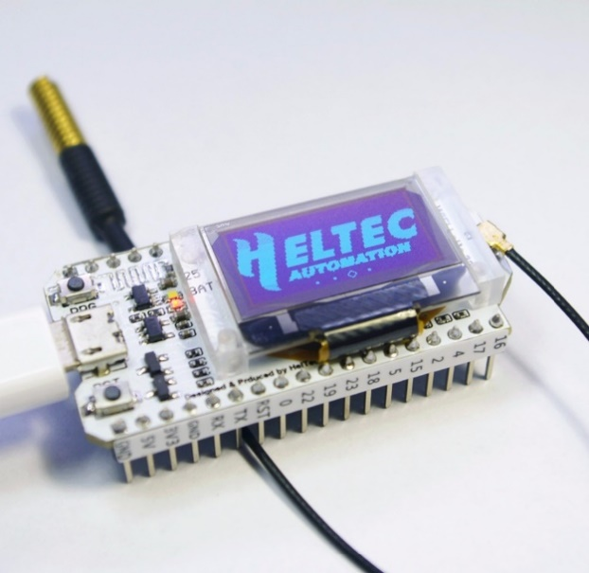
Figure #10 LoRa Transmitter
In order to transmit our signals, we will need to integrate (2) Lora Transmitters. One would be programmed to operate as a sender by transmitting data from our Ultrasonic sensor to the second device that will operate as a receiver in or to display data on the screen and/or upload it to the Internet of Things (IOT) cloud. The technology of these devices implements LoRa communication technology. It is a kind of ultra-long distance wireless transmission scheme based on spread spectrum technology (SSP) and implement wireless modulation that is used to establish long-distance communication links without using cellular data or a Wi-Fi connection. Many traditional wireless systems like our Heltec LoRa 32 transmitter use frequency shift keying (FSK) modulation as the physical layer, because it is a very effective modulation to achieve low power consumption. At present, LoRa mainly operates in the global free frequency band,

5.2 Engineering Analysis and/or Simulation (continued)
including 433, 868, 915 MHz, etc. For our project we used 915 MHz, due to U.S protocol guidelines. The Heltec Lora 32 transmitter is characterized by long transmission distance, low
power consumption, large quantity networking nodes and connectivity to the LoRa Network. These are ideal characteristics because we wanted to have a low power transmitting device that was able to communicate for long distances while also being able to support many networking nodes in the hypothetical case, we wanted to expand our network. These LoRa nodes connect with our Dragino LoRa gateway through LoRa wireless communication as specified earlier, and then connect to a network server through 3G network or Ethernet network. The gateway communicates with the network server through TCP / IP protocol.

5.3 Hardware Layout/Detailed Drawings/ Equipment Selection and Specification
1st Iteration of the parking lot detection system
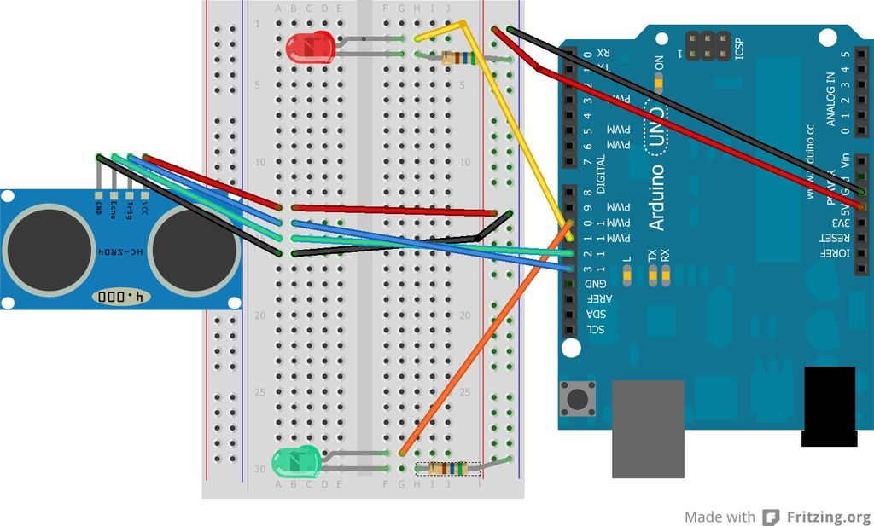
Figure #11 Ultrasonic Sensor and LED Connection Layout
In figure #11 we can have the initial configuration of our parking lot detection device. We wanted to execute a simple and clear wiring process in the 1st iteration that would let us see the functionality of the ultrasonic sensor using an electronic breadboard. The implementation of LED bulbs in this image will let us see whenever an object is detected by our device. Whenever the Green LED is ON it would signify that there is no object detected and that the space is free. However, if the Red LED is ON it would mean that the space is occupied due to an object being in close proximity. In order to assemble this iteration, we would connect the 4 pins that operate the ultrasonic sensor. These are Voltage Common Collector (VCC), ground, echo, and trig. The ground lead coming from the sensor will share a common ground with the LED bulbs that are tied to the ground pin from the Arduino Uno. While the (VCC) port is then connected to the 5volt Pin. In order to get our signals to the microcontroller we used the digital ports offered and

5.3 Hardware Layout/Detailed Drawings/ Equipment Selection and Specification (continued)
assessed the (Trig) cable to connect to port 13 and the (Echo) pin to port 12. This would take care of the sensor portion, but we also had to power the Green LED on port 10 and the Red LED
on port 11 respectively. These are meant to feed power depending on what signals are retrieved from the trig and echo wires. In order to safely operate the LED’s, we also connected 560-ohm resistors in line with each ground side as specified by LED specifications.
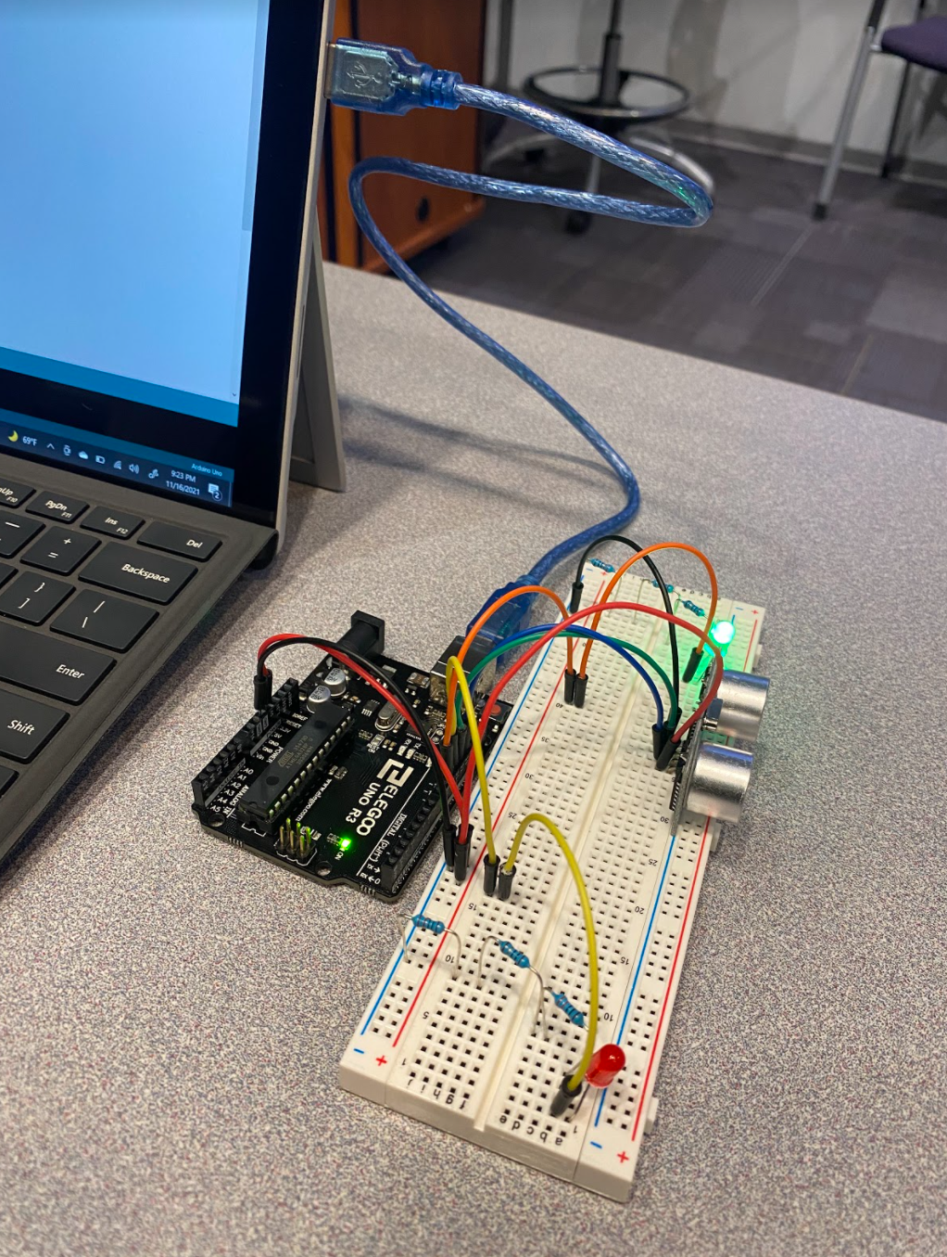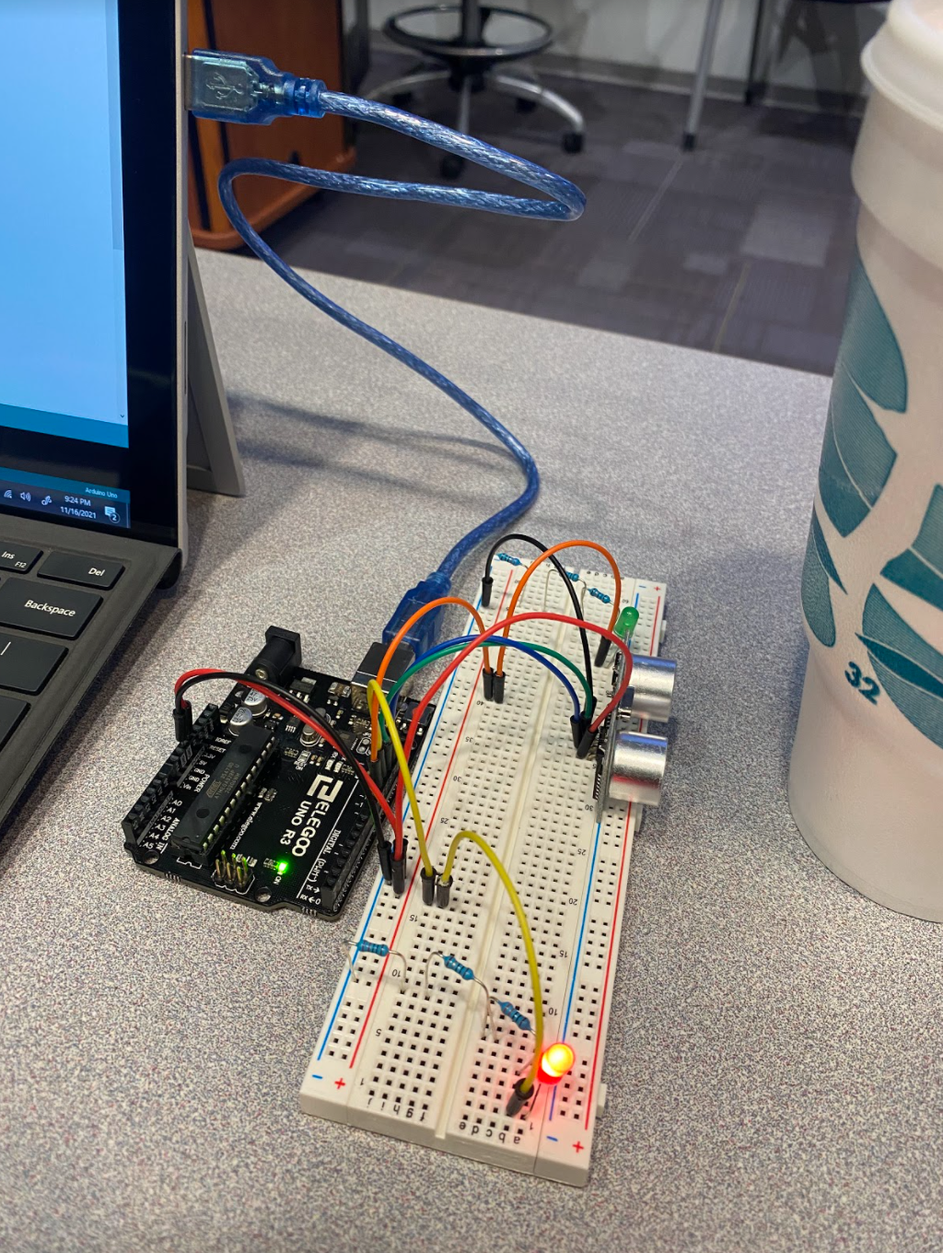
Figure #12 Green LED on Figure #13 Red LED on
In figure #12 and figure #13 we can see the 1st iteration assembled. This consisted of wiring the device and also temporarily connecting the Arduino Uno via USB to the computer in

5.3 Hardware Layout/Detailed Drawings/ Equipment Selection and Specification (continued)
order to power the device and upload the appropriate code created. Figure #12 shows the Ultrasonic sensor not detecting any objects withing the specified vicinity which is why the LED
is green. On figure #13 we can see the red LED turn on as soon as we have an object in front such as the 32oz cup used for demonstration purposes.
2nd Iteration of the parking lot detection system
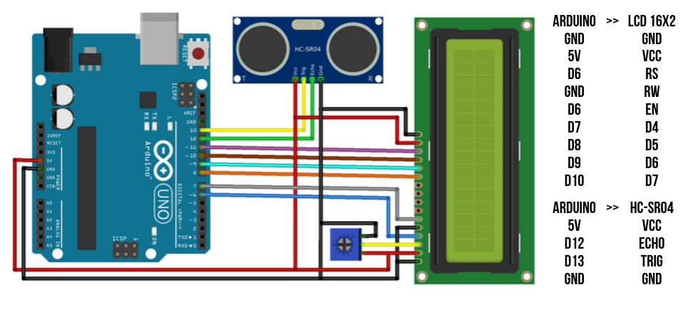
Figure #14 Ultrasonic Sensor and LED connection layout
The 2nd iteration of hour parking lot detection device consisted of illustrating the functionality and accuracy of our device by utilizing an LCD screen. This would be meant to show how far an object is from the Ultrasonic Sensor by displaying the distance in inches and/or centimeters. This was a step that was necessary in order visually represent what parameters are present in various situations. To make this work we obtained the technical pinout diagram for the LCD screen and continued to use the digital pin ports from the Arduino Uno as well as the 5 volt and
5.3 Hardware Layout/Detailed Drawings/ Equipment Selection and Specification (continued)
Ground pins. The only pins shared among all devices including the potentiometer (blue block on Figure #14) were the power and ground. The potentiometer works as a variable resistor that is
only used in conjunction with the LED screen in order to adjust the brightness of the screen. While all other connections were made in their respective digital ports and later assigned tasks in the programming stage.
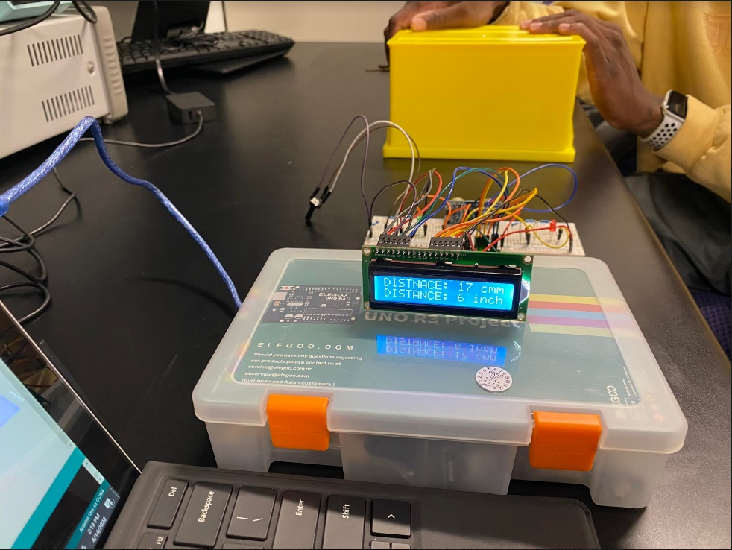
Figure #15 Ultrasonic Sensor and LDC operation with distance detection
As seen in Figure #15 we have a yellow box at a particular distance in time in order to replicate a potential vehicle. From the results shown we were able to retrieve valuable data that is displayed on the screen as 17 centimeters or 6 inches. During this stage we moved the object back and forth and got instant data that signified that the sensor was calculating distance at all instances. In
5.3 Hardware Layout/Detailed Drawings/ Equipment Selection and Specification (continued)
order to make the LCD work we had to download LCD libraries from the Arduino Uno Integrated Development Environment (IDE) that helped us program this component. We then made changes in the pre-established program in order to account for the new pin-out configuration that was established by using figure #15.
3nd Iteration of the parking lot detection system
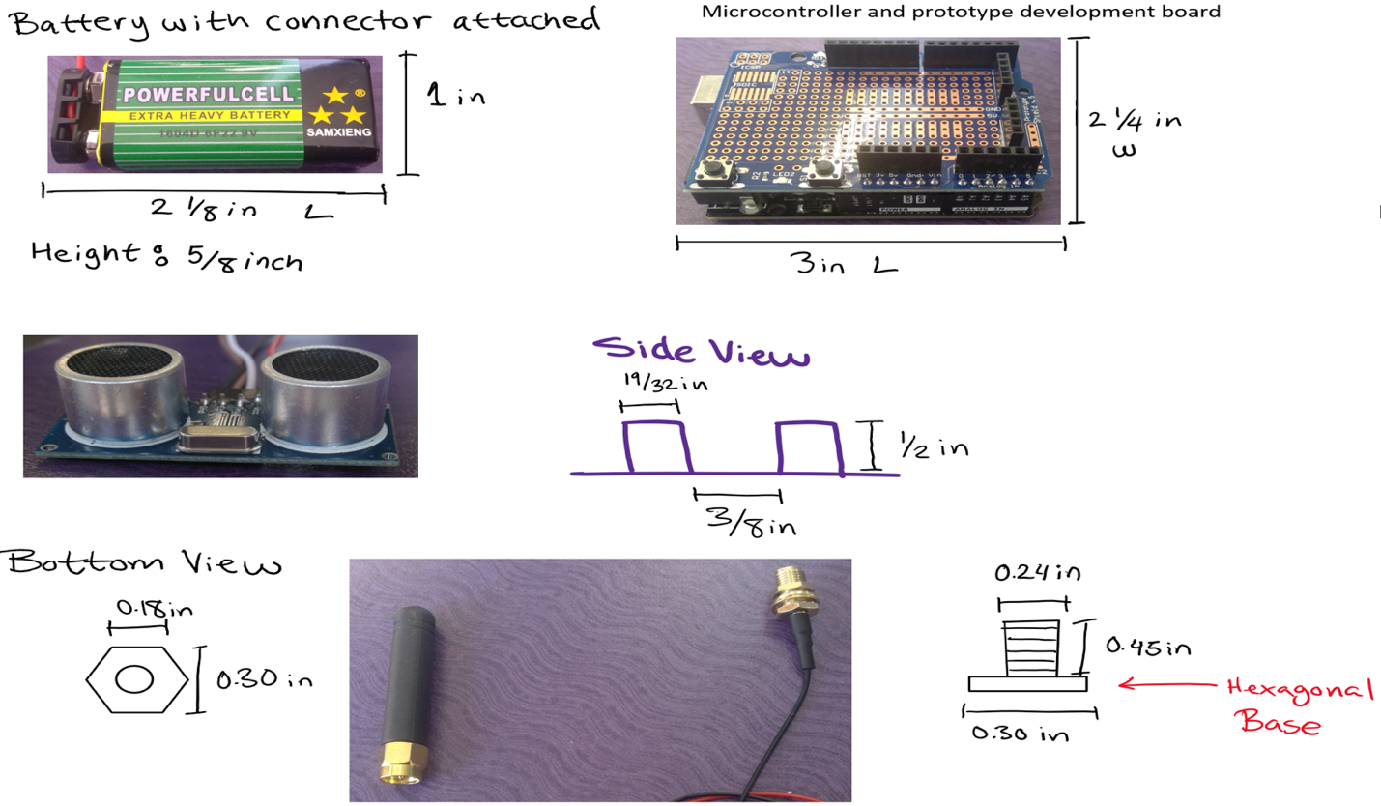
Figure #16 component dimension measurements
In figure #16 we demonstrate the apprpiate measurement that were nesseasry to make in order to built our 3D printed enclousure. These measurement were precisely measured by using a digital

5.3 Hardware Layout/Detailed Drawings/ Equipment Selection and Specification (continued)
caliper. The components measeured consisted of a 9v battery, ultrasonic sensor, Arduino UNO, and the Heltec Lora 32 antenna.
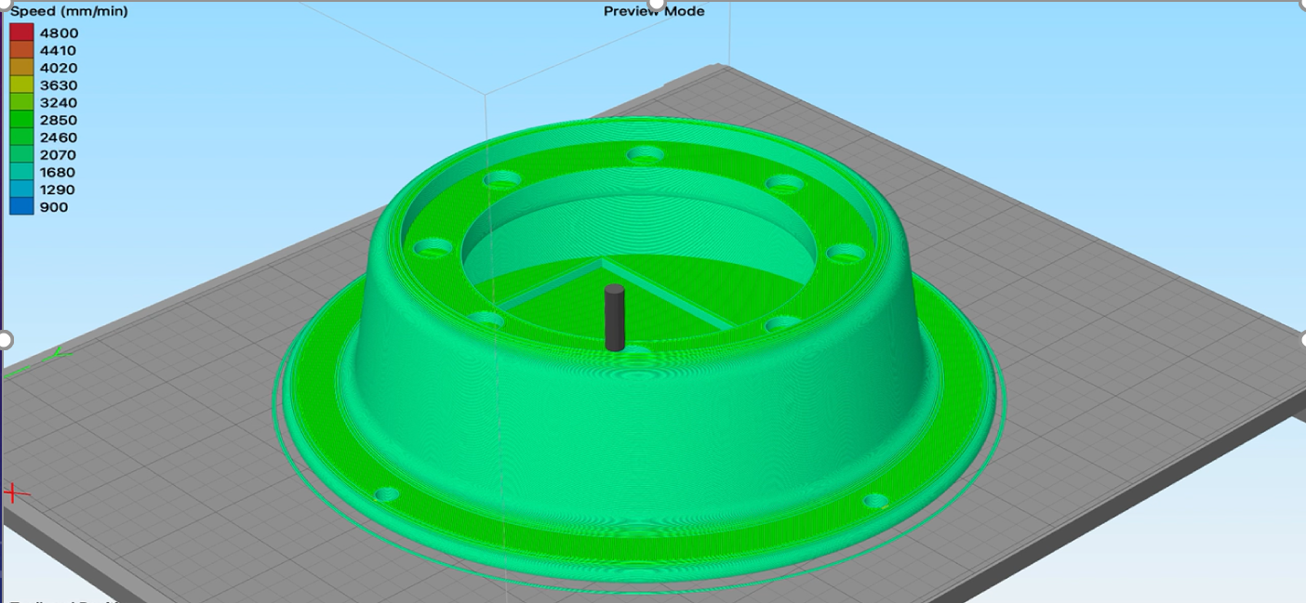
Figure #17 Base of the parking lot sensor enclosure
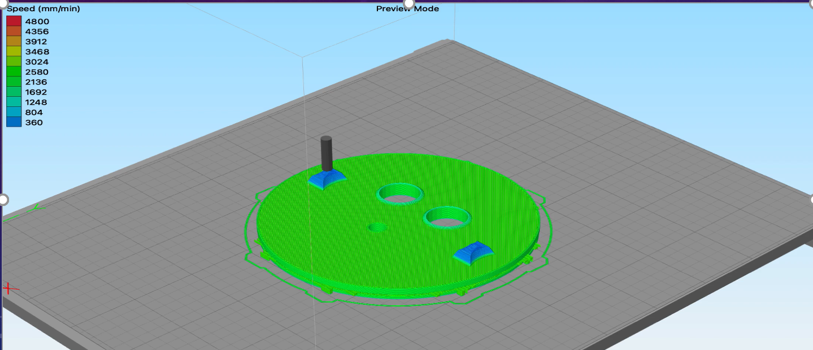
Figure #18 Top Lid of the parking lot sensor enclosure
5.3 Hardware Layout/Detailed Drawings/ Equipment Selection and Specification (continued)
In order to successfully protect our parking lot detection device we decide to build a 2 piece enclosure that consisted of a base plus a top lid as seen in figure #17 and figure#18 respectively. The base would be the main structure where the microcontroller, battery, and Lora sender node relies. Within the inside portion of the base there is borders specifically designated for the microcontroller and the battery. This was made with the intention of having all components secure within their confined perimeter. This design construction idea would make sure that any transportation of the device would not damage the components. Furthermore, the top lid of the enclosure consists of having the indicated holes that would allow the ultrasonic sensor to analyze distance and to secure the antenna for signal amplification. This lid securely locks in place with the help of built in ridges that make sure the lid is water tight. This design was made from ABS plastic in order to withstand harsh environments. The 2D models that is seen in figure #17 and #18 was successfully modeled using the program Auto-Cad.

5.3.1 Show Overview of Code Developed to Support 5.3
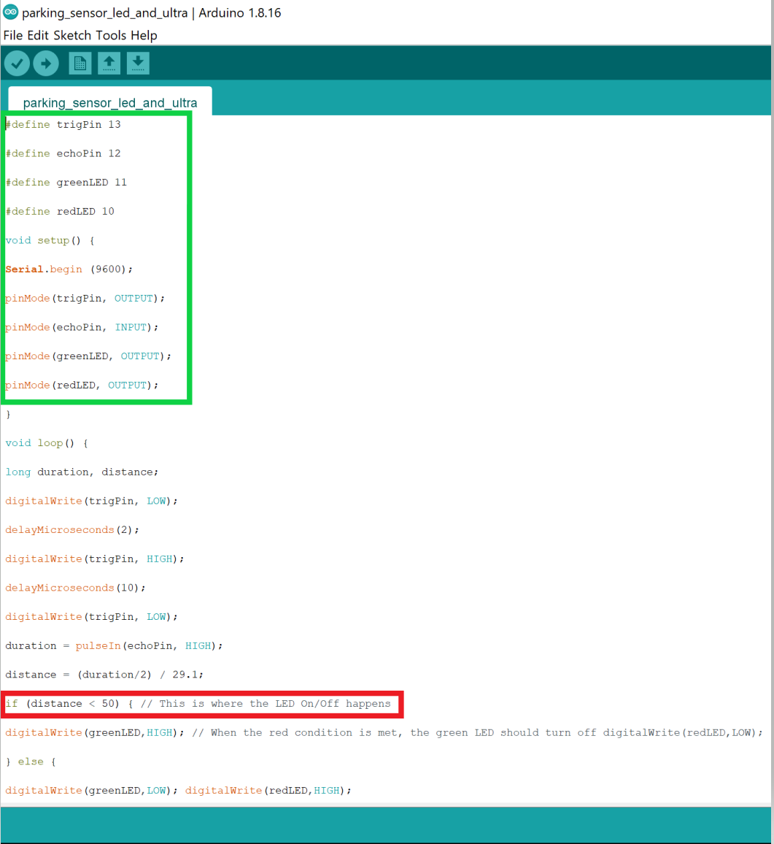
Figure #19 Arduino Code developed that operates Ultrasonic Sensor and LED’s

5.3.1 Show Overview of Code Developed to Support 5.3 (continued)

In order to successfully complete integrate our device we developed code according to each iteration phase that was worked on at the time. This was a good approach that led us to learn along the way in order to get familiar with the environment. The first iteration phase can be seen in figure #16 and highlighted is the main takeaways of the program. In the green perimeter we defined our pin numbers according to the specified connections we had made in the hardware. The important instruction comes from the red perimeter which enables the distance of object detection to be set at 50 centimeters. This value was agreed upon by taking into account the height of most vehicles. This allows the parking detection device to detect anywhere from low cars to high trucks.

5.3.1 Show Overview of Code Developed to Support 5.3 (continued)
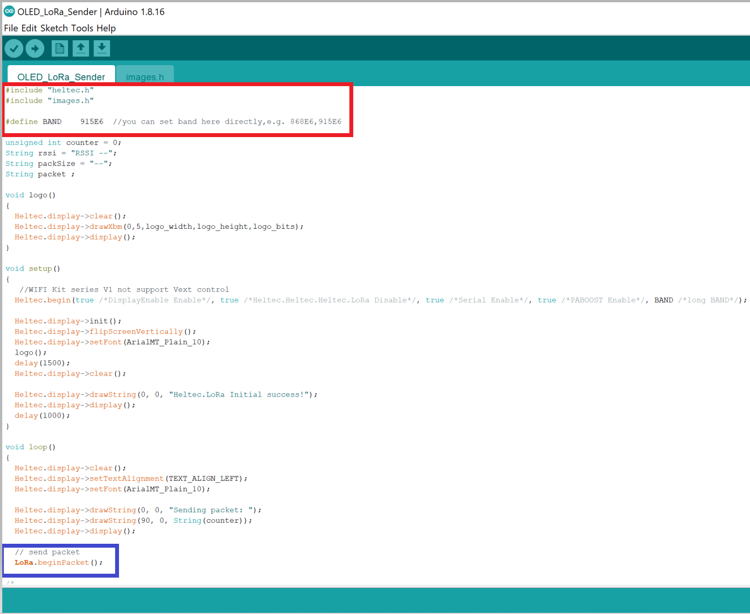
Figure #20 Code developed to configure Heltec Lora Transmitters
In order to send signals through our acquired Heltec Lora transmitters we needed to program our devices to access these capabilities. Luckily our transmitters were the ideal choice and are able to be programmed by also using the Arduino IDE interface. The process included going into the Heltec device programming website and selecting the appropriate device we were working with. In our case we were working with the Heltec Lora 32. Then they provided the necessary steps

5.3.1 Show Overview of Code Developed to Support 5.3 (continued)
such as program links that were then transferred and configured on the Arduino software itself. From figure #20 we can see the code that was necessary in order to instruct the Lora transmitters to communicate with each other. Highlighted in red are the libraries included in order to command the operations of the Lora nodes. It is also defined that we have a 915 MHz band in order to execute the frequencies specified to U.S guidelines. The blue perimeter shows the last instruction that was necessary in order to transfer the data packets. This specifically allowed the signals to be detected every couple of seconds as long as both transmitters have a power source.

5.4 Application of Engineering Codes and Standards used in Final Design
FCC Regulation
Our Lora network consists of spread spectrum modulation schemes, the chirp spread spectrum uses the complete bandwidth of its allocation (ie. signal bandwidth) when it is broadcasting a signal. In terms of the FCC certification, we meet the FCC Part 15 requirements which make certified devices abide by 915 Mhz frequency.
IEEE 802.5 Standards for token ring access and for communications between LANs and MANs
IEEE 802.6 Standards for information exchange between systems
IEEE 802.7 Standards for broadband LAN
IEEE 802.10 Standards for LAN/MAN security
IEEE 802.11 Wireless Networking - "Wi-Fi"
IEEE 1625 Standard for Rechargeable Batteries for Multi-Cell Mobile Computing Devices

5.5 Economic Analysis
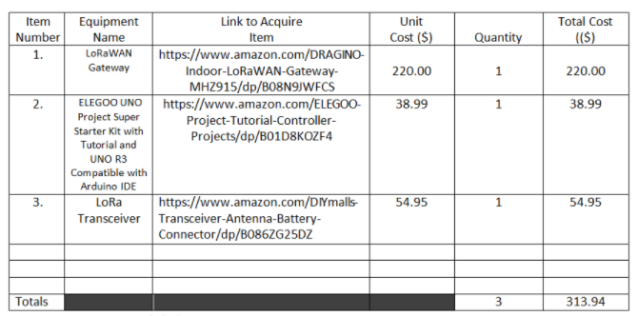
Table #2 Parts comparison
For this project we went under budget and were able to deliver our product without any economical constraint. The reason for this was due to the research done in order to find the most inexpensive products while also delivering the good performance that was desired. In the event that our device is replicated and offered as a product, the cost itself will go down furthermore due to the fact that every parking lot detection device will only need to connect to one Dragino gateway. Therefore, reducing the cost of the system by $220 after the first initial purchase.

5.6 Final Design

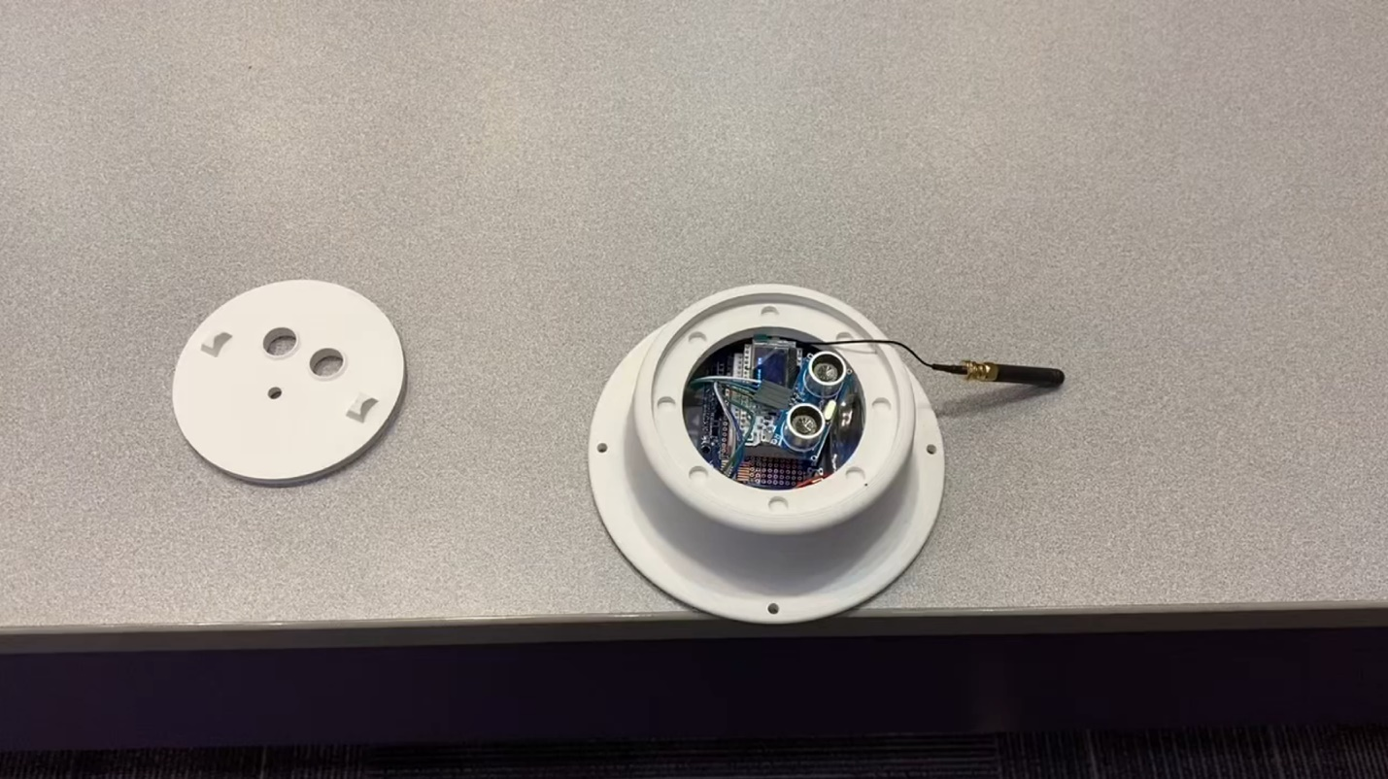
Figure #21 Final Parking Detection Device
In this final iteration we have our parking lot detection device which consists of the Arduino Uno, Heltec Lora 32 sender node, Hc-Sr04 Ultrasonic sensor and our portable power source that consists of a 9v Lithium-Ion battery. It is all tightly packaged in a configuration that fits our 3D printed capsule that is constructed of ABS plastic. This will securely protect the device from inclement weather and is capable of lasting the life of the device. The capsule is low profile with a height of only 2 inches, which is low enough for all applications.

SECTION 6: RESULTS & DISCUSSION

6.1 Summary of Goals and Objectives
In our project the deliverables consisted of three proposals. That was the target audience, budget, and our proposed deliverables. The target audience was identified as any end user of an internet of things (IoT) device. The budget project budget was $600, however we spent $313.94 and $76.41 was spent outside of the sponsor. In reference to our proposed deliverable, we check the security for the Lora OAT (over the air) activation using (Syther) a former security analysis tool and focuses on the key exchange portion. Also sending messages with the bandwidth and creating a functioning parking detection device.

6.2 Summary of Constraints and Codes met by Design elaborate
For this project we had four major constraints. Starting with the first constraint: This project incorporates the Arduino UNO which only operates using sensors and in our project we did just that. The second constraint is that for our microcontroller and sensors, the 3D casing used must be low enough for vehicles to drive and park over. Our third constraint is that while using the (LoRaWan) network, we are limited to only transferring information using low data rates. Lastly, the bandwidth of frequency must be low in order to travel long distances. There were 5 codes that applied specifically to our project (pg. 24- 4.3) but only one that stood out amongst the rest. IEEE 802.11 is the standard popularly known as Wi-Fi and it uses radio waves instead of cables to transfer data and connect devices. This code is the protocol that we had to use when monitoring the live data from our computer to the microcontroller and sensors.

6.3 Discussion of Results and Other Use Cases
This project allowed us to make a low costing and efficient method of transferring data from one node to the next with the comfortability of knowing that the information is secure during the transfer process. In our project we decided to implement this using a sensor to show the number of available spots within a parking lot. The live feed will show when a car is parked over the sensor attached to our microcontroller and the data will be sent using point to point protocol to an LCD screen. The software used during the data transfer will be specific to the nodes used and will be secure through the process.

SECTION 7: CONCLUSIONS AND RECOMMENDATIONS

Conclusion and Recommendation
Testing the security environment of the LoRa takes a lot of trial and error. Revision of the code is fundamental. When setting up the environment make sure the script is correct, perform thorough research on what security verification protocol would be the best to use, and use as much time as possible on every security measure. If an individual or company wanted to complete the work with the LoRa it would be best to have a hotspot or a single WIFI client that is not affected by two-factor authentication so that they can perform the UDP protocol with the LoRa Gateway. However, point to point communication on radio frequency works perfectly with the LoRa module.

List of References

[1] A. M. Yousuf, E. M. Rochester and M. Ghaderi, "A low-cost Lora WAN testbed for
IoT: Implementation and measurements," 2018 IEEE 4th World Forum on Internet
of Things (WF-IoT), 2018, pp. 361-366, doi: 10.1109/WF-IoT.2018.8355180
[2]Amazon.com: Weewooday 10 pieces AM312 mini human sensor module IR ...
Weewooday 10 Pieces AM312 Mini Human Sensor Module IR Pyroelectric
Infrared PIR Motion SensorDetector Modules DC 2.7V to 12V, Working
Temperature Minus 20 Degrees Celsius to 60 Degrees Celsius. (2020, December
7). Retrieved November 15, 2021, from https://www.amazon.com/Weewooday-
Pyroelectric-Infrared-Detector-Temperature/dp/B08PVB7VHQ
[3] Cerrudo, C., Fayo, E. M., & Sequeira, M. (2020, January). Lorawan networks
susceptible to hacking: Common cyber . LoRaWAN Networks Susceptible to
Hacking: Common Cyber Security Problems, How to Detect and Prevent Them.
Retrieved November 5, 2021, from https://act-
on.ioactive.com/acton/attachment/34793/f-87b45f5f-f181-44fc-82a8-
8e53c501dc4e/1/-/-/-/-
/LoRaWAN%20Networks%20Susceptible%20to%20Hacking.pdf.
[4] Eldefrawy, M., Butun, I., Pereira, N., & Gidlund, M. (2019). Formal security analysis
of Lorawan. Computer Networks, 148, 328–339.
https://doi.org/10.1016/j.comnet.2018.11.017

[5] Dynamic Product Page,” Microchip.com. [Online]. Available:
https://www.microchip.com/en-us/product/ATECC608A-TNGLORA. [Accessed:
01-Oct-2021].
[6] “FAAC B680H Automatic Barrier L Kits,” Allsecurityequipment.com. [Online].
Available: https://allsecurityequipment.com/products/faac-b680h-automatic-barrier-kits?variant=40444798369965&currency=USD&utm_medium=product_sync&utm_source=google&utm_content=sag_organic&utm_campaign=sag_organic&gclid=CjwKCAjwzOqKBhAWEiwArQGwaLh2tZh_fH1TeOE5-gGibbRmVBC762IusRHmeuEekZCdh4oFoOPEYhoC8j4QAvD_BwE. [Accessed: 01-Oct-2021]
[7]Kontogiannis, S. (2019). An internet of things-based low-power integrated beekeeping
safety and conditions monitoring system. Inventions, 4(3), 52.
https://doi.org/10.3390/inventions4030052
[8] Oniga, B., Dadarlat, V., De Poorter, E., & Munteanu, A. (2017). Analysis, design and
implementation of Secure Lorawan Sensor Networks. 2017 13th IEEE
International Conference on Intelligent Computer Communication and Processing
(ICCP). https://doi.org/10.1109/iccp.2017.8117042
[9] “Parking Today,” www.parkingtoday.com.
https://www.parkingtoday.com/blog/2019/03/stress-and-uncertainty-of-finding-
parking/.
[10]Seller, O. (2021). Lorawan security. Journal of ICT Standardization, 9, 47–60.
https://doi.org/10.13052/jicts2245-800x.915
[11]Trend Micro. (2021). Compromised Comms: Assessing the security of LoRaWAN
Radio. Retrieved October 23, 2021, from
https://documents.trendmicro.com/assets/infographics/Technical%20Brief%20-
%20Compromised%20Comms%20Assessing%20the%20Security%20of%20LoRa
WAN%20Radio.pdf.

[12] T. of UsePrivacyCopyrightTrademarksNon-DiscriminationAccessibility, “COVID
lockdown causes record drop in carbon emissions for 2020,” Stanford Earth, Dec.
10, 2020. https://earth.stanford.edu/news/covid-lockdown-causes-record-drop-
carbon-emissions-2020#gs.cfr03r (accessed Oct. 01, 2021).
[13] Ultrasonic distance sensor - HC-SR04. SEN-15569 - SparkFun Electronics. (n.d.).
Retrieved November 15, 2021, from https://www.sparkfun.com/products/15569
[14] Yang, X., Karampatzakis, E., Doerr, C., & Kuipers, F. (2018). Security vulnerabilities in Lorawan.
2018 IEEE/ACM Third International Conference on Internet-of-Things Design and Implementation (IoTDI). https://doi.org/10.1109/iotdi.2018.00022

.

Appendix

Arduino IDE development code to program Heltec Lora 32 transmitters
/*
This is the example to show the Heltec.LoRa sended data in OLED.

The onboard OLED display is SSD1306 driver and I2C interface. In order to make the
OLED correctly operation, you should output a high-low-high(1-0-1) signal by soft-
ware to OLED's reset pin, the low-level signal at least 5ms.

OLED pins to ESP32 GPIOs via this connecthin:
OLED_SDA -- GPIO4
OLED_SCL -- GPIO15
OLED_RST -- GPIO16

https://heltec.org

this project also realess in GitHub:
https://github.com/Heltec-Aaron-Lee/WiFi_Kit_series
*/

#include "heltec.h"
#include "images.h"

#define BAND 915E6 //you can set band here directly,e.g. 868E6,915E6

unsigned int counter = 0;
String rssi = "RSSI --";
String packSize = "--";
String packet ;

void logo()
{
Heltec.display->clear();
Heltec.display->drawXbm(0,5,logo_width,logo_height,logo_bits);
Heltec.display->display();
}

void setup()
{
//WIFI Kit series V1 not support Vext control
Heltec.begin(true /*DisplayEnable Enable*/, true /*Heltec.Heltec.Heltec.LoRa Disable*/, true /*Serial Enable*/, true /*PABOOST Enable*/, BAND /*long BAND*/);

Heltec.display->init();
Heltec.display->flipScreenVertically();
Heltec.display->setFont(ArialMT_Plain_10);
logo();
delay(1500);
Heltec.display->clear();

Heltec.display->drawString(0, 0, "Heltec.LoRa Initial success!");
Heltec.display->display();
delay(1000);
}

void loop()
{
Heltec.display->clear();
Heltec.display->setTextAlignment(TEXT_ALIGN_LEFT);
Heltec.display->setFont(ArialMT_Plain_10);

Heltec.display->drawString(0, 0, "Sending packet: ");
Heltec.display->drawString(90, 0, String(counter));
Heltec.display->display();

// send packet
LoRa.beginPacket();

/*
* LoRa.setTxPower(txPower,RFOUT_pin);
* txPower -- 0 ~ 20
* RFOUT_pin could be RF_PACONFIG_PASELECT_PABOOST or RF_PACONFIG_PASELECT_RFO
* - RF_PACONFIG_PASELECT_PABOOST -- LoRa single output via PABOOST, maximum output 20dBm
* - RF_PACONFIG_PASELECT_RFO -- LoRa single output via RFO_HF / RFO_LF, maximum output 14dBm
*/
LoRa.setTxPower(14,RF_PACONFIG_PASELECT_PABOOST);
LoRa.print("hello ");
LoRa.print(counter);
LoRa.endPacket();

counter++;
digitalWrite(LED, HIGH); // turn the LED on (HIGH is the voltage level)
delay(1000); // wait for a second
digitalWrite(LED, LOW); // turn the LED off by making the voltage LOW
delay(1000); // wait for a second
}

