PRAIRIE VIEW A&M UNIVERSITY
ROY G. PERRY COLLEGE OF ENGINEERING

Project Name: Misinformation Detection on Social Media Data via Deep Learning

ELEG 4482: Senior Design & Professionalism II

Topic: Final Written Report

Team Number 7

Submitted by:

Kamal Windom (Team Lead)
Anish Karki
Michael Brown
Mohammed Ahmed
Ross Adams

Instructor: Professor Turner
Sponsor: Xishuang Dong

Date of Submission: 04/25/2021

TABLE OF CONTENTS
List of Figures ……………………………………………………………………………...……...... 2
List of Team Members and Roles ………………………………………………………..………... ..3

1. PROJECT SCOPE ……………………………………………………………………........ 4
1.1 Problem Statement ………………………………………………………………............. 5
1.2 Client Identification and Recognition of Need ……………………………………......6 - 7
1.3 Project Goal and Objectives ………………………………………………………....8 - 10
1.4 Contemporary Issues Relevant to Project …………………………………………........ 11
1.5 Potential Impact of Project on Society ……………………………………………..12 - 13
(Safety, Environment, Technical, Economical)
1.6 Initial Project Constraints ………………………………………………………………. 14

- PROJECT PLANNING AND TASK DEFINITION …………………………………… 15
2.1 Task Identification ……………………………………………………………………... 16
2.2 Gantt Chart ………………………………………………………………………….17 - 18

- LITERATURE REVIEW …………………………………………………………… 19 – 21

- PRELIMINARY DESIGN ……………………………………………………………….. 22
4.1 Concept Generation ………………………………………………………………...23 - 24
4.2 Concept Evaluation and Selection Criteria……………………………………………... 25
4.3 Design Constraints and Application Codes and Standards ……………………….. 26 – 28
4.4 Preliminary Analysis …………………………………………………………….….29 - 32
4.5 Preliminary Design………………………………………………………………….33 - 34

- DETAILED SYSTEM DESIGN ………………………………………………………..... 35
5.1 Project Parts Summary………………………………………………………………….. 36
5.2 Engineering Analysis and Simulation …………………………………………..… 37 – 38
5.3 Overview of Code Developed……………………………………… …………….. 39 – 44
5.4 Application of Engineering Codes and Standards ………………………………….45 - 46
5.5 Economic Analysis ………………………………………………………………….…. 47
5.6 Final Design…………………………………………………………………………48 - 54

- RESULTS & DISCUSSION …………………………………………………………….... 55
6.1 Summary of Goals and Objectives ……………………………………………………... 56
6.2 Summary of Constraints and Codes met by Design ……………………………………. 57
6.3 Discussion of Results and Other Use Cases...…………………………………………... 58

- CONCLUSIONS AND RECOMMENDATIONS …………………………..……... 59 – 60

LIST OF REFERENCES ………………………………………………………………………...........................................61 - 62

APPENDIX ……………………………………………………………………………..…….. 63 – 66

LIST OF FIGURES
Figure 1 Social Media News Graph Source: Pew Research Center
Figure 2 Public Climate Change Consensus; Source: The Consensus Handbook
Figure 3 Public Climate Change Consensus; Source: The Consensus Handbook
Figure 4 COVID-19 Misinformation Graph Source: Nature.com
Figure 5 High Level Schedule.
Figure 6 Project Comparison
Figure 7 Random Forest Diagram
Figure 8 Preliminary Design Concept Source: Two-Path Deep Semi-Supervised Learning
Figure 9 Project Flowchart
Figure 10 Project Cell 2
Figure 11 Project Cell 9
Figure 12 SVM Algorithm
Figure 13 ADA Boost Accuracy Score
Figure 14 Final Design
Figure 15 Kernel Window
Figure 16 Run Window

LIST OF TEAM MEMBERS AND ROLES

- Kamal Windom ……………………………………………………………… Team Lead
- Muhammad Ahmed ………………………………………………......Software Developer
- Anish Karki………………………………………………………………………… Scribe
- Michael Brown…………………………………………………......................... Test Lead
- Ross Adams ………………………………………………………………… Data Analyst

- PROJECT SCOPE

1.1 Problem Statement
Misinformation on the internet, and users need to be able to discern objective truth. This is important for the sake of research not being based in falsehood. The public at large deserves access to objective news. This project seeks to write a software program that detects misinformation and provides truthful information on social media and news outlet sites. That is important because it will not only stop the spread of misinformation but also provides the truth of matter in its stead. The program will use a Deep Learning algorithm on Python to reprocess information.
Our project is mainly focused on detecting false information on social media. This project’s main goal is to tackle the fake news and misleading information on the internet by flagging and detecting fake news and providing the facts of the matter or referring the user to a reliable source. Within our scope, we are to develop an accessible program to identify misinformation on social media. We use Python coding Detection Models to obtain results of false information.
Outside of our scope, the program will not actually be implemented onto a mobile device. The team involved does not have the expertise with mobile applications required to create a true, executable application. This project will not be a downloadable application, but a code within the PyCharm Integrated Development Environment (IDE) that meets the objective.

1.2 Client Identification and Recognition of Need
Almost everyone is connected to the internet and different social media platforms. They are using such platforms in a daily basis. They get the news and updates on current events via such platforms. Our target audience will be the range of people that use the social media as the main source of learning new information. It is sure that these social media users will be exposed to several misinformation and there must be a tool to verify a news or article to be true or false. So, our software will be used to tackle the misinformation by detecting the false information. The main requirements for the software are as follows:
- Timely detection of fake news.
The software must run quickly so it will not interrupt user’s media experience. The detection models should detect fake news efficiently and effectively.
- Robust detection models.
The software must be tolerant to noises and much not crash which will disrupt user’s media experience.
- Detect fake news with high performance.
The software must correctly identify the fake or real news. The detection models must function accurately so the users can verify fake news.
- Integration of the detection models onto a social media platform.
The software can be run in the background of a device and will not generate extra attachments to social media.
- Alerts user of objective misinformation.
The software shall accurately detect fake news and alert the user of the misinformation. The notification will be linked to the mobile devices.
1.2 Client Identification and Recognition of Need (continued)
- Friendly User Interface
Software will be easy to operate, and the output will be simple to understand. The software will perform consistently and effectively giving its user a very friendly and intuitive environment.
The software needs to be simple for anyone to operate and understand. The reliability and efficiency are a must when it comes to fake news detection.

1.3 Project Goals and Objectives
The main objective of this project is to write a software program that will detect the misinformation on social media. Our delivered program will use several Deep Learning Algorithms on Python to reprocess the information. We will use the Jupyter Notebook application to ensure that eventually it can be ported to mobile devices. Following are the lists of the project’s Key Deliverables:
- Develop a presentation establishing the basics and scope of the project.
- We develop a slide presentation which includes:
- Team and Project Introduction
- Objectives
- Project Impacts
- Marketing Requirements
- Target Audience
- Design Methodology
- Preliminary Design Concept
- Constraints & Assumptions
- Proposed Solution Overview
- Project Comparison
- Advantages & Disadvantages
- High Level Schedule
- Project Deliverables
- Detailed System Design

1.3 Project Goals and Objectives (continued)
- Earlier Design & Operations of Sample Codes.
- Short Video of Final Program.
- Recommendation & Conclusion.
- IEEE Standards followed during the program development.
- Literature Review Source
- Practice Presentation of Slides
- Consult our sponsor, Dr. Xishuang Dong on the merits of each aspect of the presentation in part a.
- Implement a program for demonstration.
Write a program and implement it for demonstration. Following are the steps that needs to be successfully processed:
- Step 1: Preprocessing Data: Building deep learning samples is completed with feature extraction techniques. We use a ‘liar subset’ of data files consisting of three parts:
  - Training Set: The (train.tsv) file meant to act as a static, independent variable. This is a word embedding technique to further deep learning.
  - Testing Set: The (test.tsv) file meant to act as a dynamic, dependent variable. This file is written within the source code of the PyCharm IDE we use.
  - Validation Set: The (valid.tsv) file meant to act as a final, dependent variable. This file acts as a check to ensure the validity of the word embedding findings and check back whether the sample article scanned
1.3 Project Goals and Objectives (continued)
is false.
- Step 2: Running Benchmarks: Execute five deep learning algorithms and obtain their results. This acts as a testing stage for our program.
- Step 3: Algorithm Runtime Comparison: This ensures fast enough runtime of the program to meet our marketing requirements.
- Step 4: Algorithm Accuracy and F1 Score Comparison: Calculating and comparing the accuracies of results and F1 scores (the weighted average of precision and recall).

1.4 Contemporary Issues Relevant to Project
The rise of fake news is not to be ignored. As the use of internet and different social media platforms increases, users are constantly exposed to potential fake news and misinformation. Sometimes relying on only one source for news and current events is not good as it is uncertain if the news is real or fake. Getting news from trusted sources or multiple sources is better way to get truthful news. The availability of fake news and transfer of fake news can be severe. The potential danger of such misinformation is unimaginable.
If a tool is available that verifies certain news easily and effectively than it would make life so easier. This will not only help users to get real news but also will be a great boost in slowing down the spread misinformation. Our Fake New Detection project can solve the issues of the spread of misinformation by detecting fake news and alerting users.

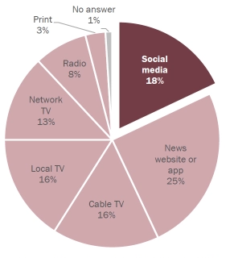
1.5 Potential Impact of Project on Society
Figure 1 Social Media News Graph Source: Pew Research Center
Political Impact: Misinformation in social media has a very major political impact. The pie chart, which is the survey done by the Pew Research Center, shows the percentage of US adults getting the news in different platforms. The data shows that the social media is a major platform for getting the news and current affairs. The Federal Bureau of Investigations has expressed concern about foreign countries such as Russia, Iran and China attempting to influence the 2020 election with disinformation campaign on social media platforms.

Technical Impact: There are several detection software packages used on social media platforms to detect fake news. Misinformation detection will soon become ubiquitous in that field. Our software detention model will cover several sample articles and should be implementable to more than one media platform.

Environmental Impact: The Scientific Consensus on climate change has been challenged in social media spheres. The public believe that climate change is still “up for debate.” More than 90% of the climate scientists agree on human-induced climate change. The public still thinks that the environmental scientists disagree on climate change.

1.5 Potential Impact of Project on Society(continued)
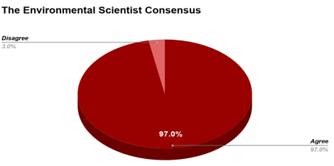
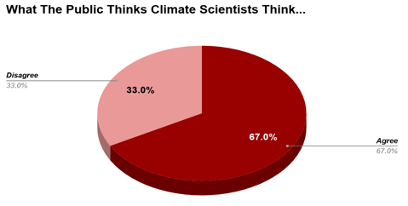
Figure 3 Public Climate Change Consensus; Source: The Consensus Handbook
Figure 2 Public Climate Change Consensus; Source: The Consensus Handbook

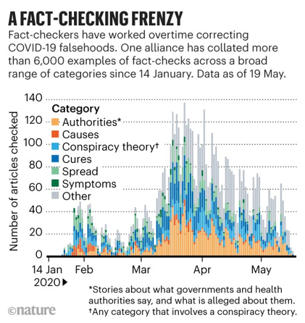
Safety Impact: Misinformation on social media and the internet can lead to a major public health and safety crisis. Several fake news articles claimed the COVID-19 virus been created in a lab by a rogue government with an agenda. This misinformation was accessed by over 20 million people. Another fake news article claimed that drinking chlorine dioxide solution can prevent microbial, viral, and bacterial infections. This claim has been disapproved by the health organizations and the health experts. The public has been warned to not follow this, as such drinking it can lead to severe vomiting and even life threatening low-blood pressure.
Figure 4 COVID-19 Misinformation Graph Source: Nature.com
Our project seeks to tackle such misleading information and provide the user with the real information. The software program we are building will detect false information and alert the user. It will also provide the user with the real news or refer the user to a reliable source.

1.6 Initial Project Constraints
This team has no prior knowledge of Python Coding:
This was our most pressing constraint. Each team member is Electrical Engineer at Prairie View A&M University. None of the team members are Computer Engineering Major. So, none of us had any prior Python coding knowledge. This was a very new challenge upon the team. Not only the team had to learn the basics of the python coding, but the team also had to build the project simultaneously. To mitigate this constraint, we opted to get help from peers, professors, and the internet. Dr. Dong specifically gave us a lot of assistance in this area. He was also limited by the time availability and the fact that he had only worked with Apple Operating Systems, made it challenging for the team as the whole group was familiar with Windows Operating Systems. At first, we tried to switch to a Linux OS (See Section 4.1) but opted instead to use Jupyter Notebook Application as a common denominator between group members and sponsor.

Covid-19 Restrictions
The global health crisis known as Coronavirus (COVID-19) went into effect before our first semester on this project. Health authorities recommended restrictions to face-to-face interactions and that limited the efficiency of design development. Our project was largely based in software, and so we were able to largely develop the program remotely. This affected our choice for final design in Jupyter Notebook (See Section 4.2). We also used effective communication via Zoom and GroupMe Applications to mitigate the constraint.

2. PROJECT PLANNING AND TASK DEFINITION

2.1 Task Identification
As a team we have a major hurdle to climb as the python programming is new to everyone and the project is all about programing in python. We will be working on studying the python coding from the basics and get help from our peers and sponsor. Another important thing for the project is the dataset, which will contain the news that the program model will be tested and trained. After some research, the team and the sponsor, Dr. Dong came up with the dataset that will be very helpful for the project moving forward.
Deep learning algorithm is also a new topic for the team. This is a project that will be using such algorithms to test and train the dataset and calculate the accuracy of the program. There are few programs that detects fake news, but they use machine learning algorithms. This will be a new technology and new challenge for the team. Team shall invest much time on learning the algorithms.
After some preliminary research, team came with the conclusion to use PyCharm IDE to run the python codes and get the results. Also, Jupyter Notebook Application shall be used to merge all the codes and show the flow of the project. Team shall learn to build the codes on Jupyter Notebook for the python codes.

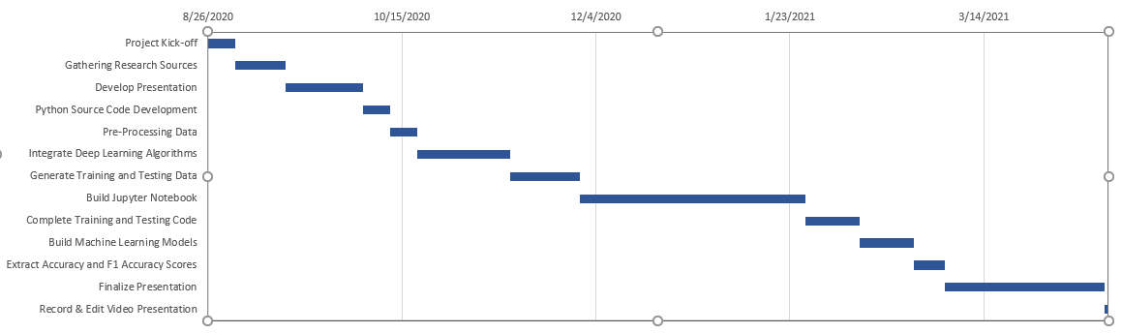
2.2 Gantt Chart
Figure 5: High Level Schedule
Project Kick-off
Our project started late August of 2020. We made a team with five group members, who will take the challenge of working together and complete the project on time.
Gathering Research Sources
Team started gathering sources for fake news and real news early September of 2020. Dr. Dong had a lair dataset provided to the team which contained a whole set of such news.
Develop Presentation
Team started preparing for the presentation starting mid-September to early October. The presentation was modified and edited as required with the updates on the project.
Python Source Code Development
Dr. Dong provided the team with a sample code to work with. The team used the PyCharm IDE to run the codes and fix the bugs.
Pre-Processing Data
We started the preprocessing of the data mid-October or 2020. Preprocessing of data involved loading the dataset and dividing the dataset into two text files.
2.2-Gantt Chart (continued)
Integrate Deep Learning Algorithms
Execute five deep learning algorithms and obtain their results. This acts as a testing stage for our project. We used the deep learning algorithms to test and train the dataset.
Generate Training and Testing Data
We used the corpus/dataset to build sample and obtain the results. This was very important task which will help us to generate a test and train file.
Build Jupyter Notebook
We started working on Jupyter Notebook application Late December of 2020. This application allowed us to merge all the necessary codes and show the flow of data and results.
Complete Training and Testing of Code
Team started merging the python codes in Jupyter Notebook and completed the training and testing of the code.
Build Machine Learning Models
Several Machine learning algorithms and Deep learning algorithms were built to train the models and display several accuracy scores which determined the efficiency of the models.
Extract Accuracy and F1 Scores
Team were able to extract the Accuracy and F1 scores by running the necessary algorithms efficiently and without any errors.
Finalize Presentation
Team edit the presentation as the project proceeded to the final stages.
Record & Edit Video Presentation.
Team recorded the flow of the codes in Jupyter Notebook and its output as a prototype.

3. LITERATURE REVIEW

For our literature review we decided to do research and comparison of our Fake New Detection Project to different other products in the market. Below is a comparison of our project with other applications in the market.
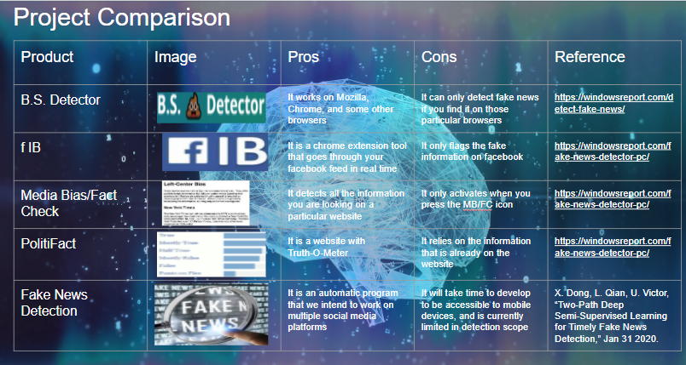
Figure 6: Project Comparison
B.S. Detector
This product only works on Mozilla, Chrome, and some other browsers. It can only detect fake news that are found in those browsers. If the news is in a different platform that the B.S. Detector will not be effectively detecting any fake news.

f IB
This product uses a chrome browser, and it is an extension tool for the Facebook application to detect fake news. If some news is posted in Facebook and need to be verified, the f IB tool will prompt a web browser to verify the news. This product will only flag the fake news on the Facebook application.
Media Bias/Fact Check
This fact check application will only work on a particular website and will only activate when the MB/FC button is pressed.
PolitiFact
It is a website with a Truth-O-Meter and just relies on the information that is already on the website.
Fake News Detection
This is our project, and it is an automatic program. We intend this program to work on various social media platforms. The other products use machine learning algorithms, but our software will use deep learning algorithms which will make it a new product in the market. Due to time constraints we will not be able to develop the program to make it accessible to mobile devices and is currently limited in detection scope.

4. PRELIMINARY DESIGN

4.1 Concept Generation
We selected this project due to relevance in our engineering curriculum: students need objective news. Also, deep learning algorithms are used as they can process a large amount of information. There are several false news detection software and applications in the market but the lack the intricacy that we have planes with our software detection model. Most misinformation detection applications have flagged articles rather than deep learning. They lack integration into the social media applications. There are intrusive and foreground User Interface.
This project started development in Python 2.7 then 3.0 for the sake of starting code development. We considered a Linux system to run the software. Linux preforms tasks in Python more efficiently than Windows or Apple machines. Thereby, we tried two methods of running Linux on our strictly Windows-based PCs. First, we tried a Linux subsystem, which did not properly compile the code. Second, we tried to dual-boot Linux onto a Window’s system, but we were not experienced in computer software development. The dual-boot method did not work. We needed a simple, streamlined integrated development environment (IDE). Last semester, we settled on the PyCharm IDE. Pycharm allowed the deep learning packages to install. We developed basic Python techniques but did not actually apply the deep learning algorithms in that stage.
In the Spring, we adjusted our strategy. At Dr. Dong’s suggestion, we moved to an IDE that could be accessed remotely. We elected to build the code again on a Jupyter Notebook. The Jupyter Notebook is an open-source webpage application. It allows software developers to develop codes in cells. The Notebook is split into several, smaller cells of code which can be compiled consecutively and separately. Jupyter is great for showcasing and passing code
4.1 Concept Generation (continued)
between teammates. It is also a common starting point for integrating a software into a mobile device. Team members have been engaging in running the codes efficiently and effectively.

4.2 Concept Evaluation and Selection Criteria
Python 2.7 & 3.0:
The basic Python 2.7 & 3.0 softwares were good for practicing the basics of Python codes, but had trouble importing and installing some of the more complex libraries such as Scikit Learn (SKLearn, a machine learning package in Python) and Numpy (a mathematics package). We did not select this for design because the software does not process data efficiently enough.
PyCharm IDE:
PyCharm is one of the best IDE’s for Python coding. This allowed us to compile sample codes from Dr. Dong and begin developing more of the software. The only issue is that it was not accessible by multiple teammates at once. We selected this for last semester because of its ease of use but did not use it in our final product.
Jupyter Notebook:
Jupyter Notebook allowed us to share notebook files back and forth between teammates and easily display changes and developments to the software. It ran with about as much simplicity as PyCharm but had the added benefit of being a pseudo–Google Drive for the programming process. We were unable to meet in person for this project, so Jupyter Notebook was doubly helpful for this purpose. This environment was chosen for our final design.

4.3 Design Constraints and Applicable Codes and Standards
Design Constraints
Devices have limited storage capacity:
The eventual plan for the software is to be implemented onto a mobile device. We understand that these devices have limited storage capacity. It is assumed that the users of this software will be able to clear files and delete any unused applications to make room for ours. This constraint also means we must consider the size of data storage going forward.

Power failure may cease the program and lead to data loss:
When devices lose power, the applications running on them stop running. This program is based entirely on processing data, and should the process be interrupted, it can mean a software failure. We assume that the user will have their battery sufficiently charged. We made some consideration for robust detection models in the design requirements partially for this reason.

4.3 Design Constraints and Applicable Codes and Standards (continued)
Codes and Standards
IEEE 24748 - A common framework for software lifecycle processes. This guideline helps with defining, controlling, and improving software life cycle processes within an organization or project.
This standard will guide us through our program development phase. Building, modifying, testing, and training the program model following the guidelines will help develop a robust program.

IEEE 26511 - Conduct for managing information for users of software. It addresses productivity and quality management for information control.
This standard will guide us to finish a robust detection model. Our program will not interrupt the user’s media experience and will execute promptly with high productivity. Software will be user friendly and will be easy to understand and run.

IEEE 26515 - Standard regarding quality information development for users in flexible programming environments.
Our engineering requirements include quality information in order to solve our problem statement.

4.3 Design Constraints and Applicable Codes and Standards (continued)
IEEE 29119 - This standard defines testing technology that can be used for software design projects.
This code will help us through our testing and training of our software. Testing and training the software will ensure the effective execution of the software and help us fix bugs if any.

P 24748-6 - Standard for systems and software Integration.
This standard will be a guideline in integration of our detection model into a social media platform. We shall use the three major steps interface, verification, and validation.
.
IEEE Code of Ethics - List of ethical engineering standards used throughout the development of this project.
Our team will always comply with the ethical engineering standards. All team members are encouraged to uphold these very important codes of ethics.

4.4 Preliminary Analysis
Deep Learning Algorithms:
These deep learning algorithms are several techniques to process the dataset being referenced for detecting misinformation. They are machine learning program sets that allow the program to learn and process data.
- Random Forest (RF): one of the many machine learning algorithms used for supervised learning, this means for learning from labelled data and making predictions based on the learned patterns. RF can be used for both classification and regression tasks. RF is based on “if…then” decision splits. Programming “if…then” statements allow the computer a choice of meeting an “if” condition and “then” completing a task. This is done on a large scale in the case of RF, then it makes predictions by combining the results from many individual decision trees. We call this a “forest” of decision trees. See this diagram to represent this process:

4.4 Preliminary Analysis (continued)

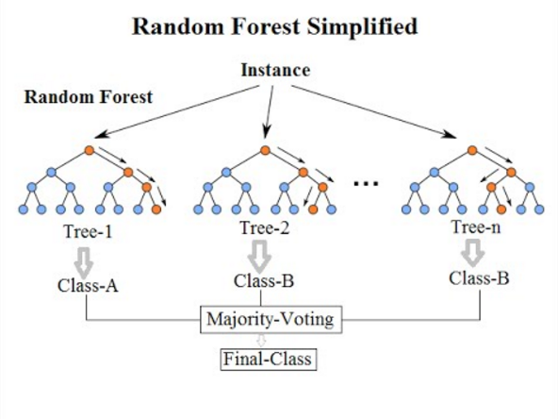

Figure 7 Random Forest Diagram

This diagram shows the random forest of decision trees used in a Majority-Voting scenario. A single “instance” produces a random forest of three decision trees in the scenario, and then narrows the possibilities into classifications.

- Decision Tree (DT): A DT is used to convert to index using a particular format. The format returns to the index, and the python standard library also supports the same format. Several variable call command examples are shown below:
dt_predict: predicts sample scores within the DT.
dt_acc: finds the accuracy score value within the DT.
4.4 Preliminary Analysis (continued)
dt_auc_val: finds the area under the curve (integral) value within the DT.
dt_precision_val: finds precision value within DT (after testing is completed).
dt_recall_val: finds the recall value within DT (after testing).
dt_f1_val: finds f1 score value within DT (after testing).

- Support Vector Machine (SVM): An SVM is a supervised learning model with associated learning algorithms. It is used for data classification and regression analysis. Several variable call command examples are shown below:
svm_predict: predicts sample scores within the SVM.
svm_acc: finds the accuracy value within the SVM.
svm_auc_val: finds the area under the curve (integral) value within the SVM.
svm_precision_val: finds the precision value within SVM (after testing is completed).
svm_recall_val: finds the recall value within SVM (after testing).
svm_f1_val: finds f1 score value within SVM (after testing).

- Neural Network (NN): Trains a NN using an optimization algorithm to find a set of weights to best map inputs to outputs. Several variable call command examples are shown below:
nn_predict: predicts sample scores within the NN
nn_acc: finds the accuracy value within the NN
nn_auc_val: finds the area under the curve (integral) value within the NN.
nn_precision_val: finds the precision value within the NN (after testing is completed)
4.4 Preliminary Analysis (continued)
nn_recall_val: finds the recall value within NN (after testing)
nn_f1_val: finds f1 score value within NN (after testing)

- Bayes Algorithm: Bayes is a probabilistic classifier that uses the basics of the Bayes theorem. It is built to make independent assumptions in the deep learning process.
by_predict: predicts sample scores within the Bayes Algorithm.
by_acc: finds the accuracy value within the Bayes Algorithm.
by_auc_val: finds the area under the curve (integral) value within the Bayes Algorithm.
by_precision_val: finds the precision value within the Bayes Algorithm (after testing is completed).
by_recall_val: finds the recall value within the Bayes Algorithm (after testing).
by_f1_val: finds f1 score value within the Bayes Algorithm (after testing).
- Adaptive Boosting (AD): AdaBoost or AD is a shorthand of Adaptive Boosting and it is a meta-algorithm in machine learning. It is adaptive learning in the sense that it corrects the misclassified information by previous classifiers automatically.
ad_predict: predicts sample scores within the AD
ad_acc: finds the accuracy value within the AD
ad_auc_val: finds the area under the curve (integral) value within the AD.
ad_precision_val: finds the precision value within the AD (after testing is completed)
ad_recall_val: finds the recall value within AD (after testing)
ad_f1_val: finds f1 score value within AD (after testing)
4.5 Preliminary Design
We are building a program software that will help detect false information or any misleading information. We are using a Deep learning algorithm on Python to reprocess information. Fake news detection through the deep learning algorithms and processing datasets allow for an efficient machine learning system. To facilitate that detection, we apply a Deep Learning framework (shown below) that acts as an input and output diagram. Word embedding detects initial frequency of words within an article. Then, those words are passed through a shared Convolutional Neural Network (CNN) and separated into supervised and unsupervised CNN’s. Both include convolutional layers (a summary of the presence of features in an image), and pooling layers (maps and averages the features found in the convolutional layers).

Unsupervised CNN’s: Input words (represented by variable x_{i}) are words that don’t trigger the word embedding process, and all data takes its path through mean squared error calculation and weighted sum of loss and finally optimization of x_{i}.

Supervised CNN’s: x_{i} words passing through the Supervised CNN are normalized through a softmax probability density function (PDF). That PDF is then measured for the difference from the norm in a cross-entropy process, and the difference is weighed. Lastly, x_{i} is optimized for results.

4.5 Preliminary Design (continued)
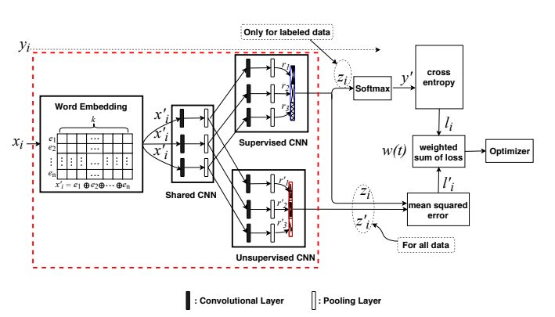
Figure 8 Preliminary Design Concept Source: Two-Path Deep Semi-Supervised Learning

5. DETAILED SYSTEM DESIGN

5.1 Project Parts Summary
Our project was entirely based in software and thus did not involve purchasable parts. Notably, we could have purchased a Linux machine to run the program. This would have facilitated a more rigid first design, but would have been difficult to share, logistically.

5.2 Engineering Analysis and/or Simulation
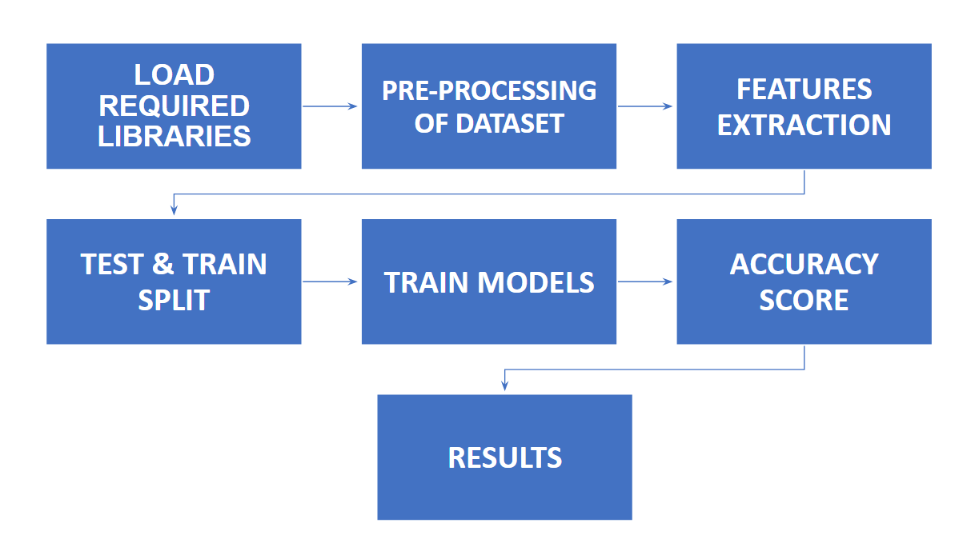
Figure 9 Project Flowchart

Shown above is a theoretical flowchart of what our program must do.
- Load Required Libraries: Import Python libraries for use of their functions.
- Pre-Processing of Dataset: Preprocessed data with predicted results of true and false news.
- Features Extraction: Extracting features from loaded libraries for machine learning tasks.
- Test & Train Split: Estimate performance of deep learning algorithms.
- Train Models: Build accuracy testing models for code.
- Accuracy Scores: Generate accuracy scores for each of the deep learning algorithms.
- Results: Display testing results, to meet marketing requirement of accurate news

5.2 Engineering Analysis and/or Simulation
Further details to each step are shown in section 5.3, where we detail each of the steps with examples.

5.3 Overview of Code Developed
- Load Required Libraries: Each step must import required, external Python libraries for Jupyter Notebook to recognize and complete steps within the software. Then, programming functions must be called upon “from” those libraries. Shown below is cell 1 in our Jupyter Notebook, which imports the “pandas” (a data analysis library), “numpy” (a mathematics package), and “matplotlib.pyplot” (a graphical plotting system emulating MatLab) libraries into the Notebook:

In [1]: #Import Python packages
import pandas as pd
import numpy as np
import matplotlib.pyplot as plt

Notably, the sklearn library does not need to be imported as it was in PyCharm (See Section 4.2) because Jupyter Notebook has some libraries inherent to the program.

- Pre-Processing of Dataset: The dataset we worked with for this program is a large amount of article statements compiled into an 11552 by 14 matrix. Each row represents a different statement given, and each column represents:
- Data Label (Labels File)
- True or False Value (Ranging from pants-fire, false, barely true, half-true, to true; also called our Corpus file)
- Statement Title
5.3 Overview of Code Developed (continued)
- Statement Subject Matter
- Speaker
- Speaker Occupation
- Speaker’s State of Residence (I.E. Texas, New York, Massachusetts)
- Speaker’s Political Affiliation
  - The total credit count, including the current statement:
9: Barely true counts
10: False counts
11: Half-true counts
12: Mostly true counts
13: Pants on fire counts
- Source of Statement (I.E. Website, Television Interview)
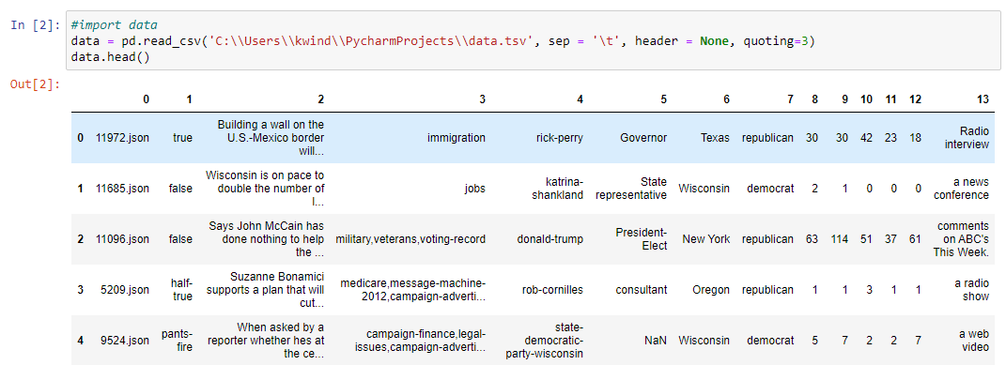
This data is imported in cell 2:

Figure 10 Cell 2

5.3 Overview of Code Developed (continued)
- Features Extraction: Feature extraction is the process of calling upon a function from a previously imported library. Several functions had to be called from the sklearn library such as in cell 6:

In [6] From sklearn.feature_extraction.text import TfidVectorizer

Where the function TfidVectorizer was imported to facilitate a vectorize function. Vectorizing is the process of modifying an algorithm to work on several values at once, thus minimizing code runtime.

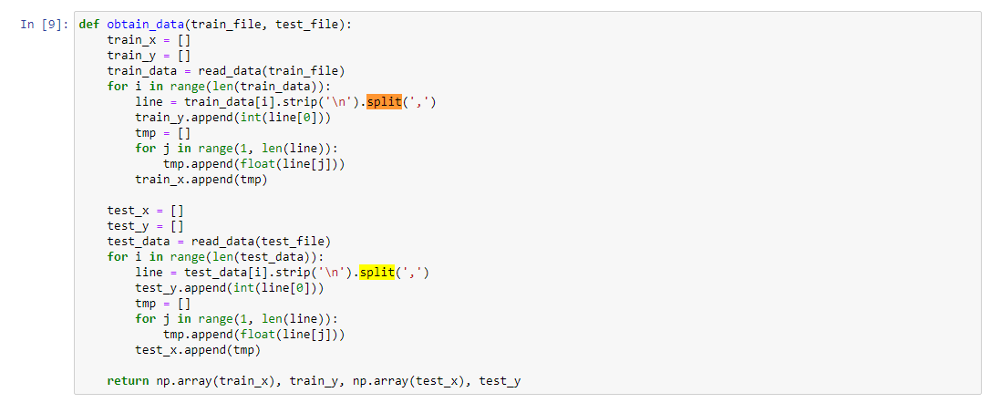
- Test and Train Split: The procedure used to estimate the performance of our deep learning algorithms. Our machine learning models make independent predictions, and so require this split to compare our algorithms to the predictive result of the pre-processed data. The process is done in cell 9:

5.3 Overview of Code Developed (continued)
Figure 11 Cell 9
In this way, the train and test models are built and split using “for” loops.

- Train Models: Using the deep learning algorithms detailed in Section 4.4, we build training models to test the accuracy values of our machine learning models.
- Accuracy Score: Once the training and testing models are built, we run several functions to generate accuracy scores on several axis. The deep learning algorithms can be found in Section 4.4, but an example is given in cell 14 with the SVM algorithm building a score for predict, accuracy (acc), area under the curve value (auc_value), precision value (precision_val), recall (recall_val), and F1 Score (F1_Val). Where the values are “returned”, but not quite displayed yet.:
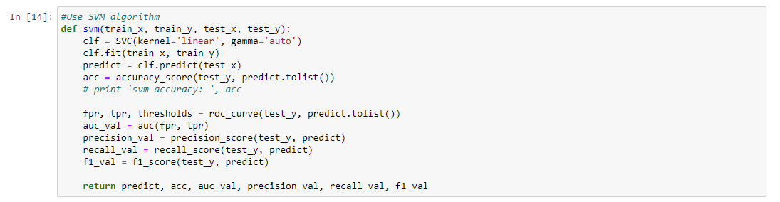
Figure 12 SVM algorithm

- Results: Lastly, we display the testing results in a matrix for the prediction score, and percentage values for each of the accuracy scores in section 5.2.6:
- Predict
- Accuracy
- Auc_value
5.3 Overview of Code Developed (continued)
- Precision
- Recall
- F1 Score

Below is an example of these scores given to the Adaptive Boosting algorithm. The scores are given in order, starting with the prediction matrix, then a percentage for the remaining scores:

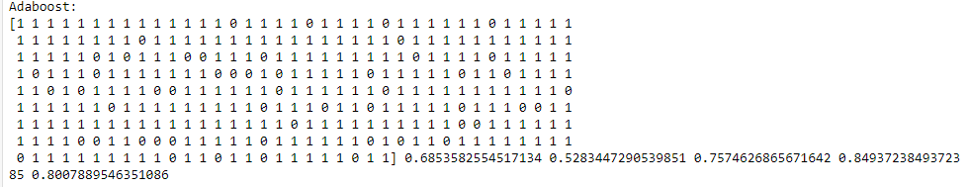
Figure 13 ADA Boost Accuracy Scores

5.4 Application of Engineering Codes and Standards used in Final Design
IEEE 24748: IEEE 24748 served as a model and guide for developing the program. It ensured we developed a robust program as it emphasized testing and training the program for efficiency and accuracy.

IEEE 26511: This code gave us a model for managing information in a project. It focused on comprehensive requirements and deliverables in our schedule. This helped us produce a project that was streamlined and understandable to a user.

IEEE 26515: IEEE 26515 was used in this project as a means of holding ourselves to a high standard of quality assurance. Specifically, we used its Clause 5 to meet requirements regarding managing information in an agile programming environment, and Clause 6 to plan development of such information.

IEEE 29119: We mostly followed Dr. Dong’s method of testing and training software, but this code served as a secondary reference to the quality assurance and vocabulary of testing software.

5.4 Application of Engineering Codes and Standards used in Final Design (Continued)
P 24748-6: This code specified in information about software life cycle development. We took guidance from it in integrating the program into our different IDE’s and would hope
to use it in the future to implement that into a mobile device. We used three major steps mentioned: interface, verification, and validation.
.
IEEE Code of Ethics - List of ethical engineering standards used throughout the development of this project.
Our team made an emphasis on the IEEE Code of Ethics philosophically. In our research, development, and design we made diligent efforts to be academically honest. We made an effort to properly cite any of our sources and committed to work in an honest way.

5.5 Economic Analysis
Our project did not need funding, as the only resources needed were work and time. Monetary analysis is not applicable.

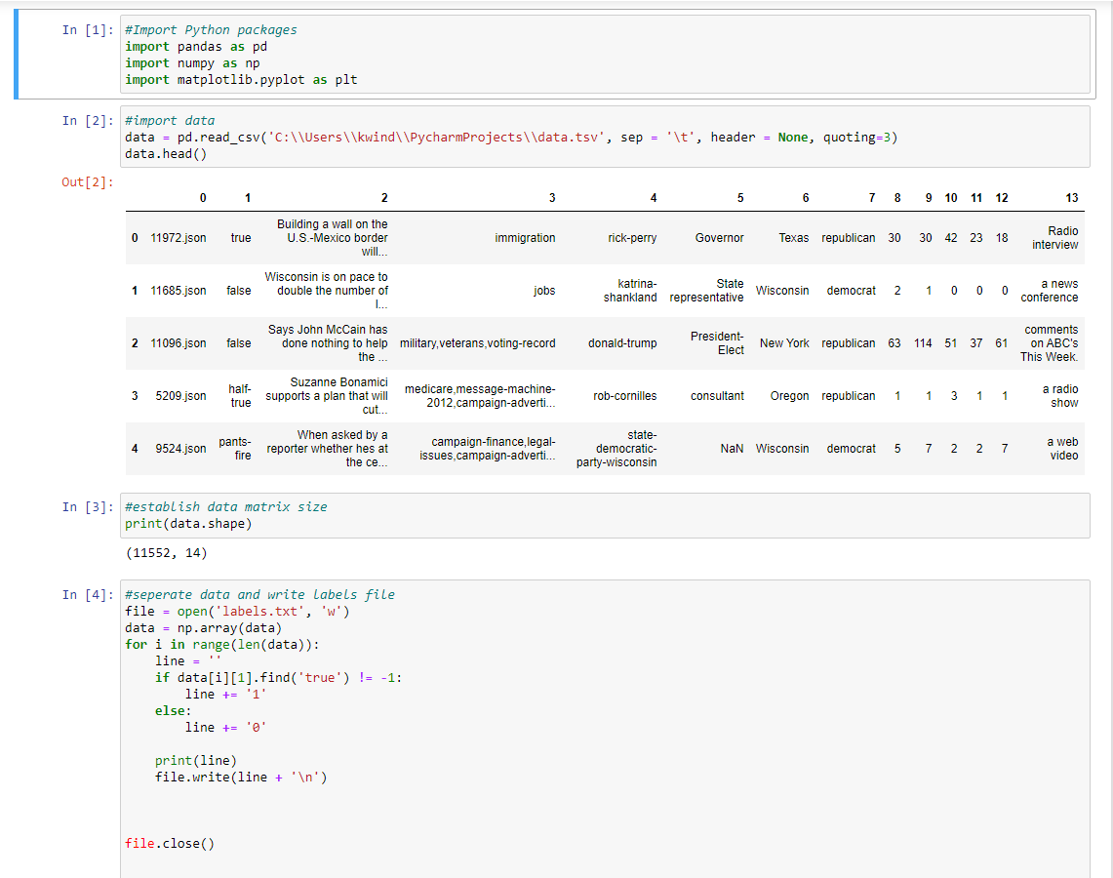
5.6 Final Design

5.6 Final Design (continued)

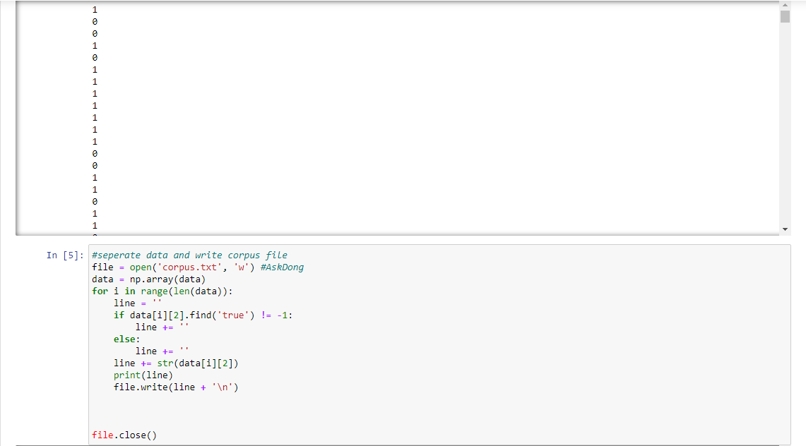

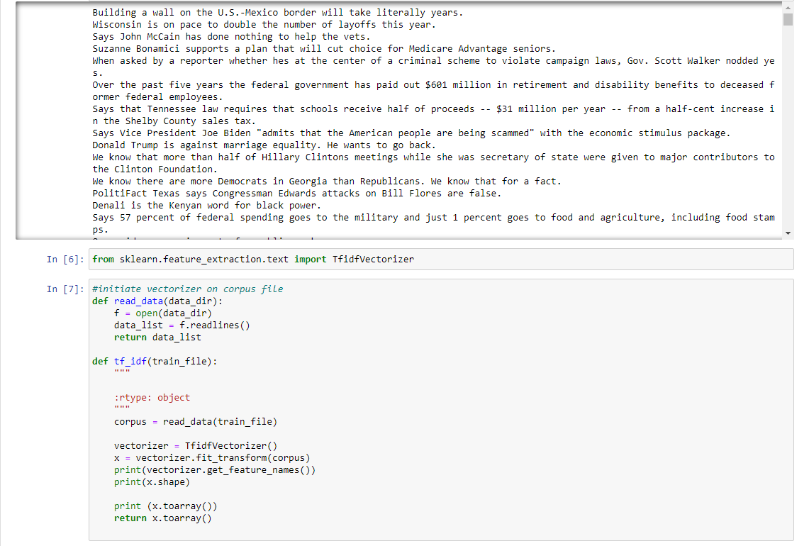

5.6 Final Design (continued)

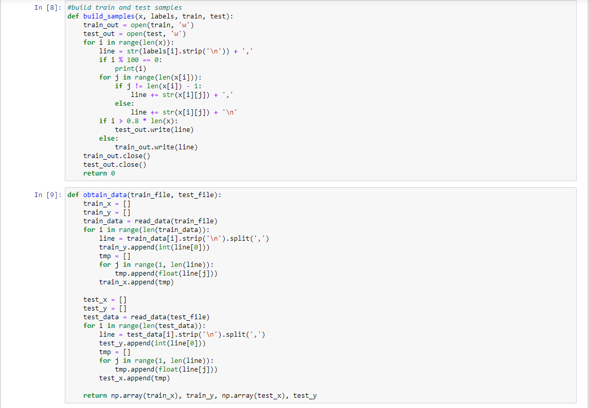

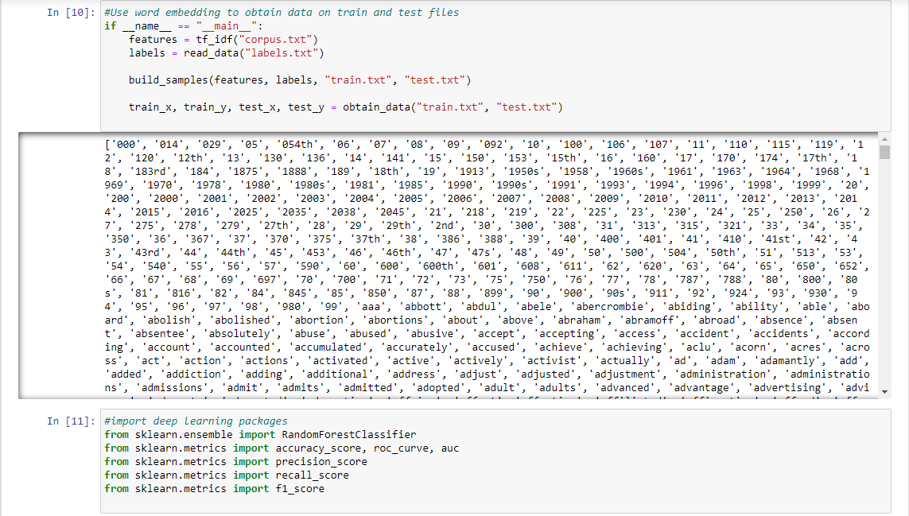

5.6 Final Design (continued)

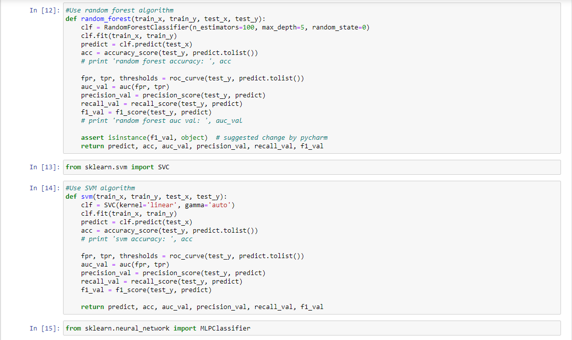

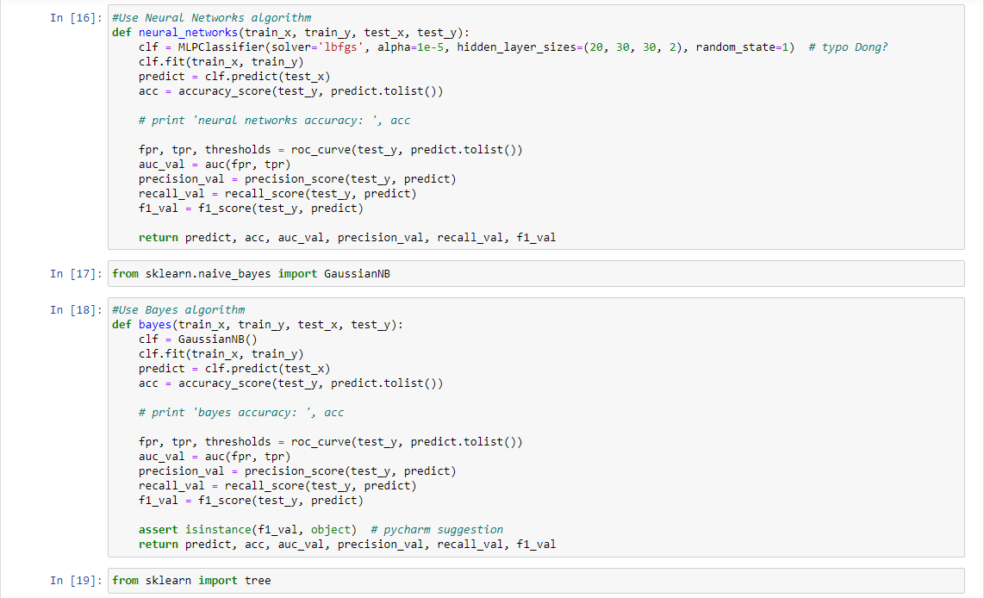

5.6 Final Design (continued)

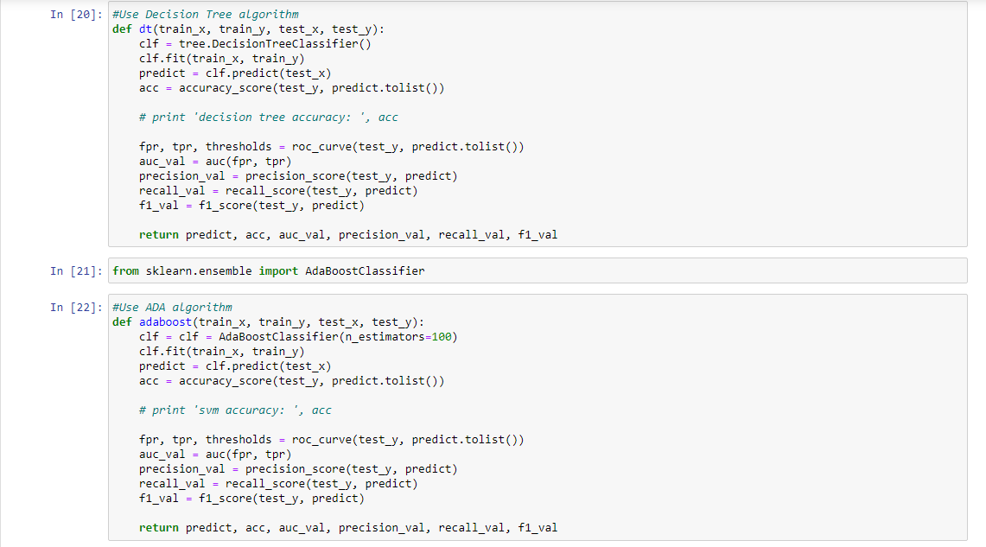

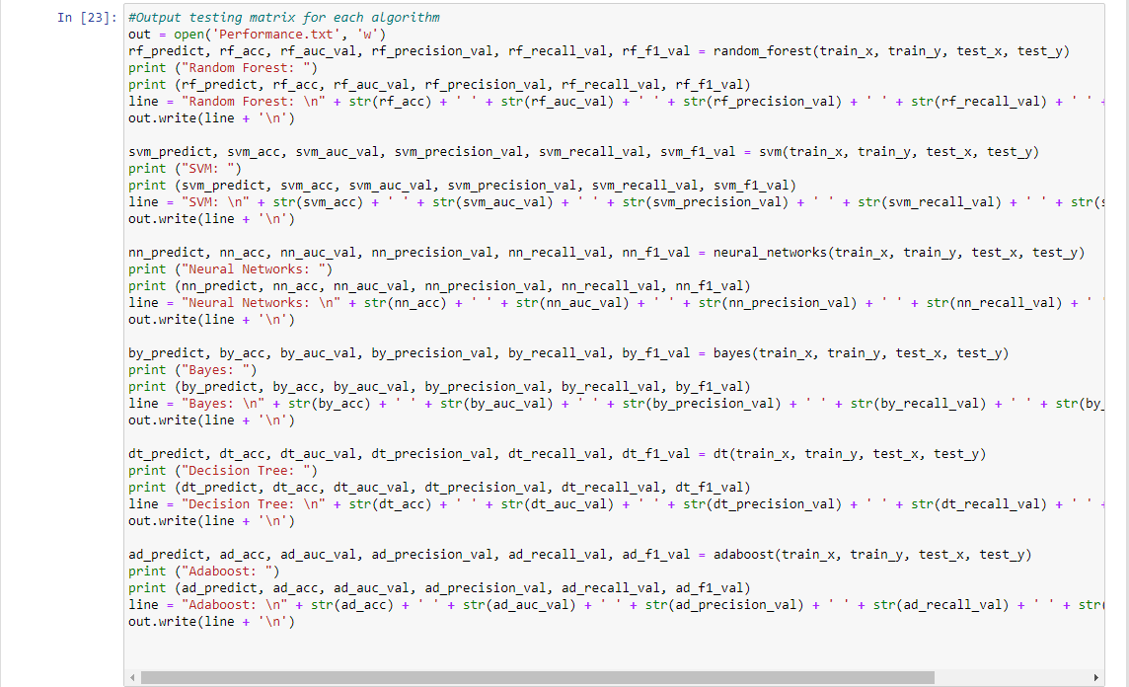
Figure 14 Final Design

5.6 Final Design (continued)
Output from In [23]:
Random Forest:
[1 1 1 1 1 1 1 1 1 1 1 1 1 1 1 1 1 1 1 1 1 1 1 1 1 1 1 1 1 1 1 1 1 1 1 1 1
1 1 1 1 1 1 1 1 1 1 1 1 1 1 1 1 1 1 1 1 1 1 1 1 1 1 1 1 1 1 1 1 1 1 1 1 1
1 1 1 1 1 1 1 1 1 1 1 1 1 1 1 1 1 1 1 1 1 1 1 1 1 1 1 1 1 1 1 1 1 1 1 1 1
1 1 1 1 1 1 1 1 1 1 1 1 1 1 1 1 1 1 1 1 1 1 1 1 1 1 1 1 1 1 1 1 1 1 1 1 1
1 1 1 1 1 1 1 1 1 1 1 1 1 1 1 1 1 1 1 1 1 1 1 1 1 1 1 1 1 1 1 1 1 1 1 1 1
1 1 1 1 1 1 1 1 1 1 1 1 1 1 1 1 1 1 1 1 1 1 1 1 1 1 1 1 1 1 1 1 1 1 1 1 1
1 1 1 1 1 1 1 1 1 1 1 1 1 1 1 1 1 1 1 1 1 1 1 1 1 1 1 1 1 1 1 1 1 1 1 1 1
1 1 1 1 1 1 1 1 1 1 1 1 1 1 1 1 1 1 1 1 1 1 1 1 1 1 1 1 1 1 1 1 1 1 1 1 1
1 1 1 1 1 1 1 1 1 1 1 1 1 1 1 1 1 1 1 1 1 1 1 1 1] 0.7445482866043613 0.5 0.7445482866043613 1.0 0.8535714285714285

SVM:
[1 1 1 1 1 1 1 1 1 1 1 1 1 1 1 1 1 1 1 1 1 1 1 1 1 1 1 1 1 1 1 1 1 1 1 1 1
1 1 1 1 1 1 1 1 1 1 1 1 1 1 1 1 1 1 1 1 1 1 1 1 1 1 1 1 1 1 1 1 1 1 1 1 1
1 1 1 1 1 1 1 1 1 1 1 1 1 1 1 1 1 1 1 1 1 1 1 1 1 1 1 1 1 1 1 1 1 1 1 1 1
1 1 1 1 1 1 1 1 1 1 1 1 1 1 1 1 1 1 1 1 1 1 1 1 1 1 1 1 1 1 1 1 1 1 1 1 1
1 1 1 1 1 1 1 1 1 1 0 1 1 1 1 1 1 1 1 1 1 1 1 1 1 1 1 1 1 1 1 1 1 1 1 1 1
1 1 1 1 1 1 1 1 1 1 1 1 1 1 1 1 1 1 1 1 1 1 1 1 1 1 1 1 1 1 1 1 1 1 1 1 1
1 1 1 1 1 1 1 1 1 1 1 1 1 1 1 1 1 1 1 1 1 1 1 1 1 1 1 1 1 1 1 1 1 1 1 1 1
1 1 1 1 1 1 1 1 1 1 1 1 1 1 1 1 1 1 1 1 1 1 1 1 1 1 1 1 1 1 1 1 1 1 1 1 1
1 1 1 1 1 1 1 1 1 1 1 1 1 1 1 1 1 1 1 1 1 1 1 1 1] 0.7414330218068536 0.497907949790795 0.74375 0.99581589958159 0.851520572450805

Neural Networks:
[1 1 1 1 1 1 1 1 1 1 0 1 1 1 0 1 1 1 1 1 1 0 1 1 1 1 1 1 1 1 1 1 1 1 1 0 1
0 1 1 0 1 0 1 1 1 1 1 1 0 1 1 0 1 1 1 1 1 0 1 1 1 1 1 0 1 1 1 1 0 1 1 1 0
0 1 1 1 0 0 1 0 1 1 1 1 1 1 1 1 0 1 1 1 1 1 0 1 1 1 1 1 1 1 1 1 1 1 1 0 1
1 0 1 1 0 1 1 1 1 1 1 1 1 1 0 1 1 1 1 1 1 1 1 0 1 1 1 1 1 0 1 1 1 0 1 1 1
1 1 0 1 0 1 0 1 1 0 0 1 1 1 1 0 1 1 1 1 1 1 1 1 0 1 0 1 1 1 1 1 1 1 1 1 0
1 1 1 1 0 0 1 1 1 1 1 0 1 1 1 1 1 1 1 1 0 1 1 0 1 1 1 1 1 1 1 0 1 0 1 1 1
1 1 1 1 1 1 1 1 0 1 1 1 1 1 1 1 0 1 0 1 1 1 1 1 1 1 1 1 0 1 0 1 1 1 1 1 1
0 1 1 1 0 1 1 1 0 1 1 1 1 1 1 1 1 1 1 1 1 1 1 0 1 1 1 1 1 1 1 1 1 1 1 0 1
1 1 1 1 1 1 0 1 1 1 0 1 1 0 1 1 1 1 1 1 1 0 0 1 1] 0.6853582554517134 0.5363557505867946 0.7613636363636364 0.8410041841004184 0.7992047713717695

Bayes:
[0 1 0 1 0 1 1 1 1 1 1 1 0 1 1 1 1 1 0 1 1 1 1 1 0 1 1 0 0 1 0 0 1 1 1 0 1
1 1 1 1 1 1 1 1 1 1 1 1 0 1 0 1 1 0 1 1 1 1 1 1 1 1 1 1 1 1 1 1 0 1 1 1 0
0 0 1 1 0 0 1 0 0 1 1 1 1 1 0 1 1 1 1 1 1 1 1 1 1 0 1 1 0 1 0 1 1 1 1 0 1
0 1 1 1 1 0 0 1 1 0 1 1 1 1 1 1 1 1 1 1 1 1 1 1 1 0 1 1 1 1 0 1 0 0 1 1 0
1 1 0 1 1 1 1 1 1 0 0 0 1 1 1 1 1 1 1 0 1 0 1 1 0 1 1 1 1 1 0 1 1 0 1 1 1
1 1 0 1 0 1 0 1 1 1 1 0 0 1 1 1 1 1 0 0 0 1 1 0 1 1 1 1 1 1 1 0 1 0 1 1 1
1 1 1 0 1 1 1 1 1 1 0 1 0 1 1 1 0 1 1 1 1 1 1 1 1 1 1 1 0 1 0 0 1 1 0 1 1
1 1 1 1 0 1 1 1 0 1 1 1 1 1 1 1 1 0 0 0 0 1 1 0 1 1 1 1 1 1 1 0 1 1 1 1 0
1 1 1 0 1 1 0 0 1 1 0 1 1 1 1 0 1 1 0 1 1 1 0 1 1] 0.6261682242990654 0.5046178181447086 0.7468879668049793 0.7531380753138075 0.75

5.6 Final Design (continued)
Decision Tree:
[1 1 1 1 1 1 1 1 1 0 0 1 1 1 1 0 1 1 1 1 0 1 1 1 0 1 1 1 1 1 0 1 1 1 1 1 1
0 1 1 1 1 1 0 1 1 1 1 1 1 0 0 1 1 1 1 0 1 0 1 1 1 1 1 1 1 1 0 1 1 0 0 1 1
1 1 1 1 1 0 1 1 1 0 1 0 1 1 1 1 0 1 1 0 1 1 1 1 1 1 1 1 0 1 1 0 0 1 1 1 1
1 1 1 1 0 1 1 1 1 1 1 1 1 1 1 0 1 1 1 1 1 1 1 1 1 0 1 1 1 0 1 1 1 0 1 1 0
1 1 0 1 1 1 1 1 1 1 1 1 1 1 1 1 1 1 1 1 1 1 0 1 1 0 1 1 1 1 0 1 1 1 1 1 1
1 1 0 1 1 1 0 1 0 1 1 0 1 1 1 1 1 1 1 1 0 1 1 1 1 1 1 0 1 1 1 1 0 1 1 1 1
1 1 1 1 0 1 1 1 1 1 1 1 1 1 1 1 1 1 1 1 1 1 1 1 1 1 0 1 1 1 0 1 1 1 0 1 0
1 1 0 1 1 0 1 1 1 1 0 1 1 1 0 1 1 1 1 1 1 1 1 0 1 0 0 1 1 1 1 1 0 1 1 1 1
1 0 1 1 1 0 0 1 1 1 0 1 1 1 1 0 0 1 1 1 1 1 1 1 0] 0.6386292834890965 0.48094193285029085 0.735632183908046 0.803347280334728 0.7680000000000001

Adaboost:
[1 1 1 1 1 1 1 1 1 1 1 1 1 1 0 1 1 1 1 0 1 1 1 1 0 1 1 1 1 1 1 0 1 1 1 1 1
1 1 1 1 1 1 1 1 0 1 1 1 1 1 1 1 1 1 1 1 1 1 1 1 1 0 1 1 1 1 1 1 1 1 1 1 1
1 1 1 1 1 0 1 0 1 1 1 0 0 1 1 1 0 1 1 1 1 1 1 1 1 1 0 1 1 1 1 0 1 1 1 1 1
1 0 1 1 1 0 1 1 1 1 1 1 1 0 0 0 1 0 1 1 1 1 1 0 1 1 1 1 1 0 1 1 0 1 1 1 1
1 1 0 1 0 1 1 1 1 0 0 1 1 1 1 1 1 0 1 1 1 1 1 1 0 1 1 1 1 1 1 1 1 1 1 1 0
1 1 1 1 1 1 0 1 1 1 1 1 1 1 1 1 0 1 1 1 0 1 1 0 1 1 1 1 1 0 1 1 1 0 0 1 1
1 1 1 1 1 1 1 1 1 1 1 1 1 1 1 1 1 1 0 1 1 1 1 1 1 1 1 1 1 0 0 1 1 1 1 1 1
1 1 1 1 0 0 1 1 0 0 0 1 1 1 1 1 0 1 1 1 1 1 1 0 1 0 1 1 0 1 1 1 1 1 1 1 1
0 1 1 1 1 1 1 1 1 1 0 1 1 0 1 1 0 1 1 1 1 1 0 1 1] 0.6853582554517134 0.5283447290539851 0.7574626865671642 0.8493723849372385 0.8007889546351086

6. RESULTS & DISCUSSION

6.1 Summary of Goals and Objectives
Our goal was to develop a software that detects and processes misinformation and informs the user of fake news. This was to solve the growing problem of misinformation in social media. We wanted our users to have access to an application that would scan and alert a user of misinformation as they scrolled through social media. The software we developed only partially met that objective: it is a webpage IDE that processes a specific dataset and returns an accurate data crunch of the misinformation contained.

6.2 Summary of Constraints and Codes met by Design
We had two major initial constraints, and two design constraints. Our lack of Python experience hindered us in our ability to fully develop a Python based software, but with research and help from Dr. Dong we gained some experience with the programming language. COVID-19 restrictions also hurt our ability to meet in real life, but we adapted quickly to remote meetings through Zoom and GroupMe. The full effect of that constraint is hard to quantify in terms of mental strain, however. We made assumptions to mitigate the two design constraints. Limited storage space is up to the user to clear to make room for this developed application, and power failure can be mitigated by the user keeping their device charged.

- IEEE 24748: Framework for software development and life cycle processes.
- IEEE 26511: Conduct reference for managing information in software development in terms of quality assurance.
- IEEE 26515: Standard for quality information development and holding the information to task.
- IEEE 29119: Used as a secondary guide for testing and training data.
- P 24748-6: Standard for integrating the program into several IDE’s.
- IEEE Code of Ethics: Used as a standard for academic honesty and research.

6.3 Discussion of Results and Other Use Cases
Our result for this project was an easily implementable software rather than a full mobile application. The program preprocesses data, extracts machine learning features, splits the test and train data, builds training models, then produces an accuracy score. It uses a preloaded dataset as a point of reference for the deep learning algorithm results. We developed this program from sample codes and further help by Dr. Dong. The accuracy scores vary in quality. Further development of the deep learning algorithms is necessary for a more perfect design. Time given and inexperience with software programming among our team contributed to our inability to take this design further.
This software could be further developed to accept an input of a vectorized article or statement, and then compare the data given to its previous findings via deep learning. Using Jupyter Notebook, we were able to develop and upload the software to a digital space. We did not have enough experience to develop an actual mobile application but given time this program could be implemented there. There are further recommendations to be mentioned in Section 7 as to the specific upgrades that could be made to the software. The program is meant to be used by social media users but could also be applied to educational databases as an automatic means of information quality assurance.

7. CONCLUSIONS AND RECOMMENDATIONS

7.1 Conclusion
Our project sought to address the issues of misinformation and misleading news on the internet and social media. We felt our project had good timing for the current environment, just after a presidential election and amidst a global health crisis. Both events spurred a large amount of misinformation in media, and further fake news can be found in subjects not necessarily related to current events. Our project could eventually be implemented in a way that would mitigate misinformation propagating through social media.
7.2 Recommendations
Our device is currently a Jupyter Notebook iteration of a software that can detect and process misinformation. The framework for our software can be applied to a greater product of deep learning algorithms being used to manage applications that automatically flag fake news. Due to time and experience constraint, we only managed to integrate our project onto a webpage IDE. We are not porting the software to a mobile device at this time, but chose a method of presentation that would make that possible. In the future, the software could also be made to access the dataset via cloud and accept data input from the user via vectorization. This would be closer to our final vision for the project. For this device to be fully marketable, we recommend making these improvements and porting it to a mobile device. The misinformation or false flag should also be linked to code that prompts a notification on a physical electronic device.

LIST OF REFERENCES
Books:

[1] J. Cook et al., The Consensus Handbook. March 2018, pp. 3-21

Papers/Articles:

[2] X. Dong, L. Qian, U. Victor, "Two-Path Deep Semi-Supervised Learning for Timely Fake News Detection," Jan 31 2020.
[3] E. Shearer, "Social Media Outpaces Print Newspapers in the U.S as a News Source," December 10 2018.
[4] J. Cook, "Understanding and Countering Misinformation About Climate Change," 2019, pp. 1-11.
[5] CITS, “Protecting Ourselves from Fake News: Fact-Checkers and Their Limitations.” Center for Information Technology and Society - UC Santa Barbara, April 2020, pp. 1-4.
[6] L. Graves, “Understanding the Promise and Limits of Automated Fact-Checking.” Reuters Institute for the Study of Journalism, June 2018, pp.1-8.
[7] A. Cortegiani, et al. (and others), “A systematic review on the efficacy and safety of chloroquine for the treatment of COVID-19”, Journal of Critical Care, Vol. 57, June 2020, pp. 279-283.
[8] S. Lin and A. Sattler and M. Smith, “Retooling Primary Care in the COVID-19 Era”, Mayo Clinic Proceedings, Vol. 95, Issue 9, September 2020, pp. 1813-1815.

Internet References:

[8] A. Sebenius, “Why Disinformation Is a Major Threat to the 2020 Election”, May 2020, https://www.bloomberg.com/news/articles/2020-05-14/how-disinformation-has-morphed-for-the-2020-election-quicktake

[9] A. Macias, “FBI Director Wray warns of ‘very active efforts’ by Russians to influence the 2020 election”, September 2020, https://www.cnbc.com/2020/09/17/fbi-director-wray-warns-russians-actively-influencing-2020-election.html

[10] A. Mitchell, et al. (and others), “Americans Who Mainly Get Their News on Social Media Are Less Engaged, Less Knowledgeable”, July 2020, https://www.journalism.org/2020/07/30/americans-who-mainly-get-their-news-on-social-media-are-less-engaged-less-knowledgeable/

[11] P. Suciu, “More Americans Are Getting Their News From Social Media”, October 2019, https://www.forbes.com/sites/petersuciu/2019/10/11/more-americans-are-getting-their-news-from-social-media/#7ed6996c3e17

[12] NATURE, “Coronavirus in Charts: The Fact-Checkers Correcting Falsehoods”, May 2020, https://www.nature.com/articles/d41586-020-01136-8

[13] Fraunhofer-Gesellschaft, “Software That Can Automatically Detect Fake News”, February 2019, https://phys.org/news/2019-02-software-automatically-fake-news.html

[14] R. Tyrsina, “6 Best Fake News Detectors for PC”, August 2017, https://windowsreport.com/fake-news-detector-pc/
[15] M. Stellino, “8 Resources To Detect Fake News”, January 2019, https://newscollab.org/2019/01/24/8-resources-to-detect-fake-news/
[15] Interntaional Standard Organization, “Standards”, April 2021, https://www.iso.org/standards.html

APPENDIX

User Guide:
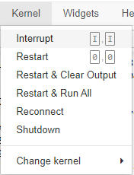
The user needs to download our dataset, preprocessed data source code, and then upload that source code to an online data hosting site such as GitHub. They also need Jupyter Notebook and Anaconda Navigator. From there, they would open the Jupyter Notebook from Github and press ‘Kernel’, then ‘Restart & Clear Output.’
Figure 15 Kernel Window

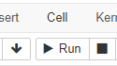
This resets all outputs and allows the user to begin compiling each of the cells of code. Notes are given throughout the source code to explain each step and suggest upgrades to the software. The user should click on each cell and hit “Run”.
Figure 16 Run Window

The user should be patient. Initial compilation of the code can take a while, but once all the cells are compiled, they should get the same results for the misinformation flags and accuracy scores:

User Guide (continued):
Output from In [23]:

Random Forest:
[1 1 1 1 1 1 1 1 1 1 1 1 1 1 1 1 1 1 1 1 1 1 1 1 1 1 1 1 1 1 1 1 1 1 1 1 1
1 1 1 1 1 1 1 1 1 1 1 1 1 1 1 1 1 1 1 1 1 1 1 1 1 1 1 1 1 1 1 1 1 1 1 1 1
1 1 1 1 1 1 1 1 1 1 1 1 1 1 1 1 1 1 1 1 1 1 1 1 1 1 1 1 1 1 1 1 1 1 1 1 1
1 1 1 1 1 1 1 1 1 1 1 1 1 1 1 1 1 1 1 1 1 1 1 1 1 1 1 1 1 1 1 1 1 1 1 1 1
1 1 1 1 1 1 1 1 1 1 1 1 1 1 1 1 1 1 1 1 1 1 1 1 1 1 1 1 1 1 1 1 1 1 1 1 1
1 1 1 1 1 1 1 1 1 1 1 1 1 1 1 1 1 1 1 1 1 1 1 1 1 1 1 1 1 1 1 1 1 1 1 1 1
1 1 1 1 1 1 1 1 1 1 1 1 1 1 1 1 1 1 1 1 1 1 1 1 1 1 1 1 1 1 1 1 1 1 1 1 1
1 1 1 1 1 1 1 1 1 1 1 1 1 1 1 1 1 1 1 1 1 1 1 1 1 1 1 1 1 1 1 1 1 1 1 1 1
1 1 1 1 1 1 1 1 1 1 1 1 1 1 1 1 1 1 1 1 1 1 1 1 1] 0.7445482866043613 0.5 0.7445482866043613 1.0 0.8535714285714285

SVM:
[1 1 1 1 1 1 1 1 1 1 1 1 1 1 1 1 1 1 1 1 1 1 1 1 1 1 1 1 1 1 1 1 1 1 1 1 1
1 1 1 1 1 1 1 1 1 1 1 1 1 1 1 1 1 1 1 1 1 1 1 1 1 1 1 1 1 1 1 1 1 1 1 1 1
1 1 1 1 1 1 1 1 1 1 1 1 1 1 1 1 1 1 1 1 1 1 1 1 1 1 1 1 1 1 1 1 1 1 1 1 1
1 1 1 1 1 1 1 1 1 1 1 1 1 1 1 1 1 1 1 1 1 1 1 1 1 1 1 1 1 1 1 1 1 1 1 1 1
1 1 1 1 1 1 1 1 1 1 0 1 1 1 1 1 1 1 1 1 1 1 1 1 1 1 1 1 1 1 1 1 1 1 1 1 1
1 1 1 1 1 1 1 1 1 1 1 1 1 1 1 1 1 1 1 1 1 1 1 1 1 1 1 1 1 1 1 1 1 1 1 1 1
1 1 1 1 1 1 1 1 1 1 1 1 1 1 1 1 1 1 1 1 1 1 1 1 1 1 1 1 1 1 1 1 1 1 1 1 1
1 1 1 1 1 1 1 1 1 1 1 1 1 1 1 1 1 1 1 1 1 1 1 1 1 1 1 1 1 1 1 1 1 1 1 1 1
1 1 1 1 1 1 1 1 1 1 1 1 1 1 1 1 1 1 1 1 1 1 1 1 1] 0.7414330218068536 0.497907949790795 0.74375 0.99581589958159 0.851520572450805

Neural Networks:
[1 1 1 1 1 1 1 1 1 1 0 1 1 1 0 1 1 1 1 1 1 0 1 1 1 1 1 1 1 1 1 1 1 1 1 0 1
0 1 1 0 1 0 1 1 1 1 1 1 0 1 1 0 1 1 1 1 1 0 1 1 1 1 1 0 1 1 1 1 0 1 1 1 0
0 1 1 1 0 0 1 0 1 1 1 1 1 1 1 1 0 1 1 1 1 1 0 1 1 1 1 1 1 1 1 1 1 1 1 0 1
1 0 1 1 0 1 1 1 1 1 1 1 1 1 0 1 1 1 1 1 1 1 1 0 1 1 1 1 1 0 1 1 1 0 1 1 1
1 1 0 1 0 1 0 1 1 0 0 1 1 1 1 0 1 1 1 1 1 1 1 1 0 1 0 1 1 1 1 1 1 1 1 1 0
1 1 1 1 0 0 1 1 1 1 1 0 1 1 1 1 1 1 1 1 0 1 1 0 1 1 1 1 1 1 1 0 1 0 1 1 1
1 1 1 1 1 1 1 1 0 1 1 1 1 1 1 1 0 1 0 1 1 1 1 1 1 1 1 1 0 1 0 1 1 1 1 1 1
0 1 1 1 0 1 1 1 0 1 1 1 1 1 1 1 1 1 1 1 1 1 1 0 1 1 1 1 1 1 1 1 1 1 1 0 1
1 1 1 1 1 1 0 1 1 1 0 1 1 0 1 1 1 1 1 1 1 0 0 1 1] 0.6853582554517134 0.5363557505867946 0.7613636363636364 0.8410041841004184 0.7992047713717695

Bayes:
[0 1 0 1 0 1 1 1 1 1 1 1 0 1 1 1 1 1 0 1 1 1 1 1 0 1 1 0 0 1 0 0 1 1 1 0 1
1 1 1 1 1 1 1 1 1 1 1 1 0 1 0 1 1 0 1 1 1 1 1 1 1 1 1 1 1 1 1 1 0 1 1 1 0
0 0 1 1 0 0 1 0 0 1 1 1 1 1 0 1 1 1 1 1 1 1 1 1 1 0 1 1 0 1 0 1 1 1 1 0 1
0 1 1 1 1 0 0 1 1 0 1 1 1 1 1 1 1 1 1 1 1 1 1 1 1 0 1 1 1 1 0 1 0 0 1 1 0
1 1 0 1 1 1 1 1 1 0 0 0 1 1 1 1 1 1 1 0 1 0 1 1 0 1 1 1 1 1 0 1 1 0 1 1 1
1 1 0 1 0 1 0 1 1 1 1 0 0 1 1 1 1 1 0 0 0 1 1 0 1 1 1 1 1 1 1 0 1 0 1 1 1
1 1 1 0 1 1 1 1 1 1 0 1 0 1 1 1 0 1 1 1 1 1 1 1 1 1 1 1 0 1 0 0 1 1 0 1 1
1 1 1 1 0 1 1 1 0 1 1 1 1 1 1 1 1 0 0 0 0 1 1 0 1 1 1 1 1 1 1 0 1 1 1 1 0
1 1 1 0 1 1 0 0 1 1 0 1 1 1 1 0 1 1 0 1 1 1 0 1 1] 0.6261682242990654 0.5046178181447086 0.7468879668049793 0.7531380753138075 0.75

User Guide (continued):

Decision Tree:
[1 1 1 1 1 1 1 1 1 0 0 1 1 1 1 0 1 1 1 1 0 1 1 1 0 1 1 1 1 1 0 1 1 1 1 1 1
0 1 1 1 1 1 0 1 1 1 1 1 1 0 0 1 1 1 1 0 1 0 1 1 1 1 1 1 1 1 0 1 1 0 0 1 1
1 1 1 1 1 0 1 1 1 0 1 0 1 1 1 1 0 1 1 0 1 1 1 1 1 1 1 1 0 1 1 0 0 1 1 1 1
1 1 1 1 0 1 1 1 1 1 1 1 1 1 1 0 1 1 1 1 1 1 1 1 1 0 1 1 1 0 1 1 1 0 1 1 0
1 1 0 1 1 1 1 1 1 1 1 1 1 1 1 1 1 1 1 1 1 1 0 1 1 0 1 1 1 1 0 1 1 1 1 1 1
1 1 0 1 1 1 0 1 0 1 1 0 1 1 1 1 1 1 1 1 0 1 1 1 1 1 1 0 1 1 1 1 0 1 1 1 1
1 1 1 1 0 1 1 1 1 1 1 1 1 1 1 1 1 1 1 1 1 1 1 1 1 1 0 1 1 1 0 1 1 1 0 1 0
1 1 0 1 1 0 1 1 1 1 0 1 1 1 0 1 1 1 1 1 1 1 1 0 1 0 0 1 1 1 1 1 0 1 1 1 1
1 0 1 1 1 0 0 1 1 1 0 1 1 1 1 0 0 1 1 1 1 1 1 1 0] 0.6386292834890965 0.48094193285029085 0.735632183908046 0.803347280334728 0.7680000000000001

Adaboost:
[1 1 1 1 1 1 1 1 1 1 1 1 1 1 0 1 1 1 1 0 1 1 1 1 0 1 1 1 1 1 1 0 1 1 1 1 1
1 1 1 1 1 1 1 1 0 1 1 1 1 1 1 1 1 1 1 1 1 1 1 1 1 0 1 1 1 1 1 1 1 1 1 1 1
1 1 1 1 1 0 1 0 1 1 1 0 0 1 1 1 0 1 1 1 1 1 1 1 1 1 0 1 1 1 1 0 1 1 1 1 1
1 0 1 1 1 0 1 1 1 1 1 1 1 0 0 0 1 0 1 1 1 1 1 0 1 1 1 1 1 0 1 1 0 1 1 1 1
1 1 0 1 0 1 1 1 1 0 0 1 1 1 1 1 1 0 1 1 1 1 1 1 0 1 1 1 1 1 1 1 1 1 1 1 0
1 1 1 1 1 1 0 1 1 1 1 1 1 1 1 1 0 1 1 1 0 1 1 0 1 1 1 1 1 0 1 1 1 0 0 1 1
1 1 1 1 1 1 1 1 1 1 1 1 1 1 1 1 1 1 0 1 1 1 1 1 1 1 1 1 1 0 0 1 1 1 1 1 1
1 1 1 1 0 0 1 1 0 0 0 1 1 1 1 1 0 1 1 1 1 1 1 0 1 0 1 1 0 1 1 1 1 1 1 1 1
0 1 1 1 1 1 1 1 1 1 0 1 1 0 1 1 0 1 1 1 1 1 0 1 1] 0.6853582554517134 0.5283447290539851 0.7574626865671642 0.8493723849372385 0.8007889546351086

From here, upgrades can be made as suggested in Section 7.2.

