PRAIRIE VIEW A&M UNIVERSITY
ROY G. PERRY COLLEGE OF ENGINEERING



HOME SECURITY ANTI-BURGLAR SYSTEM
SENIOR DESIGN AND PROFESSIONALISM II
ELEG 4248 – SPRING 2022

FINAL WRITTEN REPORT

Date Due: 5/1/2022
Team 7: Submitted to:
Ben Ombura Professor Turner, Vewiser
Elizabeth Reyna
Oluwadamilola Osuntuyi
Teminioluwa Folorunso Sponsor:
Nolan Coston Dr. Akujuobi, Cajetan

EXECUTIVE SUMMARY
Problem Statement
In the United States, an average of 4.1 property crimes occurs per second. Customers tend to pay high costs when investing into an alarm system for their protection. Often, older alarm components cannot be reused. In addition, many home security systems often fail to monitor and communicate during extended power outages.

Objective
To design a security alarm system that continues to function during power outages with the use of a versatile power supply and a system that easily integrates with a variety of monitoring and Internet of Things (IoT) devices. Our alarm system will be a low-cost design that provides security for a home and office. Home Assistant and Zigbee Alliance will be utilized to seamlessly unify brands customers love.

Project Deliverables Target Audience
- Remote Monitoring Homeowners and Businesses
- Multi-detection sensors
- Alternative energy source

Budget and Spending
- Project Budget: $600
- Amount Spent: $560

EXECUTIVE SUMMARY (continued)
Customer Requirements and Engineering Solutions
- Customers should be able to interact with security system remotely.
- Mobile application should be user-friendly.
- Camera should detect moving objects within range.
- Security alarm should notify client when alarm system is triggered due to sensor detection of potential intruder.

Major Constraints
- Storing the power with the solar panel.
- Lack of experience in code development for mobile applications.
- Electromagnetic jammers could disrupt the system.
Benefits
- Safety: The overall goal of this project is to create a product that increases the safety of the user and the customer privacy of the user using Home Assistant. This will keep more homes and businesses safer. Users will feel more comfortable away from their properties due to our unique design utilizing Home Assistant open-source software. Our design uses multiple detection sensors such as a camera, magnetic reed switch (door sensor), and a temperature and humidity sensor.
- Economic: Homeowners have a high probability of receiving discounts from Homeowners due to the fact that they have a security alarm system in their home or in this case our alarm system in their home. Security alarm systems tend to increase the value of the property. Therefore, owners can make more profit when selling or renting out their property to others. Our alarm system uses less expensive components than most systems while still being as affective or more affective at maintain the security of a property.

EXECUTIVE SUMMARY (continued)
- Technical: Our project utilizes LoRa module and ESP32 Cam microcontroller to provide security through long range communication and Wi-Fi/Bluetooth capabilities. For this project we mainly focused on utilizing the Wi-Fi and Zigbee capabilities of our design. Our alarm system will have a remote user interface that enables users to monitor and control the system from anywhere around the world.

Recommendation
- Compact and remotely accessible design
- Use solar power, as a renewable resource, for self-sustaining energy
- Device must be waterproof and weather-resistant
- Long lasting battery power

Conclusion
The design of our security system will impact the standard of safety in societies by securing people and their possessions even during extended power outages.

TABLE OF CONTENTS

EXECUTIVE SUMMARY 2-4
TABLE OF CONTENTS 5
LIST OF FIGURES 6
LIST OF TABLES 6
LIST OF TEAM MEMBERS AND ROLES 6

- PROJECT SCOPE 7
Project Statement, Business Objective and Target Audience………………....…..................….……..8
Client identification and recognition of need…………………………………………………..……9-10
Project goals and objectives…………………………………………………………………………11-12
Contemporary issues relevant to project………………………………………………………………13
Potential impact of project on society………………………………………………………………14-18
Initial Project constraints………………………………………………………………………………19

- PROJECT PLANNING AND TASK DEFINITION 20
2.1 Task Identification ……………………………………………….........................………………..21
2.2 Gantt Chart ………………………………………………………....................…………………. 22

- LITERATURE REVIEW 23
3.1 List of all sources of information ………………………………………............................…………. 24
3.2 Statement of Learning from each source …………………………………...................…………. 25-26

- PRELIMANARY DESIGN 27
4.1 Concept Generation, Evaluation and Selection..…………………………………......................….28-30
4.3 Design Constraints Used in the Preliminary Design..............................................................................31
4.3 Applicable Codes and Standards Used in the Preliminary Design……………………………………32
4.4 Preliminary Analysis ………………………………...............................……………......................33-34
4.5 Preliminary Design……………………………………………............................................................35

- DETAILED SYSTEM DESIGN 36
5.1 Project Parts Summary ……………………………………………………....................……………. 37
5.3 Overview of Code Developed to Support Engineering Analysis…………..…………………....... 38-40
5.4 Application of Engineering Codes and Standards used in Final Design…………………………........41
5.5 Economic Analysis …………………….................................………………………...........................42
5.6 Final Design ……………………………………………..................................................................43-47

- RESULTS AND DISCUSSION 48
6.1 Summary of Goals and Objectives……………………………………………............................……. 49
6.2 Summary of Constraints and Codes Met by Design ………………………........................…………. 54
6.3 Discussion of Results and Other Use Cases ……………………………………………...................... 55

- CONCLUSIONS AND RECOMMNDATIONS 56-57

LIST OF REFRENCES 58-61
APPENDIX 62
LIST OF FIGURES
Figure 1 – Statista Digital Market Statistics…………………………………………………14
Figure 2 – Home Burglary Statistics…………………………………………………………16
Figure 3 – Security System Application and Home…………………………………………17
Figure 4 – Electronics Waste Diagram………………………………………………………18
Figure 5 – Project Schedule…………………………………………………………………...21
Figure 6 – Gantt Chart………………………………………………………………………...22
Figure 7 – Project Comparison……………………………………………………………….29
Figure 8 – Engineering Design Methodology………………………………………………...30

LIST OF TABLES

Table 1 - .................................................................................................................##
Table 2 - Comparison of Security Alarm Systems…………………………………………...##

LIST OF TEAM MEMBERS AND ROLES

Elizabeth Reyna…………………….……………………………………...Team and Test Lead
Oluwadamilola Osuntuyi….……………………………….……. Scribe and Test Lead Assistant
Nolan Coston………………………...Software Programming and Document Managing Assistant
Teminioluwa Folorunso………...…...Software Programming Assistant and Document Manager
Ben Ombura………….……….…………………Software Programmer and Test Lead Assistant

PROJECT SCOPE

Project Statement, Business Objective, and Target Audience
Problem Statement: Many customers often pay a high cost when investing in alarm systems as a form of protection. More than often, older alarm components cannot be reused. In addition, many alarm systems cannot function during power outages.
Businesses Objective: To design a low-cost alarm system that provides the comfort of a secure home or office. Home Assistant and The Zigbee Alliance will allow our alarm system to seamlessly unify brands we all love. The alarm system will also monitor and communicate during extended power outages. We plan to advertise all the perks and benefits of our alarm system to increase interest from our audience during our presentation of our completed product such as the fact that our system will use solar power (renewable energy source) and many other perks.
Target Audience: Homeowners and businesses. Because both are the most targeted by burglars.

Client Identification and Recognition of Need
The security alarm system must be simple enough for homeowners and businesses to set up. Our design will be easy to manage for our customer due to the platform we have decided to use, Home Assistant, as an application for the user. Home Assistant is user friendly and will allow the user to easily customize their system, monitor, and control their system. The user can also develop their own code to utilize a sensor or any component within the system to their own liking. The microcontroller (ESP32 CAM) will be used in our design and integrated onto Home Assistant. This microcontroller camera must be capable of sending and receiving messages and commands. Our use of a LoRa module in this design will enable long range communication within and outside of the property. Homeowners and businesses need multiple detection sensor for overall safety. Therefore, this design will utilize a camera, magnetic reed switch (door sensor), and a temperature and humidity sensor. Home Assistant allows the user to many replace similar components being utilized int the system with newer or older components. This highlights Home Assistants high level of compatibility regarding seamless integration of various brands or types of components. Our design will utilize a breadboard containing and resistors, wires, a buzzer, and an LED. The LED will flash when alarm system is triggered which will inform the user that the system has been triggered. Additionally, the buzzer will sound off at a high, also adjustable, volume so the user will be able to have audible confirmation of the alarm system being triggered.

Client Identification and Recognition of Need (continued)

Table 1: Marketing and Engineering Requirements to highlight client identification and recognition of needs:
MARKETING  REQUIREMENTS | ENGINEERING  REQUIREMENTS | JUSTIFICATIONS
Integrated communication solution | - ESP32 microcontroller  - REYAX Lora module  - Texas Instrument Sonoff Zigbee analyzer | - Low energy system  - Sends data and live feed for up to 12 kilometers.  - Embedded Wi-Fi, Bluetooth, and Zigbee capabilities.
Remote monitoring | - Self-monitoring through application  - Optional 24/7 emergency and monitoring services | - 24/7 monitoring of property will reassure a customer of investment.
Multi detection sensors | - Reed switch sensor (door / window sensor)  - Camera  - Temperature and Humidity sensor | - Multiple sensors collect readings to alert the customer of a hazard or a security breach.
Off-grid power source | - Solar power  - Rechargeable battery source  (12V 10Ah Lithium Iron Phosphate Battery) | - Additional marketing tool for sales.  - Provides protection during extended power outages.  - Customer safety increased.

Project Goals and Objectives
- To create a low-cost security alarm system
How?
- Research simple yet effective alarm system designs
- Identify needed components and research costs to purchase components and the reliability or reputation of each brand. Additionally, weigh pros and cons.
- Develop design and test design for energy consumption and consistency in proper operation.

- User friendly system
How?
- Utilize a home automation platform that provides easy customization and integration capabilities. This home automation platform must be compatible with various brands and types of sensors a user may want to choose from to add to their system. Dashboard on platform must be easy to control and data should be readily available on the dashboard of the home automation application.

- Broad impact in multiple areas:
How?
  - We have designed our system to touch multiple areas of impact such as safety/welfare, economic, technical, and environmental.

Project Goals and Objectives (continued)
- Renewable energy use, power supply that enables monitoring and communication during power outage.
How?
  - Utilize solar power by incorporating a solar panel within the design of our power supply. Many people are looking for products that utilize clean energy. In addition, solar is the most abundant and renewable energy source. The design of our supply will be useful in the case of a power outage, enabling the alarm system to still monitor and communicate in that case. The power supply will also utilize a 12V 10Ah Lithium Iron Phosphate Battery.
  - 12V 10Ah Lithium Iron Phosphate Battery Features:
    - 3000+ cycles and 10+ years life span
    - High energy density and lighter weight
    - Built-in battery management system (BMS)
- Notification of threat and alarm triggered
How?
  - Program system to send a notification to the user’s phone and lcd or tablet screen when sensors detect a threat and when alarm system is triggered. Programming for sensors will be done on ESPHome within Home Assistant. Programming for camera will be done on Arduino to access live camera feed, feed will be imported onto Home Assistant.

Contemporary Issues Relevant to Project
Customers tend to overlook some of the benefits of an alarm system besides safety. When looking to purchase an alarm system, customers should look for systems that are customizable and reduce energy bills. Features such as automated temperature control and programmable lighting features can significantly decrease energy bills. According to the U.S. Environmental Protection Agency, a programmable thermostat can save homeowners an average of $180 every year in energy costs. Automated and “smart” features let you create customized schedules for lighting and thermostat activities to meet your routine and save energy. Additionally, you can manage them remotely from your smartphone.
Note: Since our system utilizes “smart” tech this will allow the user to program any sensor of their choosing to their own benefit, one of those benefits being reduced energy bills.

Potential Impact of Project on Society
Our project impacts four major areas: economic, safety and welfare, technological, and environmental.
Economic Impact
As recorded by Statista Database company, as shown in Figure 1 below, the installation of home security systems has gained a revenue of 5 billion dollars as of 2021 and is expected to increase to over 8 billion dollars by the year 2025. Therefore, signifying the demand for alarm systems around the world. Below are further benefits of our product to the economy:
- Lower product cost: The security alarm design utilizes less expensive parts than most security alarm systems; therefore, makes our design a more affordable product to purchase on the market.
- Lowers insurance: Having our design framework in your home can make home providers discount your mortgage holder's protection up to 20%.
- Increases property value: Installation of our security alarm design in homes and business will increase the value of many properties.

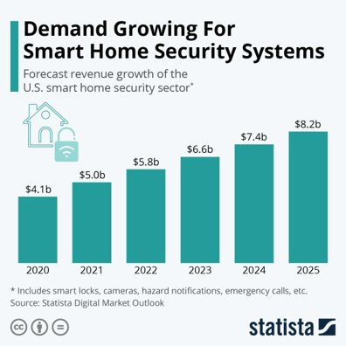
Figure 1 - Statista Digital Market Statistics
Safety and Welfare Impact
Protects valuables: This is an obvious advantage a many people consider. We probably all know somebody who has lost gadgets, adornments, or other valuable possessions because of a home or business robbery. The misfortune is intensified when the possession is an indispensable family treasure. A security system can assist in protecting these possessions that could be potentially stolen in a robbery. No one enjoys losing a possession especially the ones we hold dear to us.
Notifies you of fire or gas issue: With this alarm design the user can receive notifications of the status of the temperature and smoke or gas levels within the property. The alarm could go off when levels reach the point of a potential threat to safety.
Helps keep tabs on kids: Many homeowners have children. As the saying goes, “children are our future”, this alarm system will be a device that parents can rely on to protect the future of their children by keeping them safe. If you're away from home, and you want to monitor your home or kids back home, you can utilize our portable app to watch what's going on in your home by means of video via a surveillance camera(s). If you have an electronic entryway lock, you can open them to give the children access after school, so they don't need to stress over losing their own key to the house and unfortunately waiting for an in-person assistance to open a door to the house.
Improves peace of mind: The conviction that all is good and solace you gain with an alert framework is maybe the best advantage of all. Close to being protected, the certainty of having a sense of security will assist you with being a more useful, sound, and centered individual.
Adding a security framework to your home provides you with an additional a layer of protection against any expected interlopers. Regardless of whether you lease or own, you can partake in the advantages that accompany having a security framework.
Safety and Welfare Impact (continued)
Deters crime: A study by Rutgers University tracked down that the large quantity of home security alarm diminishes the quantity of burglaries. Having a security alarm ensures customers’ safety, frightens away burglars, and increases neighborhood peace.

Figure 2 below shows statistics from Engineering Protection System (EPS) on home burglary.

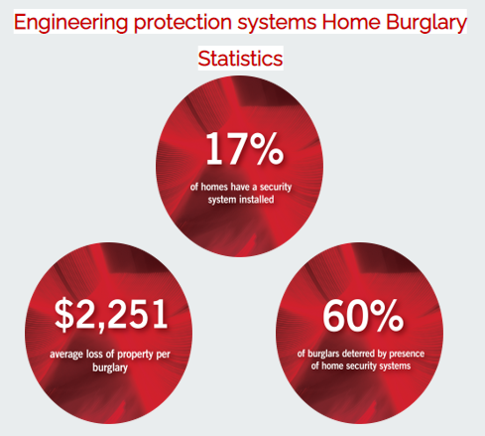
Figure 2 - Home Burglary Statistics

Technological Impact
Remote access: When the customer is away from their home, they can utilize the mobile application to survey their home by means of video footage from other surveillance camera(s) and data from sensors which will be provided on the Home Assistant application.
Tight security: With the implementation of YAML language and Home Assistant, an end-to-end encryption will be used to protect the system from possible hackers and enhance the level of security.

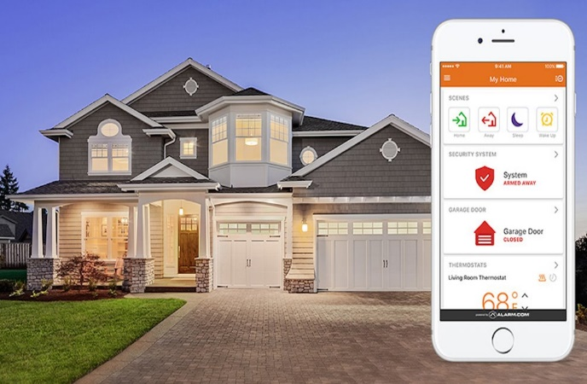
Figure 3 - Security System App and Home

Environmental Impact
When electronics are improperly disposed, toxic chemicals are released to the environment; therefore, impacting the earth’s soil, the air, water, and the public’s health. According to Global E-Waste Monitor, about $54.2 million worth of raw materials was lost in 2021, while only $8.5 million worth of raw materials were recovered.

Helps electronic waste: Our design will allow users to use older and newer components that they may have and integrate them into their alarm system. This is possible due to the fact that our alarm system is a smart alarm system that allows the user to program any sensor of their choosing on Home Assistant to tailor the system to their needs in regard to a particular sensor within the system.

Figure 4 below shows more about raw materials recovered from E-waste.

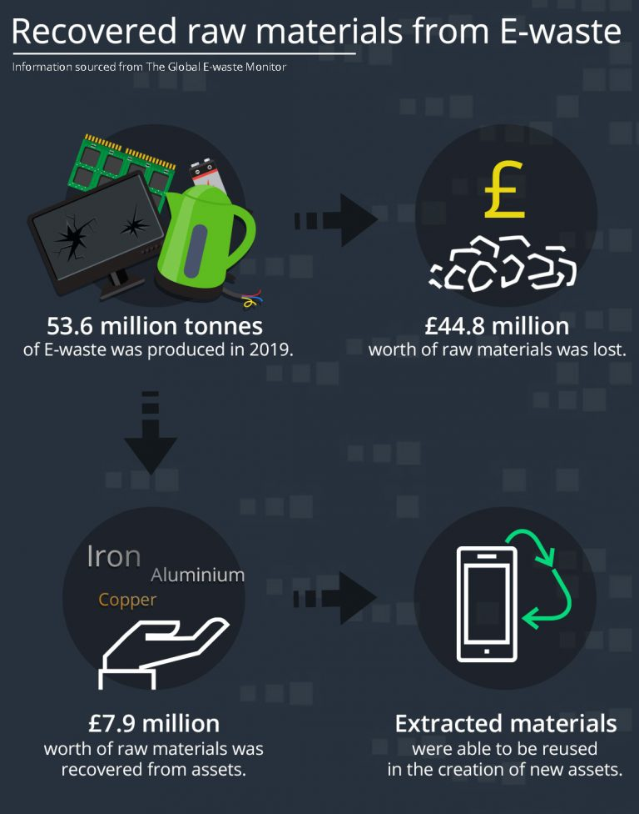
Figure 4 – Electronic waste diagram

Initial Project Constraints
We needed a solar panel as a source of supplying alternative power to security system, but the solar panel was one of the most expensive parts. Our budget was only $600 for this project. Therefore, we had to find more affordable prices for the other parts. Our minimal cybersecurity experience was hurdle we must overcome. In order to do this, we researched and educated ourselves on cybersecurity, specifically in relation to a security alarm system. Without cybersecurity, our security system is vulnerable to hackers, which endangers the client or their property. Another vulnerability is that our alarm system may be vulnerable to electromagnetic jammers, so we made sure to research on that topic.

PROJECT PLANNING AND TASK DEFINITION

Task Identification
Our team started determining phases to our project plan. We completed our hardware research and made changes to the parts list. We worked on the hardware and software development of our security alarm system. Figure 5 shows our project schedule.

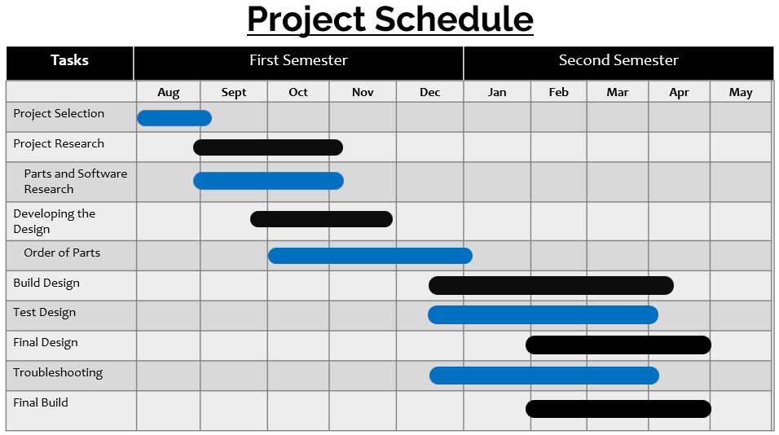
Figure 5 - Project Schedule

Gantt Chart

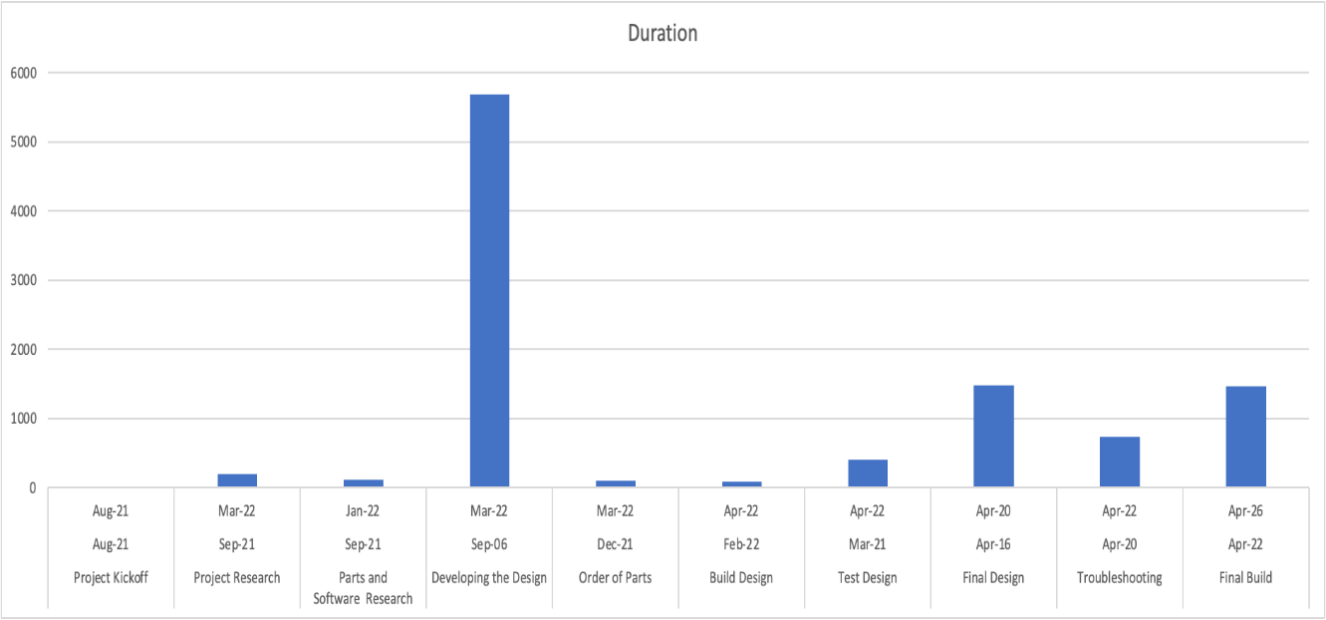
Figure 6 - Gantt Chart

LITERATURE REVIEW

List of all sources of information
The research of our security alarm system was compared with other home security systems. We compared our design to ADT security system and Simpli Safe Alarm System. The ADT wired security system is one of highly rated home securities that operates the largest national network of professional monitoring centers with money-back guarantee. Unfortunately, ADT only pro-installs full system; therefore, they do not install standalone devices. The pricing, depending on the package, can reach up to about $1,450 upfront or up to $82 monthly for 60 months. The Award Winning Wireless Simpli Safe Alarm system is an easy-to-setup system that is ran by professionals with no contracts. Simpli charges up to a monthly cost of $25 or minimum upfront cost of $230.

Statement of Learning from each source
Before we started our research and literature review for our project. We looked over the requirements and objectives of our security alarm system project by reviewing the project description we were provided with. After understanding the requirements and objectives of our selected project, we decided to focus on researching and gathering information on several topics: benefits of security alarm systems, existing alarm systems, alarm system project ideas, project impact areas, potential alarm system components, functions of alarm system components, compatibility, and app development.

As we did our research, we made sure to gather our information from credible sites and databases. As we researched about the benefits, we wanted to focus on gathering information on benefits that most people may not know about alarm systems such as the fact that most insurance carriers offer discounts on insurance premiums if a home has an installed security system. When gathering research about existing alarm systems we focused on understanding more about how an alarm system works and the communication aspect of the system. To get an idea of how we wanted to design our system, we gathered ideas from sites online on alarm system projects that have been done. Furthermore, we did research on how we can make our alarm system unique in comparison to the alarm system projects that we came across through our research.

Regarding project impacts, we concluded that our project would have an impact in five areas and gathered research on how alarm systems make an impact in those areas. The five areas of impact we decided to do research on are: economic impact, technological impact, social impact, global impact, and safety/welfare impact. The most difficult part of research and literature review was deciding what specific components we would like to use in our design. For our design we needed to have a transmitting side and receiving side consisting of two microcontrollers, two LoRa modules, sensors, reed switch, power supply, and lcd screen/buzzer (alert notification devices)

Statement of Learning from each source (continued)
In order to settle on specific components to include in our design, we gathered research/literature on various types of microcontrollers, LoRa modules, sensors, reed switches, power sources, and LCD screens/buzzers. Furthermore, we did research to understand the functions of each component. After, we then chose our components based on whether the component would help our team achieve our desired design and purpose of our alarm system based on the features provided by the component. The last area we decided to do research was app development, specifically for security alarm systems. We were able to find sites such as GitHub.com, that provided information on how to develop code for a security alarm system.

PRELIMINARY DESIGN

Concept Generation, Evaluation and Selection

Considered designs
  - Smart security design
    - Utilizes smart features and programmable capabilities for components within the system.
    - Remote monitoring via cloud and or local control.
    - Adjustable settings.
    - Saving in energy bills due to automated control and programable features of system.
  - Wired ADT security design
    - Wired system and reliable. The system does not come with user programmable capabilities.
    - System is monitored by ADT; the system comes with a minimum 36-month contract. Equipment is highly expensive on top of expense for the contract. ADT is a company that provides alarm monitoring services throughout the United States.
  - Wireless Simpli Safe security design
    - This system function wirelessly like the smart security alarm system. The design utilizes parts only provided from Simpli Safe. These parts are relatively expensive in comparison to a smart alarm system that utilizes Home Assistant like our design. Our design allows you to use multiple brands of components that can be programmed and integrated to their smart security system. This allows the use to have more control over the cost of their system. Simpli Safe does not provide this ability.
    - This system includes monthly continuous fees for monitoring services from Simpli Safe.

Concept Generation, Evaluation and Selection (continued)

Below in Figure 6 is a product comparison table of the designs we considered in comparison to the design we chose, which was the smart security alarm system. The designs compared were the smart security system, wired ADT security system, and the wireless Simpli Safe alarm system. In order to conclude which design to choose, we weighed the pros and cons between all three designs in the table below (Figure 6). Figure 6 also highlights the criteria we used to select our design as you’ll see below. We concluded that the pros of the smart security alarm system superseded any of the pros of the others and the smart security system had less cons. In addition, the smart security cost less than the others in regard to upfront cost, contracts, and maintenance.

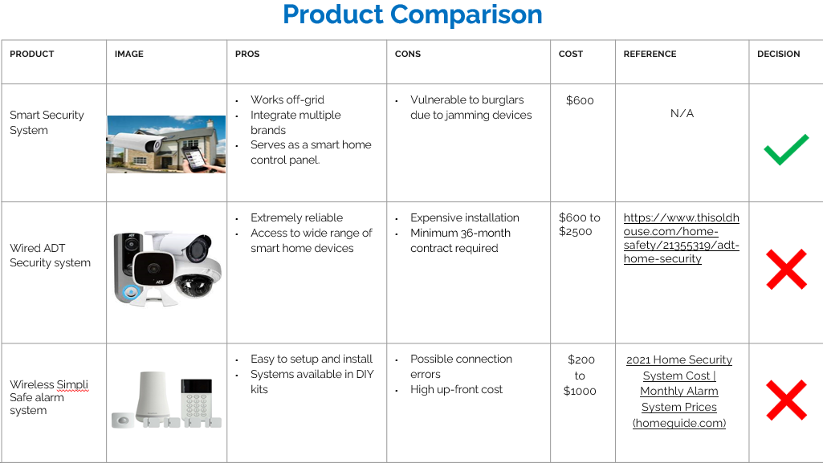
Figure 7 - Project Comparison

Concept Generation and Evaluation and Selection (continued)

Our team first came up with the methodology to complete our design. Our team collaborated to develop our design methodology in steps shown in Figure 7 below.

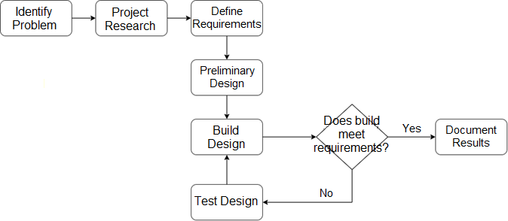
Figure 8 - Engineering Design Methodology

Using our design methodology, our team started with identifying the problem. Next, we researched sources to gain knowledge and support ideas behind our project. With a sufficient information, our team defined and understood the requirements of our project. After that, our team created concepts to form a preliminary design. Once the preliminary design agreed, we began building the design. There were a few times where our design did not meet the requirements and we needed to test design and fix any issues until the build requirements were met. After a few iterations and a successful build, we documented our results.

Design Constraints Used in the Preliminary Design

Design Constraints

Our security alarm design had constraints and limitations that were difficult to overcome. As a team, we needed to shift focus to ensuring the major parts of an average security alarm worked. One of our constraints was that our team wanted to use cybersecurity to use protocols that protect against outside harm, such as hackers, DoS attacks, viruses, etc., but we had minimal knowledge in cybersecurity. To resolve our minimal knowledge in this area, we gathered information from YouTube and sought professional help for our design. We also used Zigbee Alliance to smoothly connect many devices which makes it harder for predators to interrupt the system. Another constraint was our $600 price budget and we needed to find affordable parts for our design. A few parts were expensive, so we compared expensive parts with cheaper parts and made informed decisions to deliver a highly reliable design while staying under budget. Another constraint of our design was its ability to counter electromagnetic pulses (EMP). While EMPs are not commonly used and usually affect smaller devices, some metal wiring, a capacitor, and a large power source can be enough to disable or even damage security alarm design. In case of emergency, most of the crucial components can be stored in a metal box that is EMP resistant.

Applicable Codes and Standards Used in the Preliminary Design

Applicable Codes and Standards
While working on certain project designs, it is important to take note and stay in compliance with the safety rules, codes, and standards. It is very important to acknowledge, recognize, and abide by them. As a group we concluded that our primary focus should be on the IEEE 7.8 – Code of Ethics, highlighted in red. The list of applicable codes and standards used in the preliminary design are as followed:
- IEEE 7.1 - United States Engineering Registration: The IEEE recognizes that licensure and registration contributes to the professions' efforts to protect the health, safety, and welfare of the public by ensuring that practitioners meet minimum recognized levels of education, experience, and competence.
- IEEE 7.6 – Protection of the Public: The IEEE recognizes the obligation of the profession to protect the health, welfare and safety of the public.
- IEEE 7.8 – Code of Ethics:
  - 1) To hold paramount the safety, health, and welfare of the public, to strive to comply with ethical design and sustainable development practices.
  - 5) To seek, accept, and offer honest criticism of technical work.

- IEEE Std 1547-2020 - IEEE Conformance Test Procedures for Equipment Interconnecting Energy Resources with Electric Power Systems and Associated Interfaces: This standard is recognized that a distributed energy resource can be a single device providing all required functions or an assembly of components, each having limited functions and capabilities.
- IEEE/ASHRAE Guide for the Ventilation and Thermal Management of Batteries for Stationary Applications: Ventilation of stationary lithium-ion battery installations is critical to improving battery life.
- NESC - National Electrical Safety Code: Electrical safety precautions are specific control measures implemented to remove electrical hazards and mitigate the risks of electrical accidents and injuries.

Preliminary Analysis

When developing our initial code on the Arduino IDE platform for the camera aspect of our alarm system, we ran into multiple errors such as a “timed out waiting for packet header” error during our preliminary design phase. In order to fix this, we researched this error on google and tried various suggestions from our internet “friends.” We found out that for our code to upload successfully onto our ESP32 Camera microcontroller we had to change our upload speed on Arduino from 921,600 bits per second to 115,200 bits per second. In addition, we had to change our flash frequency from 40 MHz to 80 MHz. After doing this, our code uploaded successfully on to the ESP32 Camera microcontroller. Our chosen ESP32 cam microcontroller was perfect for our project due to features we needed like its 540 KB SRAM, 448 KB of ROM, and 16 KB of RTC SRAM. This microcontroller served well for data storage purposes of our project. The ESP32 Cam microcontroller satisfied what we were looking for in regard to high speed Wi-Fi connectivity. The device supports 802.11 b/gn Wi-Fi connectivity with speeds up to 150 Mbps!
As far as battery life, we tested our design to establish how long the battery could power the system without being plugged to a charger. Our battery was able to work continuously for 4 days without charge. Therefore, we established that every 4 days the battery should be hooked up to a charger. The battery was able to be fully recharged in less than a few hours of charging.

For our temperature humidity and magnetic reed switch (door and window sensor), we decided to use the Aqara brand. The Aqara temperature and humidity sensor has a humidity detection accuracy of ±3% and temperature detection accuracy of ±0.3℃. The Aqara door and window sensor detects the status of doors or windows via the distance of the magnets that are inside the sensors between the sensor and the magnet. The sensor is also energy efficient, and one battery can last over 2 years under normal usage.

Preliminary Analysis (continued)

Specifications of the Aqara Temperature and Humidity Sensor
Wireless Protocol:
Zigbee
Dimensions:
36 × 36 × 9 mm (1.42 × 1.42 × 0.35 in.)
Temperature Range and Precision:
-20℃– +50°C，±0.3℃ （-4℉– +122℉，±0.5°F）
Humidity Range and Precision:
0 – 100% RH (non-condensing), ±3%
Atmospheric Pressure Range and Precision:
30 kPa – 110 kPa, ±0.12 kPa

Specifications of the Aqara door and window sensor

Wireless Protocol:
Zigbee
Dimensions:
41 × 22 × 11 mm (1.61 × 0.87 × 0.43 in.)
Maximum Detection Distance:
22 mm
Operating Temperature:
-10℃ – +45°C (14℉– +113℉)
Operating Humidity:
0 - 95%RH, non-condensing

Preliminary Design
After research, concept evaluation, and selection of design, we determined how we wanted to construct our initial design. Below in Figure 8 was our initial design or preliminary design that we developed.

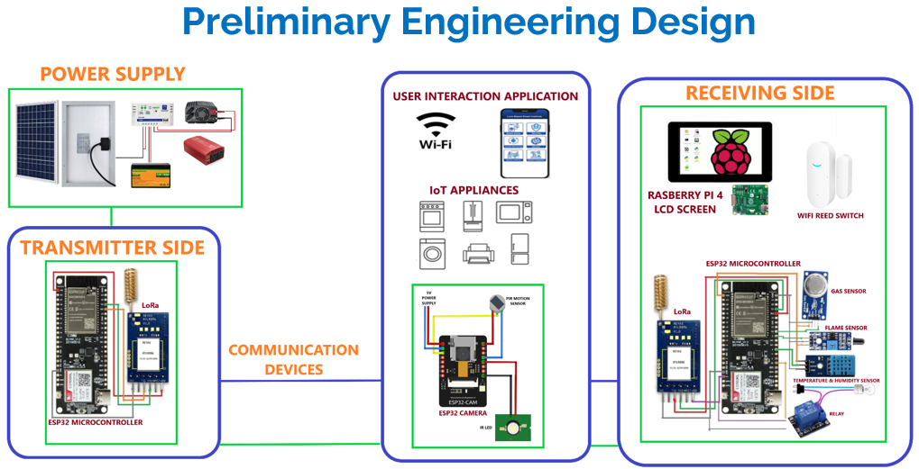
Figure 8 - Preliminary Design

This design consisted of several aspects such as a power supply, transmitting side, receiving side, and Wi-Fi / Bluetooth communication with sensor components. Transmitting side consisted of an ESP32 microcontroller and LoRa (Long Range) module for long range communication with the system. The receiving side consisted of and at home or business LCD screen, Wi-Fi reed switch, gas sensor, temperature and humidity sensor, flame sensor, and relay. In addition, a LoRa module, Raspberry Pi 4, and a ESP32 Camera were included on the receiving side. We wanted our system to be able to communicate with any IoT appliances on the users property such as a refrigerator, washing machine, or a microwave as you can see in the middle portion of Figure 8 above. As you continue in this report you will see that our group made changes within this design to establish our final design for our security alarm system.

DETAILED SYSTEM DESIGN

Project Parts Summary

In Figure 9 below is our project parts summary for our security alarm system project.

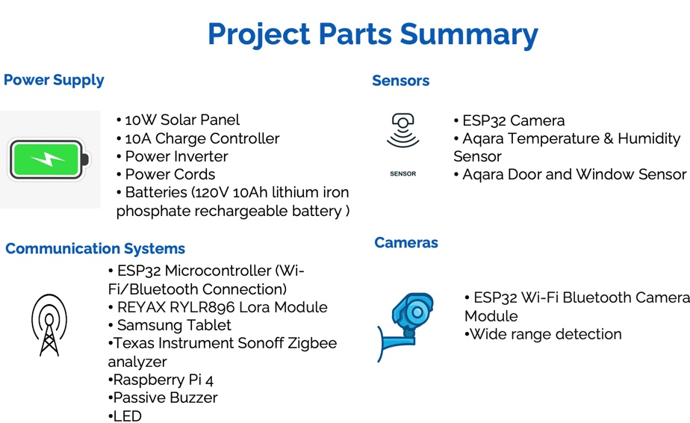
Figure 9 – Project Parts Summary

As shown in Figure 9, the security alarm system uses an ESP32 camera, REYAX LoRa module, and a Sonoff Zigbee protocol analyzer for communications between the user and the system. The ESP32 camera has a Wi-Fi and Bluetooth integrated microcontroller, the LoRa module helps send and receive data over long distances, and the protocol analyzer uses Zigbee to connect end systems to other end systems. The camera’s live feed can be seen on the Samsung tablet display or on the user’s smart phone. Our design utilizes renewable energy via a solar panel.

Overview of Code Developed to Support Engineering Analysis

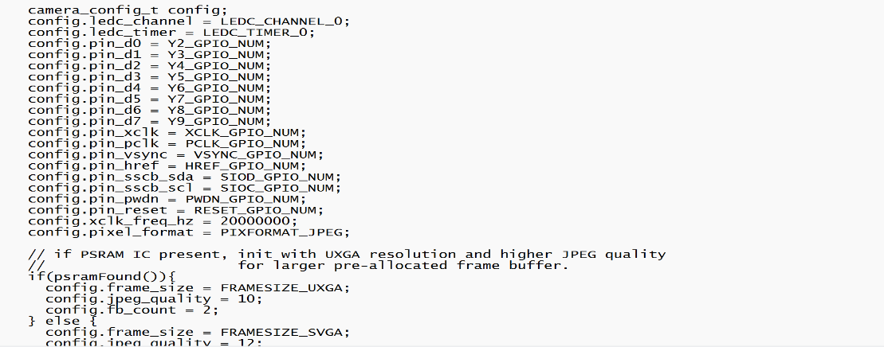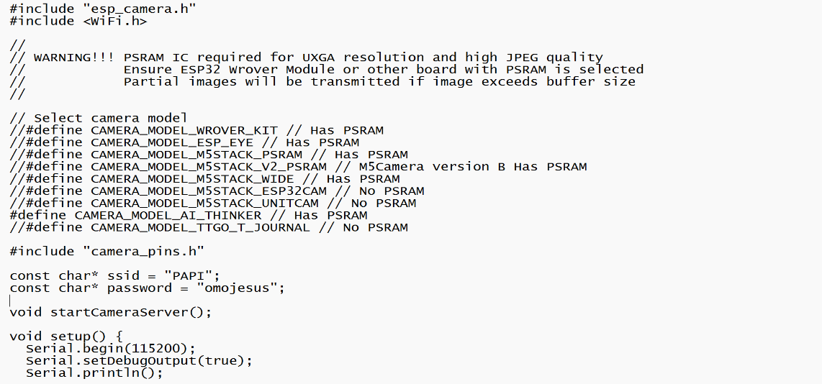
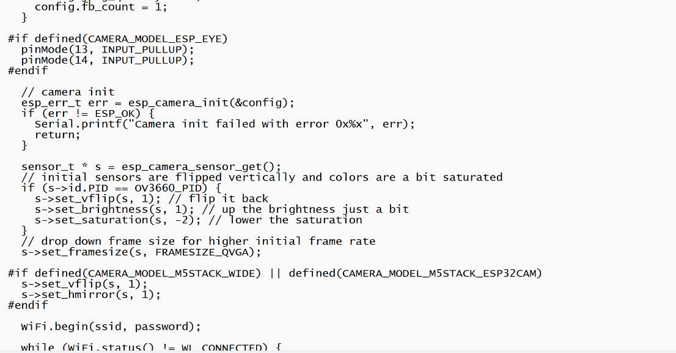

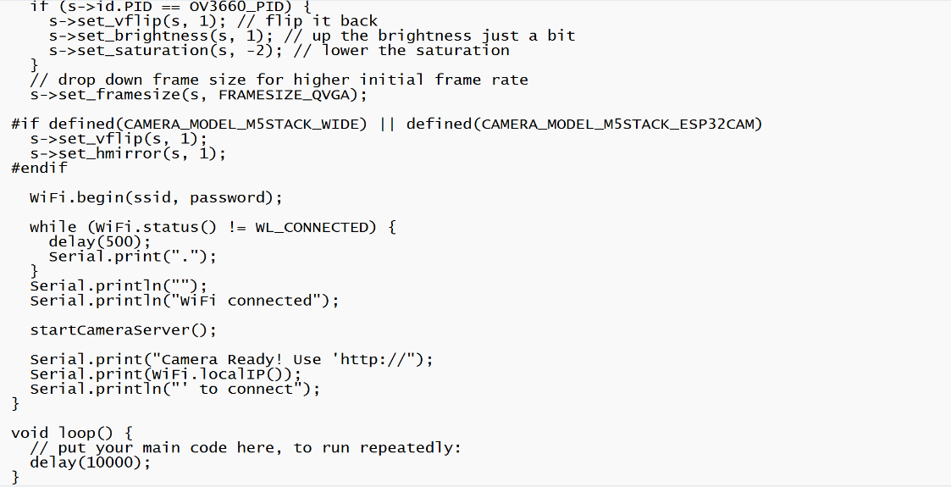
Figure 10 – Camera Codes

#Include allows us to access the needed built in Wi-Fi library on Arduino for our ESP32 device. In addition, it exposes the functions to initialize the ESP32 camera and get pictures from it. The #define statement allow us to define the specific board we are using for our alarm system. As you can see the ssid and password section allowed us to connect to a Wi-Fi network name and to have access to that network name via a password. This is done by defining variables to hold both Wi-Fi credentials. Serial.begin allows us to open up a serial connection to output results from our developed code. This section allows us to establish all our configuration pins and additional features of the camera such frame size and jpeg quality.

Overview of Code Developed to Support Engineering Analysis (continued)

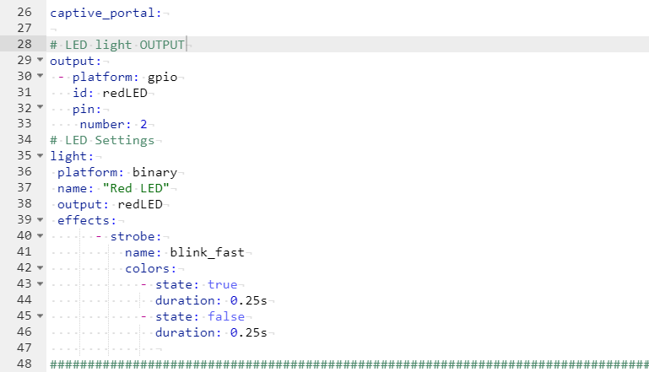

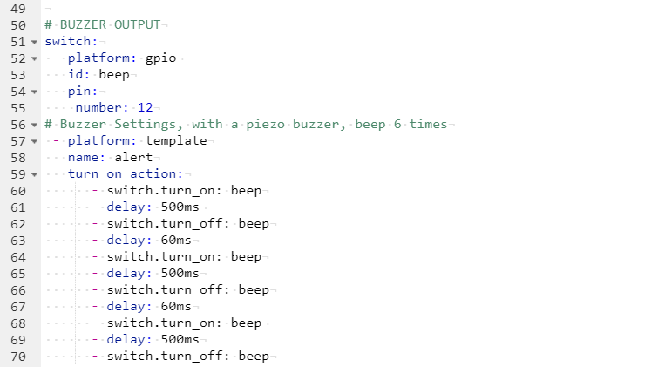

Figure 11- LED and Buzzer Codes

Above in Figure 11, is the code we developed for the LED light and buzzer. We have were able to add an action to the LED light called blink_fast so that the LED light would blink rapidly when the alarm system is triggered. In addition, we were able to use the turn_on_action option to add a loop action for the buzzer to sound and beep.

Application of Engineering Codes and Standards used in Final Design

IEEE Std 1547-2020: IEEE Conformance Test Procedures for Equipment Interconnecting Energy Resources with Electric Power Systems and Associated Interfaces – This standard is recognized that a distributed energy resource can be a single device providing all required functions or an assembly of components, each having limited functions and capabilities.
IEEE/ASHRAE Guide for the Ventilation and Thermal Management of Batteries for Stationary Applications - Ventilation of stationary lithium-ion battery installations are\ critical to improving battery life.

NESC:
National Electrical and Safety Code is a United States standard of the safe installation, operation, and maintenance of electric power and communication utility systems including power substations, power and communication overhead lines, and power and communication underground lines. This safety measure was implemented to make sure that the electrical components of the are not exposed and create any harm.

Economic Analysis

Because our team carefully analyzed various brands of components for cost and reputation, we were able to complete our build without going over budget. We were able to get great deals on several parts. As you can see below in the parts list, we only spent $392.44 which is way below our $600 budget. The cost for each part is shown in Table 3 below.
Brand | Item Name | Quantity | Total
ECO -WORTHY | Solar Panel Kit and Battery | 1 | $108.00
YuHan | Power Supply and Control | 1 | $29.99
ESP32 | Camera kit | 2 | $22.99
Aqara | Temperature Humidity Monitor  and Door / Window Sensor | 1 | $37.98
REYAX | Lora Module | 1 | $19.50
Raspberry | Raspberry Pi 4 | 1 | $145.00
Samsung | Samsung Tablet | 1 | $119.00
ELEGOO | Jumper wires | 1 | $7.99
Adafruit | Passive Buzzer | 1 | $1.50
Juried Engineering | LEDs | 1 | $8.49
 |  | Total: | $ 392.44
Table 3 – Parts Order list

Final Design

Security Alarm System
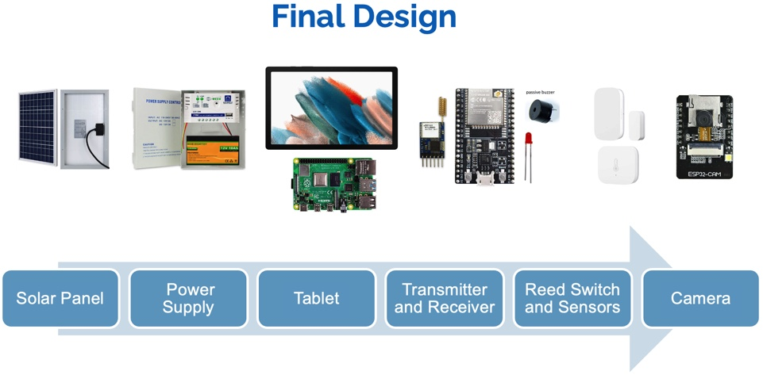
Figure 12 – Final Design

Above in Figure 12 above is our final design, we made a couple changes from our initial preliminary design to our final design. As you can see, we decided to replace our LCD screen with a Samsung tablet. In addition, we removed that PIR sensor that was combined with our ESP32 Camera. Overall, our power supply stayed the same from our preliminary design. In this design we decided to use one ESP32 camera as a transmitter and receiver instead of two microcontrollers for both functions. The LED light will serve as a visual alert that the system has triggered via sensor detection. The buzzer will serve as an audible alert that the system has been triggered. The ESP32 camera microcontroller comes with HD quality capability for live feed footage. Our sensors utilize a wireless protocol called Zigbee. These sensors and reed switch (door/window sensor) will be integrated onto the Home Assistant platform for home automation. The LoRa module will be used for long range communication as stated previously in the preliminary design section of this report.

ESP32 Camera

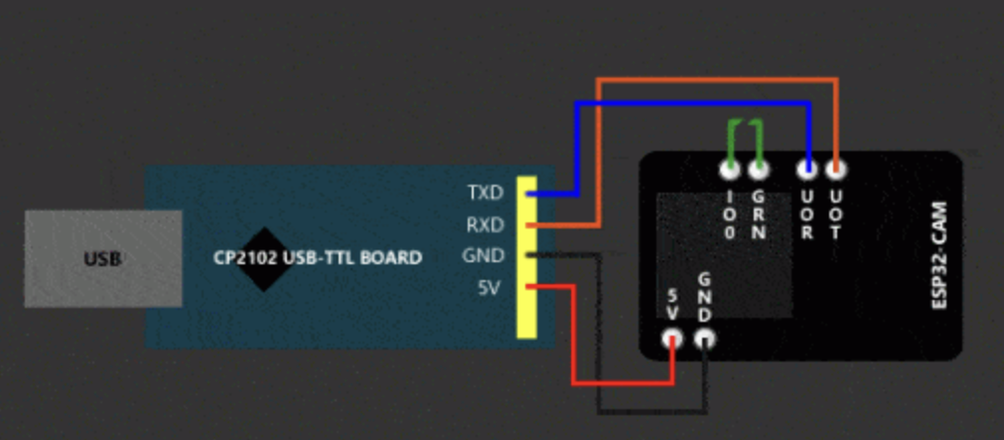
Figure 13 – Camera
Above in Figure 13 is a schematic of our camera build. On the left is an Arduino Uno microcontroller that we wired to the ESP32 Camera microcontroller via several pin connections. The ground pin (GND) serves as the reference point for all signals within the system and measures voltage within the system. The UoR pin is the pin used to receive data. The UoT pin is used for transmitting data. The 5V pin supplies power to the microcontroller. After completing all wiring, we plugged the Arduino Uno board wired to the ESP32 Camera via a USB.

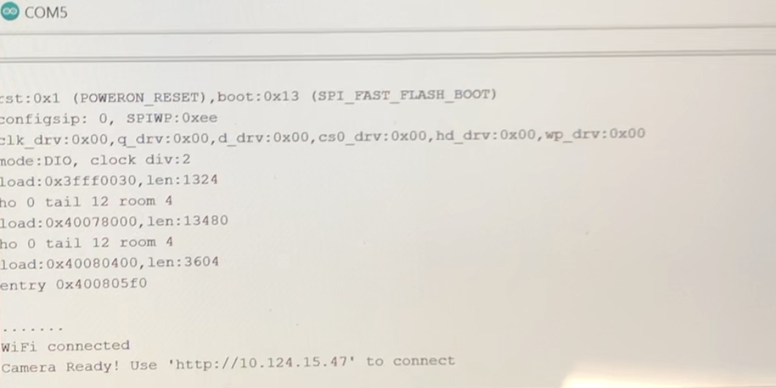
Figure 14 – Serial monitor with IP address

After completing our build of our camera and uploading the code to the ESP32 Camera we were able to receive an IP address (http://10.124.15.47) to access live feed and integrate our ESP32 Camera onto Home Assistant.

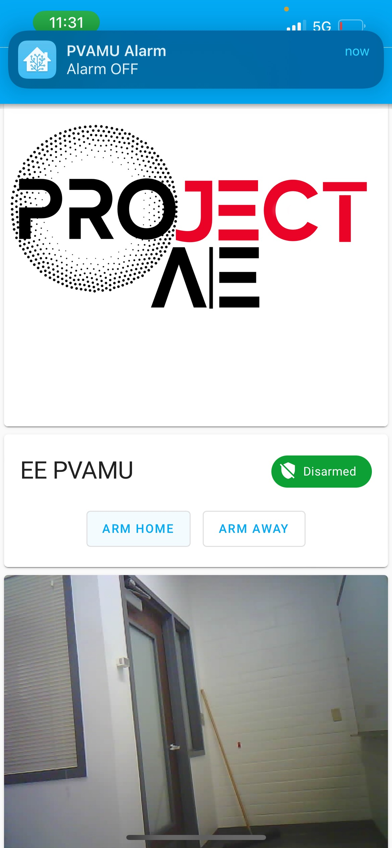
Figure 15 – Camera footage on Home Assistant platform

In Figure 15 above, we were able to get the camera footage to display on the Home Assistant app using the IP address we received from the serial monitor on Arduino.

Below are images of the breadboard build, power supply build, and the completed build of the security alarm system. The breadboard build includes a passive buzzer, LoRa module, resistors, and an ESP32 microcontroller with the camera attached or inserted on top of the microcontroller.

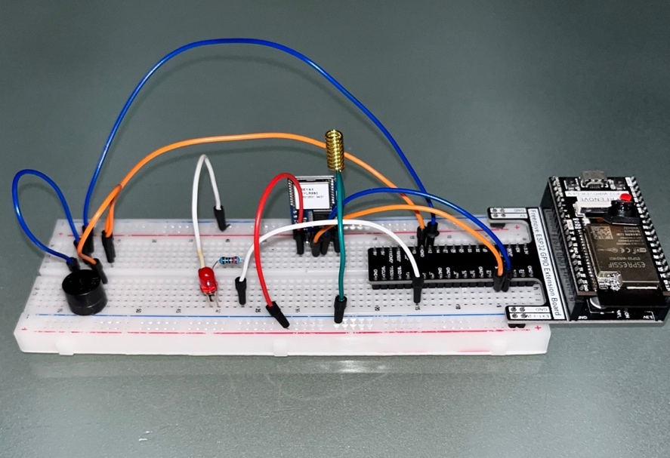
Figure 16 – Breadboard Build
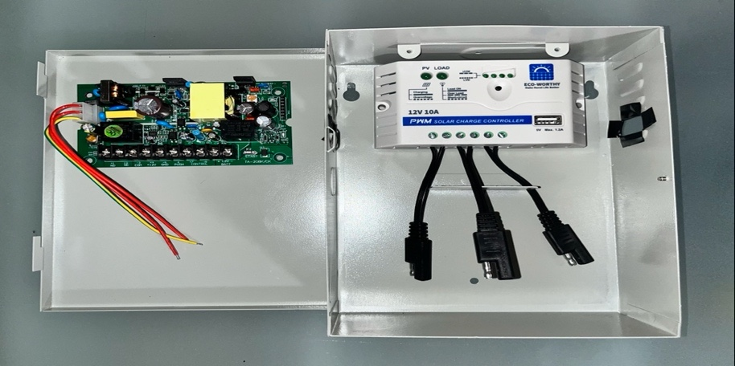
Figure 17 – Power Supply
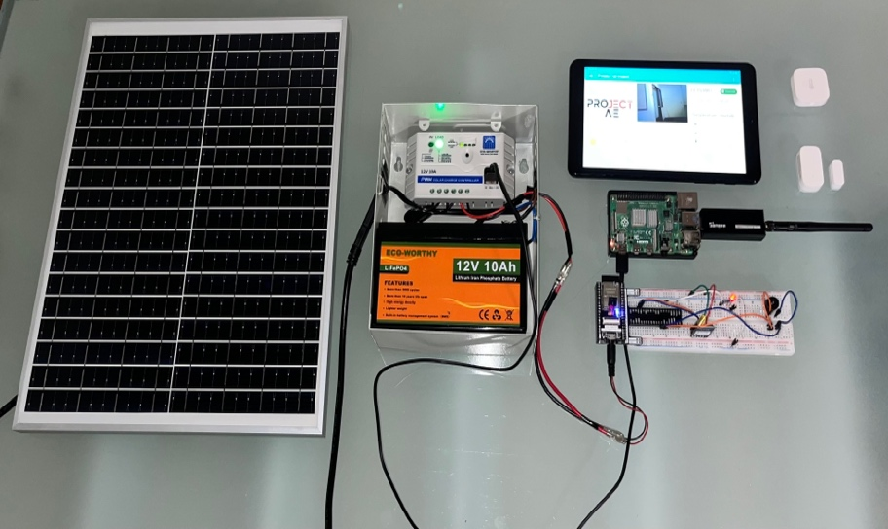
Figure 18 – Completed Final Build of Security Alarm System

RESULTS AND DISCUSSION

Summary of Goals and Objectives
The main objective of our project was to solve burglary cases in homes and offices by designing a functioning security alarm system that is reliable and affordable. The design also uses Home Assistant and Zigbee Alliance to unify devices and brands customers love to use. The goal of our team was to make our low-cost design function efficiently during power outages using batteries.

Summary of Constraints and Codes met by your Design

As far as constraints, a constraint of our design was trying to stay under a $600 budget while building a robust smart security alarm system. Most smart systems with smart features can be expensive but due to our thorough research of components we were able to stay significantly under our budget. Another constraint was EMP resistance within our system, unfortunately we were not able to purchase an EMP resistant box for our system due to time constraint towards the end of the term for this project.

The following codes were used to meet the final design:
- IEEE 7.8 – Code of Ethics:
  - 1) To hold paramount the safety, health, and welfare of the public, to strive to comply with ethical design and sustainable development practices.
  - 5) To seek, accept, and offer honest criticism of technical work.

- IEEE 7.1: U.S. Engineer Registration
  - This code informs us that we must professionally recognize the safety, welfare, and health of the public by ensuring our design does not harm any customers rather than help them.
- IEEE/ASHRAE Guide for the Ventilation and Thermal Management of Batteries for Stationary Applications
  - Some of the components of our design are in a box and ventilation and thermal management is needed to prevent damage to system or operator.
- IEEE 7.6: Protection of the Public
  - Our design must function properly to protect customers and/or their property.

Abiding by these codes, we were able to successfully complete out project. We kept in mind the IEEE 7.8 – Code of Ethics most importantly, we built our design to keep in mind the safety, health, and welfare of our customers. We touched on sustainability by building a system that uses renewable energy (solar) and we were able to build a system that allows you to reuse any previous components that you have used in a previously owned security alarm system instead of throwing away those parts. Home Assistant allows you to integrate almost any alarm system component into your system.

Discussion of Results and Other Use Cases
Discuss our results…

CONCLUSIONS AND RECOMMENDATIONS

The development of our security alarm system is a solution that protects homes and businesses, thus reducing the price of other companies’ expensive alarm systems. The final design was achieved through a few iterations of trial-and-error and could not have been successful completed without assistance.
As a recommendation, our team suggests selecting a security alarm system that provides the best protection at an affordable price. We also suggest an easy-to-setup security alarm system that brings comfort to homes and offices.

LIST OF REFERENCES

- B. McAfee, “How to keep your home safe during a power outage: Crime prevention,” CPSS, 03-Jul-2017. [Online]. Available: https://www.cpss.net/about/blog/2015/08/how-to-keep-your-home-safe-during-a-power-outage/ . [Accessed: 01-May-2022].

- “The Cybersecurity Workforce Gap,” The Cybersecurity Workforce Gap | Center for Strategic and International Studies, 27-Apr-2022. [Online]. Available: https://www.csis.org/analysis/cybersecurity-workforce-gap . [Accessed: 01-May-2022].

- A. Lauren, “How a power outage puts your home security at risk,” Reader's Digest, 11-Aug-2021. [Online]. Available: https://www.rd.com/article/power-outage-home-security/ . [Accessed: 01-May-2022].

- “Home & Business Security Systems in Jacksonville, FL,” SafeTouch. [Online]. Available: https://safetouch.com/security-during-a-power-outage/ . [Accessed: 01-May-2022].

- Carmen, “Security system creativity for remote off-the-grid living,” Off The Grid News, 24-Oct-2019. [Online]. Available: https://www.offthegridnews.com/home-defense/off-grid-security-system/ . [Accessed: 01-May-2022].

- EPS Security, “9 important home burglary statistics,” EPS Security, 09-Sep-2019. [Online]. Available: https://www.epssecurity.com/news/home-security/9-important-home-burglary-statistics/ . [Accessed: 01-May-2022].

References (continued)

- Dutta, Pallavi, et al. “5 Major Reasons for ‘Why Is Cyber Security Important?".” Security Boulevard, 13 Apr. 2021, https://securityboulevard.com/2021/04/5-major-reasons-for-why-is-cyber-security-important/.

- by, Written, and Katherine Torres. “8 Benefits to Owning a Home Security System.” SafeWise, 22 Apr. 2021, https://www.safewise.com/blog/top-8-reasons-get-home-security-system/.

- “Cybersecurity for Physical Security Systems.” UL, https://www.ul.com/services/cybersecurity-physical-security-systems

- Tatro, Kaitlyn. “Light Energy: Our Wasted Resource.” Consilience, no. 22, Columbia University, 2020, pp. 65–72, https://www.jstor.org/stable/26924963.

- CSA. 2022. Matter | Smart Home Device Solution. [online] Available at: <https://buildwithmatter.com> [Accessed 1 March 2022].

