PRAIRIE VIEW A&M UNIVERSITY
ROY G. PERRY COLLEGE OF ENGINEERING



Senior Design & Professionalism II

ELEG 4248

Team 6: Final Exam Report

Members: Isaiah Allen, John Barrett, Riley Mallet, Ahmad Yakuba

Executive Summary
Mission Statement
The mission of this project is to design a data center solution that meets the technical requirements of a smartphone application and matches the customer’s carbon neutrality goals. Then create a detailed budget report for the capital expenses and the operational expenses of the data center solution.
Problem Statement
ACME Paint Company has developed a mobile app that allows their customers to apply different paint schemes to pictures they’ve taken, and purchase paint if they like the results. The Chief Financial Officer (CFO) has begun to question the expenses of the current colocation solution for their data center, due to the expected increase in market user demand. The CFO wants to see if it would be more cost-effective, as well as line up with their carbon neutral goal, for ACME Paint to repatriate and consolidate to a more flexible and sustainable wholesale partner.
Proposed Deliverables
- Design for Information Technology (IT) Hardware Load
- Design for Power Distribution
- Design for Cooling Solution
- Colocation Plan
- Design Implementation Schedule
- Capital Expense Budget for Design
- Operational Expense Budget for Design
Budget
NA
Customer Requirements
- 50 milliseconds or less of latency to the whole United States.
- Users can store photos and color schemes on the app (In our data center).
- Start service by end of 2022 with 5 million users and ramp up to 60 million users by end of 2024
- 99.999% uptime.
- 100% renewable energy by 2025.
- Must be located within the United States.
Engineering Solutions
- 3 Data Centers placed around the United States so that data is close to end user.
- The Data Centers will have managed storage clusters that are easily implemented without taking down data center service.
- The Data Centers will back up to each other so that each data center will be mirrors of each other so that if any data center goes down the other two can take on the workload of the downed data center.
- The purchase of Renewable Energy Credits (REC’s) will allow the use of 100% renewable energy, and it can be done immediately from launch.
Major Constraints
- IT Hardware Load cannot be physically tested as the price of the equipment is too costly. Thus, our project is limited to a paper design.
- There are no software solutions to simulate the IT workload to simulate and test the IT design.

Benefits
- Environmental: by purchasing the REC the power that is used is considered to come from renewable power generation sources, i.e solar farms, wind farms, etc. Thus, we are not adding to the use of dirty power.
- Economical: Using all off the shelf components and creating modular clusters allows for a low cost easy to implement design. Then by partnering with wholesale colocation providers low-cost long-term contracts can be formed.
Recommendations
We suggest using three identical data centers, strategically placed across the United States. Each of the data centers should consist of storage clusters built to service five million users. Each of these clusters should use as many off-the-shelf components as possible so that implementation can be done easily and quickly. The data centers should not start off with a full sixty million user storage infrastructure, but should instead implement storage infrastructure as the user base grows. Each data center should be placed in a wholesale colocation facility as long-term use contracts are cheaper.
Conclusion
Our solution should allow for a relatively small initial capital expense investment and will only use more capital expenses when it is required. Using wholesale colocation facilities will allow for the operational expenses to be lower than other colocation options.

TABLE OF CONTENTS
Project Executive Summary ……………………..… 2
Table of Contents ………………………………..… 5
List of Figures …………………………………….. 6
List of Tables and Graphs …………………………. 7
List of Team Members and Roles …………………. 8

1. PROJECT SCOPE …………………………………………………………… 9
1.1 Problem Statement, Business Objective and Target Audience of your Project ………….. 10
1.2 Client identification and recognition of need……………………………………………… 11
1.3 Project goals and objectives ………………………………………………………………. 14
1.4 Contemporary issues relevant to the project ……………………………………………… 15
1.5 Potential impact of the project on society (Safety, Env, Tech, Eco) ……………………… 16
1.6 Initial Project constraints ………………………………………………………………… 19

2. PROJECT PLANNING AND TASK DEFINITION …………………………………….. 20
2.1 Task identification …………………..…………………………………………………… 21
2.2 Gantt Chart ………………………………………………………………………………. 22

3. LITERATURE REVIEW ………………………………………………………… 25
3.1 List of all sources of information ………………………………………………………. 26
3.2 Statement of Learning from each source ……………………………………………….. 27

4. PRELIMINARY DESIGN ………………………………………………………………… 30
4.1 Concept Generation …………………………………………………………………….. 31
4.2 Concept Evaluation and selection ………………………………………………………. 32 4.3 Design Constraints and Applicable Codes and Standards………………………………. 33
Used in the Preliminary Design
4.4 Preliminary Analysis ……………………………………………………………………. 34
4.5 Preliminary Design ……………………………………………………………………… 35

5. DETAILED SYSTEM DESIGN ………………………………………………………….. 36
5.1 Project Parts Summary …………………………………………………………………. 37
5.2 Engineering Analysis and/or Simulation ………………………………………………. 40
5.3 Hardware Layout/Detailed Drawings/Equipment selection …………………………… 41
and specifications
5.3.1 Power ………………………………………………………………………………… 42
5.3.2 Networking …………………………………………………………………………… 52
5.3.3 IT Hardware ………………………………………………………………………….. 56
5.4 Application of Engineering Codes and Standards used in Final Design ………………. 60 5.5 Economic Analysis …………………………………………………………………….. 61
5.6 Final Design ……………………………………………………………………………. 66
6. RESULTS & DISCUSSION ……………………………………………………………… 68
  - Summary of Goals and Objectives ……………………………………………………. 69
6.2 Summary of Constraints and Codes met by Design …………………………………… 70
6.3 Discussion of Results and Other Use Cases …………………………………………… 71

7. CONCLUSIONS AND RECOMMENDATIONS …………………………………….... 72

LIST OF REFERENCES …………………………………………………………………… 74

APPENDIX …………………………………………………………………………………… 75

List of Figures
Figure 1: Gantt Chart …………………………………………………………………………. 22
Figure 2: Utility to Colo Switch Gear …………………………………………………………. 42
Figure 3: A-Side Power ………………………………………………………………………. 43
Figure 4: B-Side Power ………………………………………………………………………… 44
Figure 5: Data Rack 1 Power ………………………..………………………………………….. 45
Figure 6: Data Rack 2 Power …………………………………………………………………… 46
Figure 7: Data Rack 3 Power ………………………………………………………………….. 47
Figure 8: Data Rack 4 Power ………………………………………………………………….. 48
Figure 9: Data Rack 5 Power ………………………………………………………………….. 49
Figure 10: Data Rack 6 Power ………………………………………………………………….. 50
Figure 11: In Row Cooler Power ………………………………………………………………. 51
Figure 12: Atlanta Latency …………………………………………………………………..... 52
Figure 13: Minneapolis Latency ……………………………………………………………… 52
Figure 14: Los Angeles 30ms Latency ……………………………………………………….. 53
Figure 15: Los Angeles and Minneapolis 30ms Latency ……………………………………... 53
Figure 16: Los Angeles and Atlanta 30ms Latency …………………………………………... 54
Figure 17: Los Angeles and Minneapolis 30ms Latency …………………………………….. 54
Figure 18: All 3 Locations 35 ms Latency …………………………………………………… 55
Figure 19: 1 Cluster Data Cabinet - Front View (Left) Back View (Right) …………………. 56
Figure 20: 2 Cluster Data Cabinet - Front View (Left) Back View (Right) …………………. 57
Figure 21: Network Gear Cabinet - Front View (Left) Back View (Right) …………………. 58
Figure 22: Specifications of the DL380 Being Used ………………………………………… 59
Figure 23: 3D Mockup Data center ………………………………………………………….. 67

List of Tables & Graphs
Table 1: Marketing Matrix …………………………………………………………. 12
Table 2: Class Timeline …………………………………………………………………… 23
Table 3: Project Timeline …………………………………………………………………. 24
Table 4: 1 Storage Cluster Cabinet (Need 6 Total) ……………………………………….. 37
Table 5: Network Gear Cabinet …………………………………………………………… 38
Table 6: Power Distribution Parts ………………………………………………………… 39
Table 7: Full Data Cabinet ………………………………………………………………… 61
Table 8: Network Gear Cabinet …………………………………………………………… 62
Table 9: Power cost/hr using example cluster rollout schedule …………………………… 64
Table 10: Hardware Rollout ………………………………………………………………. 66

List of Team Members and Roles

Isaiah Allen…………………………………………………………………………… Team Lead
John Barret………………………………………………………………………………… Scribe
Riley Mallet………………………………………………………………………… Data Analyst
Ahmad Yakuba…………………………………………………...………….. Project Coordinator

Section 1: Project Scope

1.1 Problem Statement, Business Objective and Target Audience of your Project
ACME Paint Company has developed a mobile app that allows their customers to apply different paint schemes to pictures they’ve taken, and purchase paint if they like the results. The Chief Financial Officer has begun to question the expenses of the current colocation solution for their data center, due to the expected increase in market user demand. The CFO wants to see if it would be more cost-effective, as well as line up with their carbon neutral goal, for ACME Paint to repatriate and consolidate to a more flexible and sustainable wholesale partner.

1.2 Client identification and recognition of need
Our client is not only those who directly own the data center but also those who benefit from this data center such as the users of the application. Thus, our solution will have to meet some standards that will allow the data centers to optimally serve their purpose. The first standard that we have to account for is that we must have low latency. This is to ensure a quick response time with the application to ensure user satisfaction. This can be done by spreading the data centers across the United States so that end users can connect to a data center near them thus giving lower latency times. Our data centers will also need to be able to receive and transmit user data, this can be done by paying for appropriate Internet Service Provider connections that will allow us to do so. We will also need to be able to store user data in the form of cloud storage. This requires our locations to have the storage infrastructure in order to support our users. The full expected user base of sixty million requires about 9 petabytes of storage. We are also faced with the fact of an expanding user base ranging from 5 million users in 2022 to a final total of 60 million users in 2024, in order to not waste resources by having them sit idle we are planning for a modular design that can grow as the user base grows. The application going down would be a big hit for the owners of the application, therefore we are tasked with maintaining a 99.999% uptime. This can be accomplished by having a lot of redundancy for power, internet connection, and cooling. In as much as these are needed in their own right, our three data centers also provide redundancy as they can take the load of another downed data center. We also are aiming for our locations to be operated using renewable power, which entails buying green energy credits and preferably operating in places where green energy is available.

1.2 Client identification and recognition of need (Continued)

Marketing Requirements | Engineering Requirements | Justification
Low Latency (50 milliseconds or less) | Place data centers in appropriate latency zones | Latency is a function of distance. Data center sites need to be within a reasonable range of the user population
Receive and Transmit Data | Data center will source local fiber bandwidth to supply uninterrupted use | With enough user demand, sufficient bandwidth will be needed to supply
Can store user data | Data center will have necessary data storage infrastructure (9 petabytes) | Each user needs to be able to store their photos in the “Cloud”, so our data center needs to have enough storage to handle the user data
Supply services to an estimated 60 million by 2024 (starting at 5 million in 2022) | A modular design that is capable of providing easy rollout of data center resources | The modular design simplifies the design process and allows for the easy rollout of resources when and where they’re required
99.999% Uptime | Three identical, Tier-III data centers at different points across the U.S. able to back-up data to each other. | Using three smaller data centers with independent power and fiber systems increases reliability
100% Renewable energy by 2025 | Will buy power off of the grid then purchase renewable energy credits | Taking advantage of existing renewable energy resources decreases the cost of the data center
Table 1: Marketing Matrix

1.2 Client identification and recognition of need (Continued)

- Hardware Requirements
  - Must meet N+1 redundancy.
  - Storage clusters should be able to be installed without taking down the data center.
  - Will need about 9 Petabytes of storage per data center at maximum user base. (Each user gets 50 photos of storage)
  - Hardware should be as much off the shelf components as possible.

- Final Product
  - Should be relatively cost effective to operate.
  - Should be relatively cost effective to build.
  - Storage clusters should be able to be implemented on a schedule.
  - Latency should be kept below 50ms when possible. (Two-tiered cache system will have a first access lag)
  - The three data centers should be able to back up data from the other data centers so that in the case of a site failure the other data centers can pick up the load.

1.3 Project Goals and Objectives

The purpose of this project is to create design and budget for the building of a data center solution that would be able to provide coverage for the entire United States. Our objective is to create a solution that has a low cost, both capital cost, and operational cost and meets the uptime requirements. The various sections that this project goes deeper into are as follows, IT Hardware, Mechanical/Cooling Hardware, Power Distribution, Networking, and Location Planning. In the original scope of the project, the design of the data center building would also be included, however as no architecture group members could be recruited the scope of the project was restricted to only those listed.

1.4 Contemporary issues relevant to project
- Energy Efficiency
  - As climate change comes to the forefront of concerns around the world a new focus on how the energy that we generate is used. So, around the world an effort to use energy in as an efficient way as possible is being undertaken.
- Renewable Energy
  - As climate change comes to the forefront of concerns the method in which we generate energy is being more and more scrutinized. Energy sources that do not contribute to the carbon output are becoming more in demand.
- Data Leaks
  - Data centers house many pieces of sensitive data. Examples can include credit card details, addresses, customer names, etc. Computer hackers gaining access to this data can be devastating to the customers and owners of the data center. By not storing sensitive data our data center can avoid exposure to these issues.

1.5 Potential Impacts of Project on Society
Our project has an impact on two major areas: environmental, and economical.

1.5.1 Environmental
Data centers use lots of power, and produce a lot of waste heat. If the power used comes from “dirty” energy generation a data center can contribute significantly to global carbon output. There is a statistic that data centers globally contribute to 0.3% of global carbon dioxide emissions. By using 100% renewable energy our design aims to not add to this figure.

1.5.2 Economical
Building and operating a data center is prohibitively expensive for most companies. So many small businesses with need for a data center are choosing to use colocation data centers. Colocation can have up to a 64% cost savings when compared to owning a data center. Before a business decides which colocation space to move into, they need to decide how long they plan on operating in that space. The reason is, there are two types of colocation spaces; we will focus on the long-term option which is the wholesale colocation provider. Wholesale providers offer cost savings when signing a long-term lease. Also, by designing the IT hardware solution so that it can take advantage of the time cost of money the capital expense costs can be spread out overtime with no punishment.

1.6 Initial Project Constraints
Each project has constraints that need to be considered before designing a solution to the problem dealt with at hand. In the following project these are some of the constraints and limitations that are necessary for the team to abide by.
For our project we are building a data center by concept alone as building up any level of a data center would be prohibitively expensive for this course. When we were able to talk to our industry partners, they told us that typically building up a rack and testing the expected load on that rack would be part of testing a data center design, so that is an example of what we could do if we had the budget. We are also working with the fact that a Data Center has a lot of things that go into it, the various pieces of this Data Center have a lot of parts that are required to be operable with each other and we have no way of testing that they all will be will be interoperable, we can only go off of the data sheets. Another factor is that there is no software that can accurately demonstrate the hardware component of this project which means that as we build up, we have to assume our assumptions about various workloads and tasks are correct.

Section 2: Project Planning & Task Definition
2.1 Task Identification
Our team was learning about Data Centers while we were working on making one. This led to a lot of confusion on how we should approach making one. For the entirety of the first semester, we focused on location with the assumption that everything we would do later would be entirely dependent on the initial location and things that would be available there. After the end of the first semester, we found that we had the internal systems and needs of the Data Center to still work on. The division of labor and independent work can be seen in the Gantt chart.
From there our project was split into several tasks, which included IT hardware design, Power Distribution design, Mechanical/Cooling design, Location/Networking design.

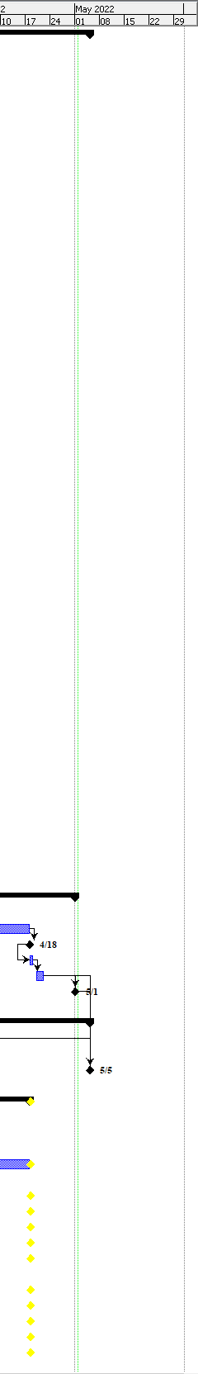
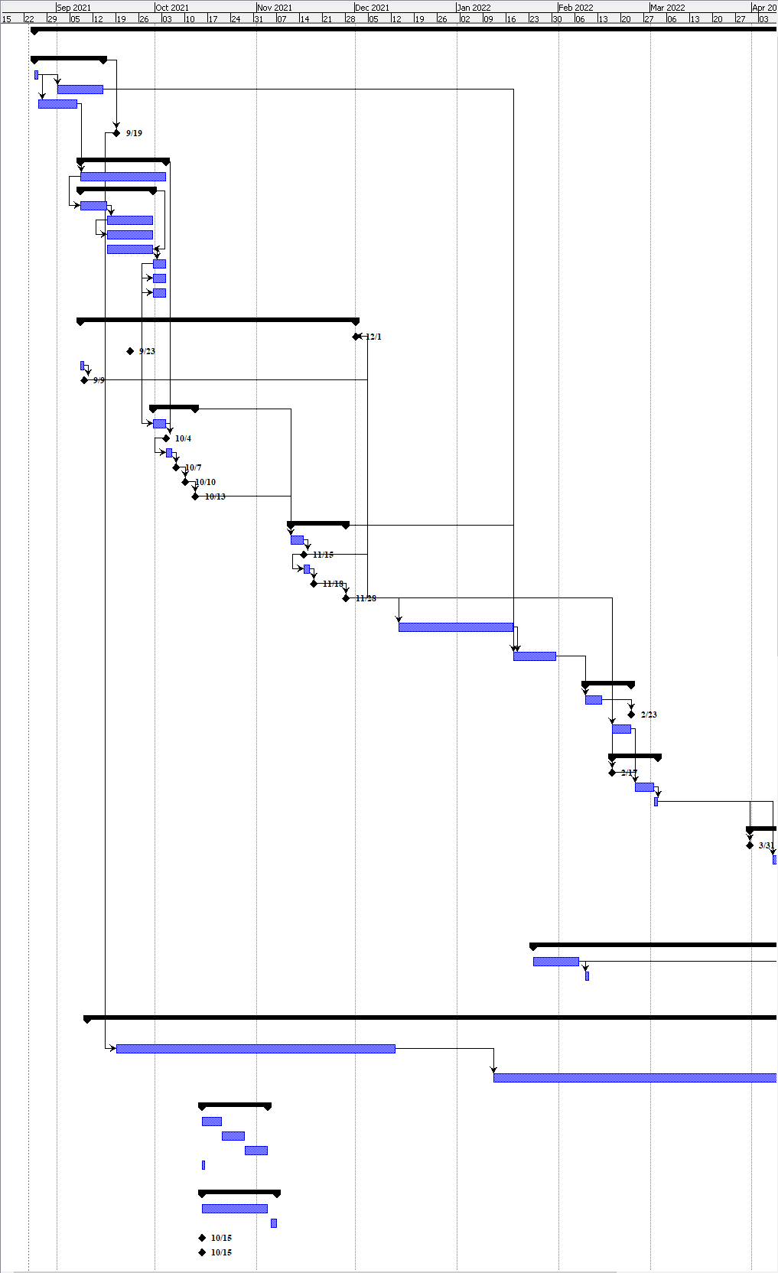
2.2 Gantt Chart
Figure 1: Gantt Chart
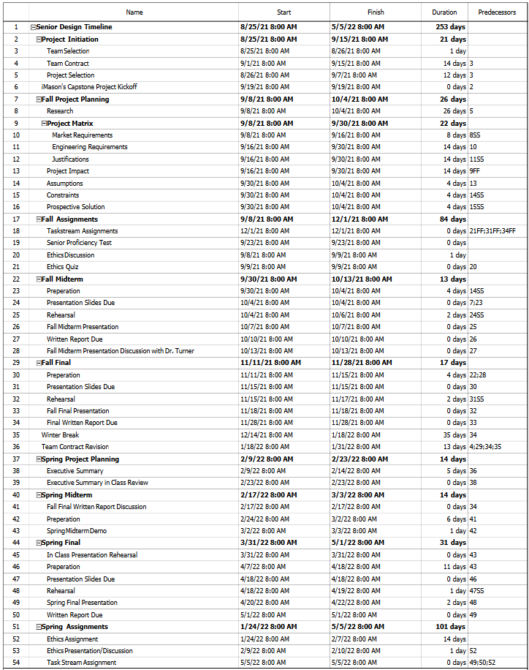
2.2 Gantt Chart (Continued)
Table 2: Class Timeline
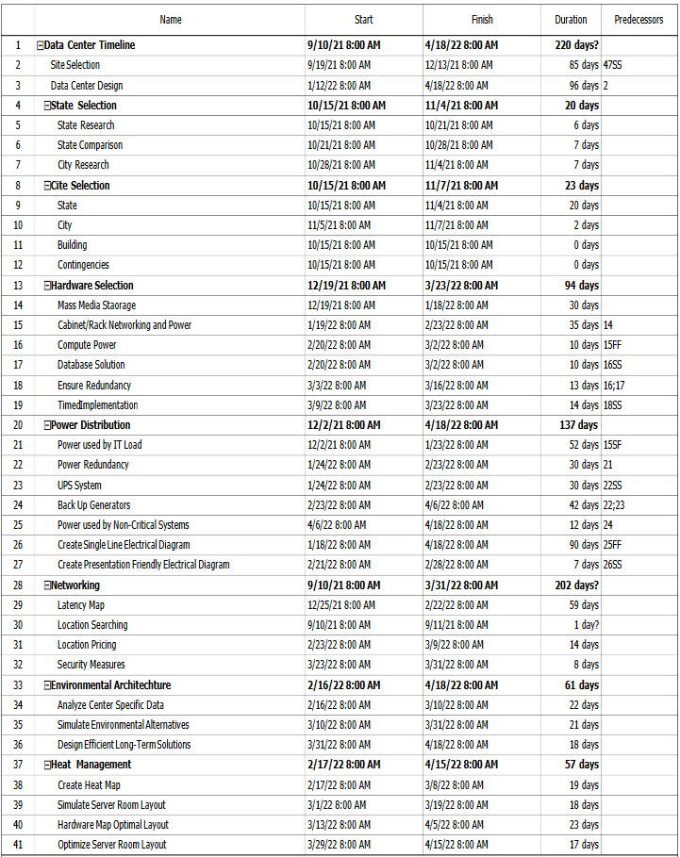
2.2 Gantt Chart (Continued)
Table 3: Project Timeline

Section 3: Literature Review
3.1 List of all sources of information
The literature review used for the making of the Data Center was a series of lectures that covered the whole of Data Center creation and structure. These were then broken into the various sections that the team broke the project into.
- Networking
  - For this section the literature reviewed comes from Data Center Hawk, a tool to compare the various facilities that would house our equipment as well as pricing for power in each location. This was used in tandem with Windstream, a website that we used to compare the latency of various points across the United States. Final Costs for ISP providers and Colo Rent were provided by an industry mentor.
- Hardware
  - Manufacturer websites.
  - Data sheets and quick spec sheets for various devices.
  - Communication, via Zoom and email, with manufacturer sales representatives.
  - Lectures provided by the industry mentors from IMasons.
- Power
  - IEEE Standard for Graphic Symbols for Electrical and Electronics Diagrams
  - IEEE Standard for Electrical Power System Device Function Numbers, Acronyms, and Contact Designations
  - Comparing Data Center Power Distribution Architectures by Schneider Electric
  - Technical Schematics for the different Power Distribution Hardware
  - A number of lectures held by iMason’s on Redundant Power
3.2 Statement of learning from each source
Before starting work on the Data Center, we gained knowledge of the industry from the mentors who worked with us over the course of the school year. This was in the form of a series of lectures that started in the Fall of 2021 and ended in Spring of 2022. While we were learning from the various lectures that were given to our group we began to work on the many parts of this project.
- Networking
  - For the networking aspect of the project various Data Center locations were compared to each other to be sure that they had the necessary resources to house the equipment that would make this project possible. This was done using a website as recommended by the mentors and some of the values for various costs associated with these locations were provided by the industry mentors as we moved closer to the end of the project.
- Hardware
  - Manufacturer websites.
    - This allowed for browsing and finding what options are available in the market.
  - Data sheets and quick spec sheets for various devices.
    - This allowed us to check whether various devices were compatible with the proposed design as well as with each other.

3.2 Statement of learning from each source (Continued)
  - Communication, via Zoom and email, with manufacturer sales representatives.
    - This allowed us to get recommendations from people whose job it is to make these solutions. This also allowed us to get pricing for all of the hardware with a realistic price.
  - Lectures provided by the industry mentors from IMasons.
    - These lectures gave great breakdown and introductions to different parts of the data center industry, construction, and operation.
- Power
  - IEEE Standard for Graphic Symbols for Electrical and Electronics Diagrams
    - This was referenced for comparison of different power distribution hardware, as well as the drawing of the Single Line Diagram.
  - IEEE Standard for Electrical Power System Device Function Numbers, Acronyms, and Contact Designations
    - This was referenced for comparison of different power distribution hardware, as well as the drawing of the Single Line Diagram.
  - Comparing Data Center Power Distribution Architectures by Schneider Electric
    - This source was key in determining the in-row power distribution solution to be implemented in the data center
  - Technical Schematics for the different Power Distribution Hardware
    - These were referenced against one and other to ensure the power distribution systems compatibility with the IT Hardware and Cooling System
3.2 Statement of learning from each source (Continued)
  - A number of lectures held by iMason’s on Redundant Power
    - The information gained from the numerous iMason’s lectures on redundant power were an introduction to what a Power Distribution System was, as well as the components that went into a Power Distribution System.

Section 4: Preliminary Design

4.1 Concept Generation
Our process of designing the data center was pretty linear. The process of a paper design does not lend itself to much testing so iterative design is stifled. So, we used a process of cross referencing and manually checking for compatibility then using outside resources such as our industry mentors to make sure that the design is at least plausible or would work.

4.2 Concept Evaluation and Selection
After every part of the project was finished with the design phase, the evaluation of capital costs and operational costs occurred. As the budget was one of the most important parts of this project this was the focus of the project evaluation. All part’s specifications were analyzed for power use, tools such as HPE’s power advisor were consulted, location costs for power and monthly lease were analyzed. The results of this analysis are in the results section later in the report.
4.3 Design Constraints and Applicable Codes and Standards Used in the Preliminary Design
Codes and Standards
- IEEE Policies, Section 7 - Professional Activities - Code of Ethics
- ANSI /IEEE Standard C37.2 Standard for Electrical Power System Device Function Numbers, Acronyms, and Contact Designations
- TUI3026E - Uptime Institute Tier Standards
- ANSI/BICSI 002-2014 - Data Center Design and Best Practices
- ANSI/TIA 942-A 2014 - Telecommunications Infrastructure Standard for Data Center
Design Constraints
Our team consisted of three electrical engineers, one computer engineer, and two mechanical engineers. Since this is our senior design project for the electrical and computer engineering college we focused on the electrical and computer engineering part of the project.

4.4 Preliminary Analysis
While we were still learning more about the Data Center industry, we began the structure of the Data Center with the knowledge of some of the requirements of the Data Centers and how people have worked in the past to attain the various specifications that are expected for Data Centers. When it comes to reaching the 99.999% Uptime for this structure, we looked to redundancies in order to make that possible. This was implemented in all aspects of our Data Center with redundancy to power, hardware, and networking being available for each step. We knew we needed a location so the first thing we tasked ourselves with was the initial location of the Data Center. After a semester of research into an ideal location for the Data Center we broke the project down further and were able to build individual sections up. These sections were built up with the idea that they were going to be able to live up to the standards and reliability expected of Data Centers so while we were planning our design, we were also building our design.
4.5 Preliminary Design
Our preliminary design was the initial plans of how we wanted to accommodate the expectations of what goes into Data Centers. Our preliminary design had to take into account the growing number of users thus we decided to make sure that our design was modular. In order to make that work we decided to clusterize every aspect of the IT hardware. Initially we were expecting to store sensitive user information and perform image processing at the data center. However, as we refined the design, we realized that these were not needed. For the sensitive user information, we decided to recommend partnering with an internet payment processor so that the data center is not exposed to the liability of storing sensitive data. The image processing hardware was decided to be unnecessary as it is faster and more cost effective to push the image processing out of the data center to the end user’s mobile device.

Section 5: Detailed System Design
5.1 Project Parts Summary
20 | HPE Apollo 4200 Gen10 90TB Hybrid Node for Qumulo
20 | HPE Ethernet 10/25Gb 2-port SFP28 MCX4121A-ACUT Adapter
1 | HPE 600mm Rack Stabilizer Kit
1 | HPE 42U 600mmx1075mm G2 Kitted Advanced Shock Rack with Side Panels and Baying
900 | Qumulo Tier H1 1TB 5-year Hardware Assurance Subscription and Support E-LTU
20 | HPE Apollo 4200 Gen10 Support
2 | Aruba 6300F 48-port 1GbE and 4-port SFP56 Switch
4 | Vertiv Geist PDU VP8965
20 | HPE Apollo 2000/4200 Install Service
Table 4: 1 Storage Cluster Cabinet (Need 6 Total)
Storage Clusters
Above is the table of parts required to build one storage cluster cabinet. As the full design needs twelve clusters and each cabinet holds two clusters, in total six of these storage cluster cabinets are needed.

5.1 Project Parts Summary (Continued)
2 | Vertiv Geist PDU VP8965
2 | HPE SN4600cM Switch Support
2 | HPE SN4600cM 100GbE 64QSFP28 Power to Connector Airflow Switch
2 | Fortigate 6500F
2 | Aruba 6300F 24-port 1GbE and 4-port SFP56 Switch
72 | Fibermart 100G QSFP28 to 4x25G SFP28 Breakout Active Optical Cable
2 | HPE ProLiant DL380 Gen10 3204 1P 16GB-R S100i NC 8LFF 500W PS Server
8 | HPE 8TB SATA 6G Business Critical 7.2K LFF LP 1-year Warranty 512e Multi Vendor HDD
1 | HPE 42U 600mmx1075mm G2 Kitted Advanced Shock Rack with Side Panels and Baying
1 | HPE 600mm Rack Stabilizer Kit
4 | HPE X240 100G QSFP28 to QSFP28 1m Direct Attach Copper Cable
Table 5: Network Gear Cabinet
Network Gear Cabinet
Above is the gear needed to network all of the clusters together and communicate between the outside world and the inner network of the data center. Only one of these cabinets is needed to network together the whole data center.

5.1 Project Parts Summary (Continued)

2 | Vertiv Liebert EXM 480V UPS
2 | Vertiv Liebert FPC 15-125kVA PDU
2 | Vertiv iMPB Powerbar
Table 6: Power Distribution Parts
The parts listed above are per data center. As the whole solution is three identical data centers spread across the United States, the parts above are then multiplied by three.

5.2 Engineering Analysis and/or Simulation
This project had many different areas in which specific engineering methods were implemented.
- Networking
  - The Networking solution started with the initial choice of Minneapolis for a location that would be a cornerstone to further efforts to cover the United States. With the goal in mind that we would need to keep Latency numbers down for the Southern United Stated along both the East and West Coasts additional location would have to be added to further push the numbers down. The final Latency we were able to get across the whole United States was 35ms.
- Hardware
  - For the IT Hardware the analysis was reading through data sheets and cross-referencing specifications to insure compatibility. Since building up a test rack and hitting it with a simulated load was out of question due to prohibitive costs no simulations could be performed.
- Power
  - For Power Distribution, initial comparison of power distribution architecture was conducted to determine a flexible solution that could achieve the level of redundancy needed. The number of kilowatts consumed by both the IT and Mechanical load was calculated, and then used for the analysis of different power distribution hardware by comparing and cross-referencing data sheets.

5.3 Hardware Layout/Detailed Drawings/Equipment Selection and Specification
In this section the Power, IT Hardware, and Networking specifications are shown.

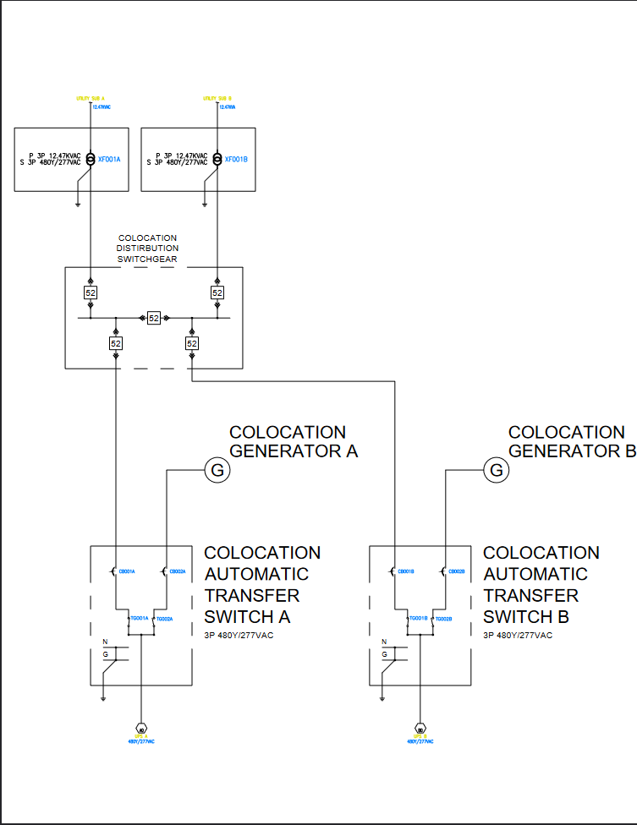
5.3.1 Power
Figure 2: Utility to Colo Switch Gear
Dual transformers connecting from utility substations to colocation switchgear then to dual automatic transfer switches.

5.3.1 Power (Continued)
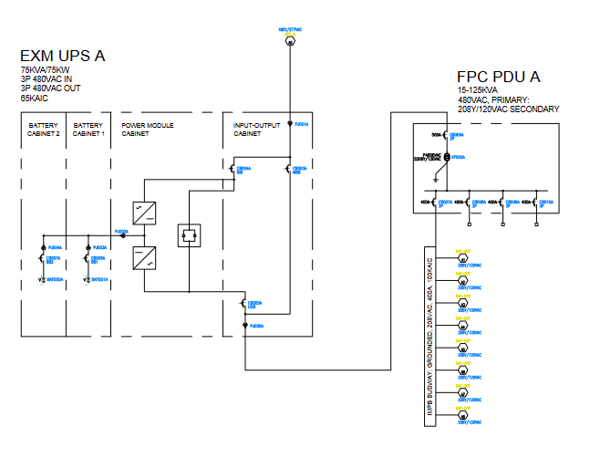
Figure 3: A-Side Power
A Side Uninterruptible Power Supply, Power Distribution Unit, and In Row Power Distribution Busway
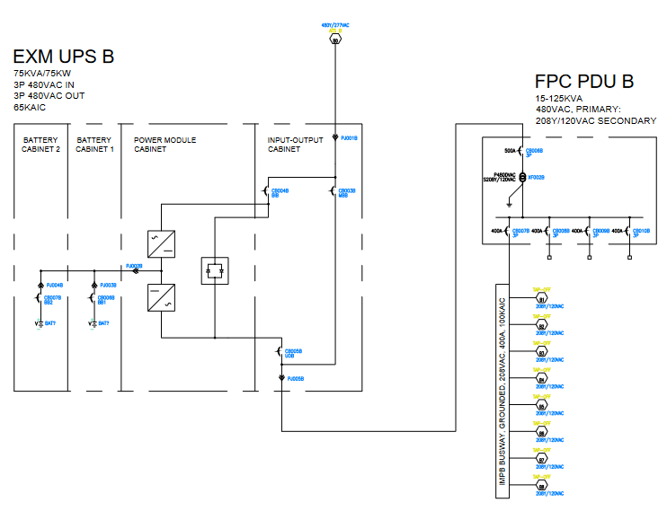
5.3.1 Power (Continued)
Figure 4: B-Side Power
B Side Uninterruptible Power Supply, Power Distribution Unit, and In Row Power Distribution Busway
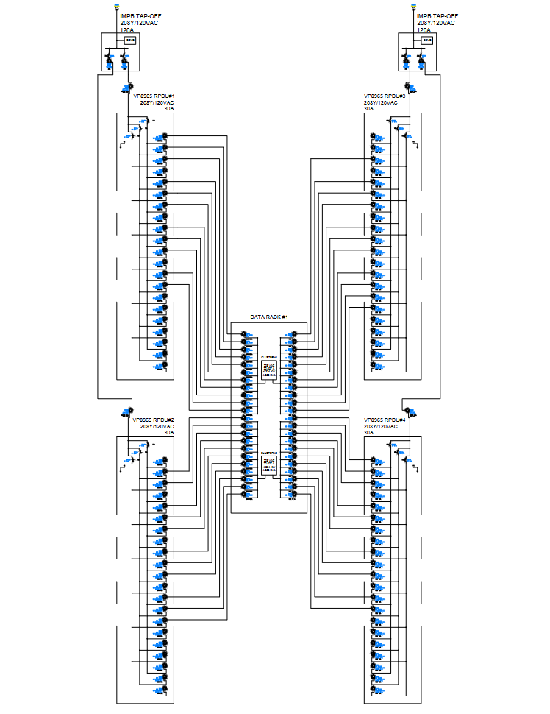
5.3.1 Power (Continued)
Figure 5: Data Rack 1 Power
Data Rack #1 with Cluster #1 powered by Rack Power Distribution Units #1 and #3 connected by Tap Off Box to power feed A, and Cluster #2 powered by Rack Power Distribution Units #2 and #4 connected by Tap Off Box to power feed B.
5.3.1 Power (Continued)
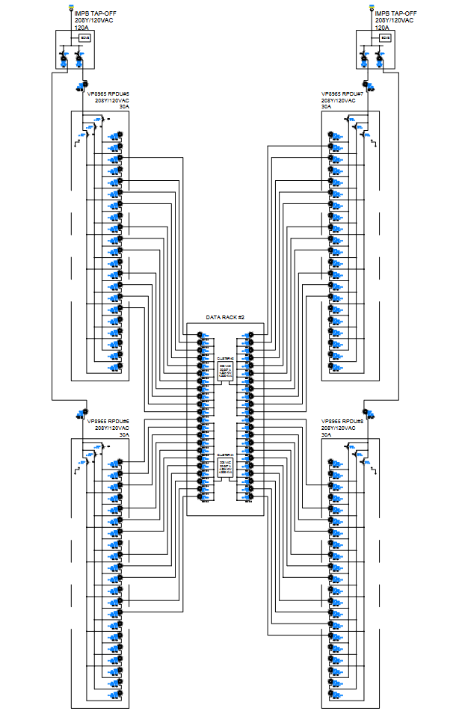
Figure 6: Data Rack 2 Power
Data Rack #2 with Cluster #3 powered by Rack Power Distribution Units #5 and #7 connected by Tap Off Box to power feed A, and Cluster #4 powered by Rack Power Distribution Units #6 and #8 connected by Tap Off Box to power feed B.
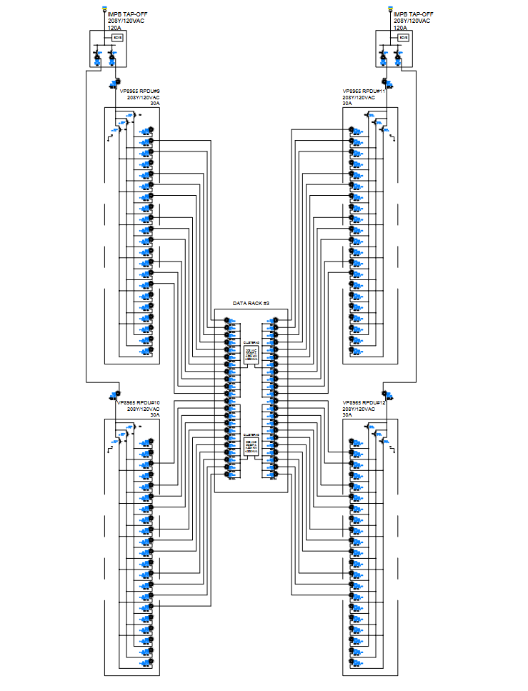
5.3.1 Power (Continued)
Figure 7: Data Rack 3 Power
Data Rack #3 with Cluster #5 powered by Rack Power Distribution Units #9 and #11 connected by Tap Off Box to power feed A, and Cluster #6 powered by Rack Power Distribution Units #10 and #12 connected by Tap Off Box to power feed B.
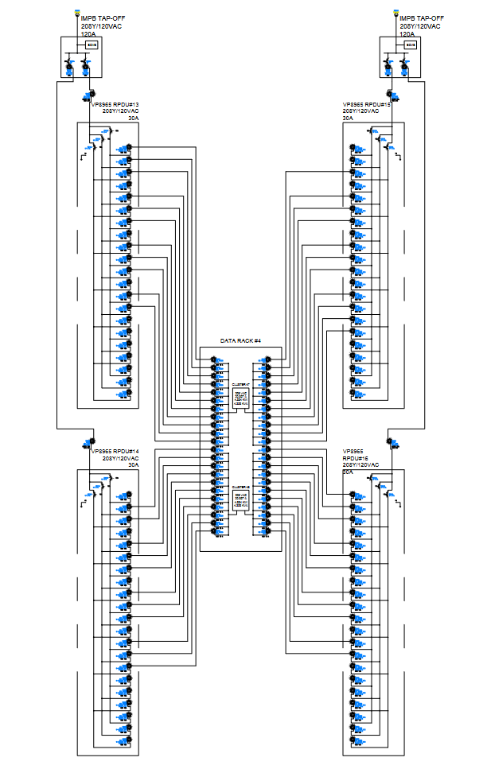
5.3.1 Power (Continued)
Figure 8: Data Rack 4 Power
Data Rack #4 with Cluster #7 powered by Rack Power Distribution Units #13 and #15 connected by Tap Off Box to power feed A, and Cluster #8 powered by Rack Power Distribution Units #14 and #16 connected by Tap Off Box to power feed B.
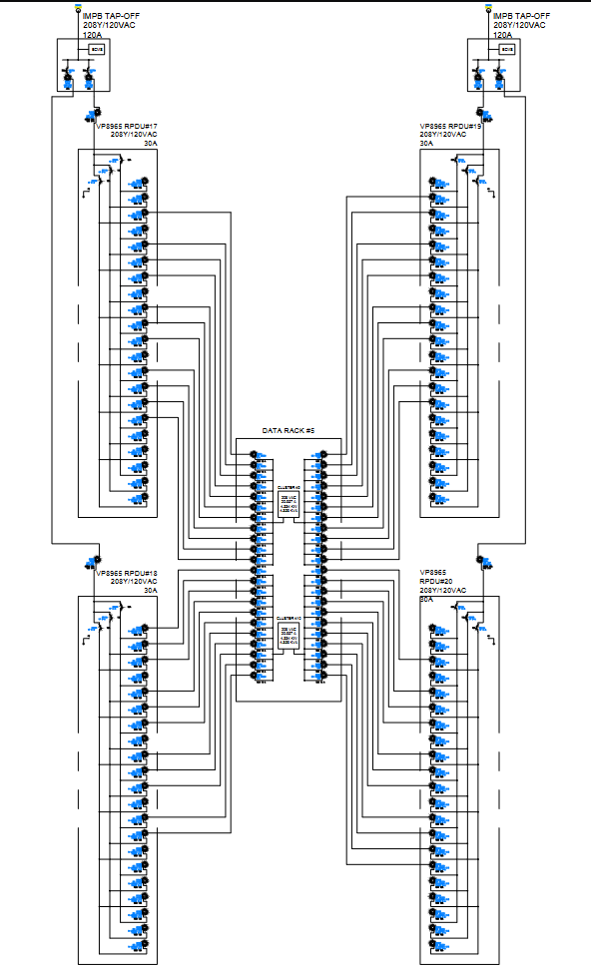
5.3.1 Power (Continued)
Figure 9: Data Rack 5 Power
Data Rack #5 with Cluster #9 powered by Rack Power Distribution Units #17 and #19 connected by Tap Off Box to power feed A, and Cluster #10 powered by Rack Power Distribution Units #18 and #20 connected by Tap Off Box to power feed B.
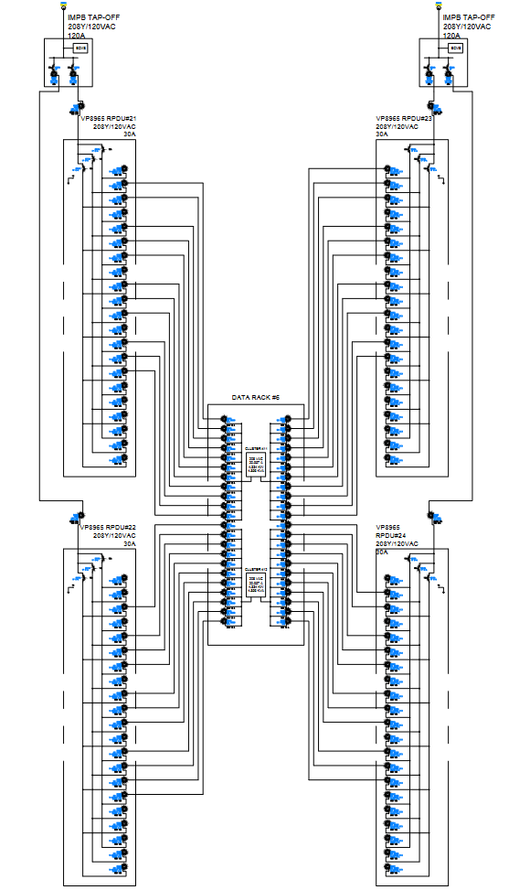
5.3.1 Power (Continued)
Figure 10: Data Rack 6 Power
Data Rack #6 with Cluster #11 powered by Rack Power Distribution Units #21 and #23 connected by Tap Off Box to power feed A, and Cluster #12 powered by Rack Power

5.3.1 Power (Continued)
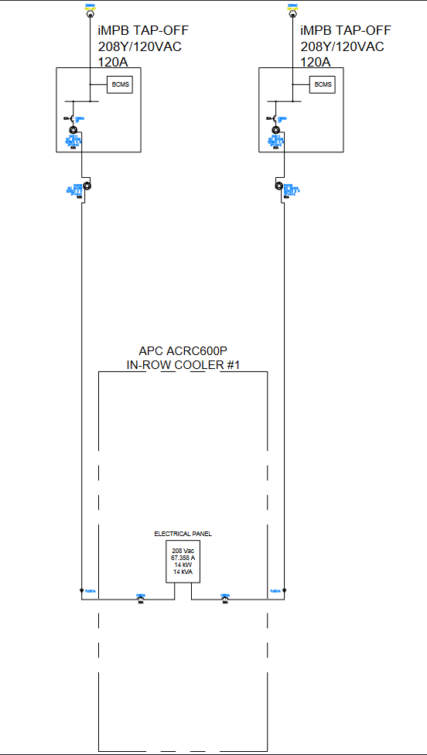
Figure 11: In Row Cooler Power
In Row Cooler #1 connected by Tap Off Box to power feed A and B.
5.3.2 Location/Networking
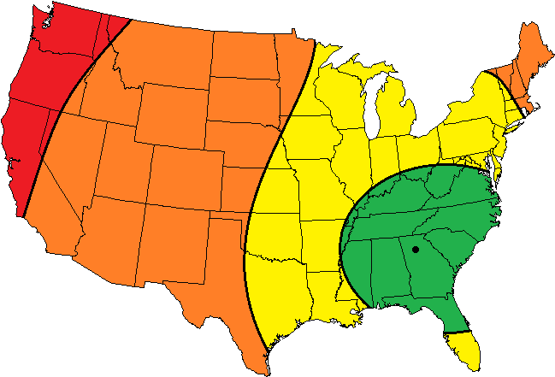
Figure 12: Atlanta Latency

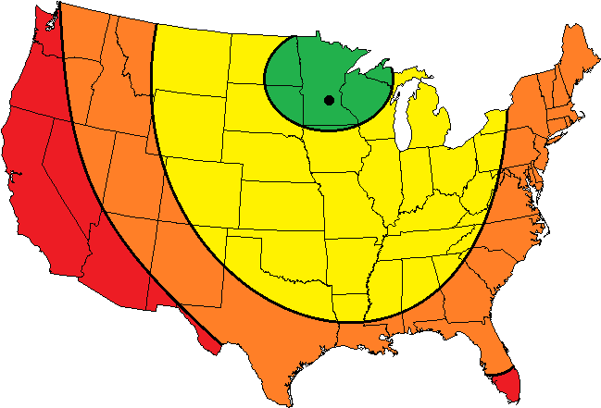
Figure 13: Minneapolis Latency

5.3.2 Location/Networking (Continued)
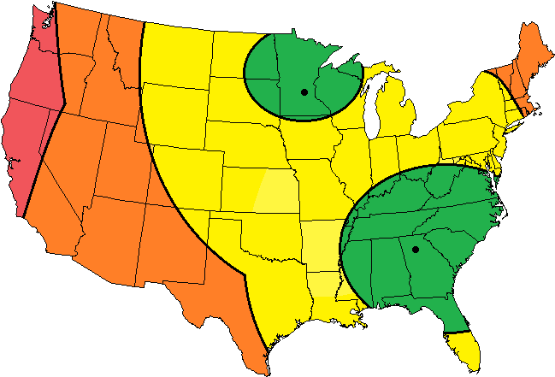
Figure 14: Los Angeles 30ms Latency
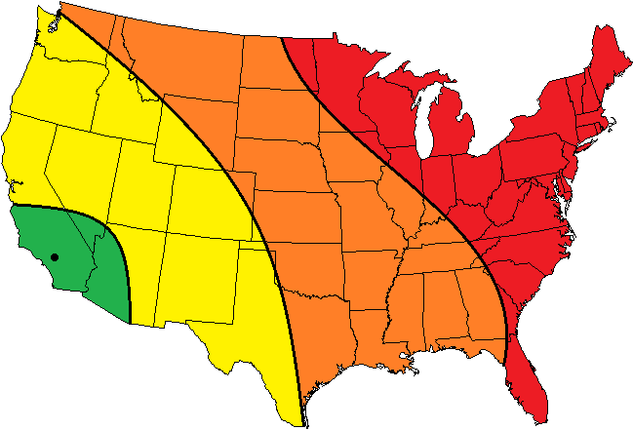
Figure 15: Los Angeles and Minneapolis 30ms Latency

5.3.2 Location/Networking (Continued)
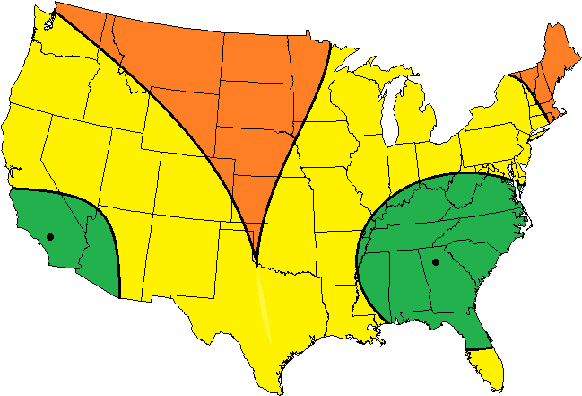
Figure 16: Los Angeles and Atlanta 30ms Latency
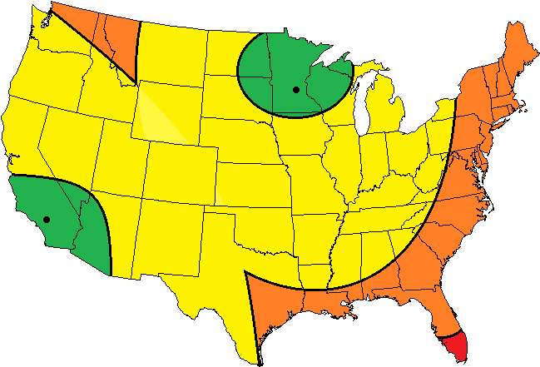
Figure 17: Los Angeles and Minneapolis 30ms Latency

5.3.2 Location/Networking (Continued)
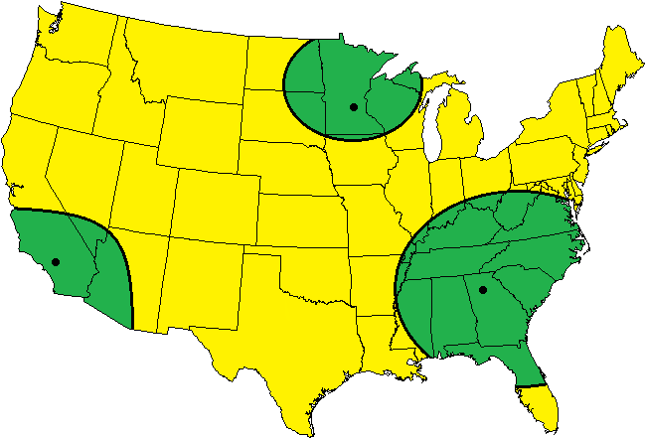
Figure 18: All 3 Locations 35 ms Latency

Figures 12-13 work to demonstrate the coverage range of the individual data centers. Figures 14-18 show the overlapping coverage of multiple data centers and how all of the data centers add up to provide the needed coverage.

5.3.3 IT Hardware
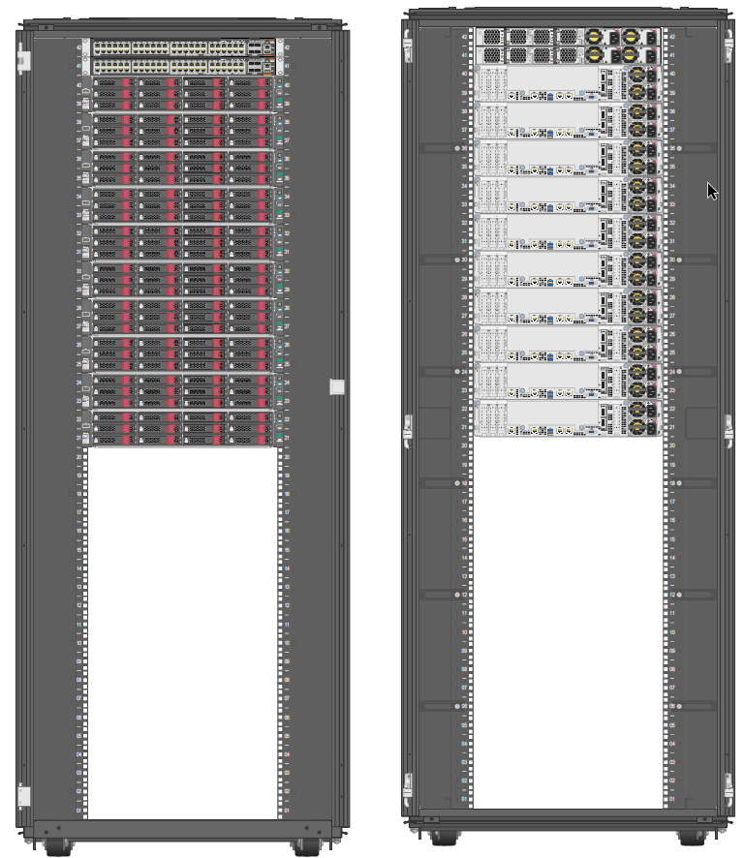
Figure 19: 1 Cluster Data Cabinet - Front View (Left) Back View (Right)

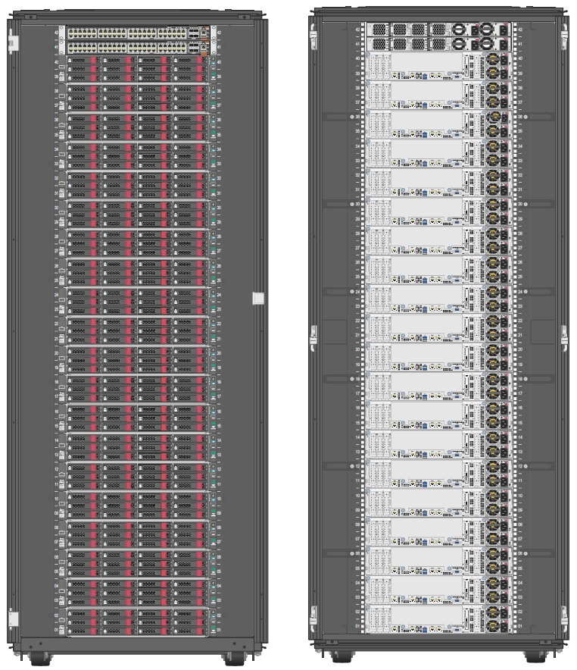
5.3.3 IT Hardware (Continue)
Figure 20: 2 Cluster Data Cabinet - Front View (Left) Back View (Right)
Figure 19 shows how a cabinet would be built when only one cluster (5 million user addition) is needed at the time. Figure 20 shows how a data cabinet would look once it is at its full 2 cluster (10 million user) capacity.

5.3.3 IT Hardware (Continue)
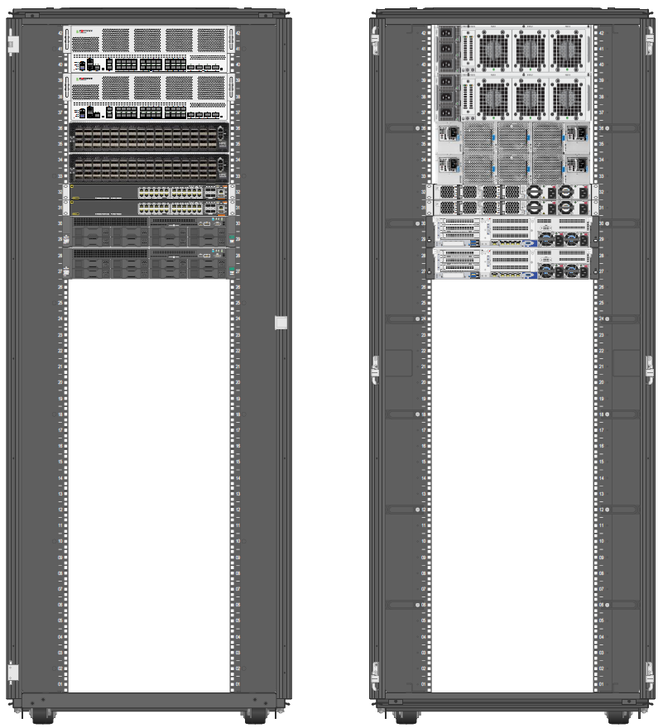
Figure 21: Network Gear Cabinet - Front View (Left) Back View (Right)
Figure 21 shows the network gear cabinet that connects all of the storage clusters together and to the outside world.
5.3.3 IT Hardware (Continue)
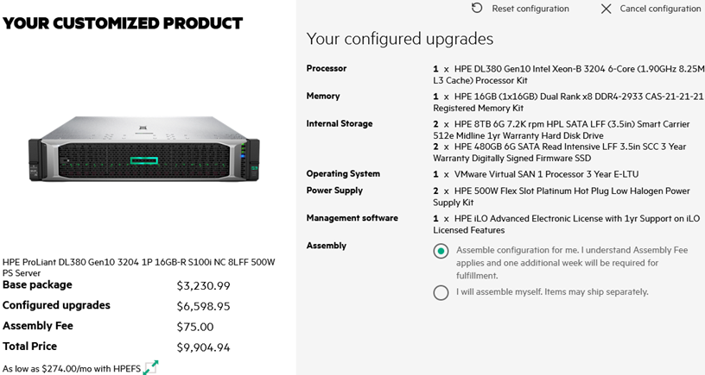
Figure 22: Specifications of the DL380 Being Used
The DL380 with the above specifications is going to be used as a supplemental database to store usernames, passwords, etc for the users.

5.4 Application of Engineering Codes and Standards used in Final Design
The team looked to the Uptime Institute, IEEE and ANSI for our ethical standards. The standards used in our final design are as such.

IEEE Policies, Section 7 - Professional Activities - Code of Ethics
- ANSI /IEEE Standard C37.2 Standard for Electrical Power System Device Function Numbers, Acronyms, and Contact Designations
  - This was a valuable standard that was used in the work relations that were made to get this Data Center together as there were a lot of companies and people from various organizations that were a part of this project.
- TUI3026E - Uptime Institute Tier Standards
  - This standard was an important standard to be used while we were looking to tier the Data Center. As it was important to make sure our Tier-3 Data Center was in line with others.
- ANSI/BICSI 002-2014 - Data Center Design and Best Practices
  - This standard was used in making the Data Centers and making sure that we were able to be in these collocations without being out of line for what was expected for someone renting space in those areas.
- ANSI/TIA 942-A 2014 - Telecommunications Infrastructure Standard for Data Center
  - This standard was helpful as we were planning for this Data Center to be dealing with large amounts of user information and the safety of the location for those who would be walking in that area as well as the user data was an important factor.

5.5 Economic Analysis
- Capex Price Breakdown
  - IT Hardware
    - Full Data Cabinet
Qty | Product Description | Unit Price (USD) | Extended List Price (USD)
1 | HPE Factory Express Base Racking Service | 300.00 | 300.00
20 | HPE Apollo 4200 Gen10 90TB Hybrid Node for Qumulo | 21260.00 | 425200.00
20 | HPE Ethernet 10/25Gb 2-port SFP28 MCX4121A-ACUT Adapter | 1023.00 | 20460.00
1 | HPE 600mm Rack Stabilizer Kit | 420.00 | 420.00
1 | HPE 42U 600mmx1075mm G2 Kitted Advanced Shock Rack with Side Panels and Baying | 2917.99 | 2917.99
900 | Qumulo Tier H1 1TB 5-year Hardware Assurance Subscription and Support E-LTU | 633.00 | 569700.00
1 | HPE Rack and Rack Options Install SVC | 550.00 | 550.00
20 | HPE Apollo 4200 Gen10 Support | 7616.00 | 152320.00
Table 7: Full Data Cabinet
5.5 Economic Analysis (Continued)
2 | Aruba 6300F 48-port 1GbE and 4-port SFP56 Switch | 7221.99 | 14443.98
4 | Vertiv Geist PDU VP8965 | 1681.00 | 6724.00
20 | HPE Apollo 2000/4200 Install Service | 275.00 | 5500.00
Total |  |  | $1,198,535.97
Table 7 (Continued): Full Data Cabinet
    - Networking Gear Cabinet
2 | Vertiv Geist PDU VP8965 | 1681.00 | 3362.00
2 | HPE SN4600cM Switch Support | 12145.00 | 24290.00
2 | HPE SN4600cM 100GbE 64QSFP28 Power to Connector Airflow Switch | 49990.00 | 99980.00
2 | Fortigate 6500F | 395472.00 | 790944.00
2 | Aruba 6300F 24-port 1GbE and 4-port SFP56 Switch | 5196.99 | 10393.98
72 | Fibermart 100G QSFP28 to 4x25G SFP28 Breakout Active Optical Cable | 550.00 | 39600.00
2 | HPE ProLiant DL380 Gen10 3204 1P 16GB-R S100i NC 8LFF 500W PS Server | 9904.94 | 19809.88
Table 8: Network Gear Cabinet

5.5 Economic Analysis (Continued)
8 | HPE 8TB SATA 6G Business Critical 7.2K LFF LP 1-year Warranty 512e Multi Vendor HDD | 883.99 | 7071.92
1 | HPE 42U 600mmx1075mm G2 Kitted Advanced Shock Rack with Side Panels and Baying | 2917.99 | 2917.99
1 | HPE 600mm Rack Stabilizer Kit | 420.00 | 420.00
4 | HPE X240 100G QSFP28 to QSFP28 1m Direct Attach Copper Cable | 550.00 | 2200.00
Total |  |  | $998,789.77
Table 8 (Continued): Network Gear Cabinet
  - Power Hardware
- Opex Price Breakdown
  - Power Opex Breakdown
    - Power costs
      - Minneapolis: $0.08/kWh
      - Atlanta: $0.06/kWh
      - Los Angeles: $0.11/kWh

5.5 Economic Analysis (Continued)
    - Power Cost/hr using an example rollout schedule
Date | Minneapolis | Atlanta | Los Angeles
12/01/2022 | $1.73 | $1.27 | $2.54
04/01/2023 | $2.06 | $1.51 | $3.01
08/01/2023 | $2.38 | $1.75 | $3.49
01/01/2024 | $2.71 | $1.98 | $3.97
03/01/2024 | $3.03 | $2.22 | $4.44
05/01/2024 | $4.01 | $2.94 | $5.87
07/01/2024 | $4.33 | $3.18 | $6.35
09/01/2024 | $4.66 | $3.41 | $6.83
11/01/2024 | $4.98 | $3.65 | $7.30
Table 9: Power cost/hr using example cluster rollout schedule

5.5 Economic Analysis (Continued)
  - Colocation Opex Breakdown
    - The Colocation Opex has many factors: the rent, cost of ISP connections and DDOS protections. The rent that we could expect was $202.55/kW this was to be a monthly expenditure that would be needed for all three locations so it would be $607.65/kW. An additional cost of $2.00/Mbps is expected for the ISP connection with every location having 2 connections
that comes out to $12.00/Mbps as a monthly expenditure. The DDOS protection is for the security of the Data Center and is a yearly fee of $13,896.09.

5.6 Final Design
The final design consists of three identical data centers, one in Atlanta (Georgia), one in Minneapolis (Minnesota), and one in Los Angeles (California). Each data center contains six data cabinets and one networking cabinet. Each data cabinet contains two storage clusters. Each storage cluster is made up of ten HPE Apollo Gen 10 90TB Hybrid Storage Nodes for Qumulo. Each cluster supports up to five million users. In the problem statement it is stated that the user base grows over time, and as such the number of clusters that are put online can grow over time. We plan to start with two clusters active on launch in late 2022 and go online over the course of the data center’s life cycle. A planned timeline is seen below though if the user base does not grow as fast or it grows faster than planned it is easy to change the schedule and order parts later or faster as needed.
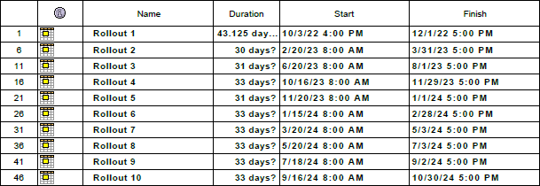
Table 10: Hardware Rollout

Each rollout is either one or two clusters as needed. The storage management software “Qumulo” allows for inter-site backups. This allows us to back up the data from each location to the other locations. So, if one location goes down for any reason the other two sites can pick up the load that the downed site was carrying. The ability to do this allows for us to have 99.999% uptime while only using tier III data center standards.
5.6 Final Design (Continued)
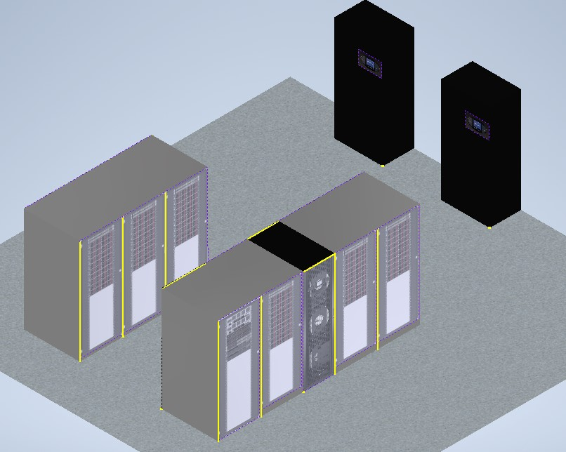
Figure 23: 3D Mockup Data center
Figure 23 shows a mockup of what one of these data centers might look like. This mockup was done with the thought that the Whitebox room that a colocation provider would provide us was relatively small. However even with the limited size a hot and cold aisle separation is still possible.

Section 6: Results & Discussion
6.1 Summary of Goals and Objectives
The objective of the project was to create a cost-effective design for a data center that would support the needs of a smartphone application. Then create a detailed budget report for both the capital expenses and operational expenses.
6.2 Summary of Constraints and Codes Met by Design
Our solution has several constraints. The first constraint is that it does not cover the non-contiguous United States within the 50ms latency zone. The second constraint is that the latency period will be violated when the customer accesses their data for the first time, this is due to the 2-tiered hybrid storage system. This was intentionally sacrificed as it made the design much cheaper overall.
- IEEE Policies, Section 7 - Professional Activities - Code of Ethics
- ANSI /IEEE Standard C37.2 Standard for Electrical Power System Device Function Numbers, Acronyms, and Contact Designations
  - This standard allowed for the easy and accurate integration of our power distribution gear with the utility’s substations.
- TUI3026E - Uptime Institute Tier Standards
  - This standard gave a redundancy goal to meet in order to guarantee our uptime goal.
- ANSI/BICSI 002-2014 - Data Center Design and Best Practices
  - This standard was used to help design our solution in accordance with what practices are used in industry.
- ANSI/TIA 942-A 2014 - Telecommunications Infrastructure Standard for Data Center
  - This standard was used so that we can feel safe with storing the user data that we do store and was crucial in deciding to not store more sensitive user information.

6.3 Discussion of Results and Other Use Cases

We were able to create a data center solution that meets all of the requirements given. By designing using as many off the shelf components as possible it allows for the easy and fast implementation of the design. This will allow for the time cost of money to be taken advantage of buy the company implementing the data center solution. Other uses for this design are any cloud storage uses. This design is not locked to storing pictures, it can store anything. However sensitive information such as credit card details should not be stored with this design as it does not meet the requirements needed by law to do so.

Section 7: Conclusions & Recommendations
Conclusion and Recommendations

The reduction of the needs of the data center combined with using off the shelf components allowed us to meet the requirements set out in the problem statement. Along with this designing the data center such that its capacity can be expanded as needed allows the capital and operational expenses to be reduced.
We recommend partnering with a payment processing service so that the data centers can be built both cost-effectively and quickly. We also recommend keeping an eye on how many resources each user is actually using, then dynamically scaling the resource allocation so that each cluster can potentially squeeze out more user base coverage. Thus, further reducing costs.

List of References
[1] “Network latency,” Network Latency. [Online]. Available: https://ipnetwork.windstream.net/. [Accessed: 01-May-2022].
[2] datacenterHawk, “Search for data centers,” datacenterHawk. [Online]. Available: https://www.datacenterhawk.com/. [Accessed: 01-May-2022].
[3] R. Asceirto, "The disrupted datacenter: Cloud, colos could become their own electric micro-utilities," June 16 2017,
[4] D. Bizo, "Global Prefabricated Modular Datacenter Forecast 2017-2021," July 2018, www.451reasearch.com
[5] J. Koomey et al., "A Simple Model for Determining True Total Cost of Ownership for Data Centers,"
[6] C. Synesael et al., "Livin' on the Edge, Part 1: Evolving Tomorrow's Internet," May 18 2020, www.cowen.com
[7] Source:Forbes, Renewable Energy Alone Can’t Address Data Centers’ Adverse Environmental Impact, Asaf Ezra
[8] Dobran, Bojana. “Demystifying Data Center Tier Ratings: Make an Educated Choice.” PhoenixNAP Blog, 16 Sept. 2021, https://phoenixnap.com/blog/data-center-tiers-classification

Appendix

Links to IT Hardware Specification Sheets

HPE ProLiant DL380 Gen10 Server https://www.hpe.com/psnow/doc/a00008180enw.pdf?jumpid=in_pdp-psnow-qs
Fortigate 6500F
https://www.fortinet.com/content/dam/fortinet/assets/data-sheets/FortiGate_6000F_Series.pdf
100Gb QSFP28 To 4x25Gb SFP28 Breakout Active Optical Cable
https://www.fiber-mart.com/custom-100g-qsfp28-to-4x25g-sfp28-breakout-active-optical-cable-p-17146.html
Vertiv VP8965
https://www.vertiv.com/en-us/products-catalog/critical-power/power-distribution/vp8965/#/downloads
HPE M-Series SN4600M Switch
https://www.hpe.com/psnow/doc/a00094648enw.pdf?jumpid=in_pdp-psnow-qs
HPE Apollo 4200 Gen 10 90TB Hybrid Storage Node for Qumulo
https://www.hpe.com/psnow/doc/a00045441enw.pdf?jumpid=in_pdp-psnow-qs
HPE Ethernet 10/25Gb Adapters
https://www.hpe.com/psnow/doc/a00047733enw.pdf?jumpid=in_pdp-psnow-qs
HPE 600mm Rack Stabilizer Kit
https://buy.hpe.com/us/en/options/rack-options/server-rack-options/server-rack-options/hpe-rack-stabilization-kits/hpe-600mm-rack-stabilizer-kit/p/BW932A

Links to IT Hardware Specification Sheets (Continued)
HPE G2 Advanced Series Racks
https://www.hpe.com/psnow/doc/c05324689.pdf?jumpid=in_pdp-psnow-qs
Aruba CX 6300 Switch Series
https://www.hpe.com/psnow/doc/a00073540enw.pdf?jumpid=in_pdp-psnow-qs

