ROY G. PERRY COLLEGE OF ENGINEERING



DragonFly: An Autonomous Drone

ELEG 4472: Senior Design & Professionalism I

Spring Final Exam Report

Team 5

Submitted by:
Charles Stewart (TL)
J’son Brim
Christian Rodriguez
Kreshaun Foreman
Michael Davis-Gay

Submitted to: Dr. Turner

Date of Submission: 4/25/2021
Project Executive Summary
Proposed Deliverables:
A small drone capable of carrying packages up to 3 pounds.

Budget:
The Project Budget is $600 and the amount spent is $1,420. We needed the additional $600 for quality LiDAR and Motors to ensure safety and performance. A bigger cut of our budget should have been allocated for the flight controller.
- The operation of the drone needs to be safe
-FAA guideline compliant and extensive pre-flight checks
- Obstacle Avoidance capability
-Simultaneous Localization and Mapping(SLAM) algorithm using Light Detection and Ranging (LiDAR)
- Autonomous Capability
-Arducopter autopilot software
-GPS module + Radio telemetry
- Capable of carrying packages up to 3 pounds
-Hexacopter motor configuration with 1000KV or lower brushless motors with at least 1045 propellers

- s (Part 107)

Table of Contents:
Project Executive Summary………………………...…………………………..1
Table of Contents……………………………………….……………..…. …….2-3
List of Figures…………………………………………..………….…….. ……..4
List of Tables and Graphs…………………………………………….… ……..4
List of Acronyms…………………………………………………….….……….5
- PROJECT SCOPE
  - Problem Statement Business Objective and Target Audience of your project …………….7
  - Client identification and recognition of need………………………………...7
  - Project goals and objectives………………………………………………….7
  - Contemporary issues relevant to project……………………………………. 8
  - Potential impact of project on society (Safety,Env,Tech,Eco).......................8-11
  - Initial Project constraints…………………………………………………….11
- PROJECT PLANNING AND TASK DEFINITION
  - Task identification ………………………………………………………………………...12
  - Gantt Chart………………………………………………………………………………...14
- LITERATURE REVIEW
  - List of all sources of information…………………………………………….15
  - Statement of Learning from each source……………………………………..16
- PRELIMINARY DESIGN
  - Concept Generation…………………………………………………………...17
  - Concept Evaluation and selection……………………………………………..17
  - Design Constraints and Applicable Codes and Standards…………………….18
  - Preliminary Analysis………………………………………………………….19
  - Preliminary Design……………………………………………………………20
- DETAILED SYSTEM DESIGN
  - Project Parts Summary………………………………………………………..22
  - Engineering Analysis and Simulation………………………………………...23
  - Hardware Layout and Detailed Drawing Equipment Selection and specifications………………………………………………………………….24
  - Application of Engineering Codes and Standards used in Final Design……..31
  - Economic Analysis…………………………………………………………...31
  - Final Design………………………………………………………………….32
- Results and Discussion
  - Summary of Goals and objectives…………………………………………….35
  - Summary of Constraints and Codes met by design…………………………...35
  - Discussion of Results and other use cases…………………………………….36

- CONCLUSIONS AND RECOMMEMDATIONS………………….………37
LIST OF REFERENCES ……………………………………………………….38
APPENDIX ………………………………………………………………………39

List of Figures:
Figure 1: Design Methodology…………………………………………………………………………..12
Figure 2: ArduPilot Software in the Loop………………………………………………………………13
Figure 3: Potential Motor Configurations……………………………………………………………...17
Figure 4: Preliminary Design…………………………………………………………………..……….20
Figure 5: Hardware layout…………………………………………………………………..…………..24
Figure 6: Turnigy LiPO Battery…………………………….………………………..………………….25
Figure 7: Mateksys Power distribution board…………………………………..…………………….25
Figure 8: Pixhawk Flight Controller………………………………………………..………………….26
Figure 9: Pixhawk Flight Controller Kit (Flight Controller + Peripherals)................................27
Figure 10: Electronic Speed Controller Diagram……………………………………………………..28
Figure 11: Jetson Nano Pin Diagram…………………………...……………………………………...28
Figure 12: Connection between pixhawk and jetson nano……...……………………………………29
Figure 13: RPLiDAR A3M1………………………………………………………………………………30
Figure 14: Starting Mission, Ready for Liftoff!.............................................................................32
Figure 15: Liftoff and travelling to GPS waypoint…………………………………………………….33
Figure 16: Return to launch and Landing!....................................................................................34

List of Tables and Graphs:
Graph 1: CO₂ Emissions Attributable to Package Delivery………………………………………….10
Graph 2: Gantt Chart……………………………………………………………………………………..14

Table 1:Preflight checklist………………………………………………………………………………..9
Table 2: Preliminary Calculations……………………………………………………………………..19
Table 3: Project Part Summary………………………………………………………………………....22
Table 4: Final Calculations……………………………………………………………………………...23
Table 5: Economic Analysis……………………………………………………………………………...31

List of Acronyms and Abbreviations:
APM - Ardupilot autopilot
ACC - Accelerometer
BEC - Battery Eliminator Circuit
CO₂ - Carbon Dioxide (carbon emission/greenhouse gas)
EKF - Extended Kalman Filter
ESC - Electronic Speed Controller
FAA - Federal Aviation Administration
FC - Flight controller
FPV - First-person View
GCS - Ground Control Station
GPS - Global Positioning System
Gyro - Gyroscope
IMU - Inertial Measurement Unit
INS - Inertial Navigation System
LiDAR - Light Detection and Ranging
LiPO - Lithium Polymer
MAVLink - Micro Air Vehicle Link
PCB - Printed Circuit Board
PCS - Position Control Station
PDB - Power Distribution Board
PPM - Pulse Position Modulation
PWM - Pulse Width Modulation
RC - Radio Control
RTL - Return to Launch
SUAS- Small Unmanned Aircraft System
Telem - Telemetry
UAV - Unmanned Aircraft Vehicle
UART- Universal Asynchronous Receiving/Transmitting
VLOS - Visual Line of Sight

- Project Scope
1.1 Problem Statement
The current trend of greenhouse gas emission in the world will soon make life as we know it unsustainable if we do not identify and implement solutions to rectify the various contributing factors. Transportation is still largely powered by fossil fuel and it is the largest source of greenhouse gas emissions in the U.S. About 25% of transportation (approx. 415 million metric tons of carbon dioxide) comes from medium to heavy duty trucks that are the kinds of vehicles that deliver freight to warehouses, businesses, and consumers’ homes. Drone delivery of a small package would result in about .42 kg of greenhouse gas emissions while standard truck delivery results in about .92 kg when factoring in the emissions created by the generation of electricity used to charge the drone batteries.

1.1 Client Identification
Our target audience for this project is the Transportation and Courier Industry. Companies such as Amazon, UPS, and FEDEX would see great benefits from this type of technology. If this project was applied on a larger scale with efficient logistics, the delivery of packages using drones would help reduce fuel consumption, reduce carbon emissions, and increase the speed of local package delivery.

1.3 Project goals and objectives
The goal of this project is to construct a drone capable of autonomously delivering packages with a weight up to 3 pounds to a destination within a 1-mile range as a stepping stone to developing greater capabilities.

1.4 Contemporary issues relevant to project
A major contemporary issue relevant to the project is safety. The drone we constructed has the size and power to cause considerable damage to people and property so ensuring safe operation is absolutely critical for a large scale application like package delivery. Things like signal loss, power loss, system malfunction, electromagnetic interference, and lack of air space for delivering packages are major safety considerations that must be taken into account before mass adoption of this technology. The Federal Aviation Administration has a strict set of guidelines and restrictions for drone operations that we follow for this project called the “Summary of Small Unmanned Aircraft Rule Part 107” (see in appendix A). Following these guidelines minimize the potential damage to people and property. Another major contemporary issue relevant to this project is the emission of CO₂ resulting from the transportation of goods. Our proposed solution to this contemporary problem seeks to ease the CO₂ emissions resulting from the medium - heavy duty trucks delivering small packages.

1.5 Potential impact of project on society
Safety Impact
More sky traffic will inherently increase the potential for damage to people and property without proper safety systems or if system failure occurs. We will minimize the chance of system failure with extensive pre-flight checks.
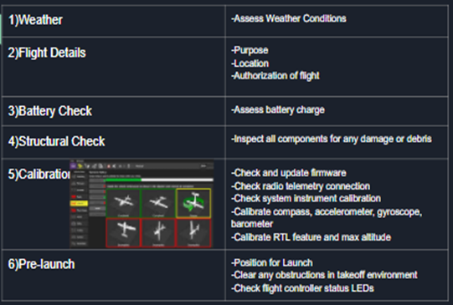
Table 1: Preflight Checklist
A delivery drone system can also improve the job safety for delivery drivers in America. According to a study done by USA Today, Delivery Driver was rated as the 7th deadliest job mostly due to fatal motor vehicle accidents. About 80% of delivery driver fatal injuries come from driving accidents.

Environmental Impact
Lawrence Livermore National Laboratory conducted a study on the environmental impact of drone delivery while also considering the impact of regional electrical energy production that drone and electric vehicle batteries will use for charging between deliveries. They found that in the cleanest energy production state of California, drone delivery of a small package would result in about .42 kg of greenhouse gas emissions while standard truck delivery results in about .92 kg. That is a savings of 54 percent. In the state of Missouri, who still relies heavily on fossil fuel and coal for power generation, that improvement would be about 23 percent less but still better. That would be approximately .64 kg of greenhouse gas emission by drone if truck delivery in Missouri were to produce .92 kg CO₂. The table below quantifies this research and shows why small drones delivering packages are better for the environment than large drones and trucks. Regular gas powered vehicles are actually still better for the environment than large drones depending on which state you live in.
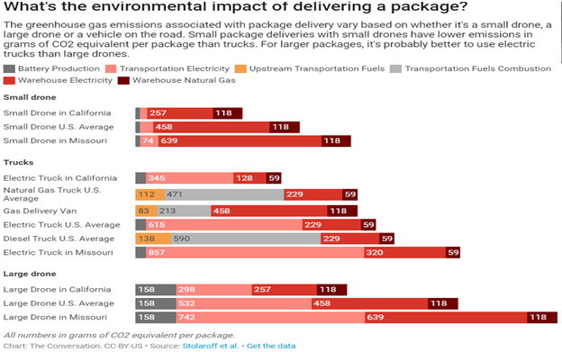
Graph 1: CO₂ emissions Attributable to Package Delivery

Technical / Social / Economic Impact
A drone delivery service will revolutionize the way packages are delivered worldwide! We would see a decrease in delivery times, increase in access to goods, increase in high paying jobs, possible increase in customer satisfaction and a reduction in traffic congestion in many cities.
According to Amazon CEO Jeff Bezos, about 86 percent of orders at the global online retailer ships weighs less than 5 pounds! Amazon is investing billions in developing autonomous aircrafts that can drop a book or a pair of shoes at your home within 30 minutes of receiving an order. This will reduce 1-2 day prime shipping to an astounding 30 minutes for millions of customers.

1.6 Initial Project constraints
Budget is the biggest constraint. High performance parts are VERY expensive while inexpensive parts can be unreliable. We had many electromagnetic interference and poor sensor performance issues with our chosen flight controller because of how cheap it was. The flight controller we choseis a pixhawk 2.4.8 and it is a clone of the original 3DRobotics pixhawk. It came in a $70 kit that included many of the necessary flight peripherals such as GPS, radio telemetry, buzzer, etc. The one we have is using a MS5607 barometer when it should have the MS5611 like the original. The price difference is only a few pennies but the performance difference is wide. This difference causes bad attitude estimation and creates imu reset and EKF resets errors in the autopilot software. These resets happen when the software deems the sensor readings as being inconsistent or unreliable. This creates inconsistent drone performance and safety concerns.
Another project constraint is our drone is not waterproof so we will only be able to operate in clear weather conditions. Due to restrictions on airspace defined by the FAA, we cannot fly above 400 feet, stadiums, buildings, crowds, highways, or busy streets without explicit permission from the local supervisory PVAMU/TAMU authorities and/or FAA. We are also constrained by any part of the FAA Summary of Small Unmanned Aircraft rules (Called Part 107) that we do not obtain a waiver for.

2.Project Planning and Task Definition
2.1 Task identification
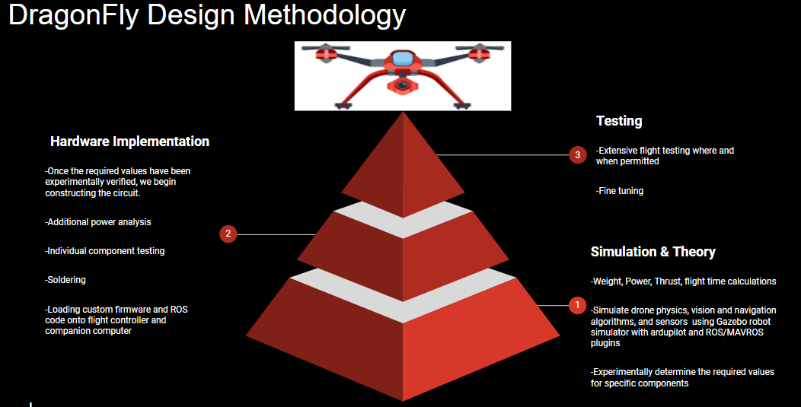
Figure 1: Task Identification for DragonFly Design
The project had three phases: Simulation & Theory, Hardware Implementation, and Testing. Our first phase for the project was to lay a sound foundation to build on. This meant researching what we would need to meet our end goal, doing the theoretical calculations, and simulating a drone to not only familiarize ourselves with drone operation but to also ensure some of our preliminary calculations were correct such as the flight time calculations. We also simulated drone physics, vision and navigation algorithms, and sensors using Gazebo robot simulator with ardupilot and ROS/MAVROS plugins. The following diagram illustrates the software flow for simulating the drone physics and operation.

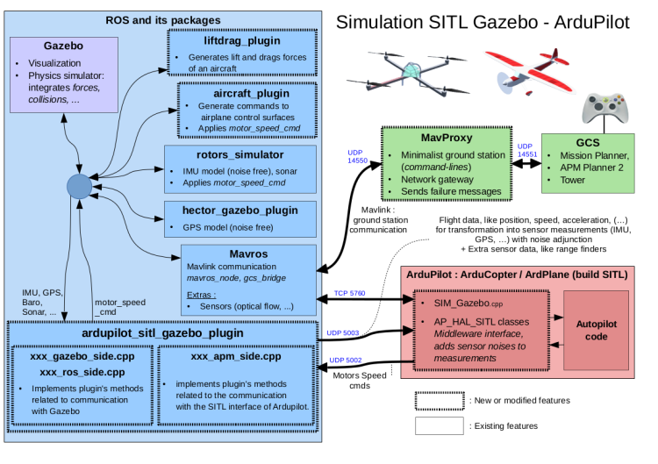
Figure 2: ArduPilot Software in the Loop
After we lay a strong foundation, we move on to the second phase and build upon our sound foundation. This phase of the project meant additional power analysis/calculations using device data sheets and building a prototype we called “Firefly” to test some of our theory on and familiarize ourselves with real time operation of a drone.

Finally, phase 3 meant extensive flight testing of both the Firefly and the DragonFly prototypes when and where permitted following our pre-flight checklist.

2.2 Gantt Chart
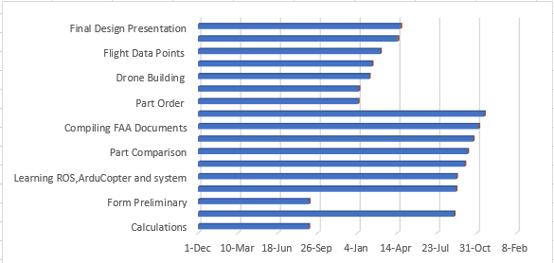
Graph 2: Gantt Chart

3. Literature review
3.1 List of all sources of information
[1] ArduPilot Dev Team “ArduCopter Documentation” 2020 https://ardupilot.org/copter/
[2] ArduPilot Dev Team “Ros for ArduPilot Documentation” 2020
https://ardupilot.org/dev/docs/ros.html

[3]Tiziano Fiorenzani Playlist “Drone Tutorials” Youtube, 2017
https://www.youtube.com/watch?v=TFDWs_DG2QY&list=PLuteWQUGtU9BcXXr3jCG00uVXFwQJkLRa
[4]Tiziano Fiorenzani Playlist “Visual Odometry and Vslam” Youtube, 2017
https://www.youtube.com/watch?v=T5Y6OPG-d08&list=PLuteWQUGtU9AoAgFtZYRSoyTTIJ5WgRqP
[5]Tiziano Fiorenzani Playlist “ROS Tutorials” Youtube, 2017
https://www.youtube.com/watch?v=N6K2LWG2kRI&list=PLuteWQUGtU9BU0sQIVqRQa24p-pSBCYNv
[6]Tiziano Fiorenzani Playlist “MAVROS = ROS + MAVLINK” Youtube, 2017
https://www.youtube.com/watch?v=e2krAUKs9G8&list=PLuteWQUGtU9AqqWgwdEJukAhawpcoIaF3

3.2 Statement of Learning from each source
We performed a literature review by first reviewing ardupilot.org/arducopter. Ardupilot is the flight controller firmware the drone will use to manage flight. The developers of Ardupilot have created documentation that gives curious minds all of the information needed to design, program, and construct your very own autonomous drone or simple multi-rotor. Here, you can find tons of videos, step by step guides, and links to other resources.. It is the main resource we reference throughout the project. After identifying the sources, we compile everything into a shared google drive and we take notes on what we read so we can extract the most crucial information. We also used YouTube channels such as Tiziano Fiorizani. Tiziano provides excellent tutorial videos on software setup, hardware interfacing, and drone programming.

4. Preliminary Design
4.1 Concept Generation
We generated the design concept of the DragonFly using the Arductopter documentation. Right from the beginning, we knew we would need a 6 motor (Hexa-copter) configuration. The six motors together provide the ideal 2 to 1 thrust to mass ratio we need for ideal flight behavior. With this extra thrust, we can carry more weight. Additionally, you only need four motors for a multi-rotor aircraft to fly, so the motor redundancy in a hexacopter configuration increases our safety margins. We can lose up to two motors before the drone plummets to the ground. Finally, a hexacopter has much greater flight stability than a quadcopter design.
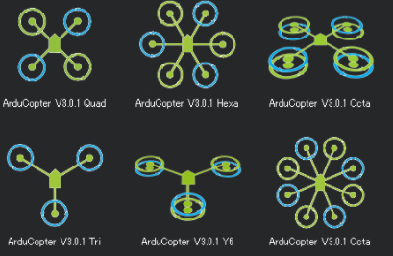
Figure 3: Potential Motor Configurations

4.2 Concept Evaluation & Selection
Considering the details stated above and our testing of the Firefly quadcopter prototype, the hexacopter configuration proved to be the ideal choice for carrying payloads for any considerable distance in terms of safety, energy efficiency, and power. Additionally, we observed first hand the benefit of having motor redundancy when our Firefly prototype crashed after losing a single propeller during a test flight.

4.3 Design Constraints and Applicable Codes and Standards
Constraints
-Budget
-Can only operate in clear weather conditions (Not waterproof)
-Restricted Airspace: We cannot fly above 400 feet, stadiums, buildings, crowds, highways, or busy streets without explicit permission from the local supervisory PVAMU/TAMU authorities and/or the FAA.
-Space on the chosen frame for mounting the electronics and payload.
-Flight controller performance
Codes and Standards
-FAA Small Unmanned Aircraft rules Part 107 (Attached in appendix)

4.4 Preliminary Design Analysis
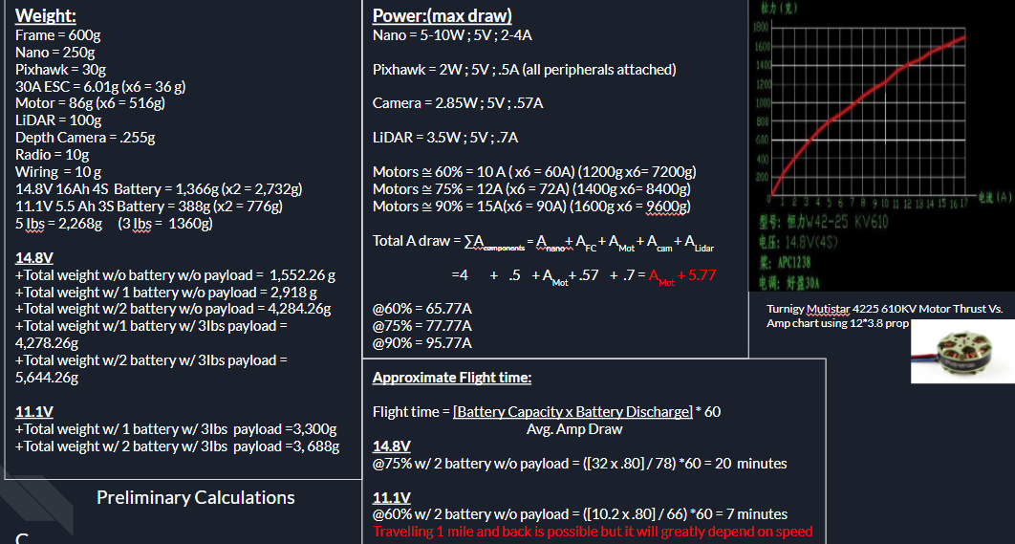
Table 2: Preliminary Calculations

We began our preliminary calculations by adding up the total weight of the drone. Once we have the total weight, we can identify how much thrust we would need to generate to achieve hover and ideal flight behaviour. A general rule of thumb is to have a 2:1 thrust to mass ratio to achieve ideal flight behaviour. However, after takeoff you only need to generate thrust equal to the weight of the drone to maintain altitude (hover). Using device data sheets we calculated the total power draw at 60%, 75%, and 90% load. We assumed we would be operating the drone at 75% for most of the time which is actually an overestimation to be safe. At a constant 75% load and consuming 80% of the total battery with two 14.8V 16A Lipo batteries, we approximated a flight time of around 20 minutes. We would definitely be able to transport a 3 pound package a mile away and return safely if we travel at least 5 miles per hour. However at the time of part purchasing, neither the batteries nor the motors were available so our design calculations had to change slightly. (see section 5.2 for calculation differences)
4.5 Preliminary Design

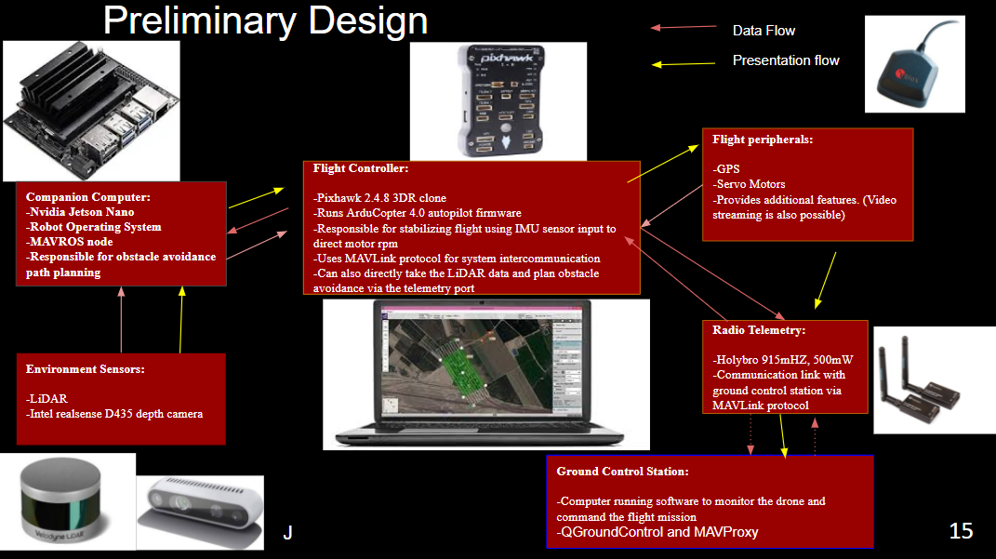
Figure 4: Preliminary Design
This diagram shows the general idea behind each component and how they work together. Starting with the bottom left box you have the environmental sensors. They are measuring the distance between the drone and its environment and feeding that data to the companion computer. The companion computer is the Nvidia Jetson Nano and it is responsible for running Robot Operating System and updating the flight controller with new flight paths to avoid collision with its environment. The flight controller is responsible for stabilizing flight by directing the rpm of each motor using the IMU sensor data. The flight peripherals such as the GPS and radio telemetry are attached to the flight controller. During the project we actually discovered that the LiDAR can be connected directly to the flight controller as if it were a flight peripheral since the autopilot software we used actually has obstacle avoidance algorithms built in. Opting for this connection would actually remove the need for a companion computer.

The flight controller communicates with the ground control station via radio telemetry at 915Mhz. The GCS we use is called Qgroundcontrol. It is a robust fully featured GCS that displays real-time data on UAV performance, position, and even a camera’s live video stream. It can also be used to control a UAV in flight, upload new mission commands and set mission parameters. It even has a “male siri” that will announce vehicle states, error messages, and other necessary information for the pilot in command!

5. Detailed System Design

5.1 Project Part Summary

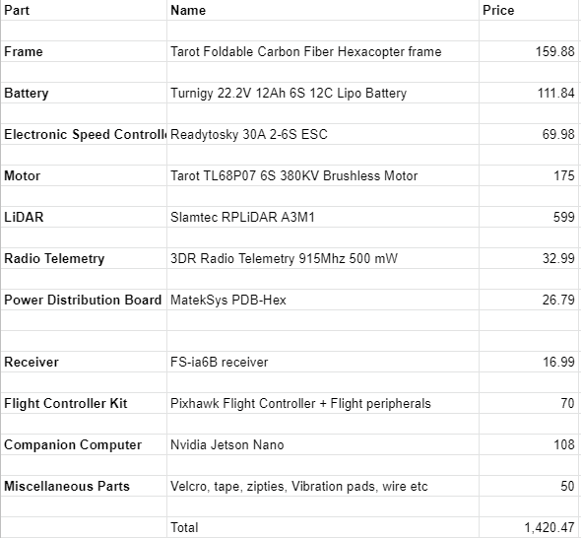
Table 3: Project Part Summary

After much consideration and unavailability of some parts at the time of purchasing, these are the parts we settled for. In hindsight, we should have allocated more of the budget towards the flight controller rather than the LiDAR and the frame since the poor performance of the flight controller made it unsafe to actually mount the LiDAR during testing.

5.2 Engineering Analysis
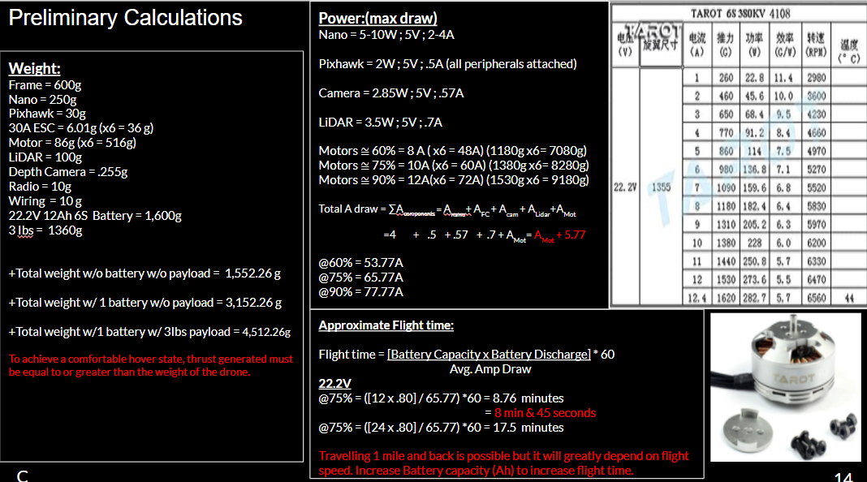
Table 4: Final Calculations

Here, not much has changed from our preliminary calculations besides the battery capacity/weight and the motors. Initially, we wanted to use a 14.8V 16A Lipo Battery and 680KV motors but due to unavailability, we went with a 22.2 V 12A Lipo Battery and 380 KV motors. We actually see a performance increase with our final motor choice. We see equivalent thrust being generated for less energy in comparison. At a constant 75% load, we approximate a flight time of around 8 minutes and 45 seconds. With a 8 minute and 45 second flight time, we would have to be travelling 6.8 miles per hour to reach a mile right at the end of that time. We would have to be traveling at about 14 miles per hour to fly a mile and back within that flight time. We can double the batteries in a parallel connection to increase flight time but we would lose the approximate 2:1 thrust to mass ratio which would impact overall flight time.
5.3 Hardware Layout/ Detailed Drawings/ Equipment Selection & Specifications
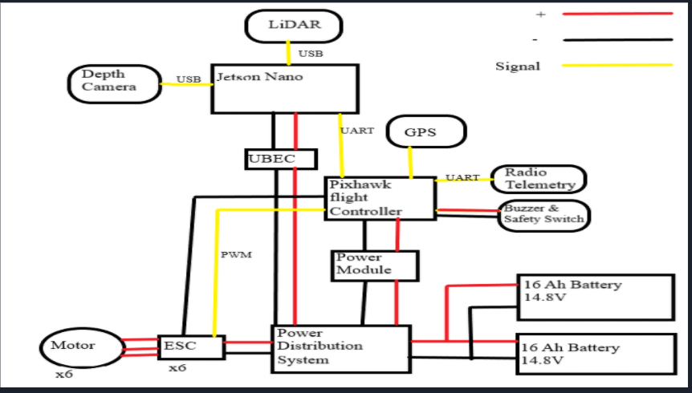
Figure 5: Hardware layout
Despite the unavailability of the batteries shown in the diagram, we left the diagram as is because they are still our ideal choice. The batteries are going to feed power to the power distribution board which is of course distributing to the rest of the electronics.
The 22.2 V battery we chose is illustrated in the following figure:
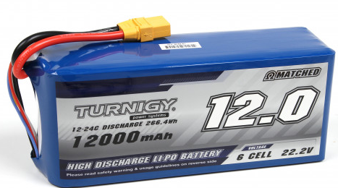
Figure 6: Turnigy LiPO Battery

The Power distribution board and specifications are illustrated in the following figure:
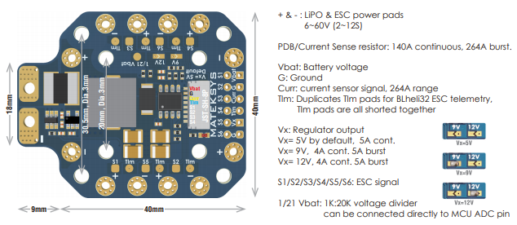
Figure 7: Mateksys Power distribution board
The flight controller requires 5V so we need a voltage regulator to step down the incoming power. Not only is the power module stepping down the voltage, it is also measuring the battery current and feeding that data to the flight controller which is relaying that information to the ground control station for the pilot to monitor. The power module can take between 6-30V and measure up to 90A continues. The GPS is connected to the flight controller via i2c and the radio is connected via UART.
The flight controller and kit we used is illustrated in the following figures:
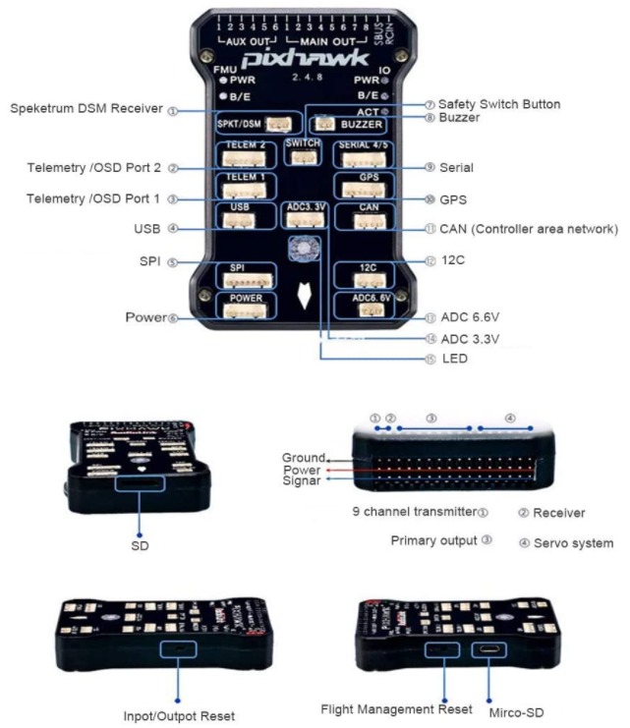
Figure 8: Pixhawk Flight Controller
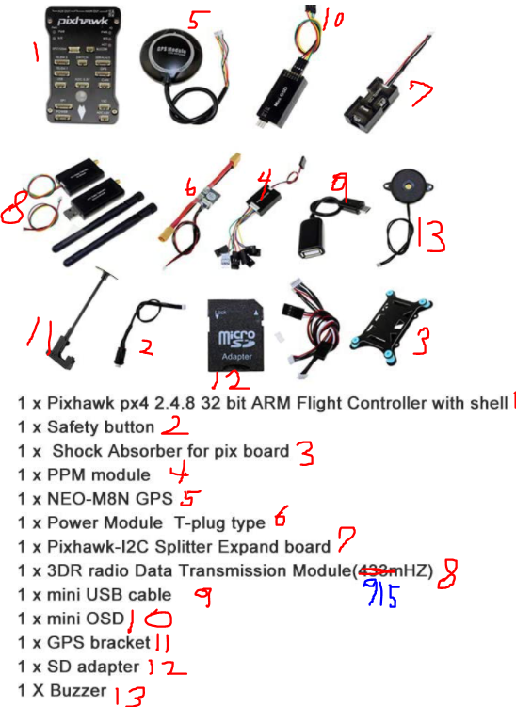
Figure 9: Pixhawk Flight Controller Kit (Flight Controller + Peripherals)

The flight controller is directing the motor rpm via pwm signals to the electronic speed controllers. The electronic speed controllers take the input signal and control the motor speed and direction by activating the appropriate MOSFETs to create the rotating magnetic field as illustrated below.
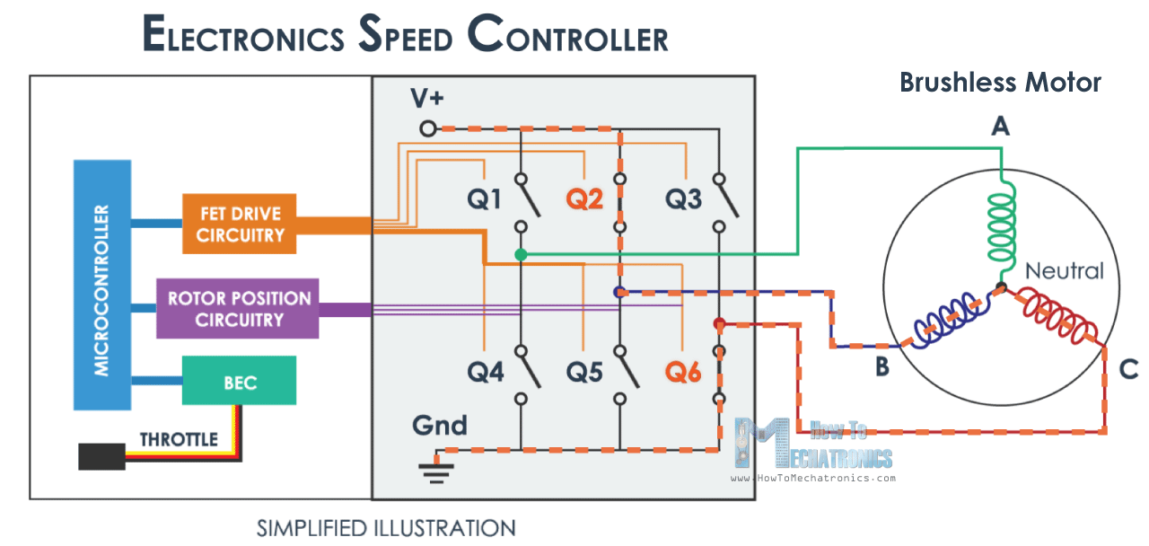
Figure 10: Electronic Speed Controller Diagram
The companion computer also operates on 5V so it also needs a voltage regulator to step down the incoming 22.2 V (14.8V in the diagram). The jetson nano is illustrated in the following figure:
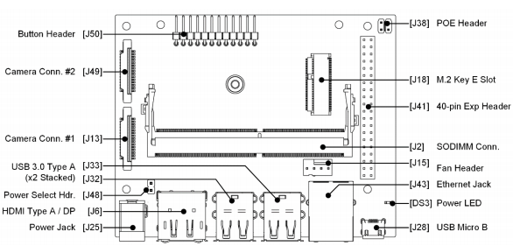
Figure 11: Jetson Nano Pin Diagram
The following figure illustrates the connection between the pixhawk and the jetson nano via UART:

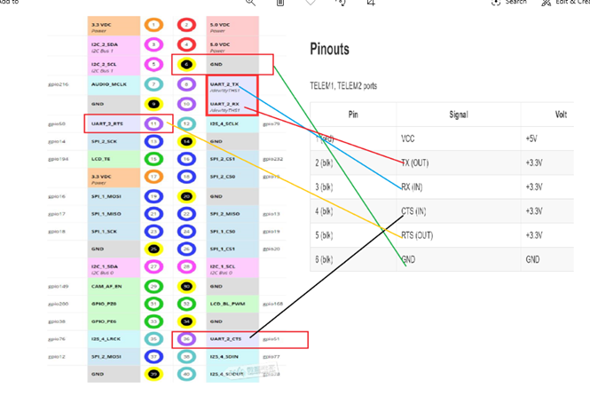
Figure 12: Connection between pixhawk and jetson nano

The following figure illustrates the LiDAR and its specifications:
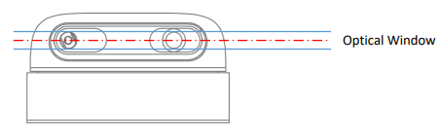
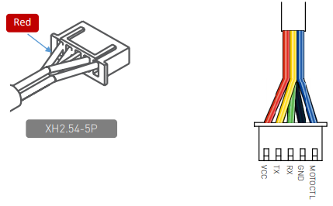
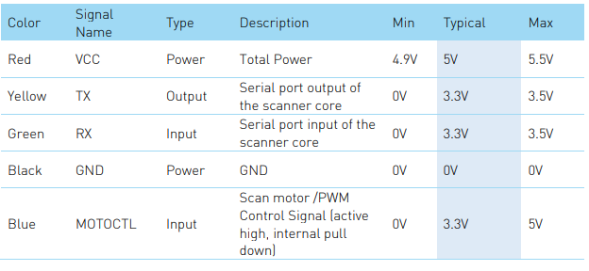
Figure 13: RPLiDAR A3M1

5.4 Application of Engineering Standards used in Final Design
For this project we primarily used the FAA Summary of Unmanned Aircraft Rules as the standard for our drone design and drone operation(see appendix A). In the rules, it details the performance and safety requirements that we must abide by if we want to be compliant with the U.S aerospace authority. Our preflight checklist (figure 1) and choice of components revolved around their guidelines. We could not perform flight tests that went beyond the boundaries laid out by the FAA and thus designed the drone around what we could actually test.
5.5 Economic Analysis
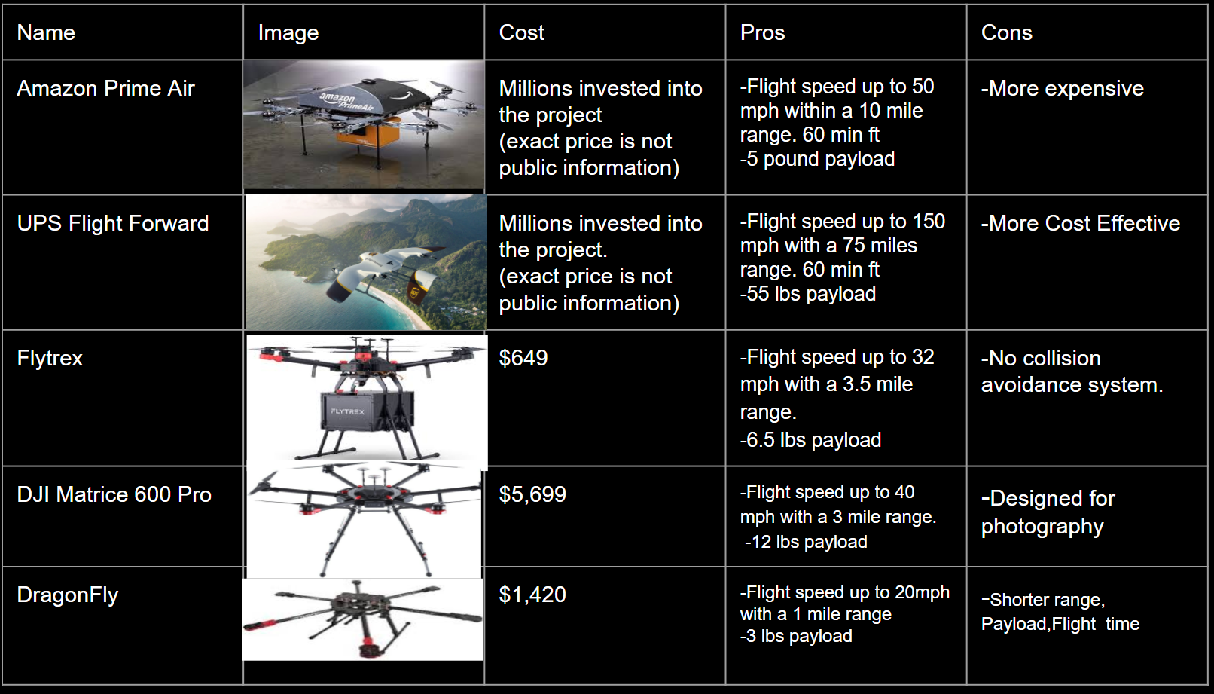
Table 5: Economic Analysis
While there are still issues that need to be addressed with the Dragonfly such as inconsistent flight controller performance, our project is competitively priced. Flytrex boasts better performance than the DragonFly but it does not have a collision avoidance system. The LiDAR and companion computer we chose for the collision avoidance system actually makes up half of our total budget. If you were to remove those two components considering we never attached them for a test flight due to safety concerns, the total cost would be $713. The DragonFly is currently not competitive at all with the other market options performance wise but that will change.

5.6 Final Design
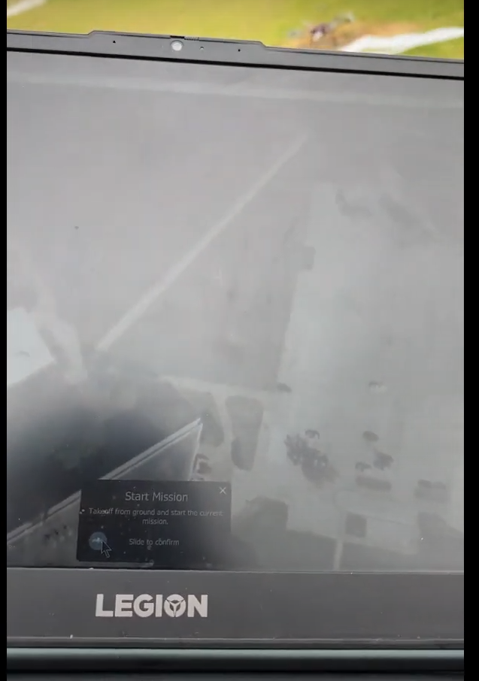
Figure 14: Starting Mission, Ready for Liftoff!

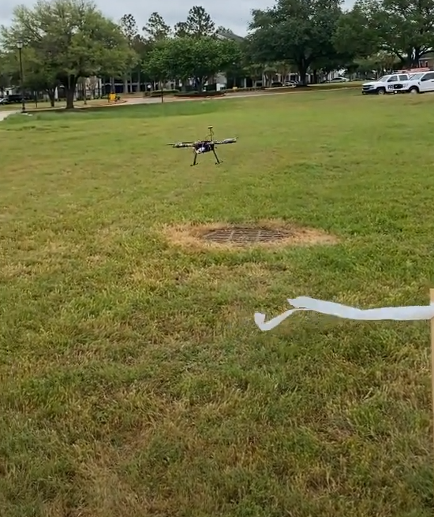
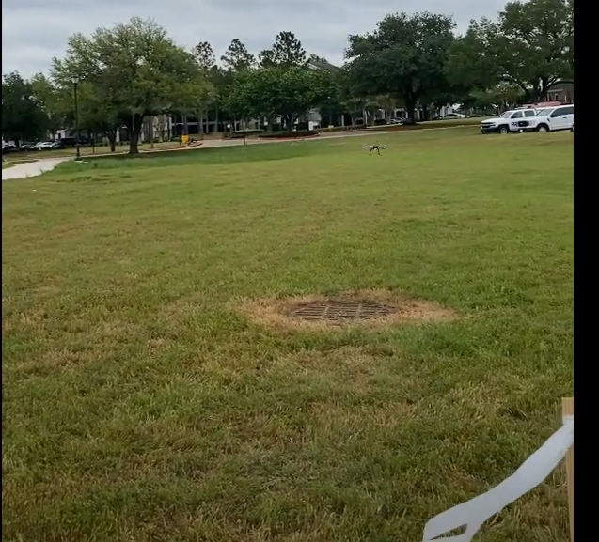
Figure 15: Liftoff and travelling to GPS waypoint

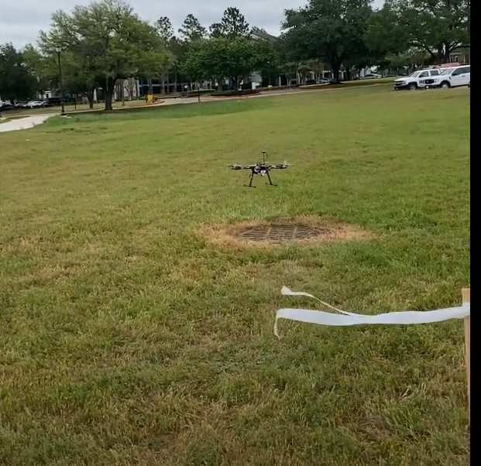
Figure 16: Return to launch and Landing!

6 Results and Discussion
6.1 Summary of Goals and objectives
We were able to successfully complete the following objectives we laid out for ourselves
      - A working prototype
      - A demonstration of the drone operating by April
      - A comprehensive final project report by April
Despite the fact we did not test the LiDAR on the drone, we did test the LiDAR connection with the flight controller and it did work. However, due to safety concerns we did not proceed to a flight test. After we install a new flight controller we will be testing the obstacle avoidance capability.
6.2 Summary of Constraints and Codes met by design
Advantages:
- Can carry packages up to 3 pounds.
- Can be controlled remotely or operate autonomously
- Easily maneuverable
- Cost effective for an autonomous drone.
- Motor redundancy
- Adheres to FAA Rules (Academic use)

Disadvantages:
- Short battery life, 8 minutes of flight time based upon flight speed.
- Exposed circuitry on drone.
- Very cheap flight controller with poor performance
- Drone isn’t waterproof.

6.3 Discussion of Results and other use cases
Our project will not have a performance advantage over any of the commercially available solutions. We simply do not have the budget to purchase the parts that would make the DragonFly competitive so this project will purely be a proof of concept. The only advantage we could claim is the price of the DragonFly.. However, in terms of quality and performance, you get what you pay for. Commercially available drones with obstacle avoidance capabilities, 5+ pound payload, and 20+ min flight time generally cost $2,000 or more. While our drone may have similar obstacle avoidance capabilities, we cannot compete in terms of payload and flight time.
The potential use cases for commercial drone technology are only limited by your own imagination! Other use cases include:
- Surveillance
- Photography
- Tourism
- Humanitarian / Disaster Relief
- Disease Control
- Advertising
- Agriculture
- Weather Forecasting
- Construction
- Sports and Entertainment!
7. Conclusions and Recommendations
This is a very comprehensive project and every single course we have taken in the Electrical & Computer Engineering Department aids us in understanding the various technical aspects. Everything from Freshman C++ programming, Calculus and circuit analysis to Senior Electromagnetism, Communication Theory, Microprocessor System & Design, Energy Conversion, Control Theory, and Principles of Solid-State devices has been revisited.
For the team members with no robotics or programming experience, there is a steep learning curve. Skills required for this project that were not taught in our coursework include advanced C++, real control systems, Robot Operating System, and soldering. Thankfully, everything you could possibly want to know is freely available online. We used YouTube videos, online forums, and developer documentation / guides to accumulate the necessary knowledge.
However, much work still needs to be done before this is a commercially viable product ready to be scaled up! We recommend further development of this project beginning with a flight controller replacement and extensive LiDAR testing.

List of References
[1] ArduPilot Dev Team “ArduCopter Documentation” 2020 https://ardupilot.org/copter/
[2] ArduPilot Dev Team “Ros for ArduPilot Documentation” 2020
https://ardupilot.org/dev/docs/ros.html

[3]Tiziano Fiorenzani Playlist “Drone Tutorials” Youtube, 2017
https://www.youtube.com/watch?v=TFDWs_DG2QY&list=PLuteWQUGtU9BcXXr3jCG00uVXFwQJkLRa
[4]Tiziano Fiorenzani Playlist “Visual Odometry and Vslam” Youtube, 2017
https://www.youtube.com/watch?v=T5Y6OPG-d08&list=PLuteWQUGtU9AoAgFtZYRSoyTTIJ5WgRqP
[5]Tiziano Fiorenzani Playlist “ROS Tutorials” Youtube, 2017
https://www.youtube.com/watch?v=N6K2LWG2kRI&list=PLuteWQUGtU9BU0sQIVqRQa24p-pSBCYNv
[6]Tiziano Fiorenzani Playlist “MAVROS = ROS + MAVLINK” Youtube, 2017
https://www.youtube.com/watch?v=e2krAUKs9G8&list=PLuteWQUGtU9AqqWgwdEJukAhawpcoIaF3

Appendix A:
FAA Guidelines for SUAS
