PRAIRIE VIEW A&M UNIVERSITY
ROY G. PERRY COLLEGE OF ENGINEERING

Object Detection on Raspberry Pi

ELEG 4247: Senior Design & Professionalism II

Topic: Final Report

Team Number 5

Submitted by:
Joshua Littleton (Team Lead)
Tri’Heem Neville
Arthur Quinney
Xavier Dukes
Christopher Rollerson

Instructor: Professor Turner
Faculty Sponsor: Dr. Dong

Date of Submission: May 1, 2022

Project Executive Summary
Problem Statement
On average, approximately 4,800 burglaries happen every day. One-third of all robberies result in injury and 39% of the time a weapon is present when an individual is harmed. Arrest rates for Weapon offenses have doubled since 1965 including unlawful possession and trespassing.
Proposed Deliverables
- We will be using a Raspberry Pi attached with a camera to survey the area and identify potential threats
- The machine learning (ML) algorithm we implement detects the threatening objects on an individual such as weapons in real-time
- Once an object defined as a threat is detected, a text notification is sent to the owner/operator’s phone allowing them to determine the course of action
Budget
- The total budget for our project is $600.00
- The total amount spent on our project is $340.00
Customer requirements And Engineering solutions
- Mass producible by using easily obtainable/cost-effective parts
- Lightweight parts for mounting purposes
- Train machine learning algorithm to detect various weapons
- The camera needs a resolution of 1080p for increasing the range of detection
- Text notification alerts of potential threats
- The algorithm classifies threats and non-threats
- Detect threats in real-time

Major Constraints
- The housing for the Raspberry Pi and camera must be mountable
- The camera resolution affects detection accuracy and distance
- The limited frame rate of the Raspberry Pi camera

Benefits
- Societal: This project will offer greater security to those that cannot afford other options. Businesses will be capable of guaranteeing the safety of customers without infringing upon a customer's 2nd amendment right to carry while within the public space.
- Safety: The primary goal of this project is to create an affordable security system for small businesses and homeowners to proactively respond to potential threats however they see fit.
- Technical: Machine learning has not been utilized within security systems to this day. Our project will pioneer a smart security system that will inform you of potential dangers at the first sighting of a weapon that would provide a danger to security or the owner.
Recommendations
We recommend that the unit is mounted to a stable elevated surface, ensure there is nothing blocking the camera lens, make sure the Raspberry Pi is located in a well-insulated area to prevent overheating the unit, provide a power source for the Raspberry to connect to, and lastly to get the best usages of our product do not forget to set up a Twilio account for all alerts and notifications.

Conclusion
Our design will identify active threats by revealing displayed weapons. This artificial intelligent threat detection system will impact many from universities and church organizations to businesses and homeowners.

Table of Contents
Project Executive Summary ii
Table of Contents v
List of Figures vii
List of Tables and Graphs viii
List of Team Members and Roles ix
Section 1 - Project Scope 1
1.1 Problem Statement, Business Objective and Target Audience 2
1.2 Client Identification and Recognition of Need 3
1.3 Project Goals and Objectives 6
1.4 Contemporary Issues Relevant to the Project 7
1.5 Potential Impacts of the Project 8
1.5.1 Societal Impact: 8
1.5.2 Safety Impact: 8
1.5.3 Technical Impact: 9
1.6 Initial Project Constraints 11
Section 2 - Project Planning and Task Definition 12
2.1 Task Identification 13
2.2 Gantt Chart 14
Section 3 - Literature Review 16
3.1 List of All Sources 17
3.2 Statement of Learning from Each Source 20
Section 4 - Preliminary Design 22
4.1 Concept Generation 23
4.2 Concept Evaluation and Selection 24
4.3 Constraints and Applicable Codes and Standards Used in Preliminary Design 26
4.4 Preliminary Analysis 27
4.5 Preliminary Design 28
Section 5 - Detailed System Design 30
5.1 Project Parts Summary 31
5.2 Engineering Analysis 32
5.3 Hardware Layout/Detailed Drawings/Equipment Selection and Specifications 35
Hardware Layout 35
Detailed Drawings 35
Equipment Selection and Specifications 44
5.4 Overview of Code 49
5.5 Application of Engineering Codes and Standards used in Final Design 54
5.6 Economic Analysis 55
5.7 Final Design - Show Pictures or Other Examples of Working Design 56
Section 6 - Results and Discussion 63
6.1 Summary of Goals and Objectives 64
6.2 Summary of Constraints and Codes met by Design 65
6.3 Discussion of Results and Other Use Cases 67
Section 7 - Conclusions and Recommendations 68
List of References R1
Appendix A1
Code to Run Camera and Send Notification: A2
Code for the Training of the Model A8

List of Figures
Figure 1.1: Example of Weapon Detection of a Firearm 10
Figure 1.2: Example of Weapon Detection of a Knife 10
Figure 2.2: Gantt Chart (part 1) 14
Figure 2.2: Gantt Chart (part 2) 14
Figure 2.3: Gantt Chart (part 3) 15
Figure 2.4: Gantt Chart (part 4) 15
Figure 3: Preliminary Design
Figure 4: Software Flow Chart
Figures 5.1-5.8: Images of Parts
Figure 6: LabelImg Software
Figure 7: Hardware Layout
Figure 8: Housing Design
Figure 9.1: Front Camera Plate
Figure 9.2: Side Camera Cover
Figure 9.3: Camera Visor
Figure 9.4: Back Camera Plate
Figure 9.5: Hinge
Figure 9.6: Upper & Lower Arm
Figure 9.7: Long & Short Screws
Figure 9.8: Pi Case Top
Figure 9.9: Pi Case Bottom
Figure 10.1: Camera Dimensions
Figure 10.2: Loading Label Map
Figure 10.3: Loading in the Model
Figure 10.4: Boxes, Scores, Classes, and Number of Boxes
Figure 10.5: Frame Rate Calculation
Figure 10.6: Running Detection Model
Figure 10.7: Visualization of Results
Figure 11.1: Twilio Setup
Figure 11.2: SMS Notification Execution
Figure 12.1: Rifle Detected with 95% Confidence
Figure 12.2: Rifle Detected with 100% Confidence
Figure 12.3: Covered Rifle Detected with 97% Confidence
Figure 13.1: Handgun Detected with 84% Confidence
Figure 13.2: Handgun Detected with 97% Confidence
Figure 13.3: Barrel Pointed at Camera Detected with 75% Confidence
Figure 13.4: Partially Covered Handgun Detected with 93% Confidence
Figure 13.5: Black Handgun Detected on Black Jacket with 99% Confidence
Figure 14.1: Blade Detected with 91% Confidence
Figure 14.2: Blade Detected with 84% Confidence
Figure 14.3: Narrow Profile of Blade not Detected
Figure 15: Example Notification
Figure 16.1: Cell Phone False-Positive Test (part 1)
Figure 16.2: Cell Phone False-Positive Test (part 2)

List of Tables and Graphs
Table 1: Matrix 5
Graph 1: Percentages of Weapons used in Robberies 9
Table 2: Project Comparison Chart 25
Table 3.1: Raspberry Pi 4 Model B Specifications 44
Table 3.2: Raspberry Pi Camera Specifications 45
Table 3.3: Coral USB Accelerator Specifications 46
Table 3.4: Power Supply Specifications 46
Table 3.5: Micro-HDMI to HDMI Cable Specifications 46
Table 3.6: MicroSD Card Specifications 47
Table 3.7: Pi-FAN Specifications 48
Table 3.8: Polylactic Acid Specifications 48
Table 4.1: Phase 1 Cost 55
Table 4.2: Smart Threat Detection System Cost 55

List of Team Members and Roles
Joshua Littleton ……….…………………………………...………………………….. Team Lead Arthur Quinney …………………………………………………………. Parts Procurement Lead Christopher Rollerson ……………………………………………………. Design Analysis Lead Tri’Heem Neville ….…………………………………………... Scribe and Presentation Manager Xavier Dukes ………………………….………………………………….......Software Developer

Section 1 - Project Scope

1.1 Problem Statement, Business Objective and Target Audience
Across the United States, a burglary happens every 15 seconds. This equates to a staggering 4800 burglaries a day on average. A burglary is defined as an unlawful entry of a structure to commit a felony or theft. Two-thirds of these burglaries affect residential properties while the remaining third affect small businesses. In 2020, 33,296 robberies involved a handgun, and an additional 8,641 involved a knife. A robbery can be more severe than a burglary, as it must involve threats or actual violence. Arrest rates for weapon offenses have doubled since 1965 including unlawful possession and trespassing. However, according to the U.S. Department of Justice, Bureau of Justice Statistics, a substantial portion of violent crimes that take place in homes have taken place during a burglary incident.
The goal of this project is to design an intelligent monitoring system that will enhance our ability to survey public and private spaces by using object detection to identify various threats that could potentially lead to security risks and/or bodily harm.
The target audience for this project is small businesses, homeowners, hospitals, schools/universities, and churches.

1.2 Client Identification and Recognition of Need
- The device should be mass-producible; to achieve this we plan to use easily obtainable parts that are cost-effective. Due to the target audience being homeowners and small businesses, we want to make this device available to everyone at a reasonable price.
- The final product must be mountable and lightweight; this will be achieved by using lightweight materials and cheaper parts. This will ensure that it can be mounted on a wall for extended periods of time without any complications. The final product will be placed in conventional security camera locations, to survey the area.
- This device must detect a variety of potential threats as weapons come in various shapes, sizes, and calibers. This is a perfect application for machine learning (M.L.) as there is not any set of definite rules to classify the myriad of types of weapons there are. The flexibility required for this particular use case lends itself very well to the use of artificial intelligence (A.I.).
- The detection of potential threats at a distance is imperative to the preemptive Smart Detection System. A high degree of accuracy is required to minimize false positives. Poor resolution can affect accuracy and may not give an adequate warning since the potential threat will have to be closer to the camera when compared to a higher resolution camera. The camera will have a minimum resolution of 1080p to accomplish the goal of high accuracy, but we are also limited by the processing power of the Raspberry Pi.
- The device needs to be able to communicate with other devices such as a phone or monitor to deliver the alert notification system. A text message should be sent immediately, via Twilio, to the home or business owner for appropriate action to be taken.
- Object detection must be able to distinguish between a threat and a non-threat entity. The Raspberry Pi has limited processing power and should not waste valuable CPU power on low-risk or non-threatening individuals. The M.L. algorithm should focus on items that are deemed as potentially dangerous.
- Real-time tracking is essential as the camera will give real-time data for the environment it is monitoring. The delay between the image processing and the time the data is received should be minimized for the most effective results. Raspberry Pis is particularly suited for real-time environments as they are often used in robotics due to their real-time clock (RTC) functionalities.
Marketing Requirements | Engineering Requirements | Justification
Mass Producible | Easily obtainable and cost-effective parts | Target audience is homeowners and small business owners
Mountable/Lightweight | Lightweight parts sturdy enough to be mounted for extended periods | Will be placed in conventional security camera locations
Detect a variety of potential threats | Train machine learning (M.L.) algorithm for weapon detection | Threats come in various forms, and this is an abstract problem with no clear formula. Requiring the flexibility of Artificial Intelligence
Detect potential threats at a distance | Camera has minimum resolution of 1080p | Poor resolution images are more difficult to decipher and can cause inaccuracies
Alert Notification System | Send an alert through a text message | Alerts the home/business owner of the potential threat near the camera
Distinguishable between threat and no threat | M.L. model will be trained to detect items deemed as threats | Camera’s tracking will not focus on low-risk individuals and will dismiss them
Real Time Tracking | Use Raspberry Pi for its real time clock (RTC) capabilities | Raspberry Pi utilizes RTC which is essential for real time environments

Table 1: Matrix

1.3 Project Goals and Objectives
The goal of this project is to design an intelligent monitoring system that will enhance our ability to survey both public and private spaces by using object detection to identify various threats. These threats could lead to security risks and or bodily harm. Utilizing machine learning (M.L.) within the Raspberry Pi, we will monitor and detect any potential threats and non-threats that would enter the surveyed area. Once an object is determined to be a threat, the homeowner or business owner will be alerted so that they may take action that they deem as necessary. The notification will be sent before any violent action takes place, making the system more proactive rather than reactive. The warning that is received is essential to the safety of the occupants of the property and any type of warning in a potentially dangerous situation can aid in the mitigation of severe bodily harm.

1.4 Contemporary Issues Relevant to the Project
Security is an essential part of our society, and our project is aimed at providing better security to small businesses, homeowners, hospitals, schools/universities, and churches. In our society, we have seen a drastic increase in gun violence and gun violence rates. In 2020, there was a 34% increase in gun violence deaths from the previous year, this also results in a 75% increase over the previous decade. Another important statistic to point out is that 79% of murders were carried out with a gun. If our project were to be implemented in our society these rates would start to decrease because people would be notified when there is a weapon present in their area.

1.5 Potential Impacts of the Project

1.5.1 Societal Impact:
- Open and constitutional carry in several states could be impacted by this technology, as of September 1, 2021, Texas became a constitutional carry state, and its residents could openly display firearms without a permit. These weapons and their visibility in society will increase
- Home and business owners will have greater security due to the threat detection services
- 30% of U.S. households have home security our system would grant greater security

1.5.2 Safety Impact:
- In 2019, there were an estimated 1,117,696 burglaries in the United States. 62.8% of those burglaries were residential properties, 37.2% of those burglaries were businesses.
- According to Statista, there were a total of 124,381 robberies that involved weapons in 2019. 66% of those robberies involved a firearm and 34% involved a knife or some other weapon.
- Statistics show that someone is present 27.6% of the time when a burglary is taking place, 7.2% of these burglaries result in someone being injured.
- Graph 1 shows the percentage of a certain type of weapon is used in robberies. This influenced our decision on what weapons our device will detect.

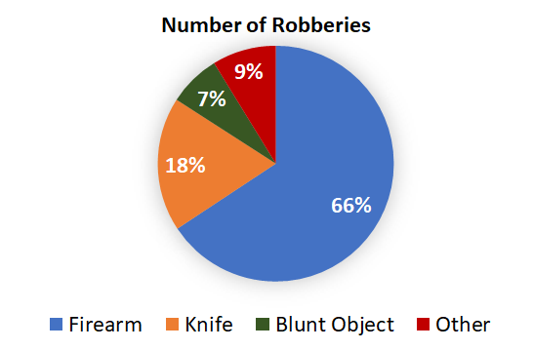
Graph 1: Percentages of Weapons used in Robberies

1.5.3 Technical Impact:
- Our project utilizes machine learning algorithms for the smart detection of weapons. The benefit of using M.L. is that our system will be able to learn on its own with the ability to detect new weapons
- Weapon detection using M.L will be done in real-time, which has not yet been implemented in conventional home and small business security systems, some examples of weapon detection are in Figures 2.1 and 2.2
- Weapon detection allows for the security system to be more proactive rather than reactive. This will help the homeowner/business owner to prevent the possibility of injury to themselves or others
- The figures below what a weapon detection interface would look like.
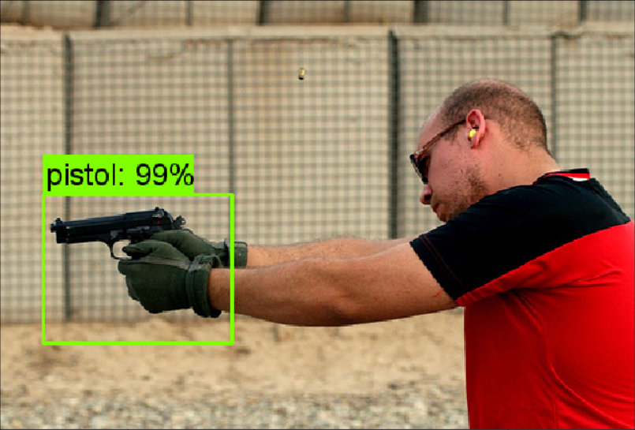
Figure 1.1: Example of Weapon Detection of a Firearm
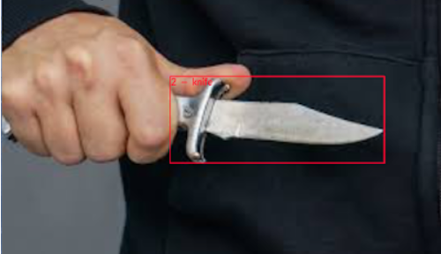
Figure 1.2: Example of Weapon Detection of a Knife

1.6 Initial Project Constraints
There are a few constraints that will influence the success of our project.
- The first is that the housing for the Raspberry Pi and camera must be mountable. This is due to our project acting as a security camera which is normally mounted to the wall in an unreachable location.
- The second constraint for our project is the camera resolution, which affects detection accuracy and distance. If our camera has a bad resolution, we will not be able to clearly detect the weapons at a distance and will have inaccurate readings.
- Our final constraint is the limited frame rate of the Raspberry Pi camera, which will also affect our detection accuracy and has an impact on our alert notification system.

Section 2 - Project Planning and Task Definition

2.1 Task Identification
The team began planning first by conversing with the faculty sponsor to choose the specialization for object detection we would implement. This built a foundation on what type of research will be needed, as well as how much data is necessary for the project to start, beginning with the understanding of object detection and the procurement of parts. The research period allowed for each group member to learn about Raspberry Pi and the operating system interface that went along with it making for the future steps to have a smoother transition.
The design and coding phase of the project allowed the group to learn the coding language, Python, and design the script for the project to run. While designing the project we began early-stage testing to determine if the code worked as expected and find if there were any errors that needed to be fixed before moving to the next step. After testing the code and determining it works as intended, the next phase was to specialize the project in weapon detection instead of just object detection. To accomplish this, an edit to the code is necessary as well as training for the machine learning model to be capable of learning and recognizing set weapons that would appear before the camera. After changing the code and training, the first prototype was complete; however, the next step was to solve the framerate issues and implement a notification system to the code.
The final phase was completing the notification system for the Raspberry Pi and solving the framerate constraint to accomplish real time tracking and provide accurate detection for when a weapon appeared on camera. These tasks ranged between being completed within a day and taking weeks, so the delegation of time and work needed to be allocated appropriately so that the project is capable of being completed before the allotted due date.

2.2 Gantt Chart
Throughout the year, time management is important for guaranteeing the project will be completed within a timely manner and that each member is working on their respective part by delegating the workload for the team to work as efficiently as possible. The following images are the complete Gantt chart displaying the detailed time delegation for each task to ensure the project progressed smoothly within the time limit.
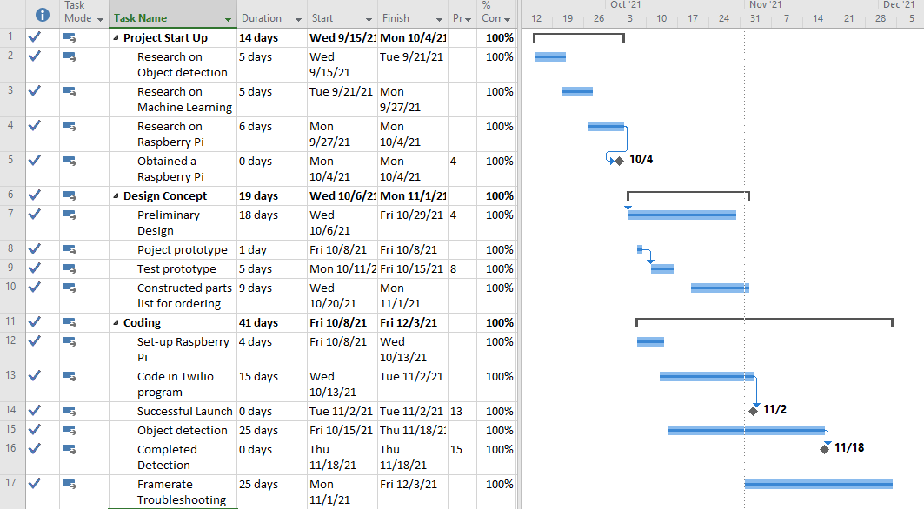
Figure 2.2: Gantt Chart (part 1)
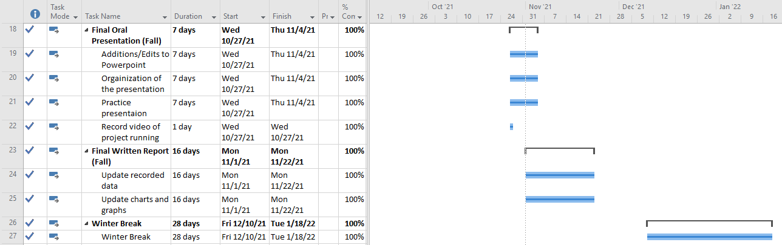
Figure 2.2: Gantt Chart (part 2)
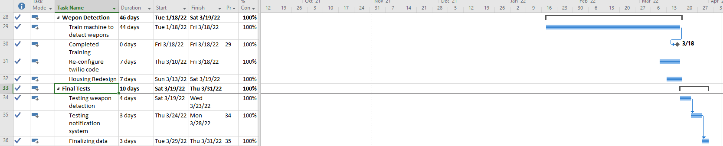
Figure 2.3: Gantt Chart (part 3)
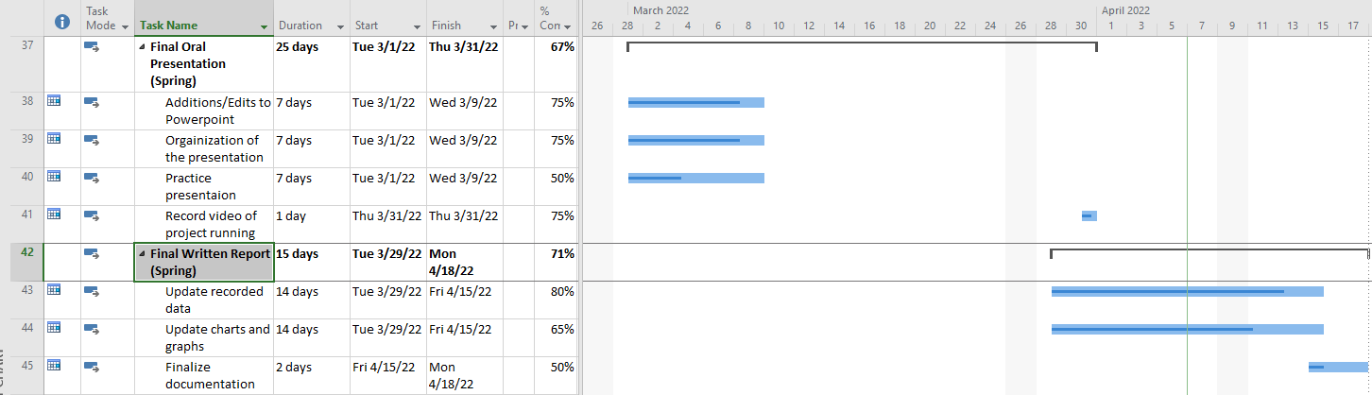
Figure 2.4: Gantt Chart (part 4)

Section 3 - Literature Review

3.1 List of All Sources
- Best Home Security System Company & Security Cameras,” Deep Sentinel, 24-Sep-2021. [Online]. Available: https://www.deepsentinel.com/. [Accessed: 04-Oct-2021].
- “Burglary Statistics: The Hard Numbers,” Alarms.org, 19-Dec-2019. [Online]. Available: https://www.alarms.org/burglary-statistics/. [Accessed: 04-Oct-2021].
- “Frequently Asked Questions About Small Businesses,” U.S. Small Business Administration Office of Advocacy, Oct-2020. [Online]. Available: https://cdn.advocacy.sba.gov/wp-content/uploads/2020/11/05122043/Small-Business-FAQ-2020.pdf. [Accessed: 04-Oct-2021].
- “Home Security Systems,” SimpliSafe, 2021. [Online]. Available: https://simplisafe.com/. [Accessed: 04-Oct-2021].
- “Introducing VEDX: GPT-3 For Vision,” Visual one. [Online]. Available: https://www.visualone.tech/index.html#python. [Accessed: 04-Oct-2021].
- J. Arora, “Theft Detection Using Machine Learning,” Medium, 25-Sep-2020. [Online]. Available: https://medium.com/analytics-vidhya/theft-detection-using-machine-learning-a4232ea51f1c. [Accessed: 04-Oct-2021].
- L. Blain, “Vaak's AI theft-detection system is already 81% accurate,” New Atlas, 11-Apr-2019. [Online]. Available: https://newatlas.com/vaak-vaakeye-ai-theft-detection/59263/. [Accessed: 04-Oct-2021].
- “More security with security cameras systems,” GW Security. [Online]. Available: https://www.gwsecurityusa.com/. [Accessed: 01-Oct-2021].
- “Product Help,” SimpliSafe. [Online]. Available: https://support.simplisafe.com/hc/en-us. [Accessed: 04-Oct-2021].
- “Weapons Offenses and Offenders”, U.S. Department of Justice. [Online]. Available: https://bjs.ojp.gov/content/pub/pdf/woofccj.pdf [Accessed: 29-Mar-2022]
- S. Catalano, “National Crime Victimization Survey: Victimization During Household Burglary,” Office of Justice Programs, 28-Sep-2010. [Online]. Available: https://bjs.ojp.gov/content/pub/ascii/vdhb.txt. [Accessed: 04-Oct-2021].
- S. Cho and N. Tin, "Using infrared imaging technology for concealed weapons detection and visualization," TENCON 2010 - 2010 IEEE Region 10 Conference, 2010, pp. 228-233, doi: 10.1109/TENCON.2010.5685995.
- S. K. Bandyopadhyay, B. Datta, and S. Roy, “Identifications of Concealed Weapon in a Human Body,” Arxiv. [Online]. Available: https://arxiv.org/ftp/ arxiv/papers/1210/1210.5653.pdf. [Accessed: 04-Oct-2021].
- S. Perkins, “Heating up the search for Hidden Weapons,” Science News for Students, 03-Dec-2019. [Online]. Available: https://www.sciencenewsfor students.org/blog/eureka-lab/heating-search-hidden-weapons.
- S. Stasha, “18+ Intriguing Home Ownership Statistics for 2021,” Policy Advice, 13-Sep-2021. [Online]. Available: https://policyadvice.net /insurance/insights/home-ownership-statistics/. [Accessed: 04-Oct-2021].
- “Self-installed DIY Home Security Systems,” Cove Security, 04-Oct-2021. [Online]. Available: https://www.covesmart.com/. [Accessed: 04-Oct-2021].
- Statista Research Department, “Number of robberies in the United States in 20119, by weapon used,” Statista, 01-Oct-2020. [Online]. Available: https://www.statista.com/statistics/251914/number-of-robberies-in-the-us-by-weapon/. [Accessed: 04-Oct-2021].
- T. Covington, “Burglary Statistics, Research, and Facts,” The Zebra, 08-Jul-2021. [Online]. Available: https://www.thezebra.com/resources/research/burglary-statistics/. [Accessed: 04-Oct-2021].
- Uniform Crime Reporting Program, “Crime in the U.S. 2019 Table 23,” FBI: UCR, 29-Aug-2019. [Online]. Available: https://ucr.fbi.gov/crime-in-the-u.s/2019/crime-in-the-u.s.-2019/tables/table-23. [Accessed: 27-Sep-2021].

3.2 Statement of Learning from Each Source
- Reference to another security device for monitoring of area; Deep Sentinel device
- Break-in and burglary statistics regarding injuries and the presence of weapons provided via FBI Uniform Crime Reporting Statistics
- Economic significance and statistics regarding the presence of small businesses
- Project comparison to SimpliSafe products
- How to integrate and set up a web client via python to send message to Twilio messaging service
- Discussion of crime statistics and how ML can be used in burglary prevention and identification
- Implementation of Vaak's AI theft-detection system and the methods of training
- Project comparison to GW security camera products and their various prices and capabilities
- Various SimpliSafe products for comparison to our product
- Bureau of Justice Statistics Weapons Offenses and Offenders statistics on firearm related criminal offense over the years and its growth
- The victimology of burglary victims according to the Department of Justice statistics, rates of burglary and harming of victims
- Exploring the possibility of infrared cameras and object detection, for this project to detect concealed weapons
- How to detect concealed weapons against the human body and when direct sightlines are obstructed
- The possibility of using infrared and heat sensitive wavelengths of light with various photo processing techniques to detect concealed weapons
- 18+ homeowner statistics, touches on various aspects of homeowning such as reports on increasing cost, less overall homeowners, and disparities in the housing market
- Cove Smart products and how they potentially compare to our product sensitive wavelengths of infrared light
- Visual data and statistics regarding the number of times a weapon was present during robberies and the types of weapons during these occurrences
- Stats on the number of burglaries, how often homes had security measures preinstalled and the economic effect such acts have on the victims
- Statistics regarding the type of locations affected by burglaries

Section 4 - Preliminary Design

4.1 Concept Generation
There are several applications that machine learning can be used for such as object detection, image classification, natural language processing, facial recognition, and much more. As a group, we decided to focus on a specific implementation of object detection in relation to threat detection. The project shifted more into the development of a pre-emptive warning and threat detection system with associated hardware and third-party text notification alert system.

4.2 Concept Evaluation and Selection
As a company, we have a favorable position to produce our goods and services at a differential value. We have demonstrated a greater comparative value than that of our competitors and conveyed this information to our target market. Production of our unique technology that offers features our competitors are not marketing paired with a lower production cost will ensure our competitive advantages.
Our technology includes a weapon detection algorithm whereas our rivals offer a general object detection algorithm. We have machine learning and real-time tracking software whereas some of our rivals only offer machine learning software. Our organization will not charge a continuous monthly service charge as many of our rivals include in their packages. Our single unit product is remarkably simple, easy to install, and lightweight, whereas our rivals have multiple heavier hardware devices and equipment to install.
With every great invention comes a challenge, and for our system to be complete, we must rely on a third-party notification company by the name of Twilio. Twilio plays a large factor in our equation as to when a threat is determined by our system. Twilio is responsible for sending out the proper notifications to the selected entities. Twilio is an independent company that the consumer will need to purchase a package plan from for our product to be utilized to its fullest capacity.
Design Options | Initial Cost | Continuous Fees | Pros | Cons | References
Smart Threat Detection System  (Our Design) | $340 | No Monthly Fee | - Weapon Detection  - Machine Learning (ML)  - Real Time Tracking  - Light Weight  - Text Notifications | - No remote monitoring  - Twilio subscription needed | N/A
GW Security  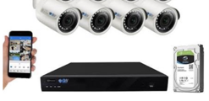 | Starts at $1400 to $6000 | No Monthly Fee | - 4k Resolution  - Uses ML  - Night Vision | - No Remote Viewing  -Heavy Camera Equipment  - No Weapon Detection | GWsecurityusa.com  BBB.com  Amazon.com
Deep Sentinel  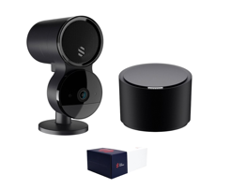 | $400 to $1200 | Monitoring Fee $60 to $200 per month | - Uses ML  - Motion Detection  - Wi-Fi or Ethernet connection | - No Weapon Detection | Deepsentinel.com
SimpliSafe  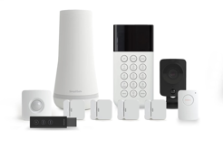 | Starts at $700 | Monitoring Starts at $15 per month | - Smoke, water, carbon & motion sensors  - Smart home integration | - No ML feature to enhance system | Simplisafe.com
Cove Smart  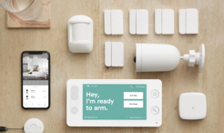 | Starts at $1200 | Monitoring $26 per month | - A+ rating  - Environmental Sensors  - Text Notifications | - No smart ML features available | Covesmart.com  BBB.com

Table 2: Project Comparison Chart

4.3 Constraints and Applicable Codes and Standards Used in Preliminary Design
One of the major design constraints for our project was the frame rate of the Raspberry Pi camera. The frame rate affects Twilio alert times as it works via a counter of frames with a weapon present. Frame rates are essential to our project because we need to be able to detect weapons clearly and accurately before an individual is harmed. To fix this issue we implemented the Google Coral USB Accelerator, this allowed our system to go from one to two frames a second to around 30 frames a second.

The following Codes and Standards were used in implementing our preliminary design:
- IEEE 3652.1-2020: Federated Machine Learning - Our machine learning model can be constructed from data distributed across various repositories owned by various companies
- IEEE P2671: Online detection with machine vision - This standard specifies through the general requirements of online detection based on machine vision
- IEEE P2247.3: Recommended Practices for Evaluation of Adaptive Instructional Systems - best practice incorporates and promotes the principles of ethically aligned design for the use of artificial intelligence
- IEEE 829-2008: IEEE Standard for Software and System Test Documentation - We used this standard when testing our software for detecting weapons
- IEEE 2755.2-2020: Recommended Practice for Implementation and Management Methodology for software Based Intelligent Process Automation
- IEEE 7.8: IEEE: Code of Ethics
  - 3) To be honest and realistic in stating claims or estimates based on available data
  - 5) To improve the understanding of technology, its appropriate application, and potential consequences

4.4 Preliminary Analysis
After determining the deliverables for our project, we were then able to research and investigate ways to complete our project. We decided that we should start with object detection on our Raspberry Pi 3b+, object detection is to detect instances of visual objects within a certain class in digital images. With object detection, we were able to detect preprogrammed objects such as chairs, cellphones, laptops, a person, and many other objects. Next, we would test object detection on our Raspberry Pi 3b+ and investigate the machine learning code so that we could determine how to go from object detection to weapon detection, which is the basis of our project. The way to do this was by “labeling”, labeling is the process of identifying raw data and adding meaningful and informative labels to provide context so that a machine learning model can learn from it. This will be addressed later in the paper. Referring to our object detection tests, we noticed that we were only getting around 1.1 to 2.5 frames per second, this would cause a delay in the timing of our text message alert system. This issue is due to the Raspberry Pi 3b+ being an older model machine that could not handle the video processing that we needed it to do. Therefore, we had to do more research to find a solution to address this problem, we arrived at the Google Coral USB Accelerator which can be plugged into our Raspberry Pi to give us a higher frame rate. The accelerator would then bring our frame rate from a maximum of 2.5 frames per second to around a maximum of 30 frames per second. We also found a newer model Raspberry Pi that was more powerful than the current one we were given; the new model was the Raspberry Pi 4b. We decided to purchase these new products that had a greater benefit on our overall project success.

4.5 Preliminary Design
Once we were given our project at the start of the fall semester, we began to consider ways that we could create the design of our project. We knew that we would need a Raspberry Pi and the associated camera, because that was the required hardware specification for our project and the camera allows us to monitor the area. Aside from the hardware of our project we also decided that we would have an alert notification system set up to alert the owner of the device that a weapon has been identified in their area. The alert notification comes through a third-party company known as Twilio that users will have to subscribe to and provide a phone number to send an alert message.
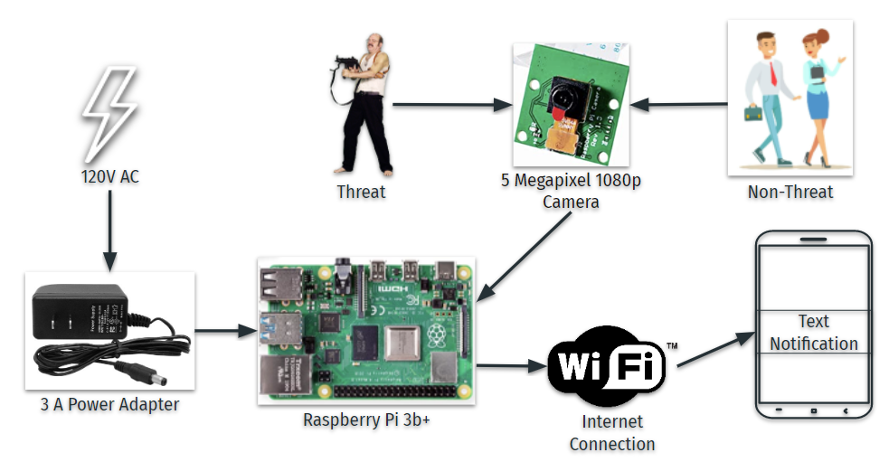
Figure 3: Preliminary Design

Once we obtained the hardware for our preliminary design, we put it together so that we could test it; the preliminary design can be seen in figure 3 above. The Raspberry Pi 3b+ is plugged in via a 3-amp power adapter, the camera is attached to the Raspberry Pi to detect threats and non-threats, and once a threat is detected an alert text message is sent over a Wi-Fi internet connection.
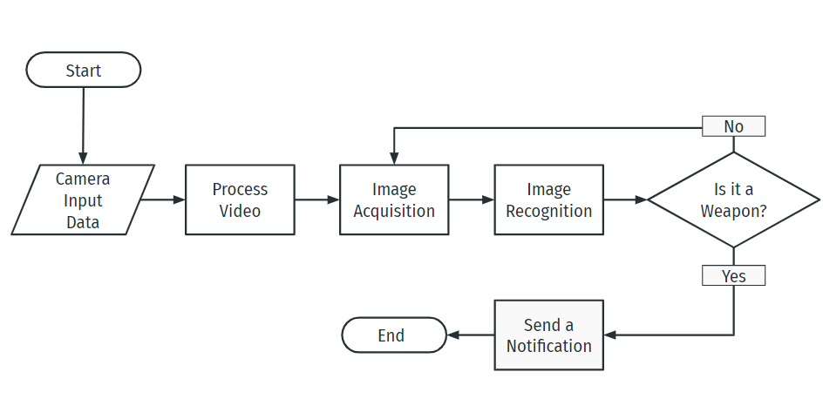
Figure 4: Software Flow Chart

In figure 4, we show the software flow chart on how the detection and notification system works. The software begins when the camera is turned on, the camera will then receive input data and will process the video. During image acquisition the system checks for weapons frame by frame, which then goes to image recognition where it will determine if a weapon has been identified in that frame. If a weapon was detected then it will send the notification to the user, if no weapon is detected it will then go back to the image acquisition stage and continue to check the next frame in the video for a weapon.

Section 5 - Detailed System Design

5.1 Project Parts Summary
All parts used in the final system design are listed below in Figures 5.1 to 5.8.
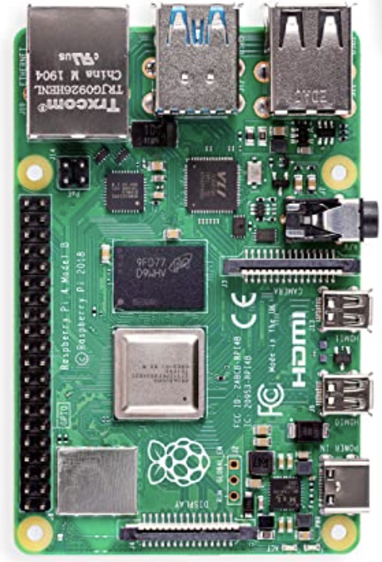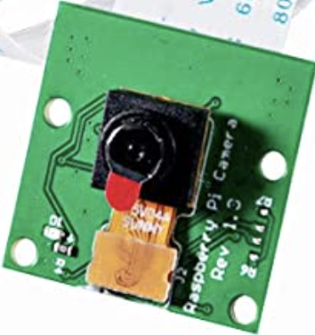
5.1: Raspberry Pi 4 Model B 5.2: Raspberry Pi Camera Rev 1.3
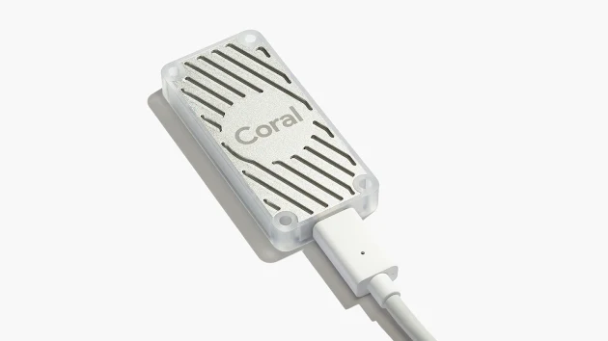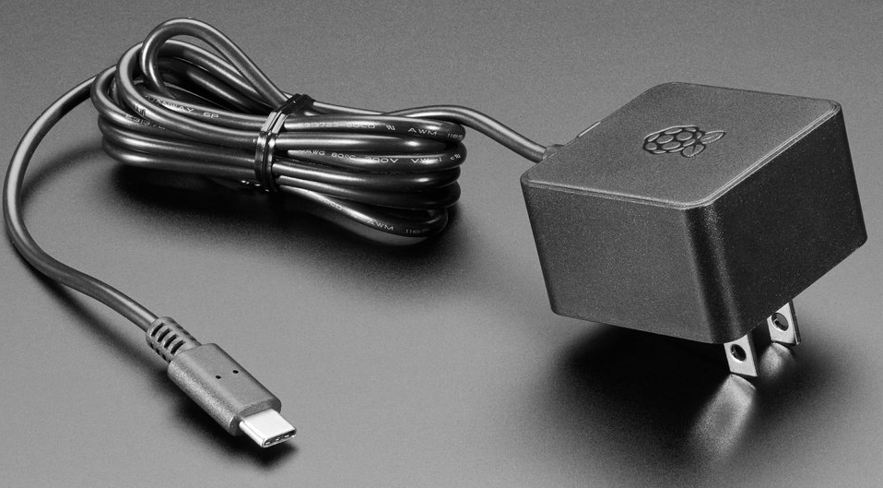
5.3: Google Coral USB Accelerator 5.4: USB-C Power Supply
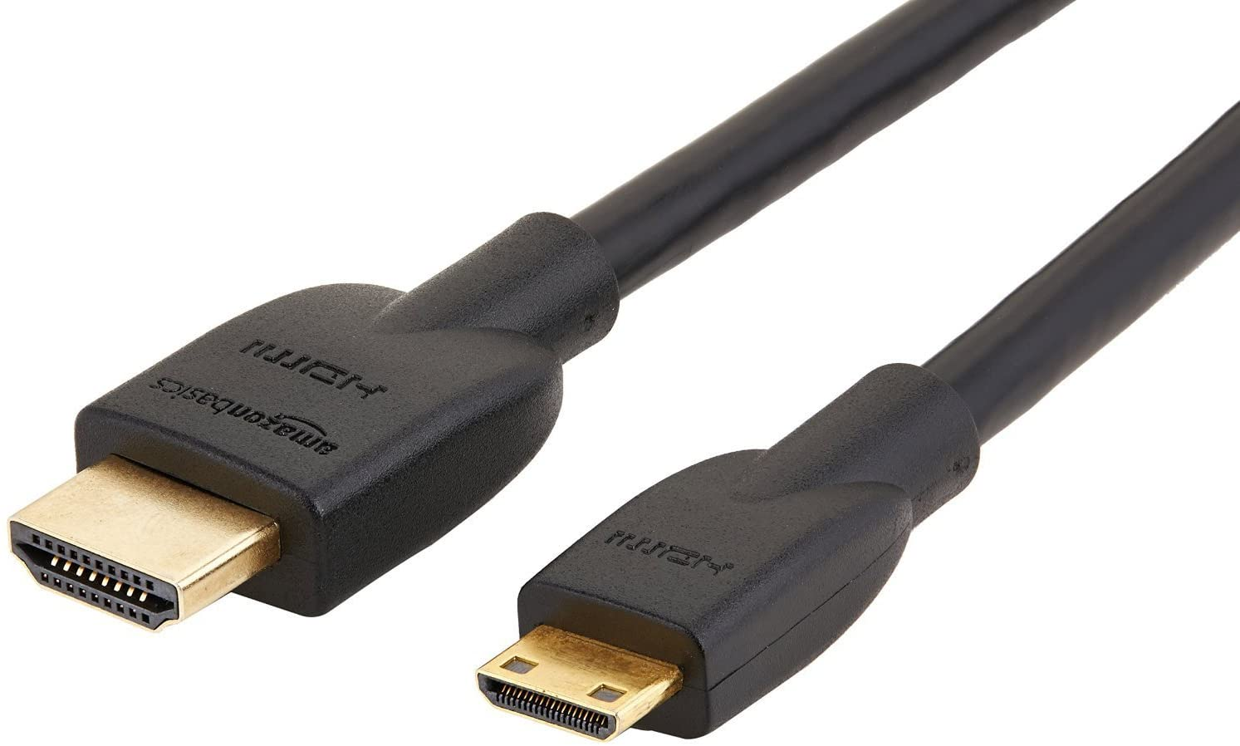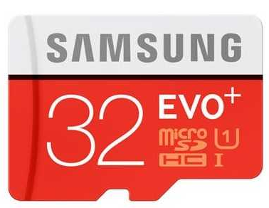
5.5: Micro HDMI to HDMI Cord 5.6: Micro SD Card
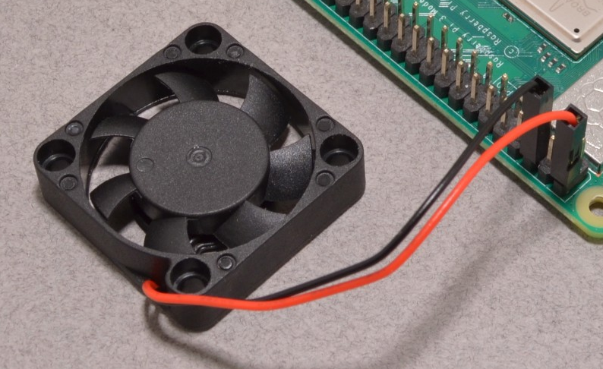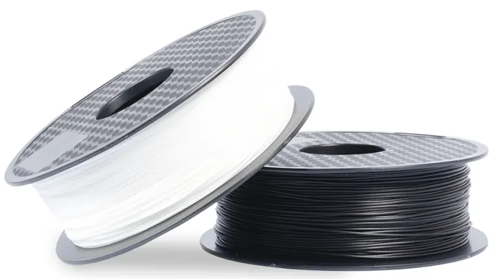
5.7: Raspberry Pi Fan 5.8: Polylactic Acid
Figures 5.1-5.8: Images of Parts

5.2 Engineering Analysis
Labeling and Training:
In order to train the model to detect weapons, we first had to label images that contained weapons. This was done using a software called LabelImg. A bounding box is drawn on the portion of the image that contains the weapon and you attach a label to that box. An example of this is shown in the figure below.
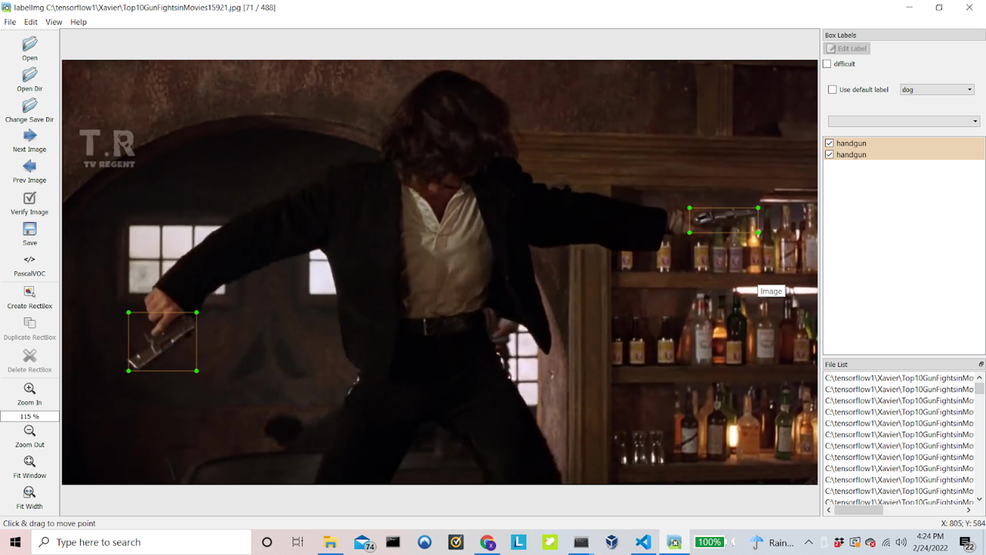
Figure 6: LabelImg Software
Here you can see that two handguns have been boxes and labeled as handguns. This had to be done for over 5000 images.
After the entire dataset is labeled, it is used to train the model. The model uses the information provided by the labeled images to recognize patterns and make predictions.
Quantization:
Quantization is the act of constraining an input and representing its value as a smaller value. Each node, or tensor, of the model is represented by some numerical value. Usually, a 64-bit floating-point value can represent an absurdly broad range of values and is computationally intensive to decipher or to use in other operations. This large computational load slows the processing of frames and therefore the frame rate. Shrinking the representation of these nodes to 8-bit unsigned integers can greatly improve the frame rate, as operations on simpler values are faster and take up significantly less space in memory.
Quantization can be applied to the model on a per tensor basis or to the outputs of individual layers which only partially optimizes the model. This process can decrease the overall size of the model when it is totally quantized by a factor of 4 times. Quantization is also essential for the implementation of the Coral USB Accelerator Tensor Processing Unit (TPU) produced by Google which will maximize the frame rate on the Raspberry Pi upwards of 25-30 frames per second (fps).
Model:
The model used for object detection was the SSD MobileNet V2 COCO model. The SSD acronym at the beginning of the model's name stands for Single Stage Detection, meaning that this algorithm for identification goes straight from pixels of an image directly to bounding box coordinates and class probabilities to be displayed around the object. This model was chosen because of its compatibility with TFlite as only a select pool of lightweight operators is available with this framework and not all models can be converted to this version. This model is also one of the few quantizable models which is necessary for frame rate solutions to be implemented such as the Coral USB accelerator.

Notification System:
Short Message Service or SMS is used as our notification system. A third-party software called Twilio is integrated into our design. Whenever a weapon is seen for a set number of frames, the notification is sent to warn anyone in danger. This type of notification was used because of its easy implementation, as well as its ability to send out notifications to any number of people with any type of phone. The messages are very quick and reliable.

5.3 Hardware Layout/Detailed Drawings/Equipment Selection and Specifications

Hardware Layout
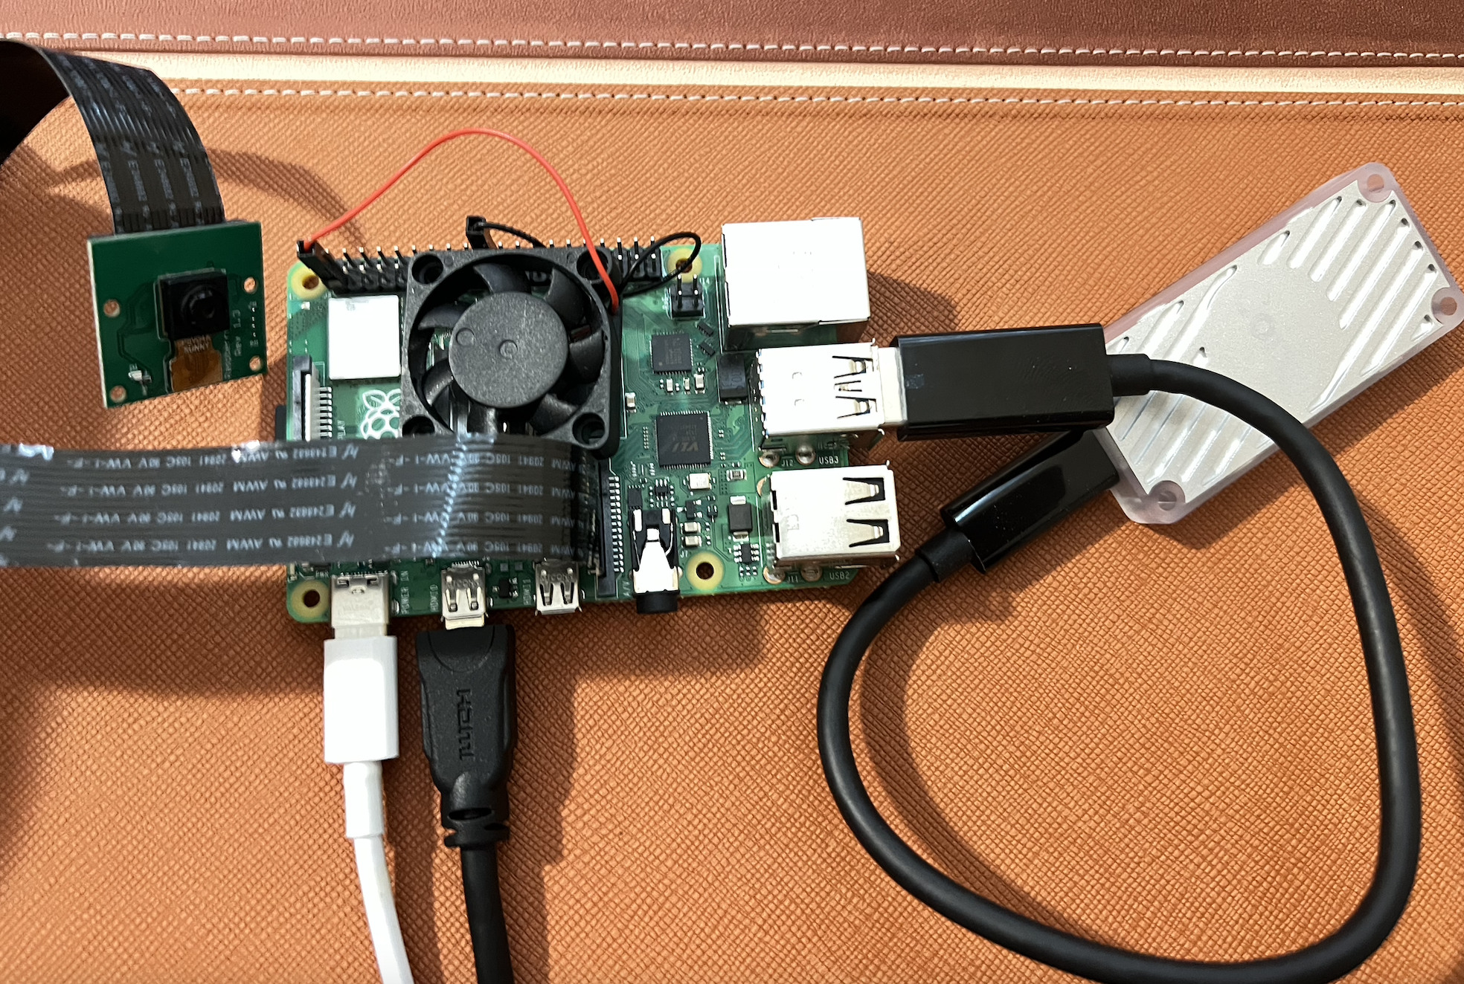
Figure 7: Hardware Layout
In the figure above, it is shown that the Raspberry Pi is connected to power via the 3-amp power supply and the Pi Camera is connected via a ribbon cable. The USB accelerator is connected to the raspberry Pi via a USB-A to USB-C cable. The fan is connected to the 5V and ground pins on the Raspberry Pi and the Raspberry Pi is connected to the monitor via the Micro HDMI to HDMI cable.

Detailed Drawings
In this section, the schematics for the housing will be shown and described. After the housing was designed. It was 3D printed out of PLA. The housing is encasing the Raspberry Pi, fan, Coral USB, camera, and the camera ribbon cable. The full housing can be seen in the figure below.
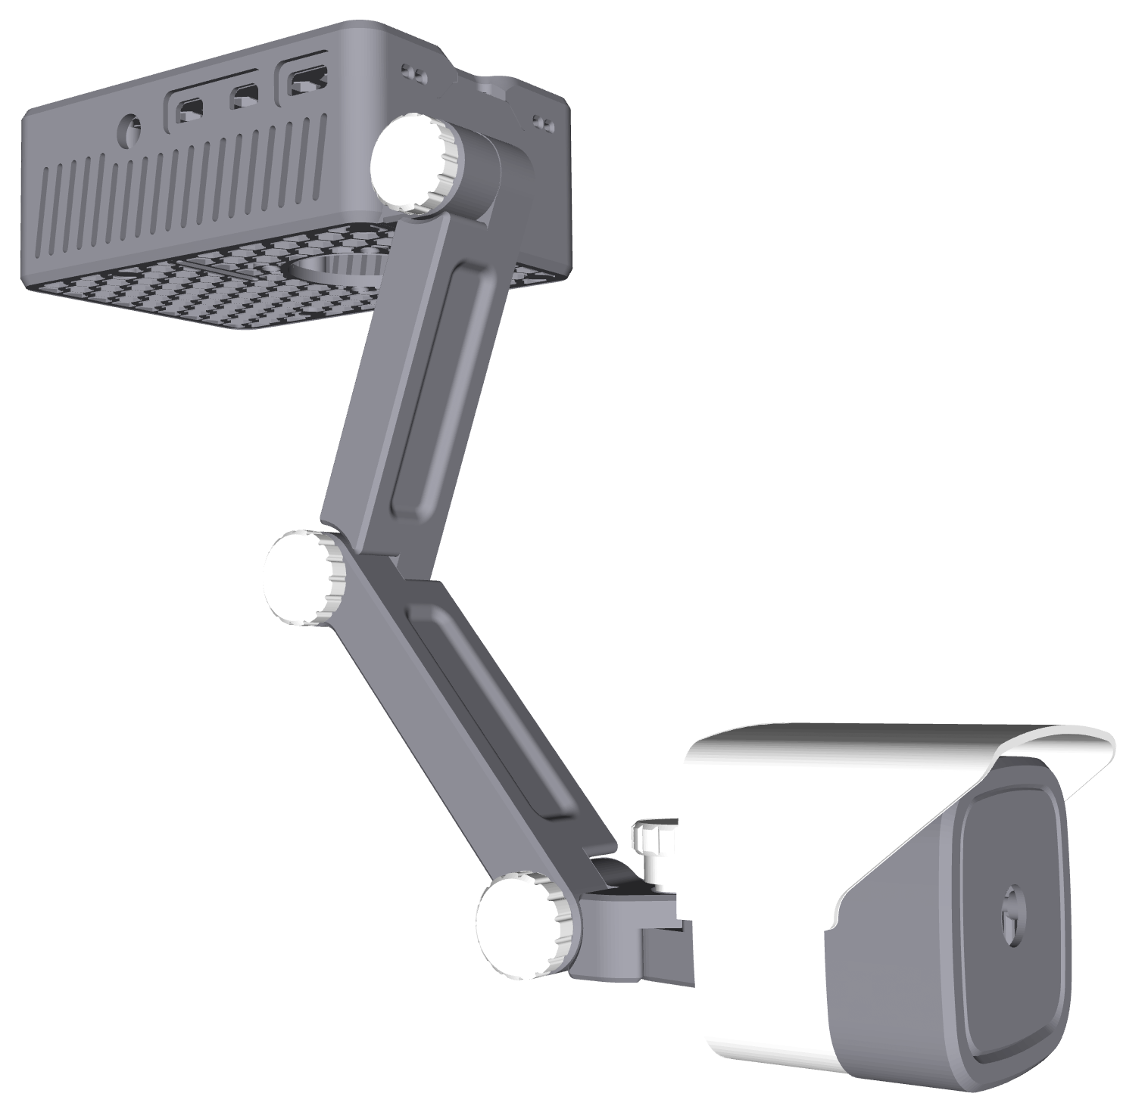
Figure 8: Housing Design
Listed below will be detailed drawings of the individual pieces of the housing. To start with we have the front camera plate. The Pi Camera snaps into place via the 4 pins that stick out on the inside. The lens of the camera sits in the whole in the center.
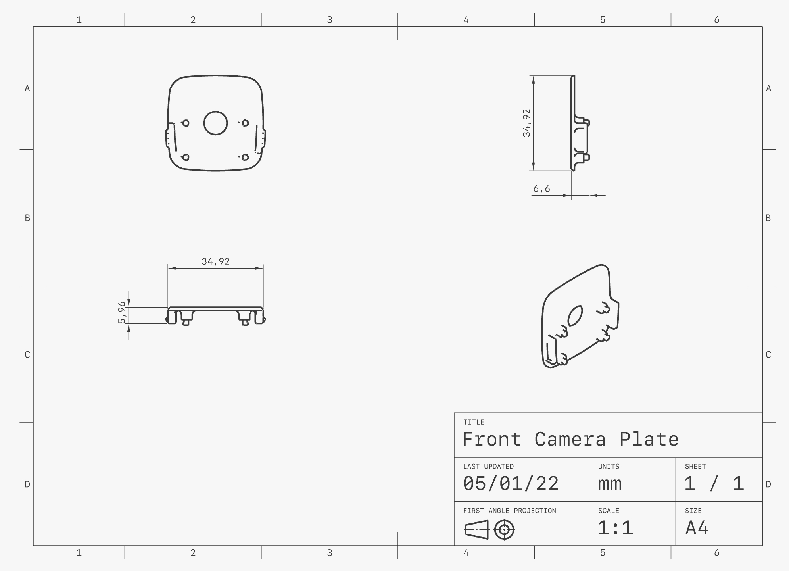
Figure 9.1: Front Camera Plate
The side camera cover is shown below. The front camera plate snaps into the side camera cover and his snaps into the camera visor.
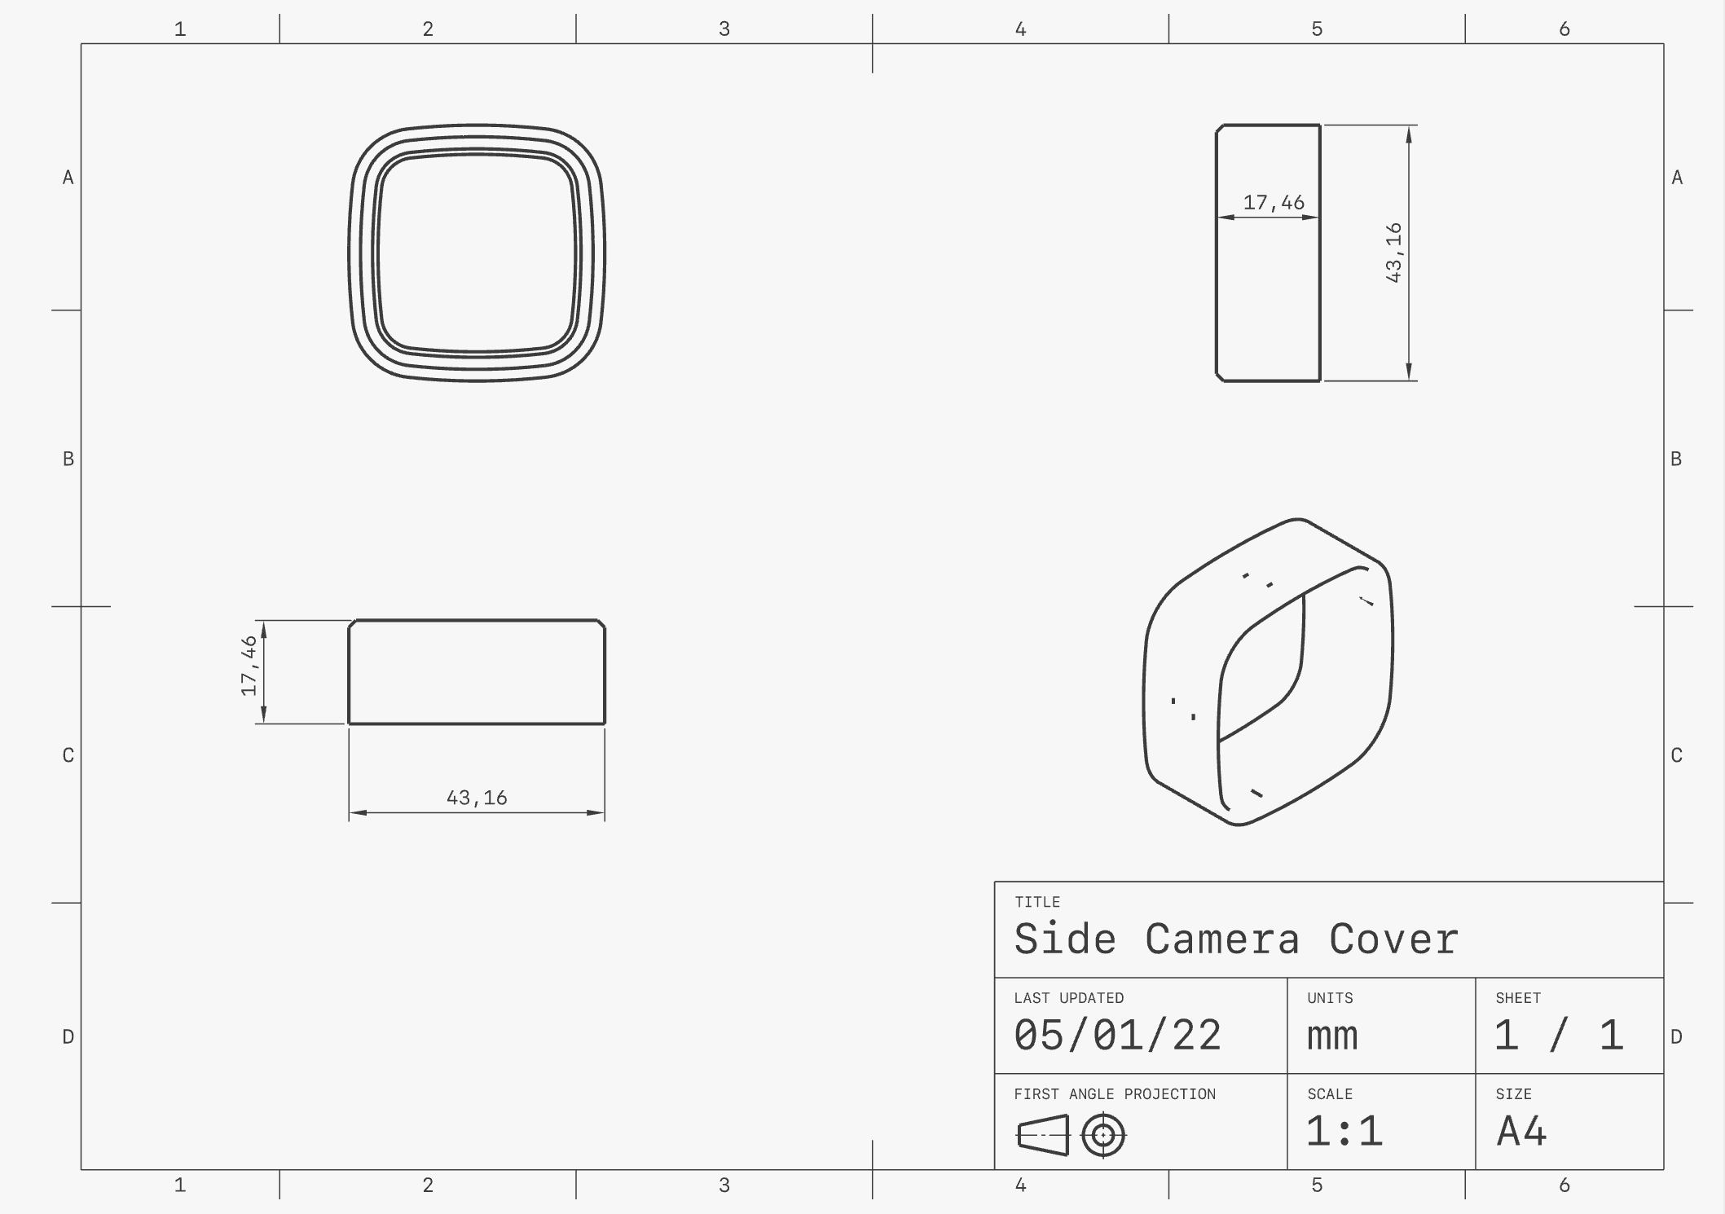
Figure 9.2: Side Camera Cover
The camera visor is shown below. The visor snaps together with the side camera cover. There is a slot on the back to allow the ribbon cable of the camera to pass through as well as a larger slot that connects the back camera plate.
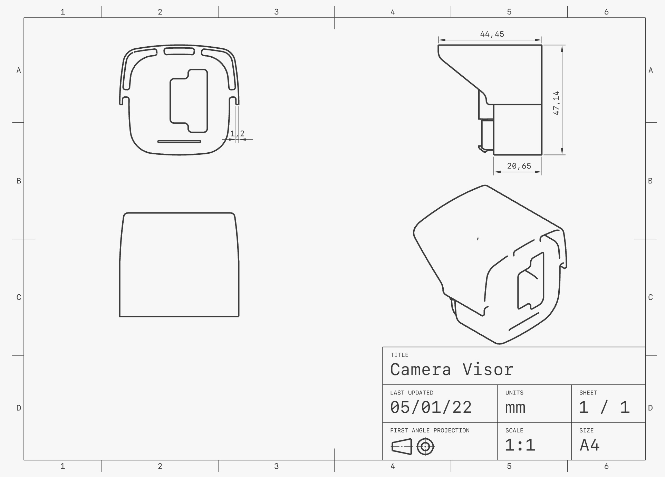
Figure 9.3: Camera Visor
The back camera plate is shown below. The interior side of the back camera plate has a notch that slides into the opening on the camera visor. There is a threaded hole to allow for a short screw attachment to the hinge.
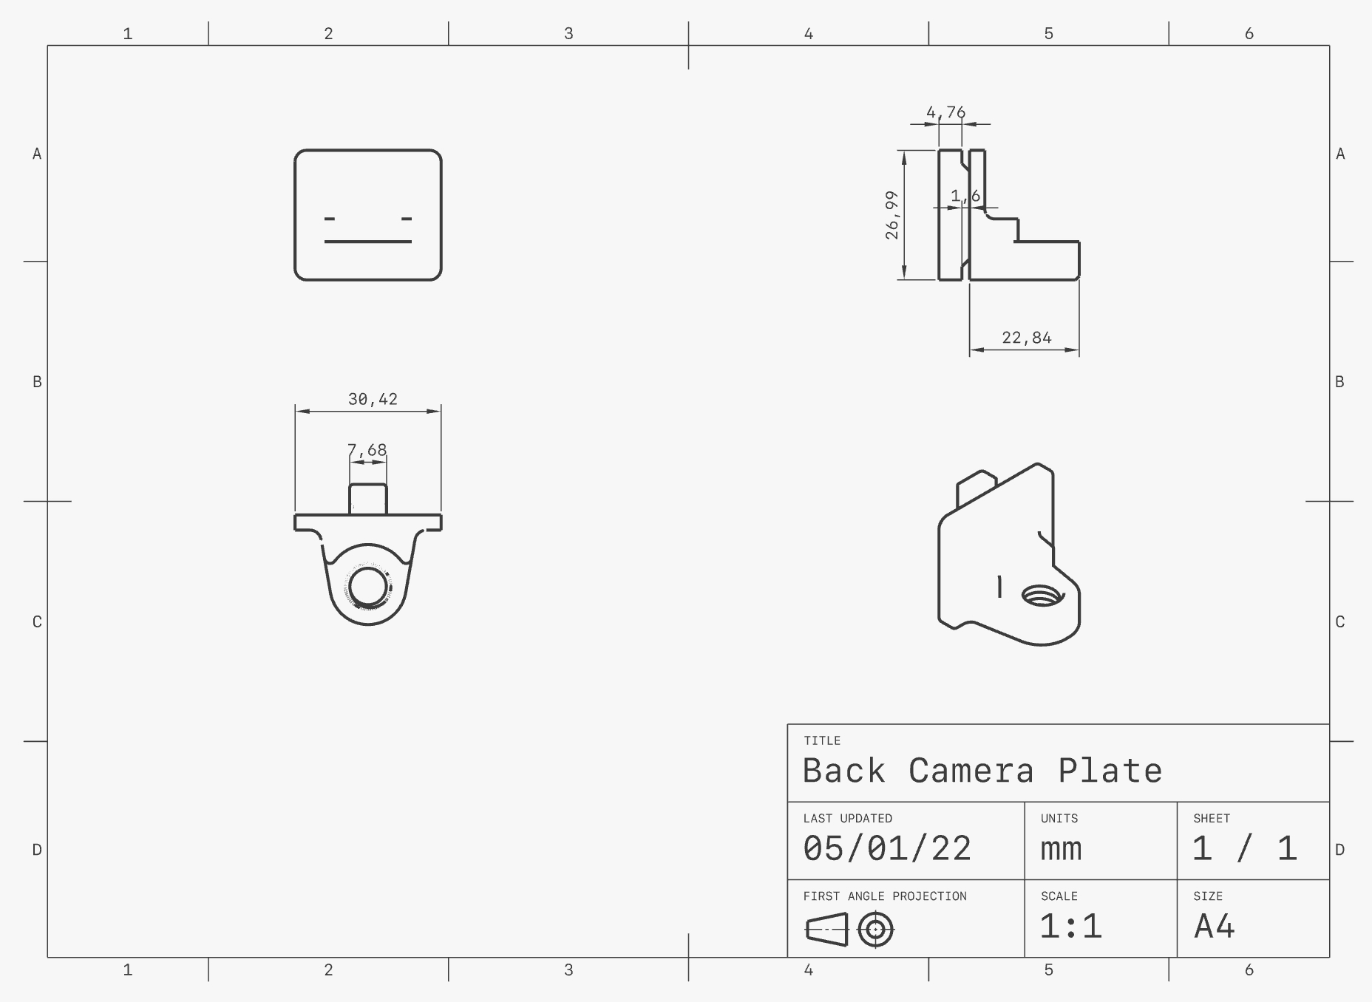
Figure 9.4: Back Camera Plate
The hinge is shown below. The hinge allows for the camera to pan left and right. The hinge is connected to the lower arm via a long screw.
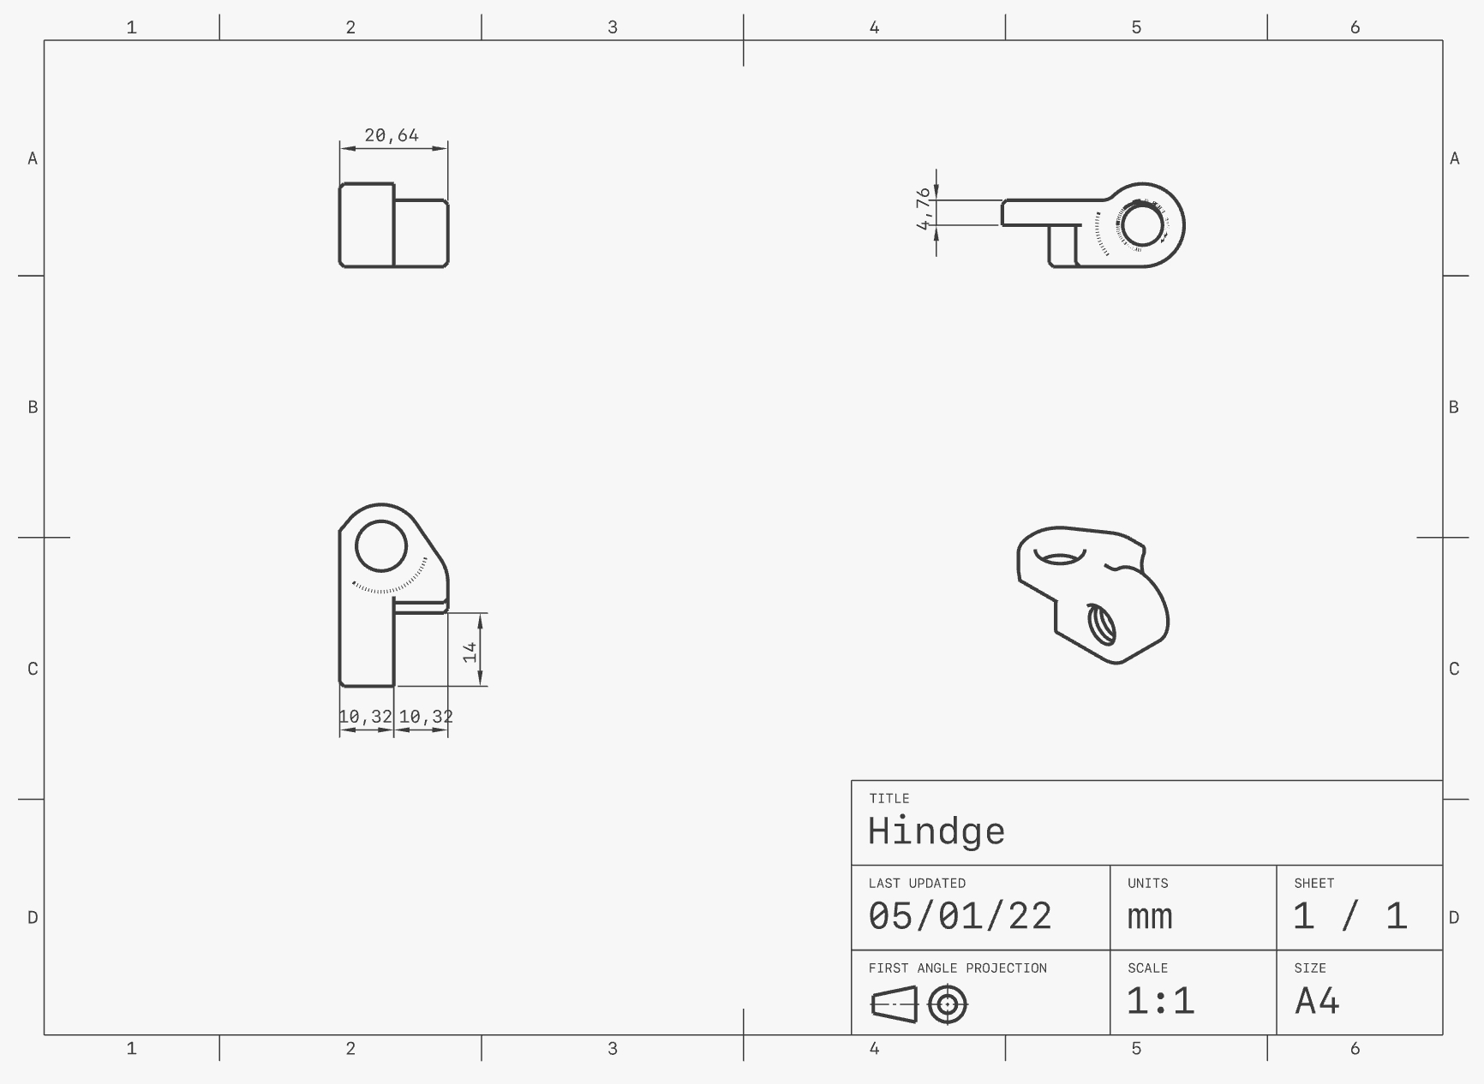
Figure 9.5: Hinge
The lower arm and upper arm are identical and shown below. They are connected via 2 long screws at either end. They have a slit that allows for the ribbon cable to run through the interior of the arm.
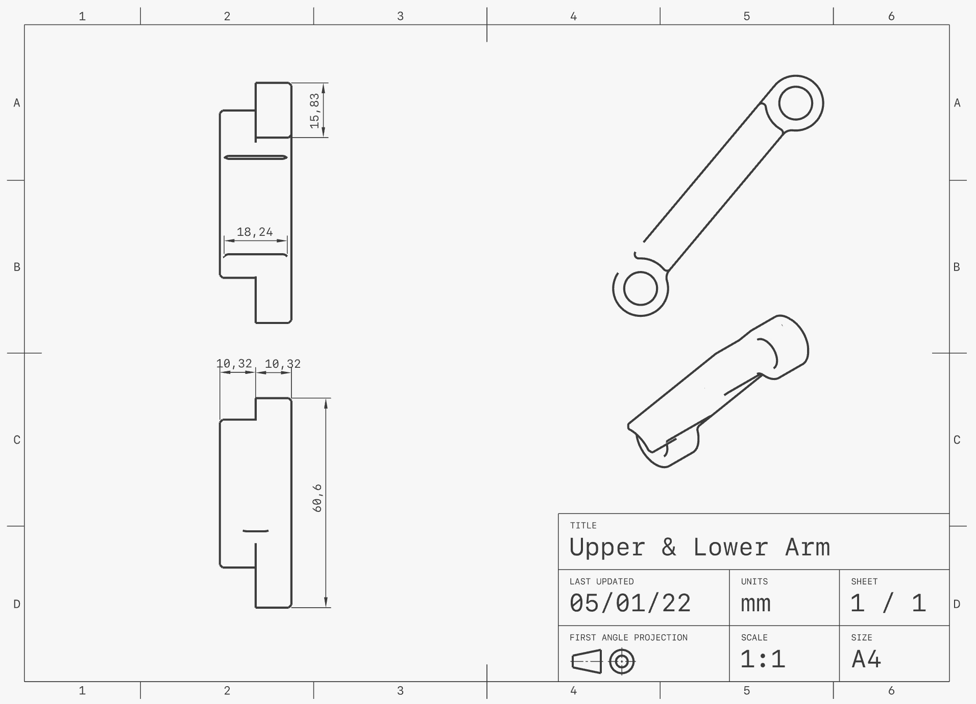
Figure 9.6: Upper & Lower Arm
The long and short screws are threaded the same way. The long screw is shown below. The short screw is ¾ the length of the long screw.
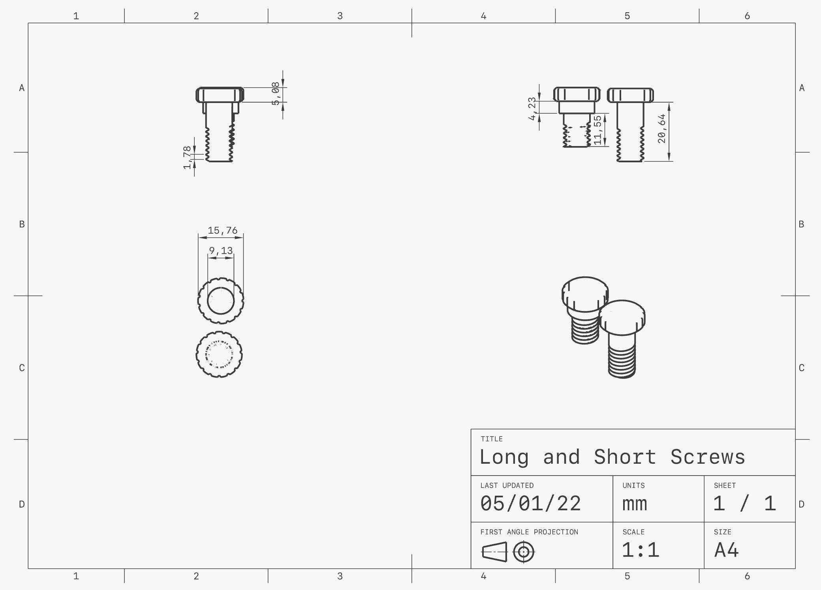
Figure 9.7: Long & Short Screws
The Raspberry Pi case top is shown below. It is the portion of the case that would face downwards if mounted to a ceiling despite being named the top. It has a cut out for the fan to sit on and has enough space to hold the Coral USB Accelerator. It also has a slit cut out for the camera ribbon cable and 3 large notches for the USB Ports and the Ethernet port. The hexagonal shape on the top and slits on the sides allow for adequate air flow as overheating used to be an issue.
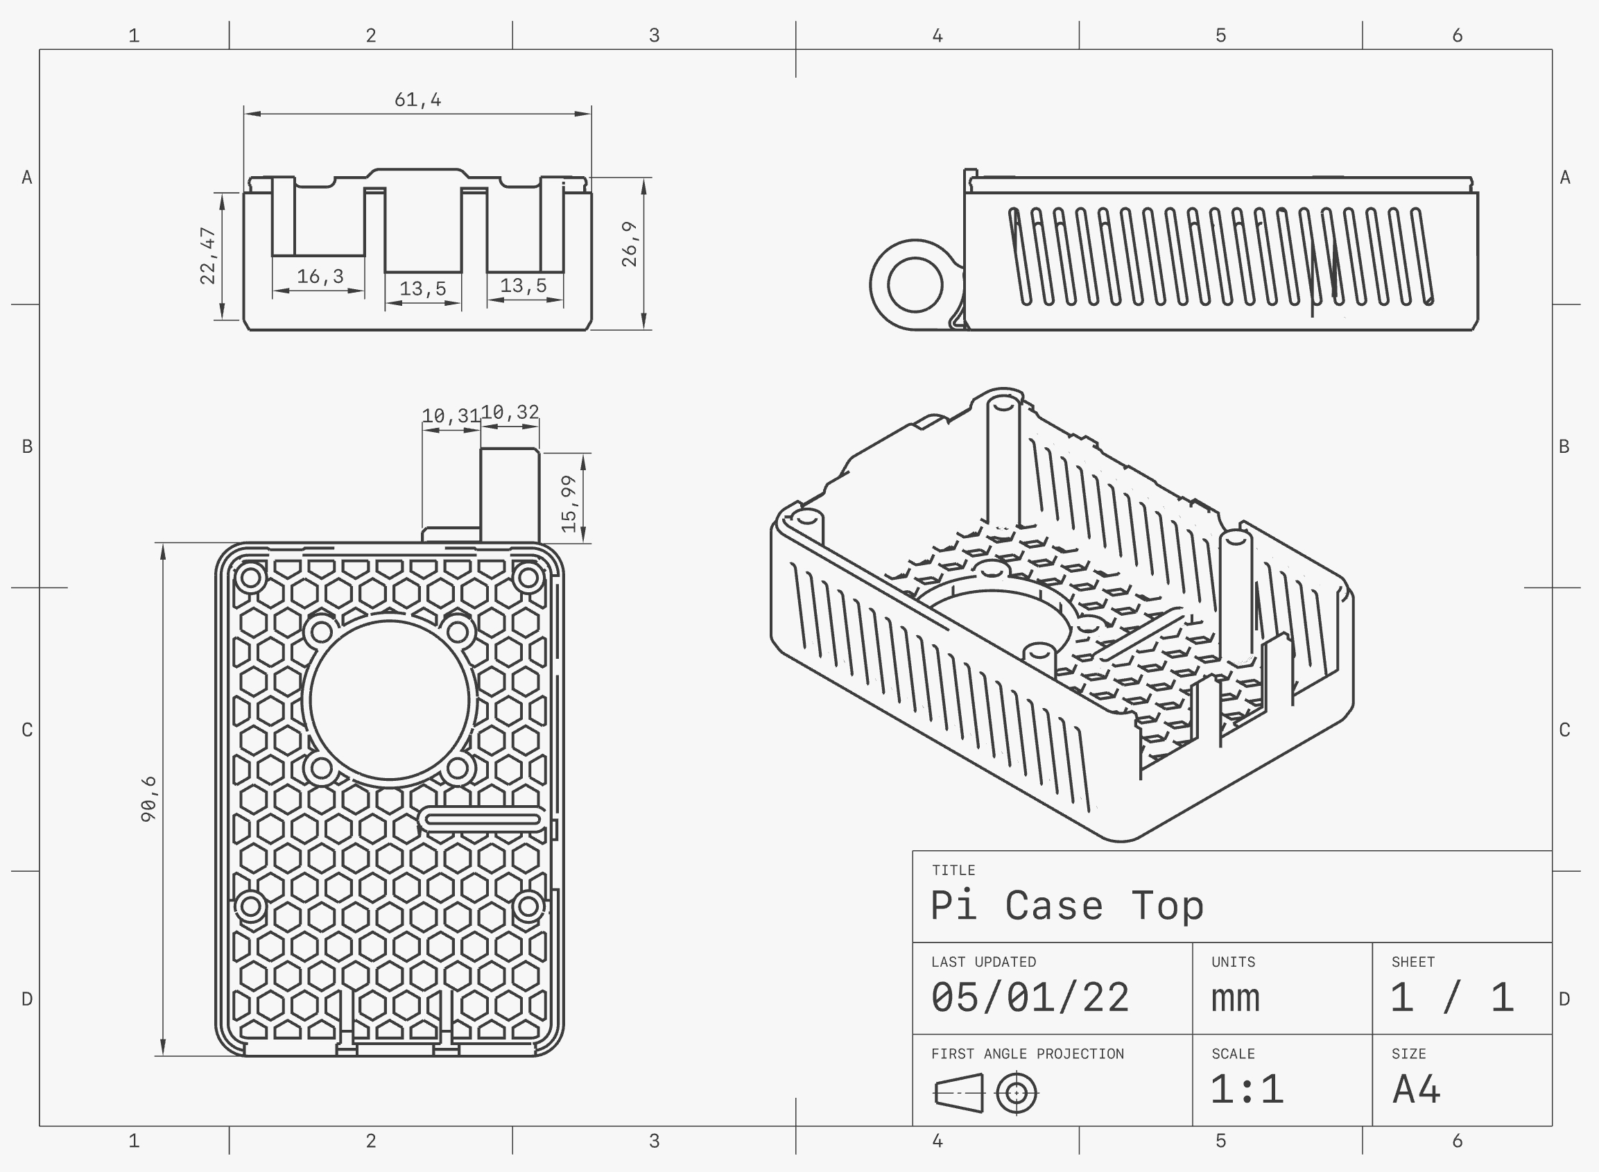
Figure 9.8: Pi Case Top
The Raspberry Pi case bottom can be seen below. It is the portion of the case that would be touching the surface in which the device is being mounted. The case has 4 cut outs for the power, HDMI ports, and the audio port. The two case pieces snap into one another with the Raspberry Pi, fan and Coral USB accelerator fixed in place on the inside.
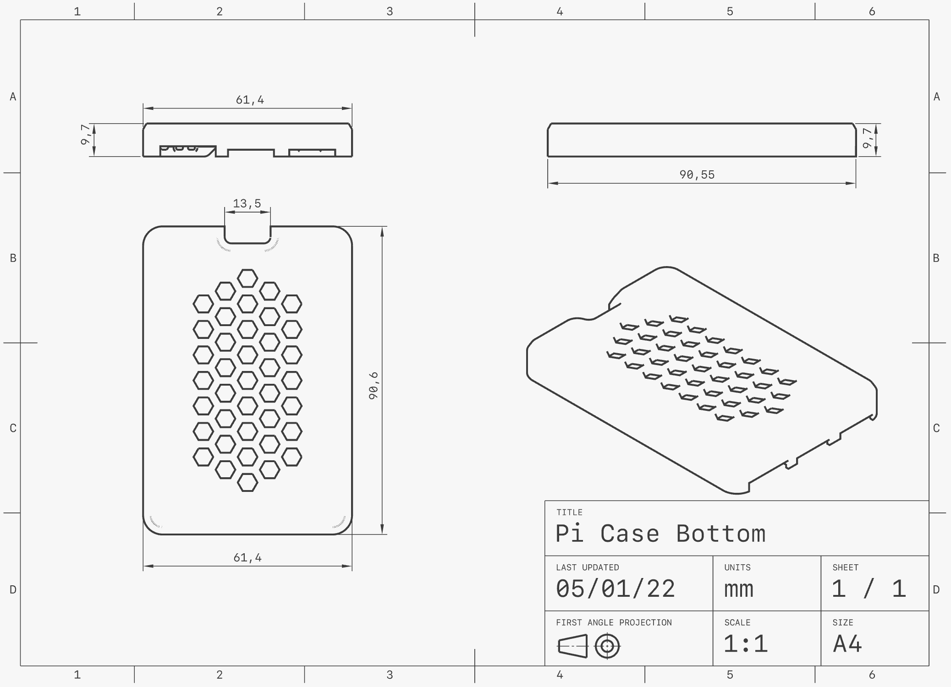
Figure 9.9: Pi Case Bottom
The parts are all 3D printed from PLA including the screws. This allows for the housing to be very lightweight.

Equipment Selection and Specifications
The Raspberry Pi 4 Model B was selected due to it being the most up to date Raspberry Pi to be released. It has a much better performance than the other Raspberry Pi models. A LINPAC benchmark test showed that the Raspberry Pi 4 B almost tripled the score of the Raspberry Pi 3B+. The specifications of the Raspberry Pi 4 Model B are shown in the table below.
Raspberry Pi 4 Model B
Processor | Broadcom BCM2711, Quad core Cortex-A72 (ARM v8) 64-bit SoC @ 1.5GHz
Ram | 8GB LPDDR4-3200 SDRAM (depending on model)
Wi-Fi/Bluetooth | 2.4 GHz and 5.0 GHz IEEE 802.11ac wireless, Bluetooth 5.0, BLE
Ethernet Port | Gigabit Ethernet
USB Ports | 2 USB 3.0 ports; 2 USB 2.0 ports.
GPIO | Raspberry Pi standard 40 pin GPIO header (fully backwards compatible with previous boards)
Display Ports | 2 × micro-HDMI ports (up to 4kp60 supported)  2-lane MIPI DSI display port
Camera Port | 2-lane MIPI CSI camera port
Audio Port | 4-pole stereo audio and composite video port
Video Encoder | H.265 (4kp60 decode), H264 (1080p60 decode, 1080p30 encode)
Graphics | OpenGL ES 3.1, Vulkan 1.0
Storage | Micro-SD card slot for loading operating system and data storage
Power | 5V DC via USB-C connector (minimum 3A*)  5V DC via GPIO header (minimum 3A*)  Power over Ethernet (PoE) enabled (requires separate PoE HAT)
Operating Temperature | 0 – 50 degrees C ambient
Table 3.1: Raspberry Pi 4 Model B Specifications
The Raspberry Pi Camera was selected due to its easy compatibility with the Raspberry Pi 4 Model B. The specifications of the Raspberry Pi Camera are shown below.
Raspberry Pi Camera Rev 1.3
Still Resolution | 5 Megapixels
Video Modes | 1080p30, 720p60 and 640 × 480p60/90
Linux Integration | 1080p30, 720p60 and 640 × 480p60/90
C Programming API | OpenMAX IL and others available
Sensor | OmniVision OV5647
Sensor Resolution | 2592 × 1944 pixels
Sensor Image Area | 3.76 × 2.74 mm
Pixel Size | 1.4 µm × 1.4 µm
Optical Size | 1/4"
Full-frame SLR Lens Equivalent | 35 mm
S/N Ratio | 36 dB
Dynamic Range | 67 dB @ 8x gain
Sensitivity | 680 mV/lux-sec
Dark Current | 16 mV/sec @ 60 C
Well Capacity | 4.3 Ke-
Depth of Field | approx. 1 m to infinity
Focal Length | 3.60 mm +/- 0.01
Horizontal Field of View | 53.50 +/- 0.13 degrees
Vertical Field of View | 41.41 +/- 0.11 degrees
Focal Ratio (F-Stop) | 2.9
Table 3.2: Raspberry Pi Camera Specifications
The Google Coral USB Accelerator was selected due to its easy compatibility with the Raspberry Pi 4 Model B. This device aided in increasing the frame rate by approximately 20 frames per second. The specifications of the Google Coral USB Accelerator are shown below.
Google Coral USB Accelerator
ML accelerator | Google Edge TPU coprocessor:  4 TOPS (int8); 2 TOPS per watt
Connector | USB 3.0 Type-C* (data/power)
Dimensions | 65 mm x 30 mm
Table 3.3: Coral USB Accelerator Specifications
The Raspberry Pi 4 Official Power Supply Unit was selected due to it being built specifically to meet the requirements for the Raspberry pi 4 Model B. The specifications of the Raspberry Pi 4 Official Power Supply Unit are shown below.
Raspberry Pi 4 Official Power Supply Unit
Power | 15.3-Watt output
Voltage | 5.1-Volt output
Current | 3.0-Amp output
Length | 1.5-m cable
Table 3.4: Power Supply Specifications
The QVS Micro-HDMI to HDMI Cable was selected because it fit the Raspberry Pi 4 B and the monitor we used. The specifications of the cable are shown below.
QVS Micro-HDMI to HDMI Cable
Supports | 15.3-Watt output
Length | 2-m cable
Connectors | HDMI Male to Micro HDMI Male
Table 3.5: Micro-HDMI to HDMI Cable Specifications
The Samsung 32GB EVO Plus UHS-I microSDHC Memory Card was selected due to it having enough storage capacity and a fast enough speed for the project. The specifications of the Raspberry Pi 4 Official Power Supply Unit are shown below.
Samsung 32GB EVO Plus UHS-I microSDHC Memory Card
Card Type | microSDHC
Storage Capacity | 32 GB
Bus Type | UHS-I
Speed Class | 10
UHS Speed Class | U1
Reed Speed | Maximum: 95 MB/s
Write Speed | Maximum: 20 MB/s  Minimum: 10 MB/s
Durability | Magnet-Proof, Temperature Extremes, Waterproof, X-Ray Proof
Operating Temperature | -13 to 185°F / -25 to 85°C
Storage Temperature | -40 to 185°F / -40 to 85°C
Wireless Capability | None
Table 3.6: MicroSD Card Specifications

The Pi-FAN was selected due to its easy compatibility with the Raspberry Pi. The specifications of the Pi-FAN are shown below.
Pi-FAN
Operating Voltage | 5 Volts
Current | 0.2 Amps
Motor | Brushless DC fan
Dimensions | 30mm x 30mm x 8mm
Wire Length | 3.25" / 80mm
Weight | 6.2g / 0.22oz
Table 3.7: Pi-FAN Specifications
The OVERTURE Polylactic (PLA) ACID Filament was selected due to its easy compatibility with the 3D printer that was used. It was also ideal for its biodegradability and was already readily available. The specifications of the OVERTURE PLA Filament are shown below.
OVERTURE Polylactic ACID Filament
Diameter | 1.75 mm diameter
Dimensional Accuracy | Accuracy +/- 0.03 mm
Material | Polylactic Acid (PLA)
Extrusion Temperature | 190°C - 220°C (374℉~ 428 ℉)
Heated Bed Temperature | 25°C - 60°C (77℉~ 140℉)
Color | Black
Table 3.8: Polylactic Acid Specifications

5.4 Overview of Code
There are three main portions of the code. The first section handles training the model to detect weapons. The second section contains everything that deals with the process of running the camera and detecting objects. The third section handles the logic behind how and when to send the notification. The main portions of these three sections will be explained below; however, to see the full-length code, see appendix page A2
Training the Model
When training the model, we used over 5000 images that we labeled as a specific category of weapon. These images became our dataset. The model is then trained on this data set by running the training executable. This code, along with instructions on how to configure the training job can be found in the appendix on page A8. This section calls many different files to aid in the training process. To summarize what is happening during training, the algorithm takes an image that looks at where the bounding box for the weapon is and looks for certain patterns and similarities throughout the various images.
Running the Camera
The code that runs the camera and weapon detection starts with the camera constraints. The dimensions of the camera must be defined because the bounding box location for the weapons is calculated using the image height and width. Below it is shown that the image width for our camera is 1280 and the height is 720.
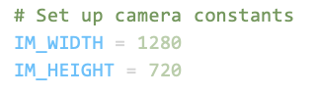
Figure 10.1: Camera Dimensions
A label map is a list of all the objects, or classes, we want to detect. In our case, it is just weapons, so we have a label map with rifle, handgun, blade, and blunt object. We call this label map file and define the number of classes. The figure below shows the code that performs these actions.
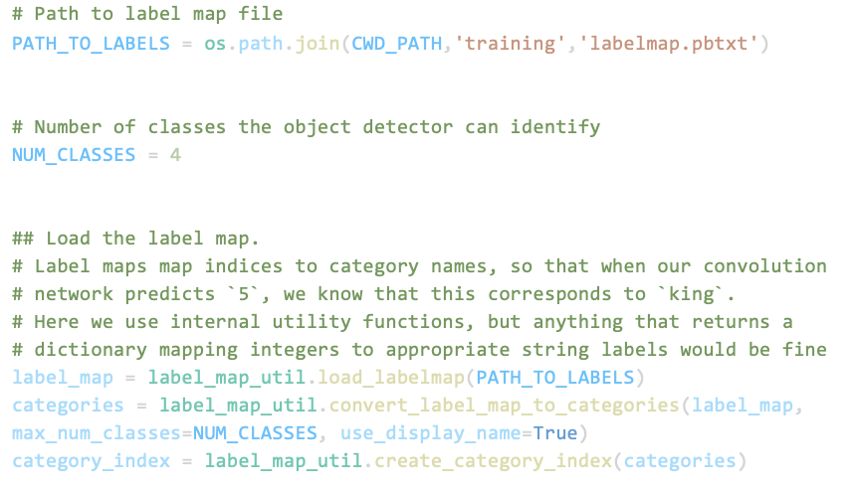
Figure 10.2: Loading Label Map
The program then loads the TensorFlow model into memory. This is the model that was trained to detect weapons. This can be seen in the figure below.
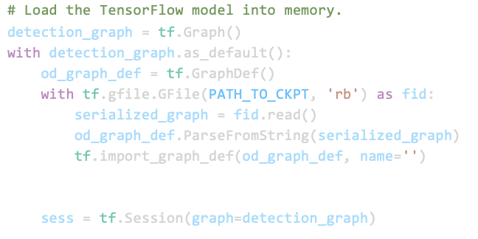
Figure 10.3: Loading in the Model
The output of the model includes the detection boxes, scores, classes, and number of objects detected. In the figure below, these are seen as detection_boxes, detection_scores, detection_classes, and num_detections. The detection boxes give the coordinates of the top left and bottom right points of the bounding box. The score is the confidence level this is displayed as a percentage. The classes are the names of the object being detected and the number of detections keeps track of how many of the detected objects are in the view of the camera.

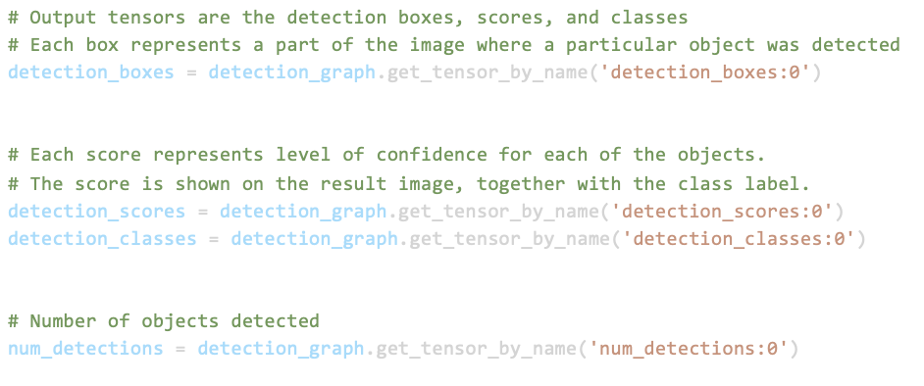
Figure 10.4: Boxes, Scores, Classes, and Number of Boxes
The live value of the frame rate is calculated by checking the tick frequency. This is shown in the figure below. It is important to have the exact frame rate of the camera as this directly affects the speed at which the notification is sent.
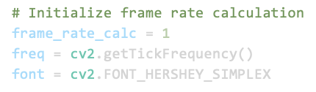
Figure 10.5: Frame Rate Calculation

The model is run and uses each frame from the camera as its input. This code is shown below.

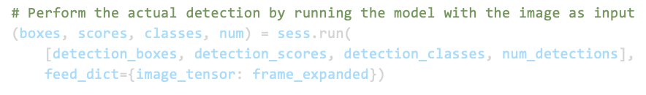
Figure 10.6: Running Detection Model
The results from the detection model are displayed over the actual live footage from the camera. This is done by drawing the boxes, showing the classes, and updating the scores for each frame. The figure below demonstrates this process.
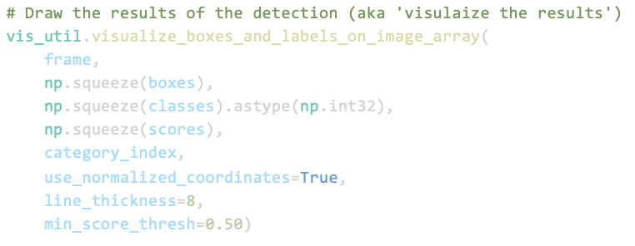
Figure 10.7: Visualization of Results
Notification System
For our notification system, we used Twilio. To code in the Twilio information we first import the Twilio client. Then the account SID number, authorization number, the phone number of who needs to receive the notification, and the number the message is being sent from are all defined. In the figure below, it is shown where these values are defined as the specific variables: account_sid, auth_token, my_number, and twilio_number, respectively. The numbers are covered for privacy purposes.
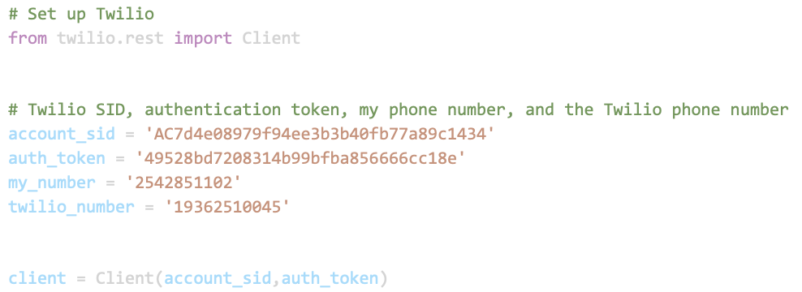
Figure 11.1: Twilio Setup
The way the program knows when to send the notification is a series of “if” statements. It determines if a weapon is on the screen. The weapons are defined by their ID classes; 1 for rifle, 2 for handgun, 3 for knife, 4 for blunt object. A predetermined area of detection is defined if it is not wanted to detect weapons in the camera’s full field of view. If one of the weapons is located within that area for 300 frames, it sends the message “A weapon has been detected on your camera” to the numbers previously defined. The program then pauses for a set amount of time to prevent messages being spammed. This can all be seen in the snapshot of the code below.
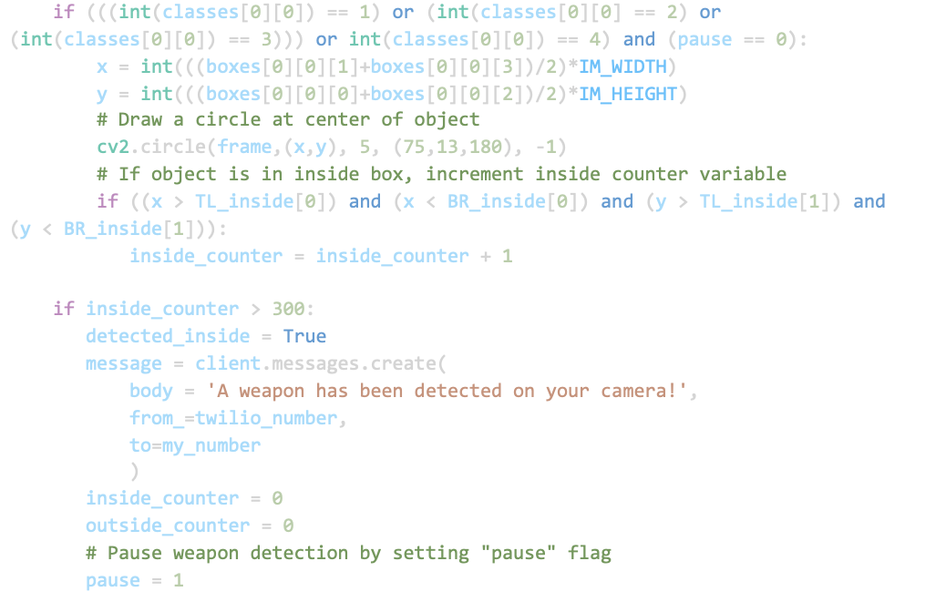
Figure 11.2: SMS Notification Execution

5.5 Application of Engineering Codes and Standards used in Final Design
The following IEEE Codes and Standards were used in the final design of our project:
IEEE 3652.1-2020: Federated Machine Learning - Our machine learning model can be constructed from data distributed across various repositories owned by various companies
IEEE P2671: Online detection with machine vision - This standard specifies through the general requirements of online detection based on machine vision
IEEE P2247.3: Recommended Practices for Evaluation of Adaptive Instructional Systems - best practice incorporates and promotes the principles of ethically aligned design for the use of artificial intelligence
IEEE 829-2008: IEEE Standard for Software and System Test Documentation - We used this standard when testing our software for detecting weapons
IEEE 2755.2-2020: Recommended Practice for Implementation and Management Methodology for software Based Intelligent Process Automation
IEEE 7.8: IEEE: Code of Ethics
3) To be honest and realistic in stating claims or estimates based on available data
5) To improve the understanding of technology, its appropriate application, and potential consequences

5.6 Economic Analysis
The economic analysis of our project can be separated into two phases. There were different components that were used in each phase which we will outline below. During phase one we were given the parts that we needed to start a preliminary design of our project. The parts that we used in our phase one design were given to us by the school and can be seen in table 4.1.
Item Name | Quantity | Total
Raspberry Pi 3b+ | 1 | Pre-owned
Raspberry Pi Camera Rev 1.3 | 1 | Pre-owned
 | Total: | $0
Table 4.1: Phase 1 Cost
After completing the testing of phase one with the given parts, we were able to identify which parts needed updating and investigate ways that we can improve our design. We needed to update our Raspberry Pi 3b+ to the Raspberry Pi 4b which is a more powerful and faster model, we also upgraded our MicroSD card so that our Raspberry Pi can hold more storage. Another upgrade to our project was the addition of the Google Coral Accelerator, which increases the frame rate of our camera and video processing. To connect the Raspberry Pi 4b to a monitor and observe an area we had to purchase a Micro HDMI to HDMI cord. The updated cost of our project can be seen in table 4.2.
Item Name | Quantity | Total
Raspberry Pi 4b | 1 | $134
Raspberry Pi Camera Rev 1.3 | 1 | Pre-owned
Google Coral USB Accelerator | 1 | $174.58
Micro HDMI to HDMI cord | 1 | $16.95
Micro SD card | 1 | $20
 | Total: | $345.53
Table 4.2: Smart Threat Detection System Cost

5.7 Final Design - Show Pictures or Other Examples of Working Design
Figures 12.1 - 12.3 depict a rifle being detected by our camera. The yellow box and word “rifle” are specific to that class of weapon. In various orientations, including partially covered, the rifle is detected with remarkably high confidence.
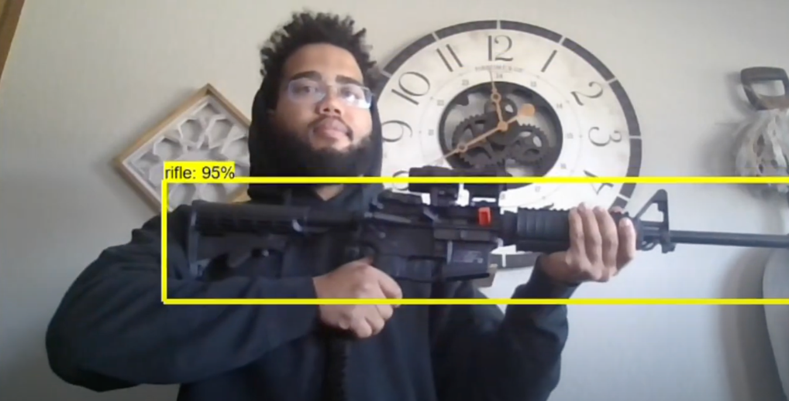
Figure 12.1: Rifle Detected with 95% Confidence

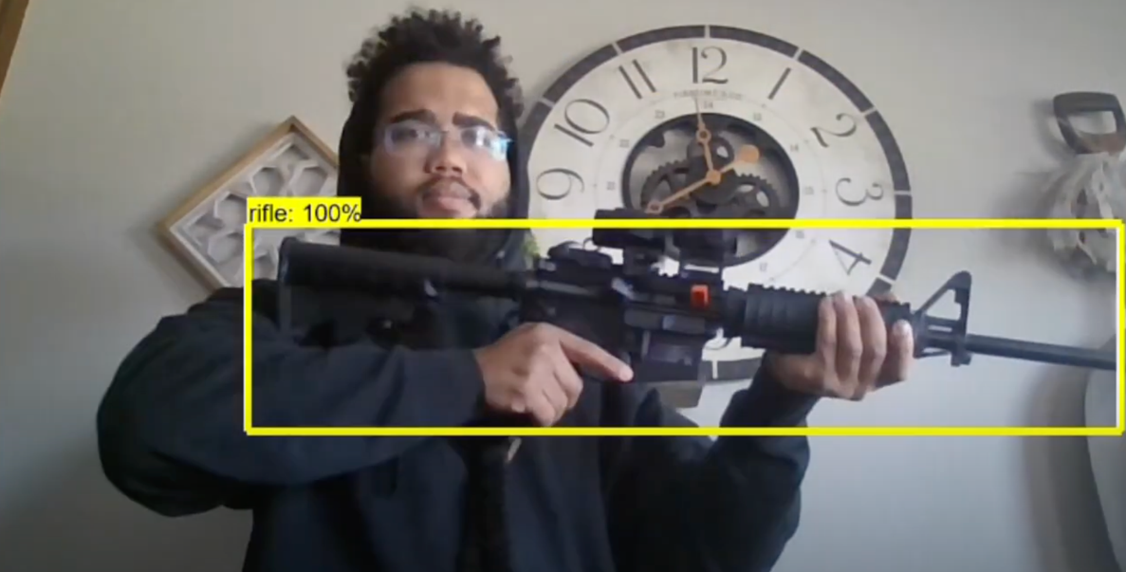
Figure 12.2: Rifle Detected with 100% Confidence
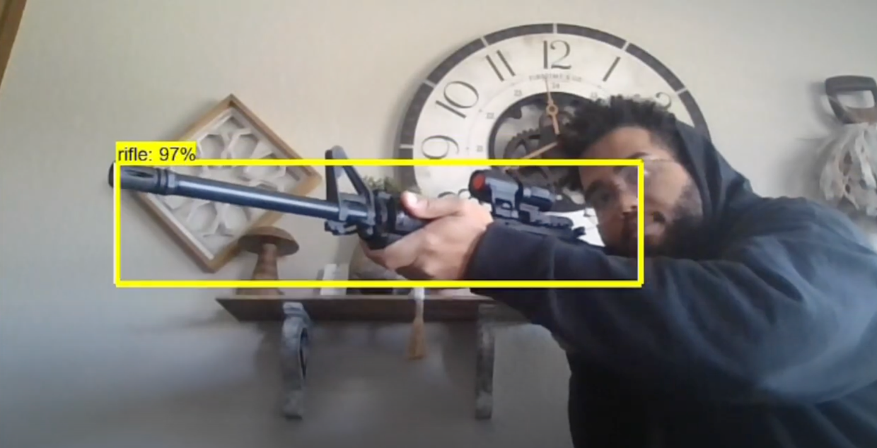
Figure 12.3: Covered Rifle Detected with 97% Confidence
Figures 13.1 - 13.5 below depict a handgun being detected by our camera. The green box and word “handgun” are specific to that class of weapon. In various orientations, including the barrel pointed towards the camera and a black gun on a black background, the handgun is detected with high confidence.
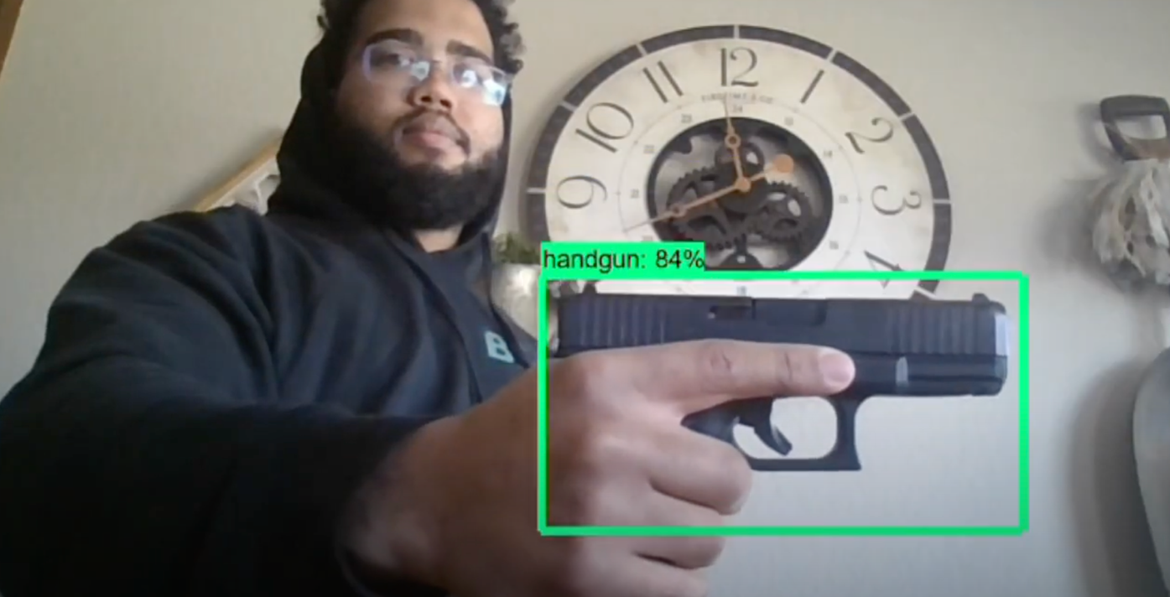
Figure 13.1: Handgun Detected with 84% Confidence

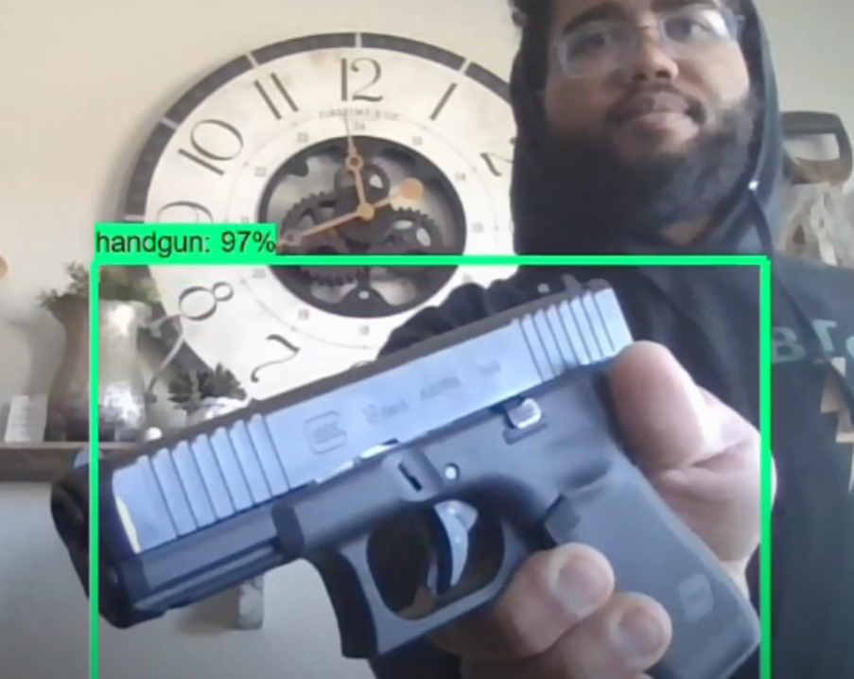
Figure 13.2: Handgun Detected with 97% Confidence

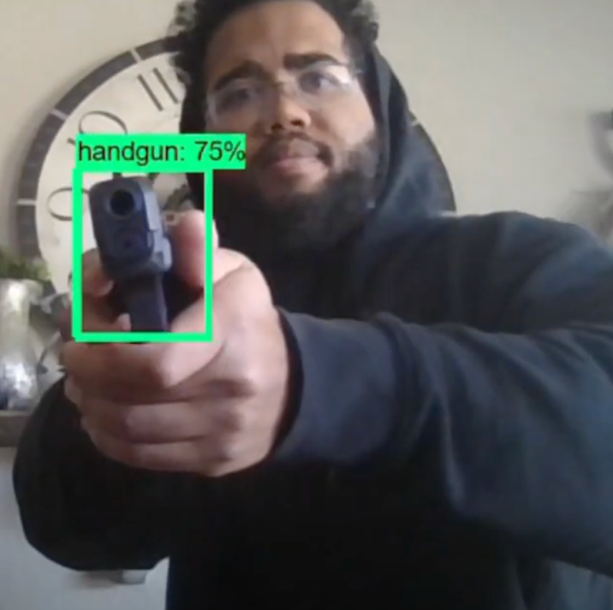
Figure 13.3: Barrel Pointed at Camera Detected with 75% Confidence

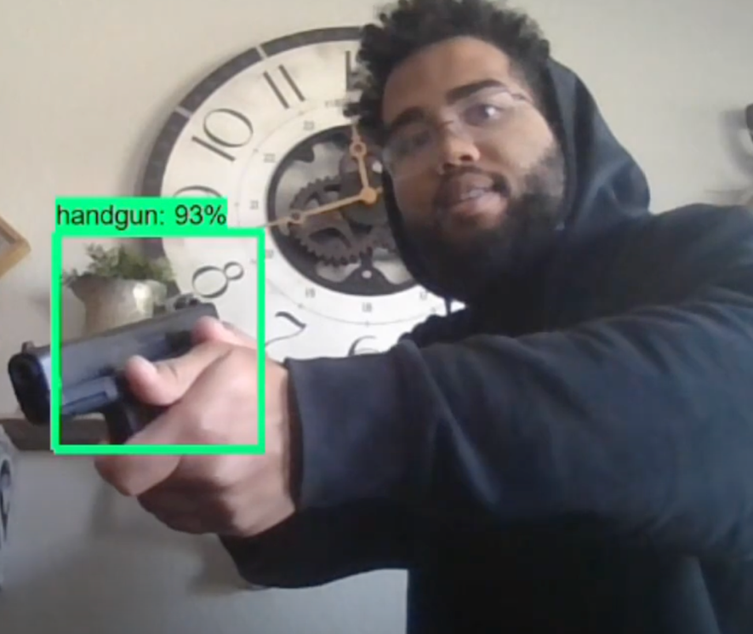
Figure 13.4: Partially Covered Handgun Detected with 93% Confidence

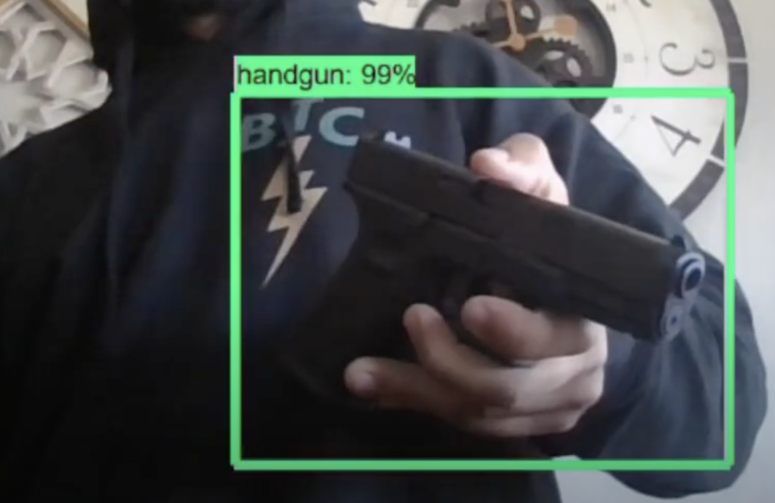
Figure 13.5: Black Handgun Detected on Black Jacket with 99% Confidence
Figures 14.1 - 14.3 below depict a blade being detected by our camera. The greenish yellow box and word “blade” are specific to that class of weapon. The blade is detected with high confidence. However, the algorithm is less than 60% confident in categorizing the blade when its narrow profile is facing the camera. Objects with a confidence level less than 60% are not displayed on the screen.
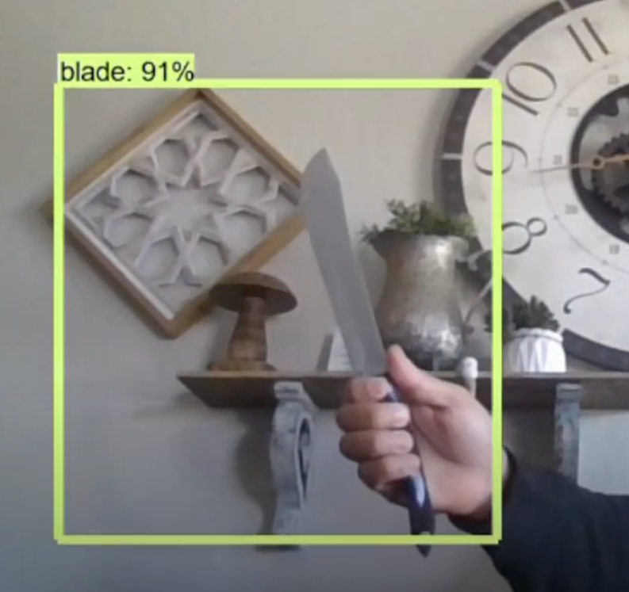
Figure 14.1: Blade Detected with 91% Confidence
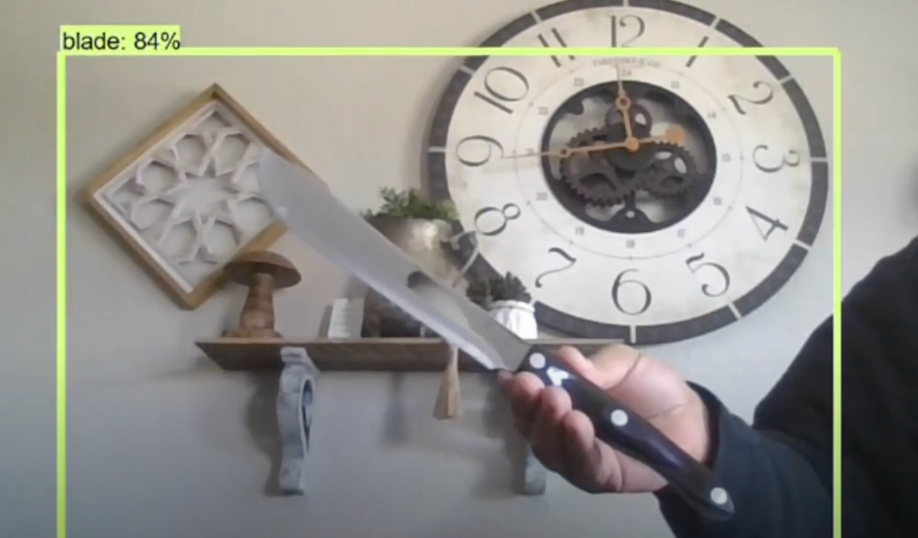
Figure 14.2: Blade Detected with 84% Confidence


Figure 14.3: Narrow Profile of Blade not Detected

Figure 15 shows an example of what the notification could read when a weapon is detected. The “Sent from your Twilio trial account” portion does not appear when the small messaging fee is paid.
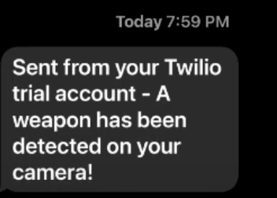
Figure 15: Example Notification
Figures16.1 & 16.2 demonstrate how the algorithm does not accidentally depict a similar looking object as a weapon. In this case, the phone is being held in a way a handgun would be held and no box is ever displayed. This shows that there are very few false positives.
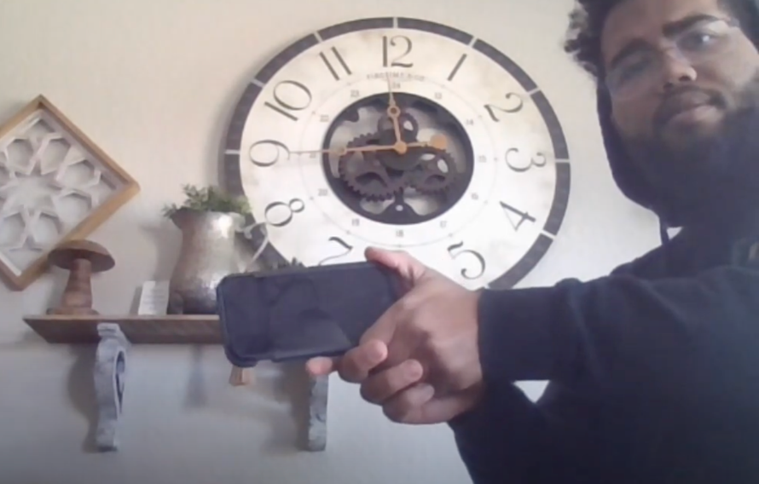
Figure 16.1: Cell Phone False-Positive Test (part 1)

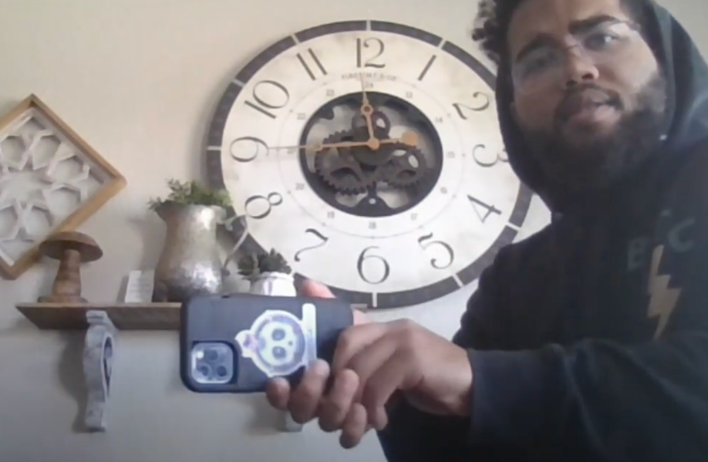
Figure 16.2: Cell Phone False-Positive Test (part 2)

Section 6 - Results and Discussion

6.1 Summary of Goals and Objectives
The main objective was to implement object detection onto Raspberry Pi. We ran a mobile deep learning model, SSD-MobileNet, on Raspberry Pi to detect various objects. Our experimental results demonstrated the effectiveness of this implementation. Moreover, the on-going work was to extend this implementation to weapon detection, which was used to detect different weapons in a real-time manner. Upon completing and validating this extension in different testing scenarios our results were successful. In order to complete the smart security system a notification system was integrated into the object detector once the new categories of objects were trained to be detected. This ensured that once a weapon was detected in the frame a text notification was sent to the appropriate authorities warning them of the potential threat.

6.2 Summary of Constraints and Codes met by Design
The main constraints we have observed with this project are creating a durable housing kit for the raspberry pi with a mountable camera that is capable of staying in place for an extended duration of time. The next constraint was the camera resolution impacting the accuracy of the weapon detection, as well as the distance that the camera is able to view, to fix this having a camera that has a minimum resolution of 1080p will ensure a clear quality to have the highest accuracy. The final notable constraint with our project was the frame rate of the real time tracking with the raspberry pi. Due to the severity of this issue we needed to increase the frame rate of the hardware, and after thorough research on how to solve the issue, the best solution to the situation was changing our software to TFlite and quantizing the data as well as utilizing a USB accelerator device in order to aid in speeding up the frame rates of the overall system.

The following codes were used in our final design:
IEEE 3652.1-2020: Federated Machine Learning - Our machine learning model can be constructed from data distributed across various repositories owned by various companies
IEEE P2671: Online detection with machine vision - This standard specifies through the general requirements of online detection based on machine vision
IEEE P2247.3: Recommended Practices for Evaluation of Adaptive Instructional Systems - best practice incorporates and promotes the principles of ethically aligned design for the use of artificial intelligence
IEEE 829-2008: IEEE Standard for Software and System Test Documentation - We used this standard when testing our software for detecting weapons
IEEE 2755.2-2020: Recommended Practice for Implementation and Management Methodology for software Based Intelligent Process Automation
IEEE 7.8: IEEE: Code of Ethics
3) To be honest and realistic in stating claims or estimates based on available data
5) To improve the understanding of technology, its appropriate application, and potential consequences

6.3 Discussion of Results and Other Use Cases
This project allowed us to design a completely unique security system by utilizing a machine learning algorithm capable of detecting weapons and immediately notifying the owner of the potential danger that is within the area. Designing this system granted us the opportunity to offer a more advanced security system to consumers at a lower cost compared to competitors. Machine learning has not been introduced to security systems easily and with the introduction of our device, we would be offering a continuously learning security system that will offer greater results as time goes on while also being capable to notify the owners of the home or establishment of a potential threat.
The use of this system can be expanded into being capable of finding concealed weapons with the implementation of an inferred camera, with this feature the number of areas this system would be able to be set up will drastically increase due to the uncertainty of if there is a weapon on a person. Taking into consideration that weapon detection is a specialization of object detection, the other uses of object detection can be implemented into several types of trackers, such as a people tracker, a vehicle tracker, or even an animal tracker. These would also easily be able to be used to notify when any object, not just a weapon, is detected in a certain area.

Section 7 - Conclusions and Recommendations
It is observed that a large population reconciles violence related to various weapons such as guns and knives all over the world. Therefore, it is a good proactive solution to detect these weapons in public areas to defend against this violence. Our Weapon Detection on Raspberry Pi design identifies active threats by revealing displayed weapons. These weapons can be either a rifle, a handgun, or a blade and the weapon must be in view of the camera. Our alert notification system provides additional time for actions to be taken to minimize casualties.
We recommend having a mountable dry surface for the Raspberry Pi platform. Wi-Fi and or data service are needed for text notifications. Electricity to run power to the Raspberry Pi system is also required. In the event of power failure, the possibility of having a backup generator is convenient to prevent system interruption. This artificially intelligent threat detection system will impact many from universities and church organizations to businesses and homeowners.

List of References

Best Home Security System Company & Security Cameras,” Deep Sentinel, 24-Sep-2021. [Online]. Available: https://www.deepsentinel.com/. [Accessed: 04-Oct-2021].
“Burglary Statistics: The Hard Numbers,” Alarms.org, 19-Dec-2019. [Online]. Available: https://www.alarms.org/burglary-statistics/. [Accessed: 04-Oct-2021].
“Frequently Asked Questions About Small Businesses,” U.S. Small Business Administration Office of Advocacy, Oct-2020. [Online]. Available: https://cdn.advocacy.sba.gov/wp-content/uploads/2020/11/05122043/Small-Business-FAQ-2020.pdf. [Accessed: 04-Oct-2021].
“Home Security Systems,” SimpliSafe, 2021. [Online]. Available: https://simplisafe.com/. [Accessed: 04-Oct-2021].
“Introducing VEDX: GPT-3 For Vision,” Visual one. [Online]. Available: https://www.visualone.tech/index.html#python. [Accessed: 04-Oct-2021].
J. Arora, “Theft Detection Using Machine Learning,” Medium, 25-Sep-2020. [Online]. Available: https://medium.com/analytics-vidhya/theft-detection-using-machine-learning-a4232ea51f1c. [Accessed: 04-Oct-2021].
L. Blain, “Vaak's AI theft-detection system is already 81% accurate,” New Atlas, 11-Apr-2019. [Online]. Available: https://newatlas.com/vaak-vaakeye-ai-theft-detection/59263/. [Accessed: 04-Oct-2021].
“More security with security cameras systems,” GW Security. [Online]. Available: https://www.gwsecurityusa.com/. [Accessed: 01-Oct-2021].
“Product Help,” SimpliSafe. [Online]. Available: https://support.simplisafe.com/hc/en-us. [Accessed: 04-Oct-2021].
“Weapons Offenses and Offenders”, U.S. Department of Justice. [Online]. Available: https://bjs.ojp.gov/content/pub/pdf/woofccj.pdf [Accessed: 29-Mar-2022]
S. Catalano, “National Crime Victimization Survey: Victimization During Household Burglary ,” Office of Justice Programs, 28-Sep-2010. [Online]. Available: https://bjs.ojp.gov/content/pub/ascii/vdhb.txt. [Accessed: 04-Oct-2021].
S. Cho and N. Tin, "Using infrared imaging technology for concealed weapons detection and visualization," TENCON 2010 - 2010 IEEE Region 10 Conference, 2010, pp. 228-233, doi: 10.1109/TENCON.2010.5685995.
S. K. Bandyopadhyay, B. Datta, and S. Roy, “Identifications of Concealed Weapon in a Human Body,” Arxiv. [Online]. Available: https://arxiv.org/ftp/ arxiv/papers/1210/1210.5653.pdf. [Accessed: 04-Oct-2021].
S. Perkins, “Heating up the search for Hidden Weapons,” Science News for Students, 03-Dec-2019. [Online]. Available: https://www.sciencenewsfor students.org/blog/eureka-lab/heating-search-hidden-weapons.
S. Stasha, “18+ Intriguing Home Ownership Statistics for 2021,” Policy Advice, 13-Sep-2021. [Online]. Available: https://policyadvice.net /insurance/insights/home-ownership-statistics/. [Accessed: 04-Oct-2021].
“Self-installed DIY Home Security Systems,” Cove Security, 04-Oct-2021. [Online]. Available: https://www.covesmart.com/. [Accessed: 04-Oct-2021].
Statista Research Department, “Number of robberies in the United States in 20119, by weapon used,” Statista, 01-Oct-2020. [Online]. Available: https://www.statista.com/statistics/251914/number-of-robberies-in-the-us-by-weapon/. [Accessed: 04-Oct-2021].
T. Covington, “Burglary Statistics, Research, and Facts,” The Zebra, 08-Jul-2021. [Online]. Available: https://www.thezebra.com/resources/research/burglary-statistics/. [Accessed: 04-Oct-2021].
Uniform Crime Reporting Program, “Crime in the U.S. 2019 Table 23,” FBI: UCR, 29-Aug-2019.[Online]. Available: https://ucr.fbi.gov/crime-in-the-u.s/2019/crime-in-the-u.s.-2019/tables/table-23. [Accessed: 27-Sep-2021].

Appendix

Code to Run Camera and Send Notification:
######## Webcam Object Detection Using TensorFlow-trained Classifier #########
#
# Description:
# This program uses a TensorFlow-trained classifier to perform object detection.
# It loads the classifier and uses it to perform object detection on a webcam feed.
# It draws boxes, scores, and labels around the objects of interest in each frame
# from the webcam.

# Import packages
import ctypes
import os
import cv2
import numpy as np
import tensorflow as tf
import sys
# This is needed since the notebook is stored in the object_detection folder.
sys.path.append("..")

# Import utilites
from utils import label_map_util
from utils import visua Explain why this would be the case and the benefits of such an
implementation? Do you expect the performance of suboptimal choice of the parameter triplet
to dramatically impact the link throughput performance?
lization_utils as vis_util

# Set up Twilio
from twilio.rest import Client

# Twilio SID, authentication token, my phone number, and the Twilio phone number
account_sid = 'AC7d4e08979f94ee3b3b40fb77a89c1434'
auth_token = '49528bd7208314b99bfba856666cc18e'
my_number = '2542851102'
twilio_number = '19362510045'

client = Client(account_sid,auth_token)
## get Screen Size
user32 = ctypes.windll.user32
screen_width, screen_height = user32.GetSystemMetrics(0), user32.GetSystemMetrics(1)
frame_height, frame_width, _ = frame.shape

scaleWidth = float(screen_width)/float(frame_width)
scaleHeight = float(screen_height)/float(frame_height)

if scaleHeight>scaleWidth:
imgScale = scaleWidth

else:
imgScale = scaleHeight

newX,newY = frame.shape[1]*imgScale, frame.shape[0]*imgScale
frame = cv2.resize(frame,(int(newX),int(newY)))
WINDOW_NAME = 'Full Integration'

# Set up camera constants
IM_WIDTH = 1280
IM_HEIGHT = 720
# Name of the directory containing the object detection module we're using
MODEL_NAME = 'inference_graph'

# Grab path to current working directory
CWD_PATH = os.getcwd()
# Path to frozen detection graph .pb file, which contains the model that is used
# for object detection.
PATH_TO_CKPT = os.path.join(CWD_PATH,MODEL_NAME,'frozen_inference_graph.pb')

# Path to label map file
PATH_TO_LABELS = os.path.join(CWD_PATH,'training','labelmap.pbtxt')

# Number of classes the object detector can identify
NUM_CLASSES = 4

## Load the label map.
# Label maps map indices to category names, so that when our convolution
# network predicts `5`, we know that this corresponds to `king`.
# Here we use internal utility functions, but anything that returns a
# dictionary mapping integers to appropriate string labels would be fine
label_map = label_map_util.load_labelmap(PATH_TO_LABELS)
categories = label_map_util.convert_label_map_to_categories(label_map, max_num_classes=NUM_CLASSES, use_display_name=True)
category_index = label_map_util.create_category_index(categories)

# Load the TensorFlow model into memory.
detection_graph = tf.Graph()
with detection_graph.as_default():
od_graph_def = tf.GraphDef()
with tf.gfile.GFile(PATH_TO_CKPT, 'rb') as fid:
serialized_graph = fid.read()
od_graph_def.ParseFromString(serialized_graph)
tf.import_graph_def(od_graph_def, name='')

sess = tf.Session(graph=detection_graph)

# Define input and output tensors (i.e. data) for the object detection classifier

# Input tensor is the image
image_tensor = detection_graph.get_tensor_by_name('image_tensor:0')

# Output tensors are the detection boxes, scores, and classes
# Each box represents a part of the image where a particular object was detected
detection_boxes = detection_graph.get_tensor_by_name('detection_boxes:0')

# Each score represents level of confidence for each of the objects.
# The score is shown on the result image, together with the class label.
detection_scores = detection_graph.get_tensor_by_name('detection_scores:0')
detection_classes = detection_graph.get_tensor_by_name('detection_classes:0')

# Number of objects detected
num_detections = detection_graph.get_tensor_by_name('num_detections:0')

#### Initialize other parameters ####

# Initialize frame rate calculation
frame_rate_calc = 1
freq = cv2.getTickFrequency()
font = cv2.FONT_HERSHEY_SIMPLEX

# Define inside box coordinates (top left and bottom right)
TL_inside = (int(IM_WIDTH*0.001),int(IM_HEIGHT*0.001))
BR_inside = (int(IM_WIDTH*0.999),int(IM_HEIGHT*0.999))

# Define outside box coordinates (top left and bottom right)
#TL_outside = (int(IM_WIDTH*0.46),int(IM_HEIGHT*0.25))
#BR_outside = (int(IM_WIDTH*0.8),int(IM_HEIGHT*.85))

# Initialize control variables used for weapon detector
detected_inside = False
#detected_outside = False

inside_counter = 0
#outside_counter = 0

pause = 0
pause_counter = 0
# Initialize frame rate calculation
frame_rate_calc = 1
freq = cv2.getTickFrequency()
font = cv2.FONT_HERSHEY_SIMPLEX

# Initialize webcam feed
video = cv2.VideoCapture(0)
ret = video.set(3,1280)
ret = video.set(4,720)

def weapon_detector(frame):

# Use globals for the control variables so they retain their value after function exits
global detected_inside
global inside_counter
global pause, pause_counter

frame_expanded = np.expand_dims(frame, axis=0)

while(True):

# Acquire frame and expand frame dimensions to have shape: [1, None, None, 3]
# i.e. a single-column array, where each item in the column has the pixel RGB value
ret, frame = video.read()
frame_rgb = cv2.cvtColor(frame, cv2.COLOR_BGR2RGB)
frame_expanded = np.expand_dims(frame_rgb, axis=0)

# Perform the actual detection by running the model with the image as input
(boxes, scores, classes, num) = sess.run(
[detection_boxes, detection_scores, detection_classes, num_detections],
feed_dict={image_tensor: frame_expanded})

# Draw the results of the detection (aka 'visulaize the results')
vis_util.visualize_boxes_and_labels_on_image_array(
frame,
np.squeeze(boxes),
np.squeeze(classes).astype(np.int32),
np.squeeze(scores),
category_index,
use_normalized_coordinates=True,
line_thickness=8,
min_score_thresh=0.50)

# Draw boxes defining "outside" and "inside" locations.
#cv2.rectangle(frame,TL_outside,BR_outside,(255,20,20),3)
#cv2.putText(frame,"Outside #box",(TL_outside[0]+10,TL_outside[1]-10),font,1,(255,20,255),3,cv2.LINE_AA)
cv2.rectangle(frame,TL_inside,BR_inside,(20,20,255),3)
cv2.putText(frame,"Detection Area",(BR_inside[0]-240,TL_inside[1]+35),font,1,(20,255,255),3,cv2.LINE_AA)
# Check the class of the top detected object by looking at classes[0][0].
# If the top detected object is a weapon (1-4)
# find its center coordinates by looking at the boxes[0][0] variable.
# boxes[0][0] variable holds coordinates of detected objects as (ymin, xmin, ymax, xmax)
if (((int(classes[0][0]) == 1) or (int(classes[0][0] == 2) or (int(classes[0][0]) == 3))) or int(classes[0][0]) == 4) and (pause == 0):
x = int(((boxes[0][0][1]+boxes[0][0][3])/2)*IM_WIDTH)
y = int(((boxes[0][0][0]+boxes[0][0][2])/2)*IM_HEIGHT)
# Draw a circle at center of object
cv2.circle(frame,(x,y), 5, (75,13,180), -1)
# If object is in inside box, increment inside counter variable
if ((x > TL_inside[0]) and (x < BR_inside[0]) and (y > TL_inside[1]) and (y < BR_inside[1])):
inside_counter = inside_counter + 1

if inside_counter > 300:
detected_inside = True
message = client.messages.create(
body = 'A weapon has been detected on your camera!',
from_=twilio_number,
to=my_number
)
inside_counter = 0
outside_counter = 0
# Pause weapon detection by setting "pause" flag
pause = 1

# All the results have been drawn on the frame, so it's time to display it.
cv2.imshow('Object detector', frame)

# Press 'q' to quit
if cv2.waitKey(1) == ord('q'):
break

# Clean up
video.release()
cv2.destroyAllWindows()

Code for the Training of the Model
r"""Training executable for detection models.

This executable is used to train DetectionModels. There are two ways of
configuring the training job:

1) A single pipeline_pb2.TrainEvalPipelineConfig configuration file
can be specified by --pipeline_config_path.

Example usage:
./train \
--logtostderr \
--train_dir=path/to/train_dir \
--pipeline_config_path=pipeline_config.pbtxt

2) Three configuration files can be provided: a model_pb2.DetectionModel
configuration file to define what type of DetectionModel is being trained, an
input_reader_pb2.InputReader file to specify what training data will be used and
a train_pb2.TrainConfig file to configure training parameters.

Example usage:
./train \
--logtostderr \
--train_dir=path/to/train_dir \
--model_config_path=model_config.pbtxt \
--train_config_path=train_config.pbtxt \
--input_config_path=train_input_config.pbtxt
"""

import functools
import json
import os
import tensorflow.compat.v1 as tf
from tensorflow.python.util.deprecation import deprecated

from object_detection.builders import dataset_builder
from object_detection.builders import graph_rewriter_builder
from object_detection.builders import model_builder
from object_detection.legacy import trainer
from object_detection.utils import config_util

tf.logging.set_verbosity(tf.logging.INFO)

flags = tf.app.flags
flags.DEFINE_string('master', '', 'Name of the TensorFlow master to use.')
flags.DEFINE_integer('task', 0, 'task id')
flags.DEFINE_integer('num_clones', 1, 'Number of clones to deploy per worker.')
flags.DEFINE_boolean('clone_on_cpu', False,
'Force clones to be deployed on CPU. Note that even if '
'set to False (allowing ops to run on gpu), some ops may '
'still be run on the CPU if they have no GPU kernel.')
flags.DEFINE_integer('worker_replicas', 1, 'Number of worker+trainer '
'replicas.')
flags.DEFINE_integer('ps_tasks', 0,
'Number of parameter server tasks. If None, does not use '
'a parameter server.')
flags.DEFINE_string('train_dir', '',
'Directory to save the checkpoints and training summaries.')

flags.DEFINE_string('pipeline_config_path', '',
'Path to a pipeline_pb2.TrainEvalPipelineConfig config '
'file. If provided, other configs are ignored')

flags.DEFINE_string('train_config_path', '',
'Path to a train_pb2.TrainConfig config file.')
flags.DEFINE_string('input_config_path', '',
'Path to an input_reader_pb2.InputReader config file.')
flags.DEFINE_string('model_config_path', '',
'Path to a model_pb2.DetectionModel config file.')

FLAGS = flags.FLAGS

@deprecated(None, 'Use object_detection/model_main.py.')
def main(_):
assert FLAGS.train_dir, '`train_dir` is missing.'
if FLAGS.task == 0: tf.gfile.MakeDirs(FLAGS.train_dir)
if FLAGS.pipeline_config_path:
configs = config_util.get_configs_from_pipeline_file(
FLAGS.pipeline_config_path)
if FLAGS.task == 0:
tf.gfile.Copy(FLAGS.pipeline_config_path,
os.path.join(FLAGS.train_dir, 'pipeline.config'),
overwrite=True)
else:
configs = config_util.get_configs_from_multiple_files(
model_config_path=FLAGS.model_config_path,
train_config_path=FLAGS.train_config_path,
train_input_config_path=FLAGS.input_config_path)
if FLAGS.task == 0:
for name, config in [('model.config', FLAGS.model_config_path),
('train.config', FLAGS.train_config_path),
('input.config', FLAGS.input_config_path)]:
tf.gfile.Copy(config, os.path.join(FLAGS.train_dir, name),
overwrite=True)

model_config = configs['model']
train_config = configs['train_config']
input_config = configs['train_input_config']

model_fn = functools.partial(
model_builder.build,
model_config=model_config,
is_training=True)

def get_next(config):
return dataset_builder.make_initializable_iterator(
dataset_builder.build(config)).get_next()

create_input_dict_fn = functools.partial(get_next, input_config)

env = json.loads(os.environ.get('TF_CONFIG', '{}'))
cluster_data = env.get('cluster', None)
cluster = tf.train.ClusterSpec(cluster_data) if cluster_data else None
task_data = env.get('task', None) or {'type': 'master', 'index': 0}
task_info = type('TaskSpec', (object,), task_data)

# Parameters for a single worker.
ps_tasks = 0
worker_replicas = 1
worker_job_name = 'lonely_worker'
task = 0
is_chief = True
master = ''

if cluster_data and 'worker' in cluster_data:
# Number of total worker replicas include "worker"s and the "master".
worker_replicas = len(cluster_data['worker']) + 1
if cluster_data and 'ps' in cluster_data:
ps_tasks = len(cluster_data['ps'])

if worker_replicas > 1 and ps_tasks < 1:
raise ValueError('At least 1 ps task is needed for distributed training.')

if worker_replicas >= 1 and ps_tasks > 0:
# Set up distributed training.
server = tf.train.Server(tf.train.ClusterSpec(cluster), protocol='grpc',
job_name=task_info.type,
task_index=task_info.index)
if task_info.type == 'ps':
server.join()
return

worker_job_name = '%s/task:%d' % (task_info.type, task_info.index)
task = task_info.index
is_chief = (task_info.type == 'master')
master = server.target

graph_rewriter_fn = None
if 'graph_rewriter_config' in configs:
graph_rewriter_fn = graph_rewriter_builder.build(
configs['graph_rewriter_config'], is_training=True)

trainer.train(
create_input_dict_fn,
model_fn,
train_config,
master,
task,
FLAGS.num_clones,
worker_replicas,
FLAGS.clone_on_cpu,
ps_tasks,
worker_job_name,
is_chief,
FLAGS.train_dir,
graph_hook_fn=graph_rewriter_fn)

if __name__ == '__main__':
tf.app.run()

