PRAIRIE VIEW A&M UNIVERSITY
ROY G. PERRY COLLEGE OF ENGINEERING



Design & Development of a Low-Cost Wireless Tracking Device

ELEG 4482: Senior Design & Professionalism II

Topic: Final Report

Team Number 5

Submitted by:
Johnny Turner
Jordan King
Malik Norris
Paul Murphy (Team Lead)
Rotimi Inyang

Sponsor: Dr. Annamalai

Facilitator: Dr. Sadiku

Date of Submission: 04/10/2019

Table of Contents
Project Executive Summary 3
List of Figures 5
List of Tables 5
List of Team Members & Roles 5
Section 1 - Project Scope 6
1.1 Problem Statement 7
1.2 Client Identification and Recognition of Need 8
1.3 Project Goals and Objectives 9
1.4 Contemporary Issues Relevant to Project 10
1.5 Potential Impact of Project on Technology, Society and Safety 11
1.6 Initial Project Constraints 12
Section 2 - Project Planning and Task Definitions 13
2.1 Task Identification 14
2.2 Timeline 16
2.3 Gantt Chart 18
Section 3 - Literature Review 19
Section 4 - Preliminary Design 21
4.1 Concept Generation 22
4.2 Concept Evaluation and Selection 23
4.3 Design Constraints and Applicable Codes and Standards Used in the Design 25
4.4 Preliminary Analysis 26
Section 5 - Detailed Systems Design 27
5.1 Equipment Selection and Specifications 28
5.2 Final Design Layout 30
5.3 Engineering Analysis and Simulation 31
5.4 Application of Engineering Codes and Standards 34
5.5 Economic Analysis 35
Section 6 – Results and Discussion 36
6.1 Summary of Goals and Objectives 37
6.2 Summary of Constraints and Codes met by Design 38
6.3 Discussion of Results 40
Section 7 - Conclusions & Recommendations 41
References 43

Project Executive Summary

Team Mission/Vision Statement
The mission of this team is to utilize our skills developed through the Electrical and Computer Engineering (ECE) Department to effectively construct our senior design product. We will accomplish this by providing a dynamic and collaborative learning environment challenging and cultivating each other’s technical prowess, and inducing innovation by igniting a collision of fresh ideas.



Team




Rotimi Inyang (CE)
Accountant
Jordan King (EE)
Project Manager

Paul Murphy (EE)
Team Lead
Johnny Turner (CE)
Secretary
Malik Norris (CE)
Data Analysis

Problem Statement
50% of youth with autism are reported to wander. 25% of these children were missing long enough to cause concern of drown or traffic accidents. Current technology and solutions such as other tracking devices, cameras, or security systems could also be used, but lack feasibility and affordability.

Propose Deliverable
3G data connectivity, effective sensing coverage for both indoor and outdoor operations, battery re-charging approximately once a day, and tracking use for both moving people and/or objects

Budget
Project Budget $600 and Amount Spent $132

Customer Requirements and Engineering Solutions
- Energy efficient device by implementing a rechargeable battery pack
- Low-cost device
- Active cellular connectivity
- Real-time GPS tracking

Major Constraints
Some Global Positioning System (GPS) devices may fail due to unforeseen reasons, a backup paper map may be needed. In the event that you are utilizing GPS on a battery worked gadget, there might be a battery failure and you may require an outer power supply which isn't constantly feasible. GPS signals are not precise because of geographical or manmade obstructions, such as buildings, trees and sometimes by extreme atmospheric conditions such as geomagnetic storms.

Benefits
- Technical Benefit: Conjoining GPS Innovation with IoT gadgets
- Societal Benefit: Alleviating senior citizens fear of nursing homes and empowering caregivers
- Safety Benefit: Better monitoring of children with special needs to protect them from injury

Recommendation
- Improve the ability to track location in an indoor environment
- Initiate geo-fencing technology into the device and alert text messaging
- Develop a waterproof shield for the device

Conclusion
This project will leverage the latest technology tools such as cloud, Internet of Things, and sensors to deliver an innovative solution which will enable caregivers to better monitor their dependent. By the completion of this project, we will have a comprehensive understanding of integrating multiple technology tools and the communication of these devices have with one another as well as their connection to the internet.

List of Figures
5.1: Front of Device ………………………………………………………………………………………28
5.2: Back of Device ………………………………………………………………………………………28
5.3: Final Device Design ………………………………………………………………………………....28
5.4: Finalized Arduino GPS Tracker Code ………………………………………………………………29
5.5: Successful Arduino GPS Tracker Code Running ……………………………………......................30
5.6: Finalized IOT Platform Design ……………………………………………………………………...31

List of Tables
5.1: Equipment …………………………………………………………………………………………...26
5.2: Literature Review …………………………………………………………………………………....33

List of Team Members & Roles
Paul Murphy – Team Lead
Jordan King – Project Manager
Rotimi Inyang – Accountant
Malik Norris – Data Analysis
Johnny Turner – Secretary

Section 1 - Project Scope

Problem Statement

The objective of this project is to find a low-cost solution to address an important societal issue of safety for some people with disabilities, especially children and elderly with special needs such as those with autism spectrum disorder and dementia. Caregivers hold a huge responsibility to monitor and keep from harm those that they are caretakers of. Even under constant human supervision, wandering can happen quickly leaving only the option of desperate manual searching. If this was to happen, the caregivers’ only options are to call the police and gain the help of first responders and community members. There are not many solutions that will help with preventing wandering. The current solutions that would help with wandering are mostly expensive, have technological disadvantages, low usability for children with autism or elderly with dementia and/or not reliable.

1.2 Client Identification and Recognition of Need

People with autism died significantly younger than the general population, at a mean age of 36 years old, compared to 72 in the general population. Among injury deaths specifically, autistic people died at a mean age of 29, while the mean age among those without autism was 55. About 40 percent of fatal injuries among people with autism occurred in homes or residential institutions. The most common causes were suffocation, choking and drowning. Children were at the greatest risk. While people with autism had three times the rate of death from accidental injury, overall, compared to the general population, the rate was 42 times higher among children under age 15. These numbers show the urgent need for caregivers to be equipped with the proper tools to better do their job. One of the major leading deaths for children with autism is a preventative injury. This data shows that caregivers are needing a tool which can track a person of interest location, environment changes, and vital signs. Through implementing our geolocating device, our customers will not only have the location of the patient, but peace of mind knowing that if our product leaves the area mapped out by the user, they will be notified. Our sensor technology is capable of also tracking environmental changes which can predict when a person enters water which has been shown as place children with autism go when wandering.

Project Goals and Objectives
Purpose
The purpose of this project is to develop a low-cost wireless tracking device to address an important societal issue of safety for some people with disabilities -, especially children and elderly with special needs. This device will enable caretakers to more effectively monitor the safety of their disabled dependent.

Scope Description / Objective
Our team will develop a low-cost personal tracking device using innovative techniques such as crowd sensing, GPS tracking, and iOS/Android mobile application. We will utilize 3G connectivity to connect our device to GPS location services, which will enable the device to effectively track the moving object. Our device will be energy efficient by having a rechargeable battery with low power usage. The band will be a comfortable wearable device that connects to a mobile application. This device will allow our customers to monitor individuals or items in real-time.

Marketing / Customer Requirements
Our customers are looking for a dynamic device which enables them to be better caregivers and eradicate their sense of worry. One of the major requirements our device must have is being energy efficient because the device must be able to endure long durations of use. If the device were to fail because of power, it would not be reliable. Therefore, we have created an energy efficient device to make sure our device is reliable. We utilized low priced equipment and platforms to produce a low-cost device. A few technical requirements are active cellular connectivity and real-time GPS tracking. Our last customer requirement is a comfortable wearable device. We hope to create a wearable Internet of Things device so that the patient can be actively tracked wirelessly. Our customers want something noninvasive, low visibility, and comfortable device.

1.4 Contemporary Issues Relevant to Project

With a click on a screen, an ordinary person can find his or her way via a complex system involving satellite technology. GPS technology has exponentially improved society. GPS technology improved navigational accuracy significantly in the military, in the economy, and in our ordinary lives. However, there are still issues with GPS tracking in modern day society. The two main contemporary issues with wireless GPS tracking are accuracy problems and issues accessing data. The accuracy problems are usually due to the area a person is located. The antenna can have issues picking up or maintain satellite signal. Normally, this can be fixed by placing the antenna in a place where it has a clear view of the sky. However, this could be due to the location a person is in. If a person is indoors, the GPS tracker can be off or if a person is in an area where there is not much signal the tracker can have a hurt time picking up the location. The second contemporary issue is the ability to access history data online. The ability to access data is important to those tracking something of interest. Access to information is due to enabled firewalls, outdated firmware, or incompatible technologies.
According to an ABI Research, the major barriers of Personal Location Devices and Applications Market have been expensive devices, cellular subscriptions, indoor locations and severe regionalization and fragmentation of coverage, and once those problems are resolved, the demand and market will scale significantly. Our innovation exactly and directly addresses those issues. In fact, Amazon customer reviews of personal tracking devices reveal that most of the tracking devices have very poor ratings. Many such products have around 50% of customers reporting a poor rating of only 1 star out of 5 and overall, average ratings range from 2 to 3 stars. Security was another important aspect that customers were concerned about in our customer interviews discovery. This project will be devoted to focusing on developing a prototype service that works well while providing the security of users.

1.5 Potential Impact of Project on Technology, Society and Safety

Technological Factors:
As of today, the is no mainstream market for GPS systems that are conjoined with the Internet of Things (IoT), although GPS innovation can offer results never envisioned when joined with the IoT gadgets.

Social Factors:
Senior citizens fear to move into a nursing home and to lose their independence more than they fear death, according to a study, “Aging in Place in America,” commissioned by The EAR Foundation. When asked what they fear most, seniors rated loss of independence (26%) and moving out of home into a nursing home (13%) as their greatest fears. Death was cited as the greatest fear for just 3% of seniors. Our device will allow nursing home residents to feel more independent since they will not have to be overseen by their caretakers for every trivial task.

Safety Factors:
Our device will allow caretakers to better monitor the location of each of their residents on a greater scale. Geofencing will enable caretakers to create zones that will automatically alert them when the tracker enters in or out of the set location.

1.6 Initial Project Constraints

- Some Global Positioning System (GPS) devices may fail due to unforeseen reasons, a backup paper map may be needed.
- In the event that you are utilizing GPS on a battery worked gadget, there might be a battery failure and you may require an outer power supply which isn't constantly feasible.
- GPS signals are not precise because of geographical or man-made obstructions, such as buildings, trees and sometimes by extreme atmospheric conditions such as geomagnetic storms.

Section 2 - Project Planning and Task Definitions

2.1 Task Identification

Roles were assigned to and agreed upon at the first team meeting. Satisfactorily time was allocated for each task completion. Tasks were assigned based on strengths and qualifications of members’ abilities. In the event of a role was vacant, the team had alternates that performed the task given for the assigned role.

a) Team Leader: Paul Murphy
Alternate: Jordan King
The team leader is to maintain group focus and efficiency of meetings. The team leader shall: hold members accountable to task assignments, and direct and assign tasks if consensus cannot be agreed upon. In the event that an informal meeting is needed, the team leader shall set up and conduct the meetings with the project sponsor and course facilitators.

b) Accountant: Rotimi Inyang
Alternate: Malik Norris
The accountant is to manage the budget and keep a detailed record of project expenditures. The accountant will also research project costs, materials, and options. In the event that a financial decision cannot be agreed upon by the team or sponsor, the accountant will make the final decision.

2.1 Task Identification (Continued)

c) Data Analysis: Malik Norris
Alternate: Jordan King
The process of evaluating data using analytical and logical reasoning to examine each component of the data provided. This form of analysis is just one of the many steps that must be completed when conducting a research experiment. Data from various sources is gathered, reviewed, and then analyzed to form some sort of finding or conclusion. There is a variety of specific data analysis method, some of which include data mining, text analytics, business intelligence, and data visualizations.

d) Project Manager: Jordan King
Alternate: Rotimi Inyang
The project manager will maintain and update the project master schedule and timeline. In the event that the weekly meeting cannot be held, the project manager will determine the reschedule time. The project manager will also determine when to hold extra meetings if progress is behind. The project manager will be representative of the team when meeting with the project sponsor.

e) Secretary: Johnny Turner
Alternate: Paul Murphy
Secretary is the attendee at the meeting whose role is to document and keep official records of events and plans for each meeting. The secretary may be a formal, professional note taker, whose only job is to take notes, or they may be an active participant in the meeting who has taken on the role for that specific meeting.

2.2 Timeline

- Project Conception
  - In the first phase of the project, we formulated our group. Our group was comprised of electrical engineers and computer engineers. We had a unique balance of coders and hardware designers. During the team formation stage, we made sure that every member on the team had a unique skill set which would be helpful for the execution of the project. Afterward, our group chose a project. We chose to work on the wireless tracking device because our collective interested aligned with this project. In the last step of the project conception, we assigned roles and developed an execution strategy to complete the project in a timely manner. This phase of the project was from September of 2018 to mid-October of 2018.

- Research & Designing
  - The second phase of this project is focused on research and development. Our team completed a literature review of the wireless GPS tracking devices space. Based on our research, we identified the key features we would like our device to have. We then ordered the necessary components to build our device. We sketched out our preliminary design which incorporated the parts we planned to use. Lastly, we used the information gathered to put together a visual presentation for our senior design class. This phase of the project was from mid-October to the end of November.

2.2 Timeline (Continued)

- Project Launch & Execution
  - This phase of the project was the building phase. During this time, our team worked to develop our first prototype. We had the opportunity to test out different variations of the power supply, connectivity options, GPS modules, and the internet of things dashboards. During this process, we could understand which components were most useful and which internet of things dashboard visualized our data the best. We completed quality testing on the wireless GPS tracker to accurately and efficiently determine our location. Our team used the information to develop a mid-term presentation which we presented to our peers. This phase of the project lasted from December to early March.

- Project Performance & Control
  - In the fourth phase of the project, we used our data to build our final prototype. We then compared our final design to our project deliverables. Our team successfully built a product which delivered on our project’s set goals and objectives. We measured our product’s performance and compared our product’s performance with industry standards. Our team utilized this data to write our project conclusion and recommendations. This phase of the project was in the month of March.

- Project Close
  - In the last phase of the project, we are taking the information we have gathered and the working product which we’ve developed to put together a formal presentation. We also have a completed report which gives full details of our project.

2.3 Gantt Chart

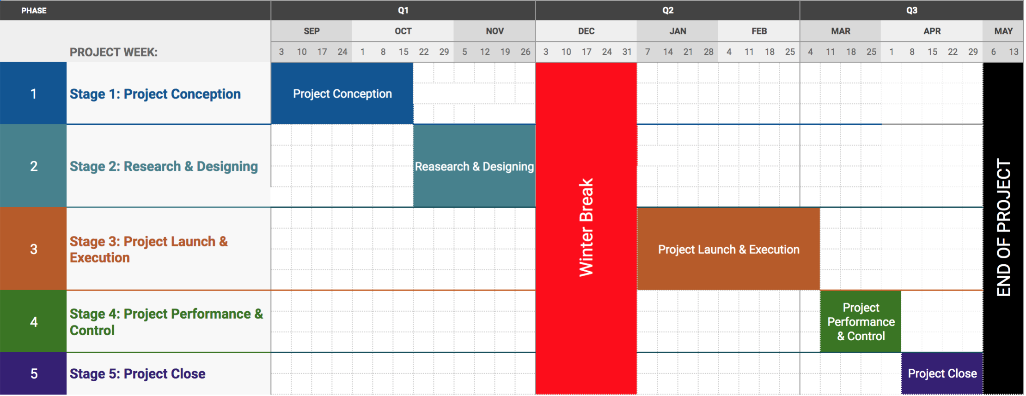

Section 3 - Literature Review

The field of GPS tracking has been thoroughly researched, implemented, and refined. There are thousands of different devices available on the market for tracking. The goal our proposed solution competitively is to stand at the pinnacle point of the industry by providing the essential capabilities of a tracker that is both functional and attractive at a reasonable price to customers to aggressively distinguish our device from others. Most GPS tracking devices are attachable and can be hooked onto a key ring or latched to the tracked object through other means. A few devices researched offer wearable accessories like belts, shirts with sleeves, or pockets pouches. However, our goals are to make the device wearable and attractive. The devices for tracking that are geared towards our same audience of parents with special needs children offer many valuable features and include most if not all of the major functions our teams are proposing. With all this though, the initial price and monthly price of the device begins to get more expensive while our project is providing a cost-effective solution. Also, the addition of the services provided by these high-end devices, such as Angel Sense monitors, can drain the battery quickly making the battery life inconsistent. Plus, our proposed device will be durable enough to handle rapid movements and fall heights from about waist level; we also plan to make the device waterproof. Another proposed plan to separate our device from others is our range of cellular connectivity. With some trackers functioning completely on Bluetooth connectivity, offering a range 150 – 300 ft, and others utilizing a 2G or 3G connection, we plan to use 2G/3G/ 4G LTE connectivity to increase our range. Overall, our device plans to fill in the blanks where current technological advancements meet economic efficiency with an attractive package.

Section 4 - Preliminary Design

4.1 Concept Generation

We arrived at our proposed design by analyzing numerous GPS tracking devices and taking notes of differences between the multiple devices. For example, we examined the Track IMO 2G GPS Tracker and the Samsung SmartThings GPS Tracker. Both of these devices have a free year of data with a set price of $5 a month after the first year of data usage. On the other hand, the Track IMO device requires a T-Mobile network, and the Samsung SmartThings GPS Tracker data coverage is based on an AT&T network. Both of these devices are water resistant, but the Samsung SmartThings GPS Tracker is also dustproof. We took similarities and differences from these two devices, along with a few more, and created a device that would be the best fit for parents with children that have special needs.

A few courses in our academic program that helped us the most in this specific design project would be Microprocessors and Electronics. Microprocessors taught us the software aspect of this project, and Electronics taught us solely about the hardware of our proposed project. With these two courses, we were skilled enough to code our application for real-time tracking and geofencing, and wiring hardware connections. The only new skill that is required for this project would be to use AutoCAD applications for 3D printing. We plan on acquiring this skill by following the manufacturer instructions that are attached with bought products as well as observing and analyzing an intensive amount of online videos.

4.2 Concept Evaluation and Selection

During the creation of our project, our team evaluated several components to determine which would produce the best outcomes. The concepts our team evaluated were power efficiency, connectivity, GPS accuracy, and data visualization. Power efficiency is critical to our project because our device will operate wirelessly meaning it will be independent of any power source. Initially, we chose selected one battery for our preliminary design concept. The battery we selected needed 1,000 milliamps of current to operate. However, the Arduino board could not handle that much current, therefore, it automatically limited the amount of power consumption by the battery. This lower power consumption affected the GPS module because the GPS module did not have enough current to operate. Because of this issue, our team decided to initiate two different power sources for our wireless tracking device. The first power source is a lithium-ion battery which powers the GPS module. The second power source is an energy shield which powers the Arduino board. By giving the GPS module and Arduino board two separate power sources, we were able to create a power efficient system. Both power sources are rechargeable which is great for wireless devices and aligns with our customer needs.

The second concept evaluated was connectivity. Our team reviewed different connection sources. The connection sources we reviewed were Bluetooth, Wi-Fi, and data connectivity. Our team selected data connectivity because it has an unlimited range for connectivity. We chose the Hologram 3 in 1 Sims Card to implement 2 and 3G LTE connectivity. This chip gives connection access in 196 countries and works on Verizon and AT&T networks. This is a developer chip for the internet of things which made it perfect for our project. The data connection is an easy pre-pay card which allows us to operate without being in a contract with a service provider. The payment to run the 2 and 3G LTE is 5 dollars a month.

4.2 Concept Evaluation and Selection (Continued)

The third concept evaluated was the GPS module. Our team needed a GPS module which was compatible with our connection source, Arduino board, and power sources. The Botletics Arduino Shield SIM 7000 A was perfectly compatible with our existing system. The Sim 7000 is a new shield which can allow up to 4G connectivity. This is an American version meaning it works specifically on the United States cellular network. This is also the highest quality GPS module in today’s market.

Our final concept the team had to evaluate was the data visualization. A critical part of our project is showing the user where the person of interest being tracked is located. We examined several Internet of Things dashboards. We reviewed the following data visualization tools: AT&T dashboard, ThingsBoard.io, Adafruit.io, and Freeboard.io. Our team chose the ThingsBoard.io because of its ability to give the best visual layout of our data. ThingsBoard.io is able to project the speed, altitude, direction, and general location of our device.

4.3 Design Constraints and Applicable Codes and Standards Used in the Design

Design Constraints:
A major design constraint was making our GPS tracker a small wearable device. Miniaturing our tracker would require the use of microchips which are outside of our $600 budget, so we decided to settle for having a bulkier, yet still reliable, GPS tracker.

IEEE Codes and Standards:
- IEEE 1801- Unified Power Format: Used to specify the power intent in power optimization of electronic design automation.
- IEEE 260- Units of Measurement: Used to provide standard letter symbols for units of measurement for use in all applications in multiple contexts.
- IEEE 1725™ standard, for rechargeable batteries for cellular telephones, addresses the quality and reliability of rechargeable lithium ion and lithium ion polymer batteries for cellular telephone applications.
- IEEE 802.15.1™, adapted from portions of the Bluetooth™ wireless specifications, is for wireless PANs in notebook computers, PDAs, cell phones and other portable handheld devices (to be specific IEEE 802.16e-2005).
- IEEE 1394™ standard, commonly called Firewire®, targets the serial buses that connect computer systems and peripherals.

4.4 Preliminary Analysis

The team evaluated the system concept for feasibility, performance, and alignment to the customer’s needs. The key requirements that our design must meet our energy efficiency, real-time GPS tracking, and active cellular connectivity. Energy efficiency is critical because the wireless tracking device must maintain power for a prolonged period of time. The two battery sources we have integrated on our device are capable of enduring 36 hours of continuous use. Our power sources are also rechargeable which makes it convenient for our customer so that they will not have to purchase new power supplies every time the old power supply dies. This also solved an environmental issue because the rechargeable battery eliminates waste. The two battery sources we have initiated are strong enough to power the entire system without any additional support. Another critical aspect of our project is real-time GPS tracking. The GPS module we chose has great accuracy. It can locate your proximity within 4.9 meters’ radius. In our code, we have a delay of 5 seconds to recalculate where the device is at. This enables continuously updated feedback of new information to be fetched from the device and shown on our internet platform. In the background, our device is sending data to our internet of things platform in real-time to give our user an active depiction of the speed, direction, battery life and location of the device. The Hologram 3 in 1 Sims Card allows for active cellular connectivity. We have access to the entire American network and our device can run on both AT&T and Verizon networks. The preliminary analysis shows that our device has successfully met our set criteria.

Section 5 - Detailed Systems Design

5.1 Equipment Selection and Specifications

Table 5.1: Equipment
Description | Specifications | Image
EnergyShield 2 Basic - Rechargeable Battery for Arduino | - All of the functionality of the energyShield 2 Basic is packed inside of a standard Arduino shield, which stack on top of the Arduino  - Adds Mobility to Arduino based projects due to its built-in power source | 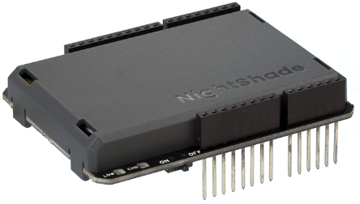
Arduino Mega 2560 Rev 3 | The MEGA 2560 is designed for more complex projects. With 54 digital I/O pins, 16 analog inputs and a larger space for our sketch; providing 256 KB of Flash Memory compared to the Uno which only as 32 KB. | 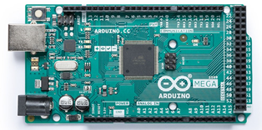
Hologram 3-in-1 Global IoT SIM Card | - One Global SIM Card for access to over 550 LTE, CAT-M, NB-IoT, 2G, 3G, and 4G networks  - Seamless network coverage in 196 countries  - Flexible, scalable pricing, no contracts required  - Developer connectivity tools for fleet and device management | 

5.1 Equipment Selection and Specifications (Continued)

Description | Specifications | Image
Botletics SIM7000 LTE CAT-M1 NB-IoT Cellular GNSS Arduino Shield | - Utilizes 2G and 3G LTE  - Run and send data via HTTP or MQTT  - Integrated multi-GNSS (GPS, GLONASS)  - Uplink speed up to 375kbps, downlink up to 300kbps  - Built-in electronic file system (EFS) for saving data | 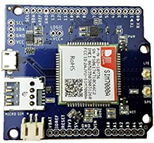
Botletics SIM7000 LTE CAT-M1 NB-IoT Cellular GNSS Arduino Antenna | Convenient u.FL antenna connectors that provide a 2.5-meter accuracy on the tracked person or object. | 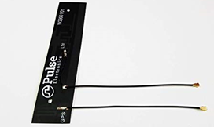
YDL 3.7V 2000mAh 654065 Lipo battery Rechargeable Lithium Polymer ion Battery Pack with JST Connector | This battery is extremely thin, lightweight compared to any rechargeable chemistry. Low weight, small size but huge capacity, with very low self-discharge. A full charge allows the battery to operate for 2-3 days. | 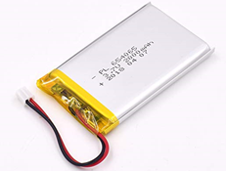

5.2 Final Design Layout

Antenna
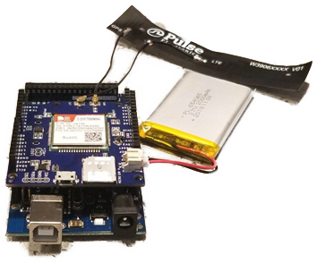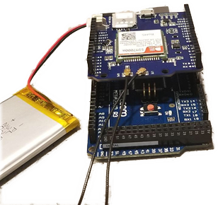
Figure 5.1: Front of Device Figure 5.2: Back of Device

Arduino Mega
GPS LTE Shield
IoT Global Sim Card
3.7V Battery

EnegryShield 2
Battery

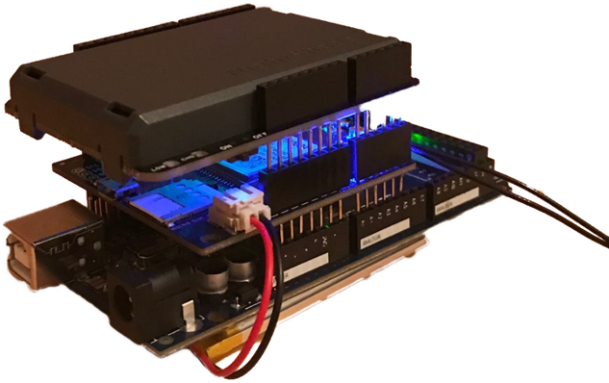

Figure 5.3: Final Device Design

5.3 Engineering Analysis and Simulation

The Arduino ecosystem is comprised of a diverse combination of hardware and software. The versatility of Arduino and its simple interface makes it a leading choice for a wide range of users around the world from hobbyists, designers, and artists to product prototypes. Both beginners and experts have access to a wealth of free resources and materials to support them. The open source behind Arduino has made it particularly friendly to new and experienced users.

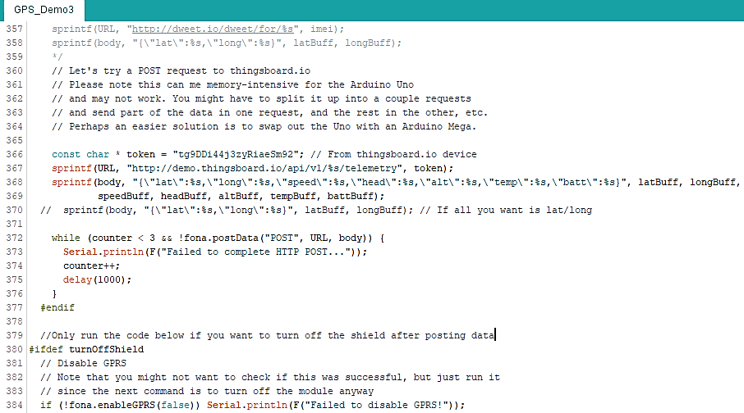
Figure 5.4: Finalized Arduino GPS Tracker Code

5.3 Engineering Analysis and Simulation (Continued)

The Arduino board is connected to a computer via USB, where it connects with the Arduino development environment (IDE). The user writes the Arduino code in the IDE, then uploads it to the microcontroller which executes the code, interacting with inputs and outputs such as sensors, motors, and lights. Our Arduino code is specifically set to track a target’s latitude, longitude, speed, heading (direction) and altitude, every 10 seconds.

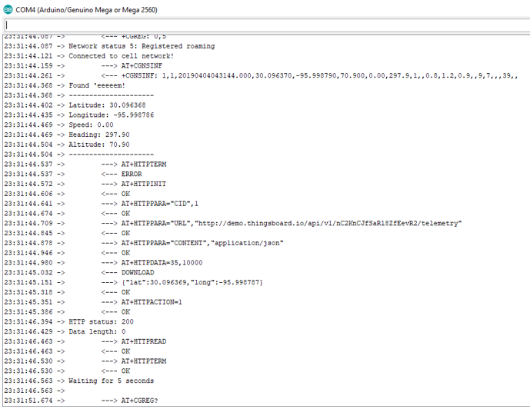
Figure 5.5: Successful Arduino GPS Tracker Code Running

5.3 Engineering Analysis and Simulation (Continued)

ThingsBoard is an open-source IoT platform for data collection, processing, visualization, and device management. It enables device connectivity via industry standard IoT protocols - MQTT, CoAP and HTTP and supports both cloud and on-premises deployments. ThingsBoard combines scalability, fault-tolerance and performance so our data is always saved. ThingsBoard has more than 30 customizable widgets allowing us to build a custom IoT dashboards for our GPS tracking device.

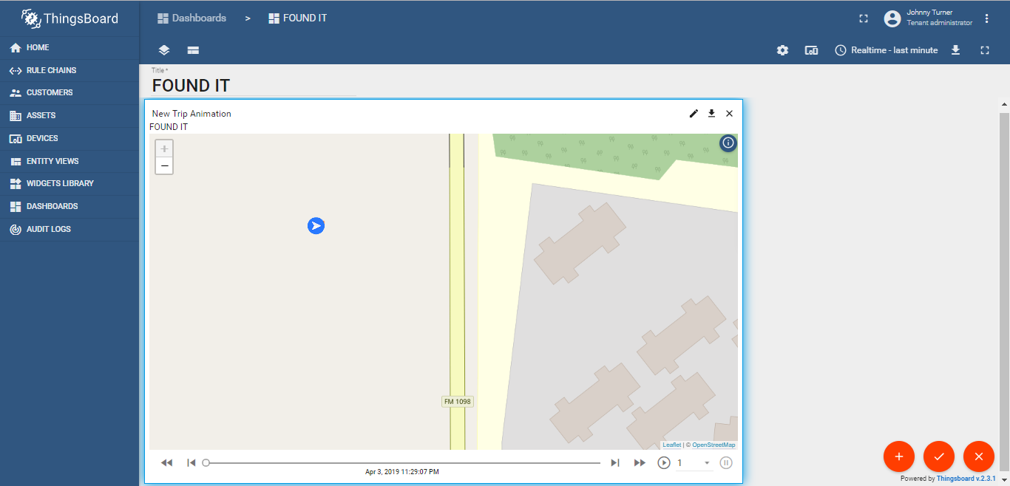
Figure 5.6: Finalized IOT Platform Design

5.4 Application of Engineering Codes and Standards

- IEEE 1801- Unified Power Format: Used to specify the power intent in power optimization of electronic design automation.
- IEEE 260- Units of Measurement: Used to provide standard letter symbols for units of measurement for use in all applications in multiple contexts.
- IEEE 1725™ standard, for rechargeable batteries for cellular telephones, addresses the quality and reliability of rechargeable lithium ion and lithium ion polymer batteries for cellular telephone applications
- IEEE 802.15.1™, adapted from portions of the Bluetooth™ wireless specifications, is for wireless PANs in notebook computers, PDAs, cell phones and other portable handheld devices ( to be specific IEEE 802.16e-2005)
- IEEE 1394™ standard, commonly called Firewire®, targets the serial buses that connect computer systems and peripherals

5.5 Economic Analysis

Table 5.2: Literature Review
 | Design | Energy Efficiency | Active Cellular Connectivity | Global Coverage | Continuous Service Fee | Initial Cost
Found It | 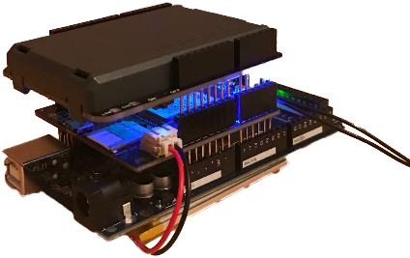 | 36 Hours of continuous activity before  rechargeable is needed | 2G/3G/4G | Yes, coverage in 180+ countries, 500+ carriers | $5/month | $123.85
AngelSense |  | Last 16-24 hours | AT&T and Verizon LTE Network | No, only supported in the U.S. and Canada | $52/month | $500.00
Trackimo TRKM010 | 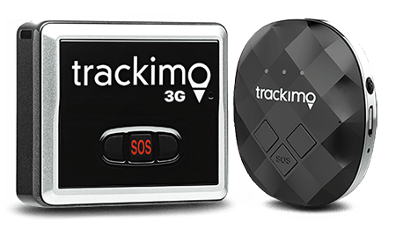 | Lasts 2-4 days per charge during tracking activity | 3G,  Wi-Fi and Bluetooth | Yes | $5/month | $189.99
Samsung SmartThings  Tracker | 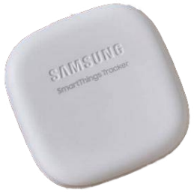 | Typical last 4-5 days before the battery needs to be rechargeable | AT&T LTE-m Network | No, the product is not supported outside of U.S. | $5/month | $89.99
Spy Tec STI GL300 | 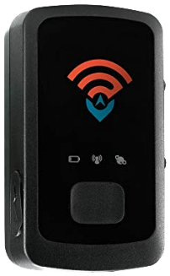 | 2 weeks, before AA battery needs to be replaced | GPS and GSM | Yes | $45/month | $49.95
Tile Sport |  | Designed to run for a full year with zero upkeep, then Tile needs to be replaced | No, Bluetooth 200 ft. range | Yes, as long as Bluetooth is available | $34.99/year | $34.99

Section 6 – Results and Discussion

6.1 Summary of Goals and Objectives

Ideally designed to assist in helping increase the safety of people with mental illness and alleviate the stress of caregivers, the fundamental objective of our project was to create a GPS tracking device that could monitor the location of animate or intimate objects. In addition, the device should be cost-effective and require low-power consumption. Our team set the goal to create a GPS device that would be small enough that could be worn as a wristband. The tracker would be able to function on both Android and Apple products while also utilizing the internet of things to allow the transfer of the data collected to be examined and manipulated by different systems. As a team we wanted to be able to have an app, created or used as a platform, to display the data and also implement the use of alerts when the tracker interacted with a point or area of interest. After analyzing the competition and other GPS tracking providers we recognized that although some features such as the ability to listen in to the environment weren’t as valuable or pertinent to the success of the project and used the decision of opting out on these to focus on the necessities. We wanted to provide a GPS tracker that could provide people with a piece of mind of having the location available to them while also not intruding too far into the privacy of the wearer.

6.2 Summary of Constraints and Codes met by Design

Global Positioning System Constraints:
The entire backbone of the system relies on signal transmission and reception. In our continuous growth in technological advancement and as more devices start to communicate wirelessly, signal interference rates increase. Due to the many ways that a signal can be interrupted the device will always be under the constraint of its environment.

Budget:
Due to the amount of money allocated towards the project, we won’t be able to create too many aspects of the project, forcing us to look at other platforms to complete our goals. This constraint brings in another one; the mercy of dependency.

Dependency:
When using open-platforms or systems that aren’t maintained and regulated by the team, the device is then at the mercy of the system chosen.

IEEE Codes and Standards:
- IEEE 1801- Unified Power Format: Used to specify the power intent in power optimization of electronic design automation.
- IEEE 260- Units of Measurement: Used to provide standard letter symbols for units of measurement for use in all applications in multiple contexts.
- IEEE 1725™ standard, for rechargeable batteries for cellular telephones, addresses the quality and reliability of rechargeable lithium ion and lithium ion polymer batteries for cellular telephone applications.

6.2 Summary of Constraints and Codes met by Design (Continued)

- IEEE 802.15.1™, adapted from portions of the Bluetooth™ wireless specifications, is for wireless PANs in notebook computers, PDAs, cell phones and other portable handheld devices ( to be specific IEEE 802.16e-2005)
- IEEE 1394™ standard, commonly called Firewire®, targets the serial buses that connect computer systems and peripherals

6.3 Discussion of Results

After the shipment of parts came in our construction of the initial prototype began. The team decided to use Arduino implement the coding, a GPS module that required a SIM card to collect location data and connect to the internet of things, and a rechargeable battery. The design was a simple plug and stack method with the battery plugging into the GPS tracker and tracker into the Arduino. Looking at the prototype design, we realized that we weren’t going to get much smaller components with the budget we had so the wearable wristband idea was disregarded and we organized a plan to research other forms of packaging. After looking online for coding GPS trackers with Arduino we found that it was possible to use the coding software in cooperation with many online platforms. We chose to work with the thingsboard.io platform because it had the most attractive display for information. Other platforms required more expensive GPS modules or Wi-Fi modules, which although allowed for tracking inside of buildings, would only work if Wi-Fi was available at these locations. With that, the team focused on implementing the GPS Arduino coding with our device and connecting the device to the ThingsBoard platform. Our result was a GPS tracker with a rechargeable battery that lasts up to 36 hours and connects to the internet of things. Since we chose to use an online platform to display our information, it is readily available for either Android or Apple devices. For our packaging, we 3-D printed a shell for ascetics and also functions to hold the device as one rather than the conjunction of parts.

Section 7 - Conclusions & Recommendations
Our team designed a low-cost, low power GPS tracking device that utilizes a SIM data subscription to upload data to the internet-of-things to an open online platform called ThingsBoard, where data can be displayed and customized. The GPS tracker is encased in a 3-D printed shell and has a rechargeable battery. The shell has a clip accessory so that the tracker can be attached to items such as a belt or backpack. For future recommendations on this project, finding a GPS module that can be solely powered by the rechargeable battery and not the conjunction of it and a lithium battery will reduce the size and energy consumption. Research ways to implement geo-fencing. This can be added to the ThingsBoard platform through widgets, these can be imported or created from scratch. A waterproof shell would be beneficial as well when it comes to dealing with people with mental illnesses that wander. Also, we spent some time researching how google maps and other mapping systems identify water in relation to latitude and longitude points. This idea can be expanded to other point characteristics and could reduce the need for geo-fencing or the frequency of use.

References

[1] Abi Research. “Tracking Device Market Projection”, 2019, www.abiresearch.com/press/gps-
tracking-devices-to-break-35-million-in-2019/.

[2] “MPU-6050 | TDK.” InvenSense, 2018, www.invensense.com/products/motion-
tracking/6-axis/mpu-6050/.

[3] “Seniors Fear Loss of Independence, Nursing Homes More Than Death.” Marketing Charts,
9 July 2013, www.marketingcharts.com/demographics-and-audiences/boomers-and-older-2343.

[4] Thingsboard. “Open-Source IoT Platform.” ThingsBoard, 2016, thingsboard.io/.

[5] Woo, Timothy. “Real-Time 2G/3G/LTE Arduino GPS Tracker + IoT
Dashboard.” Hackster.io, 27 Aug. 2018, www.hackster.io/botletics/real-time-2g-3g-lte-arduino-gps-tracker-iot-dashboard-01d471.

