
Facial Recognition Attendance Tracker (F.R.A.T)

ELEG 4482: Senior Design & Professionalism II

Topic: Final Written Report

Team Number 4

Submitted by:
Abdulwahab Abdulwahab
Abdifatah Mohamed (Team Lead)
Racine Mclean
Ray Simon
James Lyles

Instructor: Professor Turner
Date of Submission: 04/25/2021
PROJECT EXECUTIVE SUMMARY
Mission Statement

Our mission is to design a system that uses face recognition with deep learning to take class attendance. This will reduce the time professors spend taking attendance and increase the productivity of students and faculty.

Problem Statement

The current manual process of taking attendance in college is ineffective and inconvenient for both professors and students. On average, a professor spends between 5 to 10 minutes, and sometimes even longer than that, taking class attendance. In a 50-minute class session, that is 10-20% of class time spent not going over the class material. Many times, individuals complained that they had been recorded as absent when they were indeed present.

Target Audience:

- Faculty, Student, School Administrators

Proposed Deliverables

- The system should recognize a user's face.
- The system should be able to connect to a database.
- The system should mark students' attendance in the database.
- The system should be completely housed as a single unit.

Budget

- The project budget was $600. We used $450.

Customer requirements and Engineering solutions

- Capture images in different lighting and angles by using Intel Realsense Depth Camera.
- System being user friendly by showing confirmation.
- Equipment should be secure via having it in a single housing unit.
- System should be cost-effective.
- System should be quick and accurate by using the Jetson Nano.

Major Constraints

- Cannot connect to the school's database.
- Cannot recognize faces if people are not within range.
- People with disabilities might have problems using the system.

Benefits

- Safety: Implementing our F.R.A.T. system will reduce the risk of virus or germ transmission due to contactless attendance tracking.
- Environmental: Using F.R.A.T. will reduce the amount of paper used over its lifetime.
- Economical: With an average of 336 minutes being wasted per semester on attendance, its monetary value is $92 for residents and $264 for out-of-state students.
- Technical: Our product stands out using a high-resolution camera, powerful computer, and A.I. face recognition algorithm capabilities to automate the attendance tracking process.
- Society: Using our system ensures that every student's arrival time is correctly recorded, monitors tardiness & will teach students the importance of being on time.

Recommendations

- The system can be used in any environment that requires attendance tracking, i.e., work, school, and conferences.
- With simple modification, the system can be used to grant individual access to high-security areas, i.e., data centers, banks, and file storages.
- It is a system that can be easily implemented in multiple locations.

Conclusion

- The implementation of our project will reduce the time spent taking attendance, which will allow for more time to be spent doing classwork.

TABLE OF CONTENTS

Project Executive Summary ……………………………………………….………….……... 2 – 3
Table of Contents ……………………………………………………………………..............4 – 5
List of Figures ………………………………………………………………………...……..........6
List of Tables and Graphs ………………………………………………………....……………...7
List of Team Members and Roles ………………………………………………….….………….8

1. PROJECT SCOPE …………………………………………………………………….......... 9
1.1 Problem Statement ………………………………………………………………..................10
1.2 Client Identification and Recognition of Need ……………………………………...............11
1.3 Project Goal and Objectives ………………………………………………………....……....12
1.4 Contemporary Issues Relevant to Project ………………………………………….............. 13
1.5 Potential Impact of Project on Society ……………………………………………………....14
(Safety, Environment, Technical, Economical)
1.6 Initial Project Constraints …………………………………………………………………...15

2. PROJECT PLANNING AND TASK DEFINITION ……………………………………...16
2.1 Task Identification …………………………………………………………………………..17
2.2 Gantt Chart …………………………………………………………………………………..18

3. LITERATURE REVIEW ………………...………………………………………………...19
3.1 List of all sources of information …………………………………………………................20
3.2 Statement of Learning from each source ……………………………………………….21– 22
4.PRELIMINARY DESIGN …………………………………………………………………..23
4.1 Concept Generation …………………………………………………………………............24
4.2 Concept Evaluation and Selection …………………………………………………………..25
4.3 Design Constraints and Application Codes and Standards …………………………….26 – 28
4.4 Preliminary Analysis …………………………………………………………….…………..29
4.5 Preliminary Design ………………………………………………………………………….30

5. DETAILED SYSTEM DESIGN ………………………………………………………........31
5.1 Project Parts Summary …….………………………………………………………………...32
5.2 Engineering Analysis and Simulation ………………………………………….….………...33
5.3 Hardware Layout/Detailed Drawings/Equipment Selection and Specifications ………34 – 36
5.4 Application of Engineering Codes and Standards ………………………………….……….37
5.5 Economic Analysis ………………………………………………………………….……....38
5.6 Final Design – show pictures or other example of working design …………………....39 – 41

6. RESULTS & DISCUSSION ………………………………………………………….......42
6.1 Summary of Goals and Objectives ………………………………………………………….43
6.2 Summary of Constraints and Codes met by Design …………………………...……....44 – 45
6.3 Discussion of Results ………………………………………………………………………..46

7.CONCLUSIONS AND RECOMMENDATIONS …………………………..………...47 – 48

LIST OF REFERENCES ………………………………………………………………...........49

APPENDIX ……………………………………………………………………………..…50 – 55

LIST OF FIGURES
Figure 1.1 PVAMU Survey on duration of class attendance taking ……………......………13
Figure 2.1 Grant Chart …….…………..………………….…………………………………18
Figure 4.1 Preliminary Flow Diagram of System………………........……………………...29
Figure 4.2 Preliminary Design of Device…………....………………………………........... 30
Figure 5.1 User experience simulation diagram…………………………………………......33
Figure 5.2 CAD view of 3D printed screen case…………………………………………….34
Figure 5.3 Jetson nano………………………….………………...………………………….34
Figure 5.4 Intel Realsense camera……………………………………………...…………....35
Figure 5.5 7’’ Touchscreen from Raspberry Pi…………….……………………….…….....35
Figure 5.6 Overview of code developed……………….…………………………………....36
Figure 5.7 Front view of F.R.A.T hardware…………………..…....………………………..39
Figure 5.8 Side view of F.R.A.T hardware…………………………………………...……..39
Figure 5.9 F.R.A.T recognized Racine Mclean is in database………………………..……..40
Figure5.10 F.R.A.T recognizes unknown user is not in database……………………….…...40
Figure 5.11 F.R.A.T recognized Abdifatah Mohamed is in database…………………..…….41
Figure 5.12 F.R.A.T recognized Ray Simon is in database…..………………………...….....41

LIST OF TABLES AND GRAPHS

Table 5.1 Project Parts summary …….……………………………………..…………...... 32
Table 5.2 Economic analysis….. …….……………………………………..…………...... 38

LIST OF TEAM MEMBERS AND ROLES
Abdifatah Mohamed ……………………………………… Team Lead & Systems Engineer E.E
James Lyles……...……. Presentation Manager & Hardware Integration and Test Engineer E.E Racine McLean…………………………….Design Analyst & Embedded System Developer C.E
Abdulwahab Abdulwahab……….... Accountant & Product safety and Reliability Engineer E.E
Ray Simon………………………………………...Secretary & Embedded System Developer C.E

1. PROJECT SCOPE

1.1 Problem Statement
The current manual process of taking attendance in college is ineffective and inconvenient for both professors and students. On average a professor spends between 5 to 10 minutes, sometimes even longer than that, taking class attendance. In a 50-minute class session, that’s 10-20% of class time that is not going towards going over the class material. Many times, individuals complained that they have not been recorded when they indeed were present.

1.2 Client Identification and Recognition of Need
Our system's target audience will be Teachers, Student, and School Administrators.

F.R.A.T. is needed to reduce time teachers and professors take in class taking attendance. Our system will help create a smoother and more productive work environment inside any school.

1.3 Project Goal and Objectives
The goal of this project is to use face recognition to take class attendance. This will reduce the time professors spend taking attendance and increase productivity of students and faculty.

1.4 Contemporary Issues Relevant to Project
Research shows that class attendance takes about 7 minutes to record on average, which adds up to be 336 minutes per semester. This project will make this 336-minutes available by removing the need to take in-class attendance. With an average of 336 minutes being wasted per semester on attendance its monetary value is $92 for residents and $263.83 for out of state students. Our project will not only reduce time in class but also reduce the time professors take outside of class to report their class attendance report to its designated portal. A professor will be able to fit a bit more information into those few minutes gained which will be beneficial to everyone.
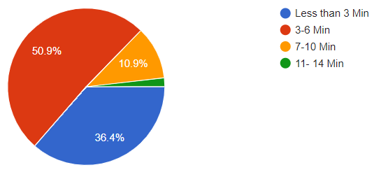
Figure 1.1: PVAMU Survey on duration of class attendance taking.

1.5 Potential Impact of Project on Society
F.R.A.T. impacts the safety of the society because according to the Centers for Disease Control (CDC) 61% of virus outbreaks and spread of germs are caused by touching a contaminated surface and then touching your mouth. Implementing our F.R.A.T. system will reduce the risk of transmission due to contactless attendance tracking.
Our projects impact the Environment by saving paper and trees. According to tiredearth.com by saving a ton of paper, 17 trees, 26000 liters of water, 4000 kilowatt of power and 240 liters of fuel. Our project will impact the environment by making it where teachers would not have to use paper to take attendance.
Our project's technical impact affects society by bringing the capability to automate the attendance tracking process. In a recent survey, with 55 students’ responses, around 63% of students reported class attendance taking 3 to 14 minutes of class time. The time it takes to take attendance only grows with class time, so with our system the time for attendance will drop plenty.

1.6 Initial Project Constraints
We identified a few constraints during our project research. We were not granted permission to connect to the school’s database. We also did not have a lot of people to test the system. We also did not have a disabled individual to see how the system would impact them. Our project would also need proper lighting to perform accurate recognition, and a based data set may need to be adjusted to match the demographic of users.

2. PROJECT PLANNING AND TASK DEFINITION

2.1 Task identification
Our project aims to use our hardware and software skills to create a solution that will automate the attendance tracking process as the current manual process of taking attendance is ineffective and inconvenient for both professors and students. With our Face Recognition Attendance Tracker (F.R.A.T.) system, we will be cutting the average 5 to 10 minutes it takes to take attendance to less than 10 seconds, increasing productivity in the classroom.

Before doing our primary design, the first step was to look at different options regarding products that were on the market that can solve the attendance tracking tack and fit the budget for the project. After researching the best way to achieve this goal, we settled on designing (F.R.A.T.) by developing a system that will integrate an embedded system to a backend system while using a hardware component to give a seamless and user-friendly capability.

The hardware part of our design will consist of a camera for face capturing, a Jetson Nano for computing and data analyzation and a display screen for the user interface. A database will be created to store the user's face, record the attendance after it has been taken, and store the attendance log until it is time to export it to the professor in need of the attendance log. The project's success will be determined by having a fully operational prototype that will be capable of demonstrating all the futures of both that hardware and software aspect of the design as well as demonstrating all the futures of both that hardware and software aspect of the design.

2.2 Gantt Chart
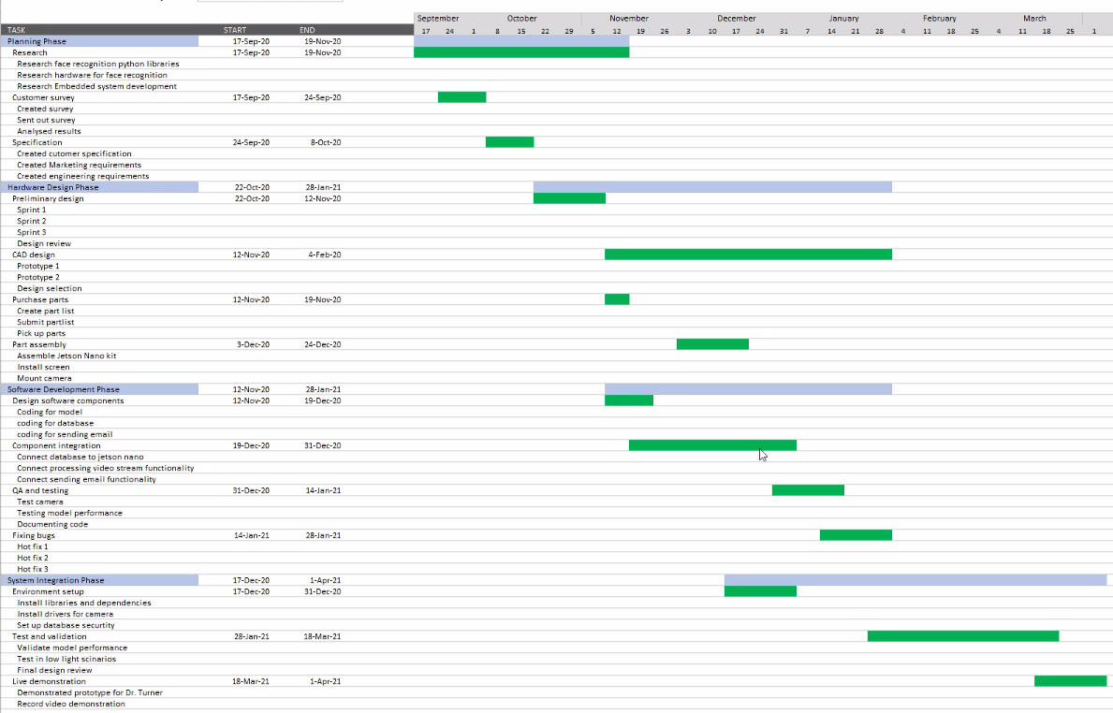

Figure 2.1: Gantt Chart

Section 3 - Literature Review

3.1 List of all sources of information
- Geitgey, A. (2019, June 25). Build a Hardware-based Face Recognition System for $150 with the Nvidia Jetson Nano and Python. Retrieved October 06, 2020, from
- Timesler. (2020, March 02). Facial recognition model in pytorch. Retrieved October 06, 2020, from https://www.kaggle.com/timesler/facial-recognition-model-in-pytorch
- Kangalow, et al. “Install RealSense Camera in 5 Minutes - Jetson Nano.” JetsonHacks, 24 Dec. 2019, www.jetsonhacks.com/2019/12/22/install-realsense-camera-in-5-minutes-jetson-nano/.
- Peterson , Mike. “The Benefits (and Risks) of ‘Swipe and Go’ Cards.” DebtGuru Credit Counseling and Debt Management Services, 23 June 2016, debtguru.com/the-benefits-and-risks-of-swipe-and-go-card
- James, Max. “Mobile App Development Cost Estimation Tool: Mobile App Development Cost Calculator.” Mobile App Development Cost Estimation Tool | Mobile App Development Cost Calculator, www.clavax.com/mobile-app-development-cost-estimation-tool
- Editorial. “Iris Recognition Explained with Pros and Cons!” RoboticsBiz, 16 May 2020, roboticsbiz.com/iris-recognition-explained-with-pros-and-cons
- Soffar, Heba. “Fingerprint Scanners Uses , Features , Advantages and Disadvantages.” Science Online, 14 Sept. 2019, www.online-sciences.com/technology/fingerprint-scanners-uses-features-advantages-and-disadvantages

3.2 Statement of Learning from each source
Build a Hardware-based Face Recognition System for $150 with the Nvidia Jetson Nano and Python.
This paper was written by Adam Geitgey, one of the main contributors to the python face recognition library. From this source we learned about the limitations of the face recognition library and how we can leverage other resources to overcome these limitations. Adam also explained how we can set up the Nvidia Jetson Nano to perform basic face recognition using the python library. After reading this article we were more competent in the necessary functions needed to perform face recognition.
Install RealSense Camera in 5 Minutes - Jetson Nano

This article was written by Kangalow and it is accompanied by a video created by Jim from Jetson Hacks. From this article we got to understand the particular features of the Intel RealSense Camera. We were able to set the camera up to work on the Jetson Nano and also access it through our code, getting the Jetson nano to work with the intel realsense camera was a vital part of our project and this resource helped us accomplish this.
The Benefits (and Risks) of ‘Swipe and Go’ Cards
In contemplating whether our idea of taking attendance using face recognition was an idea worth pursuing we looked at other alternatives to record attendance. One of these were swipe and go cards, what we learned from this source is the affordability and how quick and accurate it is. The reason why we did not choose this method is since it is easily cheated. We needed an application that is both accurate and not easily cheated.

3.2 Statement of Learning from each source(continued)
Mobile App Development Cost Estimation Tool: Mobile App Development Cost Calculator.
From this source we learned how much it will cost for us to develop a mobile app capable of taking attendance. From this knowledge we concluded that it would cost more to use a mobile application to take attendance. It will also require all students to have a smart mobile device to take attendance, though many students have these devices this is a cost that would be incurred by the students who do not have one of these devices. So, from the information gathered from this source we decided not to pursue this option.
Iris Recognition Explained with Pros and Cons!
From this site we learned the pros and cons of the iris scanner. Though this is the most secure and accurate solution to implement an attendance tracking system, it is also the costliest to be implemented. It would cost approximately $1,500 - $3,400 to implement each iris scanner. Based on this we decided this would not be a device we would implement.

Fingerprint Scanners Uses, Features, Advantages and Disadvantages

The fingerprint scanner is also a very secure method, from this source we learned about the advantages and disadvantages of the fingerprint scanner. One of the major things that we took into consideration was the ability to reduce physical interaction with the device that records the attendance. Rising covid cases and the norm to reduce physical touch went into our consideration, implementing a fingerprint scanner would expose the users to physically touching the device and will cause the spread of germs. Based on this we decided this would not be a device we would implement.

Section 4 - Preliminary Design

4.1 Concept Generation

Initially we considered having our project scan an entire classroom at once then record the attendance based on that single scan. After going over the advantages and disadvantages of this idea, we concluded that it was not the ideal way to go about doing so. We wanted our device to focus on the individual and be able to save time while being precise. The product is supposed to be user friendly as well.
This initial concept was not efficient because it did not have that individuality, we would like the project to be able to record each student individually. By processing each user individually, the device is more precise, and the user can interact with the device.
The second design was to have the device communicate with an electromechanical lock to grant access to the classrooms when a student has been authenticated. This would have been a great idea to explore since it would allow the device to be used in various ways.

4.2 Concept Evaluation and selection

Initially, we decided to have a device that would be able to unlock a door and record their attendance when a user is authenticated by face recognition. Due to time and the cost of the project, we decided to reduce the amount of functionality we will deliver. We decided to focus on getting attendance from students using face recognition. Since students and professors spend a lot of time recording attendance and reporting on it, automating this process will benefit both parties. We used the Nvidia Jetson nano to process all images and perform the face recognition, this is considered the brain of our device. Connected to the Jetson nano is a 7-inch raspberry Pi display to function as the user interface. We utilize the Intel Realsense Camera to capture the user images, this was selected over the Raspberry Pi 8mp camera because of its additional features like depth sensor and low power vision processor.

4.3 Design Constraints and Applicable Codes and Standards used in the Preliminary Design.
Major Design Constraints:
For our device one of our major design constraints is that we cannot connect to the school’s database to see how it would be able to interact with the existing school database. With this constraint we had to make sure we can replicate what we think the school database would look like to measure the effectiveness of the device. Another constraint is that the device is meant to be used by one individual at a time to ensure accuracy, it cannot recognize faces if individuals are not within a range of one to two feet. Our last constraint is the device's ability to be used by persons with disabilities, mostly folks who are bound to a wheelchair might have problems using the system. To cater for those in wheelchairs we made the camera mount adjustable so that the user can tilt it to suit them.

4.3 Design Constraints and Applicable Codes and Standards Used in the Design (Continued)
Applicable Codes and Standards Used in the Design
- IEEE Std 730-1998: IEEE Standard for Software Quality Assurance Plans
  - Implemented briefly during improving the quality of our code.
- IEEE Std P1012 - Standard for System, Software, and Hardware Verification and Validation
  - Used to evaluate the software, and hardware life cycle processes including the Agreement, Organizational Project-Enabling, Project, Technical, Software Implementation, Software Support, and Software Reuse process groups.
  - We used this code to thoroughly test and verify that our hardware and software integration was a success.
- IEEE 7.8: IEEE Code of Ethics:
  - Used to uphold the highest standards of integrity, responsible behavior, and ethical conduct in professional activities.
  - This code is used by making sure our project protects the identity and information.
- IEEE 1058.2: Guide for Software Project Management Plans
  - An SPMP is the controlling document for managing a software project; it defines the technical and managerial processes necessary to develop software work products that satisfy the product requirements.
  - This code was used when we created our software project timeline and technical pass/fail standards for prototype.

4.3 Design Constraints and Applicable Codes and Standards Used in the Design (Continued)
- IEEE Std P2884: Standard for Performance Evaluation of Biometric Information: Facial Recognition
  - This standard defines requirements and testing methods for a facial recognition testing system for end user devices. System and security requirements, algorithm testing, testing methods, and criteria level definitions are defined.
  - We adhered to this standard when performing extensive testing for system that emphasize end user experience and securing user information.

4.4 Preliminary Analysis

After doing research on the various designs, we understood the pros and cons of all the options available to us. We applied our knowledge gained from various courses (Microprocessor Design, Project Management and Programing Fundamentals) throughout our college life. This knowledge gave us the ability to select a micro-computer that can run the required libraries and deliver the performance we required to perform face-recognition. Figure 4.1 shows a preliminary flow chart of the software flow used to perform our face recognition.
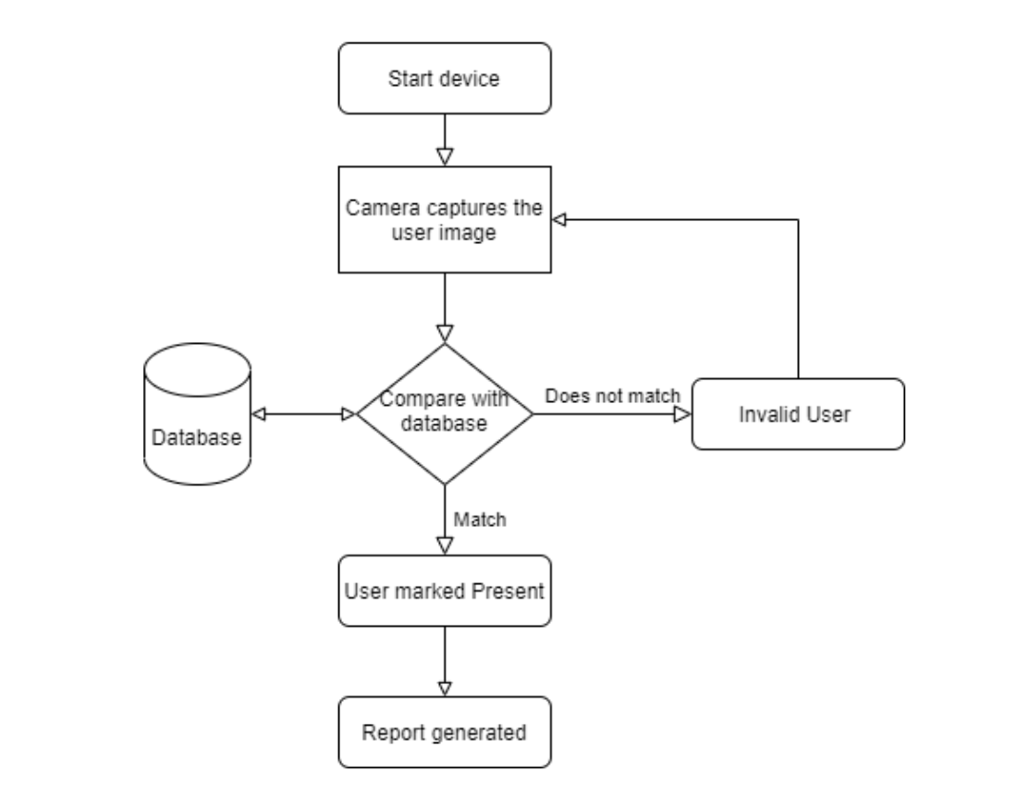

Figure 4.1: Shows the preliminary flow diagram of system.

4.5 Preliminary Design
Once the team completed the research and analysis stage, we concluded that our product should have four major components. These components are a micro-computer, camera, touchscreen display, and a database. The Nvidia Jetson nano will be our microcomputer, and this is where all the processing will take place. Next, we have the Intel Realsense depth camera to capture the user data and send it to the micro-computer for processing. We also have a Raspberry Pi display; this is to be used as a user interface. Finally, we have the device connect to a database where users data is stored.
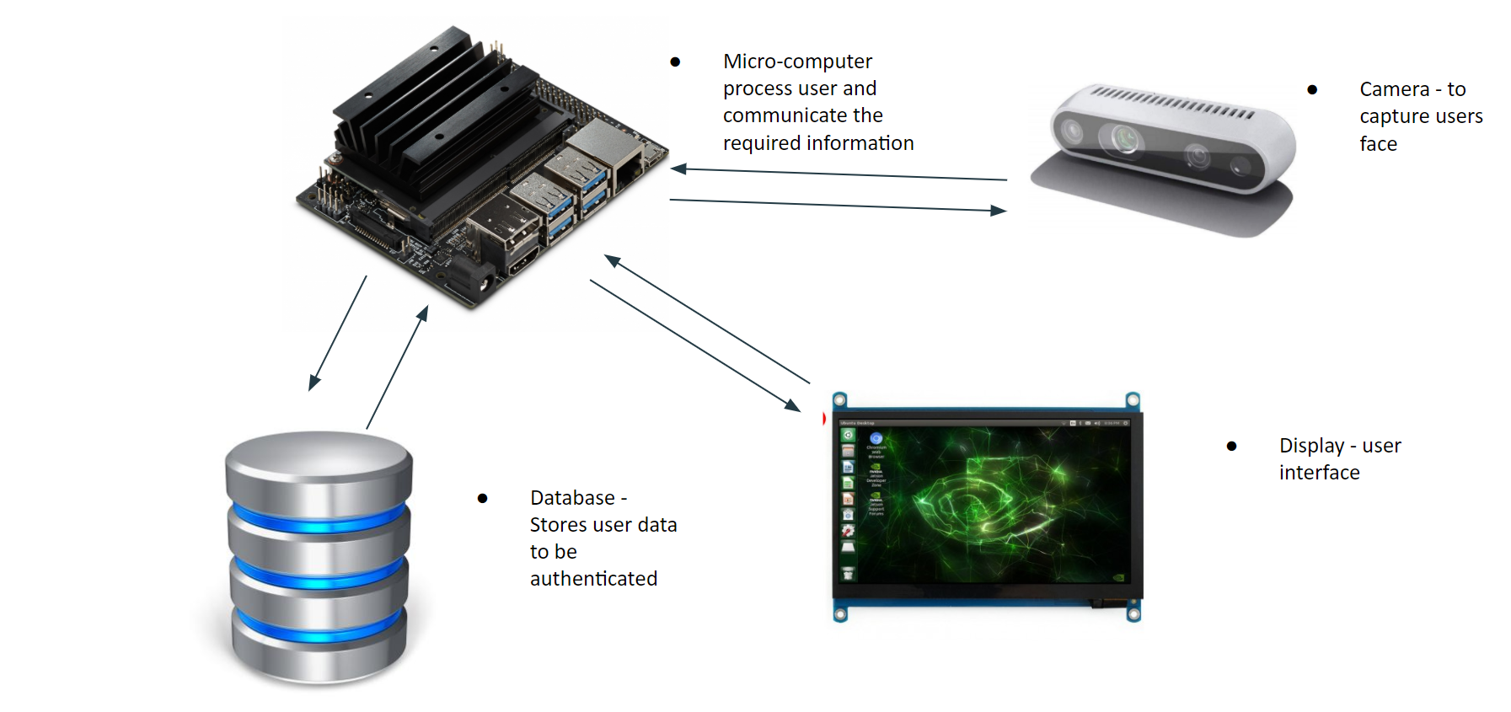

Figure 4.2: Shows the Preliminary Design of Device

SECTION 5. DETAILED SYSTEM DESIGN

5.1 Project Parts Summary

Product | Images | Quantity
NVIDIA Jetson Nano | 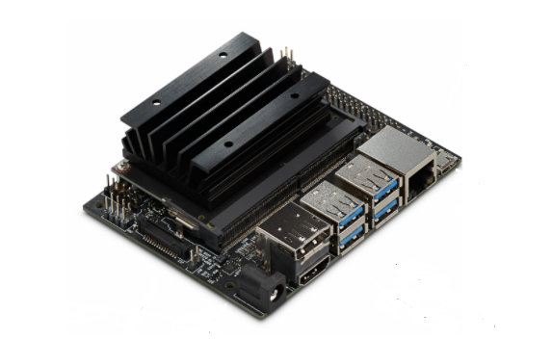 | 1
Intel RealSense Depth Camera D435 | 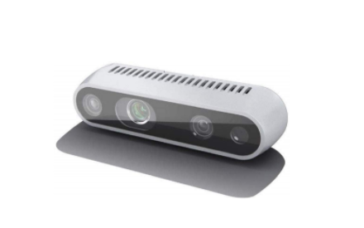 | 1
7’’ Touchscreen from Raspberry Pi | 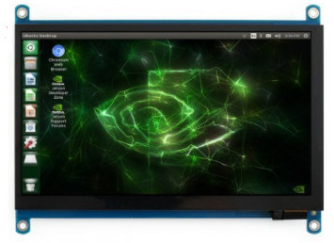 | 1
64GB Micro SD Memory Card | 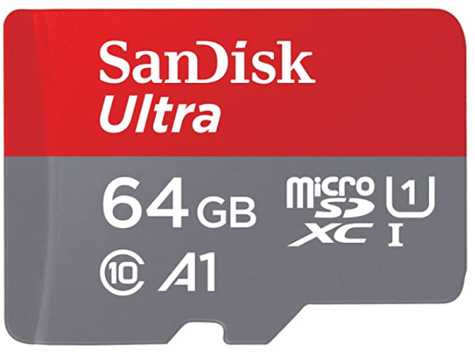 | 1

Table 5.1: Project Parts Summary
5.2 Engineering Analysis and/or Simulation

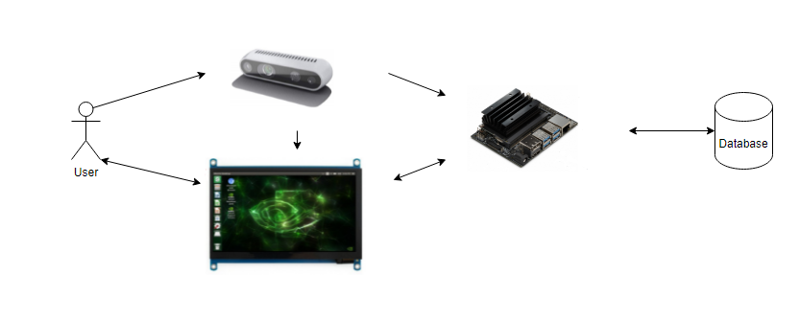
Figure 5.1: User experience simulation diagram

The physical build is housed in a singular unit. The device should be placed in a location with good lighting so that the system can capture the user's face well. The hardware of the system consists of a Jetson Nano with two connections, a touch screen, and a camera. When the system is started, the user stands in front of the camera so that their full face is in frame. The user’s face is taken as input to the camera, the face recognition model running on the Jetson Nano processes the input and the user receives recognition confirmation via the display.

5.3 Hardware Layout/Detailed Drawings/Equipment selection and specifications

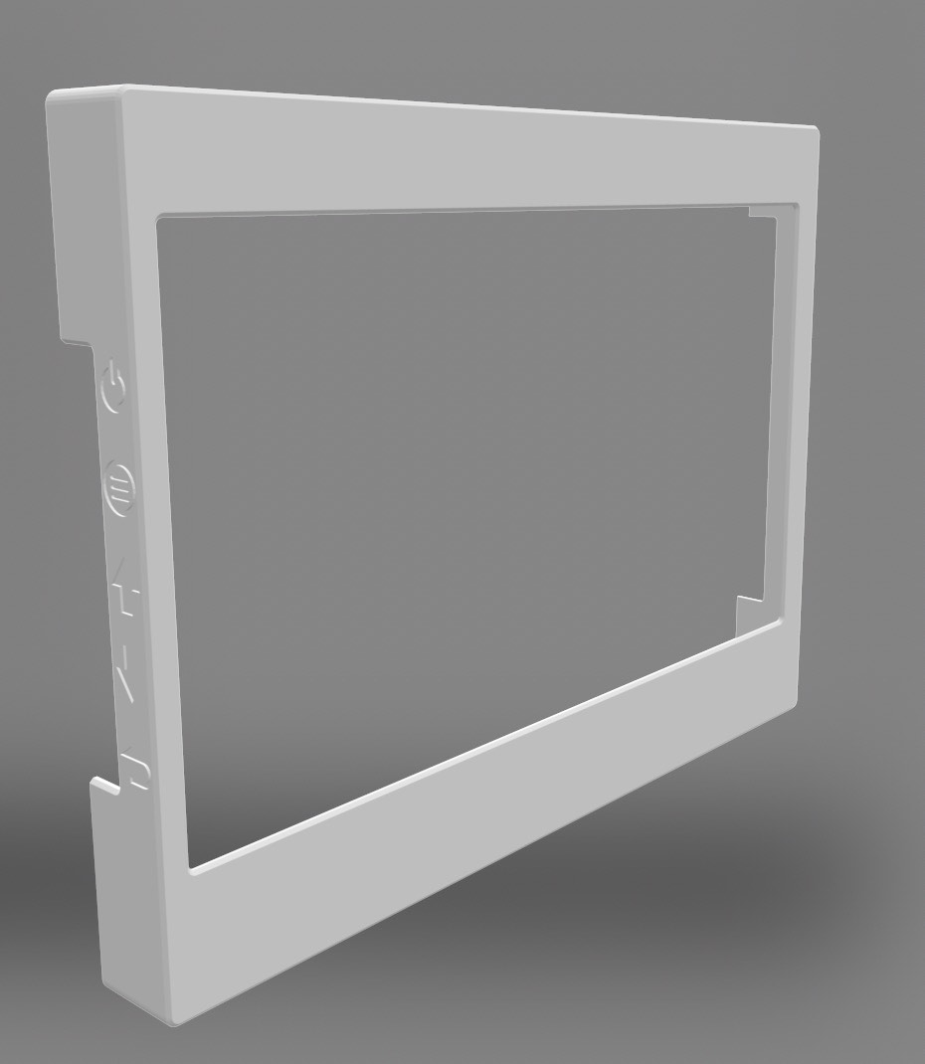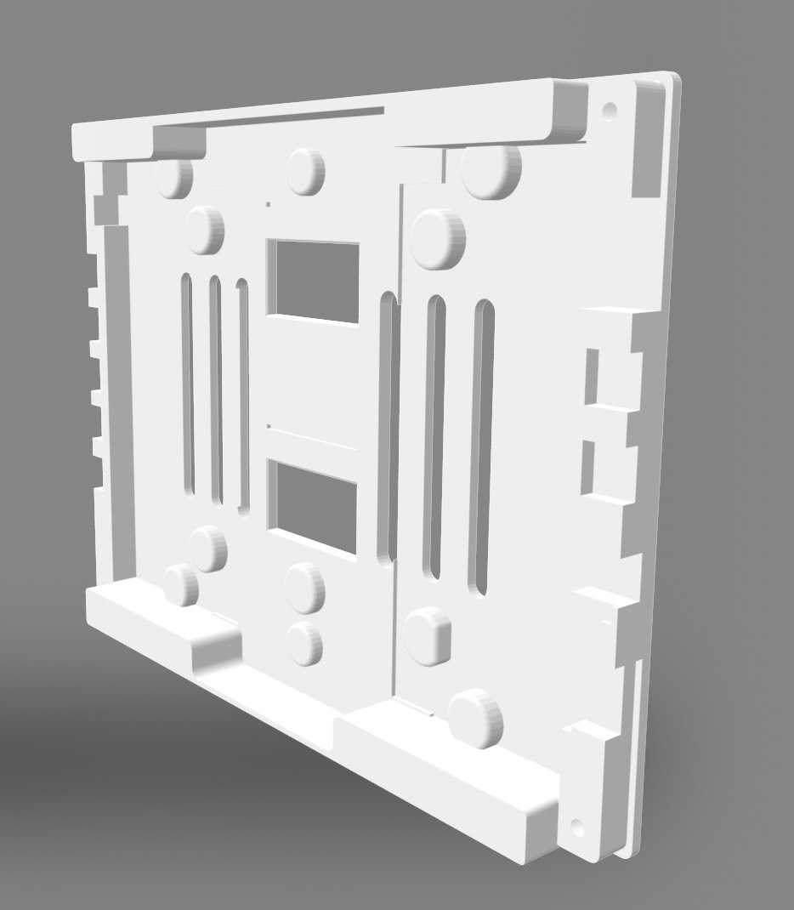
Figure 5.2: CAD view of 3D printed screen case
The Raspberry Pi touchscreen comes bare, so the hardware team needed to 3D print a case. The figure above illustrates the CAD view of the screen protector. The cover comes in two parts, the front has a cut out for screen and cut out on the side for screen navigation buttons. The back cover has cut outs for USB and display connections.

Figure 5.3: Jetson nano

NVIDIA Jetson Nano Developer Kit is a small, powerful computer that lets us run neural networks for applications like image classification. In an easy-to-use platform that runs in as little as 5 watts.

5.3 Hardware Layout/Detailed Drawings/Equipment selection and specifications(continued)

Figure 5.4: Intel Realsense camera

The Intel RealSense depth camera D435 is a great solution for our system, offering a quality clear view with depth for our application. It is wide field of view is perfect for applications such as attendance taking, where seeing as much of the scene as possible is vitally important. With a range up to 10m, this small form factor camera can be integrated into our one-unit housing with ease and comes complete with our Intel RealSense SDK 2.0 and cross-platform support. It was selected over the Raspberry Pi 8mp camera because of its additional features like depth sensor and low power vision processor.

Figure 5.5: 7’’ Touchscreen from Raspberry Pi

This 7″ touchscreen monitor for Raspberry Pi gives us the ability to complete our all-in-one, integrated embedded project with a touch screen that integrates seamlessly with the Jetson Nano. The 800 x 480 display connects via an HDMI cord and a USB which handles power and touch screen capabilities. Touchscreen drivers with support for 10-finger touch and an on-screen keyboard will be integral to providing a seamless user experience with full functionality without a physical keyboard or mouse.

5.3.1 Show Overview of Code Developed to Support 5.3
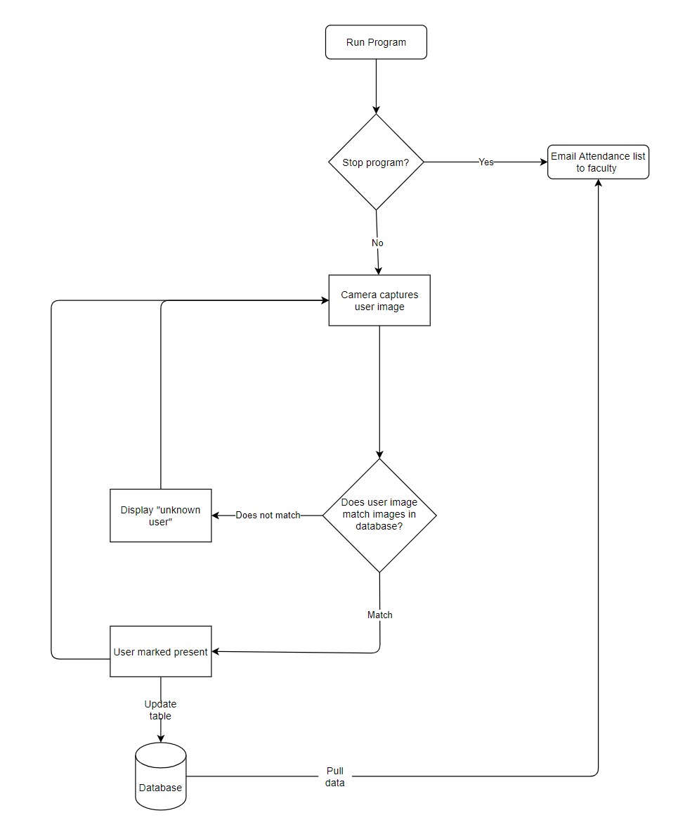
Figure 5.6: Overview of code developed.

5.4 Application of Engineering Codes and Standards used in Final Design.

- IEEE Std 730-1998: IEEE Standard for Software Quality Assurance Plans
  - Implemented briefly during improving the quality of our code through integration.
  - We refactored our codebase by implementing this code.
- IEEE Std P1012 - Standard for System, Software, and Hardware Verification and Validation
  - used to evaluate the software, and hardware life cycle processes including the Agreement, Organizational Project-Enabling, Project, Technical, Software Implementation, Software Support, and Software Reuse process groups.
  - We used this code to thoroughly test and verify that our hardware and software integration was a success.
- IEEE 7.8: IEEE Code of Ethics:
  - Used to uphold the highest standards of integrity, responsible behavior, and ethical conduct in professional activities.
  - This code is used by making sure our project protects the identity and information of users.
- IEEE 1008-1987: IEEE Standard for Software Testing
  - It uses the system design, system implementation, and system requirements to determine the completion of the testing.
  - We used this code and tested our software to discover and patch weak points in software.
- IEEE 1058.2: Guide for Software Project Management Plans
  - An SPMP is the controlling document for managing a software project; it defines the technical and managerial processes necessary to develop software work products that satisfy the product requirements.
  - This code was used when we created our software project timeline and technical pass/fail standards for prototypes.
- NESC: National Electrical Safety Code
  - Implemented to make sure that the electrical components of the are not exposed and create any harm.
  - We adhered to this code when we created a secure housing for the prototype.
- IEEE Std P2884: Standard for Performance Evaluation of Biometric Information: Facial Recognition
  - This standard defines requirements and testing methods for a facial recognition testing system for end user devices. System and security requirements, algorithm testing, testing methods, and criteria level definitions are defined.
  - We adhered to this standard when performing extensive testing for systems that emphases end user experience and securing user information.

5.5 Economic Analysis
Our product would compete with products that do identity verification. We looked at products that do identity authentication such as fingerprint scanner, RFID, Iris scanner, and mobile apps. We compared the price as well as the pros and cons for each system. The detailed economic analysis is shown below.

Design Options | Estimated Cost | Pros | Cons | Final Decision
RFID Magnetic Stripe Reader | ~ $60 - $1,400 | Quick and Accurate  Protection against germs | Easy to hack.  Easy to trick | Not Selected
Mobile App | ~$4,000-$8,000 | Easy to implement.  No physical alterations are needs to be done to the institution | Easy to trick.  Costs more for students | Not Selected
Fingerprint | ~ $60-$160 | High accuracy  Portable | Fingerprint easy to steal,  Sensitive | Not selected
Iris Scanner  (Eye Scanner) | ~ $1,500 - $3,400 | Accurate and Reliable  Highest level of security | Requires very high-level sensors.  Cannot be scanned at far distance | Not Selected
F.R.A.T | ~$400 | User friendly  Cost effective,  Quick and Accurate  Adaptable | Can’t integrate with current tracking systems | Final selection

Table 5.2: Economic Analysis

5.6 Final Design
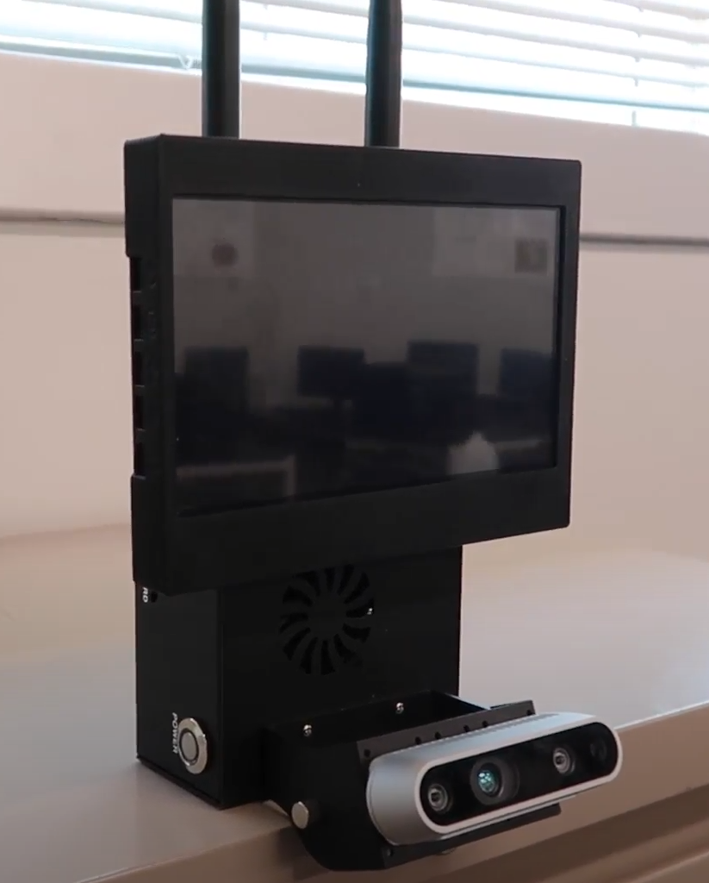

Figure 5.7: Front view of F.R.A.T hardware

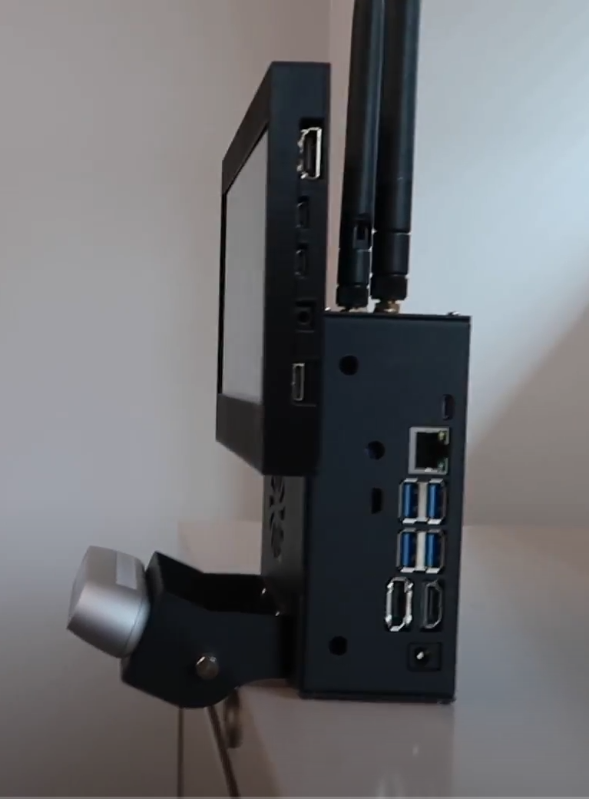
Figure 5.8: Side view of F.R.A.T hardware
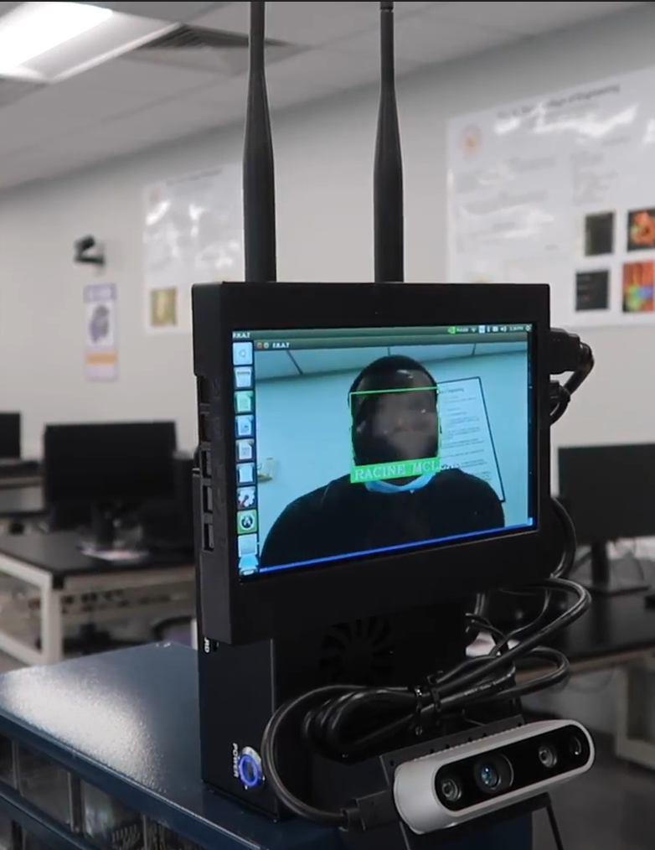

Figure 5.9: F.R.A.T recognized Racine Mclean is in database

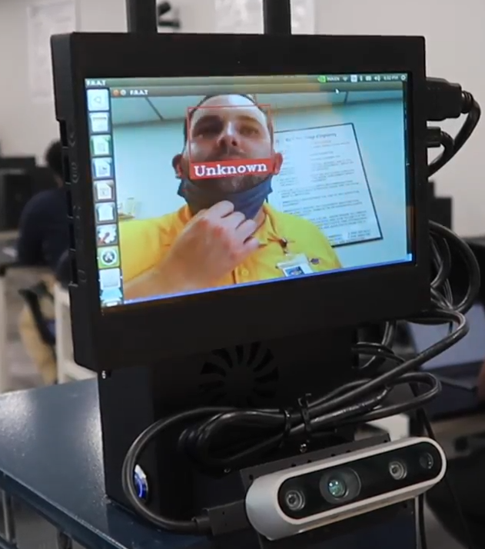

Figure 5.10: F.R.A.T recognizes unknown user is not in database.

5.6 Final Design – show pictures or other example of working design (Continued)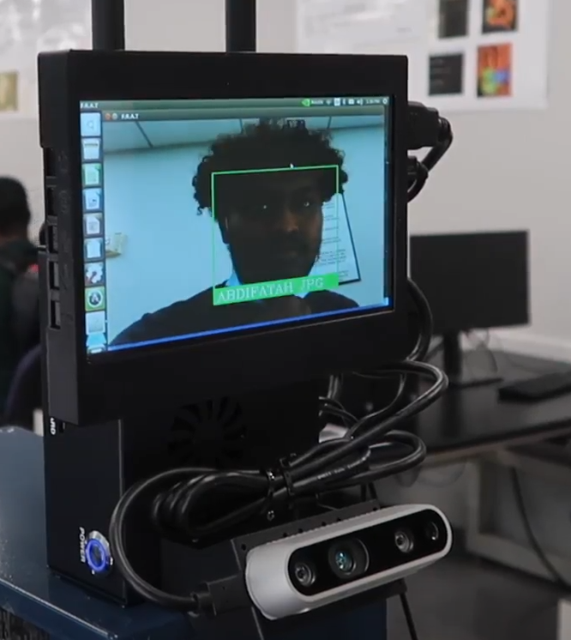

Figure 5.11: F.R.A.T recognized Abdifatah Mohamed is in database

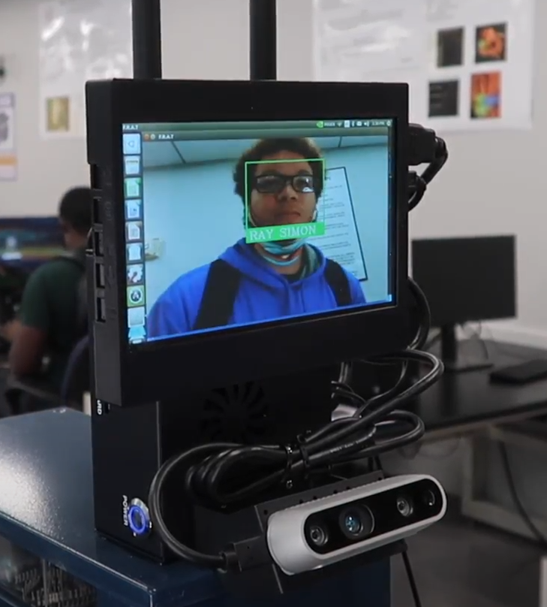

Figure 5.12: F.R.A.T recognized Ray Simon is in database

6. RESULTS & DISCUSSION

6.1Summary of Goals and Objectives
The main goal of our project was to come up with a system that allowed students to be responsible for their attendance so that we could cut the amount of time that teachers took to take attendance. For this system we came up with the idea of face recognition to track attendance. The original deliverables we came up with was the following:
- The system should be able to recognize a user's face.
- The system should connect to a database.
- The system should mark students' attendance in the database.
- The system should be completely housed as a single unit.
The Final deliverables that we have are the same as the original listed above.

6.2 Summary of Constraints and Codes met by Design.
The constraints that we had for our system were as follows:
- We are not able to connect to the school's database.
- We do not have a lot of people to test our system on due to COVID.
- We do not have access to anyone who is disabled so it is hard to tell whether the system will help or hinder them.
The first code/standard we have for our system is IEEE Std 730-1998: IEEE Standard for Software Quality Assurance Plans. We used this code during our code development stage. We used it to make sure that we knew exactly what we wanted our code to do. . The next code/standard is IEEE Std P1012 - Standard for System, Software, and Hardware Verification and Validation. We used this code to thoroughly test our hardware and software systems to make sure that when integrated they work together without any issues. Another code/standard is IEEE 1008-1987: IEEE Standard for Software Testing. We used this code to come up with different tests to make sure our system does everything we wanted it to. The next code/standard is IEEE 1058.2: Guide for Software Project Management Plans. We used this code when we created our software project timeline and technical pass/fail standards for prototype. Another code/standard is NESC: National Electrical Safety Code. We used this code when we created a secure housing unit for our prototype. The next code/standard is IEEE Std P2884: Standard for Performance Evaluation of Biometric Information: Facial Recognition. We adhered to this standard when performing extensive testing for the system that emphases end user experience and securing user information.

6.2 Summary of Constraints and Codes met by Design (Continued)
The last code/standard is IEEE 7.8: IEEE Code of Ethics. We used this code to ensure that our system is in the best interest to the public and that it keeps their information safe.

6.3 Discussion of Results and Other Use Cases
After testing our system, we were happy with most of the results. When the system is running and the user in front of the camera is in the database it would match it correctly and show their name on the screen and there would be a green box around their face. Also, if the user in front of the camera is not in the database it will show a red box around their face saying unknown. The green and red boxes that outline the users face is a way to show the user that the system is done checking their face with the database. Figures 5.10 and 5.11 above show what the user would see when they are using the system. However, while testing our system we did come across some problems with the system. One issue we came across was our system recognizing a user as a different person. For this issue we found that different lighting is one reason why the system would mistake one user for another at times and while testing it we learned that when the lighting gets better the system is also more accurate. Another issue that came up was that the camera we are using does not pick up the user's face after a certain distance.
Even though our system is created to track attendance there are other uses for it. For example, you could take the face recognition system and use it to unlock something like a door. You could set it up so that when your face is recognized it unlocks the classroom or car door.

7. CONCLUSIONS AND RECOMMENDATIONS

Conclusion
We have successfully completed all our deliverables regarding our Face Recognition Attendance Tracker (F.R.A.T.) system, which includes integrating an embedded system, backend system, and hardware together to create a seamless use of our product. With the completion of our project, we have changed the future of attendance tracking for the better. The implementation of our project will reduce the time spent taking attendance, which will allow for more time to be spent doing classwork. Our project being fully automated is the key aspect that has enabled the usability of our system.

Recommendations
With our project fully implemented and functioning, the (F.R.A.T.) system can use facial recognition to seamlessly take attendance in such a user-friendly way. This project is at a point where it can fully do what it was designed for without any complications. There is always room for improvement when it comes to technology or different useful ways to use and benefit from a system.
Our (F.R.A.T.) system can be used in other ways and applied in different settings. With some simple modifications, the system can be used to grant particular individuals’ access to high-security areas such as data centers, banks, and file storages. It can also be easily implemented into multiple other locations such as work, rentals homes, and fitness gyms.

LIST OF REFERENCES
[1] Gradilla, R. “How to build a Face Detection application using PyTorch and OpenCV” July 2020,
https://medium.com/@iselagradilla94/how-to-build-a-face-detection-application-using-pytorch-and-opencv-d46b0866e4d6
[2] Geitgey, A. “Build a Hardware-based Face Recognition System for $150 with the Nvidia Jetson Nano and Python” June 2019,
https://medium.com/@ageitgey/build-a-hardware-based-face-recognition-system-for-150-with-the-nvidia-jetson-nano-and-python-a25cb8c891fd
[3] Timesler. “Facial recognition model in pytorch” March 2020, https://www.kaggle.com/timesler/facial-recognition-model-in-pytorch
[4] Kimble, Z. “Timesler/facenet-pytorch” January 2020,
https://github.com/timesler/facenet-pytorch
[5] Peterson , Mike. “The Benefits (and Risks) of ‘Swipe and Go’ Cards.” June 2016, debtguru.com/the-benefits-and-risks-of-swipe-and-go-card
[6] James, Max. “Mobile App Development Cost Estimation Tool: Mobile App Development Cost Calculator.” www.clavax.com/mobile-app-development-cost-estimation-tool
[7] Editorial. “Iris Recognition Explained with Pros and Cons!” RoboticsBiz, May 2020, roboticsbiz.com/iris-recognition-explained-with-pros-and-cons
[8] Soffar, Heba. “Fingerprint Scanners Uses , Features , Advantages and Disadvantages.” ,Sept. 2019, www.online-sciences.com/technology/fingerprint-scanners-uses-features-advantages-and-disadvantages
[9] Paperless Productivity. Eco Impact. 3 Oct. 2017, paperlessproductivity.com/eco-impact/amp/.
[10] Steiner, Hannah, and Liang Lan. “Less Paper, Save Forests, Rescue the Environment.” Sept. 2018, www.tiredearth.com/articles/less-paper-save-forests-rescue-environment

APPENDIX (Include user manual or coding documentation if appropriate)

import platform
import cv2
import numpy as np
import face_recognition
import os
from datetime import datetime
import sys
import mysql.connector
import email_local

def clearAttendanceCSV():
f = open('/home/frat/Documents/gitProjects/Senior_Design_2020/Attendance.csv','r+')
f.truncate(0)
f.close()
def writeAttendanceCSV():
f = open('/home/frat/Documents/gitProjects/Senior_Design_2020/Attendance.csv','r+')
f.writelines("Name,Time")

clearAttendanceCSV()
writeAttendanceCSV()

conn = mysql.connector.connect(user='frat' , password='ELEG4482', host='localhost' , database='Face_Recognition')

cursor = conn.cursor()

if conn.is_connected():
print('Connected to MySQL database')

path = '/home/frat/Documents/gitProjects/Senior_Design_2020/testImages'
images = []
classNames = []
myList = os.listdir(path)
nameList= []
print( myList)
for cl in myList:
curImg = cv2.imread(f'{path}/{cl}')
images.append(curImg)
classNames.append(os.path.splitext(cl)[0])

def findEncodings(images):
encodeList = []
for img in images:
img = cv2.cvtColor(img, cv2.COLOR_BGR2RGB)
encode = face_recognition.face_encodings(img)[0]
encodeList.append(encode)
return encodeList

def markAttendanceCSV(name):
with open('/home/frat/Documents/gitProjects/Senior_Design_2020/Attendance.csv','r+') as f:
myDataList = f.readlines()
AttendanceList = []
for line in myDataList:
entry = line.split(',')
AttendanceList.append(entry[0])
if name not in AttendanceList:
AttendanceList.append(name)
# print( AttendanceList)
now = datetime.now()
dtString = now.strftime('%H:%M:%S')
f.writelines(f'\n{name},{dtString}')

def showAttendance():
cursor.execute("Select * from Attendance")
result = cursor.fetchall()
for x in result:
print(x)

def markAttendance(name):
now = datetime.now()
dtString = now.strftime('%H:%M:%S')

if name not in nameList:
nameList.append(name)
sql = "Insert INTO Attendance VALUES(%s,%s)"
val = (name,dtString)
cursor.execute(sql,val)
conn.commit()

def clearAttendanceTable():
sql= "DELETE FROM Attendance"
cursor.execute(sql)
conn.commit()

def running_on_jetson_nano():
# To make the same code work on a laptop or on a Jetson Nano, we'll detect when we are running on the Nano
# so that we can access the camera correctly in that case.
# On a normal Intel laptop, platform.machine() will be "x86_64" instead of "aarch64"
return platform.machine() == "aarch64"

def get_jetson_gstreamer_source(capture_width=1280, capture_height=720, display_width=1280, display_height=720, framerate=60, flip_method=0):
"""
Return an OpenCV-compatible video source description that uses gstreamer to capture video from the camera on a Jetson Nano
"""
return (
f'nvarguscamerasrc ! video/x-raw(memory:NVMM), ' +
f'width=(int){capture_width}, height=(int){capture_height}, ' +
f'format=(string)NV12, framerate=(fraction){framerate}/1 ! ' +
f'nvvidconv flip-method={flip_method} ! ' +
f'video/x-raw, width=(int){display_width}, height=(int){display_height}, format=(string)BGRx ! ' +
'videoconvert ! video/x-raw, format=(string)BGR ! appsink'
)

encodeListKnown = findEncodings(images)
print('Encoding Complete')

cap = cv2.VideoCapture(2)

while True:
success, img = cap.read()
imgS = cv2.resize(img,(0,0),None,0.25,0.25)
imgS = cv2.cvtColor(imgS, cv2.COLOR_BGR2RGB)

facesCurFrame = face_recognition.face_locations(imgS)
encodesCurFrame = face_recognition.face_encodings(imgS,facesCurFrame)

for encodeFace,faceLoc in zip(encodesCurFrame,facesCurFrame):
matches = face_recognition.compare_faces(encodeListKnown,encodeFace)
faceDis = face_recognition.face_distance(encodeListKnown,encodeFace)
matchIndex = np.argmin(faceDis)

if matches[matchIndex]:
name = classNames[matchIndex].upper()
y1,x2,y2,x1 = faceLoc
y1, x2, y2, x1 = y1*4,x2*4,y2*4,x1*4
cv2.rectangle(img,(x1,y1),(x2,y2),(0,255,0),2)
cv2.rectangle(img,(x1,y2-35),(x2,y2),(0,255,0),cv2.FILLED)
cv2.putText(img,name,(x1+6,y2-6),cv2.FONT_HERSHEY_COMPLEX,1,(255,255,255),2)
markAttendance(name)
markAttendanceCSV(name)
else:
y1,x2,y2,x1 = faceLoc
y1, x2, y2, x1 = y1*4,x2*4,y2*4,x1*4
cv2.rectangle(img,(x1,y1),(x2,y2),(0,0,255),2)
cv2.rectangle(img,(x1,y2-35),(x2,y2),(0,0,255),cv2.FILLED)
cv2.putText(img,"Unknown",(x1+6,y2-6),cv2.FONT_HERSHEY_COMPLEX,1,(255,255,255),2)

imgr = cv2.resize(img, (940, 540))
cv2.imshow('F.R.A.T',imgr)
if cv2.waitKey(1) & 0xFF == ord('q'):
showAttendance()
clearAttendanceTable()
email_local.send_Email()
break

