PRAIRIE VIEW A&M UNIVERSITY
ROY G. PERRY COLLEGE OF ENGINEERING


ELEG 4248: Senior Design & Professionalism II
Topic: Final Written Report

Submitted by:
Team 4
Instructor: Professor Turner

Date of Submission: 05/01/2021

Project Executive Summary
Mission Statement
Our mission is to convert a mechanical operated system to an electronic operated system. Instead of having a mechanical shifter, it will be replaced by an electronic switch that will require less effort shifting. This proposed project is to replace the mechanical switch with an electronic switch that is controlled by an Arduino microprocessor. With this implementation, it will have the benefits of having minimal maintenance cost, being user friendly, having low effort shifting, and fewer injuries will occur.

Problem Statement
Golf carts that have a mechanical operated system are used daily due to their ease of use. However, the mechanical shifters which make the golf cart go forward and reverse are prone to breaking leading to serious injuries, equipment damaged, and higher maintenance costs. Based on the study from the U.S. emergency departments, from 1990 to 2015 the injuries from golf carts tripled approximately 6,000 to 18,000. By converting a mechanical operated system to an electronic operated system will help resolve this issue.

Proposed Deliverables
- Creation of User-Friendly electrical switch to control forward and reverse movement of golfcart
- Use the same voltage source to power the newly introduced electrical system.
Budget
- The total budget for our project is $600.
- The total amount spent for our project is $114.88

Customer Requirements and Engineering Solutions
The goals for our project are given by the marketing requirements and engineering design specifications listed below.
- The electric shifter will be user friendly.
- The user will be able to move forward and backwards with just one click.
- The switch will be placed where it is easy to reach.
- Proper programming and connections will need to be ensured to control polarities contacts correctly.
- The switch will switch speeds correctly by just pressing a button.
- The electric shifter will be low cost. The microcontroller that we use will be affordable.
- The electric shifter will use the same battery source that is in the golf cart.
- Low effort-shifting, electronic shifting is faster than mechanical shifting based on the time response and the frequency of the data transmission.

Major Constraints
Due to time limitation our project had some constraints. Also, since we had to work with the golf cart provided to us. We had to come up with a solution within the time given to us and design a project that will work on that specific golf cart. Some major constraints our project faced are as follows.

- No flame-proof area- Since it will be an electrical shifter it will be required to be placed at a flame-proof area

- Skilled maintenance regulation- Our goal is to lower maintenance costs to our customers, so we were limited in the level of compellability in the electrical shifter. Design where our customers can understand what is going on.
- Expensive layout- Electrical components are more affordable than mechanical
- Good and safe wiring layout – We were also limited int the amount of wire to use to not increase cost. Components will be at good distance from each other.

Benefits
- Safety
Having an electronic switch shifter would have less failure occurrence and lessen the number of collisions cases due to switch failure.

- Cultural/Social
Due to low effort-shifting, the elderly will still be able to drive golf carts with no problem. And golf cart users will now be able to focus on enjoying the golf cart rather than getting the shifter fixed.

- Economic
The maintenance cost of an electrical shifter is lower than a mechanical. Electrical equipment for a shifter is more affordable than a mechanical one.

- Technical
The polarity contacts will be controlled by a programmed Arduino making the golf cart move forward and reverse.
Recommendations
Our recommendation is to use an electronic based switch instead of a mechanical based switch. In order to operate the electronic operated system safely, we also recommend controlling the electrical system with the Arduino Uno. Lastly, we recommend the use of the control system to be within range of set voltage.
Conclusion
The development of the electrical will be far more beneficial than replacing it with a mechanical shifter. The time in shifting will be reduced, electrical components will break down less and allow the consumer to save money for future maintenance.

TABLE OF CONTENTS
Project Executive Summary ………………………… ……….........................................................................2-5
Table of Contents ………………………………………………………………………..……………………6-7
List of Figures …………………………………………………………………………………………..…….8
List of Tables and Graphs …………………………………………………………………………………….9
List of Team Members and Roles …………………………………………………………………………….10

1. PROJECT SCOPE
1.1 Problem Statement, Business Objective and Target Audience of your Project…………...…….......................... 12
1.2 Client identification and recognition of need……………….……………………………..………………… 13-15
1.3 Project goals and objectives……………………..…………………………………….………………………… 16
1.4 Contemporary issues relevant to project……………………………………………………….…………... 17-18
1.5 Potential impact of project on society (Safety, Env, Tech, Eco) ……………………………………………….. 19
1.6 Initial Project constraints………………………………………………………..…………………………. 24-25

2. PROJECT PLANNING AND TASK DEFINITION
2.1 Task identification………………………………………………………….……………………. 26 2.2 Gantt Chart ………………………………………………………………………………………………… 27-29

3. LITERATURE REVIEW
3.1 List of all sources of information……………………………………………………………………………. 30-31
3.2 Statement of Learning from each source…………………………………………………………………... 32-34

4. PRELIMINARY DESIGN
4.1 Concept Generation………………………………………………………………………………….................... 35
4.2 Concept Evaluation and selection………………………………………..……………………….................. 36-38
4.3 Design Constraints and Applicable Codes and Standards/Used in the Preliminary Design.………………. 39 - 40
4.4 Preliminary Analysis………………………………………………………………………………………41 - 42
4.5 Preliminary Design…………………………………………………………………………......……. 43-44

5. DETAILED SYSTEM DESIGN
5.1 Project Parts Summary………………………………………………………………………………………… 45
5.2 Engineering Analysis and/or Simulation……………………………………………………….…………….46- 50
5.3 Hardware Layout/Detailed Drawings/Equipment selection and specifications……………………..................... 51
5.3.1 Show Overview of Code Developed to Support 5.3 (only if you developed any code)…….………….. 52 - 53
5.4 Application of Engineering Codes and Standards used in Final Design……………….……………………….. 54
5.5 Economic Analysis……………………………………………………………….……………………….. 55 - 56
5.6 Final Design – show pictures or other example of working design……………………………………… 57 - 59
6. RESULTS & DISCUSSION
6.1 Summary of Goals and Objectives………………………………………………………..………………..……. 61
6.2 Summary of Constraints and Codes met by Design……………………………….……………………...... 62 - 63
6.3 Discussion of Results and Other Use Cases……………………………….……………………………….……. 64

7. CONCLUSIONS AND RECOMMENDATIONS ………………………………………...……………… 65 - 66
LIST OF REFERENCES ……………………………………………………………………………………… 68

APPENDIX………………………………………………………………………………………………………69

List of Figures
List of Figures
Figure 1.5.2: Scheduled Light Duty Vehicle (LDV) Maintenance Costs …………………………………………... 21
Figure 1.5.4: Equation for the mechanical shifter on the left, and the digital logic of the program for the electronic shifter ……………………………………………………………………………………………………………….. 23
Figure 2.1: High Level Timeline ………………………………………………………………………………...…. 26
Figure 2.2. GANNT Chart ………………………………………………………………………………………….. 27
Figure 2.2.1: GANNT Chart continued …………………………………………………………………………….. 28
Figure 3.2: Processor Summary …………………………………………………………………………………….. 33
Figure 4.1: 6 pin Forward and Reverse Switch ……………………………………………………………………... 35
Figure 4.2.1: Design concept of Phase 1 ……………………………………………………………………………. 36
Figure 4.2.2: Design concept of Phase 2 ……………………………………………………………………………. 38
Figure 4.4 Shifting specifications …………………………………………………………………………………... 42
Figure 5.1: shows the mechanical shifter on the left side and electronic operation on the right……………………..45
Figure 5.2: Phase 1 design zoom in…………………………………………………………………………………..46
Figure 5.2.1: Phase 1 design….………………………………………………………………………………………47
Figure: 5.3 of the H-Bridge…………………………………………………………………………………………..48
Figure 5.4: Mechanical shifter of the Golf Cart……………………………………………………...………………49
Figure 5.5: Final design schematic, with the Arduino, electrical components, and motor connected……………….50
Figure 5.6: The final design schematic……………………………………………………………………………….51
Figure 5.7: Software Flow Chart …………………………………………………………………………………….53
Figure 5.8: Software used…………………………………………………………………………………………….53
Table 5.5.1 Schedule LDV Maintenance Cost………………………………………………………………………..55
Figure 5.6.1: Detailed Final System Design………………………………………………………………………….57
Figure 5.6.2: Hardware Final System Design………………………………………………………………………...58
Figure 5.6.3 Hardware Final System Design………………………………………………………...……………….59

List of Tables and Graphs
Table 1: Matrix………………………………………………………………………………………....14
Table 2: Primary causes of U.S golf cart related injuries………………………………………………20
Table 5.5.2 Parts price………………………………………………………………………………..…56

List of Team Members and Roles
Armand Feuba Baweu.................................Software Developer
Eulises Garcia Benito...................................Scribe
Francisco Hernandez....................................Data Analyst
Franky Williams Lonfo................................Test Lead & Product Specialist
Jacqueline Torralba.......................................Team Lead

Section 1 - Project Scope

1.1 Project Statement, Business Objective and Target Audience of your Project
Golf carts are used in many everyday settings, due to their compact size, and ease of use. Mechanically operating systems such as the mechanical shifter handles are prone to breaking. This issue leads an owner to additional costs for maintenance and potentially unsafe situations. Our goal during this project is to change to mechanical operated systems switch of a golf cart and design an electric operated system switch. This will reduce maintenance cost requirements and help golfers conveniently and safely use to golfcart. The target audience for this project is golf cart owners with older models.

1.2 Client identification and recognition of need
The project requirements are broken down into different sections displayed below. The first marketing requirement of the electrical shifter is that it must be user-friendly. This will be done by designing a simple switch, or series of buttons to easily flip polarity contacts with a simple click to make the golf cart go forward and reverse directions. Next, it must be low cost, we will be selecting an affordable microcontroller to complete this project. In this case, through careful analysis, Arduino Uno has been chosen to meet this requirement. Next, the same battery source will be kept to power the new control system. We will make the electrical shifter energy efficient in order to not increase power consumption. The electrical shifter will also require less maintenance compared to the mechanical shifter. The electrical compartments of the electrical shifter will last longer and be easier to replace if they were to fail. Lastly, low effort shifting will be required for the electrical shifter system. This requirement will be met by switching to electrical shifting since the response time will be significantly cut compared to mechanical shifting.

1.2 Client identification and recognition of need (continued)

Marketing  Requirements | Engineering  Requirement | Justification
User friendly | Integrate electric switch into circuit correctly polarity contact | The switch will flip polarity contacts with just a click to make the golf cart move forward and backward.
Low Cost | Use an affordable microcontroller | Maintenance of electronic or electric equipment is cheaper than the maintenance of mechanical or mechanical equipment
Use the same battery source to power the new control system | Arduino will be used as a built-in power source for golf carts | By not adding a new power source, it will avoid unnecessary costs and materials to be used.
Electronic Shifting requires less maintenance | By replacing a mechanical switch with an electronic switch that is controlled by an Arduino, the operating system will last much longer | Mechanical control switches are destined to eventually fail, while an electronic switch would last longer and be easier to change if needed
Low Effort-shifting | Electronic shifting is faster than mechanical shifting based on the time response and the frequency of the data transmission | Response time: 0<t<1s  T<=450ms(0.450s)  F=16MHZ  Acceleration time responding is less than 1s on electronic devices compared to the load bearing force of mechanical devices.

Table 1: Matrix
- Hardware Requirements
- DC Permanent Magnet Motor: electrical energy will be converted to mechanical energy and make golf cart go forward and reverse.
- Arduino Uno: will run software and make h-bridge act as switch.
- H-Bridge L293D 1.2A, 36V(limit): Control electric power and current by acting as switch.
- 24V Battery: Supply sufficient voltage and amperage for system to run.
- Software (C++): Software will be used to communicate between hardware and Arduino.

1.2 Client identification and recognition of need (continued)

- Final Product
    - Electrical shifter installation should be easy to set up for the first time
    - Electrical shifter must be able to detect when user wants to operate in forward or reverse direction
    - Electrical shifter must be capable of maintaining forward or reverse direction
    - Electrical shifter must be capable of avoiding voltage fluctuations
    - Electrical shifter must be capable of fitting inside golf cart compartment
    - Electrical shifter must be compatible with model of golf cart that it is being applied to

1.3 Project goals and objectives
The purpose of this project is to create an electrically operated system by designing an electrical system switch. This system will contain a motor driver, a microcontroller, and the switch or buttons to be connected directly to the motor and voltage source. The software will also be loaded into Arduino Uno and will help the user control the motion of the motor. Typical mechanical shifter systems will need replacement more sooner than an electrical shifter. Our objective is to reduce maintenance requirements, save the user future cost and help golfers conveniently and safely use the golf cart.

1.4 Contemporary issues relevant to project
Shifter systems in golf carts are an important feature of a golf cart, this system controls in what direction the golf cart will go. This system must be reliable and quick to respond for the consumer to safely use a golf cart. Mechanical shifters in golf carts are a highly bought replacement item in older golf cart models due to the breakdown of this component. When the consumer is looking for a mechanical shifter for a golf cart, the buyer must consider the following such as:
- Acceptable size to fit in golf cart bay
- Appropriate response time of system
- Durability of system
- Sufficient voltage available for newly introduced system
Potential limitations that could limit the consumer from switching from a mechanical system to an electrical system are:
- Installation could require technical knowledge they lack
- Installing an electrical system could be costly
- Installing an electrical system could be time-consuming

1.4 Contemporary issues relevant to project (continued)

Despite these possible challenges for future consumers, building and designing a system to replace the mechanical system with an electrical system will allow the consumer access to:
  - Durable electrical shifting system that will reduce future cost of the consumer
  - Low price of system will allow consumer to be introduced to electrical systems
  - Use of commonly used Arduino Uno will be easier to identify connections

1.5 Potential impact of project on society
Our project has an impact on five major areas: safety, cultural, social, economic and technical.

1.5.1 Safety
According to the National Electronic Injury Surveillance System, a study was done to examine U.S emergency department visits for golf cart-related injuries between the period of 1990 to 2015. In this study, they found that golf-cart types of injuries had tripled from 6,000 to 18,000 in this time period. This indicates that golf carts are becoming a popular mode of transportation. This would also show a higher number of repairs with a possibility of repairs for mechanical shifters.
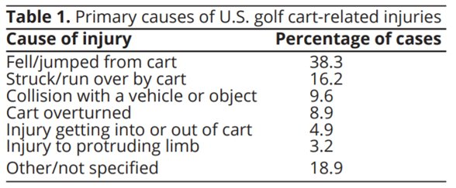
Table 2: Primary causes of U.S golf cart related injuries
As seen below in table 2 shows 9.6% of accidents were with collision with a vehicle or object and could indicate malfunction of the mechanical shifter. Eliminating this mechanical shifter and replacing it with an electrical shifter would lessen the failure and replacement of this component. This would lessen the occurrence of unsafe situations for the golf cart driver, and the number of injuries.

1.5.2 Economical
According to a study done by the United States Department of Energy, BEV (Battery Electric Vehicle) is cheaper to maintain by $0.06 per mile, when compared to ICEV (Internal Combustion engine vehicle) which is $0.10 per mile. While looking at the bar graph or figure 1 below we can see that in the BEV bar section the transmission services being, spark plugs, oxygen sensors, and timing belts are not needed since that is not a requirement for BEV. It also lacks fuel filters, engine air filters, oil filters, and cabin air filters. These are all components that BEV vehicles do not require for maintenance. In our case, we would be removing the mechanically operated shifter that works with the engine and reducing the use of these components in the golf cart. This would in the long run save the user of the golf cart money and time.
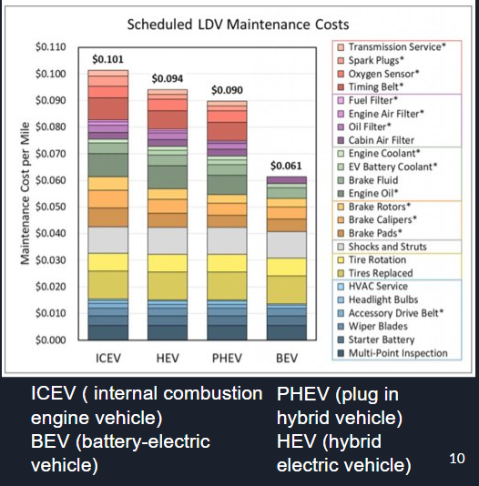
Figure 1.5.2: Scheduled Light Duty Vehicle (LDV) Maintenance Costs

1.5.3 Cultural/Social
Our project does have a society/culture impact. One of the societies that our project has a positive impact on is the elderly society. Our electrical shifter will require low effort shifting, the elderly will still be able to drive golf carts without a problem. They will be able to change directions with just one click and no extra force is required. The reason why we know that our project will positively impact the elderly is that it is proven. During our research, we found out that a lot of elderly people drive golf carts. According to a New York Times article, there is a village in central Florida where most of the residents there are 55 years and older. Another report shows that about 65,000 golf carts are reported in residence. With that in mind, we can say that our project will help them to keep on driving golf carts. Another group of people that our project positively impacts are all golf cart users. It will impact them in a positive way because it will help them to focus on what is more important rather than worrying about fixing the mechanical shifter. They will focus on their golf game or simply just cruising around the neighborhood. The number of people going through the struggle of fixing the mechanical shifter every year is high. We took this assumption based on a mechanical shifter on Amazon. A mechanical shifter on Amazon had 65 reviews within the course of one year. This indicates that about 65-200 products were sold within one year. Now, this is only 1 mechanical shifter out of thousands. If we make the math considering all other mechanical shifters in the market, we can estimate that around 65,000 – 200,000 mechanical shifters were sold in 1 year. That is a lot of people going through that problem. Our project will lower that number.

1.5.4 Technical
Based on the data analyses of low cost, safety improvement and low effort-shifting, we believe that controlling the golf cart by an electronic device will make it cheaper and safe to operate compared to the mechanical operation which requires a physical effort and load-bearing force applied on the armature. When compared to the original equation to move the golf cart forward and reverse you can see the difficult process the golf cart goes through. Then when you compare it to the right side displaying the new electronic shifting digital logic you see the simplicity now that for it go forward, reverse, or even stop. This can be seen in figure 2 below.


Figure 1.5.4: Equation for the mechanical shifter on the left, and the digital logic of the program for the electronic shifter.

1.6 Initial Project Constraints
When beginning a project there will always be factors to be considered before beginning the design. In the following project, the following constraints were identified and considered throughout the process of designing the project. The first initial constraint that was identified was the possibility of having complex networks when designing the layout of the electrical shifter. This indicated that we would have to be mindful of which compartments to use to keep the design simple as possible. The next constraint included possible errors from the software and would lead to time lag, the software would have to be passed through several checkpoints before being finalized. Lastly, DC power could have fluctuations in voltage, meaning our connections would best perform under similar gauge conditions and voltage or current checks would be done in order to avoid fluctuations.

Section 2 - Project Planning and Task Definition

2.1 Task Identification
Team 4 began by first identifying the steps needed to be able to complete the project that is displayed below in figure 3, the High-Level Timeline. The sections were as follows: project research, project design, project testing/launch, project performance review, and project close. We began creating smaller steps for these sections in order to make them manageable. This would allow the team to complete said tasks with appropriate time and to be able to be reviewed. Team roles were also assigned once sections of how to approach the project had been identified. Each team member would best apply their role to meet the goal of each section in order to complete the project.
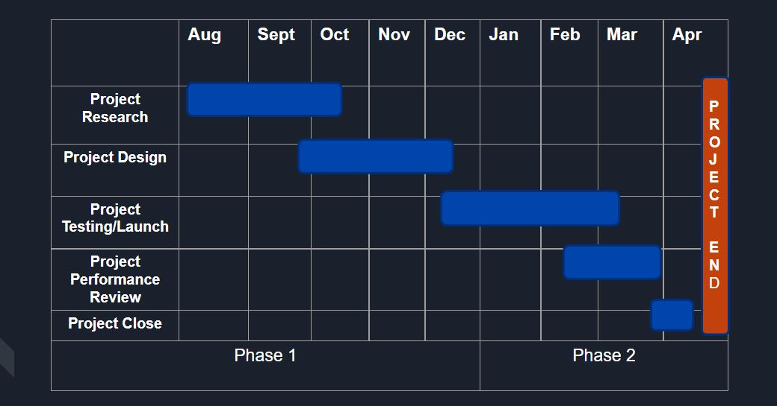
Figure 2.1: High Level Timeline

2.2 GANNTT Chart
Once the High-Level Schedule was set it, the next step would be to create smaller sections for the sections. This led to the creation of the GANNTT chart below divided into two sections. This GANTT chart visually let us know what needed to be completed in the coming months. A few tasks would be dependent on other task, but task that were not dependent could be started on. The sections in our GANNT Chart seen below in figure 4 and 5 led us to see that we invested a huge amount of our time for research, design, building, and system integration where everything was put together. Through the use of the GANNTT we were able to successfully complete everything on time in regard to the project.
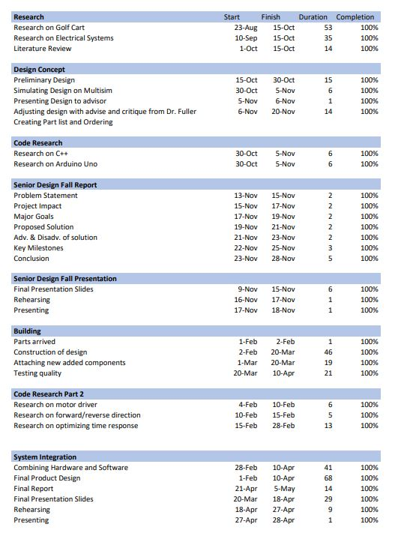
Figure 2.2: GANNT Chart
2.2 GANNTT Chart (continued)

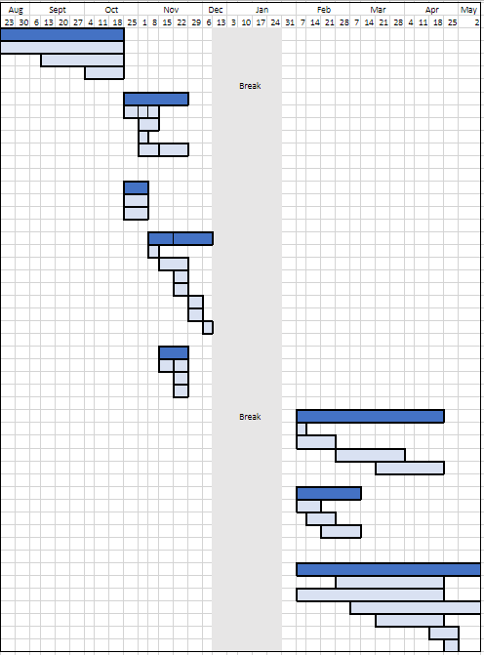
Figure 2.2.1: GANNT Chart continued.

Section 3 - Literature Review

3.1 List of all sources of information
Based on our literature review, we did an equipment comparison regarding microcontrollers. Since our design was more conceptual, we saw it only necessary to strictly keep it within microcontrollers since the other parts of our design were standard based. The top four microcontrollers that we thought could be best fitted for our design were the Arduino Uno, Arduino Nano, Arduino Mega, and the Raspberry Pi 3.
Arduino Uno:
The Arduino Uno was obviously the best choice for us. After countless hours of research, we saw how great the impact of resources the Arduino Uno had to offer. Not only that, but the learning navigation on how to use the Arduino Uno was rather simple compared to the other microcontrollers that are out there within the market. When it came to the price, it was ideal for us since we wanted to make a design that was less cost efficient but reliable. Lasty, according to our sources, we know that each microcontroller has its own set of specialties within certain projects. With that said, we found out that the Arduino Uno is more efficient within DC series motors which came to a huge advantage within our project.
Arduino Nano:
When it comes to the Arduino Nano, we saw it as a great potential. The goal was to have a simple design but at the same time reliable. Since the Arduino Nano was a small profile, it was a great consideration, as well it was on the cheap side. After looking more into it, we found out that it lacked certain connections that were needed for our design. For it to work, we needed other components which then could have later complicated our design and cost the team more money, which wasn’t ideal for us.
3.1 List of all sources of information (continued)

Arduino Mega:
Though the Arduino Mega had some great features, our team had to consider what had to meet our requirements. The Arduino Mega had 256 KB of flash memory, high input & output requirements, and 16 analog pins. Even though it had all these great features, they really weren't necessary to our design. Aside from this, the Arduino Mega was more costly and was a big profile which wasn’t ideal for our design. In the end of the day, we were more focus on meeting our requirements rather than having unnecessary features and more cost effective.

Raspberry Pi 3:
The Raspberry Pi 3 could also have been an excellent option to go with. The performance and the capability were undeniable. It has 26 analog pins, supports all types of codes, and is a faster processor overall. As much as we would have liked to go with this option, when we further investigated the cons of this device, we found out it was more expensive, and the device tends to overheat. This is a risk we didn’t want to go with.

3.2 Statement of Learning from each source
Once our team understood the concept of our design and what was needed to fit our requirements, we knew cost efficiency and reliability were ideal. By doing this, we saw the market for equipment, and compared it to what will be more ideal for us. To better organize our data and research, we made a chart table shown in Figure 6 that displays the comparison of the necessary equipment that was going to be implemented to our design. Even though all these microcontrollers could have technically worked within our design, we had to consider which was fitted the best, not just reliability but finically as well. As we investigated more within each microcontroller, we found out the benefits of each device and asked ourselves if it satisfied our requirements. We also investigated the cons and costs that helped us determine if this was the route we wanted to go with. As we continued our research, we discovered that the Arduino Nano could have cost the team more money and caused more complications within our design as it required other components. For the Arduino Mega we knew it wasn’t best fitted in our design since it had a bigger profile and had unnecessary features that didn’t satisfy our requirements. Even though the Raspberry Pi 3 could have been a great option, we understood the risks it had as far as overheating, and it was more in the higher price range within other microcontrollers in the market. Thanks to the data research, we were able to identify that the Arduino Uno was more efficient to us not just financially, but reliability as well. Overall, we learned why it is important to understand the engineering concept and do the necessary research to learn how to make a quality design, but to also consider the marketing aspect as well.

3.2 Statement of Learning from each source (continued)

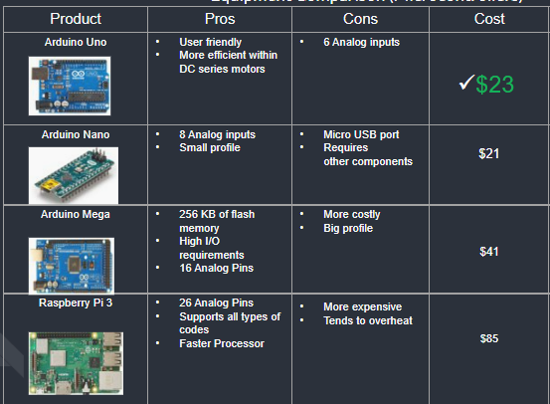
Figure 3.2: Processor Summary

Section 4 - Preliminary Design

4.1 Concept Generation
A design considered was a 6 pin forward and reverse switch like figure 4.1 below. It connects the positive and negative terminals of the battery in the center to two pins. From there we would connect one of the corner pins to the opposite corner and do the same with the other 2 corners. From there the left two corners will come out (1-positve, 1-negative power) and directly connect them to the DC motor. This is how the speeds will be switched from forward to reverse. It was a good idea; however, this kind of switch is still considered mechanical, and it will eventually go bad just as the original. Therefore, we decided to be more innovative and make it fully electrical.
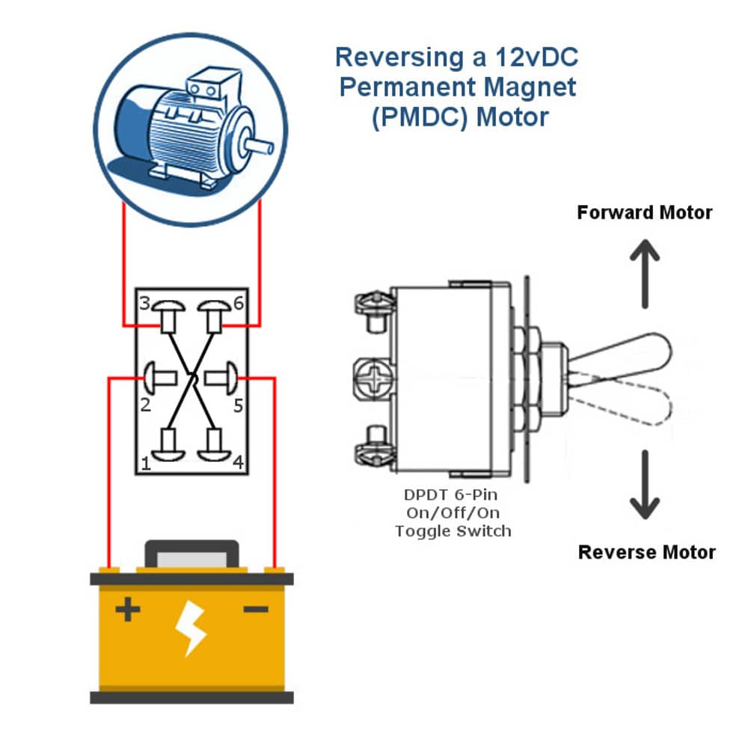
Figure 4.1: 6 pin Forward and Reverse Switch

4.2 Concept Evaluation and Selection
Three different designs were considered, and we decided on the one with the electrical h-bridge and Arduino (phase 2). The other design had the Arduino and relays to make the car go forward and reverse (phase 1). And the final design was the one mentioned above or the 6 pin one.
Phase 1: During the first semester. From August –December 2021 we considered the design with the Arduino and relays like the figure shown in bottom. The idea was good. The system was doing what we were asking it to do, which was to go forward and reverse. There were two relays controlling the speeds. One was controlling the forward position and the other one was controlling the reverse position. Though it was working, buying two relay switches was not the best thing for us to do because it will increase our costs. Our goal was to keep the cost as low as possible. Another reason why we decided to change it was because the relays were using up a lot of space.
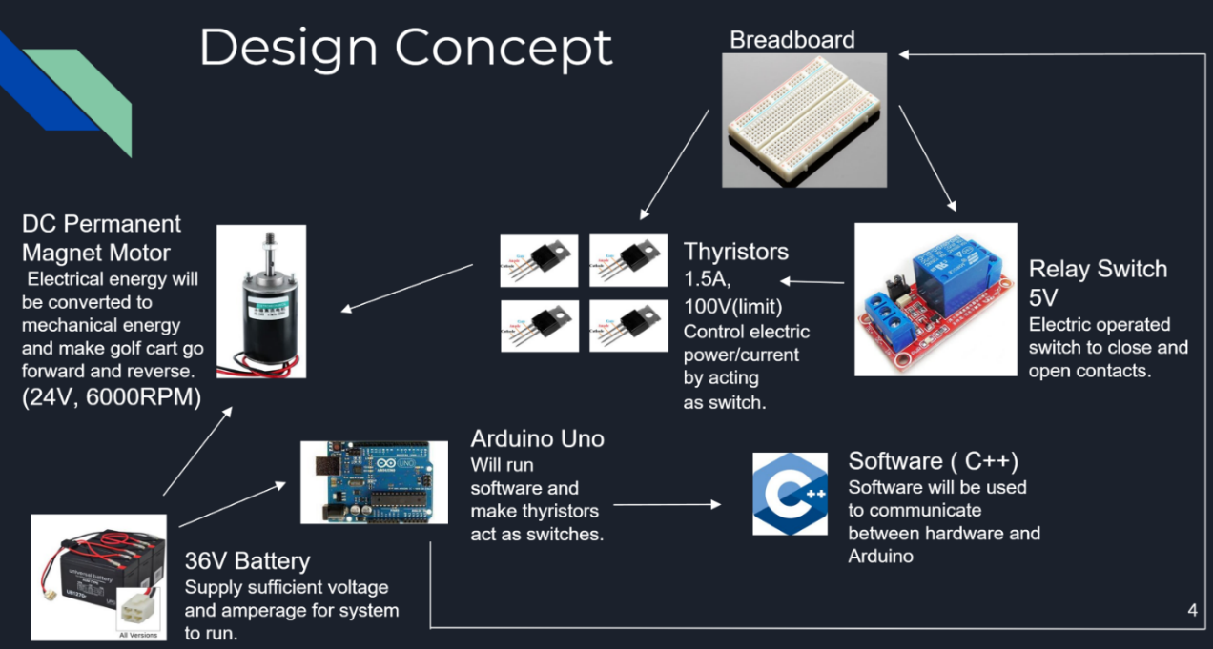
Figure 4.2.1: Design concept of Phase 1

4.2 Concept Evaluation and Selection (continued)

6 Pin switch: As mentioned in section 4.1 we considered was a 6 pin forward and reverse switch as well. This design was just a consideration, but we never actually built it. We considered it because a lot of golf cars have those switches now days. However, this kind of switch is still considered mechanical, and it will eventually go bad just as the other one. In our research we found that people must change to these kinds of switches at least once every 2 years. We want our switch to last a lot longer; therefore, we decided not to go with that one. Plus, it wouldn’t have been very innovative.
Phase 2: After the first semester we decided to not go with the relay switches anymore. Therefore, we started looking for a more innovative solution. After research we concluded that using an electrical H-Bridge (L293D). It will be doing the same job as the relay switches but all in one chip. This was very convenient for us because our goal was to keep our cost low and keep our design small enough to be able to implement into the golf cart. For this design we used a 24-volt battery and will Brach out into two different paths. For one of the paths 24 volts would go into a step-down transformer to step down the voltage from 24 volts to 5 volts. Then, that step down transformer would connect to the Arduino with 5 volts to power it. In the Arduino it was the code used to flip the polarity of the dc motor. Then, the Arduino would get connected to a breadboard where all the smaller electrical components were connected. Also 24 volts would go straight into the breadboard to connect to the H-bridge to power the dc motor. But, before voltage got to the dc motor it would first need to pass by a speed controller. The speed controller regulates voltage allowing the dc motor to speed up and slow down. This design can be better visualized in figure 4.2.2 below.
4.2 Concept Evaluation and Selection (continued)
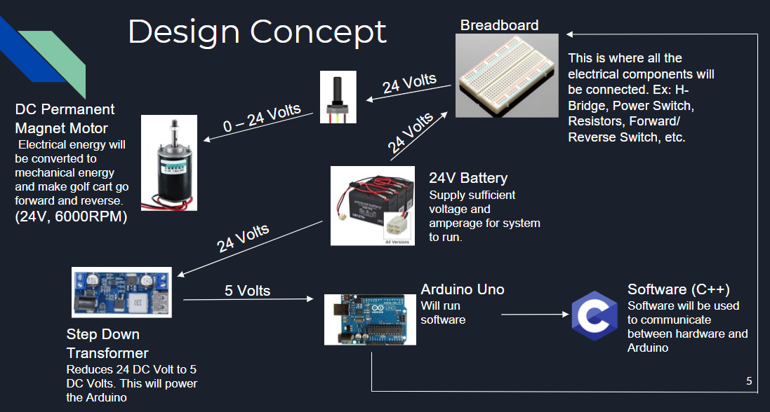
Figure 4.2.2: Design concept of Phase 2

4.3 Design Constraints and Applicable Codes and Standards Used in the Preliminary Design
There were some constraints in our design. As mentioned in section 4.2 we decided to go with the design in phase 2.
The first constraint was that the golf cart provided to us was a 36-volt battery golf cart. But for our prototype we had to use 24-volt power source instead of 36 V. The reason for that is that breadboard pins were so small that thick wires were not able to fit; therefore, we could not use thick wires for the prototype. 36 V power source requires thicker wires for it to be safe and not burn the wires. In the other hand 24 volts were enough to test our design because the wires were 24 volts resistant. For when we implement the design in the actual golf cart will have to make sure we use the proper wires to resist 36 volts. With that we will not be able to use a breadboard when connecting it to the golf cart.
Another constraint we encountered in our design was that we did not have enough time to build a safe feature to prevent the switch from switching from one direction to the other when running. In our design, if someone accidentally switches from forward to reverse while running in forward direction the H-bridge will burn and it will have to be replaced. The solution to that is to build a short circuit that does not allow the switch-to-switch direction while voltage is being applied to the dc motor. Again, due to time constraints we were not able to build that short circuit.

4.3 Design Constraints and Applicable Codes and Standards Used in the Preliminary Design (continued)
The Code and Standards used in our preliminary design is listed below.
- IEEE/ISO/IEC 24748-3-2020
  - Life cycle management provides guidance on the application of the software life cycle processes standard.
  - Establishes guidance to implement a common framework for software life cycle processes, with well-defined terminology.
- IEEE 2755.2-2020
  - Recommended Practice for Implementation and Management Methodology for Software-Based Intelligent Process Automation

- IEEE 113-1985
  - Procedures for Direct-Current Machines
  - Recommendations are made for conducting and reporting generally acceptable tests to determine the performance characteristics of conventional DC machines.
- NESC
  - National Electrical Safety Code
  - Implemented to regulate and maintain electrical components used during the creation of this project.
- IEEE 7010-2020
  - Recommended Practice for Assessing the Impact of Autonomous and Intelligent Systems on Human Well-Being
- IEEE 485-1997
  - Recommended Practice for Sizing Lead-Acid Batteries. Methods for defining the dc load and for sizing a lead-acid battery to supply that load for stationary battery applications

4.4 Preliminary Analysis
Once we got a good insight of the research needed to implement our design, our team was able to identify the obstacles and challenges to meet our design requirements. Overall, as previously discussed in section 4.2, we went with the phase 2 route. Since we did not have the necessary resources to use a 36-volt battery supply, we went ahead and used a 24-volt battery source (also used in golf carts). This allowed us to supply sufficient voltage and amperage for the system to run. To make our design efficient and reliable, we created two different pathways that came from the 24-volt battery supply. This is what made our design unique overall, because using our concept theories, we were able to connect one of the pathways to a stepdown transformer which converted 24-volt to 5-volt to power the Arduino Uno. By powering the Arduino Uno, we were also able to implement the algorithm that will run the software. This allowed the software to communicate between the hardware and Arduino.

4.4 Preliminary Analysis (continued)
As for the other pathway that we created from the battery source, we were able to connect that pathway to the breadboard. This is where all the electrical components were linked together, such as the H-bridge, Power Switch, Resistors, Forward/ Reverse Switch, etc. In theory within an electronic operated system, we had to integrate electric switch into circuit correctly to control polarity contact. To meet that requirement, the switch will flip polarity contact with just a click to make the motor move forward and reverse. By implementing this design, it will achieve reliability, cheaper cost, and low effort-shifting overall as seen figure 4.4 below.
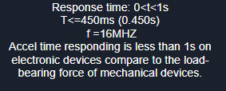
Figure 4.4 Shifting specifications
Within the data shown in the figure above, it also proves that the electronic shifting is faster than mechanical shifting based on the time response and the frequency of the data transmission.

4.5 Preliminary Design
As soon as our team understood the concept and background information of the design, we knew exactly how to proceed within our final project. Project management was ideal for us, and meeting deadlines within our team helped us prevail successfully overall. Having experience with the software NI MULTISIM from our engineering courses, we were able to make a simulation of our entire design and get a better insight into what equipment was needed for our project. By taking the initiative to complete this simulation during phase 1, this gave us a huge advantage by knowing what parts to order ahead of time. By understanding the fundamentals of our programming classes, we were able to do further research to help us encode our algorithm that needed to be implemented within the Arduino Uno to meet our requirements. Lastly, thanks to our microprocessor and circuit analysis courses, we were able to make the necessary circuit connections that needed to be made in a safe manner.
Within phase 1, we were able to build our first prototype (discussed in 4.2). Though this design technically met our requirements, we wanted to improve the design financially and make it more user friendly. By learning what we built, we were able to identify how we could make the design cheaper, which was replacing the relay switches. Not only that, but we knew we could make our design simpler to give it a better user-friendly theme. By doing this, during phase 2, we ordered a step-down transformer that allowed us to meet our safety circuit specifications. We also ordered a speed controller and three switches, that allowed the user to navigate the design to his/her liking. Once the design was implemented to our standards, we were able to overall make the design more user friendly and lower costs. (Overall Design is shown in Figure 4.2.2)

Section 5 - Detailed System Design

5.1 Project Parts Summary
As shown in figure 5.1 replacing the mechanical operated shifter with an electronic operated shifter to make the system last longer since unnecessary movement will be reduced. With an embedded system to make the golf cart move forward and reverse including electronic components, this design is identified to meet the goal and the entire customer recommendation. It would be expected for this embedded system to share the same voltage source already available in the golf cart, which is the 24V series battery.
The electric components that will be used are
- the Arduino Uno Microcontroller
- H-bridge L293D which will replace the relay switch used in phase 1.
It’s important to underline that the H-bridge L293D will be there to ameliorate the design approach of both relays and will reduce the mechanical movement that was needed before.
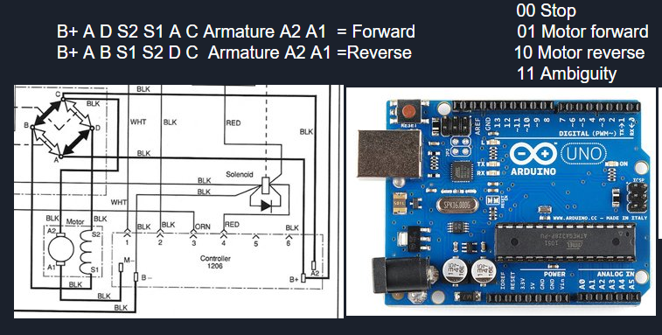
Figure 5.1 shows the mechanical shifter on the left side and electronic operation on the right

5.2 Engineering Analysis and/or Simulation
From phase 1 to phase 2, to arrive at the proposed design, the scope of the project was to convert a mechanical operated system switch of a golf cart into an electric operated system switch in order to have the golf cart moves forward and backwards when the polarities get switched.
By this given this example: if we connect a connection ‘A’ with positive polarity and a connection ‘B’ with negative polarity, the cart moves on one way and by switching those connections the cart will move in the opposite direction.
While on the mechanically operated system, a mechanical lever oversees switching those polarity connections. It’s important to underline that a specific microcontroller was needed. The first prototype was on September 6, 2021, that can be seen on figure 5.2 below.
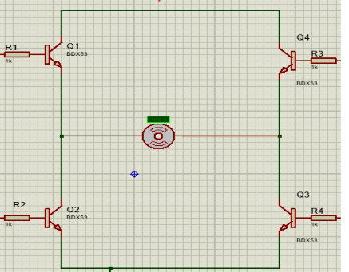
Figure 5.2: Phase 1 design zoom in

5.2 Engineering Analysis and/or Simulation (continued)

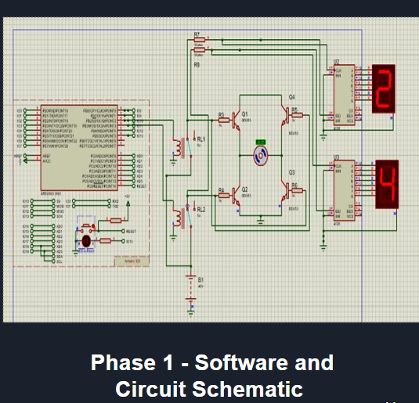
Figure 5.2.1 displays the first schematic for Team 4
Phase 2
This phase was the most complicated because the chosen element in the schematic should be compatible with Arduino and accept the programming languages that it required. For instance, we have faced so many difficulties during this phase of the project because all the unrecognized element or electronic components that were not included on phase 1 should be include in this phase and the software program should be updated as soon as we are being moving up with the project.
The writing program contained instructions to switch the polarities and make the prototype move forward and backward. The program logic can be seen in the figure (software figure). The
5.2 Engineering Analysis and/or Simulation (continued)

writing software program is made to allow the electronic operating system to work with the microcontroller Arduino Uno, and H-Bridge L293D microprocessor which will replace the relay switch used in phase 1. These would need to be part of the existing circuit and would require it to be mounted in a safe and dry place with proper connections.

To successfully accomplish this project, Multisim by National Instrumentation, Proteus Software that we all had basic understanding of initial instruction and engineering courses that were taken before and aided in the creation of this design include: logic circuit, programing, electronics II and electromechanical energy conversion. This led to the final design schematic that can be seen below in figure 5.6.
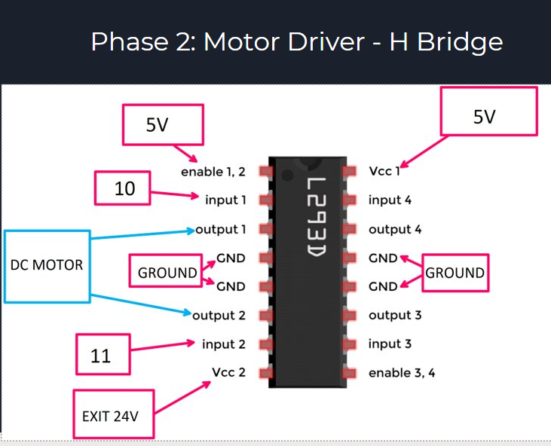
Figure: 5.3 of the H-Bridge

5.2 Engineering Analysis and/or Simulation (continued)

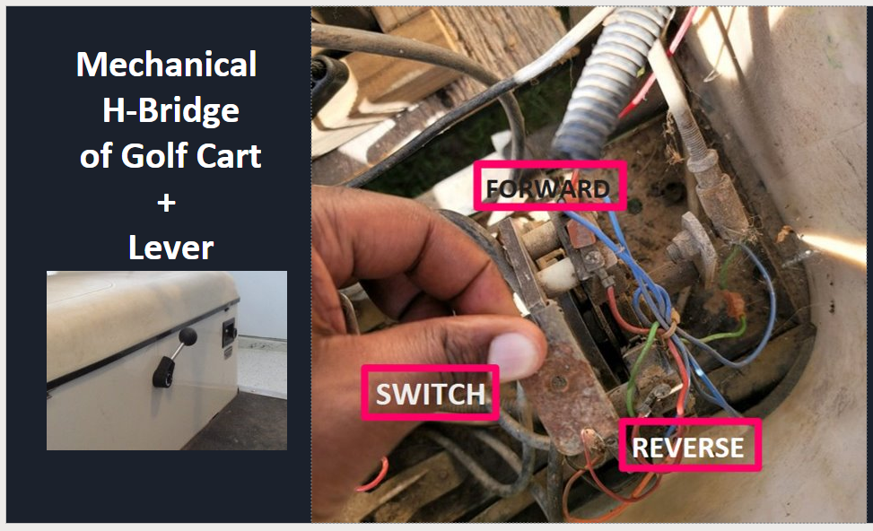
Figure 5.4: of the Mechanical shifter of the Golf Cart

5.2 Engineering Analysis and/or Simulation (continued)

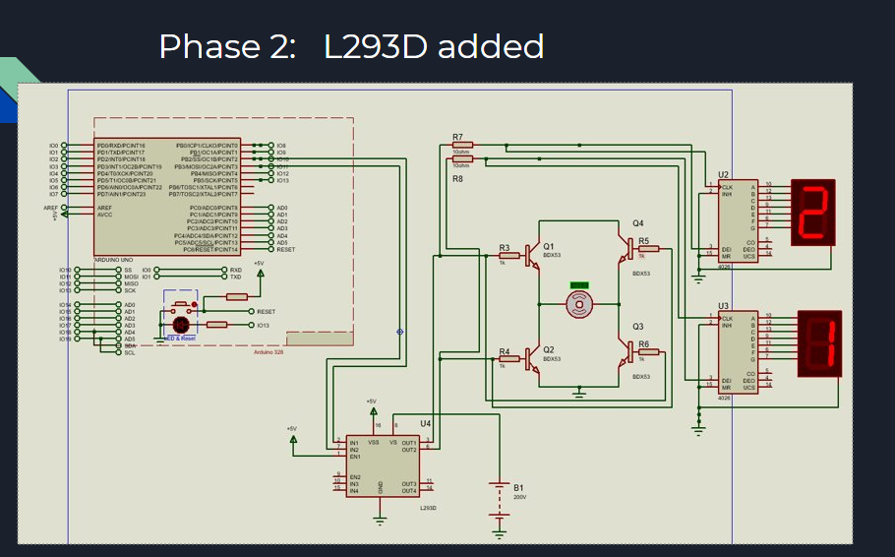Figure 5.5: displays the final design schematic, with the Arduino, electrical components, and motor connected

5.3 Hardware Layout/Detailed Drawings/ Equipment Selection and Specification
The design of Circuit and software are shown in this section.

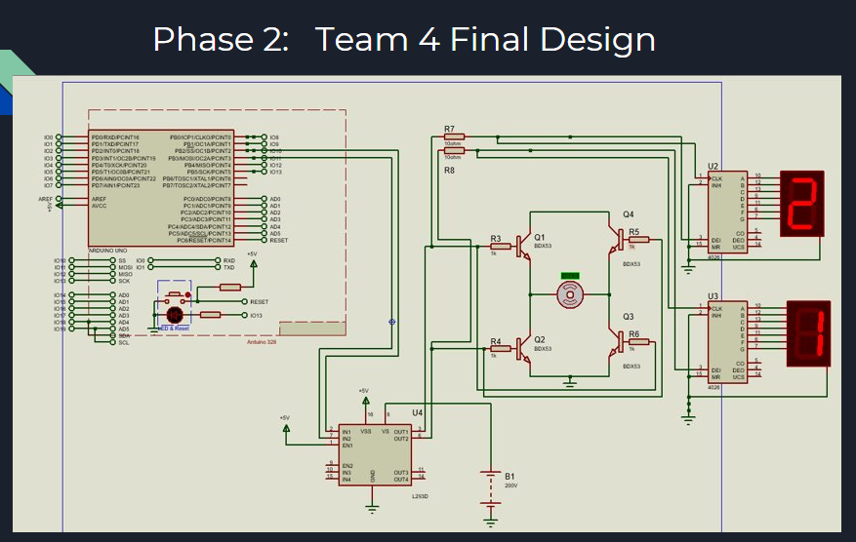 Figure 5.6: The final design schematic

5.3.1 Show Overview of Code Developed to Support 5.3
The software that we built allows the user to control the speed and motion of the mother.
  - create constants for the output and input pins
  - create the variables for remembering program state: It will use the variable to hold from our input. So, the state changes direction for both switches, comparing the state from one loop to the next. Then we need to record the previous state of each switch.
  - Create the variable for motor: motorDirection keeps track of which direction the motor is spinning and motorPower keeps track of whether the motor is spinning or not.
  - Declare the digital pins as input and output: in setup (). The direction was set for each input and output pin.
  - Turn the motor off: turn the enable pin LOW to start, so the motor isn’t spinning right away.
  - Read the sensor information: in the loop (), read the state of the on/off switch and store it in the onOffSwithcState variable.
  - Check if on/off sensor has changed: the switch is currently HIGH, set the motorPower variable to. If it is LOW, set the variable to 0. Read the value of the direction switch and potentiometer. And store the value in their respective variable.
  - Check to see if the direction has changed: check to see if the direction switch is currently in different position than it was previously. If it is different, change the motor direction variable.
  - Change the pins to turn the motor in the proper direction: the motorDirection variable determines which direction the motor is turning. We set the control pins setting one HIGH and the other LOW. So, when the motorDirection changes, reverse the states of the control pins. In the other hand, if the direction switch gets pressed, the motor will be pin in the other direction by reversing the state of the controlPins.
  - PWM the motor if it is enabled: if the motorEnable variable is 1, set the speed of the motor using analogwrite() to PWN the enable pin. If the motorEnabled is 0, then turn the motor off by setting the analogwrite value to 0.

5.3.1 Show Overview of Code Developed to Support 5.3

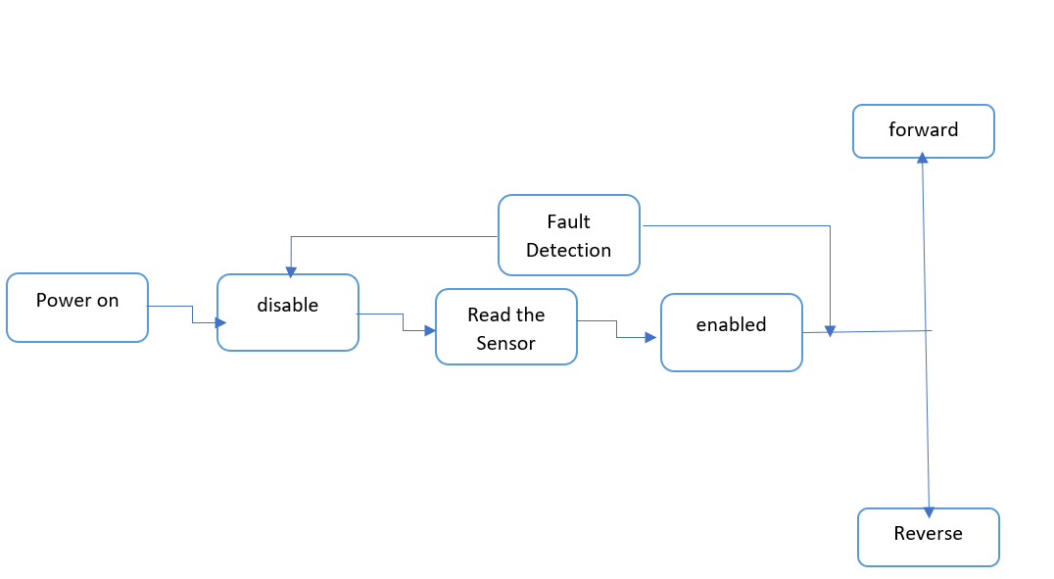

Figure 5.7: Software Flow Chart



Figure 5.8: Software used

5.4 Application of Engineering Codes and Standards used in Final Design
- IEEE/ISO/IEC 24748-3-2020
  - Life cycle management provides guidance on the application of the software life cycle processes standard.
  - Establishes guidance to implement a common framework for software life cycle processes, with well-defined terminology.

This was used to maintain proper creation of software used to communicate with motor of golfcart and motor driver.

- IEEE 2755.2-2020
  - Recommended Practice for Implementation and Management Methodology for Software-Based Intelligent Process Automation

It was used to create a proper design methodology before arriving to our final design.

- IEEE 113-1985
  - Procedures for Direct-Current Machines
  - Recommendations are made for conducting and reporting generally acceptable tests to determine the performance characteristics of conventional DC machines.

This standard was used to perform correct test on the DC motor of the golf cart.
- NESC
  - National Electrical Safety Code
Implemented to regulate and maintain electrical components used during the creation of this project.
- IEEE 485-1997
  - Recommended Practice for Sizing Lead-Acid Batteries. Methods for defining the dc load and for sizing a lead-acid battery to supply that load for stationary battery applications

The standard was used when selecting a proper battery for our design to imitate the golf cart for our design.

5.5 Economic Analysis
Electrical shifters can be a lot more affordable than mechanical shifters. The reason for this is because mechanical parts tend to be more expensive than electrical parts. Another reason is that mechanical shifters are destined to fail eventually because of the constant movement it goes through every time is used. In the other hand electrical components tend to last a lot longer because they don’t go through much movement. However, in the case of an electrical part failing the price to replace is a lot more affordable. With a lot less maintenance needed we concluded that an electrical shifter is a lot more convenient to have.
Table 5.5.1: Schedule LDV Maintenance Cost

5.5 Economic Analysis (continued)
The goal for our design is to use all affordable electrical components to keep the cost of our product low. For that we had to research affordable electrical components that met the needs of our project. The main components we needed to find were a microcontroller. After a lot of research, we concluded that Arduino Uno was the best microcontroller because it was affordable, and it did not have a lot of extra features we did not need.
Product | Price
Arduino kit  (Cables, push buttons, resisters, speed controller, H-bridge) | $91.90
Step Down Transformer | $14.99
Breadboard | $7.99
Total | $114.88
Table 5.5.2 Parts price

5.6 Final Design
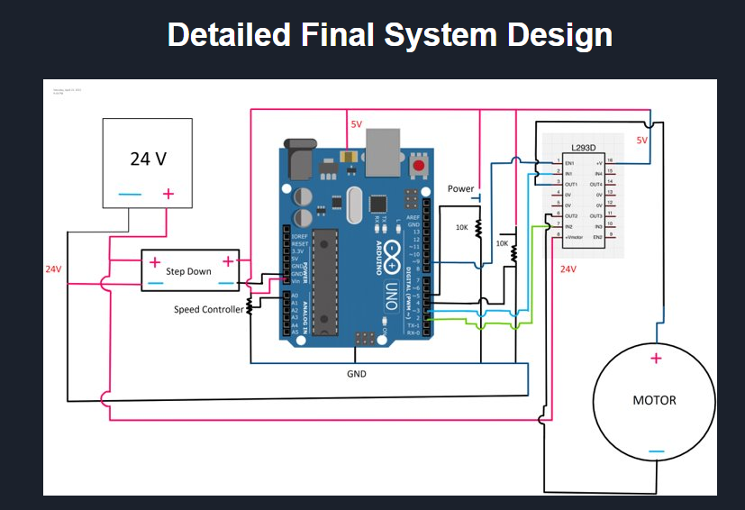Figure 5.6.1: Detailed Final System Design

5.6 Final Design (continued)

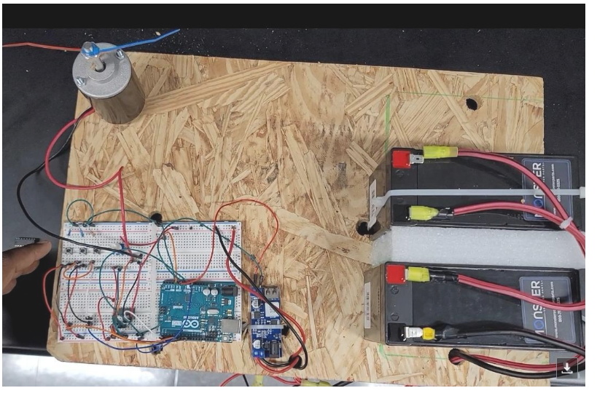Figure 5.6.2: Hardware Final System Design

5.6 Final Design (continued)

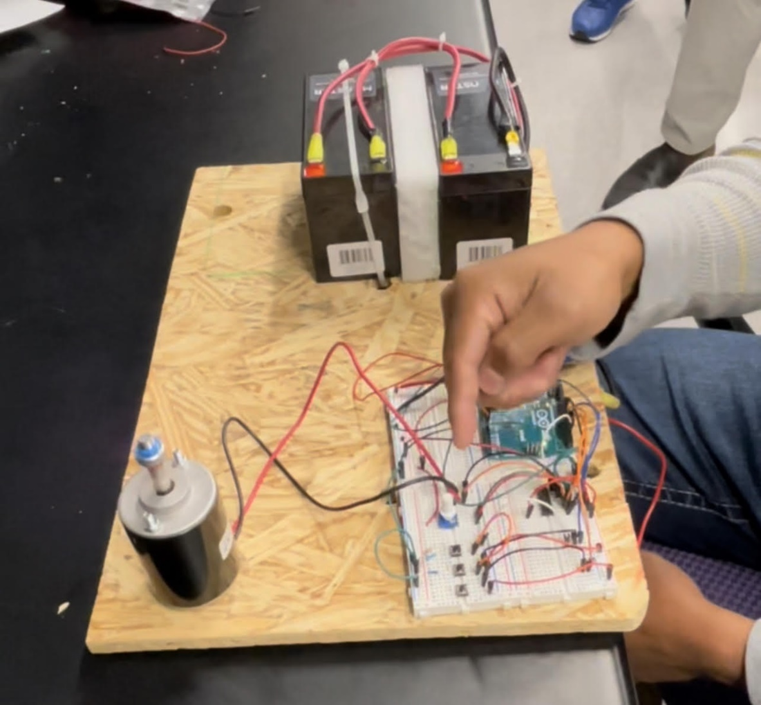
Figure 5.6.3: Hardware Final System Design

Section 6 - Results and Discussion

6.1 Summary of Goals and Objectives
Objective
The goal of this project is to change the mechanical operated system switch of a golf cart and design an electric operated system switch. This will reduce maintenance required and help golfers conveniently and safely use the golf cart.
Result
Creation of user-friendly electrical switch to control forward and reverse movement of golfcart
Use the same voltage source to power the newly introduced electrical system.

Objective:
The goal of this project is to change the mechanical operated system switch of a golf cart, ad design an electric operated system switch. This will reduce maintenance required and help golfers conveniently and safely use the golf car

Objective:
The goal of this project is to change the mechanical op operated

m switch. This will reduce maintenance required and help golfers conveniently and safely use the golf c
6.2 Summary of Constraints and Codes Met by Design

Our design faced many constraints through out the whole process. The first being that we had to build our own golf cart model in lab to test out our electrical shifter design. Since golf carts do have high voltage to make them operate, we also had to create a system that would support a high voltage of 24V. Next the software was a long process since it had to make sure the motor would go forward and reverse and not do anything else. Bugs were found throughout the software when it did not run, but at the end it was ultimately solved.
The following codes were used to meet the final design:
- IEEE/ISO/IEC 24748-3-2020
  - Life cycle management provides guidance on the application of the software life cycle processes standard.
  - Establishes guidance to implement a common framework for software life cycle processes, with well-defined terminology.

This was used to maintain proper creation of software used to communicate with motor of golfcart and motor driver.

- IEEE 2755.2-2020
  - Recommended Practice for Implementation and Management Methodology for Software-Based Intelligent Process Automation

It was used to create a proper design methodology before arriving to our final design.

- IEEE 113-1985
  - Procedures for Direct-Current Machines
  - Recommendations are made for conducting and reporting generally acceptable tests to determine the performance characteristics of conventional DC machines.

This standard was used to perform correct test on the DC motor of the golf cart.

6.2 Summary of Constraints and Codes Met by Design (continued)

- NESC
  - National Electrical Safety Code
Implemented to regulate and maintain electrical components used during the creation of this project.

- IEEE 485-1997
  - Recommended Practice for Sizing Lead-Acid Batteries. Methods for defining the dc load and for sizing a lead-acid battery to supply that load for stationary battery applications

The standard was used when selecting a proper battery for our design to imitate the golf cart for our design.

6.3 Discussion of Results and Other Use Cases
This project allowed us to create a more affordable and reliable shifter for the golf cart. The previous shifter that was replaced was a mechanical shifter as brought up by Dr. Fuller. The mechanical shifter for him in the past had to be replaced a few times during the ownership of the golf cart. This led us to the inspiration of the design on the electrical shifter. By creating a design with electrical components this would extend the use of this device since electrical components will last longer the mechanical components since there is no movement occurring. During our design phases we went through two main phases for our design.
The first phase included relays that were acting as the motor driver to make the golf cart go forward and reverse. The design did work well, but let us to realize that the design was to crowded once it had been built. This led us to end up creating another design with a different motor driver, which was the L293D H-Bridge. Once this motor driver was applied it led to a lot of freed up space. Through the final combination of our software and hardware design we were able to design an electrical shifter that would go forward and reverse electronically with the aide of the microcontroller Arduino Uno.

Section 7 - Conclusions and Recommendations

Recommendations:
Our recommendation is to use an electronic based switch instead of a mechanical based switch. To operate the electronic operated system safely, we also recommend controlling the electrical system with the Arduino Uno. Lastly, we recommend the use of the control system to be within range of set voltage.
Conclusion:
The innovation of our electrical shifter proves that having an electrical shifter is more affordable than a mechanical shifter. Electrical components used for our design are all affordable and easy to understand. Customers will now be able to enjoy their golf cart more and not worry about fixing the shifter.

List of References

[1] “Arduino Mega 2560 REV3,” Arduino Official Store. [Online]. Available: https://store.arduino.cc/products/arduino-mega-2560-rev3. [Accessed: 04-Oct-2021]. ​
​
[2] “Arduino Nano,” Arduino Official Store. [Online]. Available: https://store.arduino.cc/products/arduino-nano. [Accessed: 04-Oct-2021]. ​
​
[3] “Arduino Uno REV3,” Arduino Official Store. [Online]. Available: https://store.arduino.cc/products/arduino-uno-rev3. [Accessed: 04-Oct-2021]. ​
​
[4] , E. F., & says:, L. R. A. (2021, September 14). Arduino Uno vs nano vs mega, pinout, and technical specifications. Electronic Clinic. Retrieved November 28, 2021, from https://www.electroniclinic.com/arduino-uno-vs-nano-vs-mega-pinout-and-technical-specifications/. ​
​
[5] “Electronic and pneumatic controls analyzed,” Bright Hub Engineering, 28-Oct-2009. [Online]. Available: https://www.brighthubengineering.com/commercial-electrical-applications/53898-pneumatic-vs-electronic-control-mechanisms/. [Accessed: 04-Oct-2021]. ​
​
[6] H. Tremura and O. Toker, “Vehicle Level Software Design of the Florida Polytechnic Autonomous Golf-CART,” SoutheastCon 2021, 2021. ​
​
[7] K. Z. Horvath, et. al, “Fun Ride or risky transport: Golf cart-related injuries treated in U.S. emergency departments from 2007 through 2017,” Journal of Safety Research, 16-Nov-2020. [Online]. Available: https://www.sciencedirect.com/science/article/abs/pii/S0022437520301237?via%3Dihub. [Accessed: 04-Oct-2021]. ​
​
[8] Macfos. (2021, February 4). Pros and cons of Raspberry Pi: Detailed guide in 2020. Robu.in | Indian Online Store | RC Hobby | Robotics. Retrieved November 28, 2021, from https://robu.in/5-pros-and-5-cons-of-raspberry-pi/. ​
​
[9] S. J. Chapman, Electric Machinery and power system fundamentals. Boston: McGraw-Hill, 2002. ​
​
[10] T. Mohn, “The (mostly) safe golf cart,” The New York Times, 04-Mar-2017. [Online]. Available: https://www.nytimes.com/2017/03/04/business/retirement/the-mostly-safe-golf-cart.html. [Accessed: 04-Oct-2021].

Appendix

