PRAIRIE VIEW A&M UNIVERSITY
ROY G. PERRY COLLEGE OF ENGINEERING


Geo Location for People with Special Needs

Senior Design & Professionalism II
ELEG 4248

Final Written Report

Team Number 3

Submitted by:
Johnn Owens
Trevor Johnson
Michael Shepard
Adeola Okeowo
Osesiye Ayeni

Sponsor: Dr. Annamalai

Facilitator: Mr. Turner

Table of Contents
Section 1 – Project Scope……………………………………………………………………….…….3
1.1. Problem Statement………………………………………………………………...….4
1.2. Client identification and Recognition of Need………………………………….…....5
1.3. Project Goals and Objectives………………………………………………………....6
1.4. Contemporary Issues Relevant to Project……….………………………….……….9
1.5. Potential Impact of Project on Technology, Society, and Safety……………….…....10
1.6. Initial Project Constraints……………………………………………………….…....13
Section 2 – Project Planning and Task Definition………………………………………….……….14
2.1. Task Identification………………………………………………………….….………….15
2.2. Timeline………………………………………………………………………….………….17
2.3. Gantt Chart………………………………………………………………….….………….19
Section 3 – Literature Review……………………………………………………………………….20
Section 4 – Preliminary Design………………………………………………………………………22
4.1. Concept Generation………………………………………………………………...............23
4.2. Concept Evaluation and Selection…………………………………………….….……….24
4.3. Design Constraints and Applicable Codes and Standards Used in the Design.……………25
4.4. Preliminary Analysis……………………………………………….……….……………...26
Section 5 – Detailed System Design………………………………………………………….……...27
5.1Equipment Selection and Specification……………………………………….….………....29
5.2Final Design Layout……………………………………………………….…….………….30
5.3Engineering Analysis and Simulation………………………………….……….………….31
5.4Application of Engineering Codes and Standards………………………….…...…………...33
5.5Economic Analysis……………………………………………………………….………...34
Section 6 – Results and Discussion…………………………………………………….….….........35
6.1Summary of Goals and Objectives…………………………………………….…………...36
6.2Summary of Constraints and Codes met by Design…………………………….………….37
6.3Discussion of Results………………………………………………………….….…………38
Section 7 – Conclusion & Recommendations……………………………………….….….…........41
References………………………………………………………………………………………….43

Section 1 - Project Scope

1.1 Problem Statement

One of the major concerns of caregivers who tend to be special needs individuals is how to find an affordable solution to prevent them from wandering from their safe environment. According to statistics, "roughly 50 percent of children between the ages of 4 and 10 with autism wander at some point. More than half of these wandering children go missing – often into dangerous situations." (autismspeaks.org). The main goal of this project is to create an affordable, robust, and effective solution to locate special-needs individuals by investigating viability, performing a feasibility study, and implementing geo-location-based technology in a LoRa WAN (Wide Area Network) (Long Range Wide Area Network) platform. ​Our device will be suitable for wireless data communications that periodically send a small amount of data over long distances at a low data rate. This is a step into future network servers, focusing on expanding broader network coverage and a secure private server.

1.2 Cient Identification and recognition of need
According to childmindinstitute.org, many autistic children are prone to wander more therefore putting themselves in dangerous situations. Autistic children wander more because they have a weaker sense of danger than other kids or they may get fixated on exploring something interesting to them. This is potentially a substantial risk because they can end up lost or hurt and some may not be able to communicate their names or addresses. In a 2011 study on wandering that listed responses from more than 800 parents, 50 percent of children between the ages of 4 and 10 with an ASD were said to have wandered at some point four times more than their unaffected siblings. The behavior peaks at 4, but almost 30 percent of kids with an ASD between the ages of 7 and 10 are still eloping, eight times more than their unaffected brothers and sisters. These statistics portray the dire need for caregivers/parents to be equipped with the proper tools to locate special needs individuals. The implementation of our device in society will lower these numbers tremendously. Our device will be able to track special needs individuals effectively and keep them from the dangers of wandering or going missing without anyone noticing.

1.3 Project Goals and Objectives
Purpose:
The main goal of this project is to create an affordable, robust, and effective solution to locate special-needs individuals by investigating viability, performing a feasibility study, and implementing geo-location-based technology in a LoRa WAN (Long Range Wide Area Network) platform. Our device, the G3O (pronounced “geo”), will enable caretakers to monitor the safety of their disabled dependent more effectively.

Deliverables/Objectives / Proposed Solution:
- Embedded Tracking System:
The Arduino Uno + SX1276 LoRa Shield microcontroller will be implemented with geo fencing technology to track a specific individual while keeping battery usage at a minimum. The ideal tracker will remain in sleep mode for most of its use. The device is designed to wake when it has passed the geo-fencing threshold. From there, it will transmit its location to the gateway.

- Access Point:
The LoRa WAN gateway will act as a bridge between the LoRa tracker and The Things Network. The gateway will act as a private server linked directly to the IoT cloud. It will also protect the users’ personal information from cyber criminals.

- SMS Notification:
Once the data is received on The Things Network, it will be decoded and manipulated to send directly to the user through a notification on a cellular device. Ideally, the user will receive live location updates every 60 seconds.

Scope:
Our team will create a LoRa IoT device that is suitable for wireless data communication that sends lesser amounts of data over long distances at a low data rate periodically. This is a step into future network servers, with the focus being directed toward expanding wider network coverage and a safer and secure private server.

Marketing/Customer Requirements:
- The tracking system will be concise and reliable for the most accurate results. By effectively using LoRaWAN (Long Range Wide Area Network) technology, the G3O will be able to pinpoint an individual’s exact location.

- Should the individual wearing the device move outside of the desired radius, an alert will be sent directly to the primary caregiver or guardian. The geo-fencing feature in LoRaWAN technology will allow a specific radius to be programmed into the transceiver.

- The SMS Notification will be user friendly, meaning anyone should be able to operate it. Live GPS (Global Positioning System) coordinates will be sent every 60 seconds the device is outside of the desired boundary.

- The G3O will be lightweight and portable with the idea that it will be worn by a child. The peripheral interface controller (PIC) should fit in a case about the size of a watch or wristband.

- The G3O will be marketed at a low cost with no monthly subscription or fees. It will consist of a transceiver and tracker that will connect to a LoRa access point that will communicate with the Internet of Things (IoT) network.

- The LoRaWAN network has a range of up to two miles outside of its geo-fence. Because of this, the G3O will not need to use Bluetooth or Wi-Fi which have ranges less than 100 meters.

- The G3O will use minimal battery power and will be functional up to a week on a single charge. The LoRaWAN platform will allow the G3O to be discoverable for enough time to be located.

- Cyber security measures will be taken to ensure that the G3O is not so easily hackable. The device will require a secure logon to the cloud server and only allowed devices will be admitted to the LoRa private network.

1.4 Contemporary Issues Relevant to Project
With a click on a screen, an ordinary person can find his or her way via a complex system involving satellite technology. GPS technology has exponentially improved society. GPS technology improved navigational accuracy significantly in the military, in the economy, and in our ordinary lives. However, there are still issues with GPS tracking in modern day society. The two main contemporary issues with wireless GPS tracking are accuracy problems and issues accessing data. The accuracy problems are usually due to the area where a person is located. The antenna can have issues picking up or maintain satellite signal. Normally, this can be fixed by placing the antenna in a place where it has a clear view of the sky. However, this could be due to the location a person is in. If a person is indoors, the GPS tracker can be off or if a person is in an area where there is not much signal the tracker can have a hurt time picking up the location. The second contemporary issue is the ability to access history data online. The ability to access data is important to those tracking something of interest. Access to information is due to enabled firewalls, outdated firmware, or incompatible technologies.

1.5 Potential Impact of Project on Technology, Society, Safety

Safety:
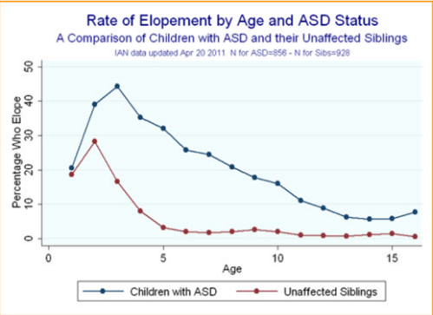
Figure 1.1
Statistics show that half of children between the ages of 4 and 10 attempt to elope or wander from their safe environments. As you can see in figure 1.1, the rate of elopement in autistic youth is significantly greater than that of their unaffected siblings. Our device will help reduce these rates and create a safer environment for children with autism.

Social:
According to the Child Mind Institute, various parents stated that wandering is the most stressful behavior. 62% of parents of autistic children stated fear of their child wandering prevented them from participating in activities outside the home, increasing their social isolation. 40% of these already exhausted parents said they lost sleep while worrying about a potential escape during the night. Our device will help ease the minds of caregivers and reduce social isolation in autistic youth.

Technological:
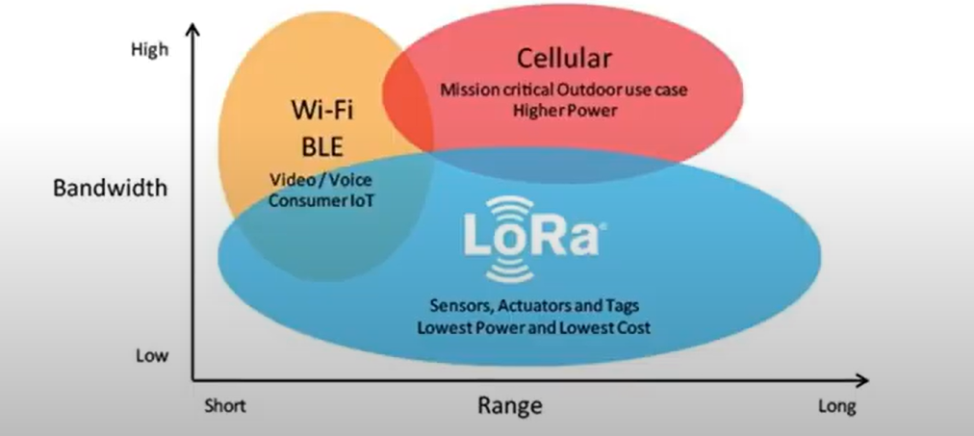
Figure 1.2
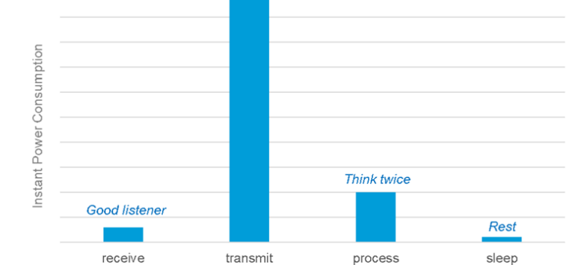
Figure 1.3
This device uses LoRa WAN based technology. As you can see in figure 1.2, Lora WAN creates a wider range of coverage. There is no mainstream market for GPS systems that utilize the Internet of Things (IoT). In an ideal IoT device, data transmission is kept to a minimum to conserve power (Figure 1.3). LoRa based sensors also do not need to pair with a gateway before sending data, which further reduces energy use and prolongs battery life.

Economic:

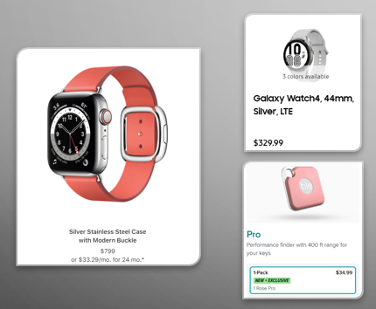
Figure 1.4

This device is designed to be an affordable method for tracking autistic children. It will be able to compete with high-tech tracking devices such as Apple and Samsung watch all while being marketed at an affordable price. The device will be marketed at just under $100 with no monthly fees.

1.6 Initial Project Constraints

- Being all Electrical Engineering majors, our group only has basic knowledge in coding
- We are limited to the number of features we can put on the device to conserve power
- If you are utilizing GPS on a battery worked gadget, there might be a battery failure and you may require an outer power supply which is not constantly feasible
- GPS signals may not always be precise due to geographical or fabricated obstructions such as trees and buildings

Section 2 - Project Planning and Task Definitions

2.1 Task Identification
Roles were delegated based on individual abilities. Each member is expected to take upon tasks based on their roles and will be scheduled to complete those tasks within a certain, reasonable period. In the event of a role vacancy, the team will have alternates that will perform the task that will be defined with the role.

- Team Leader: Johnn Owens
Alternate: Test Lead
The team lead must organize and maintain group meetings and oversee progress. A team leader must hold each member accountable and provide direction and work delegation. This person also acts as a direct communication with the sponsor, Dr. Annamalai and Dr. Chouikha. They must have a general understanding of the project’s requirements and deliverables.

- Software Developer: Trevor Johnson
Alternate: Team leader
The software developer engages in identifying, designing, installing, and testing a software system they have built from the ground up. The project will rely heavily on the LoRa WAN platform so the software developer will require sufficient knowledge of the technology and its assets.

- Data Analyst: Adeola Okeowo
Alternate: Scribe
The data analyst gathers the research and information relevant to the project’s objective. They must also draw a conclusion and link that back to the project objective. If a decision must be made on data management, the analyst will have the final say.

- Scribe: Michael Shepard
Alternate: Purchasing Lead
The scribe is the attendee at a meeting who documents and keeps the records of meetings, decisions, and updates for the project. They take on the responsibility for the weekly updates and will make final decisions on the written report.

- Test Lead: Osesiye Ayeni
Alternate: Data Analyst
The data analyst gathers the research and information relevant to the project’s objective. This project requires an understanding of the news reporting climate, and the data analyst must compile research from multiple sources and present it. Then, they must also draw a conclusion and link that back to the project objective. If a decision must be made on data management, the analyst will have the final say.

2.2 Timeline
- Project Conception
- To begin the project, we formed a group of 5, which consisted of all electrical engineers. Then roles were appointed to every one of the team members. We then signed a team contract to solidify our positions and made sure everyone was appointed to roles they would excel best in. Then we had to choose a project. We chose to work on the wireless tracking device because our collective interested aligned with this project. In the last step of the project conception, we assigned roles and developed an execution strategy to complete the project in a timely manner. This phase of the project was from September 2021 to mid-October of 2021.
- Research & Development
  - The second phase of this project focused on research and development. Our team completed literature review of the wireless GPS tracking devices space. Based on our research, we identified the key features we would like our device to have. We then ordered the necessary components to build our device. We sketched out our preliminary design which incorporated the parts we planned to use. Lastly, we used the information gathered to put together a visual presentation for our senior design class. This phase of the project was from mid-October to late November.
- Project Launch & Execution
  - Now having entered the building phase, our team worked diligently to develop our first prototype. During this process, we were able to understand which components were most useful and which internet of things dashboard would visualize our data the best. We completed quality testing on the wireless GPS tracker to determine our location accurately and efficiently. Our team used the information to develop a mid-term presentation which we presented to our peers. This phase of the project lasted from December to early March.

- Project Performance & Control
  - In the fourth phase of the project, we used our data to build our final prototype. We then compared our final design to our project deliverables. Our team successfully built a product which delivered most of our project’s set goals and objectives. We measured our product’s performance and compared our product’s performance with industry standards. Our team utilized this data to write our project conclusion and recommendations. This phase of the project took place between March and early April.
- Project Close
  - In the last phase of the project, we took the information we had gathered and the working product which we developed to put together a formal presentation. We also have a completed report which provides full details of our project.

2.3 Gantt Chart

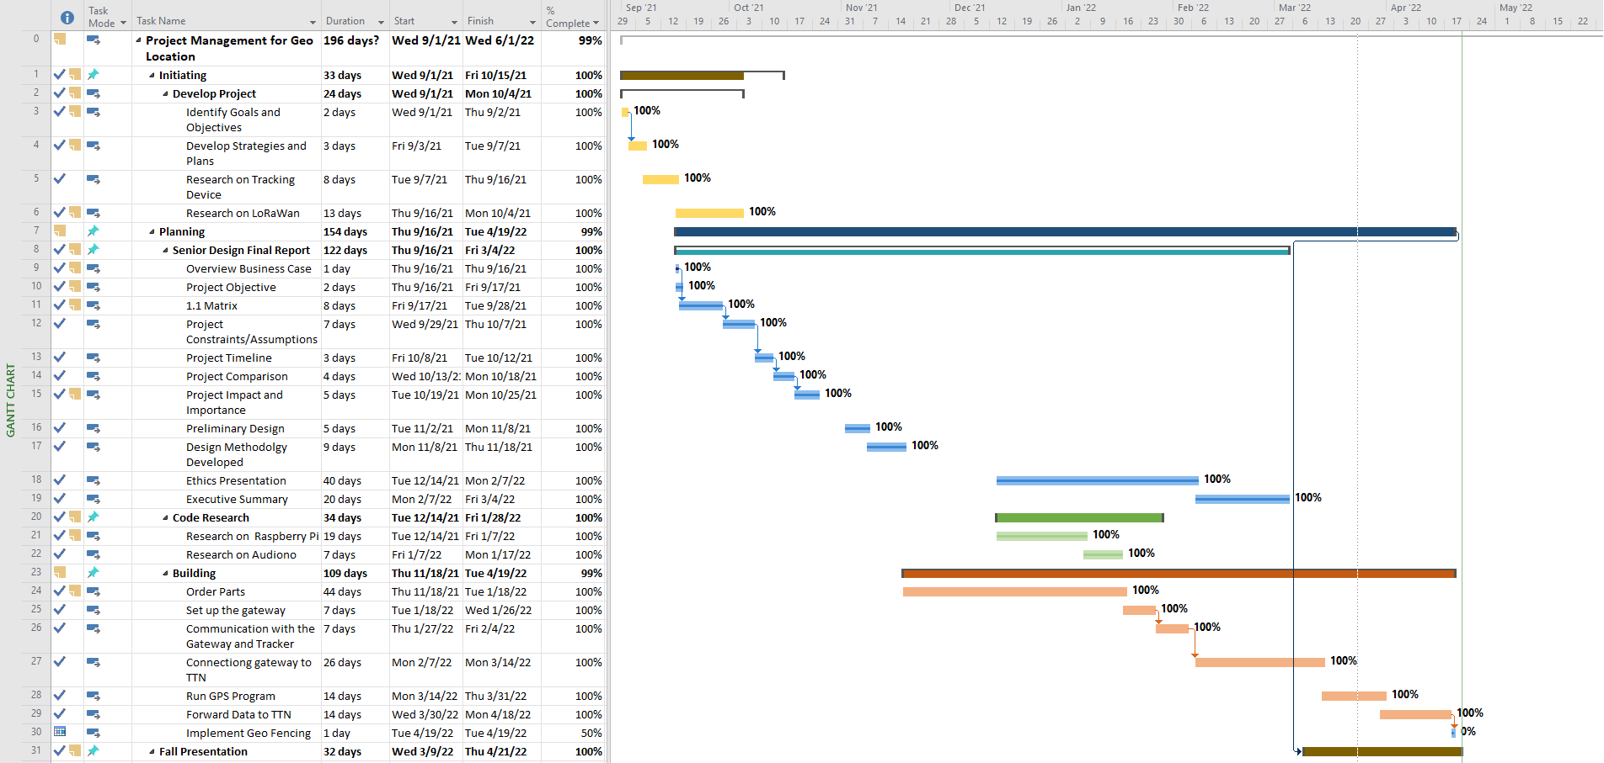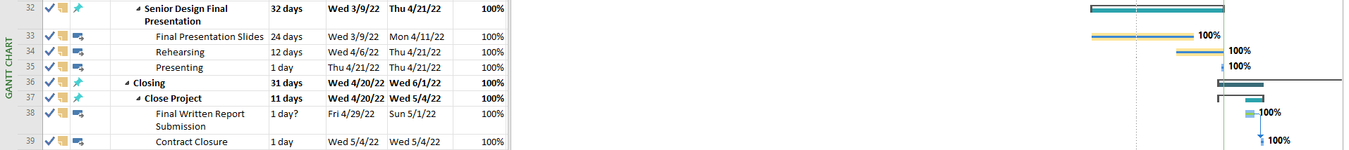Figure 2.1

Section 3 - Literature Review

There are numerous various kinds of high-end and competitive tracking devices out there in the field of GPS tracking. Our goal is to be able to compete with these high-end devices in functionality while being marketed at an affordable price. Most tracking devices are bulky and expensive like the Angel Sense 0r there are not compatible with all devices like the Apple Air Tag. With these devices, like the Angel Sense, the battery life is typically low and can only last up to 24 hours. Our device combats these issues with LoRaWAN technology which extends the range of our tracking to 2 miles. Unlike other expensive tracking devices, our device is marketed at a reasonable price at just under $100. Using LoRaWAN also helps us conserve power which in turn helps us conserve battery life. Our device also has geo-fencing capabilities which means that we set up a virtual boundary around the perimeter of the building. Everything inside that boundary is being tracked and we will always get live updates on the location. As soon as one leaves the boundary, we will be notified through The Things Network. It will notify the caregiver that the youth has wandered out of range as soon as one crosses that boundary. We also want our device to be as lightweight as possible since it will be for youth.

Section 4 - Preliminary Design

4.1 Concept Generation

We produced our proposed design by researching both GPS and LoRaWAN tracking devices noting the differences in each device. We proceeded to brainstorm multiple solutions for the requirements of our devices and the features we implemented to our devices which are discussed in our engineering matrix (pic figure 4.1). We researched various gateways and nodes we could use for our device and found the Dragino LPS8 Gateway. It has up to 8 channels and the gateway will act as a bridge between the tracker and The Things Network. For the nodes we decided to go with Arduino Uno+ LoRa Shield and Arduino Uno + LoRa/GPS Shield (915MHz). The shield on the nodes expands the capabilities of the already powerful Arduino Uno by granting the ability to send and receive data at LoRaWAN frequencies. We decided to use Arduino technology because it can cover up to 2 miles with minimum battery consumption. We also had to undergo extensive research on coding since our group lacked experience with Arduino software. We read a lot of manuals on different coding languages to learn how to program our gateway and nodes.

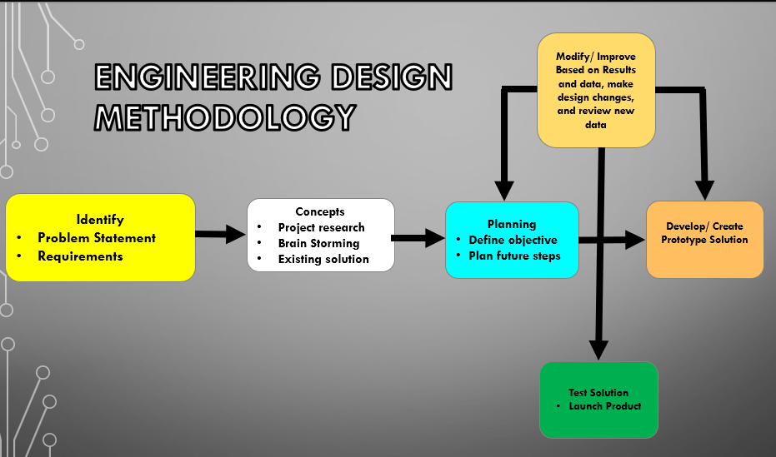
Figure 4.1

4.2 Concept Evaluation and Selection
During the creation of our project, our team evaluated several components to determine which would produce the best outcomes. The concepts our team evaluated were power efficiency, connectivity, GPS accuracy, and data visualization. For power efficiency, we used a 9V battery to power the tracker as it is in use. Dealing with connectivity, we used the LoRaWAN network to gain a wider coverage using minimal power. The GPS accuracy comes directly from the LoRa/GPS Shield’s capabilities. Through Arduino programming, we accessed and manipulated the device’s GPS coordinates. For maximum data visualization, we utilized The Things Network to display all the data read from the tracker. Using the concept described in our preliminary design, we established a successful system of communicating devices.

4.3 Design Constraints and Applicable Codes and Standards Used in the Design
- IEEE 7.6: IEEE Protection of the Public: To maintain public safety with the creation of our engineering devices
- IEEE 802.15.4: IEEE standard for 1` operation of low-rate wireless personal area networks - implemented in the design of the creation of the wireless network aspect of the system
- IEEE 730-1998: IEEE Standard for Software Quality Assurance Plans - Implemented briefly while improving the quality of our code through integration.
- IEEE 982.1-1988: IEEE Standard Dictionary of Measures to Produce Reliable Software - implemented to determine the reliability of the system.
- IEEE 802.15.9-2021: A message exchange framework based on information elements as a transport method for key management protocol (KMP) datagrams and guidelines for the use of some existing KMPs (Key Management Protocol) with IEEE Std 802.15.4(TM) is defined in this standard.
- IEEE C95.1-2019: IEEE Standard for Safety Levels with Respect to Human Exposure to Electric, Magnetic, and Electromagnetic Fields, 0 Hz to 300 GHz.
- FCC 47 CFR Part 15 regulations in the US 915 MHz band: The gateways produced under the US915 standards are FCC certified to run in the allowed frequency for our region.

4.4 Preliminary Analysis
The key requirement that our design must meet are, Implementation of LoRaWAn/Cellular technology, implementation of Geo fencing, Internet of things (IOT) Network system. The broad range communication has a coverage of up to 10 –20 meters implemented geo fencing. Making the use of the LoRawan cloud our device has a safe and secure way to log into the cloud server. Also, with the implementation of the LoRawan platform our device will operate with minimal battery power. The LoRa Tracker (Arduino Uno + LoRa/GPS shield) will transmit GPS coordinates to the gateway then the LPS8 LoRaWan gateway will receive message from the tracker and forward data to the TTN. The TTN will receive and decode data from the gateway and send to a cell phone, the phone will receive GPS co-ordinates as a SMS message.

Section 5 - Detailed Systems Design

5.1 Equipment Selection and Specifications
Component | Description | Image
LoRa Tracker (Arduino Uno + LoRa/GPS Shield) | The shields expand the capabilities of the already powerful Arduino Uno by granting the ability to send and receive data at LoRaWAN frequencies | 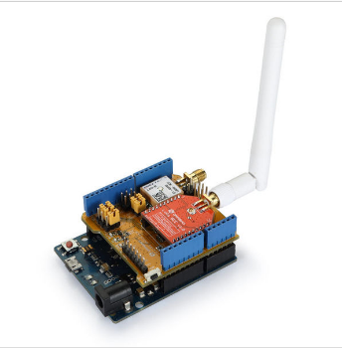
LPS8 Dragino LoRaWAN Gateway | The gateway acts as a bridge between the tracker and The Things Network | 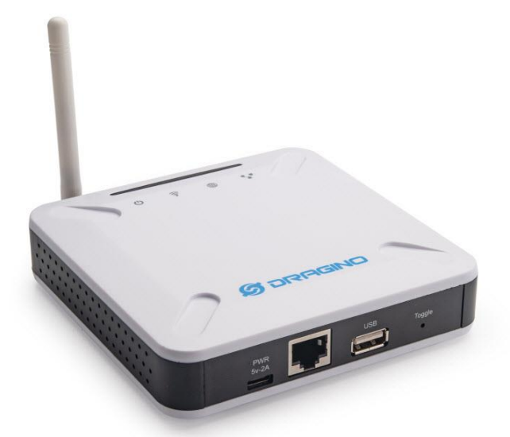
Figure 5.1

5.2 Final Design Layout
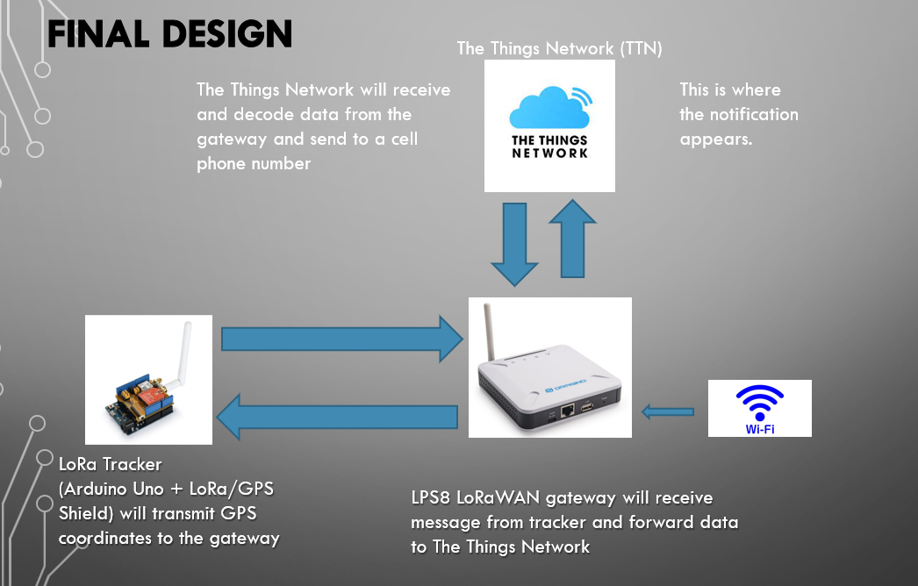Figure 5.2

For our final design layout, we were able to program the End Device to be dated. The gateway acts as a bridge between the node and TTN. As you can see in the figure above, it can only be connected when the gateway is connected to the WIFI.

5.3 Engineering Analysis and Simulation
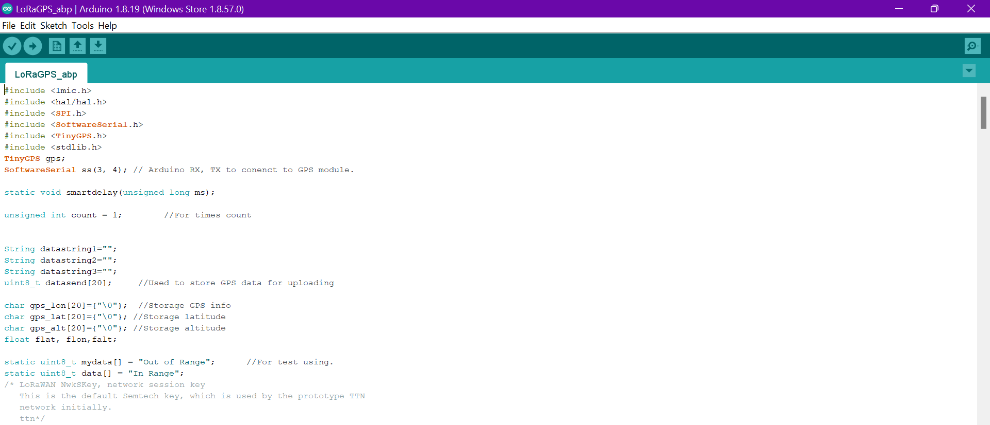
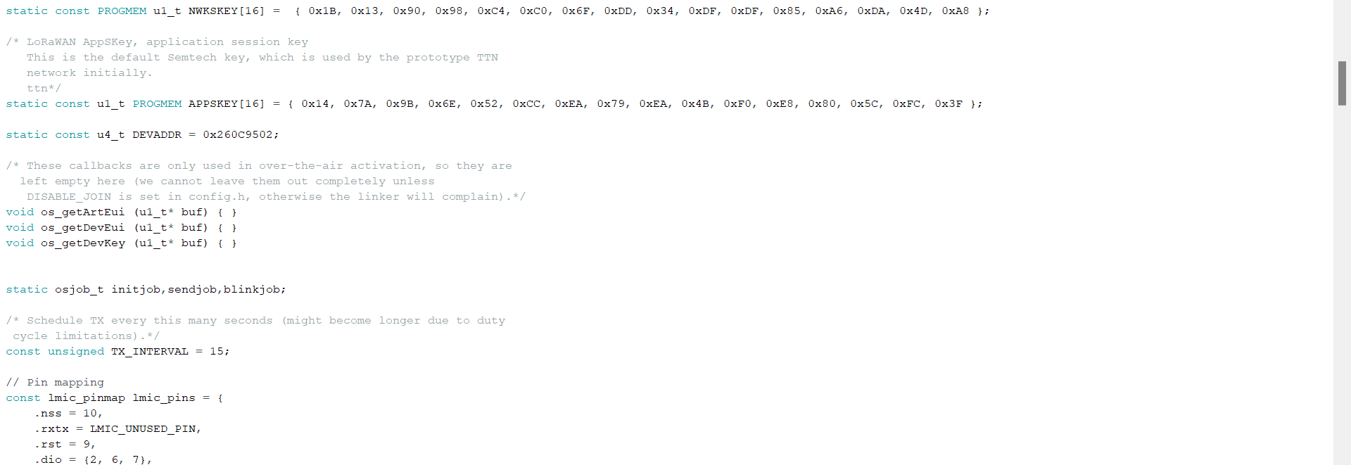
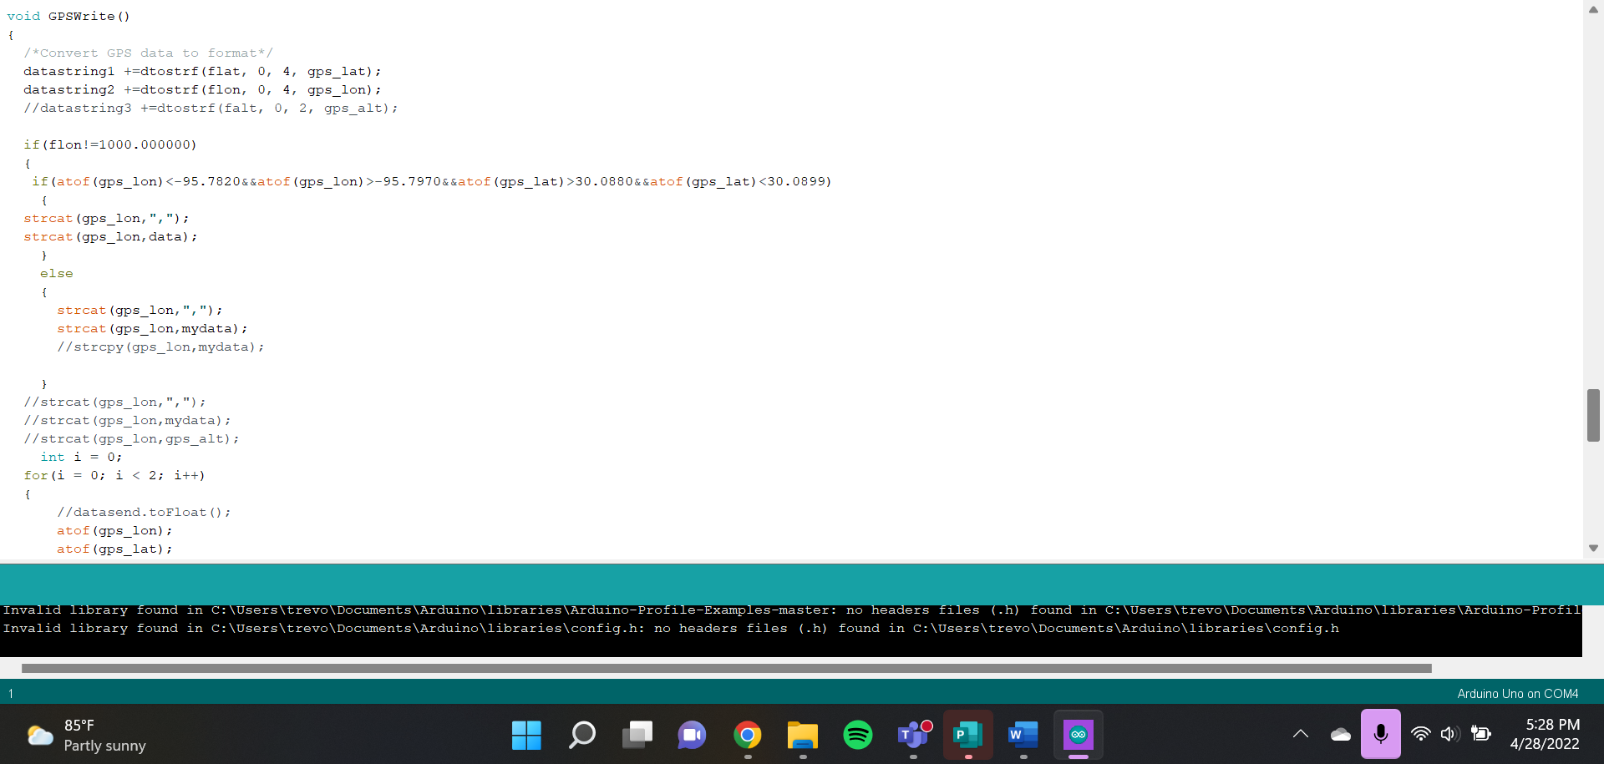
Figure 5.3

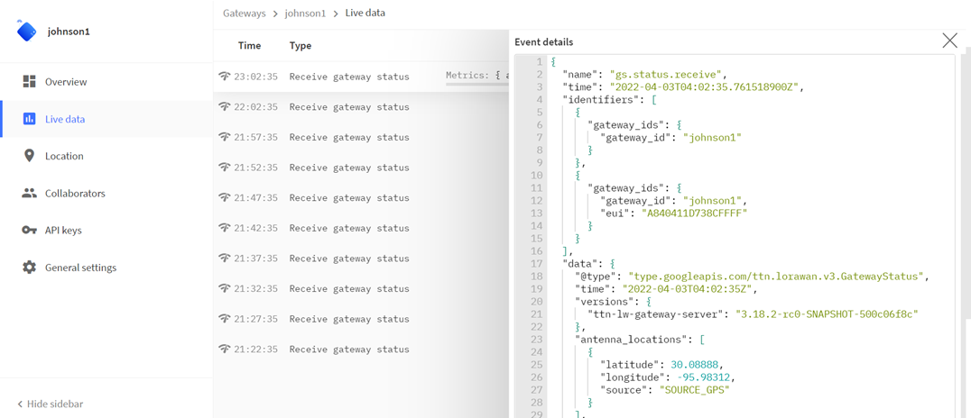
Figure 5.4

In figure 5.3, you can see the code that we used for the GPS tracking. We set up latitude and longitude coordinates which act as the boundaries. Anything inside those coordinates is constantly tracked so we will always receive data when one is on the boundary. Once one leaves the boundary, it will alert us through The Things Network that the device is out of range. As you can see in figure 5.4, it shows the live feed in The Things Network that we get from the device when it is in range and within the boundary. The live data is constantly updated, and we get new data around every 20 seconds.

Application of Engineering Codes and Standards

- IEEE 7.6: IEEE Protection of the Public: To maintain public safety with the creation of our engineering devices
- IEEE 802.15.4: IEEE standard for 1` operation of low-rate wireless personal area networks - implemented in the design of the creation of the wireless network aspect of the system
- IEEE 730-1998: IEEE Standard for Software Quality Assurance Plans - Implemented briefly while improving the quality of our code through integration.
- IEEE 982.1-1988: IEEE Standard Dictionary of Measures to Produce Reliable Software - implemented to determine the reliability of the system.
- IEEE 802.15.9-2021: A message exchange framework based on information elements as a transport method for key management protocol (KMP) datagrams and guidelines for the use of some existing KMPs with IEEE Std 802.15.4(TM) is defined in this standard.
- IEEE C95.1-2019: IEEE Standard for Safety Levels with Respect to Human Exposure to Electric, Magnetic, and Electromagnetic Fields, 0 Hz to 300 GHz.
- FCC 47 CFR Part 15 regulations in the US915 MHz band: The gateways produced under the US915 standards are FCC certified to run in the allowed frequency for our region.

5.5 Economic Analysis

Although our project budget was $500, we only made use of $260. We could have utilized more of the budget, but we had acquired all the resources we needed. Initially, the goal was to integrate the tracker into a wristwatch, which would have required us to make use of more the initial project budget. Our project will be able to compete with high-tech tracking devices such as Apple and Samsung watches while being marketed at a low and affordable price. The price for our device will be less than a $100 which is extremely competitive to the other tracking devices, and it will also not include a monthly subscription. Just like the tile mate which includes a yearly subscription, or the Angel sense device for people with special needs which has a monthly subscription of $53. Our G3O tracking device will be very economical and affordable.

Section 6 – Results and Discussion

6.1 Summary of Goals and Objectives
Ideally designed to assist in helping increase the safety of people with mental illness and alleviate the stress of caregivers, the fundamental objective of our project was to create a GPS tracking device that could monitor the location of special-needs individuals. In addition, the device should be cost effective and require low-power consumption. Our team set the goal to create a GPS device that would be small enough that could be worn as a wristband. The tracker would be able to function on both Android and Apple products while also utilizing the internet of things to allow the transfer of the data collected to be examined and manipulated by different systems. The final goal of our project was to implement SMS notifications that would alert the parent or caregiver should the tracking device exit the virtual boundary. With the time constraints and setbacks, we were unable to complete this aspect of our project. However, our initial goal was indeed met. By forwarding our sensor data to The Things Network, any device with an internet connection will be able to view and manipulate the data.

6.2 Summary of Constraints and Codes met by Design
Software:
Our team is composed of five electrical engineering majors with limited knowledge of coding platforms and software necessary to complete our project. However, with consistent research and multiple debugging sessions, we were successful in establishing the communication between the gateway and the tracker and connecting the gateway to the TTN (The Things Network).

Battey Life:
One of our initial goals was for the battery life of the tracker to last for up to a week on a single charge. To implement that, we had to limit the number of features included in our device. That is why we chose to experiment with LoRaWAN instead of Wi-Fi, Bluetooth, or Cellular which all consume more battery life.

Dependency -

- IEEE 7.6: IEEE Protection of the Public: To maintain public safety with the creation of our engineering devices
- IEEE 802.15.4: IEEE standard for 1` operation of low-rate wireless personal area networks - implemented in the design of the creation of the wireless network aspect of the system
- IEEE 730-1998: IEEE Standard for Software Quality Assurance Plans - Implemented briefly while improving the quality of our code through integration.
- IEEE 982.1-1988: IEEE Standard Dictionary of Measures to Produce Reliable Software - implemented to determine the reliability of the system.
- IEEE 802.15.9-2021: A message exchange framework based on information elements as a transport method for key management protocol (KMP) datagrams and guidelines for the use of some existing KMPs with IEEE Std 802.15.4(TM) is defined in this standard.
- IEEE C95.1-2019: IEEE Standard for Safety Levels with Respect to Human Exposure to Electric, Magnetic, and Electromagnetic Fields, 0 Hz to 300 GHz.
- FCC 47 CFR Part 15 regulations in the US915 MHz band: The gateways produced under the US915 standards are FCC certified to run in the allowed frequency for our region.

6.3 Discussion of Results
Once our parts were delivered, the initial setup of our project began. The Dragino LoRa IoT Development kit comes with many components such as two Arduino Uno's, sensors, and an LG01-P Dragino gateway. Our priority was setting up the gateway to communicate with the tracker, the Arduino Uno. Using two simultaneous Arduino programs, the Arduino Uno + LoRa Shield can send and receive data packets from the LG01-P Dragino gateway. This occurs by uploading a program to the tracker through a USB port and a separate program to the gateway via Wi-Fi network access.

Secondly, our next objective was to demonstrate the functionality of the GPS capabilities of the tracker. The Arduino Uno + LoRa/GPS Shield can access and manipulate GPS data. With proper wiring of the board and correct program instructions, the user can view GPS data in real-time using Arduino’s serial monitor. Though the program had no syntactical errors, it did not run correctly the first few times we attempted (as programs never do). We realized that the Arduino Uno + LoRa/GPS Shield works properly after being plugged in for a few minutes. We figured this out by learning about the shield’s three LED (Light Emitting Diodes) lights. The red LED indicates that it is receiving power. Its’ blue LED means that it has received a LoRa packet. The green LED, which became the most important, means that its’ GPS functions are active. We noticed that after about ten to fifteen minutes of being plugged in, the green LED would begin to blink, and the program would run efficiently.

Our next objective was to set up the gateway with The Things Network. The gateway’s default settings were set to receive internet access through an ethernet port and share its signal through a Wi-Fi access point. Once a device is connected to the gateway’s Wi-Fi, its settings are accessible by typing in the IP address into a browser (130.10.1.1). After setup is complete, the gateway will continually send status updates to The Things Network every five minutes while it has an internet connection.

Once that connection was established, we set out to send data to the gateway from the tracker and have the gateway forward that data to The Things Network. This process was supposed to be straightforward but caused us much grief. We kept running into errors regarding the programming structure. The program ran efficiently once said errors were resolved however, the data was still not appearing on The Things Network. This is when things became complicated.

For The Things Network to receive data from the tracker, specific functions must be enabled when setting up the gateway on the network. This function is called a “legacy packet forwarder,” and its primary purpose is to tell the gateway to forward all data it receives to the network. The issue with this function is that the layout of The Things Network has recently changed. After extensive digging through the topic, we concluded that The Things Network no longer supports this function for single-channel gateways such as our LG01-P Dragino gateway. This is because single-channel gateways have commonly caused issues on the network for other users therefore it is no longer supported.

Unfortunately, the next step was a step back in that we had to order a new gateway that is supported by The Things Network. We chose to order the LPS8 Dragino gateway which has eight channels and is currently supported by The Things Network. The eight channels allow it to operate at multiple frequencies which makes for a more secure and accurate method for navigating The Things Network. Once the new gateway arrived, our system of devices worked exactly as they were supposed to. The Arduino Uno would transmit a message to the gateway and then the gateway would forward that message to The Things Network to be visible from any device with an internet connection.

Initially, the goal was to find a way to manipulate the data on The Things Network to send as an SMS message and implement geo-fencing. Ideally, we wanted a notification to be sent directly to a cell phone if the tracker moved outside of a predetermined boundary. With more time and preparation, this would have been attainable. Too much time was spent on setting up the tracker application on The Things Network simply because we were not aware that our gateway was incompatible. We assumed there were just errors in the code since none of us have deep experience in complex computer programs. However, we did learn many things throughout the course of this project.

Section 7 - Conclusions & Recommendations

In conclusion, our team successfully designed a low-cost, reliable, and effective tracking device that implements LoRaWAN technology for special-needs individuals. The gateway acts as the bridge for our entire system receiving information from the end nodes and then forwarding it to The Things Network where it will display in real time the location of the desired individual. We also met all our marketing requirement listed above. For future recommendations on this project, implementing SMS notifications to our project would be a game changer. Ideally, it will send an immediate notification to the caregiver if the tracker exits the desired boundary which could have been achieved with more time on our project. We could also implement our device into a necklace or a watch for the individual to wear while keeping our product as lightweight as possible to prevent any inconvenience for the individual. The implementation of our device in society will reduce the number of accidents, injuries, and deaths in special needs individuals.

References
- Mortality & Risk in ASD wandering/elopement 2011-2016. (n.d.). Retrieved October 3, 2021, from https://nationalautismassociation.org/wp-content/uploads/2017/04/NAAMortalityRiskASDElopement.pdf.
- Autism plus wandering. Child Mind Institute. (2021, September 26). Retrieved October 3, 2021, from https://childmind.org/article/autism-plus-wandering/.
- Law, P. (2011, April 20). Ian Research Report: Elopement and wandering. IAN Research Report: Elopement and Wandering | Interactive Autism Network. Retrieved October 3, 2021, from https://iancommunity.org/cs/ian_research_reports/ian_research_report_elopement.
- SX1272. Semtech. (n.d.). Retrieved October 3, 2021, from https://www.semtech.com/products/wireless-rf/lora-core/sx1272.
- Griffey-Hill, L. (2020, June 2). ChirpStack - A LoRawan network server to make you sing. Pycom. Retrieved October 3, 2021, from https://pycom.io/chirpstack-a-lorawan-network-server-to-make-you-sing/.

- Mortality & Risk in ASD wandering/elopement 2011-2016. (n.d.). Retrieved October 3, 2021,

