PRAIRIE VIEW A&M UNIVERSITY
ROY G. PERRY COLLEGE OF ENGINEERING

Custom Actuator

ELEG 4472: Senior Design & Professionalism I

Topic: Final Written Report

Team 3

Submitted by:

Camryn Clark (Team Lead)
Kevin Le
Virgie Leyva
Gabriel Mumphrey
Vinh Pham

Instructor: Professor Turner

Date of Submission: 04/25/2021

Project Executive Summary
Mission Statement
Our mission is to design a fully integrated actuator utilizing commercial off the shelf components (COTS) for all projects small and large, that do not have the time to develop their own custom actuators. Engineers currently spend a considerable amount of time in researching, processing, developing, and testing methods for designing actuators. With a fully integrated actuator we can eliminate multiple stages of this process which in turn will allow Engineers to become more productive.
Problem Statement
The robotics industry is rising quickly with global robotic sales doubling over the past five years. As more processes become autonomous, more variety in custom actuators will be needed to fulfill these needs. The need to increase productivity while reducing downtime and manufacturing increasing across the world will result in a much greater need for custom actuators.
Proposed Deliverables
- Actuator Test bed using mostly Commercial Off The Shelf (COT) components
- High fidelity model of the final Actuator
- Control software that can measure and compensate for error
- Controlled Area Network (CAN) Bus communication
- Limit current to motor

Budget
- The total budget for our project is $600.00
- The total amount spent for our project is $699.96.
  - This is due to the iterative process done to achieve a better product.
Customer requirements and Engineering solutions
- The actuator should be easy to set up for the first time
- The actuator should be capable of reliably sending and receiving commands
- The actuator should be equipped with a status LED
- The actuator should avoid complex geometries to keep cost low
- The actuator must maintain a set rotation per seconds
- The actuator should have the capability to fail safely
- The actuator must be capable of avoiding burn out
Major Constraints
- There is a disconnection in communication between the PC and the controller
- Power loss to the actuator
- Actuator may exceed weight limits
- Software bugs that can occur when controlling the hardware
- Voltage feeding into the actuator should be constant and should not fluctuate

Benefits
- Health: Stressful work environments can cause many health problems such as high blood pressure, depression, and anxiety. Our project can work in these types of challenging environments and eliminate these conditions thus creating a healthier and safer workplace.
- Safety: Work related accidents account for nearly 40% of musculoskeletal injuries in 2016. With custom robotics this number can be greatly reduced. Robotics devices can operate for longer periods of time and with higher accuracy in turn creating a safer work environment.
- Economical: Robotics have a major economical factor. Labor rates between workers will increase while the labor rates of robotics will decrease. Labor rates show that companies save $2-3 an hour, but also that automation results in cost savings of up to 75%.
- Technical: Our actuator is an electric actuator and has technical advantages compared to other actuators. Electrical actuators have improved maintainability, reliability, and maneuverability which help when it comes to simulating human movement.
Recommendations
As a recommendation we suggest choosing an actuator that is configured to be used in the correct speed and torque application. With the process of sending data one bit at a time, we also recommend setting up the actuator using the correct configuration, Serial communication, in telecommunication and data transmission. Lastly, one must safely drive a motor using Controlled Area Network (CAN) Bus commands.
Conclusion
The development of our actuator can prove that a fully developed solution can be replaced by a Commercial Off the Shelf (COTS) product, thus reducing the time and money companies need to spend on developing their own actuators.

TABLE OF CONTENTS

PROJECT EXECUTIVE SUMMARY ii - v
TABLE OF CONTENTS vi
LIST OF FIGURES vii
LIST OF TABLES AND GRAPH viii
LIST OF TEAM MEMBERS AND ROLES ix
- PROJECT SCOPE 1
  - Project Statement, Business Objective and Target Audience of your Project ..…...........................… 2
  - Client identification and recognition of need…………………........................….……………...…..3-5
  - Project goals and objectives ….………………………………………..........................……………. 6
  - Contemporary issues relevant to project …………………………………….......................………7-8
  - Potential impact of project on society (Health, Safety, Technical and Economical)........................... 9
    - Health .................................................................................................................. 10
    - Safety.................................................................................................................... 11
    - Technical ...............................................................................................................12
    - Economical ............................................................................................................13
  - Initial Project constraints ………………………………………………........................……………14

- PROJECT PLANNING AND TASK DEFINITION 15
2.1 Task Identification ……………………………………………….........................…………………. 16
2.2 Gantt Chart ………………………………………………………....................…………………. 17-19

- LITERATURE REVIEW 20
3.1 List of all sources of information ………………………………………............................…………. 21
3.2 Statement of Learning from each source …………………………………...................…………. 22-24

- PRELIMANARY DESIGN 25
4.1 Concept Generation………………………………………………………....................…………. 26-27
4.2 Concept Evaluation and Selection ………………………………………………….......................….28
4.3 Design Constraints and Applicable Codes and Standards Used in the Preliminary Design............ 29-30
4.4 Preliminary Analysis ………………………………...............................…………….....................31-32
4.5 Preliminary Design……………………………………………....................................................... 33-35
- DETAILED SYSTEM DESIGN 36
5.1 Project Parts Summary ……………………………………………………....................……………. 37
5.2 Engineering Analysis and/or Simulation…………………………………................……………. 38-40
5.3 Hardware Layout/Detailed Drawings/ Equipment Selection and Specifications ..................................41
5.3.1 Show Overview of Code Developed to Support 5.3……………………………………....... 42-45
5.4 Application of Engineering Codes and Standards used in Final Design 46-47
5.5 Economic Analysis …………………….................................………………………..................... 48-50
5.6 Final Design ……………………………………………...................................................................... 51

- RESULTS AND DISCUSSION 52
6.1 Summary of Goals and Objectives……………………………………………............................……. 53
6.2 Summary of Constraints and Codes Met by Design ………………………........................…………. 54
6.3 Discussion of Results and Other Use Cases ……………………………………………...................... 55

- CONCLUSIONS AND RECOMMNDATIONS 56-57

LIST OF REFRENCES 58-61
APPENDIX 62-67
List of Figures
Figure 1: Robots vs. Human Rates .............................................................................................. 13
Figure 2: High Level Schedule .................................................................................................... 17
Figure 3: Gantt Chart – Task Assignments and Dates ................................................................ 18
Figure 4: Gantt Chart .................................................................................................................. 19
Figure 5: Project Comparison ..................................................................................................... 24
Figure 6: Engineering Design Methodology ............................................................................... 26
Figure 7: Preliminary Design ...................................................................................................... 35
Figure 8: Project Parts Summary ..................................................................................................37
Figure 9: Actuator Side Cutout with Part Labels ......................................................................... 39
Figure 10: Actuator Side Cutout with Load Paths ....................................................................... 40
Figure 11: Software Flow Chart .................................................................................................. 42
Figure 12: CAN Bus Transceiver PCB Schematic ...................................................................... 44
Figure 13: Magnetic Encoder PCB Schematic ............................................................................ 45
Figure 14: Phase II Final Design ................................................................................................. 51
LIST OF TABLES AND GRAPHS
Table 1: Matrix .................................................................................................................... 4
Table 2: Status LED Color Code ....................................................................................... 43
Table 3: Phase 1 Cost ........................................................................................................ 48
Table 4: Zenith Material Cost............................................................................................ 50

LIST OF TEAM MEMBERS AND ROLES

Camryn Clark …………………………………………………………………………. Team Lead
Gabriel Mumphrey ………………………………………………………………. Ideas Facilitator
Kevin Le…………………………………………...…………………………..Data Analysis Lead
Vinh Pham ………………………………………………... Design Analysis and Purchasing Lead
Virgie Leyva ……………………………………….…….....…. Scribe and Presentation Manager

SECTION 1 – PROJECT SCOPE

  - Project Statement, Business Objective and Target Audience of your Project

The robotics industry is rising quickly with global robotic sales doubling over the past five years. As more processes become autonomous, more variety in custom actuators will be needed to fulfill these needs. With industries like automotive, aerospace, oil and gas, and many more, moving towards autonomous processes, the need for custom actuators will increase by 66%. The need to increase productivity while reducing downtime and manufacturing increasing across the world will result in a much greater need for custom actuators. (Actuators Market by Actuation Global Forecast to 2024)

  - Client identification and recognition of need

The project requirements are broken up into different categories. First, the actuator must be simple to set up. By using serial communication, the actuator will be easy to implement with manageable hardware and software. The actuator must be capable of reliably sending and receiving commands. With the CAN Bus being so widely used in industry, it is in our best interest of the group to take advantage of this as our communication protocol. The actuator must have a status LED light so that the user can easily determine the state of the actuator. Some actuators are more expensive because of complex geometries on the housing that drive up manufacturing costs. Thus, by avoiding complex geometries it will reduce costs. The actuator must be accurate. By utilizing closed loop commands, it will allow the actuator to maintain a desired speed. Also, incorporating a feedback sensor will allow for correction of errors. Failure is always bound to happen. Our actuator can detect these failures and will safely shutdown and enter into failure modes. This can help prevent injuries caused by the actuator. The actuator must have a long lifespan. To assist this goal, we will limit the current going into the actuator. This will guarantee that the actuator does not overheat.
  - Client identification and recognition of need (Continued)

Marketing Requirements | Engineering Requirements | Justification
Easy to set up for the first time | Set up over Serial communication protocol | Easy to implement with basic hardware and software
Reliably send and receive commands | Control with CAN Bus communication protocol | Reliable communication protocol widely used in the industry
Status LEDs | Include LEDs to display status | Easily determine status of actuator
Low cost | Avoid complex geometries on parts | Complex geometries drive up manufacturing costs
Actuator can maintain a set rotation per seconds | Use closed loop commands | Closed loop commands utilize a feedback sensor to correct for errors
Actuator can fail safely | Actuator can detect and safety shut down during failures | Avoiding failures will prolong the life of the actuator
Actuator can avoid burnout | Current limit the motor | High amounts of current, for extended periods of time will generate excess heat
Table 1: Matrix
- Hardware Requirements
  - Microcontrollers must be able to communicate by Controlled Area Network (CAN) Bus.
  - Microcontroller must be able to correctly commutate a Brushless Direct Current (BLDC) motor.
  - Microcontroller must be capable of interpreting the data from an encoder.
  - Motor Drivers must be able to supply adequate power to the motor.
  - Encoder must be able to accurately read the position of the motor.
  - Client identification and recognition of need (Continued)

- Final Product
  - Actuator should be easy to set up for the first time
  - Actuator must be capable of maintaining a set speed while correcting for errors.
  - Actuator must be able to detect known failure modes.
  - Actuator must be able to safely shut down during failures.
  - Actuator must be capable of measuring current.
  - Actuator must be capable of avoiding generating high temperatures
  - Multi-color Light Emitting Diodes (LED) must continuously display the status of the actuator.

  - Project goals and objectives

The purpose of this project is to create a compact and flexible solution to mechanical automation by implementing the gear train, motor, electronics, and custom software into a single system. Our objective is to design and build a custom actuator that is competitive and bring it to the market. Typical actuators will have three subsystems: motor, driver, and a gear box. Our custom actuator will have two of these processes in one actuator freeing up time for engineers to work on other aspects of their project.

  - Contemporary issues relevant to project

Actuators can be found all around us, from electric door locks and vents found in automobiles, to more complex uses such as lifts. Whether the consumer is looking to perform simple or complex tasks, engineers have two options: they can either buy it or build it.
When buying a custom actuator, the consumer will need to take certain considerations into account, such as:
- Desired size
- Mounting
- Speed and torque cases
- How frequent is its intention to be used
The criteria of the project’s needs will determine the type and cost of the actuator. There are a few setbacks to buying a custom actuator, such as:
- Potentially become costly
- Installation could require technical knowledge
- Installation could become a lengthy process
1.4 Contemporary issues relevant to project (Continued)
While building a custom actuator using COTs would also take into account several of the same considerations involved when purchasing one, it is an entirely different option. The primary motivation is the reduced cost. Some of the benefits of building a custom actuator using COTs are:
- Cost will allow consumers to enter the robotics industry without paying a premium price
- Utilizes different failsafe’s which can help prevent burnout and protects the actuator
- Use of status LED lights make it clear on what state the actuator is in
By eliminating multiple stages from this process will in turn allow Engineers to manage their time efficiently.

  - Potential impact of project on society

Our project has an impact on four major areas: health, safety, technical, and economical.

1.5.1 Health

According to the US National Library of Medicine, robots can work in extremely challenging conditions. When environments start to become too difficult for humans to navigate, we can assign robots to these tasks to preserve human health. In addition, The National Institute of Health states workload and job conditions are the most common cause of stress in the workplace. Stress can cause many health problems such as high blood pressure, depression, and anxiety to name a few. Eliminating these conditions will create a healthier work environment. Chemical exposures can cause lung cancer, nerve, and brain damage while chemical burns can result in death. With robotics these risks can be greatly reduced and could potentially get rid of these problems.
1.5.2 Safety
According to Occupational Safety and Health Administration (OSHA) the common types of accidents that occur when working with robots are collisions, crushing and trapping. Our actuator will be capable of foreseeing these accidents and eliminating before they can happen. According to the U.S Bureau of Labor Statistics, back injuries for nearly 40% of musculoskeletal incidents suffered in 2016. Allowing robotics to do all the heavy lifting this number could be greatly reduced. Furthermore, robotic devices can operate for longer periods of time without a break, in turn reducing the number of accidents while giving employees more opportunities to rest. Finally, robots reduce the amount of human error allowing for more efficient work conditions.

1.5.3 Technical

The type of actuator our team is building is an electric actuator, which has technical advantages over other actuators. For example, hydraulic actuators require high maintenance and are vulnerable to high temperatures. The extreme conditions our actuator can work in are up to 100℃ whiles being able to operate up to a minimum of -20℃. Furthermore, electric actuators have better maintainability, reliability, and maneuverability which helps when it comes to imitating human movement. In addition, electric actuators are able to control their velocity, speed, and position more precisely which increases efficiency. The fact that our actuator is electric means it does not contain hazardous chemicals inside of them that could be released into the environment.

1.5.4 Economical

Robots also have major economic advantages as well. According to American National Labor Rates as time advances human labor rates will consistently increase while in robotics these labor rates will decrease. Eventually Robots will even beat China when it comes to affordable labor. These labor rates not only show that companies can save $2-3 an hour, but that automation can result in cost savings up to 75%. By 2025 it is projected that 10-15% of jobs in the manufacturing, transportation, and storage will have higher potentials of being automated.


Figure 1: Robots vs. Human Labor Rates

1.6 Initial Project Constraints

Each project has constraints that need to be considered before designing a solution to the problem dealt with at hand. In the following project these are some of the constraints and limitations that are necessary for the team to abide by.
Upon inspecting the constraints, our team wanted to focus on the internal factors that would prevent our actuator from operating. One of the possible factors the team examined was a disconnection in communication between the PC, personal computer, and the actuator. Power loss to the actuator will result in the actuator shutting down. Since, we have to take into consideration limitations, the size and weight are high benefactors that could prevent the actuator from being used in certain applications. Imperfections in the software can occur while controlling the hardware, this may come to pass if the incorrect data is sent to the hardware. Lastly, power plays a critical role in the operation of the actuator. Thus, it is imperative that any power feeding into the actuator should be constant and should not fluctuate.

SECTION 2 – PROJECT PLANNING AND TASK DEFINITION

2.1 Task Identification

The team began with first determining the necessary steps required to complete the project planning phase. This is indicated in the timeline shown below in Figure 2. The project planning phase is integral to the adequate completion of the completed project design. We began by organizing the projects tasks for the semester in their entirety. This allowed the team sufficient time to efficiently complete each project task on schedule as well as allocating additional time for revisions.
The initial phase of the project is divided into two large tasks and one small task. The large tasks were designated for the software and hardware design. It was decided by the team to go the extra step so that we could ensure that even our testbed was laid out properly. This allowed for the testbed to be neat and organized. The small task included assembly of the testbed. It was decided this task should be designated as small due to it only needing to be done once. This small task also had the potential to be completed in a day’s time, thus allocating more time to the two larger tasks. In the second phase, the larger tasks were broken up into mechanical, electrical, and software subsystems. Before each task began, the team would design a preliminary diagram to plan out the current task. This obligated the team to always be mindful of any possible constraints we would encounter and to plan accordingly.

2.2 Gantt Chart

As a team, it is important to understand each other’s strengths and weaknesses and assign tasks to balance each other out. After talking as a team, we first started with a high-level schedule that broke the project up into its basic parts shown in Figure 2. These parts are test bed design, mechanical housing design, electrical PCB design, subsystem integration, and control software. We also marked where each of the phases will take place in relation to the basic parts at the bottom of Figure 2. Lastly, we included a visual deadline to remind us to stay on track.
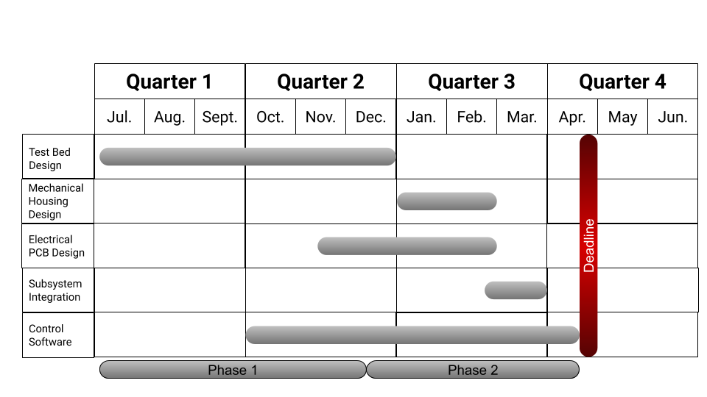
Figure 2: High Level Schedule

2.2 Gantt Chart (Continued)

After we had broken the project up, we needed to develop a more detailed Gantt chart. First, we took the basic parts and labeled them as “main tasks” in the chart. Next, we assigned a subset of members to these tasks and estimated the date for the duration of the task. While estimating the duration of each task, it was vital to account for multiple iterations. For example, this requires room for not one manufacturing lead time for PCBs, but at least two or three lead times were accounted for. Within this subset, the members created “sub tasks'' which are to be completed by individual members or a pair of members.

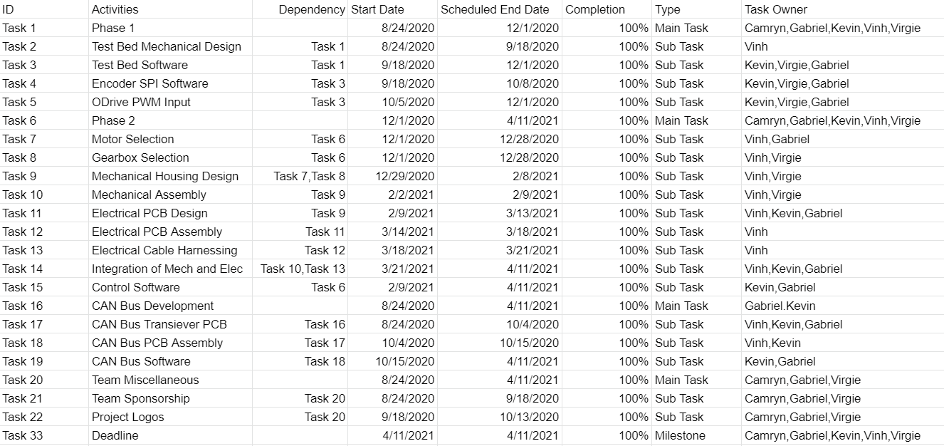
Figure 3: Gantt Chart -Task Assignments and Dates

2.2 Gantt Chart (Continued)

Lastly, taking all this information, we can create a detailed Gantt chart shown in figure 3. This provides an easy visual to understand how the dates for each task overlap and their dependencies on one another.

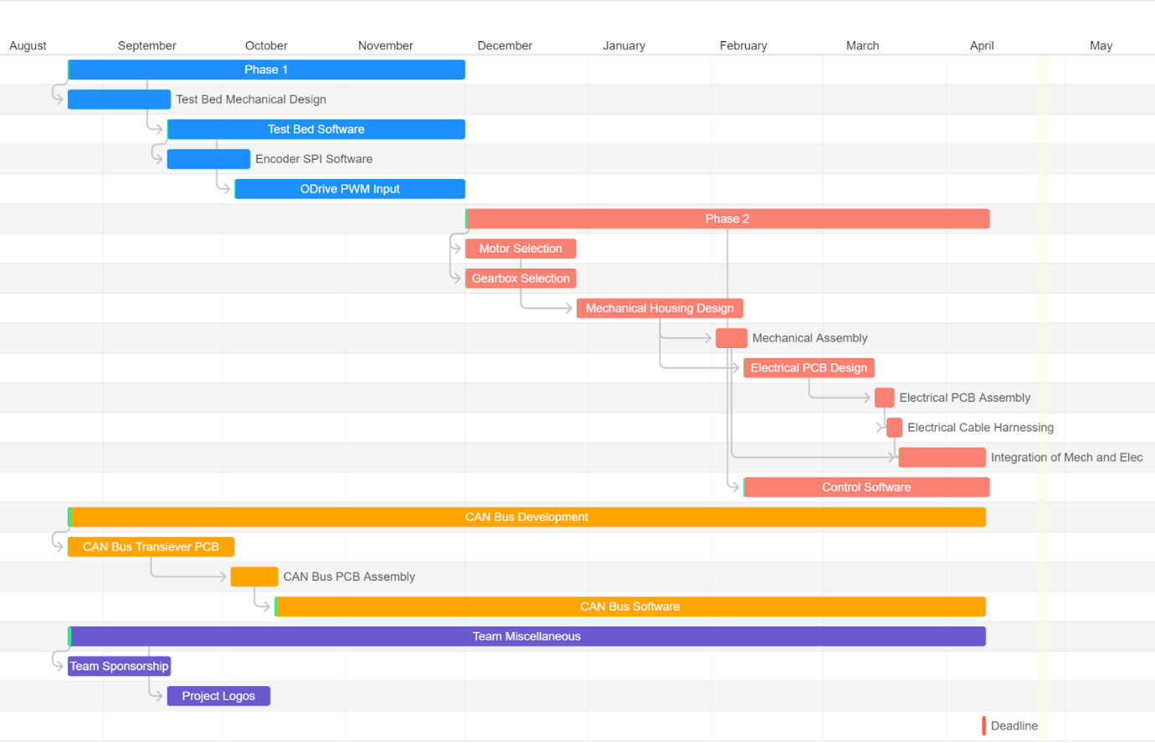
Figure 4: Gantt Chart

SECTION 3 – LITERATURE REVIEW

3.1 List of all sources of information

The literature review utilized for the research of the Zenith custom actuator is the comparison between other actuators on the market. We compared the Zenith to competing actuators such as: RDrive, MIT Actuator, GYEMS, and DJI_GM602. As shown in Figure 5:
RDrive
Rozum Robotics RDrive actuator is within the high range price. The RDrive servomotor is comprised of a single housing all the main elements. Within this housing is an encoder, a controller, a harmonic gear, and an AC brushless motor. Since the controller is integrated into the robotic actuator, the RDrive is a DC servomotor with a brushless AC core.
MIT Actuator
The MIT Actuator lies within the mid-price range. This actuator utilizes a brushless direct current motor while using a CAN Bus communication protocol. This actuator has a mid-range price as well as a planetary gear train.
GYEMS
The GYEMS can be found in the mid-level price range. It is a highly integrated servo actuator module. This actuator has a high performance FOC driver, and a high-power density brushless motor. GYEMS utilizes a high-resolution magnetic encoder, planetary gear train as well as supports CAN Bus communication.

3.1 List of all sources of information (Continued)
DJI_GM602
The RoboMaster GM602 is a brushless DC motor with an integrated driver. This particular actuator falls into the lower price range category while utilizing CAN Bus and PWM communication protocols. This actuator does not contain a gear train.

3.2 Statement of Learning from each source

Prior to beginning any designs or creation of any ideas, it was established the team needed to complete a literature review and gather an understanding of the current market. We began this process by documenting what type of competition our product would be facing. We did this by completing a chart that displayed the comparison between Zenith and similar custom actuators on the market. These actuators, though all different, also utilized similar technologies as the Zenith. As seen in Figure 5, the table displays a majority of the competing actuators available employing and implementing a Brushless Direct Current motor. Many of these also made use of CAN Bus for their communication. However, during our research it was discovered that the type of gear train utilized for each actuator was varied. One the final right-hand column, this table also shows a breakdown of cost from greatest to least. It can be seen that multiple dollar symbols signifies a greater cost than those containing a single symbol. The team decided to place the Zenith actuator in the market with the lower range actuators. For the Zenith to compete within this range, it was determined that a planetary gearbox should be utilized. In addition, by using this gear train, this allowed the team to choose from a variety of different gear reduction ratios that will allow the use of different speed and torque cases. Finally, utilizing this table allowed the team to make the proper decisions needed to allow for Zenith to be capable of an easy setup. This in turn will allow engineers to save money, and spend less time configuring custom actuators.

3.2 Statement of Learning from each source (Continued)
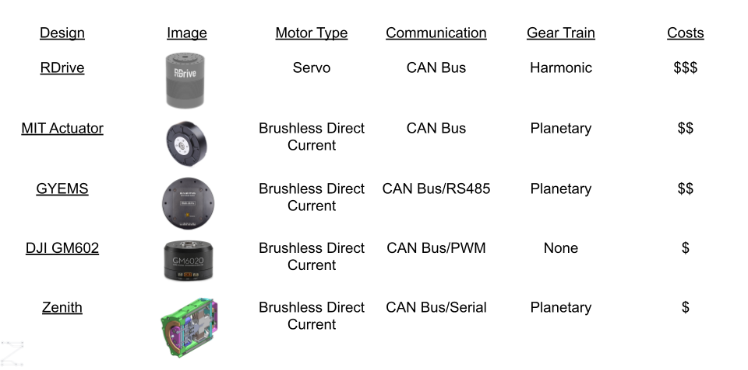
Figure 5: Project Comparison

SECTION 4 – PRELIMINARY DESIGN

4.1 Concept Generation

Before starting our concept generation, the team first came up with the methodology to solve our problem using online examples and course resources. We compiled this information together to develop our design methodology flowchart shown below.

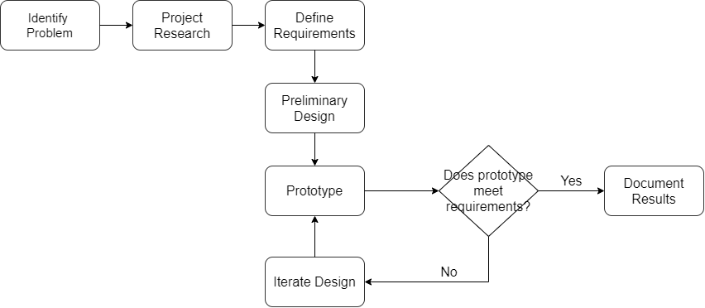

Figure 6: Engineering Design Methodology

4.1 Concept Generation (Continued)

Using our Figure 6, the team started with identifying the problem. Moving along the flow chart, we next do research to support our knowledge behind the project. With an adequate amount of information, the team defines the requirements of the project. This step of the process is important because requirements are used to define the scope or limits of the project. Almost all projects can have an infinite number of goals and requirements, however there is never an infinite amount of time to develop everything. Therefore, it is important to define what the project is required to do and how to confirm we achieved them. Moving on to the preliminary design, the team starts to sketch out our concepts to fulfill the requirements. After the team agrees on a common design, we move forward with prototyping. It is important to quickly and cheaply prototype ideas to save time and money. Typically, prototypes are either scaled down or simplified models of the real product. The mindset going into the prototyping phase is that “there are no failures, only lessons”. Here we learned the various ways on how to not implement our ideas. After we finish a prototyping, we check if the design meets the previously defined requirements. If not, we iterate on the design and return to prototyping. This feedback loop allows the team to improve the design. We believe that multiple iterations is the key to a good design. We continue this looping process until the design meets our requirements. The last step is to document our changes and results.

4.2 Concept Evaluation and Selection

With timing and budget being a factor, our team decided to focus on the various elements where our actuator could be effective. Discovering the range our actuator was capable of operating in, we concluded it would be in the Newton meter range. Further examination allowed us to conclude that the 2 Nm range is where our product would be the most successful in the time frame given to us. Moreover, it was agreed that current actuators that are successful on the market, utilized the standard communication protocol of Controlled Area Network Bus. Hence, when deciding to utilize LED lights, we desired to use a simple and easy to understand status representation that would have clear indications as to what was happening. Finally, we wanted to implement a failsafe that could detect when the actuator was not operating as intended. This failsafe will cause the actuator to detect and thus safely shut down, resulting in no damage to any of the hardware inside the actuator.

4.3 Design Constraints and Applicable Codes and Standards Used in the Preliminary Design

Each project has the constraints that need to be considered before designing a solution to the problem dealt with at hand. For the Zenith project these were some of the constraints and limitations that the group abided by. While examining the constraints we were facing, our group wanted to focus on the internal factors that would prevent our actuator from operating. Which includes the following:
- A disconnection in communication between the PC and the actuator is possible.
- Power loss to the actuator will shut down the actuator.
- Size and weight limitations could prevent our actuator from being used in certain applications.
- Software bugs can occur when controlling the hardware. Sending incorrect data to the hardware.
- Power feeding into the actuator should be constant and should not fluctuate.

When working on different engineering design projects, it is important to stay in compliance with electrical codes, rules, and regulations. Even if the project does not call for or tell you specific rules to comply with, it is still important to remember to recognize these codes and regulations and abide by them.

4.3 Design Constraints and Applicable Codes and Standards Used in the Preliminary Design (Continued)

Our group consists of three electrical engineers and two computer engineers. As the electrical engineering students for this project, we solely forced on the electrical components and systems that would need to be implemented. We had to keep in mind the rules and regulations of National Electrical Safety Code (NESC) and IEEE Codes and Standards.
The list of applicable codes and standard used in the preliminary design stage are as followed:
- IEEE Engineering Code 1872-2015: IEEE Standard Ontologies for Robotics and Automation.
- IEEE Engineering Code 730-2014: IEEE Standard for Software Quality Assurance
- IEEE Engineering Code 829-2008: Standards for Test Plan Documentation
- IEEE Engineering Code 518-1982: IEEE Guide for the installation of Electrical Equipment to minimize Electrical Noise Inputs to Controllers from extra sources
- NESC: National Electrical and Safety Code
- NSPE: Professional Obligations

4.4 Preliminary Analysis

After acquiring all the necessary background information in the literature review, the team had a better understanding of the market and what kind of requirements are necessary to create a competitive actuator. We decided the torque and speed range to cover in the market was vastly too large. Most competitors would use multiple series of actuators to cover a wider range of speeds and torques, rather than one that could do it all. This complicates defining the speeds and torque our actuator must operate at in order to compete in the market. Therefore, to first ballpark the size of the motor, we first looked into what kind of price range to be in. For a smaller range of actuators, we found that a motor with a diameter of approximately 50mm and length of 50mm would have similar torque. Typically, most affordable hobbyist brushless direct current motors have around the same power to volume ratio. Therefore, finding a motor with a similar volume will yield a similar power requirement. Next was to find the KV or velocity constant of the motor needed. This is a constant provided by the manufacturer to give the user an idea of the free speed for the motor. The free speed of the motor is fined by how fast the motor is spinning with no mechanical load on the output. The KV is the number rotations for every volt commuted to the motor. We needed to find a motor with a low KV in order to reduce the amount reduction needed in the gearbox. In addition to the motor, the mean needed to standardize on a voltage to operate at. Common voltage levels are: 3.3, 5, 12, 24, and 48V. We did not want to go as high as 48V because of the corona effect. This is where the air between two conductors could possibly breakdown and cause a discharge. Next, we knew that 3.3V and 5V were too low in order to commutate our motor. Last, the decision was between 12V and 24V.

4.4 Preliminary Analysis (Continued)
The benefit of going with 24V is that we could deliver the same amount of power to the motor with only half the amount of current. The reduced current means less power loss and voltage drop in the cables. However, after some debate, we decided to use 12V as it seemed more common, and we were not testing in ranges that would benefit the case of higher power delivery.

4.5 Preliminary Design

Once our team finished the concept evaluation and selection, we had a clear vision of how we wanted to achieve our deliverables. We used information from various engineering courses in order to do this. Utilizing the information from our electronics courses, we made sure that our circuits were designed to perform as we intended. From our micro- processing courses, our group was able to communicate between different microcontrollers and make sure commands were being intercepted perfectly. While using different aspects of project management to make sure that we organized our time effectively and set reasonable goals in adequate time frames. Our group also realized that there were new skills that we had to learn as well. Various members of our group had to learn the Controller Area Network Bus to reliably communicate between devices. Another consideration we needed to take during parts selection is we should try to use the similar hardware for both Phase 1 and Phase 2. This helps the transition between the phases and allows us to not modify any software.
First starting with the microcontroller, the first instinct is to use a microcontroller commonly found in Arduino boards. They are easy to work with and have a large community backing it up. This choice would have been the Atmega32u4. This controller already has an integrated USB to serial converter making implementing a USB interface easy. However, upon further research, we found that the Advanced RISC Machines (ARM) controllers such as the STM32F103 proved to be an even better option since the specs are even better and still had a large community providing a lot of resources and expertise. While trying to decide on which controller to use, one large factor was the STM32 controllers already had a CAN Bus controller integrated, therefore reducing the number of parts needed on the board.

4.5 Preliminary Design (Continued)
Lastly, the STM32F103 was also included on many development boards. This allowed us to buy a board for Phase 1 and then use the same processor for our custom boards for Phase 2.
Next is the CAN Bus transceiver. Luckily, this decision was not as difficult because there were not as many options in the market that utilized 3.3V from the microcontrollers and was from a reputable company. We studied multiple Texas Instruments application notes to help our decision. Texas Instruments offered a SN65HVD230 which fit the voltage requirement and had excellent documentation.
Moving on, we start to pick out which motor and motor controller. This was a simple decision. We already had a motor and motor controller pairing on hand. This meant we did not need to have procurement and have Covid-19 shipping times affect us. Since Phase 1 had no weight, power, or efficient requirements, any motor could be chosen. As for the motor controller, it must be able to supply the voltage and current needs of the motor. Additionally, we also wanted to use either pulse width modulation (PWM), serial peripheral interface (SPI), or universal asynchronous receiver/transmitter (UART) to communicate with it.

4.5 Preliminary Design (Continued)

Lastly, we wanted to have a small yet accurate encoder that did not require any mechanical parts. This meant we needed a Magnetic encoder. We also wanted the encoder to have quadrature and absolute position. The quadrature aspect is used to calculate the velocity of the motor, while the absolute position is used to determine the position of the shaft in order to commutate the motor correctly. We also wanted to abide by the requirements of COTS options for Phase 1 and custom options for Phase 2. In the end, we went with the AS5047D-TS_ED_AB. Additionally this encoder could be programmed over SPI for desired configurations. After all the components have been picked, we draft the Figure 7 together to give a visual on all the connections.
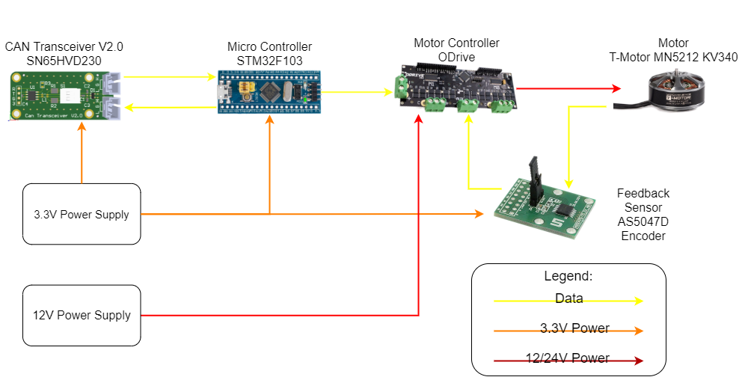
Figure 7: Preliminary Design

SECTION 5 – DETAILED SYSEM DESIGN

5.1 Project Parts Summary

As shown in Figure 8, the Zenith project utilized a CAN transceiver. This allowed Zenith to reliably send and receive commands. Many of the products on the market did not offer the EMI protections the team desired thus, the team concluded to create our own custom printed circuit board or PCB. With so many varieties of COTS on the market, the team then conducted research to discover the different parts that would be utilized in this project. It was concluded that for our particular project we would make use of an Advanced RISC Machines (ARM) based microprocessor. Some of the other components were used due their instant availability such as the ODrive motor controller, and the brushless motor. This particular magnetic encoder provided the benefit of a lack of mechanical wear on the sensor. All of the components used on the Zenith were preferred due to their ability to meet the team's project requirements as well as being readily available. The parts used in both Phase 1 and Phase 2 of this project can be seen in the project parts summary shown in Figure 8.
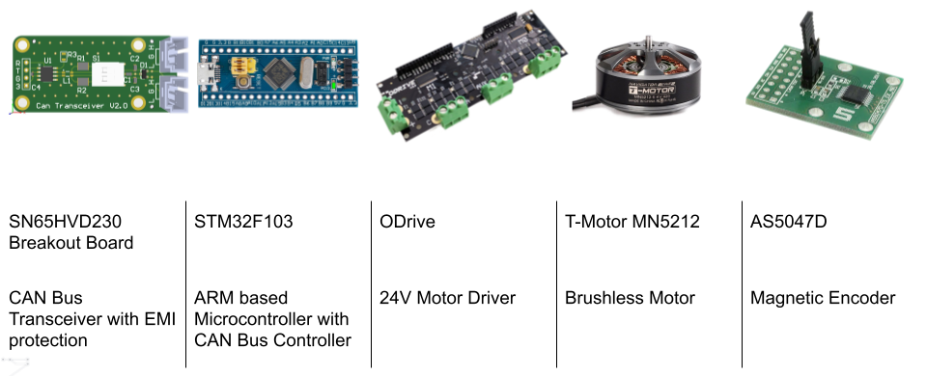
Figure 8: Project Parts Summary

5.2 Engineering Analysis and/or Simulation

At the start of the mechanical design for both Phase 1 and Phase 2, the team utilized Computer Aided Design (CAD) software such as Solidworks. This software allows us to create a close representation of the final actuator that we would bring to market. Applying CAD software allows us to design our actuator in a 3-dimensional(3D) space and provide an efficient environment to take our ideas and present them in a visible reality. CAD software also allows us to perform basic finite element analysis or FEA. Phase 1 did not need analysis because the parts were not transferring mechanical load. Therefore, this process was only applied to Phase 2. However, during the consideration of this idea, 2 factors in the nature of 3D printing were brought up as concerns. These factors are layers and infill. The nature of 3D printings causes parts to be made by creating multiple 2-dimensional (2D) layers on top of one another to form a 3D model. 3D printed models are typically printed hollow with some sort of pattern inside to provide structural support. The ratio between volume of space and plastic is the infill percentage. Percentages typically range from 10% to 50% to reduce the printing time and material cost. These 2 factors create an overabundant of unknown variables and causes FEA results to be unreliable.
One aspect of the Phase 2 that could be analyzed was the fasteners. Using Figure 9, a load path can be drawn on the actuator to see which component will be subjected to being load bearing.

5.2 Engineering Analysis and/or Simulation (Continued)

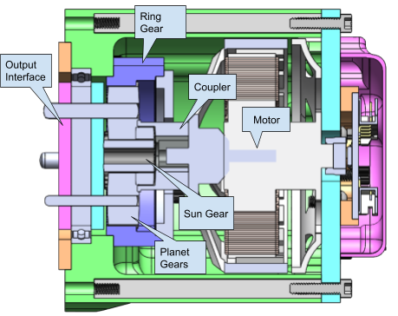
Figure 9: Actuator Side Cutout with Part Labels
The torque starts at the motor, indicated by the call out in Figure 9. The torque is then transferred through a friction fit coupler. The coupler is connected to the sun gear with a spline. The sun gear then transfers torque to the planet gears. The planet gears then all orbit or rotate around the sun gear due to a ring gear on the outside. This causes a torque transfer to the pins leading to the output interface. All these pieces in this path need to be rated for at minimum the maximum torque output from the motor. Due to Newton's third law: For every action, there is an equal and opposite reaction. We need to also study the structure that is behind the motor in order to react to the first load path. Starting with behind the motor, we analyze the interface between the motor and the teal colored part, shown in Figure 10 by a red arrow.
5.2 Engineering Analysis and/or Simulation (Continued)

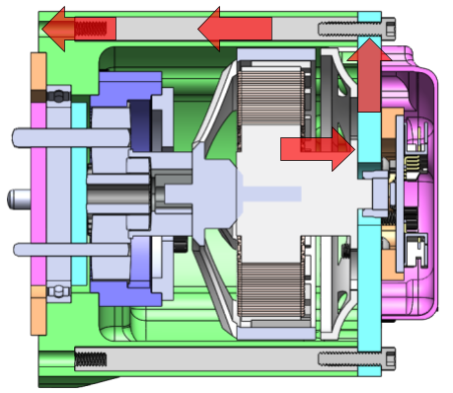
Figure 10: Actuator Side Cutout with Load Paths

Following this red arrow back to the front mounting, we can see which fasteners need to also be rated to the maximum torque of the motor. Since these parts are offset from the center of rotation, the force generated from the torque is no longer torsional but now in shear on the fasteners. We now just need to ensure all our fasteners combined can handle the shear force with an additional factor of safety. With those calculations finished, the mechanical portion of the analysis is finished.

5.3 Hardware Layout/Detailed Drawings/ Equipment Selection and Specification

The design of the hardware and software of Zenith are shown in this section.

5.3.1 Show Overview of Code Developed to Support 5.3

The Zenith actuator can enter many states and follows a sequence of functions after powering on. This is represented in Figure 11. When the actuator is turned on, it enters a disabled state where there is no power to the motor and the CAN Bus is disconnected. When a signal is received from the CAN Transceiver, the ODrive will initiate the calibration sequence where it makes one revolution in the clockwise direction and another revolution in the counterclockwise direction. Once the motor is calibrated, the actuator will enter the enabled state and the motor will be at zero velocity where the motor will be still. Power is sent to the motor to maintain its current position. When a forward command is received from the CAN Bus, the actuator will rotate in the clockwise direction. Alternatively, when the reverse command is received, the actuator will rotate in the counterclockwise direction. Zenith has built in fault detection that will cut power to the motor if failures arise. This includes putting an excess load on the actuator and exceeding the current limit imposed by the user. When a fault is detected, the actuator will enter the fault state and power will be disconnected from the motor.

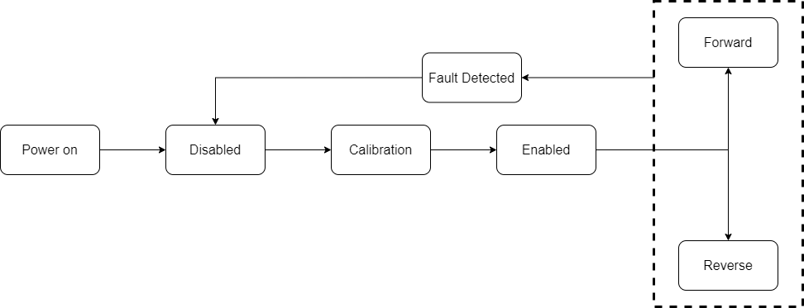
Figure 11: Software Flow Chart

5.3.1 Show Overview of Code Developed to Support 5.3 (Continued)

For each of the states that the actuator can enter in Figure 11 above, there are three colored LEDs (red, green, and yellow) to indicate the immediate state of the actuator. As shown in table 2 below, when the actuator is disabled, the red LED will be solid and all the other LEDs will remain off. When there is a fault detected, this LED will flash every 500 milliseconds. While the actuator is rotating, the LED will flash green or flash yellow when it rotates forward or in reverse respectively. The LEDs will alternate between green and yellow if the actuator is enabled and can receive the CAN Bus signal.
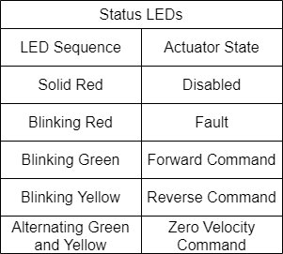
Table 2: Status LED Color Code

5.3.1 Show Overview of Code Developed to Support 5.3 (Continued)

The schematic in Figure 12 shows the layout of the PCB for all of the CAN Transceivers. This is an essential part in communicating with the actuator and all the commands are sent through these transceivers. We designed this transceiver to be versatile and reliable. The PCB contains Dual In-line Package (DIP) switches that are used to disconnect the CAN termination resistors from the bus. This allows users to use more than 2 nodes since termination is only needed at the opposite ends of the bus. Transmit Data (TXD) and Receive Data (RXD) ports are connected to the microcontroller while CAN High and CAN Low are connected to the transceivers to exchange information. In addition, a few additional components were added to improve reliability in electrically noisy environments. A common mode choke, transient voltage suppression(TVS) diode, and coupling capacitors were added. The TVS diode provides the bus a safe path to ground dude voltage spikes.

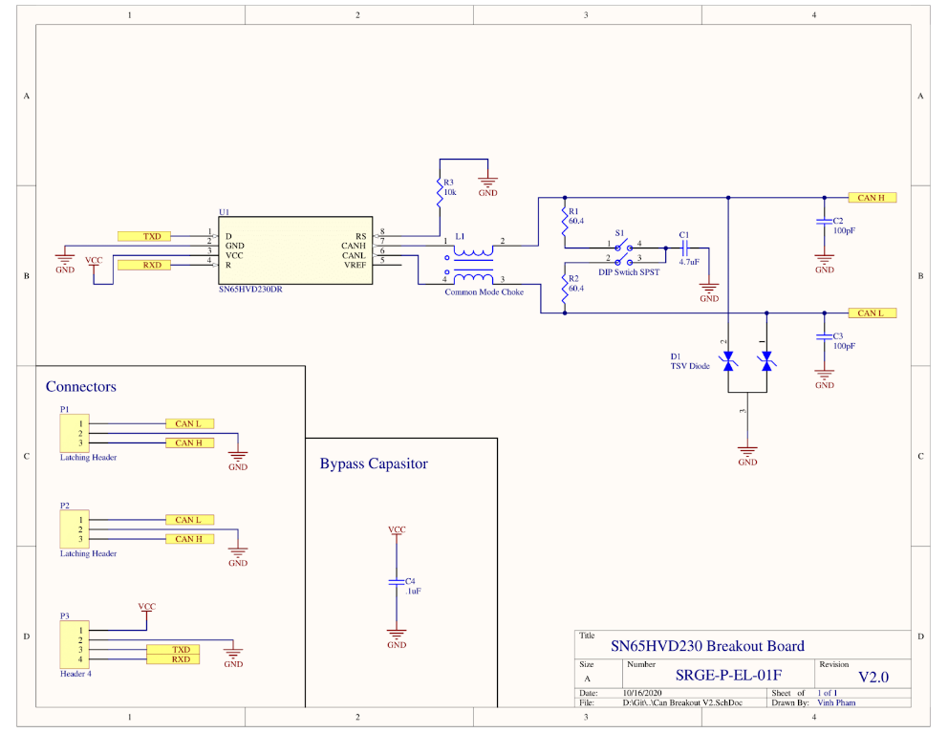
Figure 12: CAN Bus Transceiver PCB Schematic

5.3.1 Show Overview of Code Developed to Support 5.3 (Continued)

The schematic for the magnetic encoder is shown in figure 13 below. The magnetic encoder is responsible for detecting the current position of the actuator. When the encoder is powered, the blue LED is on to indicate that it is receiving power. For our project we will utilize the I/PWM pin on the encoder which will pulse the signal from high to low each time the motor makes one revolution. This pin helps our microcontroller know the speed of the motor and detect if the motor has stalled. The motor connectors are the connectors that drive the motor and is where power is sent for it to rotate. The encoder comes with Serial Peripheral Interface (SPI) and extra pins that are not required for this project.

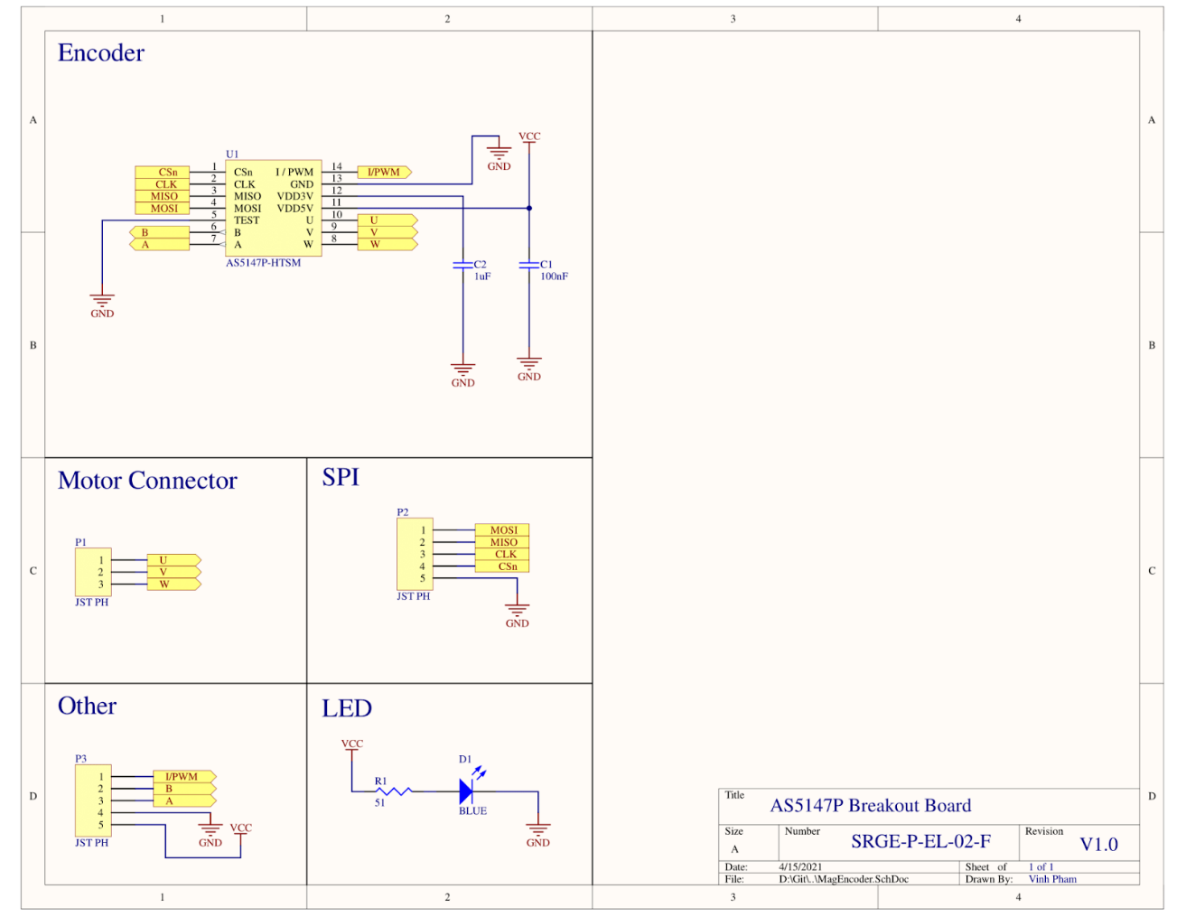
Figure 13: Magnetic Encoder PCB Schematic

5.4 Application of Engineering Codes and Standards used in Final Design

The Zenith team looked to IEEE for technical standards and NSPE for ethical standards. The codes and standards used for the final design of the Zenith actuator were:
IEEE 1872-2015: Standard Ontologies for Robotics and Automation
A core ontology that specifies the main, most general concepts, relations, and axioms of robotics and automations (R&A) is defined in this standard. This code was followed so that the correct terms were used when describing parts of the actuator.
IEEE 730-2014: IEEE Standard for Software Quality Assurance
Requirements for initiating, planning, controlling, and executing the Software Quality Assurance processes of a software development or maintenance project. This guided the projects versioning, controlling, and executing of programs during the software cycle.
IEEE 829 - 2008: Standards for Test Plan Documentation
Established standards for the testing process to be carried out. Utilizing this IEEE code allowed our team to verify that our system is satisfying the intended needs of the end user.
IEEE 518-1982: IEEE Guide for the installation of Electrical Equipment to minimize Electrical Noise Inputs to Controllers from extra sources. This code allowed the team to understand the disturbance of electrical noise when working with the electrical devices with extra sources.

5.4 Application of Engineering Codes and Standards used in Final Design (Continued)

NESC:
National Electrical and Safety Code is a United States standard of the safe installation, operation, and maintenance of electric power and communication utility systems including power substations, power and communication overhead lines, and power and communication underground lines. This safety measure was implemented to make sure that the electrical components of the are not exposed and create any harm.
NSPE: Professional Obligations
Engineers shall be guided in all their relations by the highest standards of honesty and integrity. This professional standard was utilized through the entirety of the project.

5.5 Economic Analysis

While the project itself went over budget, the project budget does not reflect the cost of an individual actuator. Because we relied on the iterative process during our prototyping phase, we had to buy multiple different parts in an attempt to find the correct parts. In addition to that, we also had to budget out for two different phases, each having their economic analysis. We started phase 1 with seeing which parts we already had on hand, then seeing what could be compatible for purchase.
Item Name | Description | Quantity | Total
T-Motor MN5112 | Brushless Direct Current Motor | 1 | Pre-owned
ODrive | Brushless Motor Driver | 1 | Pre-owned
STM32F103 | ARM Microcontroller | 1 | $ 4.99
SN65HVD230 | CAN Bus Transceiver PCB | 1 | $ 5.18
PLA Material | Plastic to 3D print Mounting Plate | 1 | $ 0.25
 |  | Total: | $ 10.42

Table 3: Phase 1 Cost

5.5 Economic Analysis (Continued)
After finishing the design for Phase 2, we started to price out the parts individually. Even though some items were bought in bigger quantities, we tried to price it out to the final cost of one actuator instead of the total cost spent for development. Table 4 shows a breakdown of every single part used on the actuator excluding the harness. We excluded the harness because this can change from user to user. While this is the material cost for one actuator, the market cost would need to also account for labor and development costs.

5.5 Economic Analysis (Continued)
Part Number | Description | Quantity | Total
ZENI-C-01AC-LC-01 | Mounting Plate | 1 | $ 8.38
ZENI-C-01AC-LC-02 | Threaded Ring | 1 | $ 3.36
ZENI-C-01AC-LC-03 | Front Half output | 1 | $ 2.90
ZENI-C-02AC-LC-04 | Back half output | 1 | $ 2.96
ZENI-C-01AC-C-02 | Sun Gear Coupler | 1 | $ 5.99
ZENI-C-01AC-C-D42DIA | Magnet | 1 | $ 0.38
ZENI-C-01AC-C-MN5212 | T-Motor MN5212 | 1 | $ 110.99
ZENI-C-01AC-C-6707-ZZ | 6707-ZZ Bearing | 1 | $ 3.20
ZENI-C-02AC-C-217-2819-1 | 5:1 planetary gear | 4 | $ 14.99
ZENI-C-02AC-C-217-2819-2 | 5:1 sun gear | 1 | $ 14.99
ZENI-C-02AC-C-217-2816 | Ring gear | 1 | $ 9.99
ZENI-C-02AC-C-91595A173 | 4mm x 24mm Steel Dowel Pin | 4 | $ 1.12
ZENI-C-01AC-C-92196A110 | 4-40 1/2" Socket head | 14 | $ 0.34
ZENI-C-01AC-C-92196A108 | 4-40 3/8" Socket head | 2 | $ 0.05
ZENI-C-01AC-C-92196A117 | 4-40 1 1/8" Socket head | 2 | $ 0.15
ZENI-C-01AC-C-92196A117 | 4-40 7/16" Flat head | 4 | $ 0.12
ZENI-C-01AC-C-98381A471 | 1/8" X 1/2" Steel Dowel pin | 4 | $ 0.84
ZENI-C-01AC-C-91780A554 | 4-40 hex standoff 2.25" | 8 | $ 14.96
ZENI-C-01AC-C-92095A181 | M3 8mm Button head | 4 | $ 1.02
ZENI-P-03AC-P-01 | Mag encoder | 1 | $ 9.19
ZENI-C-01AC-3D-01 | Actuator Housing | 1 | $ 1.73
ZENI-C-01AC-3D-02 | Back CAP | 1 | $ 0.12
ZENI-C-01AC-3D-03 | Grease Guard | 1 | $ 0.12
ZENI-C-01AC-3D-04 | Encoder PCB Spacer | 1 | $ 0.05
ZENI-C-01AC-3D-05 | Magnet holder | 1 | $ 0.02
 |  | Total: | $ 192.97
Table 4: Zenith Material Cost

5.6 Final Design
For Phase 2, Figure 14, is the cross-section view. The team can easily identify some of the major components. While designing the housing, we needed to consider the different materials with their strength and machinability. For some of the load bearing interfaces, the team decided to use aluminum 6061 - T651 alloy. This material was chosen because it does not stress corrosion cracks. Stress corrosion cracking is caused when micro cracks develop in a corrosive environment. These micro cracks can eventually creep into larger cracks and be the cause of sudden failures even if the part is way below its yield or shear strength. As for the gears, the team went and found a planetary that utilized Rockwell C 55-62 case hardened Steel Gears, this hardness reduces the wear between the gears and increases the longevity of the gear train.
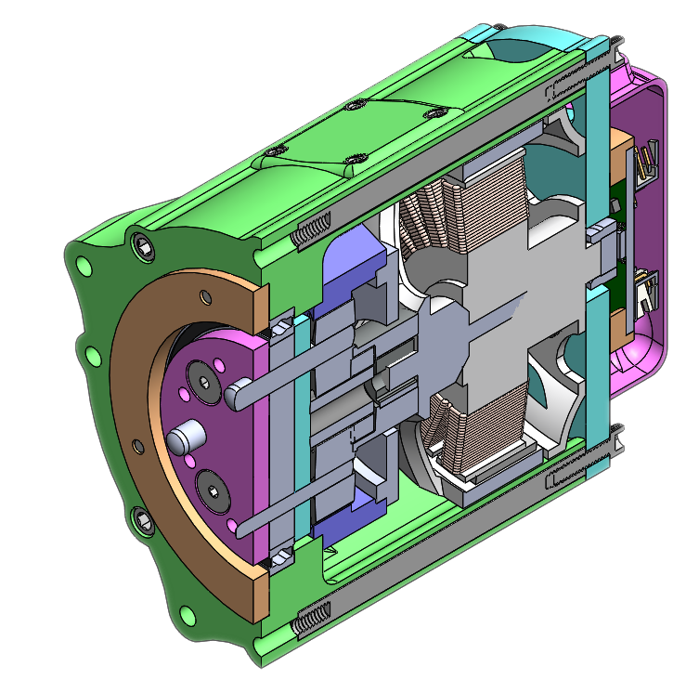
Figure 14: Phase II Final Design

SECTION 6 – RESULTS AND DISCUSSION

6.1 Summary of Goals and Objectives

The main objective of our project was to develop a fully integrated custom actuator that combines a motor, driver, and gear box. This was accomplished by taking the three components and combining them in a housing unit or shell. The goal of our group was to create a low-cost actuator that we could bring to market and be competitive. To make our actuator competitive, we added status LED’s to always be aware of the status, a failsafe, and also a current limiter as well to avoid burnout.

6.2 Summary of Constraints and Codes Met by Design

Our device had numerous constraints, first being a disconnection in communication between the PC and the controller. Another would be power loss to the actuator. Taking into consideration that the actuator may exceed the weight limit. Next would be software bugs that can occur when controlling the hardware. Lastly, the voltage feeding into the actuator should be constant and should not fluctuate.
The following codes were used to meet the final design:
- IEEE Engineering Code 1872-2015: IEEE Standard Ontologies for Robotics and Automation.
  - Using this code ensured the use of correct terms when describing parts of the actuator.
- IEEE Engineering Code 730-2014: IEEE Standard for Software Quality Assurance
  - Helped in developing and guiding the versioning, controlling, and executing of our programs during software life cycle.
- IEEE Engineering Code 829-2008: Standards for Test Plan Documentation
  - Utilized to make certain that our system satisfies the needs of intended users.
- IEEE Engineering Code 518-1982: IEEE Guide for the installation of Electrical Equipment to minimize Electrical Noise Inputs to Controllers from extra sources
  - Assisted the team on understanding the disturbance of electrical noise when working with our electrical devices with extra sources.
- NESC: National Electrical and Safety Code
- NSPE: Professional Obligations

6.3 Discussion of Results and Other Use Cases

This project allowed us to create an affordable custom actuator using mostly commercial off the shelf components. By designing this type of actuator, it allowed us to avoid complex geometries. This method in turn, allowed our team to design a fully functional custom actuator at an exceptionally low cost for the customer. While engineers spend most of their time designing, it was desired for end users to have easy implementation during their initial set up. This will allow end users to allocate more time to their project implementation. The specified hardware CAN Bus is used throughout this project and allows the actuator to successfully communicate with other components. We learned that by having this type of reliability allows for successful communication of sending and receiving commands. This sought-after feature eliminates the need for troubleshooting many communication problems between components. During the design phase, we concluded that having a status LED allowed us to successfully determine its status. With this type of feature, end users will be capable of eliminating multiple steps in determining the problem areas in which need correction. Where there was any type of power concerned, we foresaw a condition in which our product would be required to avoid burnout. The team eliminated this concern by implementing a failsafe that would allow the motor to detect power loss, as well as a fluctuation of power. This type of failsafe will allow the product to give the end user peace of mind. In conclusion, the team successfully created a custom actuator using mostly COTS. Thus, the Zenith can be successful in the competing market due to its affordability, easy setup, status display and its ability to fail safely.

SECTION 7 – CONCLUSIONS AND RECOMMENDATIONS

Conclusion and Recommendations

The development of our actuator can prove that a fully developed solution can be replaced by a Commercial Off the Shelf (COTS) product, thus reducing the time and money companies need to spend on developing their own actuators. The final design of our actuator could have only been achieved through multiple iterations, by purchasing a COTS product, the additional time and money spent on iterations can be pushed off to the manufacturers.
As a recommendation we suggest choosing an actuator that is configured to be used in the correct speed and torque application. With the process of sending data one bit at a time, we also recommend setting up the actuator using the correct configuration, Serial communication, in telecommunication and data transmission. Lastly, one must safely drive a motor using Controlled Area Network (CAN) Bus commands.

LIST OF REFERENCES

[1] Carlisle, B. "Robotics Business Review." 22 September 2017. https://www.roboticsbusinessreview.com/manufacturing/pick-place-profit-using-robot-labor-save-money/&gt. 24 September 2020.
[2] Carlisle, Brian, and Brian Carlisle. “Pick and Place for Profit: Using Robot Labor to Save Money.” Robotics Business Review, 26 Jan. 2018, www.roboticsbusinessreview.com/manufacturing/pick-place-profit-using-robot-labor-save-money/.
[3] “Chemical Exposure.” National Institute of Environmental Health Sciences, U.S. Department of Health and Human Services, tools.niehs.nih.gov/wetp/index.cfm?id=244.
[4] Guan Qiao, Geng Liu. “A Review of Electromechanical Actuators for More/All Electric Aircraft Systems - Guan Qiao, Geng Liu, Zhenghong Shi, Yawen Wang, Shangjun Ma, Teik C Lim, 2018.” SAGE Journals, journals.sagepub.com/doi/full/10.1177/0954406217749869.
[5] Hollis, Paul. “Advantages of Customized Linear Actuators.” Venture Mfg. Co., 12 June 2019, www.venturemfgco.com/blog/advantages-of-customized-linear-actuators/#:~:text=The%20immense%20flexibility%20provided%20by,motion%20tasks%20that%20require%20sophistication.
[6] Kirk, David. “KPMG BrandVoice: How Much Is Intelligent Automation Saving You?” Forbes, Forbes Magazine, 21 June 2018, www.forbes.com/sites/kpmg/2017/09/21/how-much-is-intelligent-automation-saving-you/#39cb87c1604c.
[7] Matthews, K. "EHS Today." 15 August 2019. https://www.ehstoday.com/safety-technology/article/21920298/how-warehouse-robotics-reduce-worker-injuries&gt. 24 September 2020.
[8] “Overcoming Job Stress: MedlinePlus Medical Encyclopedia.” MedlinePlus, U.S. National Library of Medicine, medlineplus.gov/ency/patientinstructions/000884.htm.
[9] Paul-Hollis. “Venture Mfg. Co. - Leader in Linear Motion Technology Since 1971.” With Various Capacities 12v, 24v, 36v, 90v, 120v - Venture Mfg Co., www.venturemfgco.com/electric-linear-actuator/.
[10] “Please Enable Cookies.” StackPath, www.ehstoday.com/safety-technology/article/21920298/how-warehouse-robotics-reduce-worker-injuries.
[11] “Please Enable Cookies.” StackPath, www.machinedesign.com/mechanical-motion-systems/hydraulics/article/21832150/comparing-electric-rod-actuators-and-hydraulic-cylinders#:~:text=Hydraulics%20do%20offer%20a%20long,control%20with%20more%20efficient%20operation.
[12] Qureshi, Mohammed Owais, and Rumaiya Sajjad Syed. “The Impact of Robotics on Employment and Motivation of Employees in the Service Sector, with Special Reference to Health Care.” Safety and Health at Work, U.S. National Library of Medicine, Dec. 2014, www.ncbi.nlm.nih.gov/pmc/articles/PMC4266810/#:~:text=Robots%20can%20do%20some%20jobs,%2Dskilled%20workers%20%5B22%5D.
[13] Roswold, J. "Kansas City Accident Injury Attorneys." 2020. https://www.kansascityaccidentinjuryattorneys.com/faqs/preventing-workplace-injuries-caused-. 2020.
[14] “What Dangers Are Present When Working with Robots?” Kansas City Accident Injury Attorneys, www.kansascityaccidentinjuryattorneys.com/faqs/preventing-workplace-injuries-caused-by-automation.cfm.
[15] Written by Jeff Desjardins, Founder and editor. “7 Charts on the Future of Automation.” World Economic Forum, www.weforum.org/agenda/2019/02/the-outlook-for-automation-and-manufacturing-jobs-in-seven-charts.

APPENDIX

Acronym | Definition
2D | 2 Dimensional
3D | 3 Dimensional
ARM | Advanced RISC Machines
BLDC | Brushless Direct Current
CAD | Computer Aided Design
CAN | Controlled Area Network
COTS | Commercial Off The Shelf
DIP | Dual Inline Package
EMI | ElectroMagnetic Interference
FEA | Finite Element Analysis
IEEE | Institute of Electrical and Electronics Engineers
KV | Velocity Constant
LED | Light Emitting Diode
NESC | National Electrical Safety Code
NSPE | National Society of Professional Engineers
PCB | Printed Circuit Board
PLA | Polylactic acid
PWM | Pulse Width Modulation
RPM | Rotations Per Minute
RXD | Receive Data
SPI | Serial Peripheral Interface
TVS | Transient Voltage Suppression
TXD | Transmit Data
UART | Universal Asynchronous Receiver/Transmitter

Microcontroller functions:

void enable()
{
static long enableLED = 0;
htim3.Instance->PSC = motorSpeed;
HAL_GPIO_WritePin(GPIOA, GPIO_PIN_4, GPIO_PIN_RESET);

if (HAL_GetTick() - enableLED > 500)
{
if (motorSpeed > 95)
{
HAL_GPIO_WritePin(GPIOA, GPIO_PIN_5, GPIO_PIN_RESET);
HAL_GPIO_TogglePin(GPIOA, GPIO_PIN_3);
}
else if (motorSpeed < 95)
{
HAL_GPIO_WritePin(GPIOA, GPIO_PIN_3, GPIO_PIN_RESET);
HAL_GPIO_TogglePin(GPIOA, GPIO_PIN_5);
}
else
{
if (greenLED == yellowLED)
{
greenLED = 1;
HAL_GPIO_WritePin(GPIOA, GPIO_PIN_3, GPIO_PIN_SET);
yellowLED = 0;
HAL_GPIO_WritePin(GPIOA, GPIO_PIN_5, GPIO_PIN_RESET);
}
}
}
}

void fault()
{
static long faultLED = 0;
HAL_GPIO_WritePin(GPIOA, GPIO_PIN_2, GPIO_PIN_RESET); //ODrive reset pin
htim3.Instance->PSC = 95;

HAL_GPIO_WritePin(GPIOA, GPIO_PIN_3, GPIO_PIN_RESET);
HAL_GPIO_WritePin(GPIOA, GPIO_PIN_5, GPIO_PIN_RESET);

if (HAL_GetTick() - faultLED > 500)
{
HAL_GPIO_TogglePin(GPIOA, GPIO_PIN_4);
}
}

void disable()
{
HAL_GPIO_WritePin(GPIOA, GPIO_PIN_2, GPIO_PIN_RESET);
htim3.Instance->PSC = 95;

HAL_GPIO_WritePin(GPIOA, GPIO_PIN_4, GPIO_PIN_SET);
HAL_GPIO_WritePin(GPIOA, GPIO_PIN_3, GPIO_PIN_RESET);
HAL_GPIO_WritePin(GPIOA, GPIO_PIN_5, GPIO_PIN_RESET);
}
CAN Bus Code:

int main(void)
{
HAL_Init();

SystemClock_Config();

MX_GPIO_Init();
MX_CAN_Init();
MX_TIM3_Init();

canfil.FilterBank = 0;
canfil.FilterMode = CAN_FILTERMODE_IDMASK;
canfil.FilterFIFOAssignment = CAN_RX_FIFO0;
canfil.FilterIdHigh = 0;
canfil.FilterIdLow = 0;
canfil.FilterMaskIdHigh = 0;
canfil.FilterMaskIdLow = 0;
canfil.FilterScale = CAN_FILTERSCALE_32BIT;
canfil.FilterActivation = ENABLE;
canfil.SlaveStartFilterBank = 14;

txHeader.DLC = 8; //Number of bites to be transmitted (max = 8)
txHeader.IDE = CAN_ID_STD;
txHeader.RTR = CAN_RTR_DATA;
txHeader.StdId = 0x030;
txHeader.ExtId = 0x02;
txHeader.TransmitGlobalTime = DISABLE;

HAL_CAN_ConfigFilter(&hcan,&canfil); //Initialize CAN Filter
HAL_CAN_Start(&hcan); //Initialize CAN Bus
HAL_CAN_ActivateNotification(&hcan,CAN_IT_RX_FIFO0_MSG_PENDING); //Initialize CAN Bus Rx Interrupt

HAL_GPIO_WritePin(GPIOA, GPIO_PIN_5, GPIO_PIN_SET);
HAL_GPIO_WritePin(GPIOA, GPIO_PIN_3, GPIO_PIN_RESET);
HAL_GPIO_WritePin(GPIOC, GPIO_PIN_13, GPIO_PIN_RESET);

HAL_TIM_PWM_Start(&htim3, TIM_CHANNEL_1);
last_time = HAL_GetTick();

long alternateLED = 0;
long CAN = 0;
_Bool greenLED = 1;
_Bool yellowLED = 0;

while (1)
{
if (HAL_GetTick() - CAN > 250)
{
uint8_t csend[] = {0x01,0x02,0x03,0x04,0x05,0x06,0x07,0x08};
HAL_CAN_AddTxMessage(&hcan,&txHeader,csend,&canMailbox);
CAN = HAL_GetTick();
}

if (HAL_GetTick() - alternateLED > 500 && CANOK == 1)
{
if (greenLED == yellowLED)
{
greenLED = 1;
yellowLED = 0;
}

if (greenLED == 1)
{
greenLED = 0;
yellowLED = 1;
}
else
{
greenLED = 1;
yellowLED = 0;
}

if (greenLED == 1)
HAL_GPIO_WritePin(GPIOA, GPIO_PIN_3, GPIO_PIN_SET);
else
HAL_GPIO_WritePin(GPIOA, GPIO_PIN_3, GPIO_PIN_RESET);

if (yellowLED == 1)
HAL_GPIO_WritePin(GPIOA, GPIO_PIN_5, GPIO_PIN_SET);
else
HAL_GPIO_WritePin(GPIOA, GPIO_PIN_5, GPIO_PIN_RESET);

HAL_GPIO_WritePin(GPIOA, GPIO_PIN_4, GPIO_PIN_RESET);
alternateLED = HAL_GetTick();
}

if (HAL_GetTick() - stateTime > 300)
{
HAL_GPIO_WritePin(GPIOA, GPIO_PIN_4, GPIO_PIN_SET);
HAL_GPIO_WritePin(GPIOA, GPIO_PIN_3, GPIO_PIN_RESET);
HAL_GPIO_WritePin(GPIOA, GPIO_PIN_5, GPIO_PIN_RESET);
HAL_GPIO_WritePin(GPIOC, GPIO_PIN_13, GPIO_PIN_SET);
greenLED = 0;
yellowLED = 0;
CANOK = 0;
}
else
{
CANOK = 1;
}
}
}

