PRAIRE VIEW A&M UNIVERSITY
ROY G. PERRY COLLEGE OF ENGINEERING



Liquid Nitrogen Doser Smart Actuator

ELEG 4248: Senior Design & Professionalism II

Topic: Final Written Report

Team 2

Submitted by:

Hyram Pouncy (Team Lead)
Matthew Barnett
Breon Holmes
George Polk
Bryce Lovejoy

Instructor: Professor Turner

Date of Submission: 05/01/2022

Project Executive Summary

Mission Statement

The goal of this project is to design a smart Internet of Things (IOT) controller for liquid nitrogen dosing actuators. This controller will increase the number of actuators they can use in a system as well as line speed to go along with other factors. This controller will also serve as a testing platform in Chart Industries transition into the “Industry 4.0” standard.

Problem Statement

Chart Industries liquid nitrogen dosers use a central programmable controller to handle all functions for an automated dosing application in which all remote inputs and outputs are wired back to the main controller.

Proposed Deliverables​

- This controller will serve as a testing platform for future IOT infrastructure
- This controller will increase the number of actuators per system
- This controller will increase line speed

Budget

There is no proposed budget, all monetary affairs were handled by Chart Industries.

*Estimated price per unit: $3,500

Customer Requirements and Engineering Solutions

- Actuators must be autonomous and able to perform different tasks​

- Each actuator must be able to detect motion and read temperature​

- Software Interface must be user friendly​

- Actuators must have sensors for motion and line speed

Major Constraints

- Due to COVID-19 shipping/fabrication times have increased​

- Linux Yocto operating system is barebones and minimal which limits testing capabilities

- Time-Zone difference with Exor and Chart Industries reps

Benefits

- Our design will create a more efficient control system

- Allow for modularity within implemented products

- Modernize Chart Industries current processes

Recommendations

As a recommendation we suggest using a Linux based machine to allow for more compatibility when reprogramming the STM32 chip in the STMCube IDE software. ​We also recommend using an electronic design software to create and design circuits on a single printed circuit board (PCB) layout.

Conclusion

The development and implementation of our breadboard will allow for modernization and modularity within many of the technological systems while also reducing the time and money spent.​

TABLE OF CONTENTS

PROJECT EXECUTIVE SUMMARY………………………………………...…… 2-4
TABLE OF CONTENTS………………………………………………………………..5
LIST OF FIGURES ……………………………………………………………………..6
LIST OF TABLES ………………………………………………………………………7
LIST OF TEAM MEMBERS AND ROLES …………………………………………..8

- PROJECT SCOPE ……………………………………………………………………...9
  - Problem Statement, Business Objective and Target Audience of Project………10
  - Client identification and recognition of need ……………………………….11-13
  - Project Goals and objectives ……………………………………………………14
  - Contemporary issues relevant to the project…………………………………… 15
  - Potential impact of project on society …………………………………………..16
    - Environmental Impact ………………………………………17-18
    - Economic Impact………………………………………………. 19
    - Technical Impact………………………………………………. 20
  - Initial Project constraints ……………………………………………………….21
- PROJECT PLANNING AND TASK DEFINITION ……………………………….22
  - Task identification ………………………………………………………………23
  - Gantt Chart …………………………………………………………………..24-25
- LITERATURE REVIEW ……………………………………………………………..26
  - List of all sources of information ……………………………………………27-28
  - Statement of Learning from each source …………………………………….29-30
- PRELIMINARY DESIGN …...………………………………………..………………31
  - Concept Generation ………………………………………………………….32-33
  - Concept Evaluation and selection ……………………………………………….34
  - Design Constraints and Applicable Codes and Standards Used in the Preliminary Design …………………………………..……………………………………35-38
  - Preliminary Analysis ………………………………………………………...39-40
  - Preliminary Design …………………………………………………………..41-45
- DETAILED SYSTEM DESIGN ………………………………………………………46
  - Project Parts Summary ………………………………………………………47-48
  - Engineering Analysis and/or Simulation ………………………………………..49
  - Hardware Layout/Detailed Drawings/Equipment selection and specifications 50-70
  - Application of Engineering Codes and Standards used in Final Design …….71-72
  - Economic Analysis ……………………………………………………………...73
  - Final Design ……………………………………………………………………..74
- RESULTS & DESCUSSION ………………………………………………………….75
  - Summary of Goals and Objectives ……………………………………………...76
  - Summary of Constraints and Codes met by Design …………………………77-78
  - Discussion of Results and Other Use Cases …………………………………….79
- CONCLUSIONS AND RECOMMENDATIONS ………………………………..80-81
LIST OF REFERENCES ……………………….………………………………….82-86
APPENDIX …………………………………………………………………….……87-88
LIST OF FIGURES

Figure 1.5.1 …………………………………………..…………………………………………...18
Figure 2.2.1 …………………………………………..…………………………………………...25
Figure 3.2.1 …………………………………………..…………………………………………...30
Figure 4.1.1 …………………………………………..…………………………………………...32
Figure 4.2.1 …………………………………………..…………………………………………...34
Figure 4.3.1 …………………………………………..…………………………………………...36
Figure 4.4.1 …………………………………………..…………………………………………...40
Figure 4.5.1 …………………………………………..…………………………………………...41
Figure 4.5.2 …………………………………………..…………………………………………...42
Figure 4.5.3 …………………………………………..…………………………………………...43
Figure 4.5.4 …………………………………………..…………………………………………...43
Figure 4.5.5 …………………………………………..…………………………………………...44
Figure 5.3.1 …………………………………………..…………………………………………...50
Figure 5.3.2 …………………………………………..…………………………………………...51
Figure 5.3.3 …………………………………………..…………………………………………...52
Figure 5.3.4 …………………………………………..…………………………………………...52
Figure 5.3.5 …………………………………………..…………………………………………...54
Figure 5.3.6 …………………………………………..…………………………………………...56
Figure 5.3.7 …………………………………………..…………………………………………...57
Figure 5.3.8 …………………………………………..…………………………………………...58
Figure 5.3.9 …………………………………………..…………………………………………...59
Figure 5.3.10 …………………………………………..………………………………………….60
Figure 5.3.11 …………………………………………..………………………………………….60
Figure 5.3.12 …………………………………………..………………………………………….61
Figure 5.3.13 …………………………………………..………………………………………….62
Figure 5.3.14 …………………………………………..………………………………………….63
Figure 5.3.15 …………………………………………..………………………………………….64
Figure 5.3.16 …………………………………………..………………………………………….65
Figure 5.3.17 …………………………………………..………………………………………….66
Figure 5.3.18 …………………………………………..………………………………………….67
Figure 5.3.19 …………………………………………..………………………………………….68
Figure 5.3.20 …………………………………………..………………………………………….69
Figure 5.3.21 …………………………………………..………………………………………….70
Figure 5.6.1 …………………………………………..…………………………………………...74

LIST OF TABLES AND GRAPHS

Table 1.2.1…………………………………………..…………………………………………...12
Table 2.2.1 …………………………………………..…………………………………………..24
Table 5.1.1 …………………………………………..…………………………………………..47
Table 5.1.2 …………………………………………..…………………………………………..48
Table 5.5.1 …………………………………………..…………………………………………..73
Table 5.5.2 …………………………………………..…………………………………………..73

LIST OF TEAM MEMBERS AND ROLES

Hyram Pouncy ………………………………………………………………..……..…Team Lead
Matthew Barnett …………………………………………………………………... Software Lead
George Polk …………………………………………………………………………….. Test Lead
Bryce Lovejoy …………………………………………………………………... Purchasing Lead
Breon Holmes …………………………………………………………………….. Hardware Lead

Section 1 – Project Scope

  - Project Statement, Business Objective and Target Audience of your Project

Chart Industries would like to redesign the control system for its liquid nitrogen dosing products using smart embedded controllers. Traditionally, Chart’s Liquid Nitrogen Dosers use a central programmable controller (Programmable Logic Controller or PLC) to handle all the functions for an automated dosing application. These systems contain a main controller, a touch screen interface (HMI), and multiple liquid nitrogen actuators and remote inputs and outputs. Currently, all these remote inputs and outputs are wired back to the main controller. Each liquid nitrogen actuator requires sensor inputs for line speed, part detection, temperature, and actuator outputs for solenoids and electric heaters. Since there is only a single central controller, there are limitations on the number of actuators in a system as well as the line speed and other factors. Therefore, if each liquid nitrogen dosing actuator is smart and independent, the system size is no longer an issue, and the overall cost is reduced. The goal of this project is to design a smart Internet-of-Things (IOT) controller for liquid nitrogen dosing actuators based on an Exor nanoSOM (System-on-Module). A system on a module is a board-level circuit that integrates a system function in a single module. Exor Embedded’s nanoSOM ns02 product is an ultra-compact and cost-effective SOM based on STM32MP1 Dual Cortex A7 + Cortex M4 embedded for Industry 4.0 (Industrial Internet of Things) applications.

  - Client identification and recognition of need

In the original scope of our project, we were tasked with creating an Internet of Things (IOT) Controller to handle automated dosing functions. Due to certain circumstances, mainly being the limited time of one calendar school year, our overall objectives were changed. In stating that, our client identification and marketing requirements include both the end goal of our IOT Controllers serving as an actuator in liquid nitrogen dosing functions, as well as serving in the IOT infrastructure space in chart industries. First, each actuator must be able to perform different tasks. For each actuator to perform distinct functions, we will program a System-on-Module patented by Exor Embedded (NanoSoM0202). This will allow production to increase and be more efficient. Next, we will implement a user-friendly interface. To complete this objective, we will be using JMobile as a Human Machine Interface (HMI) NS02 to ensure customers can make easy setting changes. Next, each actuator must be able to detect motion and read temperature. Our photoelectronic sensors will be programmed to detect motion and temperature. This allows the dosers to provide proper dosing to each individual item. The fourth task is for the actuator to be autonomous. To achieve this, we will utilize the microchip (nanoSoM02) which will not only allow it to be autonomous, but also cut costs and reduce system size. The final requirement of our actuator is it must be able to interact with sensors to monitor inputs for line speed and part detection. By utilizing ExacTrak technology we will be able to efficiently dose each individual part.

  - Client identification and recognition of need (Continued)

Marketing Requirements​ | Engineering Requirements​ | Justification​
Actuators must be able to perform different tasks​ | Use of nanoSoM02 chip to assign the different tasks​ | Higher efficiency and increased production​
Actuators must be autonomous ​ | Use of nanoSoM02 chip to control each individual actuator​ | Reduce cost and system size​
Interface for actuators should be user friendly​ | The HMI NS02 interface software will be used to control actuators​ | Easy to use for setting Modifications ​
Each actuator must be able to detect motion and read temperature​ | Photoelectronic sensors will be programmed to detect motion and temperature​ | Actuator must provide proper dosing to each individual item​
Actuators must have sensors to monitor inputs for line speed and part detection​ | ExacTrack technology. An encoder would be used for higher line speeds​ | To be able to efficiently dose each individual part.​
Table 1.2.1: Matrix

  - Client identification and recognition of need (Continued)

- Hardware Requirements:
  - NanoSoM02
  - Breadboard for circuit testing
  - Development board for analysis
- Final Product
  - Develop an interface board and development board for future testing.
  - Development board must house NanoSOM Chip
  - Interface board must include support for circuit testing.
  - The development board must have headers to allow for circuit testing.

1.3 Project Goals and objectives

The purpose of this project is to create an IOT platform for Chart Industries. Our objective is not only to design an IOT Controller for future use in liquid nitrogen dosing, but also in the entire IOT space. The end goal for this IOT controller implementation is for it to serve as a data node for data analytics while still serving in liquid nitrogen dosing applications.

1.4 Contemporary issues relevant to the project

The issue with the current configured PLC liquid nitrogen dosing system is all input and output functions being wired back to one main controller. This means if the PLC fails, every liquid nitrogen doser connected to the PLC will be down until the PLC is recommissioned. In saying that, the IOT controller/actuator will serve as a stepping-stone in allowing dosers to be autonomous and in turn adding redundancy in their liquid nitrogen dosing systems. The next issue with the PLC configured dosing is that all it limits the number of actuators can have function in each system. With the implementation of the IOT controller it will allow for an increase the number of actuators per system.

1.5 Potential impact of project on society

After many internal discussions within our senior design group as well as meetings with our sponsors at Chart Industries, we have concluded that as of right now our Liquid Nitrogen Dosing Actuator project impacts the following areas: environmental, economic, and technical.

1.5.1 Environmental Impact

- Environmental
  - Dosing Process deals with plastic packaging which is one of the most prominent forms of waste within the industrial sector as shown in Figure 1.5.1 below (Geyer, 2017).
  - Estimated by 2050 that mass of plastic waste in the world’s oceans will exceed the mass of all fish that inhabit it (Forbes, 2018), so it is vital for chart industries to improve the efficiency of their actuator process to reduce carbon footprint in hopes of helping prevent excess of plastic waste.
  - With the new Liquid Nitrogen MicroDose technology we are aiming to build, Chart Industries will be saving up to an estimated 1.6 million lbs. of plastic within their four filling operations located in Brazil.
  - The new packaging line utilizes lightweight 15g/900 mL Polyethylene bottles which operate at roughly 36,000 bottles per hour thus adding to Chart’s efforts to reduce their carbon footprint globally.

1.5.1 Environmental Impact (Continued)

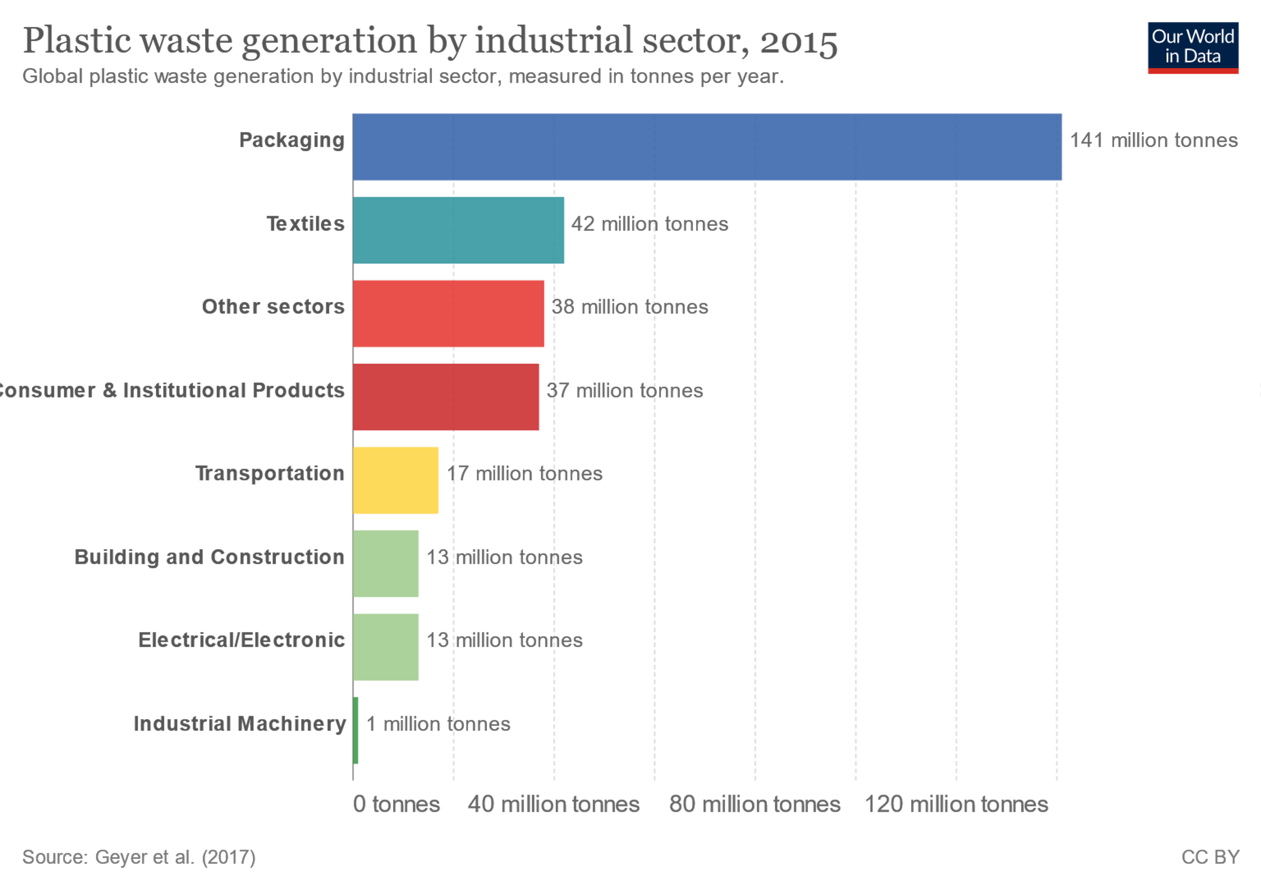
Figure 1.5.1: Global industrial waste by sector

1.5.2 Economic Impact

- Economic
  - Currently each component within the dosing system is commanded by a single controller consisting of an independent Human Machine Interface (HMI), and independent PLC totaling around $4,500.
  - Our IOT Controller will move the HMI and PLC to a single module which will be placed in each actuator and purge manifold increasing the cost of the component itself to $225 but reducing the overall control system cost by $1000.

1.5.3 Technical Impact

- Technical
  - We will increase the line speed of the packaging process by making each liquid nitrogen dosing actuator smart and independent
  - By doing this it also means the system size will no longer be a constraint for the actuator process in its entirety

1.6 Initial Project constraints

When creating an IOT Controller there are many constraints. This is mostly due to the designing of the Printed Circuit Board (PCB) layout, realizing that fabrication times vary depending on the product availability, shipping times, as well as many other factors.
After speaking amongst ourselves, we have concluded these constraints. The first constraint being COVID-19 affecting fabrication and shipping times. This resulted in us waiting much longer than expected to receive as well as order specific parts for our development and interface board. Another constraint our team discovered was the minimal documentation of the NanoSOM Chip itself. Due to this being an Exor Embedded manufactured microchip, their supported documentation was very limited. This gave us a great challenge in the design and engineering analysis portion of our project. The last major initial constraint was the team’s minimal knowledge in PCB design. Due to this, we conducted vigorous research to not only understand the components of the PCB but to be able to design a PCB to house the NanoSOM all while having the functionality of an IOT controller.

Section 2 - PROJECT PLANNING AND TASK DEFINITION

2.1 Task identification

Initially, the team used the deliverables provided by Chart Industries to formulate a plan of action of how we were going to complete the project. We decided to break up the hardware aspects and the software aspects of the project to different members of the team. The team decided to assign tasks by the semester in order to give each person ample time to complete their assigned task.

2.2 Gantt Chart

Our team started off with planning the length it would take us to conduct the research on the several different hardware components. We then had some sub tasks that for the research portion of the design phase because there specific things we were looking for like connectors, microchips, and pin sockets and headers.

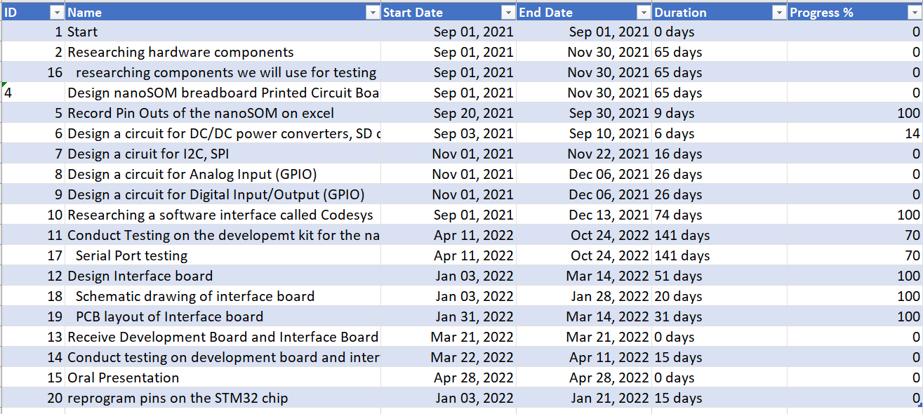Table 2.2.1:

Using the information from Table 2.2.1 we have generated a detailed Gantt chart as show in Figure 2.2.1. This gives the team a great visual of each task and their time frames.

2.2 Gantt Chart(continued)

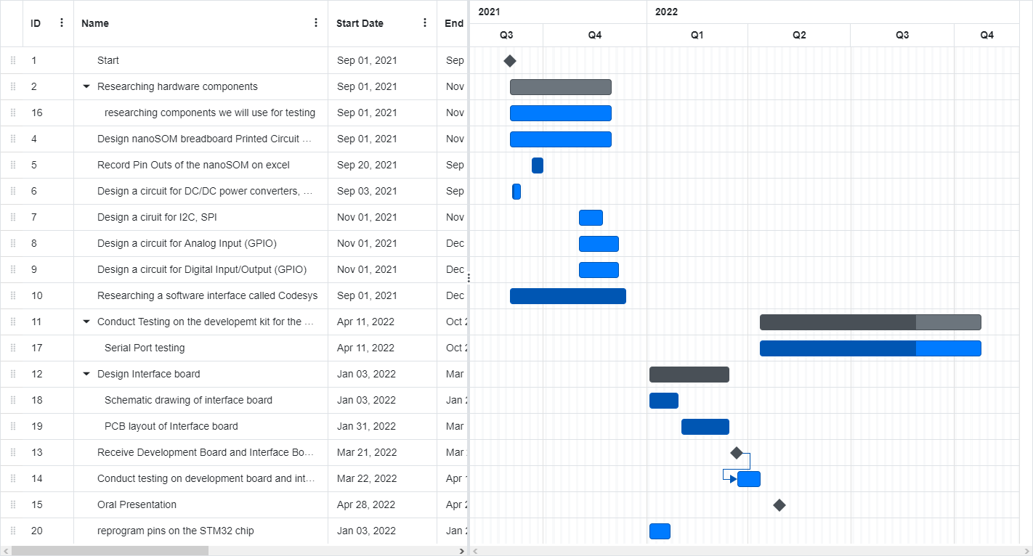
Figure 2.2.1:

Section 3 - Literature Review

3.1 List of all sources of information

The literature review utilized for the research of the NanoSOM nSO2 chip was gathered from Exor, a third-party company contracted by chart and actual developer of the NanoSOM chip itself. Even though it was already set in stone in our project scope that we would be utilizing the nSO2 chip within this design as desired and by Chart Industries and Exor, we still conducted research on some of the competitor parts as well as some of the predecessors created before the nS02 to better understand why the choice of this chip was ultimately the right decision in proposing a viable solution to the automated system control problem at hand by implementation of an Internet of Things (IOT) controller to replace the existing PLC design used by Chart as of right now. We compared our nSO2 chip with two of its predecessors in the nSO1 and uS01 chips, as well as a competitor company in Digi ConnectCore 8M NanoSOM. As shown in Figure 3.2:
NanoSOM nSO2
The proper choice for the new innovative IOT controller despite the one knock on the chip being that it had a limited number of inputs. However, for our design having a large quantity of inputs wasn’t necessary, and when you combined this with the fact it was a much more compact and efficient chip compared to its competitors to go along with a less expensive price tag it was easy to see why this should be our chip of choice as recommended by our sponsors.

3.1 List of all sources of information (continued)
NanoSOM nSO1
As one could probably guess by its name, the nSO1 is the predecessor to the aforementioned nSO2 and while it was still a great initial design compact when originally
created, the nSO2 definitely improved on the nSO1’s downfalls when it pertains to reliability and efficiency.

NanoSOM uSO1
This specific NanoSOM manufactured by Exor was a little different from their nSO chip line in the fact it predicated on having great reliability and efficiency while being equally highly compatible at the same time. However, the one major downfall when faced with our design constraints was that the uSO1 had larger dimensions than acceptable to be housed on the Dosing Actuator as desired, plus all of its other great specs significantly increased the price of the chip well over a comfortable amount for us in comparison to nSO2.
Digi ConnectCore 8M NanoSOM
When we compared our chip to outside competitors of Exor such as the 8M NanoSOM designed by Digi ConnectCore, we found that it rivaled the uSO1 in many aspects, those which did once again not meet our design constraints when it came to the actual size of the chip itself.

3.2 Statement of Learning from each source

Prior to constructing or brainstorming any designs of our interface and testing board, it was established the team needed to complete a literature review and gather a better understanding of the current market of NanoSOM’s as well as read documentation from Exor on the innovations the nSO2 improved upon from its predecessor the nSO1. We began this process by documenting what type of chips could compete with our nSO2 chip in theory even though as stated before it was decided in the original project scope given to us by Chart Industries and Exor that we would be utilizing Exor’s NanoSOM nSO2 chip to create an IOT Controller for a new overhaul of Chart’s automated systems. We did this by completing a chart that displayed a parts comparison between a few different chips manufactured by Exor as well as an outside competitor’s chip to further illustrate why the nSO2 was the correct choice at the end of the day in comparison to the other chips in the market. Although the various chips shared numerous qualities that were the same, the factors that set apart the nSO2 and the competition was its compact size while still maintaining even if not better reliability than the rest of the chips to go along with also being the cheapest option available. Lastly this comparison chart further validated and assured us that the recommendations made by our sponsors were in fact correct and we could begin to design our board tailored to the specifications of the NanoSOM nSO2.

3.2 Statement of Learning from each source(continued)

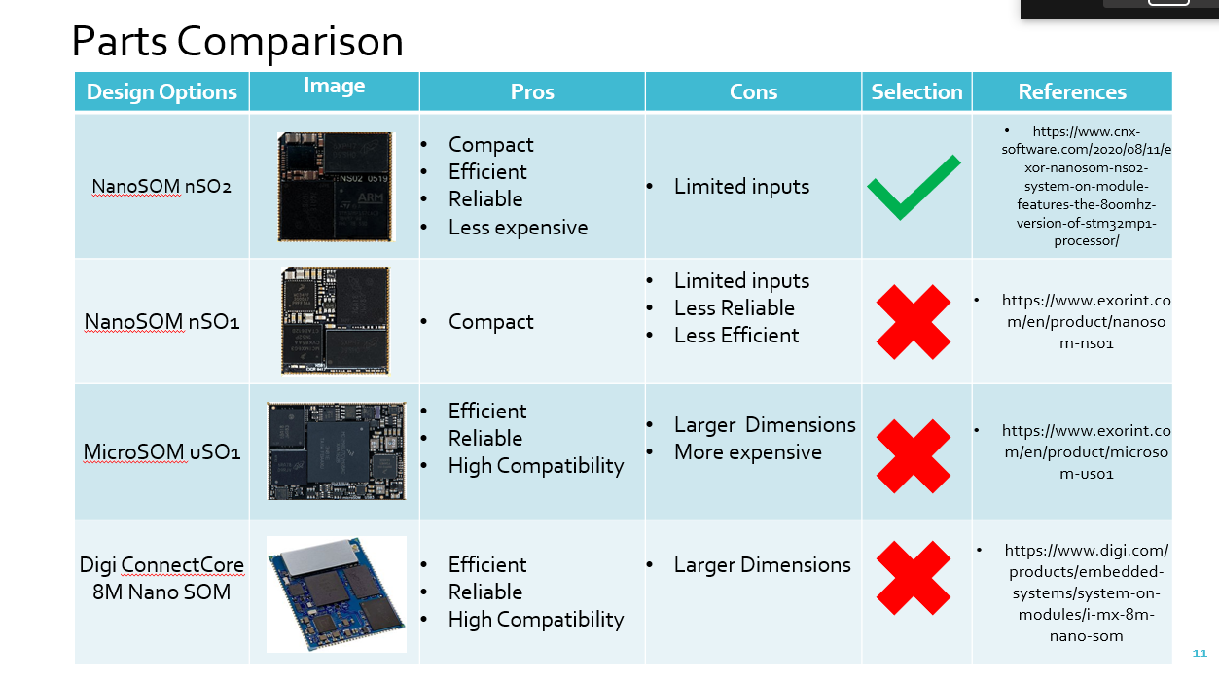
Figure 3.2.1: Parts Comparison Chart

Section 4 – PRELIMINARY DESIGN

4.1. Concept Generation

Before starting our concept generation, our team in combination with our sponsors at Chart Industries first came up with the methodology to design a new IOT automated system by building an IOT controller around the NanoSOM so that it could serve as a data node for all of Chart’s future IOT endeavors. We compiled this information together to develop our design methodology flowchart shown below.

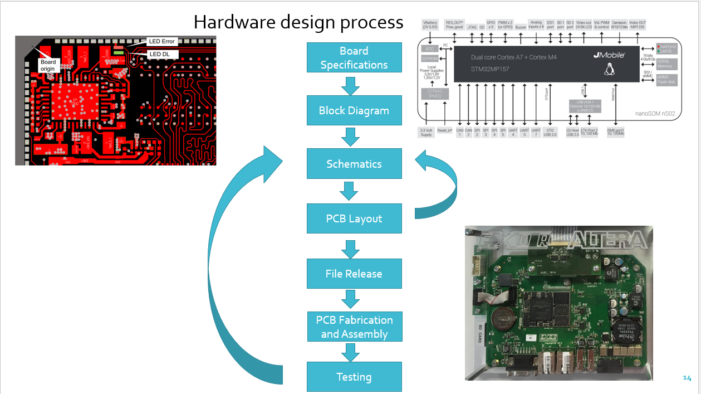
Figure 4.1.1 Engineering Design Methodology

4.1 Concept Generation (continued)

Referencing Figure 4 previously mentioned above, the team started with identifying all the board specifications tailored to our proposed design to house the NanoSOM NsO2 chip. Moving along the flow chart, we next obtained a block diagram of the aforementioned chip which listed all the pin operations that way we could designate which ones we wanted to incorporate into the final design. Dealing with the schematics portion of the project is where we designed the development board itself, and where we connected each pin of the NanoSOM Ns02 to the corresponding header pins for the most optimal circuitry design. Making progress with a successful schematic diagram we were then cleared to create a Printed Circuit Board layout which we will refer to as PCB for the remainder of this section, and this stage was essentially creating the actual layout with each design measurement, material, and pin designation etc. on a special software which could then be translated into various Gerber files in preparation for the following step so that a File Release containing the Gerber files could be sent to an outside manufacturing company utilized by Chart Industries to fabricate our test board. Rounding out our flow process is the testing stage where in theory the testing board would be sent to us after being completed by the manufacturer where we would then run through a very thorough testing process to decipher whether we could successfully program our controller to serve as an IOT data node, or we would then revert to the Schematic Design/PCB layout portion of the flow chart to try and fix any design flaws. Unfortunately, due to a shortage of circuit board parts in combination with Covid-19 shipping and handling delays we never received our official interface board, and subsequently did not complete a series of tests as thorough as originally intended.

4.2. Concept Evaluation and selection

Due to our constraints receiving the PCB pictured below in its 3D model form as shown in figure 4.2.1, we had to go a different route for proving our design a successful one. After a few internal meetings with the team as well as a few Microsoft Teams meetings with our sponsors at Chart Industries we decided we would utilize our Human Machine Interface (HMI) Development board programmed with Linux Yocto software which we received in the beginning of this spring semester to display a few demos of reprogramming certain pins to interact with its cloud environment and showcase the results on an output screen. We even went a step further and used another recommended software known as NodeRed which is another program tool used for hardware devices and further validated that our design would allow the controller to successfully connect and interact with our written software code.
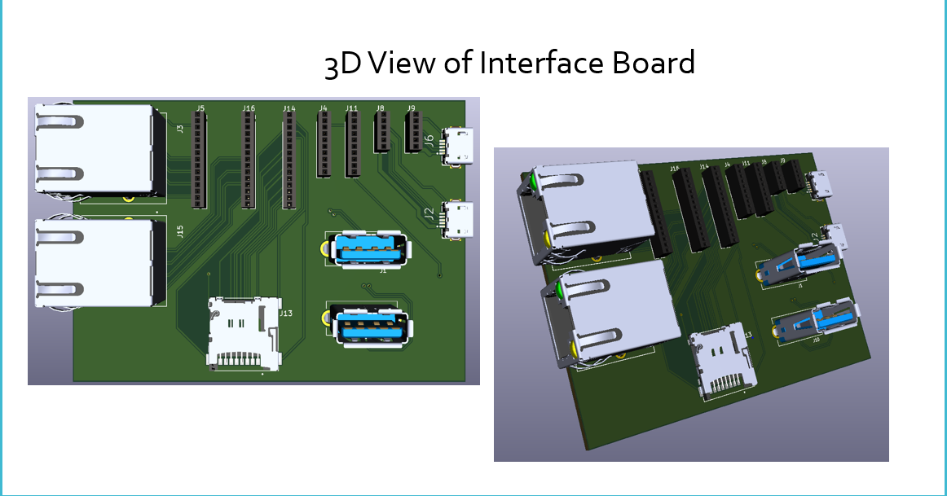
Figure 4.2.1: 3D View of Interface Board

4.3. Design Constraints and Applicable Codes and Standards Used in the Preliminary Design

Before we settled on a final design, we completed adequate research on a multitude of different design aspects related to the breadboard as well as the pins and their functionalities on the NanoSOMnS02 so that we could meet all design standards and protocol. Due to the fact this was a very high-level technical project, and it was being supported by an industry sponsor we first and foremost wanted to be working with the upmost integrity and honesty about delivering a viable design solution as mentioned in 7.8 IEEE code of ethics. Some advice we received from one of our sponsors, David Fink, was to note the difference between an engineering code and an engineering standard. A code is a law that must be followed, and standard is a recommended practice agreed upon by industry. As a result, we also researched and discovered a few codes & standards pertaining to the International Electrotechnical Commission (IEC) and the Interconnecting and Packaging Electronic Circuits (IPC) since we were in fact building a breadboard from scratch, as well as setting up a few circuits to test our equipment such as the Ethernet Testing, we completed during the last phase of our design process using a “Daisy Chain” Topology strategy as pictured in figure 4.3.1.

4.3. Design Constraints and Applicable Codes and Standards Used in the Preliminary Design(continued)
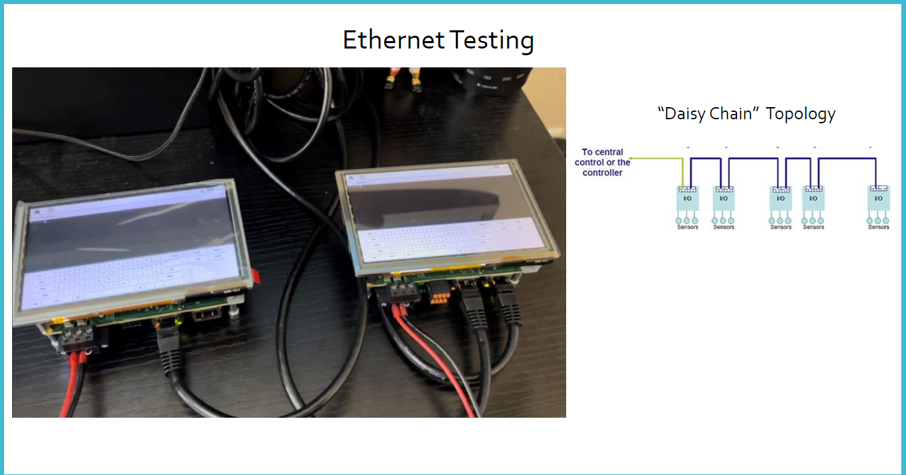Figure 4.3.1: “Daisy Chain” Ethernet Testing

For a deeper insight into some more of the Codes & Standards we selected to aid us in completing the project can be detailed as the following:
IEEE: Institute of Electrical and Electronics Engineers
- IEEE 829-2008: IEEE Standard for Software and System Test Documentation – This standard was used as the guidelines to follow when testing the performance of our system as well as functionality of individual parts.
- 7.8 IEEE Code of Ethics: To uphold the highest standards of integrity, responsible behavior, and ethical conduct in professional activities -The IEEE codes of ethics were utilized throughout our design, development, and testing processes.

4.3. Design Constraints and Applicable Codes and Standards Used in the Preliminary Design (continued)

IEC: International Electrotechnical Commission
- IEC 61010-2-202: IEC Safety requirements for electrical equipment for measurement, control, and laboratory use – This standard outlines the safety guidelines to be followed when working on/building our controller for the actuator.
IPC: Interconnecting and Packaging Electronic Circuits
- IPC-2221: This is a standard from IPC that outlines what we had to keep in mind regarding design layouts, parts lists, materials, mechanical and physical properties.
- IPC-A-600F: This standard outlined the acceptance criteria for building our board as well as what to look for in terms of defects and incident prevention.
- IPC-9701A: This specification establishes specific test methods to evaluate the performance and reliability of surface mount solder attachments of electronic assemblies. - This standard touches on guidelines to be followed when placing our NanoSOM chip on the Printed Circuit Board (PCB).
- IPC- 7711C/7721C: Prescribes the procedural requirements, tools, materials, and methods to be used in the rework, repair, modification, overhaul, or restoration of electronic products. – These particular standards outline procedures to be followed if/when we need to make design changes to PCB upon analyzing testing results

4.3. Design Constraints and Applicable Codes and Standards Used in the Preliminary Design (continued)

- IPC-A-610: IPC-A-610 standard includes requirements and guidelines to help PCBA assembly manufacturers ensure that their manufacturing process meets acceptable quality levels. - standard that ensures our PCB will meet all design inspection guidelines

4.4. Preliminary Analysis

After acquiring the necessary background information we desired before constructing the official design, the team’s comprehension level of the task at hand was significantly increased. Moving forward with this better understanding of all design requirements and specifications to be abided by, we concluded on breaking up our design process into 3 phases. The first of these focuses on all the pin outs built into the NanoSOM nS02 chip, and to begin the process of updating these pins with our desired functionalities. We first had to decipher multiple data sheets provided to us by chart listing out all 200 of the NanoSOM’s pin connection functionalities. One unique feature about this specific part of the project when it came to the NanoSOM02 is that it is a dual sided chip with external and internal connectors making up to 200 pin connections, so we first created our own excel sheet which accounted for all 200 pins and what specific functionality we wished to tie directly to that pin so that we would mitigate the process of having to go back and forth between different data sheets when it game to the programming stage of our design process, for a better understanding of the connector pads and their connections is showcased in Figure 4.4.1 on the following page which highlights a schematic diagram of the external and internal chip layout discussed here.

4.4. Preliminary Analysis (continued)
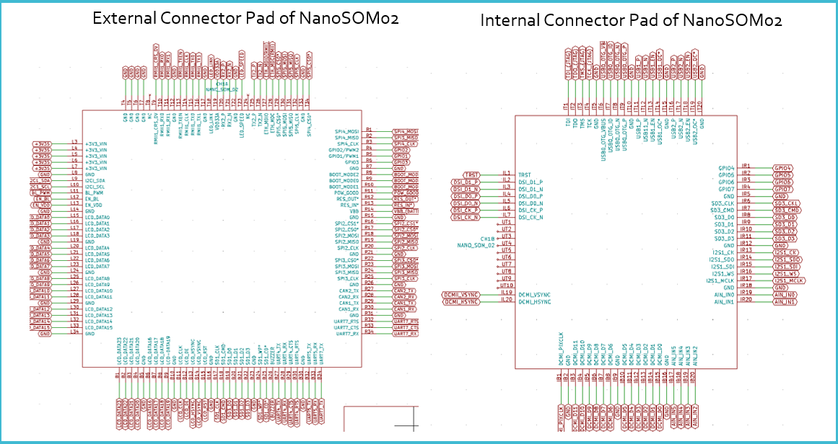
Figure 4.4.1 External/Internal Connector Schematic Diagram
Due to the fact our NanoSOM contained dual sided capabilities we would designate a square hole for its placement on the development board that way we could implement circuitry design. This would in turn help us to maximize the capability of all our NanoSOM chip’s unique features with the male and female connectors.

4.5 Preliminary Design

Lastly, with all connection Pin outs and their respective functionalities set we could then begin to designate the connection specifications on the board and start determining how those connections would be spaced and wired on the PCB for optimal production from the IOT controller itself. Completing this step within the process was very time-consuming but is also necessary in helping us scale down the size of our test board as we needed a board fit to be housed on the Dosing Actuator itself. Although we knew of the size constraint prior to our first initial design we designed a much bigger board than we expected. We did this to gain a better understanding of all the components we would be implementing on the testing board before scaling down in size to meet the constraints previously mentioned. This evolution of our board from phase 1 to phase 2 of the design process can better be seen between Figures 4.5.1 and 4.5.2 accordingly.
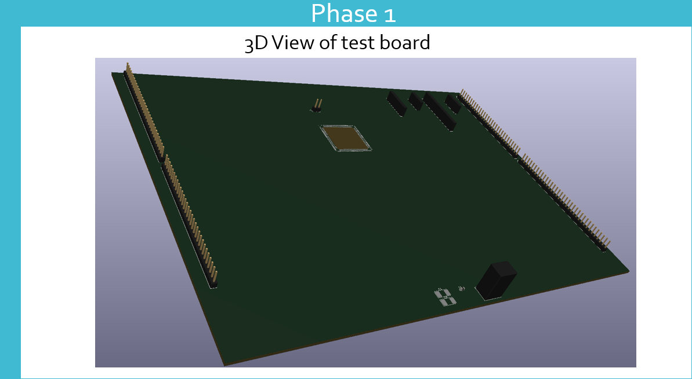
Figure 4.5.1 Phase 1 Design
4.5 Preliminary Design (continued)

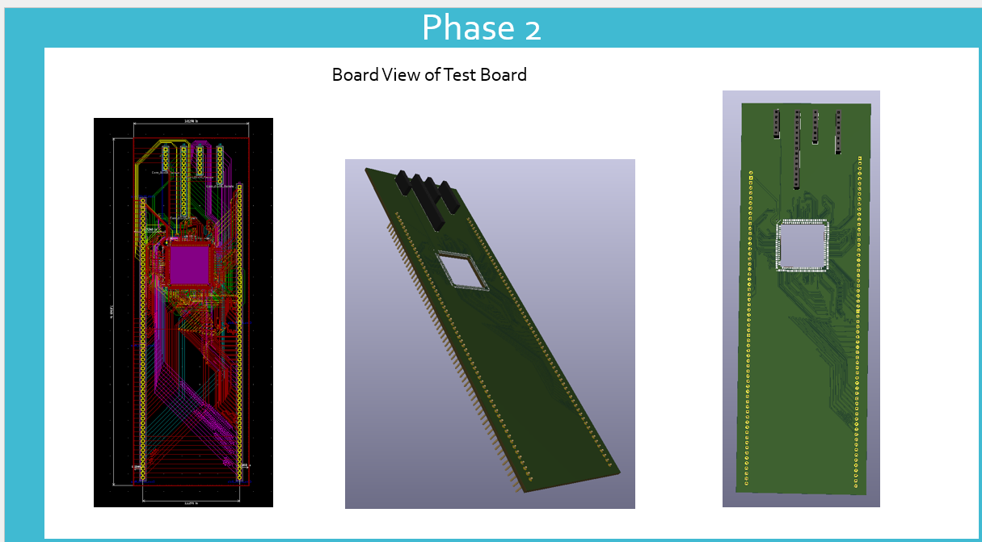
Figure 4.5.2: Phase 2 Test Board Design
As previously mentioned, getting a better feel for the spacing of each pin out connection really helped us sure up a lot of our initial design flaws related to sizing of the board as we were essentially almost able to cut down our overall size in half and we weren’t done there yet either as the final product for the interface board officially came out to be 2.28 in by 3.17 in. From here we were then able to identify which specific electronic components we needed to order which would coordinate with their respective pin out placements such as the use of ethernet connection ports which were vital in the testing stage as mentioned and depicted in section 4.3 with our “Daisy Chain” Topology setup use to showcase interaction between our components and the HMI development kit we were testing on. We then compiled a list on excel of all the necessary electrical components we wished to implement on our board by utilizing authorized electrical
4.5 Preliminary Design (continued)

component distributors such as Digi-Key and Mouser Electronics which helped to minimize the constraint of finding actual components during this time period of current shortages on parts within the industry. With the list of parts completed we could then transition into making each component’s specific diagram which detailed all its specific connections within our interface board design to be placed on the testing board. An example of this process can be found in the following two figures which highlight one of our micro-SD card connections.
Figure 4.5.3 Micro-SD Card on part list
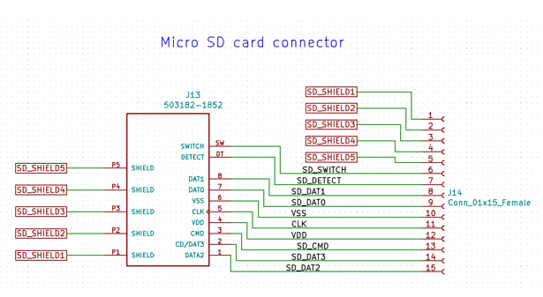
Figure 4.5.4: Micro SD Connector Schematic
4.5 Preliminary Design (continued)

Even though we never received our manufactured boards we were able to use AutoCAD software to create a 3D view of both our interface and testing board respectively which was then transcribed once more for an even more realistic view of what our finalized design would look when precisely assembled according to our design specifications and constraints for our testing procedures on the development board sent to us by chart which was a part of the original testing kit sent to us at the start of this project. The overall testing setup view was created from the initial 3D AutoCAD sketch depicted in figure 4.2 and can be seen below in an image taken from a demo testing video we created.
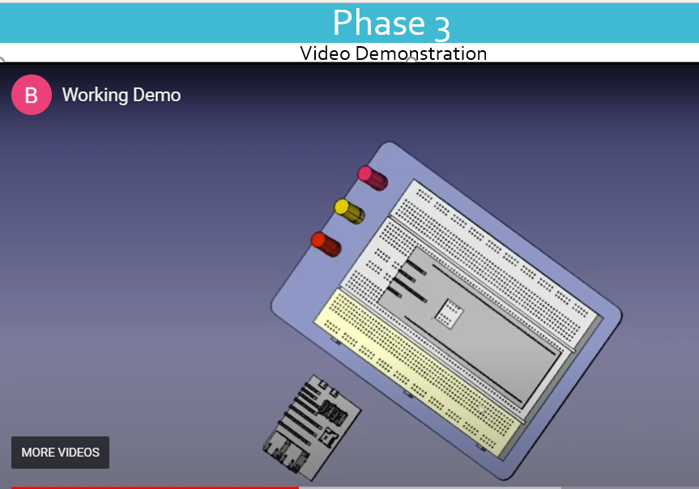
Figure 4.5.5: Final Board Testing Setup

4.5 Preliminary Design (continued)
In the end, although we were not able to physically receive our test boards, we still managed to validate success based on our proposed design by integrating the HMI development board using our various USB, Ethernet, Visual etc. port connections to interact with a host computer by way of numerous Secure Shell (SSH) network communication tests.

Section 5 - DETAILED SYSTEM DESIGN

5.1 Project Parts Summary

This project consists of several parts to make the development board and interface board functional. Table 5.1.1 shows all the components that are on the development board. Due to the numerous pins that the NanoSoM02 has it was necessary to have a large amount of pin headers that would be routed or connected to the NanoSoM02 itself. The main reason for designing pin headers and pin sockets around the NanoSoM02 is because the development board, which will be housing the NanoSoM02, will be used as a test bench. To conduct proper testing, the team decided to create a second board which is an interface board. The interface board would house several different connectors we deemed that were important to include in the project. The interface board houses two RJ45 ethernet connectors, two USB type A connectors, two micro-USB type B connectors, and one micro-SD card connector. The ethernet connectors are shown in rows one and eight, the USB connectors are shown in row two, the micro-USB connectors are shown in row six, and the micro-SD card connector is shown in row four. Both Table 5.1.1 and Table 5.1.2 were developed and used mostly in phase three of the project.

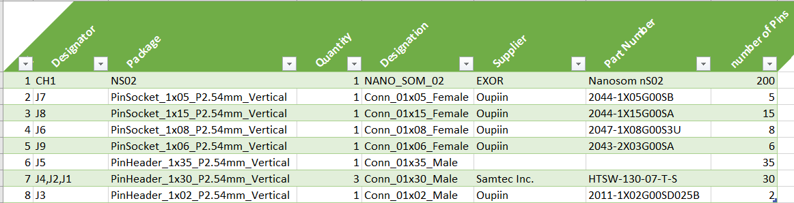
Table 5.1.1: Bill of materials for the development board

5.1 Project Parts Summary(continued)

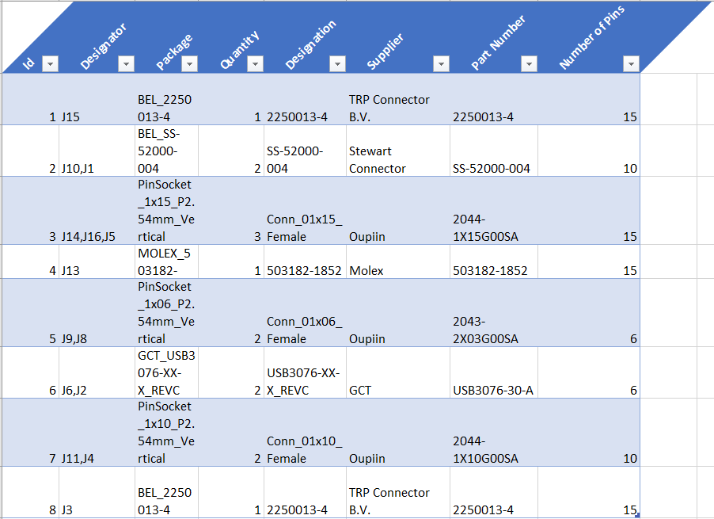
Table 5.1.2: Bill of materials for interface board
5.2 Engineering Analysis and/or Simulation

At the beginning of the design process the team deemed it important to use electronic design software for the design of the physical printed circuit board. The electronic design software the team used is KiCad Electronics Design Automation (EDA). This software allowed the team to use schematic capture, printed circuit board (PCB) layout, and 3D viewer. In the schematic capture the team was able to create circuits as well as create symbols that will be used in the design of certain circuits. Using the PCB layout function of the KiCad software the team was able to design two printed circuit boards for our project. To design the boards using PCB layout the team had to determine how to route the connections between components and parts, where the components are to be placed on the board, and the dimensions of the printed circuit board itself.

5.3 Hardware Layout/Detailed Drawings/Equipment selection and specifications

Starting off, the team began with creating the symbol for the NanoSoM02. Due to the way the NanoSoM02 is designed, the team had to create two symbols for this single chip. The reason the two symbols had to be created will be explained later in this section. The first symbol shows the external connector pads shown in Figure 5.3.1 and the second symbol shows the internal connector pads shown in Figure 5.3.2.

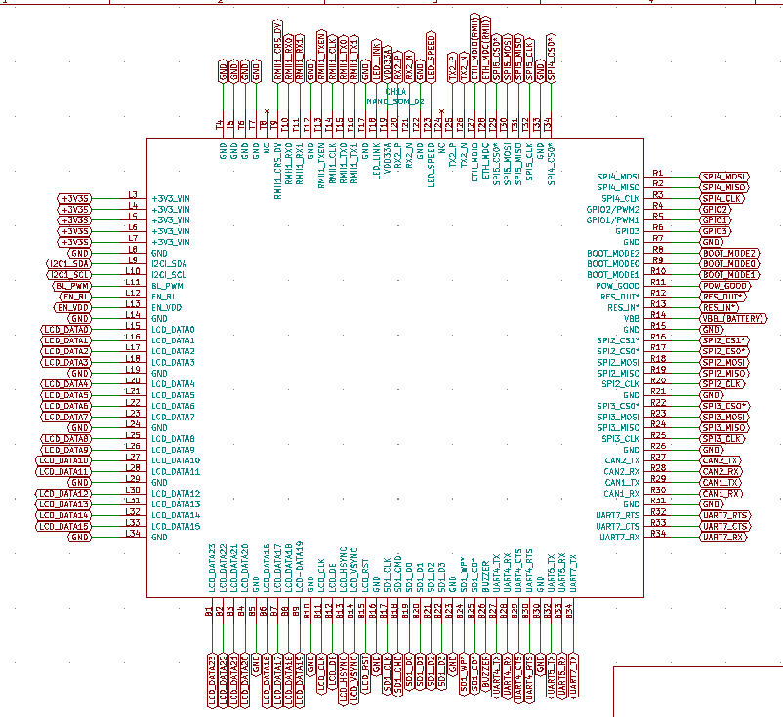
Figure 5.3.1: External connector pads
5.3 Hardware Layout/Detailed Drawings/Equipment selection and specifications (Continued)

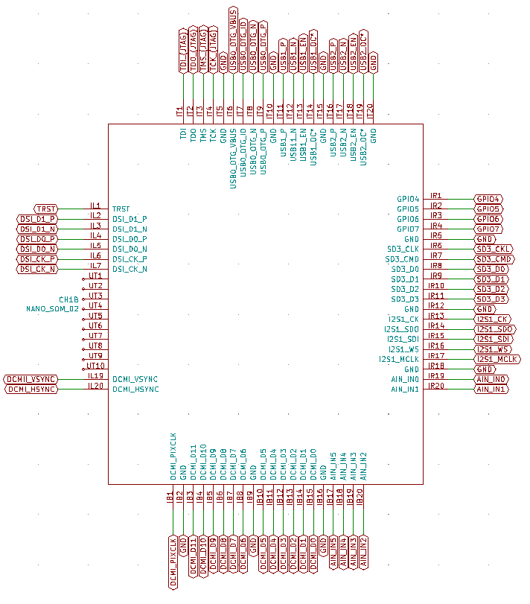
Figure 5.3.2: Internal connector pads

Once the symbols for the NanoSoM02 were created, the next step was to find symbols to represent the pin headers and pin sockets shown in Figure 5.3.3 and Figure 5.3.4 respectively. Once the symbols for the connectors were created, the team made the connections from the pins of the NanoSoM02 to the pin headers and sockets. The pin headers and pin sockets will ultimately be used to connect to a bread board to create circuits and conduct testing on the

5.3 Hardware Layout/Detailed Drawings/Equipment selection and specifications (Continued)

breadboard. A majority of the schematic design for the development board was developed in phase one.

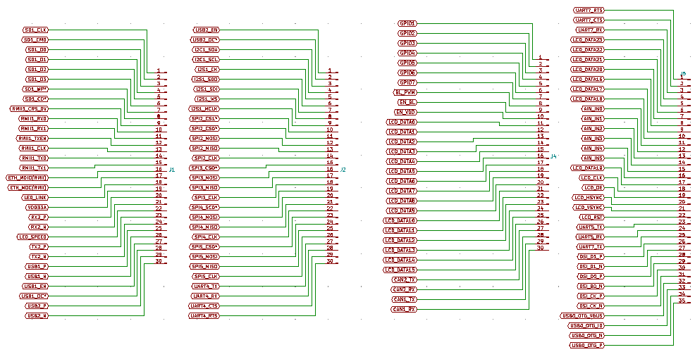
Figure 5.3.3: Male connectors/Pin headers

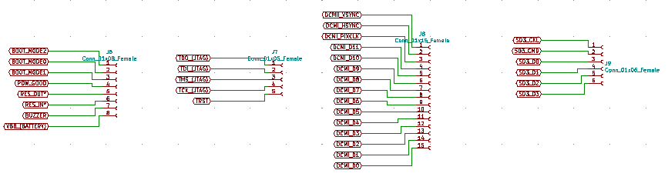
Figure 5.3.4: Female connectors/Pin sockets

5.3 Hardware Layout/Detailed Drawings/Equipment selection and specifications (Continued)

Once the connections between the NanoSoM02 and the pin headers were made, the next step was to start placing parts and routing in PCB layout. A completed view of the printed circuit board in the “layout view” is shown in Figure 5.3.6. To get to this point, first the team had to make sure the dimensions of the board itself would fit to be mounted on a breadboard. The entire development board itself is 7.65 inches by 2.5268 inches. Our team wanted to make sure that the development board was big enough to allow the proper spacing need to route traces on the board, but also slim enough to allow enough space to jumper wires off of a bread board once the development board was connected to one. For the development board to properly fit on the breadboard we had to make sure the male pin connector headers were 2.1270 inches apart from each other. Another thing to consider when we were routing the board was how many layers, we were going to make the board. We eventually, through trial and error, decided that eight layers would be enough for the development board we were designing.

5.3 Hardware Layout/Detailed Drawings/Equipment selection and specifications (Continued)

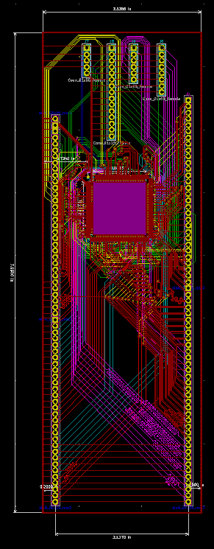
Figure 5.3.5 PCB layout of development board

In the 3D model of the development board shown below in Figure 5.3.7 it can be seen that there is a hole nearly in the center of the board. The reason behind that is because the NanoSoM02 has components on the topside as well as the bottom side of the module. A good

5.3 Hardware Layout/Detailed Drawings/Equipment selection and specifications (Continued)

visual of how the components are placed on both sides of the module and where the solder pad for the pins are placed are shown in Figure 5.3.8.

5.3 Hardware Layout/Detailed Drawings/Equipment selection and specifications (Continued)

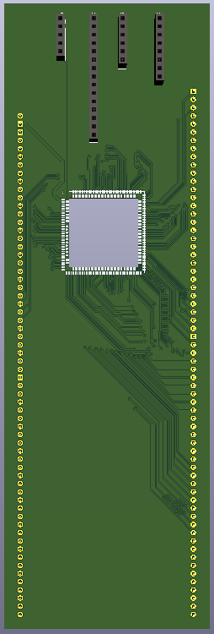
Figure 5.3.6: current 3D view of development board

5.3 Hardware Layout/Detailed Drawings/Equipment selection and specifications (Continued)

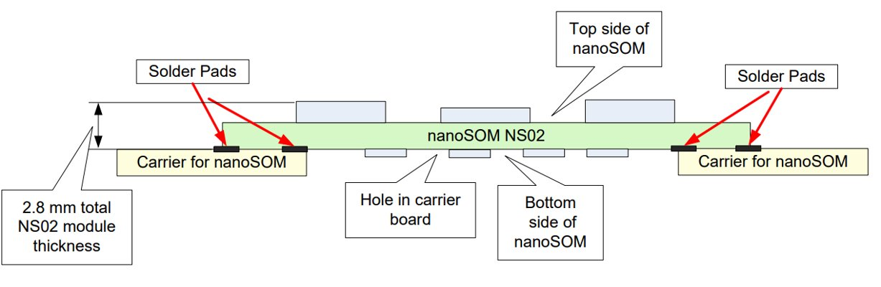
Figure 5.3.7: Side view of NanoSoM02 module

5.3 Hardware Layout/Detailed Drawings/Equipment selection and specifications (Continued)

Figure 5.3.8 gives a side profile of the development board. In this view the male pin headers can be clearly seen. With the development boards designed more than half of phase two was complete.
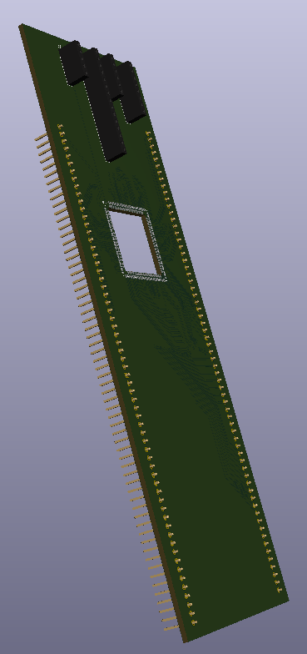
Figure 5.3.8: Side View of current 3D view of development board
5.3 Hardware Layout/Detailed Drawings/Equipment selection and specifications (Continued)

In the latter part of phase two our teams decided to design an interface board that would house several different types of external connectors. The connectors are two RJ45 ethernet connectors (Figure 5.3.9), two USB type A connectors (Figure 5.3.10), one micro-SD card connector (Figure 5.3.11), and two Micro-USB type B connectors (Figure 5.3.12).

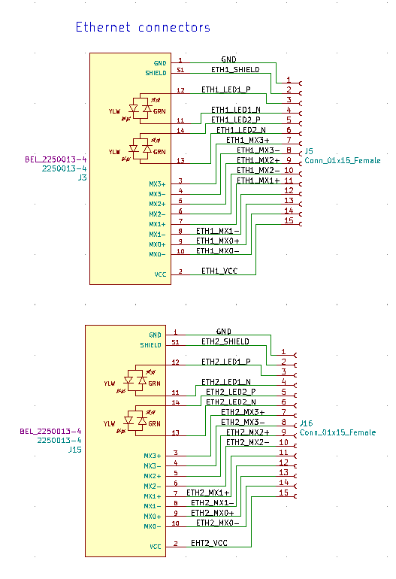
Figure 5.3.9: Symbol of RJ45 ethernet connectors

5.3 Hardware Layout/Detailed Drawings/Equipment selection and specifications (Continued)

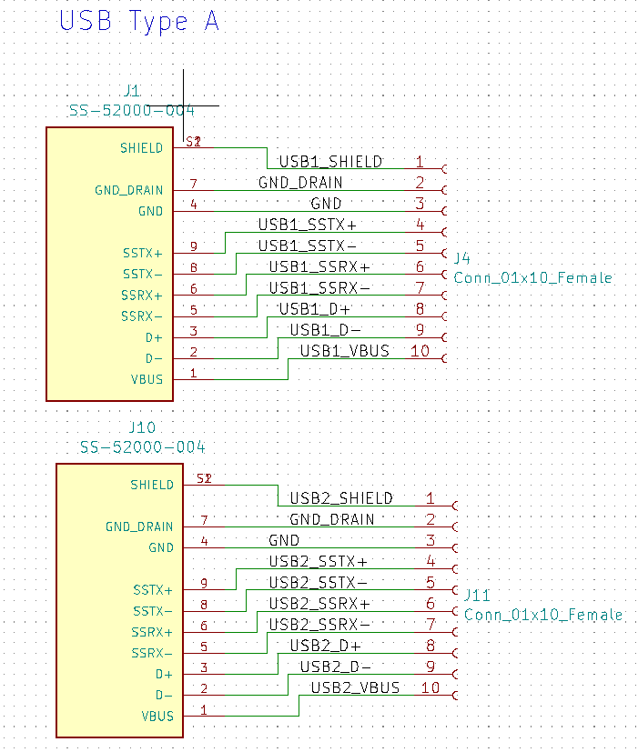
Figure 5.3.10: Symbol of USB type A connector
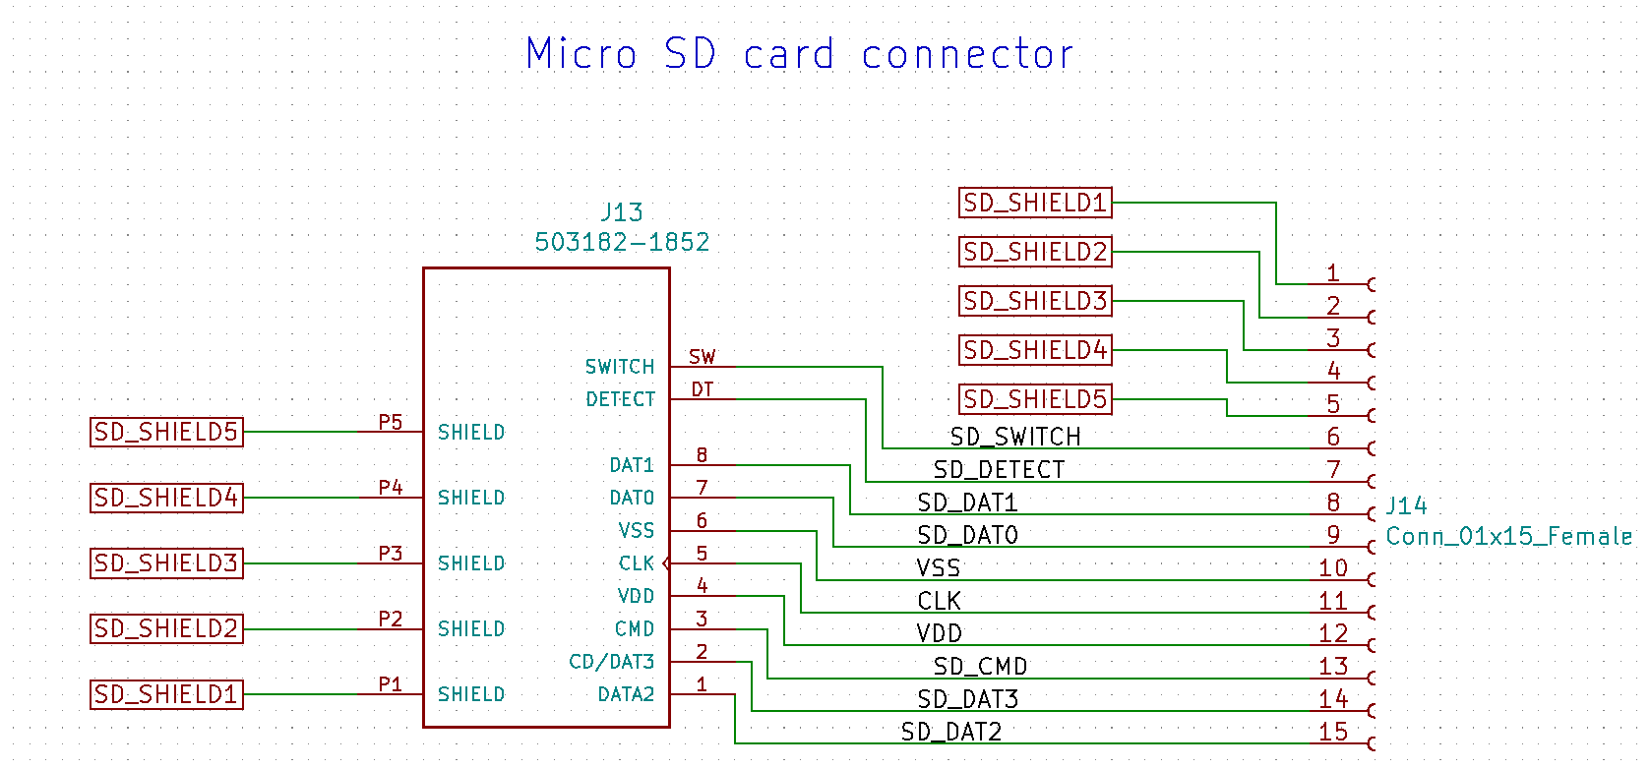
Figure 5.3.11: Symbol of micro-SD card connector

5.3 Hardware Layout/Detailed Drawings/Equipment selection and specifications (Continued)

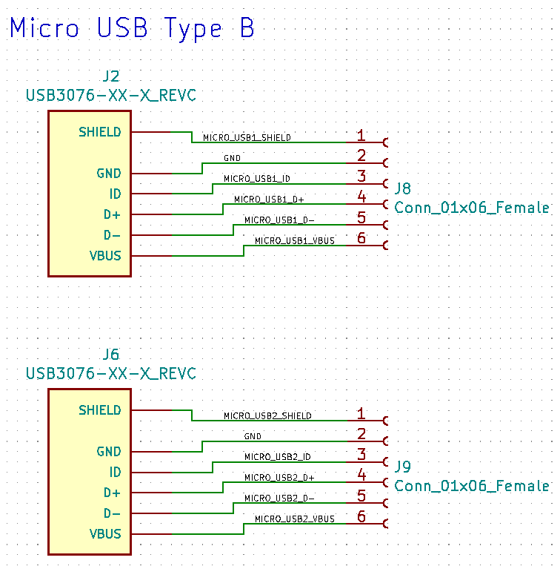
Figure 5.3.12: symbol of micro-USB type B connector

5.3 Hardware Layout/Detailed Drawings/Equipment selection and specifications (Continued)

The interface board shown in Figure 5.3.13 is 3.17 inches by 2.28 inches. The board consist of four layers and all the connectors are connected to female pin sockets.
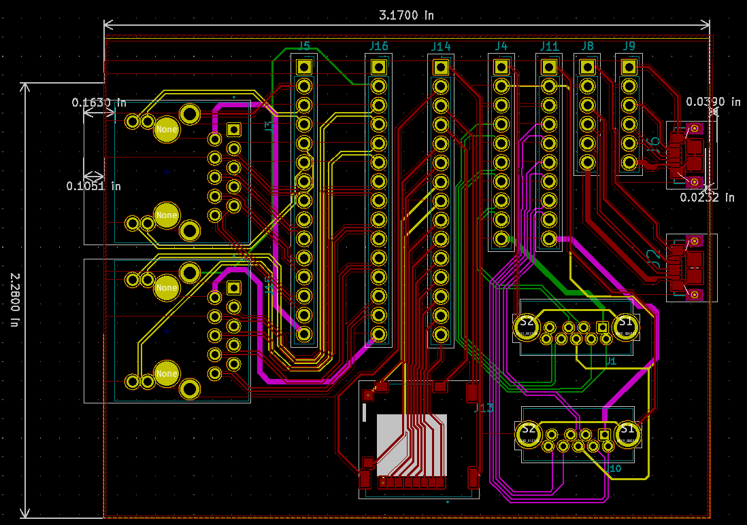
Figure 5.3.13: PCB layout of interface board

5.3 Hardware Layout/Detailed Drawings/Equipment selection and specifications (Continued)

In figure 5.3.14 a 3D model of the interface board is shown. All the parts that our team specifically picked are shown on the 3D view of this board.
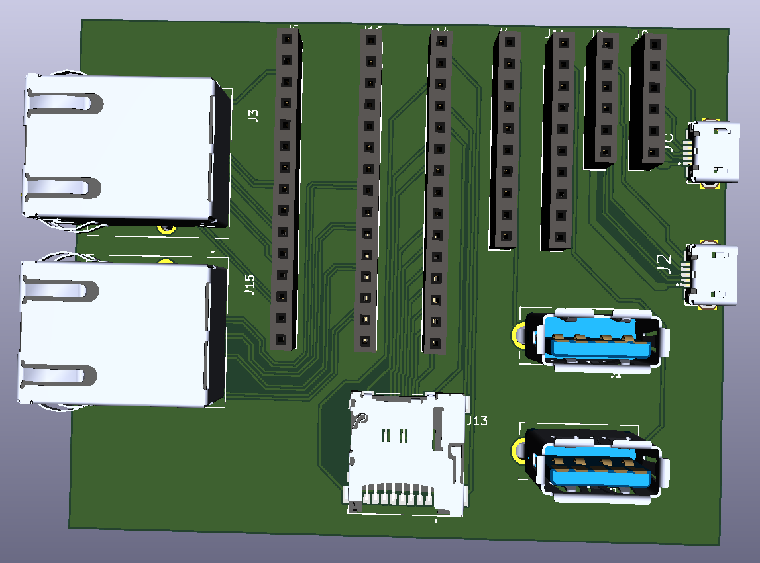
Figure 5.3.14: 3D view of interface board

5.3 Hardware Layout/Detailed Drawings/Equipment selection and specifications (Continued)

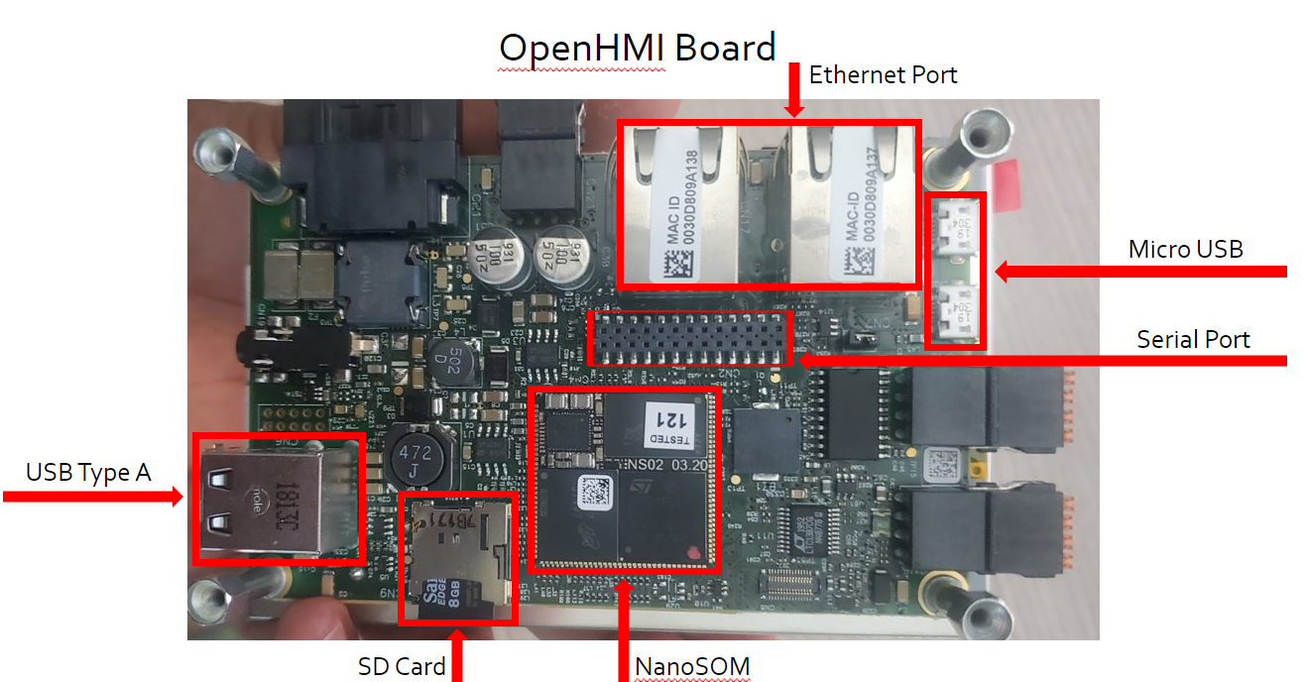
Figure 5.3.15: View of OpenHMI development kit

Figure 5.3.15 shows a board view of our OpenHMI development kit. Highlighted are the components that we have discussed and agreed on moving to our development and interface boards. One goal of our development and interface boards was to only utilize components necessary for function and eliminate any unneeded components. As you can see above, we decided first and foremost to house the NanoSoM onto our development board. Since we were creating a board based on the NanoSoM itself, it was necessary to have. Next, we moved both USB ports onto our board. The first being USB Type A to allow for connection of peripherals such as a keyboard and mouse. The use of a keyboard and mouse allowed for much easier interaction with the OpenHMI kit as the screen is very small and touch inputs had to be precise.

5.3 Hardware Layout/Detailed Drawings/Equipment selection and specifications (Continued)

Next, we had to have micro-USB ports on our board for programming and debugging
purposes. Our SD card needed to be on the interface board due to the SD card housing our operating system which Is Linux Yocto. Finally, we moved to the serial port and ethernet ports which we will further elaborate on.

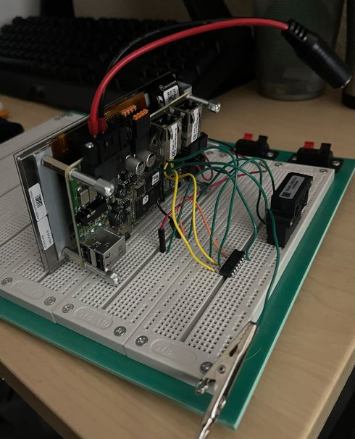
Figure 5.3.16: Picture of counter and sensor circuit

5.3 Hardware Layout/Detailed Drawings/Equipment selection and specifications (Continued)

As seen in the figure 5.3.16 above, this is our sensor (Siargo FS5001) and counter (LS733R) circuit. The reason behind creating this circuit was to validate moving the CN2 serial port (below in figure 5.3.17) onto our development or interface board. We were able to construct this circuit by cross analyzing data sheets from Exor Embedded, Siargo, and LSI/CSI. This was
supplemental in the overall design portion of our project and gave us validation to create headers on our interface board as well as interface board. These headers will serve as serial ports that allow for circuit routing.
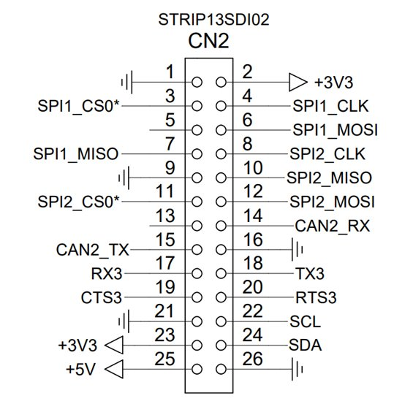
Figure 5.3.17: pinouts of serial port

5.3 Hardware Layout/Detailed Drawings/Equipment selection and specifications (Continued)

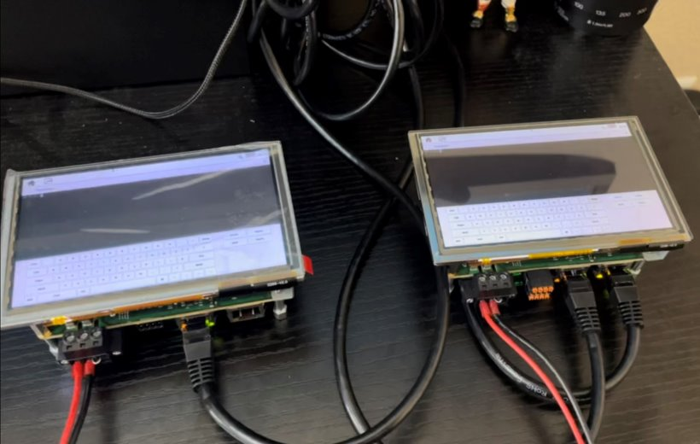
Figure 5.3.18: Two Open HMI development kits daisy chained together

For our ethernet port validation, we wanted to explore the capabilities of the ethernet ports before deciding if they were necessary for our board to be deemed functional. When speaking with Chart Industries we determined we needed a way to connect to our Open HMI boards and potentially share data across multiple devices. This is where SSH or Secure Shell testing came into fruition. With the “daisy chain” configuration seen above and below in figure 5.3.19 and figure 5.3.20, we were able to connect multiple Open HMI boards utilizing both ethernet ports. To further explain this process, these controllers are connected consecutively utilizing both ethernet ports which act as switches to give the consecutive controller ethernet connectivity. After we successfully had functionality in our ethernet ports across multiple controllers, we were

5.3 Hardware Layout/Detailed Drawings/Equipment selection and specifications (Continued)

able to SSH into our device and create directories or folders for potential data sharing and creation. This validated the need for ethernet ports on our interface board.
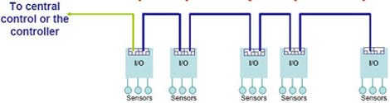
Figure 5.3.19: diagram of ethernet daisy chaining

5.3 Hardware Layout/Detailed Drawings/Equipment selection and specifications (Continued)

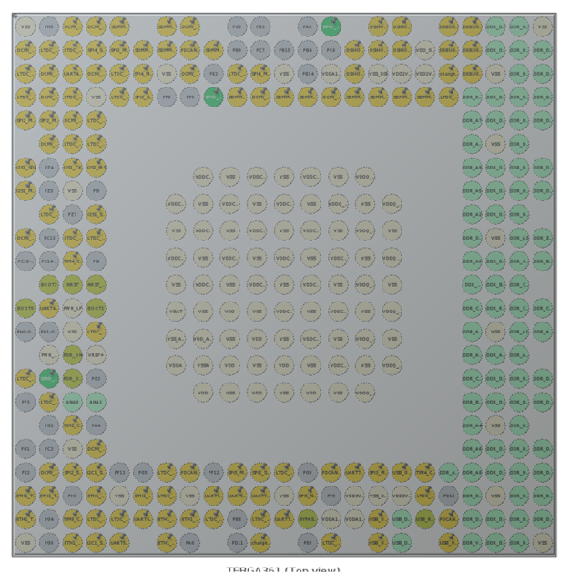
Figure 5.3.20: STM32Cube IDE

One flaw to the NanoSoM02 is the limited configured GPIO functions. To combat this, we were able to utilize the STM32Cube IDE software to reprogram certain pin functions to better fit our needs. As seen above in figure 5.3.20 this is the STM32Cube IDE running on our Linux Ubuntu machine. Below in Figure 5.3.21 is a small portion of the spread sheet we constructed to help with the reprogramming process.
5.3 Hardware Layout/Detailed Drawings/Equipment selection and specifications (Continued)

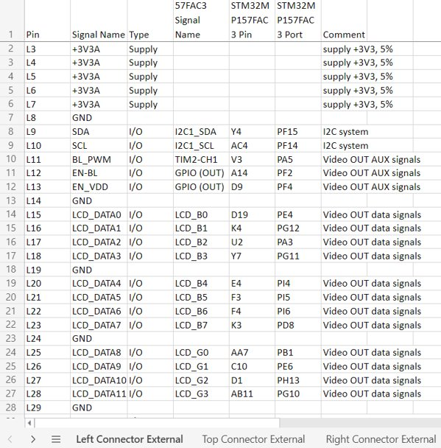
Figure 5.3.21: Pin connections on the NanoSoM and STM 32 chip
5.4 Application of Engineering Codes and Standards used in Final Design

IEEE Engineering Code 829-2008: IEEE Standard for Software and System Test Documentation
This code was used as the guidelines to follow when testing the performance of our system as well as functionality of individual parts.

IEEE Engineering Code of Ethics: To uphold the highest standards of integrity, responsible behavior, and ethical conduct in professional activities
The codes of ethics were utilized throughout our design, development, and testing processes to make sure that we were accepting criticism from our industry reps at Chart regarding our progress and sticking to the project's objective and goals.

IEC Engineering Code 61010-2-202: Safety requirements for electrical equipment for measurement, control, and laboratory use
Specifies the safety requirements for electricity Helped the team understand the safety guidelines our board needed to meet while being developed.

IPC Code 2221: IPC Standard on Printed Board Design
This helped with the development and creating the design layouts, parts lists, materials, mechanical and physical properties.

5.4 Application of Engineering Codes and Standards used in Final Design (Continued)

IPC Code -A-600F: Acceptability of Printed Boards
Established quality standards that our board needed to meet. We used this as a criterion for building our board and to develop a checklist of what to look for in terms of defects and incident prevention.
IPC Code 7711C/7721C: Rework, Modification and Repair of Electonic Assemblies
The procedural requirements, tools, materials, and methods to be used in the rework, repair, modification, overhaul, or restoration of electronic products. This code was utilized if/when we need to make design changes to our printed circuit board upon analyzing testing results so that we can make sure we follow the proper procedures.

IPC Code -A-610: Acceptability of Electronics Assemblies
Established standards for the fully assembled board. Using this code helped in ensuring that our printed circuit board will meet all design inspection guidelines for it to be fabricated.

5.5 Economic Analysis

Chart Industries handled the economics of this project providing us with the necessary parts and materials needed in order to design our breadboard. Below in Table 5.5.1 is the bill of materials for our interface board. Table 5.5.2 is the bill of materials for our development board. The estimated cost per unit is $3500.

Table 5.5.1: Bill of materials for interface board
Table 5.5.2: Bill of materials for the development board

5.6 Final Design

For phase 3 our team both the development board and the interface board are completely designed. And when the team receives both boards we will conduct testing on both of them using a bread board. As shown in Figure 5.6.1 the development board will be placed on top of the breadboard. And the team would be able to create varying circuits and test them using the both the development board and the interface board.
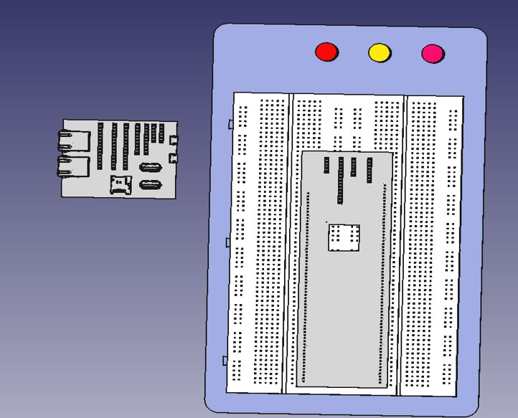
Figure 5.6.1

Section 6 - RESULTS & DESCUSSION

6.1 Summary of Goals and Objectives

The main objective of our project was to develop a more standard breadboard design for future IOT device testing at Chart Industries. This design will be used to modernize many of their technological systems rather than just the Dosing Actuator application. The goal of our group was to first design and create a breadboard that could be implemented into the systems used by Chart Industries. Secondly, make sure our device was a feasible alternative to the current devices we did research into the current systems in place to help give the basic functionality ours would need to be able to perform.

6.2 Summary of Constraints and Codes met by Design

Our device had numerous constraints, the first being that due to COVID-19 both shipping and fabrication times have increased. This delay made it difficult to acquire certain parts needed for our design and the fabrication process of our breadboard was tedious. The next constraint is that due to the Linux Yocto Operating System requiring additional coding
our testing capabilities became limited. Lastly, the time-zone difference with the Exor and Chart Industries reps proved to be a constraint when it came to providing design updates and making inquiries in real time.
The following codes were used to meet the final design:

IEEE Engineering Code 829-2008: IEEE Standard for Software and System Test Documentation
- Used as the guidelines to follow when testing the performance of our system as well as functionality of individual parts.
IEEE Engineering Code of Ethics: To uphold the highest standards of integrity, responsible behavior, and ethical conduct in professional activities
- Utilized throughout our design, development, and testing processes to make sure that we were accepting criticism from our industry reps at Chart regarding our progress and sticking to the project's objective and goals.

6.2 Summary of Constraints and Codes met by Design(continued)

IEC Engineering Code 61010-2-202: Safety requirements for electrical equipment for measurement, control, and laboratory use
- Utilized to help the team understand the safety guidelines our board needed to meet while being developed.
IPC Code 2221: Standard on Printed Board Design
- Helped in developing and creating the design layouts, parts lists, materials, mechanical and physical properties.
IPC Code -A-600F: Acceptability of Printed Boards
- Used as a criterion for building our board and to develop a checklist of what to look for in terms of defects and incident prevention.
IPC Code 7711C/7721C: The procedural requirements, tools, materials, and methods to be used in the rework, repair, modification, overhaul, or restoration of electronic products
- Utilized if/when we need to make design changes to our printed circuit board upon analyzing testing results so that we can make sure we follow the proper procedures.
IPC Code -A-610: Acceptability of Electronics Assemblies
- Using this code helped in ensuring that our printed circuit board will meet all design inspection guidelines for it to be fabricated.

6.3 Discussion of Results and Other Use Cases

This project allowed the team to develop a more standard breadboard design for future IOT device testing at Chart Industries. We were able to design a breadboard that met the standards and needs required to deliver a practicable solution which would not only solve the issue related to Chart’s current Dosing Actuator process using the current PLC system where all control was centralized and solely dependent on the PLC, This means that every input and output directly connected to it would be at the mercy of the PLC running correctly to carry out their functions. By focusing on building a new overall standard breadboard design our team plans to utilize the NanoSOM nSO2 and its features to create an IOT controller. The IOT controller would serve as a data node for all of Chart’s future IOT endeavors by way of a system that could coordinate various automated applications where each controller would be able to carry out its functions independently of each other. thus, localizing more control at the sub-system level in an overall larger control system.

Section 7 - CONCLUSIONS AND RECOMMENDATIONS

Conclusion and Recommendations

The development and implementation of our breadboard will allow for modernization and modularity within many of the technological systems while also reducing the time and money spent. Our breadboard can be utilized and incorporated into more processes than just the Dosing Actuator application.
As a recommendation we suggest choosing a Linux based machine to allow for more compatibility when reprogramming STM32 pins. Based on our experience throughout the development process we recommend using electronic design software to create and design circuits on single printed circuit boards. Some suggested programs include Eagle-CAD or Mentors Graphics. In conclusion, our team was able to work diligently to figure out a solution that could give Chart a breadboard that could be used in all systems.

LIST OF REFERENCES

LIST OF REFERENCES

[1] “AC320004-5 Microchip Technology: Mouser.” Mouser Electronics, https://www.mouser.com/ProductDetail/Microchip-Technology/AC320004-5?qs=MLItCLRbWsxiVswJmXKc5w%3D%3D.
[2] “ALT4532H-121-T10G TDK: Mouser.” Mouser Electronics, https://www.mouser.com/ProductDetail/TDK/ALT4532H-121-T10G?qs=rrS6PyfT74cmXVTZiyrodA%3D%3D.
[3] “AP-MSD256ISI-1T APACER: Mouser.” Mouser Electronics, https://www.mouser.com/ProductDetail/Apacer/AP-MSD256ISI-1T?qs=ty6qhqyUUEsB90J9X9fSoA%3D%3D.
[4] Automotive 16-Kbit, 8-Kbit, 4-Kbit, 2-Kbit and 1 ... - Stmicroelectronics. https://www.st.com/content/ccc/resource/technical/document/datasheet/66/87/db/5b/d6/38/46/1d/DM00087091.pdf/files/DM00087091.pdf/jcr:content/translations/en.DM00087091.pdf.
[5] “Digi Connectcore 8m Nano Som Based on NXP I.MX 8M Nano.” I.MX 8M Nano SOM | Digi ConnectCore 8M Nano SOM | Digi International, https://www.digi.com/products/embedded-systems/system-on-modules/i-mx-8m-nano-som.

List Of References (continued)
[6] GrrlScientist. “Five Ways That Plastics Harm the Environment (and One Way They May Help).” Forbes, Forbes Magazine, 10 Dec. 2021, https://www.forbes.com/sites/grrlscientist/2018/04/23/five-ways-that-plastics-harm-the-environment-and-one-way-they-may-help/?sh=70cdd26767a0.
[7] “HM1331NL Pulse Electronics: Mouser.” Mouser Electronics, https://www.mouser.com/ProductDetail/Pulse-Electronics/HM1331NL?qs=BZBei1rCqCDBvnO3RHfasQ%3D%3D.
[8] “Home.” SA Main Site, 30 Jan. 2022, https://standards.ieee.org/.
[9] Https://Www.digikey.com/En/Products/Detail/Stewart-Connector/SS-52000-004/9921570?s=N4IgTCBcDaIMpwLQFYwAYOIwFhAXQF8g.
[10] IEC 61010 Overview – Standard for Safety Requirements for Electrical ... https://hightechdesignsafety.com/iec-61010-overview-standard-for-safety-requirements-for-electrical-equipment/.
[11] “IPC Design.” IPC International, Inc., 5 Nov. 2021, https://www.ipc.org/standards/ipc-design

List Of References (continued)
[12] Micro-SIM Card Optimize Space Savings with Highly Compact ... - Digi-Key. https://media.digikey.com/pdf/Data%20Sheets/Molex%20PDFs/micro-SIM_CardSockets(Hinged,PushPull).pdf.
[13] “MTSD032AHC6MS-1WTCS Micron: Mouser.” Mouser Electronics, https://www.mouser.com/ProductDetail/Micron/MTSD032AHC6MS-1WTCS?qs=0lSvoLzn4L85WI4L6vshdw%3D%3D.
[14] NS01: Embedded SOM Nano Ultimate Edge component. ns01 | Embedded SOM Nano Ultimate Edge Component. (n.d.). Retrieved 25 Jan. 2022, from https://www.exorint.com/en/product/nanosom-ns01
[15] “Running Node-Red Locally.” Node, https://nodered.org/docs/getting-started/local.
[16] “USB1086-Gf-B.” DigiKey, https://www.digikey.com/en/products/detail/gct/USB1086-GF-B/12088515.
[17] “US01: Embedded Som Micro Ultimate Edge Component.” us01 | Embedded SOM Micro Ultimate Edge Component, https://www.exorint.com/en/product/microsom-us01.
[18] “2044-1X15G00SA.” 2044-1X15G00SA Oupiin | Connectors, Interconnects | DigiKey Marketplace, https://www.digikey.com/en/products/detail/oupiin/2044-1X15G00SA/13251246?s=N4IgTCBcDa4AwBYEFoCMANVBWA4nOAygIIgC6AvkA.
List Of References
[19 ] “2250013-4.” DigiKey, https://www.digikey.com/en/products/detail/trp-connector-b-v/2250013-4/9451594?s=N4IgTCBcDa5grABkQRgMwFoAsIC6BfIA.

APPENDIX

APPENDIX

Acronym | Definition
3D | 3 Dimensional
CAD | Computer Aided Design
EDA | Electronic Design Automation
GPIO | General Purpose Input/Output
HMI | Human Machine Interface
IOT | Internet-of-Things
LCD | Liquid Crystal Display
MISO | Master In Slave Out
MOSI | Master Out Slave In
PCB | Printed Circuit Board
SOM | System-on-Module
SPI | Serial Peripheral Interface
SSH | Secure Shell

