PRAIRIE VIEW A&M UNIVERSITY
ROY G. PERRY COLLEGE OF ENGINEERING

Senior Design & Professionalism II
ELEG 4482 – P01

Final Written Report
Team Number 1
James Wellington (TL)
Avery Johnson
Lamar Johnson
Khala Hanson
Christian Ayala

Instructor: Professor Turner
Sponsor: Dr. Wilkins
Submission Date: 04/25/21

Mission Statement
To produce a system that uses non-harmful gases and water to maintain power in the efforts to succeed the use non-renewable resources and pioneer more applications of clean energy.

Problem Statement:
Hydrogen can be produced from domestic resources with the potential of near-zero gas emissions. Fossil fuels are the most used energy source today, but they are rapidly depleting and are causing drastic effects to the environment via toxic emissions. According to the U.S. Department of Energy, one-third of U.S. carbon dioxide emissions account for the transportation sector. Our project aims to produce a system that uses non-harmful gases and water to maintain power to replace dangerous and nonrenewable gasoline, which may be the pioneering step for clean energy applications.

Proposed Deliverables:
- Creation of Compact System between a Hydrogen Electrolyzer and Hydrogen Fuel Cell.
- Using water as the only component to be added or removed, which allows a safer non-harmful substitute to gasoline.
- Use of Polymer Exchange Membrane Fuel Cell system for efficiency and economic reasons.

Budget:
- The project budget given was $600, roughly $540 was spent.

Customer Requirements and Engineering Solutions
- Uses water as a renewable source of energy.
- Development of self-sustaining energy.
- Diverse fuel applications.
- Long lasting storage of power.
- Simple ignition and shut off.
- Compact and mobile design.

Major Constraints:
- System can only maintain set amount of voltage.
- Size of prototype while maintaining lab safety rules.
- Hydrogen is combustible so there can’t be a high concentration flowing.
- COVID-19 restrictions limiting face to face interactions.
- Project budget of $600.

Benefits:
Throughout the research and information gathered on our project, we found that there were three major impacts categories that we fell into. Dealing with the environment and the safety of people, the aim of our project is to produce a product that uses non-harmful gases and water to maintain power, in order to replace gasoline. Gasoline is a finite source that will run out eventually and we must have systems and plans ready to replace its use.
Economically hydrogen is cheaper than gasoline, therefore meaning that over time large amounts of money can be saved and used elsewhere. One objective of this project is to make a product that can be used by anyone with very minimum requirements and little expenditure.
Lastly the technical impact of our project focuses on using hydrogen as a way to store energy. Our project utilizes the storage and usage of electricity retrieved from hydrogen through electrolysis and an Alkaline Fuel Cell.

Recommendation:
- Use a battery source instead of a solar powered source for efficiency and convenience.
- Clean the cylinders of water and replace them with fresh distilled water before use.
- In prototype I, be sure to close the release valves so that the water does not enter hydrogen fuel cell once water has begun moving. If water does enter fuel cell close valves anyway to force the water to expel itself naturally
- In Prototype II, release the hydrogen in small amounts to power the device of your choice (LED, Fan, Wheel)
- When restarting circuit, start back from step one to ensure there is no leakage or other complications with the device.

Conclusion:
The design and demonstration of this fuel cell system will show how this alternative energy source will greatly benefit many industries (especially technological) in the upcoming future. The easier it is to demonstrate its applications, the more capable the demonstration will be for companies to implement.
TABLE OF CONTENTS
Project Executive Summary ……………………………………………………….……………………….….… ii – iv
Table of Contents …………………………………………………………………………..…..................................... v
List of Figures ……………………………………………………………………………...……………………..... viii
List of Tables and Graphs ……………………………………………………………....…………………………......ix
List of Team Members and Roles ………………………………………………………..…………………………….x

1. PROJECT SCOPE …………………………………………………………………….........................................11
1.1 Problem Statement ………………………………………………………………..................................................12
1.2 Client Identification and Recognition of Need ……………………………………...............................................13
1.3 Project Goal and Objectives ………………………………………………………....…………………….….14-16
1.4 Contemporary Issues Relevant to Project …………………………………………...............................................17
1.5 Potential Impact of Project on Society ……………………………………………... …………………….….18-19
(Safety, Environment, Technical, Economical)
  - Initial Project Constraints …………………………………………………………………….…………………..20

2. PROJECT PLANNING AND TASK DEFINITION …………………………………………………….……. 21
2.1 Task Identification ……………………………………………………………………......................................... 22
  - Gantt Chart ……………………………………………………………………………....................................23-24

3. LITERATURE REVIEW ………………………………………………………………………………………..25
3.1 List of all sources of Information ……………………………………………………………………...................26
  - Statement of Learning from each source………………………………………………………………………....27

4. PRELIMINARY DESIGN …………………………………………………………………….………………... 28
4.1 Concept Generation ………………………………………………………………….......................................29-30
4.2 Concept Evaluation and Selection ………………………………………………………………………………. 31
4.3 Design Constraints and Application Codes and Standards ……………………………………………………….32
4.4 Preliminary Analysis …………………………………………………………….…….........................................33
  - Preliminary Design………………………………………………………………………………………………..34

5. DETAILED SYSTEM DESIGN ………………………………………………………........................................35
5.1 Design Methodology ……………………………………………………………………………………………..36
5.2 Engineering Analysis and Simulation ………………………………………………………………………...37-38
5.3 Layout/Detailed Drawings/Equipment Selection and Specifications ………………………………………...39-40
5.4 Application of Engineering Codes and Standards ………………………………….…………………………41-42
5.5 Economic Analysis ………………………………………………………………….……………………………43
  - Final Design……………………………………………………………………………………………………….44

6. RESULTS & DISCUSSION ……………………………………………………………......................................45
6.1 Summary of Goals and Objectives ……………………………………………………....................................46-47
6.2 Summary of Constraints and Codes met by Design ……………………………………………………………...48
6.3 Discussion of Results …………………………………………………………………..........................................49

7. CONCLUSIONS AND RECOMMENDATIONS …………………………..…….............................................50
7.1 Conclusion ……………………………………………………..............................................................................51
7.2 Recommendations ………………………………………………………………………………………………...52

LIST OF REFERENCES ……………………………………………………………………….........................53-55
APPENDIX ……………………………………………………………………………..………………………56-57

List of Figures
Figure 4.4.1: Electrolyzer and Fuel Cell (Electrochemistry Diagram)..…………………………..……........… 30
Figure 4.5.1: Hydrogen Reactor Preliminary Design ………………………………………....…...................... 31
Figure 5.1.1: Alpha Prototype Set-Up Kit …………………………………………………..........……............. 33
Figure 5.1.2: Beta Prototype Set-Up Kit ……………………….…………………...…....…………...…….….. 33
Figure 5.3.1: Alpha Prototype Diagram ……………………………………..……………………...……...…... 36
Figure 5.3.2: Beta Prototype Diagram ……………………………………..…………………………….......... 37
Figure 5.6.1: Alpha Prototype (with functioning LED lights) ………..……………………………....……...... 41
Figure 5.6.2: Beta Prototype (with small functioning fan) ………………………………....………………….. 41
Figure 5.6.3: Omega Prototype (with small functioning fan) ………………………………..………….……... 41

List of Tables and Graphs
Graph 1.5.1: Gasoline vs. Hydrogen Energy levels Produced (graph)………………………….....……........… 15
Chart 2.2.1: Detailed Timeline in Gantt Chart (table) …………………………………....…............................. 20
Table 2.2.2: Detailed Dates and information of what we completed throughout our project....…....................... 21
Table 4.1.1: Fuel Cell Comparison Chart Reference ………...…....………………………...……...…...….….. 26

List of Team Members and Roles
Lead Design Engineer (Team Lead): James Wellington

Leads in design on project.
Helps with theory development and calculation.
Works with math magician on applications design.

Project Manager: Christian Ayala

Works as assistant design engineer.
Coordinates the direction of project.
Maintains key deliverable timeline.
Assist with other aspects of project.

Material Technician: Avery Johnson

Material management.
Budget management.
Applications of material uses.
Assistance in Safety Regulations.

Interactive Scribe: Khala Hanson

Documentation and keep official records.
Weekly Reports.
Budget management.
Assist with other aspects of project.

Data Analyst: Lamar Johnson

Covers the calculations of the project applications.
Covers Safety regulations with input and output of project parameters.
Documentation and keep official records.

Section 1 – Project Scope

1.1 Problem Statement, Business Objective and Target Audience of your Project:
Hydrogen can be produced from domestic resources with the potential of near-zero gas emissions. Fossil fuels are the most used energy source today, but they are rapidly depleting and are causing drastic effects to the environment via toxic emissions. According to the U.S. Department of Energy, one-third of U.S. carbon dioxide emissions account for the transportation sector. Our project aims to produce a system that uses non-harmful gases and water to maintain power to replace dangerous and nonrenewable gasoline, which may be the pioneering step for clean energy applications. Our targeted audience primarily includes fossil fuel consumers.

1.2 Client identification and recognition of need:
Noting the recent power outage crisis suffered nationwide caused by Winter Storm Uri; an energy source needing only water would have definitely been of use. Since our compact device aims to provide energy to small devices, many appliances would have been available to use during this rough week. This device will be targeted for fossil fuel consumers, as we aspire to transition from these nonrenewable resources that are leaving damaging affects to the environment. Given the compact dynamics of this system, we expect this system to be in a typical household in the near future.

1.3 Project goals and objectives:
Our major goals for this project are to think outside of the box. We expected the other groups’ projects to deal with more coding and computer engineering, so we decided to take an approach that best suited our major in electrical engineering. We also realized that our project would incorporate some physics and chemical engineering which gave us inspiration for our next goal: to imitate the arc reactor from the comic series Iron-Man. We drew this idea from our shared affections for science fiction and Marvel comic books, and with Tony Stark being one of the greatest electrical engineers to ever live in that world, we wanted to imitate if not replicate what he accomplished in some form. With this, we drew one of our final goals to be maintaining 60% of the electric power we input into our device. We know there is bound to be power and current loss throughout our circuit, so we plan to maintain 60% of this throughout an elongated period of time in order to maximize the potential of our product.
We produced our marketing requirements by researching current needs and demands made by customers within the engineering field. We narrowed down the requirements to 6 for marketing and 6 for engineering. Our marketing and engineering requirements are as follows:
- The product must be able to use a renewable, clean source of energy. Our device will consume water as the main source of energy as well as an electric current which will be distributed throughout the device. We plan on testing with different amounts of water such as a liter or a gallon to see what will produce the best result for our product. Since water is cleaner, cheaper, more efficient, and safer to the environment compared to burning fossil fuels, it is the better overall option for our product.
- Our product must be able to sustain itself for an ideally great amount of time. Our goal is to create a stable connection between our Electrolyzer and the fuel cell so that they can flow in a cycle between each other, creating a self-sustaining reactor. The Electrolyzer will take in water and excrete hydrogen and oxygen, essentially splitting the water into its basic elemental form. The gases will then be input.
1.3 Project goals and objectives (continued):
into the fuel cell and go through a cathode and anode in order to remerge them, creating water with a by-product of heat. That water will be input back into the Electrolyzer, thus completing the cycle. Self-sustaining energy causes less maintenance, meaning that it is more convenient for customers.
- Since our product utilizes aspects of both electrical and chemical engineering, our product will be able to draw power from these applications efficiently. Our product deals with not only gases and water elements, but also electric current and a constant flow of energy. We want our device to be malleable enough to use either of these engineering fields in order to operate at an optimum rate.
- As well as being self-sustaining our product will be able to store power for a long period of time. Our goal for this product is to be able to maintain 60% of the current inputted into the device. We will test this by timing how long the device can hold the charge while continuing to sustain itself. With long lasting energy being a growing necessity within the community due to its convenience and efficiency, we knew this requirement was a must and we plan on dedicating our time to accomplish this goal at a high level.
- Our device may sound complicated to most people hearing about it, so the team decided to add some simplicity to the design with a simplistic ignition and shut-off switch. We will connect a switch of sorts to our voltage input (for testing purposes, a 9-volt battery). This will allow easy ignition of our product as well as a simple shutdown. We are choosing to use a 9-volt battery for its multiple uses within everyday appliances such as flashlights, clocks, and other portable handheld devices. This will give us a base on how the circuitry and cycle will flow within our product and allow us to further branch out and explore new and better ideas for our product.
- The average size for a hydrogen reactor is beyond that of both our resources and budget. Due to this we are making a more compact version of a hydrogen reactor with dimensions of about 19” by 13”. These dimensions resemble that of a handbag or backpack which is something used in a majority of people’s.
1.3 Project goals and objectives (continued):
day to day lives. This will give our design a familiar feel and give us a better perspective of how a hydrogen reactor operates on a smaller scale.

1.4 Contemporary issues relevant to project:
Our project focuses on producing a system that will use non- harmful gases and water to maintain power within our system. Therefore, we won’t be using non- renewable sources such as gasoline and carbon dioxide. High usage of fossil fuels today is causing them to run low at rapid rates. It is widely known that the earth is running low on fossils fuels and gasoline is a huge component of that. Since gasoline may run out in the next century, it is imperative that we find alternatives to the usage of such fossil fuels.

1.5 Potential impact of project on society (Safety, Env, Tech, Eco):
Our compact Hydrogen system entails a Hydrogen Electrolyzer and a Hydrogen Fuel Cell. One of our proposed deliverables states that we are trying to maintain/store energy that is ran throughout our system. Hydrogen storage is an excellent way to store energy, hydrogen fuel cells with electric motors are two-three more times as efficient as combustion engines. Our project utilizes the storage and usage of electricity retrieved from hydrogen through electrolysis and a PEM fuel cell.
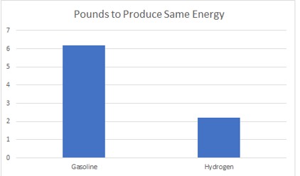
Graph 1.5.1: Gasoline vs. Hydrogen Energy levels Produced.
Since we used hydrogen and water, we are trying to provide an alternative to high usage of gasoline and fossil fuels. The usage of gasoline has caused many accidents and injuries over time. Accidents with gasoline are a major cause of thermal burns in the U.S. It has been reported that gasoline- related burns account for 13,000-15,000 emergency visits per year. Gasoline vapors/fumes can lead to carbon monoxide poisoning, according to consumer Product Safety Commission 820 people have died from CO poisoning from 2009-2019.

1.5 Potential impact of project on society (Safety, Env, Tech, Eco) (continued):
Many things play a part into the destruction of our environment and one of those actually includes crude oil, which is the substance used to produce gasoline. It is also very harmful to the environment and difficult to transport. Due to this there have been accidents with oil spills where the oil sank into the ground polluting the ocean waters.
Economically hydrogen is cheaper than gasoline. Water and hydrogen are infinite products, while gasoline is finite. When we compare the average price per gallon for gasoline, Hydrogen gas, and water; water and Hydrogen gas cost the least at $1.50, while gasoline was $2.19.
If we are able to replace the usage of fossil fuels with renewable resources globally, we will be able to potentially help minimum 150 million (2% of the world) and maximum 7.2 billion (96% of the world). With the usage of water and hydrogen to maintain energy/electricity, water can be potentially transported to areas where there is a shortage for systems to be created and maintained.

1.6 Initial Project Constraints:
Before completion of our project, we were able to make assumptions about certain goals that we wanted to achieve and deliverables that were expected from our project. This included our system being able to create a renewable, self- sustaining energy source. Within the compact system, the electrolyzer and fuel cell will work together allowing our system to use non-harmful gases and water to maintain power. Lastly, we assumed that the parts and pieces received would be in good condition and would not delay the progress of out project build.
Due to Covid-19 and natural disasters, we as a team were limited to the amount of time and group face to face interaction that we were allowed to this semester. This pushed our project build and completion time back a couple of weeks. Therefore, we had to adapt and work with the opportunities that presented themselves, which included zoom meetings outside of class time to thoroughly plan and execute our project, and also lab member rotations weekly for different members to work on different parts of the project. Since this was a senior design project on a budget of $600, we had to find and build a Compact Hydrogen system that was not too large but also capable of adjusting to suit the needs as the project progressed. In the beginning stages of building Prototype Alpha, we quickly learned that this system had great room for human error and would have different results for different set-ups. While early on in the building process of Prototype Beta, we realized that we were not able to use a solar panel for the power source and would have to now use a battery source instead. Therefore, we realized that our system was only able to maintain a set amount of voltage.

Section 2 –
Project Planning and Task Definition

2.1 Task Identification:
The task that we faced with as a team was to implement two known systems, an electrolyzer and fuel cell, in a manner that can be applicational in different industries. The planning of our project began in the summer of 2020, however, due to the restrictions of our budget, resources, and time constraints we had to alter our project at many points in the development process. To complete our project, we must create a clean energy system in which can be used to maintain energy input into the system for an extended period. With these parameters set as the control for the direction of our project we simplified our electrolyzer system and introduced the fuel cell system.
The focus was shifted from the applications of each system to the capabilities of both systems working in series. We conducted research to see the pros and cons of making the connection between the two device systems. To our awe, we are not the first ones think of the same theory and utilization for energy storage. After comparing preceding work, we determined that we could make our design and prototypes uncomplicated and still capable to perform and showcase its ability. We searched for sets that came with as many components to complete one device system or both where possible and we decided on two prototypes that we considered adept.
Once both sets had come in, it was rather difficult to put together the prototypes due to the COVID – 19 restrictions for in person labs and the natural disasters took place this semester. This pushed our project timeline off by some weeks but as soon as we returned to the lab, we got both prototypes working for phase 1. Phase 1 completed our primary task, but as an engineer it would be unheard of not to expand the scope of the prototypes. Phase 2 entailed both prototypes being analyzed. We then attempted to leverage both systems to try to account for one another’s deficiencies. The connection of both prototypes was successful, however, did not give the results we expected.

2.2 Gantt Chart:
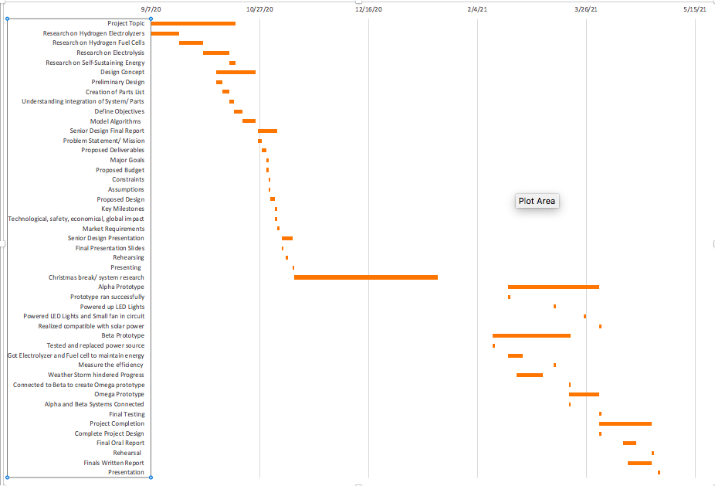
Chart 2.2.1: Detailed Timeline in Gantt Chart
In the above Gantt Chart, we have highlighted important timeline points that were reached and completed throughout our project.

2.2 Gantt Chart: (continued)
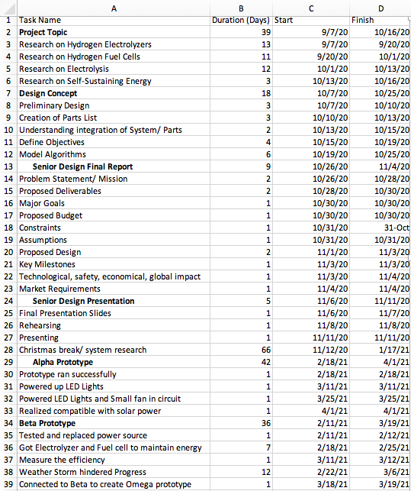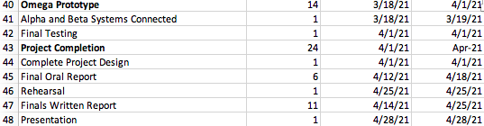
Table 2.2.2: Detailed Dates and information of what we completed throughout our project.

Section 3 – Literature Review

3.1 List of all sources of Information:
[1] https://energystorage.org/why-energy-storage/technologies/hydrogen-energy- storage/#:~:text=Hydrogen%20Storage&text=Very%20large%20amounts%20of%20hydrogen,GWh%20of%20sto red%20electricity%20electricity.
[2] https://heshydrogen.com/hydrogen-fuel-cost-vs-gasoline/
[3] https://www.hyperlube.com/blog/blog/does-gasoline-go-bad/
[4] https://wha-international.com/safety-in-the-fast-growing-hydrogen-economy/
[5] https://www.aria.developpement-durable.gouv.fr/wp-content/files_mf/SY_hydrogen_GB_2009.pdf
[6] https://www.airgas.com/msds/001026.pdf
[7] HEP Video: Hydrogen generator split cell demo (hydrogen and oxygen separation)
[8] https://www.energy.gov/eere/fuelcells/types-fuel-cells

3.2 Statement of Learning from each source:
With gasoline and fossil fuel consumers being identified as the main competitor for this project, research was needed to provide key distinctions between Hydrogen Gas and Gasoline. Specifically, from [2, 3] we were able to differentiate costs per gallon, source costs, refinery costs, miles per gallon, and the lifespan for each source. This data was key in defining the environmental and global impacts set forth by our project proposal. Further analysis provided us a nice, detailed history on the advancement of fuel cell technology.
Specific sources focused on understanding the unique risks and safety precautions to be aware of when dealing with hydrogen gas [4]-[6]. Based on information, we were able to appropriately choose our workspace that was equipped with a fume hood to safely work with this gas.
We cited information in [8] that was used to determine which fuel cell system was the most ideal setup that would accommodate the given budget and time constraints. We transferred this information over into a formulated project comparison chart. Each system was thoroughly explained, differentiating pros and cons of each fuel cell, and how we ultimately concluded on which system to use. Many videos, like in [7], were studied before working on our design. These videos provided different configurations of systems that we ultimately used to influence our design ideology. They provided visual representations of what we were researching in theory. These clips were important when we were taking measurements, especially in defining the correct points to calculate these measured values.

Section 4 – Preliminary Design

4.1 Concept Generation:
Fuel Cell Type | Stack Size | Pros | Cons
Phosphoric Acid (PAFC) | 5 – 400 kW | - Fuel impurity tolerant | - Long start-up  - Expensive catalysts  - Sulfur sensitive
Molten Carbonate (MCFC) | 300 kW – 3MW | - Fuel flexibility  - High electrical efficiency | - High temperature  - Long start-up  - Low power density
Solid Oxide (SOFC) | 1 kW – 2MW | - Fuel flexibility  - High electrical efficiency  - Solid electrolyte | - High temperature  - Long start-up
Alkaline (AFC) | 1 – 100 kW | - Lowest temperature  - Quick start-up  - Low-cost components | - CO₂ sensitive
Polymer  Electrolyte  Membrane (PEM) | <1 kW – 100kW | - Quick start-up  - Low temperature  - Solid electrolyte | - Expensive catalysts  - Sensitive to fuel impurities
Table 4.1.1: Fuel Cell Comparison Chart Reference

4.1 Concept Generation (continued):
As stated in section 2.1, our project started as a one-part system with an intricate electrolyzer design which would be capable to demonstrate the use of water and electricity to produce hydrogen fuel. After more research leveraged with the project constraints given, we simplified our project to a simplified electrolyzer and fuel cell. Electrolyzers and fuel cells come in many different types with some requiring a higher cost to produce a higher efficiency. Fuel cells get exponentially expensive fast the more surface area you need and the more efficient to want it to be. We leveraged different sets with different fuel cell types as shown in Figure 4.1.1. The PEM fuel cell was the choice for us in terms of time and budget of our design.

4.2 Concept Evaluation and Selection:
The research process took longer than expected because there are many components to account for when the project is not trivial hardware or software based. This introduced more room for error when setting up the systems separately and together. Once we decided on the type of components to get, we had to find a set-up we thought would be malleable to meet the needs for the task. The biggest benefits we experienced with simplifying the system were the cost and convivence of the prototypes. Instead of putting our budget towards one prototype, we had the means to get two prototypes and leverage them for which is more efficient before connecting both to produce our Omega prototype. The Alpha prototype gave us more problems than the Beta due to the set-up of the system being more free flow, which as a result, left more room for human error when designing the system. The Beta prototype was easier to improve and implement with the Omega Prototype, but it was easily deemed less multifunctional as the Alpha. In terms of efficiency, both seemed to be better off separate, but the better idea would be to take the Beta prototype and scale it up.

4.3 Design Constraints and Applicable Codes and Standards:
Both Alpha and Beta Prototypes are PEM fuel cells and electrolyzers which can only be ran using distilled water due to the catalyst being sensitive to impurities. If either system gets flood with water the system will completely cease working until full reset from the beginning. The system takes time to fully run as hydrogen has to build up to a certain threshold before the fuel cell will operate at full capacity.
- IEC 62282-5-100 Portable Fuel Cell Appliances – Safety
http://fuelcellstandards.com/iec62282_5_100.htm
Applies to all ac and dc type portable fuel cell appliances, not exceeding 600V, for commercial, industrial and residential indoor and outdoor use in non-hazardous locations.
- CGA Publication PS31 Cleanliness for PEM Hydrogen Piping / Components
http://www.fuelcellstandards.com/2.1.2.22.htm
This position statement addresses the potential negative impact of impurities on Proton Exchange Membrane (PEM) equipment and the steps that may be taken to manage the solid, liquid, and transitional impurities that can be introduced into a hydrogen supply system during the fabrication and installation of a hydrogen supply system.
- NFPA 2 Hydrogen Technologies Code
http://fuelcellstandards.com/nfpa2.htm
The purpose of this code shall be to provide fundamental safeguards for the generation, installation storage, piping, use, and handling of hydrogen in compressed gas (GH2) form or cryogenic liquid (LH2) form.

4.4 Preliminary Analysis:
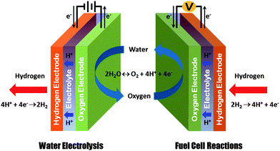
Figure 4.4.1: Electrolyzer and Fuel Cell (Electrochemistry Diagram)
Our project is not simply hardware or software but more on the electrochemical side of electronics. Electrochemistry is the study focused on the generated movements of electrons from one element to another via the reactions of oxidation and reduction. Both the electrolyzer and fuel cell use an anode and cathode for the same oxidation-reduction reaction but in reverse of one another as shown in Figure 4.4.1. An electrolyzer produces hydrogen gas at the cathode, but a fuel cell consumes hydrogen gas at the anode. The electrolyzer requires an electrical element to complete the action, while the fuel cell does not require one; its reaction produces an electrical current as its output. With the knowledge of both electrochemical systems, it was not long before we thought to leverage both to work together.
There are uses of electrolyzers industry as well as fuel cells but not both together. In industry, its large scale electrolyzers are used to produce hydrogen gas and fuel cells are used to power devices such as electric vehicles. The applicational abilities of both systems working together in an industrial scale setting could be grand and help with the advancement of clean energy technologies.

4.5 Preliminary Design
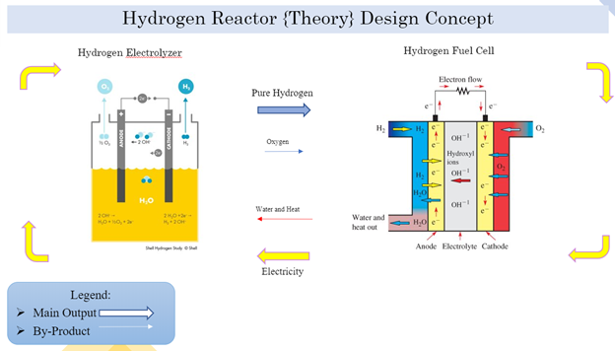
Figure 4.5.1: Hydrogen Reactor Preliminary Design
Figure 4.5.1 is a diagram representation of our preliminary design. It shows both the electrolyzer and fuel cell with its inputs and outputs. The electrolyzer system requires electricity and water to produce pure hydrogen as its output and oxygen as its by-product, and the fuel cell requires hydrogen and oxygen to produce electricity and water in the form as water vapor as its by-product. Our design diagram shows to path in which we will attempt to connect the two systems, and this will be what we model our prototypes after. The diagram is simple which makes it easy to interpret but also get a lot of leeway with what components we decided to use.

Section 5 –
Detailed System Design

5.1 Hardware Summary:
For our project we purchased and used two different compact systems. They were both purchased online from fuelcellstore.com. Both of the systems cost less than $300, and our total purchase cost was roughly $540. We have prototype Alpha, which was a self-assemble and multi-applicational system, while prototype Beta was a premade system that came already connected. Below you will see the set-up kits for each system.
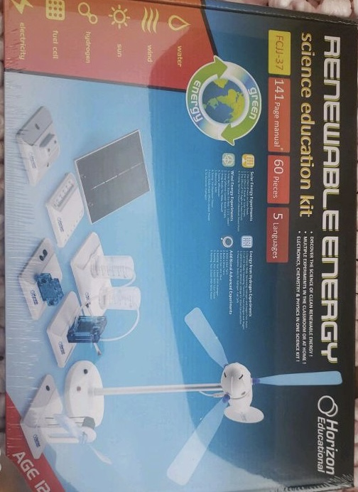
Figure 5.1.1: Alpha Prototype Set-Up Kit


Figure 5.1.2: Beta Prototype Set-Up Kit

5.2 Engineering Analysis and/or Simulation:
Comparing our final product to the engineering requirements we came up with, our project upholds a lot of the standards we set but does fall short in some areas that we were striving for. Our project utilizes water and the vapors within it to power itself. This use of water means that our project successfully reaches the requirement of eliminating the use fossil fuels and using clean, renewable energy. The fact that our project can be powered by solar energy as well as wind energy means that our project can operate while being 100% renewable and efficient.
Our final project also has the dimensions that we were looking for whenever we were looking into our engineering requirements. Keeping the product small and compact had its upsides as well as its downs, but the fact that project carried so much potential in such a small space made us confident with the result of our final design. The Omega prototype is only a scale model of what we envisioned when brainstorming the idea of a Hydrogen Reactor, so seeing how our model reacted when we made adjustments and added devices to power was something we focused on closely.
All of our prototypes upheld the requirement of being self-sustaining and sustaining its energy over large periods of time. As a test, we powered up each prototype and timed how long each one operated until the hydrogen levels decreased. The times were as follows:
(Disclaimer: Times vary depending on how much hydrogen is stored up.)
- Alpha Prototype: Approx. 1 hour
- Beta Prototype: Approx. 4 hours
- Omega Prototype: Approx. 2-3 Hours
The area in which our product does not reach the requirements we had set is in the category of efficiency. The requirement was to hold around 60% of the current inputted into the device, but our product only held around 43-52% of the current depending on the amount of hydrogen built up within the system. We discovered that the Alpha and Beta prototypes were more efficient when operating separately, holding the required current that we
5.2 Engineering Analysis and/or Simulation (continued):
aimed for. This is something that we have taken into consideration and we aim to improve on if we continue this project in the future.

5.3 Hardware Layout/Detailed Drawings/Equipment selection and Specifications:
Provided below are diagrams of our Alpha and Beta Prototypes that explain the energy flow in each stage of each prototype.
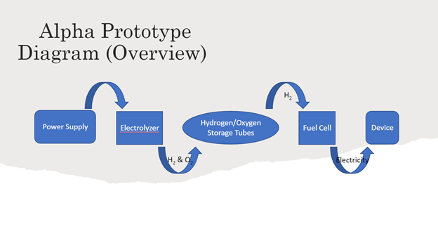
Figure 5.3.1: Alpha Prototype Diagram
In Figure 5.3.1, there is an initial source that give the system the power to run. This can be a battery pack, a solar panel, a wind turbine, or anything else that can generate voltage and a current. This source is used to power the electrolyzer. The electrolyzer is connected to two storage tubes filled with distilled water. The electrolyzer then produces hydrogen and oxygen and stores them within the tubes. The hydrogen and oxygen levels steadily rise the longer they are connected to the electrolyzer with the hydrogen rising double that of the oxygen. The hydrogen tube is then removed (using a clip to ensure there is no leakage of gas) and input into the fuel cell. Hydrogen can be released into the fuel cell in small amounts into the fuel cell to power it while still having reserve hydrogen left in the storage tube. The fuel cell can then be plugged into a small device (such as a small fan or LED lights) and power that device. The more hydrogen the fuel cell is fed, the longer the device will be powered.

5.3 Hardware Layout/Detailed Drawings/Equipment selection and Specifications (continued):
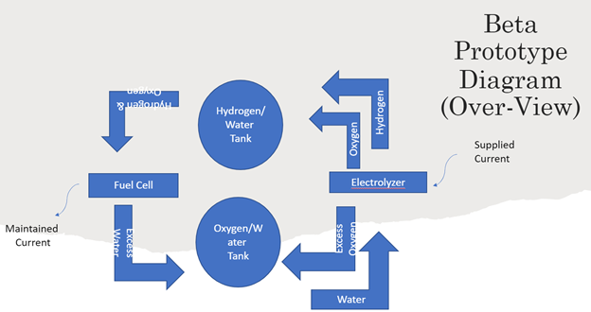
Figure 5.3.2: Beta Prototype Diagram
In Figure 5.3.2, once again there is a supplied current that is input into the electrolyzer. Hydrogen and oxygen are produced and pumped into storage tanks filled with distilled water. The hydrogen storage tank then releases the gas into the fuel cell while simultaneously releasing trace amounts of oxygen as a biproduct. The fuel cell is then used to power a small device at a maintained current while also releasing excess water as a biproduct. That water is then input into the oxygen tank, which pumps that water back into the electrolyzer as the cycle is then repeated as long as there is current flowing through the system and hydrogen levels are optimal.

5.4 Application of Engineering Codes and Standards used in Final Design:
- 7.8 IEEE Code of Ethics
https://www.ieee.org/about/corporate/governance/p7-8.html
Used throughout the entirety of the project to ensure safe and ethical results.
- IEEE C2-2017 - 2017 National Electrical Safety Code(R) (NESC)
https://standards.ieee.org/standard/C2-2017.html
Standard to ensure our device electrical components do not create nor cause harm.
- IEC 62282-5-100 Portable Fuel Cell Appliances – Safety
http://fuelcellstandards.com/iec62282_5_100.htm
Applies to all ac and dc type portable fuel cell appliances, not exceeding 600V, for commercial, industrial and residential indoor and outdoor use in non-hazardous locations.
- IEC 62282-6-200 Micro Fuel Cell Power Systems – Performance
http://www.fuelcellstandards.com/iec62282_6_200.htm
Specifies test methods for the performance evaluation of micro fuel cell power systems for laptop computers, mobile phones, personal digital assistants (PDAs), cordless home appliances, TV broadcast cameras, autonomous robots, etc.
- CGA Publication PS31 Cleanliness for PEM Hydrogen Piping / Components
http://www.fuelcellstandards.com/2.1.2.22.htm
This position statement addresses the potential negative impact of impurities on Proton Exchange Membrane (PEM) equipment and the steps that may be taken to manage the solid, liquid, and
5.4 Application of Engineering Codes and Standards used in Final Design (continued):
transitional impurities that can be introduced into a hydrogen supply system during the fabrication and installation of a hydrogen supply system.
- NFPA 2 Hydrogen Technologies Code
http://fuelcellstandards.com/nfpa2.htm
The purpose of this code shall be to provide fundamental safeguards for the generation, installation, storage, piping, use, and handling of hydrogen in compressed gas (GH2) form or cryogenic liquid (LH2) form.

5.5 Economic Analysis:
An economic transition from a gasoline to a hydrogen-based economy would create many jobs and projects in infrastructure. A study by Swansea University in the UK found that up to 30 percent of domestic gas could be safely replaced with hydrogen, thereby reducing carbon emissions by 18 percent, with no changes to existing infrastructure. As the technology behind hydrogen improves, an economic transition is becoming more foreseeable as the International Energy Agency expects the cost of producing hydrogen to fall by a further 30 percent by 2030. As of right now, many programs, projects, research and companies with environmental focuses including hydrogen-based alternative energy are being federal-funded by agencies such as the Environmental Protection Agency.

5.6 Final Design:
When it came down to the final design, we wanted to test the boundaries and possibilities our project had. We wanted to discover the potential our prototypes had so we connected our Alpha and Beta prototypes together to create the Omega. Below are pictures showing each prototype powering up a small device to prove they are functioning:
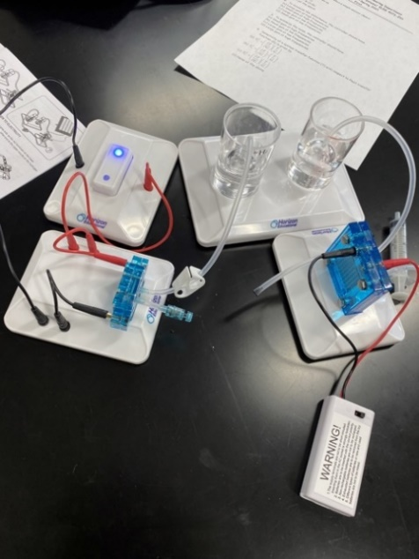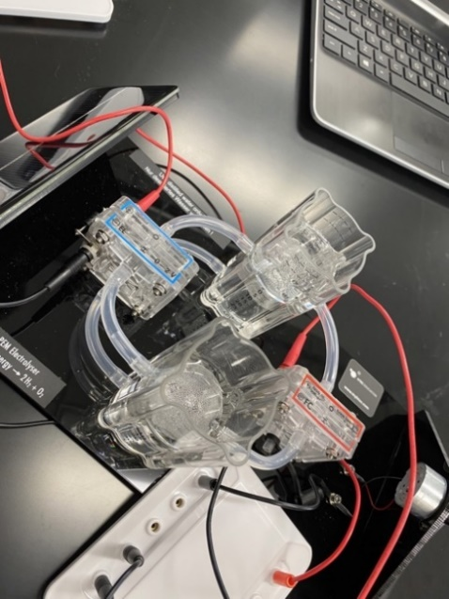
Figure 5.6.1: Alpha Prototype (with functioning LED lights) Figure 5.6.2: Beta Prototype (with small functioning fan)
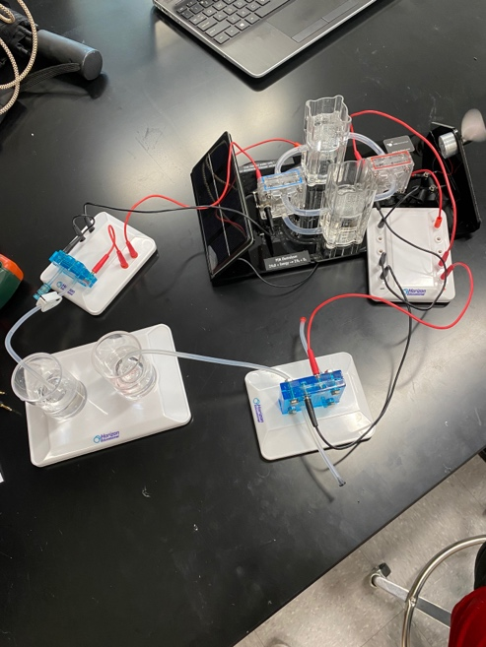
Figure 5.6.3: Omega Prototype (with small functioning fan)

Section 6 –
Results & Discussions

6.1 Summary of Goals and Objectives:
Before designing this project, particular goals and objectives were set forth in order to meet the requirements of those we intended to market to. Based off our problem statement, project need, target audience, and budget we were able to clearly define these needs and checkpoints to perhaps build off one another, in progression to designing such a breakthrough system. Initial goals and objectives consisted of:
- The product must be able to use a renewable, clean source of energy. Our device will consume water as the main source of energy as well as an electric current which will be distributed throughout the device. We plan on testing with different amounts of water such as a liter or a gallon to see what will produce the best result for our product. Since water is cleaner, cheaper, more efficient, and safer to the environment compared to burning fossil fuels, it is the better overall option for our product.
- Our product must be able to sustain itself for an ideally great amount of time. Our goal is to create a stable connection between our Electrolyzer and the fuel cell so that they can flow in a cycle between each other, creating a self-sustaining reactor. The Electrolyzer will take in water and excrete hydrogen and oxygen, essentially splitting the water into its basic elemental form. The gases will then be input into the fuel cell and go through a cathode and anode in order to remerge them, creating water with a by-product of heat. That water will be input back into the Electrolyzer, thus completing the cycle. Self-sustaining energy causes less maintenance, meaning that it is more convenient for customers.
- Since our product utilizes aspects of both electrical and chemical engineering, our product will be able to draw power from these applications efficiently. Our product deals with not only gases and water elements, but also electric current and a constant flow of energy. We want our device to be malleable enough to use either of these engineering fields in order to operate at an optimum rate.
- As well as being self-sustaining our product will be able to store power for a long period of time. Our goal for this product is to be able to maintain 60% of the current inputted into the device. We will test.
6.1 Summary of Goals and Objective (continued):
- this by timing how long the device can hold the charge while continuing to sustain itself. With long lasting energy being a growing necessity within the community due to its convenience and efficiency, we knew this requirement was a must and we plan on dedicating our time to accomplish this goal at a high level.
- Our device may sound complicated to most people hearing about it, so the team decided to add some simplicity to the design with a simplistic ignition and shut-off switch. We will connect a switch of sorts to our voltage input (for testing purposes, a 9-volt battery). This will allow easy ignition of our product as well as a simple shutdown. We are choosing to use a 9-volt battery for its multiple uses within everyday appliances such as flashlights, clocks, and other portable handheld devices. This will give us a base on how the circuitry and cycle will flow within our product and allow us to further branch out and explore new and better ideas for our product.
- The average size for a hydrogen reactor is beyond that of both our resources and budget. Due to this we are making a more compact version of a hydrogen reactor with dimensions of about 19” by 13”. These dimensions resemble that of a handbag or backpack which is something used in a majority of people’s day to day lives. This will give our design a familiar feel and give us a better perspective of how a hydrogen reactor operates on a smaller scale.
After initial expectations were met, the team took on the initiative to implement more goals that we hoped too successfully complete. We also made long term goals that we hoped would be able to be expunged upon by future engineers, taking the ground foundation laid into this project, and ultimately exploring the many applications applicable to everyday life. Some of the bonus goals met included: Replacing the 9-volt startup ignition with a solar panel; Replacing the 9-volt startup with a wind turbine; Observing the effects of combining two different hydrogen reactor system; and observing the effects of multiple loads.
6.2 Summary of Constraints and Codes met by Design:
In according to our constraints of our design all were met for prototypes Alpha and Beta. For the final prototype, Omega, we were not able to deliver the constraint of sixty percent of voltage maintained as due to discovery of compatibility issues and unknown human error between the connection of Alpha and Beta. In accordance with the codes the top priority was safety as the hydrogen is a volatile gas. The prototypes we assembled during our project are confirmed to be safe in the aspects of dealing with the hydrogen following codes:
- IEC 62282-5-100 Portable Fuel Cell Appliances – Safety
- CGA Publication PS31 Cleanliness for PEM Hydrogen Piping / Components
- NFPA 2 Hydrogen Technologies Code
As a device that deals with electricity and power the prototype’s electrical components are confirmed not to damage or harm persons nor the environment around it, in accordance with code:
- IEEE C2-2017 - 2017 National Electrical Safety Code(R) (NESC)
When performing the tests and trials the used the methods specified in the standards of code:
- IEC 62282-6-200 Micro Fuel Cell Power Systems – Performance

6.3 Discussion of Results and Other Use Cases:
Upon connecting the Alpha and Beta prototypes to create the Omega Prototype, we came across a few revelations that we observed further into. We noticed that upon creating the Omega Prototype the efficiency of the decreased compared to the Alpha and Beta prototypes working on their own. We believe this is the case because a bigger circuit would require more energy and power in order to produce the same amount of output. The system would need a larger amount of hydrogen to produce more power within the system. We also discovered that although the efficiency was decreased, the capabilities of the prototype increased. We were able to power more devices even though the efficiency was lower. This meant that although the capabilities were increased, the decrease in efficiency affected the overall functionality of the prototype. We also noticed that with this prototype human error was more prominent. With one of the disadvantages of the Alpha prototype being there is a great room for human error, we discovered that human error increased with the Omega prototype. This is since assembly is crucial with this prototype and any small error will cause the circuit to not work properly. After making all these assessments we concluded that the Alpha and Beta prototypes were more adept apart than together.

Section 7 –
Conclusions and Recommendations
7.1 Conclusion:
The design and demonstration of this fuel cell system will show how this alternative energy source will greatly benefit many industries (especially technological) in the upcoming future. The easier it is to demonstrate its applications, the more capable the demonstration will be for companies to implement.

7.2 Recommendation:
• Use a battery source instead of a solar powered source for efficiency and convenience​
• Clean the cylinders of water and replace them with fresh distilled water before use​
• In Prototype I, be sure to close the release valves so that water does not enter hydrogen fuel cell once water has begun moving. If water does enter fuel cell close valves anyway to force the water to expel itself naturally​
• In Prototype II, release the hydrogen in small amounts to power the device of your choice (LED, Fan, Wheel)​
• When restarting circuit, start back from step one to ensure there is no leakage or other complications with the device​.

List of References

List of References:
- [1] Afdc.energy.gov. 2020. Alternative Fuels Data Center: Hydrogen Benefits and Considerations. [online] Available at: <https://afdc.energy.gov/fuels/hydrogen_benefits.html> [Accessed 2 October 2020]. ​
- [2] D. C. Spiegel, “Introduction to Electrolyzers,” Fuel Cell Store. [Online]. Available: <https://www.fuelcellstore.com/blog-section/introduction-to-electrolyzers.> [Accessed: 02-Oct-2020].​
- [3] English, T., McFadden, C., Papadopoulos, L., McFadden, C. and Bergan, B., 2020. How To Build Iron Man's Reactor. [online] Interestingengineering.com. Available at: <https://interestingengineering.com/how-does-iron-mans-arc-reactor-work> [Accessed 4 November 2020].​
- [4] Energy.gov. 2020. Hydrogen Production: Electrolysis. [online] Available at: <https://www.energy.gov/eere/fuelcells/hydrogen-production-electrolysis> [Accessed 4 October 2020].​
- [5] “Fuel Cells,” Energy.gov. [Online]. Available: <https://www.energy.gov/eere/fuelcells/fuel-cells.> [Accessed: 02-Oct-2020].​
- [6] Fuel Cell & Hydrogen Energy Association. 2020. Fuel Cell Basics — Fuel Cell & Hydrogen Energy Association. [online] Available at: <http://www.fchea.org/fuelcells> [Accessed 2 October 2020].​
- [7] Homann, Q., 2020. Using Electrolyzers To Produce Renewable Hydrogen — Fuel Cell & Hydrogen Energy Association. [online] Fuel Cell & Hydrogen Energy Association. Available at: <http://www.fchea.org/in-transition/2020/3/30/using-electrolyzers-to-produce-renewable-hydrogen> [Accessed 4 October 2020].​

List of References (continued):
- [8] Lasser, R., 2020. Engineering Method | Electrical And Computer Engineering Design Handbook. [online] Sites.tufts.edu. Available at: <https://sites.tufts.edu/eeseniordesignhandbook/2013/engineering-method/> [Accessed 4 October 2020].​
- [9] Montoya, A., 2013. Stark Industries Desktop.. [video] Available at: <https://www.youtube.com/watch?v=58-2y-1MUPw&feature=emb_title> [Accessed 4 November 2020].​

APPENDIX

Appendix
N/A

