PRAIRIE VIEW A&M UNIVERSITY
ROY G. PERRY COLLEGE OF ENGINEERING

Real-Time Crowd Detection System using Raspberry Pi and Deep Learning

ELEG 4248: Senior Design & Professionalism II

Topic: Final Written Report

Team Number 1

Submitted by:
Deonna London
Jalyn Beaty (Team Lead)
Gabriel Maxwell
Alexis Hunter
Alyssa Reed

Instructor: Professor Turner

Due Date: Sunday, May 1st by 5:00pm
Date of Submission: April 29th, 2022

TABLE OF CONTENTS
Table of Contents ………………………………………...………………………………….. 1 Executive Summary ………….……………...……………...………………………………. 2-5
List of Figures ……………………………………………………………………………… 6-7
List of Tables ……………………………………….…..………...………………………….. 8
List of Team Members and Roles ………………….….……….…..……….……………….. 9-10

1. PROJECT SCOPE
1.1 Problem Statement, Business Objective and Target Audience of Project …..…………12-13
1.2 Client identification and recognition of need …………………………...…...…………14-17
1.3 Goals and Objectives ……………………………………………………………………18
1.4 Contemporary Relevant Issues ……………………………………………...……………19
1.5 Potential Societal Impacts (Safety, Env, Tech, Eco)
1.5.1 Safety ………………………………………………..…….……..……. 20
1.5.2 Cultural ………………………………………...……………….………21
1.5.3 Societal ..………………………………………….……………………22
1.5.4 Economical ..………………………………………………...…………23
1.6 Assumptions and Constraints ..…………………………………………………………..24

2. PROJECT PLANNING AND TASK DEFINITION
2.1 Task identification ………………………..….………………………...……….………27-29
2.2 Gantt Chart ….…………………………….………………………………....….………30-31

3. PRELIMINARY DESIGN
3.1 Concept Generation ….…………………………….……………...……..………………. 33
3.2 Concept Evaluation and selection ……………………………………...…..…………. 34-35
3.3 Design Constraints and Applicable Codes & Standards
Used in the Preliminary Design …………………………………….…….…………...……. 36-37
3.4 Preliminary Analysis …………………….………………….………….….….………….38
3.5 Preliminary Design
3.5.1 Hardware Design …………………………………….………..………..39-40
3.5.2 Software Design ……………………………………….………..……. 41-42

4. DETAILED SYSTEM DESIGN
4.1 Project Parts Summary ………………………………………………..……………… 44-46
4.2 Engineering Analysis and/or Simulation ……………………………….……………….47-48
4.3 Hardware Layout/Detailed Drawings/Equipment
selection and specification ………………………………………………………...……….. 49-50
4.3.1 Show Overview of Code Developed to Support 4.3 …………………. 51-53
4.4 Application of Engineering Codes and Standards used in Final Design …………...…. 54-55
4.5 Economic Analysis ….…………………………….……………………………..……… 56-57
4.6 Final Design – show pictures or other examples of working design …………………… 58
5. RESULTS & DISCUSSION
5.1 Summary of Goals and Objectives……………………...………..………………………. 60-61
5.2 Summary of Constraints and Codes met by Design………………..……………………… 62-63
5.3 Discussion of Results and Other Use Cases………………………………………………… 64
6. LITERATURE REVIEW
6.1 Literature Sources…………………………………………………………………………. 66 6.2 Statement of Learning from each source………………………………………………….. 67

7. CONCLUSIONS AND RECOMMENDATIONS ………………………………….….….…….. 68-70

LIST OF REFERENCES …………………………….…………...……………………....….…….. 70-71

APPENDIX …………………………………………………………………………………..….…….. 72-73
Executive Summary

Mission Statement:
The mission of this project is to design a device that will monitor large crowd gathering sizes to slow the spread of COVID-19. We will implement a real time crowd size detection and alarm system for reduction in social distancing violation to allow people to go to necessary places while still being as safe as possible.

Problem Statement:
According to the World Health Organization (WHO), the risk of catching COVID-19 is higher in crowded and inadequately ventilated areas. As of September 2021, Harris County was at a level one (severe) threat level. Level one signifies that the spread of COVID-19 was uncontrolled.

Proposed Deliverables:
- Object Detection for locating people in the space
- People Counter to keep count of a safe number of occupants
- Crowd Detection to determine distance between occupants
- Sound alarm to make our device accessible to blind users
- Light alarm for accessibility to the hearing impared

Budget:
Project Budget: $500
Amount Spent: $200
Executive Summary Continued

Customer Requirements and Engineering Solutions:
- Facial recognition software using Open Computer Vision (Open CV)
- Sound and light alarms
- Sound alarms will be between 40 and 80 decibels to allow them to be heard but not overwhelming
- Light alarm will be red and non-blinking to be courteous of those with epilepsy
- People counter using Open CV, python, and object tracking algorithms
- Distance detection using python code

Major Constraints:
- Wi-Fi and external monitor required
- The room dimensions must be known and inputted by the user
- A constant power supply is required for our system to function

Benefits:
- Public, Health, Safety and Welfare: Reducing the spread of COVID-19
- Cultural: Reopening of World Heritage Sites
- Societal: Increased socialization thus reducing anxiety, depression, aggressive behavior, etc
- Economic: Reopening of businesses thus more income for those businesses and lower unemployment rates

Executive Summary Continued
Recommendations:
- The software used should be TensorFlow and Open Computer Vision
- The device should be small enough to be positioned in the corner of a room
- A machine learning model will be used to train the device to recognize the difference between a person and an object

Target Audience:
Our product is targeted at those who need to enforce strict COVID-19 Guidelines. These could include the following:
- Workplaces
- Schools
- Hospitals
- Airports

Our device will make sure those restrictions and rules for the public’s safety are being
abided by on a regular basis.

Executive Summary Continued
Engineering Codes and Standards:
IEEE 7.6: IEEE Protection of the Public: To maintain public safety with the creation of our engineering devices
IEEE 7.8: IEEE Code of Ethics 1.5: Seek and accept honest Criticism of technical work
IEEE 7.8: IEEE Code of Ethics 1.6: to maintain and improve our technical competence we also use this standard in our engineering methodology
IEEE C37.21-2017: Standard for Control Switchboards: Implemented to assure that the alarms work properly.
IEEE 829-2008: Software and System Test Documentation: Used to ensure that the device is working as intended
IEEE 802.11: Wireless Networking: the use of Wi-Fi on our Raspberry pi

List Of Figures
Figure 1: Positive COVID Cases in Harris County ........................................................................ 12
Figure 2: Positive Total Number of COVID Cases ....................................................................... 20
Figure 3: Loss of Revenue ............................................................................................................. 21
Figure 4: Survey Results .................................................................................................................. 22
Figure 5: Quarterly Unemployment Rate......................................................................................... 23
Figure 6: Project Schedule .............................................................................................................. 28
Figure 7: Detailed project Schedule ............................................................................................... 29
Figure 8: Gantt Chart ...................................................................................................................... 30
Figure 9:: Gantt Chart Continued .................................................................................................. 30
Figure 10: Engineering Design Methodology ................................................................................ 32
Figure 11: Project Comparison ....................................................................................................... 34
Figure 12: Hardware Design.......................................................................................................... 39
Figure 13: Detailed System Design................................................................................................ 39
Figure 14: Software Design............................................................................................................ 41
Figure 15: Raspberry Pi 3B+.......................................................................................................... 43
Figure 16: Case & Cooling Fan ................................................................................................... 44
Figure 17: Stereo ............................................................................................................................44
Figure 18: LED Light Strip .......................................................................................................... 45
List Of Figures Continued
Figure 19: Raspberry Pi 3B+ Layout .......................................................................................... 48
Figure 20: Camera ......................................................................................................................... 49
Figure 21: Code Snippet 1 ............................................................................................................. 52
Figure 22: Code Snippet 2 ............................................................................................................. 52
Figure 23: Code Snippet 3 ............................................................................................................. 53
Figure 24: Code Snippet 4 ............................................................................................................. 53
Figure 25: Final Design ............................................................................................................... 49
Figure 26: Project Demonstration.................................................................................................. 64

List Of Tables
Table 1: Marketing and Engineering Design Specification …........................................................17
Table 2: Total Cost.......................................................................................................................... 57

List of Team Members and Roles

Alexis Hunter, Data Analyst
The data analyst researches information that relates to the project. They will collect the information and go through and interpret it. After researching multiple sources, the data analyst must clean and compile the information found.

Alyssa Reed, Software Developer
Alternate: Scribe
The software developer will do the required coding. They will research, design, implement and manage software programs. They will test all codes and make modifications accordingly. They will ensure the code is efficient and unique and reliable.

Deonna London, Scribe
Alternate: Test Lead
The scribe is the attendee at a meeting who documents and keeps the records of meetings, decisions, and updates for the project. They take on the responsibility of the weekly updates and will make final decisions on the written report.
The test lead will be responsible for handling the equipment. This is the person who assembles the test for the project. This person leads decisions on how equipment will be handled and serves as the final say for decisions made about the assembly of the project.

Gabriel Maxwell, Procurement lead
Alternate: Data Analyst
The procurement lead oversees the project materials. They will purchase and manage the budget for the project costs. If a financial decision cannot be agreed upon by the team or sponsor, the procurement lead makes that final decision. They must have a complete understanding of the list of parts and prices of the project. The procurement lead is also responsible for reaching out to the sponsor to gather any materials needed for the project.

Jalyn Beaty, Team Lead
Alternate: Software Developer
The team lead must organize and maintain group meetings and oversee progress. A team leader must hold each member accountable and provide direction and work delegation. This person also acts as a direct communication with the sponsor Lijun Qian. They must have a general understanding of the project’s requirements and deliverables. The team lead must also aid other members to help with all aspects of the project.

Section 1 – Project Scope

1.1 Problem Statement, Business Objective, and Target Audience

Problem Statement:
According to the World Health Organization, the risk of catching COVID-19 is higher in crowded and inadequately ventilated areas. As of September 2021, Harris County is at a level one (severe) threat level. Level one signifies the spread of COVID-19 is uncontrolled; outbreaks are worsening. The 7-day average of new cases is 125.85 per 100,000. Figure 1 shows the sum of new cases reported in the past 7 days based on the population. Where the graph exceeds the 100 thresholds, it reflects red severity. Where it exceeds the 50 thresholds, it reflects orange severity. Where it exceeds the 10 thresholds, it reflects yellow severity. Harris county has been in the red and remained in the red as of the end of July 2021. Without proper social distancing being enforced, COVID-19 and the consequences that come with it will continue to impact the world.

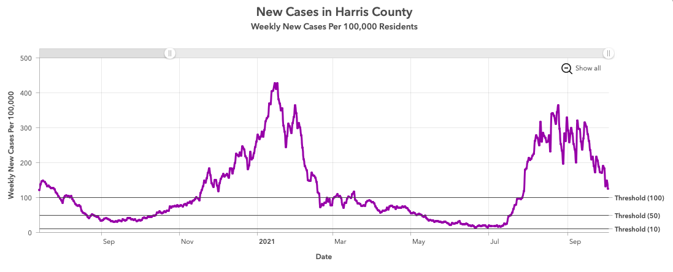
Figure 1: COVID Cases in Harris County

1.1 Problem Statement, Business Objective, and Target Audience Continued

Business Objective:
The objective of this project is to design a device that will monitor large crowd gathering sizes to slow the spread of COVID-19. We will implement a crowd size detection and alarm system for violation reduction, so that people can go to necessary places, while still being as safe as possible.

Target Audience of Project:
Our product is targeted at those who need to enforce strict Covid guidelines. (Workplaces, schools, etc…)

1.2 Client Identification and Recognition of Need
Table 1 shows our marketing requirements, engineering requirements, and justifications for those requirements. The marketing requirements are necessary to meet the needs of potential customers. Engineering requirements details specifications necessary in bringing those marketing requirements to life. There are 8 requirements:
- The detection system will be designed to fit in the top corner of a room, facing the door. The position of the system affects the accuracy of the results. We want to design it to take up as little space as possible and to have easy mobility.
- The system will be able to recognize the difference between a human face and an inanimate object. Misidentified objects could result in inaccurate assumptions and false alarms. To achieve this, we will use object detection in our software programming. Object detection is finding out what and where multiple objects are in an image. It is a combination of image processing and computer vision. There are a variety of libraries in deep learning and python to incorporate object detection. The system will be using Open-Source Computer Vision Library (Open CV) and TensorFlow. OpenCV is a library of functions aimed at real-time computer vision and TensorFlow is a framework for machine learning. Both have their pros and cons like any other technique, but together they align well for our object detection programming.

1.2 Client Identification and Recognition of Need Continued
- The system will be accessible for those who are deaf. The system also incorporates a light alarm system; Those that cannot hear the alarm, can see the alarm. The light will be a red light because red is known to be an attention getting color. Those with epilepsy are more likely to have seizures with lights that flash between 5 and 30 times per second. In order to incorporate the safety concerns of all our users, the light will not flash. The light alarm will come on and remain on until the issues are resolved.
- The alarm system will also have an accessibility option for those who are blind. The volume will be adjustable, so that it serves the needs of whoever is using it. We wouldn't want the alarm to be incorporated in a house and sound as a fire alarm. It would be between 40-80 decibels.
- A main function of our system will be for it to keep count of the amount of people in a room. To do this we will be using OpenCV and Python. Object tracking will be added to our already incorporated object detection to create the most efficient people tracker. Object tracking takes coordinates of where an object is in an image and assigns an ID to that object. It tracks this ID as it moves in a stream predicting the new location it will have in the next frame, based on its previous location. The two together will incorporate two steps to perform the function. First, it will detect what new objects enter. Then, these objects will enter the tracking phase where they are traced throughout various frames. These two phases of detecting and tracking will continue to run, and when going back into the detecting phase some objects that were lost could be found.

1.2 Client Identification and Recognition of Need Continued
- The other function of the system is for it to be able to detect distance between objects in each area. For this we will be using an ultrasonic sensor that is able to detect the proximity between people. This sensor would be able to use object detection and tracking to see where all objects are and then measure the distance between the bounding boxes they create when they are identified.
- In order for our device to be able to work properly, all of the parts that are attached to the device need to be compatible with the Raspberry Pi 3B+. Our project consists of using a Camera Board v.1.3 which is compatible with Model B of the Raspberry Pi. Any other attachments like the sensors, light and sound alarm will be compatible as well.
- This camera system must be reliable and consistent. Users don't want a system that proves many inaccuracies. In order to accomplish this, there will be test trials, good camera quality and a consistent frame rate. This will help avoid unwarranted alarms.

1.2 Client Identification and Recognition of Need Continued
Marketing Requirements | Engineering Requirements | Justification
Fit in the top corner of a room facing the door | Raspberry Pi - 85x56x17mm  Camera Board v1.3 - 20x25x9mm  sound and light alarms | Device will need to take up minimum space
Facial recognition | Open-Source Computer Vision Library (OpenCV) | Misidentified objects could result in inaccurate assumptions; false alarms
Light alarm system | Red light remains on until the spatial issue(s) are resolved  Epilepsy Seizure Sensitive | Accessible for deaf while taking in account of other safety risks  5-30 flashes per second may cause seizures
Sound alarm system | Concealed  Adjustable volume (40-80 Decibels) | Accessible for blind
Should be able to keep count of people in a given area | Create people tracker using:  Python  OpenCV  Object tracking Algorithms | Count of people in a given area needs to be kept in order for the alarms to sound at the correct times
Distance detection between people in a given area | HC-SR04 Ultrasonic Sensor  (2mm - 4m) | Device must be able to detect violation
All added parts and enhancements compatible to computed device | Camera Board v1.3 compatible with Model B | Parts need to be compatible to the Raspberry Pi 3 B+ in order for them to be programmed
Reliable and consistent | Test trials and Result Analysis  1080p | Unwarranted alarms can be alerted
Table 1: Marketing and Engineering Design Specification

1.3 Project Goals and Objectives
The objective of this project is to design a device that will monitor large crowd gathering sizes to slow the spread of COVID-19. We will implement a crowd size detection and alarm system for violation reduction, so that people can go to necessary places, while still being as safe as possible.
The proposed solution is to design a real-time crowd size detection device with an alarm system using Raspberry Pi 3 B+ and other compatible attachments. The attachments would include a camera for video and image processing, a sound alarm to alert those in the room and include the blind, and a light alarm to include those who are deaf. The Raspberry Pi will serve as the brain of the system as it will be programmed to scan frame-by-frame live video and use TensorFlow and OpenCV to perform object detection. Using deep learning, the system would be able to not only keep track of how many individuals are in a room but determine how far apart they are as well. If any requirements are not met the system would then send a signal to sound an alarm until the violation is corrected.

1.4 Contemporary Relevant Issues
When thinking about the audience that would use this product. It is important for them to understand some of the issues that may present themselves when tackling the problem of COVID-19. Firstly, social distancing alone will not prevent the spreading of COVID. The amount of people in a room may be irrelevant if someone in the area had the virus.
The customer must also consider the setup of the device. It will require a position such that it faces the door but catches the image of a human body. It must not only catch faces. The device can be ineffective if positioned incorrectly.

1.5 Potential Societal Impacts
1.5.1 Public Health, Welfare and Safety Impact
After researching and truly diving into this project, our team decided that our project is important because it impacts health, culture, society, and the economy. We will first discuss how our project impacted public health, safety, and welfare. As of September 2021, there have been about 230 million positive COVID 19 cases around the world. The pandemic has made day to day activities such as class, work, or even the grocery stores a real health risk. Figure 2 is a linear representation that shows how the number of positive covid cases have drastically multiplied from Jan 2020 to Sept 2021. Our project will help to reduce the number of positive COVID cases by monitoring spatial issues and preventing gatherings that are too large. It will force users to adhere to CDC guidelines and maintain a minimum of 6 feet apart.

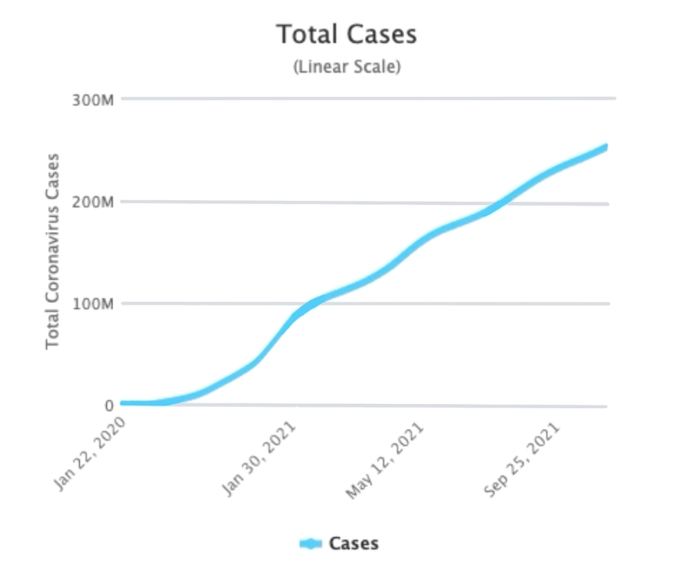
Figure 2: Positive Total Number of COVID Cases

1.5.2 Cultural Impact
At COVID 19’s peak, 90 percent of countries closed their World Heritage site according to a World Bank article. Places such as museums, libraries, churches, and art galleries have been closed. Due to these businesses being shut down, they have lost money and now it is no longer an option for them to reopen. COVID has changed the way populations not only go to class, work, or the grocery store but the way we go to school, interact with society, entertain ourselves and spread our traditions. Figure 3 shows the loss of revenue reported by 981 cultural organizations. The higher the loss of revenue, the more likely the business will have to shut down. Our device will help reopen these organizations. Creating and launching this device will reduce the number of COVID cases and make it less likely that businesses have to close.
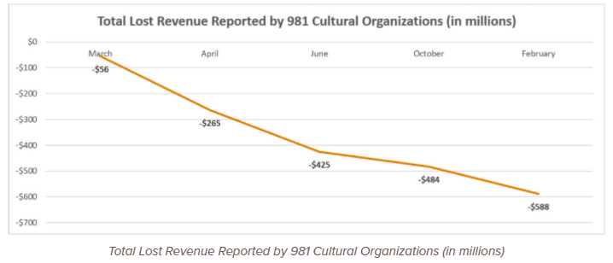
Figure 3: Loss of Revenue

1.5.3 Societal Impact
The number of adults attempting to get a divorce has risen by 34 percent since 2019. The percentage has risen due to couples being stuffed in the house together which forced them to realize things about one another that they didn't know before. Couples have also disagreed more on parenting decisions. According to the Center for Disease Control and prevention (CDC), “teens and adolescents' social, emotional and mental well-being have been impacted by the pandemic”. Figure 4 displays the results of a survey based on responses from 977 parents with teens aging from 13-18 years old. Anxiety, Depression, Sleep issues, withdrawal, and aggressive behavior are effects brought along by COVID isolation. With the use of our device people will once again be able to meet in group settings. Our device will ensure individuals are able to receive the necessary socialization while not endangering their health or the health of those around them.
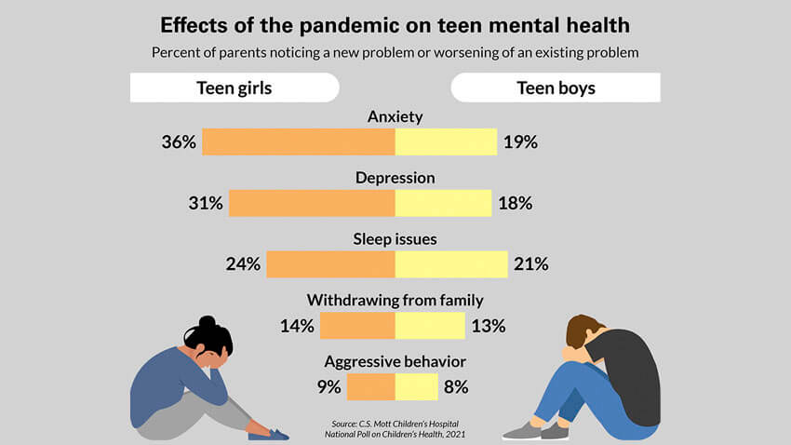
Figure 4: Survey Results

1.5.4 Economical Impact
Our economy took a major hit during the pandemic. In 2020, the Gross Domestic Product (GDP) has decreased by 3.5 percent which is the lowest it has been since 1946.The average unemployment rate in 2020 was about 8 percent higher than the annual averages during the Great Recession in 2009. Figure 5 shows the quarterly unemployment rate from 1968 to 2020. As you can see, in 2020 the unemployment rate reached 13 percent. Our project will mend our economy by reducing the spreading rate of COVID 19. Reducing the number of COVID cases will lead to businesses being able to reopen, thus jobs being available to those in need. After jobs are secured as normal, our unemployment rate and GDP will increase.
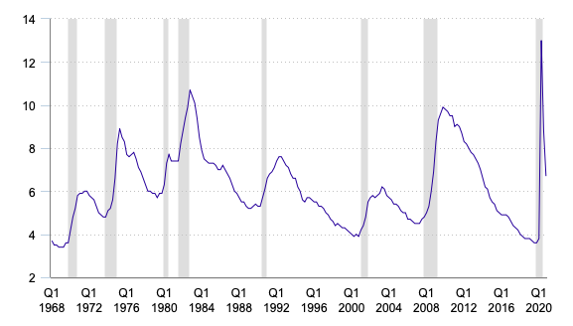
Figure 5: Quarterly Unemployment Rate

1.6 Assumptions and Constraints
As a part of project planning, you must come up with some assumptions and constraints. When coming up with these things you must ask your team two questions:
- What must happen for this project to be successful?
- What are some things that will hinder your projects’ success if they occur or fail to occur?
Assumptions:
- The area in which our system is located isn't too loud. To be deemed successful, we want to assume that when our system is sounded, the sound of its surroundings is not louder than our alarm system.
- Those involved are aware of the system and its purpose. What good is a working project if nobody knows its purpose?
- Participating parties don't enter in groups. For the best results, we want to ensure that our count is accurate. To be as accurate as possible, we would need participants to enter one by one to ensure our system can catch the face and body of each participant.
- An alert will sound when a violation occurs. We assume our system will do what it was designed to do. When a violation occurs, we want users to be notified by both sound and light.
- Our system will monitor the amount of people entering the room as well as any spatial issues that occur. This is another main goal for our project. If it does not monitor the amount of people in an area, then it cannot be deemed a successful project.

1.6 Assumptions and Constraints Continued
Constraints:
- Our system will require a strong Wi-Fi signal to function. Our raspberry pi must be connected to Wi-Fi to maintain the proper date and time. We also need Wi-Fi to be able to send out the alerts.
- Our camera must be in a position that can catch people of varying heights. If the camera is too high or too low, then we won't be able to catch every user. Missing count decreases our accuracy.
- A constant power supply is required for our system to function. Our Raspberry Pi must be always plugged in to complete the necessary tasks. If there is no power, there is no functionality.
- The room dimensions must be known and inputted by the user. In our program, we will ask the user to input the dimensions of a room. We ask for this information to help set the capacity of each room. Knowing the dimensions will allow us to have an idea of how many users can fit into that given area while adhering to CDC guidelines.
- Once the camera is mounted, it cannot be easily moved. Due to the wiring and set up of the device, moving it will not be easy.
- Raspberry pi requires an external monitor. Raspberry pi is a computer. It will require a monitor to complete user interfacing and to display frames and current participant counts.

Section 2 – Project Planning and Task Definition

2.1 Task Identification
Figure 6 shows the obscure project schedule. There were 5 phases incorporated in completing this project in a timely manner. Phase 1 was project conception and initiation. This is where the topic was established, all research was done, and the project initiation began. Phase 2 was the project definition and planning. In this phase the design and budget were created. There were weekly reports and multiple weekly team meetings. Supplies were secured and this schedule was made.
Phase 3 was the project launch and execution. In this phase the construction of the hardware and software were done. There was a 3D case that was designed and printed. This phase is also when testing of our designs were done. Phase 4 was project performance and control. This is when the executive summary was created, along with the deliverables. There was feedback given and the team made the necessary improvements to the hardware and software design. Phase 5 was project closing. This was midterm and final presentations and reports.

2.1 Task Identification Continued
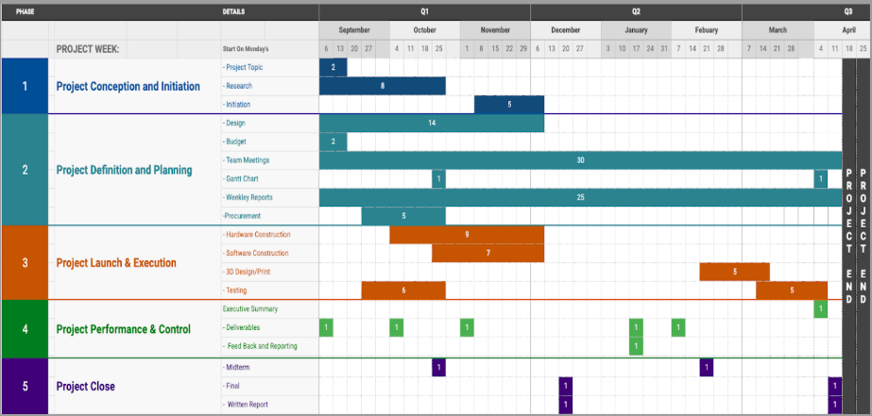
Figure 6: Project Schedule
As the team progressed through both semesters there was a more detailed project schedule. The detailed project schedule, for the most part, reiterates the schedule shown in Figure 6 while adding more specific time periods. Figure 7 shows task dates and time periods in which we completed each task.

2.1 Task Identification Continued
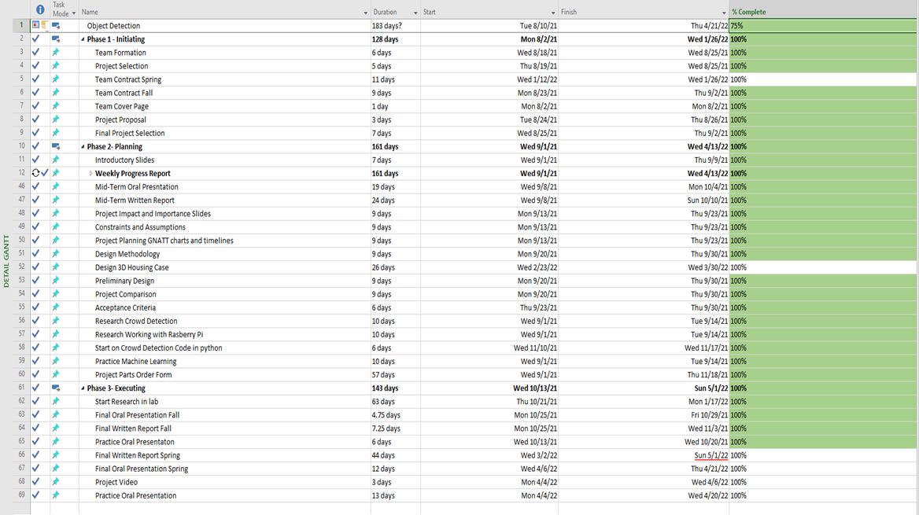
Figure 7: Detailed project Schedule

2.2 GANTT Chart
Taking in account the previous schedule, the team developed the detailed Gantt chart show in figures 8 and 9. The Gantt chart has those same phases mentioned above in the previous two project schedules. The Gantt chart also shows how we completed each phase in relation to another phase. You can see if we were completing multiple phases at a time, or if the team had to dedicate all focus to that 1 phase. The execution phase came out to be the phase in which the team spent the most time on.

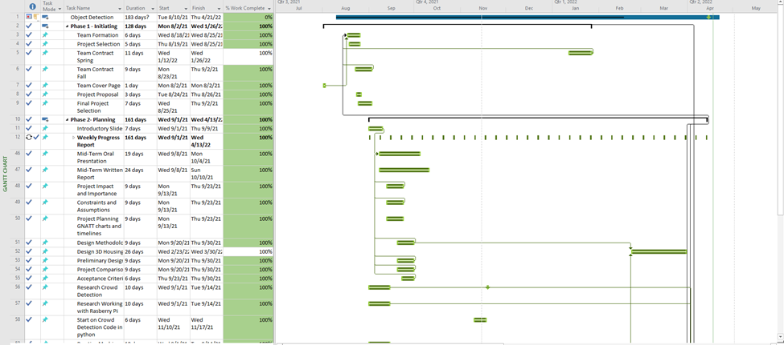
Figure 8: Gantt Chart

2.2 GANTT Chart Continued
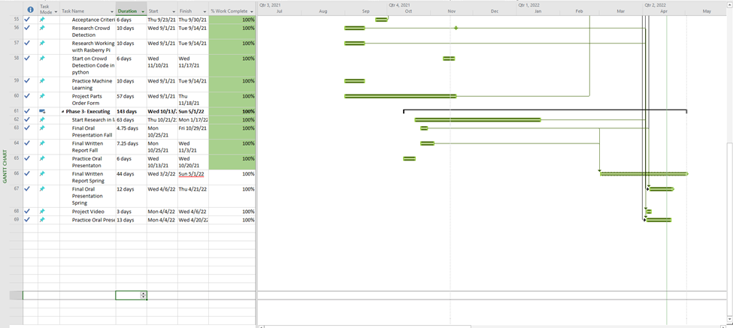
Figure 9: Gantt Chart Continued

Section 3 – Preliminary Design

3.1 Concept Generation
Engineering Design Methodology
The engineering design methodology shown in Figure 10 shows the approach taken to solve the problem. Define and identify (Step 1) is where the problem, possible solutions and impacts of those solutions are derived. Brainstorm and select (Step 2) is where solutions are compared, and a final decision is made. Prototype (Step 3) is where the device is assembled, and parts are being put together. Test (Step 4) is where solutions are tested, and the device is improved after trials and error. Communicate (Step 5) is where the idea is presented both orally and written.
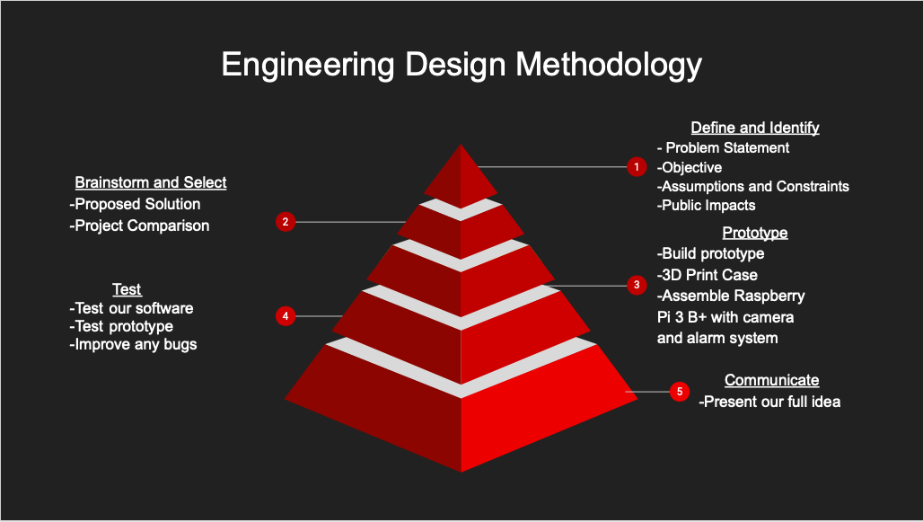 Figure 10: Engineering Design Methodology

3.2 Concept Evaluation and Selection
There are other products on the market for enforcing social distancing. Figure 11 shows the comparison of 3 other products in relation to ours. There is a Geovision People Counter device that is used to keep count of how many people are in each space. Though this meets one of the requirements of our device, it does not meet the distance detection also provided by our device. The Geovision People Counter may be able to count the number of people in a room, but it won’t tell you how close those people are. A critical part of social distancing is staying 6 feet apart. The price of this device is also higher than ours.
Another device created for social distancing purposes is the Ultimaxx wristband. This is a watch-like device that will sound off when one user comes within 6 feet of another user. This device relies on battery life and will only work if there are 2 of them active. If an office used these for their employees, they would have to buy one for each participant, which could result in a high cost. This device is also limited to the willingness of a person. If someone chooses not to wear it, much like people choose not to wear a mask, then they are not going to be aware or abide by social distancing rules. Our device will be stationed in a room and anyone who enters will be detected and monitored for violations.
The last product found is a tool used in iOS called the Magnifier Tool. This is a software used by apple users that can be programmed by the user to sound or alert when they are within a specific distance of something else. This tool has some of the same constraints as the Ultimaxx Wristband as far as participation. It also has its own con of accessibility as it is only for iOS users and not easily programmable to the average person. Below in Figure, is a chart that depicts these different products in comparison to ours, the Covid-19 Crowd Detector.
3.2 Concept Evaluation and Selection Continued
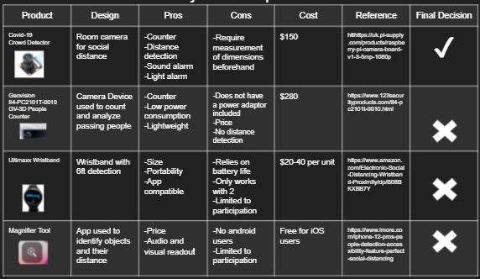
Figure 11: Project Comparison

3.3 Design Constraints and Applicable Codes and Standards Used in the Preliminary Design
Design Constraints:
This project included some design constraints. These constraints prevented the team from being able to make a design that was unnoticeable and more compact.
- 3D printed case. The case had to be big enough to not only hold all the components, but the wiring to each component as well. The case also had to be designed in a way that the speakers were a part of the design but not inside the case, so the sound wasn’t muffled.
- Wiring. The Raspberry Pi had to be connected to a monitor. This would mean the monitor would have to be in close proximity thus compromising one of the marketing requirements or there would be extra wiring needed to extend the length of the cords thus making it look messier.

3.3 Design Constraints and Applicable Codes and Standards Used in the Preliminary Design Continued
- Compatibility. It was difficult finding compatible components on both the hardware and software aspects of this project.
Hardware: It was hard to ensure a component was compatible and was also the best fit. The team purchased a component that was said to be compatible but fried the system. It was too much of a hassle to try and reorder a different component due to longer delivery times due to COVID.
Software: When programming the system with a software that was not compatible there was no error message that let you know the software was incompatible. It just simply wouldn’t work. This led to a lot of time spent troubleshooting errors that could have been fixed simply.
Codes & Standards Used in The Preliminary Design:
IEEE C37.21-2017: Standard for Control Switchboards: Implemented to assure that the alarms work properly.
IEEE 829-2008: Software and System Test Documentation: Used to ensure that the device is working as intended
IEEE 802.11: Wireless Networking: The technical guidelines that are in place for implementing Wi-Fi. This was necessary due to the use of Wi-Fi on our Raspberry pi.
3.4 Preliminary Analysis
After the literature review, a plan was devised for the design of the Covid-detection device. The plan was to go step by step with the programming of the Raspberry Pi. The first task was to train the Raspberry Pi with a pre-trained model. This required setting up and becoming familiar with the device. After the device is capable of detecting objects, it must then be able to detect only people. This requires either a change in the code or a new model specifically for person detection. We planned to try both options. After being able to detect people, the next target was for the device to count people. Exploring an accelerator was an option for this. The Intel USB Compute Stick is an accelerator and has a pretrained YOLO model embedded in it. After the device could detect and counting people, it would need to keep track of the amount of people in a specific space. To do this, a boundary line was proposed. This line would be established in the middle of the frame and track those who crossed in and out of it.
For the hardware, it was planned out what parts were needed very early. The original device package came with the device, the power source, the HDMI adapter, and the Raspberry Pi camera. Many options for the alarm system were discussed. Sensors were thought of, but essentially ruled since many would be needed. The final option was to use compatible speakers for a sound alarm and a LED strip for the light alarm.
Once the components and coding plans were established, so was the plan for the design of the entire system.

3.5 Preliminary Design
Given the project objective, purpose, and key deliverables the team had to have 2 preliminary designs. The project consisted of both a hardware and software design.
3.5.1 Hardware Design:
The hardware preliminary design shown in Figure 12 starts off with the power source. The power source will input 100-240V and output 5V/2500mA of power. The power cord is then connected to Raspberry Pi 3B+. A Raspberry Pi functions as any computer does, thus it needs to be connected to an external monitor. This connection is created using an HDMI cord. This system will also require a mouse and keyboard. Those will be hooked up via USB connection as shown in Figure 13.
Then from the Raspberry Pi, there will be 6 components connected including the mouse and keyboard. The speaker will serve as the sound alarm and will be connected via an audio hat. The audio hat will be connected to pins just like the cooling system and the LED lights. The camera will be connected in the camera port. You can see exactly where these components will be hooked up by referring to Figure 13.

3.5 Preliminary Design Continued
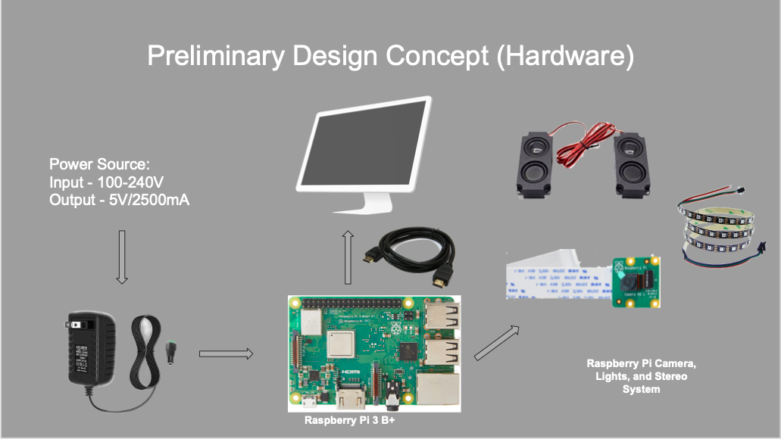
Figure 12: Hardware Design
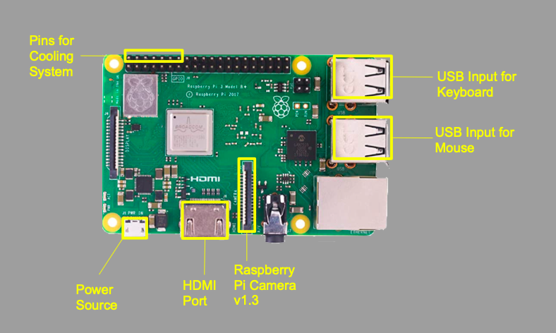
Figure 13: Detailed System Design

3.5 Preliminary Design Continued
3.5.2 Software Design
The software design consisted of 4 main steps as shown in Figure 14. Step 1 was downloading the necessary libraries. Each library has a function that helps to execute the objective of this project. The team used 7 libraries including:
- SciPy (version 1.4.1) which stands for scientific python is a collection of mathematical algorithms.
- NumPy (version 1.19.2) also performs mathematical operations but on arrays.
- OpenCV (4.2.0.32) which stands for open-source computer vision, was used to process the images. It played a huge part in performing object detection.
- Imutils (version 0.5.3) calls the OpenCV interface. It is used to manipulate images by translating, rotating, scaling, etc.
- Argparse (version 1.4.0) makes it easy to write user-friendly, command line interfaces.
- Schedule (version 0.6.0) allows you to run python functions at predetermined intervals using simple syntax.
- Dlib (version 19.18.0) is a pre-trained facial detection model.

3.5 Preliminary Design Continued
After downloading these necessary libraries, the next step is to initialize them. To understand the software portion of the project, one must first understand the process of going from object detection to crowd detection. The first step is object localization. This is where you find out what and where a single object is in an image. Then you can move on to object detection. This is where you find out what and where multiple objects are in each image. To do this a combination of image processing and computer vision are needed. The libraries mentioned above are the tools used to implement it in actual computer programming.
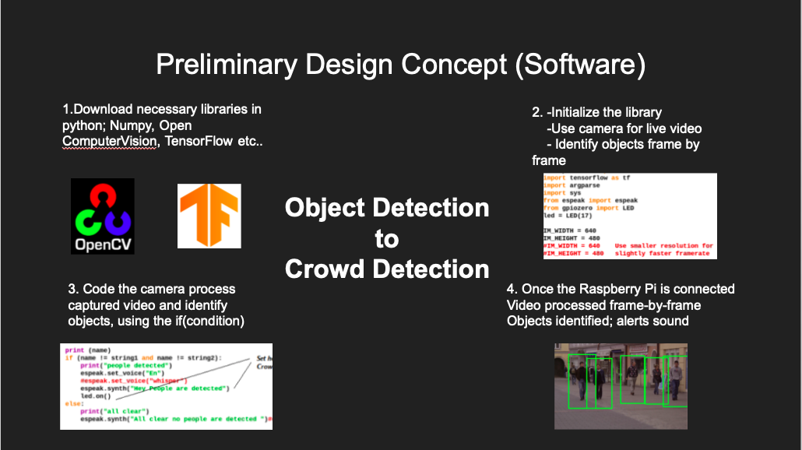
Figure 14: Software Design

Section 4 – Detailed System Design

4.1 Project Parts Summary
The project design specifications called for 4 parts.
Raspberry Pi 3B+, as shown in Figure 15. This system was provided to us, free of charge, by our university. If you wanted to buy this product, the cost would be approximately $200. A raspberry Pi is a pocket-sized, low-cost computer system that requires an external monitor, keyboard and a mouse to function.
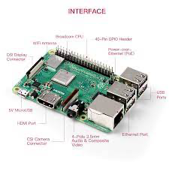
Figure 15: Raspberry Pi 3B+
Miuzei Case with cooling fan, as shown in Figure 16. This case aided in regulating the temperature of our computer system to avoid overheating. This case also served as physical protection of our Raspberry Pi 3B+. This product can be purchased from amazon for $20.

4.1 Project Parts Summary Continued
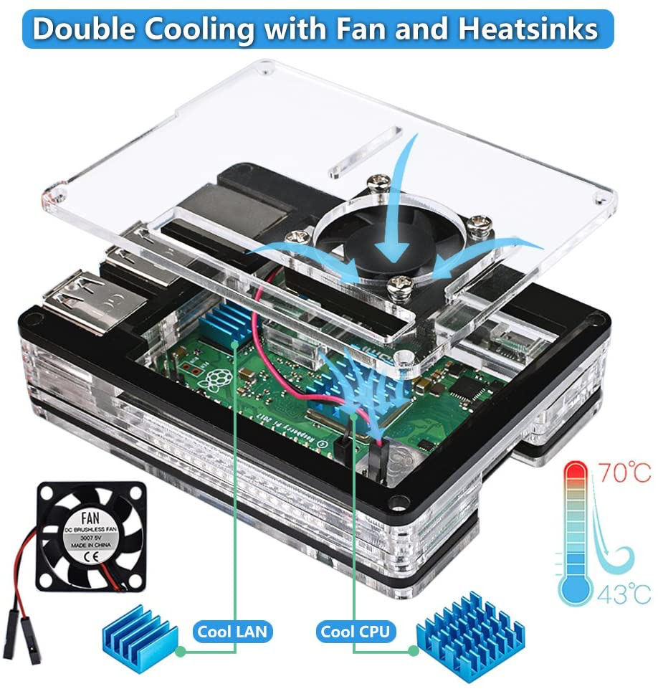
Figure 16: Case & Cooling Fan
Audio Hat Module, as shown in Figure 17. This is used to output the audio necessary in alerting violations. The stereo can be purchased for $22.
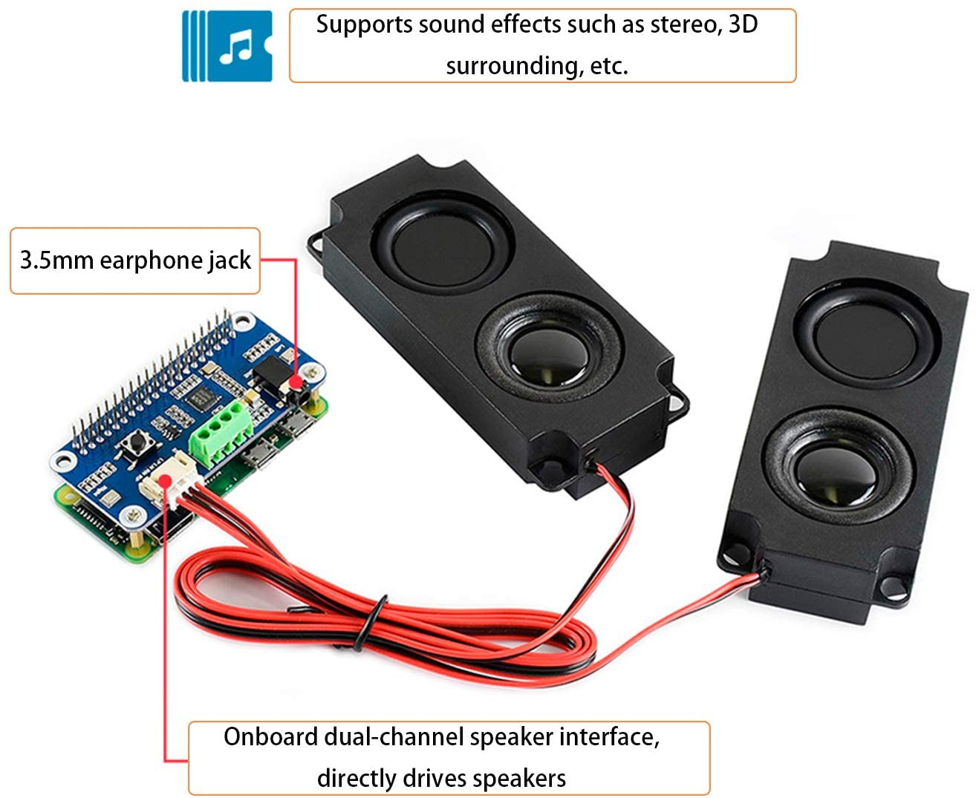
Figure 17: Stereo
4.1 Project Parts Summary Continued
RGB LED strip, as shown in figure 18. This is used as a visual alert and can be purchased for $10.
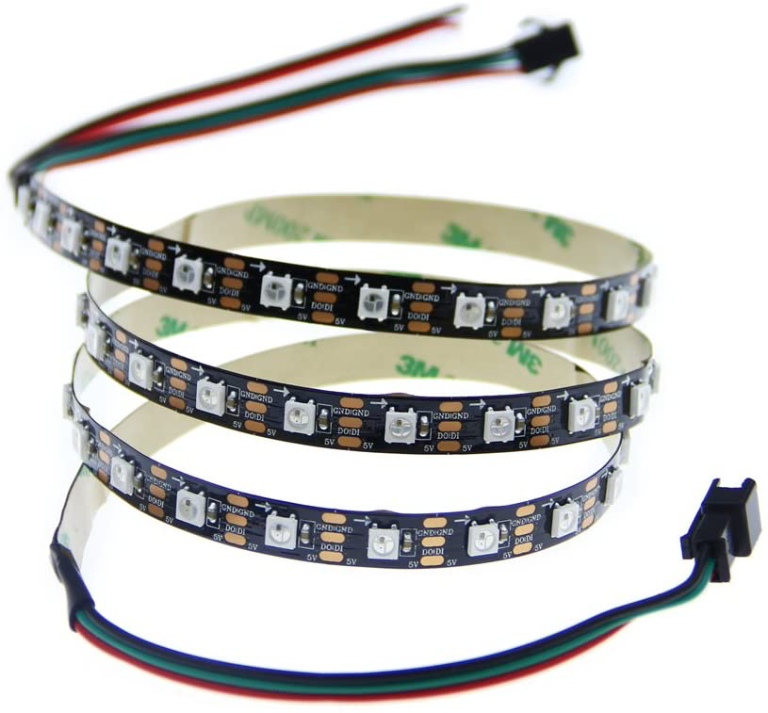
Figure 18: LED Light Strip

4.2 Engineering Analysis and/or Simulation
To get to the point in the project where the team proposed design, the team started by developing a plan for the hardware and software aspects of the project. For the hardware portion of the project, the team knew the system we wanted to utilize was the Raspberry Pi 3 B+. This is the main component of the hardware design of the project. Since this is the heart of the project, the team took the Raspberry Pi and stemmed all further design aspects from it.
A Raspberry Pi needs the basic hardware such as a mouse, keyboard, and a monitor to function. To ensure this project satisfied all our marketing requirements, the team had to incorporate more hardware components. These hardware components consist of a speaker that was able to reach the volume parameters (20-40 decibels) and a light that was bright enough to catch the attention of our audience.
Once the team assembled all of the hardware components there would be a 3D printed housing unit that holds all of these pieces together to make the system much more aesthetically pleasing. Successful completion of this project meant utilizing the knowledge the team previously attained as well as doing necessary research to gain knowledge on the unfamiliar aspects of this project. Intro to Electrical Engineering helped the team with the hardware aspect of the project. The team would need to utilize a breadboard in our final product to connect our LED. This skill was taught in that course.
As far as the software aspect is concerned, none of the team knew how to code in Python. This is a skill the team had to do research on. One of the team members was able to utilize skills learned from an internship to navigate the Linux terminal. That background knowledge gave the team the edge needed to begin completing this project.
4.2 Engineering Analysis and/or Simulation Continued
To understand the software portion of our project one must understand the basics of identifying objects through computer programming. The base is object localization. This is finding out what and where a single object exists in an image. An advanced version of this is object detection. This is finding out what and where multiple objects are in an image. This combined image processing and computer vision. Object detection is the ground of this project. This is made possible by downloading necessary libraries.

4.3 Hardware Layout/ Equipment Selection
The figures shown below show our final hardware selection. Figure 19 shows the Raspberry Pi 3B+, which is the computer system. This was the main component used in the design of this project. Figure 20 shows the camera (version 1.3). This camera was used to input a live feed into the computer system. The team was unable to incorporate the light and sound alarms.
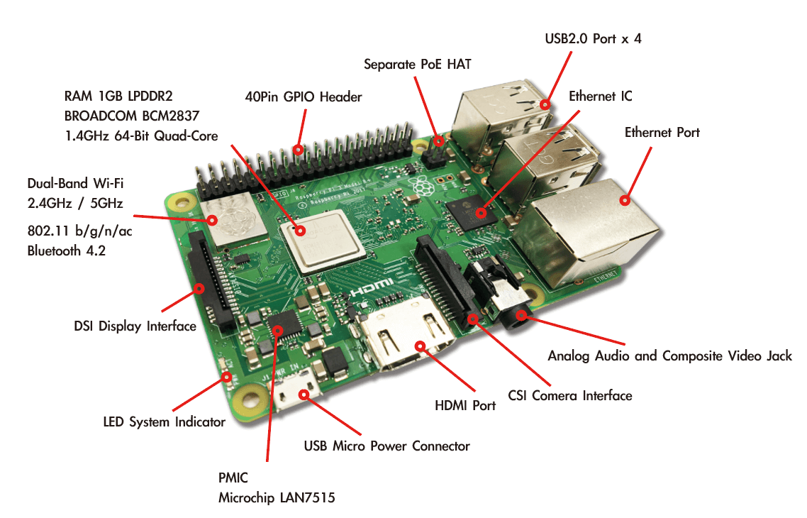
Figure 19 : Raspberry Pi 3B+

4.3 Hardware Layout/ Equipment Selection Continued
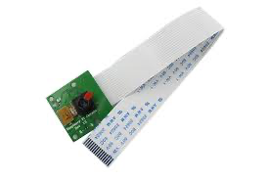
Figure 20: Camera

4.3.1 Overview of Code
In this section, the team will highlight a few major sections of our code. Figure 21 shows importing of some of those major libraries. Figure 22 is a simple if else statement as used in other programming languages. This if else statement gives users the option to use a prerecorded video or live feed. Due to the slow frame rate of the Raspberry Pi 3B+, we chose to utilize a prerecorded video stream.
Figure 23 is a loop. This loop ensures that, whether using a live feed or prerecorded video, the software runs every frame and actively continues to run and identify people until told to do otherwise. As long as the prerecorded video did not run out or the software didn’t lose live feed, it would continue to run.
Figure 24 is the line of code which assigned which direction was considered entrance and which was an exit. The team decided that if a person approached the line coming from the top, they would be counted as entering, otherwise, they would be counted as an exit.

4.3.1 Overview of Code Continued
- 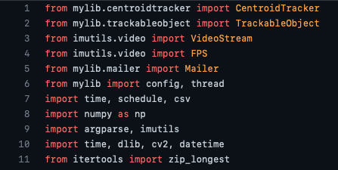
- Figure 21: Code Snippet 1
- 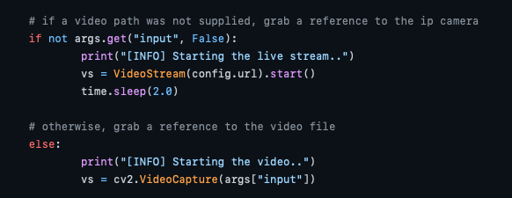
Figure 22: Code Snippet 2

4.3.1 Overview of Code Continued
- 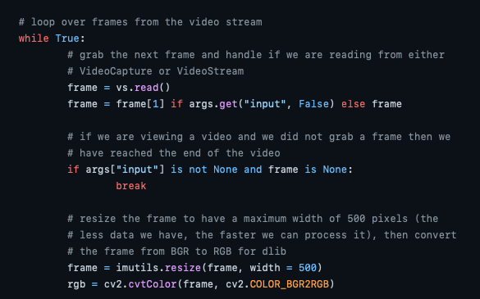
Figure 23: Code Snippet 3
- 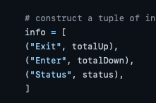
Figure 24: Code Snippet 4

- 4.4 Application of Engineering Codes and Standards used in the Final Design
Engineering codes and standards are a set of rules that are designed to protect the integrity of our past, present and future engineers. The team looked at the IEEE codes and standards and decided that there were 5 that aligned with our project's goals. Below are the codes and standards we used in the final design.
IEEE 7.6: IEEE Protection of the Public: the obligation of the profession to protect the health, welfare, and safety of the public. Where legislation, regulations, codes, or customs impact on electrical and electronics engineering. The team decided this code should be used due to the nature of our project using a raspberry pi and camera to implement crowd detection to reduce the spread of Covid-19.
IEEE 7.8: IEEE Code of Ethics 1.5: Seek and accept honest Criticism of technical work. This code aided the team in accepting constructive criticism. The team was able to receive feedback then make the necessary changes that led to the efficient improvement of our final design.
IEEE C37.21-2017: Standard for Control Switchboards: Implemented to assure that the alarms work properly. Utilizing this IEEE code allowed our team to verify that our system is satisfying the intended needs of the end user.
IEEE 802.11: Wireless Networking : The technical guidelines that are in place for implementing Wi-Fi. The team thought this was necessary due to the use of our Raspberry pi needing to communicate with other devices to access the internet without connecting wires.
- 4.4 Application of Engineering Codes and Standards used in the Final Design Continued
IEEE 730-2014: IEEE Standard for Software Quality Assurance: Requirements for initiating, planning, controlling, and executing the Software Quality Assurance processes of a software development or maintenance project. This guided the project's versioning, controlling, and executing of programs during the software cycle.

4.5 Economic Analysis
Table 2 exhibits the final cost of this project. Although we were within our budget of $600, the projects’ budget could have been optimized by doing a more thorough research on the parts that we purchased. The intel compute stick turned out not to be the fitting part for this project. The team could have utilized this part, but it was difficult to connect and had its own software involved. Using it, would have redesigned the entire software design process.
When connecting the Stereo, it fried the Raspberry Pi and the team decided that though this product was deemed compatible, it may not have been the best option. Due to the stereo frying a Raspberry Pi and causing the team to have to restart, this piece was not used. Having to restart was something the team was not willing to risk due to time issues.
All other parts were price effective and worked exactly as we planned. Receiving all Raspberry Pi’s as well as the analog kit also helped the team remain under budget.

4.5 Economic Analysis Continued
Item Name | Description | Quantity | Total
Raspberry Pi 3b+ | Raspberry Pi is a low cost, credit-card sized computer | 2 | Pre-owned
DC Power Supply | electronic device with a battery for a power source | 1 | $9.99
LED Lights | A semiconductor device that emits visible light when an electrical current passes through it. | 1 | $ 9.99
Stereo | Speaker | 1 | $19.99
Intel Neutral Compute Stick | A simple USB device that can greatly accelerate AI processing and deep learning inference on consumer PCs. | 1 | $71.99
Raspberry Pi 3 B+ Case with Fan Cooling, | Protective case with a cooling fan. | 1 | $19.99
Analog Parts Kit | contains a large selection of components perfect for creating a wide variety of useful circuits & devices. | 1 | Pre-owned
 |  | Total: | $131.95
Table 2: Total Cost

4.6 Final Design
Figure below shows the final design of the project. The Raspberry Pi was double-housed. The device itself was enclosed in a case that incorporated a fan, needed to keep the Raspberry pi cool. The device was tasked with a complex mission that could cause it to run hot, so the fan was a much-needed addition. The outside is a 3-D model used to keep all the added components for the project compact. It also allows for the camera to be strategically placed. The 3-D model was printed as a design similar to that of a surveillance camera for the user to place at the top of the room.

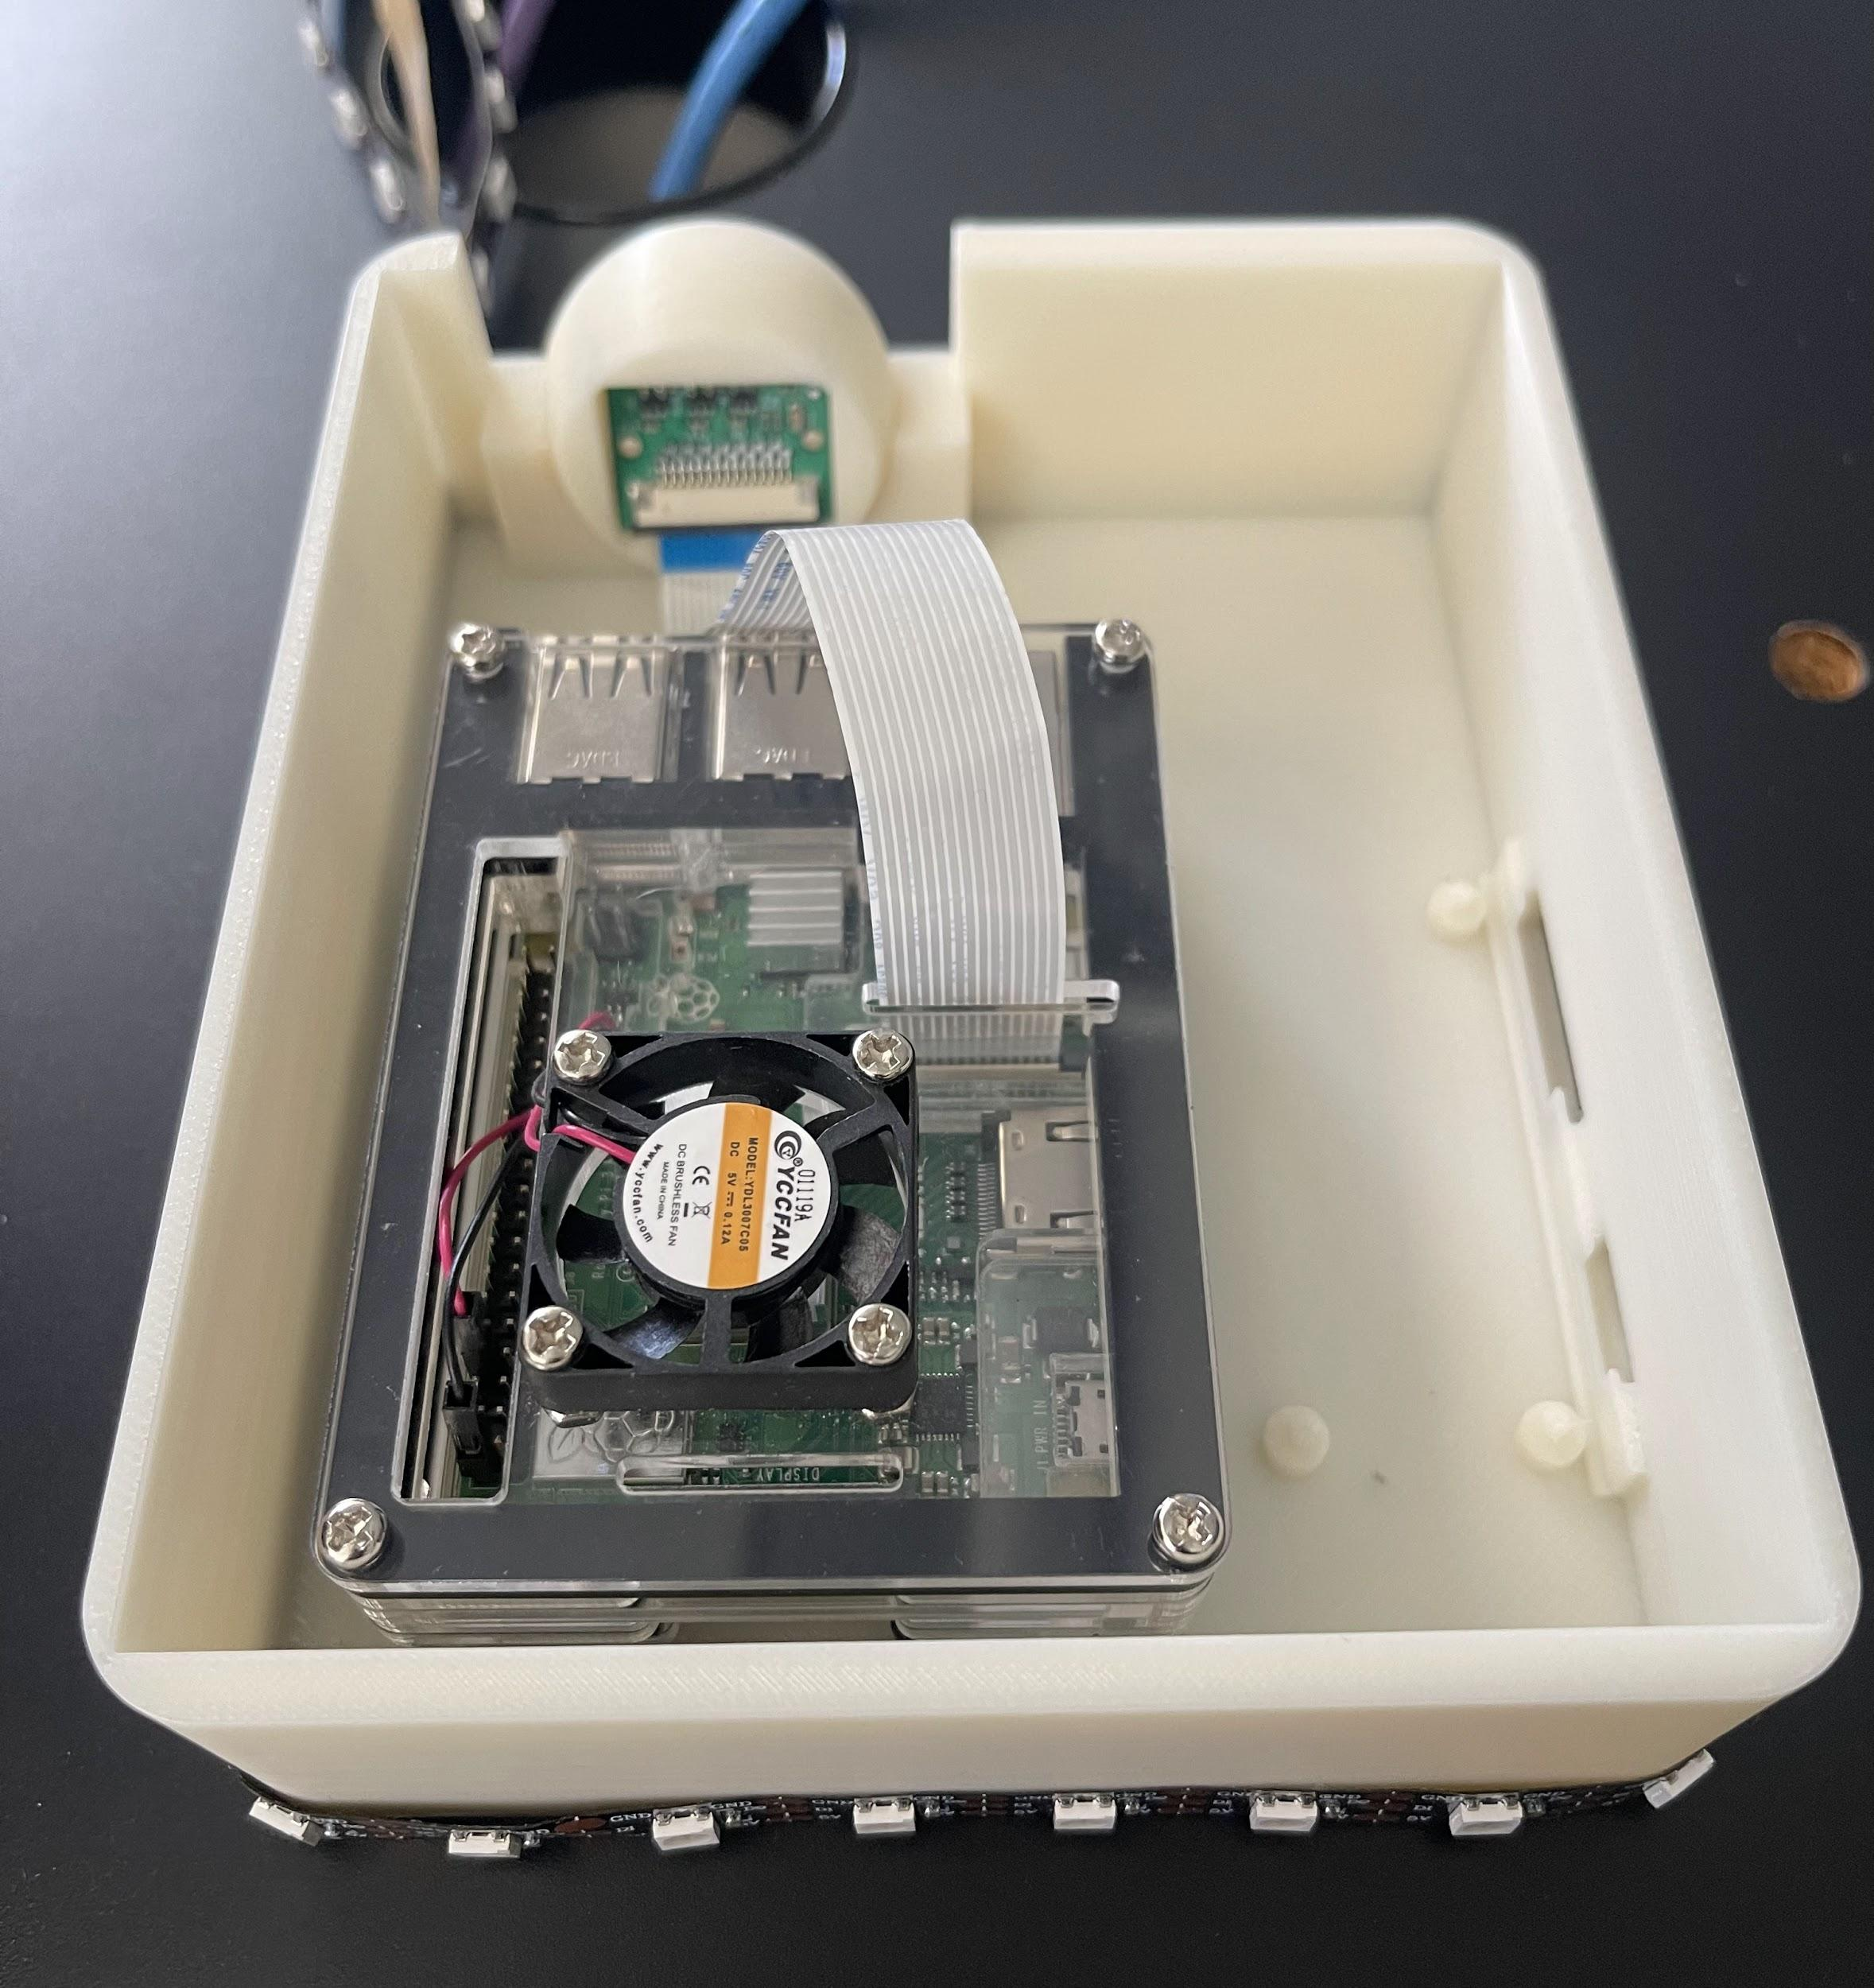
Figure 25: Final Design

Section 5 – Results and Discussion

5.1 Summary of Goals and Objectives
As this project was developed, there were a couple of things which needed to happen to deem the project successful. There are 5 major goals/key deliverables:
The project will incorporate object detection. Object detection is a computer vision technique that will allow us to identify and locate objects in each frame. This is an important 1st step in the design of this project. The system must be trained not only to see a laptop, for example, but recognize it as a laptop and not a person.
This project will also incorporate a people counter. Incorporating a people counter will allow us to monitor how many people are in a room. An important part of this project is that we recognize people for people then keep count of those people for the entire time that they occupy a space.
The system will be able to perform crowd detection. Crowd detection utilizes object detection and a people counter to monitor the amount of people in each area and give a notification when capacity has been reached. This is the main final functionality of the project.
Finally, the device will incorporate a sound alarm as well as a light alarm. After utilizing crowd detection, when capacity has been reached, both alarms will activate. The sound alarm will have an adjustable volume, so it is able to fit the needs of each individual user. This alarm will make the design accessible for blind users. The light alarm will come on and remain on to be courteous to those with epilepsy. We chose a red light because red is known to be an attention seeking color. This alarm makes the device accessible to those who are deaf.

5.1 Summary of Goals and Objectives Continued
All our beginning goals and objectives remained necessary in deeming this project successful. Unfortunately, due to some issues, the team could not deliver every requirement. The team was able to perform object detection, incorporate a people counter, and perform crowd detection. When attempting to incorporate the sound alarm, the audio hat fried the Raspberry Pi and due to a time constraint, the team never got around to attempting to incorporate the light alarm.

5.2 Summary of Constraints and Codes Met by Design
Our device had five main constraints, first being we needed a strong reliable Wi-Fi connection. Another is that the device requires a constant power supply to keep the raspberry pi running. The raspberry pi also requires an external monitor to view what the computer is currently displaying. Next the camera must be positioned at a certain height level to catch people of varying heights. Lastly our device cannot be moved easily due to the height requirement due to the device needing to be mounted.
The team decided on six IEEE codes and standards to be implemented in the design and development of our device. The explanation and implementation of the codes and standards that we used are listed below.
- IEEE 7.6: IEEE Protection of the Public: This code is to maintain public safety. This was implemented in the objective of our device being to help slow the spread of COVID-19 which would help maintain public health and safety.
- IEEE 7.8: IEEE Code of Ethics 1.5: This code states to improve the understanding of technology, its appropriate application, and potential consequences. This code was useful in helping the team can take constructive criticism and make the necessary changes to the project based on the given feedback.
- IEEE 7.8: IEEE Code of Ethics 1.6: This code is to maintain and improve our technical competence. We used this code in our methodology process by learning how to code and use the Raspberry Pi.

5.2 Summary of Constraints and Codes Met by Design Continued
- IEEE C37.21-2017: Standard for Control Switchboards: This standard covers the construction and testing of devices such as alarms. It also includes regulating devices and accessories. This was carried out in the testing of the alarms and execution of the development of the device.
- IEEE 829-2008: Software and System Test Documentation: This standard identifies the need to test processes to determine if the development produces the intended outcome. The project was tested numerous times to assure that the set requirements were met.
- IEEE 802.11: Wireless Networking: The wireless networking standard provides the basis of Wi-Fi use. This standard was necessary due to the Raspberry Pi being connected to Wi-Fi.

5.3 Discussion of Results
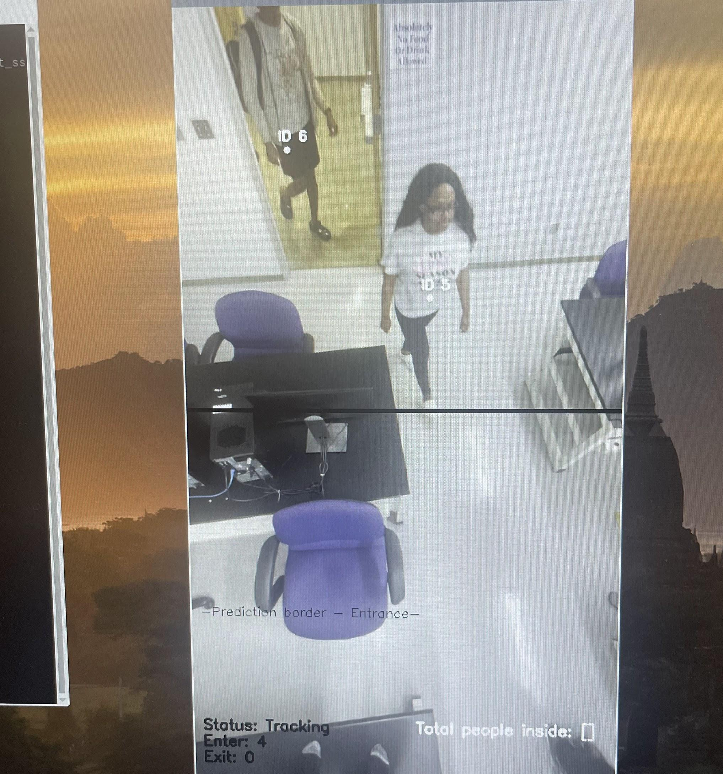
At the conclusion of the project, the device was able to detect, count, and keep track of the people in each area. The team achieved this by programming the Raspberry Pi 3B+. The device is to be positioned to catch the entire door frame. The frame establishes a boundary line in the middle. This program assigned an ID to each person detected as soon as they entered the scope. Once that ID crossed the boundary line, depending on the direction in which they crossed, they were counted as either entered or exited. This system alone kept track of the people in an area and successfully implemented the objective of the project.

Figure 26: Project Demonstration

Section 6 – Literature Review

6.1 Literature Sources
Using a Machine Learning Model to Train Device
Rosenberg, Chuck; Hebert, Martial; Schneiderman, Henry (2018): Semi-Supervised Self-Training of Object Detection Models. Carnegie Mellon University. Journal contribution. https://doi.org/10.1184/R1/6560834.v1
How to Achieve Objection Detection on Raspberry Pi
Huang, Z., Yang, S., Zhou, M. et al. Making accurate object detection at the edge: review and new approach. Artif Intell Rev 55, 2245–2274 (2022). https://doi.org/10.1007/s10462-021-10059-3
How to Speed up Framerate
P. Sismananda, M. Abdurohman and A. G. Putrada, "Performance Comparison of Yolo-Lite and YoloV3 Using Raspberry Pi and MotionEyeOS," 2020 8th International Conference on Information and Communication Technology (ICoICT), 2020, pp. 1-7, doi: 10.1109/ICoICT49345.2020.9166199.
How to Connect and Program Compatible Alarm Parts
S. V. Militante and N. V. Dionisio, "Real-Time Facemask Recognition with Alarm System using Deep Learning," 2020 11th IEEE Control and System Graduate Research Colloquium (ICSGRC), 2020, pp. 106-110, doi: 10.1109/ICSGRC49013.2020.9232610.

6.2 Statement of Learning from Each Source
Using a Machine Learning Model to Train a Device
This article was used to get an understanding of how a device can be trained using a machine learning model. This article explains how many training models must be put together and labeled before use. This article introduces the concept of a semi-supervised training model. This type of model is meant to save time with a fully labeled model.
How to Achieve Object Detection
In this article, the limitations of computer devices like the Raspberry Pi are discussed. It is acknowledged that convolutional neural network (CNN) models are used in the Internet of Things for solving privacy leaks and server overload issues. The article proposes a CNN model for machine learning to reduce the input size for object detection.
How to Speed up Framerate
This paper compares two specific image processing algorithms: YOLOLITE and YOLOV3. The results show that the Raspberry Pi camera worked at 15 fps on YOLO-LITE and 1 fps on YOLOV3. This introduces the different options and algorithms the Raspberry Pi has and the advantages and disadvantages of them all.
How to Connect and Program Alarm Parts
This paper covers a project very similar to this project. It detects face-masks and also incorporates an alarm system. The information in this research explains how to connect and program an alarm system after the Raspberry Pi camera detects a mask on a person.

Section 7 – Recommendations and Conclusions

Recommendations:
- When completing a project of this caliber, you should use certain software to make the process more efficient. You should research which software versions are both compatible with one another as well as the system you are using. You should use the same libraries and their versions if using the Raspberry Pi 3B+.
- When setting up this device, it should be elevated while facing the door and catching the entire door frame. Incorrect positioning can result in inaccurate results.
- If time is a constraint, the team recommends using a pre-trained machine learning module. This will save a lot of time.
- The team recommends using a more up to date device. This project is beyond the capabilities of a Raspberry Pi 3B+. The device is slow which results in having a slow frame rate.
Conclusion:
Implementing real-time crowd detection on a Raspberry Pi 3 pushes the device to its limits. The team was able to perform all given tasks but implementing a live feed on this device is unreliable due to the slow frame rate. The team programmed the device to be able to perform this function, but it is useless because of the inaccuracies of the frame captures. The team was unable to implement the sound and light alarm aspects of this project. If given more time, the team would be able to deliver all marketing requirements. This was a great experience and it taught us a lot.

List of References
Internet Sources:
[1] “Coronavirus Cases.” Worldometer, https://www.worldometers.info/coronavirus/?utm_campaign=homeAdUOA%3FSi.
[2] Covid-19 parental resources kit – adolescence. (2021, July 27). Retrieved October 04, 2021, from https://www.cdc.gov/mentalhealth/stress-coping/parental-resources/adolescence/index.html
[3]Culture in the COVID-19 recovery: Good for your wallet, good for resilience, and good for you. (n.d.). Retrieved October 04, 2021, from https://blogs.worldbank.org/sustainablecities/culture-covid-19-recovery-good-your-wallet-good-resilience-and-good-you
[4] “Harris County / City of Houston Covid-19 Data Hub.” Harris County / City of Houston COVID-19 Data Hub, https://covid-harriscounty.hub.arcgis.com/.
[5] NBC Chicago. (2020, June 23). What are the odds someone at a gathering has covid-19? Chicago health officials break down the math. Retrieved October 04, 2021, from https://www.nbcchicago.com/news/local/what-are-the-odds-someone-at-a-gathering-has-covid-19-chicago-health-officials-break-down-the-math/2294188/
[6] Olson, P. (2020, May 15). Don't stand so close to me: Ai cameras police social distancing at work. Retrieved October 04, 2021, from https://www.wsj.com/articles/dont-stand-so-close-to-me-ai-cameras-police-social-distancing-at-work-11589452202
[7] Rosner, E. (2020, September 02). US divorce rates skyrocket amid covid-19 pandemic. Retrieved October 04, 2021, from https://nypost.com/2020/09/01/divorce-rates-skyrocket-in-u-s-amid-covid-19/

List of References Continued
[8] Saladino, V., Algeri, D., & Auriemma, V. (2020, October 2). The psychological and social impact of covid-19: New perspectives of well-being. Retrieved October 04, 2021, from https://www.ncbi.nlm.nih.gov/pmc/articles/PMC7561673/#!po=12.2642
[9]State of the US economy: GDP, unemployment, Jobs & More: 2021 State of the union facts. (2021, April 22). Retrieved October 04, 2021, from https://usafacts.org/state-of-the-union/economy/?gclid=CjwKCAjw4qCKBhAVEiwAkTYsPFMgXd_vhIkd1arBJjHS5kjdLP5wQZxKfkG5hl4GkeeHabrl9KFGfxoC16cQAvD_BwE
[10] Jay, et al. “OpenCV People Counter.” PyImageSearch, 13 July 2021, https://www.pyimagesearch.com/2018/08/13/opencv-people-counter/.

Appendix
Although the programming of this device was a complex process, using the device after it has been distributed will be easy to use.
Step 1: Set Up
Connect all the given components to your Raspberry Pi. Connect the Raspberry Pi to power as well as an external monitor and power it on. Follow the on-screen instructions to set up the date and time
After connecting all components, position your camera in an elevated area that catches the entire door frame in its view.
Step 2: Running the program
Open your terminal and run the following command line to open up the software. After this is ran, the device will be fully functional.
python run.py --prototxt mobilenet_ssd/MobileNetSSD_deploy.prototxt --model mobilenet_ssd/MobileNetSSD_deploy.caffemodel

Acronym | Definition
3D | 3 Dimensional
CDC | Centers for Disease Control and Prevention
CNN | Convolutional Neural Network
GDP | Gross Domestic Product
HDMI | High -Definition Multimedia Interface
IEEE | Institute of Electrical and Electronics Engineers
LED | Light Emitting Diode
OPEN CV | Open Computer Vision
RGB | Red, Blue, Green
USB | Universal Serial Bus
WHO | World Health Organization
YOLO | You Only Look Once

