ROY G. PERRY COLLEGE OF ENGINEERING
MECHANICAL ENGINEERING DEPARTMENT
PRAIRIE VIEW A&M UNIVERSITY

ASSESSMENT REPORT COVER PAGE

MCEG 4093 FINITE ELEMENT ANALYSIS & DESIGN

FALL 2020 SEMESTER

NAME OF INSTRUCTOR: Dr. Shield B. Lin

TABLE OF CONTENTS

- Report Cover Page

- Detailed Course Syllabus

- End of Semester Outcomes Assessment Report

- Grade Sheet Showing Student and Class Performance in Outcomes

- Supporting Outcomes Specific Assignments (Minimum of 2 per outcome)

Assignments assessing students’ ability to identify, formulate, and solve complex engineering problems (CEP) by applying principles of engineering, science, and mathematics.
(Outcome 1)

Sample Assignment 1: A design project of a holding structure in a spacecraft using a finite element program to achieve the minimum weight and satisfying the material integrity under extreme accelerating forces. It is a complex engineering problem which involves conflicting technical issues, and has no obvious solution.

Sample Assignment 2: Test 2 for finite element equation formulation. Although the individual test problems are not full “complex engineering problems,” they represent important equation derivations and solving processes that can be used to solve a complex problem. The “in-class” test is the best means to evaluate students’ individual ability in equation derivation.

Sample Assignment 3: Test 4 using finite element program ANSYS to solve an engineering problem. Although the test problem itself is not a full “complex engineering problem,” it represents an important step of using a modern computer tool, ANSYS, to solve a complex problem. The “in-class” test is the best means to evaluate students’ individual ability in software skills.

Detailed Course Syllabus
(Distributed to Students at the beginning of the Semester)
ABET Outcomes measured using course should be
explicitly listed in the syllabus

Course Description in ABET Format
MCEG 4093 Finite Element Analysis and Design

1. | Course number and name: | MCEG 4093 Finite Element Analysis and Design
2. | Credits and contact hours: | 3 credit hours; 3 contact hours
3. | Instructor’s or course  coordinator’s name: | Dr. Shield Lin
4. | Text book: Title: | Finite Element Modeling and Simulation with ANSYS Workbench
 | Author: | Xiaolin Chen and Yijun Liu
 | Publisher, Year & Edition: | CRC Press, Taylor & Francis Group, New York, 2018, 2nd Edition
 | - Other Supplemental material | ANSYS Workbench User’s Guide, Release 18.2, ANSYS, Inc., Canonsburg, Pennsylvania, August 2017.
5. | Specific course information
 | - Brief description of the content of the course (catalog description) | An Introduction to finite element analysis as a modern computational tool to solve boundary value problems. Applications will be in structural mechanics, fluid flow, and heat transfer. Design and computer projects included.
 | - Prerequisites or  Co-requisites | CVEG2063 – Mechanics of Materials.  Prerequisite or Taking Concurrently: MCEG3013 – Heat Transfer.
 | - *Indicate whether a required, elective, or selected elective (as per definition provided) course in the program | Required.
6. | Specific goals for the course | Students will be able to:
 | - specific outcomes of instruction (e.g. The student will be able to explain the significance of current research about a particular topic.) | 1. derive, formula, and solve equations using the finite element method.  2. apply finite element tool to solve engineering problems using ANSYS Workbench in solid mechanics, heat transfer, fluid mechanics, mechanical vibration, and design optimization.  3 understand a design project problem statement, conduct information research, produce engineering drawings, identify critical issues, collect and calculate required parameters, create a finite element model on computer, perform analysis, interpolate finite element analysis results, make conclusions, discuss results and suggest options.
 | - Explicitly indicate which of the student outcomes listed in Criterion 3 or any other outcomes are addressed by the course. | This course addresses:  Outcome 1  Ability to identify, formulate, and solve complex engineering problems (CEP) by applying principles of engineering, science, and mathematics.
7 | Brief list of topics to be covered | 1.Matrix Algebra and Matlab (3)  2. Finite Element Formulation for one-dimensional problems (6)  3. Finite Element Formulation for two-dimensional problems (9)  4. Using ANAYS Workbench to solve structure problems (6)  5. Using ANSYS Workbench to solve fluid and heat transfer problems (6)  6. Using ANSYS Workbench to solve vibration and optimization problems (6)  7. Design project and project presentations (6)

 |  | SYLLABUS
MCEG 4093 Finite Element Analysis and Design
Fall Semester 2020

General Course Information

Information Item | Information
Instructor: | Dr. Shield Lin
Section # and CRN: | Section Z02, CRN # 16357
Office Location: | S. R. Collins Building, Room 302A
Office Phone: | (936) 261-9958
Email Address: | shlin@pvamu.edu
Office Hours: | 3:00 – 5:00 p.m., MTW, through electronic means
Mode of Instruction: | Online, Synchronous Instructional Method
Course Location: | Zoom meetings online
Class Days & Times: | Tuesday and Thursday 7:00 a.m. to 8:20 a.m.
Catalog Description: | An Introduction to finite element analysis as a modern computational tool to solve boundary value problems. Applications will be in structural mechanics, fluid flow, and heat transfer. Design and computer projects included.
Prerequisites: | CVEG2063 – Mechanics of Materials
Co-requisites: | Prerequisite or Taking Concurrently: MCEG3013 – Heat Transfer.
Required Text(s): | Finite Element Modeling and Simulation with ANSYS Workbench, Second Edition, by Xiaolin Chen and Yijun Liu, CRC Press, Taylor & Francis Group, New York, 2018.
Recommended Text(s): | ANSYS Workbench User’s Guide, Release 18.2, ANSYS, Inc., Canonsburg, Pennsylvania, August 2017.  Finite Element Analysis - Theory and Application with ANSYS, Third Edition, by Saeed Moaveni, Pearson Education, Inc., Upper Saddle River, NJ, 2008.
General Course Information Table
Student Learning Outcomes:
Upon successful completion of this course, students will be able to: |  |  | Program Learning Outcome Alignment | Core Curriculum Outcome Alignment
1.understand the fundamental concepts of finite element analysis and the formulation of one and two-dimensional elements and the construction of the system. |  |  | Gain techniques and skills for modern mechanical engineering practices. | Develop critical thinking skills.
2. use finite element tool to solve engineering problems using ANSYS Workbench in solid mechanics, heat transfer, fluid mechanics, mechanical vibration, and design optimization. |  |  | Gain techniques and skills for modern mechanical engineering practices. | Develop critical thinking skills.
3. conduct engineering design utilizing a modern finite element computer tool and write a design report. |  |  | Gain an ability in life-long learning skills and an ability to communicate effectively. | Develop communication skills.
Student Learning Outcomes Table

The Mechanical Engineering Program Objectives are to produce graduates who have:

- the techniques and skills necessary for modern mechanical engineering practices, and an ability to function effectively in multi-disciplinary teams.
- an ability in life-long learning skills, a knowledge of contemporary issues, and an ability to communicate effectively.
- an understanding of global and societal context in the aspects of professional and ethical responsibility and the impact of engineering solutions on society.
- the qualifications to be employed by major industries and government agencies in the State of Texas and the nation.
- the qualifications to pursue graduate degrees.

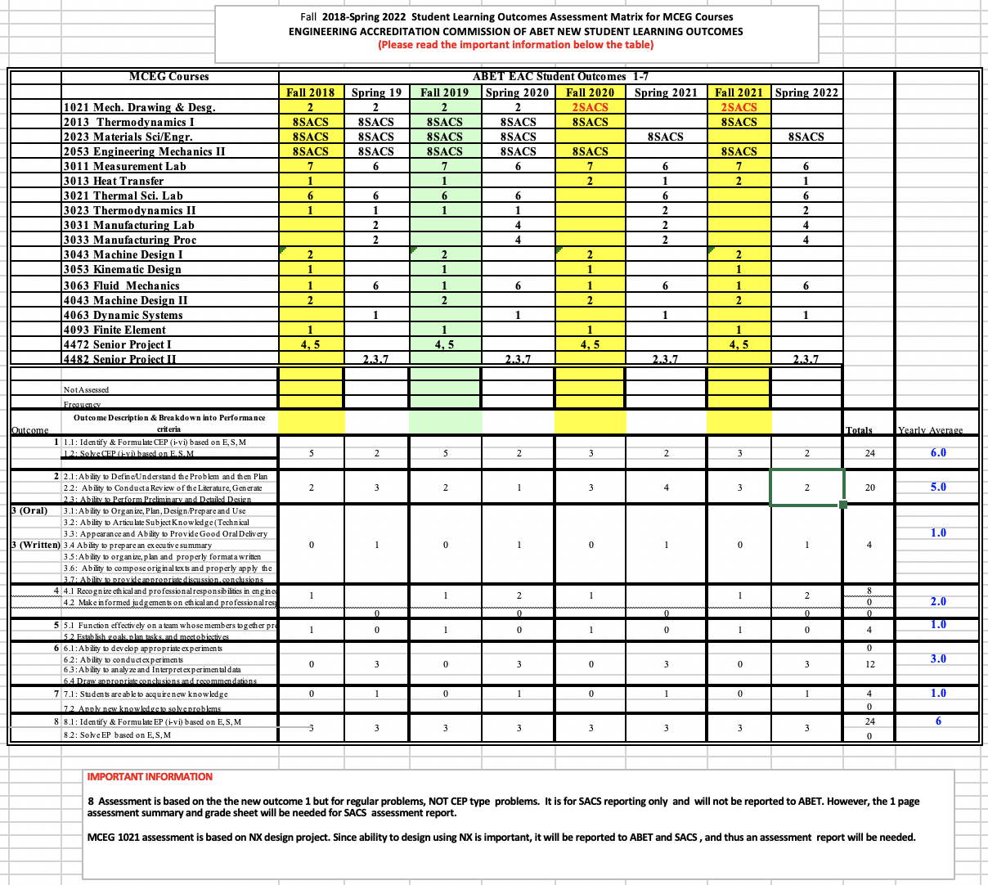

Major Course Requirements
Method of Determining Final Course Grade
 | Course Grade Requirement |  | Value | Total
 | 1. attendance, discussion, homework, quiz, etc. |  | Various points | 20%
 | 2. Test 1 (problem solving) |  | 100 | 15%
 | 3. Test 2 (problem solving) |  | 100 | 15%
 | 4. Test 3 (computer test) |  | 100 | 15%
 | 5. Test 4 (computer test) |  | 100 | 15%
 | 6. Design Project |  | 100 | 20%
 | Total: |  |  | 100%
Course Grade Requirement Table
Grading Criteria and Conversion: 100
A = 90-100
B = 80-89
C = 70-79
D = 60-69
F = 0-59
Detailed Description of Major Assignments: [Describe each assignment valued at 10% of grade or more]
Assignment Title or Grade Requirement |  | Description
1. Test 1 |  | Matrix Operations, Formulation of 1D finite element system, Solving for solutions.
2. Test 2 |  | Formulation of 2D finite element system, Solving for solutions.
3. Test 3 |  | Use of ANSYS program to solve a structure problem on computer.
4. Test 4 |  | Use of ANSYS program to solve a heat transfer or vibration problem on computer.
5. Design Project |  | Design an assembly device using finite element method and write a report.
Detailed Description of Major Assignments Table

Course Procedures or Additional Instructor Policies
Taskstream
Taskstream is a tool that Prairie View A&M University uses for assessment purposes. One of your assignments may be required to be submitted as an "artifact,” an item of coursework that serves as evidence that course objectives are met. If applicable, more information will be provided during the semester by your department, but for general information, you can visit Taskstream via the link in eCourses.

Assignments & Due Dates
Homework and project should be submitted to eCourse on the due day and time, Late homework and project report will not be accepted unless having prior approved official reasons.

Email Messages
For non-urgent issues, the instructor encourages the students to use emails to communicate with the instructor. The instructor will reply email messages within 24 hours.

Office Hours
The students, as a group or an individual, are welcome to schedule zoom meetings with the instructor during the office hours. Scheduling can be done by a meeting invite or an email request.

Grading Feedback
Other than the final design project, the instructor will grade assignments, discussions, and tests within one week. The results of grading and comments will be posted on CANVAS.

Professionalism of On-line Discussions
When responding to discussion assignments, all responders shall be professional during the entire communication. We shall considerate to others and use encourage words even you do not agree with other’s opinions. We also must adhere to the privacy of personal data.

Semester Calendar for Fall 2020 Semester

Week | Description
Week One:  8/25  8/27 | Introduction of Finite Element Method and Software Access  Matrix Algebra and MATLAB
Assignment (s): | Matrix Operations assignments
Week Two:  9/01 | Finite Element Basics
9/03 | Finite Element Formulation – Spring
Assignment (s): | Chapter 1: problems 4, 6 & 7
Week Three:  9/08  9/10  Week Four:  9/15  9/17 | Finite Element Formulation – Bars  Test 1  Finite Element Formulation – Trusses  Examples of Truss Problems
Assignment (s): | Chapter 2: problems 1, 2 & 3
Week Five:  9/22  9/24  Assignment (s): | Formulation of Beam Element  Modeling of Beams and Frames  Chapter 3: problems 2 & 5
Week Six:  9/29  10/01 | Examples of Beam and Frame Problems  Test 2
Week Seven:  10/06  10/08 | Modeling and Solution Techniques  ANSYS Workbench – Trusses
Week Eight:  10/13  10/15 | ANSYS Workbench – Framing System  ANSYS Workbench – Wrench
Assignment (s): | Case study assignments
Week Nine:  10/20  10/22 | ANSYS Workbench – Rotating Fountain  ANSYS Workbench – Stand Assembly
Assignment (s): | Case study assignments
Week Ten:  10/27  10/29 | Design Project  Test 3 (Computer)
Assignment (s): | Case study and Design Project assignments
Week Eleven:  11/03  11/05  Assignment (s): | ANSYS Workbench – Vase  ANSYS Workbench – Heat Transfer Analysis  Case study assignments
Week Twelve:  11/10  11/12  Assignment (s): | ANSYS Workbench – Guitar Vibration Modes  ANSYS Workbench – Aerodynamics of Car  Case study assignments
Week Thirteen:  11/17  11/19  Assignment (s): | Design Optimization with Finite Element  Test 4 (Computer)  Case study assignments
Week Fourteen:  11/24  11/26 | Project Presentation  Thanksgiving Holiday
Week Fifteen:  12/01 | Project presentation/Industry Applications

Student Support and Success

John B. Coleman Library
The library and its partners have as their mission to provide resources and instructional material in support of the evolving curriculum, as a partner in Prairie View A&M University's mission of teaching, research, and service and to support the University's core values of access and quality, diversity, leadership, relevance, and social responsibility through emphasis on ten key areas of service. It maintains library collections and access both on campus, online, and through local agreements to further the educational goals of students and faculty. Phone: 936-261-1500; Website: J. B. Coleman Library.

Academic Advising Services
Academic Advising Services offers students a variety of services that contributes to student success and leads towards graduation. We assist students with understanding university policies and procedures that affect academic progress. We support the early alert program to help students get connected to success early in the semester. We help refer students to the appropriate academic support services when the student is unsure of the best resource for their needs. Some students are supported by faculty advisors in their respective colleges. Your faculty advisor can be identified in PantherTracks. Advisors with Academic Advising Services are available to all students. We are located across campus. You can find your advisor’s location by academic major at the Academic Advising Website, Phone: 936-261-5911.

The University Tutoring Center
The University Tutoring Center (UTC) offers free tutoring and academic support to all registered PVAMU students. The mission of the UTC is to help provide a solid academic foundation that enables students to become confident, capable, independent learners. Competent and caring staff and peer tutors guide students in identifying, acquiring, and enhancing the knowledge, skills, and attitudes needed to reach their desired goals. Tutoring and academic support is offered face-to-face in the UTC, in virtual face-to-face sessions, and through online sessions at PVPlace. Other support services available for students include Supplemental Instruction, Study Break, Academic Success Workshops, and Algebra Study Jam. Location: J. B. Coleman Library, Rm. 307; Phone: 936-261-1561; Email: pvtutoring@pvamu.edu; Website: University Tutoring Center.

The Writing Center
The Writing Center provides well-trained peer tutors that assist students with writing assignments at any stage of the writing process. Tutors help students with various writing tasks from understanding assignments, brainstorming, drafting, revising, editing, researching, and integrating sources. Students have free access to Grammarly online writing assistance. Grammarly is an automated proofreading and plagiarism detection tool. Student must register for Grammarly by using their student email address. In addition, students have access to face-to-face as well as virtual tutoring services either asynchronously via email or synchronously via Zoom. Location: J. B. Coleman Library, Rm. 209; Phone: 936-261-3724; Website: The Writing Center; Grammarly Registration.

Academic Early Alert
Academic Early Alert is a proactive system of communication and collaboration between faculty, academic advisors, and PVAMU students that is designed to support student success by promptly identifying issues and allowing for intervention. Academic Early Alert helps students by providing a central location to schedule advising appointments, view advisor contact information, and request assistance. Students who recognize that they have a problem that is negatively affecting their academic performance or ability to continue school may self-refer an Academic Early Alert. To do so, students will log in to PVPlace and click on Academic Early Alert on the left sidebar. Phone: 936-261-5902; Website: Academic Early Alert.

Student Counseling Services
The Student Counseling Services unit offers a range of services and programs to assist students in maximizing their potential for success: short-term individual, couples, and group counseling, as well as crisis intervention, outreach, consultation, and referral services. The staff is licensed by the State of Texas and provides assistance to students who are dealing with academic skills concerns, situational crises, adjustment problems, and emotional difficulties. Information shared with the staff is treated confidentially and in accordance with Texas State Law. Location: Hobart Taylor, 2nd floor; Phone: 936-261-3564; Website: Student Counseling Services.

Office of Testing Services
Testing Services serves to create opportunities by offering suite of exams that aid in the students’ academic and professional success. Currently we administer entrance (HESI A2), college readiness (TSI assessment), Prior Learning (CLEP, DSST), and proctored exams. Location: Wilhelmina Delco, 3rd Floor, Rm. 305; Phone: 936-261-3627; Email: aetesting@pvamu.edu; Website: Testing Services.

Office of Diagnostic Testing and Disability Services
The Americans with Disabilities Act (ADA) is a federal anti-discrimination statute that provides comprehensive civil rights protection for persons with disabilities. Among other things, this legislation requires that all students with disabilities be guaranteed a learning environment that provides for reasonable accommodation of their disabilities. If you believe you have a disability requiring an accommodation, contact the Office of Disability Services. As a federally-mandated educational support unit, the Office of Disability Services serves as the repository for confidential disability files for faculty, staff, and students. For persons with a disability, the Office develops individualized ADA letters of request for accommodations. Other services include: learning style inventories, awareness workshops, accessibility pathways, webinars, computer laboratory with adapted hardware and software, adapted furniture, proctoring of non-standardized test administrations, ASL interpreters, ALDs, digital recorders, livescribe, and a comprehensive referral network across campus and the broader community. Location: Hobart Taylor, Rm. 1D128; Phone: 936-261-3583; Website: Disability Services.

Center for Instructional Innovation and Technology Services (CIITS)
Distance Learning, also referred to as Distance Education, is the employment of alternative instructional delivery methods to extend programs and services to persons unable to attend college in the traditional manner. The Center for Instructional Innovation and Technology Services (CIITS) supports student learning through online, hybrid, web-assisted and 2-way video course delivery. For more details and contact information, visit: CIITS Student Webpage; Phone: 936-261-3283.

Veteran Affairs
Veteran Services works with student veterans, current military and military dependents to support their transition to the college environment and continued persistence to graduation. The Office coordinates and certifies benefits for both the G.I. Bill and the Texas Hazlewood Act. Location: Evans Hall, Rm. 102; Phone: 936-261-3563; Website: Veteran Affairs.

Office for Student Engagement
The Office for Student Engagement delivers comprehensive programs and services designed to meet the co-curricular needs of students. The Office implements inclusive and accessible programs and services that enhance student development through exposure to and participation in diverse and relevant social, cultural, intellectual, recreational, community service, leadership development and campus governance. Location: Memorial Student Center, Rm. 221; Phone: 936-261-1340; Website: Office for Student Engagement.

Career Services
Career Services supports students through professional development, career readiness, and placement and employment assistance. The Office provides one-on-one career coaching, interview preparation, resume and letter writing, and career exploration workshops and seminars. Services are provided for students at the Northwest Houston Center and College of Nursing in the Medical Center twice a month or on a requested basis. Distance Learning students are encouraged to visit the Career Services website for information regarding services provided. Location: Anderson Hall, 2nd floor; Phone: 936-261-3570; Website: Career Services.

University Rules and Procedures

Academic Misconduct (See Student Planner)
You are expected to practice academic honesty in every aspect of this course and all other courses. Make sure you are familiar with your Student Planner, especially the section on academic misconduct (see University Administrative Guidelines on Academic Integrity). Students who engage in academic misconduct are subject to university disciplinary procedures. As listed in the PVAMU Undergraduate Catalog, Graduate Catalog, and the Student Planner, the following are examples of prohibited conduct. This list is not designed to be all-inclusive or exhaustive. In addition to academic sanctions, any student found to have committed or to have attempted to commit the following academic misconduct may also be subject to disciplinary review and action as outlined in the PVAMU Student Planner.

Forms of Academic Dishonesty:

- Cheating: Deception in which a student misrepresents that he/she has mastered information on an academic exercise that he/she has not learned, giving or receiving aid unauthorized by the instructor on assignments or examinations. Examples: unauthorized use of notes for a test; using a “cheat sheet” on a quiz or exam; any alteration made on a graded test or exam which is then resubmitted to the teacher.

- Plagiarism: Careless or deliberate use of the work or the ideas of another; representation of another’s work, words, ideas, or data as your own without permission or appropriate acknowledgment. Examples: copying another’s paper or answers, failure to identify information or essays from the Internet and submitting or representing it as your own; submitting an assignment which has been partially or wholly done by another and claiming it as yours; not properly acknowledging a source which has been summarized or paraphrased in your work; failure to acknowledge the use of another’s words with quotation marks.

- Multiple Submission: Submission of work from one course to satisfy a requirement in another course without explicit permission. Example: using a paper prepared and graded for credit in one course to fulfill a requirement and receive credit in a different course.

- Conspiracy: Agreeing with one or more persons to commit an act of academic/scholastic dishonesty.

- Fabrication of Information/Forgery: Use or submission of contrived, invented, forged, or altered information in any assignment, laboratory exercise, or test; tampering with or production of a counterfeit document, particularly documents which make up the student’s academic record. Examples: making up a source or citing nonexistent publication or article; representing made up data as real for an experiment in a science laboratory class; forging a change of grade or student withdrawal record; falsifying any document related to a student academic exercise.

Nonacademic Misconduct (See Student Planner)
The University respects the rights of instructors to teach and students to learn. Maintenance of these rights requires campus conditions that do not impede their exercise. Campus behavior that interferes with either (1) the instructor’s ability to conduct the class, or (2) the ability of students to benefit from the instructional program, or (3) the rights of others will not be tolerated. An individual engaging in such disruptive behavior may be subject to disciplinary action. Such incidents will be adjudicated by the Office for Student Conduct under nonacademic procedures.

Sexual Misconduct
Sexual harassment of students and employees at Prairie View A&M University is unacceptable and will not be tolerated. Any member of the university community violating the university’s sexual harassment policy will be subject to disciplinary action. In accordance with the Texas A&M University System guidelines, your instructor is obligated to report to the Office of Title IX Compliance (titleixteam@pvamu.edu) any instance of sexual misconduct involving a student, which includes sexual assault, stalking, dating violence, domestic violence, and sexual harassment, about which the instructor becomes aware during this course through writing, discussion, or personal disclosure. The faculty and staff of PVAMU actively strive to provide a learning, working, and living environment that promotes respect that is free from sexual misconduct, discrimination, and all forms of violence. If students, faculty, or staff would like assistance, or have questions, they may contact the Title IX Coordinator at 936-261-2144 or titleixteam@pvamu.edu. More information can be found at the Title IX Webpage including confidential resources available on campus.

Pregnancy, Pregnancy-related, and Parenting Accommodations
Title IX of the Education Amendments of 1972 prohibits sex discrimination, which includes discrimination based on pregnancy, marital status, or parental status. Students seeking accommodations related to pregnancy, pregnancy-related condition, or parenting (reasonably immediate postpartum period) are encouraged to contact Student Disability Services or the Dean of Students’ Office for additional information and to request accommodations. More information can be found at this webpage.

Non-Discrimination Statement
Prairie View A&M University does not discriminate on the basis of race, color, sex, religion, national origin, age, disability, genetic information, veteran status, sexual orientation or gender identity in its programs and activities. The University is committed to supporting students and complying with the Texas A&M University System non-discrimination policy. It seeks to establish an environment that is free of bias, discrimination, and harassment. If you experience an incident of discrimination or harassment, we encourage you to report it. If you would like to speak with someone who may be able to afford you privacy or confidentiality, there are individuals who can meet with you. The Director of Equal Opportunity & Diversity has been designated to handle inquiries regarding the non-discrimination policies, and can be reached at Harrington Science Building, Suite 109 or by phone 936-261-1744 or 1792.

Class Attendance Policy (See Catalog for Full Attendance Policy)
Prairie View A&M University requires regular class attendance. Attending all classes supports full academic development of each learner whether classes are taught with the instructor physically present or via distance learning technologies such as interactive video and/or internet. Excessive absenteeism, whether excused or unexcused, may result in a student’s course grade being reduced or in assignment of a grade of “F”. Absences are accumulated beginning with the first day of class during regular semesters and summer terms. Each faculty member will include the University’s attendance policy in each course syllabus.
Student Academic Appeals Process
Authority and responsibility for assigning grades to students rests with the faculty. However, in those instances where students believe that miscommunication, errors, or unfairness of any kind may have adversely affected the instructor's assessment of their academic performance, the student has a right to appeal by the procedure listed in the University Catalog and by doing so within thirty days of receiving the grade or experiencing any other problematic academic event that prompted the complaint. Students can file Academic Complaints and/or Grade Appeals at this webpage.

Technical Considerations

Minimum Recommended Hardware and Software:
- Intel PC or Laptop with Windows 10 or later version; Mac with OS High Sierra*
- Smartphone or iPad/Tablet with Wi-Fi*
- High speed Internet access
- 8 GB Memory
- Hard drive with 320 GB storage space
- 15” monitor, 800x600, color or 16 bit
- Sound card w/speakers
- Microphone and recording software
- Keyboard & mouse
- Most current version of Google Chrome, Safari or Firefox

*Smartphone, Google Chrome books and Android tablets may not be supported. iPads are the only tablets supported.

Note: Be sure to enable Java & pop-ups in the Web browser preferences

Participants should have a basic proficiency of the following computer skills:
- Sending and receiving emails
- A working knowledge of the Internet
- Microsoft Word (or a program convertible to Word)
- Acrobat PDF Reader
- Windows or Mac OS
- Video conferencing software

Netiquette (online etiquette)
Students are expected to participate in all discussions and virtual classroom chats as directed. Students are to be respectful and courteous to others on discussions boards. Foul or abusive language will not be tolerated. Do not use ALL CAPS for communicating to others AS IT CAN BE INTERPRETED AS YELLING. Avoid slang terms such as “wassup?” and texting abbreviations such as “u” instead of “you.” Limit and possibly avoid the use of emoticons. Be cautious when using humor or sarcasm as tone is sometimes lost in an email or discussion post and the message might be taken seriously or sound offensive.

Video Conferencing Etiquette
When using Zoom, WebEx or other video conferencing tools, confirm the visible area is tidy, clear of background clutter, inappropriate or offensive posters, and other distractions. Ensure you dress appropriately and avoid using high traffic or noisy areas. Stay muted when you are not speaking and avoid eating/drinking during session. Before class session begins, test audio, video and lighting to alleviate technology issues.
Technical Support
Students should go to the Password Reset Tool if they have password issues. The page will provide instructions for resetting passwords and contact information if login issues persist. For other technical questions regarding eCourses, call the Center for Instructional Innovation and Technology Services (CIITS) at 936-261-3283 or email ciits@pvamu.edu.

Communication Expectations and Standards
Emails or discussion postings will receive a response from the instructor, usually in less than 48 hours. Urgent emails should be marked as such. Check regularly for responses.

Discussion Requirement
Online courses often require minimal to no face-to-face meetings. However, conversations about the readings, lectures, materials, and other aspects of the course can take place in a seminar fashion. This will be accomplished by the use of the discussion board. The exact use of discussion will be determined by the instructor.

It is strongly suggested that students type their discussion postings in a word processing application such as Word and save it to their PC or a removable drive before posting to the discussion board. This is important for two reasons: 1) If for some reason your discussion responses are lost in your online course, you will have another copy; 2) Grammatical errors can be greatly minimized by the use of the spell-and-grammar check functions in word processing applications. Once the post(s) have been typed and corrected in the word processing application, copy and paste to the discussion board.

COVID-19 Campus Safety Measures [NOTE: Delete this section when the COVID-19 pandemic is over]

To promote public safety and protect students, faculty, and staff during the COVID-19 pandemic, Prairie View A&M University has adopted policies and practices for the Fall 2020 academic term to limit virus transmission. Students must observe the following practices while participating in face-to-face courses and course-related activities (office hours, help sessions, transitioning to and between classes, study spaces, academic services, etc.):

- Self-monitoring - Students should follow CDC recommendations for self-monitoring. Students who have a fever or exhibit symptoms of COVID-19 should participate in class remotely and should not participate in face-to-face instruction.

- Face Coverings - Face coverings (cloth face covering, surgical mask, etc.) must be properly worn in all non-private spaces including classrooms, teaching laboratories, common spaces such as lobbies and hallways, public study spaces, libraries, academic resource and support offices, and outdoor spaces where 6 feet of physical distancing is difficult to reliably maintain.

- Physical Distancing - Physical distancing must be maintained between students, instructors, and others in course and course-related activities.

- Classroom Ingress/Egress - Students must follow marked pathways for entering and exiting classrooms and other teaching spaces. Students should leave classrooms promptly after course activities have concluded, should not congregate in hallways and should maintain 6-foot physical distancing when waiting to enter classrooms and other instructional spaces.

- Face-to-face Class - To attend a face-to-face class, students must wear a face covering (or a face shield if they have an exemption letter). If a student refuses to wear a face covering, the instructor should ask the student to leave and join the class remotely. If the student does not leave the class, the faculty member should report that student to the Office for Student Conduct for adjudication. Additionally, the faculty member may choose to teach that day’s class remotely for all students.

- COVID-19 Guidelines for Student Conduct Adjudication - The mandatory COVID-19 Training/Certification taken by all students serves as the 1st Warning for violation of COVID-19 Guidelines.

  - 1st incident: upon review of Incident Report and finding of responsibility — Conduct Probation

  - 2nd incident: upon review of Incident Report and finding of responsibility — Suspension

  - Consult the Code of Student Conduct in the Student Planner or Student Conduct website for additional information on Conduct Probation and Suspension.

- Personal Illness and Quarantine - Students required to quarantine must participate in courses and course-related activities remotely and must not attend face-to-face course activities. Students should notify their instructors of the quarantine requirement. Students under quarantine are expected to participate in courses and complete graded work unless they have symptoms that are too severe to participate in course activities. Students experiencing personal injury or illness that is too severe for the student to attend class qualify for an excused absence. To receive an excused absence, students must provide appropriate documentation to the Office for Student Conduct, studentconduct@pvamu.edu.

End of Semester
Course Assessment Report

This summary contains the following Information

1. Performance Statistics
- Total number of students in class
- The class average performance (stated as %) in each course outcome assessed in this class and the two previous times course was assessed.
- The acceptable class average for the class in each outcome area as set by your Department.
- Percentage of students who scored below the expected average in each outcome.

2. Implementation Summary
- Brief summary of plans implemented during the semester based on last assessment report

3. Perceived Problems
- Instructor’s critical evaluation of perceived problems that affected students’ performance. Realistic problems should be identified throughout the semester and summarized in this section of the report.

4. New Plans for Addressing Problems
- Instructor’s plans for addressing the perceived problems the next time the class is taught.
5. Overall Trend over last three assessment periods
- Instructors summary of overall performance trend for each outcome measured over the last three periods.

5. Were Expectations Met?
- Answer YES if the class average was above the expected average and the stated percentage of students scored at or above the expected average, else answer NO.

END OF SEMESTER COURSE OUTCOME ASSESSMENT REPORT
MCEG 4093-Z01 and Z02 FINITE ELEMENT ANALYSIS & DESIGN

FALL 2020 SEMESTER

Report Prepared by: Dr. Shield Lin

Report Date: December 2020
Semester | Analysis Type | Number of Students | Outcome 1.
Semester | Analysis Type | Number of Students | Expected Average | Expected Percent of students at or above average | Class Average | % Students meeting Expected Average
Fall 2020 | Direct | 54 | 70 | 70 | 74.1 | 74%
Fall 2019 | Direct | 40 | 70 | 70 | 78.4 | 77%
Fall 2018 | Direct | 19 | 70 | 70 | * | * | *The course was not assessed under Outcome 1 in 2018
Implementation Summary | Items implemented from previous report or after meeting previous instructor |  | Due to the pandemic, the class was offered under Internet-Synchronous mode. The students may login the university’s server to use the finite element program, ANSYS, version 18.2. The students can also download, free of charge, ANSYS 2019, or 2020 version from the ANSYS website. |  |  |  | Performance Criteria for Outcome 1  Ability to identify, formulate, and solve complex engineering problems (CEP) by applying principles of engineering, science, and mathematics.  The instructor used the average of a design project score and two “in-class” test scores to evaluate students’ ability.  1. A design project of a holding structure for spacecraft using a finite element program to achieve the minimum weight and satisfying the material integrity under extreme accelerating forces. It is a complex engineering problem which involves conflicting technical issues, and has no obvious solution.  2. Test 2 for finite element equation formulation. Although the individual test problems are not full “complex engineering problems,” they represent important equation derivations and solving processes that can be used to solve a complex problem. The “in-class” test is the best means to evaluate students’ individual ability in equation derivation.  3. Test 4 using finite element program ANSYS to solve an engineering problem. Although the test problem itself is not a full “complex engineering problem,” it represents an important step of using a modern computer tool, ANSYS, to solve a complex problem. The “in-class” test is the best means to evaluate students’ individual ability in software skills.
Perceived Problems | Perceived problems are directly related to the PC and the sub items under them |  | In general, the learning pace is the same as teaching in face-to-face mode. Some students have issues when using remotely login program, ANSYS, especially at busy time of assignment/project due date when the network/server being pushed to its limit.
Plans for Addressing Problems | Plans for address specific measures to address PC and their sub areas |  | In the next semester, the instructor plans to strongly encourage the students to download the free version software from the ANSYS website to the students’ personal computers. It could eliminate the Internet jam issue, or at least, reduce the severity of the Internet congestion.
Overall Trend over Periods | Ascertain if there were improvements over previous semesters |  | 74% students met expectation in the outcome (1) for this semester. A little lower than last year’s rate, but maintain at the same level.
Were Expectations Met? | Class Average ≥70% and ≥70% of Students Performed at or Above Expected Average. |  | YES

Grade Sheet Showing
Student and Class Performance in Outcome (1)
Outcome (1) was evaluated in this semester by

1. A design project of a holding structure for spacecraft using a finite element program to achieve the minimum weight and satisfying the material integrity under extreme accelerating forces. It is a complex engineering problem which involves conflicting technical issues, and has no obvious solution.

2. Test 2 for finite element equation formulation. Although the individual test problems are not full “complex engineering problems,” they represent important equation derivations and solving processes that can be used to solve a complex problem. The “in-class” test is the best means to evaluate students’ individual ability in equation derivation.

3. Test 4 using finite element program ANSYS to solve an engineering problem. Although the test problem itself is not a full “complex engineering problem,” it represents an important step of using a modern computer tool, ANSYS, to solve a complex problem. The “in-class” test is the best means to evaluate students’ individual ability in software skills.

Grades for Test 2, Test 4, Design Project, and Their Average
(Section Z01 has 27 students; Section Z02 has 27 students)

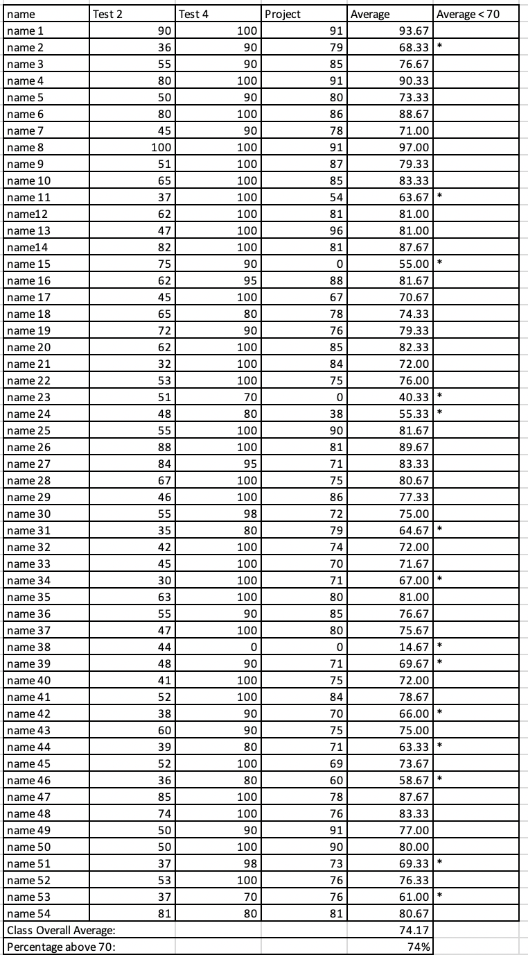

SPECIFIC ASSIGNMENTS
USED TO ASSESS OUTCOME (1)
(A sample of a design project report and two tests are included)

Assignments assessing students’ ability to identify, formulate, and solve complex engineering problems (CEP) by applying principles of engineering, science, and mathematics.
(Outcome 1)

MECHANICAL ENGINEERING DEPARTMENT
OUTCOMES SPECIFIC ASSIGNMENT COVER SHEET
ENERGY SYSTEMS DESIGN
Fall 2020
Instructor: Dr. Shield Lin
Title of Assignment

DESIGN PROJECT of
Holding Structure in a Spacecraft

Outcome Measured Using this Assignment
Outcome 1
An ability to identify, formulate, and solve complex engineering problems by applying principles of engineering, science, and mathematic.

Check the complex engineering problem characteristics related to this assignment

Assignment problem
X | involves wide-ranging or conflicting technical issues,
X | has no obvious solution
 | Addresses problems not encompassed by current standards and codes
 | involves diverse groups of stakeholders
X | includes many component parts or sub-problems
 | involves multiple disciplines
 | has significant consequences in a range of contexts
Assignment problem involves the application of the principles of
X | engineering
 | science
X | mathematics

Brief justification of why this assignment is suitable for this outcome

The design project involves conflicting technical issues. As an example, the “minimum-weight” holding structure requires the students to design a small device. However, the large accelerating loads requires the students to design a sturdy device which cannot be too small to avoid high stresses. The device shall also include several components that allows the users to take it apart and put it back in an assembly.

FINITE ELEMENT ANALYSIS AND DESIGN
FALL 2020

Title of Assignment: Design Project

TOPICS COVERED IN DESIGN PROJECT

Project Title: Holding Structure in a Spacecraft
Report Due: on November 24, 2020 (to Canvas and Taskstream via eCourse)
PowerPoint Presentation Due: on November 24, 2020 (to Canvas)

A weight is shown below with a cylindrical shape and a mass of 400 kg. It will be hung onto a spacecraft structure; let’s call the location “ceiling of spacecraft.” The gap between the top surface of the weight and the ceiling can be as small as the height of your designed device, but cannot exceed 80 mm. You are asked to design a minimum-weight “holding structure” between the top surface of the cylindrical weight and the ceiling of spacecraft. You can choose any material and geometry shape to design the holding structure within the space directly above the top surface of the weight and below the ceiling, namely, within a cylindrical region of 100 mm in diameter x 80 mm in length (you can design a smaller device in both of height and diameter). The design goal is to achieve structure integrity under a critical acceleration of 8 times earth gravity in any direction. The holding structure has to be designed so that an astronaut can conveniently remove and restore the weight. The bottom surface of the holding structure will be bonded on the top surface of the weight, and the top surface of the holding structure will be bonded on the ceiling of spacecraft within the circular area of 100 mm in diameter.

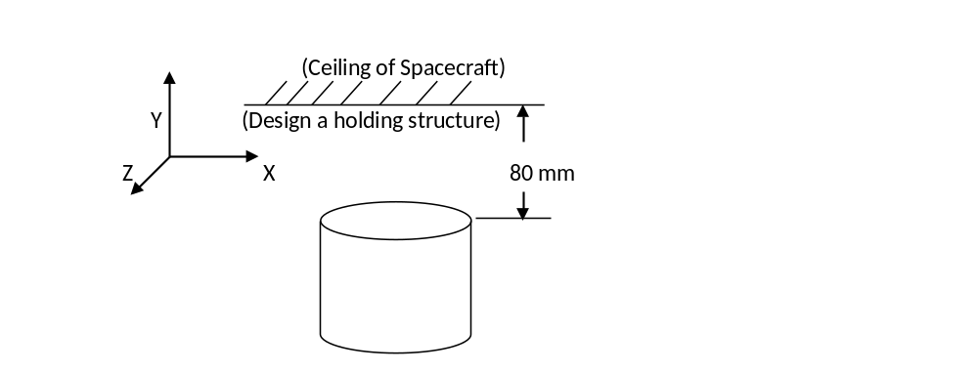
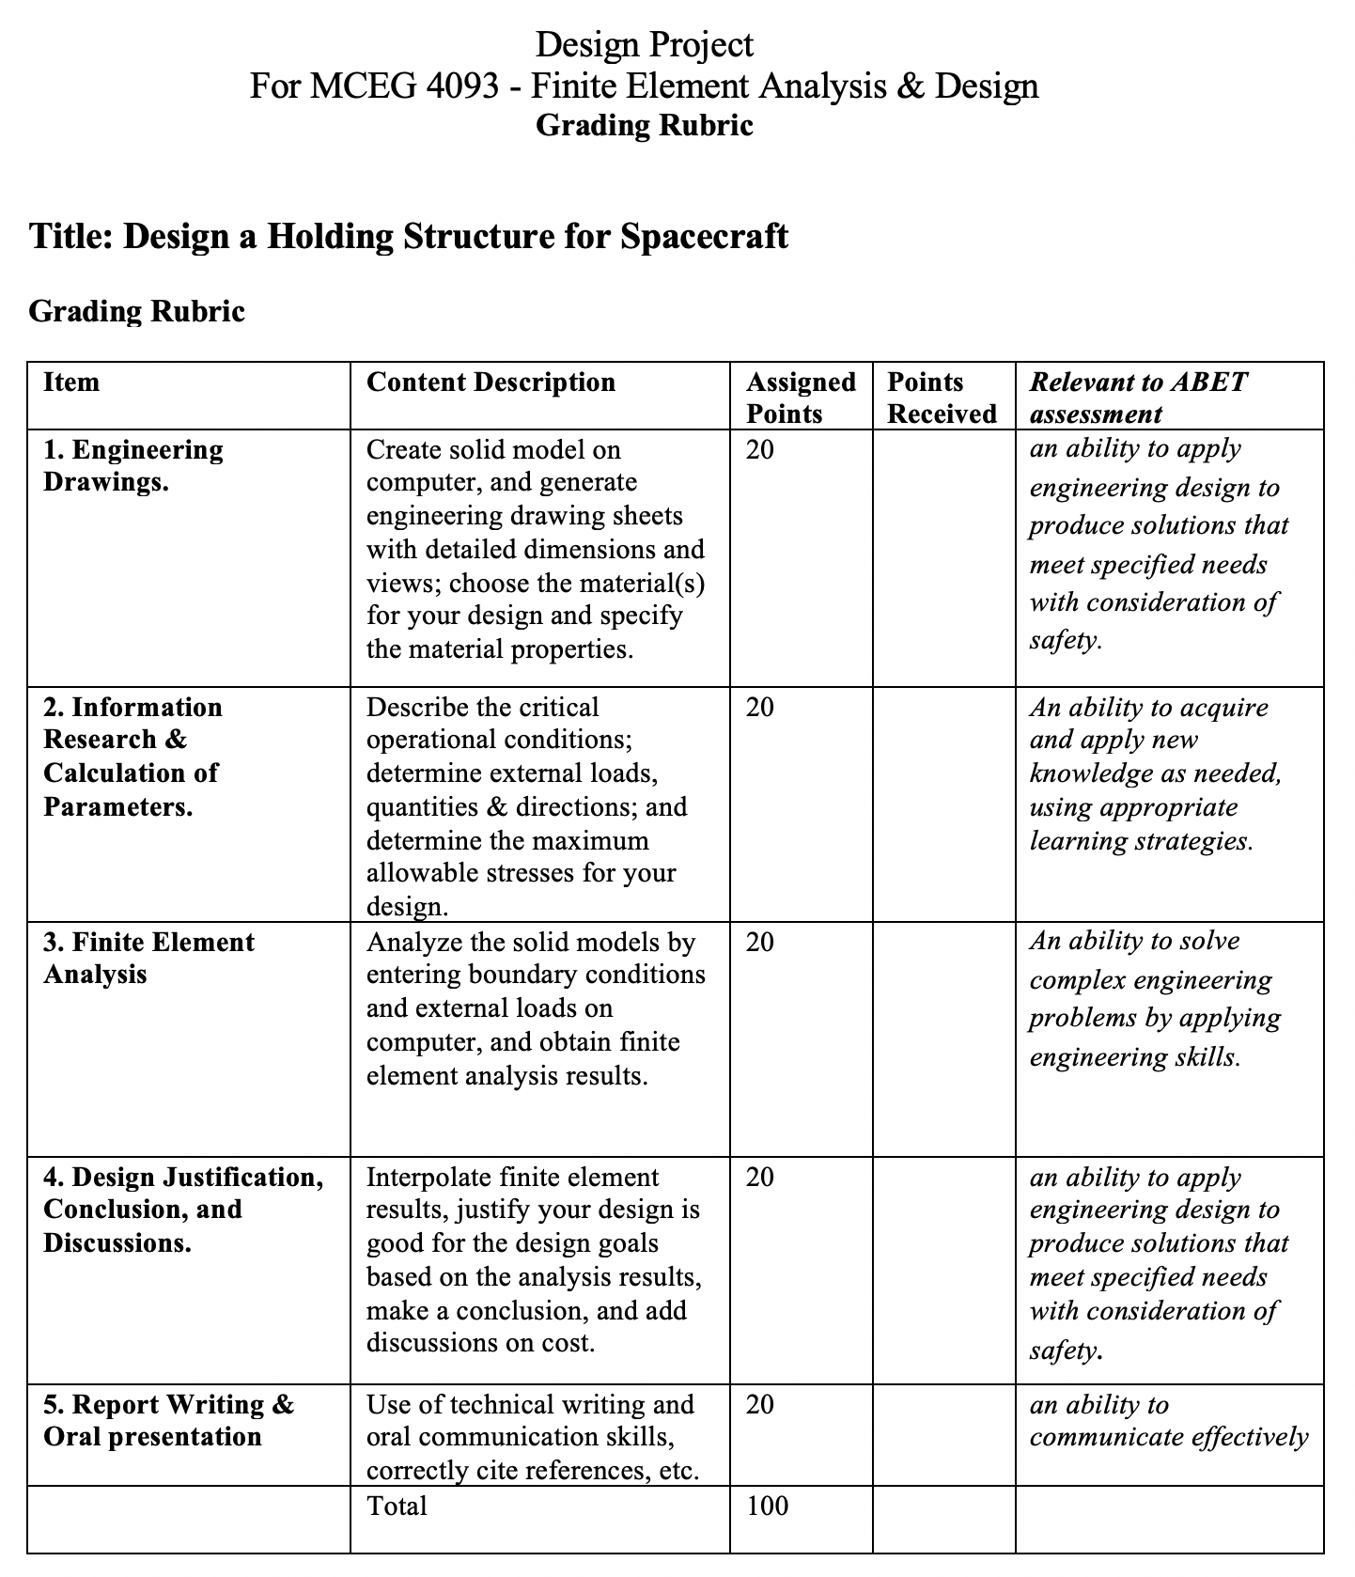
A student’s report

MECHANICAL ENGINEERING DEPARTMENT
PRAIRIE VIEW A&M UNIVERSITY

MCEG 4093-Z02
Finite Element & Analysis

Fall 2020

REPORT ON

Holding Structure in a Spacecraft

Submitted by
Timothy Reed

On
November 22, 2020

To
Dr. Shield Lin
Finite Element Analysis Instructor

Introduction

In the Finite Element & Analysis course students are introduced to the subject matter by understanding the definition engineering subtopic. Finite Element & Analysis is defined as a method in engineering to perform simulation of materials/structures to optimize its design for enhanced performance. This problem-solving approach is used across several industries and in this case, will be applied to a scenario in the space industry. The project scope, parameters, and constraints are outlined in the problem statement.

Problem Statement

A weight shown below with a cylindrical shape and a mass of 400 kg. It will be hung onto a spacecraft structure; let us call the location “ceiling of spacecraft.” The gap between the top surface of the weight and the ceiling is 80 mm. You are asked to design a minimum-weight “holding structure” between the top surface of the cylindrical weight and the ceiling of spacecraft. You can choose any material and geometry shape to design the holding structure within the space directly above the top surface of the weight and below the ceiling, namely, within a cylindrical region of 100 mm in diameter x 80 mm in length. The design goal is to
achieve structure integrity under a critical acceleration of 8 times earth gravity in any direction. The holding structure must be designed so that an astronaut can conveniently remove and restore the weight. The bottom surface of the holding structure will be bonded on the top surface of the weight, and the top surface of the holding structure will be bonded on the ceiling of spacecraft within the circular area of 100 mm in diameter.

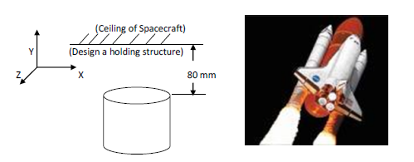

1. The Design Process
Using the design parameters provided in the problem statement, a holding structure assembly was created in the CAD software AutoDesk Inventor. The assembly is comprised of three components, which was a design inspired by Case Study 7.5 of the official course textbook. A figure of the holding structure is shown below in the following figure.
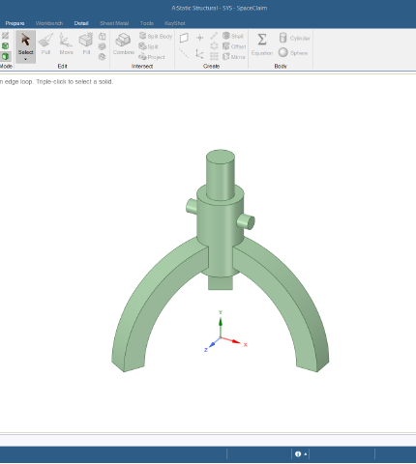

Figure 1.1 Case Study 7.5 Holding Structure [4]

After analyzing the structure previously used in an assignment, elements from the design were used to construct a similar fixture for the application of the project. Before drafting the first design iteration a material best suited for the parameters of the problem needed to be selected. Considering the substantial forces that holding structure would be under a variant of steel used in the space industry was chosen. The mechanical properties of Stainless Steel 15-5 are shown below in the table.

Table 1.1 Stainless Steel 15-5 Mechanical Properties Table [2]
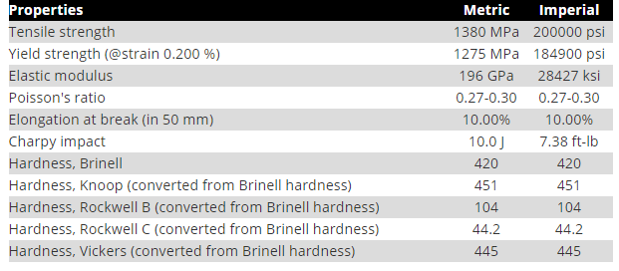

In addition to the mechanical properties of the material, the safety factor used by design engineers in the space industry was needed for calculating the allowable stress for each component of the assembly.
According to the Shigley’s Mechanical Engineering Design the allowable stress is defined by the following equation below. [3]
$$σ= \frac{Yield Strength}{Safety factor}$$
According to NASA’s Technical Reports, the safety factor used for the space industry was 1.4. Using that information, the allowable stress was calculated, and the result is shown below. [1]

$$σ= \frac{1275 MPa}{1.4}=910 MPa$$
The allowable stress will be used as a benchmark of pass or failure of the designs that are simulated on ANSYS, which will be further explained later in the report. Following the critical calculation, the first iteration of the design was constructed. The rendering of the components and assembly are provided in the following figures.
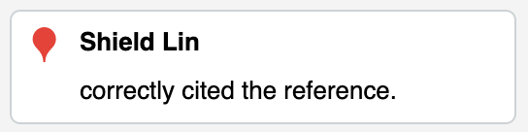
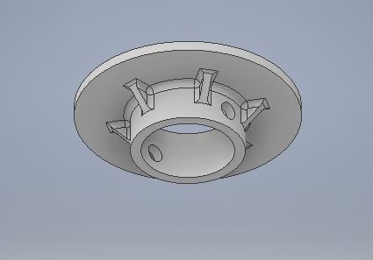

Figure 1.2 1st Ceiling Mount Design

In the first figure, the ceiling mount was designed to bond with the rocket and server as a mating mechanism to join the spacecraft and mass together. This component takes on a circular shape accompanied by flanges to distribute the load applied on perpendicular planes. The largest hole shown is to support the main body of the holding structure, where another component passes through them to secure the positioning.

Figure 2 is the main body component of the holding structure and like the ceiling mount, it also supports the pass-through of the final part that serves as a joint. A rendering of the component is shown below in the following figure.
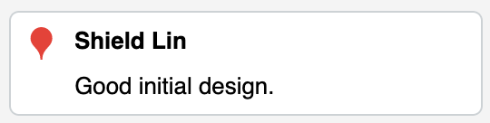
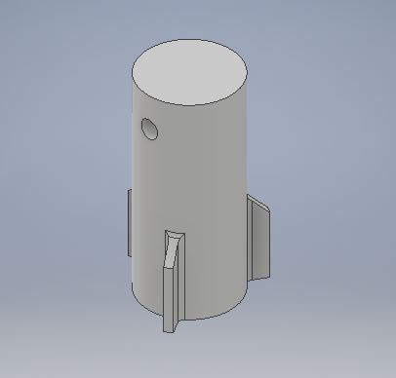

Figure 1.3 1st Body Design
The final part of the assembly is the pin and as previously mentioned is used for holding the positioning of the body and ceiling mount together. Its geometry takes on the uniform shape of a cylinder and is shown in figure 3.
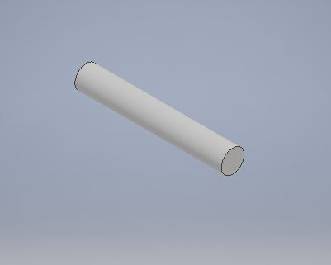

Figure 1.4 Pin Design

In the final figure for design iteration 1, the assembly of all the listed components are aligned and constrained to support the load that it will be under. A rendering of the assembly is shown below in the following figure.
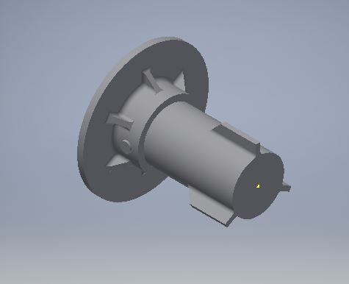

Figure 1.5 1st Assembly

2. Finite Element Analysis of Design
Using the software ANSYS, stress analysis was performed on the structure to visualize the distribution of forces. The information from the diagrams were used to determine what parts of the assembly can be refined. The equivalent stresses along with total deformation were simulated, and the solutions provided detailed the stress concentration locations on the structure.
Before analyzing the stress concentration boundary conditions and applied forces must be set according to the parameters of the problem statement. Beginning with the fixed support it is known that the ceiling mount will be bonded to the spacecraft. Within the static structural program, the appropriate face was selected as the desired geometry and defined as the fixed support shown in the figure below
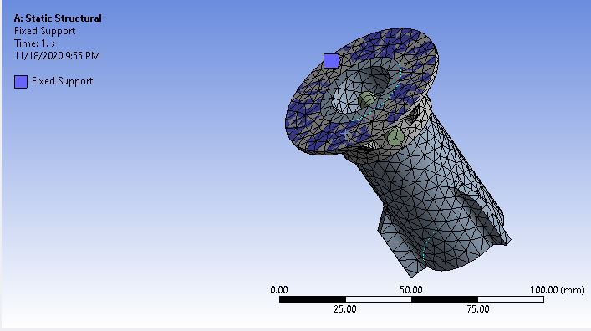
Figure 2.1 Fixed Support Applied to Geometry

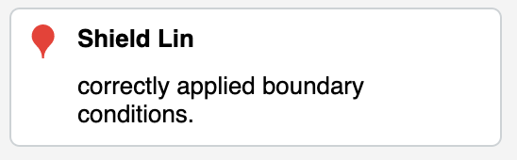

As for the applied forces, the values were calculated based on the following relation

F_{A} = 400 kg * 8 * 9.81 m/s² = 31,360 N

The downward force from the cylinder due to gravity was placed on the bottom contact surface of the holding structure that is circled in the following figure. Since the structure needs to withstand the applied force in all directions, separate solutions were solved for in the z and y direction
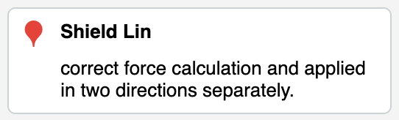
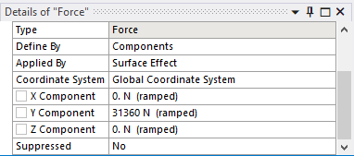
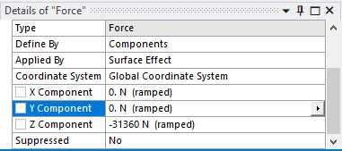
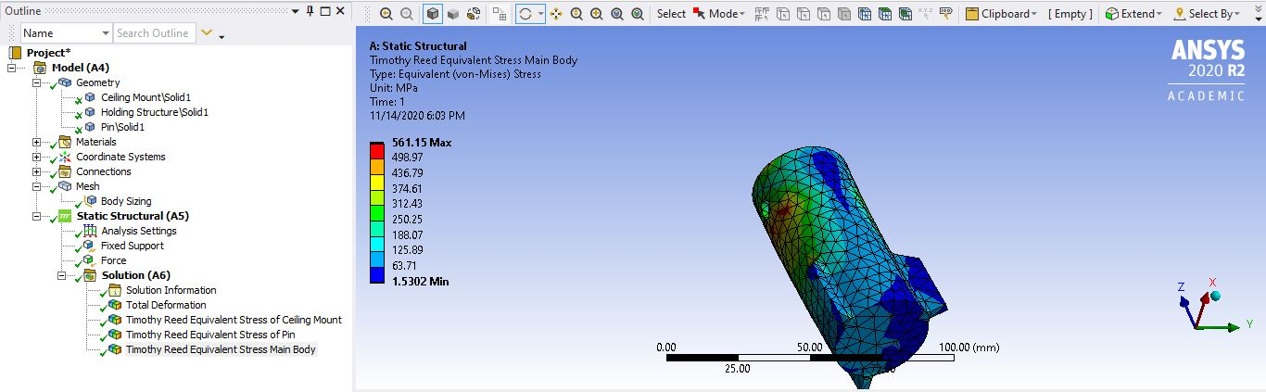

Figure 2.2 Applied Force in Y and Z Direction on the Geometry

The first step is to identify the largest equivalent stress in the legend to determine if the component can withstand the forces it will be put under. Earlier in the report, it was mentioned that the max allowable stress is 910 MPa, and according to the figure, that requirement is met in both the Z and Y direction

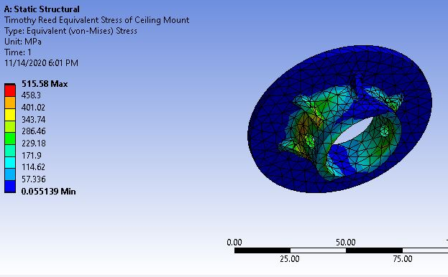

Figure 2.3 Finite Element Analysis of Ceiling Mount

However, the ceiling mount on the circular contact face has a low-stress concentration shown in blue. When that occurs that allows for the opportunity to reduce the material used in that particular by either reducing the surface area or thickness.

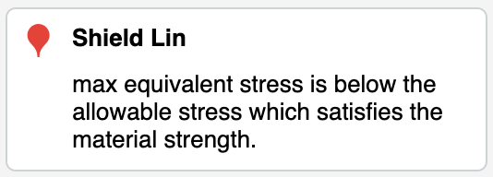

As for the main body of the holding structure, the equivalent stress is also below the allowable even at the maximum value due to the force in the Y direction. This also allows for conserving material and having a more modest design

Figure 2.4 Finite Element Analysis of Body

The pin component of the structure is the only part that will be excluded from the refinement process. Due to its small size and, little to no refinement can be done for its design. The result of the simulation is in the following figure.
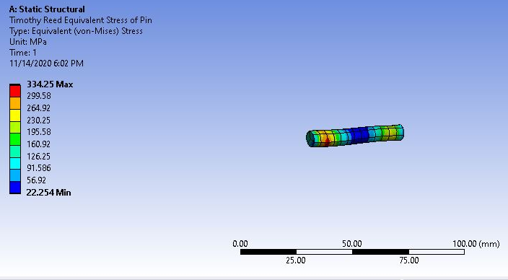

Figure 2.5 Finite Element Analysis of Pin

3. Refinement Process of Design
After noting the areas of low-stress concentration, it was determined that a more efficient use of the material can be used. Only two out of the three components designs were modified and the 3-D renderings reflecting the changes are in the following figures shown below.
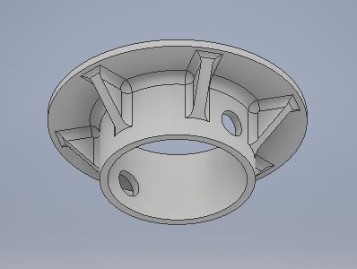

Figure 3.1 Refine Ceiling Mount Design

In figure 3.1 the ceiling mount was thinned by 5 mm while reducing the diameter on the contact surface by 10 mm. As for the main holding body the base was hollowed with a 5 mm thickness and shortened by 15 mm in length, reducing the amount of material used significantly

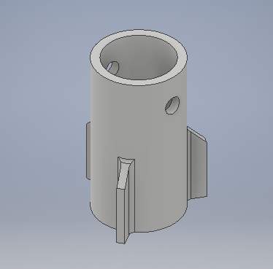

Figure 3.2 Refined Body Design
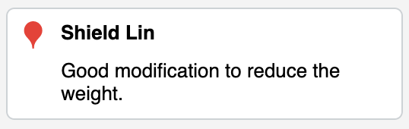
After modifying the design, the models were then imported into ANSYS and put through another simulation under the same conditions previously defined. The results from the static structural solutions are shown below.

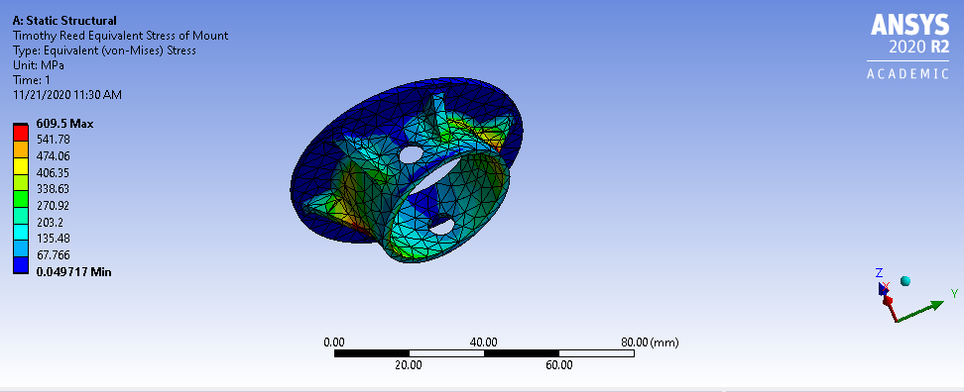

Figure 3.3 2nd ANSYS Analysis of Ceiling Mount in Y Direction

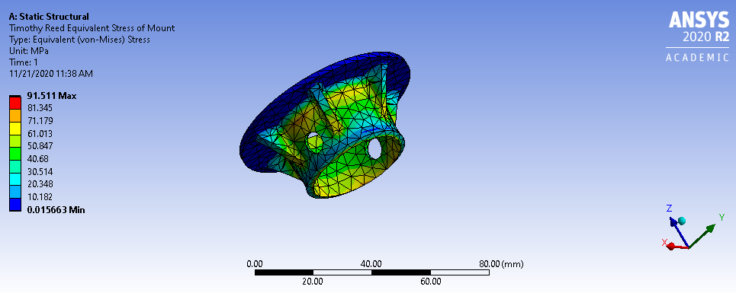

Figure 3.4 2nd ANSYS Analysis of Ceiling Mount in Z Direction

The equivalent stresses are now higher but still below allowable in the y direction. This is the same case for the main body and the outcome of the load are detailed in figure 3.4.

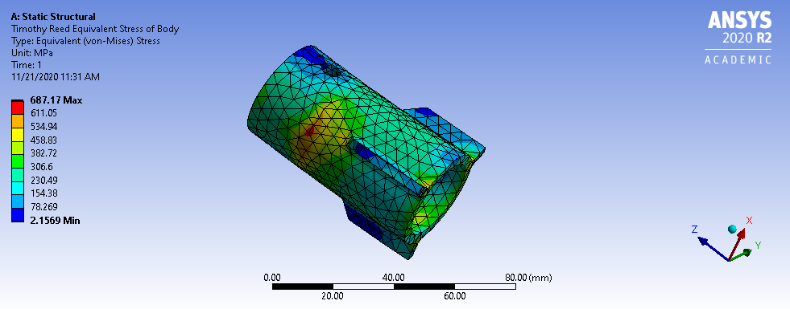

Figure 3.5 2nd ANSYS Analysis of Body in Y Direction

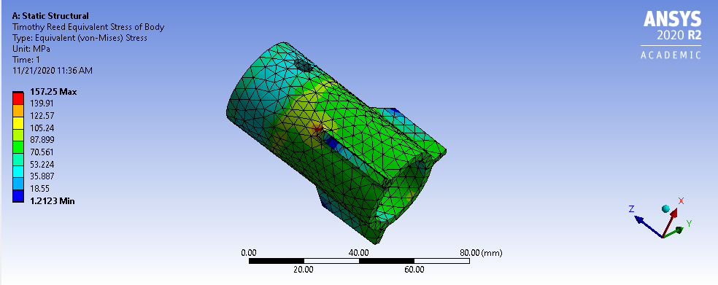

Figure 3.6 2nd ANSYS Analysis of Body in Z Direction

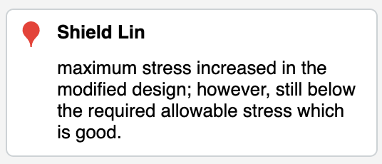

The final step of the solution is to obtain the minimum mass achieved by removing the excess material from the design. In the following 3 figures, the mass of the three components is generated based on the material selected.

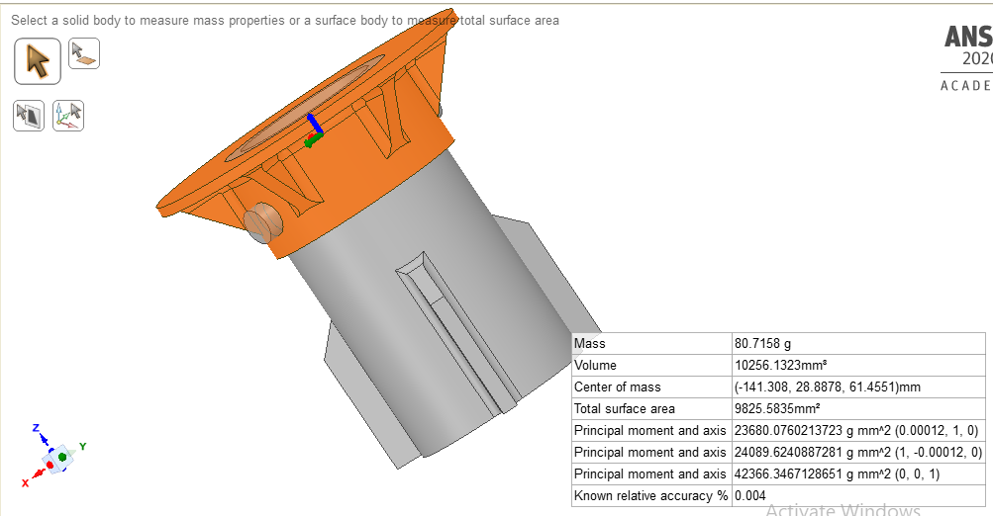

Figure 3.7 Mass of Ceiling Mount

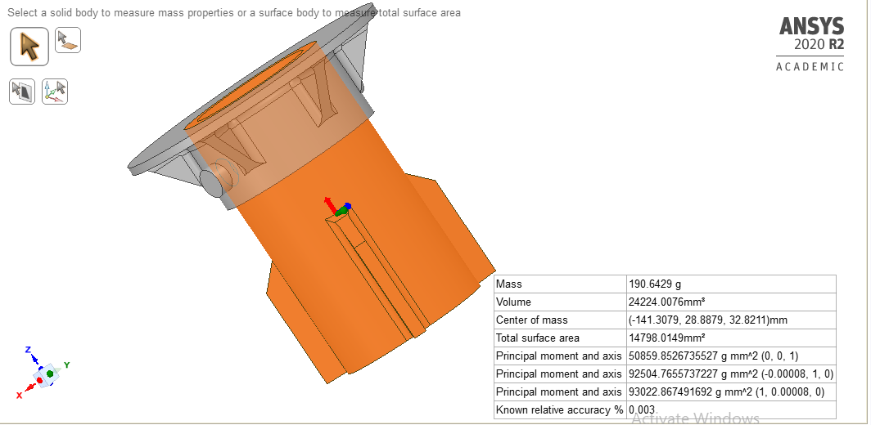

Figure 3.8 Mass of Body
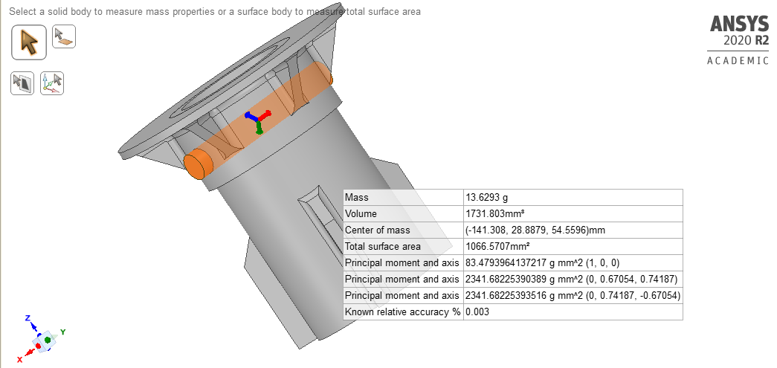
Figure 3.9 Mass of Pin

The minimum mass of the structure is totaled in Table 3.1 detailing the individual mass of each component.
Table 3.1 Mass of the Holding Structure
Ceiling Mount | 80.7158 g
Body | 190.6429 g
Pin | 13.6293 g
Total | 285 g

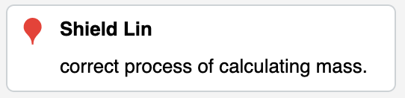

4. Engineering Drawings
After meeting the design requirements outlined, the next phase of the project is to provide engineering drawings of each component, detailing their size specifications. Fully dimensioned drawings of the ceiling mount, body, and pin are shown below.

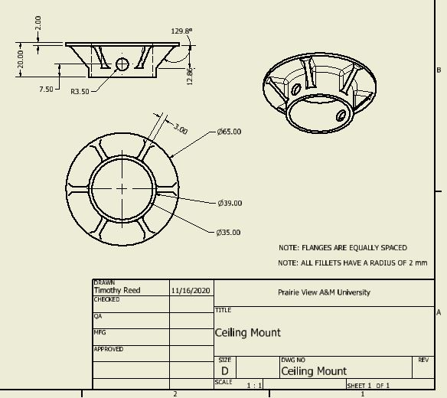

Figure 4.1 Engineering Drawing of Ceiling Mount

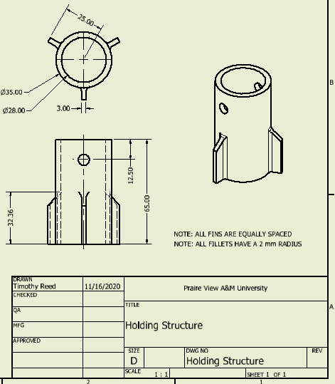

Figure 4.2 Engineering Drawing of Main Holding Structure

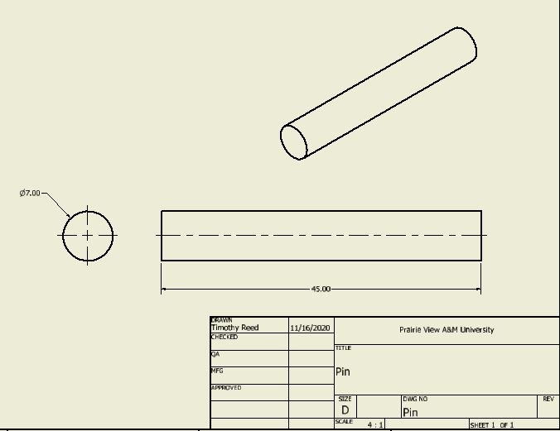
Figure 4.3 Engineering Drawing of Pin

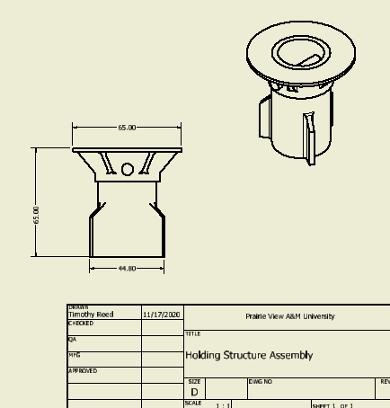

Figure 4.4 Engineering Drawing of Holding Structure Assembly
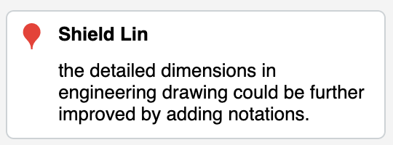

Conclusion & Recommendations
To complete this project a thorough understanding of the subject matter and application of the concepts are needed to arrive at a solution. After several tests and modifications, the refinement portion of the project in ANSYS was completed averaging at an approximate 190 MPa difference between the solution’s equivalent stress and the calculated allowable stress. Due to the geometry of the structure tensile forces were considerable low while planar were not. Attention and focus of the design were centered in the critical Y direction for that reason.
The engineering drawings in section 3 of the report consisted primarily of whole number dimensions and design instructions featured as notes to ensure the reader can fully understand the geometry of each component and duplicate it if needed.
The outcome of the simulation solutions passed the design requirements, and the scope of the project was fulfilled in its entirety. There are no recommendations for the project.

References
- “NASA Technical Reports Server (NTRS),” NASA. [Online]. Available:
https://ntrs.nasa.gov/citations/20150003482. [Accessed: 19-Nov-2020].

- “Stainless Steel Grade 15-5 (UNS S15500),” AZoM.com, 11-Jun-2013. [Online]. Available: https://www.azom.com/article.aspx?ArticleID=6786. [Accessed: 19-Nov-2020].

- R. G. Budynas, J. K. Nisbett, and J. E. Shigley, Shigley's mechanical engineering design, 10th ed. New York: McGraw-Hill, 2016.

- X. Chen and Y. Liu, Finite Element Modeling and Simulation with ANSYS Workbench. Boca Raton, Fl: CRC Press, 2019.

Design Project
For MCEG 4093 - Finite Element Analysis & Design
Grading Rubric

Title: Design a Holding Structure for Spacecraft

Grading Rubric (Score for T. Reed)

Item | Content Description | Assigned Points | Points Received | Relevant to ABET assessment
1. Engineering Drawings. | Create solid model on computer, and generate engineering drawing sheets with detailed dimensions and views; choose the material(s) for your design and specify the material properties. | 20 | 16 | an ability to apply engineering design to produce solutions that meet specified needs with consideration of safety.
2. Information Research & Calculation of Parameters. | Describe the critical operational conditions; determine external loads, quantities & directions; and determine the maximum allowable stresses for your design. | 20 | 19 | An ability to acquire and apply new knowledge as needed, using appropriate learning strategies.
3. Finite Element Analysis | Analyze the solid models by entering boundary conditions and external loads on computer, and obtain finite element analysis results. | 20 | 19 | An ability to solve complex engineering problems by applying engineering skills.
4. Design Justification, Conclusion, and Discussions. | Interpolate finite element results, justify your design is good for the design goals based on the analysis results, make a conclusion, and add discussions on cost. | 20 | 18 | an ability to apply engineering design to produce solutions that meet specified needs with consideration of safety.
5. Report Writing & Oral presentation | Use of technical writing and oral communication skills, correctly cite references, etc. | 20 | 19 | an ability to communicate effectively
 | Total | 100 | 91

MECHANICAL ENGINEERING DEPARTMENT
OUTCOMES SPECIFIC ASSIGNMENT COVER SHEET
ENERGY SYSTEMS DESIGN
Fall 2020
Instructor: Dr. Shield Lin
Title of Assignment

Test 2

Outcome Measured Using this Assignment
Outcome 1
An ability to identify, formulate, and solve complex engineering problems by applying principles of engineering, science, and mathematic.

Check the complex engineering problem characteristics related to this assignment

Assignment problem
 | involves wide-ranging or conflicting technical issues,
 | has no obvious solution
 | Addresses problems not encompassed by current standards and codes
 | involves diverse groups of stakeholders
 | includes many component parts or sub-problems
 | involves multiple disciplines
X | has significant consequences in a range of contexts
Assignment problem involves the application of the principles of
X | engineering
 | science
X | mathematics

Brief justification of why this assignment is suitable for this outcome
Test 2 is for finite element equation formulation. Although the individual test problems are not a full “complex engineering problem,” they represent important equation derivations and solving processes that can be used to solve a complex problem. The “in-class” test is the best means to evaluate students’ individual ability of equation derivation and solving process.

Name (print) ______________________________________ Signature: ___________________
(last name, first name)

The 2nd Test
For MCEG 4093 - Finite Element Analysis & Design, Fall 2020
October 1, 2020
(50%)
- The plane truss is loaded with a downward force P = 100 lb as shown below. Truss element 1 is between nodes 2 and 1, and has the cross-sectional area A₁= 0.5 in². Truss element 2 is between nodes 2 and 3, and has a cross-sectional area
A₂ = $\sqrt{2}$in². Both truss elements have the same Young's modulus E = 20,000 lb/in². Length L = 20 inches.

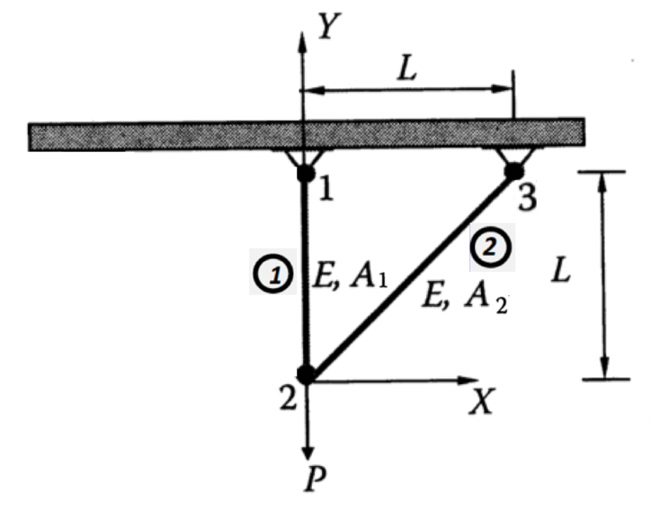

- To solve this problem, what are the variables that you choose to the three nodes?

- What are the boundary conditions (write in terms of equations)?

- What is the external load (write in terms of equation)?

- Use finite element method to find the displacements at node 2 assuming there is no buckling effect for the truss system.

- Find stresses in the two elements.

(50%)
- An L-shape beam shown below has a length L = 10 in, modulus of elasticity E = 10⁶ psi, the area moment of inertia of the beam’s cross-section I = 1 in⁴, and the cross-sectional area A = 1 in².

The beam is fixed on its two ends at point 1 and point 3. A positive moment of 200 in-lbs is applied to the beam at the corner of the L-beam at point 2. Use finite element method to find linear displacements and angular rotation at point 2.

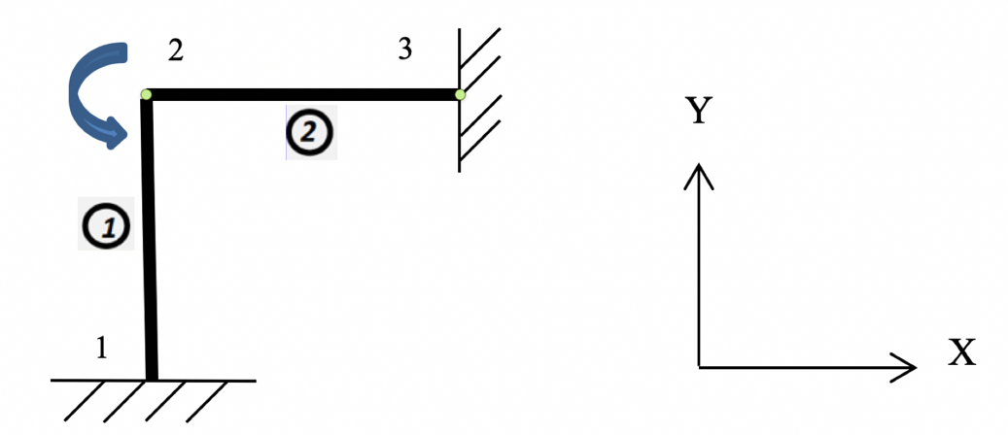

- What are the variables will you choose to attach the 3 nodes when you solve this problem?

- What are the boundary conditions (write in terms of equations)?

- What are the external loads?

- Use finite element method to solve for the linear displacements and angular rotation at point 2. (if you do not have Matlab or equivalent calculation tool, you may stop at the final form of the FE equation).

A student’s test result:
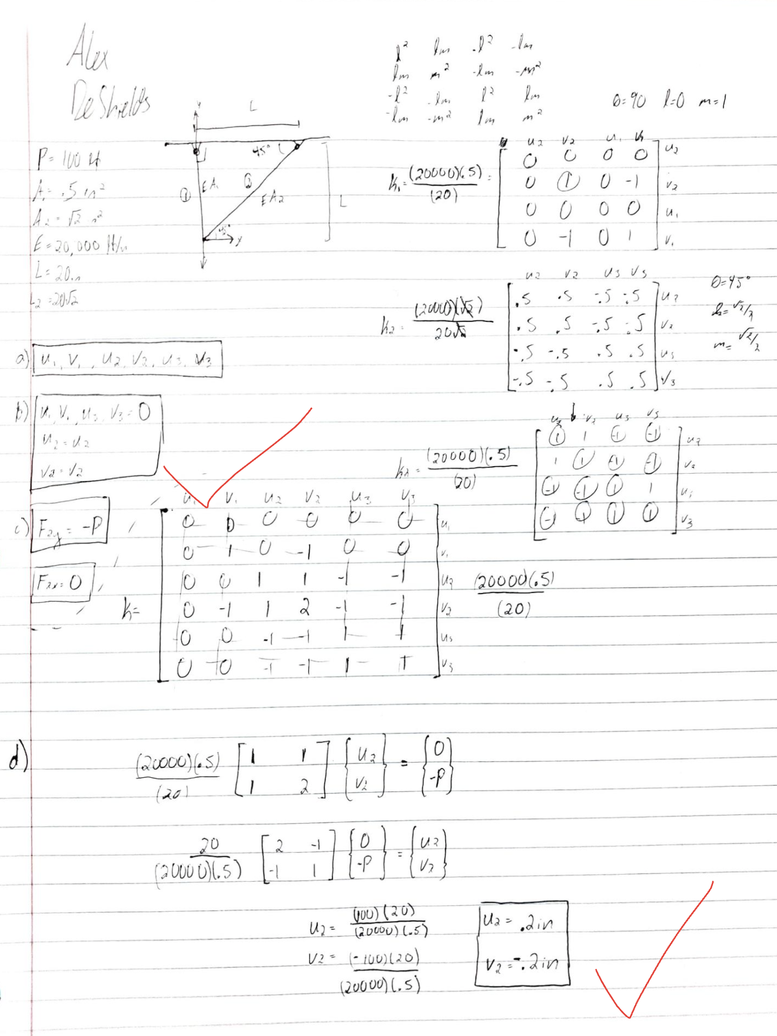

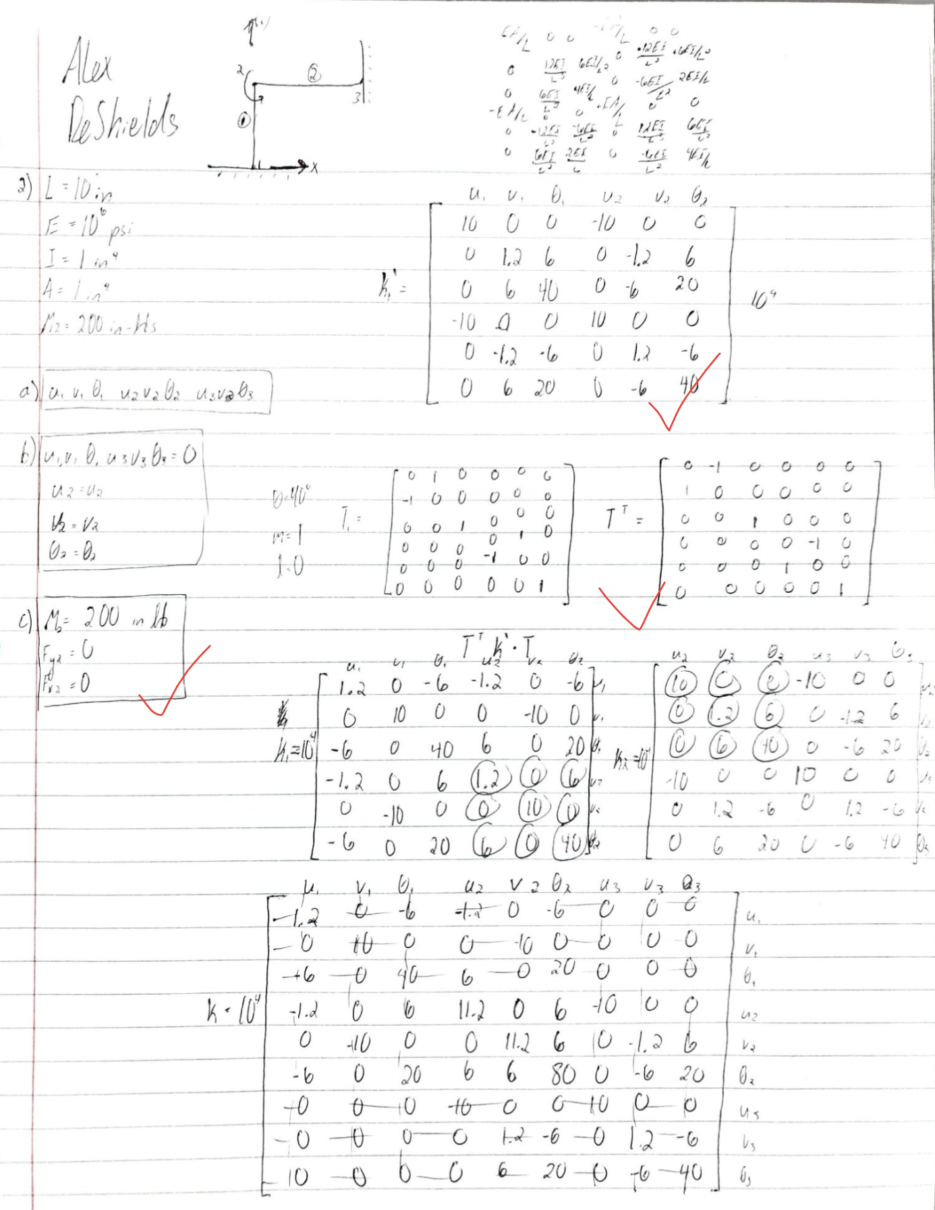

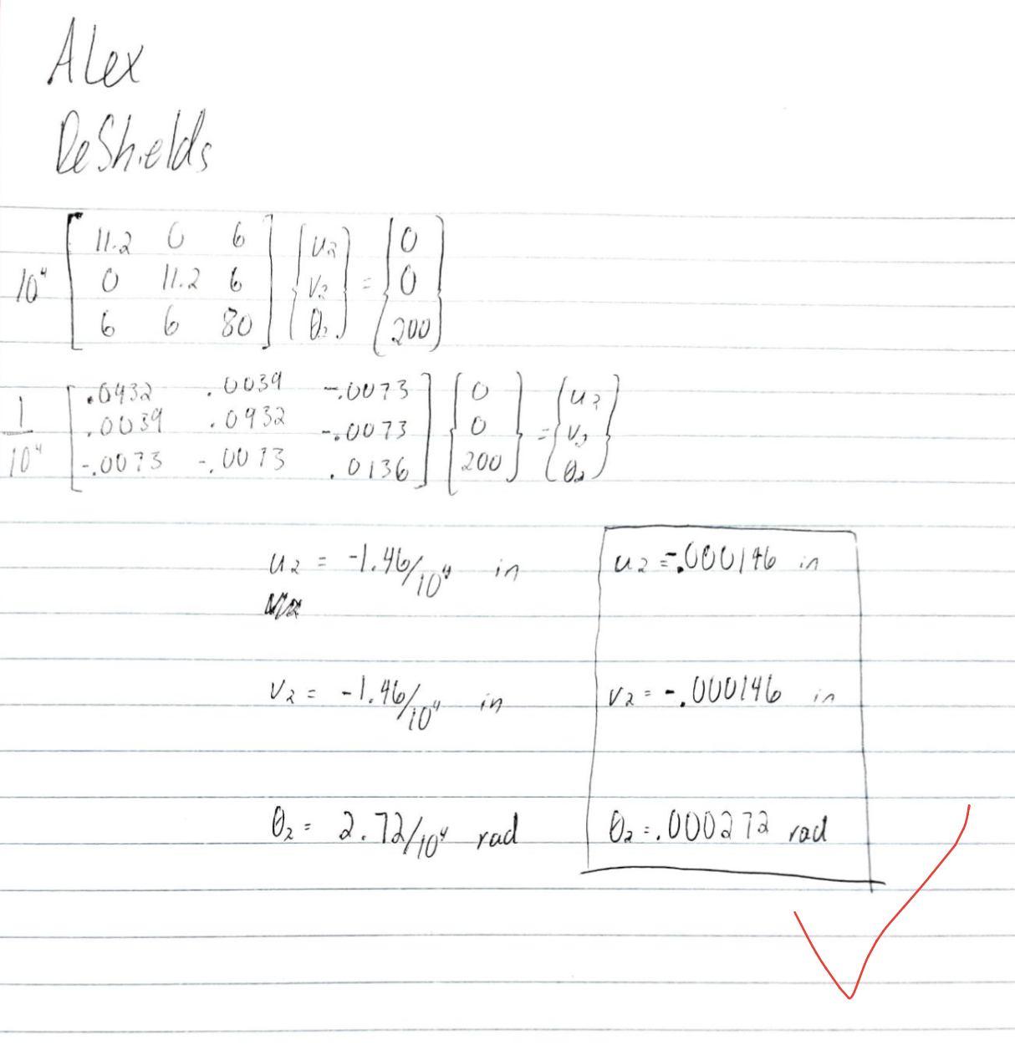

MECHANICAL ENGINEERING DEPARTMENT
OUTCOMES SPECIFIC ASSIGNMENT COVER SHEET
ENERGY SYSTEMS DESIGN
Fall 2020
Instructor: Dr. Shield Lin
Title of Assignment

Test 4

Outcome Measured Using this Assignment
Outcome 1
An ability to identify, formulate, and solve complex engineering problems by applying principles of engineering, science, and mathematic.

Check the complex engineering problem characteristics related to this assignment

Assignment problem
 | involves wide-ranging or conflicting technical issues,
 | has no obvious solution
 | Addresses problems not encompassed by current standards and codes
 | involves diverse groups of stakeholders
 | includes many component parts or sub-problems
 | involves multiple disciplines
X | has significant consequences in a range of contexts
Assignment problem involves the application of the principles of
X | engineering
 | science
X | mathematics

Brief justification of why this assignment is suitable for this outcome
Test 4 requires the students to use finite element program ANSYS to solve an engineering problem. Although the test problem itself is not a full “complex engineering problem,” it is an important step of using a modern computer tool, ANSYS, to solve a complex problem. The “in-class” test is the best means to evaluate students’ individual ability of applying software to solve finite element problem.

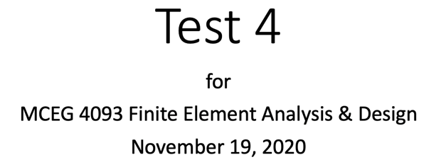

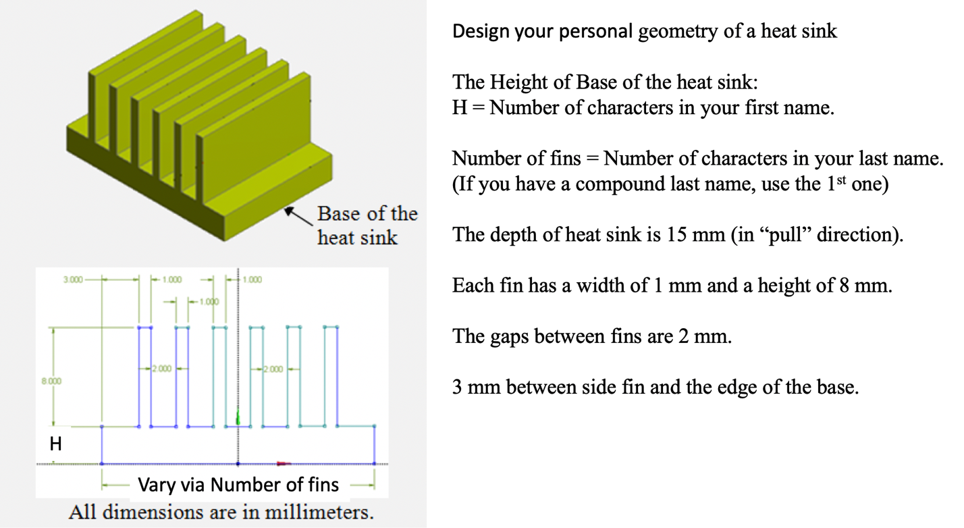

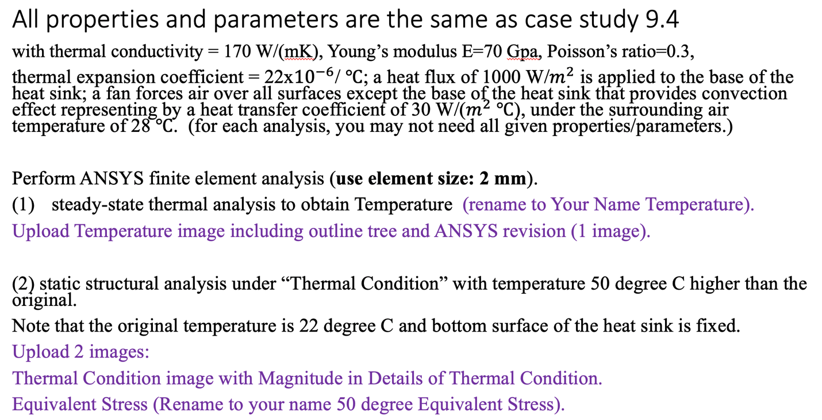

A student’s test result:
