ROY G. PERRY COLLEGE OF ENGINEERING
MECHANICAL ENGINEERING DEPARTMENT
PRAIRIE VIEW A&M UNIVERSITY

ASSESSMENT REPORT COVER PAGE

MCEG 4093 FINITE ELEMENT ANALYSIS & DESIGN

FALL 2019 SEMESTER

NAME OF INSTRUCTOR: Dr. Shield B. Lin

TABLE OF CONTENTS

- Report Cover Page

- Detailed Course Syllabus

- End of Semester Outcomes Assessment Report

- Grade Sheet Showing Student and Class Performance in Outcomes

- Supporting Outcomes Specific Assignments (Minimum of 2 per outcome)

Assignments assessing students’ ability to identify, formulate, and solve complex engineering problems (CEP) by applying principles of engineering, science, and mathematics.
(Outcome 1)

Sample Assignment 1: A design project using a finite element program, ANSYS. It is a complex engineering problem which involves conflicting technical issues, and has no obvious solution.

Sample Assignment 2: Test 2 for finite element equation formulation. Although the individual test problems are not “complex engineering problems,” they represent important equation derivations and solving processes that can be used to solve a complex problem such as in assignment 1. And an in-class test is the best means to evaluate students’ individual ability.

Sample Assignment 3: Test 4 using finite element program ANSYS to solve an engineering problem. Although the test problem itself is not a “complex engineering problem,” it is an important step of using a modern computer tool, ANSYS, to solve a complex problem such as in assignment 1. And an in-class test is the best means to evaluate students’ individual ability.

Detailed Course Syllabus
(Distributed to Students at the beginning of the Semester)
ABET Outcomes measured using course should be
explicitly listed in the syllabus

Course Description in ABET Format
MCEG 4093 Finite Element Analysis and Design

1. | Course number and name: | MCEG 4093 Finite Element Analysis and Design
2. | Credits and contact hours: | 3 credit hours; 3 contact hours
3. | Instructor’s or course  coordinator’s name: | Dr. Shield Lin
4. | Text book: Title: | Finite Element Modeling and Simulation with ANSYS Workbench
 | Author: | Xiaolin Chen and Yijun Liu
 | Publisher, Year & Edition: | CRC Press, Taylor & Francis Group, New York, 2018, 2nd Edition
 | - Other Supplemental material | ANSYS Workbench User’s Guide, Release 18.2, ANSYS, Inc., Canonsburg, Pennsylvania, August 2017.
5. | Specific course information
 | - Brief description of the content of the course (catalog description) | An Introduction to finite element analysis as a modern computational tool to solve boundary value problems. Applications will be in structural mechanics, fluid flow, and heat transfer. Design and computer projects included.
 | - Prerequisites or  Co-requisites | CVEG2063 – Mechanics of Materials.  Prerequisite or Taking Concurrently: MCEG3013 – Heat Transfer.
 | - *Indicate whether a required, elective, or selected elective (as per definition provided) course in the program | Required.
6. | Specific goals for the course | Students will be able to:
 | - specific outcomes of instruction (e.g. The student will be able to explain the significance of current research about a particular topic.) | 1. derive, formula, and solve equations using the finite element method.  2. apply finite element tool to solve engineering problems using ANSYS Workbench in solid mechanics, heat transfer, fluid mechanics, mechanical vibration, and design optimization.  3 understand a design project problem statement, conduct information research, produce engineering drawings, identify critical issues, collect and calculate required parameters, create a finite element model on computer, perform analysis, interpolate finite element analysis results, make conclusions, discuss results and suggest options.
 | - Explicitly indicate which of the student outcomes listed in Criterion 3 or any other outcomes are addressed by the course. | This course addresses:  Outcome 1  Ability to identify, formulate, and solve complex engineering problems (CEP) by applying principles of engineering, science, and mathematics.
7 | Brief list of topics to be covered | 1.Matrix Algebra and Matlab (3)  2. Finite Element Formulation for one-dimensional problems (6)  3. Finite Element Formulation for two-dimensional problems (9)  4. Using ANAYS Workbench to solve structure problems (6)  5. Using ANSYS Workbench to solve fluid and heat transfer problems (6)  6. Using ANSYS Workbench to solve vibration and optimization problems (6)  7. Design project and project presentations (6)

Course Title: Finite Element Analysis and Design
Course Prefix: |  |  | MCEG |  |  |  |  |  | Course No.: |  | 4093 |  |  | Section No.: |  | P01 & P02
Department of |  |  |  |  |  | Mechanical Engineering |  |  |  |  |  | College of |  |  | Engineering
Instructor Name: |  |  |  |  |  | Shield Lin
Office Location: |  |  |  |  |  | Room 302A, S.R. Collins Bldg.
Office Phone: |  |  |  |  |  | 936-261-9958
Email Address: |  |  |  |  |  | shlin@pvamu.edu
U.S. Postal Service Address: |  |  |  |  |  |  |  |  |  | Prairie View A&M University
 |  |  |  |  |  |  |  |  |  | P.O. Box |  |  | 519
 |  |  |  |  |  |  |  |  |  | Mail Stop |  |  | 2525
 |  |  |  |  |  |  |  |  |  | Prairie View, TX 77446
Office Hours: |  | 11:30 a.m. – 2:00 p.m. Tuesday & Thursday  9:30 a.m. – 1:30 p.m. Wednesday
Virtual Office Hours: |  |  |  |  | Anytime by emails
Course Location: |  |  |  | Room 116 & 114, S.R. Collins Bldg.
Class Meeting Days & Times: |  |  |  |  |  |  | Tuesday and Thursday, 8:00 a.m.- 9:20 a.m./9:30 a.m. – 10:50 a.m.
Catalog Description: |  |  |  |  | An Introduction to finite element analysis as a modern computational tool to solve boundary value problems. Applications will be in structural mechanics, fluid flow, and heat transfer. Design and computer projects included.
Prerequisites: |  |  | CVEG2063 – Mechanics of Materials.
 |  |  | Prerequisite or Taking Concurrently: MCEG3013 – Heat Transfer.
Required Text: |  |  | Finite Element Modeling and Simulation with ANSYS Workbench, Second Edition, by Xiaolin Chen and Yijun Liu, CRC Press, Taylor & Francis Group, New York, 2018.
Recommended Text/Readings: |  |  |  |  |  |  |  | ANSYS Workbench User’s Guide, Release 18.2, ANSYS, Inc., Canonsburg, Pennsylvania, August 2017.  Finite Element Analysis - Theory and Application with ANSYS, Third Edition, by Saeed Moaveni, Pearson Education, Inc., Upper Saddle River, NJ, 2008.
Access to Learning Resources: |  |  |  |  |  |  |  | PVAMU Library:  phone: (936) 261-1500;  web: http://www.pvamu.edu/library/  University Bookstore:  phone: (936) 261-1990;  web: https://www.bkstr.com/Home/10001-10734-1?demoKey=d
Course Goals or Overview:
 | Teach the students to learn the fundamental concepts of finite element modeling and to use a general-purpose finite element computer tool to solve engineering problems. The students will learn to simulate and solve a variety of problems in structure analysis, heat transfer, fluid flow, mechanical vibration, and design optimization.
Topics to be Covered:
1.Matrix Algebra and Matlab (3)
2. Finite Element Formulation for one-dimensional problems (6)
3. Finite Element Formulation for two-dimensional problems (9)
4. Using ANAYS Workbench to solve structure problems (6)
5. Using ANSYS Workbench to solve fluid and heat transfer problems (6)
6. Using ANSYS Workbench to solve vibration and optimization problems (6)
7. Design project and project presentations (6)

Specific Outcomes of Instruction:
The students will be able to:
1. derive, formula, and solve equations using the finite element method.
2. apply finite element tool to solve engineering problems using ANSYS Workbench in solid mechanics, heat transfer, fluid mechanics, mechanical vibration, and design optimization.
3. understand a design project problem statement, conduct information research, produce engineering drawings, identify critical issues, collect and calculate required parameters, create a finite element model on computer, perform analysis, interpolate finite element analysis results, make conclusions, discuss results and suggest options.

How Mechanical Engineering Courses meet Department Objectives (MCEG Objectives) at Prairie View A&M are to produce graduates who have:

- the techniques and skills necessary for modern mechanical engineering practices, and an ability to function effectively in multi-disciplinary teams.
- an ability in life-long learning skills, a knowledge of contemporary issues, and an ability to communicate effectively.
- an understanding of global and societal context in the aspects of professional and ethical responsibility and the impact of engineering solutions on society.
- the qualifications to be employed by major industries and government agencies in the State of Texas and the nation.
- the qualifications to pursue graduate degrees.

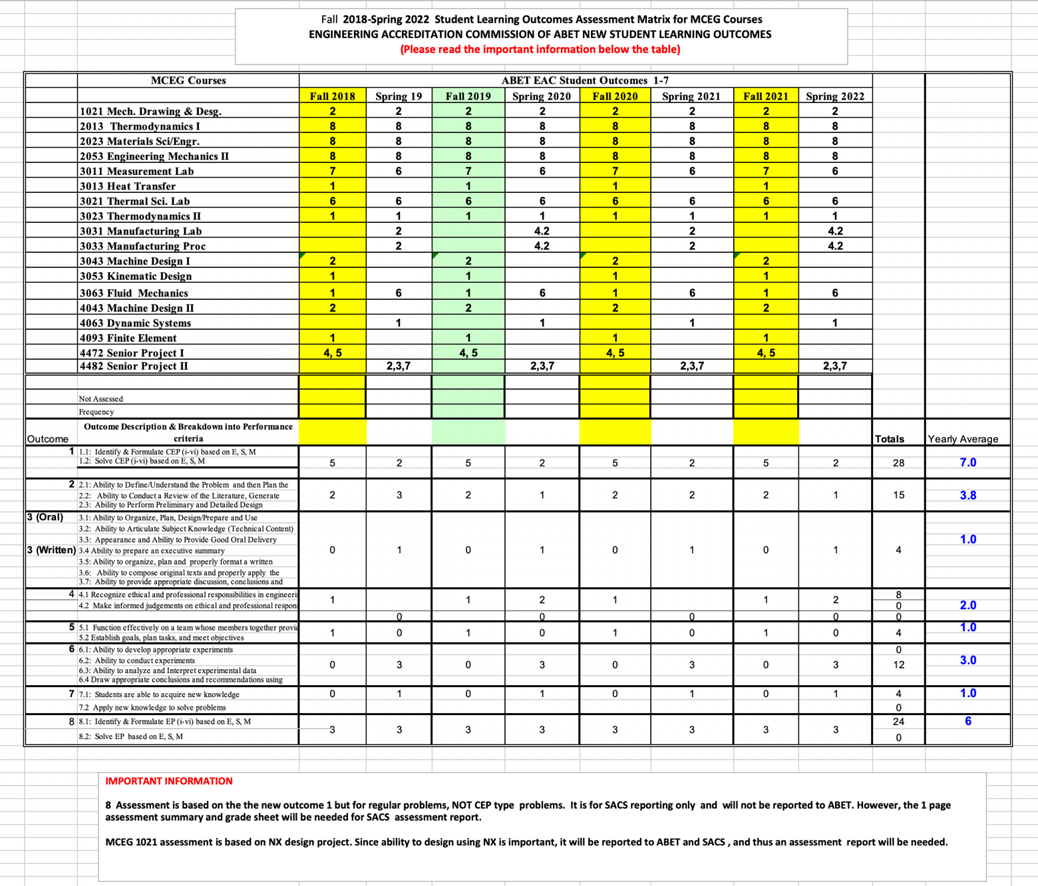

 | Course Requirements & Evaluation Methods
 | This course will utilize the following instruments to determine student grades and proficiency of the learning outcomes for the course.
Exams – problem solving and computer tests measure knowledge learned in course materials
Assignments – problem solving and computer assignments reinforce the learning of course materials
Projects – measure design and analysis ability to apply presented course materials
Class Participation – daily attendance and participation in class discussions are required.
Grading Matrix Problem Solving & Computer Assignments 20%
Test 1 (problem solving) 15%
Test 2 (problem solving) 15%
Test 3 (computer test) 15%
Test 4 (computer test) 15%
Design Project 20%

Grading Scale: A: 90-100, B: 80-89, C: 70-79, D: 60-69, F: 0-59.
Course Policy |  | Use of eCourse (http://ecourese.pvamu.edu)  eCourse will be used extensively in this class. lecture slides, assignments, and project statement will be provided on eCourse. All grades including homework, tests, and project will be posted on eCourse.  Academic Integrity  Academic dishonesty of any sort (plagiarism, cheating, fabrication or facilitation) is prohibited under any circumstance. Any detected actions of dishonesty will cause the failure of the class directly.  Assignments & Due Dates  Homework and project will be submitted to eCourse on the due day and time, generally at the beginning of class on the assigned day. Hardcopy may also be required as determined by the instructor. Late homework and project report will not be accepted.  Attendance  Class attendance is mandatory. Being late class for more than 15 minutes will count as one absence. As a university policy, if you have more than 3 absence, you may receive an “F” grade.  Tests  You will be expected to complete the tests in the allotted time period and days as stated on this syllabus.  Grades Progress  Progress of grades will be displayed on eCourse throughout the semester. Questions about grade should be brought up to the instructor at a timely manner.

MCEG 4093 Finite Element Analysis & Design
Fall 2019 SEMESTER SCHEDULE

Date | Topics | Assignments  (Except for Design Project, all other assignments due in a week from the assigned date)
08/27 | Matrix Algebra and Matlab | Handout assignments
08/29 | Finite Element Introduction | Chapter 1: problems 4, 6 & 7
09/03 | Finite Element Formulation – Spring
09/05 | Finite Element Formulation – Bars
09/10 | Finite Element Formulation – Summary
09/12 | Test 1 (Problem Solving)
09/17 | Finite Element Formulation – Trusses | Chapter 2: problems 1, 2 & 3
09/19 | Modeling of Beams and Frames
09/24 | Formulation of Beam Element
09/26 | Examples of Beam Element | Chapter 3: problems 2 & 5
10/01 | ANSYS Workbench – Truss Bridge | 2.6 Case Study
10/03 | ANSYS Workbench – Framing System | 3.6 Case Study
10/08 | Modeling and Solution Techniques
10/10 | Test 2 (Problem Solving)
10/15 | ANSYS Workbench – Wrench | 4.5 case study
10/17 | ANSYS Workbench – Rotating Fountain | 5.8 Case Study
10/22 | ANSYS Workbench – Guitar Vibration Modes | 8.7 Case Study
10/24 | Design Project
10/29 | Test 3 (Computer)
10/31 | ANSYS Workbench – Vase under Pressure | 6.5 Case Study
11/01 | (Final day to withdraw from course with “W”)
11/05 | ANSYS Workbench – Failure Analysis
11/07 | ANSYS Workbench – Stand Assembly | 7.5 Case Study
11/12 | ANSYS Workbench – Heat Transfer Analysis | 9.4 Case Study
11/14 | ANSYS Workbench – Aerodynamics of Car
11/19 | ANSYS Workbench – Design Optimization | 11.5 Case Study
11/21 | Test 4 (Computer)
11/26 | Project Presentation
12/03 | Project Presentation

University Rules and Procedures

Disability statement (See Student Handbook):
Students with disabilities, including learning disabilities, who wish to request accommodations in class should register with the Services for Students with Disabilities (SSD) early in the semester so that appropriate arrangements may be made. In accordance with federal laws, a student requesting special accommodations must provide documentation of their disability to the SSD coordinator.

Academic misconduct (See Student Handbook):
You are expected to practice academic honesty in every aspect of this course and all other courses. Make sure you are familiar with your Student Handbook, especially the section on academic misconduct. Students who engage in academic misconduct are subject to university disciplinary procedures.

Forms of academic dishonesty:
- Cheating: deception in which a student misrepresents that he/she has mastered information on an academic exercise that he/she has not mastered; giving or receiving aid unauthorized by the instructor on assignments or examinations.

- Academic misconduct: tampering with grades or taking part in obtaining or distributing any part of a scheduled test.

- Fabrication: use of invented information or falsified research.

- Plagiarism: unacknowledged quotation and/or paraphrase of someone else’s words, ideas, or data as one’s own in work submitted for credit. Failure to identify information or essays from the Internet and submitting them as one’s own work also constitutes plagiarism.

Nonacademic misconduct (See Student Handbook)
The university respects the rights of instructors to teach and students to learn. Maintenance of these rights requires campus conditions that do not impede their exercise. Campus behavior that interferes with either (1) the instructor’s ability to conduct the class, (2) the inability of other students to profit from the instructional program, or (3) campus behavior that interferes with the rights of others will not be tolerated. An individual engaging in such disruptive behavior may be subject to disciplinary action. Such incidents will be adjudicated by the Dean of Students under nonacademic procedures.

Sexual misconduct (See Student Handbook):
Sexual harassment of students and employers at Prairie View A&M University is unacceptable and will not be tolerated. Any member of the university community violating this policy will be subject to disciplinary action.

Attendance Policy:
Prairie View A&M University requires regular class attendance. Excessive absences will result in lowered grades. Excessive absenteeism, whether excused or unexcused, may result in a student’s course grade being reduced or in assignment of a grade of “F”. Absences are accumulated beginning with the first day of class.

Student Academic Appeals Process
Authority and responsibility for assigning grades to students rests with the faculty. However, in those instances where students believe that miscommunication, errors, or unfairness of any kind may have adversely affected the instructor's assessment of their academic performance, the student has a right to appeal by the procedure listed in the Undergraduate Catalog and by doing so within thirty days of receiving the grade or experiencing any other problematic academic event that prompted the complaint.

End of Semester
Course Assessment Report

This summary contains the following Information

1. Performance Statistics
- Total number of students in class
- The class average performance (stated as %) in each course outcome assessed in this class and the two previous times course was assessed.
- The acceptable class average for the class in each outcome area as set by your Department.
- Percentage of students who scored below the expected average in each outcome.

2. Implementation Summary
- Brief summary of plans implemented during the semester based on last assessment report

3. Perceived Problems
- Instructor’s critical evaluation of perceived problems that affected students’ performance. Realistic problems should be identified throughout the semester and summarized in this section of the report.

4. New Plans for Addressing Problems
- Instructor’s plans for addressing the perceived problems the next time the class is taught.
5. Overall Trend over last three assessment periods
- Instructors summary of overall performance trend for each outcome measured over the last three periods.

5. Were Expectations Met?
- Answer YES if the class average was above the expected average and the stated percentage of students scored at or above the expected average, else answer NO.

END OF SEMESTER COURSE OUTCOME ASSESSMENT REPORT
MCEG 4093-P02 FINITE ELEMENT ANALYSIS & DESIGN

FALL 2019 SEMESTER

Report Prepared by: Dr. Shield Lin

Report Date: December 2019
Semester | Analysis Type | Number of Students | Outcome 1.
Semester | Analysis Type | Number of Students | Expected Average | Expected Percent of students at or above average | Class Average | % Students meeting Expected Average
Fall 2019 | Direct | 40 | 75 | 70 | 78.4 | 77%
Fall 2018 | Direct | 19 | 75 | 70 | * | * | *The course was not assessed under Outcome 1 in 2018
Fall 2017 | Direct | 30 | 75 | 70 | * | * | *The course was not assessed under Outcome 1 in 2017
Implementation Summary | Items implemented from previous report or after meeting previous instructor |  | - The instructor used updated software – version 18.2 ANSYS Workbench in this class.  2. The instructor switched to the newer edition, the 2nd Edition of the textbook “Finite Element Modeling and Simulation with ANSYS Workbench” by X. Chen & Y. Liu. |  |  |  | Performance Criteria for Outcome 1  Ability to identify, formulate, and solve complex engineering problems (CEP) by applying principles of engineering, science, and mathematics.  Students are able to use knowledge and skills acquired in their studies for engineering practice in performing design and computer analysis of a heat sink for electronic devices.  Since the design project is a “take home” project, the instructor uses the average of the design project score along with two in-class test scores to evaluate students’ ability.  1. A design project using a finite element program, ANSYS. It is a complex engineering problem which involves conflicting technical issues, and has no obvious solution.  2. Test 2 for finite element equation formulation. Although the individual test problems are not “complex engineering problems,” they represent important equation derivations and solving processes that can be used to solve a complex problem such as in assignment 1. And an in-class test is the best means to evaluate students’ individual ability.  3. Test 4 using finite element program ANSYS to solve an engineering problem. Although the test problem itself is not a “complex engineering problem,” it is an important step of using a modern computer tool, ANSYS, to solve a complex problem such as in assignment 1. And an in-class test is the best means to evaluate students’ individual ability.
Perceived Problems | Perceived problems are directly related to the PC and the sub items under them |  | Many students have limited ability of using technical references in their design project. Particularly, some students failed to identify correct methods to obtain a key parameter, convection coefficient, in the thermal analysis. The convection coefficient has to be recalculated when the students change their heat sink configuration.
Plans for Addressing Problems | Plans for address specific measures to address PC and their sub areas |  | In next year, the instructor plans to share a couple of examples of using technical references (attached at the end of this document) to the students for the design project.  The instructor plans to use the same assessment items, namely, design project, Test 2, and Test 4, in year 2020. The results of 2020 can be used to compare the results in 2019.
Overall Trend over Periods | Ascertain if there were improvements over previous semesters |  | 77% students met expectation in the outcome (1) for this semester.
Were Expectations Met? | Class Average ≥75% and ≥70% of Students Performed at or Above Expected Average. |  | YES

Grade Sheet Showing
Student and Class Performance in Outcome (1)
Outcome (1) was evaluated in this semester by

1. A design project using a finite element program, ANSYS. It is a complex engineering problem which involves conflicting technical issues, and has no obvious solution.

2. Test 2 for finite element equation formulation. Although the individual test problems are not “complex engineering problems,” they represent important equation derivations and solving processes that can be used to solve a complex problem such as in assignment 1. And an in-class test is the best means to evaluate students’ individual ability.

3. Test 4 using finite element program ANSYS to solve an engineering problem. Although the test problem itself is not a “complex engineering problem,” it is an important step of using a modern computer tool, ANSYS, to solve a complex problem such as in assignment 1. And an in-class test is the best means to evaluate students’ individual ability.

Grades for Test 2, Test 4, Design Project, and Their Average
(Section P01 has 22 students; Section P02 has 18 students)

SPECIFIC ASSIGNMENTS
USED TO ASSESS OUTCOME (1)
(A sample of a design project report and two tests are included)

Assignments assessing students’ ability to identify, formulate, and solve complex engineering problems (CEP) by applying principles of engineering, science, and mathematics.
(Outcome 1)

MECHANICAL ENGINEERING DEPARTMENT
OUTCOMES SPECIFIC ASSIGNMENT COVER SHEET
ENERGY SYSTEMS DESIGN
Fall 2019
Instructor: Dr. Shield Lin
Title of Assignment

DESIGN PROJECT of
Heat Sink for Electronic Devices

Outcome Measured Using this Assignment
Outcome 1
An ability to identify, formulate, and solve complex engineering problems by applying principles of engineering, science, and mathematic.

Check the complex engineering problem characteristics related to this assignment

Assignment problem
X | involves wide-ranging or conflicting technical issues,
X | has no obvious solution
 | Addresses problems not encompassed by current standards and codes
 | involves diverse groups of stakeholders
 | includes many component parts or sub-problems
 | involves multiple disciplines
 | has significant consequences in a range of contexts
Assignment problem involves the application of the principles of
X | engineering
 | science
X | mathematics

Brief justification of why this assignment is suitable for this outcome

The design project involves conflicting technical issues. As an example, increasing the number of fins of a heat sink results more surface areas that helps transfer heat. However, increasing the number of fins also reduces the gap between fins that has a negative effect on convection. Every student can design its own heat sink configuration; there is no obvious solution.

Design Project
MCEG 4093 - Finite Element Analysis & Design, Fall 2019

Title: Heat Sink for Electronic Device

Many electronic devices generate a great deal of heat during operations. Overheating could cause malfunction and reduce the lifespan of the devices. A heat sink with other accessories is commonly used to take the excessive heat away and keep the electronic device under an acceptable temperature.

- You are required to investigate the design of an existing heat sink on the market. The product will serve as the benchmark design. Use a Finite Element Analysis Program (ANSYS or an equivalent) to determine temperature distribution in the benchmark heat sink under a force convective condition, such as using an electrical fan. Calculate the convective coefficient based on air speed and configuration of the heat sink, and apply the coefficient in your ANSYS computer analysis.

- You shall modify or completely redesign the heat sink using the same material and within the original outer dimensions. Prove via the Finite Element Analysis Program that “your redesigned heat sink is better,” i.e., your heat sink can “keep the electronic device cooler” than the benchmark heat sink under the same operational conditions.

- If you are allowed to select a different material for the heat sink, what material will you select? Perform Finite Element Analysis of your heat sink using the new material. Discuss the performance of your heat sink with the new material.

- Discuss the estimated cost of your heat sink in comparison to the benchmark.

Due Date of Project Report

November 21, 2019: complete the project and upload the project report to eCourse as well as to Taskstream.

November 26, 2019: complete a PowerPoint presentation and upload the PowerPoint slides to eCourse.

Oral Presentation: November 26 and December 3

Design Project
For MCEG 4093 - Finite Element Analysis & Design
Grading Rubric

Title: Design & Finite Element Analysis of a Heat Sink for Electronic Device

Grading Rubric
Item | Content Description | Assigned Points | Points Received
1. Engineering Drawings. | Create engineering drawings with detailed dimensions and materials from a heat sink on the market & design a modified heat sink with new configuration and dimensions. | 20
2. Information Research & Calculation of Parameters. | Describe the critical operational conditions of the heat sink. Research and calculate all parameters required for finite element analysis. | 20
3. Finite Element Analysis | Create solid models on computer, input parameters to a finite element program- ANSYS or equivalent, solve and obtain results. | 20
4. Design Justification, Conclusion, and Discussions. | Interpolate finite element results, justify your design is better based on the analysis results, make a conclusion, and add discussions on materials and manufacturing cost. | 20
5. Report Writing & Oral presentation | Use of technical writing and oral communication skills, correctly cite references, etc. | 20
 | Total | 100

A student’s report
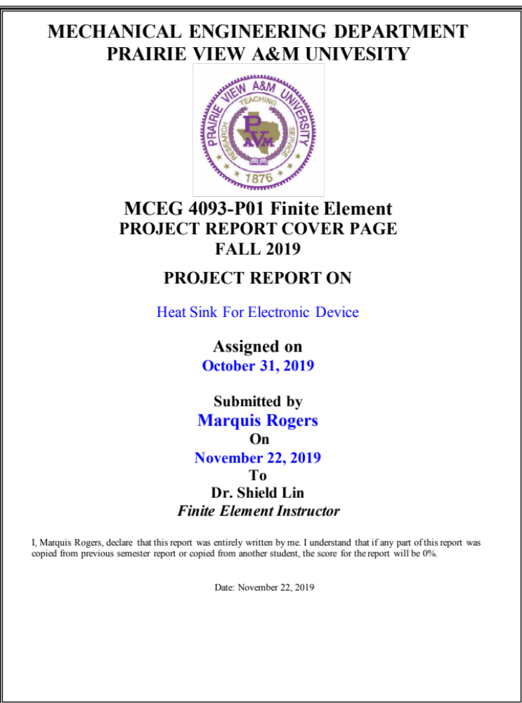

Letter of Transmittal

Marquis Rogers
Mechanical Engineering Student
7802 Glen Sides
San Antonio, Texas 78239
Email: marquisr511@gmail.com
Phone: 210-744-0305

Dr. Shield Lin
Finite Element Instructor
Prairie View A&M University
C.L. Wilson Engineering Building Room 103

November 21, 2019

Dear Dr. Lin:

The following pages contain a detailed report for the project, “Heat Sink For Electronic Device” This report addresses the improvement of the performance of an existing heat sink device using geometry and material consideration. This report was assigned on October 31, 2019 and was submitted on November 22, 2019.

If you have any questions or concerns, please email or call me at any time

Sincerely,

Marquis Rogers
Enclosure: Project Report

INTRODUCTION

A heat sink is a reactive heat exchanger that transmits the heat generated by an electronic device to a fluid medium (often air). During this process, the heat is dissipated away from the device, which allows that device’s temperature to be regulated at optimum levels. Heat sinks are mainly used in computers, serving to cool CPUs, GPUs, and RAM modules. Within its overall design, a heat sink maximizes its surface area that is in contact with the cooling medium surrounding it. In this report, an existing heat sink will be selected, analyzed, and altered for its overall improvement and efficiency.

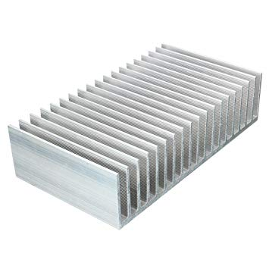

TABLE OF CONTENT

INTRODUCTION ……………………………………………………………… i

LIST OF FIGURES. …………………………………………………………… ii

LIST OF TABLES ……………………………………………………………… iii

1. ORIGINAL HEAT SINK DESIGN ………………………………………….1
1.1 Original Design Parameters and Specifications……………………………………1
1.2 Calculations Based On Original Design……………………………………………4
1.3 Thermal Analysis Using ANSYS Software………………………………………...6

2. ALTERATION OF ORIGINAL DESIGN ………………………………………….7
2.1 Altered Design Parameters and Specifications…………………………………….7
2.2 Calculations Based On Altered Design…………………………………………….8
2.3 Analysis of Altered Design using ANSYS software………………………………9

3. MATERIAL CONSIDERATION ……………………………………………………10
3.1 Material Change on Altered Design………………………………………………..10
3.2 Analysis of Material Change using ANSYS software……………………………...11

4. COST ANALYSIS, CONCLUSION AND RECOMMENDATIONS ……………...12
4.1 Cost Analysis on Proposed Designs………………………………………………...12
4.2 Conclusions Based on Engineering Judgement……………………………………..12
4.3 Recommendations…………………………………………………………………...13

REFERENCES………………………………………………………..14

APPENDIX A Air Property Table ……………………………………15

LIST OF FIGURES

Figure 1.1 StarTech.com 85x70x50 Socket 478 CPU Cooler Fan with Heatsink………………..1
Figure 1.2 Specifications of product design……………………………………………………....2
Figure 1.3 Volume Flow Rate of CPU cooler fan………………………………………………...2
Figure 1.4 Power Requirement of CPU processor………………………………………………..2
Figure 1.5 Original Heat Sink Dimensions……………………………………………………….3
Figure 1.6 Calculations for Design of Original Heat Sink………………………………………..5

Figure 2.1 Altered Heat Sink Dimensions……………………………………………………….7
Figure 2.2 Calculations For Altered Design of Heat Sink……………………………………….8
Figure 2.3 Temperature Distribution of Altered Heat Sink……………………………………...9

Figure 3.1 Temperature Distribution of Copper Heat Sink……………………………………..11

LIST OF TABLES

Table 3.1 Material Properties of Copper………………………………………………………..10
Table 4.1 Price Comparison of Original, Altered, and Altered Heat Sink Designs…………….12

CHAPTER 1
ORIGINAL HEAT SINK DESIGN

1.1 Original Design Parameters and Specifications

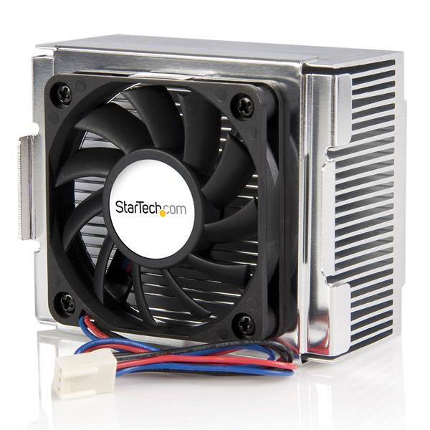
A heat sink on the market was researched and selected based on the compatibility with an electronic CPU of interest. Figure 1.1 below displays the selected heat sink paired with a Socket 478 CPU Cooler Fan.

Figure 1.1 StarTech.com 85x70x50 Socket 478 CPU Cooler Fan with Heatsink [1]

As shown in the figure above, the heat sink is made to be compatible with CPU Cooler fan. The cooler fan provides extra cooling to prevent the electronic device from overheating. In order to make the necessary calculations needed for the analysis of the heat sink, certain specifications of the overall product were needed. Figures 1.2, 1.3, and 1.4 below displays some of these specifications in further detail.

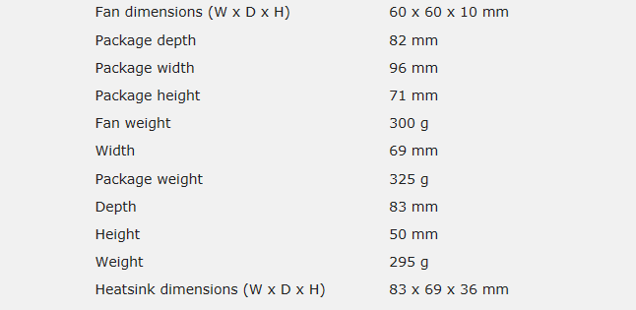

Figure 1.2 Specifications of product design [1]

Figure 1.3 Volume Flow Rate of CPU cooler fan [1]

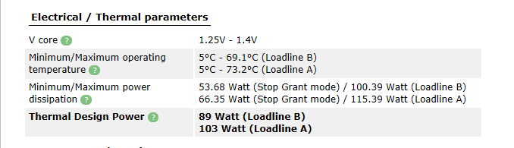

Figure 1.4 Power Requirement of CPU processor [2]

Parameters of interest that are displayed in the figures above include fan dimensions, heat sink dimensions, airflow/volume flow rate, and minimum/maximum power dissipation. These parameters are very important for they will be used for all of the calculations regarding the 3 total designs of the heat sink.

Figure 1.4 below shows the dimensions of the original heat sink used for analysis. The values of width, depth, and height were given as 83, 69, and 36 mm respectively. All units displayed in the engineering drawing below are in mm.
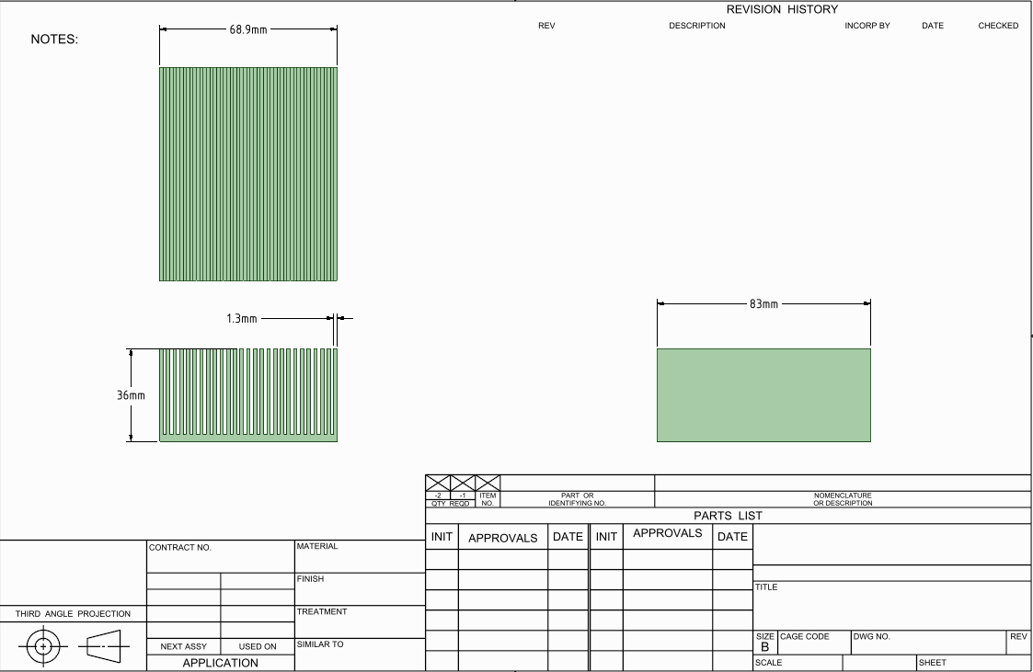

Figure 1.5 Original Heat Sink Dimensions

These dimensions were taken based off an engineering drawing that utilized the values detailed in the technical specification section of the product information. The engineering drawing was made using ANSYS drawing software.

1.2 Calculations Based on Original Design

For the overall analysis of the original design, different parameters that include material properties, and boundary conditions needed to be justified in order to perform the needed calculations. Below are all of the gathered material properties, and boundary conditions used for all of the important calculations.

Material Properties:

Material: Aluminum
Thermal Conductivity: K= 170 W/ (m*K)
Density: 2800 kg/m³; c= 870 J/(kg.K)
Modulus of Elasticity: E= 70GPa
Poission’s Ratio: v=0.3
α=22* 10^-6/Celsius

Boundary Conditions:

Air temperature: 27 ℃
Air density: ρ = 1.1614 kg/m³
Air thermal conductivity: 22.5x10e-6 W/m-K
Dynamic air viscosity: µ = 1.849x10⁻⁵ kg/m-s
Heat Transfer Mode: Steady State Convection
Prandtl Number: Pr = 0.707

Variable Names:

Lf = Length of Fin
b = Gap between fins
W = Width of heat sink
$N_{fin}=Number of Fins$
$t_{fin}=thickness of each individual fin$
G = Volume flow rate
$H_{f}=Height of each individual fin$
${Nu}_{b}=$ Nusselt Number

With the above conditions established, the following calculations were performed [2]:

Fin Length:

$$Lf=\frac{83}{1000} m$$

Gap Between Fins:

$$b= \frac{W-N_{fin}*t_{fin}}{N_{fin}-1}=\frac{0.069-35*0.0013}{27-1}=0.0013m$$

Air Velocity:

$$V_{air}=\frac{G}{N_{fin}*b* H_{f}}=\frac{0.0132 m^{3}/s}{27*0.0013m*0.0334m}=11.22 \frac{m}{s}$$

Reynolds Number:

$$R_{e}=\frac{ρ*V*b}{μ}*\frac{b}{L}=\frac{\frac{1.1614kg}{m^{3}}*\frac{11.22m}{s}*0.0013m}{\frac{1.846x{10}^{-5}kg}{m*s}}*\frac{0.0013m}{0.083m}=14.373$$
Nusselt Number:

$${Nu}_{b}={\left[\frac{1}{{\left(\frac{Re*Pr}{2}\right)}^{3}}+\frac{1}{{\left(0.664\sqrt{Re}*{Pr}^{0.33}\sqrt{1+\frac{3.65}{\sqrt{Re}}}\right)}^{3}}\right]}^{-0.33}= 2.898638283$$

Heat transfer coefficient:

$$h={Nu}_{b}*\frac{k_{fluid}}{b}=2.898638283*\frac{0.0263}{0.0013}=58.64\frac{w}{m^{2}⋅c}$$

Heat Flux:

$$q=\frac{P}{A_{b}}=\frac{55W}{0.005727m^{2}}=9603.63\frac{w}{m^{2}}$$

Figure 1.6 Calculations for Design of Original Heat Sink

1.3 Thermal Analysis Using ANSYS Software

Using the calculations derived from section 1.2, thermal analysis was performed on the original heat sink using ANSYS software. Figure 1.5 below shows the results of the temperature distribution of the heat sink after inputting the calculated values of heat flux, heat transfer coefficient, and ambient temperature.
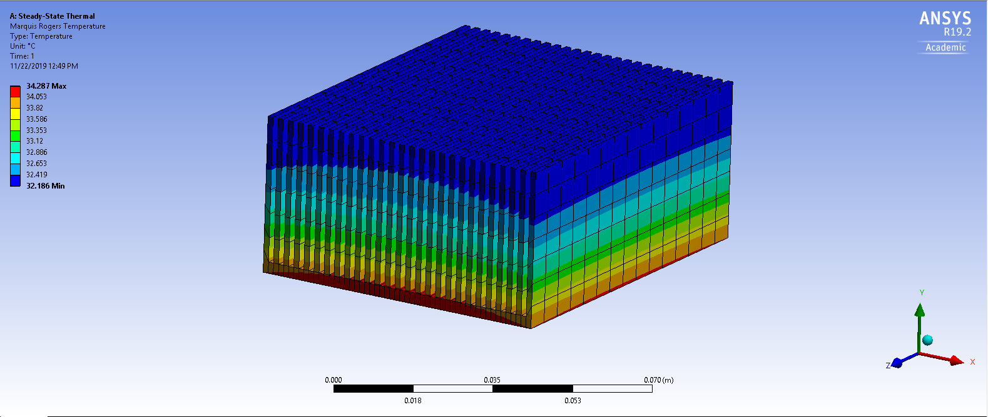

Figure 1.6 Temperature Distribution of Original Heat Sink

The analysis conducted mainly utilized the steps detailed in case study 9.4 of “Finite Element Analysis with ANSYS Workbench” [4]. The top number placed by the red bar represents the maximum temperature distribution throughout the heat sink. This number is represented as 34.287 °C.

CHAPTER 2
ALTERATION OF ORIGINAL DESIGN

2.1 Altered Design Parameters

After the initial thermal analysis using ANSYS software was conducted on the original aluminum heat sink, the design was then altered for improved results. With this alteration the main dimensions and parameters remained the same, while the overall geometry was altered to reduce the temperature distribution. Figure 2.1 below shows an engineering drawing detailing the altered design.

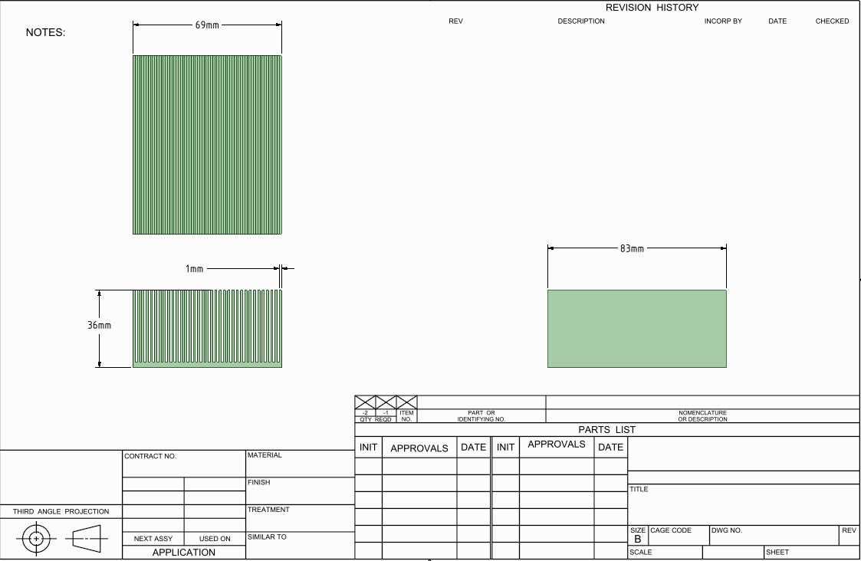

Figure 2.1 Altered Heat Sink Dimension
As shown above, the only major change within the design is the width of each individual fin being smaller. This alteration is desired to improve the overall temperature distribution by increasing the overall amount of fins that will serve to decrease the maximum temperature.

2.2 Calculations Based On Altered Design

Due to the change in geometry, a number of calculations regarding the finding of properties such as the Nusselt Number, and the heat transfer coefficient were subject to change. Figure 2.2 below shows these calculations in further detail.

Gap Between Fins:

$$b= \frac{W-N_{fin}*t_{fin}}{N_{fin}-1}=\frac{0.069-35*0.0013}{27-1}=0.001m$$

Air Velocity:
$$V=\frac{G}{N_{fin}*b* H_{f}}=\frac{0.0132 m^{3}/s}{27*0.0013m*0.0334m}=11.29 \frac{m}{s}$$

Reynolds Number:

$$R_{e}=\frac{ρ*V*b}{μ}*\frac{b}{L}=\frac{\frac{1.1614kg}{m^{3}}*\frac{11.29m}{s}*0.001m}{\frac{1.846x{10}^{-5}kg}{m*s}}*\frac{0.001m}{0.083m}=8.557875727$$
Nusselt Number:

$${Nu}_{b}={\left[\frac{1}{{\left(\frac{Re*Pr}{2}\right)}^{3}}+\frac{1}{{\left(0.664\sqrt{Re}*{Pr}^{0.33}\sqrt{1+\frac{3.65}{\sqrt{Re}}}\right)}^{3}}\right]}^{-0.33}= 2.182578662$$

Heat transfer coefficient:
$$h={Nu}_{b}*\frac{k_{fluid}}{b}=2.18258*\frac{0.0263}{0.001}=58.64\frac{w}{m^{2}⋅c}$$

Heat Flux:

$$q=\frac{P}{A_{b}}=\frac{55W}{0.005727m^{2}}=9603.63\frac{w}{m^{2}}$$

Figure 2.2 Calculations For Altered Design of Heat Sink

2.3 Thermal Analysis of Altered Design Using ANSYS Software

Using the same material, the altered design was simulated through ANSYS software and evaluated for improvement in comparison to the original. Figure 2.3 below displays the results gathered from simulating the new design.
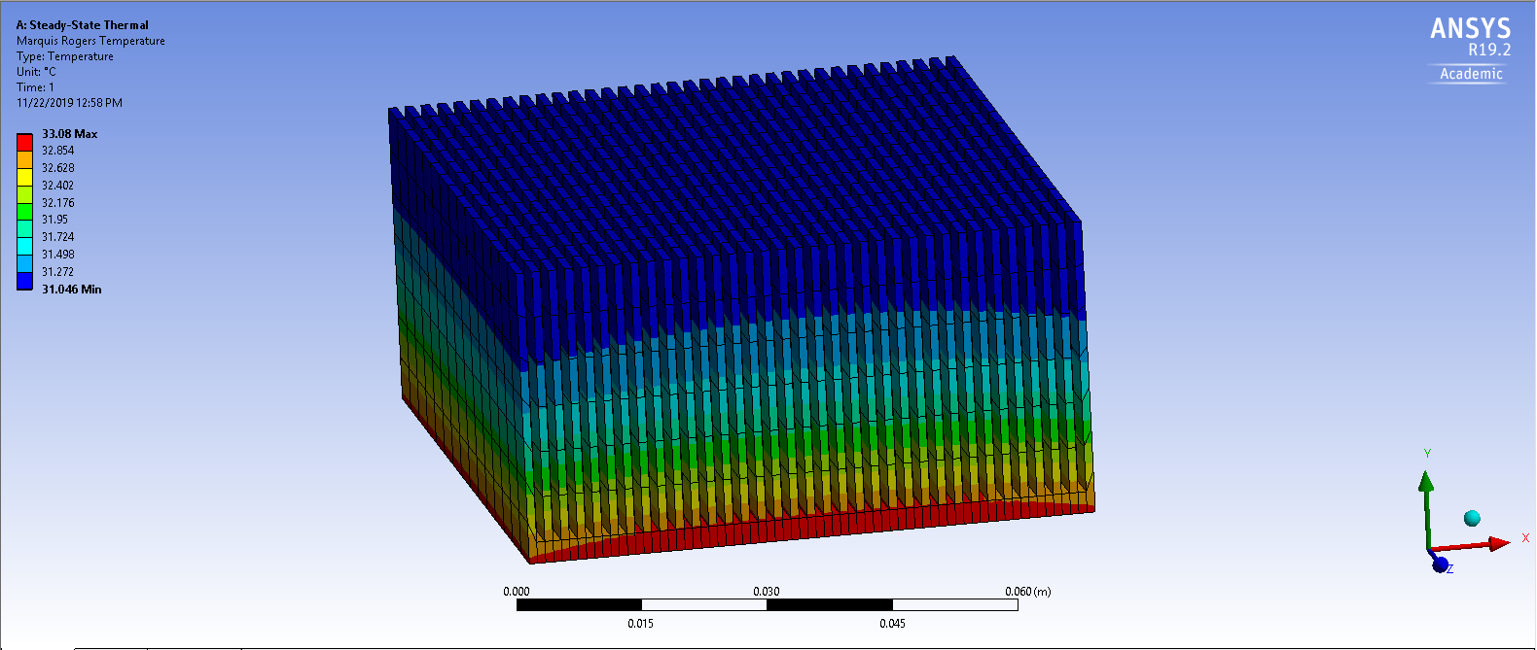

Figure 2.3 Temperature Distribution of Altered Heat Sink

The analysis conducted mainly utilized the steps detailed in case study 9.4 of “Finite Element Modeling and Simulation with ANSYS Workbench”[4]. The top number by the red square represents the maximum temperature distribution of the altered heat sink. This value was recorded as 33.08°C.

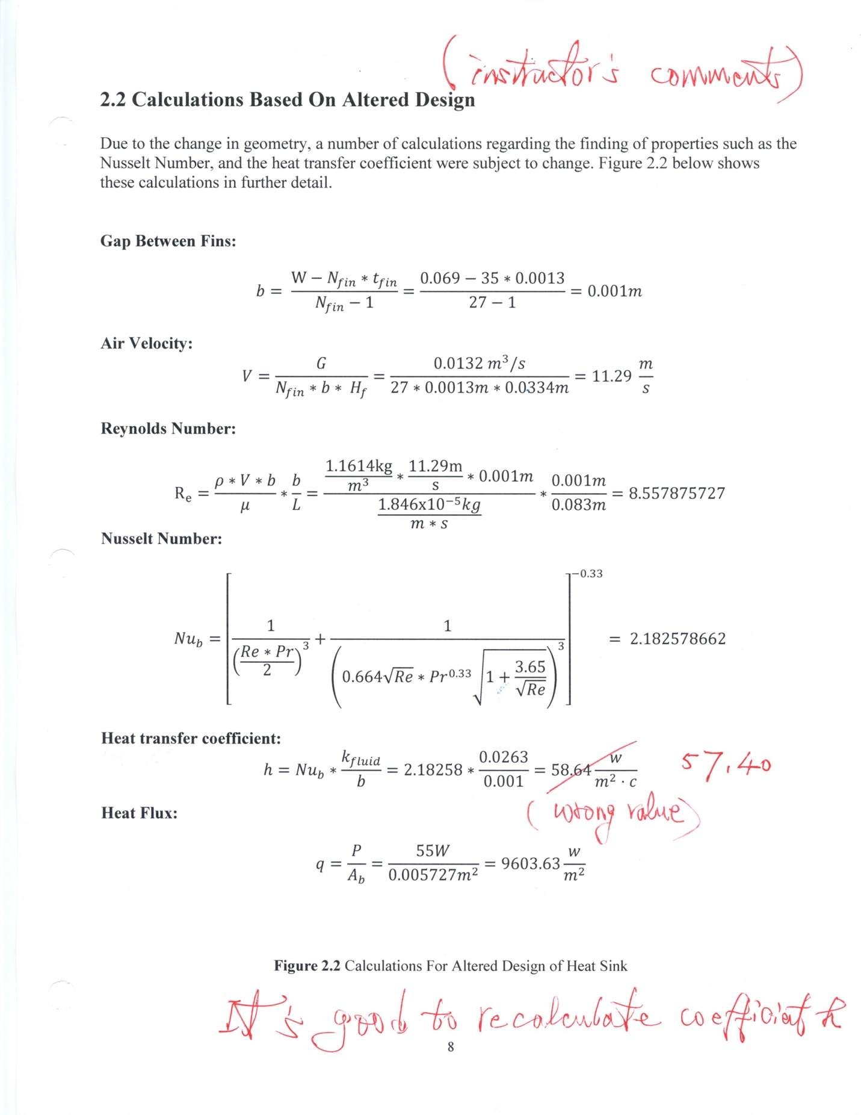

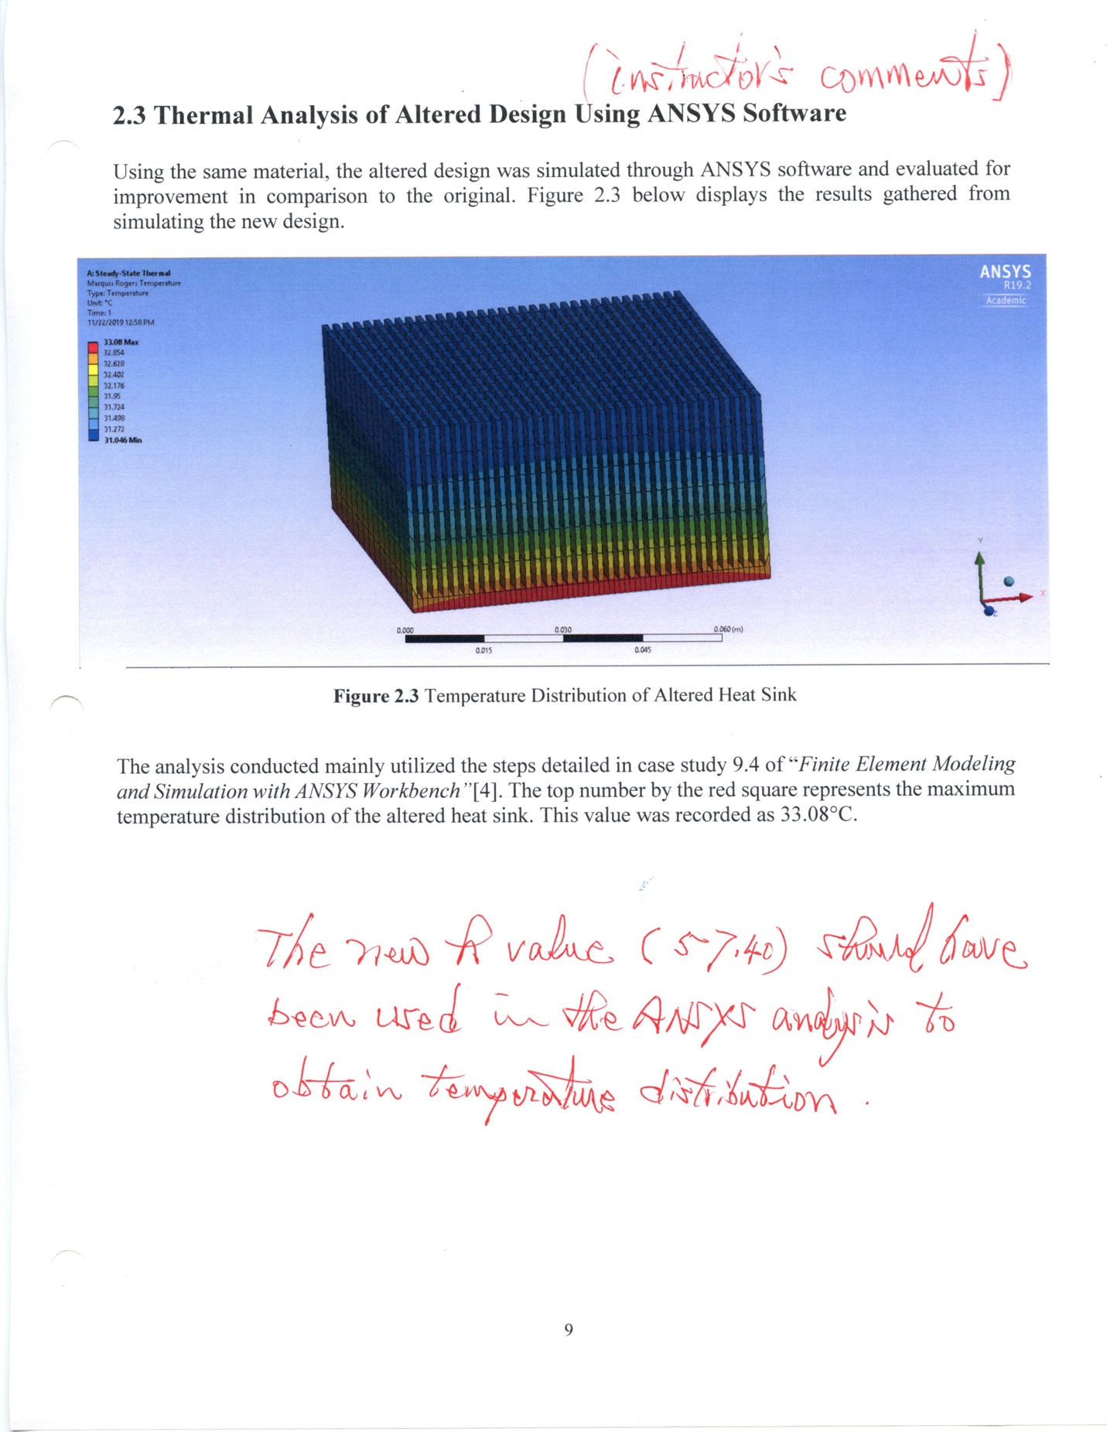

CHAPTER 3
MATERIAL CONSIDERATION

3.1 Material Change on Altered Design

In order to attempt to continue the process of improving the results of the temperature distribution of the original heat sink, an overall change in material was considered. Aluminum, the original material, is the material of choice in most heat sink applications due to its compatibility and thermal conductivity. With this in mind, materials that shared these characteristics were researched and considered. Copper, was found to the best material to choose for further analysis based on its high thermal conductivity, and properties that fit within the heat sink design. Table 3.1 display some of the main properties of interest for copper.

Table 3.1 Material Properties of Copper

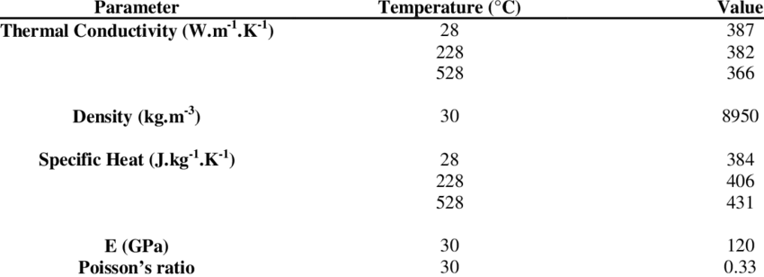

3.2 Thermal Analysis of Material Change Using ANSYS Software

Using the altered design, a material change was input into the ANSYS software to review the results of the heat sink with copper material. Besides material, all other parameters input into the analysis from the altered design remained the same. Figure 3.1 below displays the temperature distribution results gathered from the change of material from aluminum to copper.

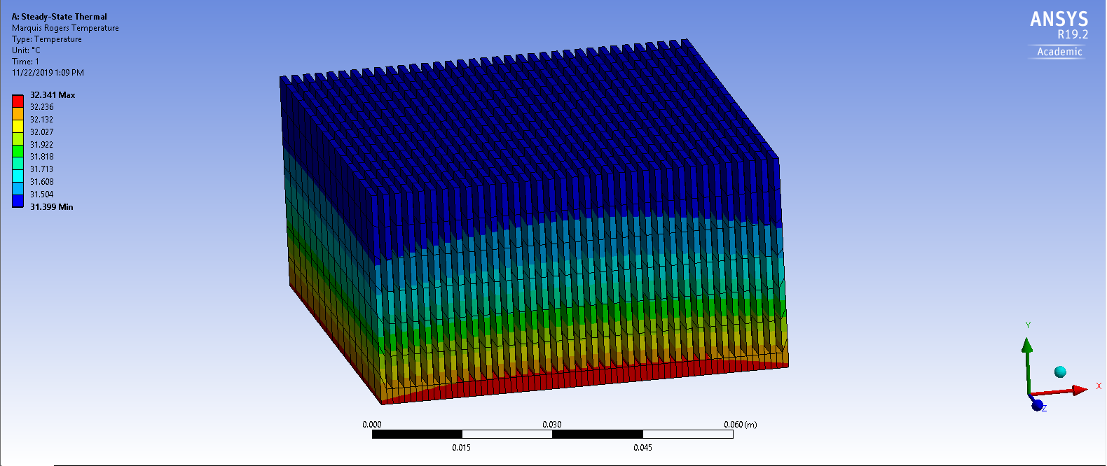

Figure 3.1 Temperature Distribution of Copper Heat Sink

CHAPTER 4
COST ANALYSIS, CONCLUSION, AND RECOMMENDATIONS

4.1 Cost Analysis on Proposed Designs

When looking at the overall improvement of a design’s performance, one has to take into consideration how much an improvement in the design will cost to the consumer. The selected original heat sink according the manufacturer’s website, is currently priced at $11.90. With the changes in geometry, and material change proposed, the following prices for each heat sink design were composed. Table 4.1 below shows the comparison of the approximate prices of each design.

Table 4.1 Price Comparison of Original, Altered, and Altered Heat Sink Designs
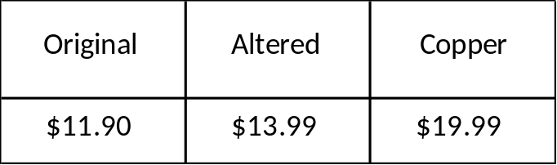

The original heat sink design cost can be found from source [6] in the references section at the end of the report. The altered, and copper design’s cost were decided upon based on based on research of similar products/designs found in the market.

4.2 Conclusions Based on Engineering Judgement

Looking at the results for the original, altered, and copper heat sink designs, the results gathered show overall improvement between the 3 designs. The decreasing of fin thickness allowed for a decrease in the maximum temperature from the original to the altered design. With this decrease in maximum temperature, one can conclude that the overall thermal efficiency increased based on how much better the altered heat sink controlled the peak temperature versus the original. With the change to copper material, the thermal efficiency increased even further, making for the copper design to fit best for the best overall design for the functionality of the overall dimensions of this heat sink.

4.3 Recommendations

Recommendations for this project:
1. The EES program should be better understood before taking this course. Knowing how to operate the software would drastically reduce the time for the analysis part of the report.
2. Students should study the theory associated with the experiment with more detail before writing a very detailed report such as this one.
3. Knowledge of thermodynamic and concepts regarding physics does greatly assist with the understanding of the experimental theory and objectives.

REFERENCES

[1] “StarTech.com 85x70x50mm Socket 478 CPU Cooler Fan with Heatsink & TX3 Connector.” PCM, https://uk.pcm.com/startech-com-85x70x50mm-socket-478-cpu-cooler-fan-with-heatsink-tx3-connector.

[2] “Intel Pentium 4 3.4 GHz specifications.” CPU World , 15 Nov. 2019,
http://www.cpu-world.com/CPUs/Pentium_4/Intel-Pentium%204%203.4%20GHz%20-%20RK80546PG0961M%20(BX80546PG3400E).html

[3] Teertstra, P., Yovanovich, M.M., and Culham, J.R., “Analytical Forced Convection Modeling of Plate Fin Heat Sinks,” Proceedings of 15th IEEE Semi-Therm Symposium, pp. 34-41, 1999.

[4] Bergman L. Theodore et al, “Fundamentals of Heat and Mass Transfer,” pp. 995

[5] Chen Xiaolin, Liu Yijun, “Finite Element Modeling and Simulation with ANSYS Workbench,” pp. 308-329

[6] “StarTech.com FAN478 Socket 478 CPU Cooler Fan w/ Heatsink.” Office Specialties , 22 Nov. 2019, https://www.officespecialties.com/startech.com_fan478_socket_478_cpu_cooler_fan_w_heatsink_22580_prd1.htm?productFeedId=0&utm_source=googleBaseFeed&utm_medium=shoppingEngine&utm_campaign=Google&source=productlistings18283950120&origin=pla&gclid=Cj0KCQiAq97uBRCwARIsADTziyY2Fx7o7dH3jtRaXgzWKQzFVCj-q9HXItz0OFniDE2SLg43PasXzZEaApVLEALw_wcB.

Source For Introduction Picture:

“ELEGIANT Cooling Module, 7.1x3.9x1.8inch Aluminum Heat Sink Heatsink Cooler Fin for High Power LED Amplifier Transistor.” Amazon Prime, https://www.amazon.com/ELEGIANT-7-1x3-9x1-8inch-Aluminum-Amplifier-Transistor/dp/B01HMCYV80

APPENDICE A

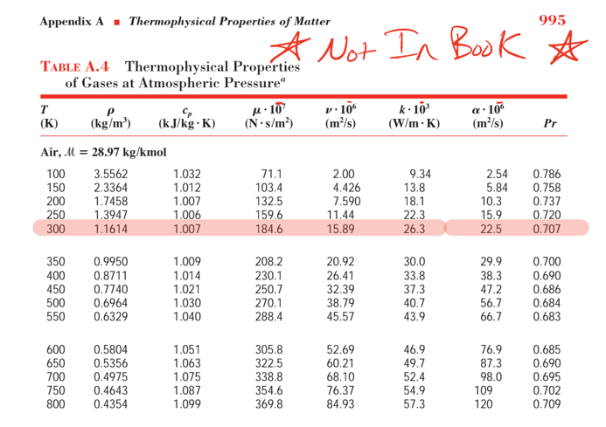

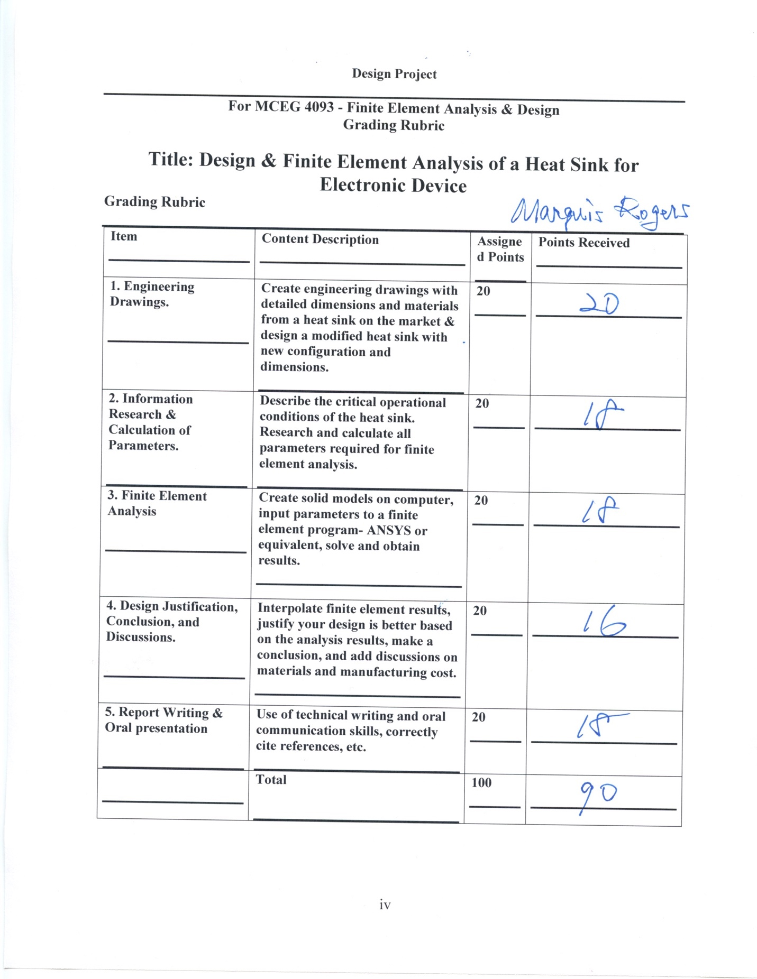

MECHANICAL ENGINEERING DEPARTMENT
OUTCOMES SPECIFIC ASSIGNMENT COVER SHEET
ENERGY SYSTEMS DESIGN
Fall 2019
Instructor: Dr. Shield Lin
Title of Assignment

Test 2

Outcome Measured Using this Assignment
Outcome 1
An ability to identify, formulate, and solve complex engineering problems by applying principles of engineering, science, and mathematic.

Check the complex engineering problem characteristics related to this assignment

Assignment problem
 | involves wide-ranging or conflicting technical issues,
 | has no obvious solution
 | Addresses problems not encompassed by current standards and codes
 | involves diverse groups of stakeholders
 | includes many component parts or sub-problems
 | involves multiple disciplines
X | has significant consequences in a range of contexts
Assignment problem involves the application of the principles of
X | engineering
 | science
X | mathematics

Brief justification of why this assignment is suitable for this outcome
Test 2 is for finite element equation formulation. Although the individual test problems are not “complex engineering problems,” they represent important equation derivations and solving processes that can be used to solve a complex problem such as in assignment 1. And an in-class test is the best means to evaluate students’ individual ability.

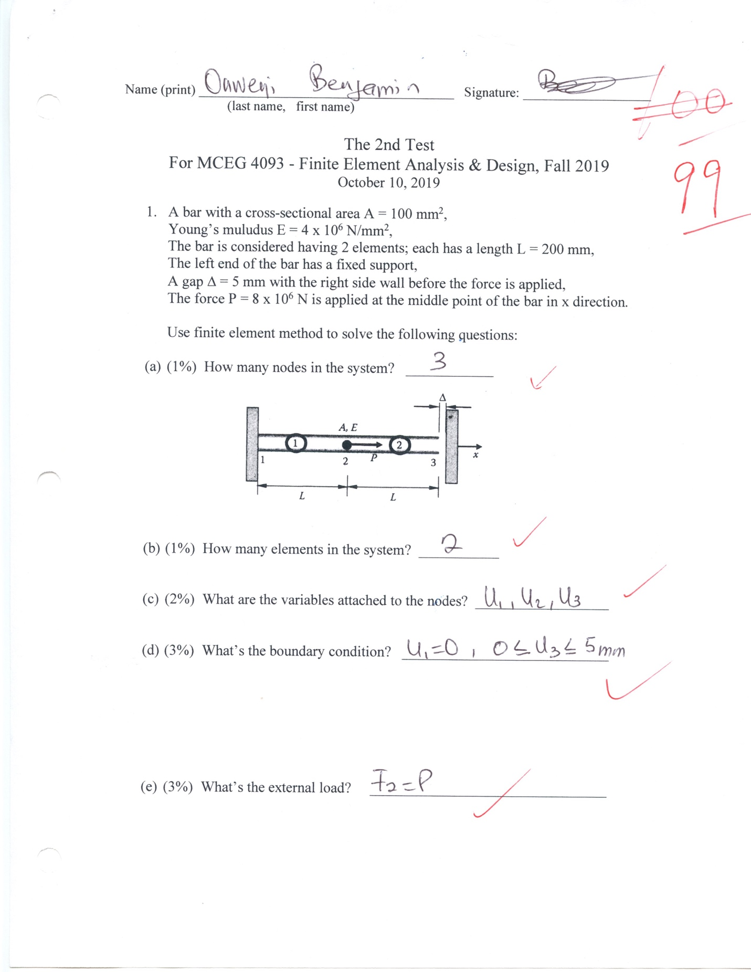

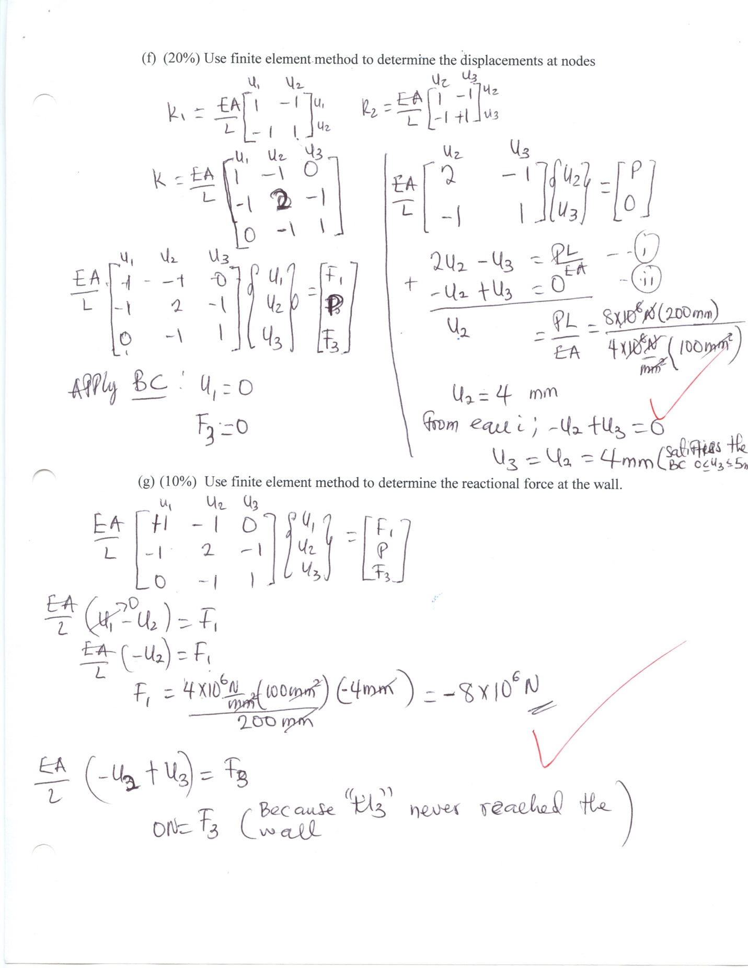

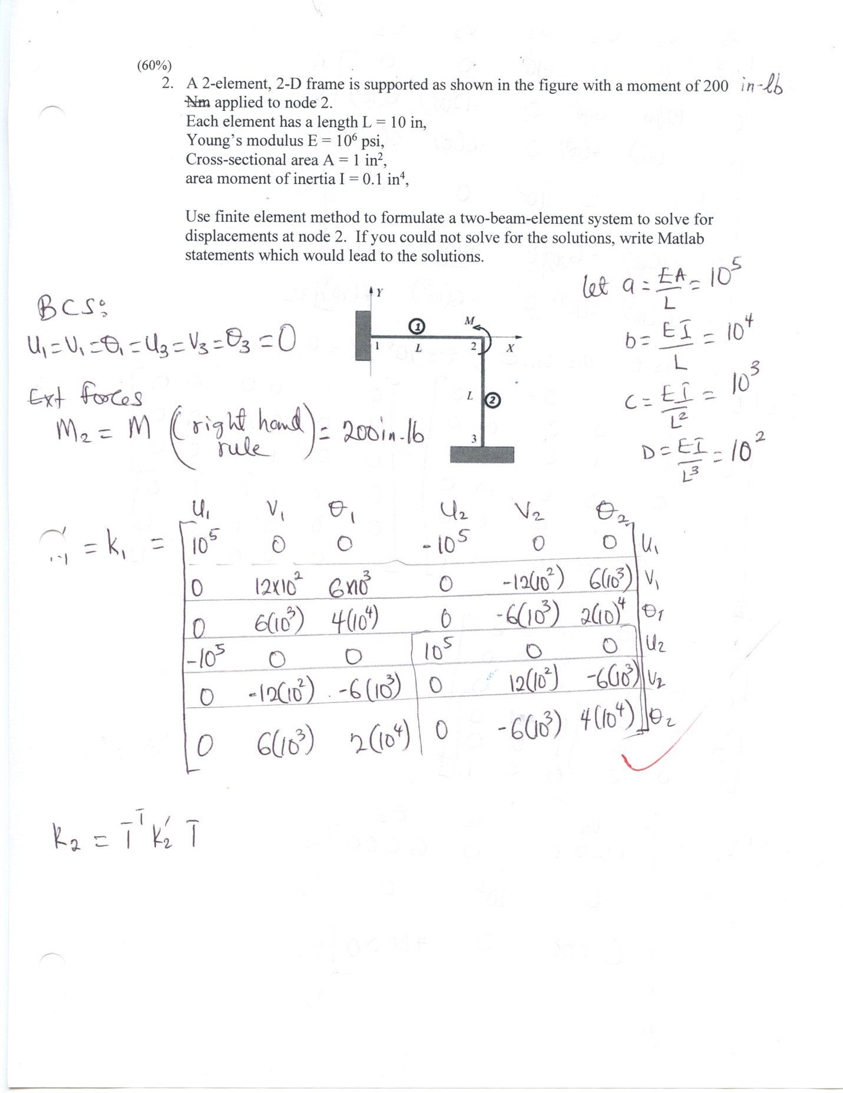

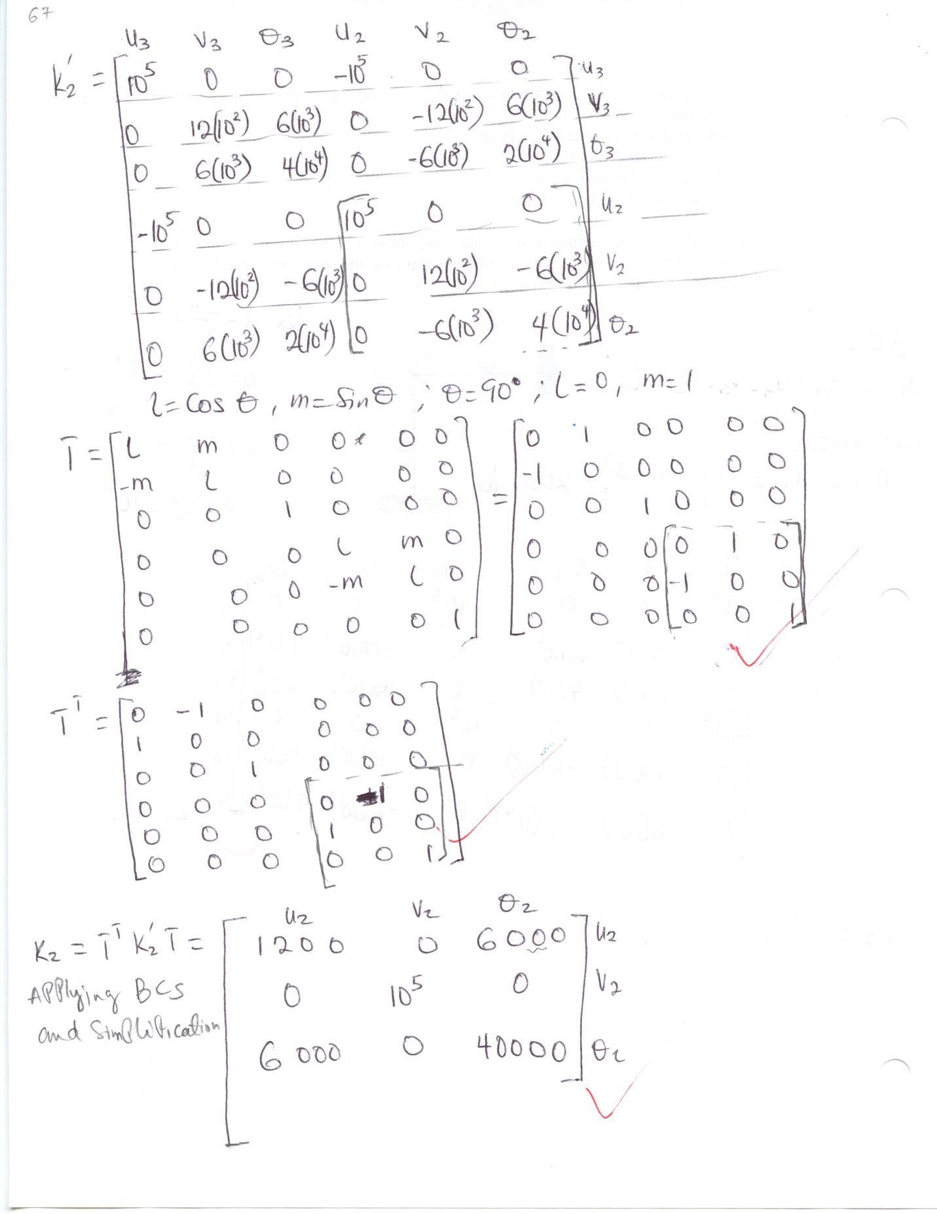

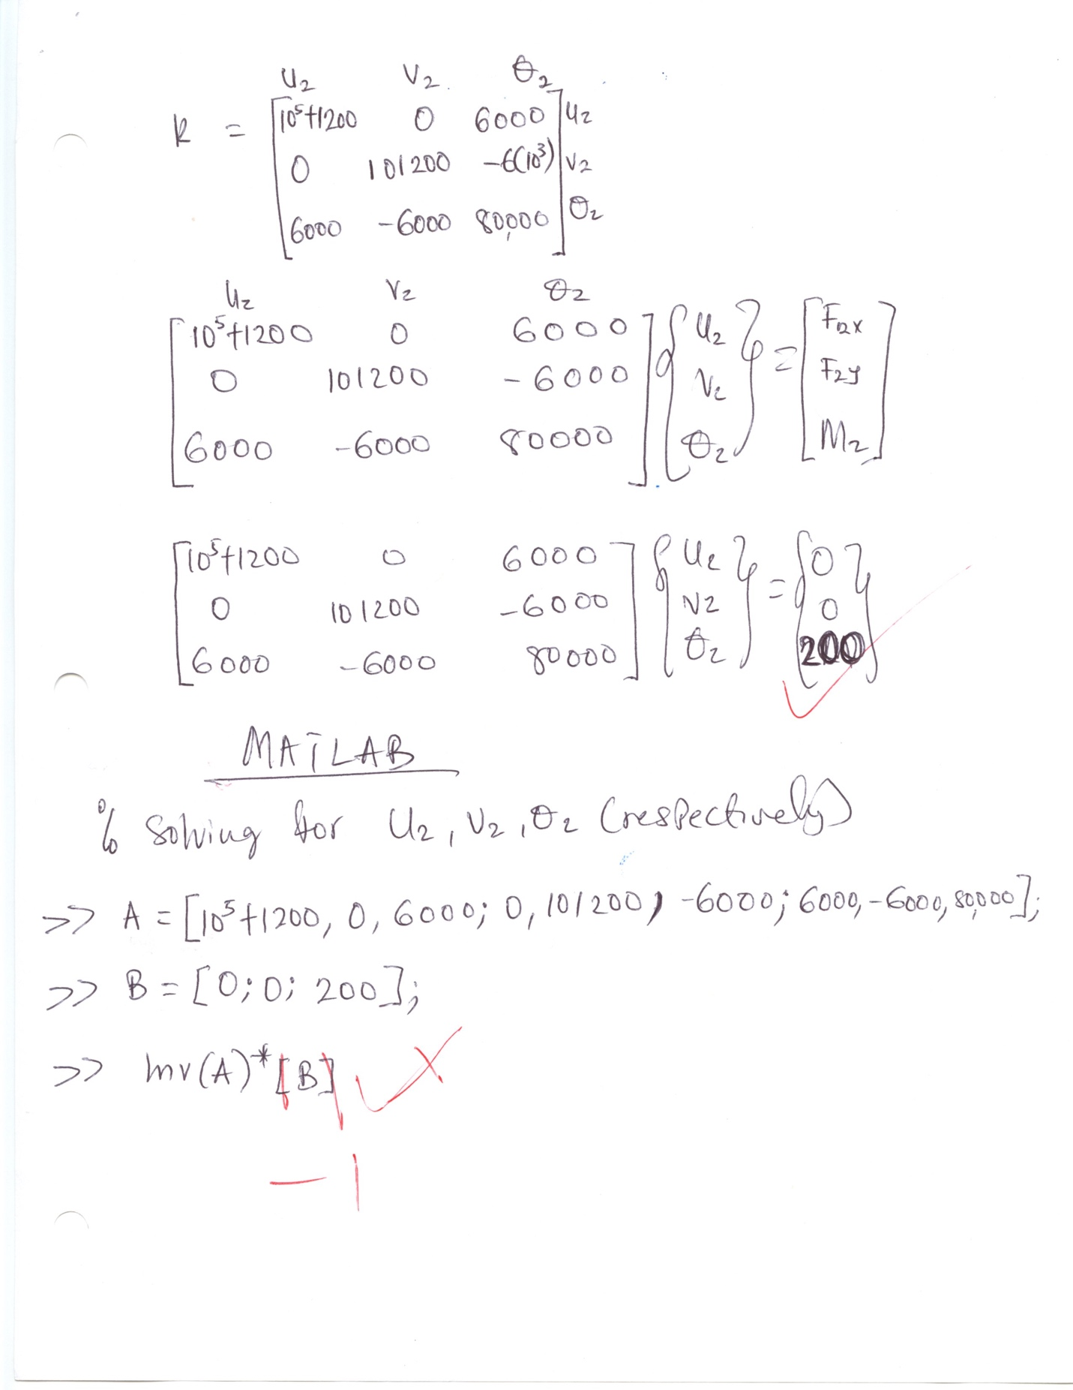

MECHANICAL ENGINEERING DEPARTMENT
OUTCOMES SPECIFIC ASSIGNMENT COVER SHEET
ENERGY SYSTEMS DESIGN
Fall 2019
Instructor: Dr. Shield Lin
Title of Assignment

Test 4

Outcome Measured Using this Assignment
Outcome 1
An ability to identify, formulate, and solve complex engineering problems by applying principles of engineering, science, and mathematic.

Check the complex engineering problem characteristics related to this assignment

Assignment problem
 | involves wide-ranging or conflicting technical issues,
 | has no obvious solution
 | Addresses problems not encompassed by current standards and codes
 | involves diverse groups of stakeholders
 | includes many component parts or sub-problems
 | involves multiple disciplines
X | has significant consequences in a range of contexts
Assignment problem involves the application of the principles of
X | engineering
 | science
X | mathematics

Brief justification of why this assignment is suitable for this outcome
Test 4 requires the students to use finite element program ANSYS to solve an engineering problem. Although the test problem itself is not a “complex engineering problem,” it is an important step of using a modern computer tool, ANSYS, to solve a complex problem such as in assignment 1. And an in-class test is the best means to evaluate students’ individual ability.

Test #4
MCEG 4093 - Finite Element Analysis & Design
November 21, 2019

Print Your Name: ___________________________ Signature: __________________________

The heat sink shown is made of an "X metal" with a thermal conductivity k = 190 W/(m ○C), Young’s modulus E = 118 Gpa, poisson’s ratio of 0.29, and thermal expansion coefficient of 25x10⁻⁶/○C. The heat sink is stress-free when it is fixed on the bottom surface and fixed on the top surface of the fins under the ambient temperature of 45○C before thermal loads are applied. Find the steady-state temperature distribution and thermal stress distributions within the heat sink, under the following thermal load conditions:
A constant heat flux of 280 W/m² is applied to the bottom surface of the heat sink as well as the top surface of the fins; all other surfaces of the heat sink are exposed to convection heat transfer with a film coefficient of 35 W/(m^{2 ○}C) under the ambient temperature of 45○C.

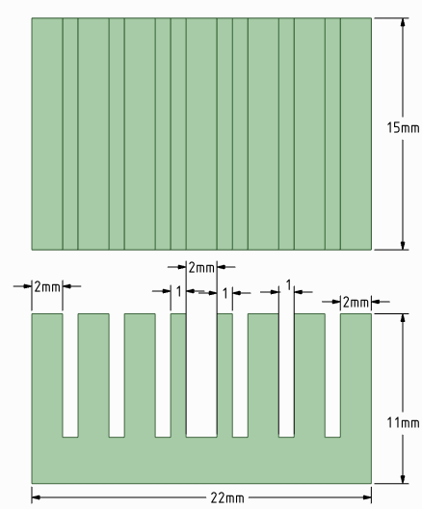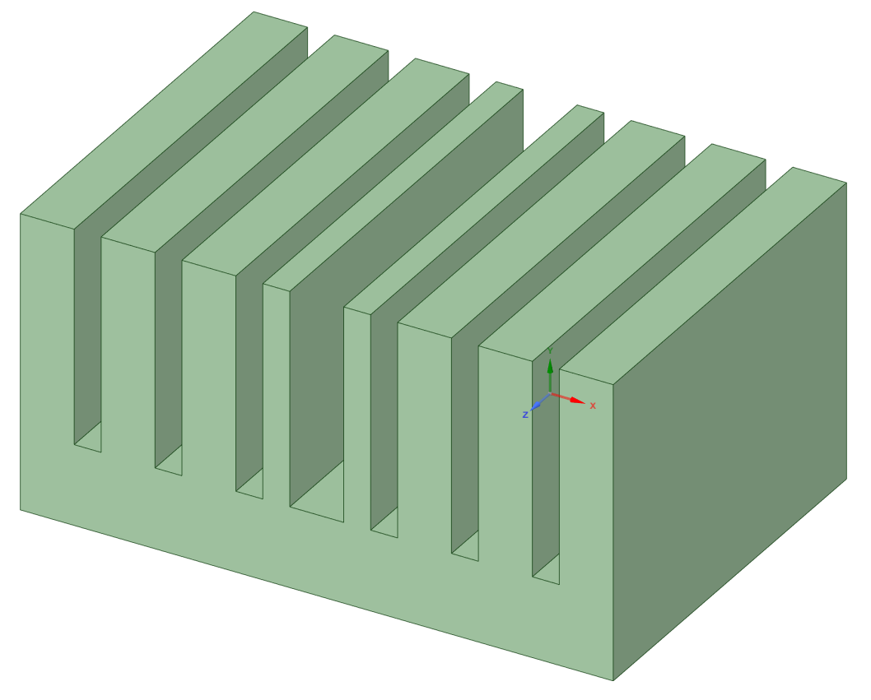
3mm

- Use ANSYS finite element program to solve the problem. Upload a file to eCourse that includes graphic results of (a) temperature distribution, and (b) the equivalent stress distribution (Add your name to the graphic images as you did in the ANSYS case studies).

- The maximum temperature in the heat sink is ______________

- The maximum equivalent stress in the heat sink is ______________

