ROY G. PERRY COLLEGE OF ENGINEERING
MECHANICAL ENGINEERING DEPARTMENT
PRAIRIE VIEW A&M UNIVERSITY

ASSESSMENT REPORT COVER PAGE

MCEG 4043 MACHINE DESIGN II

FALL 2020 SEMESTER

NAME OF INSTRUCTOR: Dr. Jaejong Park

TABLE OF CONTENTS

- Report Cover Page

- Detailed Course Syllabus

- End of Semester Outcomes Assessment Report (New Format)

- Grade Sheet Showing Student and Class Performance in Outcomes

- Supporting Outcomes Specific Assignments (Minimum of 2 per outcome except for Project Reports where one is enough)

Assessing students’ ability to apply engineering design to produce solutions that meet specified needs with consideration of public health, safety, and welfare, as well as global cultural, social, environmental, and economic factor (outcome - 2).

Sample Assignment: Gear and driveshaft design for automotive powertrain system
(Project)

Detailed Course Syllabus
(Distributed to Students at the beginning of the Semester)

 |  | SYLLABUS
MCEG4043 Machine Design II
Fall 2020
General Course Information

Information Item | Information
Instructor: | Jaejong Park, Ph.D.
Section # and CRN: | Section Y02, 16345
Office Location: | S. R. Collins Building, Room 324
Office Phone: | 936-261-9967
Email Address: | japark@pvamu.edu
Office Hours: | Tu and Th, 1:00 PM ~3:00 PM or by appointment
Mode of Instruction: | Hybrid
Course Location: | Online sessions: Zoom, Offline sessions: New Electrical Engr Bldg 213
Class Days & Times: | MW: 8:00 AM ~ 9:50 AM
Catalog Description: | This is a design course featuring a design project using strength of materials, kinematics of machines, machine element design (e.g. gears and shafts), and CAD.
Prerequisites: | MCEG 3043 and MCEG 3053 (may be taken concurrently)
Co-requisites: | None
Required Text(s): | Budynas, R. G. and Nisbett, J. K., Shigley’s Mechanical Engineering Design, 11th edition, McGraw-Hill Book Company, ISBN 978-0073398211
Recommended Text(s): | None
General Course Information Table
Please be advised that this is a hybrid class and there may be a face to face sessions.
Dates for f2f sessions will be notified at least a week ahead. However, your attendance is NOT mandatory.

Course Goals and Overview:
This course is designed to introduce students in mechanical engineering to the contemporary mechanical design methodology as applied to machine elements and to the process of mechanical design. The student will design mechanical elements using concepts developed in design of machine elements, engineering graphics and other related courses. This class will specifically focus on gears, shafts, clutches, brakes and other flexible mechanical elements.

Student Learning Outcomes:
Upon successful completion of this course, students will be able to: |  |  | Program Learning Outcome Alignment | Core Curriculum Outcome Alignment
- Develop the skills for mechanical element design |  |  | 2.1 | 2.1
- Be able to analyze mechanical engineering elements |  |  | 2.1 | 2.1
- Have the knowledge of various machine elements |  |  | 2.2 | 2.2
- Be able to complete a mechanical design project |  |  | 2.3 | 2.3
Student Learning Outcomes Table
Major Course Requirements
Students are required to have proper equipment (e.g. Laptops, Desktop computers, Smartphones, etc) to complete the course requirement. If the student needs an equipment, please contact the financial aid.

Method of Determining Final Course Grade
This course will utilize the following instrument to determine student grades and proficiency of the learning outcomes for the course.
- Exams: written test designed to measure knowledge of presented course material
- Quizzes: written quizzes designed to measure knowledge of presented course material
- Homework: written assignments designed to supplement and reinforce course material
- Project: design project to measure ability to apply presented course material
 | Course Grade Requirement |  | Value | Total
 | 1. Homework |  | 10% | 10
 | 2. Project |  | 30% | 30
 | 3. Quiz |  | 10% | 10
 | 4. Exam 1 |  | 20% | 20
 | 6. Final Exam |  | 30% | 30
 | Total: |  | 100% | 100
Course Grade Requirement Table

The instructor has rights to modify the contents in this syllabus throughout the semester.
Students will get notified anytime a major change is made.

Grading Criteria and Conversion:
A = 90 – 100%
B = 80 – 89%
C = 70 – 79%
D = 60 – 69%
F = 0 – 59%
Detailed Description of Major Assignments:
Assignment Title or Grade Requirement |  | Description
- Homework |  | written assignments designed to supplement and reinforce course material
- Project |  | design project to measure ability to apply presented course material
- Quiz |  | written quizzes designed to measure knowledge of presented course material
- Exams |  | written test designed to measure knowledge of presented course material
Detailed Description of Major Assignments Table

Course Procedures or Additional Instructor Policies
Assignments & Due Dates
The students are expected to follow the submission guidelines for each assignment. The submission platform may be different for the course assignments. Same day late submission will be deducted by 10%. Homework will not be accepted after the day it is due. Exceptions will only be made under extreme circumstances and at the discretion of the instructor. Assigned homework will be graded either for completeness and 1~2 problems per set will be graded for correctness. Students are encouraged to work together on the assignments; however, all students must submit an assignment that consist of their own work for any individual assignment.
Taskstream
Taskstream is a tool that Prairie View A&M University uses for assessment purposes. One of your assignments may be required to be submitted as an "artifact,” an item of coursework that serves as evidence that course objectives are met. If applicable, more information will be provided during the semester by your department, but for general information, you can visit Taskstream via the link in eCourses.
Semester Calendar
Dates for f2f sessions will be notified at least a week ahead. However, your attendance is NOT mandatory.
Week | Topics | Chapter
1~3 | Course Introduction, Mechanics of Materials review, and  Gears – General (Ch. 13)  Gear types, nomenclature, gear fundamentals, gear trains, force analysis | 13
1~3 | Assignments: Homework 1, Quiz 1 | 13
4~5 | Spur and Helical Gears  Lewis bending, AGMA equations and relative factors  Group Project Introduction | 14
4~5 | Assignments: Homework 2, Quiz 2 | 14
6-7 | Failure Resulting from Variable Loading  Fatigue, fatigue failure analysis, endurance limit, fatigue strength, Marin factors | 6
6-7 | Assignments: Homework 3, Quiz 3 | 6
8 | Midterm review and Exam 1
9 | Shaft and Shaft Components  Shaft materials, layout, design for stress, deflection considerations | 7
10 | Bearings  Rolling contact bearings, Journal bearings and their lubrication | 11,12
10 | Assignments: Homework 4, Quiz 4 | 11,12
11-12 | Clutches, Brakes, Couplings, and Flywheels  Static analysis, Internal expanding & external contracting, band type, disk brakes | 16
 | Assignments: Homework 4, Quiz 5
13 | Flexible Mechanical Elements  Belts, chains, ropes, drives | 17
14 | Project Presentations
15 | Course Review and Final Exam (Date & Time: TBD)
Student Support and Success

John B. Coleman Library
The library and its partners have as their mission to provide resources and instructional material in support of the evolving curriculum, as a partner in Prairie View A&M University's mission of teaching, research, and service and to support the University's core values of access and quality, diversity, leadership, relevance, and social responsibility through emphasis on ten key areas of service. It maintains library collections and access both on campus, online, and through local agreements to further the educational goals of students and faculty. Phone: 936-261-1500; Website: J. B. Coleman Library.

Academic Advising Services
Academic Advising Services offers students a variety of services that contributes to student success and leads towards graduation. We assist students with understanding university policies and procedures that affect academic progress. We support the early alert program to help students get connected to success early in the semester. We help refer students to the appropriate academic support services when the student is unsure of the best resource for their needs. Some students are supported by faculty advisors in their respective colleges. Your faculty advisor can be identified in PantherTracks. Advisors with Academic Advising Services are available to all students. We are located across campus. You can find your advisor’s location by academic major at the Academic Advising Website, Phone: 936-261-5911.

The University Tutoring Center
The University Tutoring Center (UTC) offers free tutoring and academic support to all registered PVAMU students. The mission of the UTC is to help provide a solid academic foundation that enables students to become confident, capable, independent learners. Competent and caring staff and peer tutors guide students in identifying, acquiring, and enhancing the knowledge, skills, and attitudes needed to reach their desired goals. Tutoring and academic support is offered face-to-face in the UTC, in virtual face-to-face sessions, and through online sessions at PVPlace. Other support services available for students include Supplemental Instruction, Study Break, Academic Success Workshops, and Algebra Study Jam. Location: J. B. Coleman Library, Rm. 307; Phone: 936-261-1561; Email: pvtutoring@pvamu.edu; Website: University Tutoring Center.

The Writing Center
The Writing Center provides well-trained peer tutors that assist students with writing assignments at any stage of the writing process. Tutors help students with various writing tasks from understanding assignments, brainstorming, drafting, revising, editing, researching, and integrating sources. Students have free access to Grammarly online writing assistance. Grammarly is an automated proofreading and plagiarism detection tool. Student must register for Grammarly by using their student email address. In addition, students have access to face-to-face as well as virtual tutoring services either asynchronously via email or synchronously via Zoom. Location: J. B. Coleman Library, Rm. 209; Phone: 936-261-3724; Website: The Writing Center; Grammarly Registration.

Academic Early Alert
Academic Early Alert is a proactive system of communication and collaboration between faculty, academic advisors, and PVAMU students that is designed to support student success by promptly identifying issues and allowing for intervention. Academic Early Alert helps students by providing a central location to schedule advising appointments, view advisor contact information, and request assistance. Students who recognize that they have a problem that is negatively affecting their academic performance or ability to continue school may self-refer an Academic Early Alert. To do so, students will log in to PVPlace and click on Academic Early Alert on the left sidebar. Phone: 936-261-5902; Website: Academic Early Alert.

Student Counseling Services
The Student Counseling Services unit offers a range of services and programs to assist students in maximizing their potential for success: short-term individual, couples, and group counseling, as well as crisis intervention, outreach, consultation, and referral services. The staff is licensed by the State of Texas and provides assistance to students who are dealing with academic skills concerns, situational crises, adjustment problems, and emotional difficulties. Information shared with the staff is treated confidentially and in accordance with Texas State Law. Location: Hobart Taylor, 2nd floor; Phone: 936-261-3564; Website: Student Counseling Services.

Office of Testing Services
Testing Services serves to create opportunities by offering suite of exams that aid in the students’ academic and professional success. Currently we administer entrance (HESI A2), college readiness (TSI assessment), Prior Learning (CLEP, DSST), and proctored exams. Location: Wilhelmina Delco, 3rd Floor, Rm. 305; Phone: 936-261-3627; Email: aetesting@pvamu.edu; Website: Testing Services.

Office of Diagnostic Testing and Disability Services
The Americans with Disabilities Act (ADA) is a federal anti-discrimination statute that provides comprehensive civil rights protection for persons with disabilities. Among other things, this legislation requires that all students with disabilities be guaranteed a learning environment that provides for reasonable accommodation of their disabilities. If you believe you have a disability requiring an accommodation, contact the Office of Disability Services. As a federally-mandated educational support unit, the Office of Disability Services serves as the repository for confidential disability files for faculty, staff, and students. For persons with a disability, the Office develops individualized ADA letters of request for accommodations. Other services include: learning style inventories, awareness workshops, accessibility pathways, webinars, computer laboratory with adapted hardware and software, adapted furniture, proctoring of non-standardized test administrations, ASL interpreters, ALDs, digital recorders, livescribe, and a comprehensive referral network across campus and the broader community. Location: Hobart Taylor, Rm. 1D128; Phone: 936-261-3583; Website: Disability Services.

Center for Instructional Innovation and Technology Services (CIITS)
Distance Learning, also referred to as Distance Education, is the employment of alternative instructional delivery methods to extend programs and services to persons unable to attend college in the traditional manner. The Center for Instructional Innovation and Technology Services (CIITS) supports student learning through online, hybrid, web-assisted and 2-way video course delivery. For more details and contact information, visit: CIITS Student Webpage; Phone: 936-261-3283.

Veteran Affairs
Veteran Services works with student veterans, current military and military dependents to support their transition to the college environment and continued persistence to graduation. The Office coordinates and certifies benefits for both the G.I. Bill and the Texas Hazlewood Act. Location: Evans Hall, Rm. 102; Phone: 936-261-3563; Website: Veteran Affairs.

Office for Student Engagement
The Office for Student Engagement delivers comprehensive programs and services designed to meet the co-curricular needs of students. The Office implements inclusive and accessible programs and services that enhance student development through exposure to and participation in diverse and relevant social, cultural, intellectual, recreational, community service, leadership development and campus governance. Location: Memorial Student Center, Rm. 221; Phone: 936-261-1340; Website: Office for Student Engagement.

Career Services
Career Services supports students through professional development, career readiness, and placement and employment assistance. The Office provides one-on-one career coaching, interview preparation, resume and letter writing, and career exploration workshops and seminars. Services are provided for students at the Northwest Houston Center and College of Nursing in the Medical Center twice a month or on a requested basis. Distance Learning students are encouraged to visit the Career Services website for information regarding services provided. Location: Anderson Hall, 2nd floor; Phone: 936-261-3570; Website: Career Services.

University Rules and Procedures

Academic Misconduct (See Student Planner)
You are expected to practice academic honesty in every aspect of this course and all other courses. Make sure you are familiar with your Student Planner, especially the section on academic misconduct (see University Administrative Guidelines on Academic Integrity). Students who engage in academic misconduct are subject to university disciplinary procedures. As listed in the PVAMU Undergraduate Catalog, Graduate Catalog, and the Student Planner, the following are examples of prohibited conduct. This list is not designed to be all-inclusive or exhaustive. In addition to academic sanctions, any student found to have committed or to have attempted to commit the following academic misconduct may also be subject to disciplinary review and action as outlined in the PVAMU Student Planner.

Forms of Academic Dishonesty:

- Cheating: Deception in which a student misrepresents that he/she has mastered information on an academic exercise that he/she has not learned, giving or receiving aid unauthorized by the instructor on assignments or examinations. Examples: unauthorized use of notes for a test; using a “cheat sheet” on a quiz or exam; any alteration made on a graded test or exam which is then resubmitted to the teacher.

- Plagiarism: Careless or deliberate use of the work or the ideas of another; representation of another’s work, words, ideas, or data as your own without permission or appropriate acknowledgment. Examples: copying another’s paper or answers, failure to identify information or essays from the Internet and submitting or representing it as your own; submitting an assignment which has been partially or wholly done by another and claiming it as yours; not properly acknowledging a source which has been summarized or paraphrased in your work; failure to acknowledge the use of another’s words with quotation marks.

- Multiple Submission: Submission of work from one course to satisfy a requirement in another course without explicit permission. Example: using a paper prepared and graded for credit in one course to fulfill a requirement and receive credit in a different course.

- Conspiracy: Agreeing with one or more persons to commit an act of academic/scholastic dishonesty.

- Fabrication of Information/Forgery: Use or submission of contrived, invented, forged, or altered information in any assignment, laboratory exercise, or test; tampering with or production of a counterfeit document, particularly documents which make up the student’s academic record. Examples: making up a source or citing nonexistent publication or article; representing made up data as real for an experiment in a science laboratory class; forging a change of grade or student withdrawal record; falsifying any document related to a student academic exercise.

Nonacademic Misconduct (See Student Planner)
The University respects the rights of instructors to teach and students to learn. Maintenance of these rights requires campus conditions that do not impede their exercise. Campus behavior that interferes with either (1) the instructor’s ability to conduct the class, or (2) the ability of students to benefit from the instructional program, or (3) the rights of others will not be tolerated. An individual engaging in such disruptive behavior may be subject to disciplinary action. Such incidents will be adjudicated by the Office for Student Conduct under nonacademic procedures.

Sexual Misconduct
Sexual harassment of students and employees at Prairie View A&M University is unacceptable and will not be tolerated. Any member of the university community violating the university’s sexual harassment policy will be subject to disciplinary action. In accordance with the Texas A&M University System guidelines, your instructor is obligated to report to the Office of Title IX Compliance (titleixteam@pvamu.edu) any instance of sexual misconduct involving a student, which includes sexual assault, stalking, dating violence, domestic violence, and sexual harassment, about which the instructor becomes aware during this course through writing, discussion, or personal disclosure. The faculty and staff of PVAMU actively strive to provide a learning, working, and living environment that promotes respect that is free from sexual misconduct, discrimination, and all forms of violence. If students, faculty, or staff would like assistance, or have questions, they may contact the Title IX Coordinator at 936-261-2144 or titleixteam@pvamu.edu. More information can be found at the Title IX Webpage including confidential resources available on campus.

Pregnancy, Pregnancy-related, and Parenting Accommodations
Title IX of the Education Amendments of 1972 prohibits sex discrimination, which includes discrimination based on pregnancy, marital status, or parental status. Students seeking accommodations related to pregnancy, pregnancy-related condition, or parenting (reasonably immediate postpartum period) are encouraged to contact Student Disability Services or the Dean of Students’ Office for additional information and to request accommodations. More information can be found at this webpage.

Non-Discrimination Statement
Prairie View A&M University does not discriminate on the basis of race, color, sex, religion, national origin, age, disability, genetic information, veteran status, sexual orientation or gender identity in its programs and activities. The University is committed to supporting students and complying with the Texas A&M University System non-discrimination policy. It seeks to establish an environment that is free of bias, discrimination, and harassment. If you experience an incident of discrimination or harassment, we encourage you to report it. If you would like to speak with someone who may be able to afford you privacy or confidentiality, there are individuals who can meet with you. The Director of Equal Opportunity & Diversity has been designated to handle inquiries regarding the non-discrimination policies, and can be reached at Harrington Science Building, Suite 109 or by phone 936-261-1744 or 1792.

Class Attendance Policy (See Catalog for Full Attendance Policy)
Prairie View A&M University requires regular class attendance. Attending all classes supports full academic development of each learner whether classes are taught with the instructor physically present or via distance learning technologies such as interactive video and/or internet. Excessive absenteeism, whether excused or unexcused, may result in a student’s course grade being reduced or in assignment of a grade of “F”. Absences are accumulated beginning with the first day of class during regular semesters and summer terms. Each faculty member will include the University’s attendance policy in each course syllabus.
Student Academic Appeals Process
Authority and responsibility for assigning grades to students rests with the faculty. However, in those instances where students believe that miscommunication, errors, or unfairness of any kind may have adversely affected the instructor's assessment of their academic performance, the student has a right to appeal by the procedure listed in the University Catalog and by doing so within thirty days of receiving the grade or experiencing any other problematic academic event that prompted the complaint. Students can file Academic Complaints and/or Grade Appeals at this webpage.

Technical Considerations

Minimum Recommended Hardware and Software:
- Intel PC or Laptop with Windows 10 or later version; Mac with OS High Sierra*
- Smartphone or iPad/Tablet with Wi-Fi*
- High speed Internet access
- 8 GB Memory
- Hard drive with 320 GB storage space
- 15” monitor, 800x600, color or 16 bit
- Sound card w/speakers
- Microphone and recording software
- Keyboard & mouse
- Most current version of Google Chrome, Safari or Firefox

*Smartphone, Google Chrome books and Android tablets may not be supported. iPads are the only tablets supported.

Note: Be sure to enable Java & pop-ups in the Web browser preferences
Participants should have a basic proficiency of the following computer skills:
- Sending and receiving emails
- A working knowledge of the Internet
- Microsoft Word (or a program convertible to Word)
- Acrobat PDF Reader
- Windows or Mac OS
- Video conferencing software

Netiquette (online etiquette)
Students are expected to participate in all discussions and virtual classroom chats as directed. Students are to be respectful and courteous to others on discussions boards. Foul or abusive language will not be tolerated. Do not use ALL CAPS for communicating to others AS IT CAN BE INTERPRETED AS YELLING. Avoid slang terms such as “wassup?” and texting abbreviations such as “u” instead of “you.” Limit and possibly avoid the use of emoticons. Be cautious when using humor or sarcasm as tone is sometimes lost in an email or discussion post and the message might be taken seriously or sound offensive.

Video Conferencing Etiquette
When using Zoom, WebEx or other video conferencing tools, confirm the visible area is tidy, clear of background clutter, inappropriate or offensive posters, and other distractions. Ensure you dress appropriately and avoid using high traffic or noisy areas. Stay muted when you are not speaking and avoid eating/drinking during session. Before class session begins, test audio, video and lighting to alleviate technology issues.
Technical Support
Students should go to the Password Reset Tool if they have password issues. The page will provide instructions for resetting passwords and contact information if login issues persist. For other technical questions regarding eCourses, call the Center for Instructional Innovation and Technology Services (CIITS) at 936-261-3283 or email ciits@pvamu.edu.

Communication Expectations and Standards
Emails or discussion postings will receive a response from the instructor, usually in less than 48 hours. Urgent emails should be marked as such. Check regularly for responses.

Discussion Requirement
Online courses often require minimal to no face-to-face meetings. However, conversations about the readings, lectures, materials, and other aspects of the course can take place in a seminar fashion. This will be accomplished by the use of the discussion board. The exact use of discussion will be determined by the instructor.

It is strongly suggested that students type their discussion postings in a word processing application such as Word and save it to their PC or a removable drive before posting to the discussion board. This is important for two reasons: 1) If for some reason your discussion responses are lost in your online course, you will have another copy; 2) Grammatical errors can be greatly minimized by the use of the spell-and-grammar check functions in word processing applications. Once the post(s) have been typed and corrected in the word processing application, copy and paste to the discussion board.

COVID-19 Campus Safety Measures

To promote public safety and protect students, faculty, and staff during the COVID-19 pandemic, Prairie View A&M University has adopted policies and practices for the Fall 2020 academic term to limit virus transmission. Students must observe the following practices while participating in face-to-face courses and course-related activities (office hours, help sessions, transitioning to and between classes, study spaces, academic services, etc.):

- Self-monitoring - Students should follow CDC recommendations for self-monitoring. Students who have a fever or exhibit symptoms of COVID-19 should participate in class remotely and should not participate in face-to-face instruction.

- Face Coverings - Face coverings (cloth face covering, surgical mask, etc.) must be properly worn in all non-private spaces including classrooms, teaching laboratories, common spaces such as lobbies and hallways, public study spaces, libraries, academic resource and support offices, and outdoor spaces where 6 feet of physical distancing is difficult to reliably maintain.

- Physical Distancing - Physical distancing must be maintained between students, instructors, and others in course and course-related activities.

- Classroom Ingress/Egress - Students must follow marked pathways for entering and exiting classrooms and other teaching spaces. Students should leave classrooms promptly after course activities have concluded, should not congregate in hallways and should maintain 6-foot physical distancing when waiting to enter classrooms and other instructional spaces.

- Face-to-face Class - To attend a face-to-face class, students must wear a face covering (or a face shield if they have an exemption letter). If a student refuses to wear a face covering, the instructor should ask the student to leave and join the class remotely. If the student does not leave the class, the faculty member should report that student to the Office for Student Conduct for adjudication. Additionally, the faculty member may choose to teach that day’s class remotely for all students.

- COVID-19 Guidelines for Student Conduct Adjudication - The mandatory COVID-19 Training/Certification taken by all students serves as the 1st Warning for violation of COVID-19 Guidelines.

  - 1st incident: upon review of Incident Report and finding of responsibility — Conduct Probation
  - 2nd incident: upon review of Incident Report and finding of responsibility — Suspension
  - Consult the Code of Student Conduct in the Student Planner or Student Conduct website for additional information on Conduct Probation and Suspension.

- Personal Illness and Quarantine - Students required to quarantine must participate in courses and course-related activities remotely and must not attend face-to-face course activities. Students should notify their instructors of the quarantine requirement. Students under quarantine are expected to participate in courses and complete graded work unless they have symptoms that are too severe to participate in course activities. Students experiencing personal injury or illness that is too severe for the student to attend class qualify for an excused absence. To receive an excused absence, students must provide appropriate documentation to the Office for Student Conduct, studentconduct@pvamu.edu.

End of Semester
Course Assessment Report

This summary contains the following Information

1. Performance Statistics
- Total number of students in class
- The class average performance (stated as %) in each course outcome assessed in this class and the two previous times course was assessed.
- The acceptable class average for the class in each outcome area as set by your Department. You cannot use any number of your choice
- Percentage of students who scored below the expected average in each outcome.

2. Implementation Summary
- Brief summary of plans implemented during the semester based on last assessment report

3. Perceived Problems
- Instructor’s critical evaluation of perceived problems that affected students’ performance. Realistic problems should be identified throughout the semester and summarized in this section of the report.

4. New Plans for Addressing Problems
- Instructor’s plans for addressing the perceived problems the next time the class is taught. These should be specific enough for another instructor to implement. Most of these should be things that, you, the instructor can implement to help students to improve. Be creative.

5. Overall Trend over last three assessment periods
- Instructors summary of overall performance trend for each outcome measured over the last three periods.

5. Were Expectations Met?
- Answer YES if the class average was above the expected average and the stated percentage of students scored at or above the expected average, else answer NO.

END OF SEMESTER COURSE OUTCOME ASSESSMENT REPORT

MCEG 4043 MACHINE DESIGN II
FALL 2020 SEMESTER

Report Prepared by: Dr. Jaejong Park
Report Date: Dec 11, 2020
Semester | Analysis Type | Number of Students |  | Outcome 2  An ability to apply engineering design to produce solutions that meet specified needs with consideration of public health, safety, and welfare, as well as global, cultural, social, environmental, and economic factor
Semester | Analysis Type |  |  | Expected Class Average/ | Expected Percent of students at or above average | Class Average | % Students meeting Expected Average
Fall 2020 | Direct |  | 28 | 70 | 70 | 75.9 | 74.1
Spring 2020 | Direct |  | 29 | 70 | 70 | 84.1 | 96.6
Fall 2019 | Direct |  | 32 | 70 | 70 | 79.5 | 71.8
Implementation Summary | Items implemented from previous report or after meeting previous instructor |  |  | Regular meetings were scheduled to encourage students to be on track to finish the project on time.
Perceived Problems | Perceived problems are directly related to the PC and the sub items under them |  |  | There was a significant grade discrepancy between groups.
Plans for Addressing Problems | Plans for address specific measures to address PC and their sub areas |  |  | The groups can be partially chosen by the instructor based on GPA so that baseline knowledge of each group is comparable.
Overall Trend over Periods | Ascertain if there were improvements over previous semesters |  |  | Slight decreased class average and % students meeting expected average was observed this semester compared to previous semester. However, the numbers are still well above the expected values.
Were Expectations Met? |  |  |  | Yes

Grade Sheet Showing
Student and Class Performance in Outcomes
The computed semester average in each outcome
as stated in the Assessment report are
highlighted in boldface

Grade Sheet Showing Student and Class
Performance in Course Outcomes
MCEG 4043 Machine Design II
FALL 2020 Semester

 | Outcome 2
 | Total | PCENT
 | 100 | 100
 | 65 | 65
 | 72.2 | 72.2
 | 54.5 | 54.5
 | 70 | 70
 | 77 | 77
 | 82.2 | 82.2
 | 74.9 | 74.9
 | 83 | 83
 | 92.6 | 92.6
 | 81.5 | 81.5
 | 84.7 | 84.7
 | 57.4 | 57.4
 | 62.4 | 62.4
 | 81.5 | 81.5
 | 88 | 88
 | 92.6 | 92.6
 | 92.6 | 92.6
 | 84.7 | 84.7
 | 78.6 | 78.6
 | 63 | 63
 | 69.4 | 69.4
 | 69.4 | 69.4
 | 76.4 | 76.4
 | 63.7 | 63.7
 | 95 | 95
 | 67.1 | 67.1
 | 69.4 | 69.4
 | Class average | 75.9
% STUDENT ABOVE  EXPECTED AVERAGE |  | 74.1

PECIFIC ASSIGNMENTS
USED TO ASSESS OUTCOME - 2

Students are able to apply engineering design to produce solutions that meet specified needs with consideration of public health, safety, and welfare, as well as global cultural, social, environmental, and economic factor

Performance criterion:

Assessing students’ ability to apply engineering design to produce solutions that meet specified needs with consideration of public health, safety, and welfare, as well as global cultural, social, environmental, and economic factor (outcome - 2).

Sample Assignment: Gear and driveshaft design for automotive powertrain system (Project)

MECHANICAL ENGINEERING DEPARTMENT

OUTCOMES SPECIFIC ASSIGNMENT COVER SHEET
MCEG4043 MACHINE DESIGN II
FALL 2020
Instructor: Dr. Jaejong Park

Title of Assignment

Gear and driveshaft design for automotive powertrain system

Outcome 2
An ability to apply engineering design to produce solutions that meet specified needs with consideration of public health, safety, and welfare, as well as global, cultural, social, environmental, and economic factor

Brief Description of the suitability of this assignment for the outcome
This project examines the students’ ability to analyze and design various engineering components that comprises a mechanical system, Gear and driveshaft design for automotive powertrain system. Students are asked to come up with a design that satisfies specified driving conditions. All relevant components (gears, shafts, and keys) need to be designed to meet design constraints. The nature of this assignment also allows testing student’s project planning skills.

Gear and driveshaft design for automotive powertrain system
Presentation: 8~9:50 AM on Nov 23, 2020
Report due date: 12 PM on Nov 23, 2020, for full credit (No extension will be granted)
Overview
Transmission is a vital part of the ICE-powered vehicles. Gear systems in transmission delivers power from the engine to the wheels via rotary motion of a shaft or shafts. The goal of this project is to design a multi-speed gearbox based on a dyno graph by performing detailed analysis and design of the shafts (chapter 7), gears (chapters 13 and 14), and rolling element bearings (chapter 11). The values in the dyno graph are from the crank. The power transmission case study in chapter 18 serves as guidance for this design exercise. Student groups can assume that torque converter, final drive, axle shafts and their components operate 100% efficiency and have infinite life. The coefficient of friction of tires can be assumed to be 0.5. Gear changing mechanism is not required in this project.
Design specification and constraints
The purpose of this project is to design a transmission that has 6 forward and 1 reverse speeds with a minimum safety factor of 2.5 for all components.
Gear surface wear (pitting) can be ignored.
Refer to data sheet to obtain values for power, torque, vehicle weight, final drive ratio, wheel & tire size, and engine characteristics.
The vehicle needs to climb up a 40% grade hill (starting from the specified RPM).
The reverse gear can have the same gear ratio as the first forward gear.
Shafts need to have infinite life based on the DE-Goodman failure criterion.
Bearings are expected to have at least 20,000 hours of life.
You need to have at least three design iterations to improve your shaft design.
Smaller gearbox is preferred due to overall packaging constraints.
If in doubt, please ask your Dr. Park! He WILL help you.
Machine elements to be designed and/or selected
Gear ratio, gear geometry, shafts (gear and drive shafts), other machine elements discussed in this class (e.g., bearings and keys). The design should include material decisions based on appropriate analysis. Use the following for your reference. Shaft design for stress (see Example 7-2, pg. 366), Shaft design for deflection (see Example 7-3, pg. 372), Bearing selection (see Case Study Part 7, pg. 947), Key design (see Case Study Part 8, pg. 948).
Components listed in the following should be included in your project report
- A hand calculation of the components (e.g., gear ratio, bending & contact stress, shaft diameter) with proper description. Screenshot of handwritten equations are NOT accepted.
- Ansys stress and deflection analysis for gears and shafts. Material properties, boundary conditions, mesh, stress and displacement plots with legible legends. Maximum stress and displacement locations with values.
- 3D models of shafts, spur gears, and bearings made in NX. White background please!
- 3D assembly of your overall design & animation (the animation can be used in presentation)
- The 2D drawing of shafts gears keys and bearing with detailed dimensions made in NX. All necessary dimensions should be included that any person can redraw parts just based on your 2D drawing.
- Compare the calculated gear ratios with actual factory gear ratio values. Comment why there is such discrepancies.
Due 9/30:
Hand calculation of ratio for the highest gear. Must consider all parameters provided (engine speed, final drive, tire size, etc.). Write a computer code that correlates the engine speed and ground speed based on your preliminary hand calculation. MATLAB, Python, or C++ are accepted. Both hand calculations and codes need to be submitted.
Due 10/12:
Hand calculation of ratio for the lowest gear. Must consider all driving conditions provided (hill grade, vehicle weight, tire size, etc.). The document you submit must have all free body diagrams. Write a computer code that correlates the engine speed and the torque or the transmitted force on the drive shaft (propeller shaft) – that connects the transmission and the differential (final drive) based on your hand calculation. Both hand calculations and codes need to be submitted.
Due 10/28:
Size analysis on all the gears (forward and reverse) based on your assumption on the diametral pitch (English unit) or module (SI unit). Number of teeth, pitch radii should be calculated. Need to consider all design constraints such as interference, etc. Write a computer code that provides diameter and radii upon necessary inputs (e.g., gear ratio, diametral pitch). Both hand calculations and codes need to be submitted.
Force analysis on all gears (bending and contact). Based on your force values, choose the face width along with the materials for all gears. All gears are preferred to be in the same materials. Hand calculation needs to be submitted.
Due 11/11 (Updated)
Propeller shaft design. The purpose is to find the diameter of the shaft.
HINT: Assume a material for the shaft. Consider the most severe condition of the vehicle – when the engine is making its peak power. If it is the case, you have the load coming from the first gear (transmission) and you have a load coming from the final gear (differential). Do not forget to use the designated fatigue criterion. Use safety factor of 1.5 if necessary
Choose the length of the propeller shaft such that it is reasonable for your vehicle. Keep the source so that you can refer to it in the report.
Bearing catalog load rating (C₁₀) should be computed. Appropriate key needs to be designed as well.

Use the final two weeks to work on your report, CAD, and presentations. No photo of your hand calculation is allowed in your report. Properly write it in word or neatly take screenshots from any source (needs citation).

I will NOT answer to your project calculation related questions after 11/11. Seek for help before it gets too late.

Vehicle #1 (Mid-size sedan-2018 Honda Accord 2.0t)
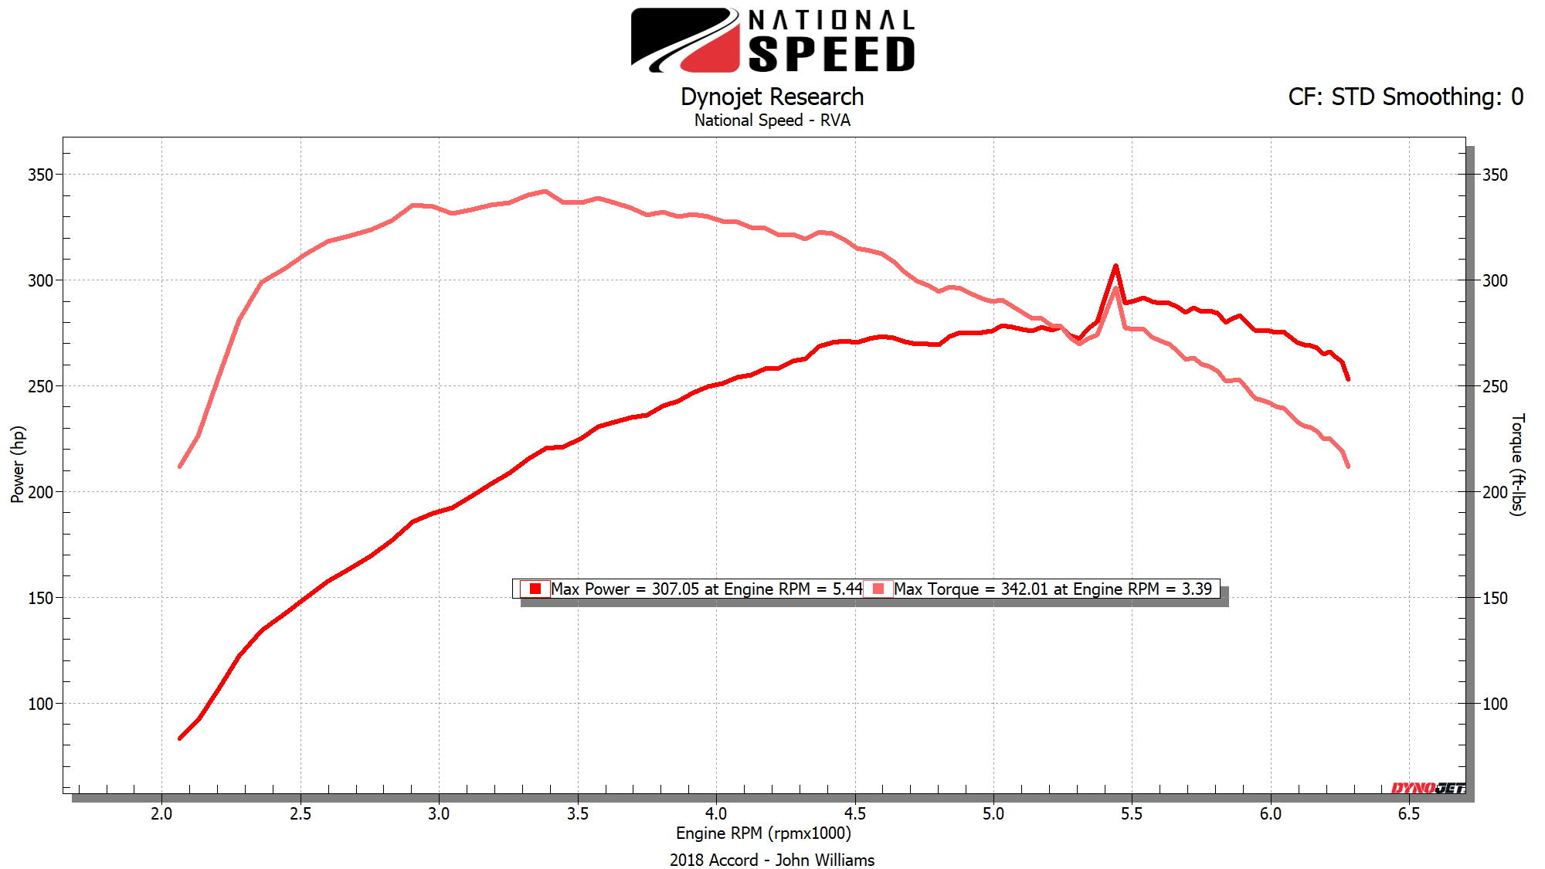
Vehicle weight: 3300 lb
Tire size: 225/50/R17
Final drive: 3.55
Constraint:
- 85 mph should take place at 2500 RPM (highest gear)
- Initial effort to climb 40% grade hill is made at 2500 RPM (lowest gear)

Prairie View A&M University

Mechanical Engineering

MCEG 4043 – Z0X
Machine Design II Fall 2020
FINAL REPORT
Transmission Design
Submitted by

Amna Jangda | Am a Jan
Ximena Cifuentes | Xime Cif es
Jeremy Hunter | Jere�y Hunter
David Trevino | Davicl Trevii,o
Abdullah EL Aker | Abclufl t, EL Aker
to

Dr. Jaejong Park
By signing above, we declare that the contents within this report were generated solely by us. We understand the consequences of academic misconduct.

1
/

Letter of Transmittal

November 23, 2020

Dr. Jaejong Park
Prairie View A&M University

Dear Dr. Park:
Enclosed within this document is our report entitled Gear and Driveshaft Design for Automotive Powertrain System. This report outlines the specific design and analysis conditions, machine design elements used to base the designs and representation of the analytical procedures used. Throughout this project, many iterations were needed to make sure all calculations were precise and accurate showing us that when engineering, the best solutions are not evident the first time.

Should you have any questions or concerns, please feel free to contact Aamna Jangda via e-mail at ajangda@student.pvamu.edu. We greatly appreciate your time in reviewing this report.

Sincerely, Aamna Jangda
Ximena Cifuentes Jeremy Hunter David Trevino Abdullah EL Aker

Enclosed Final Report

2
/


ABSTRACT
japark
2020-12-02 10:38:09
--------------------------------------------
Closing "?

The purpose of the “Gear and Driveshaft Design for Automotive Powertrain System is to design a multi-speed gearbox based on a dyno graph by performing detailed analysis and design of the shafts, gears, and rolling element bearings. The project first needed for students to pick a car design which was illustrated in the project description, in our case, it was a mid-size sedan-2018 honda accord. This specific design included values and analysis conditions which include the vehicle weight, tire size, final drive, velocity of the highest gear and the rpm of highest and lowest gear. Additionally, a graph was provided that compares the engine rpm vs the power output of the car. The calculations were first completed by hand and then translated to MATLAB in order to provide accurate results and allow for multiple iterations if calculations needed to be changed. Fusion 360 was used to design and 3D model the vital components which included the gearbox and driveshaft. Additionally, the simulation software ANSYS was utilized to analyze the stress and deflection of the gears and shafts.
Using the information provided in the project description, multiple iterations had to be made due feedback provided on initial calculations. With the use of MATLAB, the values simply had to be changed in the coding in order to provide new and accurate values. Changing one value would drastically change the outcome that was desired so it took a few attempts to get it right. Once the desired values were obtained, the group was able to begin designing all the machine elements in the project.
In conclusion, to achieve the desired design considering the given constraints and safety requirements a multiple set of calculations had to be made. The highest gear ratio was calculated to be 0.684 and lowest gear ratio was 2.661. Frictional forces were taken into account. Gear Analysis yielded fairly reasonable values for the gear teeth, face width, etc.. Finally to determine the propeller shaft diameter and its components we assumed the length to be 35 in. All hand calculations were followed by MATLAB calculations tests to verify the accuracy of the final values.

3
/

CONTENTS
Contents
Abstract 3
- Introduction 9
  - Background 9
  - Problem definition 9
  - Strategy 9
  - Project planning 10
- Executive Summary 11
  - Gearbox 11
  - Propeller Shaft 12
  - Shaft components 13
    - Key 13
    - Bearing 14
- Design Methodology 15
  - Gear design methodology 15
    - Gear ratios 16
    - Gear size and force analysis 18
      - Interference check 20
      - First iteration – Face width 20
      - Subsequent iterations – Face width 21
      - Gear sizes 22
  - Shaft design methodology 23
    - Shaft shear, moment & torque diagram (If necessary) 23
    - Critical location 27
    - Fatigue analysis 28
  - Key and Bearing design methodology 29
    - Key design 30
- 3D CAD model 30
  - Pinion 31
  - 1st gear 32
  - 2nd gear 33
4
/

  - 3rd gear 34
  - 4th gear 35
  - 5th gear 36
  - 6th gear 37
  - Reverse gear 38
  - Shaft and its components (keys and bearings) 39
- ANSYS Simulation (optional) 46
- Conclusion 48
References 49
Appendix 50

5
/

LIST OF FIGURES
Figure 3.1 Dyno graph for Honda Accord 16
Figure 3.1.1 Gear 1 Force Analysis 18
Figure 3.1.2 Gear 2 Force Analysis 18
Figure 3.1.3 Gear 3 Force Analysis 18
Figure 3.1.4 Gear 4 Force Analysis 19
Figure 3.1.5 Gear 5 Force Analysis 19
Figure 3.1.6 Gear 6 Force Analysis 19
Figure 3.1.7 Image of minimum Np Table 20
Figure 3.2.1 Shaft A Free Body Diagram on XY plane 23
Figure 3.2.2 Shaft A Shear Diagram on XY plane 24
Figure 3.2.3 Shaft A Moment Diagram on XY plane 25
Figure 3.2.4 Shaft A Free Body Diagram on XZ plane 25
Figure 3.2.5 Shaft A Shear Diagram on XZ plane 26
Figure 3.2.6 Shaft A Moment Diagram on XZ Plane 27
Figure 3.2.7 Notch Sensitivity… 29
Figure 3.3.1 Key Selection… 30
Figure 4.1 Pinion Gear 3D Model… 31
Figure 4.2 Pinion Gear 2D Model… 32
Figure 4.3 First Gear 3D Model… 32
Figure 4.4 First Gear 3D Model… 33
Figure 4.5 Second Gear 3D Model… 33
Figure 4.6 Second Gear 2D Model… 34
Figure 4.7 Third Gear 3D Model 34
Figure 4.8 Third Gear 2D Model… 35
Figure 4.9 Fourth Gear 3D Model… 35
6
/

Figure 4.10 Fourth Gear 2D Model… 36
Figure 4.11 Fifth Gear 3D Model… 36
Figure 4.12 Fifth Gear 2D Model… 37
Figure 4.13 Sixth Gear 3D Model… 37
Figure 4.14 Sixth Gear 2D Model… 38
Figure 4.15 Reversed Gear 3D Model… 39
Figure 4.16 Reversed Gear 2D Model… 39
Figure 4.17 Propeller Shaft 3D Model… 40
Figure 4.18 Propeller Shaft 2D Model… 40
Figure 4.19 Drive Shaft 3D Model… 40
Figure 4.20 Drive Shaft 2D Model… 41
Figure 4.21 Shaft Key 3D Model… 42
Figure 4.22 Shaft Key 2D Model… 43
Figure 4.23 Bearing 3D Model… 43
Figure 4.24 Bearing 2D Model… 44
Figure 4.25 Fully Assembled Gears… 44
Figure 4.26 Fully assembled 2D model… 45
Figure 5.1 Propeller Shaft Total Deformation… 46
Figure 5.2 Propeller Shaft Equivalent Stress… 46
Figure 5.3 Driver Shaft Total Deformation… 47
Figure 5.4 Driver Shaft Equivalent Stress… 47

7
/

LIST OF TABLES
Table 2.1 Summary of Final Gear Design Specifications 11
Table 2.2 Summary of Final Shaft Design Specifications 12
Table 2.3 Summary of Final Key Design Specifications 13
Table 2.4 Summary of Final Bearing Design Specifications 14
Table 3.1 Gear Design Equations 15
Table 3.2 Gear Ratios 23
Table 3.2.1 Kt and Kts Values 28

8
/

japark
2020-12-02 10:42:44
--------------------------------------------
Reference?
japark
2020-12-02 10:43:22
--------------------------------------------
Interesting information in the beginning of the report.

Chapter 1: Introduction
This chapter discusses the background of the project. In the next few sections, the problem statement will be clearly identified along with the strategy used to approach it. In addition, the last section includes the different tasks within the project along with a plan that ensures completion of each task in a timely manner.
  - Background

When it comes to traveling by land, nothing comes closer than a vehicle. Within a vehicle, we have a transmission that transfers the power created by the engine to the wheels via a drive shaft and axles. Within this transmission, different gears are utilized and allow for different levels of torque to be applied to the wheels depending on the speed of the vehicle. In order to increase or decrease the torque, the gears in the transmission need to be shifted in either manual or automatic. Before we had automatic cars, only manual cars existed. Manual vehicles were first invented in 1894 by French inventors Louis-Rene Panhard and Emile Lavassor. They developed and demonstrated the world’s first three-speed transmission and slowly improved upon their design. By the beginning of the 20th century, car manufacturing became common and utilized the non-synchronized manual transmission based on the design of Panhard and Lavassor.
However, the next major innovation happened in 1928 by Cadillac when they introduced the very first synchronized manual transmission which reduced the gear grinding and made it easier to shift between different levels of torque. The very first automatic transmission was invented in 1904, however did not take off until the invention of the Buick Dynaflow transmission in 1948.

  - Problem Definition
The scope of the project is to design a gearbox that provides different speeds based on a dyno graph. Successful completion of the design required the team to assume that torque converter, final drive, axle shafts and their components operate at a 100% efficiency and contain infinite life. Finally, the coefficient of friction of tires was assumed to be 0.5.
  - Strategy
It is common to transmit power from an engine or motor to an output action through gear reducers which provides an efficient means for the transmission of power through the rotary motion of a shaft or shafts supported by bearings. The goal of this project is to design a 6 gear gearbox with an idler gear such as that shown below by performing a detailed analysis and design of the shafts (Chapter 7), gears (Chapters 13 and 14) and rolling element bearings (Chapter 11) of this relatively simple gear train. The design process described in the power transmission case study in Chapter 18 serves as guidance for this design exercise.

9
/

  - Project Planning
This project was split into seven phases. In the first phase, the hand calculation of ratio for the highest gear was created by considering all parameters provided in the problem statement such as the speed, final drive, tire size and diameter. Similar to the last phase, in the second phase, the hand calculation of ratio for the lowest gear was created by considering the parameters such as hill grade, vehicle weight, tire size, coefficient of friction, final drive and initial constraints.
Utilizing the values from the first two phases, in phase three, we began the gear analysis of our 6-gear gearbox. The free body diagrams were generated for the 6 gears and the number of teeth for each gear was calculated using values gathered from the lowest and highest gear ratio. From here, the bending stress, dynamic factor, transmitted load, diametral pitch and Lewis bending factor were calculated in order to find the face width of the gears. In phase four, the propellor shaft was designed and values were calculated by assuming the length of the shaft and finding the diameter utilizing DE-Goodman equation. Once all the values were gathered from all the previous phases, modeling was started utilizing Fusion 360 software. Within Fusion, the gears were generated as well as the key, shaft, and ball bearings in phase five. In the sixth phase
ANSYS software was used to do stress and deflection analysis for the gears and shafts by setting material properties, boundary conditions, mesh, stress, and displacement plots. Finally, in the seventh phase, the final report was created by combining all previous phases

10
/

Chapter 2: Executive Summary
japark
2020-12-02 10:52:21
--------------------------------------------
Same face width led to the same safety factors? I will need to see the calculation for that!
japark
2020-12-02 10:53:22
--------------------------------------------
module is irrelevant as we are working with US customary unit system.
This chapter summarizes the design specifications of the gearbox, propeller shaft, bearings, and key components of the transmission design. In addition, the chapter contains all the formulas needed to draw the appropriate measurement conclusions along with the computational values that were assumed or given by the problem statement. Finally, the calculated specifications can be observed in Table 2.1-2.4.

  - Gearbox
In this section the gearbox specifications are displayed on Table 2.1. The table contains the number of teeth, diameter, face width, and maximum bending stress for each gear designed. In addition, from the table it can be concluded that the material and safety factor for all gears is constant. Moreover, this section includes the formulas used to calculate the values displayed on Table 2.1.
Table 2.1 Summary of Final Gear Design Specifications

2.5
2.5
AISI 1095 HR
37245 psi
2.3230 in
2.75 in
22
Reverse gear
AISI 1095 HR
37245 psi
2.3230 in
2.8 in
23
5
2.5
AISI 1095 HR
37245 psi
2.3229 in
4 in
32
4
2.5
AISI 1095 HR
37245 psi
2.3228 in
5.12 in
41
3
2.5
AISI 1095 HR
37245 psi
2.3227 in
6.25 in
50
2
2.5
AISI 1095 HR
37245 psi
2.3227 in
7.37 in
59
1

Forward gears
2.5
AISI 1095 HR
37245 psi
2.3230 in
2.75 in
22
Pinion
Safety factor
Material
Max σbending
F
d
N
Gear number

To calculate the number of teeth the following equation was used:
N 1 = m ( NP )
where,

m is the module

NP is the number of teeth of the pinion
N 1 is the number of teeth to calculate

11
/

japark
2020-12-02 10:52:49
--------------------------------------------
Font is broken here.
japark
2020-12-02 10:56:28
--------------------------------------------
This value seems to be absurdly high. the ratio of first gear was less than 3. This means the torque will get amplified by less than 3 times in the propeller shaft. Accord engine is making less than 300 ftlb of torque at the crank.
To calculate the diameter of the gear the following equation was used:
d = N /P
Where,

N is the number of teeth P is the pitch diameter
To calculate the face width the following formula was used:

F=(Kv×Wt×P)/(𝜎×Y)
where,

Kv is dynamic factor
Wt is the transmitted load
𝜎 is the bending stress
Y is the Lewis form factor

To calculate the maximum bending stress the following formula was used:

��max = √(Mxy 2 + Mxz 2 )

Where M is the maximum bending stress occurring at the critical point at the surface of x-y and x-z

  - Propellor Shaft
In this section the propeller shaft crucial data is shown in Table 2.2, it includes the shaft diameter, maximum torque applied, maximum shear stress, failure criteria, material used, and safety factor. Across all the components used for this design it has a constant safety factor with the same material. Table 2.2 is followed by the equations used to calculate each variable.

Table 2.2 Summary of Final Shaft Design Specifications
Shaft diameter | Max torque |  |  | Material | Max τ torsion | Failure criteria | Safety factor
1.0454 in | 7291.3 ft.lb |  |  | AISI 1095  HR Steel | 34585 lbf.in | 24.9744 kpsi | 2.5
Maximum torque

12
/

where D is the diameter
Tmax
= Wt
× (D/2)

Maximum torsion was calculated using the highest force value times the distance

Failure criteria

S_{e} = K_{a} × Kb × K_{c} × Kd × S_{e}`

where K_{a}
is the surface factor

japark
2020-12-02 10:57:52
--------------------------------------------
Table could have been made to look better.
Kb is the size factor

K_{c} is the loading factor

Kd is the temperature modification factor
S_{e}` is the endurance limit

  - Shaft Components
In this section a summary of the two major components calculated values for the shaft key and bearing is represented in Table 2.3 and 2.4. After determining the shaft critical values with the maximum bending stress we were able to pick the key size of the same material and consider a fixed safety factor. Using the standard size of the key, we were able to calculate the load (force and torque) applied on the key. Afterwards a similar approach was used to determine the bearing load.

    - Key
Table 2.3 displays the key specifications based on the calculated shaft diameter. Some of the items listed on the table include but are not limited to the key sizing, the loading, and material specifications.
Table 2.3 Summary of Final Key Design specifications

Shaft diameter | Key size |  |  | Loads |  | Material | Safety factor
Shaft diameter | w | h | l | Forc  e | Torqu  e | Material | Safety factor
1 to 1 ¼ in | ¼ in | 3/16 in | 3/32 in | 2845  .56  lb | 3557.  3  lb.in | AISI 1095  HR Steel | 2.5

13
/

The shaft key standard dimensions were found from the table. To calculate the force

where T is the torque r is the radius

Torque

where HP is the horsepower n is the rotational speed
F = T/r

T = (63025 × HP) / n

    - Bearing
Table 2.4 displays the bearing specifications. The table contains the bearing, radial load, axial load, catalog load rating, catalog, and the specific item number.

Table 2.4 Summary of Final Bearing Design Specifications

Bearing | Radial load | Axial load | Catalog load  rating | Catalog | Item number
½ in | 342.01 lbf | 0 | 4932 lbf | 62mm OD | 26.553

The bearing standard dimensions were found from the table. On the other hand, force was given in the dyno graph. To calculate the catalog load rating C10
C10 = FD ((LDnD 60)/(L_{r}n_{r}60))¹/a

Where FD is
the desired radial laid

LD is the desired lif e, hours nD is the desired speed
L_{r} is the rating lif e in hours

nR is the rating speed

14
/

japark
2020-12-02 10:59:12
--------------------------------------------
What is this space for?

Chapter 3: Design Methodology

  - Gear Design Methodology
When designing and analyzing the gears, various equations and steps were necessary to successfully obtain the design elements to complete analysis. The first step taken was to create the free body diagrams for each gear. When creating the free body diagrams the group was able to see the forces and loads that would be acting on each gear. Additionally, the group was able to analyze the direction of rotation that the gears would be moving in. Considering all driving conditions that were given in the dyno graph such as the hill grade, vehicle weight, tire size, coefficient of friction, final drive and initial constraints, the gear ratio of the highest and lowest gear were calculated. Starting off with the gear ratio of the highest gear, it was calculated to be 0.6384 by having the highest gear rpm be divided by the transmission shaft rpm. Utilizing values from the problem statement, the gear ratio for the lowest gear was calculated to be 2.661. Using values obtained from the lowest and highest gear ratio, the gear ratio for all six gears were generated. Using this information, the number of teeth were found by using the initial rpm provided and the gear ratios that were calculated. Once the number of teeth for each gear was found, the diametral pitch, speed, and pitch line velocities were found for each gear. Once the pitch line velocities were obtained, the group was able to calculate the transmitted, axial, and radial loads using the power input given as well as the torque for each gear. Finally, the face width was calculated using the values such as the bending stress, dynamic factor, transmitted load, diametral pitch and Lewis bending factor.
Table 3.1 Gear Design Equations

15
/

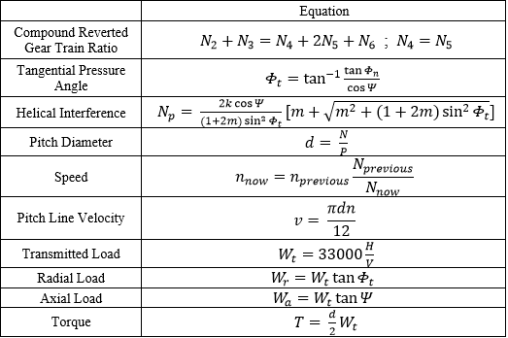
japark
2020-12-02 11:00:17
--------------------------------------------
You have lots of parameters here. You should include a paragraph that explains every single one of them unless you have defined it earlier in the report.

    - Gear Ratios
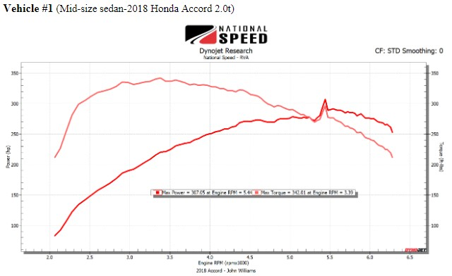
Using values given in the project statement, the highest and lowest gear ratios were calculated for a mid-size sedan-2018 Honda Accord. Additionally, a dyno graph was provided to the group to provide additional information.
Figure 3.1 Dyno graph for Honda Accord
16
/

To find the highest gear ratio, the group considered all the following parameters

d = Diameter = 25.9 in

Nin = Rotational speed = 2500 rpm

V _{x} = Expected speed = 85 mph

Where
f .d = F inal drive ratio = 3.55

Distance moved in 1 revolution = πd = π (25.9) = 81.36 in/rev

Mph converted to rpm =
85 miles
1 hour
5280 ft
- 1 mile
12 in
- 1 f t
1 hr
- 60 min
= 89, 760 in/min

Distance = 89,760 in/min = 1103.11 rpm

Rpm
81.36 in/rev

In order to find the rpm of the transmission shaft we used the equation

T ire rpm * f inal drive ratio where 1103.11 rpm * 3.55 = 3, 916.04 rpm . Using this value, we
are able to calculate for the highest gear ratio using the equation

Gear Ratio(Highest) = Nin
N
= = 0.6384
out
2500 rpm 3,916.04 rpm

To find the lowest gear ratio, the group considered all the following parameters
japark
2020-12-02 11:01:02
--------------------------------------------
unit?

μ = Coefficient of f riction = 0.5

d = Diameter = 25.9 in

f .d = F inal drive ratio = 3.55

θ = Grade hill incline =
40
Where 17
/

Pressure Angle = Tan−1 (θ) = Tan−1 (0.40) = 21.8


Force of f riction = μ (mg * cos (θ)) = (0.5) (3300 lb * cos cos (21.8) ) = 1531.991 lbf Force in x direction = Fx = F f + mg * sinθ = 1531.911 + 3300 sin sin (21.8) =
2757.558
2757.558
Transmitted Load = Wt = F_{x} =

d = 25.9 = 12.95
2
T ire radius =
2

Applied torque = T = r * Wt
= 12.95 in (2757.558) = (35710.38 lb * in) (1 ft ) = 2975.865 lb f t

Shaft transmission = T = ^{2975.865} ^{lb} ^{ft} = 838.272 lb f t
12
Final Drive 3.55

Gear Ratio(Lowest) = ^{N}in
N
= = 2.661
out
838.272 lb ft 315 lb f t

japark
2020-12-02 11:01:12
--------------------------------------------
unit?
japark
2020-12-02 11:01:21
--------------------------------------------
unit?
japark
2020-12-02 11:02:01
--------------------------------------------
what is this space for?
japark
2020-12-02 11:02:09
--------------------------------------------
sinsin?

    - Gear Size and Force Analysis
The force analysis for each gear was generated by hand and analysis on gear size was performed by using values gathered from the lowest and highest gear ratio. This analysis can be shown in chapter 3.1.2.4 gear sizes in the report.

18
/

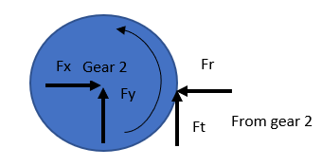
japark
2020-12-02 11:03:25
--------------------------------------------
Curved arrow, does this represent torque or rotation direction?
japark
2020-12-02 11:04:34
--------------------------------------------
Figure caption and content are not consistent. Figure 3.1.3 says gear 3 but the figure itself says gear 4? Also, why is this gear compound?
Figure 3.1.1 Gear 1 Force Analysis

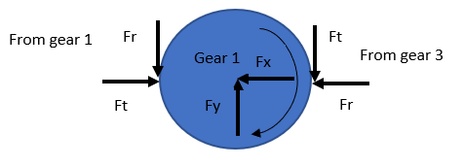

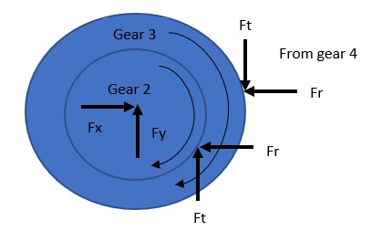
Figure 3.1.2 Gear 2 Force Analysis

Figure 3.1.3 Gear 3 Force Analysis

19
/

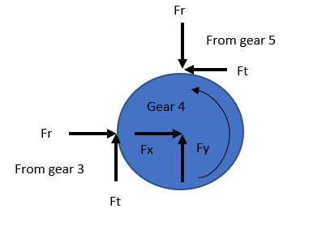
japark
2020-12-02 11:04:49
--------------------------------------------
Another compound gear?
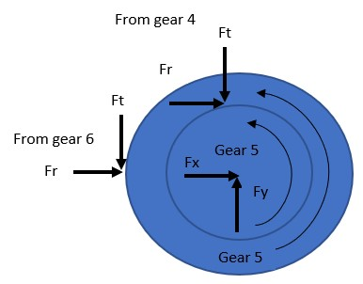
Figure 3.1.4 Gear 4 Force Analysis

Figure 3.1.5 Gear 5 Force Analysis
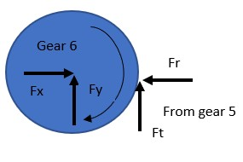
Figure 3.1.6 Gear 6 Force Analysis

20
/

japark
2020-12-02 11:04:59
--------------------------------------------
Space
japark
2020-12-02 11:05:14
--------------------------------------------
Make the equation fonts look consistent!
japark
2020-12-02 11:25:59
--------------------------------------------
This should be labeled as a table.
japark
2020-12-02 11:26:06
--------------------------------------------
unit missing.
      - Interference Check

If m < 1, the given equation for interference cannot be used, instead the Np is derived from a table.

N_{p} = ^{2kcos(φ)} [m + √m2 + (1 + 2m) sin²(θ)
(1+2m)sin²(θ)
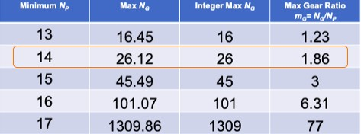

Figure 3.1.7: Image of Minimum Np Table
As Figure 3.1.7 shows, 14 was used as the minimum Np, since the max gear ratio is closest to
1.86. Spur gears were used since the interference equation was not used for the Np.

      - First Iteration – Face Width

Once all of the equations for the gear analyses were found, it was necessary to calculate both the bending stress for each shaft. In order to calculate the bending stress, the Lewis Form Factor and the dynamic factor were needed. The Lewis Form Factor was found on Table 14-2 based on the number of teeth of the gear per shaft.Using equation (14-7) from page 371, we can manipulate and rearrange the equation in order to find the face width.
Where
Bending stress = σ = 165000

Dynamic factor = K_{v} = 4352.6085

21
/

= 1.943
Diametral pitch = P = 6

Face width = F = 2.3230 in
Wt
Transmitted load =

Lewis bending factor = Y = 0.311 @ 22 Teeth

Kv*Wt
F =
σ*Y
(1.943)(4352.61)(6)
165000(0.331)
=
= 2.320 in

japark
2020-12-02 11:26:22
--------------------------------------------
units are missing.
japark
2020-12-02 11:27:00
--------------------------------------------
description as to why you need subsequent iteration is necessary would have been nice here.
japark
2020-12-02 11:27:37
--------------------------------------------
should this be iteration 3?

      - Subsequent Iterations – Face Width

For this section, a few different iterations using different materials and altering diametral pitch was performed in MATLAB. The best one among the 3 interactions performed was chosen. The determining factor was the iteration that resulted in a small, realistic diameter and a small face width, either equal to or less than the gear diameter.

        - Assumptions made for Iteration 1:
          - P=8, diametral pitch (teeth/in)
          - AISI 1060 HR Steel; Sy=54kpsi, Sut=98 kpsi

Iteration 1 resulted in smaller diameters across all gears, but the face width was too high.

        - Assumptions made for Iteration 2:
          - P=4, diametral pitch (teeth/in)
          - AISI 4130 Q&T Steel; Sy=212 kpsi, Sut=236 kpsi

Iteration 2 resulted in small face widths, but the diameters were resulting in one gear being more than 1.5 ft, which was too large.
        - Assumptions made for Iteration 2:
          - P=8, diamteral pitch (teeth/in)
          - AISI 1095 HR Steel; Sy=66 kpsi, Sut=120 kpsi
22
/

Iteration 3 was the chosen one because it yielded in realistic, small diameters and face widths.

      - Gear sizes

Where

Lowest gear ratio = 2.661

japark
2020-12-02 11:28:10
--------------------------------------------
How about material? Is the 1095 HR steel reasonable for the type of application?
japark
2020-12-02 11:28:44
--------------------------------------------
subsection starting with "Where"?
japark
2020-12-02 11:28:54
--------------------------------------------
unit missing
japark
2020-12-02 11:30:28
--------------------------------------------
What is this and why and how are you using it? I can see it in the calculation but have description explaining it. Just like I said, this report is targeting a person who does not have solid ME knowledge.
Highest gear ratio = 0.6384

Safety factor = 2.5

Power = 307.5

Revolution per minute = 5.44 rpm

AISI 1095 HR

Lowest gear ratio − Highest gear ratio = 2.661 − 0.6384 = 2.0226

Utilizing the value obtained, we can calculate the average gear ratio when we use the formula

2.026 = 0.40452
5
We can add this value to the lowest gear ratio to get the ratio for gear 2 and the rest of the gears. Where

m6 = 0.6384
m5 = 0.6384 + 0.40452 = 1.04292

23
/

m4 = 1.04292 + 0.40452 = 1.44744
japark
2020-12-02 11:30:42
--------------------------------------------
Space note necessary.
japark
2020-12-02 11:31:23
--------------------------------------------
What about the ground speed?
japark
2020-12-02 11:32:15
--------------------------------------------
unit is missing, and your 6th gear is giving the highest torque? Does not seem right. Gear 5 gives 0 torque at the wheel?

m3 = 1.44744 + 0.40452 = 1.85196

m2 = 1.85196 + 0.40452 = 2.25648

m1 = 2.25648 + 0.40452 = 2.661

Table 3.2 Gear ratios
Gears |  | Gear ratio | Diameter | Max torque  at the wheel |  | Max speed at the wheel
Forward Gears | 1 | 2.661 | 2.75 in |  |  | 2028.5 rpm
Forward Gears | 2 | 2.25648 | 7.37 in | 1819.4 |  | 2393.6 rpm
Forward Gears | 3 | 1.85196 | 6.25 in | 1819.4 |  | 2919 rpm
Forward Gears | 4 | 1.44744 | 5.12 in | 15766 |  | 3740 rpm
Forward Gears | 5 | 1.04292 | 4 in | 0 |  | 5203 rpm
Forward Gears | 6 | 0.6384 | 2.8 in | 141900 |  | 5440 rpm
Reverse gear |  | 2.661 | 2.75 in |  |  | 2028.5 rpm

  - Shaft Design Methodology
The first step taken was creating a preliminary shaft layout for each shaft including dimensions such as the length of the shaft. Once the layout was developed, the free body diagrams for each shaft were created incorporating the loads previously calculated. After the free body diagrams were completed, shear and moment diagrams were generated for both the XY and XZ planes.
    - Shaft Shear, Moment and Torque Diagram

24
/

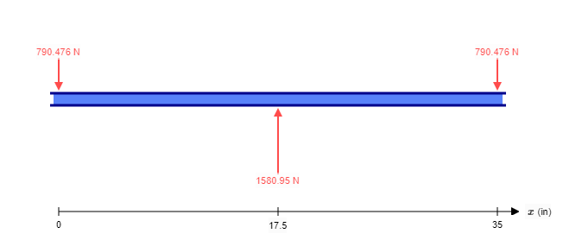
Figure 3.2.1 through figure 3.2.5 are all of the free body diagrams with their shear and moment diagrams for each shaft on both the XY plane and the XZ plane. All of the moment diagrams show what that max bending moment is on all of the shafts.
japark
2020-12-02 11:33:12
--------------------------------------------
So you only have one support. This will lead to unstable solution.

Figure 3.2.1 Shaft A Free Body Diagram on XY plane
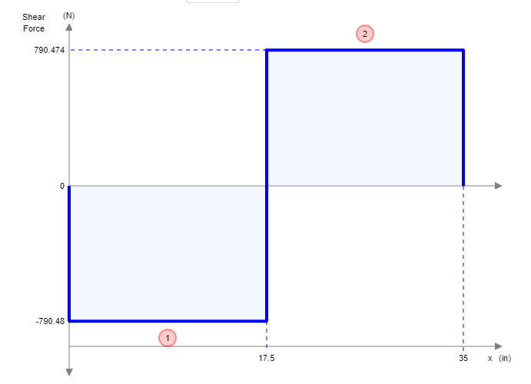

25
/
Figure 3.2.2 Shaft A Shear Diagram on XY plane
japark
2020-12-02 11:34:34
--------------------------------------------
The transmitted loads from gears at both ends should point to other direction, otherwise, you will have nonzero net torque at the shaft resulting in angular acceleration. This is why you will have stability issues if you decide to have only one support.

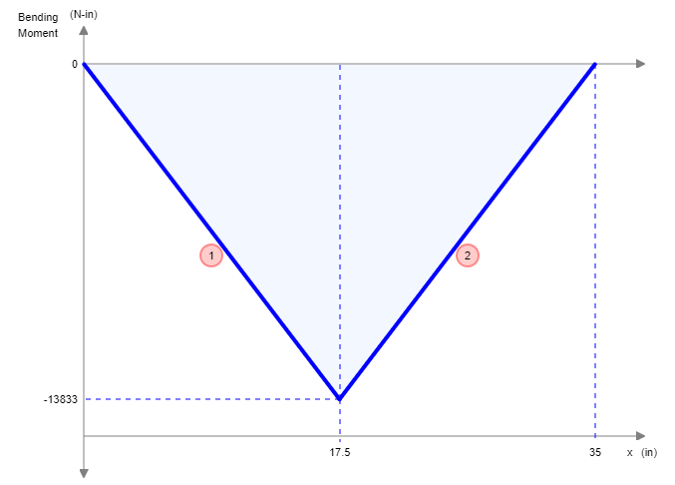
Figure 3.2.3 Shaft A Moment Diagram on XY plane
In X-Z plane

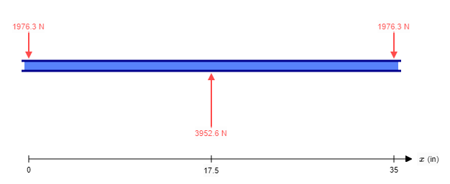
Figure 3.2.4 Shaft A Free Body Diagram on XZ plane

26
/

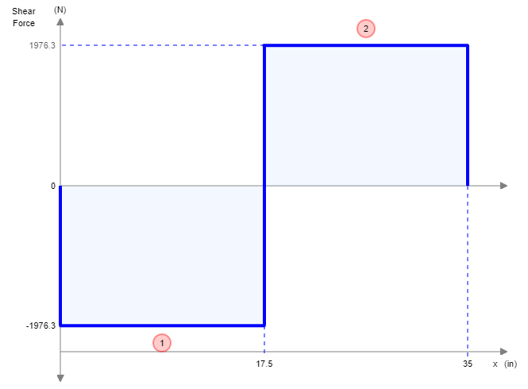
Figure 3.2.5 Shaft A Shear Diagram on XZ plane

27
/

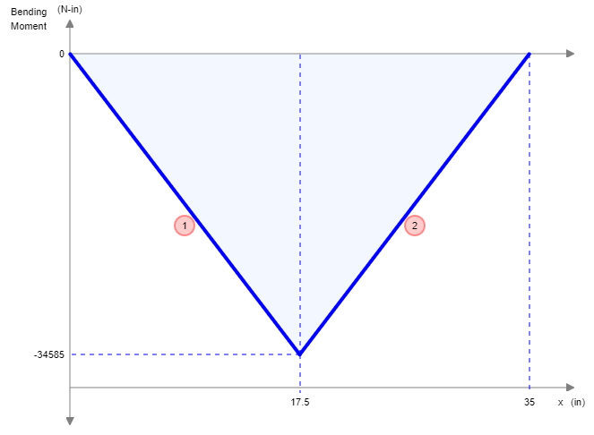
japark
2020-12-02 11:43:57
--------------------------------------------
Where is it?
Figure 3.2.6 Shaft A Moment Diagram on XZ plane

Critical Locations
Next, the Se equation was used to calculate the endurance limit at the critical location of a machine part in the geometry and condition of use.

S_{e} = k_{a}kbk_{c}S′_{e}
Ka = Surface condition modification factor

kb = Size modification factor

k_{c} = Load modification factor

S′_{e} = Rotary − beam test specimen endurance limit

Given

28
/

Shaft Material = AISI 1095 HR
Sut = 120 kpsi
S_{y} = 66 kpsi
S_{e} = 0.5 (120) = 60 kpsi

Using Table 6-2 and equation (6-19) from page 295

k_{a} = aS^{b} , where a = 14.4 kpsi, b =− 0.718
ut

Using equation (6-20) from page 296
ut
k_{a} = (14.4) S^{(−0.718)} = 0.4897

Using equation (6-26) from page 298
kb = 0.85

k_{c} = 1

Additionally, we assume

Using equation (6-8) from page 290
kd = 1, k_{e} = 1

S′_{e} = 0.5 (120) = 60 kpsi
Using all gathered values, we calculated for Se by using the following equation from equation (6-18) from page 295

S_{e} = k_{a}kbk_{c} = S′

S_{e} = (0.4897)(0.85)(1)(1) (60) = 24.9744

    - Fatigue Analysis

The fatigue analysis was performed finding kt
and kts
values from the book Table 7.1 in page

365 or Table 3.2.1 of this report. The Kt and Kts values were taken at the Shoulder fillet and were

used to solve for kf and kfs .
29
/

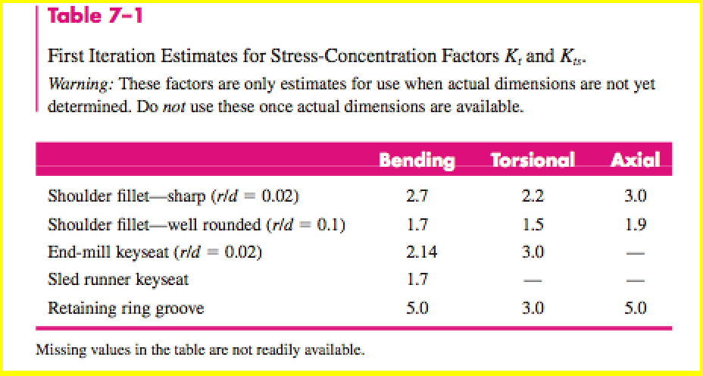
Table 3.2.1 Kt and Kts values

Using the table above, our kt
= 2.7 and kts = 2.2 . Now that we have our kt
and kts
values, we

assume the a notch radius to be 0.1 and used figure 6-20 in page 303 to find our q and qs

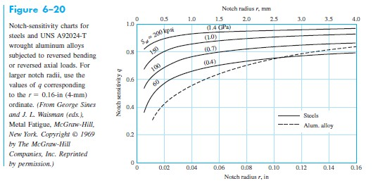
values. Utilizing the figure, the q = 0.85 and qs = 0.9
Figure 3.2.7 Notch sensitivity Using equation (6-32) from page 303

k_{f} = 1 + q (k_{t} − 1) = 1 + 0.85 (2.7 − 1) = 2.4450

k_{fs} = 1 + qs (k_{ts} − 1) = 1 + 0.9 (2.2 − 1) = 2.0800
30
/

Now that all the values have been found, we can use equation (7-8) in page 360 to find the diameter of the shaft utilizing DE-Goodman equation.

d = (16{ 1 [4 (K M )
2
π
S
e
f a
+ 3(KfsT _{a}
2 1 1 [4 (K M
) + 3(K T
2)]1} 1

  - Key Methodology
2
)s]2 + S
ut
f m
fs m
2
)3 = 1.05 in
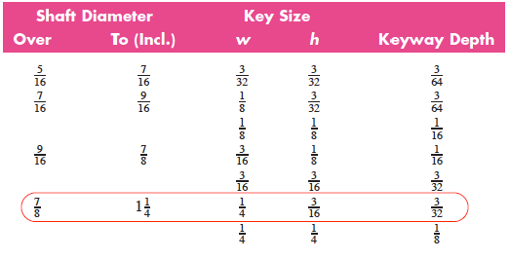
When considering what bearing to select, different parameters have to be considered such as the contact stress that will be occurring on the inner ring, rolling element, and the outer ring along with the overall bearing life and loads. When considering the bearing life common measures are the number of revolutions of the inner ring until fatigue becomes evident and how long the bearing will be at use at its specific speed until fatigue becomes evident. Additionally, the key was chosen from table 7-6 in page 383.
Figure 3.3.1 Key Selection
rating was calculated using equation (11-3) from page 367 and using values given in the dynograph.
All bearings selected for this project were rolling bearings. In addition, the bearing catalog load

C10
= FD( L_{D}n_{D}60 1/a
R R
L n 60 ) Where a = 3,
= 342.01 lbf , LD
= 20, 000, nD
= 2500 rpm ,

C = 342.01( 20,000(2500)60 1/3
FD

10 106
) = 4932 lbf

japark
2020-12-02 11:46:31
--------------------------------------------
How did you find this value? Referring to your V&M diagram, shaft experiences 1580 lb on XY and 3952 lb on XZ plane.
japark
2020-12-02 11:47:06
--------------------------------------------
This is bearing analysis not key.

31
/

    - Key Design
The key specifications were chosen after determining the shaft length and diameter. Using the standard table we were able to pick a proper key size to meet the safety requirements for the shaft. After picking the material, AISI 1095 HR, same material as the shaft we calculated the loads on the key (Torque and Force). Using the standard dimensions of the shaft key size we generated a sketch of the key.

Chapter 4: CAD Models
In this chapter the CAD models the output transmission shaft components are displayed. The components included in the following sections include six forward gears, one reverse gear, the output shaft, driving shaft, keys, and bearings. The models are displayed along with their respective engineering drawings. In addition, the engineering drawings contain all of their critical dimensions.

  - Pinion

FFigure 4.1 is the 3D model of pinion gear. The pinion is attached to shaft 2 by Key 1. The number or teeth selected for the pinion was based on the pressure angle 20° There is also a groove in the bore of the gear, which is the keyway to help connect to the propeller shaft.

32
/

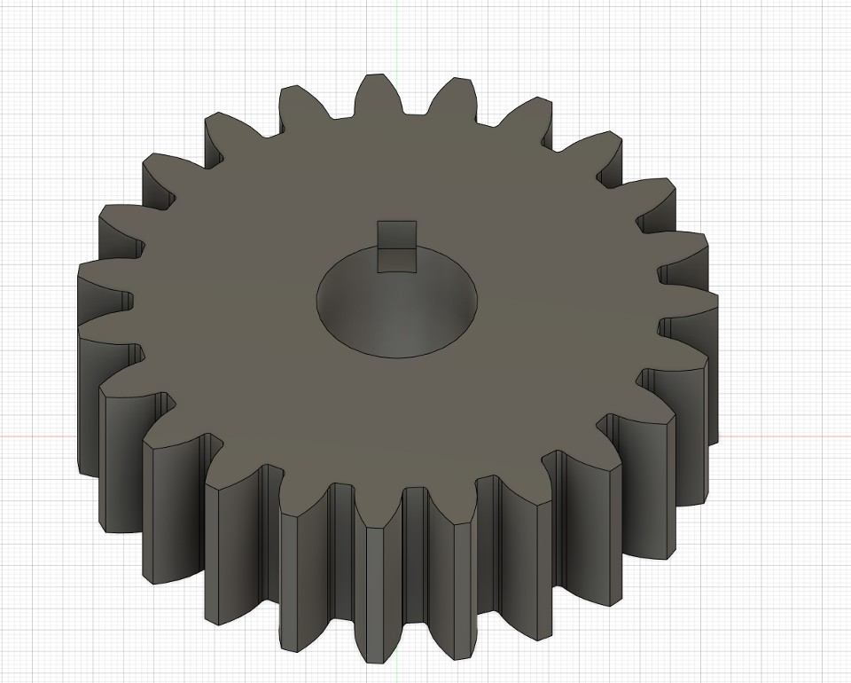
japark
2020-12-02 11:48:14
--------------------------------------------
The engineering drawing should contain all necessary information for anyone to replicate your part. Number of teeth, pressure angle and dimensions of the pitch circle, key, etc. are missing.
Figure 4.1 Pinion Gear 3D Model

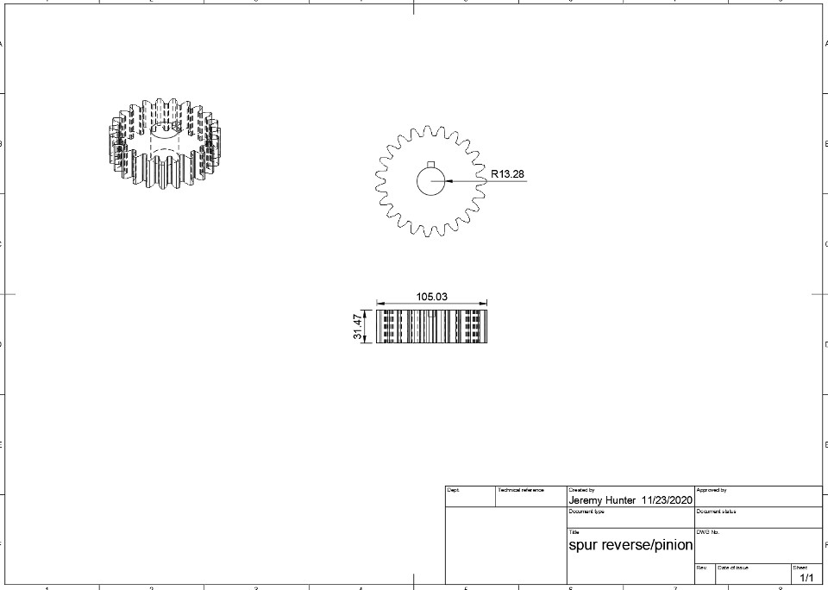
Figure 4.2 is the 2D model drawing of the Pinion Gear. The model was done in Fusion based on the 3D model.
Figure 4.2 Pinion Gear 2D Model
33
/

  - 1st Gear
japark
2020-12-02 11:48:27
--------------------------------------------
The same thing happens here.
Figure 4.2 through 4.14 show the 3D models and their 2D drawings of gear 1 through 6. All of these gears are on the propeller shaft. They are attached by Key 1 to the shaft. The pressure angle of 21.8° was used on all the gears and it is a spur gear. The groove in the bore of the gear helps keyway connect to the propeller shaft.
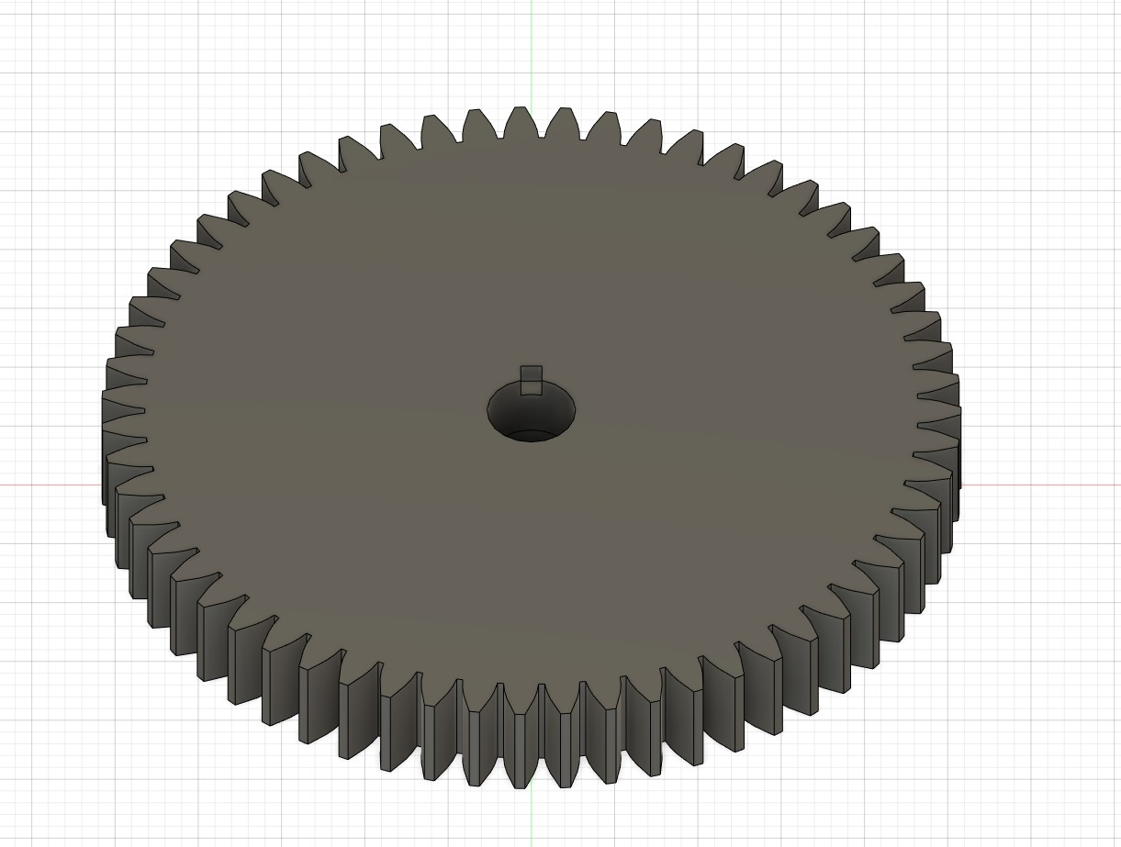
Figure 4.3 First Gear 3D Model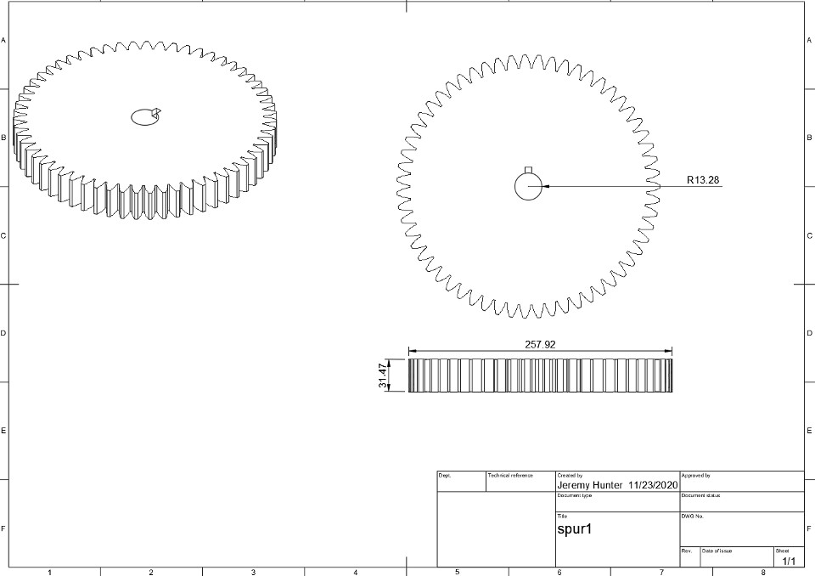
34
/

  - 2nd Gear
Figure 4.4 First Gear 2D Model

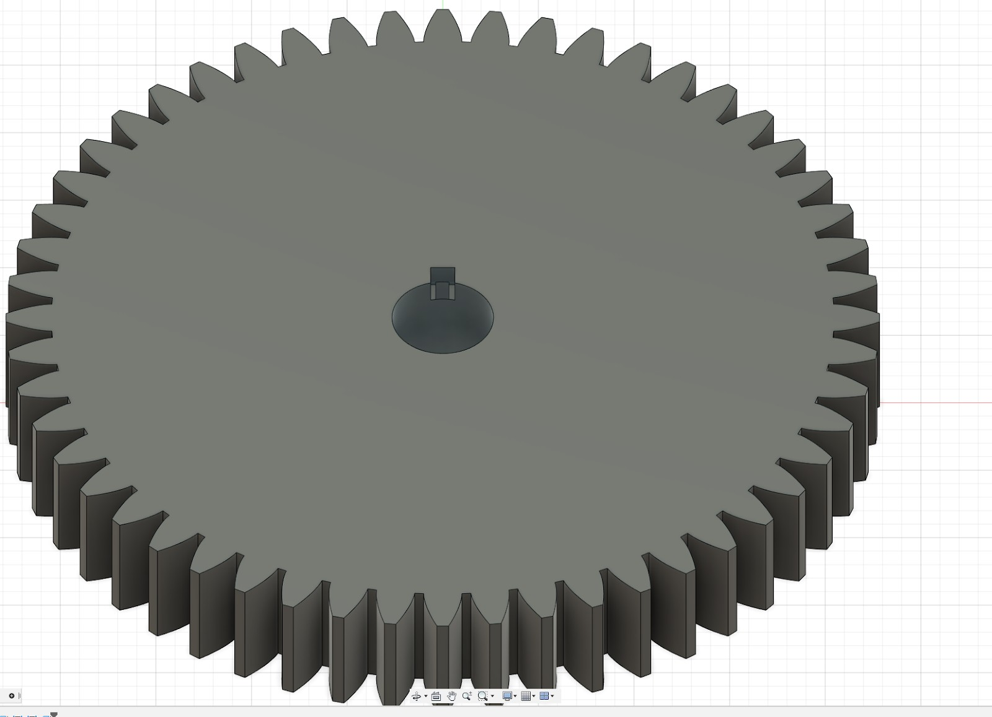
Figure 4.5 Second Gear 3D Model

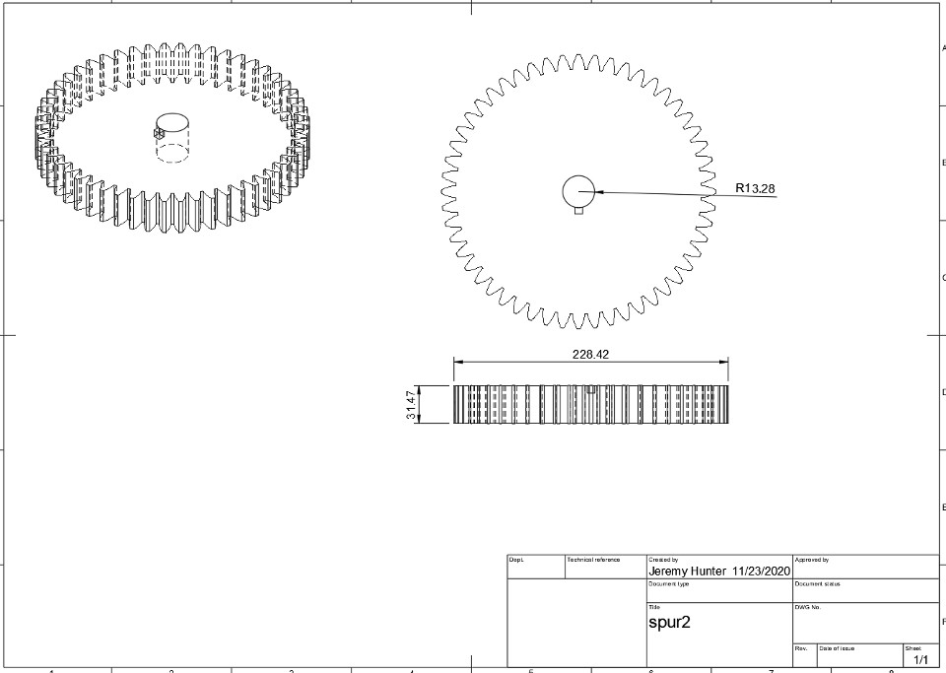
Figure 4.6 Second Gear 2D Model

  - 3rd Gear

35
/

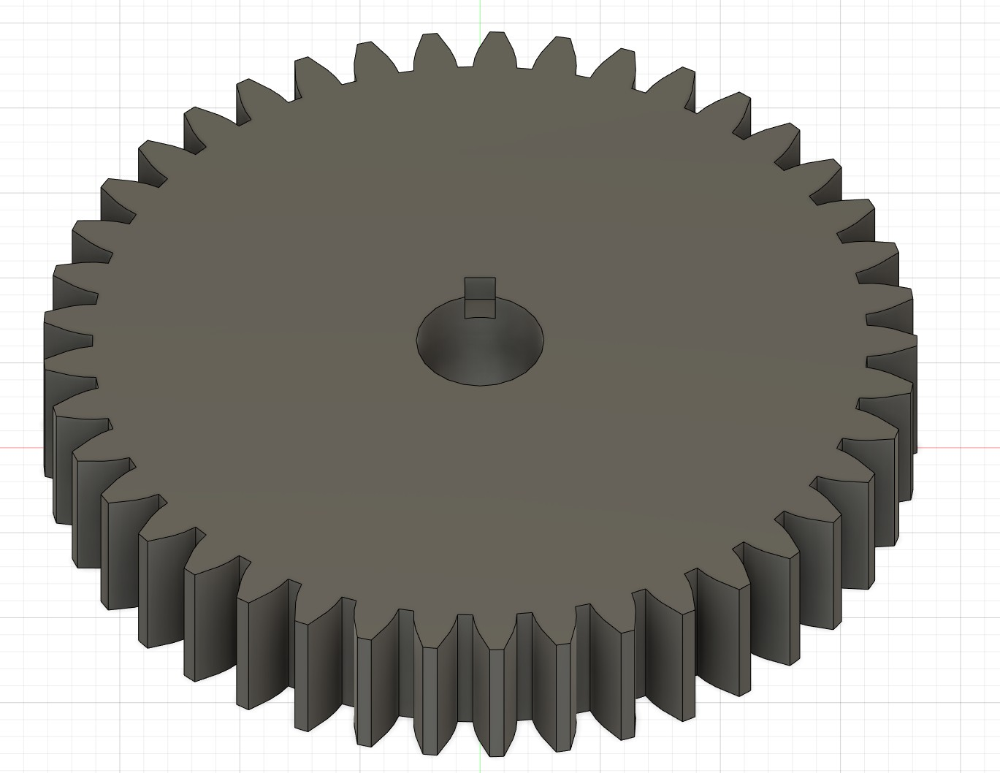
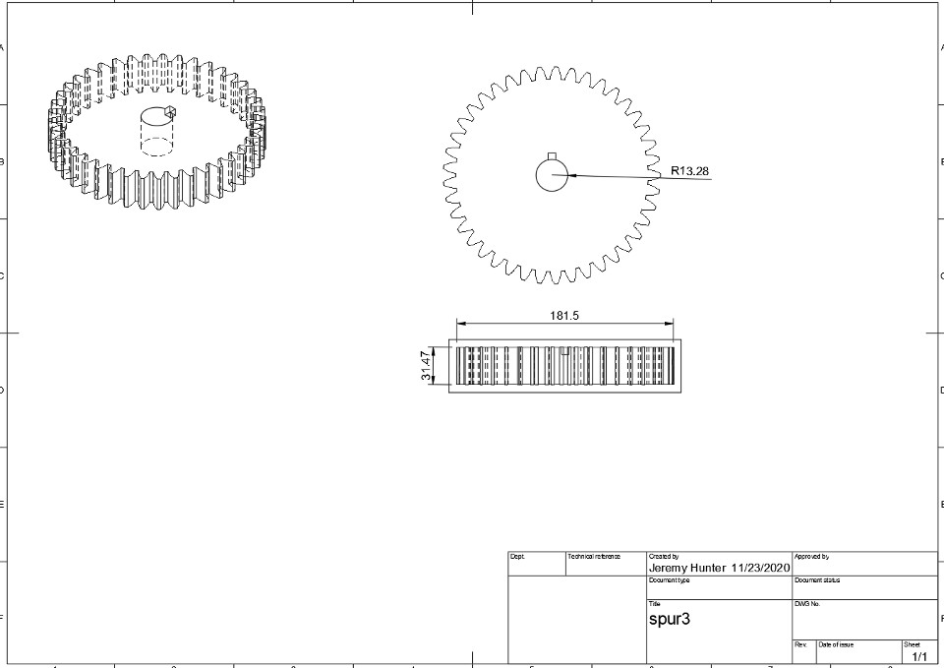
Figure 4.7 Third Gear 3D Model
Figure 4.8 Third Gear 2D Model

  - 4th Gear

36
/

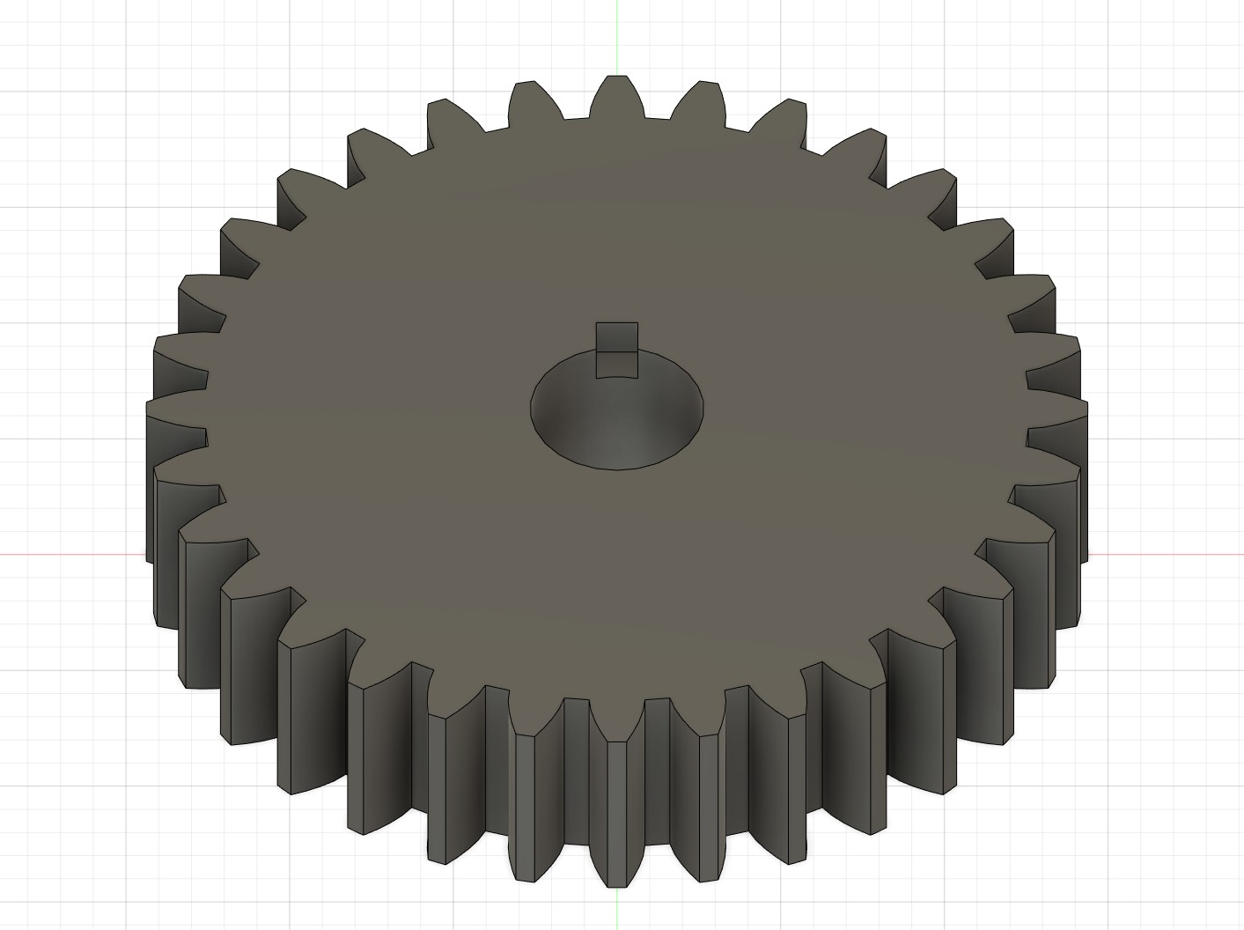
Figure 4.9 Fourth Gear 3D Model

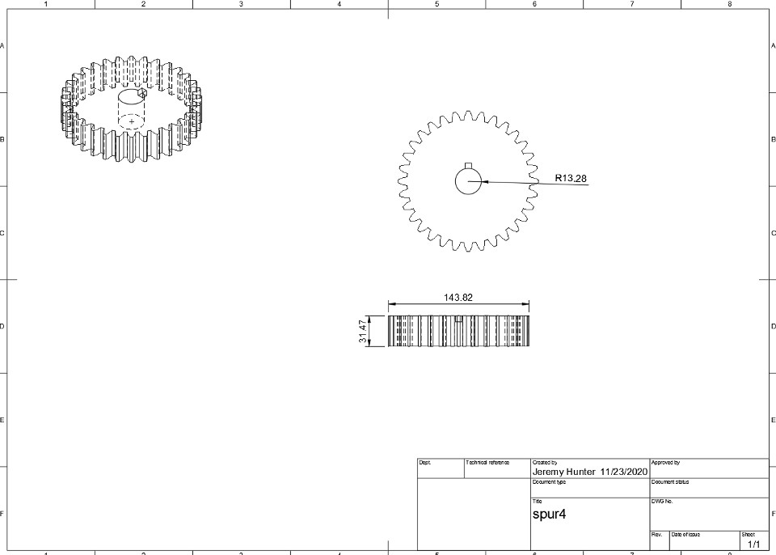
  - 5th Gear
Figure 4.10 Fourth Gear 2D Model

37
/

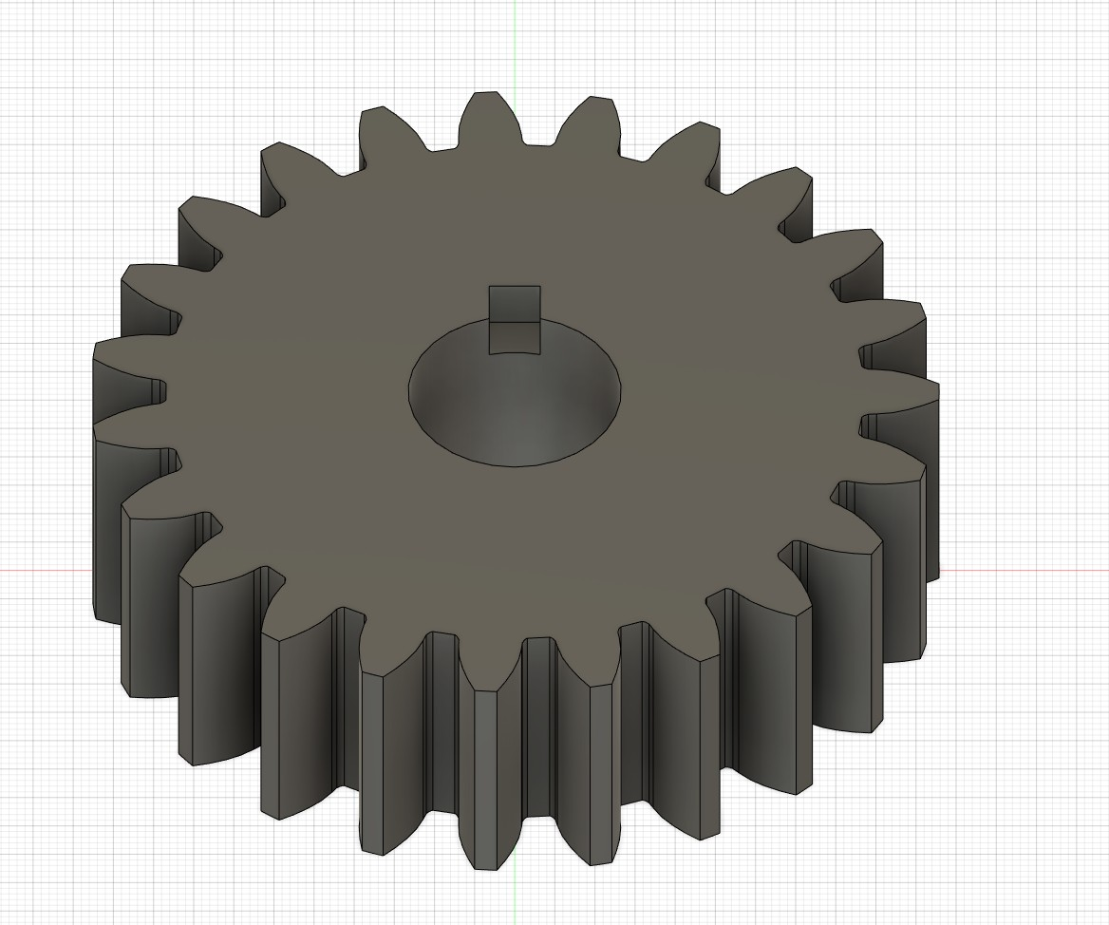
Figure 4.11 Fifth Gear 3D Model

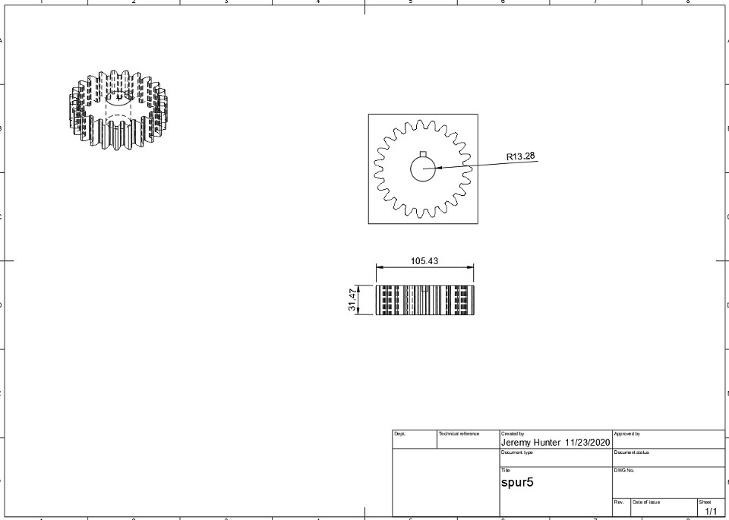
Figure 4.12 Fifth Gear 2D Model

  - 6th Gear

38
/

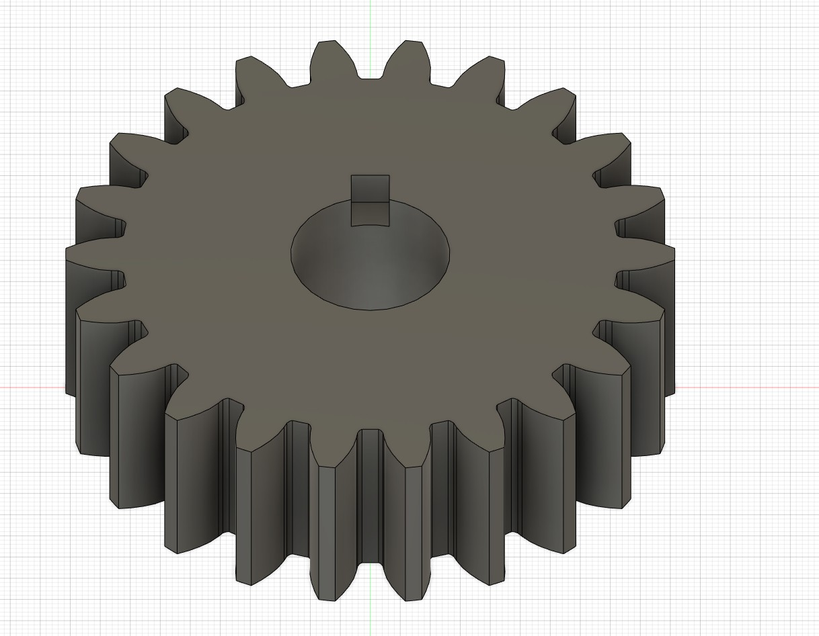
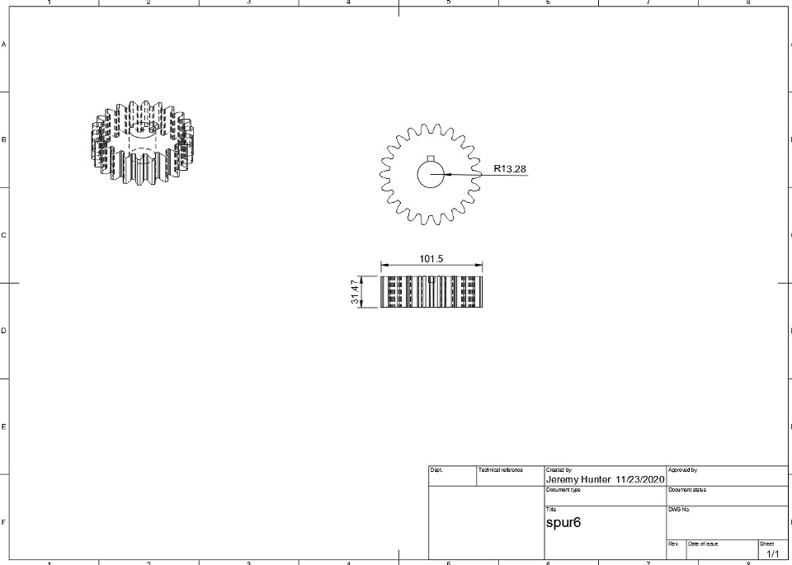
Figure 4.13 Six Gear 3D Model
Figure 4.14 Six Gear 2D Model

  - Reverse Gear

39
/

Figure 4.15 & 4.16 is the 3D model of reverse gear and the 2D drawing model. The reverse gear has the same parameters as the pinion. It does not alter the speed or the torque, but it changes the direction of the wheels by using an extra gear to change shaft rotation. It is not connected to either shaft.

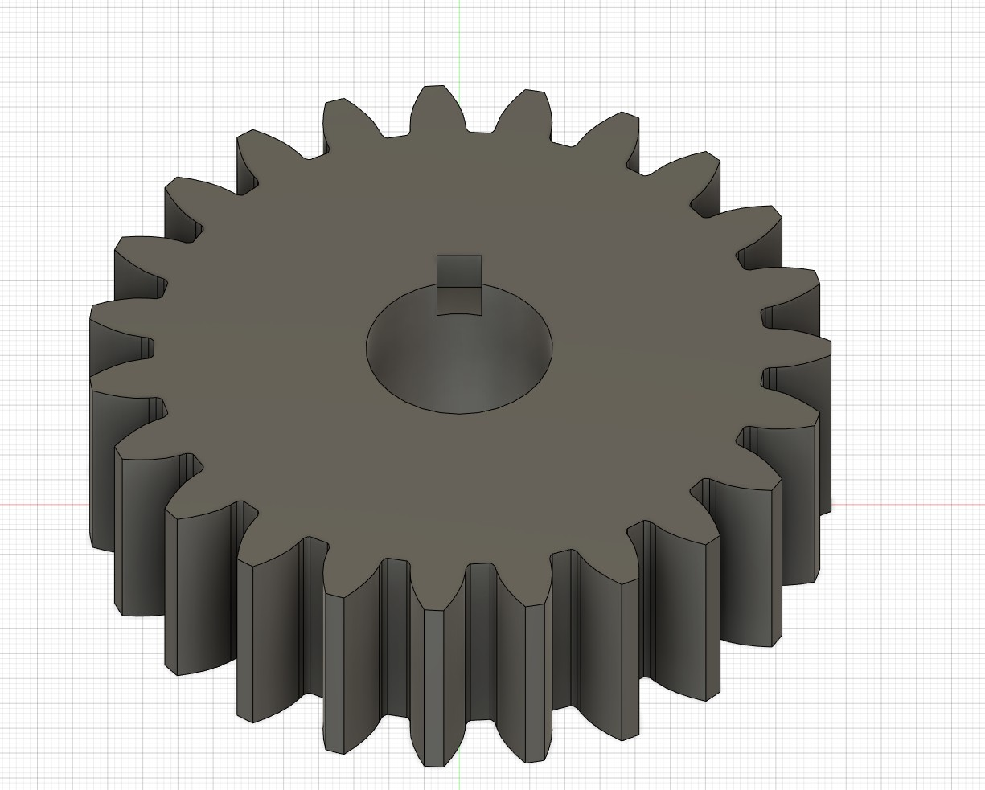
Figure 4.15 Reversed Gear 3D Model
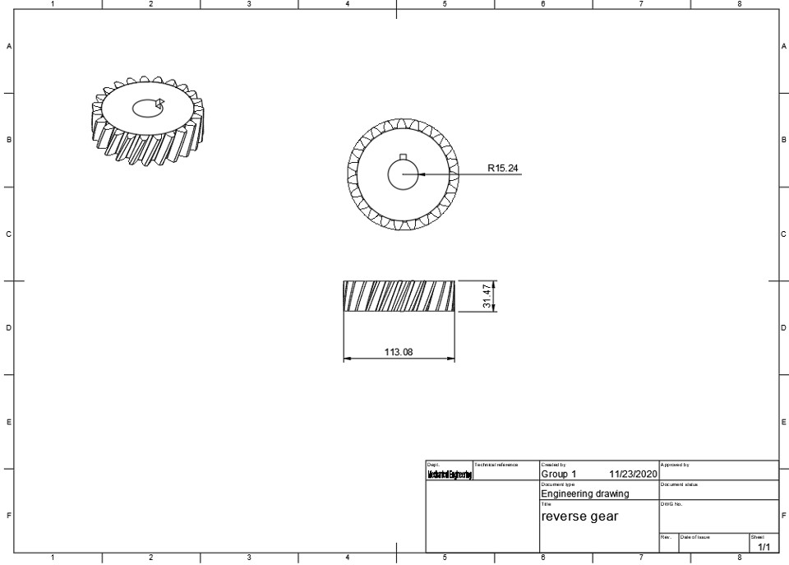
Figure 4.16 Reversed Gear 2D Model
40
/

  - Shaft and its Components (Keys and Bearings)

In this section the propeller and driver shaft 3D and 2D models can be found. The Models were developed in the Fusion 360 software and are displayed in Figures 4.16-4.19.

Propeller Shaft
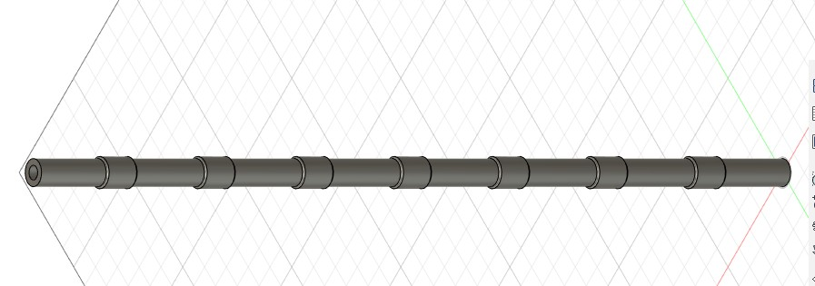
The propeller shaft 3D model is displayed in Figure 4.16. The shaft is 35 in long and has a diameter of 1.05 in. In addition, on Figure 4.17 the 2D model of the propeller shaft is shown along with the mentioned dimensions.
Figure 4.17 Propeller Shaft 3D Model

41
/

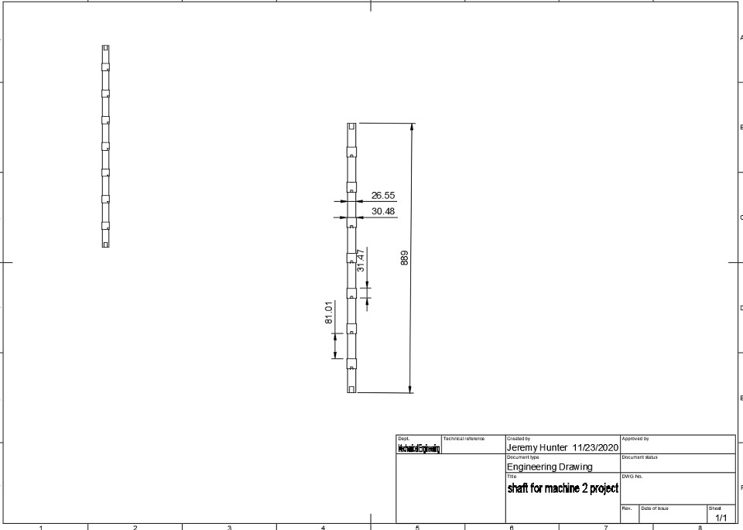
japark
2020-12-02 11:49:36
--------------------------------------------
What is the driver shaft? The description says pinion will be mounted on this, does this mean this is part of crankshaft?
Figure 4.18 Propeller Shaft 2D Model

Driver Shaft

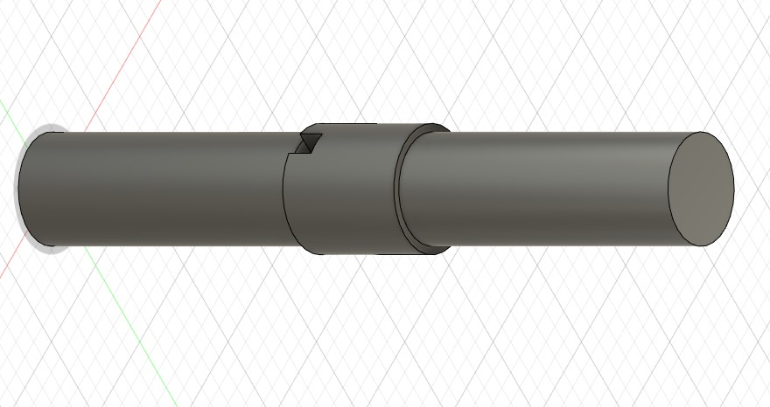
In figure 4.18 the 3D model of the driver shaft can be found. The driver shaft only holds space for 1 pinion who serves as the driving gear for the proposed design. In addition, the 2D model is provided in Figure 4.19.
42
/

Figure 4.19 Driver Shaft 3D Model

Figure 4.20 Driver Shaft 2D Model

Shaft Keys

The shaft keys dimensions selected based on the shaft diameter can be visualized in Figure 4.20 as it contains the 3D model of one of the shaft keys used on the proposed transmission design. In addition, the 2D model of the shaft key can be found in Figure 4.21.

43
/

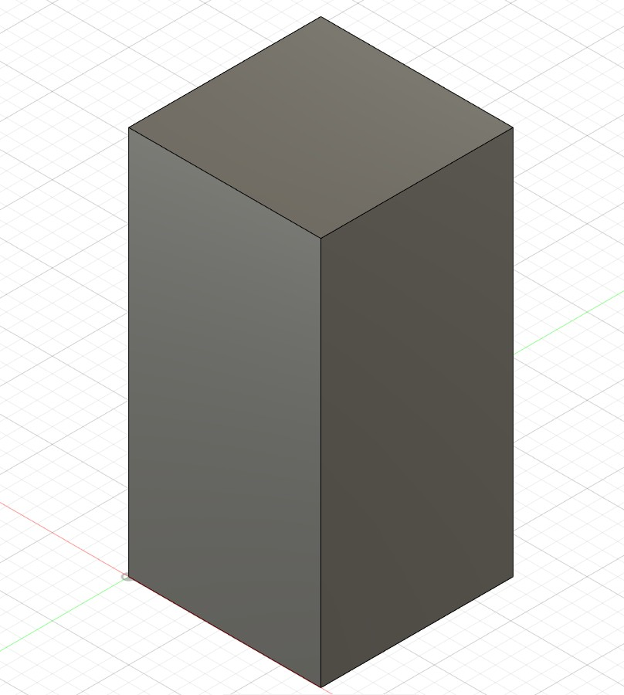
Figure 4.21 Shaft Key 3D Model

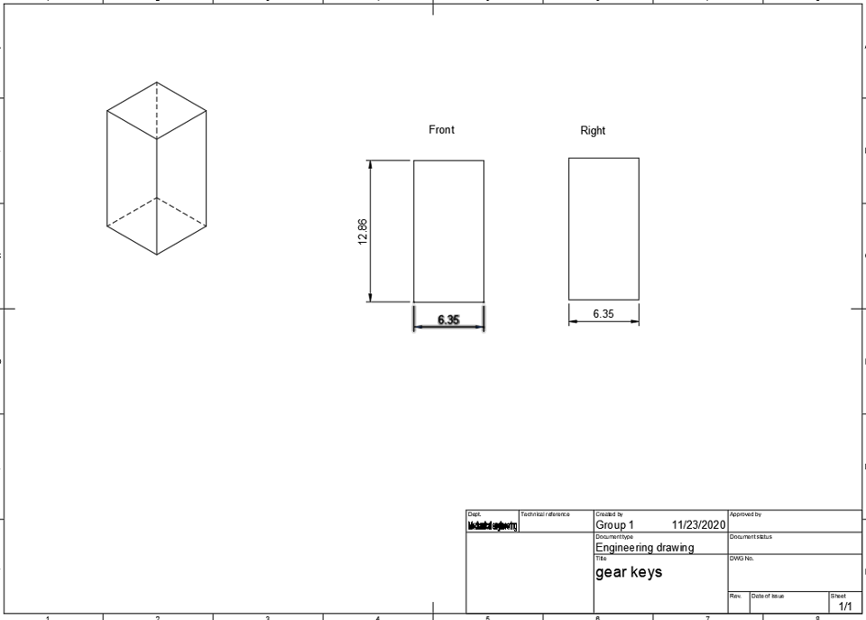
Figure 4.22 Shaft Key 2D Model

Bearing

Figure 4.22 & 4.23 shows the 3D model and 2D drawing of the Radial Ball Bearing which are the most widely used type of rolling element bearing in the world today due to their versatility and

44
/

overall performance. These bearings are produced with high quality materials and exacting tolerances. Figure 4.22 represents the bearings on the propeller shaft.

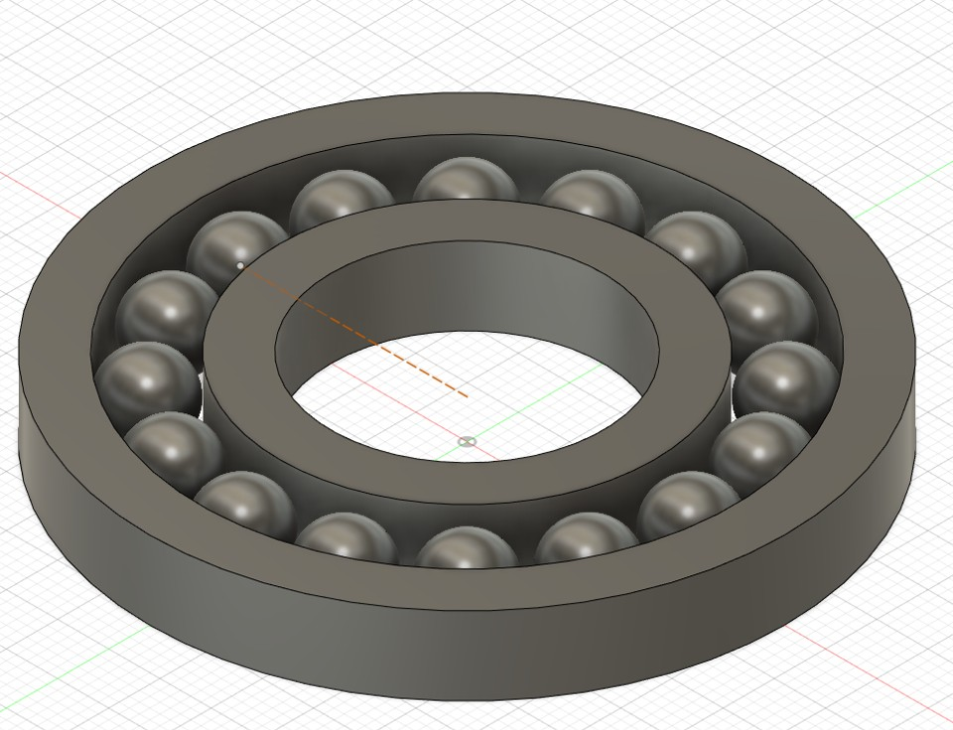
Figure 4.23 Bearing 3D Model

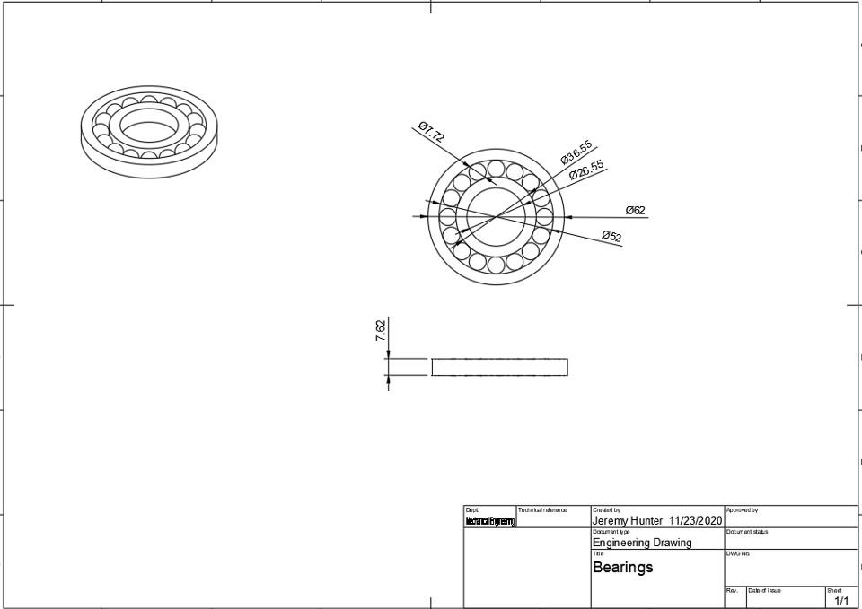
Figure 4.24 Bearing 2D Model

Figures 4.25 and 4.26 display the assembled model of the proposed transmission design. Figure
4.25 contains the 3D model of the combination of all the gears 6 forward, one reversed, and the

45
/

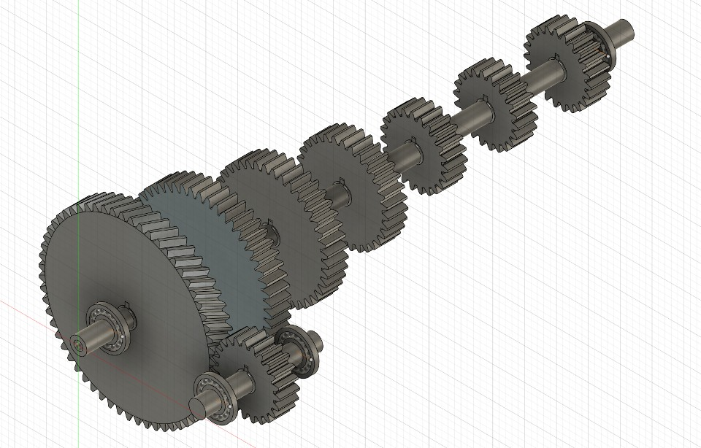
pinion. In addition, figure 4.26 contains the 2D drawing of all the components assembled together along with the general measurements of the system.
japark
2020-12-02 11:50:05
--------------------------------------------
The gears will not be assembled like this but it is ok. Your first gear is helical.
Figure 4.25 Fully Assembled Gears

46
/

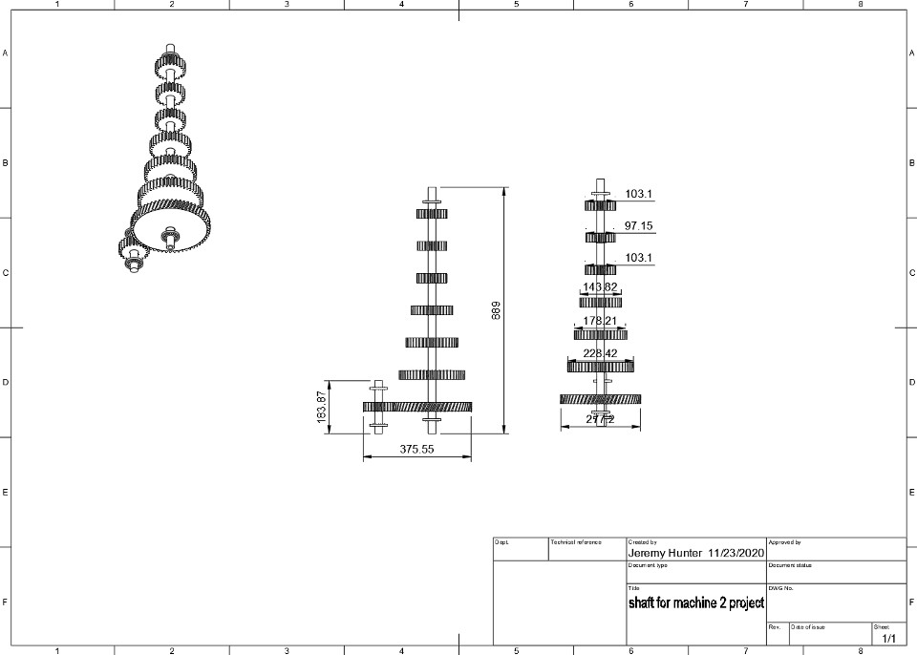
Figure 4.26 Fully assembled 2D model

47
/

Chapter 5: ANSYS Simulation
japark
2020-12-02 11:52:32
--------------------------------------------
Whenever you are showing FEA results, there are things that must go with it. 1) Geometry - it is provided in the previous chapter
2) Boundary conditions - although your description partially describes it, you need to provide a figure that how your model is setup. 3) Material properties
4) Result contours - the color legends should be clearly legible.
Without any one of these, the FEA result does not give the reader any usable information.
Stress analysis of the propeller shaft was done using ANSYS. The shaft is fixed and one end is selected, forces are given at chosen points. The reactant forces act in opposite directions. Torque
acts at two points in opposite directions. The reactant forces and bending moments were initially calculated. Then the maximum shear stress, normal stress were calculated. Those calculated values were then used to create ANSYS model.

  - Propeller Shaft Analysis
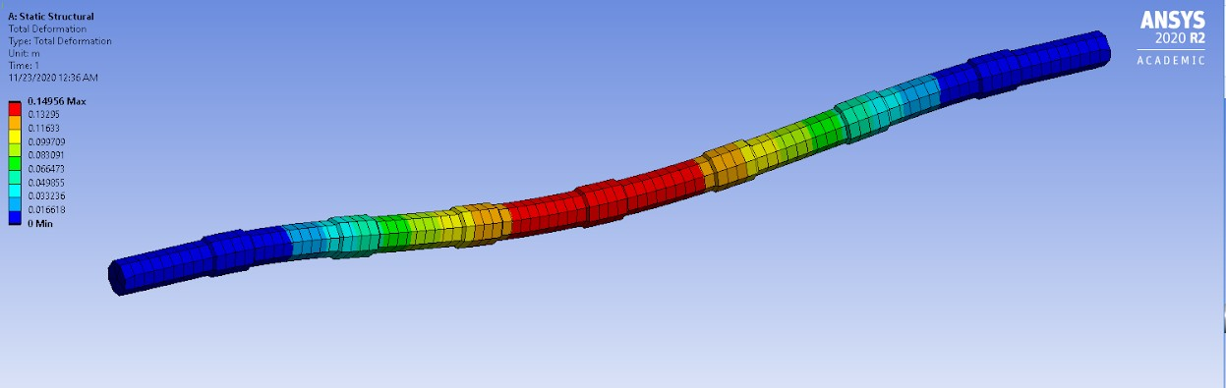
In figure 5.1 the total deformation of the propeller shaft is displayed. As part of the simulation, each gear transmitted load was applied in the same direction. In addition, the ends of the shaft were marked as fixed cylindrical supports and an acceleration was added to the shaft. Moreover, in figure 5.1 the equivalent stress simulation is displayed. Finally, the same process was followed to perform the simulation analysis of the driver shaft. However, the force applied to the pinion was in the opposite direction to the ones on the propeller shaft.
Figure 5.1 Propeller Shaft Total Deformation
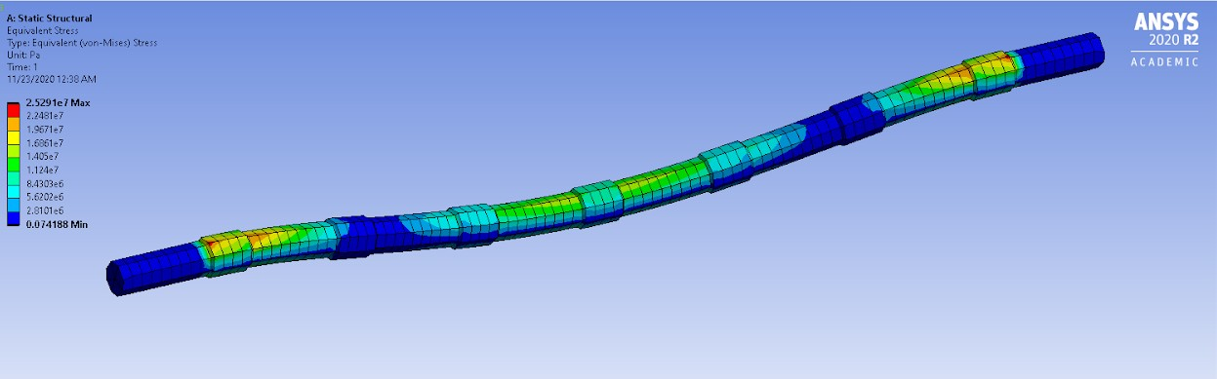
Figure 5.2 Propeller Shaft Equivalent Stress

48
/

  - Driver Shaft Analysis

Figure 5.2 shows the Driver shaft total deformation. It was created in ANSYS using the calculated loads. The red areas represent the highest area of twist due to torque causing extreme stress in the area. That could be due to the pinion being at that location.
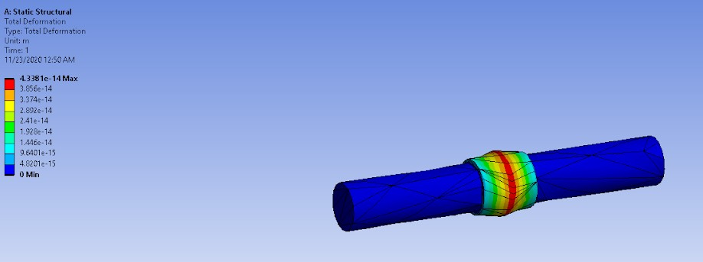
Figure 5.3 Driver Shaft Total Deformation

In Figure 5.4, the equivalent stress across the drive shaft is displayed. This was done in ANSYS by using the calculated bending and shear stress. The figure shows evenly distributed stress and no extreme high points of stress which could lead to material failure.

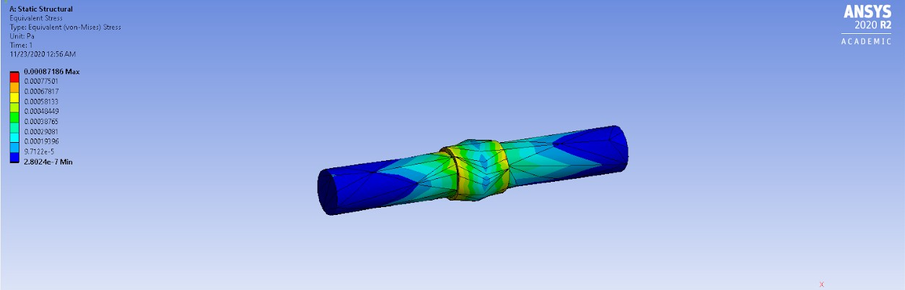
Figure 5.4 Driver Shaft Equivalent Stress

49
/

Chapter 6: Conclusion

In this project, a variety of analysis were carried out in order to achieve an optimal gearbox design for 2018 Honda Accord. The manual calculations were carried out, three different iterations of values were investigated. First, the gear ratios were calculated, which ranged from 0.6384 to 2.661. Using the values for the ratios, the teeth of the pinion was determined using a table. After the pinion teeth were found the calculations for the rest of the gears were done by using equations from the book. A variety of parameters were found like diameter, face width, etc.. After the manual calculations were completed, the code was created in MATLAB. The code enabled a more flexible and reliable analysis during the design process, the numbers were easy to change and outputted more precise results. The gearbox design was then constructed in Fusion
360. All the gears and shafts were constructed by hand. Then a simulation was run in ANSYS for the shafts using the calculated loads.
Furthermore, the results of this project match the standard Honda Accord parameters. For starters, the values of the gear ratio range from 0.566 to 2.652 which is extremely close to what was calculated. In addition, in order to find the length of the shaft, Honda was called and asked to provide an accurate shaft length for their vehicle which was 35 in. Using data provided in the problem statement and data gathered from honda, the group was able to accurately calculate the required values and demonstrate that our calculations are not far off from real world tests.
Throughout this project, the group encountered multiple problems. For starters, the shaft analysis had multiple iterations and fixes due to it not being correctly done. EES allowed us to minimize the effect of having to hand calculate everything, however it was still a shore. Additionally multiple iterations had to be done when choosing a material that would fit our standards to ensure that the values gathered were accurate resulting in the group having to backtrack.
Overall, the group obtained valuable learning experience when tasked with completing this project. Reinforcing what we learned in class, this project allowed the students to be able to apply their knowledge to a potential real world scenario. Additionally, it demonstrated that we won’t always get the right answer in our first run and sometimes multiple if not dozen attempts must be made.

5.2 Recommendations
In order to design an effective transmission gear box, students have to make sure to have a good understanding of the gear and shaft nomenclature. In addition, the student should develop skills in CAD drawing, ANSYS analysis, and MATLAB code before working on a project of this nature. Finally, several iterations need to be made to be able to select the best transmission design.

50
/

References
Budynas, R. G., Nisbett, J. K., & Shigley, J. E. (2015). Shigley’s mechanical engineering design.
New York, NY: McGraw-Hill Education.
SkyCiv. (n.d.). Free Online Beam Calculator for Cantilever or Simply Supported Beams.
Retrieved November 25, 2019, from https://skyciv.com/free-beam-calculator/.

51
/

Appendix
MATLAB Code for Lowest Gear Calculations :
MATLAB Code Input "friction coefficient" u=.5
"incline 40% tan-1(.40)" oo=21.801
"tire diameter" td=25.9
"weight" w=3300
"friction force" Ff=u*(w*.928) "Force in x" Fx=Ff+(w*.3714)
"tire radius" Tr=25.9/2
"Torque" T=(Tr)*(Fx)
"applied torque into feet"
Ta=T/12
"Final drive" fd=3.55
"shaft transmission"
St=Ta/fd
"graph torque at 2500 RPM" gt=315
"Lowest gear ratio" LGR=St/gt
52
/

Machine2projectpt2 MATLAB Code Output ans =
"friction coefficient" u =
0.5000
ans =
"incline 40% tan-1(.40)" oo =
21.8010
ans =
"tire diameter" td =
25.9000
ans = "weight" w = 3300
ans =
"friction force" Ff =
1532
ans = "Force in x" Fx = 2.755e+03
ans =
"tire radius" Tr =

53
/

12.9500
ans = "Torque" T =
2.7575e+04
ans =
"applied torque into feet" Ta =
2.9756e+03
ans =
"Final drive" fd =
3.5500
ans =
"shaft transmission" St =
831.8613
ans =
"graph torque at 2500 RPM" gt =
315
ans =
"Lowest gear ratio" LGR =
2.6515
Hand Calculation: 2.661
MATLAB Solution: 2.6515

MATLAB Code for Highest Gear calculations:
54
/

MATLAB Input
"Diameter in Inches"
D = 25.9
"Rotational Speed in RPM"
Nin = 2500
"Expected Speed MPH"
Vx = 85
"Pi = 3.14"
Pi = 3.14
"Distanced moved in 1 revolution in Inches"
Dis = Pi*D "MPH to in/in"
"Miles/hour->feet/miles->inches/feet->hour/min" "Mile in feet"
M=5280
"Feet in inches" f= 12
"Hour in minutes" h= 60
"Distance traveled per minute at 85 MPH in inches per minute" dm=((Vx)*(M)*(f))/h
"Tire RPM" Trpm=dm/Dis "Final Drive Ratio" fd= 3.55
"RPM of transmission"
T=Trpm*fd
"Highest gear ratio is GR" GR= Nin/T
55
/

MATLAB Output
> Machine2projectpt1 ans =
"Diameter in Inches" D =
25.9000
ans =
"Rotational Speed in RPM" Nin =
2500
ans =
"Expected Speed MPH" Vx =
85
ans =
"Pi = 3.14"
Pi = 3.1400
ans =
"Distanced moved in 1 revolution in Inches" Dis =
81.3260
ans =
"MPH to in/in" ans =
"Miles/hour->feet/miles->inches/feet->hour/min"
ans =
"Mile in feet" M =
56
/

5280
ans =
"Feet in inches" f =
12
ans =
"Hour in minutes" h =
60
ans =
"Distance traveled per minute at 85 MPH in inches per minute" dm =
89760
ans =
"Tire RPM" Trpm = 1.1037e+03
ans =
"Final Drive Ratio" fd =
3.5500
ans =
"RPM of transmission" T =
3.9182e+03
ans =
"Highest gear ratio is GR" GR =
0.6381
57
/

>> Machine2projectpt1 ans =
"Diameter in Inches" D =
25.9000
ans =
"Rotational Speed in RPM" Nin =
2500
ans =
"Expected Speed MPH" Vx =
85
ans =
"Pi = 3.14"
Pi = 3.1400
ans =
"Distanced moved in 1 revolution in Inches" Dis =
81.3260
ans =
"MPH to in/in" ans =
"Miles/hour->feet/miles->inches/feet->hour/min" ans =
"Mile in feet" M =
5280
58
/

ans =
"Feet in inches" f =
12
ans =
"Hour in minutes" h =
60
ans =
"Distance traveled per minute at 85 MPH in inches per minute" dm =
89760
ans =
"Tire RPM" Trpm = 1.1037e+03
ans =
"Final Drive Ratio" fd =
3.5500
ans =
"RPM of transmission" T =
3.9182e+03
ans =
"Highest gear ratio is GR" GR =
0.6381
Hand Calculation: 0.6384
59
/

MATLAB Calculation: 0.6381

MATLAB Code for Gear Analysis
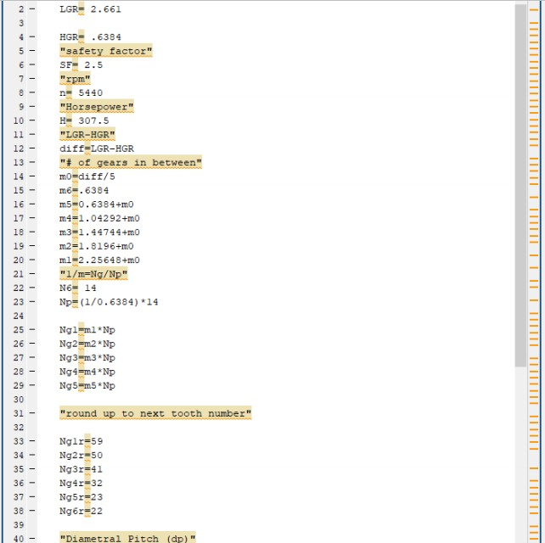

60
/

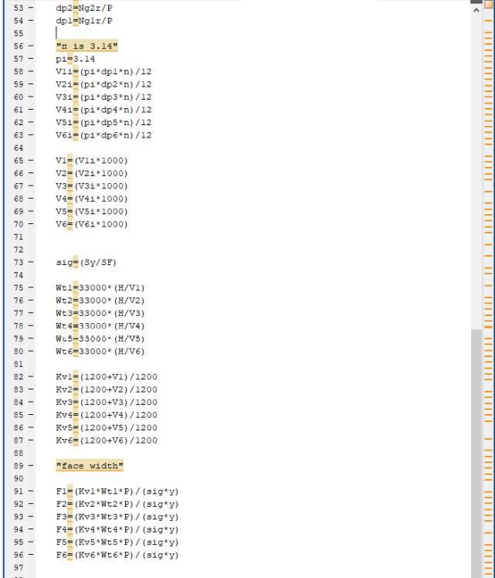

61
/

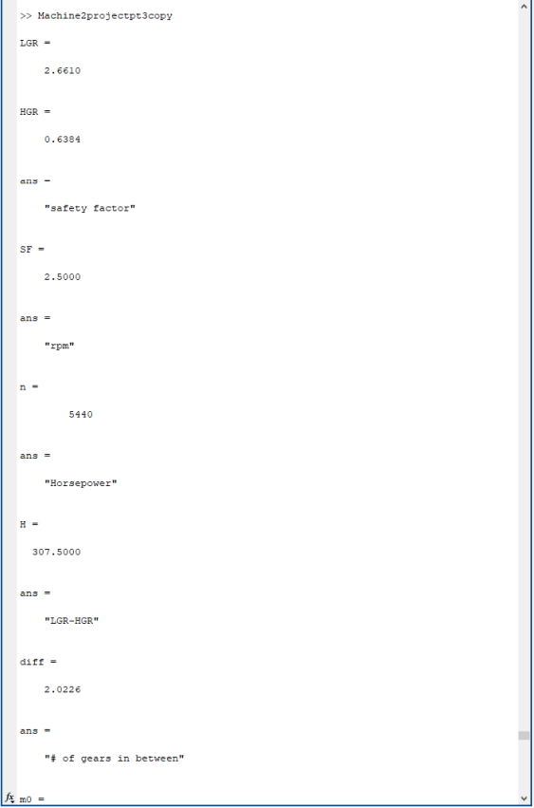

62
/

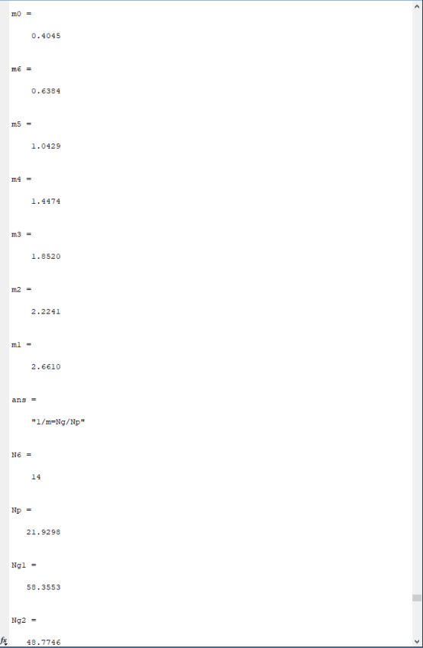

63
/

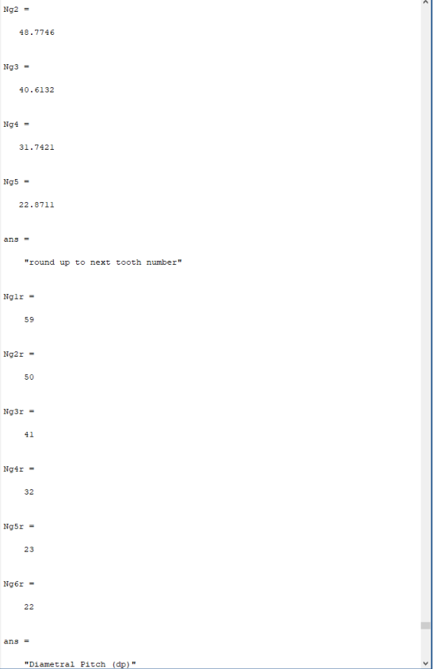

64
/

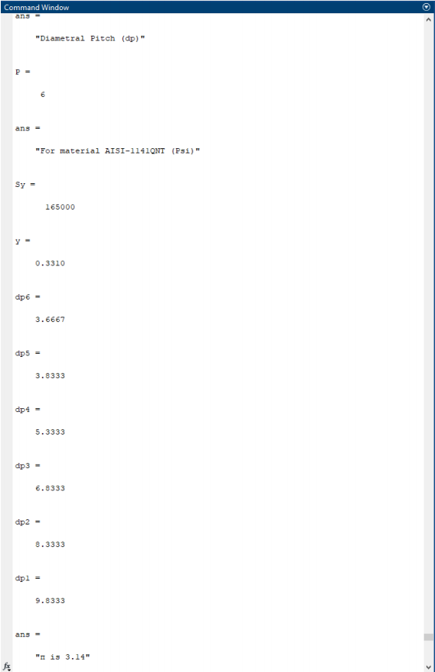
65
/

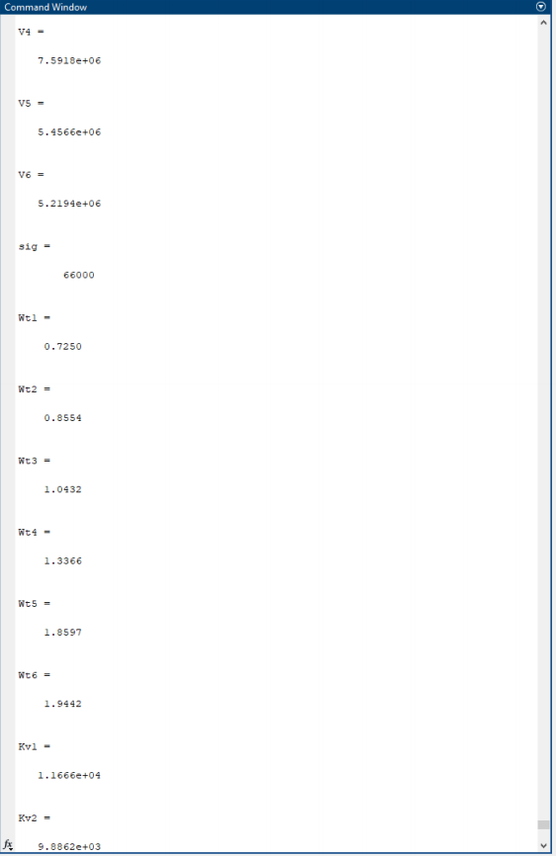
66
/

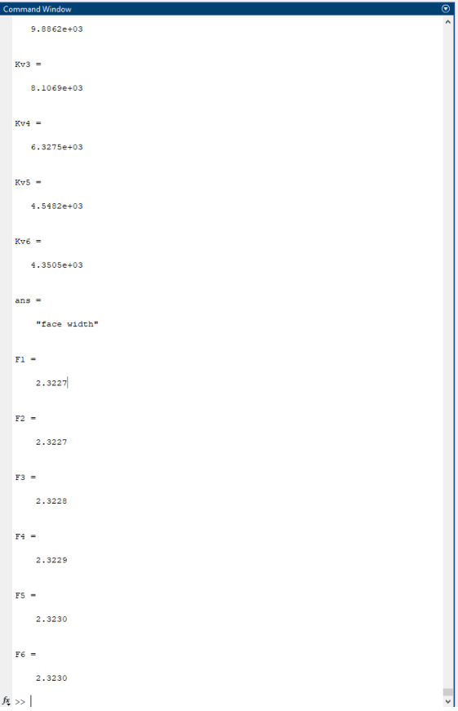
67
/

MATLAB Code for Shaft Design
"Material Description AISI 1095 HR Steel" "Sut=120 Sy=66"
dp=3.6 n=5440 hp=307.05
"diameter assumptions in inches" D=2.95
L=35 SF=2.5 pi=3.14
Vf=(pi*dp*n)/12 Wt=(33000*hp)/Vf "p=tan21.8=.3999" Fr=Wt*.3999
"magnitude" Fm=((Wt^2)+(Fr^2))^(1/2)
"torque (T1=Tm)" P=8
NG1=59 D1=NG1/8 T1=Wt*(D1/2)
"Moments" "XY Plane" Fy=(Fr*L)/(L/2) Mb1=Fr*(L/2) "XZ Plane" Ma1=0
Ma2=(Wt*L)/(L/2)

68
/

Mb2=(Wt*L)/2 Mc1=0
Mc2=0
"Resultant moment MB=Ma Because critical location is B" MA=((Ma1^2)+(Ma2^2))^(1/2)
MB=((Mb1^2)+(Mb2^2))^(1/2)
MC=((Mc1^2)+(Mc2^2))^(1/2)
"Calculations for Endurance Limit" Sut=120
Sy=66
SEp=0.5*Sut a=11
b=-0.650
Ka=a*(Sut^b) Kb=.85
Kc=1 Kd=1 Ke=1
Se=Ka*Kb*Kc*Kd*Ke*SEp "Kf and Kfs"
r=D1/2
"Notch radius assumption"
Nr=.1
"Figure 6-20/6-21" q=0.85
qs=0.9
"Table 7.1"
Kt=2.7 Kts=2.2 Kf=1+(q*(Kt-1))
Kfs=1+(qs*(Kts-1))
69
/

"Because shaft has constant rotation" Mm=0
Ta=0 Ma=MB Tm=T1
"Diameter of shaft" AA=((4*(Kf*Ma)^2)+(3*(Kfs*Ta)^2))^(1/2)
BB=((4*(Kf*Mm)^2)+(3*(Kfs*Tm)^2))^(1/2)
N=((pi*(D1^3))/16)*((AA/Se)+(BB/Sut))^-1
Ds=(((16*N)/pi))*((AA/Se)+(BB/Sut))^(1/3) "Bearing Life hrs"
Ld=20000 nd=2500 Fd=342.01
C10= Fd*(((Ld*nd*60)/10^6)^(1/3)) >> Shaftmachinedesign ans =
"Material Description AISI 1095 HR Steel" ans =
"Sut=120 Sy=66" dp = 3.6000
n = 5440
hp = 307.0500
ans =
"diameter assumptions in inches" D = 2.9500
L = 35
SF = 1.5000
pi = 3.1400
Vf = 5.1245e+03
70
/

Wt = 1.9773e+03
ans = "p=tan21.8=.3999"
Fr = 790.7235
ans = "magnitude"
Fm = 2.1295e+03
ans =
"torque (T1=Tm)" P = 8
NG1 = 59
D1 = 7.3750
T1 = 7.2913e+03
ans = "Moments" ans =
"XY Plane"
Fy = 1.5814e+03 Mb1 = 1.3838e+04
ans =
"XZ Plane" Ma1 = 0
Ma2 = 3.9546e+03 Mb2 = 3.4603e+04 Mc1 = 0
Mc2 = 0
ans =
"Resultant moment MB=Ma Because critical location is B" MA = 3.9546e+03 71
/

MB = 3.7267e+04 MC = 0
ans =
"Calculations for Endurance Limit" Sut = 120
Sy = 66
SEp = 60
a = 11
b = -0.6500
Ka = 0.4897
Kb = 0.8500
Kc = 1
Kd = 1
Ke = 1
Se = 24.9744
ans =
"Kf and Kfs" r = 3.6875
ans =
"Notch radius assumption"
Nr = 0.1000
ans =
"Figure 6-20/6-21" q = 0.8500
qs = 0.9000
ans = "Table 7.1"
Kt = 2.7000
Kts = 2.2000
72
/

Kf = 2.4450
Kfs = 2.0800
ans =
"Because shaft has constant rotation" Mm = 0
Ta = 0
Ma = 3.7267e+04 Tm = 7.2913e+03
ans =
"Diameter of shaft" AA = 1.8224e+05 BB = 2.6268e+04 N = 0.0105
Ds = 1.0454
ans =
"Bearing Life hrs"
Ld = 20000
nd = 2500
Fd = 342.0100 C10 = 4.9326e+03 73
/

