ROY G. PERRY COLLEGE OF ENGINEERING
MECHANICAL ENGINEERING DEPARTMENT
PRAIRIE VIEW A&M UNIVERSITY

ASSESSMENT REPORT COVER PAGE

MCEG 4043 MACHINE DESIGN II

FALL 2020 SEMESTER

NAME OF INSTRUCTOR: Dr. Jaejong Park

TABLE OF CONTENTS

- Report Cover Page

- Detailed Course Syllabus

- End of Semester Outcomes Assessment Report (New Format)

- Grade Sheet Showing Student and Class Performance in Outcomes

- Supporting Outcomes Specific Assignments (Minimum of 2 per outcome except for Project Reports where one is enough)

Assessing students’ ability to apply engineering design to produce solutions that meet specified needs with consideration of public health, safety, and welfare, as well as global cultural, social, environmental, and economic factor (outcome - 2).

Sample Assignment: Gear and driveshaft design for automotive powertrain system
(Project)

Detailed Course Syllabus
(Distributed to Students at the beginning of the Semester)

 |  | SYLLABUS
MCEG4043 Machine Design II
Fall 2020
General Course Information

Information Item | Information
Instructor: | Jaejong Park, Ph.D.
Section # and CRN: | Section Y01, 16341
Office Location: | S. R. Collins Building, Room 324
Office Phone: | 936-261-9967
Email Address: | japark@pvamu.edu
Office Hours: | Tu and Th, 1:00 PM ~3:00 PM or by appointment
Mode of Instruction: | Hybrid
Course Location: | Online sessions: Zoom, Offline sessions: New Electrical Engr Bldg 213
Class Days & Times: | TR: 10:00 AM ~ 11:50 AM
Catalog Description: | This is a design course featuring a design project using strength of materials, kinematics of machines, machine element design (e.g. gears and shafts), and CAD.
Prerequisites: | MCEG 3043 and MCEG 3053 (may be taken concurrently)
Co-requisites: | None
Required Text(s): | Budynas, R. G. and Nisbett, J. K., Shigley’s Mechanical Engineering Design, 11th edition, McGraw-Hill Book Company, ISBN 978-0073398211
Recommended Text(s): | None
General Course Information Table
Please be advised that this is a hybrid class and there may be a face to face sessions.
Dates for f2f sessions will be notified at least a week ahead. However, your attendance is NOT mandatory.

Course Goals and Overview:
This course is designed to introduce students in mechanical engineering to the contemporary mechanical design methodology as applied to machine elements and to the process of mechanical design. The student will design mechanical elements using concepts developed in design of machine elements, engineering graphics and other related courses. This class will specifically focus on gears, shafts, clutches, brakes and other flexible mechanical elements.

Student Learning Outcomes:
Upon successful completion of this course, students will be able to: |  |  | Program Learning Outcome Alignment | Core Curriculum Outcome Alignment
- Develop the skills for mechanical element design |  |  | 2.1 | 2.1
- Be able to analyze mechanical engineering elements |  |  | 2.1 | 2.1
- Have the knowledge of various machine elements |  |  | 2.2 | 2.2
- Be able to complete a mechanical design project |  |  | 2.3 | 2.3
Student Learning Outcomes Table
Major Course Requirements
Students are required to have proper equipment (e.g. Laptops, Desktop computers, Smartphones, etc) to complete the course requirement. If the student needs an equipment, please contact the financial aid.

Method of Determining Final Course Grade
This course will utilize the following instrument to determine student grades and proficiency of the learning outcomes for the course.
- Exams: written test designed to measure knowledge of presented course material
- Quizzes: written quizzes designed to measure knowledge of presented course material
- Homework: written assignments designed to supplement and reinforce course material
- Project: design project to measure ability to apply presented course material
 | Course Grade Requirement |  | Value | Total
 | 1. Homework |  | 10% | 10
 | 2. Project |  | 30% | 30
 | 3. Quiz |  | 10% | 10
 | 4. Exam 1 |  | 20% | 20
 | 6. Final Exam |  | 30% | 30
 | Total: |  | 100% | 100
Course Grade Requirement Table

The instructor has rights to modify the contents in this syllabus throughout the semester.
Students will get notified anytime a major change is made.

Grading Criteria and Conversion:
A = 90 – 100%
B = 80 – 89%
C = 70 – 79%
D = 60 – 69%
F = 0 – 59%
Detailed Description of Major Assignments:
Assignment Title or Grade Requirement |  | Description
- Homework |  | written assignments designed to supplement and reinforce course material
- Project |  | design project to measure ability to apply presented course material
- Quiz |  | written quizzes designed to measure knowledge of presented course material
- Exams |  | written test designed to measure knowledge of presented course material
Detailed Description of Major Assignments Table

Course Procedures or Additional Instructor Policies
Assignments & Due Dates
The students are expected to follow the submission guidelines for each assignment. The submission platform may be different for the course assignments. Same day late submission will be deducted by 10%. Homework will not be accepted after the day it is due. Exceptions will only be made under extreme circumstances and at the discretion of the instructor. Assigned homework will be graded either for completeness and 1~2 problems per set will be graded for correctness. Students are encouraged to work together on the assignments; however, all students must submit an assignment that consist of their own work for any individual assignment.
Taskstream
Taskstream is a tool that Prairie View A&M University uses for assessment purposes. One of your assignments may be required to be submitted as an "artifact,” an item of coursework that serves as evidence that course objectives are met. If applicable, more information will be provided during the semester by your department, but for general information, you can visit Taskstream via the link in eCourses.
Semester Calendar
Dates for f2f sessions will be notified at least a week ahead. However, your attendance is NOT mandatory.
Week | Topics | Chapter
1~3 | Course Introduction, Mechanics of Materials review, and  Gears – General (Ch. 13)  Gear types, nomenclature, gear fundamentals, gear trains, force analysis | 13
1~3 | Assignments: Homework 1, Quiz 1 | 13
4~5 | Spur and Helical Gears  Lewis bending, AGMA equations and relative factors  Group Project Introduction | 14
4~5 | Assignments: Homework 2, Quiz 2 | 14
6-7 | Failure Resulting from Variable Loading  Fatigue, fatigue failure analysis, endurance limit, fatigue strength, Marin factors | 6
6-7 | Assignments: Homework 3, Quiz 3 | 6
8 | Midterm review and Exam 1
9 | Shaft and Shaft Components  Shaft materials, layout, design for stress, deflection considerations | 7
10 | Bearings  Rolling contact bearings, Journal bearings and their lubrication | 11,12
10 | Assignments: Homework 4, Quiz 4 | 11,12
11-12 | Clutches, Brakes, Couplings, and Flywheels  Static analysis, Internal expanding & external contracting, band type, disk brakes | 16
 | Assignments: Homework 4, Quiz 5
13 | Flexible Mechanical Elements  Belts, chains, ropes, drives | 17
14 | Project Presentations
15 | Course Review and Final Exam (Date & Time: TBD)
Student Support and Success

John B. Coleman Library
The library and its partners have as their mission to provide resources and instructional material in support of the evolving curriculum, as a partner in Prairie View A&M University's mission of teaching, research, and service and to support the University's core values of access and quality, diversity, leadership, relevance, and social responsibility through emphasis on ten key areas of service. It maintains library collections and access both on campus, online, and through local agreements to further the educational goals of students and faculty. Phone: 936-261-1500; Website: J. B. Coleman Library.

Academic Advising Services
Academic Advising Services offers students a variety of services that contributes to student success and leads towards graduation. We assist students with understanding university policies and procedures that affect academic progress. We support the early alert program to help students get connected to success early in the semester. We help refer students to the appropriate academic support services when the student is unsure of the best resource for their needs. Some students are supported by faculty advisors in their respective colleges. Your faculty advisor can be identified in PantherTracks. Advisors with Academic Advising Services are available to all students. We are located across campus. You can find your advisor’s location by academic major at the Academic Advising Website, Phone: 936-261-5911.

The University Tutoring Center
The University Tutoring Center (UTC) offers free tutoring and academic support to all registered PVAMU students. The mission of the UTC is to help provide a solid academic foundation that enables students to become confident, capable, independent learners. Competent and caring staff and peer tutors guide students in identifying, acquiring, and enhancing the knowledge, skills, and attitudes needed to reach their desired goals. Tutoring and academic support is offered face-to-face in the UTC, in virtual face-to-face sessions, and through online sessions at PVPlace. Other support services available for students include Supplemental Instruction, Study Break, Academic Success Workshops, and Algebra Study Jam. Location: J. B. Coleman Library, Rm. 307; Phone: 936-261-1561; Email: pvtutoring@pvamu.edu; Website: University Tutoring Center.

The Writing Center
The Writing Center provides well-trained peer tutors that assist students with writing assignments at any stage of the writing process. Tutors help students with various writing tasks from understanding assignments, brainstorming, drafting, revising, editing, researching, and integrating sources. Students have free access to Grammarly online writing assistance. Grammarly is an automated proofreading and plagiarism detection tool. Student must register for Grammarly by using their student email address. In addition, students have access to face-to-face as well as virtual tutoring services either asynchronously via email or synchronously via Zoom. Location: J. B. Coleman Library, Rm. 209; Phone: 936-261-3724; Website: The Writing Center; Grammarly Registration.

Academic Early Alert
Academic Early Alert is a proactive system of communication and collaboration between faculty, academic advisors, and PVAMU students that is designed to support student success by promptly identifying issues and allowing for intervention. Academic Early Alert helps students by providing a central location to schedule advising appointments, view advisor contact information, and request assistance. Students who recognize that they have a problem that is negatively affecting their academic performance or ability to continue school may self-refer an Academic Early Alert. To do so, students will log in to PVPlace and click on Academic Early Alert on the left sidebar. Phone: 936-261-5902; Website: Academic Early Alert.

Student Counseling Services
The Student Counseling Services unit offers a range of services and programs to assist students in maximizing their potential for success: short-term individual, couples, and group counseling, as well as crisis intervention, outreach, consultation, and referral services. The staff is licensed by the State of Texas and provides assistance to students who are dealing with academic skills concerns, situational crises, adjustment problems, and emotional difficulties. Information shared with the staff is treated confidentially and in accordance with Texas State Law. Location: Hobart Taylor, 2nd floor; Phone: 936-261-3564; Website: Student Counseling Services.

Office of Testing Services
Testing Services serves to create opportunities by offering suite of exams that aid in the students’ academic and professional success. Currently we administer entrance (HESI A2), college readiness (TSI assessment), Prior Learning (CLEP, DSST), and proctored exams. Location: Wilhelmina Delco, 3rd Floor, Rm. 305; Phone: 936-261-3627; Email: aetesting@pvamu.edu; Website: Testing Services.

Office of Diagnostic Testing and Disability Services
The Americans with Disabilities Act (ADA) is a federal anti-discrimination statute that provides comprehensive civil rights protection for persons with disabilities. Among other things, this legislation requires that all students with disabilities be guaranteed a learning environment that provides for reasonable accommodation of their disabilities. If you believe you have a disability requiring an accommodation, contact the Office of Disability Services. As a federally-mandated educational support unit, the Office of Disability Services serves as the repository for confidential disability files for faculty, staff, and students. For persons with a disability, the Office develops individualized ADA letters of request for accommodations. Other services include: learning style inventories, awareness workshops, accessibility pathways, webinars, computer laboratory with adapted hardware and software, adapted furniture, proctoring of non-standardized test administrations, ASL interpreters, ALDs, digital recorders, livescribe, and a comprehensive referral network across campus and the broader community. Location: Hobart Taylor, Rm. 1D128; Phone: 936-261-3583; Website: Disability Services.

Center for Instructional Innovation and Technology Services (CIITS)
Distance Learning, also referred to as Distance Education, is the employment of alternative instructional delivery methods to extend programs and services to persons unable to attend college in the traditional manner. The Center for Instructional Innovation and Technology Services (CIITS) supports student learning through online, hybrid, web-assisted and 2-way video course delivery. For more details and contact information, visit: CIITS Student Webpage; Phone: 936-261-3283.

Veteran Affairs
Veteran Services works with student veterans, current military and military dependents to support their transition to the college environment and continued persistence to graduation. The Office coordinates and certifies benefits for both the G.I. Bill and the Texas Hazlewood Act. Location: Evans Hall, Rm. 102; Phone: 936-261-3563; Website: Veteran Affairs.

Office for Student Engagement
The Office for Student Engagement delivers comprehensive programs and services designed to meet the co-curricular needs of students. The Office implements inclusive and accessible programs and services that enhance student development through exposure to and participation in diverse and relevant social, cultural, intellectual, recreational, community service, leadership development and campus governance. Location: Memorial Student Center, Rm. 221; Phone: 936-261-1340; Website: Office for Student Engagement.

Career Services
Career Services supports students through professional development, career readiness, and placement and employment assistance. The Office provides one-on-one career coaching, interview preparation, resume and letter writing, and career exploration workshops and seminars. Services are provided for students at the Northwest Houston Center and College of Nursing in the Medical Center twice a month or on a requested basis. Distance Learning students are encouraged to visit the Career Services website for information regarding services provided. Location: Anderson Hall, 2nd floor; Phone: 936-261-3570; Website: Career Services.

University Rules and Procedures

Academic Misconduct (See Student Planner)
You are expected to practice academic honesty in every aspect of this course and all other courses. Make sure you are familiar with your Student Planner, especially the section on academic misconduct (see University Administrative Guidelines on Academic Integrity). Students who engage in academic misconduct are subject to university disciplinary procedures. As listed in the PVAMU Undergraduate Catalog, Graduate Catalog, and the Student Planner, the following are examples of prohibited conduct. This list is not designed to be all-inclusive or exhaustive. In addition to academic sanctions, any student found to have committed or to have attempted to commit the following academic misconduct may also be subject to disciplinary review and action as outlined in the PVAMU Student Planner.

Forms of Academic Dishonesty:

- Cheating: Deception in which a student misrepresents that he/she has mastered information on an academic exercise that he/she has not learned, giving or receiving aid unauthorized by the instructor on assignments or examinations. Examples: unauthorized use of notes for a test; using a “cheat sheet” on a quiz or exam; any alteration made on a graded test or exam which is then resubmitted to the teacher.

- Plagiarism: Careless or deliberate use of the work or the ideas of another; representation of another’s work, words, ideas, or data as your own without permission or appropriate acknowledgment. Examples: copying another’s paper or answers, failure to identify information or essays from the Internet and submitting or representing it as your own; submitting an assignment which has been partially or wholly done by another and claiming it as yours; not properly acknowledging a source which has been summarized or paraphrased in your work; failure to acknowledge the use of another’s words with quotation marks.

- Multiple Submission: Submission of work from one course to satisfy a requirement in another course without explicit permission. Example: using a paper prepared and graded for credit in one course to fulfill a requirement and receive credit in a different course.

- Conspiracy: Agreeing with one or more persons to commit an act of academic/scholastic dishonesty.

- Fabrication of Information/Forgery: Use or submission of contrived, invented, forged, or altered information in any assignment, laboratory exercise, or test; tampering with or production of a counterfeit document, particularly documents which make up the student’s academic record. Examples: making up a source or citing nonexistent publication or article; representing made up data as real for an experiment in a science laboratory class; forging a change of grade or student withdrawal record; falsifying any document related to a student academic exercise.

Nonacademic Misconduct (See Student Planner)
The University respects the rights of instructors to teach and students to learn. Maintenance of these rights requires campus conditions that do not impede their exercise. Campus behavior that interferes with either (1) the instructor’s ability to conduct the class, or (2) the ability of students to benefit from the instructional program, or (3) the rights of others will not be tolerated. An individual engaging in such disruptive behavior may be subject to disciplinary action. Such incidents will be adjudicated by the Office for Student Conduct under nonacademic procedures.

Sexual Misconduct
Sexual harassment of students and employees at Prairie View A&M University is unacceptable and will not be tolerated. Any member of the university community violating the university’s sexual harassment policy will be subject to disciplinary action. In accordance with the Texas A&M University System guidelines, your instructor is obligated to report to the Office of Title IX Compliance (titleixteam@pvamu.edu) any instance of sexual misconduct involving a student, which includes sexual assault, stalking, dating violence, domestic violence, and sexual harassment, about which the instructor becomes aware during this course through writing, discussion, or personal disclosure. The faculty and staff of PVAMU actively strive to provide a learning, working, and living environment that promotes respect that is free from sexual misconduct, discrimination, and all forms of violence. If students, faculty, or staff would like assistance, or have questions, they may contact the Title IX Coordinator at 936-261-2144 or titleixteam@pvamu.edu. More information can be found at the Title IX Webpage including confidential resources available on campus.

Pregnancy, Pregnancy-related, and Parenting Accommodations
Title IX of the Education Amendments of 1972 prohibits sex discrimination, which includes discrimination based on pregnancy, marital status, or parental status. Students seeking accommodations related to pregnancy, pregnancy-related condition, or parenting (reasonably immediate postpartum period) are encouraged to contact Student Disability Services or the Dean of Students’ Office for additional information and to request accommodations. More information can be found at this webpage.

Non-Discrimination Statement
Prairie View A&M University does not discriminate on the basis of race, color, sex, religion, national origin, age, disability, genetic information, veteran status, sexual orientation or gender identity in its programs and activities. The University is committed to supporting students and complying with the Texas A&M University System non-discrimination policy. It seeks to establish an environment that is free of bias, discrimination, and harassment. If you experience an incident of discrimination or harassment, we encourage you to report it. If you would like to speak with someone who may be able to afford you privacy or confidentiality, there are individuals who can meet with you. The Director of Equal Opportunity & Diversity has been designated to handle inquiries regarding the non-discrimination policies, and can be reached at Harrington Science Building, Suite 109 or by phone 936-261-1744 or 1792.

Class Attendance Policy (See Catalog for Full Attendance Policy)
Prairie View A&M University requires regular class attendance. Attending all classes supports full academic development of each learner whether classes are taught with the instructor physically present or via distance learning technologies such as interactive video and/or internet. Excessive absenteeism, whether excused or unexcused, may result in a student’s course grade being reduced or in assignment of a grade of “F”. Absences are accumulated beginning with the first day of class during regular semesters and summer terms. Each faculty member will include the University’s attendance policy in each course syllabus.
Student Academic Appeals Process
Authority and responsibility for assigning grades to students rests with the faculty. However, in those instances where students believe that miscommunication, errors, or unfairness of any kind may have adversely affected the instructor's assessment of their academic performance, the student has a right to appeal by the procedure listed in the University Catalog and by doing so within thirty days of receiving the grade or experiencing any other problematic academic event that prompted the complaint. Students can file Academic Complaints and/or Grade Appeals at this webpage.

Technical Considerations

Minimum Recommended Hardware and Software:
- Intel PC or Laptop with Windows 10 or later version; Mac with OS High Sierra*
- Smartphone or iPad/Tablet with Wi-Fi*
- High speed Internet access
- 8 GB Memory
- Hard drive with 320 GB storage space
- 15” monitor, 800x600, color or 16 bit
- Sound card w/speakers
- Microphone and recording software
- Keyboard & mouse
- Most current version of Google Chrome, Safari or Firefox

*Smartphone, Google Chrome books and Android tablets may not be supported. iPads are the only tablets supported.

Note: Be sure to enable Java & pop-ups in the Web browser preferences
Participants should have a basic proficiency of the following computer skills:
- Sending and receiving emails
- A working knowledge of the Internet
- Microsoft Word (or a program convertible to Word)
- Acrobat PDF Reader
- Windows or Mac OS
- Video conferencing software

Netiquette (online etiquette)
Students are expected to participate in all discussions and virtual classroom chats as directed. Students are to be respectful and courteous to others on discussions boards. Foul or abusive language will not be tolerated. Do not use ALL CAPS for communicating to others AS IT CAN BE INTERPRETED AS YELLING. Avoid slang terms such as “wassup?” and texting abbreviations such as “u” instead of “you.” Limit and possibly avoid the use of emoticons. Be cautious when using humor or sarcasm as tone is sometimes lost in an email or discussion post and the message might be taken seriously or sound offensive.

Video Conferencing Etiquette
When using Zoom, WebEx or other video conferencing tools, confirm the visible area is tidy, clear of background clutter, inappropriate or offensive posters, and other distractions. Ensure you dress appropriately and avoid using high traffic or noisy areas. Stay muted when you are not speaking and avoid eating/drinking during session. Before class session begins, test audio, video and lighting to alleviate technology issues.
Technical Support
Students should go to the Password Reset Tool if they have password issues. The page will provide instructions for resetting passwords and contact information if login issues persist. For other technical questions regarding eCourses, call the Center for Instructional Innovation and Technology Services (CIITS) at 936-261-3283 or email ciits@pvamu.edu.

Communication Expectations and Standards
Emails or discussion postings will receive a response from the instructor, usually in less than 48 hours. Urgent emails should be marked as such. Check regularly for responses.

Discussion Requirement
Online courses often require minimal to no face-to-face meetings. However, conversations about the readings, lectures, materials, and other aspects of the course can take place in a seminar fashion. This will be accomplished by the use of the discussion board. The exact use of discussion will be determined by the instructor.

It is strongly suggested that students type their discussion postings in a word processing application such as Word and save it to their PC or a removable drive before posting to the discussion board. This is important for two reasons: 1) If for some reason your discussion responses are lost in your online course, you will have another copy; 2) Grammatical errors can be greatly minimized by the use of the spell-and-grammar check functions in word processing applications. Once the post(s) have been typed and corrected in the word processing application, copy and paste to the discussion board.

COVID-19 Campus Safety Measures

To promote public safety and protect students, faculty, and staff during the COVID-19 pandemic, Prairie View A&M University has adopted policies and practices for the Fall 2020 academic term to limit virus transmission. Students must observe the following practices while participating in face-to-face courses and course-related activities (office hours, help sessions, transitioning to and between classes, study spaces, academic services, etc.):

- Self-monitoring - Students should follow CDC recommendations for self-monitoring. Students who have a fever or exhibit symptoms of COVID-19 should participate in class remotely and should not participate in face-to-face instruction.

- Face Coverings - Face coverings (cloth face covering, surgical mask, etc.) must be properly worn in all non-private spaces including classrooms, teaching laboratories, common spaces such as lobbies and hallways, public study spaces, libraries, academic resource and support offices, and outdoor spaces where 6 feet of physical distancing is difficult to reliably maintain.

- Physical Distancing - Physical distancing must be maintained between students, instructors, and others in course and course-related activities.

- Classroom Ingress/Egress - Students must follow marked pathways for entering and exiting classrooms and other teaching spaces. Students should leave classrooms promptly after course activities have concluded, should not congregate in hallways and should maintain 6-foot physical distancing when waiting to enter classrooms and other instructional spaces.

- Face-to-face Class - To attend a face-to-face class, students must wear a face covering (or a face shield if they have an exemption letter). If a student refuses to wear a face covering, the instructor should ask the student to leave and join the class remotely. If the student does not leave the class, the faculty member should report that student to the Office for Student Conduct for adjudication. Additionally, the faculty member may choose to teach that day’s class remotely for all students.

- COVID-19 Guidelines for Student Conduct Adjudication - The mandatory COVID-19 Training/Certification taken by all students serves as the 1st Warning for violation of COVID-19 Guidelines.

  - 1st incident: upon review of Incident Report and finding of responsibility — Conduct Probation
  - 2nd incident: upon review of Incident Report and finding of responsibility — Suspension
  - Consult the Code of Student Conduct in the Student Planner or Student Conduct website for additional information on Conduct Probation and Suspension.

- Personal Illness and Quarantine - Students required to quarantine must participate in courses and course-related activities remotely and must not attend face-to-face course activities. Students should notify their instructors of the quarantine requirement. Students under quarantine are expected to participate in courses and complete graded work unless they have symptoms that are too severe to participate in course activities. Students experiencing personal injury or illness that is too severe for the student to attend class qualify for an excused absence. To receive an excused absence, students must provide appropriate documentation to the Office for Student Conduct, studentconduct@pvamu.edu.

End of Semester
Course Assessment Report

This summary contains the following Information

1. Performance Statistics
- Total number of students in class
- The class average performance (stated as %) in each course outcome assessed in this class and the two previous times course was assessed.
- The acceptable class average for the class in each outcome area as set by your Department. You cannot use any number of your choice
- Percentage of students who scored below the expected average in each outcome.

2. Implementation Summary
- Brief summary of plans implemented during the semester based on last assessment report

3. Perceived Problems
- Instructor’s critical evaluation of perceived problems that affected students’ performance. Realistic problems should be identified throughout the semester and summarized in this section of the report.

4. New Plans for Addressing Problems
- Instructor’s plans for addressing the perceived problems the next time the class is taught. These should be specific enough for another instructor to implement. Most of these should be things that, you, the instructor can implement to help students to improve. Be creative.

5. Overall Trend over last three assessment periods
- Instructors summary of overall performance trend for each outcome measured over the last three periods.

5. Were Expectations Met?
- Answer YES if the class average was above the expected average and the stated percentage of students scored at or above the expected average, else answer NO.

END OF SEMESTER COURSE OUTCOME ASSESSMENT REPORT

MCEG 4043 MACHINE DESIGN II
FALL 2020 SEMESTER

Report Prepared by: Dr. Jaejong Park
Report Date: Dec 11, 2020
Semester | Analysis Type | Number of Students |  | Outcome 2  An ability to apply engineering design to produce solutions that meet specified needs with consideration of public health, safety, and welfare, as well as global, cultural, social, environmental, and economic factor
Semester | Analysis Type |  |  | Expected Class Average/ | Expected Percent of students at or above average | Class Average | % Students meeting Expected Average
Fall 2020 | Direct |  | 28 | 70 | 70 | 79.7 | 85.7
Spring 2020 | Direct |  | 29 | 70 | 70 | 84.1 | 96.6
Fall 2019 | Direct |  | 32 | 70 | 70 | 79.5 | 71.8
Implementation Summary | Items implemented from previous report or after meeting previous instructor |  |  | Regular meetings were scheduled to encourage students to be on track to finish the project on time.
Perceived Problems | Perceived problems are directly related to the PC and the sub items under them |  |  | There was a significant grade discrepancy between groups.
Plans for Addressing Problems | Plans for address specific measures to address PC and their sub areas |  |  | The groups can be partially chosen by the instructor based on GPA so that baseline knowledge of each group is comparable.
Overall Trend over Periods | Ascertain if there were improvements over previous semesters |  |  | Slightly decreased class average and % students meeting expected average was observed this semester compared to previous semester. However, the numbers are still well above the expected values.
Were Expectations Met? |  |  |  | Yes

Grade Sheet Showing
Student and Class Performance in Outcomes
The computed semester average in each outcome
as stated in the Assessment report are
highlighted in boldface

Grade Sheet Showing Student and Class
Performance in Course Outcomes
MCEG 4043 Machine Design II
FALL 2020 Semester

 | Outcome 2
 | Total | PCENT
 | 100 | 100
 | 55.9 | 55.9
 | 84 | 84
 | 56.3 | 56.3
 | 83.5 | 83.5
 | 81.5 | 81.5
 | 84.1 | 84.1
 | 79.8 | 79.8
 | 98 | 98
 | 74.6 | 74.6
 | 72.5 | 72.5
 | 57.4 | 57.4
 | 84.1 | 84.1
 | 84.1 | 84.1
 | 77 | 77
 | 74.6 | 74.6
 | 95.2 | 95.2
 | 74.6 | 74.6
 | 57.4 | 57.4
 | 89 | 89
 | 96 | 96
 | 88.5 | 88.5
 | 85.5 | 85.5
 | 74.6 | 74.6
 | 82 | 82
 | 77.6 | 77.6
 | 85.5 | 85.5
 | 93.3 | 93.3
 | 84.1 | 84.1
 | Class average | 79.7
% STUDENT ABOVE  EXPECTED AVERAGE |  | 85.7

PECIFIC ASSIGNMENTS
USED TO ASSESS OUTCOME - 2

Students are able to apply engineering design to produce solutions that meet specified needs with consideration of public health, safety, and welfare, as well as global cultural, social, environmental, and economic factor

Performance criterion:

Assessing students’ ability to apply engineering design to produce solutions that meet specified needs with consideration of public health, safety, and welfare, as well as global cultural, social, environmental, and economic factor (outcome - 2).

Sample Assignment: Gear and driveshaft design for automotive powertrain system (Project)

MECHANICAL ENGINEERING DEPARTMENT

OUTCOMES SPECIFIC ASSIGNMENT COVER SHEET
MCEG4043 MACHINE DESIGN II
FALL 2020
Instructor: Dr. Jaejong Park

Title of Assignment

Gear and driveshaft design for automotive powertrain system

Outcome 2
An ability to apply engineering design to produce solutions that meet specified needs with consideration of public health, safety, and welfare, as well as global, cultural, social, environmental, and economic factor

Brief Description of the suitability of this assignment for the outcome
This project examines the students’ ability to analyze and design various engineering components that comprises a mechanical system, Gear and driveshaft design for automotive powertrain system. Students are asked to come up with a design that satisfies specified driving conditions. All relevant components (gears, shafts, and keys) need to be designed to meet design constraints. The nature of this assignment also allows testing student’s project planning skills.

Gear and driveshaft design for automotive powertrain system
Presentation: 10~11:50 AM on Nov 24, 2020
Report due date: 12 PM on Nov 24, 2020, for full credit (No extension will be granted)
Overview
Transmission is a vital part of the ICE-powered vehicles. Gear systems in transmission delivers power from the engine to the wheels via rotary motion of a shaft or shafts. The goal of this project is to design a multi-speed gearbox based on a dyno graph by performing detailed analysis and design of the shafts (chapter 7), gears (chapters 13 and 14), and rolling element bearings (chapter 11). The values in the dyno graph are from the crank. The power transmission case study in chapter 18 serves as guidance for this design exercise. Student groups can assume that torque converter, final drive, axle shafts and their components operate 100% efficiency and have infinite life. The coefficient of friction of tires can be assumed to be 0.5. Gear changing mechanism is not required in this project.
Design specification and constraints
The purpose of this project is to design a transmission that has 6 forward and 1 reverse speeds with a minimum safety factor of 2.5 for all components.
Gear surface wear (pitting) can be ignored.
Refer to data sheet to obtain values for power, torque, vehicle weight, final drive ratio, wheel & tire size, and engine characteristics.
The vehicle needs to climb up a 40% grade hill (starting from the specified RPM).
The reverse gear can have the same gear ratio as the first forward gear.
Shafts need to have infinite life based on the DE-Goodman failure criterion.
Bearings are expected to have at least 20,000 hours of life.
You need to have at least three design iterations to improve your shaft design.
Smaller gearbox is preferred due to overall packaging constraints.
If in doubt, please ask your Dr. Park! He WILL help you.
Machine elements to be designed and/or selected
Gear ratio, gear geometry, shafts (gear and drive shafts), other machine elements discussed in this class (e.g., bearings and keys). The design should include material decisions based on appropriate analysis. Use the following for your reference. Shaft design for stress (see Example 7-2, pg. 366), Shaft design for deflection (see Example 7-3, pg. 372), Bearing selection (see Case Study Part 7, pg. 947), Key design (see Case Study Part 8, pg. 948).
Components listed in the following should be included in your project report
- A hand calculation of the components (e.g., gear ratio, bending & contact stress, shaft diameter) with proper description. Screenshot of handwritten equations are NOT accepted.
- Ansys stress and deflection analysis for gears and shafts. Material properties, boundary conditions, mesh, stress and displacement plots with legible legends. Maximum stress and displacement locations with values.
- 3D models of shafts, spur gears, and bearings made in NX. White background please!
- 3D assembly of your overall design & animation (the animation can be used in presentation)
- The 2D drawing of shafts gears keys and bearing with detailed dimensions made in NX. All necessary dimensions should be included that any person can redraw parts just based on your 2D drawing.
- Compare the calculated gear ratios with actual factory gear ratio values. Comment why there is such discrepancies.
Due 9/29:
Hand calculation of ratio for the highest gear. Must consider all parameters provided (engine speed, final drive, tire size, etc.). Write a computer code that correlates the engine speed and ground speed based on your preliminary hand calculation. MATLAB, Python, or C++ are accepted. Both hand calculations and codes need to be submitted.
Due 10/8:
Hand calculation of ratio for the lowest gear. Must consider all driving conditions provided (hill grade, vehicle weight, tire size, etc.). The document you submit must have all free body diagrams. Write a computer code that correlates the engine speed and the torque or the transmitted force on the drive shaft (propeller shaft) – that connects the transmission and the differential (final drive) based on your hand calculation. Both hand calculations and codes need to be submitted.
Due 10/27:
Size analysis on all the gears (forward and reverse) based on your assumption on the diametral pitch (English unit) or module (SI unit). Number of teeth, pitch radii should be calculated. Need to consider all design constraints such as interference, etc. Write a computer code that provides diameter and radii upon necessary inputs (e.g., gear ratio, diametral pitch). Both hand calculations and codes need to be submitted.
Force analysis on all gears (bending and contact). Based on your force values, choose the face width along with the materials for all gears. All gears are preferred to be in the same materials. Hand calculation needs to be submitted.
Due 11/12
Propeller shaft design. The purpose is to find the diameter of the shaft.
HINT: Assume a material for the shaft. Consider the most severe condition of the vehicle – when the engine is making its peak power. If it is the case, you have the load coming from the first gear (transmission) and you have a load coming from the final gear (differential). Do not forget to use the designated fatigue criterion. Use safety factor of 2.5 if necessary
Choose the length of the propeller shaft such that it is reasonable for your vehicle. Keep the source so that you can refer to it in the report.
Bearing catalog load rating (C₁₀) should be computed. Appropriate key needs to be designed as well.

Use the final two weeks to work on your report, CAD, and presentations. No photo of your hand calculation is allowed in your report. Properly write it in word or neatly take screenshots from any source (needs citation).
I will NOT answer to your project calculation related questions after 11/12. Seek for help before it gets too late.

Vehicle #1 (Mid-size sedan-2011 Hyundai Sonata 2.0t)
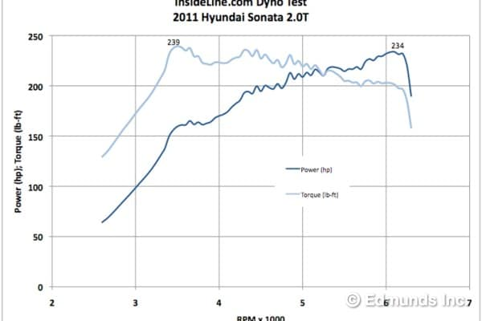
Vehicle weight: 3500 lb
Tire size: 225/45/R18
Final drive: 2.885
Constraint:
- 65 mph should take place at 2000 RPM (highest gear)
- Initial effort to climb 40% grade hill is made at 2500 RPM (lowest gear)

japark
2020-12-03 17:17:14
-------------------------------------------- Y01
Prairie View A&M University
Mechanical Engineering

MCEG 4043 –
Machine Design II Fall 2020
Z0X

FINAL REPORT
Transmission Design
Submitted by

Benita Maforzang | Benita Maforzang
Clarence Reed | Clarence Reed
Malik Williams | Malik Williams
Ziraguen Cisneros-Williams | Ziraguen Cisneros-Williams
to
Dr. Jaejong Park
By signing above, we declare that the contents within this report were generated solely by us. We understand the consequences of academic misconduct.

japark
2020-12-03 17:52:52
--------------------------------------------
Use a consistent font.
japark
2020-12-03 17:53:15
--------------------------------------------
at a designated rpm.
japark
2020-12-03 17:53:36
--------------------------------------------
at a designated rpm.
japark
2020-12-03 17:54:21
--------------------------------------------
A quantitative description would have been a nice addition to your abstract.

Abstract

The project was to design a 6 speed transmission. The design was to incorporate a minimum safety factor of 2.5. The engine output values for power & torque, the vehicle weight, final drive ratio, and wheel & tire size were provided for a 2011 Hyundai Sonata 2.0t. The gears needed to be a reasonable size because the transmission has to be able to fit the car. Since bearings would be used to support the shaft they must at least have a 20,000 hours lifespan. The propeller shaft needed to be designed to have an infinite lifespan based on the DE-Goodman criterion. The gear surface wear was to be ignored.
The strategy for approaching this design was to break up the assignment into 5 sections. These sections include determining the highest gears’ gear ratio so that the vehicle could reach a speed of 60 mph. The next step was calculating the lowest gears’ gear ratio so that the vehicle is able to climb a hill with a 40% grade. The following step became determining the appropriate dimensions of all the gears that will be included within this transmission. The following task became designing the propeller shaft, its keys, and the bearings.
The challenges following this strategy mainly came from understanding exactly what is being asked during the design process. The assumptions came from material selection to analysis consideration that had to be chosen reasonably. When making these decisions it was important to notice how they would change the results from one step to the next.

The results gave a reasonable set of gears that are able to mate with the propeller shaft. These components had to be made of different materials however so that failure of the parts could be avoided for a long operating time. One of the conditions became that the bearings should be able to operate for 20,000 hours and the results show that the bearings are one of the critical locations meaning that the system as a whole should be able to last somewhere close to 20,000 hours.

japark
2020-12-03 17:54:49
--------------------------------------------
Proofread!
Contents
Abstract i
1. 1
  - Background 1
  - Problem definition 1
  - Strategy 2
  - Project planning 3
- Executive Summary44
  - Gearbox 4
  - Propeller Shaft 4
  - Shaft components 5
    - Key 5
    - Bearing 5
- Design Methodology 6
  - Gear design methodology 6
    - Gear ratios 6
    - Gear size and force analysis 9
      - Interference check 9
      - First iteration – Face width 9
      - Subsequent iterations – Face width 10
      - Gear sizes 11
  - Shaft design methodology 11
    - Shaft shear, moment & torque diagram (If necessary) 12
    - Critical location 15
    - Fatigue analysis 16
  - Key and Bearing design methodology1817
    - Key design 17
    - Bearing design 19
- 3D CAD models 21
  - Pinion 21
  - 1st gear 22
  - 2nd gear 23
4.5 3rd gear 24

4.5 4th gear | 25
4.6 5th gear | 26
4.7 6th gear | 27
4.8 Reverse gear | 28
4.9 Shaft and its components (keys and bearings) | 29
5. Simulation (optional) | 343
6. Conclusion | 354
References | 36
Appendix | 37

japark
2020-12-03 17:56:50
--------------------------------------------
Not clear what exactly transmission is doing to achieve a quick acceleration.
- Introduction
  - Background
A transmission is a machine that moves power from one component to another. Gears and shafts allow the transmission to provide speed and torque conversions to the different components. In a motor vehicle a transmission moves power from the engine to the driving wheels. When a vehicle comes to a stop, the transmission disconnects the engine from the drive wheels so that the engine can keep idling when the wheels aren’t in motion.
Quick acceleration is allowed by
the transmission from a stop and enables the engine to run more slowly to cut down on wear while the vehicle is driving at constant speeds.
  - Problem definition
The project was to design a 6 speed transmission which included the following parts:
- A pinion gear
- Gears 1 through 6
- A reverse gear that was the same gear ratio as gear 1
- A propeller shaft
- Keys and keyways to attach the gears to the shaft
- Bearings to support the shaft
The design was to incorporate a minimum safety factor of 2.5. The engine output values for power & torque, the vehicle weight, final drive ratio, and wheel & tire size were provided for a 2011 Hyundai Sonata 2.0t. The gears needed to be a reasonable size because the transmission has to be able to fit the car. Since bearings would be used to support the shaft they must at least have a 20,000 hours lifespan. The propeller shaft needed to be designed to have an infinite lifespan based on the DE-Goodman criterion. The gear surface wear was to be ignored.
The transmission needed to be able to meet two constraints. Constraint one was to be able to climb up a 40% grade hill with a RPM of 2,500 and with the tires having a friction coefficient of
0.5. The second constraint was that the car hit 65 MPH on the 6th gear at 2,000 RPM.

japark
2020-12-03 17:57:12
--------------------------------------------
Figure resolution could be a bit better.
japark
2020-12-03 17:57:31
--------------------------------------------
redundant information here.
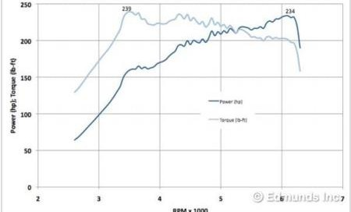
Figure 1 Power & Torque bands for 2011 Hyundai Sonata 2.0t
Vehicle weight: 3500 lb Tire size: 225/45/R18 Final drive: 2.885

Constraint:
 | 1. | 65 mph should take place at 2000 RPM (highest gear)
 | 2. | Initial effort to climb 40% grade hill is made at 2500 RPM (lowest gear)

  - Strategy
The project was split into five sections. The order of the sections naturally flowed and helped in finding a complete solution.
Section 1
The calculation of the highest gear, which was gear 6. This calculation was done to meet constraint number two. The engine speed, final drive, tire size, and car velocity was used to find the appropriate gear ratio. Matlab code was developed to make the calculations easier.
Section 2
The calculation of the lowest gear, which was gear 1. This calculation was used to meet constraint number one. The hill grade, vehicle weight, tire size, coefficient of friction of the tire, and final drive were used to find the correct gear ratio. Matlab code was developed to find

japark
2020-12-03 17:58:16
--------------------------------------------
incomplete sentence.
japark
2020-12-03 17:58:36
--------------------------------------------
Could have been more elaborated to include who is responsible for what.
Section 3
Both hand and computer code calculation for the diametral pitch, number of teeth, pitch radii, for all the gears were calculated using the interference design constraints. hand and computer code calculations for the face with for all gears based on the force value from the force analysis on all the gears.

Section 4
Considering the most severe condition when the car engine is making its peak power and the material of the shaft to determine its diameter. The appropriate key and bearing catalog was calculated.

Section 5
Completion of report, PowerPoint presentation, all CAD models and drawings

Project planning

Deliverable | Tasks | Due date
Section 1 | - Highest gear calculation  - Matlab speed calculator code | 9/29/2020
Section 2 | - Lowest gear calculation | 10/08/2020
Section 3 | - Gear size calculations  - Matlab gear parameters calculator code  - Force Analysis | 10/27/2020
Section 4 | - Propeller shaft design  - Picking bearings  - Keyway design | 11/10/2020
Section 5 | - Project Report  - PowerPoint  - Presentation  - Group Evaluations | 12/24/2020

japark
2020-12-03 18:00:28
--------------------------------------------
How come you achieve the same safety factor with same face width? If you used same safety factor that means sigma in the face width calculation would be the same. But Y (Lewis form factor) is different from gear to gear since N is different which ultimately would result in different face width values. Hence, the same face width should result in different safety factor.
japark
2020-12-03 18:02:38
--------------------------------------------
How is this compared to common automotive gear material? If properties different a big time why?
japark
2020-12-03 18:03:22
--------------------------------------------
with 2.75in face width in all gears, maximum bending stress would be different.
japark
2020-12-03 18:03:40
--------------------------------------------
This is not a stress.
- Executive Summary
  - Gearbox
Size analysis on all the gears (forward and reverse) based on the assumption of the diametral pitch (English unit). Number of teeth and pitch radii were calculated. Consideration of all design constraints such as interference were used. Force analysis on all gears (bending) are utilized. Based on the force values, the face width is chosen along with the materials for all gears. All gears are preferred to be in the same materials.

Gear number |  | N | d | F |  | Max  𝜎𝑏𝑒𝑛𝑑𝑖𝑛𝑔 |  | Material |  |  |  |  |  | Safety
 |  |  |  |  |  |  |  |  |  |  |  |  |  | factor
Pinion |  | 16T | 4.00in | 2.75in | 110000psi |  |  |  | 17-4 PH S.S. |  |  |  | 2.5
 |  |  |  |  |  |  |  |  |  | H1150
Forward gears | 1 | 60T | 15.00in | 2.75in | 110000psi |  |  | 17-4 PH S.S. H1150 |  |  |  |  | 2.5
Forward gears | 2 | 50T | 12.50in | 2.75in | 110000psi |  |  | 17-4 PH S.S.  H1150 |  |  |  |  | 2.5
Forward gears | 3 | 40T | 10.00in | 2.75in | 110000psi |  |  | 17-4 PH S.S. H1150 |  |  |  |  | 2.5
Forward gears | 4 | 32T | 8.00in | 2.75in | 110000psi |  |  | 17-4 PH S.S. H1150 |  |  |  |  | 2.5
Forward gears | 5 | 23T | 5.75in | 2.75in | 110000psi |  |  | 17-4 PH S.S. H1150 |  |  |  |  | 2.5
Forward gears | 6 | 13T | 3.25in | 2.75in | 110000psi |  |  | 17-4 PH S.S. H1150 |  |  |  |  | 2.5
Reverse gear |  | 60T | 15.00in | 2.75in | 110000psi |  |  | 17-4 PH S.S. H1150 |  |  |  |  | 2.5

The results are shown to account for the highest face width and account for the safety factor. If the individual bending stress is calculated using the given gear information the subsequent stress will always be below the maximum stress. If the maximum stress was used then the face width could be decreased further for the 1st and Forward gears as they had the highest face width.
  - Propeller Shaft
The maximum torque applied on the shaft was calculated in order to find all the reactionary loads. The reactionary loads were used to find the bending moments on the shaft. The torque and bending moments at critical locations along with the minimum safety factor were used to find the minimum required diameter for the shaft.

Shaft diameter | Max torque | Material | Max  𝜏𝑡𝑜𝑟𝑠𝑖𝑜𝑛 | Failure criteria | Safety factor
1.75in | 8920.12 lbf-in | AISI 4340  Normalize d at 870 ℃ | 8920.12 lbf-  in | DE-Goodman | 2.5

japark
2020-12-03 18:04:19
--------------------------------------------
Consistent formatting should be used.
japark
2020-12-03 18:04:25
--------------------------------------------
Nice
japark
2020-12-03 18:04:49
--------------------------------------------
This is absurdly high. We shall check the calculation.

The shaft exceeds the minimum safety factor of 2.5 while having a diameter of 1.75in. The position of the bearings and the material strength make sure that the shaft can easily handle
 the stresses induced on the shaft by the engine through the gears. This diameter provides
enough room to have a key in even the smallest gear.
  - Shaft components
The shaft needs to be able to transmit torque to and from gears and it also needs to be supported under the vehicle. The transmission of torque from gear to shaft is done by using square keys.
The shaft is supported by two bearings which are placed near the gears to minimize bending forces. The keys are designed by picking the appropriate width and height for the shaft diameter that was chosen, then using the material properties and the loads that are going to be applied to find the minimum length to resist crushing and shearing forces. The bearings are chosen by using the applied loads and desired life (hours of use)

    - Key
Shaft diameter | Key size |  |  | Loads |  | Material | Safety factor
Shaft diameter | w | h | l | Force | Torque | Material | Safety factor
1.750in | 0.375in | 0.375in | 1.087in | 10,194.42  lbf | 8,920.12  lbf-in. | AISI 4340 | 2.5

The key was designed to take the max torque scenario from the shaft design segment. The width and height were appropriate for the shaft diameter and the length ensures that it resists crushing and shearing forces on all the gears and worst case scenarios.
    - Bearing
Bearing | Radial load | Axial load | Catalog load rating | Catalog |  |  | Item number
Cylindrical Roller Bearing | 46,879 lbf | 0 | 72,000 lbf | Grainger (FAG |  |  | NU209-E-M1-C3
 |  |  |  | Bearings) |  |  | NU209-E-M1-C3

The roller bearing from Grainger was chosen because it is commercially available, it exceeds the required load rating, the bore size is approximately the same size as our shaft, and the speed ratings slightly exceed the rotational speeds of the propeller shaft.

- Design Methodology
  - Gear design methodology
The lowest and highest gear ratios were calculated first. These calculations were made to meet the two constraints discussed in section 1.2. Later the lowest and highest gear ratios served to find the interim gear ratio for gears 2 through 5. Matlab code was developed to find gear ratios near the ones we calculated that resulted in a whole number of teeth for each gear. The matlab code for the gear size is available in Appendix A.
    - Gear ratios
For the lowest gear, gear 1, the required torque to go up a 40% grade hill was calculated. Using the required torque the gear ratio was developed. For the highest gear, gear 6, a speed of 65 MPH and the engineer RPM of 2,500 was used to calculate the appropriate gear ratio.
Highest gear ratio (lowest gear)

Given:
dw = wheel diameter = 18 in w = tire width = 225 mm
W = weight in pounds = 3,500 lb AR = aspect ratio = 45% final drive = FD = 2.885 Grade of slope = 40%
r = tire radius npropeller = RPM of propeller
nwheel = RPM of wheel vt = 65 mph
Tengine= torque engine Tpropeller = torque propeller T wheels = torque wheels

Conversion Factor:

Equations:

𝑟𝑎𝑑
1
𝑠

60
= 2𝜋
60 𝑅𝑃𝑀
𝑅𝑃𝑀 → 1 = 2𝜋
1𝑟𝑎𝑑/𝑠

𝑠𝑙𝑜𝑝𝑒 =
𝑟𝑖𝑠𝑒

𝑟𝑢𝑛

= 𝑡𝑎𝑛(𝜃)

∑𝐹_{𝑋} =0
𝑇𝑤ℎ𝑒𝑒𝑙𝑠 = 𝐹 × 𝑟𝑤ℎ𝑒𝑒𝑙

Free Body Diagram:

𝐺𝑅 =

𝐹𝐷 =
𝑛𝑝𝑖𝑛𝑖𝑜𝑛

𝑛𝑔𝑒𝑎𝑟
𝑛𝑝𝑖𝑛𝑖𝑜𝑛

𝑛𝑔𝑒𝑎𝑟
𝑇𝑔𝑒𝑎𝑟
=
𝑇𝑝𝑖𝑛𝑖𝑜𝑛
𝑇𝑔𝑒𝑎𝑟
=
𝑇𝑝𝑖𝑛𝑖𝑜𝑛
𝑇𝑝𝑟𝑜𝑝𝑒𝑙𝑙𝑒𝑟
=
𝑇𝑒𝑛𝑔𝑖𝑛𝑒
𝑇𝑤ℎ𝑒𝑒𝑙𝑠
=
𝑇𝑝𝑟𝑜𝑝𝑒𝑙𝑙𝑒𝑟

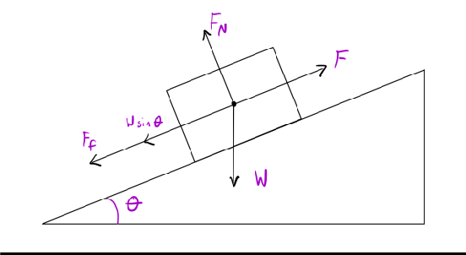

Figure 3.1 FBD for car going uphill

Solution:
4 2
𝑠𝑙𝑜𝑝𝑒 = 10 = 5

𝜃 = 𝑡𝑎𝑛⁻¹
2
(5) = 21.8

𝐹_{𝑓} = 0.5 × 𝑊 × 𝑐𝑜𝑠 𝜃= 1624.85 lb
∑𝐹_{𝑋} = 𝐹 − 𝑊 × 𝑠𝑖𝑛 𝜃 − 𝐹_{𝑓}= 0
𝐹 = 𝑊 × 𝑠𝑖𝑛 𝜃 + 0.5 × 𝑊 × 𝑐𝑜𝑠 𝜃=1299.78 lb
1 𝑓𝑡
𝑇_{𝑤ℎ𝑒𝑒𝑙} = 𝐹 × 𝑟_{𝑤ℎ𝑒𝑒𝑙} = 1299.78 𝑙𝑏 × 12.99 𝑖𝑛 × (12 𝑖𝑛) = 1407.01 𝑙𝑏 ∗ 𝑓𝑡

𝑇𝑝𝑟𝑜𝑝𝑒𝑙𝑙𝑒𝑟 =
𝑇𝑤ℎ𝑒𝑒𝑙
=
𝐹𝐷
1407.02 𝑙𝑏 ∗ 𝑓𝑡
2.885 = 487.73 𝑙𝑏 ∗ 𝑓𝑡

𝐺𝑅 =
𝑇𝑝𝑟𝑜𝑝𝑒𝑙𝑙𝑒𝑟

𝑇𝑒𝑛𝑔𝑖𝑛𝑒
487.73 𝑙𝑏 ∗ 𝑓𝑡
= 130 𝑙𝑏 ∗ 𝑓𝑡

Lowest gear ratio (highest gear)

Given:

Conversion Factor:
𝐺𝑅 = 3.752

dw = wheel diameter = 18 in w = tire width = 225 mm AR = aspect ratio = 45% final drive = FD = 2.885 rwheel = tire radius
npropeller = RPM of propeller nwheel = RPM of wheel
v = 65 mph

Equations:

𝑟𝑎𝑑
1
𝑠

60
= 2𝜋
60 𝑅𝑃𝑀
𝑅𝑃𝑀 → 1 = 2𝜋
1𝑟𝑎𝑑/𝑠

𝐺𝑅 =
𝑛𝑝𝑖𝑛𝑖𝑜𝑛

𝑛𝑔𝑒𝑎𝑟

𝐹𝐷 =
𝑛𝑝𝑖𝑛𝑖𝑜𝑛

𝑛𝑔𝑒𝑎𝑟
𝑛𝑝𝑟𝑜𝑝𝑒𝑙𝑙𝑒𝑟
=
𝑛𝑤ℎ𝑒𝑒𝑙

→ 𝑛𝑝𝑟𝑜𝑝𝑒𝑙𝑙𝑒𝑟 = 𝐹𝐷 × 𝑛𝑤ℎ𝑒𝑒𝑙

𝑟𝑤ℎ𝑒𝑒𝑙 =
𝑑_{𝑤}
2 +
𝐴𝑅
100 × 𝑤

𝑣
𝑣 = 𝑟_{𝑤ℎ𝑒𝑒𝑙} × 𝜔 → 𝜔 = 𝑟
𝑤ℎ𝑒𝑒𝑙

60 𝑅𝑃𝑀
𝑛_{𝑤ℎ𝑒𝑒𝑙} = 𝜔 × (2𝜋 )
1
𝑟𝑎𝑑/𝑠

Solution:

60

65 𝑚 × ( 1 ℎ

63360 𝑖𝑛

60

𝑛𝑤ℎ𝑒𝑒𝑙
= 𝜔 × (2𝜋 𝑅𝑃𝑀) =
1 𝑟𝑎𝑑/𝑠
ℎ 3600 𝑠) × (
18 𝑖𝑛 45
1 𝑚 )
1 𝑖𝑛
× (2𝜋 𝑅𝑃𝑀)
1 𝑟𝑎𝑑/𝑠

2 + 100 (225 𝑚𝑚 ×
→ 𝑛_{𝑤ℎ𝑒𝑒𝑙} = 841.230 𝑅𝑃𝑀
25.4 𝑚𝑚)

𝑛𝑝𝑟𝑜𝑝𝑒𝑙𝑙𝑒𝑟 = 𝐹𝐷 × 𝑛𝑤ℎ𝑒𝑒𝑙 = 2.885 × 841.230 𝑅𝑃𝑀
→ 𝑛𝑝𝑟𝑜𝑝𝑒𝑙𝑙𝑒𝑟 = 2426.95 𝑅𝑃𝑀

𝐺𝑅 =
𝑛𝑝𝑖𝑛𝑖𝑜𝑛

𝑛𝑔𝑒𝑎𝑟
𝑛𝑒𝑛𝑔𝑖𝑛𝑒
=
𝑛𝑝𝑟𝑜𝑝𝑒𝑙𝑙𝑒𝑟
2,000 𝑅𝑃𝑀
= 2,426.95 𝑅𝑃𝑀

= 0.82407

𝐺𝑅 = 0.82407
    - Gear size and force analysis
The size of each gear and an analysis of the bending force are used to determine the face width needed for each gear. The interference analysis is used so that the module and number of teeth can be found for the two smallest gears in the gearbox. Modules for the subsequent gears are estimated and used so that the remaining number of teeth for each gear are calculated. The bending stress equation is then used to describe the relation between the bending moment and the face width. Once the equation is rearranged to solve for face width the banding stress is assumed based on material selection and the other parameters are calculated from the given vehicle information.
      - Interference check
Using Highest gear ratio:

𝑁6
2 ∗ 1
= (1 + 2 ∗ 1.213)𝑠𝑖𝑛220

∗ (1.213 + √1.213² + (1 + 2 ∗ 1.213)𝑠𝑖𝑛220) = 12.88𝑇 = 13𝑇

𝑚 = 𝑁𝑔 → 0.8 = 13𝑇 → 𝑁

= 13𝑇

= 15.77𝑇 =
16𝑇

𝑁𝑝
𝑁𝑝 𝑝
13

0.8241

      - First iteration – Face width
𝑚 = 16 = 0.8125

The assumptions used in this section include the materials used for the gears, AISI 1020 steel [1] & 17-4 PH Stainless H1150 [2]. For these assumptions, the yield strength (Sy)
japark
2020-12-03 18:07:21
--------------------------------------------
Your ratio for highest gear is 0.82. Why are you using 1.213 instead? I know why but have a description. Remember, this report is targeting a client who does not have a solid ME knowledge.
japark
2020-12-03 18:07:58
--------------------------------------------
have you checked whether this guarantees for gear ratio of 3.752?

was taken from the sources and used for the bending stress analysis after accounting for the safety factor, 2.5.

Material Selection:
AISI 1020 Steel - HR Sy = 30ksi & CD Sy = 57ksi
17-4 PH Stainless H1150 Sy = 110ksi

Face Width:

𝑉 = 𝜋𝑑𝑛 → 𝑉 = 𝜋𝑑𝑝𝑛 → 𝑉 = 𝜋∗3.2𝑖𝑛∗6200𝑅𝑃𝑀 = 5194.1ft/min

12 12 12
𝐾 = 1200+𝑉 = 1200+5194.1 = 5.3

𝑣 1200
1200

𝑊𝑡
= 33,000 ∗ 234 ℎ𝑝
5194.1𝑡/𝑚𝑖𝑛

= 1486.7lb

𝐹 = 𝐾𝑣∗𝑊𝑡∗𝑃 → 𝐹 = 5.3∗1486.7𝑙𝑏∗5 = 4.67𝑖𝑛

𝜎 ∗𝑌
𝑆𝐹
Iteration 1 (P = 5 & 𝜎 = 57000psi)
57000 𝑝𝑠𝑖
2.5 ∗ .
0 296

japark
2020-12-03 18:08:29
--------------------------------------------
Why two materials? which one for what?
Gears |  | Gear ratio | Number of Teeth | Diametral Pitch | Gear Diameter | Stress | F
Pinion |  |  | 16T | 5 | 3.20in | 57000psi | 4.67in
Forwa rd gears | 1 | 3.75 | 60T | 5 | 12.00in | 57000psi | 3.55in
Forwa rd gears | 2 | 3.125 | 50T | 5 | 10.00in | 57000psi | 3.71in
Forwa rd gears | 3 | 2.50 | 40T | 5 | 8.00in | 57000psi | 3.96in
Forwa rd gears | 4 | 2.00 | 32T | 5 | 6.40in | 57000psi | 4.31in
Forwa rd gears | 5 | 1.4375 | 23T | 5 | 4.60in | 57000psi | 4.90in
Forwa rd gears | 6 | 0.8125 | 13T | 5 | 2.60in | 57000psi | 6.94in
Reverse gear |  | 3.75 | 60T | 5 | 12.00in | 57000psi | 3.55in

      - Subsequent iterations – Face width
The second iteration utilized a smaller Diametral Pitch (P) that gave us a larger gear diameter but decreased the overall face width. This made the gears slightly bigger but allowed the face width to become significantly smaller as a result.
Iteration 2 (P = 3 & 𝜎 = 57000psi)

Gears | Gear ratio | Number of Teeth | Diametral Pitch | Gear Diameter | Stress | F

Pinion |  |  | 16T | 3 | 5.33in | 57000psi | 2.80in
Forwar d gears | 1 | 3.75 | 60T | 3 | 20.00in | 57000psi | 2.08in
Forwar d gears | 2 | 3.125 | 50T | 3 | 16.67in | 57000psi | 2.16in
Forwar d gears | 3 | 2.50 | 40T | 3 | 13.33in | 57000psi | 2.30in
Forwar d gears | 4 | 2.00 | 32T | 3 | 10.67in | 57000psi | 2.48in
Forwar d gears | 5 | 1.4375 | 23T | 3 | 7.67in | 57000psi | 2.78in
Forwar d gears | 6 | 0.8125 | 13T | 3 | 4.33in | 57000psi | 3.80in
Reverse gear |  | 3.75 | 60T | 3 | 19.7in | 57000psi | 2.08in

Iteration 3 (P = 4 & 𝜎 = 110000psi)

Gears |  | Gear ratio | Number of Teeth | Diametral Pitch | Gear Diameter | Stress | F | Face
 |  |  |  |  |  |  |  | Width
Pinion |  |  | 16T | 4 | 4.00in | 110000psi | 1.94in | 2.75in
Forwar d gears | 1 | 3.75 | 60T | 4 | 15.00in | 110000psi | 1.45in | 2.75in
Forwar d gears | 2 | 3.125 | 50T | 4 | 12.50in | 110000psi | 1.6in | 2.75in
Forwar d gears | 3 | 2.50 | 40T | 4 | 10.00in | 110000psi | 1.61in | 2.75in
Forwar d gears | 4 | 2.00 | 32T | 4 | 8.00in | 110000psi | 1.75in | 2.75in
Forwar d gears | 5 | 1.4375 | 23T | 4 | 5.75in | 110000psi | 1.98in | 2.75in
Forwar d gears | 6 | 0.8125 | 13T | 4 | 3.25in | 110000psi | 2.75in | 2.75in
Reverse gear |  | 3.75 | 60T | 4 | 15.00in | 110000psi | 1.45in | 2.75in

Iteration 3 gave us reasonable face widths to work with when using 17-4 PH Stainless H1150. The largest face width is 2.75 in. so all of the gears for our project will have a face width of 2.75 in.
      - Gear sizes
The number of teeth were calculated using the gear ratio estimates between the highest and lowest gear in the gearbox. Those gear ratios are used along with the calculated number of teeth for the pinion. These gear ratios along with the pinions number of teeth are used to calculate the number of teeth for each respective gear.
Gear Ratio Calculation:

𝐺𝑅_{𝐿} − 𝐺𝑅_{𝐻}
5 =
3.75 − 0.8125
5 = 0.59

(Subtract increments of 0.59 from the lowest Gear Ratio) Assumed gear ratios (later corrected for whole number of teeth):
japark
2020-12-03 18:10:33
--------------------------------------------
Looking at the values for diameter and face width, face width could be a bit bigger. Why not the values from iteration 2? What you did not like about it?
𝐺𝑅_{𝐿} = 𝐺𝑅₁ = 3.75 , 𝐺𝑅₂ = 3.16, 𝐺𝑅₃ = 2.57, 𝐺𝑅₄ = 1.98, 𝐺𝑅₅ = 1.39, 𝐺𝑅₆ = 0.8
Number of teeth:

𝑁_{𝑔} = 𝑁_{𝑝} ∗ 𝑚 = 𝑁_{𝑝} ∗ 𝐺𝑅

Gear Diameter:
𝑁₁ = 𝑁_{𝑝} ∗ 𝑚 = 𝑁_{𝑝} ∗ 𝐺𝑅₁ → 𝑁₁ = 16𝑇 ∗ 3.75 = 60𝑇

𝑃 = 𝑁 → 𝑑 = 𝑁 = 16 = 3.2𝑖𝑛

𝑑 𝑃 5
japark
2020-12-03 18:13:29
--------------------------------------------
This is a bit too high? Wheelbase is 110 inches. If I were to assume, it would be maybe 4 ft.

Gears |  | Gear ratio | Diameter | Max torque at  the wheel (239 lbf-ft) | Max speed at  the wheel (6250 RPM)
Forward gears | 1 | 3.75 | 4.00in | 2,585.68 lbf-ft | 44.64 MPH
Forward gears | 2 | 3.125 | 15.00in | 2,154.73 lbf-ft | 53.57 MPH
Forward gears | 3 | 2.50 | 12.50in | 1,723.79 lbf-ft | 66.96 MPH
Forward gears | 4 | 2.00 | 10.00in | 1,379.03 lbf-ft | 83.70 MPH
Forward gears | 5 | 1.4375 | 8.00in | 991.18 lbf-ft | 116.45 MPH
Forward gears | 6 | 0.8125 | 5.75in | 560.23 lbf-ft | 206.02 MPH
Reverse gear |  | 3.75 | 3.25in | 2,585.68 lbf-ft | 44.64 MPH

  - Shaft design methodology
The shaft that was designed is 99 inches in total length, it has two bearings which are located 1 inch from either end, it has a gear on the engine side and a pinion gear on the final drive side. The shaft and related components were designed to withstand the worst case scenario and have infinite life. The primary load is a torque that is transmitted to the shaft from the engine through the pinion and gear. The highest torque applied was found by using the first gear. The shaft is supported by two bearings which apply reactionary forces on the shaft in response to the input torque. The reactionary forces on the shaft cause bending stresses.
Using the torque, the bending moment, material properties, safety factor, and other design parameters the minimum shaft diameter was calculated.

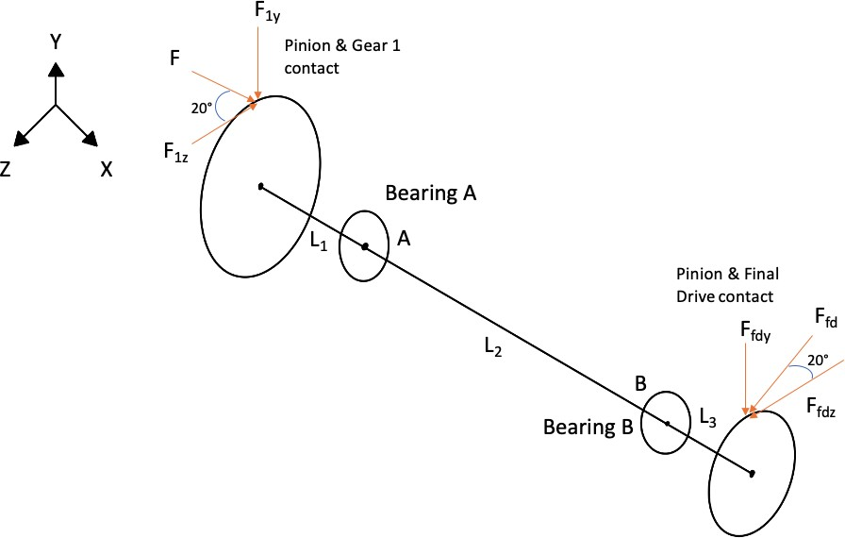

Figure 3.2 Shaft Diagram (not drawn to scale)
A and B are the locations of the bearings. The pressure angles are 20 degrees for all gear.
L1= L3 = 1 in. L2= 97 in.
    - Shaft shear, moment & torque diagram (If necessary)
Shaft Torque Calculations:

𝑛𝑝𝑟𝑜𝑝𝑒𝑙𝑙𝑒𝑟 =
𝑛𝑒𝑛𝑔𝑖𝑛𝑒
=
𝐺𝑅
6,200 𝑅𝑃𝑀
3.75 = 1,653.33 𝑅𝑃𝑀

𝑉 =
𝜋 × 15 𝑖𝑛.× 1,653.33 𝑅𝑃𝑀
12 = 6,492.62 𝑓𝑡/𝑚𝑖𝑛
234 ℎ𝑝

𝑊_{𝑡} = 33,000 × 6292.62 𝑓𝑡/𝑚𝑖𝑛 = 1,189.35 𝑙𝑏𝑓
𝑇_{𝑚𝑎𝑥} = 1,189.35 𝑙𝑏𝑓 × 7.5 𝑖𝑛. = 8,920.12 𝑙𝑏𝑓 ∙ 𝑖𝑛.
Force on gear 1 in the z direction
F1z= Wt=1,189.35 𝑙𝑏𝑓
Forces on the pinion gear which transmits to the final drive

𝑑𝑓𝑖𝑛𝑎𝑙 𝑑𝑟𝑖𝑣𝑒 =
16
4 = 4.0 𝑖𝑛.

𝑟𝑓𝑖𝑛𝑎𝑙 𝑑𝑟𝑖𝑣𝑒 =
4.0 𝑖𝑛.
2 = 2.0 𝑖𝑛.

𝑇𝑚𝑎𝑥

+𝑐𝑐𝑤 𝛴 𝑇 = 0 = 𝐹𝑓𝑑𝑧 × 𝑟𝑓𝑖𝑛𝑎𝑙 𝑑𝑟𝑖𝑣𝑒 − 𝑇𝑚𝑎𝑥 → 𝐹𝑓𝑑𝑧 =
𝑟
𝑓𝑖𝑛𝑎𝑙 𝑑𝑟𝑖𝑣𝑒

𝐹𝑓𝑑𝑧 =
8,920.12 𝑙𝑏𝑓 ∙ 𝑖𝑛.
2.0 𝑖𝑛. = 4,460.06 𝑙𝑏𝑓

𝐹_{𝑓𝑑𝑦} = 𝑡𝑎𝑛(20 ∘) × 4,460.06 𝑙𝑏𝑓 = 1623.33 𝑙𝑏𝑓
Calculating the component of the force on gear 1 in the y direction
𝐹_{1𝑦} = 𝑡𝑎𝑛(20 ∘) × 1,189.35 𝑙𝑏𝑓 = 432.89 𝑙𝑏𝑓
Moment about point A to find the reaction force at point B in the Y direction, XY-plane
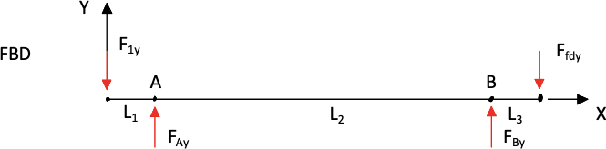

Figure 3.3 FBD in XY plane

+𝑐𝑐𝑤 𝛴 𝑀_{𝐴} = 0 = 𝐹_{1𝑦} × 1 𝑖𝑛. +𝐹_{𝐵𝑦} × 97 𝑖𝑛. −𝐹_{𝑓𝑑𝑦} × 98 𝑖𝑛.
1623.33 𝑙𝑏𝑓𝑓 × 98 𝑖𝑛. − 432.89 𝑙𝑏𝑓 × 1 𝑖𝑛.

𝐹_{𝐵𝑦} =
97 𝑖𝑛. = 1,635.60 𝑙𝑏𝑓

Summation of Forces on Y axis to find reaction force at point A, XY-plane
+↑ 𝛴 𝐹_{𝑦} = 0 = −𝐹_{1𝑦} + 𝐹_{𝐴𝑦} + 𝐹_{𝐵𝑦} − 𝐹_{𝑓𝑑𝑦} → 𝐹_{𝐴𝑦} = 𝐹_{1𝑦} − 𝐹_{𝐵𝑦} + 𝐹_{𝑓𝑑𝑦}
𝐹_{𝐴𝑦} = 432.89 𝑙𝑏𝑓 − 1,635.60 𝑙𝑏 + 1,623.33 𝑙𝑏𝑓 = 420.62 𝑙𝑏𝑓
Bending Moment at A on Y axis, XY-plane
𝑀_{𝐴𝑦} = 1 𝑖𝑛.× 𝐹_{1𝑦} = 1 𝑖𝑛.× −432.89 𝑙𝑏𝑓 = −432.89 𝑙𝑏𝑓 ∙ 𝑖𝑛.
Bending Moment at B on Y axis, XY-plane
𝑀_{𝐵𝑦} = 1 𝑖𝑛.× 𝐹_{𝑓𝑑𝑦} = 1 𝑖𝑛.× −1,623.33 𝑙𝑏𝑓 = −1,623.33 𝑙𝑏𝑓 ∙ 𝑖𝑛.

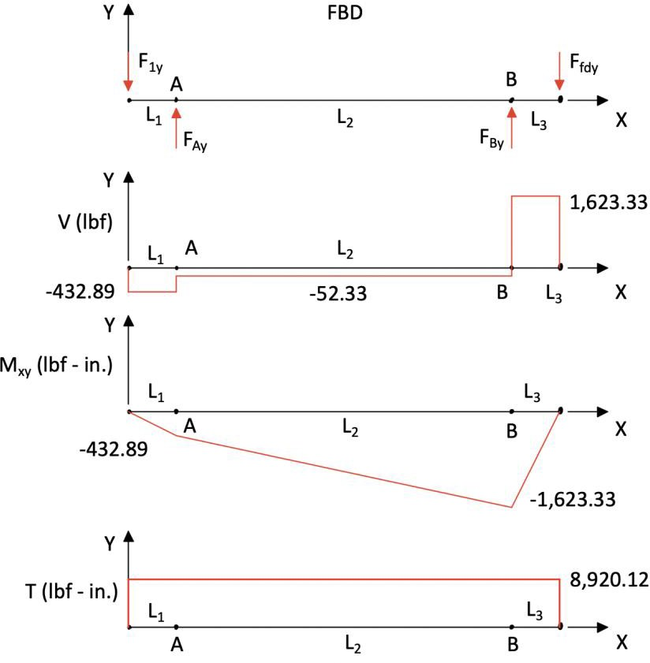

Figure 3.4 Shear-moment diagram, XY-plane

Moment about point A to find the reaction force at point B in the Z direction, XZ-plane
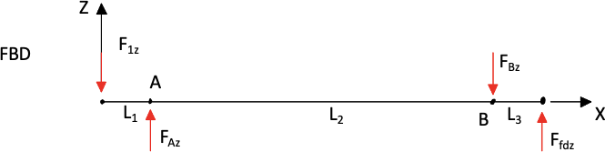

Figure 3.5 FBD in XZ plane

+𝑐𝑐𝑤 𝛴 𝑀_{𝐴} = 0 = 𝐹_{1𝑧} × 1 𝑖𝑛. −𝐹_{𝐵𝑧} × 97 𝑖𝑛. +𝐹_{𝑓𝑑𝑧} × 98 𝑖𝑛.
1,189.35 𝑙𝑏𝑓 × 1 𝑖𝑛 + 4,460.06 𝑙𝑏𝑓 × 98 𝑖𝑛. .

𝐹_{𝐵𝑧} =
97 𝑖𝑛. = 4,518.30 𝑙𝑏𝑓

Summation of Forces on Z axis to find reaction force at point A, XZ-plane

japark
2020-12-03 18:14:45
--------------------------------------------
I do not see 40k lb of bearing load here.
+ ⊙ 𝛴 𝐹_{𝑧} = 0 = −𝐹_{1𝑧} + 𝐹_{𝐴𝑧} − 𝐹_{𝐵𝑧} + 𝐹_{𝑓𝑑𝑧} → 𝐹_{𝐴𝑧} = 𝐹_{1𝑧} + 𝐹_{𝐵𝑧} − 𝐹_{𝑓𝑑𝑧}
𝐹_{𝐴𝑧} = 1,189.35 𝑙𝑏𝑓 + 4,518.30 𝑙𝑏𝑓 − 4,460.06 𝑙𝑏𝑓 = 1,247.59 𝑙𝑏𝑓
Bending Moment at A on Z axis, XZ-plane
𝑀_{𝐴𝑧} = 1 𝑖𝑛.× 𝐹_{1𝑧} = 1 𝑖𝑛.× −1,189.35 𝑙𝑏𝑓 = −1,189.35 𝑙𝑏𝑓 ∙ 𝑖𝑛.
Bending Moment at B on Z axis, XZ-plane
𝑀_{𝐵𝑧} = 1 𝑖𝑛.× 𝐹_{𝑓𝑑𝑧} = 1 𝑖𝑛.× 4,460.06 𝑙𝑏𝑓 = 4,460.06 𝑙𝑏𝑓 ∙ 𝑖𝑛.

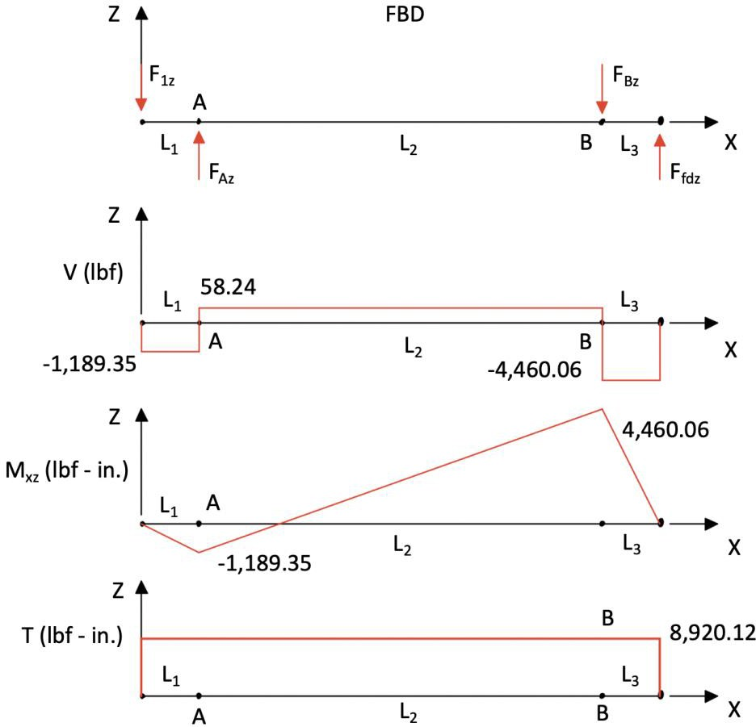
Figure 3.6 Shear-moment diagram, XZ-plane
    - Critical location
In order to determine the critical locations the magnitude of the moments at A and B needed to be compared. The magnitudes of the forces at A and B were also calculated to be used with the bearing calculations. The critical point is used to find the minimum shaft diameter and to find the maximum load on the bearings.
Moment Calculations:

𝑀_{𝐴} = √𝑀² + 𝑀² = √(−432.89 𝑙𝑏𝑓 ∙ 𝑖𝑛. )2 + (−1,189.35 𝑙𝑏𝑓 ∙ 𝑖𝑛. )2
𝐴𝑥𝑦 𝐴𝑥𝑧
= 1,265.68 𝑙𝑏𝑓 ∙ 𝑖𝑛.

𝑀_{𝐵} = √𝑀² + 𝑀² = √(−1623.33 𝑙𝑏𝑓 ∙ 𝑖𝑛. )2 + (4,460.06 𝑙𝑏𝑓 ∙ 𝑖𝑛. )2
𝐵𝑥𝑦 𝐵𝑥𝑧
= 4,746.30 𝑙𝑏𝑓 ∙ 𝑖𝑛.
Force Calculations:

𝐹_{𝐴} = √𝐹² + 𝐹² = √(420.62 𝑙𝑏𝑓)2 + (1,247.59 𝑙𝑏𝑓)2 = 1,316.59 𝑙𝑏𝑓
𝐴𝑦 𝐴𝑧

𝐹_{𝐵} = √𝐹² + 𝐹² = √(1,635.60 𝑙𝑏𝑓)2 + (−4,518.30 𝑙𝑏𝑓)2 = 4,805.23 𝑙𝑏𝑓
𝐵𝑦 𝐵𝑧

The critical point is: B

    - Fatigue analysis
The shaft was designed using the DE-Goodman criterion. It was assumed that the shaft material would be AISI 4340 steel, the shaft was of a constant diameter, the shaft would see constant torque, and the shaft would spin continuously.

Equations:
DE-Goodman criterion

16𝑛 1
𝑑 = ( {

[4(𝐾 𝑀

)² + 3(𝐾

𝑇 )2]1/2

𝜋 𝑆𝑒
𝑓 𝑎
𝑓𝑠 𝑎

1

+ [4(𝐾 𝑀

)² + 3(𝐾
𝑇 )2]1/2})1/3

Endurance Strength
𝑆𝑢𝑡
𝑓 𝑚
𝑓𝑠 𝑚

Assumptions:
Shaft material:
𝑆_{𝑒} = 𝑘_{𝑎}𝑘_{𝑏}𝑘_{𝑐}𝑆′_{𝑒}

Sut = 186 kpsi Sy = 125 kpsi
AISI 4340 Normalized at 870 ℃ (1600 ℉)
𝑆_{𝑒} ′ = 0.5 × 𝑆_{𝑢𝑡} 𝑘𝑝𝑠𝑖 Sut < 200 kpsi

Shaft is approximately 1.75 inches in diameter (used for calculating kb)
japark
2020-12-03 18:15:29
--------------------------------------------
Why strikethrough?
japark
2020-12-03 18:16:21
--------------------------------------------
This is an expensive material, just saying.

𝑘_{𝑏} = 0.879𝑑^{−0.107}
Shaft has constant torque and spins continuously, therefore:
𝑀_{𝑎} = 4,746.30 𝑙𝑏𝑓 ∙ 𝑖𝑛.
𝑇_{𝑎} = 0
𝑀_{𝑚} = 0
𝑇_{𝑚} = 8,920.12 𝑙𝑏𝑓 ∙ 𝑖𝑛.

Constant diameter shaft

Solution:
Shaft Se Calculations

𝑘_{𝑓} = 𝑘_{𝑓𝑠} = 1

𝑆_{𝑒} ′ = 0.5 × 186 𝑘𝑝𝑠𝑖 = 93 𝑘𝑝𝑠𝑖

𝑘_{𝑎} 𝑚𝑎𝑐ℎ𝑖𝑛𝑒𝑑 ⇒ 𝑘_{𝑎} = 𝑎𝑆_{𝑢𝑡}^{𝑏} = 2.70(108)^{−0.265} = 0.780
𝑘_{𝑏} = 0.879 × 1.75^{−0.107} = 0.827
𝑘_{𝑐} = 0.59 torsion
𝑆_{𝑒} = 0.780 × 0.827 × 0.59 × 93 𝑘𝑝𝑠𝑖 = 35.433 𝑘𝑝𝑠𝑖
Shaft Diameter Calculations

16 × 2.5 1

𝑑 = ( {

[4(4,746.30 𝑙𝑏𝑓 ∙ 𝑖𝑛. )²]^{1/2}

𝜋 35.433 𝑘𝑝𝑠𝑖

1
+ 186 𝑘𝑝𝑠𝑖
[3(8,920.12 𝑙𝑏𝑓 ∙ 𝑖𝑛. )²]^{1/2}})^{1/3}

𝑑 = 1.647 𝑖𝑛.
The diameter at B must be at least 1.647 in. for a safety factor of 2.5. common off the shelf diameter.
Round up 1.75 in.
  - Key and Bearing design methodology
The gears need a way to transmit the rotational forces to the shaft. In this design the transmission of rotational forces were done using a key/keyway. This section covers

for

minimum key length required to resist crushing and shearing forces. In order to calculate the minimum length of the key a key height and width were chosen using Table 7-6 [1] based on the diameter of the shaft. The max torque applied on the shaft was used to calculate the force
japark
2020-12-03 18:16:54
--------------------------------------------
good practice.

at the shearing point (at the outside diameter of the shaft). Combining the shearing force, height/width, and yield strength the length was found.

    - Key design
Equations:

Assumptions: Square key: w = h = t Solution:

𝑇
𝐹 = 𝑟
𝑆𝑠𝑦 = 0.577𝑆𝑦

𝑛𝐹
𝑙 =
𝑡𝑆
𝑆𝑌

𝑛𝐹
𝑙 = (𝑡/2)𝑆
𝑌

Calculating the force at the shearing point

8,920.12 𝑙𝑏𝑓 ∙ 𝑖𝑛.
𝐹 = 0.875 𝑖𝑛. = 10,194.42 𝑙𝑏𝑓
Calculating the shearing yield strength of the material
𝑆𝑠𝑦 = 0.577 × 125 𝑘𝑝𝑠𝑖 = 72.125 𝑘𝑝𝑠𝑖
Calculating the width, height so we can use it as the thickness in the following equations

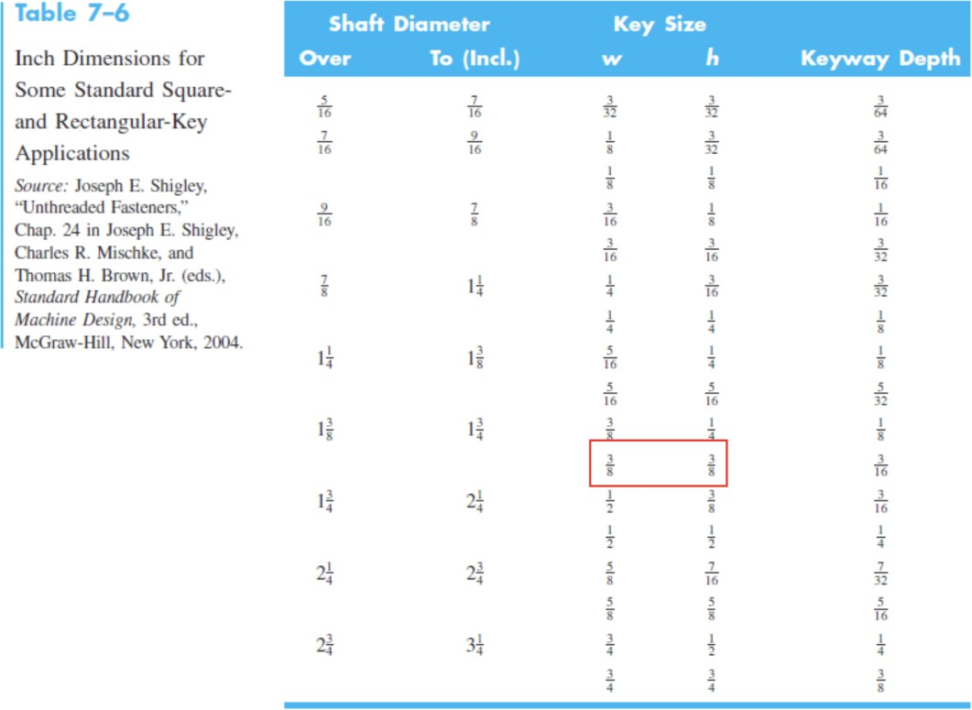

From Table 7-6 for 1.750 in. diameter shaft:
w = h = t = 0.375 in.
Keyway depth = 0.1875 in.
Calculating the min length to resist the shearing force

𝑛𝐹
𝑙 =
𝑡𝑆
𝑆𝑌
2.5 × 10,194.42 𝑙𝑏𝑓
= 0.375 × 72.125 𝑘𝑝𝑠𝑖
𝑙 = 0.942 𝑖𝑛.

Calculating the min length to resist the crushing force

𝑛𝐹
𝑙 = (𝑡/2)𝑆
𝑌
2.5 × 10,194.42 𝑙𝑏𝑓
= (0.375/2) × 125 𝑘𝑝𝑠𝑖
𝑙 = 1.087 𝑖𝑛.

Our minimum key length is 1.087 in. All gears have the same bore diameter which is equal to the shaft diameter 1.75 in. Therefore, the minimum length for the key is equal for all gears.
Final Key dimensions:

𝑤 = ℎ = 0.375 𝑖𝑛.
𝑙 = 1.087 𝑖𝑛.

    - Bearing Design
The shaft in this design is supported by two bearings. The bearings will only see radial loads because the design has called for spur gears. The requirements need the bearing to be able to last for 20,000 hours. Roller bearings were chosen because they are able to handle larger loads than ball bearings at bore diameters close to our shaft diameter of 1.75 in. The RPM for gear 1 was used in the calculations. The catalog rating (C10) was calculated using this process and assumptions.

Equations:

𝐶 = 𝐹

𝑙_{𝐷}𝑛_{𝐷}60
(

1/𝑎

Given:
10 𝐷
)
𝐿_{𝑅}

lD = 20,000 hrs

Assumptions:

Roller bearing ⇒ a = 10/3
LR = 10⁶

Solution:

nD = 1,653.33 RPM

𝐶10
FB = 4,805.23 lbf

20,000 ℎ𝑟𝑠 × 1,653.33 𝑅𝑃𝑀 × 60
= 4,805.23 𝑙𝑏𝑓 × ( 106 )
𝐶₁₀ = 46,878.79 𝑙𝑏𝑓 = 208.527 𝑘𝑁

1/(10/3)

The cylindrical roller bearing catalog rating is a 03-series C10= 212 kN. Bearing NU209-E- M1-C3 from FAG Bearings was selected from the online Grainger catalog. This bearing was selected because it has a high load rating, its bore diameter is approximately the same

japark
2020-12-03 18:18:15
--------------------------------------------
There is a gap of 0.02in. How are you going to handle this?
as our shaft, and it has sufficient speed rating to meet our RPM requirements for gear 6 at the highest engine RPM. [3]

Part # | C10 | Speed Rating | Bore Dia. | Width | Brand
NU209-E-M1-C3 | 72,000 lbf | 8500 RPM | 1.77 in | 0.75 in | FAG Bearings

japark
2020-12-03 18:19:21
--------------------------------------------
Engineering drawing should have all necessary information (e.g., number of teeth, pressure angle, material, etc.) such that any body can reproduce your part just by looking at it.
- CAD models
NX 10.0 from Siemens was used to make the models, assembly, and drawings for this design.
  - Pinion
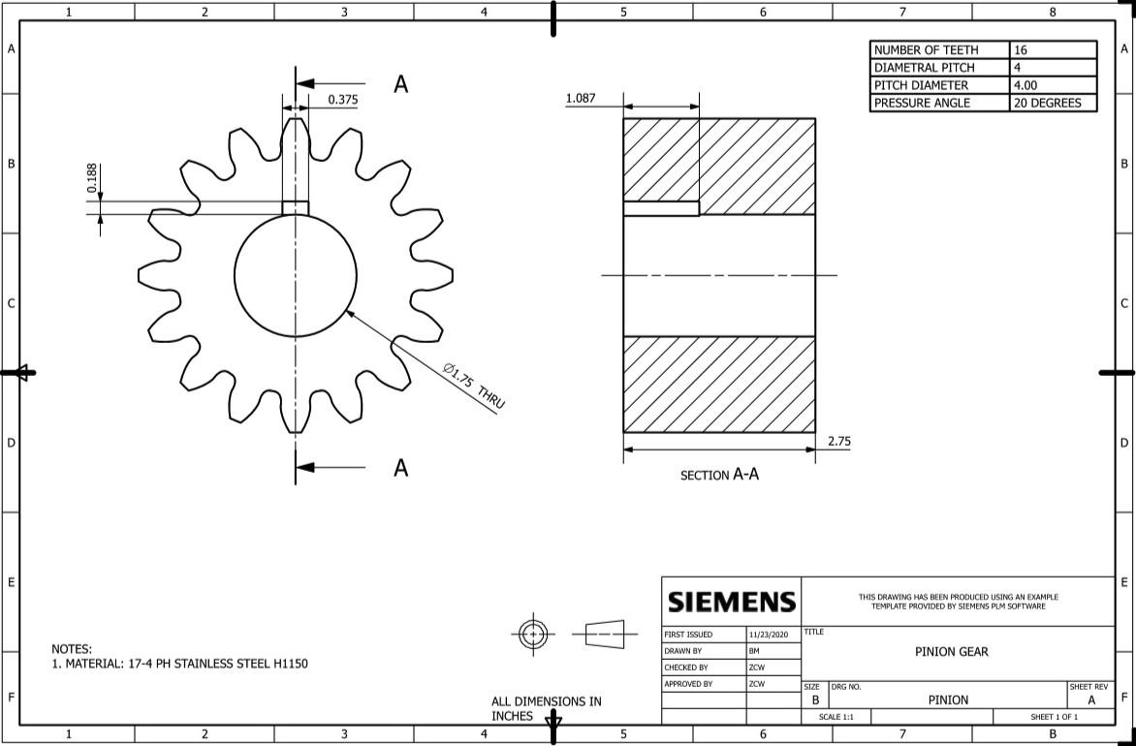
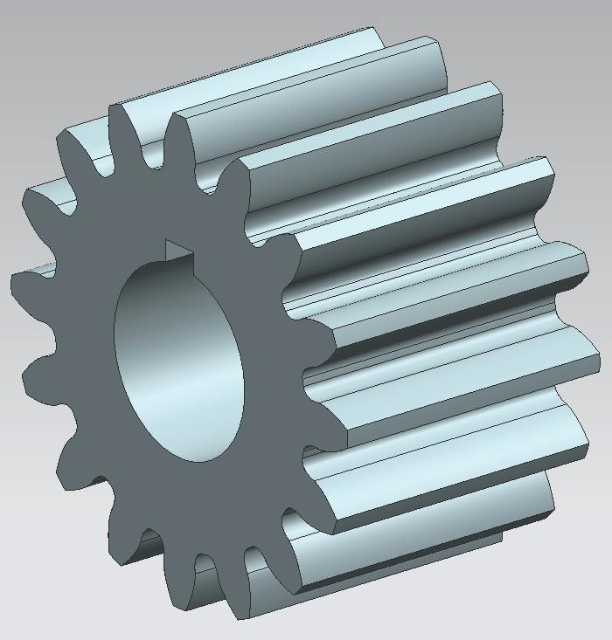

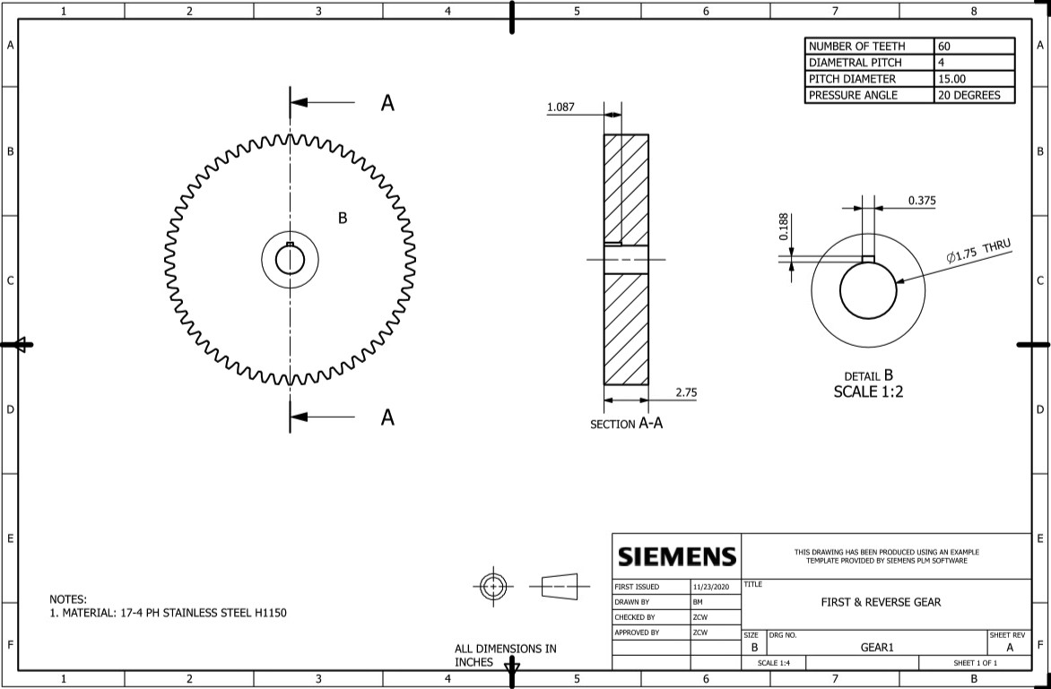
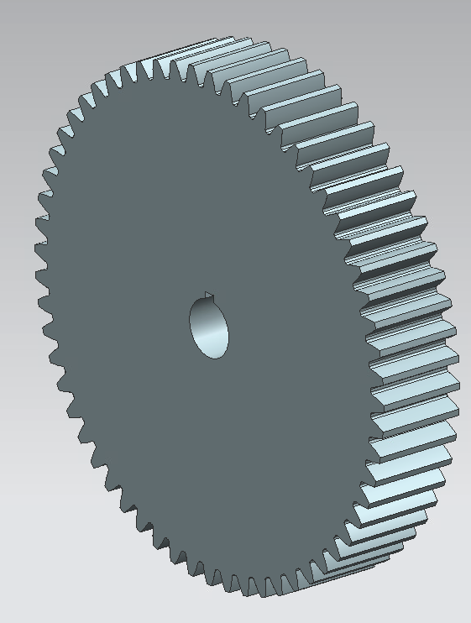
  - 1st gear

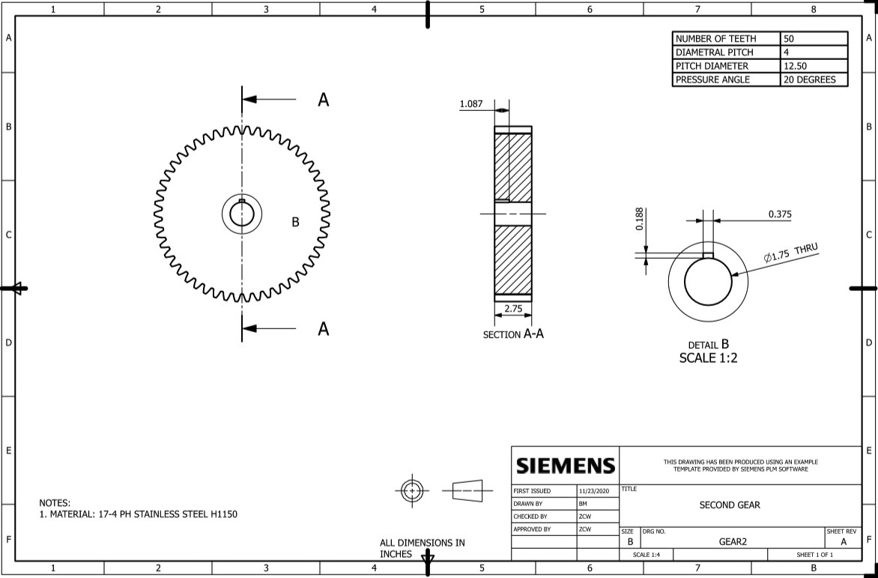
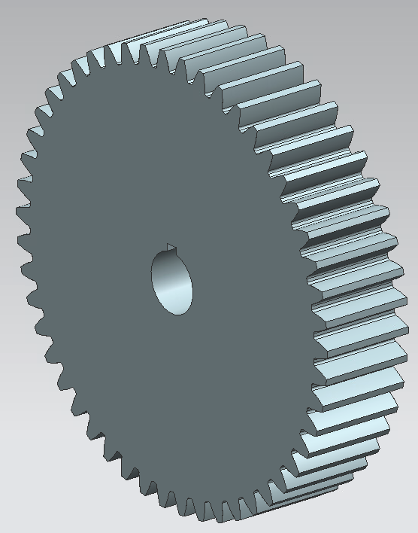
  - 2nd gear

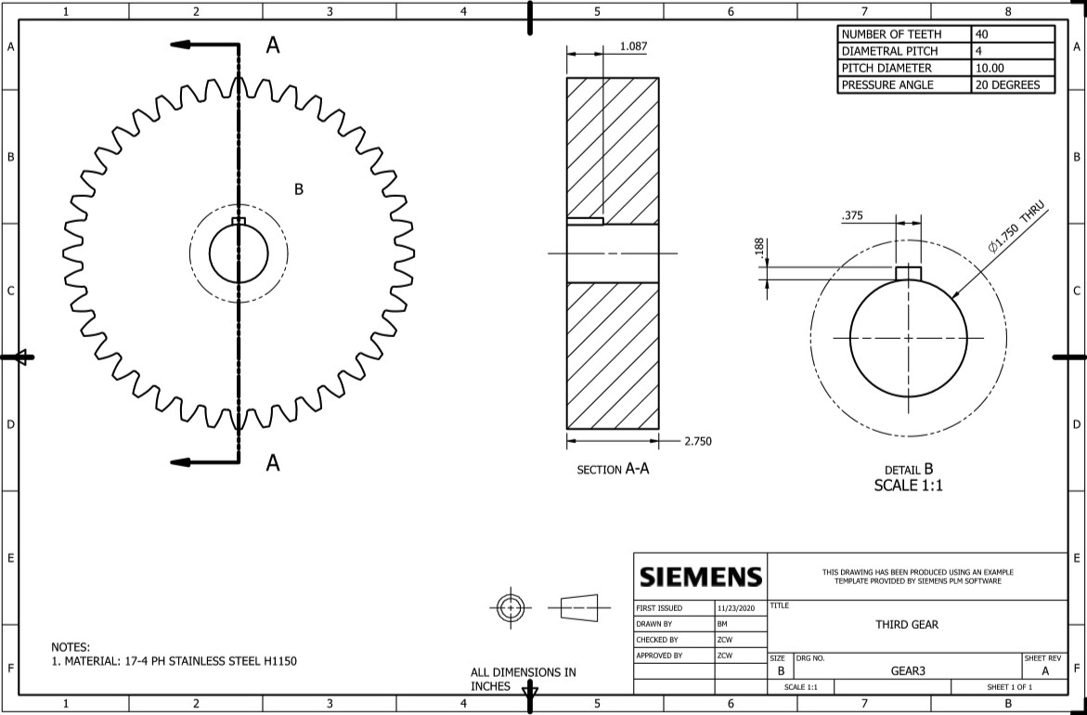
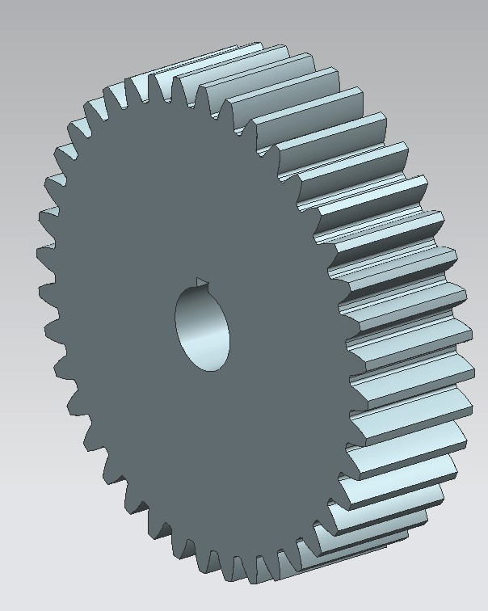
  - 3rd gear

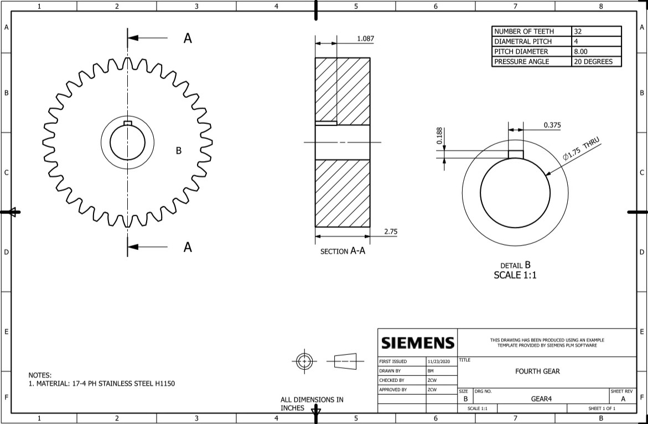
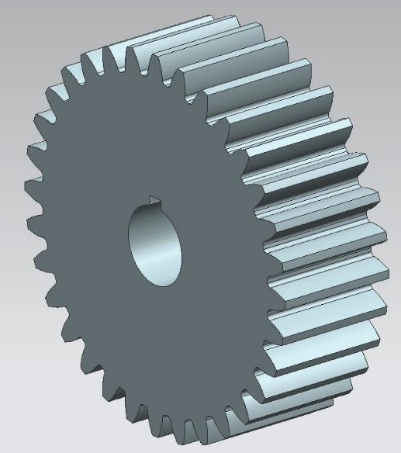
  - 4th gear

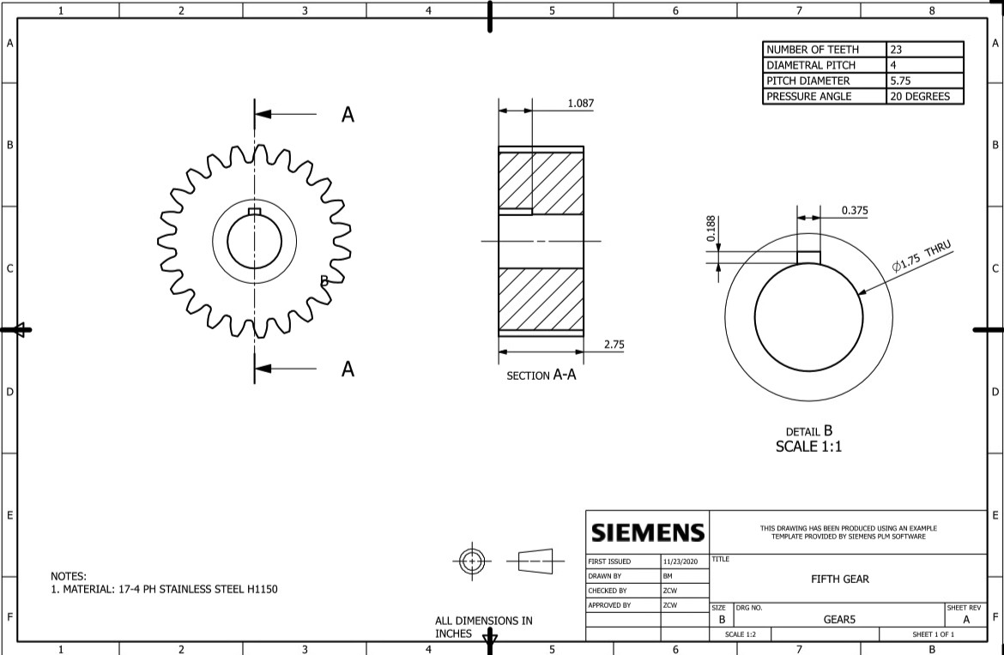
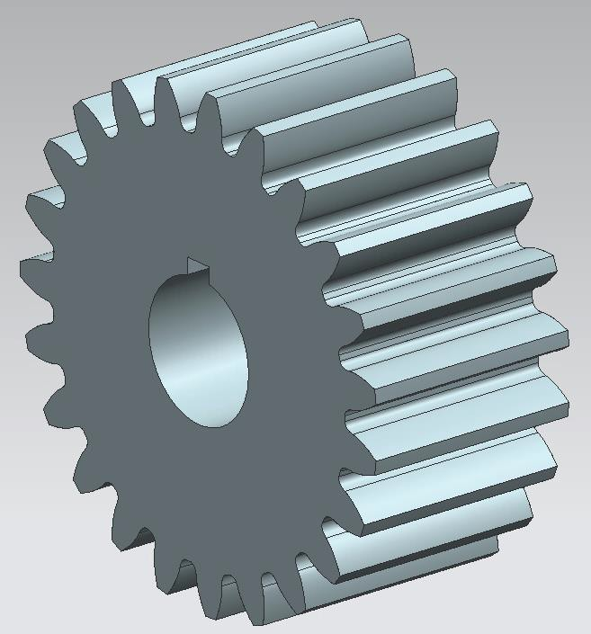
  - 5th gear

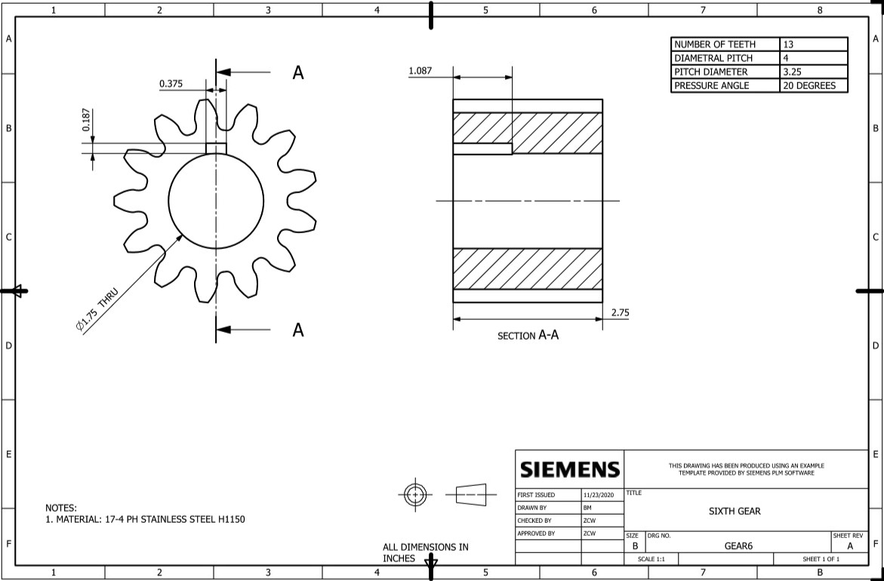
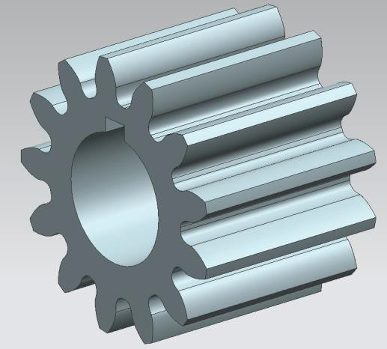
  - 6th gear

  - Reverse gear

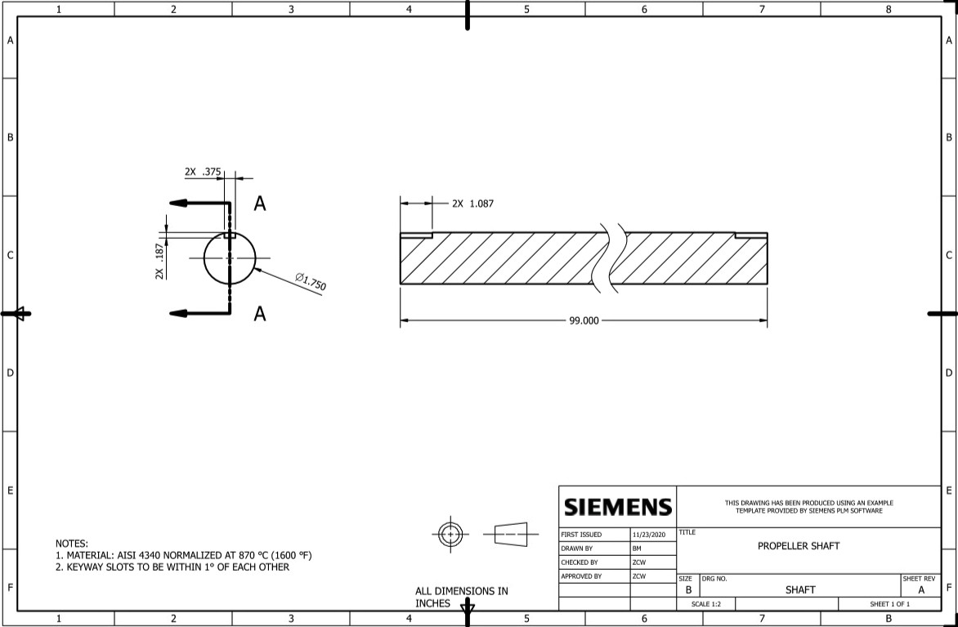
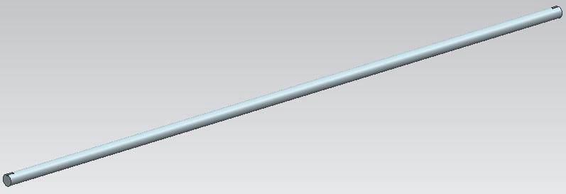
  - Shaft and its components (keys and bearings)

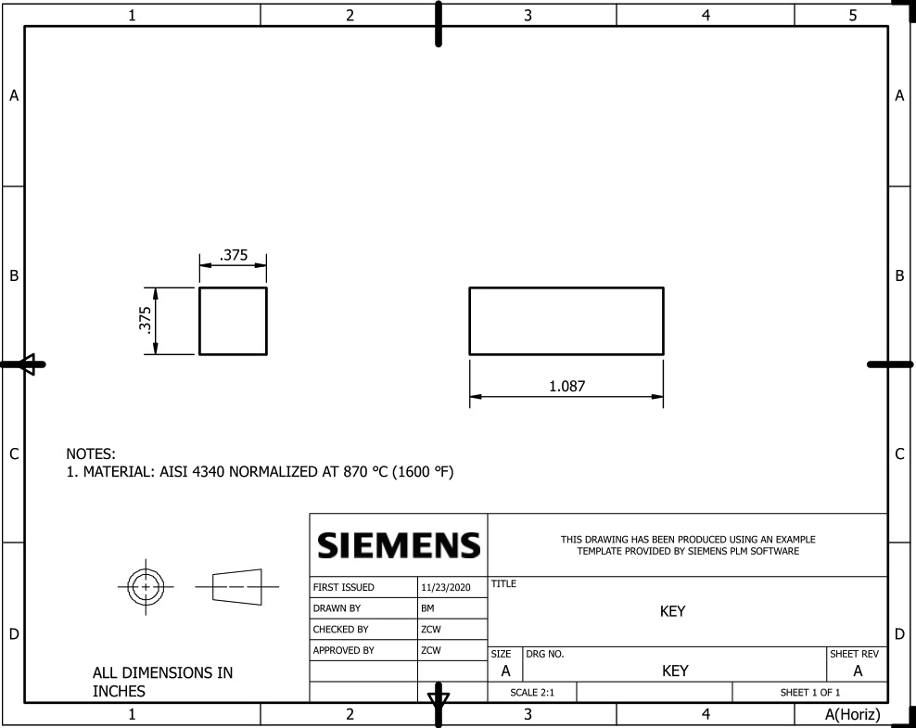
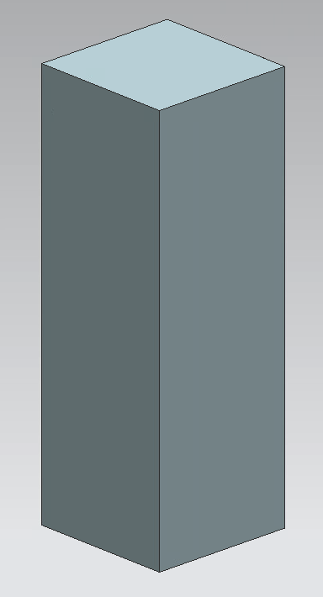


3
japark
2020-12-03 18:19:50
--------------------------------------------
Is there 1 in space between the gear and bearing?

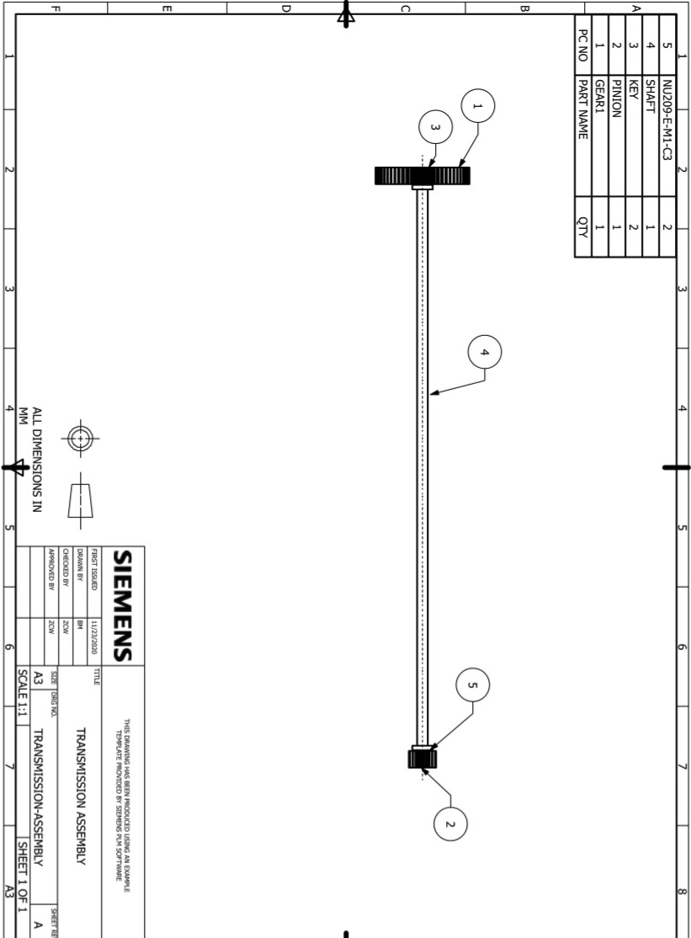

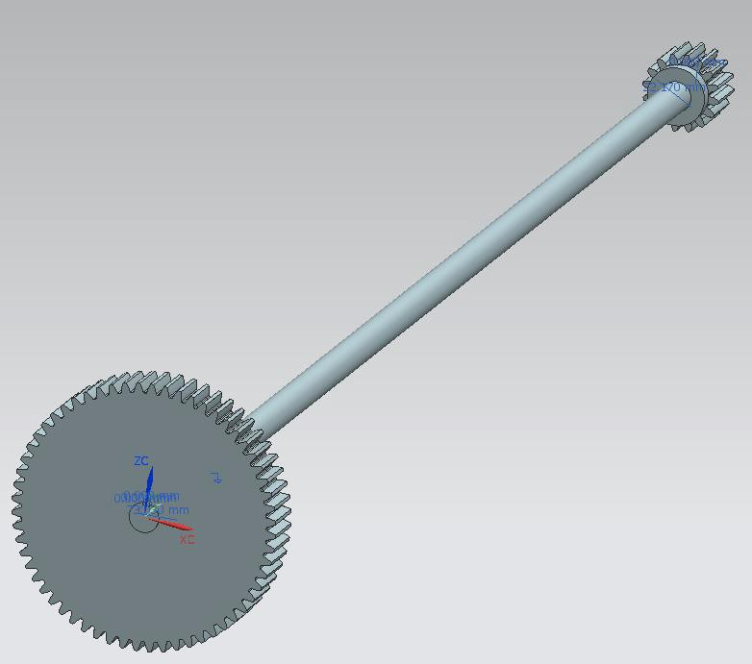

- Simulation (optional)
No simulation was performed

japark
2020-12-03 18:20:34
--------------------------------------------
You were not required to use NX to create CAD models.
- Conclusion
The transmission design met all the constraints and criteria for a successful design. The car would be able to travel up a 40% grade hill and drive at 65 MPH in sixth gear while the engine rotates at 2,500 RPM. The two bearings can handle the loads applied to them. The shaft is large to have an infinite lifespan according to the DE-Goodman criterion.

Some of the most difficult parts of this project were dealing with NX since there is much better CAD

software available and going through the iterations to choose a material that is suitable for the

application.

References
- Budynas, Richard G., et al. Shigley's Mechanical Engineering Design. McGraw-Hill Education,
2015.

- Stainless, Best. “17-4 PH Stainless Steel Bar.” Best Stainless, www.beststainless.com/17-4-ph- stainless-steel.html.

- “FAG Bearings.” Cylindrical BRG, Bore 45 Mm, Brass, www.grainger.com/product/FAG-BEARINGS-Cylindrical-BRG-5JCV0.

Appendix A

% Speed Calculator - v4.0
% Has two input arguments: (1) RPM and (2) gear number function SpeedCalc(n_engine, gear)
% Car Attributes d_w = 18;
w = 225;
AR = 45;
FD = 2.885;
T_engine_max = 239.0;
% Checks gear to set gear ratio (will add nore as project progresses) if gear == 6
GR = 0.8125;
elseif gear == 5 GR = 1.4375;
elseif gear == 4 GR = 2.00;
elseif gear == 3 GR = 2.50;
elseif gear == 2 GR = 3.125;
elseif gear == 1 GR = 3.75;
else
disp("Input valid gear number. At the moment, only gears 1 & 6 are available."); return
end
% Speed Calculations
r_wheel = (d_w/2) + ((AR/100)*(w/25.4)); n_propeller = n_engine / GR;
n_wheel = n_propeller / FD;; omega = n_wheel * (1/(60/(2*pi)));
V = r_wheel * omega * (1/63360)*(3600);
% Torque at wheels calculation T_wheel = FD * GR * T_engine_max;
% Prints speed, RPM, and gear
fprintf('Car speed is: %f MPH @ %d RPM on gear #%i \n', V, n_engine, gear); fprintf('Max Torque at Wheels is: %f lbf-ft on gear #%i \n', T_wheel, gear); end

Appendix B

% Gear diameter and face width calculator - v1.0
% Has two input arguments: (1) Gear ratio, (2) Pitch, (3) Strength of
% material
% This program prints several parameters for users function GearCalc(GR, P, sigma)
% PITCH DIAMETER
% Number of teeth for the engine shaft N_p = 16;
% Calculates the number of teeth for the properller shaft N = GR * N_p;
r = rem(N, 1); if r > 0
N_g = floor(N); GR_c = N_g / N_p;
fprintf('Corrected GR to have integer # of teeth: %f \n', GR_c); fprintf('Number of gear teeth: %i teeth \n', N_g);
else
N_g = N;
fprintf('GR: %f \n', GR);
fprintf('Number of gear teeth: %i teeth \n', N_g); end
% Calculates the pitch diameter for the gear d = N_g / P;
% Outputs the pitch diameter fprintf('Pitch diameter: %f inches \n', d);
%FACE WIDTH
% Engine parameter RPM and horse power n = 6200;
H = 234;
% Calculates pitch line velocity V = (pi*d*n)/12;
% Assume cut or milled K_v = (1200 + V)/1200;
% Calculates force W_t = 33000*(H/V);
% Y table
Y_mat = [12 0.245; 13 0.261; 14 0.277; 15 0.290; 16 0.296; 17 0.303; 18 0.309; 19 0.314; 20 0.322; 21
0.328; 22 0.331; 24 0.337; 26 0.346; 28 0.353; 30 0.359; 34 0.371; 38 0.384; 43 0.397; 50 0.409; 60
0.422; 75 0.435; 100 0.447; 150 0.460; 300 0.472; 400 0.480];
% Finds matching Y for number of teeth

c = ismember(Y_mat, N_g); k = find(c);
TF = isempty(k);
% If number of teeth does not match table then we interpolate if TF == 1
x = N_g; i = x;
j = x;
TF_min = TF; TF_max = TF;
% Finds lower number of teeth while TF_min == 1
i = i - 1;
c_min = ismember(Y_mat, i); k_min = find(c_min); TF_min = isempty(k_min); Y_min = Y_mat(k_min+25);
end
% Finds higher number of teeth while TF_max == 1
j = j + 1;
c_max = ismember(Y_mat, j); k_max = find(c_max); TF_max = isempty(k_max); Y_max = Y_mat(k_max+25);
end
% Interpolates Y x_1 = i;
x_2 = j;
y_1 = Y_min; y_2 = Y_max;
Y = y_1 + (x - x_1)*((y_2 - y_1)/(x_2 - x_1)); else
Y = Y_mat(k+25); end
% Calculates face width SF = 2.5;
f = (K_v*W_t*P)/((sigma/SF)*Y); fprintf('Gear face width: %f inches \n', f); end

