Assignment for Outcome 7

An ability to acquire and apply new knowledge as needed, using appropriate learning strategies

Demonstrated by ability to conduct a review of the literature for the design project
Demonstration of group’s ability to acquire and apply new knowledge as needed, using appropriate learning strategies using scope of literature review, references independently consulted, and codes and standards identified and used for our design project

MECHANICAL ENGINEERING DEPARTMENT
OUTCOMES SPECIFIC ASSIGNMENT COVER SHEET
MCEG 4248 SENIOR DESIGN & PROFESSIONALISM II P01, P02, & P03
SPRING 2022
Instructors: Dr. P.O. Biney, Dr. X. Peng, & Dr. C. Duan

Title of Assignment
Application of new knowledge using appropriate learning strategies for studying and gathering information for literature review of all project aspects

Outcome Measured Using this Assignment
Outcome 7
An ability to acquire and apply new knowledge as needed, using appropriate learning strategies

Check the outcome characteristics related to this assignment

Ability to Acquire new knowledge using the appropriate learning strategies
Requires students to:
√ | Be knowledgeable of and use different learning strategies (Instructor may provide information on different learning strategies  different learning strategies)
√ | Identify and take advantage of learning opportunities available in the library, online resources, seminars, webinars, conferences, workshops and tutorials.
√ | Be aware of the need for and are able to independently acquire additional knowledge and data needed for solving problem using appropriate learning strategies and tools.
Ability to apply new knowledge to solve problems
Requires students to:
√ | Demonstrate appropriate use of the new knowledge to solve problems.

Brief justification of why this assignment is suitable for this outcome
This section of the project design tests the students’ ability to recognize the need for, and ability to engage in life long learning as demonstrated by their ability to conduct a review of the literature for the design project and learning new information from various sources for the design project. The work for one of the nine project groups is presented as a demonstration of the students' abilities in this area and also as part of the design process. Information provided include:
(a) Project Planning chapter of the final report showing how students independently learned project management and software for project management.
(b) Literature review chapter of the final report
(c) List and discuss relevant codes and standards applicable to your design and show how they were applied in the design.
(d) List of references used
COLLEGE OF ENGINEERING
SENIOR DESIGN & PROFESSIONALISM I
FALL 2021- SPRING 2022 SEMESTERs

Status Report on Literature Review

This status report covers the information on the Literature Review chapter of the project report. Consequently, it should be written in a detailed descriptive form as we discussed in class for the assignment #2. The report should be prepared using the chapter title. ” 3. LITERATURE REVIEW” . The subsections highlighted in blue fonts should be used in the status report.

3. LITERATURE REVIEW
- Provide introductory paragraphs for this chapter that discuss the purpose of the this chapter.

3.1 Identification of Information Relevant to the Project

- Identify and list the types of information needed to be reviewed for a complete understanding of all aspects of the project. Describe in detail how you identified the types of information relevant to the project as an introduction to your response to this question.

3.2 Potential Sources of Information for Project

- For each information type listed in item 2 above, identify the sources you will need to use to obtain the information. This will also serve as a partial reference list for your project. Refer to how to list references in the Senior Project manual for the format for this section. Describe how you identified the sources as an introduction to the answer for this question.

- Plan the literature review chapter by carefully developing a Table of Content page for the subsections to be included in the literature review.
See example below

3. LITERATURE REVIEW …………………………………………………………….. 13

3.1 Identification of Information Relevant to the Project …………………… 14
3.2 Potential Sources of Information for Project……………………………………….. 14
3.3 Major Subsection Title 3 …………………………………………………………… 14
3.3.1 Minor subsection title 1………………………………………………….. 15
3.3.2 Minor subsection title 2 ………………………………………………….. 15
3.4 Major Subsection Title 4 ……………………………………………………………. 18
3.4.1 Minor subsection title 1 …………………………………………………… 20
3.4.2 Minor subsection title 2 ……………………………………………………. 21
Etc.

- Using the sources identified in item 2, and following your planned table of content, develop a well planned and exhaustive literature review for your project. The literature review should focus on relevant items that would help you with the design. This should include but not limited to:
- existing similar designs and how each functions, advantages and disadvantages of each of the existing designs;
- identifying the major components of the existing similar designs and how they function;
- identifying subject areas that are relevant as well as the design equations in these subject areas that are relevant for the design analysis that can be used for sizing and specifying the components of the design;
- identifying fabrication and testing methods and procedure for similar designs.
- Identifying codes and standards applicable to the design

- References should be properly cited in the literature review, and a list of references provided using the format provided in the Senior Project Manual which is available to you free on e-course.

Note: Attach a copy of this assignment statement sheet to your homework (placed after the cover sheet)
Assignment for Assessing Outcome c.2

Title: Demonstration of group’s ability to acquire and apply new knowledge as needed, using appropriate learning strategies using scope of literature review, references independently consulted, and codes and standards identified and used for our design project.

(a) Literature review chapter of the final report

3. Literature Review
The purpose of this chapter is to provide the resources and information to be utilized and referenced in the build of the deployable thermal shield. The information that is researched provides guidelines and previous examples of different variations that are similar to the project along with other resources that provide slightly different functions and different types of materials. The literature review provides a breakdown of types of necessary information regarding the project. Information that is relevant to the overall project along with a list of the cited sources of information is to be provided in this chapter. Following a construction of detailed information regarding the details of the project. In the subchapter following the list of cited sources the list of major sections including; Current technology, design aspects, fabrication, and the identification of applicable codes and standards for the design. Each of the major sections has subsections that detail the important and relevant information that is necessary for the project.

3.1 Identification of Information Relevant to the Project

For the project to be completely analyzed, there will be a summary of all aspects to take into consideration for the project. So that the team may have a better grasp on the overall evaluation, a breakdown of previous projects and necessary information provided in final reports create a general outline for the basics of understanding how to build the deployable thermal shield. The very first vital piece of information was understanding what the need for the project was. Understanding the purpose behind the initial drive allows engineers to build and design with the purpose to create an efficient machine. Also knowing that what is being built is not the first iteration, finding sources of information for technology that currently exists, and analyzing where the pros and cons reside within this engineering can designate a path that will allow for a clearer desired result. With previous projects, the important aspects that were taken into consideration were how the existing technology worked and the details regarding the build, cost of operation and manufacturing, and the longevity of the build. Research regarding the instruments the thermal deployable shield was used for, the details regarding the different mechanisms used for deployment, and the structure for storage. Also, the minimum requirements that had to be met for each build are different, so working with the company to find out what our restrictions would be and any codes that must be abided by for the build to be a success.

3.2 Potential Sources of Information for Project

The sources utilized were chosen through recommendations from the company representative and through research regarding studies and projects that have a similar concept and goal as that of the Deployable Thermal Shield. Proper sources were defined as scholarly articles, research papers, and lab studies. Material and functions that are used in space along with compartmentalizing the build were two main research points that guided the team through the research. Also, other projects that have been used in the past and have a report of success and failures were used to guide the research choices.

References

Article Arrange by information type: Still not heeded.

[1] Dew, M., Allwein, K., Kutter, B., Ware, J., Lin, J., Madlangbayan, A., Willey, C., Pitchford, B., O’Neil, G., Design, and Development of an In-Space Deployable Sun Shield for the Atlas-Centaur, NASA NTRS 20130010783, NASA, September 9, 2008, pp 4-11
Arrange by information type
[2] Ball Aerospace, Ball Aerospace’s Land Imaging Instrument on NASA’s Landsat 9 Satellite Launches Successfully, https://www.ball.com/na/newsroom/detail?newsid=124088 (September 27, 2021)

[3] NASA James Webb Space Telescope, https://www.jwst.nasa.gov/content/about/innovations/coating.html, 2021
Website
Research Paper
[4] Quest Thermal Group, Load Bearing MLI, https://www.questthermal.com/products/load-bearing-mli (September 29, 2021)

[5] Tuttle, J., DiPirro, M., Canavan, E., Hait, T., Thermal Properties of Double-Aluminized Kapton at Low Temperatures, NASA NTRS 20080045503, NASA, Jan. 1, 2007, pp 2-8

[6] Kopelove, A., Quest Thermal Group/ Ball Aerospace Next Generation MLI Products, Research Equipment Brochure, Quest Thermal Group, 2021

Aerospace Codes & requirements
[7] Ball Aerospace, AIAA Requirement Verification Matrix, AIAA S-114-2005, Ball Aerospace, 2005

3.3 Current technology used for Thermal Protection in the Aerospace environment

This section covers the current technology in regards to our working device. Topics within this section range from space instruments, radiators, and currently developed shields. The thermal shields that are talked about in this section have similar functions to our deployable thermal shield. There are also figures to go along with the functions and descriptions of the following space instruments.

3.3.1 Current Thermal Shield Space Instruments
Hypersonic Inflatable Aerodynamic Decelerator (HIAD)- is designed to be a protective shield for spacecraft headed to Mars. In figure 3.1,the thermal protection system is made from a variety of advanced materials including Nextel, Pyrogen, and Kapton to provide heat shielding, which is expected to be generated in the Martian atmosphere. This Hypersonic Inflatable Aerodynamic Decelerator has the strength to resist airspeeds as high as 42,000 kilometers per hour. The inflatable rings are made from braided Kevlar which is a material normally found in bulletproof vests. The Hypersonic inflator is portable and small. The whole shield can fit inside a bag around half a meter in diameter, which, when deployed, expands to more than six meters. This makes it far easier to package and can be placed in the nose of a rocket.[2]
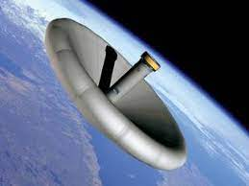
Figure 3.1 Hypersonic Inflatable Aerodynamic Decelerator (ref 2)
Designed to be a protective shield for spacecraft headed to Mars. (HIAD)

3.3.2 Thermal Shield Radiation

The Multi-Arm Radial Composite (MARCO)- reflector uses sectioned, high-strain composite shells as the intelligent opening. The Multi-Arm Radial Composite (MARCO) deployable receiving wire reflector is presently being created at the Air Force Research Laboratory Space Vehicles Directorate to give a moderately minimal expense, high-acquire, versatile design for shuttle radio recurrence (RF) applications.

The shell sections are intended to get back to the ostensible illustrative shape utilizing put away strain energy and keep up with required shape exactness without outside help. The methodology expects to altogether decrease cost through the decrease of created parts and get-together time contrasted with existing cross section-based frameworks that flexibly couple the reflector surface to the supporting construction using the links requiring individual length acclimation to accomplish a precise surface figure.

The MARCO reflector antenna is shown in figure 3.2. The radial arm assembly is structurally independent of the other arms and is only connected to the center structure at the base of the radial arm. The radial arm contains a rotating joint at the center location, as well as the radial arm mid-span, which causes the structure to open and close. When the structure is opened, it is called the deployed state, when the structure is closed, it is called the stowed state. The inner and outer shell segments are changed into a circular overlapping fold so the reflector can sustain the stowed shape, as shown in figure 3.2(b).[6]

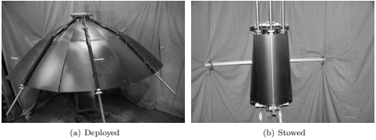

Figure 3.2 The demonstration of the novel MARCO feasibility (ref 6)

3.3.3 Current Aerospace shield Insulations

Load Bearing Multi-layer insulation- Mission Thermal Group and Ball Aerospace, with NASA SBIR support, have fostered an original Load Bearing multi-layer insulation (LBMLI) fit for self-supporting warm safeguards and giving a high thermal performance. The project has proceeded with improvement in Load Bearing multi-layer insulation a Phase III NASA multicenter test program, including configuration, demonstrations and theories, underlying testing through energy and acoustic stacking, calorimeter warm testing, and Reduced Boil-Off (RBO) testing for NASA enormous scope cryo tanks. Teammates included Ball Aerospace, NASA Marshall Space Flight Center, NASA Ames Research Center, NASA Glenn Research Center, and NASA Kennedy Space Center.

In figure 3.3, the Load-bearing multi-layer insulation is advanced insulation that utilizes discrete polymer spacers to keep up with layer thickness that supports warm safeguards and diminishes heat loss through the protection framework. The load-bearing multi-layer insulation uses a refrigeration loop to block the energy flowing through the multi-layer system to a liquid hydrogen tank that is used in the system. The temperature between the environment and the liquid hydrogen can lower the heat load to as much as 50%. Load-bearing multi-layer insulation is a cutting-edge ultrahigh execution warm protection.

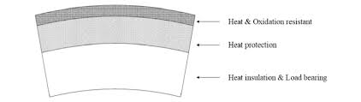
Figure 3.3 Load bearing Multi-Layer Insulation

Launch Vehicle multi-layer insulation- offers the protecting properties of Integrated multi-layer insulation with a vigorous construction and more strong external layer to withstand streamlined dispatch loads. In figure 4.4, the Launch Vehicle multi-layer insulation incorporates more unbending layer division than integrated multi-layer insulation to work in both the aerothermal dispatch climate and the ground climate. Launch vehicle multi-layer insulation upholds an inside vacuum that expands its protecting abilities over Integrated multi-layer insulation. This insulation prototype demonstrates survivability in the aerodynamic launch environment. The Launch Vehicle multi-layer insulation offers more structural strength than the Load-bearing multilayer insulations, which proves to be a more effective mechanism. The LVMI had a 68-fold lower heat leak and has a 43% lighter mass.

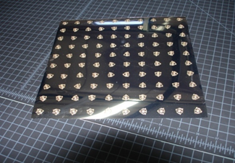

Figure 3.4 Launch Vehicle multi-layer insulation

Load Responsive Multi-Layer Insulation - (LRMLI) utilizes a dynamic spacer and a measured, lightweight vacuum shell to withstand environmental burdens. In figure 3.5, the LRMLI gives both high warm execution in-air, and super superior on-circle. LRMLI is a Spray on Foam Insulation supplanting framework with considerably better performance. The LRMLI framework is the most solid item in the cutting-edge multilayer insulation item family. LRMLI is the ideal protection for LH2-tanks with in-air activity. LRMLI uses a novel, proprietary, and patented discrete spacer that provides both low thermal conductance and the ability to support over 90psi when loaded but disconnect when unloaded (external load). LRMLI insulation structures use a modular, flexible thin vacuum shell that allows the insulation to maintain an internal high vacuum while minimizing system mass.

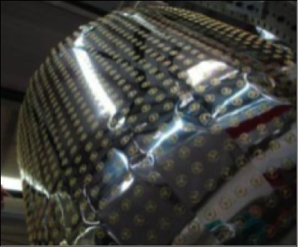
Figure 3.5 Load Responsive Multi-Layer Insulation

3.4 Design Characteristics

This section is to cover the possible different design aspects that come together to create the operating mechanism. The different types of involved ideas include thermal shielding material; the storage and weight constraints of the structure, the strain energy deployment mechanism, inflating deployment mechanism, and the necessary coding for each of the different deployment types to be controlled. Each different design will include a description of how those developed ideas would work. Although the same basic idea is created, a protective covering that opens and closes around the payload, the different approaches all leave with different problems and approaches that have their own individual advantages.

3.4.1 Thermal shielding materials

In order for the requirements, stated previously in the project goals and objectives section, to be upheld a material that is capable of protecting the working device in extreme temperature conditions while maintaining low mass structural integrity must be used. Aluminized Kapton (AK), which is commonly used in cryogenic systems, is the desired material for the thermal shield. Strategically aligning sheets of this material will allow for the instrument to properly function as thermal radiation from the sun, earth, and the instrument itself reflect away from the protected load and into space. To obtain such a practical material for the desired task various tests such as emissivity, resistivity, and thermal conductivity must be analyzed. Equations for the respected parameters can be found below:

Residual resistivity ratio (also known as Residual-resistance ratio or just RRR) is usually defined as the ratio of the resistivity of a material at room temperature and at 0K. Since 0K can never be reached in practice some estimation is usually made. In space, the temperature is roughly 2.7K and that would be roughly the range of the calculations used for this thermal shield.

Residual Resistance Ratio → RRR = $\frac{ρ(300K)}{ρ(2.7K)}$;

Where, ?? not still explained
RRR = residual resistance ratio
$ρ$ = resistance
300K and 2.7 K are set parameters

Deforming the material resulting in varying thicknesses would suggest that the purity and structure of the material will not change drastically and any damage done to the deformed material will not require a measurable resistivity change.

The total emissivity of the material is derived by the expression:

$ϵ=\frac{Q}{σA(T^{4}{}_{material}- T^{4}{}_{environment})}$; ($\frac{J*s^{-1}}{m^{2}}$)

Where,
$Q$= Heat Transferred
$ϵ$= Emissivity
$T^{4}{}_{environment }$= Environmental Temperature
$T^{4}{}_{material}$= Temperature of Material
A = Area of Material

The thermal conductivity of the material is derived by the expression:

K = $\frac{Qd}{AΔT}$; ($W*m^{-1}*k^{-1}$)

Where,
Q = Heat Transferred
d = Distance of Material
A = Area of Material
$ΔT$= Change in Time

The steady-state temperature of the material, the area, and the material’s temperature must be obtained to find effective emissivity. The Aluminized Kapton material meets the specifications set out as its structure is durable enough for the environment while being lightweight and pliable enough to be manipulated. Depending on the preferred mechanism, such as strain energy deployment or inflating deployment, additional material can be introduced in order for the working device to function accurately in protecting the payload.

3.4.2 Storage and Weight Constraints

To reduce the mass of the thermal shield the development of a working device with functional thermal shielding materials throughout must be utilized. In the stowed state, the shell is layered with a material that is light in mass allowing for weight to be distributed elsewhere within the instrument. When deployed, energy is required to elongate and shield the device. To minimize the mass of the reflecting shell from its current value of 36% of the reflector mass, manipulations must be assessed in arranging and storing the selected material throughout the instrument. To attain reliability and redundancy when storing and deploying, the working device various mechanisms were assessed.

3.4.3 Strain Energy Deployment Mechanism

A major type of energy that appears within the working device is stored strain energy which allows for the shell to be deployed and stowed through radio frequency (RF) applications. This particular energy is stored within a spring-loaded structure. This allows for the strain energy stored within the shell to be equal to the strain energy in its stored state. The equation for strain energy can be found below:

Strain Energy Formula → $U=\frac{Fδ}{2}$; (J)

Where,
U = Strain Energy
F = Force Applied
$δ$= Deformation

When stress is proportional to strain, the strain energy formula is → $U=\frac{1}{2}Vσϵ$; (J)

Where,
U = Strain Energy
V = Volume of Body
$σ$= Strain
$ϵ$= Tensile Strain
Regarding Young’s Modulus, the strain energy formula is → $U=\frac{σ{{{}^{}}^{2}}^{}}{2E}V$; (J)

Where,
U = Strain Energy
$σ$= Strain
V = Volume of Body
E = Young’s Modulus

3.4.4 Inflating Deployment Mechanism

To land bigger payloads on other planets and into orbit a thermal shield that is inflatable must be introduced. From figure 3.6, the mechanism will allow the shield to produce more drag while saving on mass in the payload. Previously stated within the current thermal shield space instrument section, the Hypersonic Inflatable Aerodynamic Decelerator (HIAD) overcomes the packaging limitations of rigid systems by utilizing inflatable materials that can be stowed within the payload.

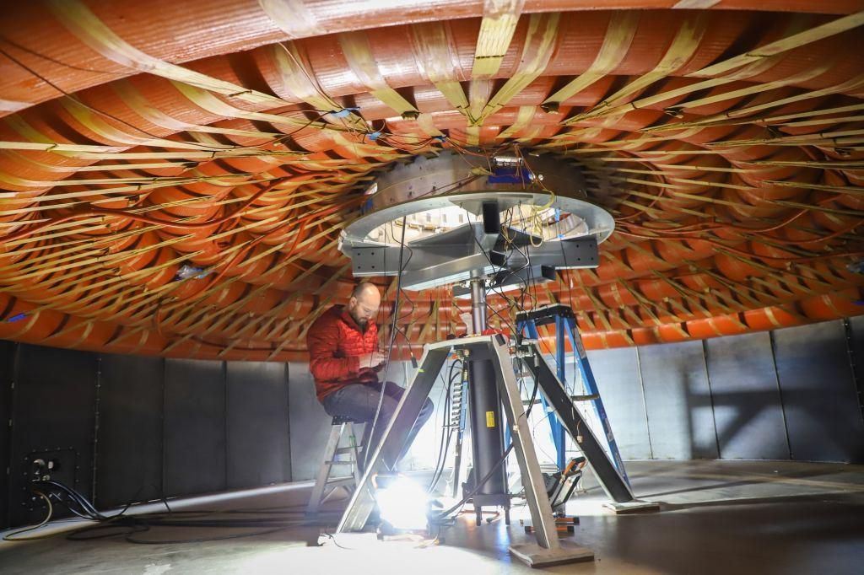
Figure 3.6 Testing on Base of Inflatable Heat Shield.

Other spacecraft have used solid heat shields that drop away as the spacecraft nears the surface or gradually erode in the atmosphere. Not only does this affect the environment, but these solid shields are also heavy which limits the weight of the payload. Their physical size is also limiting since the shields must be small enough to fit inside a launch rocket. In saying this, we can rather address these issues by utilizing inertial force, or specifically, centrifugal force generated from autorotation to deploy and stiffen a flexible heat shield. Centrifugal force can be categorized as a particle moving on a circular path that has the same magnitude and dimensions as the force that keeps the particle on its circular path but in the opposite direction.[5]

Centrifugal Force → $F=m ω^{2}r$; (kN)

Where,
F = centrifugal force
$m$ = mass of the material
$ω$= angular velocity
$r$ = distance from the origin of the material

3.5 Fabrication

This section covers the fabrication process, including the material being used, and the required working device structure.

3.5.1 Material Tested
The material that is used in this design is Aluminized Kapton is shown below in Figure 3.7.

Figure 3.7 Aluminized Kapton
Based on the thermal properties, double-layered Aluminized Kapton is a good thermal insulator. Kapton has a high heat resistance and remains stable throughout a wide range of temperatures from minus 269 to plus 400 degrees celsius. The Kapton is coated with aluminum and a doped silicon for durability in space and optical properties ref [6]. A report from the NASA Technical Reports Server describes the shield's thermal properties. The shields made from this material reflect away thermal radiation from the sun, while on the other side radiates the heat to space ref [1].

3.5.2 Processes and Fabrication
The frame was fabricated in a metal shop. Light frame pieces were attached using bolts or welded depending on their specific application. Aluminized Kapton is commercially available from Dupont.

3.5.3 Working Device Structure

The thermal shield in Figure 3.8 is made from Kapton coated with reflected metal. The working device structure used in the making of the shield is a stand that holds the sun shield. This is the working device structure to put the frame and the shield together.
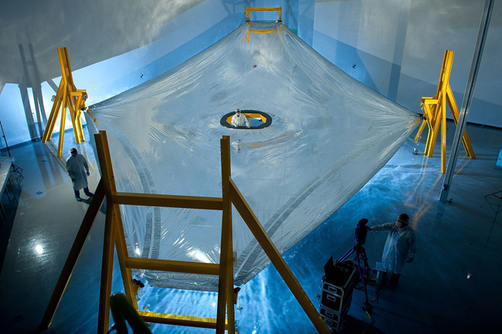
Figure 3.8 Thermal Shield ref [6]
Figure 3.9 shows a foldable thermal shield from NASA in which demonstrates an example of a mechanism for how the thermal shield can be folded. As the working device is pushing down on the arms, the shield opens up.
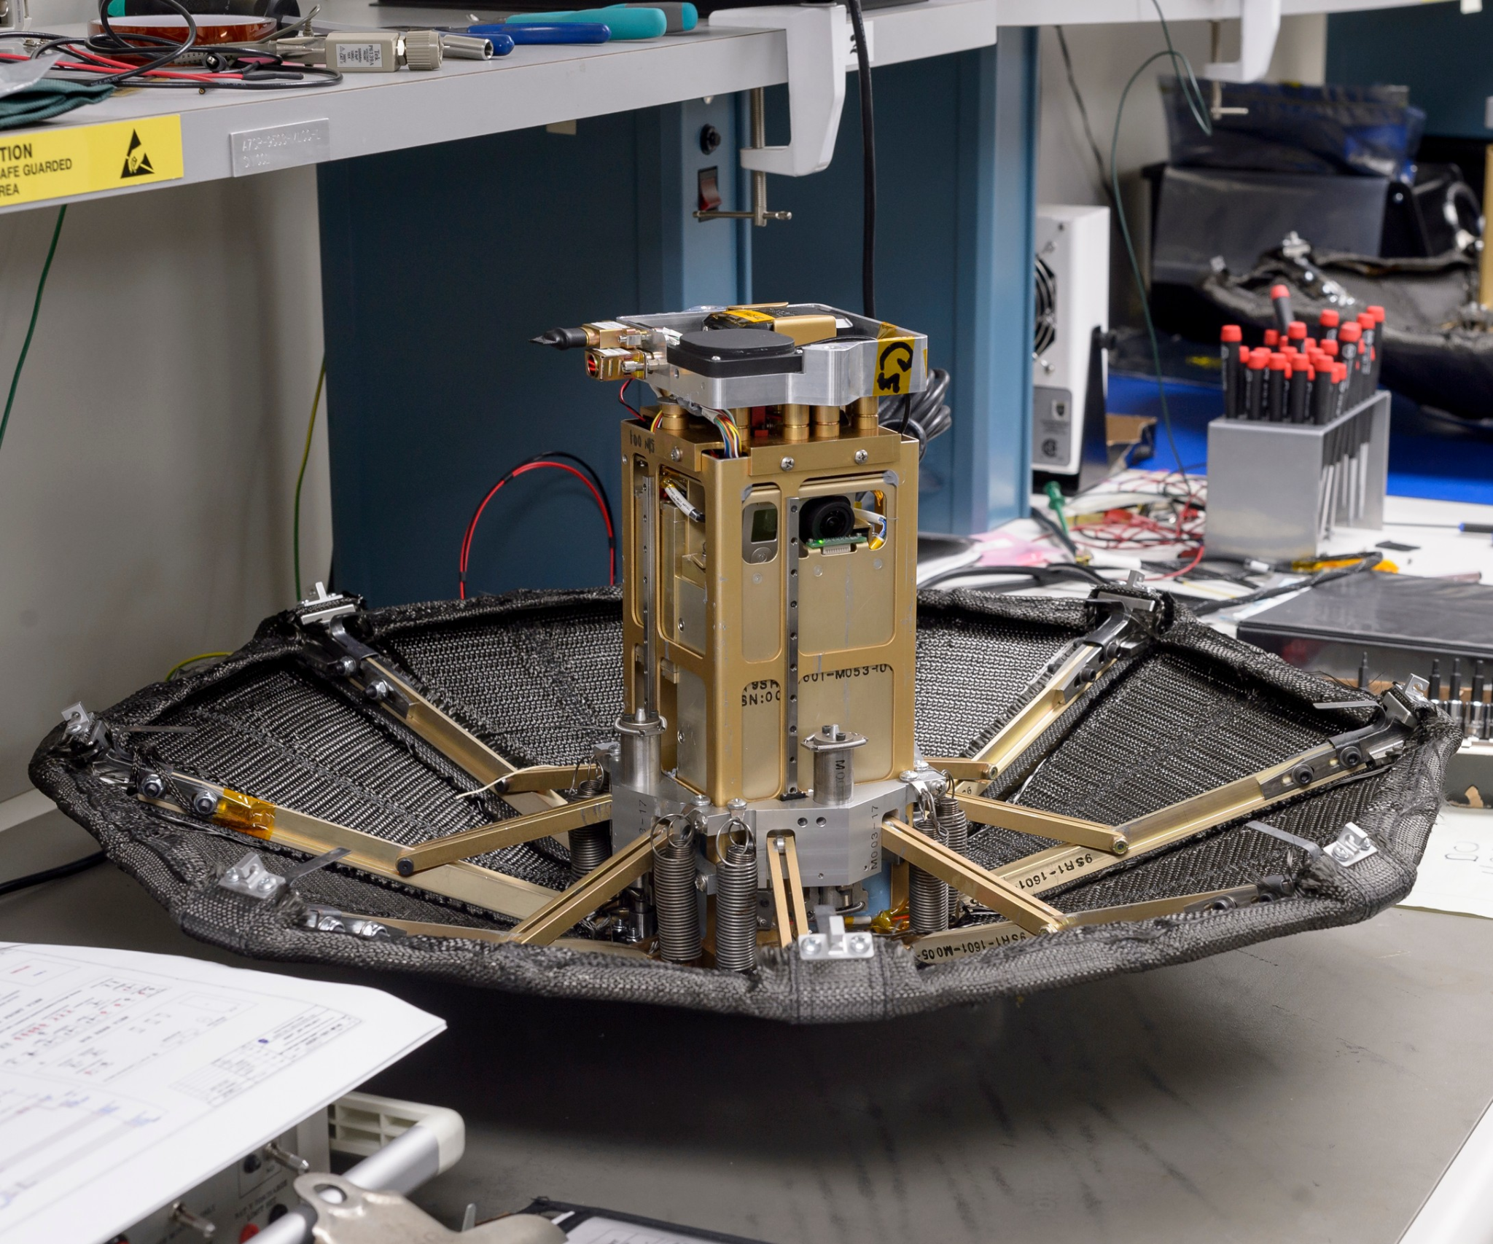
Figure 3.9 Foldable Thermal Shield

3.6 Identifying Codes and Standards Applicable to the Design

The American Institute of Aeronautics and Astronautics created the AIAA S-114-2005 Requirements Verification matrix which outlines requirements and standards for the building of Moving Mechanical Assemblies(MMAs). The Codes are divided into sections to detailed specific requirements.[7]

Section Identification |  | Requirement description
5.1 General Performance Requirements | 1 | Deployables and other movable systems shall, where practical, be designed so that they are self-supporting when placed in any orientation relative to gravity, while in either the stowed or deployed configuration.
 | 2 | They shall be designed with sufficient motive force to permit full operation during ground testing without depending on the assistance of gravity to demonstrate deployment. Off-loading devices to simulate a zero “g” condition are allowed so that the movable system is adequately supported.
 | 3 | For all deployables, the deployment motion shall, where practical, be controlled for the full range of travel.
 | 4 | Where two or more deployables are used on a space vehicle, the deployment/operation of one shall,  where practical, be independent of the successful deployment/operation of the other.
 | 5 | Deployables and other movable systems that require discrete sequential motions, each initiated by separate commands, or any mission-critical deployable shall, where practical, have a backup ground command for each event.
5.1.2 Force/Torque Margins | 1 | MMAs should be designed with the highest practical torque margin or, for linear devices, the highest practical force margin.
 | 2 | The performance sensitivity of MMAs to environmental variations such as temperature, pressure, acceleration, vibration, and radiation shall be evaluated.
5.1.2.1 Static Torque or Force Margin | 1 | The static torque margin shall be expressed in percentage and is calculated as follows:  % = {[drive torque / resisting torque] -1} * 100  For linear devices, "force" replaces "torque".  The static margin is calculated by using the minimum driving torque or force and maximum static resisting  torques or forces.
Section Identification |  | Requirement Description
5.1.2.2 Dynamic Torque or Force Margin | 1 | The dynamic torque margin shall be expressed in percentage and is calculated as follows:  % = {[drive torque - resisting torque / torque required for acceleration] -1} * 100  For linear devices, "force" replaces "torque"  The dynamic torque or force margin is calculated by using the minimum drive capability available to  accelerate specified inertia or mass at a specified rate. Acceleration due to vehicle motion or  maneuvers which can retard deployment shall be included as part of the required acceleration.
5.1.4 Dynamic Performance | 1 | Dynamic analyses shall consider the resonant frequency, damping characteristics, and dynamic loading  effects such as cyclic/harmonic disturbance torque from gear error, bearing noise, motor ripple, and other  cyclic disturbances.
5.2 Environmental Design Requirements | 1 | The MMAs shall be designed to function within performance specifications when exposed to  environmental levels that exceed the maximum levels predicted during its service life by the contractually  specified margins. Unless otherwise specified, maximum predicted environments shall be determined in  accordance with the definitions in TR-2004(8583)-1 (to be superseded by MIL-STD-1540E and  subsequent versions).
5.2.1 Launch Environment | 1 | The equipment shall be designed to function within performance specifications after exposure in the  launch configuration to the maximum launch or other non-orbital service environments. These  environments include temperature, vibration, acoustic noise, shock, acceleration, atmospheric pressure  including vacuum, humidity, low-pressure–induced corona, and electrical storms with associated  radiation.
Section Identification |  | Requirement description
5.2.2 On-Orbit Environment | 1 | MMAs shall be designed to function within performance specifications following or, if required, during exposure to the specified environments. These environments include thermal, vacuum, atomic oxygen, micrometeoroids, radiation, shock, random vibration, and acceleration.
5.2.3 Fabrication, Storage, transportation, and Handling Environment | 1 | Environmental conditions (including cleanliness, temperature, and humidity) shall be controlled for the  MMA throughout storage, fabrication, handling, and transportation so they do not exceed those imposed  by the maximum specified environment.
5.3 Physical Requirements
5.2.2.1 Clearance | 1 | The clearance requirements within the MMA and between the MMA and any other structure, component, and field of view shall be established and maintained.
 | 2 | The manufacturing, assembly, and alignment  tolerances as well as environmental conditions such as temperature, temperature gradients, vibration,  distortion due to relaxation of the “g” field, effects of centrifugal forces, and acceleration during the critical  periods of launch and on-orbit operations shall be taken into consideration for establishing clearance  adequacy.
 | 3 | Those clearances shall, where practical, be  checked throughout integration and test and before launch.
5.3.2.2 Alignments | 1 | Provisions shall be included to ensure alignment of MMAs for the next higher assembly and  other subsystem elements if alignments cannot be controlled by drawing tolerances. A shimming-type  alignment technique may be used where additional surface area is necessary to provide a bearing  surface or where electrical bonding is required.
Section Identification |  | Requirement description
5.3.2.3 Mechanical | 1 | Field joints shall, where practical, be provided to permit disassembly of all MMAs, deployables, and other movable systems from the next higher assembly to facilitate testing or replacement of parts.
 | 2 | A common interface drill template may be used to ensure correct mechanical mating, particularly for  interfaces external to the MMA.
 | 3 | The MMA shall, where practical, be easily installed and readily accessible for inspection or removal.
5.3.3 Operability
5.3.3.1 Human Engineering | 1 | The design of all MMAs shall be such that they may be tested or inspected to ensure that they are  assembled and installed correctly.
 | 2 | Provisions such as tabs and shoulders should be used to prevent assembly in any incorrect manner that may impair the intended functions of the MMA.
5.3.3.2 Safety | 1 | A safety hazard to personnel and surrounding equipment shall not be created during installation,  maintenance, ground test, and transportation of MMAs and deployables.
 | 2 | MMAs, particularly those associated with deployables, shall be protected from damage that may occur at any stage of the fabrication, assembly, testing, or transportation.
5.3.4 Interchangeability | 1 | The marking of any two or more items with the same item number or identification shall indicate that they  are capable of being changed, one for another, without alteration of the items or adjoining equipment except for alignment adjustments.
5.4 Electrical and Electronic Requirements
Section Identification |  | Requirement description
5.4.1 Cables and Wiring | 1 | Cable and harness construction, durability, and flexibility shall be considered early in the MMA design.
 | 2 | Wiring external to MMA components shall be by MIL-HDBK-83575.
 | 3 | Wire shall be properly sized and derated for maximum operating voltage and current,  allowable voltage loss, temperature rise, and cable resistance changes as a function of temperature.
5.4.2 Connectors | 1 | Electrical connectors should be chosen so that power sources use sockets instead of pins. This  minimizes the possibility of the inadvertent grounding of an unmated, powered connector or injury to an operator.
 | 2 | Separate connectors shall, where practical, be used to physically isolate primary and redundant  circuits.
5.4.3 Cable Supports and Strain Relief | 1 | Cable supports and cable strain relief devices shall be designed to prevent chafing of harnesses during test, launch, and on-orbit environments.
 | 2 | Cable service loops shall, where practical, be used to minimize the possibility that thermal expansion effects will cause damage to the cable and to allow rework.
5.4.4 Cable Loops | 1 | Where wiring harnesses cross a moving or rotating interface, the parameters affecting loop torque,  stiffness, and life shall be identified, controlled, and documented. Examples include loop sizes, wire type,  distances to attachments, tightness of outer wrap or lacing.
 | 2 | Attachment clamps shall be provided  sufficiently close to any loops so that movement of the harness into the path of motion of the MMA cannot occur under any conditions.
Section Identification |  | Requirement description
5.4.5 Current Draw | 1 | The total current drawn during each mode of operation shall be determined to preclude inadvertently electrical overloads and related thermal issues.
 | 2 | These determinations or measurements shall be made at the nominal and maximum operating voltages and under the most severe environmental conditions.
5.4.6 Grounding | 1 | All conductive parts of the MMA shall be grounded to the vehicle structure or ground plane to minimize or eliminate charge buildup and shock hazards.
5.5 Structural Requirements | 1 | Structural design of each MMA shall be performed based on load analysis, stress analysis, fatigue  analysis, and the substantiating test program.
 | 2 | Fracture mechanics analysis shall be performed if the brittle failure mode cannot be avoided.
 | 3 | The design shall possess sufficient  strength, rigidity, preload, and other necessary characteristics required to survive all loads and  environmental conditions that exist within the envelope of mission requirements, to meet the performance requirements.
5.6 Reliability | 1 | The MMAs shall, where practical, utilize redundancy in the design to improve reliability.
 | 2 | Where redundancy is provided, the redundant portion of the MMA shall be following all the  requirements of this standard.

(b) Project Planning chapter of the final report

2. PROJECT PLANNING AND TASK DEFINITION

When planning the project and defining the task of this assignment the group focused on various aspects. By using a Gantt Chart, the group was able to keep track of deadlines and how long each task took to complete. The group had to identify the tasks, state the objective and the deliverables of each task. After completion the group estimated the personnel, time, and other resources needed to meet the objectives. Lastly, the group developed a sequence for the tasks and estimated the product development cost.

2.1 Task identification

Tasks are activities that need to be performed to bring the problem from its current stage to the final product. In order to identify these tasks the group focused on who on the design team will be responsible for meeting each objective. The group also addressed the time required per task as well as confirmed the feasibility of the personnel, equipment, and time available. All tasks were made specific and clear.

2.1.1 Tasks for Fall 2021

The tasks for fall 2021 were created by using the senior design template as a guide in properly following through with the creation of the project. By researching each major task to discover the correct engineering method for the task to be completed. After all group members researched these tasks individually through text, web, or other sources we all came up with multiple suggestions. Once assessed we discussed and agreed upon 4-6 sub-tasks then divided these tasks up between all members.

- Problem Formulation
  - To describe the problem formulation task it was broken down into multiple sub-tasks. These tasks are represented as identifying the customer, identifying the needs, formulating the goal statement, defining the objectives, developing the objective diagram, and identifying constraints and operating environments.

- Project Planning
  - To provide a detailed description of the literature review task, it was broken down into multiple parts. These tasks are represented as task identification and detailed list, development objectives for each task, determine all deliverables, create a timeline, and execute the project assigned.

- Literature Review
  - To describe the literature review task it was broken down into multiple sub-tasks. These tasks are represented as identification of information relevant to the project, identify potential sources of the information, use the sources to develop a comprehensive literature review for the project, and list sources of information using acceptable reference citation format.

- Functional Decomposition
  - In describing the functional decomposition, the roles were broke down into multiple sub-tasks. These tasks are represented as: find the most general function, find the closest sub-function, break down the sub-function to simplest form, create the function diagram, define the material needed.

- Concepts Generation
  - To describe the concept generation task, it was broke down into multiple sub-tasks. These tasks are represented as: define individual concepts, generate concepts using well-established concepts generation techniques, consolidate individual concepts and sketches into team concepts for each function, and determine the needed function for generating the concept.

- Concept Evaluation
  - In describing the concept generation task the evaluation was broke down into multiple sub-tasks. These tasks are represented as assembly all ideas relate to the concept, evaluate concepts through multiple methods, apply evaluation techniques to evaluate concepts for each function, choose one focal point of evaluation for the project
- Preliminary Design
  - For the preliminary design section, it began by listing the boundaries to which the design is to be confined. Taking into consideration at this level would be the overall size, function of the major components, and storage. The idea is to gather an overview of what the project is to do within what is allowed. The team then reviews the functionality of the design and evaluates it as a whole. Once the initial evaluation is complete, it is to be reviewed in its entirety once again.

- Detailed Design
  - The detailed design was required to be broken down the project into separate components and then assess each section individually. This task requires identifying where different components start and finish, along with reviewing their functionality and contribution to the overall build. Once each component has been separated and assessed, an overview evaluation is completed followed by a team review of each component design.

2.1.2 Tasks for Spring 2022

The tasks for the Spring semester were identified by using the senior design template as a guide for how to properly follow through with the creation of the project along with brainstorming with the team with what actions need to be followed. We had reached a point of concept evaluation and then broke down how the team would transition from a concept to a manufactured product. The team started with the broad concept of the chosen project idea and then broke it down into smaller components once the larger sections were detailed to satisfactory. These tasks started with the major concept, then more specific information was defined, and once the product itself had been evaluated, the ideas for budgeting, purchasing, and fabricating commenced. This was then followed by the steps necessary to present and discuss the finished product. Each task was created through research to discover the correct engineering method for the task to be completed. From the research 4-6 sub-tasks were identified then divided by group members and assigned dates.

- Detailed Parts Specifications
  - Detailed parts specification requires taking all the information from the previous major task and incorporating all the information necessary to build. This requires but is not limited to, connection diagrams for the location of bolts and screws, material that components are made out of, the weight of each component, identify the quality of the parts, and reevaluating all decisions made in this task to ensure consistent productivity from each subsection. This is all to be followed by a developed list of required parts that will be essential to the organization and build of each subsection.

- Budget and Project Cost (Economic Analysis)
  - The economic analysis task is the section that requires the identification of direct costs, indirect costs, and intangible costs. Direct costs can be completely attributed to the production of the product. Indirect costs are those that would not be directly attributed to the build of the product but would be necessary for a specific circumstance or unexpected situation. And intangible costs would be those not necessarily paid monetarily, but through sacrifice, effort, and participation. This section also requires the acknowledgments of potential risks and will require the team to formulate this list. And once the costs have been identified, formulating the direct and indirect benefits is the next necessary step in the procedure for budget and project cost.

- Purchasing
  - In the Purchasing section, the definition for an affordable budget is created. Once formulated, the minimum necessary inventory requirements will be made and listed for organizational purposes. Next, the negotiation of the price for materials can be made. Once there are definitive prices on materials, the list for tools, material, and necessary manufacturing are taken into consideration to formulate the bill of quantities and estimated overall price.

- Fabricating and Testing
  - This task requires the fabrication and testing of different models to be evaluated for the final product. The test models are to be built to meet the design specification and tested for functionality, durability, and capability to meet company demands. The test models will be reviewed and modified as necessary and will alter the manufacturing for the fabrication of the final product.

- Final Report and Presentation
  - The final report task requires the review of the initial design, followed by an analytical review in order to make sure that all the components are completing the requirements asked of by the sponsoring entity. Once it has been confirmed, the instrument instruction manual is formulated and the final presentation is given which provides all the necessary information about the product, how to use it, and what it will be used for.

2.2 Timeline

Within this section, table 2.1 illustrates the objectives for each sub-task and the deliverables that were made. It also delegates the responsibilities of all group members and the respected amount of time needed to deliver the result. To construct the timeline, a reasonable amount of time was allocated for each task. A full timeline for the working device is represented below. Table 2.2 shows the updated tasks that were completed in the spring semester. Additional task and corrections to the previous work was completed and added to the list.
Table 2.1 Detailed Project Tasks, Objectives, Deliverables, Task Duration & Responsible Personnel. Fall

Major Tasks Description | Sub-Task Description | Objective(s) for Task | Deliverables to be Submitted | Duration (Days) | Start date | End Date | Primary Responsible Person
- Problem Formulation | 1.1  Identify customer  1.2  Identify needs  1.3  Formulate goal statement  1.4  Define objectives  1.5  Develop objective diagram  1.6  Identify constraints and operating environments | To find who will potentially use/buy product  To determine why this product is needed  To formulate a goal statement  To define measurable performance characteristics of design  To arrange performance characteristics into higher-level & lower-level objectives in diagrammatic tree structure showing hierarchical relationships and interconnections  To identify the permissible range of the design and performance parameters and the operating environment | A list of at least 4 potential customers & why they will need our product  Complete description of unsatisfactory conditions that are being addressed by the design  A structured statement that defines the overall project goal  A list of all measurable performance characteristics with units  Well drawn and labelled objective tree showing hierarchical relationships and interconnections of the performance characteristics.  A list of permissible ranges for the design parameters, a description of the environment in which the design will operate. | 8  8  8  8  8  8 | 09/10/21  09/10/21  09/10/21  09/10/21  09/10/21  09/10/21 | 09/17/21  09/17/21  09/17/21  09/17/21  09/17/21  09/17/21 | Mr. Herrera  Mr. Herrera  Mr. Herrera  Mr. Herrera  Mr. Herrera  Mr. Herrera
Project Planning | 2.1  Task identification  2.2  Develop an objective for each task  2.3  Determine the deliverable  2.4  Develop a timeline  2.5  Execute plan  2.6  Adjust if necessary | To identify all the tasks that could be involved in the project.  Develop objectives (actions needed) for each task.  Determine what needs to be delivered.  Layout an estimated plan with dates expected to be started and finished.  Follow the plan as best as possible.  Make any modifications if something goes wrong, etc. | A list of all the tasks needed to be accomplished for the project  List of things that need to be submitted for each objective to indicate completion of a task.  List of items to be delivered.  Gantt Chart can be used to draw out a timeline.  Meet each goal for each objective on time as best as possible.  Make adjustments fast if needed. | 5  5  5  5  5  5 | 09/18/21  09/18/21  09/18/21  09/18/21  09/18/21  09/18/21 | 09/22//21  09/22/21  09/22/21  09/22/21  09/22/21  09/22/21 | Mr. Herrera  Mr. Herrera  Mr. Herrera  Mr. Herrera  Mr. Herrera  Mr. Herrera
- Literature Review | 3.1  Identify concepts  3.2  Gather information and compare mechanisms.  3.3  Choose the best mechanism and understand why the other mechanisms failed  3.4  Organize and divide the information gathered to be analyzed | Review the basic terminology associated with the project, along with their key functions.  Retrieve information pertaining to the shield, and analyze the information to grasp a good understanding of the overall functions of each component.  Research current solutions and technologies related to the design Identify strengths and weaknesses.  Arrange all required information necessary for review and make final decisions on the information needed. | Research and gather information to identify the key concepts of the overall function.  Collect information to aid specific design features and functions.  Provide information on current technologies and their advantages and disadvantages.  Provide all information needed to complete the review, and use important information to analyze the proper mechanism. | 10  10  10  10 | 09/21/21  09/21/21  09/21/21  09/21/21 | 09/30/21  09/30/21  09/30/21  09/30/21 | Mr. Brumfield  Mr. Brumfield  Mr. Brumfield  Mr. Brumfield
- Functional Decomposition | 4.1  Break down the overall function of the system and compare it to the ones that were researched about  4.2  Find the closest sub-function to the basic overall function.  4.3  Break down sub-function to simplest form to understand each component  4.4  Create function diagram to provide a visual representation of the functions  4.5  Define material needed to enable all functions. | Identify the most general task the design needs to complete, this is known as the most basic function and overall function of the design.  Find sub-functions needed to complete the main function of design.  Identify the most simple functions of the design.  Combine all functions into a flow chart and put like functions together.  Create a list of materials needed to complete the design. | Provide the specific overall function of the system and justify how the task applies to the system.  Provide a list of individual sub-functions and the importance of each one.  Provide a description of necessary functions and parameters to be met by each function.  Create a flowchart to show the outline and relationships between functions.  Deliver materials and substitute materials need to meet parameters, identify pros and cons of each material. | 12  12  12  12  12 | 10/01/21  10/01/21  10/01/21  10/01/21  10/01/21 | 10/12/21  10/12/21  10/12/21  10/12/21  10/12/21 | Mr. Brumfield  Mr. Brumfield  Mr. Brumfield  Mr. Brumfield  Mr. Brumfield
- Concepts Generation | 5.1  Simplify and break down the problem and analyze different ways to solve the problem.  5.2  Look for outcomes  5.2.1  Internally  5.2.2  Externally  5.3  Construct a system to search for results.  5.4  Contemplate and have an understanding of your solutions | To perform any restriction on the design given previously within the project statement and clearly understand the problems the group needs to focus on.  To find various outcomes needed for the group to come up with specific solutions per task internally and externally.  To allow the group to attack each solution within a functional system while directing questions toward the scope of our design.  Once performed the group should be able to address each task while recognizing its solution. | A discussion between all group members to clearly label and understand the problem.  A search for various outcomes that best fit the ideals of the project. These ideas can be found internally and/or externally for all group members.  A functional system will be laid out to efficiently allow all group members to hone in on particular solutions directed to the scope of the design.  An understanding by all group members of the task performed and its corresponding solution. | 29  29  29  29 | 10/13/21  10/13/21  10/13/21  10/13/21 | 11/10/21  11/10/21  11/10/21  11/10/21 | Mr. Smith  Mr. Smith  Mr. Smith  Mr. Smith
- Concept Evaluation | 6.1  Assemble all ideas  6.2  Evaluate idea strength  6.3  List ideas varying on important concepts.  6.4  Evaluate all ideas  6.5  Choose one project idea | To gather all ideas from all group members and assemble the ideas that best fit our project goals.  To assess all ideas and evaluate the strength of all concepts  To catalog all chosen ideas that best fit our project scope and rank from most important to least important.  To assess the compressed list of ideas to begin final selection.  To choose one distinct concept that best fits our project concept. | A list of all ideas gathered will be assembled for the task while removing ideas that are not needed.  A discussion of agreement and understanding of select concepts.  A list is constructed within a graph or figure that specifically identifies the importance of all concepts.  A discussion of agreement and understanding of the final concept selection.  A selection by all group members of one singular concept that best fits the idea of our given project. | 7  7  7  7  7 | 11/11/21  11/11/21  11/11/21  11/11/21  11/11/21 | 11/17/21  11/17/21  11/17/21  11/17//21  11/17/21 | Mr. Smith  Mr. Smith  Mr. Smith  Mr. Smith  Mr. Smith
- Detailed Design | 8.1  Separate each component  8.2  Component assessment  8.3  Overview assessment  8.4  Review detailed design | To organize each section of the project individually for inspection  To create a design for each component separately in order to make sure they each function appropriately  To ensure that all the detailed components function together.  To review and adjust any functions or sections as needed. | Organization of each component and their functions  A list of each component and their approval by the team of their functionality and contribution to the design  A discussion and agreement about the functions and capabilities of each component/section of the project.  A design of the project that details the functionality and the operations of each section of the project. | 8  8  8  8 | 11/11/21  11/11/21  11/11/21  11/11/21 | 11/18/21  11/18/21  11/18/21  11/18/21 | Mr. Murcia  Mr. Murcia  Mr. Murcia  Mr. Murcia
- Detailed Parts Specifications | 9.1  Organize for each component what is needed  9.2  Determine what is needed  9.3  Determine the quality of parts  9.4  Develop a list of Required Parts | Create a model to represent each component  Based on the model determine how much of each part is needed  Based on the different manufacturers reviews determine from who is the best to purchase based on price and quality for later to develop a project cost  To make a list of required parts based on the detailed design for later to purchase | An organized diagram or model of each component  A list of required parts for each component  A table to compare the quality and costs  Deliver a table of parts specifying quantity and brand | 17  17  17  17 | 11/19/21  11/19/21  11/19/21  11/19/21 | 12/05/21  12/05/21  12/05/21  12/05/21 | Mr. Herrera  Mr. Herrera  Mr. Herrera  Mr. Herrera
- Budget & Project Cost (Economic Analysis) | 10.1  Identify the direct costs  10.2  Formulate the indirect cost  10.3  Cost of potential risks  10.4  Intangible costs  10.5  Direct and indirect benefits | Costs that are directly related to the manufacturing of the project  Other expenses that are not directly related to the project  Unexpected costs within the project  Other costs that can not be quantified  Revenue and sales/ profit (if any) | A list that shows all the direct costs.  A table that has the list of the total indirect costs.  Evaluate all possible risks and errors.  Record of all intangible costs  Calculation of all direct and indirect benefits. | 17  17  17  17  17 | 11/19/21  11/19/21  11/19/21  11/19/21  11/19/21 | 12/05/21  12/05/21  12/05/21  12/05/21  12/05/21 | Mr. LeBlanc  Mr LeBlanc  Mr. LeBlanc  Mr. LeBlanc  Mr. LeBlanc
- Purchasing | 11.1  Define an affordable budget  11.2  Negotiation of price for materials  11.3  Bill of quantities  11.4  Generate a list of tools and materials | Establish a budget based on school funding.  Find the best price of materials based on the project’s requirements.  Select a list of resources that need to be purchased.  Create a total list of materials that need to be purchased, and present it to the company that will be supplying materials. | Cost of materials and labor added to have a reasonable budget.  List of companies that have the materials that are needed, along with the prices.  Receipt of the bill of quantities.  Tools and materials are needed for everything. | N/A | N/A | N/A | Mr. LeBlanc  Mr. LeBlanc  Mr. LeBlanc  Mr. LeBlanc
- Fabricating & Testing | 12.1  Fabricate of test models  12.2  Testing the product  12.3  Review and modify (if needed)  12.4  Fabrication of final | To fabricate test models to see what can be improved.  Conduct experiments on the test model.  Decide what complications the test model had and develop a solution.  Fabricate the final with the solutions implemented. | The test model was fabricated.  A list of defects.  The solution for the defects.  The final product. | N/A | N/A | N/A | Mr. Herrera  Mr. Herrera  Mr. Herrera  Mr. Herrera
- Final Report & Presentation | 13.1  Initial design review  13.2  Analytical design review  13.3  Instrument Instruction manual  13.4  Final Presentation | To construct design and make certain all qualifications are met.  To distinguish a respective set of sufficient restrictions during testing, fabrication, and various other tasks.  To develop a document informing the user of how to properly use the working device.  The final unveiling of the working device and all other requirements are due. | A discussion presenting the information by all group members using Powerpoint slides and various other applications needed.  A discussion presenting the information by all group members using Powerpoint slides and various other applications needed.  A document constructed by all group members provides a detailed explanation of how the working device performs.  A presentation was given by all group members. | 7  7  7  7 | 12/01/21  12/01/21  12/01/21  12/01/21 | 12/07/21  12/07/21  12/07/21  12/07/21 | Mr. Smith  Mr. Smith  Mr. Smith  Mr. Smith

Table 2.2 Detailed Project Tasks, Objectives, Deliverables, Task Duration & Responsible Personnel (Spring 2022)

Team Agreements | 1.1  Understand the course’s scope  1.2  Develop and describe the process for selecting a group leader  1.3  Identify technical & non-technical roles  1.4  Develop and describe how the group selected the group meeting times and meeting  locations  1.5  Write a simple group agreement using appropriate legal terms | Identify and understand all the tasks needed to complete the semester  Identify the group leader by performing a process chosen by the group  Identify all roles needed an assign to remaining members  Identify all available times and select appropriate times  Construct a legal agreement | A review of all material was conducted  A process was followed choosing the group’s group leader  Roles were identified after discussing each members traits  Times were identified after discussing availability within the group  Legal agreement was constructed and signed by all members | 9  9  9  9  9 | 01/19/22  01/19/22  01/19/22  01/19/22  01/19/22 | 01/27/22  01/27/22  01/27/22  01/27/22  01/27/22 | Mr. Herrera  Mr. Herrera  Mr. Herrera  Mr. Herrera  Mr. Herrera
Project Planning | 2.1  Task identification  2.2  Develop an objective for each task  2.3  Determine the deliverable  2.4  Develop a timeline  2.5  Execute plan  2.6  Adjust if necessary | To identify all the tasks that could be involved in the project.  Develop objectives (actions needed) for each task.  Determine what needs to be delivered.  Layout an estimated plan with dates expected to be started and finished.  Follow the plan as best as possible.  Make any modifications if something goes wrong, etc. | A list of all the tasks needed to be accomplished for the project  List of things that need to be submitted for each objective to indicate completion of a task.  List of items to be delivered.  Gantt Chart can be used to draw out a timeline.  Meet each goal for each objective on time as best as possible.  Make adjustments fast if needed. | 9  9  9  9  9  9 | 01/19/22  01/19/22  01/19/22  01/19/22  01/19/22  01/19/22 | 01/27/22  01/27/22  01/27/22  01/27/22  01/27/22  01/27/22 | Mr. Herrera  Mr. Herrera  Mr. Herrera  Mr. Herrera  Mr. Herrera  Mr. Herrera
Final Report Corrections | 1.1  Correct Problem Formulation  1.2  Correct Literature Review  1.3  Correct Functional Decomposition  1.4  Correct Concept Generation  1.5  Correct Concept Evaluation  1.6  Correct Preliminary Design  1.7  Correct Detailed Design | Identify all mistakes and correct the problem formulation  Identify all mistakes and correct the literature review  Identify all mistakes and correct the functional decomposition  Identify all mistakes and correct the concept generation  Identify all mistakes and correct the concept evaluation  Identify all mistakes and correct the preliminary design  Identify all mistakes and correct the detailed design | Corrections made to problem formulation document  Corrections made to literature review document  Corrections made to functional decomposition document  Corrections made to concept generation document  Corrections made to concept evaluation document  Corrections made to preliminary design document  Corrections made to detailed design document | 109  109  109  109  109  109  109 | 01/19/22  01/19/22  01/19/22  01/19/22  01/19/22  01/19/22  01/19/22 | 05/07/22  05/07/22  05/07/22  05/07/22  05/07/22  05/07/22  05/07/22 | Mr. Herrera  Mr. Herrera  Mr. Herrera  Mr. Herrera  Mr. Herrera  Mr. Herrera  Mr. Herrera
Final  Corrected Detailed Design  Analysis for Sizing  Parts/Components | 4.1  Identify corrections  4.2  Identify specific equations  4.3  Perform analysis  4.4  Indicate codes and standards  4.5  Consider safety factors | Identify additional/correction analyses needed  for the design and the subject area for the  analysis.  Identify specific equations needed for the  analysis  Perform detailed engineering  analysis/corrections needed to correctly size,  specify parameters needed for selecting parts  and components of the design.  Indicate applicable codes and standards used for  the design  Consider public health, safety, welfare, and  other factors in the design | List of additional/correction of analysis needed for the design.  Detailed and organized equations for the design.  Detailed engineering analysis for the final design.  List of codes and standards.  List of safety factors. | 7  7  7  7  7 | 01/27/22  01/27/22  01/27/22  01/27/22  01/27/22 | 02/03/22  02/03/22  02/03/22  02/03/22  02/03/22 | Mr. Brumfield  Mr. Brumfield  Mr. Brumfield  Mr. Brumfield  Mr. Brumfield
Final Corrected Cad Models & Drawings of parts | 5.1  Model parts using CAD software  5.2  Assemble parts using CAD software  5.3  Create engineering drawings of each part. | Use NX or other CAD software to model parts  and components of the design and generate well  labeled engineering drawings from the parts.  Use NX or other CAD software to assemble  parts into subassemblies and sub- assemblies  into system assembly  Apply drawing standards when generating  drawings of the parts.  Specify parts based on design analysis and CAD  drawings | Provide 3D CAD models of each part.  Provide 3D CAD assembly of the whole design.  Provide engineering drawings for each part of the design. | 8  8  8 | 02/02/22  02/02/22  02/02/22 | 02/10/22  02/10/22  02/10/22 | Mr. Brumfield  Mr. Brumfield  Mr. Brumfield
Final Parts Specification,Cost Analysis and Purchasing | 6.1  Specify parts  6.2  Select vendors  6.3  Obtain quotes  6.4  Place order | Specify designed part based on design  analysis results.  Select vendors for specified parts  Obtain quotes from vendors for parts to  be purchased or fabricated outside.  Place order for the parts | Provide a list of parts.  Provide a list of vendors for the specified parts  Provide a list of quotes and final cost.  Final parts on hand. | 8  8  8  8 | 02/09/22  02/09/22  02/09/22  02/09/22 | 02/17/22  02/17/22  02/17/22  02/17/22 | Mr. Herrera  Mr. Herrera  Mr. Herrera  Mr. Herrera
Consideration of Design  Factors | 6.1  Consideration of public health  6.2  Establish safety precautions  6.3  Evaluate economic factors  6.4  Review social impacts  6.5  Consideration of Aesthetics | To assess how the product will affect public health  To create a list of safety precautions to avoid injury.  To assess and include rates, laws, and policies.  To assess the compressed list of social impacts  To ensure the product is visually appealing | A list of all ideas gathered will be assembled to consider public health.  A discussion of agreement for safety precautions.  A list is constructed to asses rates, laws and policies.  A discussion of agreement and understanding of the final concept selection.  A selection by all group members to ensure that the product is visually appealing. | 8  8  8  8  8 | 02/16/22  02/16/22  02/16/22  02/16/22  02/16/22 | 02/24/22  02/24/22  02/24/22  02/24/22  02/24/22 | Mr. Smith  Mr. Smith  Mr. Smith  Mr. Smith  Mr. Smith
Project  Proposal | 7.1  List of Objectives  7.2  List of Project Goals  7.3  Evaluate design as a whole  7.4  Review design | To list all the limiting factors of the design in order to stay within the objectives.  To assess and evaluate the entirety of the design and its functionality to ensure it align with project goals  To create the design of moving components as a whole for the project  To review and adjust any functions or sections as needed | A list of limitations created for the project that must be followed  A discussion and agreement on the functionality of the design  A discussion and agreement of the project design as one large unit  A design of the project that details the functionality and the operations of the project | 7  7  7  7 | 02/23/22  02/23/22  02/23/22  02/23/22 | 03/02/22  03/02/22  03/02/22  03/02/22 | Mr. Murcia  Mr. Murcia  Mr. Murcia  Mr. Murcia
Impact of  Engineering on Society | 8.1  Identify codes and standards  8.2  Asses impact of project | To identify and use codes and standards in the design  Assess the impact of the project and  proposed design solution on society (both  local and global) | Codes and standards were identified  Impact of the project was assessed and a solution is developed | 14  14 | 03/30/22  03/30/22 | 04/07/22  04/07/22 | Mr. Murcia  Mr. Murcia
- Purchasing | 10.1  Define an affordable budget  10.2  Negotiation of price for materials  10.3  Bill of quantities  10.4  Generate a list of tools and materials | Establish a budget based on school funding.  Find the best price of materials based on the project’s requirements.  Select a list of resources that need to be purchased.  Create a total list of materials that need to be purchased, and present it to the company that will be supplying materials. | Cost of materials and labor added to have a reasonable budget.  List of companies that have the materials that are needed, along with the prices.  Receipt of the bill of quantities.  Tools and materials are needed for everything. | 10  10  10  10 | 02/09/22  02/09/22  02/09/22  02/09/22 | 02/17/22  02/17/22  02/17/22  02/17/22 | Mr. LeBlanc  Mr. LeBlanc  Mr. LeBlanc  Mr. LeBlanc
- Fabricating & Testing | 11.1  Fabricate of test models  11.2  Testing the product  11.3  Review and modify (if needed)  11.4  Fabrication of final | To fabricate test models to see what can be improved.  Conduct experiments on the test model.  Decide what complications the test model had and develop a solution.  Fabricate the final with the solutions implemented. | The test model was fabricated.  A list of defects.  The solution for the defects.  The final product. | 56  56  56  56 | 02/23/22  02/23/22  02/23/22  02/23/22 | 04/20/22  04/20/22  04/20/22  04/20/22 | Mr. Herrera  Mr. Herrera  Mr. Herrera  Mr. Herrera
- Final Report & Presentation | 12.1  Initial design review  12.2  Analytical design review  12.3  Instrument Instruction manual  12.4  Final Presentation | To construct design and make certain all qualifications are met.  To distinguish a respective set of sufficient restrictions during testing, fabrication, and various other tasks.  To develop a document informing the user of how to properly use the working device.  The final unveiling of the working device and all other requirements are due. | A discussion presenting the information by all group members using Powerpoint slides and various other applications needed.  A discussion presenting the information by all group members using Powerpoint slides and various other applications needed.  A document constructed by all group members provides a detailed explanation of how the working device performs.  A presentation was given by all group members. | 7  7  7  7 | 05/05/22  05/05/22  05/05/22  05/05/22 | 05/12/21  05/12/21  05/12/21  05/12/21 | Mr. Smith  Mr. Smith  Mr. Smith  Mr. Smith

2.3 Gantt Chart

Within this section, Figure 2.1 illustrates the tasks to be done for the fall semester of 2021 and the spring semester of 2022. The tasks that are illustrated are represented in great detail along with important points in the project that are subjected to recorded. This Gantt chart is used to monitor the progress of the project at hand. Figure 2.2 illustrates the updated tasks that will be completed during the spring semester. The chart serves as a guide to complete the design process.

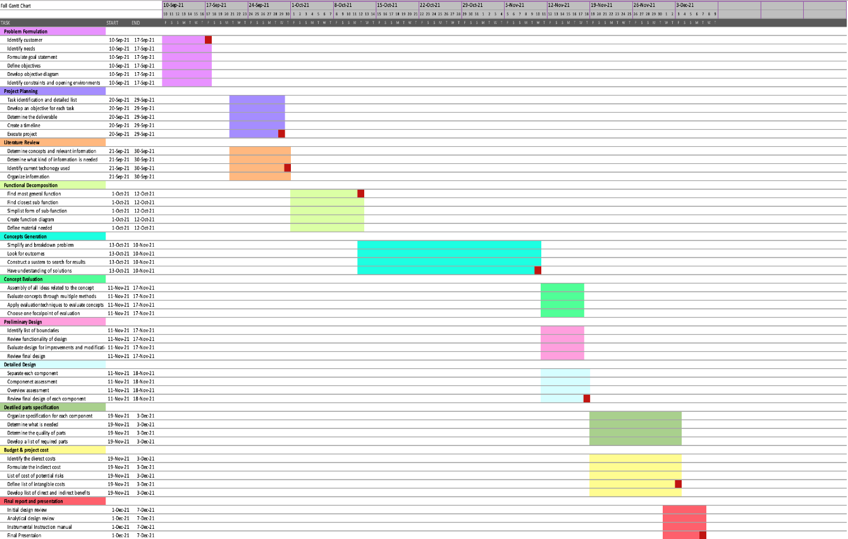
Figure 2.1 Gantt Chart for Fall Semester

*All milestones are indicated in red.

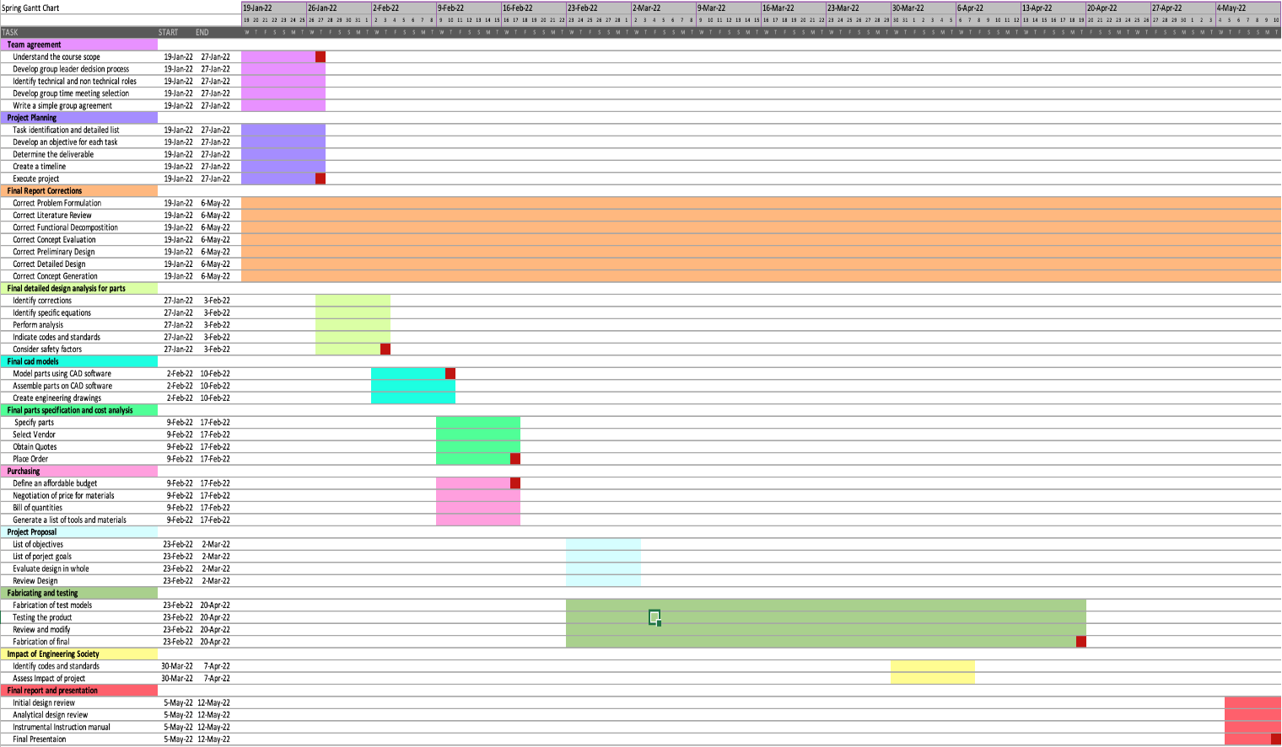

Figure 2.2 Gantt Chart for Spring Semester

*All milestones are indicated in red.

(c) List and discuss relevant codes and standards applicable to your design and show how they were applied in the design.

5.4 Standards used to generate models
The following standards were used to generate models;

- NX Programming Standards
- ASME Standards
- AISS S-114-2005 (The American Institute of Aeronautics and Astronautics)

(d) List of references used
References

[1] Dew, M., Allwein, K., Kutter, B., Ware, J., Lin, J., Madlangbayan, A., Willey, C., Pitchford, B., O’Neil, G., Design, and Development of an In-Space Deployable Sun Shield for the Atlas-Centaur, NASA NTRS 20130010783, NASA, September 9, 2008, pp 4-11
Arrange by information type
[2] Ball Aerospace, Ball Aerospace’s Land Imaging Instrument on NASA’s Landsat 9 Satellite Launches Successfully, https://www.ball.com/na/newsroom/detail?newsid=124088 (September 27, 2021)
[3] Johnson, Michele. “Mission Overview.” NASA, NASA, 14 Apr. 2015, https://www.nasa.gov/mission_pages/kepler/overview/index.html.
[4] Quest Thermal Group, Load Bearing MLI, https://www.questthermal.com/products/load-bearing-mli (September 29, 2021)

[5] Tuttle, J., DiPirro, M., Canavan, E., Hait, T., Thermal Properties of Double-Aluminized Kapton at Low Temperatures, NASA NTRS 20080045503, NASA, Jan. 1, 2007, pp 2-8

[6] NASA James Webb Space Telescope, https://www.jwst.nasa.gov/content/about/innovations/coating.html, 2021
Website

[7]Johnson, Michele. “Mission Overview.” NASA, NASA, 14 Apr. 2015, https://www.nasa.gov/mission_pages/kepler/overview/index.html.

[8] Kopelove, A., Quest Thermal Group/ Ball Aerospace Next Generation MLI Products, Research Equipment Brochure, Quest Thermal Group, 2021

[9]Slider - Worcester Polytechnic Institute (WPI). (n.d.). Retrieved March 11, 2022, from https://web.wpi.edu/Pubs/E-project/Available/E-project-042513-103948/unrestricted/Slider-Crank_MQP_Final_Draft.pdf
[10]Google. (n.d.). WO2012033276A1 - umbrella which has a simple coupling structure, which does not rust, and which can be used for a long time. Google Patents. Retrieved March 11, 2022, from https://patents.google.com/patent/WO2012033276A1/en
[11]Jani, J. M., Leary, M., Subic, A., & Gibson, M. A. (2013, December 17). A review of shape memory alloy research, applications and opportunities. Materials & Design (1980-2015). Retrieved March 11, 2022, from https://www.sciencedirect.com/science/article/pii/S0261306913011345
[12] Ball Aerospace, AIAA Requirement Verification Matrix, AIAA S-114-2005, Ball Aerospace, 2005

[13]Carr. McMaster. (n.d.). Retrieved April 8, 2022, from https://www.mcmaster.com/
[14]Industrial Configurable Components Supply. MISUMI. (n.d.). Retrieved April 8, 2022, from https://us.misumi-ec.com/

[15]Thomson Linear Motion Optmized. Linear Motion Optimized. (n.d.). Retrieved April 8, 2022, from https://www.thomsonlinear.com/en/index

