Course ASSESSMENT REPORT

ROY G. PERRY COLLEGE OF ENGINEERING
MECHANICAL ENGINEERING DEPARTMENT
PRAIRIE VIEW A&M UNIVERSITY

ASSESSMENT REPORT COVER PAGE

MCEG 3053 Kinematics Design and Analysis

FALL 2020 SEMESTER

NAME OF INSTRUCTOR: Dr. Mingli Han

Date: 12/18/2020

TABLE OF CONTENTS

- Report Cover Page

- Detailed Course Syllabus

- End of Semester Outcomes Assessment Report

- Grade Sheet Showing Student and Class Performance in Outcomes

- Supporting Outcomes Specific Assignments (Minimum of 2 per outcome except for Project Reports where one is enough)

5.1 Assignments assessing students’ ability to identify, formulate, and solve complex engineering problems (CEP) by applying principles of engineering, science, and mathematics. (outcome “1”)

Detailed Course Syllabus
(Distributed to Students at the beginning of the Semester)
ABET outcomes measured using this course should be
explicitly listed in the syllabus
Prairie View A&M University
Department of Mechanical Engineering
MCEG 3053 Kinematic Design and Analysis
Fall Semester 2020

COURSE | Kinematic Design and Analysis
COURSE NO | MCEG 3053
CREDIT | 3 Semester Hours
SECTION | Y01
PRE-REQUISITES: | Mechanical Engineering Drawing I (MCEG 1021)  Engineering Mechanics II (CVEG/MCEG 2053)
CLASS HOURS | TR 8:00 -9:50 AM
CLASS ROOM | C. L. Wilson Engineering Building 103
INSTRUCTOR | Dr. Mingli Han
OFFICE | S. R. Collins Engineering Building 311
OFFICE HOURS | Tuesday 9 AM – 12 PM, Wednesday 8 PM – 10 PM, Thursday 10 – 11 AM
TELEPHONE | (936)261-9952
E-MAIL | mihan@pvamu.edu
Catalog Data: | MCEG 3053 Kinematic Design and Analysis.  This course includes the theory and application for the kinematic design of mechanisms. The students will be required to use computers to model, analyze, and synthesize mechanical systems.
Textbook | Robert L. Norton, Design of Machinery, 5th Edition, McGraw Hill.  ISBN 978-0077421717
Reference | Shigley and Uicker, Theory of Machines and Mechanisms, McGraw Hill.
Goals | The Goals of this course is to provide students with an in-depth study of the displacement, velocity and acceleration of machine parts. This course shall also introduce the students to design methods for mechanisms yielding a desired set of motion characteristics.
Outcome | On completion of this course, the students will be able to design viable mechanism solutions to engineering problems. The students will know how to:  - Analyze mechanisms in order to determine their rigid-body dynamic behavior  - Synthesize mechanisms in order to accomplish desired motions or tasks  - Use computer aided engineering software for mechanisms analysis, synthesis and design
Course objective | To introduce students to kinematics of machinery, analysis and synthesis of mechanisms as part of a design process.
Topics | 1. Introduction to the kinematics fundamentals (1 class)  2. Position and Displacement (4 classes)  3. Velocity by Components and by Instant Centers (2 classes)  4. Graphical Synthesis (3 classes)  5. Velocity Analysis (5 classes)  6. Acceleration Analysis (3 classes)  7. Mathematical Analysis (2 classes)  8. Design Project (1 classes)  9. Cams (5 classes)  10. Gear Trains (2 classes)
Grading | The final grade will be computed according to the following weight distribution:  Homework 10%  Graded Forum Discussion 10%  Project 20%  Test 1 20%  Test 2 20%  Final Exam 20%  The distribution of grades will be as follows:  A = 90 - 100  B = 80 - 89  C = 70 - 79  D = 60 - 69  F = 0 - 59
Course Policy | Note: The instructor reserves the right to alter it during the semester.  Use of ecourses (http://ecourese.pvamu.edu)  Ecourses will be used extensively in this class. Lecture slides, assignment, and tutorials will be provided on Ecourses.  Academic Integrity  Academic dishonesty of any sort (plagiarism, cheating, fabrication or facilitation) is prohibited under any circumstance. Any detected actions of dishonesty will cause the failure of the class directly.  Assignments & Due Dates  Homework will be submitted according to the requirement of the instructor. Late homework will be charged a 20% penalty for each day late – weekend days do count. Circumstances beyond your control (i.e. illness, computer failure, weather, etc.) will be considered as required.  Projects  You need to submit one electronic copy online. The detail will be presented in the project description.  Attendance  Joining the synchronous sessions is highly encouraged. Viewing the recorded sessions within two days of posting is expected. You should notify the instructor if you can neither attend the synchronous sessions nor review the recorded sessions within two days of posting.  Examinations  You will be expected to complete the exam in the allotted time period. Portions of each exam may be either closed or open book. You will be notified of the exam format at least one week in advance.  Question/concern about grades  All discussion about grades excluding final exam grade should happen before final exam. Questions about grade of quizzes, homework, exams should be brought up within one week after they are graded and given back to you.
IMPORTANT DATES | Please visit  https://www.pvamu.edu/registrar/academic-calendars/fall-2020-full-term/

Kinematic Design and Analysis
Tentative Course Schedule

WEEK | Lecture | REMARKS
1st week | Introduction to mechanisms analysis and synthesis;  Kinematics and Kinetics;  Mechanisms and Machines;  Getting started in MATLAB;  Mobility, Transmission angle, vectors
2nd week | Position analysis;  Position analysis using vector loop equations;  Couples curves
3rd week | Velocity analysis;  Velocity analysis by components;  Analysis by use of instant centers;
4th week | The velocity Polygon  Analytic velocity Analysis
5th week | Acceleration analysis;  Graphical acceleration analysis;  Accelerations in rolling contact;  Coriolis component of acceleration
6th week | Graphical analysis;  Analytic acceleration analysis;  Midterm exam | (possibly face to face session on 09/28 and 09/30)
7th week | Introduction to cams;  Cam displacement diagrams  Cam Profile layout
8th week | Pressure angle;  Roller follower diameter;  Cam profile production problems
9th week | Introduction to graphical and analytical synthesis;  Specified transmission angle;
10th week | Crank rocker mechanisms;  Inversion
11th week | Projects  Introduction to gear trains
12th week | Gear contact kinematics  Velocity ratio (train ratio)
13th week | Review | (possibly face to face session on 11/16 and 11/18)
14th week | Final Exam
How Mechanical Engineering Courses meet Department Objectives & ABET Criterion 3
Specific Objectives of the Mechanical Engineering Program (MCEG Objectives) at Prairie View A&M are to produce graduates who have:

- the techniques and skills necessary for modern mechanical engineering practices, and an ability to function effectively in multi-disciplinary teams.
- an ability in life-long learning skills, a knowledge of contemporary issues, and an ability to communicate effectively.
- an understanding of global and societal context in the aspects of professional and ethical responsibility and the impact of engineering solutions on society.
- the qualifications to be employed by major industries and government agencies in the State of Texas and the nation.
- the qualifications to pursue graduate degrees.

ABET Criterion 3: Program Outcomes and Assessment
Engineering Programs must demonstrate that their graduates have:
- the ability to identify, formulate, and solve complex engineering problems by applying principles of engineering, science, and mathematics.;
- the ability to apply engineering design to produce solutions that meet specified needs with consideration of public health, safety, and welfare, as well as global, cultural, social, environmental, and economic factor;
- the ability to communicate effectively with a range of audiences;
- the ability to recognize ethical and professional responsibilities in engineering situations and make informed judgments, which must consider the impact of engineering solutions in global, economic, environmental, and societal contexts;
- the ability to function effectively on a team whose members together provide leadership, create a collaborative and inclusive environment, establish goals, plan tasks, and meet objectives;
- ability to develop and conduct appropriate experimentation, analyze and interpret data, and use engineering judgment to draw conclusions; and
- the ability to acquire and apply new knowledge as needed, using appropriate learning strategies.

MCEG 3053 Course Objectives and Anticipated Outcomes

Course Objectives

- Introduce the students the concepts and understanding of the displacement, velocity and acceleration in machine parts. (1, 4, 5)
Anticipated Outcomes: The students will be able to solve the mechanism problems (1)

- Introduce the students to current mechanical design methodology as applied to mechanism. (1, 4, 5)
Anticipated Outcomes: The students should be able to analyze motion in machine parts and use synthesis to design mechanism using modern tools. (1)

University Rules and Procedures

Academic Misconduct (See Student Planner)
You are expected to practice academic honesty in every aspect of this course and all other courses. Make sure you are familiar with your Student Planner, especially the section on academic misconduct (see University Administrative Guidelines on Academic Integrity). Students who engage in academic misconduct are subject to university disciplinary procedures. As listed in the PVAMU Undergraduate Catalog, Graduate Catalog, and the Student Planner, the following are examples of prohibited conduct. This list is not designed to be all-inclusive or exhaustive. In addition to academic sanctions, any student found to have committed or to have attempted to commit the following academic misconduct may also be subject to disciplinary review and action as outlined in the PVAMU Student Planner.

Forms of Academic Dishonesty:

- Cheating: Deception in which a student misrepresents that he/she has mastered information on an academic exercise that he/she has not learned, giving or receiving aid unauthorized by the instructor on assignments or examinations. Examples: unauthorized use of notes for a test; using a “cheat sheet” on a quiz or exam; any alteration made on a graded test or exam which is then resubmitted to the teacher.

- Plagiarism: Careless or deliberate use of the work or the ideas of another; representation of another’s work, words, ideas, or data as your own without permission or appropriate acknowledgment. Examples: copying another’s paper or answers, failure to identify information or essays from the Internet and submitting or representing it as your own; submitting an assignment which has been partially or wholly done by another and claiming it as yours; not properly acknowledging a source which has been summarized or paraphrased in your work; failure to acknowledge the use of another’s words with quotation marks.

- Multiple Submission: Submission of work from one course to satisfy a requirement in another course without explicit permission. Example: using a paper prepared and graded for credit in one course to fulfill a requirement and receive credit in a different course.

- Conspiracy: Agreeing with one or more persons to commit an act of academic/scholastic dishonesty.

- Fabrication of Information/Forgery: Use or submission of contrived, invented, forged, or altered information in any assignment, laboratory exercise, or test; tampering with or production of a counterfeit document, particularly documents which make up the student’s academic record. Examples: making up a source or citing nonexistent publication or article; representing made up data as real for an experiment in a science laboratory class; forging a change of grade or student withdrawal record; falsifying any document related to a student academic exercise.

Nonacademic Misconduct (See Student Planner)
The University respects the rights of instructors to teach and students to learn. Maintenance of these rights requires campus conditions that do not impede their exercise. Campus behavior that interferes with either (1) the instructor’s ability to conduct the class, or (2) the ability of students to benefit from the instructional program, or (3) the rights of others will not be tolerated. An individual engaging in such disruptive behavior may be subject to disciplinary action. Such incidents will be adjudicated by the Office for Student Conduct under nonacademic procedures.

Sexual Misconduct
Sexual harassment of students and employees at Prairie View A&M University is unacceptable and will not be tolerated. Any member of the university community violating the university’s sexual harassment policy will be subject to disciplinary action. In accordance with the Texas A&M University System guidelines, your instructor is obligated to report to the Office of Title IX Compliance (titleixteam@pvamu.edu) any instance of sexual misconduct involving a student, which includes sexual assault, stalking, dating violence, domestic violence, and sexual harassment, about which the instructor becomes aware during this course through writing, discussion, or personal disclosure. The faculty and staff of PVAMU actively strive to provide a learning, working, and living environment that promotes respect that is free from sexual misconduct, discrimination, and all forms of violence. If students, faculty, or staff would like assistance, or have questions, they may contact the Title IX Coordinator at 936-261-2144 or titleixteam@pvamu.edu. More information can be found at the Title IX Webpage including confidential resources available on campus.

Pregnancy, Pregnancy-related, and Parenting Accommodations
Title IX of the Education Amendments of 1972 prohibits sex discrimination, which includes discrimination based on pregnancy, marital status, or parental status. Students seeking accommodations related to pregnancy, pregnancy-related condition, or parenting (reasonably immediate postpartum period) are encouraged to contact Student Disability Services or the Dean of Students’ Office for additional information and to request accommodations. More information can be found at this webpage.

Non-Discrimination Statement
Prairie View A&M University does not discriminate on the basis of race, color, sex, religion, national origin, age, disability, genetic information, veteran status, sexual orientation or gender identity in its programs and activities. The University is committed to supporting students and complying with the Texas A&M University System non-discrimination policy. It seeks to establish an environment that is free of bias, discrimination, and harassment. If you experience an incident of discrimination or harassment, we encourage you to report it. If you would like to speak with someone who may be able to afford you privacy or confidentiality, there are individuals who can meet with you. The Director of Equal Opportunity & Diversity has been designated to handle inquiries regarding the non-discrimination policies, and can be reached at Harrington Science Building, Suite 109 or by phone 936-261-1744 or 1792.

Class Attendance Policy (See Catalog for Full Attendance Policy)
Prairie View A&M University requires regular class attendance. Attending all classes supports full academic development of each learner whether classes are taught with the instructor physically present or via distance learning technologies such as interactive video and/or internet. Excessive absenteeism, whether excused or unexcused, may result in a student’s course grade being reduced or in assignment of a grade of “F”. Absences are accumulated beginning with the first day of class during regular semesters and summer terms. Each faculty member will include the University’s attendance policy in each course syllabus.
Student Academic Appeals Process
Authority and responsibility for assigning grades to students rests with the faculty. However, in those instances where students believe that miscommunication, errors, or unfairness of any kind may have adversely affected the instructor's assessment of their academic performance, the student has a right to appeal by the procedure listed in the University Catalog and by doing so within thirty days of receiving the grade or experiencing any other problematic academic event that prompted the complaint. Students can file Academic Complaints and/or Grade Appeals at this webpage.

Technical Considerations

Minimum Recommended Hardware and Software:
- Intel PC or Laptop with Windows 10 or later version; Mac with OS High Sierra*
- Smartphone or iPad/Tablet with Wi-Fi*
- High speed Internet access
- 8 GB Memory
- Hard drive with 320 GB storage space
- 15” monitor, 800x600, color or 16 bit
- Sound card w/speakers
- Microphone and recording software
- Keyboard & mouse
- Most current version of Google Chrome, Safari or Firefox

*Smartphone, Google Chrome books and Android tablets may not be supported. iPads are the only tablets supported.

Note: Be sure to enable Java & pop-ups in the Web browser preferences

Participants should have a basic proficiency of the following computer skills:
- Sending and receiving emails
- A working knowledge of the Internet
- Microsoft Word (or a program convertible to Word)
- Acrobat PDF Reader
- Windows or Mac OS
- Video conferencing software

Netiquette (online etiquette)
Students are expected to participate in all discussions and virtual classroom chats as directed. Students are to be respectful and courteous to others on discussions boards. Foul or abusive language will not be tolerated. Do not use ALL CAPS for communicating to others AS IT CAN BE INTERPRETED AS YELLING. Avoid slang terms such as “wassup?” and texting abbreviations such as “u” instead of “you.” Limit and possibly avoid the use of emoticons. Be cautious when using humor or sarcasm as tone is sometimes lost in an email or discussion post and the message might be taken seriously or sound offensive.

Video Conferencing Etiquette
When using Zoom, WebEx or other video conferencing tools, confirm the visible area is tidy, clear of background clutter, inappropriate or offensive posters, and other distractions. Ensure you dress appropriately and avoid using high traffic or noisy areas. Stay muted when you are not speaking and avoid eating/drinking during session. Before class session begins, test audio, video and lighting to alleviate technology issues.
Technical Support
Students should go to the Password Reset Tool if they have password issues. The page will provide instructions for resetting passwords and contact information if login issues persist. For other technical questions regarding eCourses, call the Center for Instructional Innovation and Technology Services (CIITS) at 936-261-3283 or email ciits@pvamu.edu.

Communication Expectations and Standards
Emails or discussion postings will receive a response from the instructor, usually in less than 48 hours. Urgent emails should be marked as such. Check regularly for responses.

Discussion Requirement
Online courses often require minimal to no face-to-face meetings. However, conversations about the readings, lectures, materials, and other aspects of the course can take place in a seminar fashion. This will be accomplished by the use of the discussion board. The exact use of discussion will be determined by the instructor.

It is strongly suggested that students type their discussion postings in a word processing application such as Word and save it to their PC or a removable drive before posting to the discussion board. This is important for two reasons: 1) If for some reason your discussion responses are lost in your online course, you will have another copy; 2) Grammatical errors can be greatly minimized by the use of the spell-and-grammar check functions in word processing applications. Once the post(s) have been typed and corrected in the word processing application, copy and paste to the discussion board.
COVID-19 Campus Safety Measures

To promote public safety and protect students, faculty, and staff during the COVID-19 pandemic, Prairie View A&M University has adopted policies and practices for the Fall 2020 academic term to limit virus transmission. Students must observe the following practices while participating in face-to-face courses and course-related activities (office hours, help sessions, transitioning to and between classes, study spaces, academic services, etc.):

- Self-monitoring - Students should follow CDC recommendations for self-monitoring. Students who have a fever or exhibit symptoms of COVID-19 should participate in class remotely and should not participate in face-to-face instruction.

- Face Coverings - Face coverings (cloth face covering, surgical mask, etc.) must be properly worn in all non-private spaces including classrooms, teaching laboratories, common spaces such as lobbies and hallways, public study spaces, libraries, academic resource and support offices, and outdoor spaces where 6 feet of physical distancing is difficult to reliably maintain.

- Physical Distancing - Physical distancing must be maintained between students, instructors, and others in course and course-related activities.

- Classroom Ingress/Egress - Students must follow marked pathways for entering and exiting classrooms and other teaching spaces. Students should leave classrooms promptly after course activities have concluded, should not congregate in hallways and should maintain 6-foot physical distancing when waiting to enter classrooms and other instructional spaces.

- Face-to-face Class - To attend a face-to-face class, students must wear a face covering (or a face shield if they have an exemption letter). If a student refuses to wear a face covering, the instructor should ask the student to leave and join the class remotely. If the student does not leave the class, the faculty member should report that student to the Office for Student Conduct for adjudication. Additionally, the faculty member may choose to teach that day’s class remotely for all students.

- COVID-19 Guidelines for Student Conduct Adjudication - The mandatory COVID-19 Training/Certification taken by all students serves as the 1st Warning for violation of COVID-19 Guidelines.

  - 1st incident: upon review of Incident Report and finding of responsibility — Conduct Probation

  - 2nd incident: upon review of Incident Report and finding of responsibility — Suspension

  - Consult the Code of Student Conduct in the Student Planner or Student Conduct website for additional information on Conduct Probation and Suspension.

- Personal Illness and Quarantine - Students required to quarantine must participate in courses and course-related activities remotely and must not attend face-to-face course activities. Students should notify their instructors of the quarantine requirement. Students under quarantine are expected to participate in courses and complete graded work unless they have symptoms that are too severe to participate in course activities. Students experiencing personal injury or illness that is too severe for the student to attend class qualify for an excused absence. To receive an excused absence, students must provide appropriate documentation to the Office for Student Conduct, studentconduct@pvamu.edu.

End of Semester
Course Assessment Report

This summary contains the following Information

1. Performance Statistics
- Total number of students in class
- The class average performance (stated as %) in each course outcome assessed in this class and the two previous times course was assessed.
- The acceptable class average for the class in each outcome area as set by your Department. You cannot use any number of your choice
- Percentage of students who scored below the expected average in each outcome.

2. Implementation Summary
- Brief summary of plans implemented during the semester based on last assessment report

3. Perceived Problems
- Instructor’s critical evaluation of perceived problems that affected students’ performance. Realistic problems should be identified throughout the semester and summarized in this section of the report.

4. New Plans for Addressing Problems
- Instructor’s plans for addressing the perceived problems the next time the class is taught. These should be specific enough for another instructor to implement. Most of these should be things that, you, the instructor can implement to help students to improve. Be creative.

5. Overall Trend over last three assessment periods
- Instructor’s summary of overall performance trend for each outcome measured over the last three periods.

5. Were Expectations Met?
- Answer YES if the class average was above the expected average and the stated percentage of students scored at or above the expected average, else answer NO.

END OF SEMESTER COURSE OUTCOME ASSESSMENT REPORT
MCEG 3053-Y01 and Y03 KINEMATICS DESIGN AND ANALYSIS
FALL 2020 SEMESTER

Report Prepared by: Dr. Mingli Han
Report Date: December 18, 2020

Semester | Analysis Type | Number of Students | Outcome 1*  The ability to identify, formulate, and solve complex engineering problems by applying principles of engineering, science, and mathematics.
Semester | Analysis Type | Number of Students | Expected Class Average | Expected Percent of students at or above average | Class Average | % Students meeting Expected Average
Fall 2020 | Direct | 45 | 70 | 70 | 90.8 | 100
Fall 2019 | Direct | 26 | 70 | 70 | 90 | 100
Fall 2018 | Direct | 36 | 75/70 | 70 | 88.3 | 97.2
Fall 2017 | Direct | 45 | 75/70 | 70 | 81.8 | 88.2
Implementation Summary | Items implemented from previous report or after meeting previous instructor |  | Math review tutorials are posted as supplementary material. Project is assigned earlier so that students have enough time to work on it. More exercises emphasizing on use of engineering software is given.
Perceived Problems | Perceived problems are directly related to the PC and the sub items under them |  | Students struggled in some fundamental math problems.  The ability of using engineering software varies drastically among students. In particular, the ability of using UG NX for motion simulation and the ability of using MATLAB for calculation, plotting and analysis.
Plans for Addressing Problems | Plans for address specific measures to address PC and their sub areas |  | Math review (outside of classroom) and quizzes will help student review and improve their math capabilities relate to this course.  More tutorial and exercises will be given to improve the students’ ability of using engineering software.  Smaller class size helps the interaction during and after class.
Overall Trend over Periods | Ascertain if there were improvements over previous semesters |  | Class average and expected percent of students is improving over the last three years
Were Expectations Met? | Class Average ≥75% and ≥70% of Students Performed at or Above Expected Average. |  | YES

*: ABET switched to outcome 1-7 in May 2018. Outcome e is assessed in Fall 2017 and before that. Outcome 1 is assessed in Fall 2018 and onwards.

Grade Sheet Showing
Student and Class Performance in Outcomes
The computed semester average in each outcome
as stated in the Assessment report are
highlighted in boldface

Grade Sheet Showing Student and Class Performance in Course Outcomes
MCEG 3053-Y01 and Y03 Kinematics Design and Analysis
Fall 2020 Semester
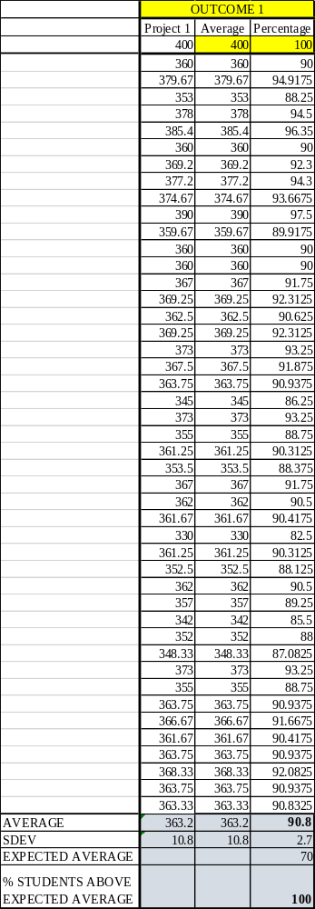

OUTCOME SPECIFIC ASSIGNMENTS
USED TO ASSESS OUTCOMES
(Provide at least two assignments used to specifically measure each outcome and justify the suitability of the assignments for the outcome being measured)

ASSIGNMENTS FOR OUTCOME “e”

Ability to design a system, a component, or a process to meet a desired need

MECHANICAL ENGINEERING DEPARTMENT
OUTCOMES SPECIFIC ASSIGNMENT COVER SHEET
MCEG3053 Kinematics Design and Analysis
FALL 2020
Instructor: Dr. Mingli Han

Title of Assignment

Project

Outcome Measured Using this Assignment
Outcome 1
An ability to identify, formulate, and solve complex engineering problems by applying principles of engineering, science, and mathematic.

Check the complex engineering problem characteristics related to this assignment

Assignment problem
involves wide-ranging or conflicting technical issues,
has no obvious solution
Addresses problems not encompassed by current standards and codes
involves diverse groups of stakeholders
includes many component parts or sub-problems
involves multiple disciplines
has significant consequences in a range of contexts
Assignment problem involves the application of the principles of
engineering
science
mathematics

Brief justification of the suitability of assignment for the outcome
This is a group project to design, simulate and analyze an actual mechanism using the knowledge of this course (engineering, mathematics) and engineering software such as UG NX and MATLAB.

MCEG3053: Kinematics Design and Analysis
Fall 2019
MCEG3053: Kinematics Design and Analysis
Fall 2020

Project: Four-bar Linkage Simulation and Analysis

I. Project description
This is a group project to design and simulate different types of four-bar linkage using UG NX and MATLAB. Each group is assigned a type of four-bar linkage. You need to model the mechanism simulate your mechanism using Siemens NX and perform position, velocity and acceleration analysis with MATLAB.

II. Four types of Four-bar linkage:

- Crank-rocker

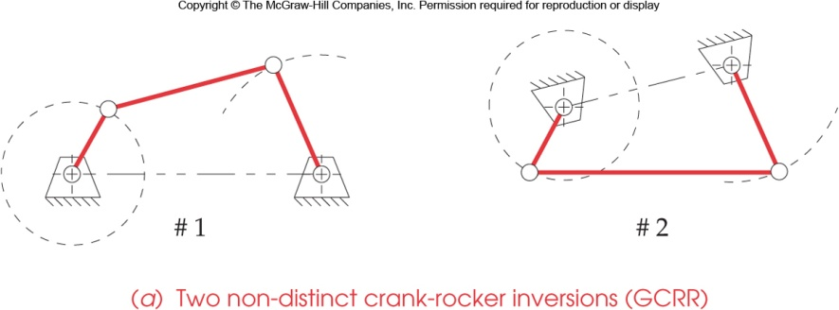
Figure 1. Crank-rocker

- Double-crank

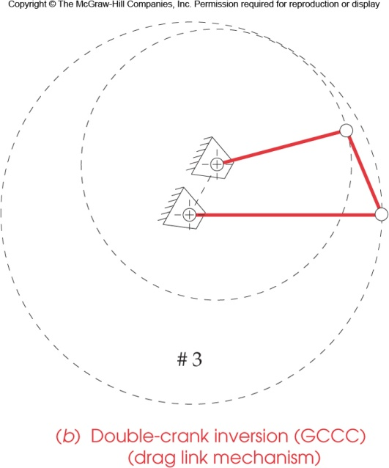
Figure 2. Double-Crank
- Double-rocker

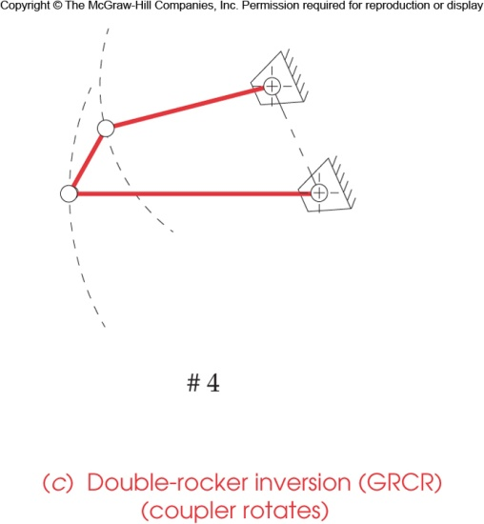
Figure 3. Double-rocker

- Triple-rocker

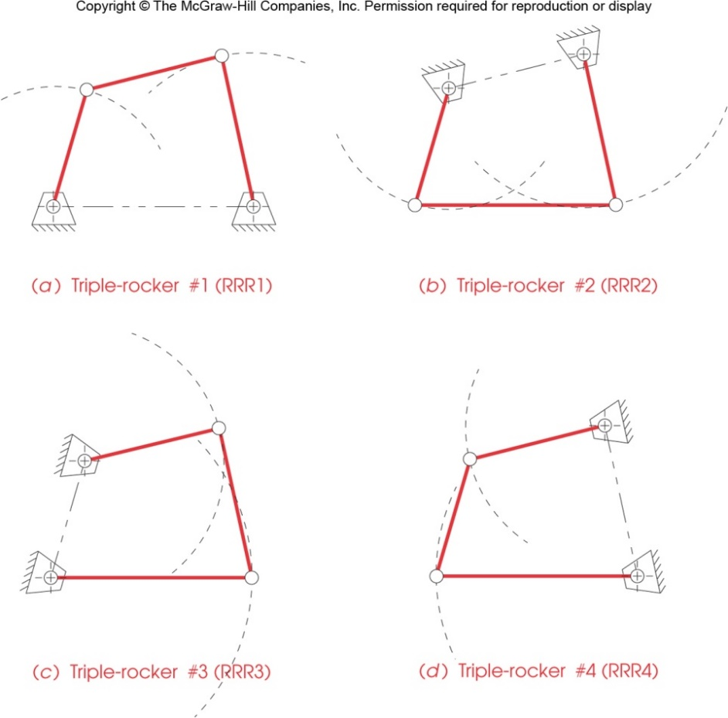
Figure 4. Triple-rocker

III. Design Tasks:
- Select the dimension of the four-bar linkage that satisfies the type requirement;
- Create models of the four links using NX;
- Create the assembly of the mechanism;
- Create the links and joints for the motion analysis;
- Select input/driver joint, assuming an angular velocity and perform the motion analysis;
- Note the extreme positions of the four-bar linkage;
- Create a mpeg video or other sort of animation to demonstrate your motion;
- Analyze the displacement, velocity and acceleration of the four-bar linkage using MATLAB;
- Plot the displacement, velocity and acceleration and compare the results with the motion simulation.

IV. Deliverable Results:
1. Proposal report: maximum 2 pages; Due date: Oct. 22.
The proposal must describe:
A. Lengths of the four links and verification using Grashof condition.
B. Proposed work schedule.
C. Tasks distribution. (What will each group member work on?)

2. Final Project Presentations (November 19): Every group will be asked to give a 10-minute presentation using PowerPoint.

3. Final Report and soft copy of your project (Due: December 1)
A. A final report in electronic format should be documented in Word format. There is no specific format and page limitation, but your report should include the following contents:
          - Abstract (100-150 words);
          - Introduction (design objectives);
          - Project description (mechanism’s functional requirements, design constrains, design parameters, etc.);
          - NX models and motion (models of components, drafting of major components, assembly, extreme positions, motion analysis and simulation, etc.);
          - Position, velocity and acceleration analysis using MATLAB (equations used, MATLAB code, MATLAB plots; comparison with the NX motion, etc.)
          - Conclusion and suggestion; and
          - Reference, if any.

B. Please submit
Electronic version of the report, presentation, and animation video as one compressed file to Canvas.

4. Taskstream submission (Due: December 1)
Submit the final report to Taskstream in response to Outcome 1 Assignment 1

V. Point Distribution:
- Proposal: 30 pts.
- Quality and results (creativity, completeness, etc.): 120 pts
3. Final Presentation: 50 pts
4. Final Report (documentation style, neatness, clarity): 80 pts
5. Taskstream submission: 20 pts
6. Peer Evaluation 100 pts

Total: 400 pts

PVAMU College of Engineering
Sub: MCEG 3053 Kinematics
Project: Four-bar Linkage Simulation and Analysis


Submitted By: Isaac Berry 367/400
Lance Johnson 361.25/400
Priscille Djomo 361.25/400
Thomas Jacob 330/400

Abstract
This is a group project that is meant to model and stimulate the Triple Rocker mechanism using Siemens NX and getting the position, velocity and acceleration using MATLAB. For that, we learned the Triple Rocker mechanism. As a group, we were able to create the four links and joints of our mechanism using NX for the dimensions. Then, we were able to find the position, velocity and acceleration analysis by using MATLAB and compare results with the motion analysis simulation. The main two things which results in our research are The Triple Rocker satisfies the Grashof condition class 2 and also we were able to find out that the triple rocker mechanism cannot make full rotation.

Introduction
In the Triple Rocker mechanism, one link is fixed while the other three oscillates. It is a non Grashof class 2 linkage for which the sum of the lengths of the shortest link and the longest link is greater than the sum of the lengths of the other two links. s + l > p + q where s is the length of the shortest link, l is the length of the largest link and p and q are lengths of the other two links. All the Triple Rocker invasions are triple rocker only. This project is to model and stimulate the Triple Rocker mechanism using Siemens NX and getting the position, velocity and acceleration using MATLAB.

Project Description
A non Grashof class 2 Triple rocker 4 bar linkage is meant to do a quarter to half rotation always. It cannot make a full rotation because the longest link is fixed and cannot rotate. Thus, causing the entire object to only oscillate partly never making a full rotation.
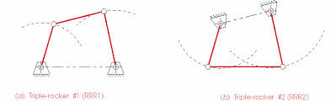

NX model’s
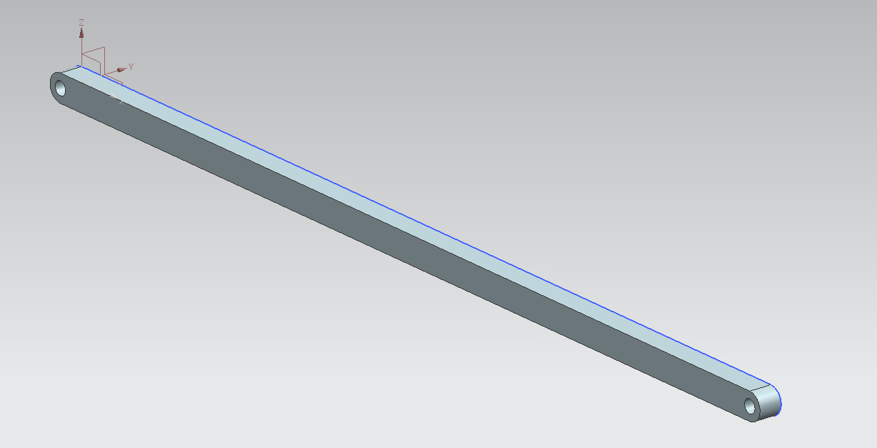
Link 1 the longest link at 1000mm length

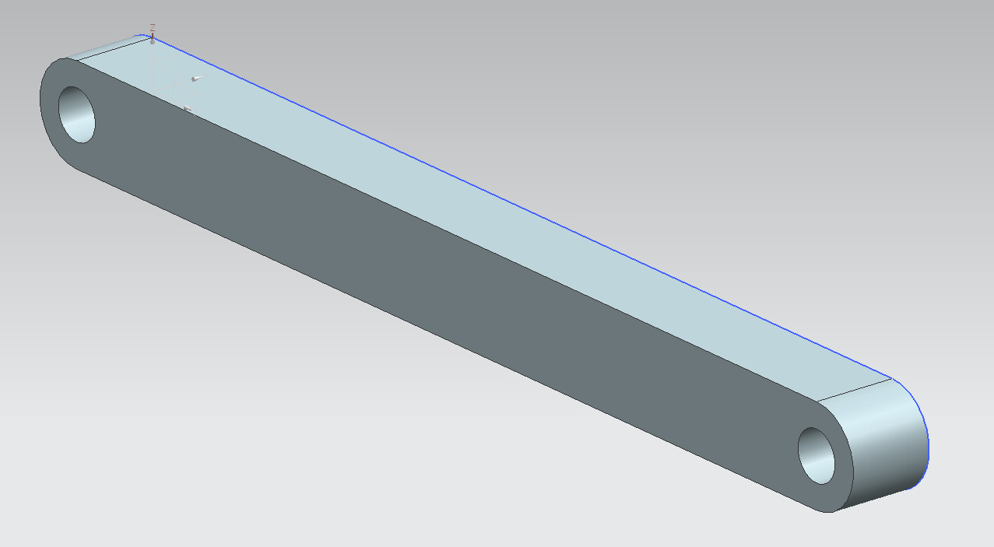
Link 2 this is the shortest link at 300mm length
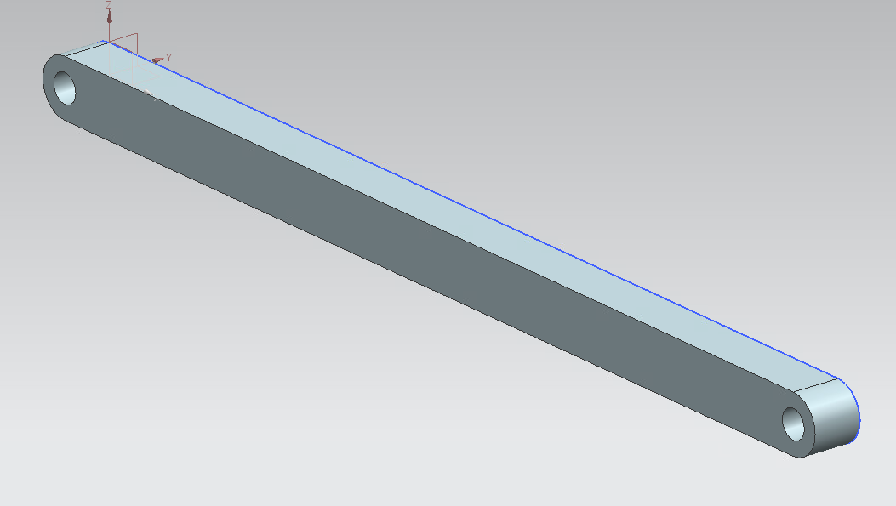
Link 3 that is 500mm long
Link 4 that is also 500 mm long
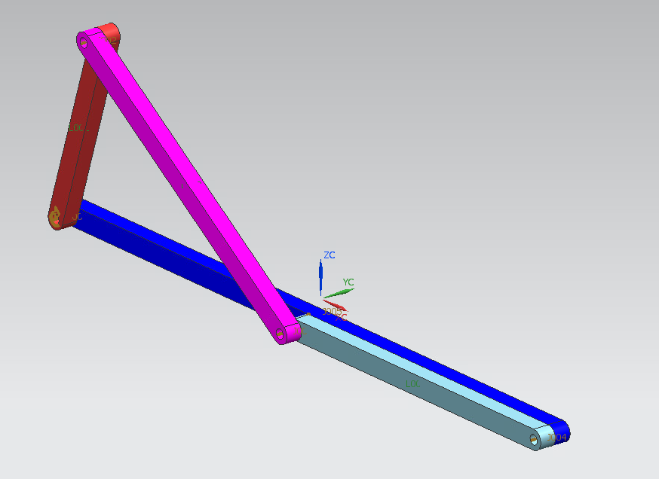
This is our entire assembly after arranging them in a way to make a simulation of the rotation.

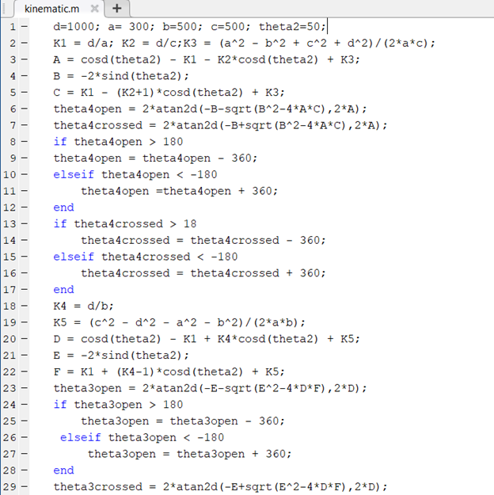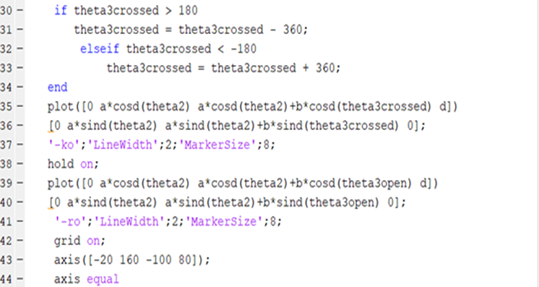

This is the motion analysis code that we had to input into MATLAB and be able to solve.
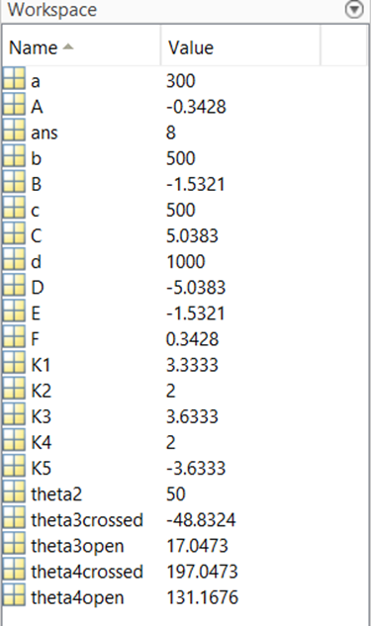
These are the result’s of the motion analysis code

Position Velocity and Acceleration analysis
In this section we are asked to analyze the position, the velocity and the acceleration of the triple rocker. We know that the triple rocker due to its ground link, must satisfy the Grashof condition class 2 stated as follows: S+LP+Q. Therefore, we chose S =a =300mm,
L =d= 1000m, P =b=500mm and Q =c=500mm, we also assume that theta 2= 50 degree and
Omega = 2 rad/s. The different steps that we followed to analyze the position, the velocity and the acceleration are found on the pictures below.
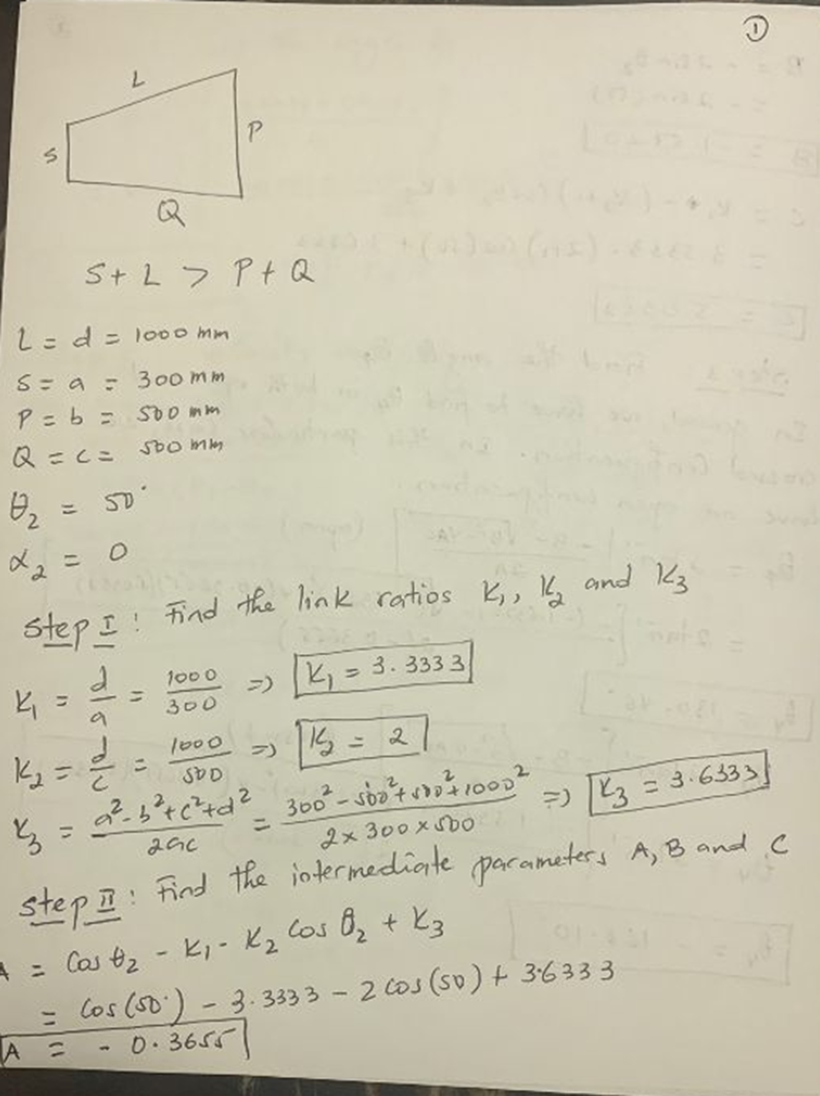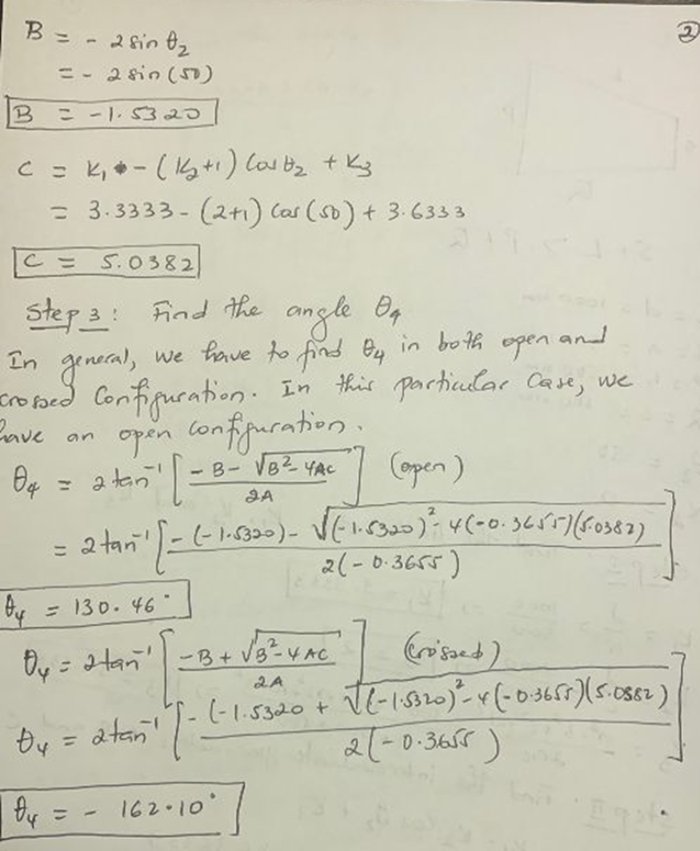

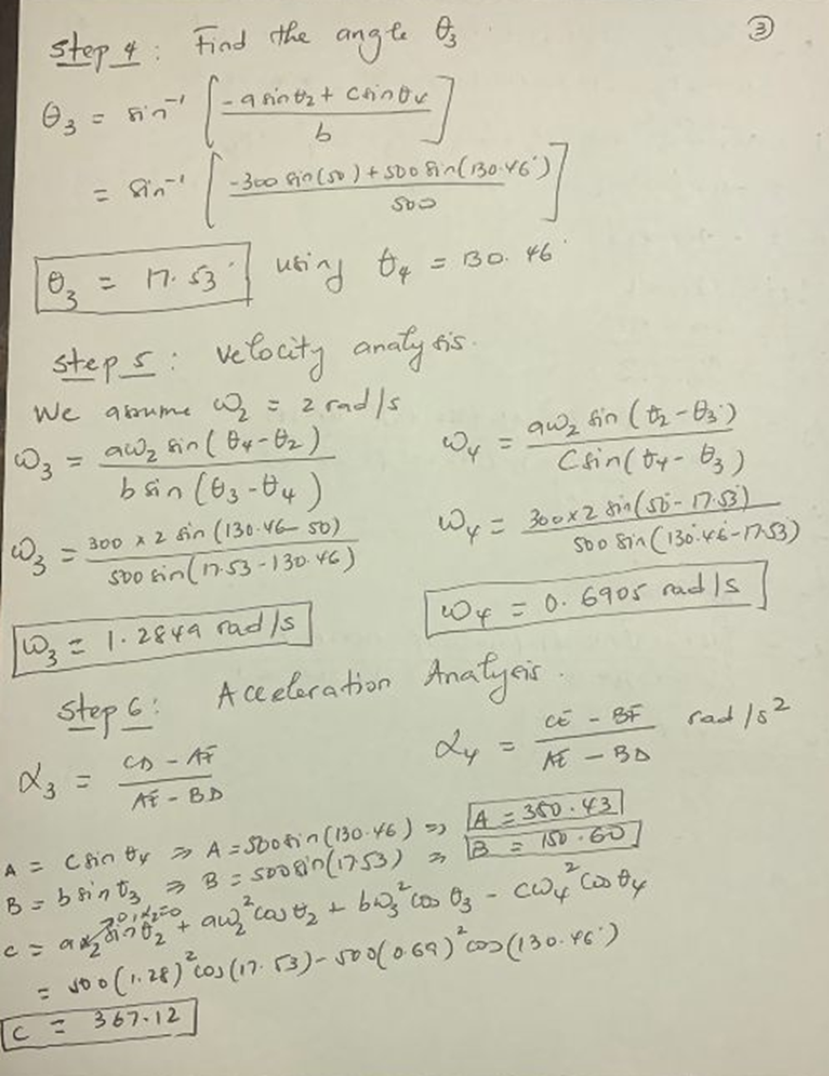
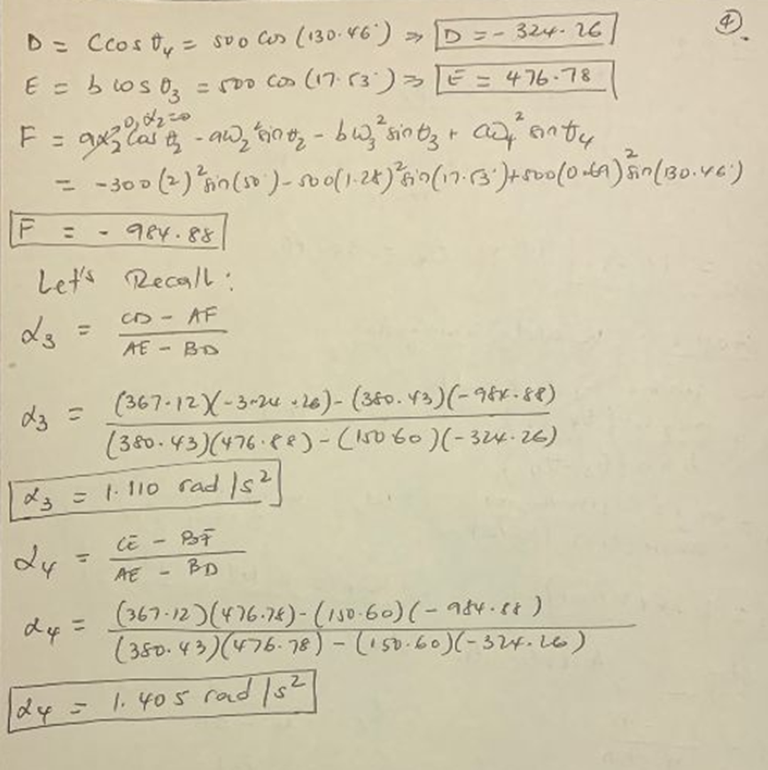

Conclusion and Suggestions
In conclusion, we learned the conditions required of a triple rocker mechanism. The triple rocker that we designed satisfies the Grashof condition class 2. With the dimensions we came up with as a group we were able to create the four links and joints of our mechanism using the NX software. With the links we were able to make an assembly with all of the links with link 1 being the fixed link. From the assembly we were able to make an animation compiled together with the joints that were also made using the NX software. From there we were able to use the code provided in MATLAB to make an analysis. We were able to define the position, velocity and acceleration analysis by using MATLAB and compare results with the motion analysis simulation. From our analysis we were able to conclude that a triple rocker mechanism cannot make a full rotation.

MECHANICAL ENGINEERING DEPARTMENT
PRAIRIE VIEW A&M UNIVESITY

MCEG 3053 KINEMATIC DESIGN AND ANALYSIS

Fall 2020 Section P01

FINAL PROJECT REPORT ON

“Four-bar Linkage Simulation and Analysis”

GROUP 2
Saif Jawad 390/400
Omar Attia 353/400
Jaibeli Desai 369.2/400
Hamed Dicko 377.2/400
Ziraguen Cisneros-Williams 385.4/400

December 1, 2020

To

Dr. Mingli Han
Instructor

ABSTRACT

The purpose of this group project was to design Four Bar-Linkage and simulate a mechanism using UG NX and MATLAB. For this project, Double cranked was chosen from the pre-defined topics. To begin this project, a thorough understanding of the mechanism was researched where the mechanisms functional requirements, design parameters, and design constraints were defined. Using MATLAB and NX, models of each component of the mechanism were created and then an assembly was created to model the mechanism completely. A motion analysis is then created with the NX Motion Analysis tool to create a motion scenario. Furthermore, an interference/clearance analysis was performed to verify that there was no interference throughout the complete range of motion. Displacement, velocity, and acceleration of important components were mathematically analyzed as well.

Saif Jawad 390/400
Omar Attia 353/400
Jaibeli Desai 369.2/400
Hamed Dicko 377.2/400
Ziraguen Cisneros-Williams 385.4/400

TABLE OF CONTENT

ABSTRACT …………………..……………………………………………..…………. i

LIST OF FIGURES. ………………………………………………………….………… ii

LIST OF TABLES ……………………………………………………………………… iii

1. INTRODUCTION AND PROJECT DESCRIPTION …………………...……..… 1
1.1 Introduction……………………………………………………………..……………….. 1
1.2 Project Description ………………………………….…...……………………………… 1

2. MECHANISM DESIGN …………………………………………………………...…. 2
2.1 Calculations and Dimensions……………………………………………………………. 2
2.2 Vector Loop Equation ……………………….……………………………………….…. 3
2.3 Extreme Positions…………..………….…………………………...……………………. 4
2.4 Mechanism Animation……...………….…………………………...……………………. 4

3 CONCLUSION & RECOMMENDATIONS …………………..………………...…….. 5
3.1 Presentation of Final Graphs/Figures……….………………………...……………….… 5
3.2 Conclusions………………………………………………………………………...….… 8
3.3 Recommendations …………………………………………………………………...….. 8

APPENDIX A MATLAB Code ………………………………...……………....………. 9

APPENDIX B Drawings…………………………………………..………………..…… 12

LIST OF FIGURES

Figure 2.1 Grashof Condition……...………….…………………………...……………………... 2
Figure 2.2 Link S Drawing………………………………………...……………………...……… 3
Figure 2.3 Double-Crank………………………………….............................................………... 3
Figure 2.4 Animation……..……………………………….............................................………... 4
Figure 3.1 Input Angle $θ_{2}$ (degrees) VS Angles $θ_{1}$, $θ_{3}$, & $θ_{4}$ (degrees)……...…………………. 5
Figure 3.2 Input Angle $θ_{2}$ (degrees) VS Angular Velocity ${\dot{θ}}_{1}$, ${\dot{θ}}_{3}$, & ${\dot{θ}}_{4}$ (degree/s)………...….... 6
Figure 3.3 Angular Velocity ${\dot{θ}}_{2}$ (degree/s) VS Angular Velocity ${\dot{θ}}_{1}$, ${\dot{θ}}_{3}$, & ${\dot{θ}}_{4}$ (degree/s)………. 6
Figure 3.4 Input angle $θ_{2}$ (degrees) VS Angular Acceleration ${\ddot{θ}}_{1}$, ${\ddot{θ}}_{3}$, & ${\ddot{θ}}_{4}$ (degrees/s²)……..…. 7
Figure 3.5 Angular Acceleration ${\ddot{θ}}_{2}$ (degrees/s²) VS Angular Acceleration ${\ddot{θ}}_{1}$, ${\ddot{θ}}_{3}$, & ${\ddot{θ}}_{4}$
(degrees/s²)……………………………………………………………………………. 7

LIST OF TABLES

Table 2.1 Extreme Positions……………………………………………………………….………... 4

CHAPTER 1
INTRODUCTION & PROJECT DESCRIPTION

  - Introduction

Kinematics is a subfield of physics developed in classical mechanics that describes the motion of points, bodies, and system of bodies without considering the force that cause them to move. To achieve the ultimate functional design of the wide variety of mechanism that we use in daily bases, a lot of parameters and disciplines must be considered. In this work we will focus on applying kinematics to design a real-world mechanism using some common tools such as UG NX and MATLAB to show a simulation of the mechanism.

A four-bar linkage, also called a four-bar, is the simplest movable closed-chain linkage. It consists of four bodies, called bars or links, connected in a loop by four joints. Generally, the joints are configured so the links move in parallel planes, and the assembly is called a planar four-bar linkage. Spherical and spatial four-bar linkages also exist and are used in practice.

  - Project Description

The four-bar linkage that was required for group 2 was a double-crank linage. In the double-crank design there is one fixed link, two links that rotate at the attachment joints of the fixed link, and the last link attaches the free ends of the two rotating links. This project required:

- Finding the link dimensions for the links that satisfy the Grashof condition
- Modeling the links using NX
- Making an assembly from the linkages using NX
- A motion analysis using MX
- Developing code for MATLAB based on position vectors
- A motion analysis using MATLAB
- A comparison of MATLAB and NX motion analysis
- Having a complete drawing set for the double-crank mechanism
CHAPTER 2
MECHANISM DESIGN

2.1 Calculations and Dimensions

This four-bar linkage mechanism consist of two “cranks” which rotate on the S bar.
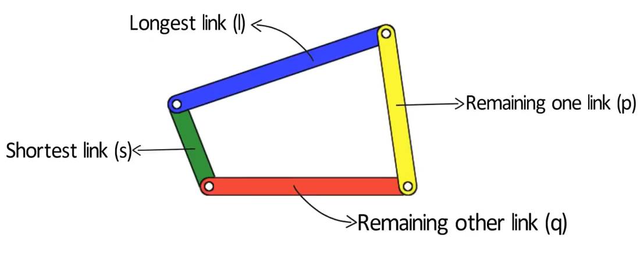
Figure 2.1 Grashof Condition

Figure 2.1 shows a four-bar linkage that forms the notation of linkages that is necessary for the calculations.

$$S + L<P+Q$$

Where:
S = length of the shortest link
L = length of the largest link
P and Q = lengths of the other two links

In order to find the dimensions, the Grashof condition had to be satisfied. The following is the calculations that were performed to find the appropriate length for the links.

$$S=200 mm$$

$$L=700 mm$$

$$P=L-S$$

$$P=500 mm$$

$$Q = 600 mm$$

$$200 mm + 700 mm<500 mm+600 mm → 900 mm<1100 mm$$

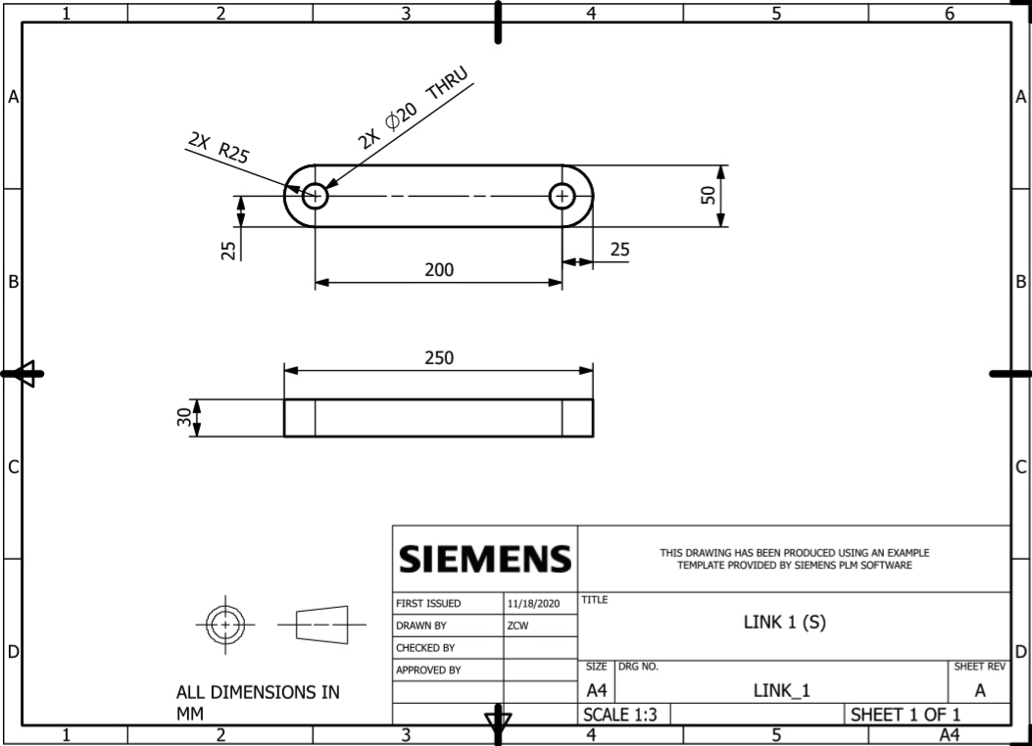

Figure 2.2 Link S Drawing

Figure 2.2 shows a drawing for link S. Dimensions for thickness, width, and diameter for the joint hole were arbitrarily picked. The other drawings can be found in appendix B.

2.2 Vector Loop Equation

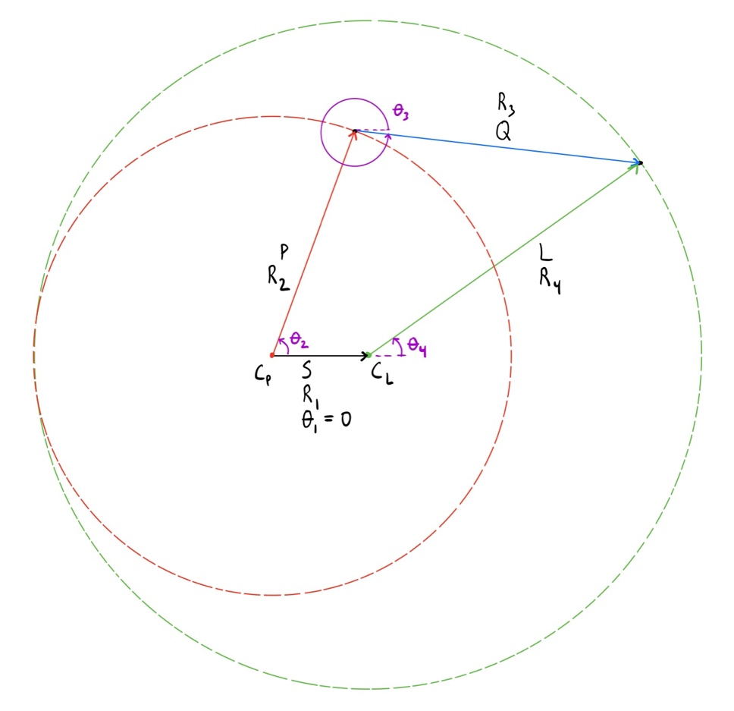
Figure 2.3 Double-Crank
Figure 2.3 shows the schematic of the double crank linkage. This was used to develop the vector loop equation which was necessary for the position, velocity, and acceleration analysis.

$$R2+R3=R1+R4$$

$$θ_{4}=θ_{2}-34.44076°$$

2.3 Extreme Positions

An analysis of extreme positions was performed to find how $θ_{3}$ and $θ_{4}$vary with the input $θ_{2}$. This was done using the MATLAB code that was developed. The MATLAB code is available in appendix A.
Table 2.1 Extreme Positions

Input ($θ_{2}$) | $$θ_{3}$$ | $$θ_{4}$$
360° | -41.1618° | 325.6559°
180° | 41.1618° | 145.6559°

2.4 Mechanism Animation

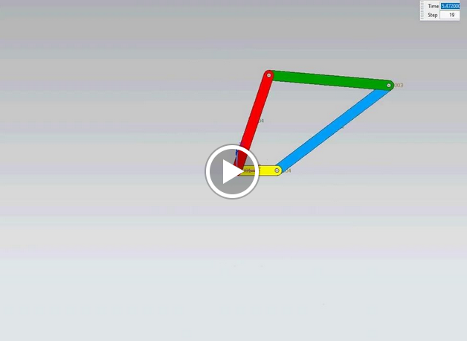
Figure 2.4 Animation

https://drive.google.com/file/d/1b3cVIfWSSe8oWoOpe2LRdgEFggPe_hjv/view?usp=sharing

(Click link not picture)

CHAPTER 3
ABILITY TO INTERPRET EXPERIMENTAL DATA

3.1 Presentation of Graphs/Figures

A series of 5 graphs were generated to shows how the angles, angular velocity, and angular acceleration vary. The joint between link S and link P was the driving joint so theta 2 was the input to the system.
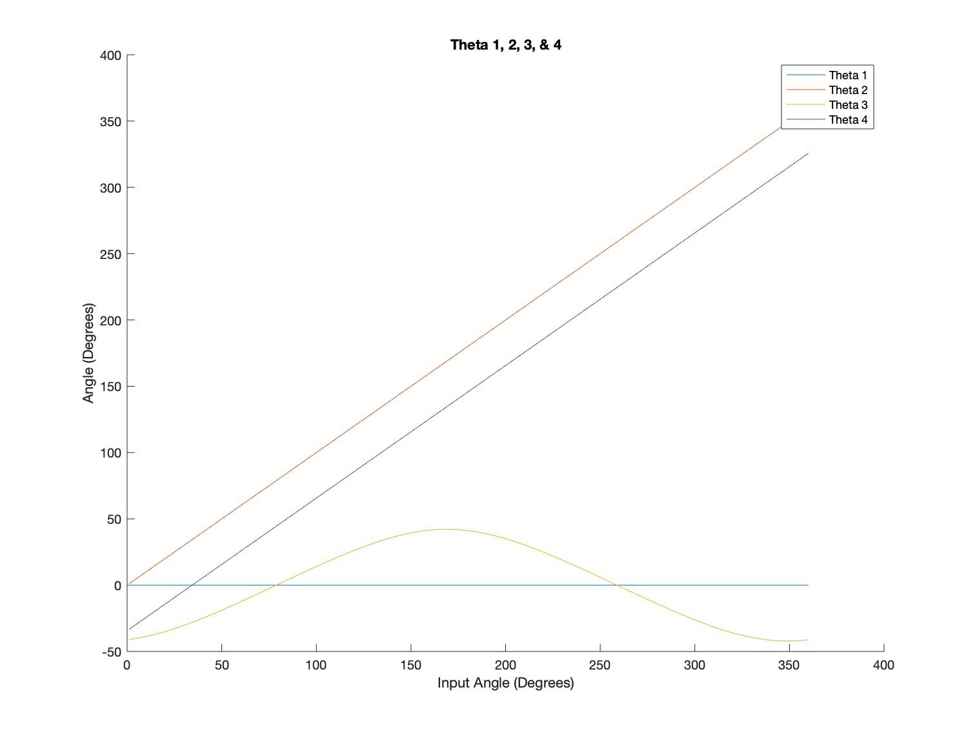
Figure 3.1 Input Angle $θ_{2}$ (degrees) VS Angles $θ_{1}$, $θ_{3}$, & $θ_{4}$ (degrees)
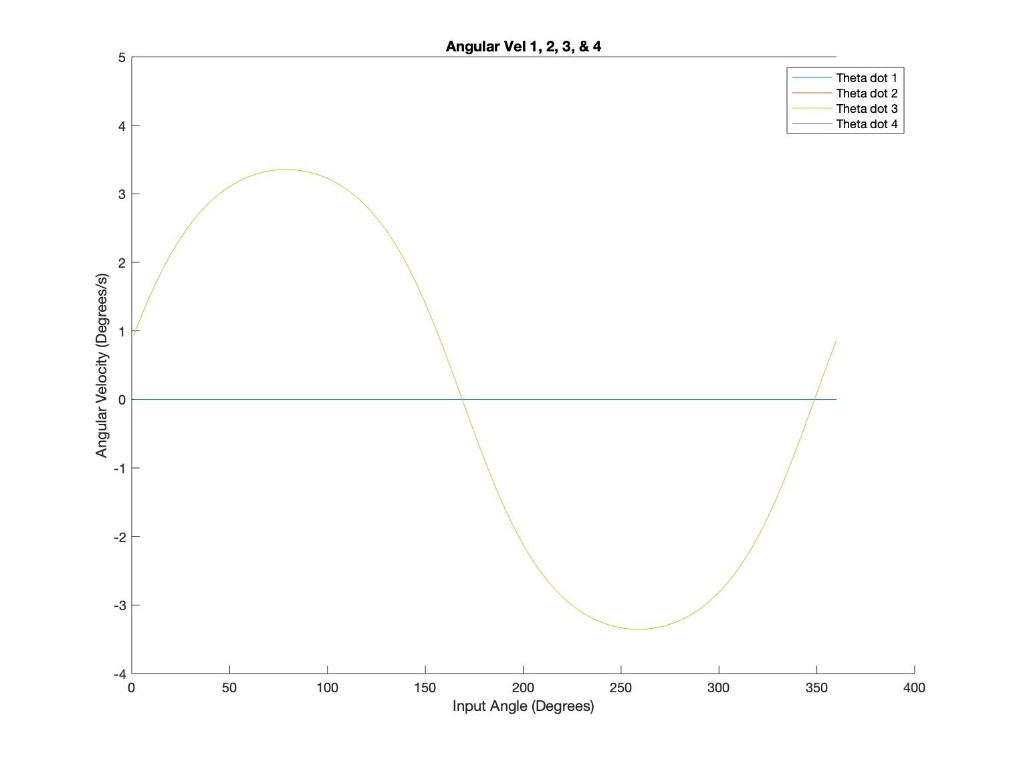
Figure 3.2 Input Angle $θ_{2}$ (degrees) VS Angular Velocity ${\dot{θ}}_{1}$, ${\dot{θ}}_{3}$, & ${\dot{θ}}_{4}$ (degree/s)

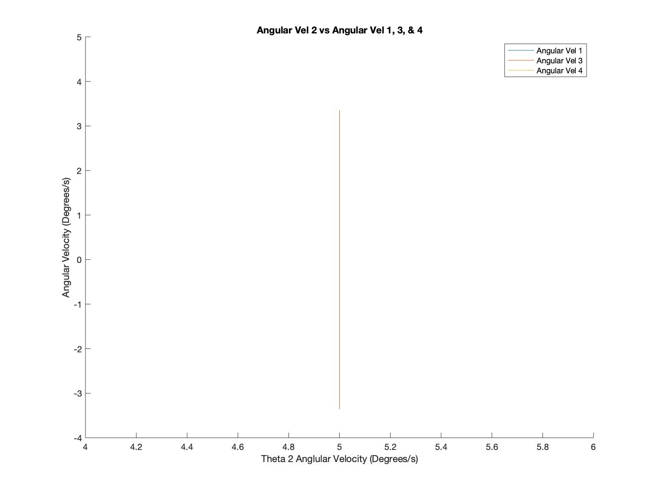
Figure 3.3 Angular Velocity ${\dot{θ}}_{2}$ (degree/s) VS Angular Velocity ${\dot{θ}}_{1}$, ${\dot{θ}}_{3}$, & ${\dot{θ}}_{4}$ (degree/s)

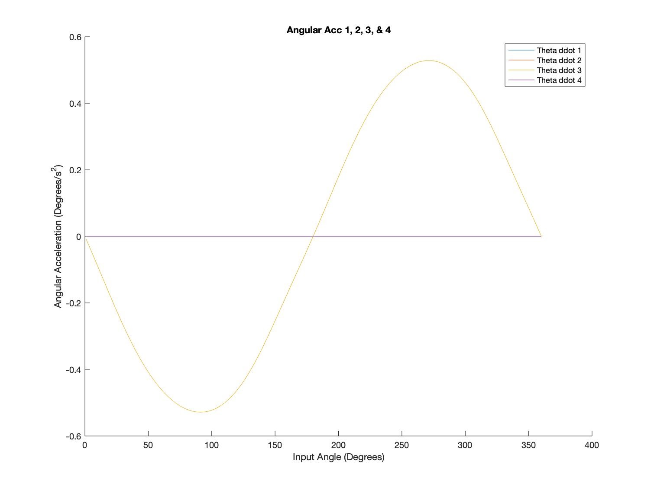
Figure 3.4 Input angle $θ_{2}$ (degrees) VS Angular Acceleration ${\ddot{θ}}_{1}$, ${\ddot{θ}}_{3}$, & ${\ddot{θ}}_{4}$ (degrees/s²)

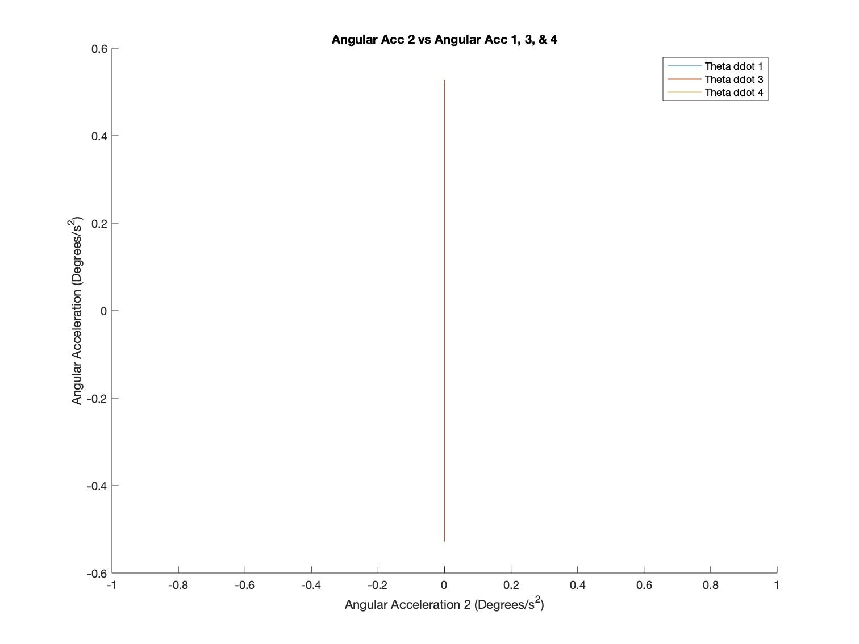
Figure 3.5 Angular Acceleration ${\ddot{θ}}_{2}$ (degrees/s²) VS Angular Acceleration ${\ddot{θ}}_{1}$, ${\ddot{θ}}_{3}$, & ${\ddot{θ}}_{4}$ (degrees/s²)

3.2 Conclusions Based on each Objective and the Results

To conclude, kinematics has been used around us, all over the word, while this project is in its infancy as a mechanism we will venture into different branches and products like mathematical analysis, by using the “NX & MATLAB” software application to make our calculation and graphics more accurate and efficient. Using the requirements given we will calculate and design an optimal four bar linkage design “Double-Crank”, it is important that our research and design produce a safe, yet effective mechanism. Each step of the process is important and has been divided among the group members to ensure the completion and timely submission of the project.

3.3 Recommendations

This project has been done by Group #2, who work fairly to separate the responsibilities and mission on the team, and each step had been taken was under supervision of the class instructor! We are as group #2 really appreciate the help and kind of efforts from Dr. Han. Hopefully, this semester is the last semester we are dealing with virtual learning school and we go back to meet face to face as normal.

APPENDIX A MATLAB Code

% MCEG 3053 Double Crank Project - Group 2
% This programs computes angles, angular velocity, and angular acceleration
% for our 4 bar linkage
S = 200;
P = 500;
Q = 600;
L = 700;
r1 = S;
r2 = P;
r3 = Q;
r4 = L;

% Link 1 is fixed
theta1 = 0;
dtheta1 = 0;
ddtheta1 = 0;

% Driver rotates Link 2 at 5 degrees per second
dtheta2 = 5;
% dtheta 2 and dtheta 4 are equal
dtheta4 = dtheta2;
% Convert degrees per second to radians per second
Rdtheta2 = dtheta2 *(pi/180);
Rdtheta4 = Rdtheta2;

% Since angular velocity is constant for the input, the angular accelerations
% are zero
ddtheta2 = 0;
ddtheta4 = 0;

% Vectors for plotting results
V1 = zeros(360,1);
V2 = zeros(360,1);
V3 = zeros(360,1);
V4 = zeros(360,1);
V1d = zeros(360,1);
V2d = zeros(360,1);
V3d = zeros(360,1);
V4d = zeros(360,1);
V1dd = zeros(360,1);
V2dd = zeros(360,1);
V3dd = zeros(360,1);
V4dd = zeros(360,1);

% Calculates for 360 degrees of input rotation
for i=1:360
% Sets variables related to theta 2
theta2 = i;
V2(i,1) = theta2;
V2d(i,1) = dtheta2;
V2dd(i,1) = ddtheta2;
Rdtheta2 = dtheta2 *(pi/180);
% Sets variables related to theta 4
theta4 = theta2 - (34.344076);
V4(i,1) = theta4;
V4d(i,1) = dtheta4;
V4dd(i,1) = ddtheta4;
Rdtheta4 = Rdtheta2;

% Calculates theta 3
theta3 = asind(( (r1*sind(theta1))-(r2*sind(theta2))+(r4*sind(theta4)) )/r3 );
V3(i,1) = theta3;
% Calculates dtheta 3
Rdtheta3 = (-(r2*Rdtheta2*cosd(theta2))+(r4*Rdtheta4*cosd(theta4))) / (r3*cosd(theta3));
dtheta3 = Rdtheta3 *(180/pi);
V3d(i,1) = dtheta3;
% Calculates ddtheta 3
Rddtheta3 = ((r2*(Rdtheta2^2)*(-sind(theta2)))+(r4*(Rdtheta3^2)*(-sind(theta4)))-(r3*(Rdtheta3^2)*(-sind(theta3))))/(r3*cosd(theta3));
ddtheta3 = Rddtheta3 *(180/pi);
V3dd(i,1) = ddtheta3;
end

% Angle Plot
% Plot 1
figure;
hold on;
plot(V1);
plot(V2);
plot(V3);
plot(V4);
legend('Theta 1', 'Theta 2', 'Theta 3', 'Theta 4');
xlabel('Input Angle (Degrees)');
ylabel('Angle (Degrees)');
title('Theta 1, 2, 3, & 4');

% Angular Velocity Plots
% Plot 2
figure;
hold on;
plot(V2, V1d);
plot(V2, V2d);
plot(V2, V3d);
plot(V2, V4d);
legend('Theta dot 1', 'Theta dot 2', 'Theta dot 3', 'Theta dot 4');
xlabel('Input Angle (Degrees)');
ylabel('Angular Velocity (Degrees/s)');
title('Angular Vel 1, 2, 3, & 4');
% Plot 3
figure;
hold on;
plot(V2d, V1d);
plot(V2d, V3d);
plot(V2d, V4d);
legend('Angular Vel 1', 'Angular Vel 3', 'Angular Vel 4');
xlabel('Theta 2 Angular Velocity (Degrees/s)');
ylabel('Angular Velocity (Degrees/s)');
title('Angular Vel 2 vs Angular Vel 1, 3, & 4');

% Angular Acceleration Plots
% Plot 4
figure;
hold on;
plot(V2, V1dd);
plot(V2, V2dd);
plot(V2, V3dd);
plot(V2, V4dd);
legend('Theta ddot 1', 'Theta ddot 2', 'Theta ddot 3', 'Theta ddot 4');
xlabel('Input Angle (Degrees)');
ylabel('Angular Acceleration (Degrees/s^2)');
title('Angular Acc 1, 2, 3, & 4');
% Plot 5
figure;
hold on;
plot(V2dd, V1dd);
plot(V2dd, V3dd);
plot(V2dd, V4dd);
legend('Theta ddot 1', 'Theta ddot 3', 'Theta ddot 4');
xlabel('Angular Acceleration 2 (Degrees/s^2)');
ylabel('Angular Acceleration (Degrees/s^2)');
title('Angular Acc 2 vs Angular Acc 1, 3, & 4');

APPENDIX B Drawings

