Course ASSESSMENT REPORT

ROY G. PERRY COLLEGE OF ENGINEERING
MECHANICAL ENGINEERING DEPARTMENT
PRAIRIE VIEW A&M UNIVERSITY

ASSESSMENT REPORT COVER PAGE

MCEG 3305 Kinematics Design and Analysis

FALL 2021 SEMESTER

NAME OF INSTRUCTOR: Dr. Chang Duan

Date: 12/17/2021

TABLE OF CONTENTS

- Report Cover Page

- Detailed Course Syllabus

- End of Semester Outcomes Assessment Report

- Grade Sheet Showing Student and Class Performance in Outcomes

- Supporting Outcomes Specific Assignments (Minimum of 2 per outcome except for Project Reports where one is enough)

5.1 Assignments assessing students’ ability to identify, formulate, and solve complex engineering problems (CEP) by applying principles of engineering, science, and mathematics. (outcome “1”)

Detailed Course Syllabus
(Distributed to Students at the beginning of the Semester)
ABET outcomes measured using this course should be
explicitly listed in the syllabus
Course Syllabus in ABET Format
MCEG 3305 Kinematics Design and Analysis

1. | Course number and name: | MCEG 3305 Kinematics Design and Analysis
2. | Credits and contact hours: | 3 credit hours
3. | Instructor’s or course  coordinator’s name: | Dr. Chang Duan
4. | Text book: Title: | Design of Machinery
 | Author: | Robert L. Norton
 | Publisher, Year & Edition: | McGraw Hill, 2012, 5th Edition
 | - Other Supplemental material | Shigley and Uicker, Theory of Machines and Mechanisms, McGraw Hill.
5. | Specific course information
 | - Brief description of the content of the course (catalog description) | This course is to provide students with an in-depth study of the displacement, velocity and acceleration of machine parts. This course shall also introduce the students to design methods for mechanisms yielding a desired set of motion characteristics.
 | - Prerequisites or  Co-requisites | MCEG 1102 Mechanical Engineering Drawing I  MCEG 2302 Engineering Mechanics II
 | - *Indicate whether a required, elective, or selected elective (as per definition provided) course in the program | Required
6. | - Specific goals for the course specific outcomes of instruction (e.g. The student will be able to explain the significance of current research about a particular topic.)  Students will be able to : | - Explicitly indicate which of the student outcomes listed in Criterion 3 or any other outcomes are addressed by the course.  The specific goals for the course specific outcomes listed on the left column will address the following student learning outcomes:
 | 1. Analyze mechanisms in order to determine their rigid-body dynamic behavior | Outcome 1  The ability to identify, formulate, and solve complex engineering problems by applying principles of engineering, science, and mathematics.
 | 2.Synthesize mechanisms in order to accomplish desired motions or tasks
 | 3. Use computer aided engineering software for mechanisms analysis, synthesis and design
7 | Brief list of topics to be covered | 1. Introduction to the kinematics fundamentals (1 class)  2. Position and Displacement (4 classes)  3. Velocity by Components and by Instant Centers (2 classes)  4. Graphical Synthesis (3 classes)  5. Velocity Analysis (5 classes)  6. Acceleration Analysis (3 classes)  7. Mathematical Analysis (2 classes)  8. Design Project (1 classes)  9. Cams (5 classes)  10. Gear Trains (2 classes)

*Required courses are required of all students in the program, elective courses (often referred to as open or free electives) are optional for students, and selected elective courses are those for which students must take one or more courses from a specified group

Additional Course Syllabus Information

CLASS HOURS | 12:00 -1:50 MW
CLASS ROOM | Gilchrist Engineering Bldg. 109
INSTRUCTOR | Dr. Chang Duan
OFFICE | C.L. Wilson Engineering Complex Room 105H
OFFICE HOURS | As Posted
TELEPHONE | (936)261-9954

Grading | The final grade will be computed according to the following weight distribution:  Homework 10%  Graded Forum Discussion 10%  Project 20%  Test 1 20%  Test 2 20%  Final Exam 20%  The distribution of grades will be as follows:  A = 90 - 100  B = 80 - 89  C = 70 - 79  D = 60 - 69  F = 0 - 59
Course Policy | Note: The instructor reserves the right to alter it during the semester.  Use of ecourses (http://ecourese.pvamu.edu)  Ecourses will be used extensively in this class. Lecture slides, assignment, and tutorials will be provided on Ecourses.  Academic Integrity  Academic dishonesty of any sort (plagiarism, cheating, fabrication or facilitation) is prohibited under any circumstance. Any detected actions of dishonesty will cause the failure of the class directly.  Assignments & Due Dates  Homework will be submitted at the beginning of class on the assigned day. Late homework will be charged a 20% penalty for each day late – weekend days do count. Circumstances beyond your control (i.e. illness, computer failure, weather, etc.) will be considered as required.  Projects  You need to submit all the projects with one hardcopy printed out on papers and one electronic copy on ecourses. The final project will be team project.  Attendance  Class attendance is mandatory. Being late class for more than 15 minutes will count as one absence. Viewing the recorded sessions within two days of posting is expected. You should notify the instructor if you can neither attend nor review the recorded sessions within two days of posting.  Examinations  No makeup test will be given. You will be expected to complete the exam in the allotted time period. Portions of each exam may be either closed or open book. You will be notified of the exam format at least one week in advance.  Question/concern about grades  All discussion about grades excluding final exam grade should happen before final exam. Questions about grade of quizzes, homework, exams should be brought up within one week after they are graded and given back to you.
IMPORTANT DATES | Please visit  https://www.pvamu.edu/registrar/academic-calendars/fall-2021-16-week-session/

Kinematic Design and Analysis
Tentative Course Schedule

WEEK | Lecture | REMARKS
1st week | Introduction to mechanisms analysis and synthesis;  Kinematics and Kinetics;  Mechanisms and Machines;  Getting started in MATLAB;  Mobility, Transmission angle, vectors
2nd week | Position analysis;  Position analysis using vector loop equations;  Couples curves
3rd week | Velocity analysis;  Velocity analysis by components;  Analysis by use of instant centers;
4th week | The velocity Polygon  Analytic velocity Analysis
5th week | Acceleration analysis;  Graphical acceleration analysis;  Accelerations in rolling contact;  Coriolis component of acceleration
6th week | Graphical analysis;  Analytic acceleration analysis;  Midterm exam
7th week | Introduction to cams;  Cam displacement diagrams  Cam Profile layout
8th week | Pressure angle;  Roller follower diameter;  Cam profile production problems
9th week | Introduction to graphical and analytical synthesis;  Specified transmission angle;
10th week | Crank rocker mechanisms;  Inversion
11th week | Projects  Introduction to gear trains
12th week | Gear contact kinematics  Velocity ratio (train ratio)
13th week | Review
14th week | Final Exam
How Mechanical Engineering Courses meet Department Objectives & ABET Criterion 3
Specific Objectives of the Mechanical Engineering Program (MCEG Objectives) at Prairie View A&M are to produce graduates who have:

- the techniques and skills necessary for modern mechanical engineering practices, and an ability to function effectively in multi-disciplinary teams.
- an ability in life-long learning skills, a knowledge of contemporary issues, and an ability to communicate effectively.
- an understanding of global and societal context in the aspects of professional and ethical responsibility and the impact of engineering solutions on society.
- the qualifications to be employed by major industries and government agencies in the State of Texas and the nation.
- the qualifications to pursue graduate degrees.

ABET Criterion 3: Program Outcomes and Assessment
Engineering Programs must demonstrate that their graduates have:
- the ability to identify, formulate, and solve complex engineering problems by applying principles of engineering, science, and mathematics.;
- the ability to apply engineering design to produce solutions that meet specified needs with consideration of public health, safety, and welfare, as well as global, cultural, social, environmental, and economic factor;
- the ability to communicate effectively with a range of audiences;
- the ability to recognize ethical and professional responsibilities in engineering situations and make informed judgments, which must consider the impact of engineering solutions in global, economic, environmental, and societal contexts;
- the ability to function effectively on a team whose members together provide leadership, create a collaborative and inclusive environment, establish goals, plan tasks, and meet objectives;
- ability to develop and conduct appropriate experimentation, analyze and interpret data, and use engineering judgment to draw conclusions; and
- the ability to acquire and apply new knowledge as needed, using appropriate learning strategies.

The table below shows how required Mechanical Engineering courses at Prairie View A&M University contribute to the student’s knowledge and ability to meet ABET criterion 3.

Numerical values – items that the course contents are significantly relevant to ABET Criterion 3 and the instructor will use these items for course assessment. The values represent for “contribution factor” of the specific course toward the assessment of the particular item of ABET Criterion 3. A summation of the values in each column equals to 100.

x – items that the course contents are somewhat relevant to ABET Criterion 3. However, the instructor will not use these items for course assessment.

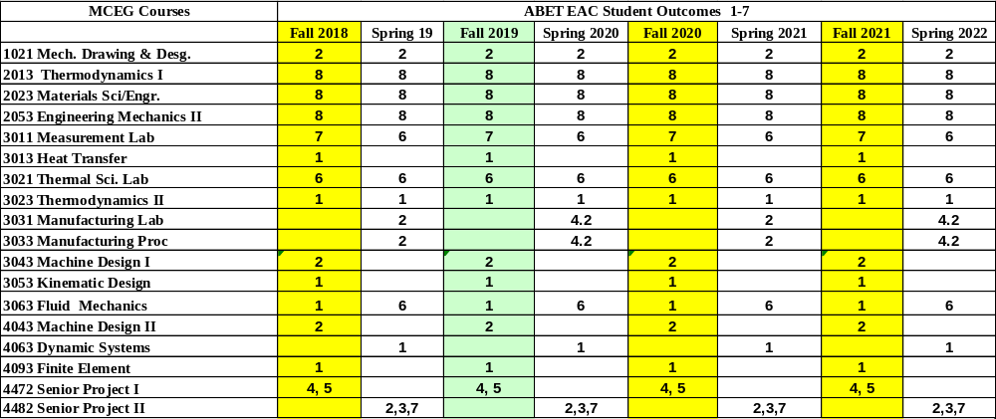

MCEG 3305 Course Objectives and Anticipated Outcomes

Course Objectives

- Introduce the students the concepts and understanding of the displacement, velocity and acceleration in machine parts. (1, 4, 5)

Anticipated Outcomes: The students will be able to solve the mechanism problems (1)

- Introduce the students to current mechanical design methodology as applied to mechanism. (1, 4, 5)

Anticipated Outcomes: The students should be able to analyze motion in machine parts and use synthesis to design mechanism using modern tools. (1)

Student Support and Success

John B. Coleman Library
The John B. Coleman Library’s mission is to enhance the scholarly pursuit of knowledge, to foster intellectual curiosity, and to promote life-long learning and research through our innovative services, resources, and cultural programs, which support the Prairie View A&M University’s global mission of teaching, service, and research. It maintains library collections and access both on campus, online, and through local agreements to further the educational goals of students and faculty. Website: https://www.pvamu.edu/library/; Phone: 936-261-1500

Academic Advising Services
Academic Advising Services offers students a variety of services that contributes to student success and leads towards graduation. We assist students with understanding university policies and procedures that affect academic progress. We support the early alert program to help students get connected to success early in the semester. We help refer students to the appropriate academic support services when they are unsure of the best resource for their needs. Faculty advisors support some students in their respective colleges. Your faculty advisor can be identified in PantherTracks. Advisors with Academic Advising Services are available to all students. We are located across campus. Find your advisor's location by academic major at www.pvamu.edu/advising. Phone: 936-261-5911

The University Tutoring Center
The University Tutoring Center (UTC) offers free tutoring and academic support to all registered PVAMU students. The mission of the UTC is to help provide a solid academic foundation that enables students to become confident, capable, independent learners. Competent and caring staff and peer tutors guide students in identifying, acquiring, and enhancing the knowledge, skills, and attitudes needed to reach their desired goals. Tutoring and academic support are offered face-to-face in the UTC, in virtual face-to-face sessions (https://www.pvamu.edu/student-success/sass/university-tutoring-center/), and through online sessions (https://www.pvamu.edu/pvplace/). Other support services available for students include Supplemental Instruction, Study Break, Academic Success Workshops, and Algebra Study Jam. Location: J. B. Coleman Library, Rm. 307; Phone: 936-261-1561; Email: pvtutoring@pvamu.edu; Website: https://www.pvamu.edu/student-success/sass/university-tutoring-center/

Writing Center
The Writing Center provides well-trained peer tutors to assist students with writing assignments at any stage of the writing process. Tutors help students with various writing tasks from understanding assignments, brainstorming, drafting, revising, editing, researching, and integrating sources. Students have free access to Grammarly online writing assistance. Grammarly is an automated proofreading and plagiarism detection tool. Students must register for Grammarly by using their student email address. In addition, students have access to face-to-face and virtual tutoring services either asynchronously via email or synchronously via Zoom. Location: J. B. Coleman Library, Rm. 209; Phone: 936-261-3724; Website: https://www.pvamu.edu/student-success/writing-center/; Grammarly Registration: https://www.grammarly.com/enterprise/signup

Academic Early Alert
Academic Early Alert is a proactive system of communication and collaboration between faculty, academic advisors, and PVAMU students that is designed to support student success by promptly identifying issues and allowing for intervention. Academic Early Alerts help students by providing a central location to schedule advising appointments, view advisor contact information, and request assistance. Students who recognize that they have a problem that is negatively affecting their academic performance or ability to continue school may self-refer an Academic Early Alert. To do so, students will log in to PV Place and click on Academic Early Alert on the left sidebar. Phone: 936-261-5902; Website: https://www.pvamu.edu/student-success/early-alert/

Student Counseling Services
The Student Counseling Services unit offers a range of services and programs to assist students in maximizing their potential for success: short-term individual, couples, and group counseling, as well as crisis intervention, outreach, consultation, and referral services. The staff is licensed by the State of Texas and assists students who are dealing with academic skills concerns, situational crises, adjustment problems, and emotional difficulties. Information shared with the staff is treated confidentially and in accordance with Texas State Law. Location: Hobart Taylor, 2nd floor; Phone: 936-261-3564; Website: https://www.pvamu.edu/healthservices/student-counseling-services/

Office of Testing Services
Testing Services serves to create opportunities by offering a suite of exams that aid in the students' academic and professional success. Currently, we administer entrance (HESI A2), college readiness (TSI assessment), Prior Learning (CLEP, DSST), and proctored exams. Location: Wilhelmina Delco, 3rd Floor, Rm. 305; Phone: 936-261-3627; Email: aetesting@pvamu.edu; Website: www.pvamu.edu/testing

Office of Diagnostic Testing and Disability Services
The Americans with Disabilities Act (ADA) is a federal anti-discrimination statute that provides comprehensive civil rights protection for persons with disabilities. Among other things, this legislation requires that all students with disabilities be guaranteed a learning environment that provides for reasonable accommodation of their disabilities. If you believe you have a disability requiring an accommodation, contact the Office of Disability Services. As a federally-mandated educational support unit, the Office of Disability Services serves as the repository for confidential disability files for faculty, staff, and students. For persons with a disability, the Office develops individualized ADA letters of request for accommodations. Other services include learning style inventories, awareness workshops, accessibility pathways, webinars, computer laboratory with adapted hard and software, adapted furniture, proctoring non-standardized test administrations, ASL interpreters, ALDs, digital recorders, Livescribe, and a comprehensive referral network across campus and the broader community. Location: Hobart Taylor, Rm. 1D128; Phone: 936-261-3583; Website: https://www.pvamu.edu/disabilityservices/

Center for Instructional Innovation and Technology Services (CIITS)
Distance Learning, also referred to as Distance Education, is the employment of alternative instructional delivery methods to extend programs and services to persons unable to attend college in the traditional manner. The Center for Instructional Innovation and Technology Services (CIITS) supports student learning through online, hybrid, web-assist, and 2-way video course delivery. For more details and contact information, visit:
https://www.pvamu.edu/dlearning/distance-learning-2-2/students-2/; Phone: 936-261-3283

Veteran Affairs
Veterans Services works with student veterans, current military and military dependents to support their transition to the college environment and continued persistence to graduation. The Office coordinates and certifies benefits for both the G.I. Bill and the Texas Hazlewood Act. Location: Evans Hall, Rm. 102; Phone: 936-261-3563; Website: https://www.pvamu.edu/sa/departments/veteranaffairs/

Office for Student Engagement
The Office for Student Engagement delivers comprehensive programs and services designed to meet the co-curricular needs of students. The Office implements inclusive and accessible programs and services that enhance student development through exposure to and participation in diverse and relevant social, cultural, intellectual, recreational, community service, leadership development, and campus governance. Location: Memorial Student Center, Rm. 221; Phone: 936-261-1340; Website: https://www.pvamu.edu/studentengagement/

Career Services
Career Services supports students through professional development, career readiness, and placement and employment assistance. The Office provides one-on-one career coaching, interview preparation, resume and letter writing, and career exploration workshops and seminars. Services are provided for students at the Northwest Houston Center and College of Nursing in the Medical Center twice a month or on a requested basis. Distance Learning students are encouraged to visit the Career Services website for information regarding services provided. Location: Anderson Hall, 2nd floor; Phone: 936-261-3570; Website: https://www.pvamu.edu/careerservices/

University Rules and Procedures

Academic Misconduct
Academic dishonesty is defined as any form of cheating or dishonesty that has the effect or intent of interfering with any academic exercise or fair evaluation of a student's performance. The college faculty can provide additional information, particularly related to a specific course, laboratory, or assignment.

You are expected to practice academic honesty in every aspect of this course and all other courses. Make sure you are familiar with the University Administrative Guidelines on Academic Integrity, which can be found on the Academic Integrity webpage. Students who engage in academic misconduct are subject to university disciplinary procedures. As listed in the University Administrative Guidelines on Academic Integrity, the University Online Catalog, and the Student Code of Conduct, the following are examples of prohibited conduct. This list is not designed to be all-inclusive or exhaustive. In addition to academic sanctions, any student found to have committed academic misconduct that is also a violation of criminal law may also be subject to disciplinary review and action by the Office of Student Conduct (as outlined in the Student Code of Conduct).

Forms of Academic Dishonesty:

- Cheating: Deception in which a student misrepresents that he/she has mastered information on an academic exercise that he/she has not learned, giving or receiving aid unauthorized by the instructor on assignments or examinations. Examples: unauthorized use of notes for a test; using a "cheat sheet" on a quiz or exam; any alteration made on a graded test or exam which is then resubmitted to the teacher;
- Plagiarism: Careless or deliberate use of the work or the ideas of another; representation of another's work, words, ideas, or data as your own without permission or appropriate acknowledgment. Examples: copying another's paper or answers, failure to identify information or essays from the internet and submitting or representing it as your own; submitting an assignment which has been partially or wholly done by another and claiming it as yours; not properly acknowledging a source which has been summarized or paraphrased in your work; failure to acknowledge the use of another's words with quotation marks;
- Collusion: When more than one student or person contributes to a piece of work that is submitted as the work of an individual;
- Conspiracy: Agreeing with one or more persons to commit an act of academic/scholastic dishonesty; and
- Multiple Submission: Submission of work from one course to satisfy a requirement in another course without explicit permission. Example: using a paper prepared and graded for credit in one course to fulfill a requirement and receive credit in a different course.

Nonacademic Misconduct
The university respects the rights of instructors to teach and students to learn. Maintenance of these rights requires campus conditions that do not impede their exercise. Campus behavior that interferes with either (1) the instructor's ability to conduct the class, (2) the inability of other students to profit from the instructional program, or (3) campus behavior that interferes with the rights of others will not be tolerated. An individual engaging in such disruptive behavior may be subject to disciplinary action. The Office of Student Conduct will adjudicate such incidents under nonacademic procedures.

Sexual Misconduct
Sexual harassment of students and employees at Prairie View A&M University is unacceptable and will not be tolerated. Any member of the university community violating the university's sexual harassment policy will be subject to disciplinary action. In accordance with the Texas A&M University System guidelines, your instructor is obligated to report to the Office of Title IX Compliance (titleixteam@pvamu.edu) any instance of sexual misconduct involving a student, which includes sexual assault, stalking, dating violence, domestic violence, and sexual harassment, about which the instructor becomes aware during this course through writing, discussion, or personal disclosure. The faculty and staff of PVAMU actively strive to provide a learning, working, and living environment that promotes respect that is free from sexual misconduct, discrimination, and all forms of violence. If students, faculty, or staff would like assistance or have questions, they may contact the Title IX Coordinator at 936-261-2144 or titleixteam@pvamu.edu. More information can be found at www.pvamu.edu/titleix, including confidential resources available on campus.

Pregnancy, Pregnancy-related, and Parenting Accommodations
Title IX of the Education Amendments of 1972 prohibits sex discrimination, which includes discrimination based on pregnancy, marital status, or parental status. Students seeking accommodations related to pregnancy, pregnancy-related conditions, or parenting (reasonably immediate postpartum period) are encouraged to contact Student Disability Services or the Dean of Students' Office for additional information and to request accommodations.

Non-Discrimination Statement
Prairie View A&M University does not discriminate on the basis of race, color, sex, religion, national origin, age, disability, genetic information, veteran status, sexual orientation, or gender identity in its programs and activities. The University is committed to supporting students and complying with The Texas A&M University System non-discrimination policy. It seeks to establish an environment that is free of bias, discrimination, and harassment. If you experience an incident of discrimination or harassment, we encourage you to report it. If you would like to speak with someone who may be able to afford you privacy or confidentiality, there are individuals who can meet with you. The Director of Equal Opportunity & Diversity has been designated to handle inquiries regarding the non-discrimination policies and can be reached at Harrington Science Building, Suite 109 or by phone at 936-261-1744 or 1792.

Class Attendance Policy (See the University Online Catalog for Full Attendance Policy)
Prairie View A&M University requires regular class attendance. Attending all classes supports the full academic development of each learner, whether classes are taught with the instructor physically present or via distance learning technologies such as interactive video and/or the internet. Excessive absenteeism, whether excused or unexcused, may result in a student's course grade being reduced or in the assignment of a grade of "F." Absences are accumulated beginning with the first day of class during regular semesters and summer terms. Each faculty member will include the University's attendance policy in each course syllabus.
Student Academic Appeals Process
Authority and responsibility for assigning grades to students rest with the faculty. However, in those instances where students believe that miscommunication, errors, or unfairness of any kind may have adversely affected the instructor's assessment of their academic performance, the student has a right to appeal by the procedure listed in the University Online Catalog and by doing so within thirty days of receiving the grade or experiencing any other problematic academic event that prompted the complaint.

Technical Considerations

Minimum Recommended Hardware and Software:
- Intel PC or Laptop with Windows 10 or later version; Mac with OS High Sierra*
- Smartphone or iPad/Tablet with Wi-Fi*
- High-speed Internet access
- 8 GB Memory
- Hard drive with 320 GB storage space
- 15" monitor, 800x600, color or 16 bit
- Sound card w/speakers
- Microphone and recording software
- Keyboard & mouse
- Most current version of Google Chrome, Safari, or Firefox

Note: Be sure to enable Java & pop-ups in the Web browser preferences

* Smartphones, Google Chrome books, and Android tablets may not be supported. iPads are the only tablets supported.

Participants should have a basic proficiency of the following computer skills:
- Sending and receiving email
- A working knowledge of the Internet
- Microsoft Word (or a program convertible to Word)
- Acrobat PDF Reader
- Windows or Mac OS
- Video conferencing software

Netiquette (online etiquette)
Students are expected to participate in all discussions and virtual classroom chats as directed. Students are to be respectful and courteous to others on discussion boards. Foul or abusive language will not be tolerated. Do not use ALL CAPS for communicating to others AS IT CAN BE INTERPRETED AS YELLING. Avoid slang terms such as "wassup?" and texting abbreviations such as "u" instead of "you." Limit and possibly avoid the use of emoticons. Be cautious when using humor or sarcasm as tone is sometimes lost in an email or discussion post, and the message might be taken seriously or sound offensive.

Video Conferencing Etiquette
When using Zoom, WebEx, or other video conferencing tools, confirm the visible area is tidy, clear of background clutter, inappropriate or offensive posters, and other distractions. Ensure you dress appropriately and avoid using high traffic or noisy areas. Stay muted when you are not speaking and avoid eating/drinking during the session. Before the class session begins, test audio, video, and lighting to alleviate technology issues.

Technical Support
Students should go to https://mypassword.pvamu.edu/ if they have password issues. The page will provide instructions for resetting passwords and contact information if login issues persist. For other technical questions regarding eCourses, call the Center for Instructional Innovation and Technology Services at 936-261-3283 or email ciits@pvamu.edu.

Communication Expectations and Standards
Emails or discussion postings will receive a response from the instructor, usually in less than 48 hours. Urgent emails should be marked as such. Check regularly for responses.

Discussion Requirement
Online courses often require minimal to no face-to-face meetings. However, conversations about the readings, lectures, materials, and other aspects of the course can occur in a seminar fashion. The use of the discussion board will accomplish this. The instructor will determine the exact use of discussion boards.

It is strongly suggested that students type their discussion postings in a word processing application such as Word and save it to their PC or a removable drive before posting to the discussion board. This is important for two reasons: 1) If for some reason your discussion responses are lost in your online course, you will have another copy; 2) Grammatical errors can be greatly minimized by the use of the spell-and-grammar check functions in word processing applications. Once the post(s) have been typed and corrected in the word processing application, copy and paste to the discussion board.

COVID-19 Campus Safety Measures

To promote public safety and protect students, faculty, and staff during the coronavirus pandemic, PVAMU has adopted policies and practices to limit virus transmission.

- Self-monitoring - Students should follow CDC recommendations for self-monitoring. Students who have a fever or exhibit symptoms of COVID-19 should participate in class remotely and should not participate in face-to-face instruction.

- Face Coverings - Face coverings (cloth face covering, surgical mask, etc.) are recommended in classrooms, teaching laboratories, common spaces such as lobbies and hallways, public study spaces, libraries, academic resource, and support offices, and outdoor spaces where 6 feet of physical distancing is challenging to maintain reliably.

- Physical Distancing - Physical distancing should be maintained between students, instructors, and others in course and course-related activities where possible.

- Personal Illness and Quarantine - Students required to quarantine are to participate in courses and course-related activities remotely and must not attend face-to-face course activities. Students should notify their instructors of the quarantine requirement. Students under quarantine are expected to participate in courses and complete graded work unless they have symptoms that are too severe to participate in course activities. Students experiencing personal injury or illness that is too severe for the student to attend class qualify for an excused absence. To receive an excused absence, students must provide appropriate documentation to the Office for Student Conduct, studentconduct@pvamu.edu.

End of Semester
Course Assessment Report

This summary contains the following Information

1. Performance Statistics
- Total number of students in class
- The class average performance (stated as %) in each course outcome assessed in this class and the two previous times course was assessed.
- The acceptable class average for the class in each outcome area as set by your Department. You cannot use any number of your choice
- Percentage of students who scored below the expected average in each outcome.

2. Implementation Summary
- Brief summary of plans implemented during the semester based on last assessment report

3. Perceived Problems
- Instructor’s critical evaluation of perceived problems that affected students’ performance. Realistic problems should be identified throughout the semester and summarized in this section of the report.

4. New Plans for Addressing Problems
- Instructor’s plans for addressing the perceived problems the next time the class is taught. These should be specific enough for another instructor to implement. Most of these should be things that, you, the instructor can implement to help students to improve. Be creative.

5. Overall Trend over last three assessment periods
- Instructor’s summary of overall performance trend for each outcome measured over the last three periods.

5. Were Expectations Met?
- Answer YES if the class average was above the expected average and the stated percentage of students scored at or above the expected average, else answer NO.

END OF SEMESTER COURSE OUTCOME ASSESSMENT REPORT
MCEG 3305-P04 KINEMATICS DESIGN AND ANALYSIS
FALL 2021 SEMESTER

Report Prepared by: Dr. Chang Duan
Report Date: December 17, 2021

Semester | Analysis Type | Number of Students | Outcome 1*  An ability to identify, formulate, and solve complex engineering problems by applying principles of engineering, science, and mathematic.
Semester | Analysis Type | Number of Students | Expected Class Average | Expected Percent of students at or above average | Class Average | % Students meeting Expected Average
Fall 2021 | Direct | 20 | 70 | 70 | 78.5 | 85
Fall 2020 | Direct | 27 | 70 | 70 | 76.6 | 88.9
Fall 2019 | Direct | 27 | 70 | 70 | 80.1 | 92.6
Fall 2018 | Direct | 36 | 75/70 | 70 | 88.3 | 97.2
Fall 2017 | Direct | 45 | 75/70 | 70 | 81.8 | 88.2
Implementation Summary | Items implemented from previous report or after meeting previous instructor |  | Math review tutorials are posted as supplementary material. A self-paced MATLAB tutorial is given in the beginning of the class. Project is assigned earlier so that students have enough time to work on it.
Perceived Problems | Perceived problems are directly related to the PC and the sub items under them |  | Students struggled in some fundamental math problems.  Students still have the expectation of the hybrid teaching mode and seems to be less focused in the classroom.  The ability of using engineering software varies drastically among students. In particular, the ability of using UG NX for motion simulation and the ability of using MATLAB for calculation, plotting and analysis.
Plans for Addressing Problems | Plans for address specific measures to address PC and their sub areas |  | Math review (outside of classroom) and quizzes will help student review and improve their math capabilities relate to this course.  More tutorial and in-class demonstration will be given to improve the students’ ability of using engineering software.  Online discussion forum on ecourses can be a good way to engage students outside of the class time.
Overall Trend over Periods | Ascertain if there were improvements over previous semesters |  | Class average and expected percent of students declined in recent years, though still meet the expectations.
Were Expectations Met? | Class Average ≥75% and ≥70% of Students Performed at or Above Expected Average. |  | YES

*: ABET switched to outcome 1-7 in May 2018. Outcome e is assessed in Fall 2017 and before that. Outcome 1 is assessed in Fall 2018 and onwards.

Grade Sheet Showing
Student and Class Performance in Outcomes
The computed semester average in each outcome
as stated in the Assessment report are
highlighted in boldface

Grade Sheet Showing Student and Class
Performance in Course Outcomes
MCEG 3305-P04 Kinematics Design and Analysis
Fall 2021 Semester

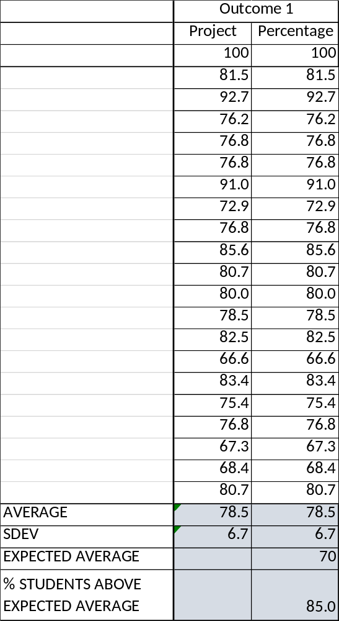

OUTCOME SPECIFIC ASSIGNMENTS
USED TO ASSESS OUTCOMES
(Provide at least two assignments used to specifically measure each outcome and justify the suitability of the assignments for the outcome being measured)

ASSIGNMENTS FOR OUTCOME “e”

Ability to design a system, a component, or a process to meet a desired need

MECHANICAL ENGINEERING DEPARTMENT
OUTCOMES SPECIFIC ASSIGNMENT COVER SHEET
MCEG3305 Kinematics Design and Analysis
FALL 2021
Instructor: Dr. Chang Duan

Title of Assignment

Project

Outcome Measured Using this Assignment
Outcome 1
An ability to identify, formulate, and solve complex engineering problems by applying principles of engineering, science, and mathematic.

Check the complex engineering problem characteristics related to this assignment

Assignment problem
involves wide-ranging or conflicting technical issues,
has no obvious solution
Addresses problems not encompassed by current standards and codes
involves diverse groups of stakeholders
includes many component parts or sub-problems
involves multiple disciplines
has significant consequences in a range of contexts
Assignment problem involves the application of the principles of
engineering
science
mathematics

Brief justification of the suitability of assignment for the outcome
This is a group project to design, simulate and analyze an actual mechanism using the knowledge of this course (engineering, mathematics) and engineering software such as UG NX and MATLAB.

MCEG3053: Kinematics Design and Analysis
Fall 2019
MCEG3305: Kinematics Design and Analysis
Fall 2021

Project: Pedal Bin Mechanism Design and Analysis

I. Project description
This is a group project to design and analyze the pedal bin mechanism using Siemens NX and MATLAB. You need to model and simulate your mechanism using Siemens NX and perform position, velocity, and acceleration analysis with MATLAB.

II. The pedal bin mechanism:

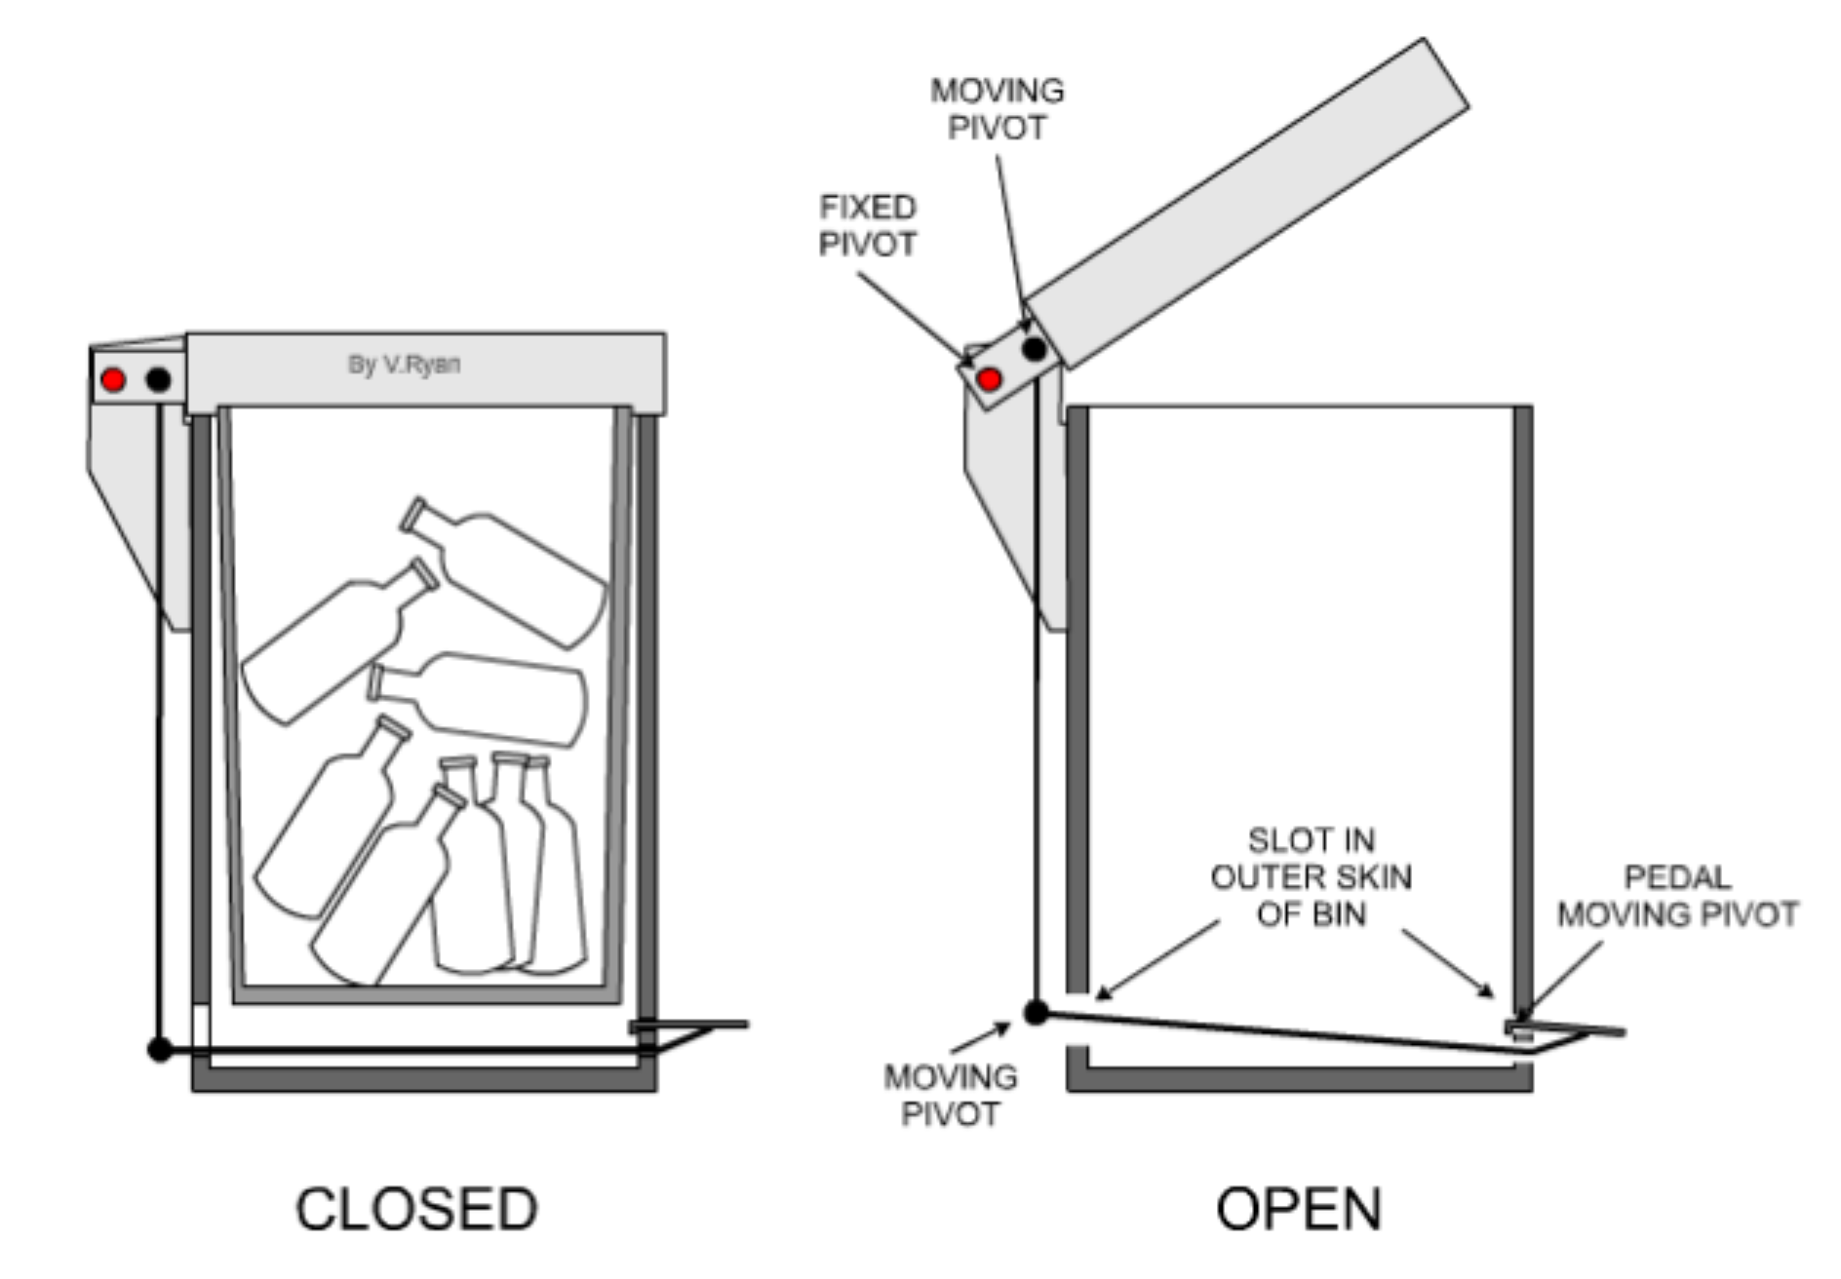
Figure 1. The pedal bin mechanism [1]

Figure 1 shows the closed and open position of the pedal bin mechanism. It shows the fixed and moving pivots.

III. Design Tasks:
- Determine the dimension of the pedal bin mechanism;
- Create the pedal bin using NX;
- Create the assembly of the mechanism;
- Create the links and joints for the motion analysis;
- Select input/driver joint, assuming an angular velocity and perform the motion analysis;
- Note the angles of the pedal and the lids for the open and closed positions;
- Create a mpeg video or other sort of animation to demonstrate your motion;
- Analyze the position, velocity and acceleration of the linkage using MATLAB;
- Plot the position, velocity and acceleration and compare the results with the motion simulation.

IV. Deliverable Results:
1. Proposal report: maximum 2 pages; Due date: Oct. 20.
The proposal must describe:
A. Proposed work schedule.
B. Tasks distribution. (What will each group member work on?)

2. Final Project Presentations (Nov. 24): Every group will be asked to give a 10-minute presentation using PowerPoint.

3. Final Report and soft copy of your project (Due: Dec. 1)
A. A final report in electronic format should be documented in Word format. There is no specific format and page limitation, but your report should include the following contents:
          - Abstract (100-150 words);
          - Introduction (design objectives);
          - Project description (mechanism’s functional requirements, design constrains, design parameters, etc.);
          - NX models and motion (models of components, drafting of major components, assembly, extreme positions, motion analysis and simulation, etc.);
          - Position, velocity, and acceleration analysis using MATLAB (equations used, MATLAB code, MATLAB plots; comparison with the NX motion, etc.)
          - Conclusion and suggestion; and
          - Reference, if any.

B. Please submit
Electronic version of the report, presentation, and your project as one compressed file to Canvas.

4. Taskstream submission (Due: Dec. 1)
Submit the final report to Taskstream in response to Outcome 1 Assignment 1

V. Point Distribution:
Category |  | Points
Proposal |  | 30
Quality, completeness and results (120 pts) | Create NX model | 20
Quality, completeness and results (120 pts) | Assembly of the mechanism | 10
Quality, completeness and results (120 pts) | Motion demonstration | 30
Quality, completeness and results (120 pts) | Determine input/output joint for position analysis | 10
Quality, completeness and results (120 pts) | Analyze the position, velocity and acceleration of the linkage using MATLAB | 30
Quality, completeness and results (120 pts) | Plot the position, velocity and acceleration and compare the results with the motion simulation. | 20
Final presentation |  | 50
Final report | Format | 30
Final report | Phrasing and clarity | 30
Final report | Neatness | 20
Taskstream submission |  | 20
Peer evaluation |  | 100
Total |  | 400

Reference:
[1] Ryan, V., “The pedal mechanism 1”, https://technologystudent.com/rmprep09/ped1.html (March 28, 2021)

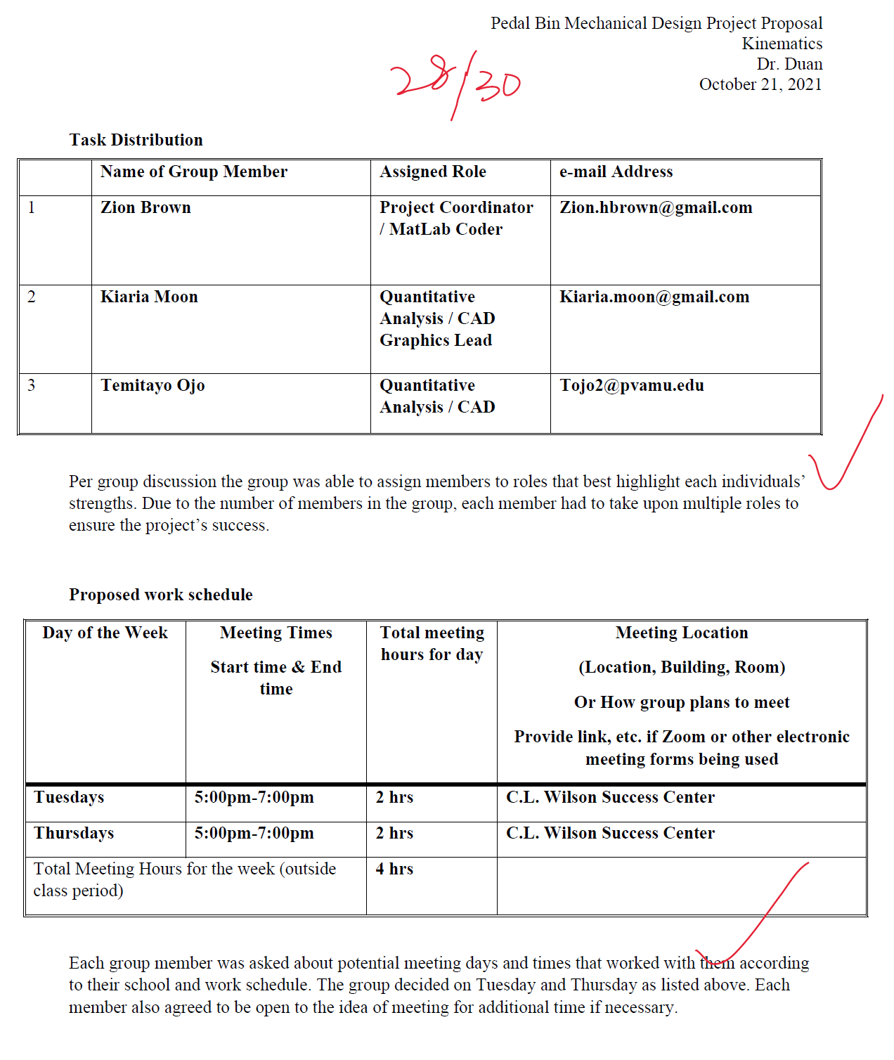

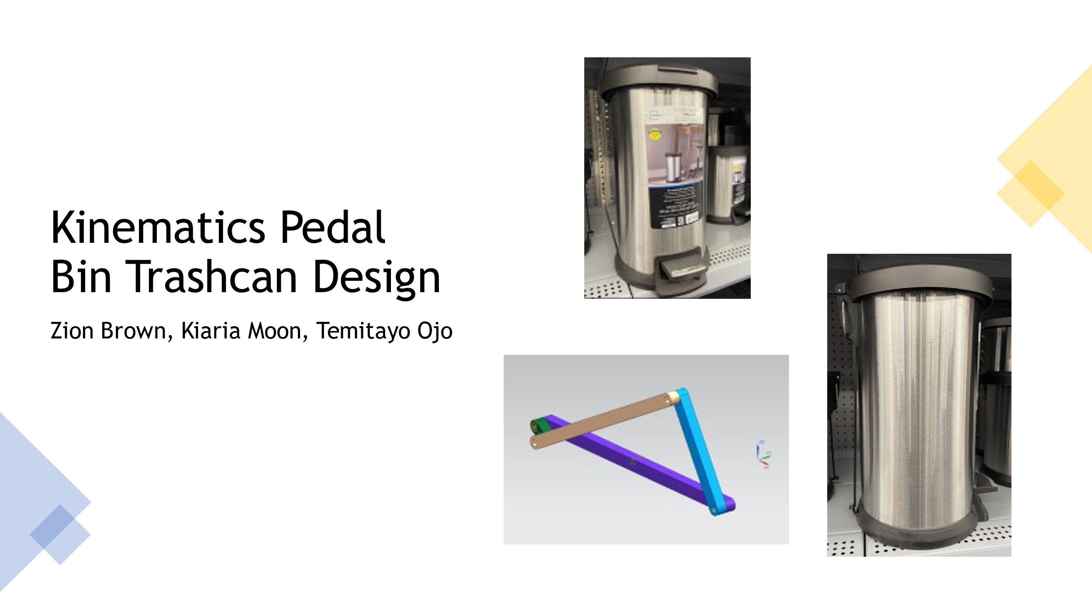
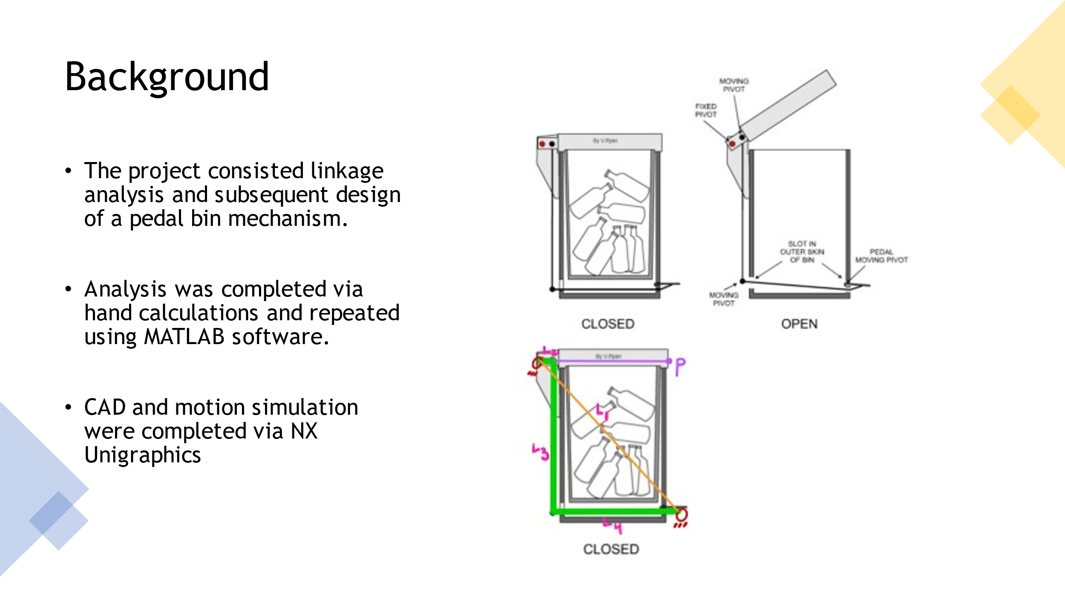
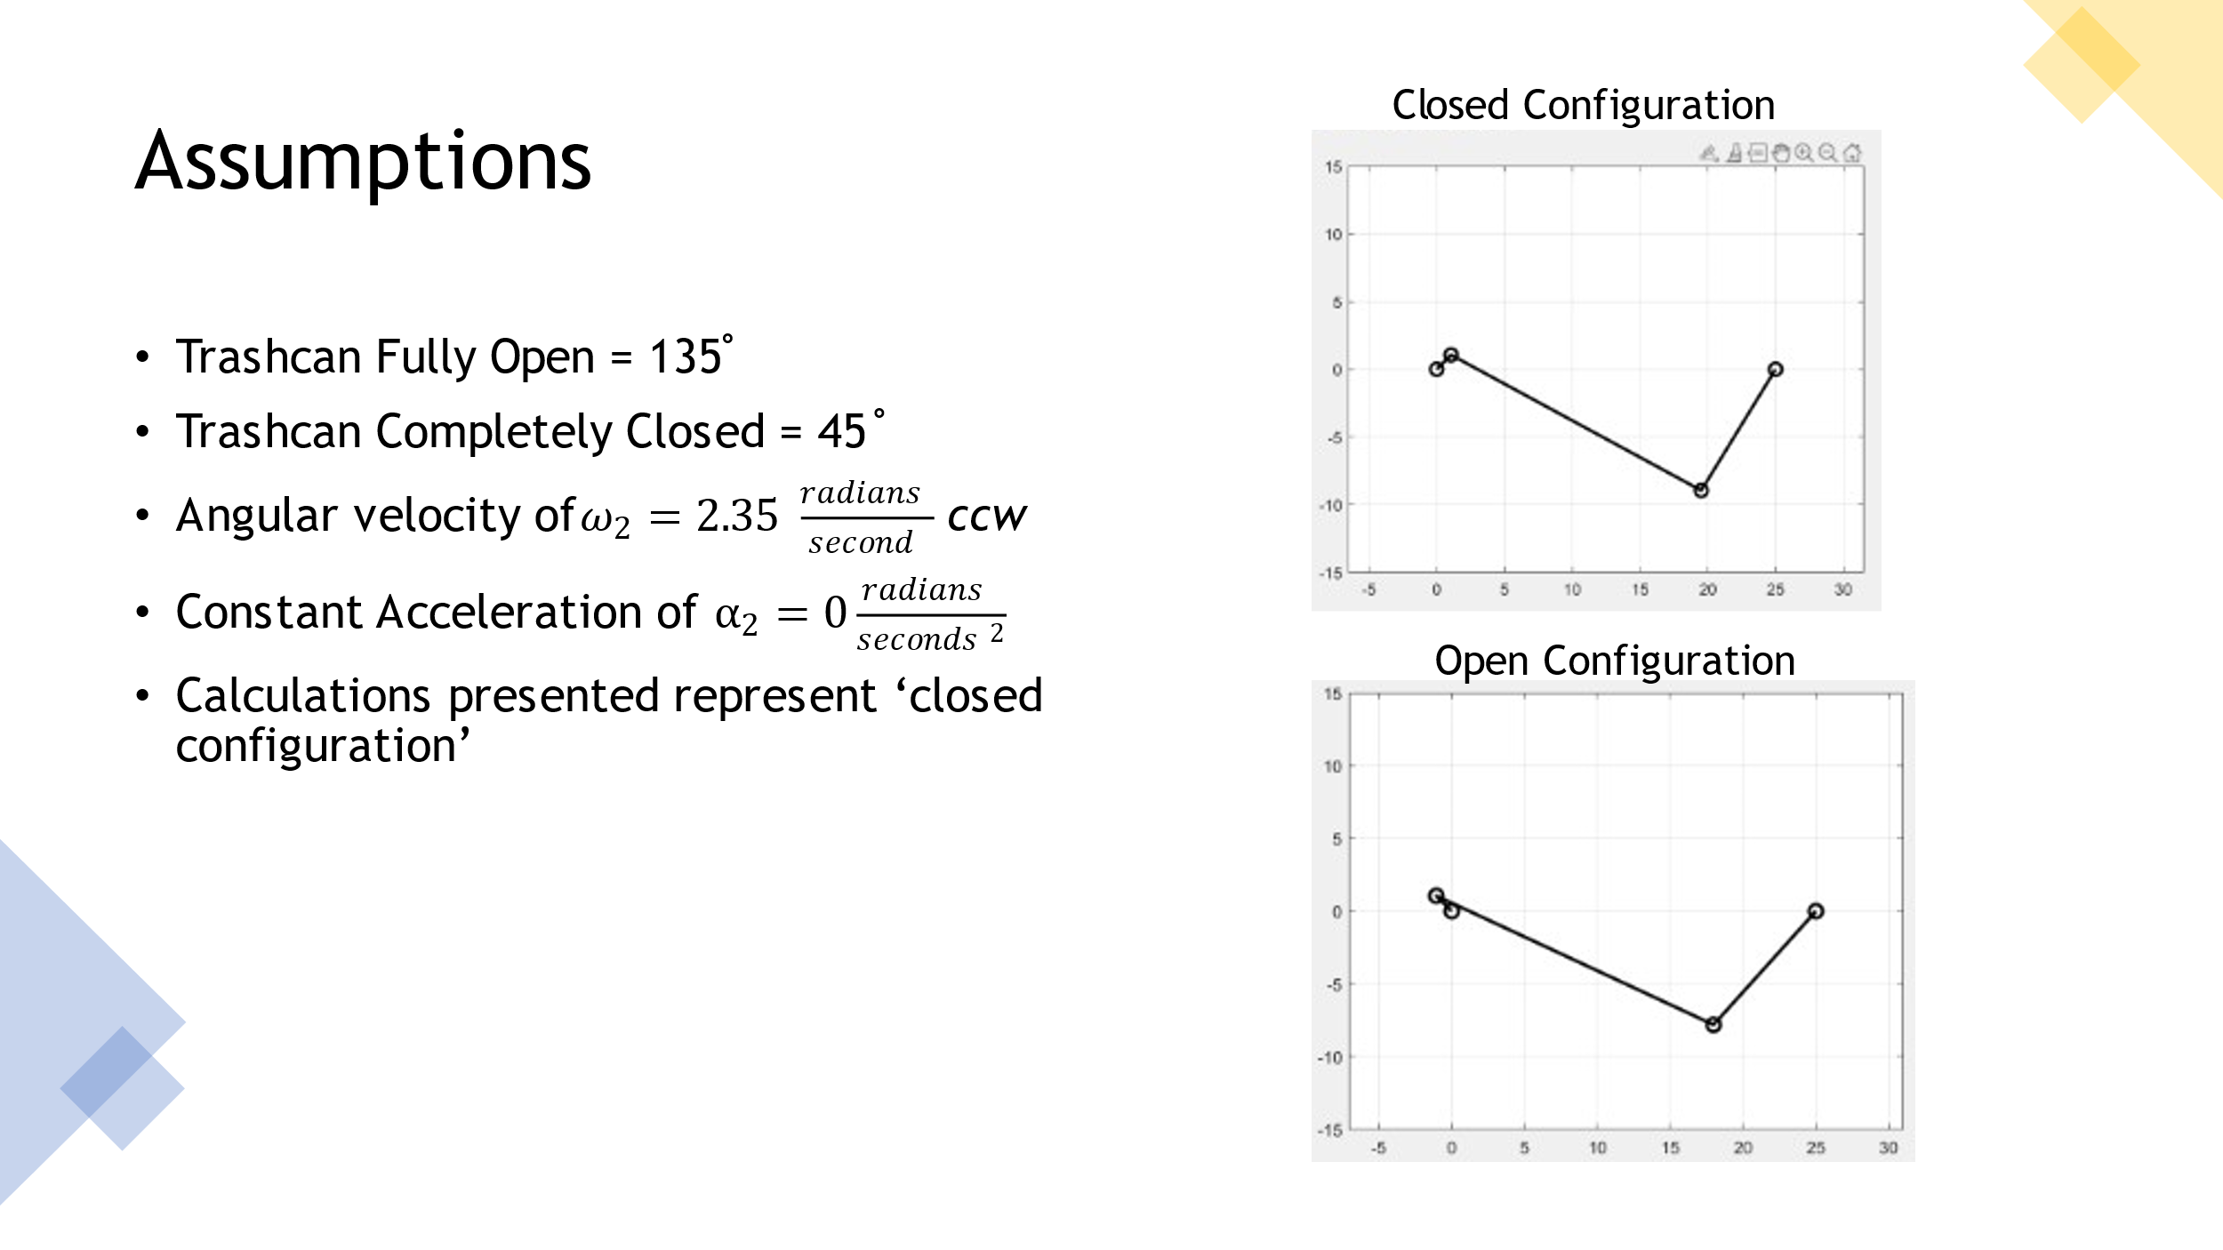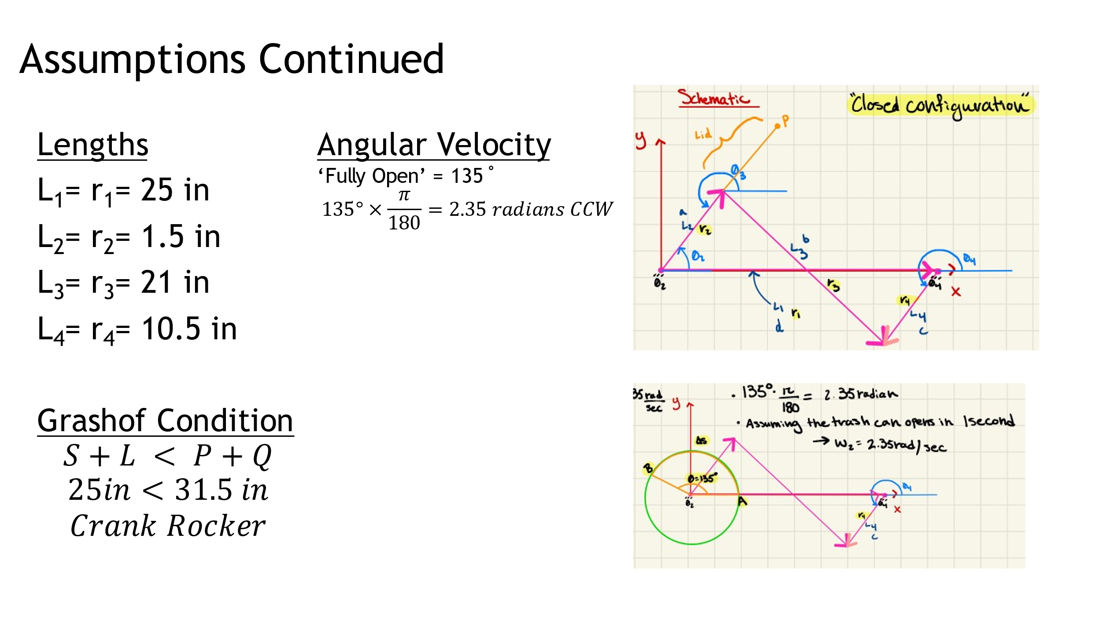

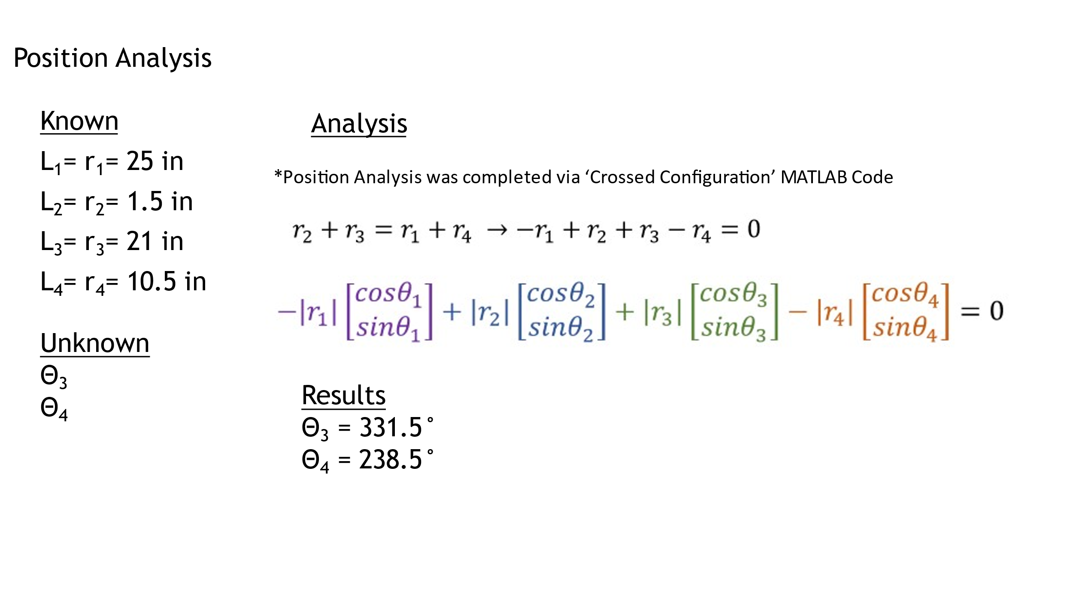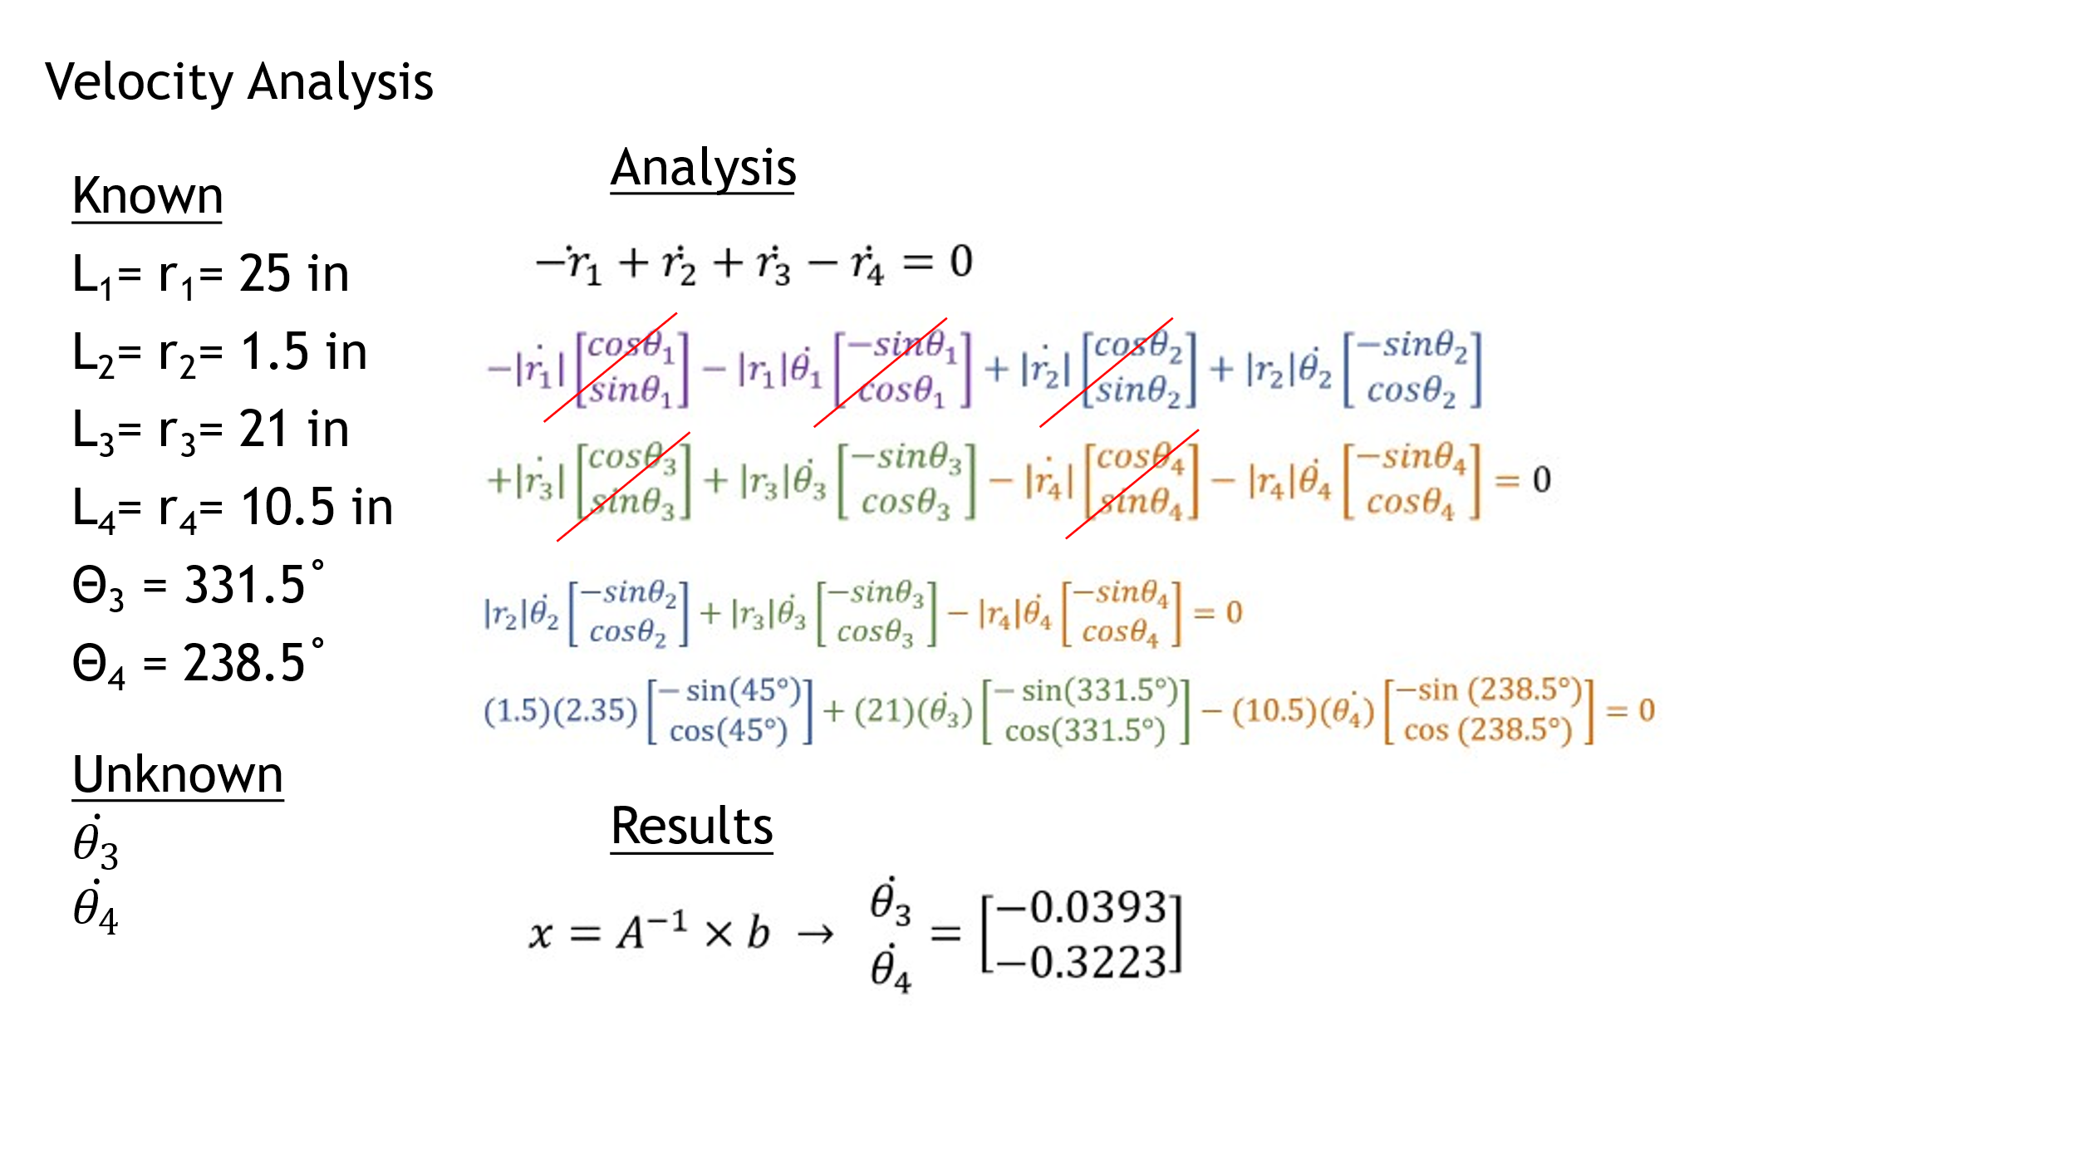

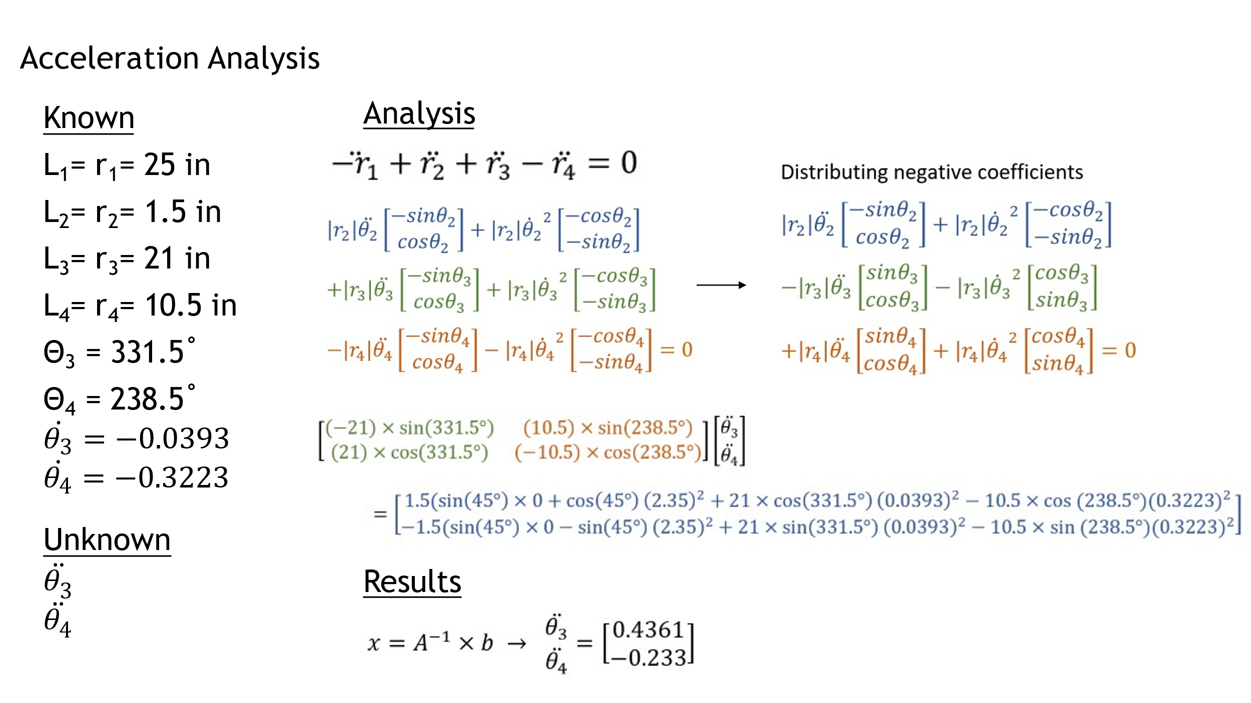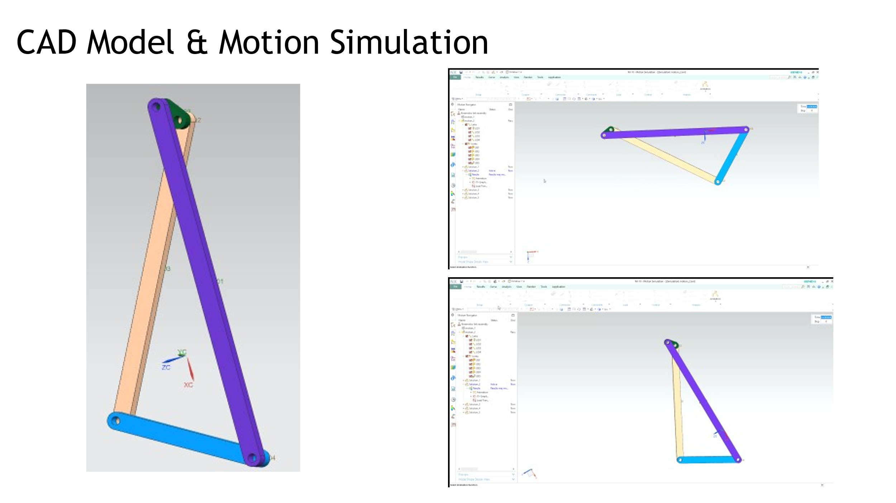

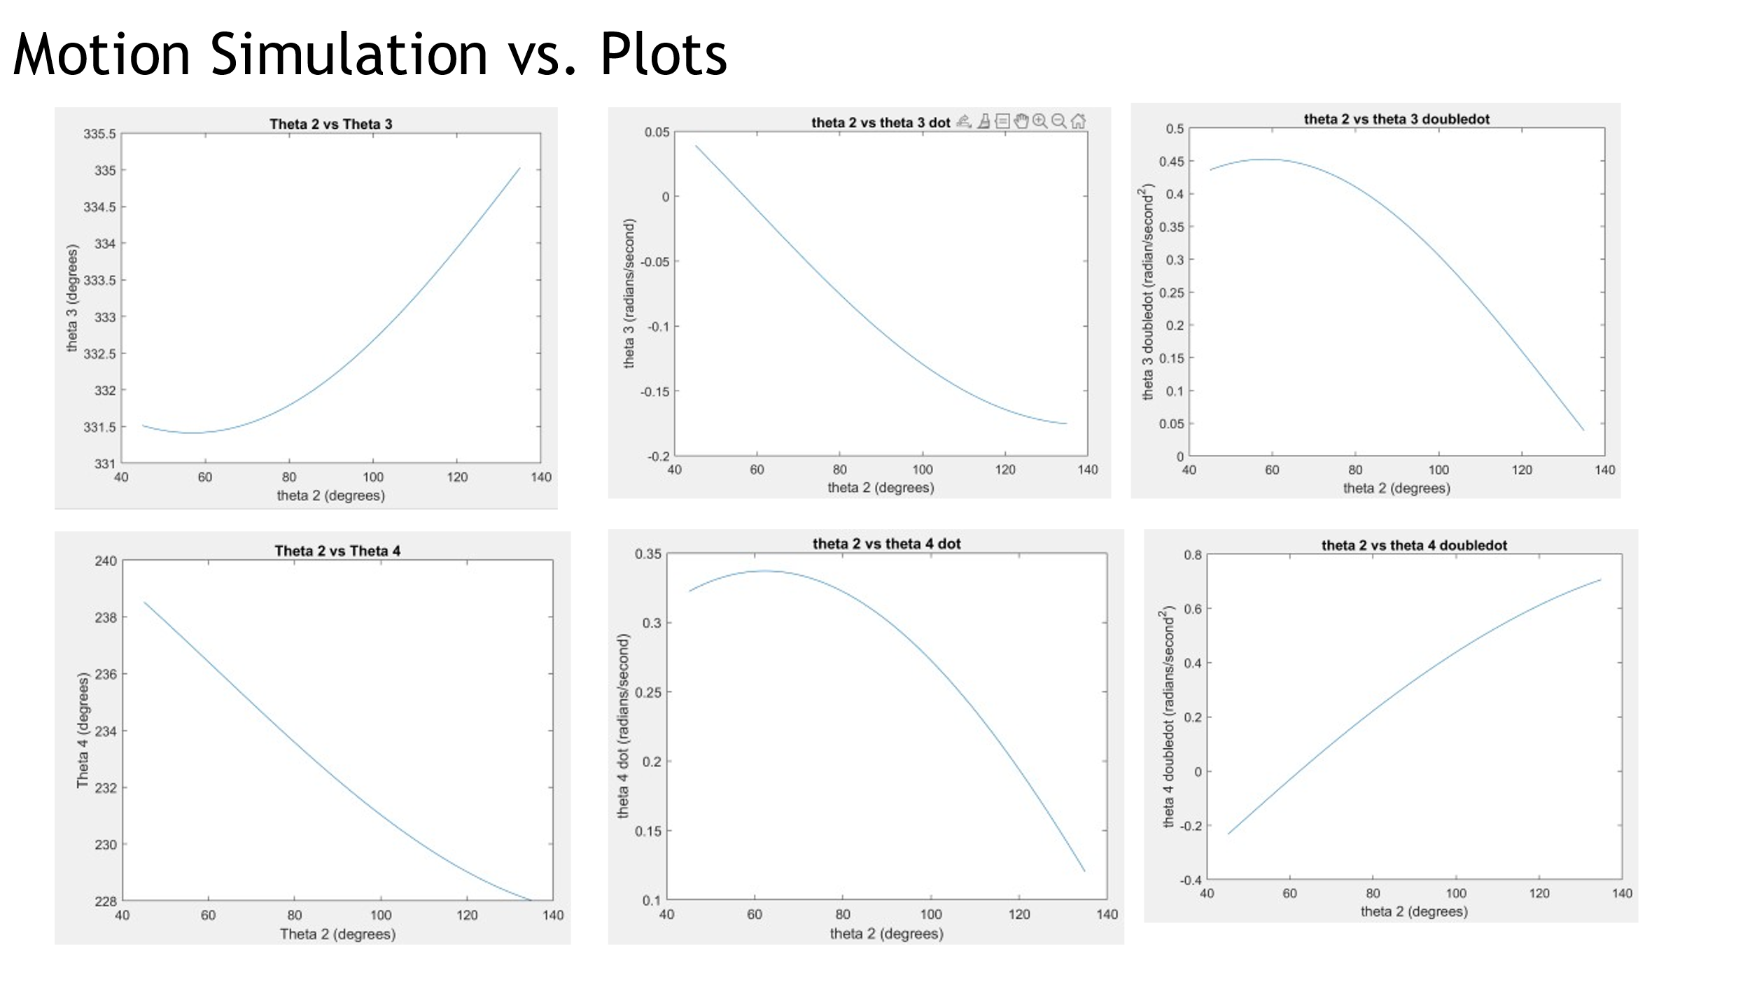

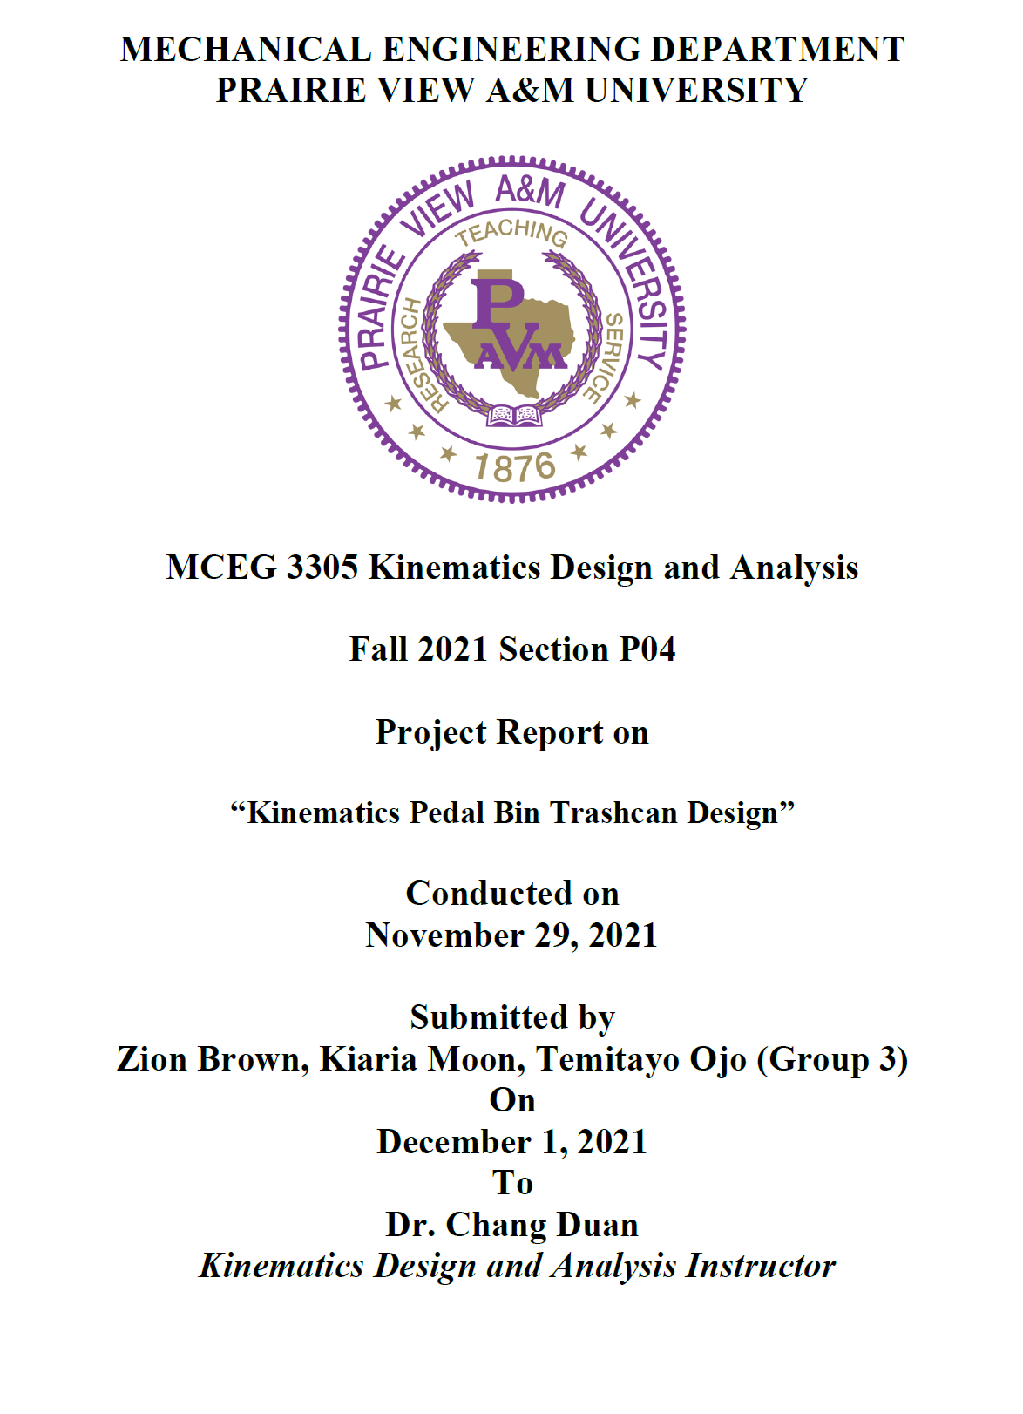

Category |  | Points | Score
Proposal |  | 30 | 28
Quality, completeness and results (120 pts) | Create NX model | 20 | 18
Quality, completeness and results (120 pts) | Assembly of the mechanism | 10 | 10
Quality, completeness and results (120 pts) | Motion demonstration | 30 | 24
Quality, completeness and results (120 pts) | Determine input/output joint for position analysis | 10 | 10
Quality, completeness and results (120 pts) | Analyze the position, velocity and acceleration of the linkage using MATLAB | 30 | 28
Quality, completeness and results (120 pts) | Plot the position, velocity and acceleration and compare the results with the motion simulation. | 20 | 20
Final presentation |  | 50 | 48
Final report | Format | 30 | 28
Final report | Phrasing and clarity | 30 | 27
Final report | Neatness | 20 | 18
Taskstream submission |  | 20 | 20
Peer evaluation |  | 100 | 80
Total |  | 400 | 359

