MECHANICAL ENGINEERING DEPARTMENT
PRAIRIE VIEW A&M UNIVERSITY

ASSESSMENT REPORT COVER PAGE

MCEG 3043-P02 MACHINE DESIGN I

Fall 2019 SEMESTER

NAME OF INSTRUCTOR: Dr. Lai Jiang

TABLE OF CONTENTS

- Report Cover Page

- Detailed Course Syllabus

- End of Semester Outcomes Assessment Report

- Grade Sheet Showing Student and Class Performance in Outcomes

- Supporting Outcomes Specific Assignments (Minimum of 2 per outcome)
5.1 Assignments assessing students’ ability to apply engineering design to produce solutions that meet specified needs with consideration of public health, safety, and welfare, as well as global, cultural, social, environmental, and economic factors

Detailed Course Syllabus

Prairie View A&M University
Department of Mechanical Engineering
MCEG 3043 Machine Design I
Fall Semester 2019

COURSE | Fundamentals of mechanical design methodology, design of machine elements for static and fatigue failure, individual projects and classroom discussions of various design solutions.
COURSE NO | MCEG 3043
CREDIT | 3 Credit Hours
PRE-REQUISITES | CVEG 2063 Mechanics of Materials  MCEG1021 Mechanical Engineering Lab I
CLASS HOURS | MW 8:00 – 9:50
CLASS ROOM | Juvenile Justice Building 137
INSTRUCTOR | Dr. Lai Jiang
OFFICE | C. L. Wilson Engr. Bldg. Room 105A
OFFICE HOURS | M & W: 11AM ~ 12PM, 2PM ~ 4PM
TELEPHONE | (936) 261-9927
E-MAIL | lajiang@pvamu.edu
REQUIRED  TEXTBOOK | Budynas, R. G. and Nisbett, J. K., Shigley’s Mechanical Engineering Design, 10th edition, McGraw-Hill Book Company, ISBN 978-0-07-339820-4.
GOALS | This course is designed to introduce students in mechanical engineering to the contemporary mechanical design methodology as applied to machine elements and to the process of mechanical design. The student will design mechanical elements using concepts developed in design of machine elements, engineering graphics and other related courses.
OUTCOMES | After completion of this course, the students should be able to apply the design processes to mechanical elements, using contemporary design standards and tools and have developed the following:  - Skills for mechanical element design;  - An ability to analyze mechanical engineering elements;  - Knowledge of various machine elements;  - An ability to complete a mechanical design project.
Topics | (1) Introduction/Basics.  (2) Design Process and Project Management  (3) Material, Load and stress analysis  (4) Deflection and stiffness  (5) Failures resulting from static loading  (6) The design of screws, fasteners, and connections  (7) Rolling contact bearings
Grading | The final grade will be computed according to the following weight distribution:  Homework 5%  Project 15%  Quiz 5%  Exam 1 25%  Exam 2 25%  Final exam 25%  The distribution of grades will be as follows:  A = 90 - 100  B = 80 - 89  C = 70 - 79  D = 60 - 70  F = 0 - 59
Course Policy | Note: The instructor reserves the right to alter it during the semester.  Use of eCourses (http://ecourses.pvamu.edu)  eCourses will be used extensively in this class. Lecture slides, assignment, and tutorials will be provided on eCourses. It is suggested to have the printout of the lecture PPT with you when you come to the class.  Academic Integrity  Academic dishonesty of any sort (plagiarism, cheating, fabrication or facilitation) is prohibited under any circumstance. Any detected actions of dishonesty will cause the failure of the class directly.  Assignments & Due Dates  Homework needs submitted at the beginning of class on the assigned day. Late homework will be charged a 10% penalty for each day late – weekend days do count. Circumstances beyond your control (i.e. illness, computer failure, weather, etc.) will be considered as required.  Projects  You need to submit all the projects with one hardcopy printed out on papers and one electronic copy via Taskstream.  Attendance  Class attendance is mandatory. Excessive absenteeism, whether excused or unexcused, may result in a student’s course grade being reduced or in assignment of a grade of “F”.  Examinations  Neither programmable calculator nor calculator which can save pictures is allowed during exams. No cell phone can be kept in your pocket during exams. You cannot leave the classroom during the exam. Portions of each exam may be either closed or open book. You will be notified of the exam format at least one week in advance.  College of Engineering Textbook Policy  Students MUST acquire the required textbook that is listed on the course syllabus for this course. The textbook must be acquired by the 10th class day. Students are not allowed to share textbooks with students who are currently registered in the same class. Failure to acquire (or show proof of purchase) the required textbook by the 10th class day will result in the student being administratively dropped from the course. The University will assess financial obligations for the course to the student as with any other dropped class according to the fee schedule as well as your financial aid may be affected.  If you are not financially able to purchase a required textbook for an engineering course prior to the 10th class day, you may apply to the College of Engineering Textbook Fund for a textbook voucher. The voucher can only be used at the Campus Bookstore. This voucher is a loan and must be paid back to the College of Engineering prior to the start of pre-registration for the coming semester. If the loan is not repaid, a hold will be placed on your account. Additional information and application materials can be obtained from the Assistant Dean’s Office (SR Collins Rm 349) and obtained online at the College of Engineering website under student resources.
IMPORTANT DATES | Last day to withdraw from course(s) without record, 9/11/2019  Withdrawal from courses with record “W” ends, 11/1/2019  Course review day, 12/2-3/2019  Final exam period, 12/4-10/2019

Machine Design I

Tentative Course Schedule
DATA | TOPICS | Chapter
Week 1 | INTRODUCTION/BASICS  Design considerations, codes and standards, stress and strength considerations, factor of Safety, units, etc. | 1
Week 2 | MATERIALS | 2
Week 2-5 | LOAD AND STRESS ANALYSIS  Free-body diagrams  Stress  Cartesian stress components  Mohr’s circle  General stress-dimensional stress  Normal stresses for beams in bending  Shear stresses for beams in bending  Torsion  Stress concentration  Stress in pressurized cylinders | 3
Week 6 | DEFLECTION AND STIFFNESS | 4
Spring rates
Tension, compression, and torsion
Defection due to bending
Beam deflection methods
Finding beam deflections by superposition
Strain Energy
Compression members – general
Long length columns with central loading
Intermediate length columns with central loading
Struts, or short compression members
Week 7-9 | FAILURES RESULTING FROM STATIC LOADING  Static strength  Stress concentration  Failure theories  Maximum-shear-stress theory for ductile materials  Distortion-energy theory for ductile materials  Failure of ductile materials | 5
Week 10-12 | THE DESIGN OF SCREWS, FASTENERS, AND CONNECTIONS  The mechanics of power screws  Threaded fasteners  Joints – fastener stiffness  Joints – member stiffness  Bolt strength  Tension connections – the external load  Bolt preload | 8
Week 13-14 | ROLLING-CONTACT BEARINGS  Bearing types  Bearing life  Bearing load  Selection of ball and cylindrical roller bearings  Selection of tapered roller bearings  Mounting and enclosure | 11
Week 14 | MECHANICAL SPRINGS  Curvature effect  Deflection of helical springs  Extension springs  Compression springs  Stability  Spring materials | 10

How Mechanical Engineering Courses meet Department Objectives & ABET Criterion 3
Specific Objectives of the Mechanical Engineering Program (MCEG Objectives) at Prairie View A&M are to produce graduates who have:

- the techniques and skills necessary for modern mechanical engineering practices, and an ability to function effectively in multi-disciplinary teams.
- an ability in life-long learning skills, a knowledge of contemporary issues, and an ability to communicate effectively.
- an understanding of global and societal context in the aspects of professional and ethical responsibility and the impact of engineering solutions on society.
- the qualifications to be employed by major industries and government agencies in the State of Texas and the nation.
- the qualifications to pursue graduate degrees.

ABET Criterion 3: Program Outcomes and Assessment
Engineering Programs must demonstrate that their graduates have:
- an ability to identify, formulate, and solve complex engineering problems by applying principles of engineering, science, and mathematics.
- an ability to apply engineering design to produce solutions that meet specified needs with consideration of public health, safety, and welfare, as well as global, cultural, social, environmental, and economic factors.
- an ability to communicate effectively with a range of audiences.
- an ability to recognize ethical and professional responsibilities in engineering situations and make informed judgments, which must consider the impact of engineering solutions in global, economic, environmental, and societal contexts.
- an ability to function effectively on a team whose members together provide leadership, create a collaborative and inclusive environment, establish goals, plan tasks, and meet objectives.
- an ability to develop and conduct appropriate experimentation, analyze and interpret data, and use engineering judgment to draw conclusions.
- an ability to acquire and apply new knowledge as needed, using appropriate learning strategies.

The table below shows how required Mechanical Engineering courses at Prairie View A&M University contribute to the student’s knowledge and ability to meet ABET criterion 3.
Numerical values – items that the course contents are significantly relevant to ABET Criterion 3 and the instructor will use these items for course assessment. The values represent for “contribution factor” of the specific course toward the assessment of the particular item of ABET Criterion 3. A summation of the values in each column equals to 100.
x – items that the course contents are somewhat relevant to ABET Criterion 3. However, the instructor will not use these items for course assessment.

MCEG Courses | ABET EAC Criteria 1-7
 | Fall 2018 | Spring 19 | Fall 2019 | Spring 2020 | Fall 2020 | Spring 2021 | Fall 2021 | Spring 2022
1021 Mech. Drawing & Desg. | 2 | 2 | 2 | 2 | 2 | 2 | 2 | 2
2013 Thermodynamics I | 8 | 8 | 8 | 8 | 8 | 8 | 8 | 8
2023 Materials Sci/Engr. | 8 | 8 | 8 | 8 | 8 | 8 | 8 | 8
2053 Engineering Mechanics II | 8 | 8 | 8 | 8 | 8 | 8 | 8 | 8
3011 Measurement Lab | 7 | 6 | 7 | 6 | 7 | 6 | 7 | 6
3013 Heat Transfer | 1 |  | 1 |  | 1 |  | 1
3021 Thermal Sci. Lab | 6 | 6 | 6 | 6 | 6 | 6 | 6 | 6
3023 Thermodynamics II | 1 | 1 | 1 | 1 | 1 | 1 | 1 | 1
3031 Manufacturing Lab |  | 2 |  | 4.2 |  | 2 |  | 4.2
3033 Manufacturing Proc |  | 2 |  | 4.2 |  | 2 |  | 4.2
3043 Machine Design I | 2 |  | 2 |  | 2 |  | 2
3053 Kinematic Design | 1 |  | 1 |  | 1 |  | 1
3063 Fluid Mechanics | 1 | 6 | 1 | 6 | 1 | 6 | 1 | 6
4043 Machine Design II | 2 |  | 2 |  | 2 |  | 2
4063 Dynamic Systems |  | 1 |  | 1 |  | 1 |  | 1
4093 Finite Element | 1 |  | 1 |  | 1 |  | 1
4472 Senior Project I | 4, 5 |  | 4, 5 |  | 4, 5 |  | 4, 5
4482 Senior Project II |  | 2,3,7 |  | 2,3,7 |  | 2,3,7 |  | 2,3,7

End of Semester
Course Assessment Report

This summary contains the following Information

1. Performance Statistics
- Total number of students in class
- The class average performance (stated as %) in each course outcome assessed in this class and the two previous times course was assessed.
- The acceptable class average for the class in each outcome area as set by your Department.
- Percentage of students who scored below the expected average in each outcome.

2. Implementation Summary
- Brief summary of plans implemented during the semester based on last assessment report

3. Perceived Problems
- Instructor’s critical evaluation of perceived problems that affected students’ performance.

4. New Plans for Addressing Problems
- Instructor’s plans for addressing the perceived problems the next time the class is taught.

5. Overall Trend over last three assessment periods
- Instructor’s summary of overall performance trend for each outcome measured over the last three periods.

END OF SEMESTER COURSE OUTCOME ASSESSMENT REPORT
MCEG3043-002 MACHINE DESIGN I
Fall 2019 SEMESTER

Report Prepared by: Dr. Lai Jiang

Report Date: December 12, 2019

Semester | Analysis Type | Number of Students | Outcome 2  Ability to apply engineering design to produce solutions
Semester | Analysis Type | Number of Students | Expected Average | Class Average | % Students meeting Expected Average
Fall 2019 | Direct | 19 | 75 | 75.4 | 58%
Fall 2018 | Direct | 20 | 75 | 81.7 | 90%
Implementation Summary |  |  | The following activities have been implemented to improve the student learning on outcome 2:  (1) A series of tutorials on how to apply engineering design to solve engineering problems are developed and distributed to students;  (2) One design project was assigned which required students to use ANSYS software to solve engineering problems;  (3) eCourses was utilized for the class to distribute the tutorials and submit projects.
Perceived Problems |  |  | 1. Students lack the abilities in applying the fundamentals to formulate the design problem and to validate the design using analysis.  2. Students showed more enthusiasm on working on the project than working on the homework.
Plans for Addressing Problems |  |  | It is suggested to do the following:  (1) More in-class training sessions are needed to give students more training on ANSYS software.  (2) More out-of-class tutoring sessions are needed.  (3) A tutor is needed to provide help to students.
Overall Trend over Periods |  |  | The overall performance is better than the expected average.

Grade Sheet Showing
Student and Class Performance in Outcomes
The computed semester average in each outcome
as stated in the Assessment report are
highlighted in boldface

Grade Sheet Showing Student and Class
Performance in Course Outcomes
MCEG 3043-P02 MACHINE DESIGN I
Fall 2019 Semester

Outcomes to be Measured | Outcome (2)
Title of Assignment | Project
Max. Points for Assignment | 100
Name
1 | 76
2 | 71
3 | 77
4 | 77
5 | 75
6 | 84
7 | 87
8 | 66
9 | 65
10 | 80
11 | 0
12 | 77
13 | 83
14 | 85
15 | 57
16 | 73
17 | 83
18 | 66
19 | 73
Average for all students | 75.4
No. of students above expected average | 11
Percentage of student above average | 58%

OUTCOME SPECIFIC ASSIGNMENTS
USED TO ASSESS OUTCOMES

MECHANICAL ENGINEERING DEPARTMENT
OUTCOMES SPECIFIC ASSIGNMENT COVER SHEET
MACHINE DESIGN I
FALL 2019

Title of Assignment
Project: I Beam Size Selection based on Safety Factors

Outcome Measured Using this Assignment
(2) apply engineering design to produce solutions that meet specified needs.

Brief Description of the suitability of this assignment for the outcome
MCEG3043: Machine Design I
This project is to apply the Machine Design knowledge and commercial software package ANSYS to: (1) analyze the stress in the I beam under load; (2) pick the I beam with the right size with the consideration of two safety factors.
Fall 2019 Section P02 Course Project
Analysis and Design of the Overhead Crane Beam
Due date: 11/27/2019

1. Project Overview
An overhead crane (shown in Fig. 1) is a type of machine that can be used both to lift and lower heavy materials and to move them horizontally in a high-bay shop. It is generally equipped with a hoist rope, wire ropes or chains, and sheaves. Overhead cranes are commonly employed in the manufacturing industry for the moving and assembling of heavy equipment.
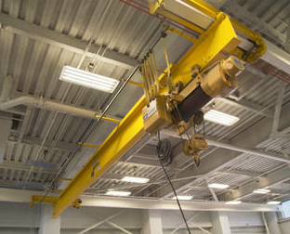
Fig. 1: A crane in a high-bay shop
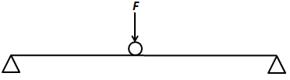
Fig.2: Loading on the I beam of an overhead crane
When the overhead crane is moving a heavy item, the loading situation of the crane beam can be simplified to as shown in Fig. 2, with the loading force F being movable along the beam. Assume the overall length of the beam is 60 ft, and the cross-section of the beam is in the shape of the letter “I”. The material for the I beam is 1045 carbon steel, with a tensile yield strength of 45,000 psi. You are now the chief designer for this I beam, and your employer has asked you to design the I beam with the right size for the crane so it can pick up items with a maximum weight of 50 tons (100 kips).
2. Analyses to be performed for the crane beam
(1) Find the location of the applied load that will generate the largest bending moment for the I beam;
(2) Calculate the reaction forces at two ends when the largest bending moment is generated, and draw the shear force and the bending moment diagrams;
(3) Base on the calculated maximum bending moment and the beam’s material, select the optimal I beam dimension from the provided Wide Flange Beams catalog (assuming the I beam made with the least material will be the most less expensive one) using both MSS and DE theories. This step may require several iterations, so a recommended method is to use an analytical software package (e.g., Matlab, EES, or C++, etc.) to calculate the critical stresses of the I beam (Note: you can simplify all the round angles to right angles for all calculations);
(4) If a square cross-section beam with the same cross-sectional area as your selected I beam in Step 3 is used, can they still take the maximum load mentioned at the beginning of the project? Show your calculations and explain the reason behind your results.
(5) Use any finite element software (e.g. ANSYS, ABAQUS, etc.), model the I beam you selected in Step 3 (again, simplify all round angles to right angles) under the maximum load, and validate whether your calculation in Step 3 is correct (within 5% difference range).
(6) Discuss the results you found from steps above (e.g., where the location of the critical point on the I beam, why the square cross section beam is able/unable to carry the same load, etc.)

3. Report Format
The report should include the following sections:
  - A cover page;
  - This handout as the problem description;
  - The detailed manual calculation performed for Steps 1 − 4;
  - The source code of your calculations performed in Step 3 and explanations to your codes;
  - ANSYS Analysis (Explain the inputs of each step using ANSYS. You may use screenshots from your ANSYS user interfaces to help with the explanation);
  - Results and discussion.
4. Project Submission (Missing either hardcopy or soft copy will result in a “0” grade)
(1) A hardcopy of the report to your instructor;
(2) Submit the soft copy of your report to “Assignment 2” on Taskstream.

5. Grades
Hard copy of the Report 80%
Taskstream submission 20%

MECHANICAL ENGINEERING DEPARTMENT
PRAIRIE VIEW A&M UNIVERSITY

MCEG 3043
Fall 2019

Machine Design Final Project

Submitted by,
Ximena Cifuentes

November 27, 2019

3. Hand Calculations of Problems 1- 4

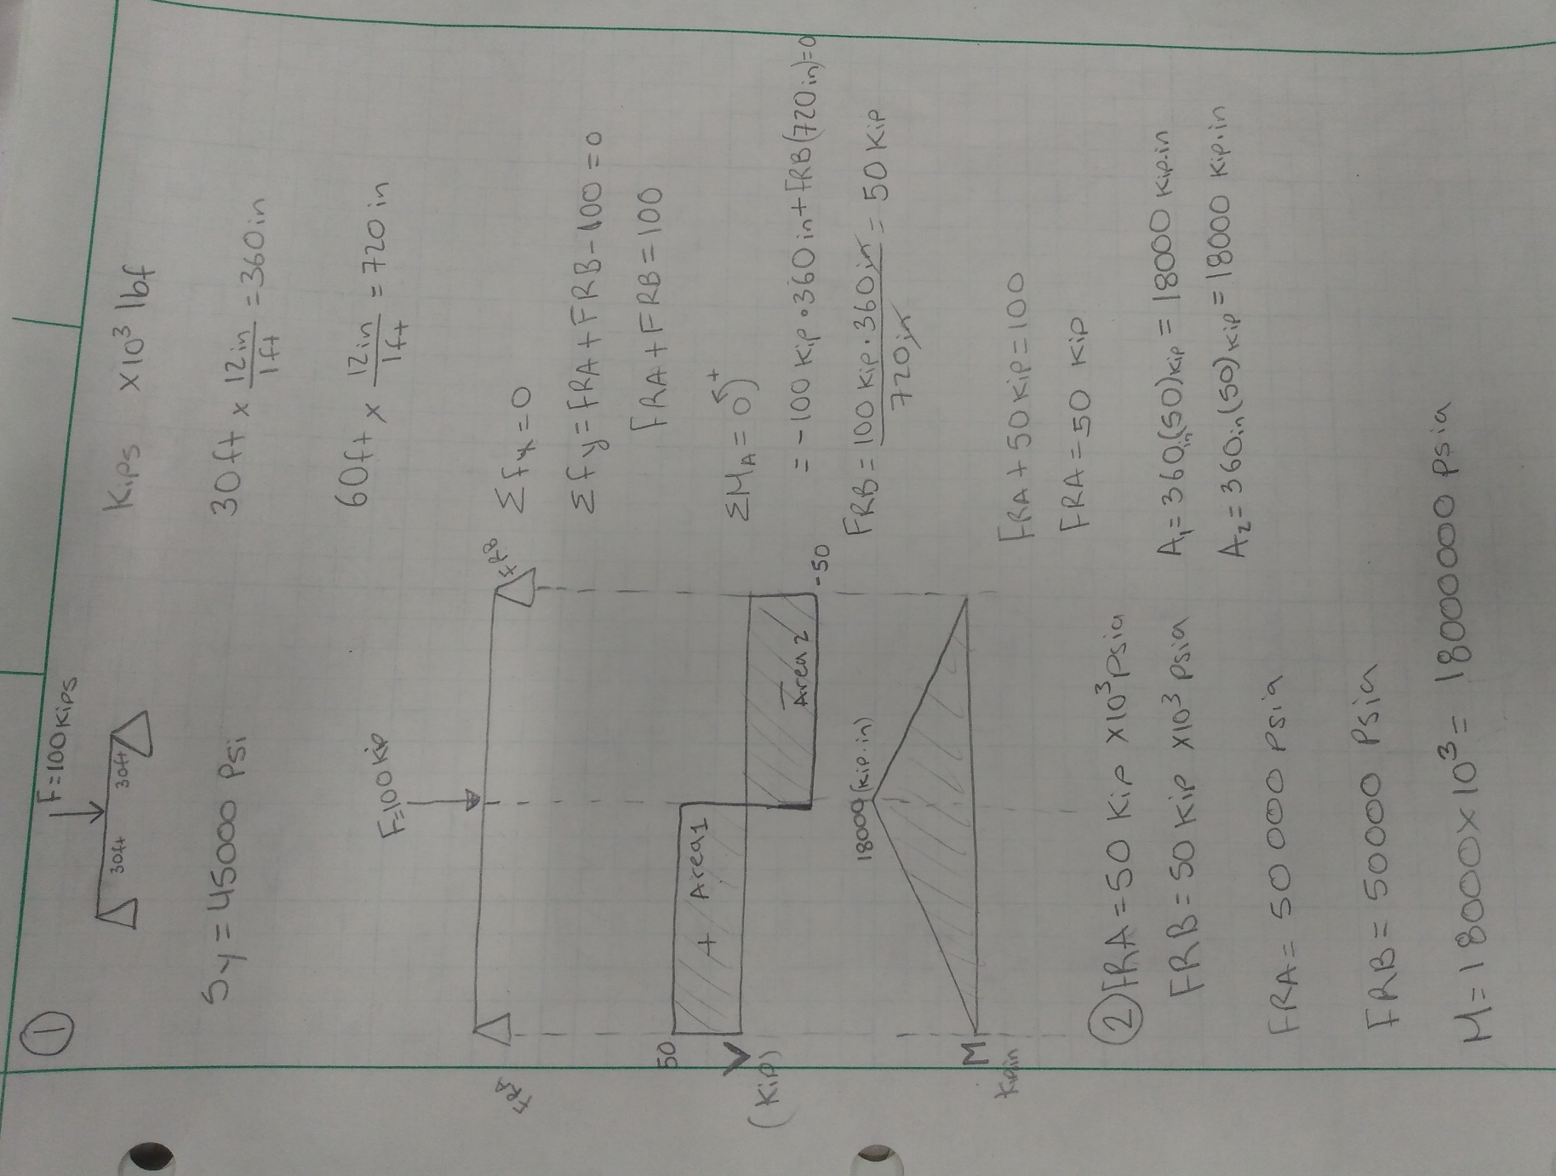
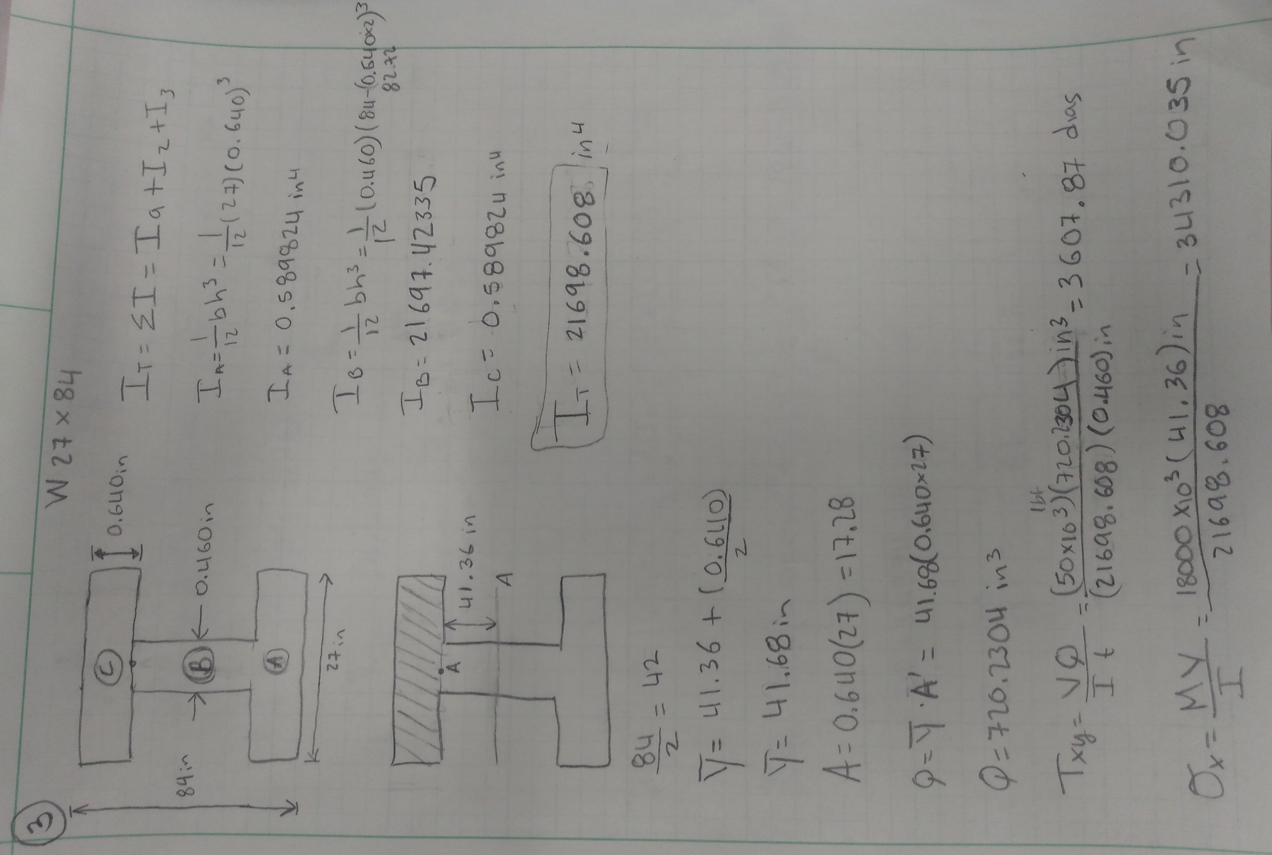
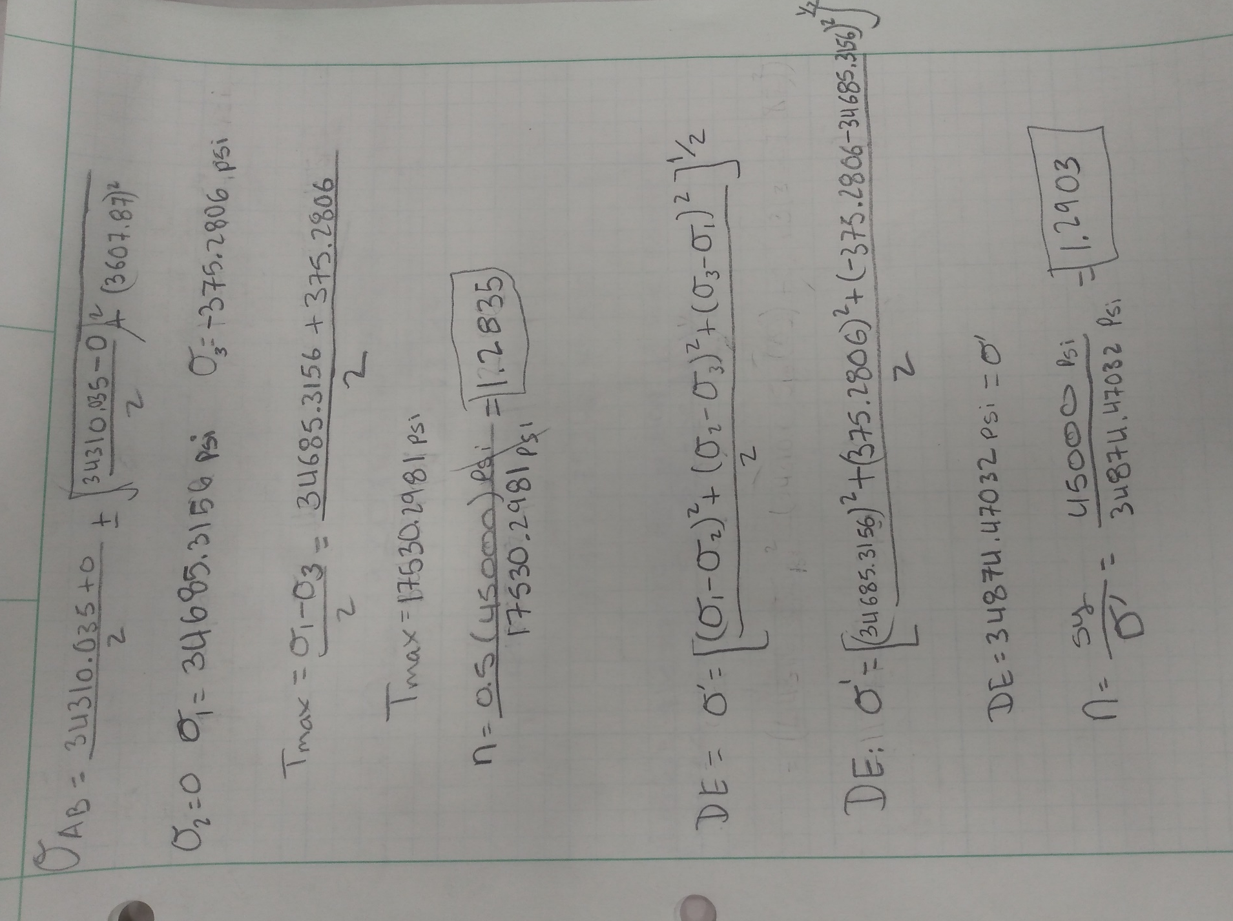
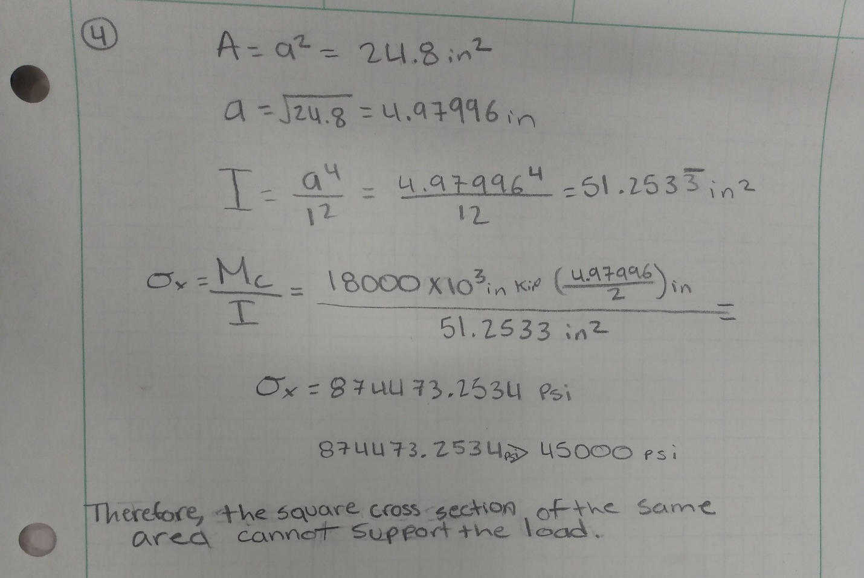

4. Source Code of Calculations

To initiate my code I did a list of equations that would be needed to solve this problem. I was asked to find the MSS and DE values for an I beam that would not only pass all stress test, but that it was also cost efficient. Before attempting to select the right beam, I selected a big size beam that would help me conduct the calculations in order and I could successfully start organizing my code.

I divided the symmetrical beam into three parts to ensure a more organized analysis:

h2 - The program to subtract (h1) and (h3) from (H).
Ia-Ic – The program was asked to solve for the (I) of each individual part from the beam cross section.
Aa – Was set to represent the area above the point of interest.
Na – Was set to be the middle point of the beam (Neutral Axis).
YR – Covers the distance between the neutral axis of the entire beam to the neutral axis of the area above the point of interest.
Q – Was set to multiply the area above the point of interest and the YR.
M – The symbol is used to indicate the bending moment.
V – The symbol is used to indicate Maximum shear stress.

The code was designed to follow the following order:
- Calculate the moment of inertia .
- Find both YR and Aa.
- Solve for Q by multiplying YR and Aa .
- Plug in Q, V, I, t to find the Shear on the x and y.
- Solve for Sigma_X by plugging in the M,I,Y to the listed formula.
- Once you have the shear on the x and y and Sigma_X you plug them in the formula to solve for Sigma 1, 2, and 3.
- Then you use the values you get to solve for T-max.
- Then you solve for the factor of safety and test for failure.
- Then you the valued will be plugged into the DE formula.
- Once Sigma prime is found then it will find the factor of safety.
- Finally test for failure.

Bellow you can observe only three of the many different beams that were tested using my code:

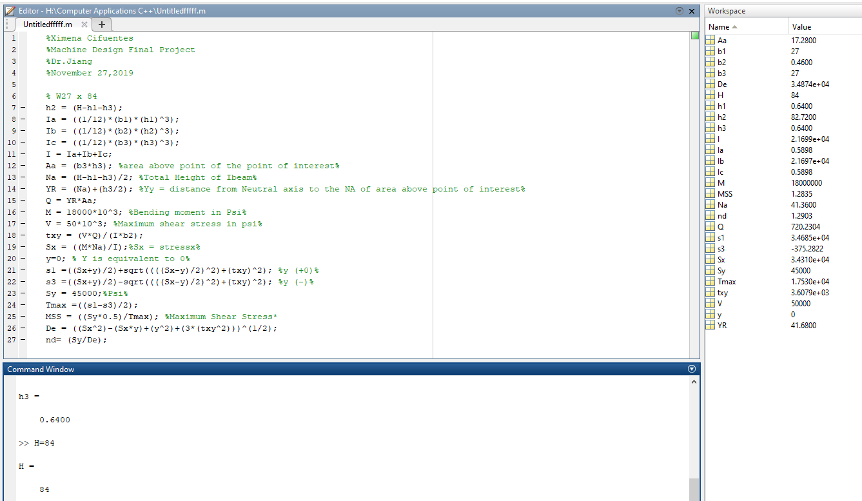

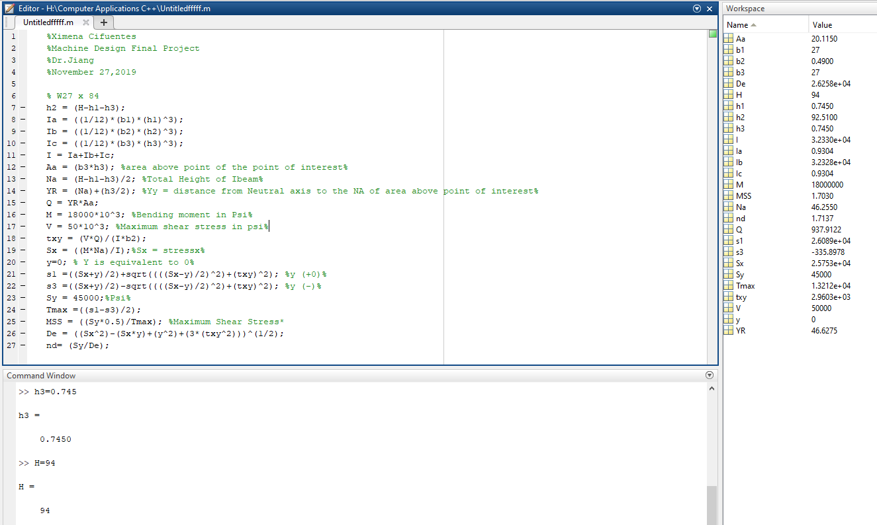

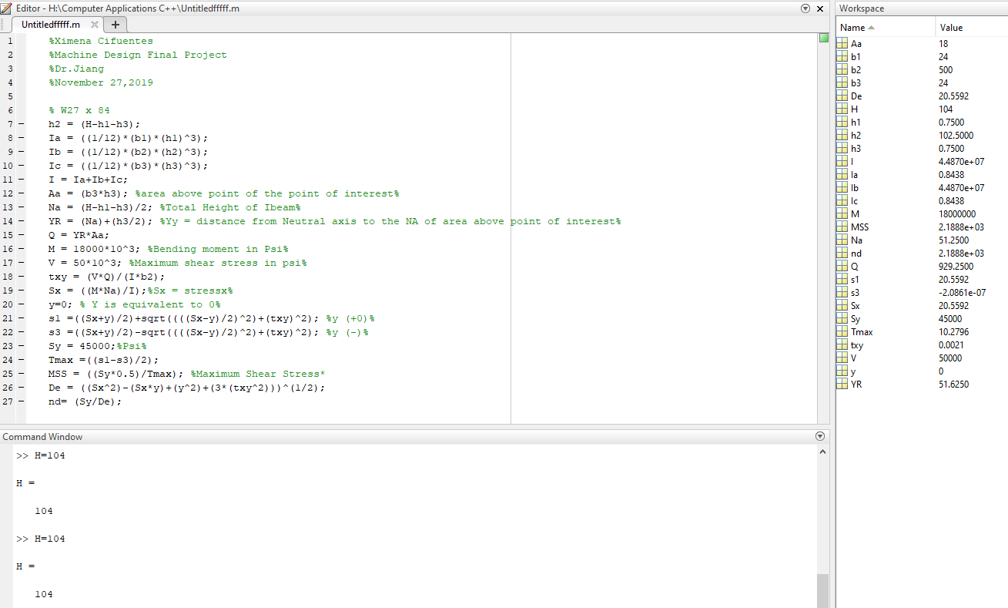

I was able to run several dimensions of different beams on MATLAB during the course of my project. After several hours of testing, I concluded that the W27x84 would be the most efficient beam to use for this project. Using the chart below and the chart provided by the instructor, I was able to make the most accurate decision in choosing the most convenient beam.
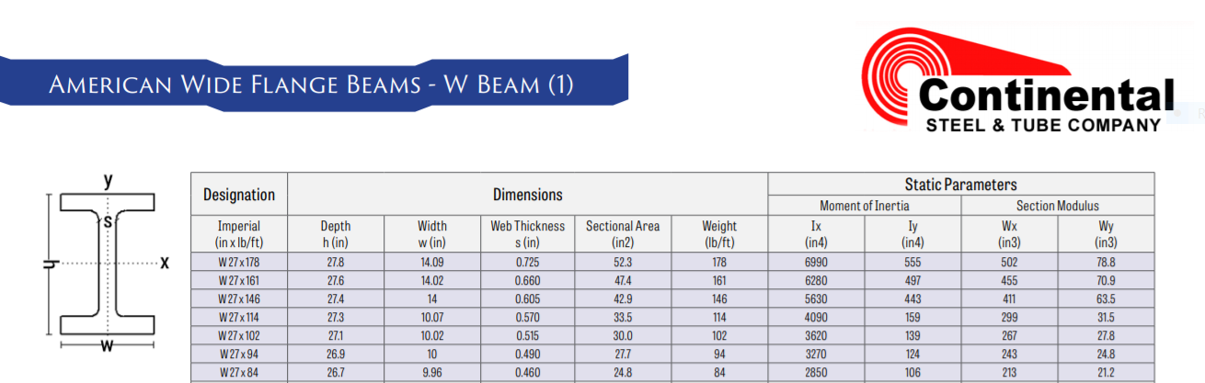

- ANSYS Analysis

Using ANSYS I was able to sketch and enter the measurements of the beam and point out the stress point located in the center of the top of the beam.

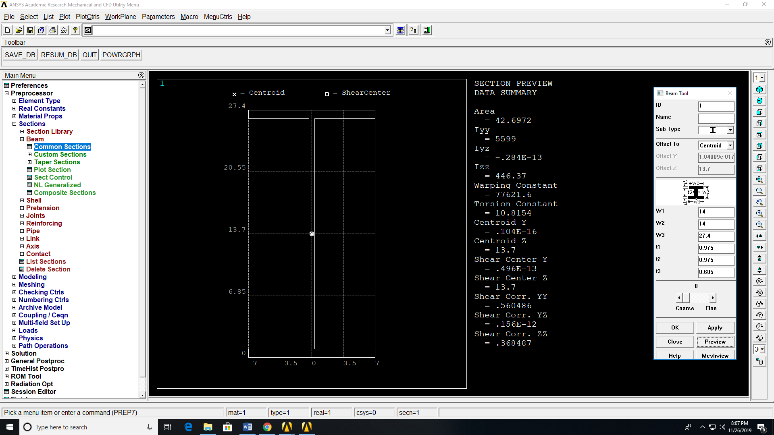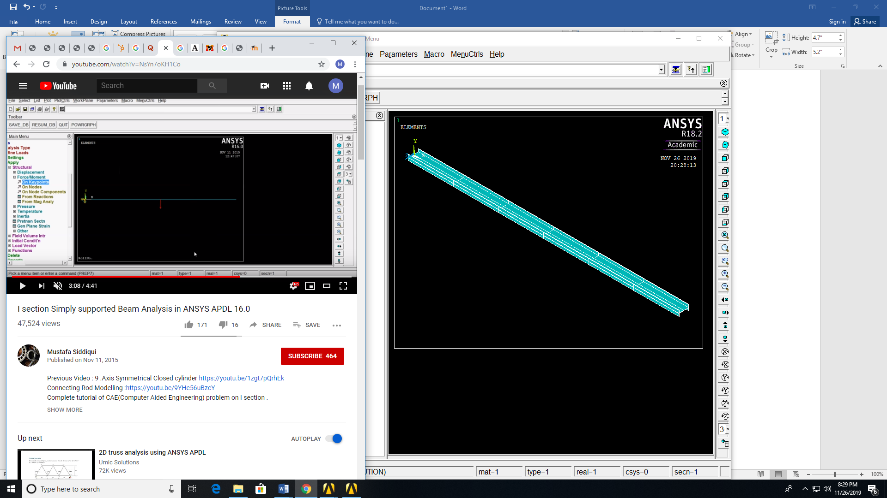

I was then able to use the modeling tool and bring the beam to life on the screen. I was also able to do stress analysis on the part and found very cool features that the software contained.

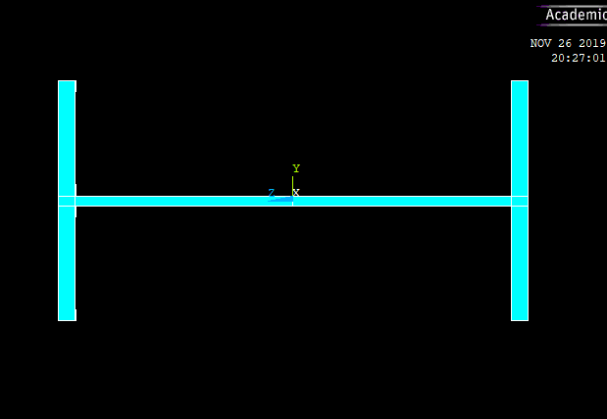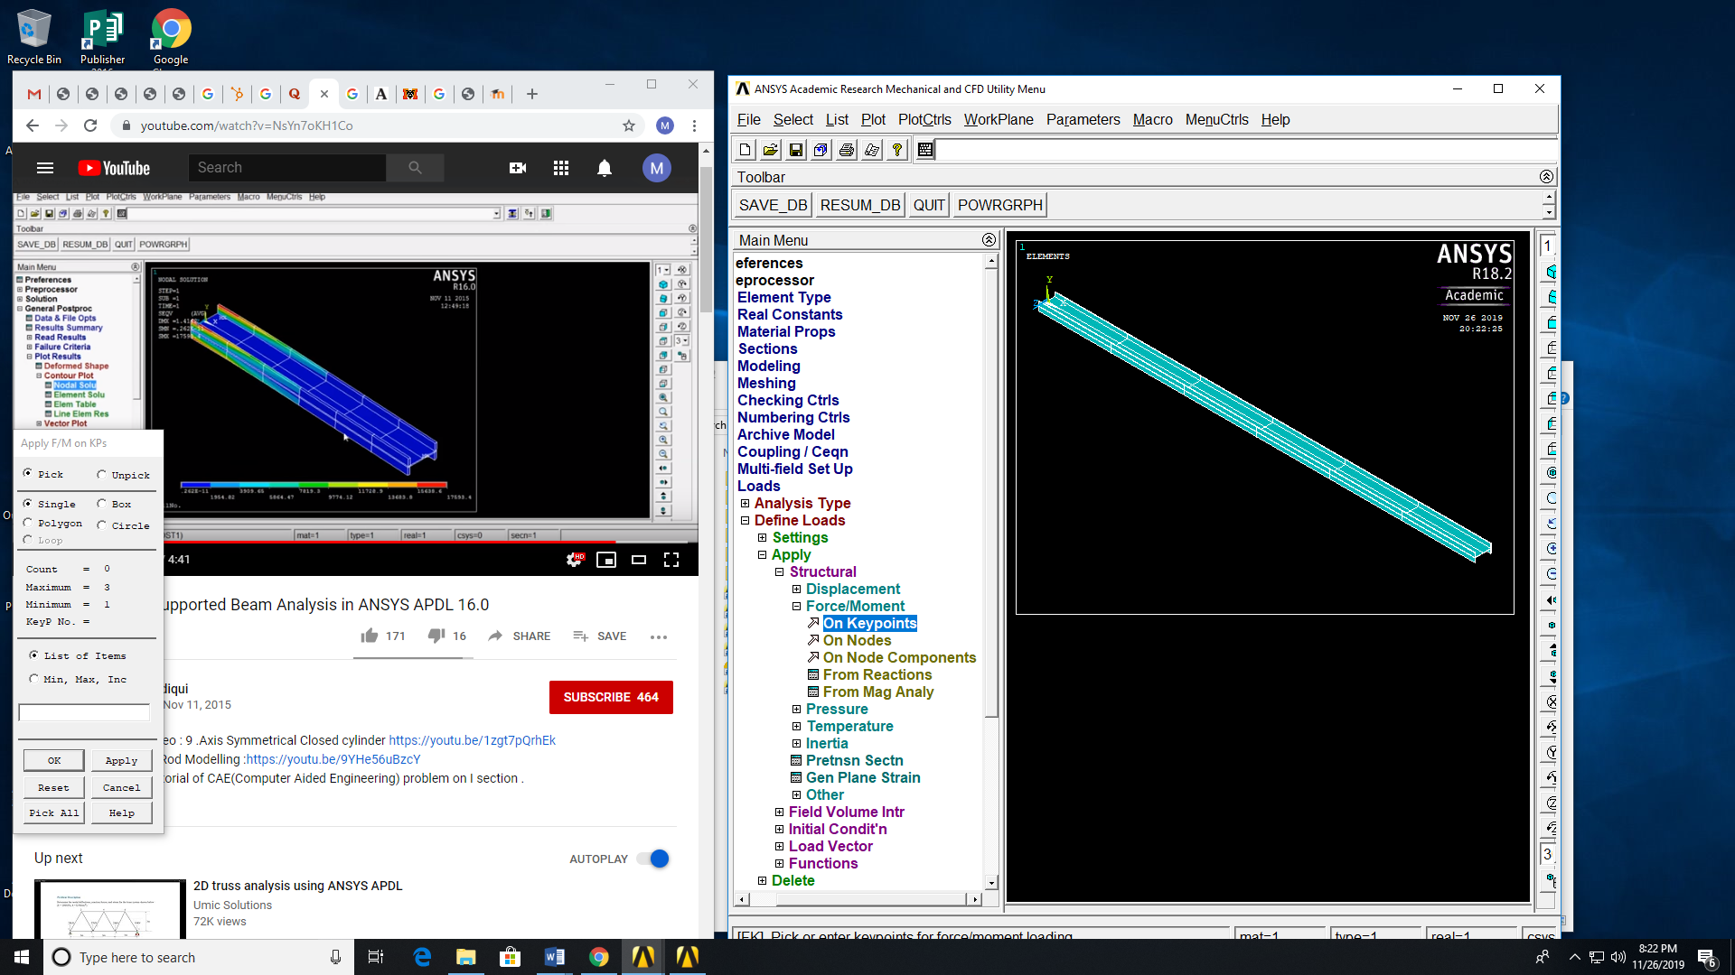

To be able to use the software, I was able to find videos that could guide me through the process and I attached the main link to this presentation. The video helped me learn how to use this software and was the key to success of this project. https://www.youtube.com/watch?v=NsYn7oKH1Co

To conclude, I will like to say that this class really prepared me to be able to execute this project. I was really excited to learn how to use MATLA and I will continue to expand my knowledge on the software. I also believe that the project was challenging and it help me develop as my technical skills. I will continue to explore the different ways I can make use of the ANSYS software to solve complex problems.

