Course ASSESSMENT REPORT

ROY G. PERRY COLLEGE OF ENGINEERING
MECHANICAL ENGINEERING DEPARTMENT
PRAIRIE VIEW A&M UNIVERSITY

ASSESSMENT REPORT COVER PAGE

MCEG 3053 Kinematics Design and Analysis

FALL 2019 SEMESTER

NAME OF INSTRUCTOR: Dr. Chang Duan

Date: 12/17/2019

TABLE OF CONTENTS

- Report Cover Page

- Detailed Course Syllabus

- End of Semester Outcomes Assessment Report

- Grade Sheet Showing Student and Class Performance in Outcomes

- Supporting Outcomes Specific Assignments (Minimum of 2 per outcome except for Project Reports where one is enough)

5.1 Assignments assessing students’ ability to identify, formulate, and solve complex engineering problems (CEP) by applying principles of engineering, science, and mathematics. (outcome “1”)

Detailed Course Syllabus
(Distributed to Students at the beginning of the Semester)
ABET outcomes measured using this course should be
explicitly listed in the syllabus
Course Syllabus in ABET Format
MCEG 3053 Kinematics Design and Analysis

1. | Course number and name: | MCEG 3053 Kinematics Design and Analysis
2. | Credits and contact hours: | 3 credit hours
3. | Instructor’s or course  coordinator’s name: | Dr. Chang Duan
4. | Text book: Title: | Design of Machinery
 | Author: | Robert L. Norton
 | Publisher, Year & Edition: | McGraw Hill, 2012, 5th Edition
 | - Other Supplemental material | Shigley and Uicker, Theory of Machines and Mechanisms, McGraw Hill.
5. | Specific course information
 | - Brief description of the content of the course (catalog description) | This course is to provide students with an in-depth study of the displacement, velocity and acceleration of machine parts. This course shall also introduce the students to design methods for mechanisms yielding a desired set of motion characteristics.
 | - Prerequisites or  Co-requisites | MCEG 1021 Mechanical Engineering Drawing I  CVEG/MCEG 2053Engineering Mechanics II
 | - *Indicate whether a required, elective, or selected elective (as per definition provided) course in the program | Required
6. | - Specific goals for the course specific outcomes of instruction (e.g. The student will be able to explain the significance of current research about a particular topic.)  Students will be able to : | - Explicitly indicate which of the student outcomes listed in Criterion 3 or any other outcomes are addressed by the course.  The specific goals for the course specific outcomes listed on the left column will address the following student learning outcomes:
 | 1. Analyze mechanisms in order to determine their rigid-body dynamic behavior | Outcome 1  The ability to identify, formulate, and solve complex engineering problems by applying principles of engineering, science, and mathematics.
 | 2.Synthesize mechanisms in order to accomplish desired motions or tasks
 | 3. Use computer aided engineering software for mechanisms analysis, synthesis and design
7 | Brief list of topics to be covered | 1. Introduction to the kinematics fundamentals (1 class)  2. Position and Displacement (4 classes)  3. Velocity by Components and by Instant Centers (2 classes)  4. Graphical Synthesis (3 classes)  5. Velocity Analysis (5 classes)  6. Acceleration Analysis (3 classes)  7. Mathematical Analysis (2 classes)  8. Design Project (1 classes)  9. Cams (5 classes)  10. Gear Trains (2 classes)

*Required courses are required of all students in the program, elective courses (often referred to as open or free electives) are optional for students, and selected elective courses are those for which students must take one or more courses from a specified group

Additional Course Syllabus Information

CLASS HOURS | 12:00 -1:50 MW
CLASS ROOM | C.L. Wilson Engineering Complex Room 103
INSTRUCTOR | Dr. Chang Duan
OFFICE | C.L. Wilson Engineering Complex Room 105H
OFFICE HOURS | As Posted
TELEPHONE | (936)261-9954

Grading | The final grade will be computed according to the following weight distribution:  Homework 10%  In-class exercises 10%  Project 20%  Test 1 20%  Test 2 20%  Final Exam 20%  The distribution of grades will be as follows:  A = 90 - 100  B = 80 - 89  C = 70 - 79  D = 60 - 69  F = 0 - 59
Course Policy | Note: The instructor reserves the right to alter it during the semester.  Use of ecourses (http://ecourese.pvamu.edu)  Ecourses will be used extensively in this class. Lecture slides, assignment, and tutorials will be provided on Ecourses.  Academic Integrity  Academic dishonesty of any sort (plagiarism, cheating, fabrication or facilitation) is prohibited under any circumstance. Any detected actions of dishonesty will cause the failure of the class directly.  Assignments & Due Dates  Homework will be submitted at the beginning of class on the assigned day. Late homework will be charged a 20% penalty for each day late – weekend days do count. Circumstances beyond your control (i.e. illness, computer failure, weather, etc.) will be considered as required.  Projects  You need to submit all the projects with one hardcopy printed out on papers and one electronic copy on ecourses. The final project will be team project.  Attendance  Class attendance is mandatory. Being late class for more than 15 minutes will count as one absence.  Examinations  No makeup test will be given. You will be expected to complete the exam in the allotted time period. Portions of each exam may be either closed or open book. You will be notified of the exam format at least one week in advance.  Question/concern about grades  All discussion about grades excluding final exam grade should happen before final exam. Questions about grade of quizzes, homework, exams should be brought up within one week after they are graded and given back to you.
IMPORTANT DATES | Last day to withdraw from course(s) without record, 9/11/2019  Withdrawal from courses with record “W” ends, 11/01/2019  Course review day, 12/02-12/03/2019  Final exam period, 12/04-12/10/2019

Kinematic Design and Analysis
Tentative Course Schedule

WEEK | Lecture | REMARKS
1st week | Introduction to mechanisms analysis and synthesis;  Kinematics and Kinetics;  Mechanisms and Machines;  Getting started in MATLAB;  Mobility, Transmission angle, vectors
2nd week | Position analysis;  Position analysis using vector loop equations;  Couples curves
3rd week | Velocity analysis;  Velocity analysis by components;  Analysis by use of instant centers;
4th week | The velocity Polygon  Analytic velocity Analysis
5th week | Acceleration analysis;  Graphical acceleration analysis;  Accelerations in rolling contact;  Coriolis component of acceleration
6th week | Graphical analysis;  Analytic acceleration analysis;  Midterm exam
7th week | Introduction to cams;  Cam displacement diagrams  Cam Profile layout
8th week | Pressure angle;  Roller follower diameter;  Cam profile production problems
9th week | Introduction to graphical and analytical synthesis;  Specified transmission angle;
10th week | Crank rocker mechanisms;  Inversion
11th week | Projects  Introduction to gear trains
12th week | Gear contact kinematics  Velocity ratio (train ratio)
13th week | Review
14th week | Final Exam
How Mechanical Engineering Courses meet Department Objectives & ABET Criterion 3
Specific Objectives of the Mechanical Engineering Program (MCEG Objectives) at Prairie View A&M are to produce graduates who have:

- the techniques and skills necessary for modern mechanical engineering practices, and an ability to function effectively in multi-disciplinary teams.
- an ability in life-long learning skills, a knowledge of contemporary issues, and an ability to communicate effectively.
- an understanding of global and societal context in the aspects of professional and ethical responsibility and the impact of engineering solutions on society.
- the qualifications to be employed by major industries and government agencies in the State of Texas and the nation.
- the qualifications to pursue graduate degrees.

ABET Criterion 3: Program Outcomes and Assessment
Engineering Programs must demonstrate that their graduates have:
- the ability to identify, formulate, and solve complex engineering problems by applying principles of engineering, science, and mathematics.;
- the ability to apply engineering design to produce solutions that meet specified needs with consideration of public health, safety, and welfare, as well as global, cultural, social, environmental, and economic factor;
- the ability to communicate effectively with a range of audiences;
- the ability to recognize ethical and professional responsibilities in engineering situations and make informed judgments, which must consider the impact of engineering solutions in global, economic, environmental, and societal contexts;
- the ability to function effectively on a team whose members together provide leadership, create a collaborative and inclusive environment, establish goals, plan tasks, and meet objectives;
- ability to develop and conduct appropriate experimentation, analyze and interpret data, and use engineering judgment to draw conclusions; and
- the ability to acquire and apply new knowledge as needed, using appropriate learning strategies.

The table below shows how required Mechanical Engineering courses at Prairie View A&M University contribute to the student’s knowledge and ability to meet ABET criterion 3.

Numerical values – items that the course contents are significantly relevant to ABET Criterion 3 and the instructor will use these items for course assessment. The values represent for “contribution factor” of the specific course toward the assessment of the particular item of ABET Criterion 3. A summation of the values in each column equals to 100.

x – items that the course contents are somewhat relevant to ABET Criterion 3. However, the instructor will not use these items for course assessment.

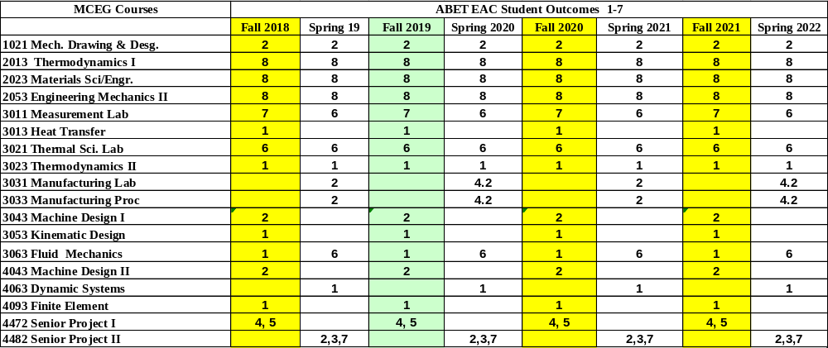

MCEG 3053 Course Objectives and Anticipated Outcomes

Course Objectives

- Introduce the students the concepts and understanding of the displacement, velocity and acceleration in machine parts. (1, 4, 5)

Anticipated Outcomes: The students will be able to solve the mechanism problems (1)

- Introduce the students to current mechanical design methodology as applied to mechanism. (1, 4, 5)

Anticipated Outcomes: The students should be able to analyze motion in machine parts and use synthesis to design mechanism using modern tools. (1)

University Rules and Procedures

Disability statement (See Student Handbook):
Students with disabilities, including learning disabilities, who wish to request accommodations in class should register with the Services for Students with Disabilities (SSD) early in the semester so that appropriate arrangements may be made. In accordance with federal laws, a student requesting special accommodations must provide documentation of their disability to the SSD coordinator.

Academic misconduct (See Student Handbook):
You are expected to practice academic honesty in every aspect of this course and all other courses. Make sure you are familiar with your Student Handbook, especially the section on academic misconduct. Students who engage in academic misconduct are subject to university disciplinary procedures.

Forms of academic dishonesty:
- Cheating: deception in which a student misrepresents that he/she has mastered information on an academic exercise that he/she has not mastered; giving or receiving aid unauthorized by the instructor on assignments or examinations.

- Academic misconduct: tampering with grades or taking part in obtaining or distributing any part of a scheduled test.

- Fabrication: use of invented information or falsified research.

- Plagiarism: unacknowledged quotation and/or paraphrase of someone else’s words, ideas, or data as one’s own in work submitted for credit. Failure to identify information or essays from the Internet and submitting them as one’s own work also constitutes plagiarism.

Nonacademic misconduct (See Student Handbook)
The university respects the rights of instructors to teach and students to learn. Maintenance of these rights requires campus conditions that do not impede their exercise. Campus behavior that interferes with either (1) the instructor’s ability to conduct the class, (2) the inability of other students to profit from the instructional program, or (3) campus behavior that interferes with the rights of others will not be tolerated. An individual engaging in such disruptive behavior may be subject to disciplinary action. Such incidents will be adjudicated by the Dean of Students under nonacademic procedures.

Sexual misconduct (See Student Handbook):
Sexual harassment of students and employers at Prairie View A&M University is unacceptable and will not be tolerated. Any member of the university community violating this policy will be subject to disciplinary action.

Attendance Policy:
Prairie View A&M University requires regular class attendance. Excessive absences will result in lowered grades. Excessive absenteeism, whether excused or unexcused, may result in a student’s course grade being reduced or in assignment of a grade of “F”. Absences are accumulated beginning with the first day of class.

Student Academic Appeals Process
Authority and responsibility for assigning grades to students rests with the faculty. However, in those instances where students believe that miscommunication, errors, or unfairness of any kind may have adversely affected the instructor's assessment of their academic performance, the student has a right to appeal by the procedure listed in the Undergraduate Catalog and by doing so within thirty days of receiving the grade or experiencing any other problematic academic event that prompted the complaint.

End of Semester
Course Assessment Report

This summary contains the following Information

1. Performance Statistics
- Total number of students in class
- The class average performance (stated as %) in each course outcome assessed in this class and the two previous times course was assessed.
- The acceptable class average for the class in each outcome area as set by your Department. You cannot use any number of your choice
- Percentage of students who scored below the expected average in each outcome.

2. Implementation Summary
- Brief summary of plans implemented during the semester based on last assessment report

3. Perceived Problems
- Instructor’s critical evaluation of perceived problems that affected students’ performance. Realistic problems should be identified throughout the semester and summarized in this section of the report.

4. New Plans for Addressing Problems
- Instructor’s plans for addressing the perceived problems the next time the class is taught. These should be specific enough for another instructor to implement. Most of these should be things that, you, the instructor can implement to help students to improve. Be creative.

5. Overall Trend over last three assessment periods
- Instructor’s summary of overall performance trend for each outcome measured over the last three periods.

5. Were Expectations Met?
- Answer YES if the class average was above the expected average and the stated percentage of students scored at or above the expected average, else answer NO.

END OF SEMESTER COURSE OUTCOME ASSESSMENT REPORT
MCEG 3053-P02 KINEMATICS DESIGN AND ANALYSIS
FALL 2019 SEMESTER

Report Prepared by: Dr. Chang Duan
Report Date: December 17, 2019

Semester | Analysis Type | Number of Students | Outcome 1*  An ability to design a system, component, or process to meet desired needs within realistic constraints
Semester | Analysis Type | Number of Students | Expected Class Average | Expected Percent of students at or above average | Class Average | % Students meeting Expected Average
Fall 2019 | Direct | 27 | 70 | 70 | 80.1 | 92.6
Fall 2018 | Direct | 36 | 75/70 | 70 | 88.3 | 97.2
Fall 2017 | Direct | 45 | 75/70 | 70 | 81.8 | 88.2
Fall 2016 | Direct | 70 | 75 | 70 | 81.6 | 71.4
Fall 2015 | Direct | 35 | 75 | 70 | 75.7 | 78.8
Implementation Summary | Items implemented from previous report or after meeting previous instructor |  | Math review tutorials are posted as supplementary material. Project is assigned earlier so that students have enough time to work on it. More exercises emphasizing on use of engineering software is given.
Perceived Problems | Perceived problems are directly related to the PC and the sub items under them |  | Students struggled in some fundamental math problems.  The ability of using engineering software varies drastically among students. In particular, the ability of using UG NX for motion simulation and the ability of using MATLAB for calculation, plotting and analysis.
Plans for Addressing Problems | Plans for address specific measures to address PC and their sub areas |  | Math review (outside of classroom) and quizzes will help student review and improve their math capabilities relate to this course.  More tutorial and exercises will be given to improve the students’ ability of using engineering software.  Smaller class size helps the interaction during and after class.
Overall Trend over Periods | Ascertain if there were improvements over previous semesters |  | Class average and expected percent of students maintains its level the last three years
Were Expectations Met? | Class Average ≥75% and ≥70% of Students Performed at or Above Expected Average. |  | YES

*: ABET switched to outcome 1-7 in May 2018. Outcome e is assessed in Fall 2017 and before that. Outcome 1 is assessed in Fall 2018 and onwards.

Grade Sheet Showing
Student and Class Performance in Outcomes
The computed semester average in each outcome
as stated in the Assessment report are
highlighted in boldface

Grade Sheet Showing Student and Class
Performance in Course Outcomes
MCEG 3053-P02 Kinematics Design and Analysis
Fall 2019 Semester
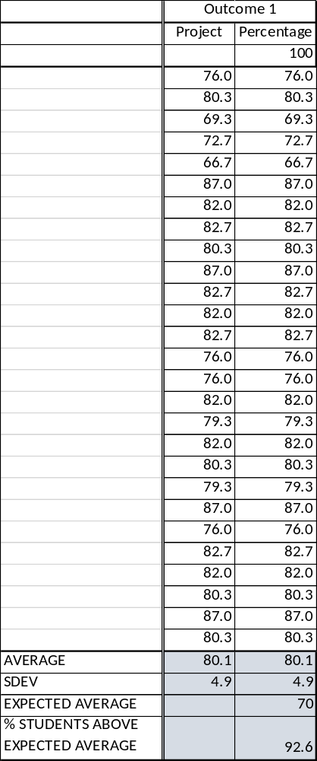

OUTCOME SPECIFIC ASSIGNMENTS
USED TO ASSESS OUTCOMES
(Provide at least two assignments used to specifically measure each outcome and justify the suitability of the assignments for the outcome being measured)

ASSIGNMENTS FOR OUTCOME “e”

Ability to design a system, a component, or a process to meet a desired need

MECHANICAL ENGINEERING DEPARTMENT
OUTCOMES SPECIFIC ASSIGNMENT COVER SHEET
MCEG3053 Kinematics Design and Analysis
FALL 2019
Instructor: Dr. Chang Duan

Title of Assignment

Project

Outcome Measured Using this Assignment
Outcome 1
An ability to identify, formulate, and solve complex engineering problems by applying principles of engineering, science, and mathematic.

Check the complex engineering problem characteristics related to this assignment

Assignment problem
involves wide-ranging or conflicting technical issues,
has no obvious solution
Addresses problems not encompassed by current standards and codes
involves diverse groups of stakeholders
includes many component parts or sub-problems
involves multiple disciplines
has significant consequences in a range of contexts
Assignment problem involves the application of the principles of
engineering
science
mathematics

Brief justification of the suitability of assignment for the outcome
This is a group project to design, simulate and analyze an actual mechanism using the knowledge of this course (engineering, mathematics) and engineering software such as UG NX and MATLAB.

MCEG3053: Kinematics Design and Analysis
Fall 2019

Project: Real Mechanism Simulation and Analysis

I. Project description
This is a group project to design and simulate kinematics mechanism using UG NX and MATLAB. Four students maximum are allowed per group. You can either design a real mechanism chosen from the pre-defined topics or choose any other mechanism which you would like to design. Then you need to model the mechanism and use NX to simulate your mechanism and verify your designed analysis task with MATLAB.

II. Mechanism Design Topics:
The four pre-defined topics are list blew. You may choose any mechanism other than them. For students that are currently in Senior Design, you are encouraged to use the mechanism in your senior design project if there is kinematic design and analysis involved. Parallelogram and Antiparallelogram form are not allowed.

- A power hacksaw

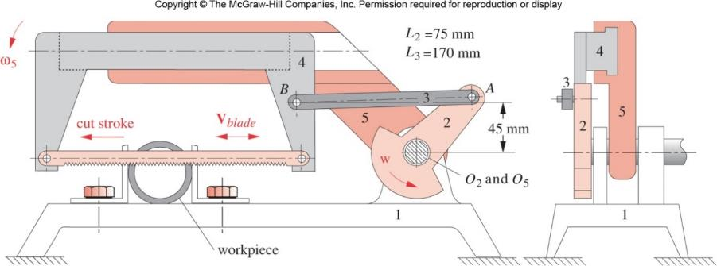

Figure 1. Power hacksaw (Refer to textbook Figure P2-15)

- Oil field pump

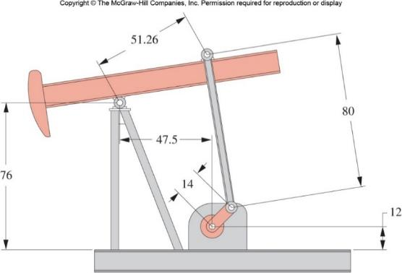
Figure 2. Oil field pump (Refer to textbook Figure P2-18)

- An aircraft overhead bin mechanism

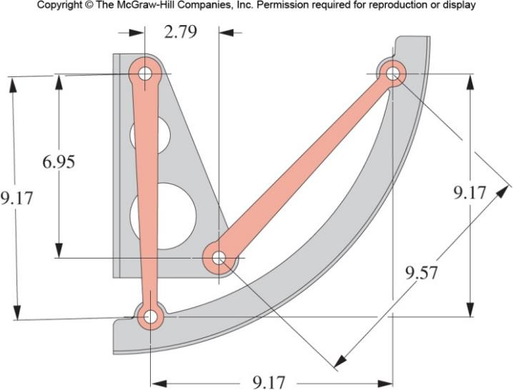
Figure 3. An aircraft overhead bin mechanism (Refer to textbook Figure P2-19)

- Walking-beam with pick-and place mechanism

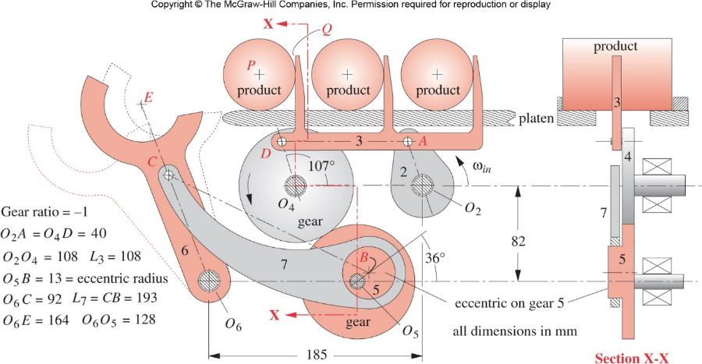
Figure 4. Walking-beam with pick-and-place mechanism (Refer to textbook Figure P4-6)

III. Design Tasks:
- Define the mechanism’s functional requirements, design parameters, and design constrains;
- Create models of each components of the mechanism using NX;
- Create the assembly of the mechanism;
- Optional (extra bonus points): using NX Motion Analysis to create motion scenario. Create the links, joints, and motions for the motion analysis;
- Perform an interference/clearance analysis to verify that there is no interference throughout the complete range of motion of the mechanism;
- Analyze the displacement, velocity and acceleration of important components; (Hint: refer to textbook problems for the pre-defined projects)
- Create a mpeg video or other sort of animation to demonstrate your motion.

IV. Deliverable Results:
1. Proposal report: maximum 2 pages; Due date: Oct. 28.
The proposal must describe:
A. The mechanism you have selected to design. (Describe the functionalities/design tasks of the mechanism)
B. Proposed work schedule.
C. Tasks distribution. (What will each group member will work on?)

2. Final Project Presentations (November 25 & 27): If time is available, every group will be asked to give a 15-minute presentation using PowerPoint.

3. Final Report and soft copy of your project (Due: November 27)
A. A final report in electronic format should be documented in Word format. There is no specific format and page limitation, but your report should include the following contents:
          - Abstract (100-150 words);
          - Introduction (design objectives);
          - Project description (mechanism’s functional requirements, design constrains, design parameters, etc.);
          - Design details (models of components, drafting of major components, assembly, mechanism design, positon, velocity and acceleration analysis, motion simulation, simulation graphs, etc.);
          - Conclusion and suggestion; and
          - Reference, if any.

B. Please submit
(1) Hardcopies of the report and presentation to the instructor;
(2) Electronic version of the report, presentation, and your project as one compressed file to ecourses.

4. Taskstream submission (Due: November 27)
Submit the final report to Taskstream assignment 1(e)

V. Point Distribution:
- Proposal: 30 pts.
- Quality and results (creativity, completeness, etc.): 120 pts
3. Final Presentation: 50 pts
4. Final Report (documentation style, neatness, clarity): 80 pts
5. Taskstream submission: 20 pts

Total: 300 pts
Bonus points for motion analysis and simulation: 50 pts

