COURSE ASSESSMENT REPORT

ROY G. PERRY COLLEGE OF ENGINEERING
MECHANICAL ENGINEERING DEPARTMENT
PRAIRIE VIEW A&M UNIVERSITY

ASSESSMENT REPORT COVER PAGE

MCEG 3043-Y02 MACHINE DESIGN I

Fall 2020 SEMESTER

NAME OF INSTRUCTOR: Dr. Lai Jiang

TABLE OF CONTENTS

- Report Cover Page

- Detailed Course Syllabus (ABET + Additional Information)

- End of Semester Outcomes Assessment Report (New Format)

- Grade Sheet Showing Student and Class Performance in Outcomes

- Supporting Outcomes Specific Assignments (Minimum of 2 per outcome)
5.1 Assignments assessing students’ ability to apply engineering design to produce solutions that meet specified needs with consideration of public health, safety, and welfare, as well as global, cultural, social, environmental, and economic factors (Outcome 2)

Detailed Course Syllabus
(Distributed to Students at the beginning of the Semester)
ABET Outcomes measured using course should be
explicitly listed in the syllabus

Course Description in ABET Format

1. | Course number and name: | MCEG 3043 MACHINE DESIGN I
2. | Credits and contact hours: | 3 credit hours; 4 contact hours  * Subject Area: Engineering Topics
3. | Instructor’s or course  coordinator’s name: | Dr. Lai Jiang
4. | Text book:  Title: | Shigley’s Mechanical Engineering Design
 | Author: | Budynas, Richard G.
 | Publisher, Year & Edition: | McGraw Hill Education, New York, NY. 2020, 11th Edition
 | - Other Supplemental material | N/A
5. | Specific course information
 | - Brief description of the content of the course (catalog description) | This course provides the Fundamentals of mechanical design methodology, design of machine elements for static and fatigue failure, individual projects and classroom discussions of various design solutions.
 | - Prerequisites or  Co-requisites | CVEG 2063 Mechanics of Materials  MCEG1021 Mechanical Engineering Lab I
 | - ** Indicate whether a required, elective, or selected elective (as per definition provided) course in the program | Required
6. | - Specific goals for the course specific outcomes of instruction (e.g., The student will be able to explain the significance of current research about a particular topic.)  Students will be able to : | - Explicitly indicate which of the student outcomes listed in Criterion 3 or any other outcomes are addressed by the course.  The specific goals for the course specific outcomes listed on the left column will address the following student learning outcomes:
 | 1. Demonstrate fundamental knowledge on machine design and engineering materials. | Outcome 2  An ability to apply engineering design to produce solutions that meet specified needs with consideration of public health, safety, and welfare, as well as global, cultural, social, environmental, and economic factor (including use of the techniques, skills, and modern engineering tools necessary for engineering practice).
 | 2. Analyze stresses of mechanical engineering elements under various loading situations.
 | 3. Implement failure theories commonly used in load carrying mechanical elements.
 | 4. Select various machine elements with the right size and capacity.
7 | Brief list of topics to be covered | Introduction/Basics (2 hours)  Engineering Materials (2 hours)  Load and stress analysis (20 hours)  Deflection and stiffness (8 hours)  Failure resulting from static loading (8 hours)  The design of screws, fastener, and connections (8 hours)  Rolling contact bearings (8 hours)

Prairie View A&M University
Department of Mechanical Engineering
MCEG 3043 Machine Design I
Fall Semester 2020

COURSE | Fundamentals of mechanical design methodology, design of machine elements for static and fatigue failure, individual projects and classroom discussions of various design solutions.
COURSE NO | MCEG 3043
CREDIT | 3 Credit Hours
PRE-REQUISITES | CVEG 2063 Mechanics of Materials  MCEG1021 Mechanical Engineering Lab I
CLASS HOURS | MW 8:00 – 9:50
CLASS ROOM | Juvenile Justice & Psyc. Bldg. 137
INSTRUCTOR | Dr. Lai Jiang
OFFICE | C. L. Wilson Engr. Bldg. Room 105A
OFFICE HOURS | M & W: 10:30 ~ 11:30AM, 3 ~ 5PM
TELEPHONE | (936) 261-9927
E-MAIL | lajiang@pvamu.edu
REQUIRED  TEXTBOOK | No hard copy of the textbooks required. But the access to McGraw Hill Connect website is required. Please follow the link: https://connect.mheducation.com/class/l-jiang-section-y02-1 to register for the course section. A 2-week courtesy access can be registered through the guidance in the link: Courtesy Access.
GOALS | This course is designed to introduce students in mechanical engineering to the contemporary mechanical design methodology as applied to machine elements and to the process of mechanical design. The student will design mechanical elements using concepts developed in design of machine elements, engineering graphics and other related courses.
OUTCOMES | After completion of this course, the students should be able to apply the design processes to mechanical elements, using contemporary design standards and tools and have developed the following:  1. Demonstrate fundamental knowledge on machine design and engineering materials;  2. Analyze stresses of mechanical engineering elements under various loading situations;  3. Implement failure theories commonly used in load carrying mechanical elements;  4. Select various machine elements with the right size and capacity.
Topics | (1) Introduction/Basics.  (2) Design Process and Project Management  (3) Material, Load and stress analysis  (4) Deflection and stiffness  (5) Failures resulting from static loading  (6) The design of screws, fasteners, and connections  (7) Rolling contact bearings
Grading | The final grade will be computed according to the following weight distribution:  Attendance: 5%  Homework: 5%  Quiz: 5%  Project: 10%  Exam 1: 25%  Exam 2: 25%  Final Exam: 25%  Total: 100%  The distribution of grades will be as follows:  A = 90 - 100  B = 80 - 89  C = 70 - 79  D = 60 - 70  F = 0 - 59
Course Policy | Note: The instructor reserves the right to alter it during the semester.  Use of eCourses (http://ecourses.pvamu.edu)  eCourses will be used extensively in this class. Lecture slides, assignment, and tutorials will be provided on eCourses.  Academic Integrity  Academic dishonesty of any sort (plagiarism, cheating, fabrication or facilitation) is prohibited under any circumstance. Any detected actions of dishonesty will cause the failure of the class directly.  Assignments & Due Dates  Homework needs submitted at the beginning of class on the assigned day. Late homework will be charged a 10% penalty for each day late – weekend days do count. Circumstances beyond your control (i.e. illness, computer failure, weather, etc.) will be considered as required.  Projects  You need to submit the project with an electronic copy on Taskstream.  Attendance  Class attendance is mandatory. Excessive absenteeism, whether excused or unexcused, may result in a student’s course grade being reduced or in assignment of a grade of “F”.  Examinations  Neither programmable calculator nor calculator which can save pictures is allowed during exams. No cell phone can be kept in your pocket during exams. You cannot leave the classroom during the exam. Portions of each exam may be either closed or open book. You will be notified of the exam format at least one week in advance.  College of Engineering Textbook Policy  Students MUST acquire the required textbook that is listed on the course syllabus for this course. The textbook must be acquired by the 10th class day. Students are not allowed to share textbooks with students who are currently registered in the same class. Failure to acquire (or show proof of purchase) the required textbook by the 10th class day will result in the student being administratively dropped from the course. The University will assess financial obligations for the course to the student as with any other dropped class according to the fee schedule as well as your financial aid may be affected.  If you are not financially able to purchase a required textbook for an engineering course prior to the 10th class day, you may apply to the College of Engineering Textbook Fund for a textbook voucher. The voucher can only be used at the Campus Bookstore. This voucher is a loan and must be paid back to the College of Engineering prior to the start of pre-registration for the coming semester. If the loan is not repaid, a hold will be placed on your account. Additional information and application materials can be obtained from the Assistant Dean’s Office (SR Collins Rm 349) and obtained online at the College of Engineering website under student resources.
IMPORTANT DATES | Last day to withdraw from course(s) without record: 9/9/2020  Withdrawal from courses with record “W” ends: 11/2/2020  Course review day: 12/2/2020  Final exam period: 12/3-9/2020

Machine Design I

Tentative Course Schedule
Chapter | TOPICS
1 | INTRODUCTION/BASICS  Design considerations, codes and standards, stress and strength considerations, factor of Safety, units, etc.
2 | MATERIALS
3 | LOAD AND STRESS ANALYSIS  Free-body diagrams  Stress  Cartesian stress components  Mohr’s circle  General stress-dimensional stress  Normal stresses for beams in bending  Shear stresses for beams in bending  Torsion  Stress concentration  Stress in pressurized cylinders
4 | DEFLECTION AND STIFFNESS
Spring rates
Tension, compression, and torsion
Defection due to bending
Beam deflection methods
Finding beam deflections by superposition
Strain Energy
Compression members – general
Long length columns with central loading
Intermediate length columns with central loading
Struts, or short compression members
5 | FAILURES RESULTING FROM STATIC LOADING  Static strength  Stress concentration  Failure theories  Maximum-shear-stress theory for ductile materials  Distortion-energy theory for ductile materials  Failure of ductile materials
8 | THE DESIGN OF SCREWS, FASTENERS, AND CONNECTIONS  The mechanics of power screws  Threaded fasteners  Joints – fastener stiffness  Joints – member stiffness  Bolt strength  Tension connections – the external load  Bolt preload
11 | ROLLING-CONTACT BEARINGS  Bearing types  Bearing life  Bearing load  Selection of ball and cylindrical roller bearings  Selection of tapered roller bearings  Mounting and enclosure

How Mechanical Engineering Courses meet Department Objectives & ABET Criterion 3
Specific Objectives of the Mechanical Engineering Program (MCEG Objectives) at Prairie View A&M are to produce graduates who have:

- the techniques and skills necessary for modern mechanical engineering practices, and an ability to function effectively in multi-disciplinary teams.
- an ability in life-long learning skills, a knowledge of contemporary issues, and an ability to communicate effectively.
- an understanding of global and societal context in the aspects of professional and ethical responsibility and the impact of engineering solutions on society.
- the qualifications to be employed by major industries and government agencies in the State of Texas and the nation.
- the qualifications to pursue graduate degrees.

ABET Criterion 3: Program Outcomes and Assessment
Engineering Programs must demonstrate that their graduates have:
- an ability to identify, formulate, and solve complex engineering problems by applying principles of engineering, science, and mathematics.
- an ability to apply engineering design to produce solutions that meet specified needs with consideration of public health, safety, and welfare, as well as global, cultural, social, environmental, and economic factors.
- an ability to communicate effectively with a range of audiences.
- an ability to recognize ethical and professional responsibilities in engineering situations and make informed judgments, which must consider the impact of engineering solutions in global, economic, environmental, and societal contexts.
- an ability to function effectively on a team whose members together provide leadership, create a collaborative and inclusive environment, establish goals, plan tasks, and meet objectives.
- an ability to develop and conduct appropriate experimentation, analyze and interpret data, and use engineering judgment to draw conclusions.
- an ability to acquire and apply new knowledge as needed, using appropriate learning strategies.

The table below shows how required Mechanical Engineering courses at Prairie View A&M University contribute to the student’s knowledge and ability to meet ABET criterion 3.
Numerical values – items that the course contents are significantly relevant to ABET Criterion 3 and the instructor will use these items for course assessment. The values represent for “contribution factor” of the specific course toward the assessment of the particular item of ABET Criterion 3. A summation of the values in each column equals to 100.
x – items that the course contents are somewhat relevant to ABET Criterion 3. However, the instructor will not use these items for course assessment.

MCEG Courses | ABET EAC Criteria 1-7
 | Fall 2018 | Spring 19 | Fall 2019 | Spring 2020 | Fall 2020 | Spring 2021 | Fall 2021 | Spring 2022
1021 Mech. Drawing & Desg. | 2 | 2 | 2 | 2 | 2 | 2 | 2 | 2
2013 Thermodynamics I | 8 | 8 | 8 | 8 | 8 | 8 | 8 | 8
2023 Materials Sci/Engr. | 8 | 8 | 8 | 8 | 8 | 8 | 8 | 8
2053 Engineering Mechanics II | 8 | 8 | 8 | 8 | 8 | 8 | 8 | 8
3011 Measurement Lab | 7 | 6 | 7 | 6 | 7 | 6 | 7 | 6
3013 Heat Transfer | 1 |  | 1 |  | 1 |  | 1
3021 Thermal Sci. Lab | 6 | 6 | 6 | 6 | 6 | 6 | 6 | 6
3023 Thermodynamics II | 1 | 1 | 1 | 1 | 1 | 1 | 1 | 1
3031 Manufacturing Lab |  | 2 |  | 4.2 |  | 2 |  | 4.2
3033 Manufacturing Proc |  | 2 |  | 4.2 |  | 2 |  | 4.2
3043 Machine Design I | 2 |  | 2 |  | 2 |  | 2
3053 Kinematic Design | 1 |  | 1 |  | 1 |  | 1
3063 Fluid Mechanics | 1 | 6 | 1 | 6 | 1 | 6 | 1 | 6
4043 Machine Design II | 2 |  | 2 |  | 2 |  | 2
4063 Dynamic Systems |  | 1 |  | 1 |  | 1 |  | 1
4093 Finite Element | 1 |  | 1 |  | 1 |  | 1
4472 Senior Project I | 4, 5 |  | 4, 5 |  | 4, 5 |  | 4, 5
4482 Senior Project II |  | 2,3,7 |  | 2,3,7 |  | 2,3,7 |  | 2,3,7
End of Semester
Course Assessment Report

This summary contains the following Information

1. Performance Statistics
- Total number of students in class
- The class average performance (stated as %) in each course outcome assessed in this class and the two previous times course was assessed.
- The acceptable class average for the class in each outcome area as set by your Department. You cannot use any number of your choice.
- Percentage of students who scored below the expected average in each outcome.

2. Implementation Summary
- Brief summary of plans implemented during the semester based on last assessment report

3. Perceived Problems
- Instructor’s critical evaluation of perceived problems that affected students’ performance. Realistic problems should be identified throughout the semester and summarized in this section of the report.

4. New Plans for Addressing Problems
- Instructor’s plans for addressing the perceived problems the next time the class is taught. These should be specific enough for another instructor to implement. Most of these should be things that, you, the instructor can implement to help students to improve. Be creative.

5. Overall Trend over last three assessment periods
- Instructors summary of overall performance trend for each outcome measured over the last three periods.

6. Were Expectations Met?
- Answer YES if the class average was above the expected average and the stated percentage of students scored at or above the expected average, else answer NO.

END OF SEMESTER COURSE OUTCOME ASSESSMENT REPORT
MCEG3043-Y02 MACHINE DESIGN I
Fall 2020 SEMESTER

Report Prepared by: Dr. Lai Jiang

Report Date: December 18, 2020

Semester | Analysis Type | Number of Students | Outcome 2  Ability to apply engineering design to produce solutions
Semester | Analysis Type | Number of Students | Expected Class Average | Expected Percent of students at or above average | Class Average | % Students meeting Expected Average
Fall 2020 | Direct | 18 | 70 | 70 | 67.8 | 27.8%
Fall 2019 | Direct | 19 | 70 | 70 | 75.4 | 73.7%
Fall 2018 | Direct | 20 | 75 | 70 | 81.7 | 90%
Implementation Summary | Items implemented from previous report or after meeting previous instructor |  | The following activities have been implemented to improve the student learning on Outcome 2:  (1) A series of examples on how to apply engineering design to solve engineering problems were delivered to students;  (2) One design project was assigned which required students to use any calculation software, such as Matlab, C++, etc. to solve engineering problems;  (3) eCourses was utilized for the class to distribute the course materials and submit projects.
Perceived Problems | Perceived problems are directly related to the PC and the sub items under them |  | 1. Students lack the abilities in applying the fundamentals to formulate the design problem and to validate the design using analysis.  2. Students lacks the ability in writing a program using any coding language.
Plans for Addressing Problems | Plans for address specific measures to address PC and their sub areas |  | It is suggested to do the following:  (1) More in-class training sessions are needed to give students more training on some programing language/software.  (2) More out-of-class tutoring sessions are needed.  (3) A tutor is needed to provide help to students.
Overall Trend over Periods | Ascertain if there were improvements over previous semesters |  | The overall performance is below the expected average.
Were Expectations Met? |  |  | NO

Grade Sheet Showing
Student and Class Performance in Outcomes
The computed semester average in each outcome
as stated in the Assessment report are
highlighted in boldface

Grade Sheet Showing Student and Class
Performance in Course Outcomes
MCEG 3043-P02 MACHINE DESIGN I
Fall 2019 Semester

Outcomes to be Measured |  |  | Outcome (2)
Title of Assignment |  |  | Project
 | Cover Page | Problem Description | Manual Calculations (40%) |  |  |  | Software | Discussion | Report Quality | Taskstream | Total | Curved
 | Cover Page | Problem Description | Step 1 | Step 2 | Step 3 | Step 4
# | 5 | 5 | 5 | 5 | 15 | 15 | 20 | 10 | 10 | 10 | 100 | 100
1 | 5 | 3 | 5 | 3 | 7 | 8 | 10 | 8 | 5 | 10 | 64 | 80
2 | 5 | 5 | 4 | 4 | 0 | 5 | 5 | 5 | 3 | 10 | 46 | 67.8
3 | 5 | 5 | 5 | 5 | 1 | 5 | 0 | 5 | 2 | 10 | 43 | 65.6
4 | 5 | 5 | 4 | 4 | 0 | 0 | 0 | 0 | 1 | 10 | 29 | 53.9
5 | 5 | 2 | 4 | 5 | 5 | 5 | 5 | 2 | 5 | 10 | 48 | 69.3
6 | 5 | 4 | 4 | 4 | 2 | 8 | 0 | 5 | 5 | 10 | 47 | 68.6
7 | 5 | 5 | 5 | 0 | 0 | 0 | 0 | 0 | 1 | 10 | 26 | 51.0
8 | 5 | 0 | 5 | 5 | 1 | 5 | 0 | 0 | 5 | 10 | 36 | 60
9 | 5 | 5 | 5 | 5 | 1 | 5 | 0 | 5 | 3 | 10 | 44 | 66.3
10 | 5 | 2 | 4 | 4 | 2 | 8 | 0 | 5 | 5 | 10 | 45 | 67.1
11 | 5 | 4 | 5 | 5 | 2 | 8 | 0 | 5 | 3 | 10 | 47 | 68.6
12 | 5 | 4 | 4 | 4 | 2 | 8 | 2 | 5 | 5 | 10 | 49 | 70
13 | 5 | 5 | 5 | 5 | 2 | 8 | 2 | 8 | 5 | 10 | 55 | 74.2
14 | 5 | 5 | 4 | 5 | 7 | 8 | 15 | 7 | 8 | 5 | 69 | 83.1
15 | 5 | 5 | 5 | 5 | 2 | 8 | 4 | 10 | 10 | 10 | 64 | 80
16 | 0 | 5 | 5 | 4 | 2 | 8 | 0 | 5 | 3 | 10 | 42 | 64.8
17 | 5 | 3 | 4 | 4 | 2 | 8 | 0 | 5 | 5 | 10 | 46 | 67.8
18 | 5 | 4 | 4 | 4 | 3 | 0 | 5 | 0 | 3 | 10 | 38 | 61.6
Average for all students |  |  |  |  |  |  |  |  |  |  |  | 67.75
No. of students above expected average |  |  |  |  |  |  |  |  |  |  |  | 5
Percentage of student above average |  |  |  |  |  |  |  |  |  |  |  | 27.8%

OUTCOME SPECIFIC ASSIGNMENTS
USED TO ASSESS OUTCOMES

MECHANICAL ENGINEERING DEPARTMENT

Check the engineering design characteristics related to this assignment
X | Involves identifying the specific needs to be met by defining/understanding the problem and developing plans for the project to satisfy the need
X | Involves conducting a review of the literature and performing preliminary design by generating alternative ideas/solutions and applying creativity
X | Involves performing detailed engineering design leading to specification and fabrication/selection of components for system being designed.
X | Involves consideration of one or more of the following (Please check those involved in this assignment.)
X |  | Public health
X |  | Safety and welfare
X |  | Global factors
X |  | Cultural factors
X |  | Social factors
X |  | Environmental factors
X | X | Economic factors
 | Involves fabrication and testing of model or prototype

OUTCOMES SPECIFIC ASSIGNMENT COVER SHEET
MACHINE DESIGN I
FALL 2020

Title of Assignment
Course Project: I Beam Size Selection based on Safety Factors

Outcome Measured Using this Assignment
Outcome 2
An ability to apply engineering design to produce solutions that meet specified needs with consideration of public health, safety, and welfare, as well as global, cultural, social, environmental, and economic factor.

Brief Justification of the suitability of this assignment for the outcome
MCEG3043: Machine Design I
This project is to apply the Machine Design knowledge and commercial software package Matlab to: (1) analyze the stress in the I beam under load; (2) pick the I beam with the right size with the consideration of two safety factors.
Fall 2020 Section Y02 Course Project
Analysis and Design of the Overhead Crane Beam
Due: midnight on 11/24/2020

1. Project Overview
An overhead crane (shown in Fig. 1) is a type of machine that can be used both to lift and lower heavy materials and to move them horizontally in a high-bay shop. It is generally equipped with a hoist rope, wire ropes or chains, and sheaves. Overhead cranes are commonly employed in the manufacturing industry for the moving and assembling of heavy equipment.

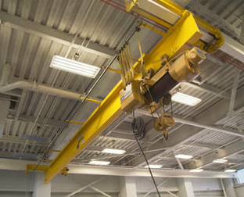
Figure 1: A crane in a high-bay shop
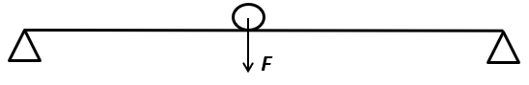
Figure 2: Loading on the I beam of an overhead crane
When the overhead crane is moving a heavy item, the loading situation of the crane beam can be simplified to a beam being supported on both ends with the loading force F being movable along the beam, as shown in Fig. 2. Assume the overall length of the beam is 60 ft, and the cross-section of the beam is in the shape of the letter “I”. The material for the beam is 1045 carbon steel, with tensile yield strength of 45,000 psi. You are now the chief designer for this I beam, and your employer has asked you to design the beam with the right size for the crane so it can pick up items with a maximum weight of 50 tons (100,000 lbf).
2. Analyses to be performed for the crane beam
(1) Find the location of the applied load that will generate the largest bending moment for the I beam;
(2) Calculate the reaction forces at two ends when the largest bending moment is generated, and draw the shear force and the bending moment diagrams;
(3) Base on the calculated maximum bending moment and the beam’s material, select the optimal I beam dimension from the provided “Wide Flange Beams catalog” on eCourses in the “Course Project” module (assuming the I beam made with the least material will be the most less expensive one), using both MSS and DE theories. This step may require several iterations, so a recommended method is to use an analytical software package (e.g., Matlab, or C++, C, etc., if you have no remote access to the college’s computer, try to use the 30-day free trial for Matlab, or there are many free online compliers for both C++ and C) to calculate the critical stresses of the I beam (Note: you can simplify all the round angles to right angles for all calculations);
(4) If a square cross-section beam with the same cross-sectional area as your selected I beam in Step 3 is used, can they still take the maximum load mentioned at the beginning of the project? Show your calculations and explain the reason behind your results.
(5) Discuss the results you found from steps above (e.g., where the location of the critical point on the I beam, why the square cross section beam is able/unable to carry the same load, etc.)

3. Report Format
The report should include the following sections:
  - A cover page;
  - This handout as the problem description;
  - The detailed manual calculation performed for Steps 1 − 4;
  - The source code of your calculations performed in Step 3 and explanations to your codes;
  - Results and discussion.
4. Project Submission
Submit the soft copy of your report to Taskstream.

5. Grades
Manual calculation and discussions: 40%
Software analysis: 20%
Report quality 30%
Taskstream submission 10%

6. Helpful Resources:
Textbook Examples 3-7, 5-3.

MECHANICAL ENGINEERING DEPARTMENT
PRAIRIE VIEW A&M UNIVERSITY



MCEG 3043
Machine Design
Fall 2020

COVER PAGE

REPORT ON
“Overhead Beam”

Submitted by
Drake Cheatum

On
November 24, 2020

To
Dr. Jiang

An overhead crane (shown in Fig. 1) is a type of machine that can be used both to lift and lower
heavy materials and to move them horizontally in a high-bay shop. It is generally equipped with a
hoist rope, wire ropes or chains, and sheaves. Overhead cranes are commonly employed in the
manufacturing industry for the moving and assembling of heavy equipment.

When the overhead crane is moving a heavy item, the loading situation of the crane beam can
be simplified to a beam being supported on both ends with the loading force F
being movable along the beam, as shown in Fig. 2. Assume the overall length of the beam is 60 ft,
and the cross-section of the beam is in the shape of the letter “I”. The material for the beam is 1045
carbon steel,with tensile yield strength of 45,000 psi. You are now the chief designer for this I beam, and your
employer has asked you to design the beam with the right size for the crane so it can pick up items
with a maximum weight of 50 tons (100,000 lbf).

2. Analyses to be performed for the crane beam
(1) Find the location of the applied load that will generate the largest bending moment for the I
beam;
(2) Calculate the reaction forces at two ends when the largest bending moment is generated, and
draw the shear force and the bending moment diagrams;
(3) Base on the calculated maximum bending moment and the beam’s material, select the optimal
I beam dimension from the provided “Wide Flange Beams catalog” on eCourses in the “Course
Project” module (assuming the I beam made with the least material will be the most less expensive
one), using both MSS and DE theories. This step may require several iterations, so a recommended
method is to use an analytical software package (e.g., Matlab, or C++, C, etc., if you have no
remote access to the college’s computer, try to use the 30-day free trial for Matlab, or there are
many free online compliers for both C++ and C) to calculate the critical stresses of the I beam
(Note: you can simplify all the round angles to right angles for all calculations);
(4) If a square cross-section beam with the same cross-sectional area as your selected I beam in
Step 3 is used, can they still take the maximum load mentioned at the beginning of the project?
Show your calculations and explain the reason behind your results.
(5) Discuss the results you found from steps above (e.g., where the location of the critical point on
the I beam, why the square cross section beam is able/unable to carry the same load, etc.)

Calculations
First step is to find where the maximum bending moment is located on the beam. To find the maximum bending moment we must find out where the load applied P is farthest from both supports. So that means that the maximum bending moment occurs in the middle. x= (60/2)= 30ft=360 inch so the maxim bending moment occurs 30ft or 360 inches away from support A. Which is the support to the left.
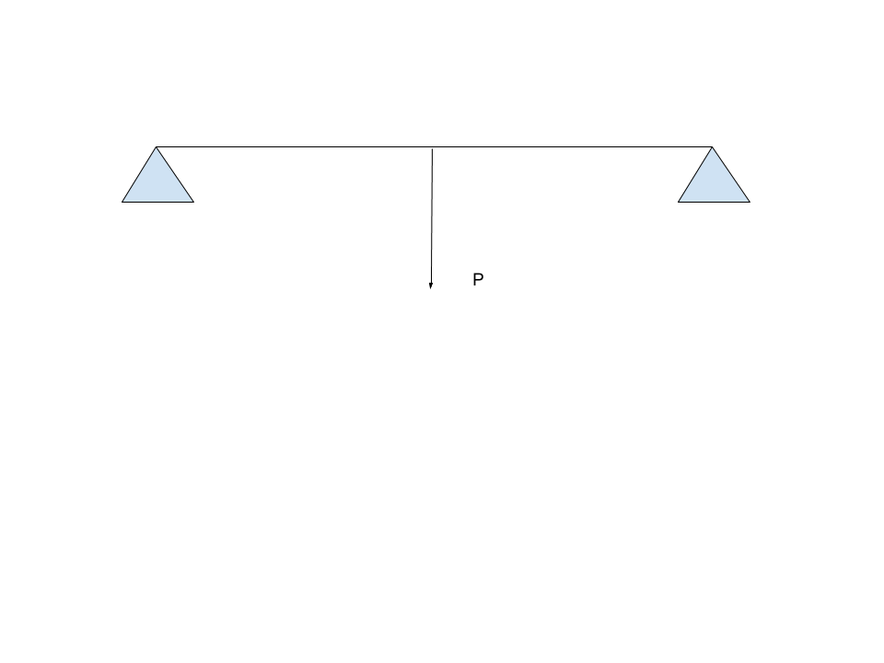

To Calculate the support reactions due to the load you must take a Moment about A and set it equal to zero. Support A is on the far left side of the beam and Support B is on the far right side of the beam.
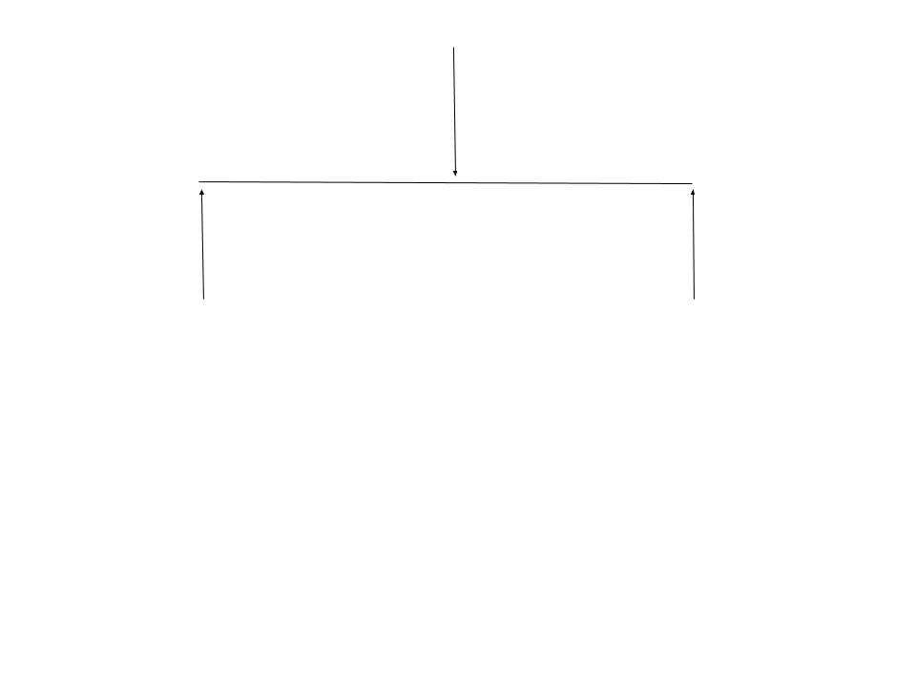
When finding the moment about A neglect Support A and take the moment so you multiply P times the distance from support A minus then support By times its distance from point A which is 60ft. Therefore Ay=By=(100kip/2)= 50kip
50 kip
-50 kip

0
V(x)
60 ft
For the bending Moment diagram you use the shear force diagram you must integrate the shear force from 0 to 30ft then integrate the shear force from 30ft to 60ft. When you use both those integrations to create your bending moment diagram you will notice that the maximum bending moment occurs in the middle of the beam.

50kip x180in = 9000kip
0
60ft

Now that we know the Maximum bending moment and the maximum shear stress that the beam will be put under due to the load. Then you calculate the maximum transverse shear stress and the maximum bending stress. You use the equation 3-31 and 3-26 below
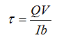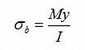
To find the transverse shear stress of the beam we must use the first equation V will be constant throughout all the different beams being tested. The maximum transverse shear stress will always happen in the middle of the I beam, because that is when Q is at its highest value and b is at its smallest. The Value Q is the first moment of area with respect to the neutral axis. The Value I is the second moment of area which is bh^3 /12 for both equations. The Y in the second equation is half of the height of the I beam or neutral axis. Since we have an I beam it isn’t just base and height you will have to rearrange the equation to find the real the second moment of area. The way to find that is to subtract the space from the I formation which will then lead you to bh^3/12 - 2 (bh^3/12). The 2 in front is because there are two gaps of space on both sides of the I beam. The value of Q is the cross sectional area of the beam with respect to the neutral axis. A is the area above the point of interest and Y is the distance of the center of area from the neutral axis. Y times A will give you Q used in the equation. The symbol b in the equation above is the base size of your beam. That is why as stated above in the I beam shape the b will be at its smallest value and Q will be at its highest value. Using those equations to gather our transfer shear stress and the maximum bending moment We must now figure out now which beam can handle this amount of stress. We must use the D.E. theory and M.S.S. Theory below.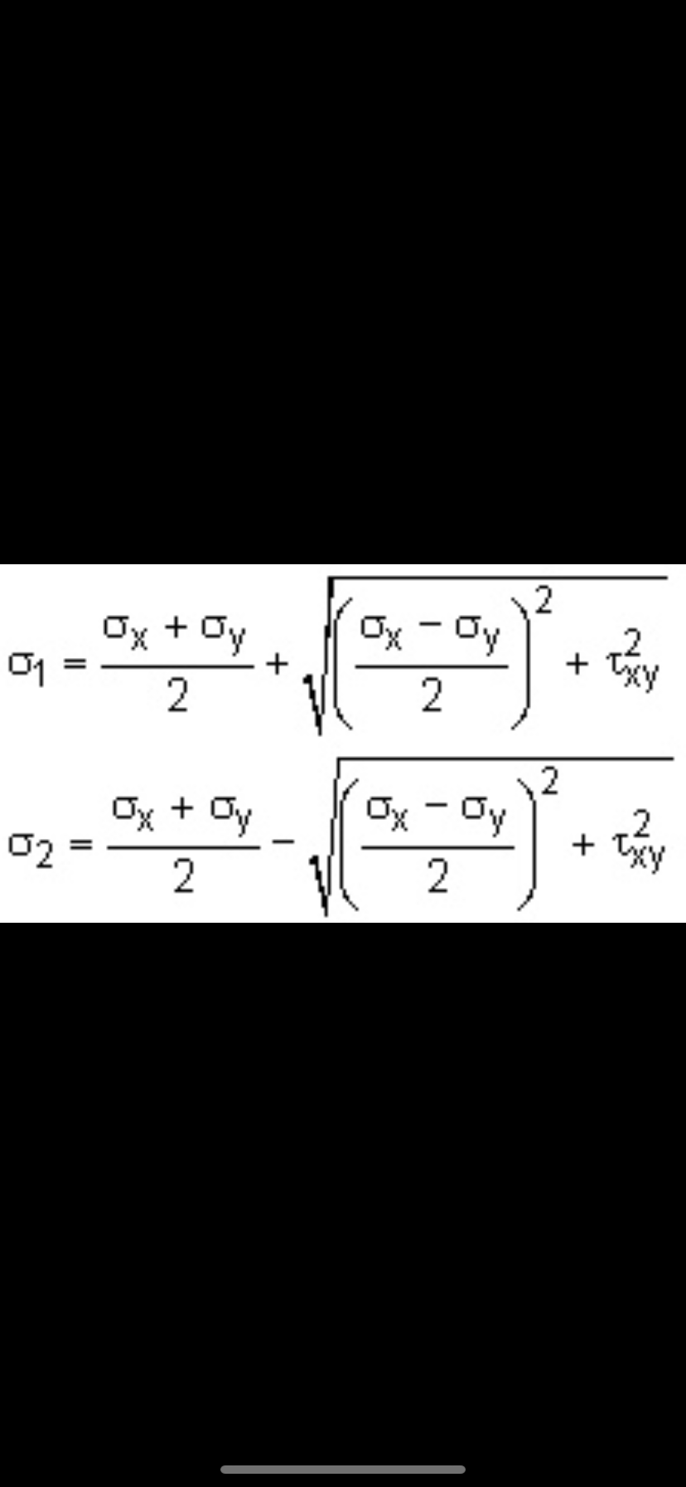
This Equation is used for the M.S.S. Theory or the Maximum Shear Stress Theory. The bending moment stress is sigma x and the transverse shear stress is txy. In this situation because there are no other loads the sigma y is equal to 0 in this situation. When you use these two equations you will get sigma 1 and sigma 3 and sigma two = zero because there is no stress in z direction. Once you find the largest and smallest normal stresses. To find out if it is safe or not you must use the equation below to see if it can withstand the load the symbol n which is the factor of safety must be greater than or equal to 1. Also Sy which is the Tensile Yield Strength = 45,000 pounds per square inch for 1045 Carbon Steel.
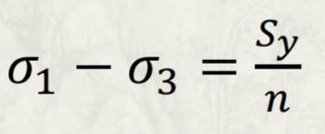
Now for the D.E. Theory or Distortion Energy theory we must use the equation below to find sigmaprime.
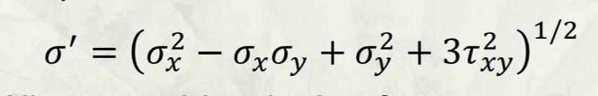
As stated before sigmax equals your bending moment stress and your transverse shear stress equals txy in this equation. Sy is also still the same because it is the same material of 1045 Carbon steel so it still equals 45,000 pound per square inch Also again because there is no load or stress in any other direction sigma y will be set equal to zero, so that should cancel two terms in the equation above. When you find sigmaprime you will then use the equation below.

Once again as stated before for the I beam to withstand the amount of load without failure meaning that it will break, n must be greater than or equal to 1. Using these two equations and assuming that the more area used the more expensive the beam will be. The best choice for the I beam is W 27 x 84 where the total height of the I beam is 26.7, the total width is 9.96 and the web thickness is .46 and the Flange thickness is .640 all measurements are in inches. This is the smallest beam where it passes the safety safety factor test for both the D.E. Theory and the M.S.S. theory. Below is the Matlab script that I wrote that helped me figure out the best beam for this situation. The best I beam will be as close to 1 as possible without going under 1. My safety Factor for my M.S.S. theory was 1.0228 and for my D.E. theory my safety factor was 1.0286. Those two numbers are both greater than 1 therefore it will be able to withstand the given load.

b = 9.96
h = 26.7
tf = .64
tw = .46
r = (b*h^3)/12

s = 2*(((b/2)-(tw/2))*((h-(2*tf))^3)/12)

I = r - s

sigmax = (9000000*(h/2)/I)

Q = ((h/2)-(tf/2))*(b*tf)+(((h/2)-tf)/2)*(((h/2)-tf)*tw)

txy = (50000*Q)/(I*tw)

sigmaprime = (sigmax^2 + 3* (txy^2))^.5

safetyDE = 45000/sigmaprime

sigma1 = (sigmax/2) + sqrt((sigmax/2)^2 + (txy)^2)

sigma3 = sigmax/2 - sqrt((sigmax/2)^2 + (txy)^2)

safetyMSS = 45000/(sigma1 - sigma3)

Based on the area from the I beam if we were to convert it to a square would it pass the safety factor test. We know the area of the I beam is 24.8 in^2 now considering that if the I beam was a square beam. The square root of 24.8 equals 4.98 in to figure the amount of bending stress the value I will change and the value Q will change due to the change of shape so the second moment of inertia will be 4.98^4 /12 = 51.25 in^2. Now that I is smaller sigmax will be larger the new sigmax will be 437.2ksi based on the bending stress equation and the new transverse shear stress 6,048.78 per square inch and using the M.S.S. Theory you will find that if you convert the same area of I beam to a square it will fail and not be able to withstand the load.in this situation if it is still made out of 1045 carbon steel. The Square beam cannot withstand the load because the I beam has a better design to withstand the bending moment stress load because there is more area at the top and bottom of the beam. That is why the I beam is a better design for this situation because it is able to withstand a higher bending moment stress. The second moment of inertia is way smaller when it is a square compared to when it is a I shaped beam. Therefore the bending moment stress will be a lot higher as to if it were a I beam.

Conclusion
In conclusion the best I beam for this situation to withstand the amount of load given of 50 tons is I beam W 27 x 84. According to the D.E. and M.S.S. theory the beam I have chosen is the best for this situation, because it is as small as possible to save money without being too small to break. The Maximum bending moment will happen in the middle of the beam which is 9,000 kip per inch and the maximum shear is 50 kip. If we converted the same size I beam to a square beam it would fail, because it wouldn’t be able to withstand the amount of bending moment stress. The I beam is better suited for the bending moment stress because it has more area at the top and bottom of its surface.

