ROY G. PERRY COLLEGE OF ENGINEERING
MECHANICAL ENGINEERING DEPARTMENT
PRAIRIE VIEW A&M UNIVERSITY

ASSESSMENT REPORT COVER PAGE

MCEG 3013 HEAT TRANSFER

FALL 2020 SEMESTER

NAME OF INSTRUCTOR: Dr. Ziaul Huque

TABLE OF CONTENTS

- Report Cover Page

- Detailed Course Syllabus

- End of Semester Outcomes Assessment Report

- Grade Sheet Showing Student and Class Performance in Outcomes

- Supporting Outcomes Specific Assignments

5.1 Assignments assessing students’ ability to identify, formulate, and solve complex engineering problems by applying principles of engineering, science, and mathematic (outcome 1)

Course Syllabus – ABET Format

Course Description in ABET Format

MECHANICAL ENGINEERING DEPARTMENT
MCEG 3013 HEAT TRANSFER

1. | Course number and name: | MCEG 3013 HEAT TRANSFER
2. | Credits and contact hours: | 3 credit hours; 3 contact hours
3. | Instructor’s or course  coordinator’s name: | Dr. Ziaul Huque
4. | Text book: Title: | FUNDAMENTALS OF HEAT AND MASS TRANSFER
 | Author: | Theodore L. Bergman, Adrienne S. Lavine, Frank P. Incropera, and David P. DeWitt
 | Publisher, Year & Edition: | 2011, John Wiley & Sons, New York., 7th Edition
 | - Other Supplemental material | “Principles of Heat Transfer,” Frank Kreith, Raj M. Manglik, and Mark S. Bohn, 2011, 7th Edition, Cengage Learning, Stamford, CT
5. | Specific course information
 | - Brief description of the content of the course (catalog description) | MCEG 3013. Heat Transfer. (3-0) Credit 3 semester hours. Study of the fundamental modes of heat transfer, conduction, convection, and thermal radiation, separately and in combination. Theoretical, numerical, and design methods of analysis of steady, transient, single, and multidimensional problems will be emphasized. Co-requisite or prerequisite: MCEG 3063, MCEG 2013 & MATH 2043.
 | - Prerequisites or  Co-requisites | MCEG 2013 Thermodynamics I  MATH 2043 Differential Equations I  MCEG 3063 Fluid Mechanics
 | - *Indicate whether a required, elective, or selected elective (as per definition provided) course in the program | Required course
6. | Specific goals for the course | Students will be able to :
 | - Specific outcomes of instruction (e.g. The student will be able to explain the significance of current research about a particular topic.) | - display and apply an understanding of the various modes (conduction, convection, and radiation) in which heat can be transferred and relate these to other engineering requirements using a First Law of Thermodynamics Analysis.  - evaluate, compare, and assess the significance of heat transfer in multi-mode applications.  - address heat transfer design requirements in processes or devices subject to specified or implied constraints.  - determine the local rate of energy transfer and the relationship it has with thermodynamics properties, fluid flow properties, and other non-dimensional parameters (e.g., the Reynolds and Biot numbers).  - apply engineering approximation, methodology, design, and analysis (empirical, analytical, and numerical) of both steady and transient problems in both simple and complex geometries.
 | - Explicitly indicate which of the student outcomes listed in Criterion 3 or any other outcomes are addressed by the course. | This course addresses:  Outcome 1  An ability to identify, formulate, and solve complex engineering problems by applying principles of engineering, science, and mathematics.
7 | Brief list of topics to be covered | Fundamental Laws of Heat Transfer and Methodology.  Steady State One-D, Multi-Dimensional, and Numerical Conduction.  Transient and Numerical Conduction.  Heat and Mass Transfer Due to Forced Convection (External and Internal Flow).  Heat Transfer Due to Free Convection.  Heat Exchangers and Design Methods.  Heat Transfer Due to Radiation.  Heat Transfer in Condensing and Boiling and Mass Diffusion (if time permits).

*Required courses are required of all students in the program, elective courses (often referred to as open or free electives) are optional for students, and selected elective courses are those for which students must take one or more courses from a specified group.

End of Semester
Course Assessment Report

This summary contains the following Information

1. Performance Statistics
- Total number of students in class
- The class average performance (stated as %) in each course outcome assessed in this class and the two previous times course was assessed.
- The acceptable class average for the class in each outcome area as set by the Department.
- Percentage of students who scored below the expected average in each outcome.

2. Implementation Summary
- Brief summary of plans implemented during the semester based on last assessment report or after meeting previous instructor.

3. Perceived Problems
- Instructor’s critical evaluation of perceived problems that affected students’ performance. Realistic problems have been identified throughout the semester and summarized in this section of the report.

4. New Plans for Addressing Problems
- Instructor’s recommendations for addressing the perceived problems the next time the class is taught.

5. Overall Trend over last three assessment periods
- Instructor’s recommendations for addressing the perceived problems the next time the class is taught.

6. Were Expectations Met?
- YES is the answer of this question if the class average is above the expected average and the stated percentage of students scores at or above the expected average, otherwise NO is the answer to this question.

END OF SEMESTER COURSE OUTCOME ASSESSMENT REPORT
MCEG 3013 HEAT TRANSFER, SECTION Z02
FALL 2020 SEMESTER

Report Prepared by: Dr. Ziaul Huque
Report Date: December 21, 2020
Semester | Analysis Type | Number of Students | Outcome 1  Ability to identify, formulate, and solve complex engineering problems by applying principles of engineering, science, and mathematic
Semester | Analysis Type | Number of Students | Expected Class Average | Expected Percent of students at or above average | Class Average | % Students meeting Expected Average
Fall 2020 | Direct | 26 | 70 | 70 | 76 | 69.2
Fall 2019 | Direct | 30 | 70 | 70 | 74 | 63.3
Fall 2018 | Direct | 30 | 70 | 70 | 57 | 16.7
Implementation Summary | Items implemented from previous report or after meeting previous instructor |  | 1. In class discussion about the process were done in class  2. Work expectations were also discussed
Perceived Problems | Perceived problems are directly related to the PC and the sub items under them |  | - Students do not give expected effort on the class before the first exam  - Background mathematics preparation is not adequate  - Do not follow class lectures and procedures presented in the class properly indicating that they take preparation before exam and just follow the book.
Recommendations for Addressing Problems | Plans for address specific measures to address PC and their sub areas |  | The following are recommended for implementation:  - Spend time on prerequisite materials during the first week of class  - Take an exam on prerequisite materials within the first two weeks  - Breakdown the class lectures into smaller modules.
Overall Trend over Periods | Ascertain if there were improvements over previous semesters |  | There was a clear improvement on the percentage of students meeting expected average. The percentage improved from 63.3 to 69.2 from Fall 2019 to Fall 2020
Were Expectations Met? |  |  | NO

Grade Sheet Showing
Student and Class Performance in Outcomes

The computed semester average in each outcome as stated in the assessment report is in red bold font.

Grade Sheet Showing Student and Class
Performance in Course Outcomes
MCEG 3013 Heat Transfer, Section Z02
FALL 2020 Semester

Outcome
Assignment Description |  | Project |  | Percentage
MAX POINTS |  | 100 |  | 100
First name | Last name
 |  | 80 |  | 80
 |  | 82 |  | 82
 |  | 30 |  | 30
 |  | 82 |  | 82
 |  | 50 |  | 50
 |  | 72 |  | 72
 |  | 72 |  | 72
 |  | 87 |  | 87
 |  | 80 |  | 80
 |  | 60 |  | 60
 |  | 70 |  | 70
 |  | 65 |  | 65
 |  | 88 |  | 88
 |  | 87 |  | 87
 |  | 88 |  | 88
 |  | 55 |  | 55
 |  | 82 |  | 82
 |  | 80 |  | 80
 |  | 85 |  | 85
 |  | 84 |  | 84
 |  | 80 |  | 80
 |  | 90 |  | 90
 |  | 92 |  | 92
Average |  |  |  | 76
Total No. of students |  | 26
No. of students above accepted AVG |  | 18
% of students above accepted AVG |  | 69.2

OUTCOME SPECIFIC ASSIGNMENTS
USED TO ASSESS OUTCOMES

MECHANICAL ENGINEERING DEPARTMENT
ASSIGNMENTS FOR OUTCOME “1”

Ability to identify, formulate, and solve complex engineering problems by applying principles of engineering, science, and mathematic

OUTCOMES SPECIFIC ASSIGNMENT COVER SHEET
HEAT TRANSFER, SECTION Z02
FALL 2020
Instructor: Dr. Ziaul Huque

Title of Assignment

Class Project: Design an engine cover insulation in order to keep the temperature on the outside of the cover to remain below the auto ignition temperature of any leaked fuel. Discuss various approach to the design.

Outcome Measured Using this Assignment
Outcome 1
An ability to identify, formulate, and solve complex engineering problems by applying principles of engineering, science, and mathematic.

Check the complex engineering problem characteristics related to this assignment

Assignment problem
 | involves wide-ranging or conflicting technical issues,
x | has no obvious solution
 | Addresses problems not encompassed by current standards and codes
 | involves diverse groups of stakeholders
x | includes many component parts or sub-problems
 | involves multiple disciplines
 | has significant consequences in a range of contexts
Assignment problem involves the application of the principles of
x | engineering
 | science
 | mathematics

Brief Description of the suitability of this assignment for the outcome

Students need to correctly identify the boundary conditions and thus formulate the problem to solve the problem. Students also need to make appropriate estimations in order to find a proper insulation thickness or air flow velocity or insulation material to meet the requirement of the design.

MCEG 3013 Heat Transfer Course Project
Fall 2020
Design of an Insulation Layer to Prevent Fire Hazard

Due: November 19, 2020, at 2:00 pm
Taskstream submission is required.

PROJECT DESCRIPTION
Heat dissipated from an engine in operation can cause hot spots on its surface. If the outer surface of an engine is situated in a place where oil leakage is possible, then when leaked oil comes in contact with hot spots above the oil’s autoignition temperature, it can ignite spontaneously. Consider an engine cover that is made of a stainless steel plate with a thickness of 1 cm and a thermal conductivity of 14 W/m∙K. The stainless steel plate is covered with a 5-mm-thick insulation (k = 0.5 W/m∙K). The inner surface of the engine cover is exposed to hot air at 350°C with a convection heat transfer coefficient of 7 W/m²∙K, as shown in the figure below.

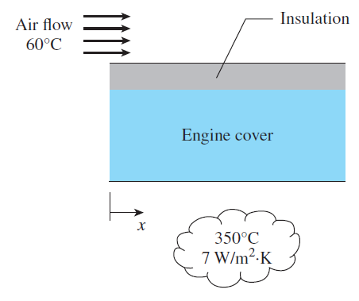

The 2-m-long engine outer surface is cooled by air blowing in parallel over it at 7 m/s, in an environment where the ambient air is at 60°C. To prevent fire hazard in the event of oil leak on the engine cover, the engine cover surface should be kept below 180°C. It has been determined that the 5-mm-thick insulation layer is not sufficient to keep the engine cover surface below 180°C.
To solve this problem, you are asked to design a new insulation layer so that the engine outer surface temperature will be kept below the fire hazard limit of 180°C for the safety operation of the engine. Complete the following tasks for this design project.
(a) Discuss your new design of the insulation layer to satisfy the safety operation requirements.
(b) Compute the outer surface temperature with your design to justify that your design is a viable method for keeping the outer surface temperature below 180°C. Evaluate the air properties at 120°C. Clearly list all the assumptions you use for your calculations. Show all steps in your calculations and type equations directly in Microsoft Word.
(c) In addition to your design proposed in (a), briefly discuss another method that could be explored to keep the engine outer surface temperature below the fire hazard limit of 180°C and explain why. (Note that no additional calculations are needed for this step.)

REPORT REQUIREMENTS
A detailed report should be submitted for the project, and the following contents should be included:
- (2%) A “Cover Page” with the course number and name, section number, semester, and your name. See the next page for a sample cover page.
- (3%) A “Project Description” page that includes the original problem (as provided in the previous page of this document).
- (5%) A “Abstract” page summarizes your design, your calculations/justifications, and other potential designs you would propose.
- (80%) A detailed presentation of all technical components of your design (i.e., Tasks a-c in the “Project Description” section).

SUBMISSION
- (10%) Upload your report in Microsoft Word format (.doc or .docx), which include all the contents described in the “Report Requirements” section, to both Taskstream and the “Project Submission” portal on eCourses (Canvas).

MECHANICAL ENGINEERING DEPARTMENT
PRAIRIE VIEW A&M UNIVERSITY



MCEG 3013-Z02
Heat Transfer
Fall 2020

COVER PAGE

REPORT ON
“Design of an Insulation Layer to Prevent Fire Hazard”

Submitted by
YOUR NAME

On
November 19, 2020

To
Dr. Ziaul Huque

MCEG 3013 Fall 2020 Project Solutions
(a) (10%) The proposed design is to increase the insulation thickness by threefold.
(b) (55%)

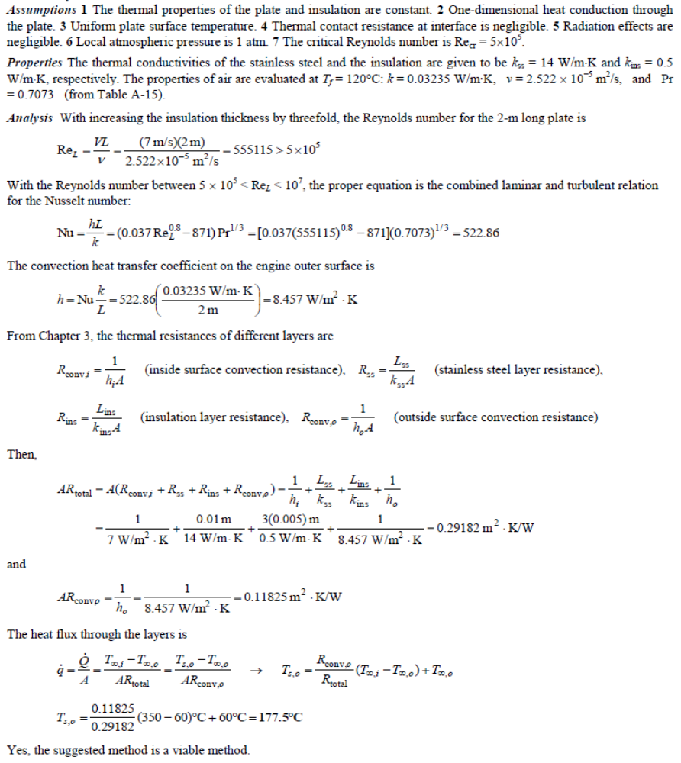
(c) (15%) The other method could be to increase the cooling air velocity. With the increased convection heat transfer between the outer surface and the ambient, the engine cover surface temperature will be reduced.

