Course ASSESSMENT REPORT

ROY G. PERRY COLLEGE OF ENGINEERING
MECHANICAL ENGINEERING DEPARTMENT
PRAIRIE VIEW A&M UNIVERSITY

ASSESSMENT REPORT COVER PAGE

MCEG 3101 MEASUREMENT AND INSTRUMENTATION LABORATORY

FALL 2021 SEMESTER

NAME OF INSTRUCTOR: Dr. Mingli Han

Revised: 12/10/2021

TABLE OF CONTENTS

- Report Cover Page

- Detailed Course Syllabus

- End of Semester Outcomes Assessment Report (New Format)

- Grade Sheet Showing Student and Class Performance in Outcomes

- Supporting Outcomes Specific Assignments (Minimum of 2 per outcome except for Project Reports where one is enough)

5.1 An ability to acquire and apply new knowledge as needed, using appropriate learning strategies (outcome 7)

Detailed Course Syllabus
(Distributed to Students at the beginning of the Semester)
ABET Outcomes measured using course should be
explicitly listed in the syllabus
Course Description in ABET Format
MCEG 3101 Measurement and Instrumentation Laboratory
1. | Course number and name: | MCEG 3101 Measurement and Instrumentation Laboratory
2. | Credits and contact hours: | 1 credit hours, 5 contact hours
3. | Instructor’s or course  coordinator’s name: | Dr. Mingli Han
4. | Text book: Title: | Measurement Laboratory Manual
 | Author: | Paul. Biney
 | Publisher, Year & Edition: | 2nd edition
 | - Other Supplemental material | Experimental Methods for Engineers by J. P. Holman, 7th Edition, McGraw Hill, 2001
5. | Specific course information
 | - Brief description of the content of the course (catalog description) | Credit 1 semester hour. The scope of this course includes fundamentals in measurement theory, statistical analysis of experimental data, uncertainty, accuracy assessments, calibration techniques and robotics. The course includes the use and applications of instruments for measuring area, pressure, time, speed, temperature, strain, hardness, and deflection.
 | - Prerequisites or  Co-requisites | PHYS 2513, PHYS 2511, PHYS 2521
 | - *Indicate whether a required, elective, or selected elective (as per definition provided) course in the program | Required
6. | - Specific goals for the course specific outcomes of instruction (e.g. The student will be able to explain the significance of current research about a particular topic.)  Students will be able to : | - Explicitly indicate which of the student outcomes listed in Criterion 3 or any other outcomes are addressed by the course.  The specific goals for the course specific outcomes listed on the left column will address the following student learning outcomes:
 | 1. Understand fundamentals in measurement theory, statistical analysis of experimental data, uncertainty, accuracy assessments, and calibration techniques | Outcome 6  An ability to develop and conduct appropriate experimentation, analyze and interpret data, and use engineering judgment to draw conclusions (including use of the techniques, skills, and modern engineering tools necessary for engineering practice)
 | 2. Use instruments for measuring area, pressure, time, speed, temperature, strain, hardness, and deflection
 | 3. Analyze experimental data, interpret experimental results and prepare scientific reports.
 | 4. Understand the concept of life-long learning | Outcome 7  An ability to acquire and apply new knowledge as needed, using appropriate learning strategies.
7 | Brief list of topics to be covered | Experiment 1: Statistical Analysis of Experimental Data: Length measurement with Micrometer (2 classes)  Experiment 2: Statistical Analysis of Experimental Data: (1) Length measurement with Vernier Caliper. (2) Area measurement using a Planimeter. (2 classes)  Experiment 3: Statistical Analysis of Experimental Data: Local gravitational acceleration measurement using a simple pendulum (2 classes)  Experiment 4: Pressure Gauge Calibration using Dead Weight Tester (2 classes)  Experiment 5: Measuring Frequency Response of a Dynamic System (2 classes)  Experiment 6: Robotic Dispensing System (2 classes)

Additional Course Syllabus Information

Prairie View A&M University
Department of Mechanical Engineering
MCEG 3101 Measurement and Instrumentation Laboratory
Fall Semester 2021

Course Title |  | Measurement an Instrumentation Laboratory
Course Prefix & No |  | MCEG 3101
Section |  | P01
Credit |  | 1 Credit Hour
Instructor Name |  | Dr. Mingli Han
Office Location |  | S. R. Collins Engineering Building, Room 311
Office Phone |  | 936-261-9952
Fax |  | 936-261-9969
Email Address |  | mihan@pvamu.edu
U.S. Postal Address |  | Prairie View A&M University  P.O. Box 519, Mal Stop 2525  Prairie View, TX 77446
Office Hours |  | TBD
Course Location |  | New Electrical Engineering 117
Class Days & Times |  | Tuesday: 2:00 – 4:50 PM
Catalog Description |  | MCEG 3101. Measurement and Instrumentation Laboratory. Credit 1 semester hour. The scope of this course includes fundamentals in measurement theory, statistical analysis of experimental data, uncertainty, accuracy assessments, calibration techniques and robotics. The course includes the use and applications of instruments for measuring area, pressure, time, speed, temperature, strain, hardness, and deflection.
Pre-requisites |  | PHYS 2513/2325, PHYS 2511/2125, PHYS 2521/2126
Required Textbook |  | Measurement Laboratory Manual by Paul O. Biney
Recommended Text |  | Experimental Methods for Engineers by J. P. Holman, 7th Edition, McGraw Hill, 2001
Access to Learning Resources: |  | PVAMU Library:  Phone: (936) 261-1500;  web: http://www.tamu.edu/pvamu/library/  University Bookstore:  Phone: (936) 261-1990;  web: https://www.bkstr.com/Home/10001-10734-1?demoKey=d
Course Goals or Overview |  | The Goals of this course are to (1) introduce the fundamentals in measurement theory, statistical analysis of experimental data, uncertainty, accuracy assessments, and calibration techniques; (2) introduce students to the use and applications of instruments for measuring area, pressure, time, speed, temperature, strain, hardness, and deflection; and (3) introduce students to the analysis of experimental data, interpretation of experimental results and preparation of scientific reports. This course also introduces students to the concept of life-long learning.
Course Outcomes/Objectives |  | On completion of this course, the students will be able to use various instruments for mechanical measurements, perform statistical analysis on the data to determine the uncertainty in the dependent variables resulting from the uncertainty in the independent variables, conduct experiments, analyze and interpret experimental data. Students will also be able to use other resources to further their understanding of concepts through life-long learning.
Course Requirements &
Evaluation Methods This course will utilize the instruments to determine student grades and
proficiency of the learning outcomes for the course.

Requiring students to read ahead of time the theory and method for analyzing
the experiments to be performed

Laboratory Reports: Requiring students to write a detailed technical report following normal accepted
standards to describe the method used to conduct the experiment, detailed
analysis of the data, and interpretation of the results.

Class Attendance: Daily attendance and participation in class discussion required.
Instrument | Total  (%)
Quizzes | 10
Ability to Conduct Experiment | 10
Ability to Analyze Experimental Data | 20
Ability to Interpret Experimental Data | 20
Awareness and engagement in life-long learning activities | 10
Tests | 30
Total: | 100
Grading Matrix
Grade Determination | A = 90 - 100  B = 80 - 89  C = 70 - 79  D = 60 - 69  F = 0 - 59
Course Policy |  | Note: The instructor reserves the right to alter it during the semester.  Academic Integrity  Academic dishonesty of any sort (plagiarism, cheating, fabrication or facilitation) is prohibited under any circumstance. Any detected actions of dishonesty will cause the failure of the class directly.  Assignments & Due Dates  Lab reports will be submitted online by the due dates. Late submission will be charged a 20% penalty for each day late – weekend days do count. Circumstances beyond your control (i.e. illness, weather, etc) will be considered as required.  Attendance  Class attendance is mandatory. Late class for more than 10 minutes will count as one absence. If you have 3 or more than 3 absence, you will receive an “F” automatically.  Labs  No makeup labs will be given. You will be expected to conduct the lab in the allotted time period on the lab day.  Exams  There will be a mid-term exam and a final exam. No makeup test will be given. Circumstances beyond your control will be considered.
Important Dates |  | https://www.pvamu.edu/registrar/academic-calendars/fall-2021-16-week-session/

How Mechanical Engineering Courses meet Department Objectives & ABET Criterion 3
Specific objectives of the Mechanical Engineering Program are to produce graduates who will:

- have the necessary knowledge and skills to enable them have successful careers in mechanical engineering and related fields;
- have leadership skills to advance their careers through increasing levels of responsibilities and leadership;
- have the necessary educational background to successfully pursue graduate or advanced professional degrees and continuing professional development, and
- actively participate in professional and community services.

ABET Criterion 3: Program Outcomes and Assessment
Engineering Programs must demonstrate that their graduates have:
- the ability to identify, formulate, and solve complex engineering problems by applying principles of engineering, science, and mathematics;
- the ability to apply engineering design to produce solutions that meet specified needs with consideration of public health, safety, and welfare, as well as global, cultural, social, environmental, and economic factor;
- the ability to communicate effectively with a range of audiences;
- the ability to recognize ethical and professional responsibilities in engineering situations and make informed judgments, which must consider the impact of engineering solutions in global, economic, environmental, and societal contexts;
- the ability to function effectively on a team whose members together provide leadership, create a collaborative and inclusive environment, establish goals, plan tasks, and meet objectives;
- ability to develop and conduct appropriate experimentation, analyze and interpret data, and use engineering judgment to draw conclusions;
- the ability to acquire and apply new knowledge as needed, using appropriate learning strategies.

Program Outcomes
Covered by Course Program Outcomes 6 and 7, as defined above

Program Outcomes
Measured by Course Program outcomes 7 as defined above

Data Used in Assessing
Outcomes in Course 1. Quizzes
2. Laboratory Report
3. Class Participation
4. Life-long learning assignment

Data Used to Show
Student Proficiency
in Outcomes 1. Samples of student work in a Binder
2. Excel Spreadsheet showing student performance and class average in outcomes
3. End of Semester Course Assessment report

TENTATIVE CLASS/LAB SCHEDULE

Week Lecture and Lab
1 Syllabus
Laboratory safety rules & lab report format

2 Theory: Statistical Analysis of Experimental Data

3 Experiment 1: Statistical Analysis of Experimental Data: (1) Length measurement with Micrometer.

4 Theory : Statistical Analysis and Chauvenets Criterion for Rejecting Data

5 Experiment 2: Statistical Analysis of Experimental Data: (1) Length measurement with Vernier Caliper. (2) Area measurement using a Planimeter.

6 Theory: Sonar Sensor Calibration

7 Experiment 3: Sonar Sensor Calibration

8 Mid-term Exam

9 Theory: Simple Harmonic Motion

.
10 Experiment 4: Statistical Analysis of Experimental Data: Local gravitational
acceleration measurement using a simple pendulum.

11 Theory: Pressure Measurement and Pressure Gauge Calibration
using dead Weight Tester.

12 Experiment 5: Pressure Gauge Calibration using dead Weight Tester

13 Theory: Robotics

14 Experiment 6: Robotic Dispensing System

15 Final Exam

Student Support and Success

John B. Coleman Library
The John B. Coleman Library’s mission is to enhance the scholarly pursuit of knowledge, to foster intellectual curiosity, and to promote life-long learning and research through our innovative services, resources, and cultural programs, which support the Prairie View A&M University’s global mission of teaching, service, and research. It maintains library collections and access both on campus, online, and through local agreements to further the educational goals of students and faculty. Website: https://www.pvamu.edu/library/; Phone: 936-261-1500

Academic Advising Services
Academic Advising Services offers students a variety of services that contributes to student success and leads towards graduation. We assist students with understanding university policies and procedures that affect academic progress. We support the early alert program to help students get connected to success early in the semester. We help refer students to the appropriate academic support services when they are unsure of the best resource for their needs. Faculty advisors support some students in their respective colleges. Your faculty advisor can be identified in PantherTracks. Advisors with Academic Advising Services are available to all students. We are located across campus. Find your advisor's location by academic major at www.pvamu.edu/advising. Phone: 936-261-5911

The University Tutoring Center
The University Tutoring Center (UTC) offers free tutoring and academic support to all registered PVAMU students. The mission of the UTC is to help provide a solid academic foundation that enables students to become confident, capable, independent learners. Competent and caring staff and peer tutors guide students in identifying, acquiring, and enhancing the knowledge, skills, and attitudes needed to reach their desired goals. Tutoring and academic support are offered face-to-face in the UTC, in virtual face-to-face sessions (https://www.pvamu.edu/student-success/sass/university-tutoring-center/), and through online sessions (https://www.pvamu.edu/pvplace/). Other support services available for students include Supplemental Instruction, Study Break, Academic Success Workshops, and Algebra Study Jam. Location: J. B. Coleman Library, Rm. 307; Phone: 936-261-1561; Email: pvtutoring@pvamu.edu; Website: https://www.pvamu.edu/student-success/sass/university-tutoring-center/

Writing Center
The Writing Center provides well-trained peer tutors to assist students with writing assignments at any stage of the writing process. Tutors help students with various writing tasks from understanding assignments, brainstorming, drafting, revising, editing, researching, and integrating sources. Students have free access to Grammarly online writing assistance. Grammarly is an automated proofreading and plagiarism detection tool. Students must register for Grammarly by using their student email address. In addition, students have access to face-to-face and virtual tutoring services either asynchronously via email or synchronously via Zoom. Location: J. B. Coleman Library, Rm. 209; Phone: 936-261-3724; Website: https://www.pvamu.edu/student-success/writing-center/; Grammarly Registration: https://www.grammarly.com/enterprise/signup

Academic Early Alert
Academic Early Alert is a proactive system of communication and collaboration between faculty, academic advisors, and PVAMU students that is designed to support student success by promptly identifying issues and allowing for intervention. Academic Early Alerts help students by providing a central location to schedule advising appointments, view advisor contact information, and request assistance. Students who recognize that they have a problem that is negatively affecting their academic performance or ability to continue school may self-refer an Academic Early Alert. To do so, students will log in to PV Place and click on Academic Early Alert on the left sidebar. Phone: 936-261-5902; Website: https://www.pvamu.edu/student-success/early-alert/

Student Counseling Services
The Student Counseling Services unit offers a range of services and programs to assist students in maximizing their potential for success: short-term individual, couples, and group counseling, as well as crisis intervention, outreach, consultation, and referral services. The staff is licensed by the State of Texas and assists students who are dealing with academic skills concerns, situational crises, adjustment problems, and emotional difficulties. Information shared with the staff is treated confidentially and in accordance with Texas State Law. Location: Hobart Taylor, 2nd floor; Phone: 936-261-3564; Website: https://www.pvamu.edu/healthservices/student-counseling-services/

Office of Testing Services
Testing Services serves to create opportunities by offering a suite of exams that aid in the students' academic and professional success. Currently, we administer entrance (HESI A2), college readiness (TSI assessment), Prior Learning (CLEP, DSST), and proctored exams. Location: Wilhelmina Delco, 3rd Floor, Rm. 305; Phone: 936-261-3627; Email: aetesting@pvamu.edu; Website: www.pvamu.edu/testing

Office of Diagnostic Testing and Disability Services
The Americans with Disabilities Act (ADA) is a federal anti-discrimination statute that provides comprehensive civil rights protection for persons with disabilities. Among other things, this legislation requires that all students with disabilities be guaranteed a learning environment that provides for reasonable accommodation of their disabilities. If you believe you have a disability requiring an accommodation, contact the Office of Disability Services. As a federally-mandated educational support unit, the Office of Disability Services serves as the repository for confidential disability files for faculty, staff, and students. For persons with a disability, the Office develops individualized ADA letters of request for accommodations. Other services include learning style inventories, awareness workshops, accessibility pathways, webinars, computer laboratory with adapted hard and software, adapted furniture, proctoring non-standardized test administrations, ASL interpreters, ALDs, digital recorders, Livescribe, and a comprehensive referral network across campus and the broader community. Location: Hobart Taylor, Rm. 1D128; Phone: 936-261-3583; Website: https://www.pvamu.edu/disabilityservices/

Center for Instructional Innovation and Technology Services (CIITS)
Distance Learning, also referred to as Distance Education, is the employment of alternative instructional delivery methods to extend programs and services to persons unable to attend college in the traditional manner. The Center for Instructional Innovation and Technology Services (CIITS) supports student learning through online, hybrid, web-assist, and 2-way video course delivery. For more details and contact information, visit:
https://www.pvamu.edu/dlearning/distance-learning-2-2/students-2/; Phone: 936-261-3283

Veteran Affairs
Veterans Services works with student veterans, current military and military dependents to support their transition to the college environment and continued persistence to graduation. The Office coordinates and certifies benefits for both the G.I. Bill and the Texas Hazlewood Act. Location: Evans Hall, Rm. 102; Phone: 936-261-3563; Website: https://www.pvamu.edu/sa/departments/veteranaffairs/

Office for Student Engagement
The Office for Student Engagement delivers comprehensive programs and services designed to meet the co-curricular needs of students. The Office implements inclusive and accessible programs and services that enhance student development through exposure to and participation in diverse and relevant social, cultural, intellectual, recreational, community service, leadership development, and campus governance. Location: Memorial Student Center, Rm. 221; Phone: 936-261-1340; Website: https://www.pvamu.edu/studentengagement/

Career Services
Career Services supports students through professional development, career readiness, and placement and employment assistance. The Office provides one-on-one career coaching, interview preparation, resume and letter writing, and career exploration workshops and seminars. Services are provided for students at the Northwest Houston Center and College of Nursing in the Medical Center twice a month or on a requested basis. Distance Learning students are encouraged to visit the Career Services website for information regarding services provided. Location: Anderson Hall, 2nd floor; Phone: 936-261-3570; Website: https://www.pvamu.edu/careerservices/

University Rules and Procedures

Academic Misconduct
Academic dishonesty is defined as any form of cheating or dishonesty that has the effect or intent of interfering with any academic exercise or fair evaluation of a student's performance. The college faculty can provide additional information, particularly related to a specific course, laboratory, or assignment.

You are expected to practice academic honesty in every aspect of this course and all other courses. Make sure you are familiar with the University Administrative Guidelines on Academic Integrity, which can be found on the Academic Integrity webpage. Students who engage in academic misconduct are subject to university disciplinary procedures. As listed in the University Administrative Guidelines on Academic Integrity, the University Online Catalog, and the Student Code of Conduct, the following are examples of prohibited conduct. This list is not designed to be all-inclusive or exhaustive. In addition to academic sanctions, any student found to have committed academic misconduct that is also a violation of criminal law may also be subject to disciplinary review and action by the Office of Student Conduct (as outlined in the Student Code of Conduct).

Forms of Academic Dishonesty:

- Cheating: Deception in which a student misrepresents that he/she has mastered information on an academic exercise that he/she has not learned, giving or receiving aid unauthorized by the instructor on assignments or examinations. Examples: unauthorized use of notes for a test; using a "cheat sheet" on a quiz or exam; any alteration made on a graded test or exam which is then resubmitted to the teacher;
- Plagiarism: Careless or deliberate use of the work or the ideas of another; representation of another's work, words, ideas, or data as your own without permission or appropriate acknowledgment. Examples: copying another's paper or answers, failure to identify information or essays from the internet and submitting or representing it as your own; submitting an assignment which has been partially or wholly done by another and claiming it as yours; not properly acknowledging a source which has been summarized or paraphrased in your work; failure to acknowledge the use of another's words with quotation marks;
- Collusion: When more than one student or person contributes to a piece of work that is submitted as the work of an individual;
- Conspiracy: Agreeing with one or more persons to commit an act of academic/scholastic dishonesty; and
- Multiple Submission: Submission of work from one course to satisfy a requirement in another course without explicit permission. Example: using a paper prepared and graded for credit in one course to fulfill a requirement and receive credit in a different course.

Nonacademic Misconduct
The university respects the rights of instructors to teach and students to learn. Maintenance of these rights requires campus conditions that do not impede their exercise. Campus behavior that interferes with either (1) the instructor's ability to conduct the class, (2) the inability of other students to profit from the instructional program, or (3) campus behavior that interferes with the rights of others will not be tolerated. An individual engaging in such disruptive behavior may be subject to disciplinary action. The Office of Student Conduct will adjudicate such incidents under nonacademic procedures.

Sexual Misconduct
Sexual harassment of students and employees at Prairie View A&M University is unacceptable and will not be tolerated. Any member of the university community violating the university's sexual harassment policy will be subject to disciplinary action. In accordance with the Texas A&M University System guidelines, your instructor is obligated to report to the Office of Title IX Compliance (titleixteam@pvamu.edu) any instance of sexual misconduct involving a student, which includes sexual assault, stalking, dating violence, domestic violence, and sexual harassment, about which the instructor becomes aware during this course through writing, discussion, or personal disclosure. The faculty and staff of PVAMU actively strive to provide a learning, working, and living environment that promotes respect that is free from sexual misconduct, discrimination, and all forms of violence. If students, faculty, or staff would like assistance or have questions, they may contact the Title IX Coordinator at 936-261-2144 or titleixteam@pvamu.edu. More information can be found at www.pvamu.edu/titleix, including confidential resources available on campus.

Pregnancy, Pregnancy-related, and Parenting Accommodations
Title IX of the Education Amendments of 1972 prohibits sex discrimination, which includes discrimination based on pregnancy, marital status, or parental status. Students seeking accommodations related to pregnancy, pregnancy-related conditions, or parenting (reasonably immediate postpartum period) are encouraged to contact Student Disability Services or the Dean of Students' Office for additional information and to request accommodations.

Non-Discrimination Statement
Prairie View A&M University does not discriminate on the basis of race, color, sex, religion, national origin, age, disability, genetic information, veteran status, sexual orientation, or gender identity in its programs and activities. The University is committed to supporting students and complying with The Texas A&M University System non-discrimination policy. It seeks to establish an environment that is free of bias, discrimination, and harassment. If you experience an incident of discrimination or harassment, we encourage you to report it. If you would like to speak with someone who may be able to afford you privacy or confidentiality, there are individuals who can meet with you. The Director of Equal Opportunity & Diversity has been designated to handle inquiries regarding the non-discrimination policies and can be reached at Harrington Science Building, Suite 109 or by phone at 936-261-1744 or 1792.

Class Attendance Policy (See the University Online Catalog for Full Attendance Policy)
Prairie View A&M University requires regular class attendance. Attending all classes supports the full academic development of each learner, whether classes are taught with the instructor physically present or via distance learning technologies such as interactive video and/or the internet. Excessive absenteeism, whether excused or unexcused, may result in a student's course grade being reduced or in the assignment of a grade of "F." Absences are accumulated beginning with the first day of class during regular semesters and summer terms. Each faculty member will include the University's attendance policy in each course syllabus.
Student Academic Appeals Process
Authority and responsibility for assigning grades to students rest with the faculty. However, in those instances where students believe that miscommunication, errors, or unfairness of any kind may have adversely affected the instructor's assessment of their academic performance, the student has a right to appeal by the procedure listed in the University Online Catalog and by doing so within thirty days of receiving the grade or experiencing any other problematic academic event that prompted the complaint.

Technical Considerations

Minimum Recommended Hardware and Software:
- Intel PC or Laptop with Windows 10 or later version; Mac with OS High Sierra*
- Smartphone or iPad/Tablet with Wi-Fi*
- High-speed Internet access
- 8 GB Memory
- Hard drive with 320 GB storage space
- 15" monitor, 800x600, color or 16 bit
- Sound card w/speakers
- Microphone and recording software
- Keyboard & mouse
- Most current version of Google Chrome, Safari, or Firefox

Note: Be sure to enable Java & pop-ups in the Web browser preferences

* Smartphones, Google Chrome books, and Android tablets may not be supported. iPads are the only tablets supported.

Participants should have a basic proficiency of the following computer skills:
- Sending and receiving email
- A working knowledge of the Internet
- Microsoft Word (or a program convertible to Word)
- Acrobat PDF Reader
- Windows or Mac OS
- Video conferencing software

Netiquette (online etiquette)
Students are expected to participate in all discussions and virtual classroom chats as directed. Students are to be respectful and courteous to others on discussion boards. Foul or abusive language will not be tolerated. Do not use ALL CAPS for communicating to others AS IT CAN BE INTERPRETED AS YELLING. Avoid slang terms such as "wassup?" and texting abbreviations such as "u" instead of "you." Limit and possibly avoid the use of emoticons. Be cautious when using humor or sarcasm as tone is sometimes lost in an email or discussion post, and the message might be taken seriously or sound offensive.

Video Conferencing Etiquette
When using Zoom, WebEx, or other video conferencing tools, confirm the visible area is tidy, clear of background clutter, inappropriate or offensive posters, and other distractions. Ensure you dress appropriately and avoid using high traffic or noisy areas. Stay muted when you are not speaking and avoid eating/drinking during the session. Before the class session begins, test audio, video, and lighting to alleviate technology issues.

Technical Support
Students should go to https://mypassword.pvamu.edu/ if they have password issues. The page will provide instructions for resetting passwords and contact information if login issues persist. For other technical questions regarding eCourses, call the Center for Instructional Innovation and Technology Services at 936-261-3283 or email ciits@pvamu.edu.

Communication Expectations and Standards
Emails or discussion postings will receive a response from the instructor, usually in less than 48 hours. Urgent emails should be marked as such. Check regularly for responses.

Discussion Requirement
Online courses often require minimal to no face-to-face meetings. However, conversations about the readings, lectures, materials, and other aspects of the course can occur in a seminar fashion. The use of the discussion board will accomplish this. The instructor will determine the exact use of discussion boards.

It is strongly suggested that students type their discussion postings in a word processing application such as Word and save it to their PC or a removable drive before posting to the discussion board. This is important for two reasons: 1) If for some reason your discussion responses are lost in your online course, you will have another copy; 2) Grammatical errors can be greatly minimized by the use of the spell-and-grammar check functions in word processing applications. Once the post(s) have been typed and corrected in the word processing application, copy and paste to the discussion board.

COVID-19 Campus Safety Measures [NOTE: Delete this section when the COVID-19 pandemic is over]

To promote public safety and protect students, faculty, and staff during the coronavirus pandemic, PVAMU has adopted policies and practices to limit virus transmission.

- Self-monitoring - Students should follow CDC recommendations for self-monitoring. Students who have a fever or exhibit symptoms of COVID-19 should participate in class remotely and should not participate in face-to-face instruction.

- Face Coverings - Face coverings (cloth face covering, surgical mask, etc.) are recommended in classrooms, teaching laboratories, common spaces such as lobbies and hallways, public study spaces, libraries, academic resource, and support offices, and outdoor spaces where 6 feet of physical distancing is challenging to maintain reliably.

- Physical Distancing - Physical distancing should be maintained between students, instructors, and others in course and course-related activities where possible.

- Personal Illness and Quarantine - Students required to quarantine are to participate in courses and course-related activities remotely and must not attend face-to-face course activities. Students should notify their instructors of the quarantine requirement. Students under quarantine are expected to participate in courses and complete graded work unless they have symptoms that are too severe to participate in course activities. Students experiencing personal injury or illness that is too severe for the student to attend class qualify for an excused absence. To receive an excused absence, students must provide appropriate documentation to the Office for Student Conduct, studentconduct@pvamu.edu.

MECHANICAL ENGINEERING DEPARTMENT
PRAIRIE VIEW A&M UNIVESITY

MCEG 3101 MEASUREMENT LABORATORY

Fall 2021 Section P01

LABORATORY REPORT ON

“Measurement Using Micrometers and Statistical Analysis of Data”

Conducted on
August 24, 2021

Submitted by
__________________
On
August 24, 2021

To

Dr. Mingli Han
Measurement Laboratory Instructor
MECHANICAL ENGINEERING DEPARTMENT
MEASUREMENT LABORATORY GRADING SHEET

FALL 2021 SECTION P01

Title of Experiment: ____________________________________________

Name:_____________________________________

Date Lab was Performed: _______________ Report Due Date:_______________

Ability to Conduct Experiments | MAX | Your Score | Comments
Ability to demonstrate general lab safety (by your conduct and observations). | 3
Ability to follow the procedure and properly rephrasing the procedure to reflect what you did during the experiment. | 7
Ability to demonstrate knowledge of how equipment function, their limitations, and the uncertainty associated with reading the instruments. | 5
Ability to collect and record the raw data using appropriate units of measurement and identify the dependent and independent variables in the experiment. | 5
Total for Ability to Conduct Experiments | 20
Percentage for this Performance Criteria
Ability to Analyze and Interpret experimental Data in a Formal Report

Report format (Ability to properly format and present a technical report) | 13
Provides appropriate abstracts for the experimental report | 5
Ability to analyze the data using appropriate software to generate the required parameters using consistent units | 27
Ability to present the data (raw /derived) in tabular and graphical form to meet the objectives and to aid in interpretation. | 14
Ability to discuss the raw and derived data/graphs and assess the validity of the results in relation to the underlying theory and expected trends. | 14
Ability to draw appropriate and reasonable conclusions in relations to each of the experimental objectives. One conclusion statement for each objective. | 7
Total for Ability to Analyze and Interpret experimental Data | 80
TOTAL FOR THIS LAB

End of Semester
Course Assessment Report

This summary contains the following Information

1. Performance Statistics
- Total number of students in class
- The class average performance (stated as %) in each course outcome assessed in this class and the two previous times course was assessed.
- The acceptable class average for the class in each outcome area as set by your Department. You cannot use any number of your choice
- Percentage of students who scored below the expected average in each outcome.

2. Implementation Summary
- Brief summary of plans implemented during the semester based on last assessment report

3. Perceived Problems
- Instructor’s critical evaluation of perceived problems that affected students’ performance. Realistic problems should be identified throughout the semester and summarized in this section of the report.

4. New Plans for Addressing Problems
- Instructor’s plans for addressing the perceived problems the next time the class is taught. These should be specific enough for another instructor to implement. Most of these should be things that, you, the instructor can implement to help students to improve. Be creative.

5. Overall Trend over last three assessment periods
- Instructors summary of overall performance trend for each outcome measured over the last three periods.

5. Were Expectations Met?
- Answer YES if the class average was above the expected average and the stated percentage of students scored at or above the expected average, else answer NO.

END OF SEMESTER COURSE OUTCOME ASSESSMENT REPORT
MCEG 3101-P01 MEASUREMENT AND INSTRUMENTATION LABORATORY
FALL 2021 SEMESTER

Report Prepared by: Dr. Mingli Han
Report Date: Dec 10, 2021

Semester | Analysis Type | Number of  Students | Outcome 7  An ability to acquire and apply new knowledge as needed, using appropriate learning strategies
Semester | Analysis Type | Number of  Students | Expected Average | Expected Percent of students at or above average | Class Average | % Students Above Expected Average
Fall 2021 | Direct | 16 | 70 | 70 | 82.5 | 75
Fall 2020 | Direct | 17 | 70 | 70 | 79.1 | 76.5
Fall 2019 | Direct | 14 | 70 | 70 | 83.5 | 92.8
Fall 2018 | Direct | 14 | 70 | 70 | 78.8 | 78.6
Implementation Summary |  |  | Students were made aware of the importance of life-long learning in the beginning of the course. Resources outside of the classroom are identified and made available to students.
Perceived Problems |  |  | Students are not aware of the importance of life-long learning assignments.  Students lack the motivation to find answers to problems that are not discussed in the classroom.
Plans for Addressing Problems |  |  | The following is recommended for implementation:  The importance of life-long learning assignments is emphasized on the first day of the class and also the time when the assignments are assigned.  To design the assignment associated with the recent technology trend. Students are more motivated when they find the knowledge of the assignment is interesting.
Overall Trend over Periods |  |  | Students’ performance is not as good as the previous semester.
Were Expectations Met? | Average≥70 |  | YES

Grade Sheet Showing
Student and Class Performance in Outcomes
The computed semester average in each outcome
as stated in the Assessment report are
highlighted in boldface

Grade Sheet Showing Student and Class
Performance in Course Outcomes
MCEG 3101-P01 Measurement and Instrumentation Laboratory
FALL 2021 Semester

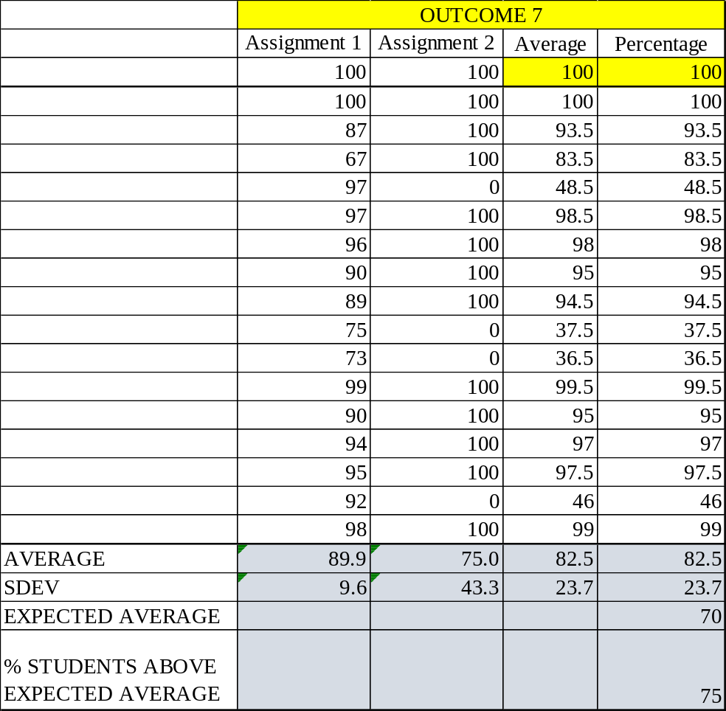
The Class averages for the outcomes shown here should match those listed for the outcomes in the End of Semester assessment Report

OUTCOME SPECIFIC ASSIGNMENTS
USED TO ASSESS OUTCOMES
(Provide at least two assignments used to specifically measure each outcome and justify the suitability of the assignments for the outcome being measured)

ASSIGNMENTS FOR OUTCOME 7

An ability to acquire and apply new knowledge as needed, using appropriate learning strategies.

MECHANICAL ENGINEERING DEPARTMENT OUTCOMES SPECIFIC ASSIGNMENT COVER SHEET
MCEG 3101 MEASUREMENT AND INSTRUMENTATION LABORATORY
FALL 2021

Instructor: Dr. Mingli Han

Title of Assignment

LIFE-LONG LEARNING ASSIGNMENT 1

Outcome Measured Using this Assignment
Outcome 7
An ability to acquire and apply new knowledge as needed, using appropriate learning strategies

Check the outcome appropriate characteristics related to this assignment

Ability to Acquire new knowledge using the appropriate learning strategies
Requires students to:
Be knowledgeable of and use different learning strategies (Instructor may provide information on different learning strategies
different learning strategies)
Identify and take advantage of learning opportunities available in the library, online resources, seminars, webinars, conferences, workshops and tutorials.
Be aware of the need for and are able to independently acquire additional knowledge and data needed for solving problem using appropriate learning strategies and tools.
Ability to apply new knowledge to solve problems
Requires students to:
Demonstrate appropriate use of the new knowledge to solve problems.

Brief justification of the suitability of assignment for the outcome
Life-long Learning Assignment
Life-long learning assignment 1 tests the students the ability to engage in life-long learning.

What is life-long learning and why?
A simple definition of lifelong learning is that it is “development after formal education: the continuing development of knowledge and skills that people experience after formal education and throughout their lives” (Encarta, 2008).

The basic premise of lifelong learning is that it is not feasible to equip learners at school, college, or university with all the knowledge and skills they need to prosper throughout their lifetimes. Therefore, people will need continually to enhance their knowledge and skills, in order to address immediate problems and to participate in a process of continuous vocational and professional development. The new educational imperative is to empower people to manage their own learning in a variety of contexts throughout their lifetimes (Sharples, 2000, p. 178; see also Bentley, 1998).

A life-long learning assignment

- Go to the url: https://academy.universal-robots.com/, click ‘Create Account’
- After login, go through Free E-learning -> e-Series e-Learning -> e-Series Core Track -> the first 4 webinar modules
- Take a screenshot with ‘completed’ status of the first 4 modules
- Complete the questions in the next page
- Put the screenshot, questions and answers into a word document
- Upload the document on Canvas by Tuesday, November 9, 2021

MCEG3101 Measurement and Instrumentation Laboratory
Life-long Learning 1

Student Name: Grade:

- How many axis does a Universal Robot have? Please list every joints. (12 points)

- How can you set up a robot for a task? (18 points)

- What is payload? (10 points)

- What is a Tool Center Point and how can you find the Tool Center Point? (15 points)

- What is a Center of Gravity and why you need to define it in the robotic software? (15 points)

- Can the software calculate the TCP for you? How? (10 points)

- When to calculate the orientation of a Tool? And how to calculate it? (20 points)

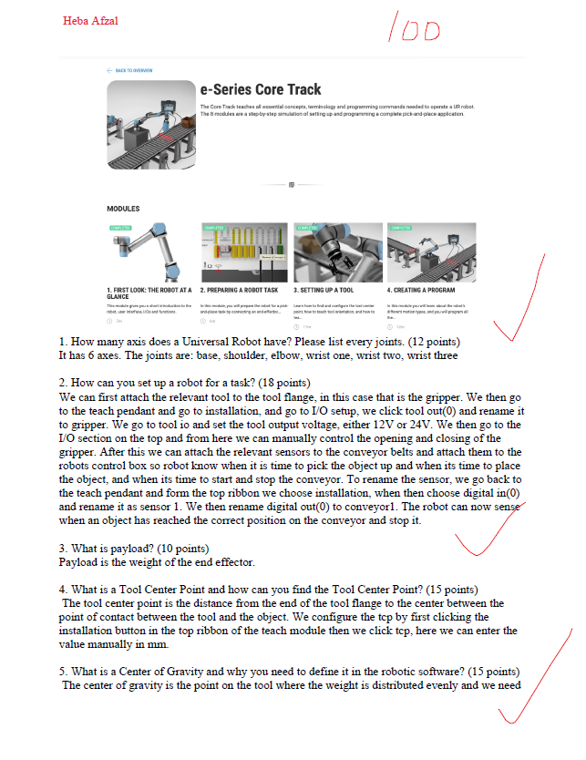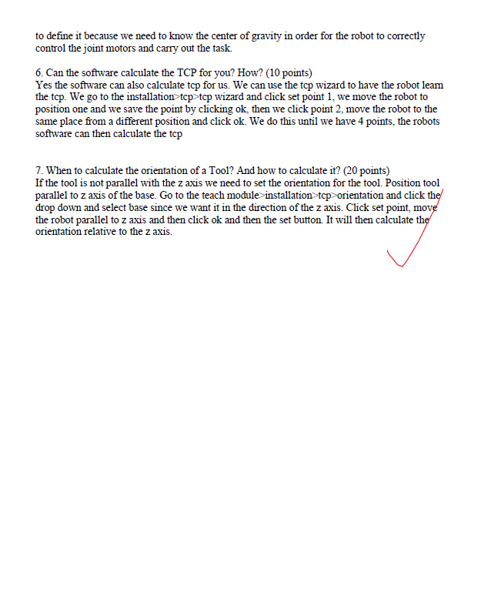
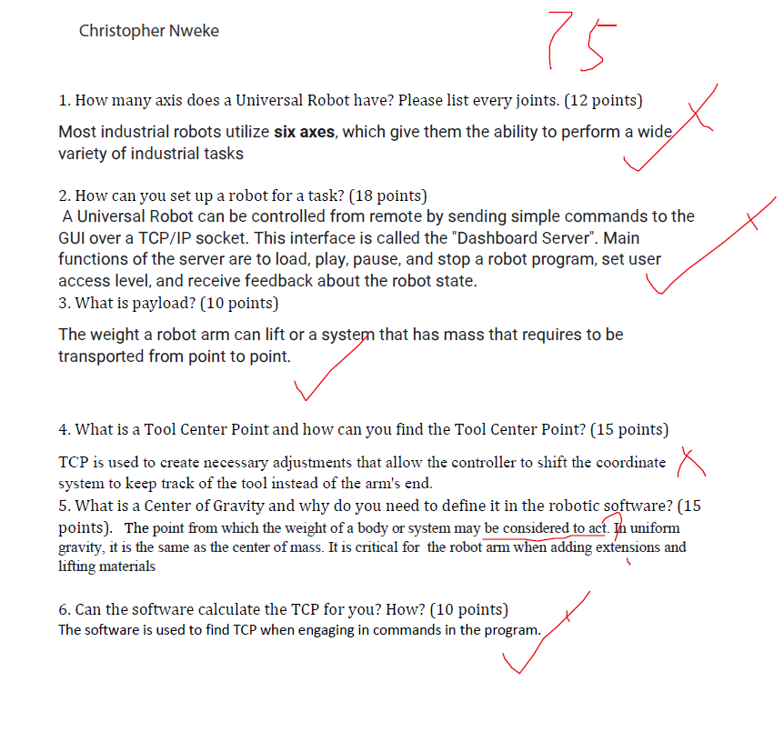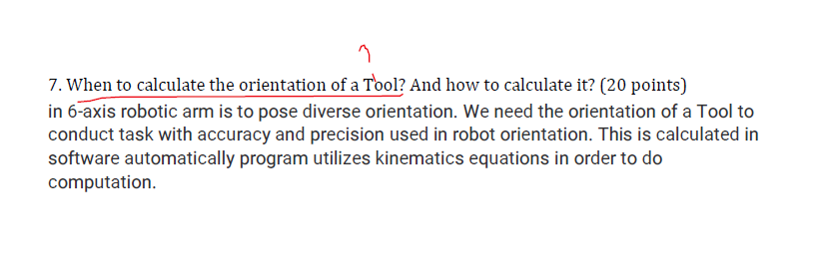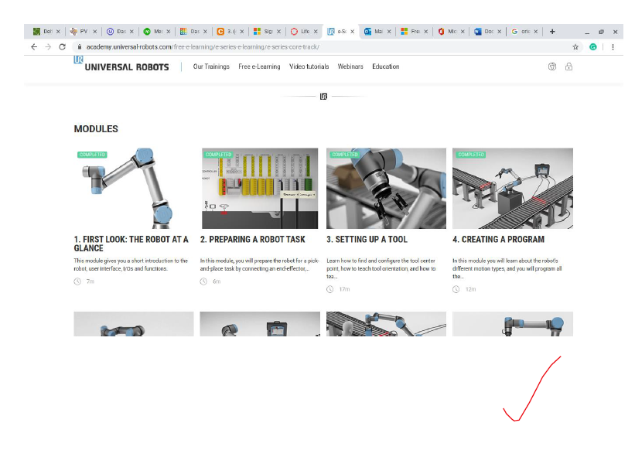

MECHANICAL ENGINEERING DEPARTMENT OUTCOMES SPECIFIC ASSIGNMENT COVER SHEET
MCEG 3101 MEASUREMENT AND INSTRUMENTATION LABORATORY
FALL 2021

Instructor: Dr. Mingli Han

Title of Assignment

LIFE-LONG LEARNING ASSIGNMENT 2

Outcome Measured Using this Assignment
Outcome 7
An ability to acquire and apply new knowledge as needed, using appropriate learning strategies

Check the outcome appropriate characteristics related to this assignment

Ability to Acquire new knowledge using the appropriate learning strategies
Requires students to:
Be knowledgeable of and use different learning strategies (Instructor may provide information on different learning strategies
different learning strategies)
Identify and take advantage of learning opportunities available in the library, online resources, seminars, webinars, conferences, workshops and tutorials.
Be aware of the need for and are able to independently acquire additional knowledge and data needed for solving problem using appropriate learning strategies and tools.
Ability to apply new knowledge to solve problems
Requires students to:
Demonstrate appropriate use of the new knowledge to solve problems.

Brief justification of the suitability of assignment for the outcome
Life-long learning assignment 2 tests the students the ability to engage in life-long learning.

Life-long Learning Assignment 2

- Go to https://matlabacademy.mathworks.com/. Click on the “MATLAB for Data Processing and Visualization” course.
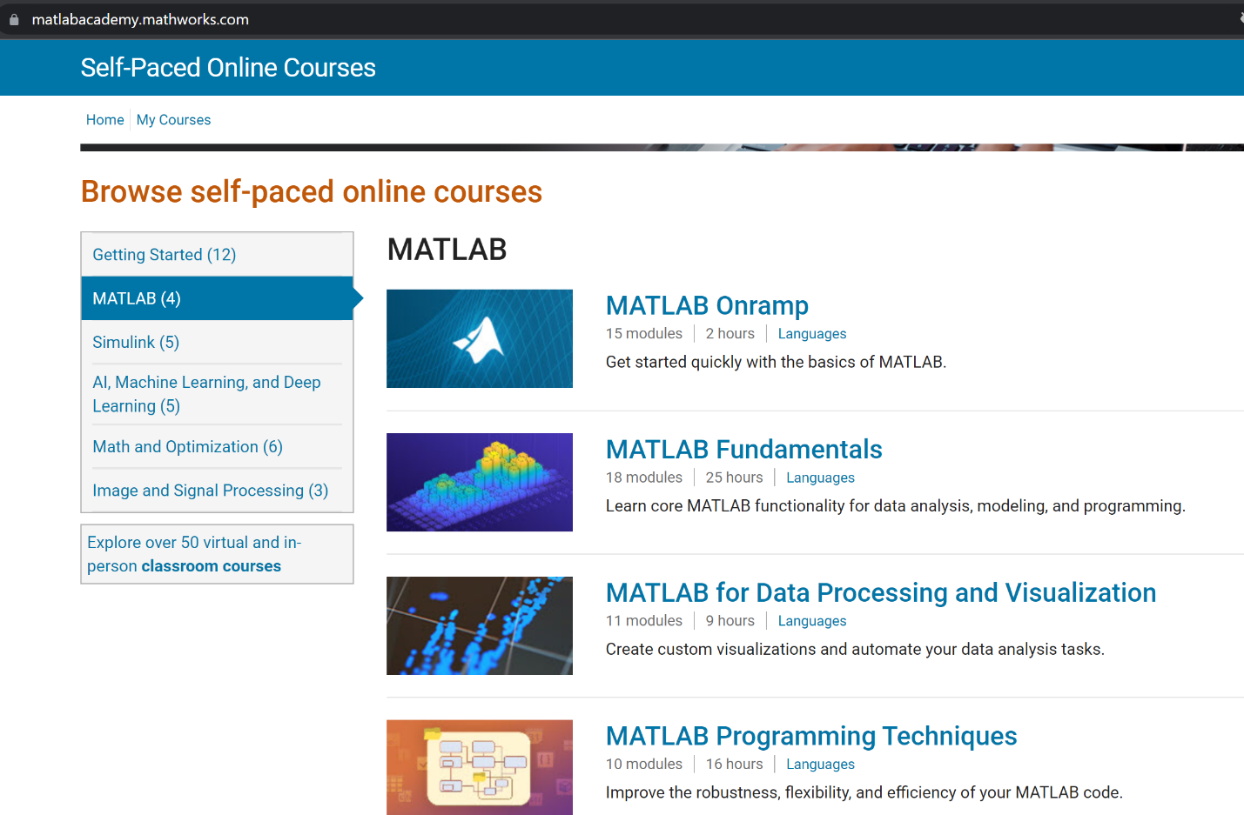

- Click on “Sign in to take course”. If you do not have an MathWorks account, create one using your pvamu email address. Note that the email sent by MathWorks likely will be held. In your email, look for “PV Mimecast Email Digest”, and permit the email sent from MathWorks.
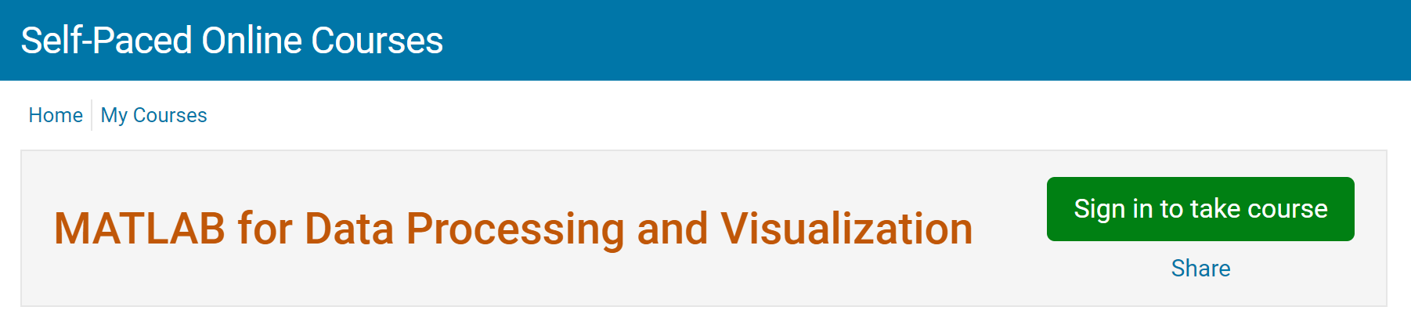
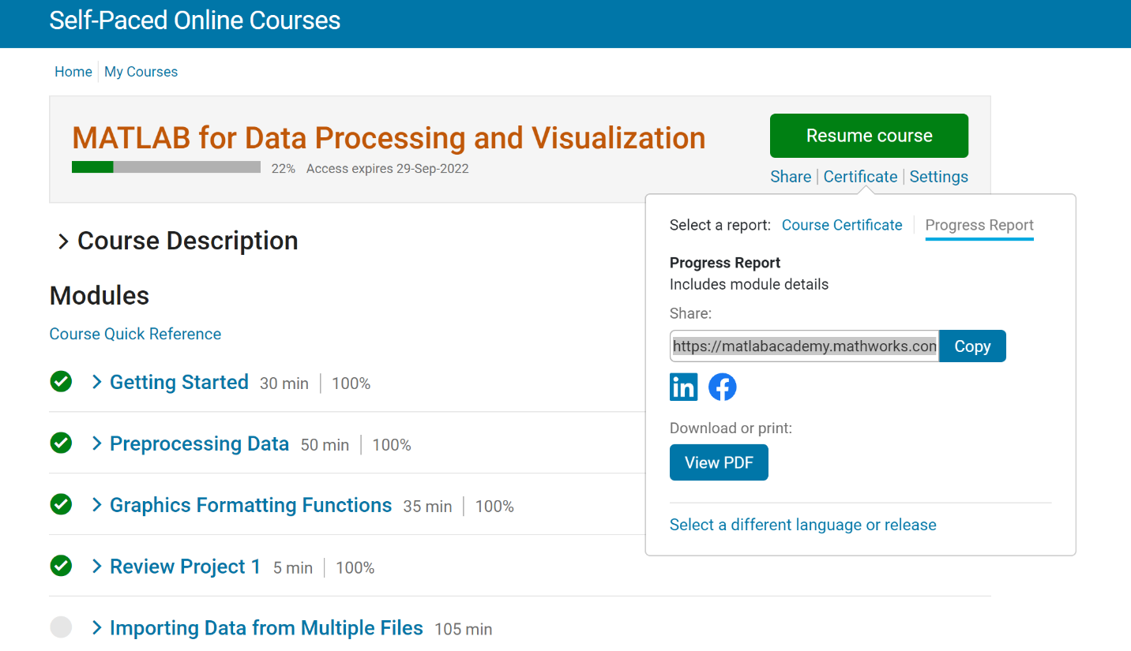
- Complete the first four modules of this course (from “Getting Started” to “Review Project 1”). Then, at the course page, click on “Certificate”, then “Progress Report”. Copy the url using the “Copy” button, then paste it on ecourses to submit.

The correct url should look like the following: 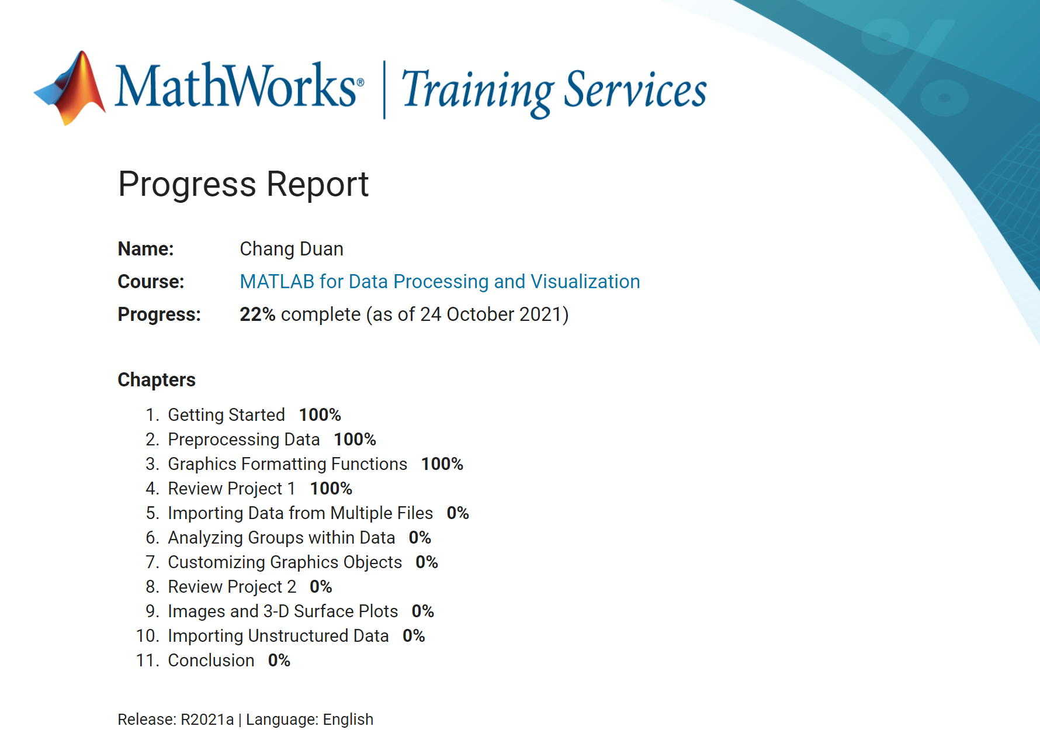
- 2 bonus points can be earned if you complete the whole course:
Your final average grade = final average grade based all your assignments (reports, exams, quizzes) + 2
