Course ASSESSMENT REPORT

ROY G. PERRY COLLEGE OF ENGINEERING
MECHANICAL ENGINEERING DEPARTMENT
PRAIRIE VIEW A&M UNIVERSITY

ASSESSMENT REPORT COVER PAGE

MCEG 3011 MEASUREMENT AND INSTRUMENTATION LABORATORY

FALL 2019 SEMESTER

NAME OF INSTRUCTOR: Dr. Mingli Han

Revised: 12/17/2019

TABLE OF CONTENTS

- Report Cover Page

- Detailed Course Syllabus

- End of Semester Outcomes Assessment Report (New Format)

- Grade Sheet Showing Student and Class Performance in Outcomes

- Supporting Outcomes Specific Assignments (Minimum of 2 per outcome except for Project Reports where one is enough)

5.1 An ability to acquire and apply new knowledge as needed, using appropriate learning strategies (outcome 7)

Detailed Course Syllabus
(Distributed to Students at the beginning of the Semester)
ABET Outcomes measured using course should be
explicitly listed in the syllabus
Course Description in ABET Format
MCEG 3011 Measurement and Instrumentation Laboratory
1. | Course number and name: | MCEG 3011 Measurement and Instrumentation Laboratory
2. | Credits and contact hours: | 1 credit hours
3. | Instructor’s or course  coordinator’s name: | Dr. Mingli Han
4. | Text book: Title: | Measurement Laboratory Manual
 | Author: | Paul. Biney
 | Publisher, Year & Edition: | 2nd edition
 | - Other Supplemental material | Experimental Methods for Engineers by J. P. Holman, 7th Edition, McGraw Hill, 2001
5. | Specific course information
 | - Brief description of the content of the course (catalog description) | Credit 1 semester hour. The scope of this course includes fundamentals in measurement theory, statistical analysis of experimental data, uncertainty, accuracy assessments, calibration techniques and robotics. The course includes the use and applications of instruments for measuring area, pressure, time, speed, temperature, strain, hardness, and deflection.
 | - Prerequisites or  Co-requisites | PHYS 2513, PHYS 2511, PHYS 2521
 | - *Indicate whether a required, elective, or selected elective (as per definition provided) course in the program | Required
6. | - Specific goals for the course specific outcomes of instruction (e.g. The student will be able to explain the significance of current research about a particular topic.)  Students will be able to : | - Explicitly indicate which of the student outcomes listed in Criterion 3 or any other outcomes are addressed by the course.  The specific goals for the course specific outcomes listed on the left column will address the following student learning outcomes:
 | 1. Understand fundamentals in measurement theory, statistical analysis of experimental data, uncertainty, accuracy assessments, and calibration techniques | Outcome 6  An ability to develop and conduct appropriate experimentation, analyze and interpret data, and use engineering judgment to draw conclusions (including use of the techniques, skills, and modern engineering tools necessary for engineering practice)
 | 2. Use instruments for measuring area, pressure, time, speed, temperature, strain, hardness, and deflection
 | 3. Analyze experimental data, interpret experimental results and prepare scientific reports.
 | 4. Understand the concept of life-long learning | Outcome 7  An ability to acquire and apply new knowledge as needed, using appropriate learning strategies.
7 | Brief list of topics to be covered | Experiment 1: Statistical Analysis of Experimental Data: Length measurement with Micrometer (2 classes)  Experiment 2: Statistical Analysis of Experimental Data: (1) Length measurement with Vernier Caliper. (2) Area measurement using a Planimeter. (2 classes)  Experiment 3: Statistical Analysis of Experimental Data: Local gravitational acceleration measurement using a simple pendulum (2 classes)  Experiment 4: Pressure Gauge Calibration using Dead Weight Tester (2 classes)  Experiment 5: Measuring Frequency Response of a Dynamic System (2 classes)  Experiment 6: Robotic Dispensing System (2 classes)

Additional Course Syllabus Information

Office Location |  | S. R. Collins Engineering Building, Room 311
Office Phone |  | 936-261-9952
Office Hours |  | As posted
Course Location |  | Gilchrist Engineering Building 104
Class Days & Times |  | Tuesday: 2:00 – 4:50 PM, Thursday: 2:00 – 4:50 PM
Grading Matrix
Instrument | Total  (%)
Pre-lab & Homework Assignments | 10
Ability to Conduct Experiment | 10
Ability to Analyze Experimental Data | 20
Ability to Interpret Experimental Data | 20
Awareness and engagement in life-long learning activities | 10
Tests | 30
Total: | 100

Grade Determination | A = 90 - 100  B = 80 - 89  C = 70 - 79  D = 60 - 69  F = 0 - 59
Course Policy |  | Academic Integrity  Academic dishonesty of any sort (plagiarism, cheating, fabrication or facilitation) is prohibited under any circumstance. Any detected actions of dishonesty will cause the failure of the class directly.  Assignments & Due Dates  Homework will be submitted at the beginning of class on the due day. Late submission will be charged a 20% penalty for each day late – weekend days do count. Circumstances beyond your control (i.e. illness, weather, etc) will be considered as required.  Attendance  Class attendance is mandatory. Late class for more than 10 minutes will count as one absence. If you have 3 or more than 3 absence, you will receive an “F” automatically.  Labs  No makeup labs will be given. You cannot submit a lab report if you did not participate in conducting in the lab experiment. You will be expected to conduct the lab in the allotted time period on the lab day.  Exams  There will be a mid-term exam and a final exam. No makeup test will be given. In case the exams are not given, your average in all of the labs will be used for your exam score.
Important Dates |  | Last day to withdraw from course(s) without record, 9/11/2019  Withdrawal from courses with record “W” ends, 11/01/2019  Course review day, 12/2-3/2019  Final exam period, 12/4-10/2019

How Mechanical Engineering Courses meet Department Objectives & ABET Criterion 3
Specific objectives of the Mechanical Engineering Program are to produce graduates who will:

- have the necessary knowledge and skills to enable them have successful careers in mechanical engineering and related fields;
- have leadership skills to advance their careers through increasing levels of responsibilities and leadership;
- have the necessary educational background to successfully pursue graduate or advanced professional degrees and continuing professional development, and
- actively participate in professional and community services.

ABET Criterion 3: Program Outcomes and Assessment
Engineering Programs must demonstrate that their graduates have:
- the ability to identify, formulate, and solve complex engineering problems by applying principles of engineering, science, and mathematics;
- the ability to apply engineering design to produce solutions that meet specified needs with consideration of public health, safety, and welfare, as well as global, cultural, social, environmental, and economic factor;
- the ability to communicate effectively with a range of audiences;
- the ability to recognize ethical and professional responsibilities in engineering situations and make informed judgments, which must consider the impact of engineering solutions in global, economic, environmental, and societal contexts;
- the ability to function effectively on a team whose members together provide leadership, create a collaborative and inclusive environment, establish goals, plan tasks, and meet objectives;
- ability to develop and conduct appropriate experimentation, analyze and interpret data, and use engineering judgment to draw conclusions;
- the ability to acquire and apply new knowledge as needed, using appropriate learning strategies.

Program Outcomes
Covered by Course Program Outcomes 6 and 7, as defined above

Program Outcomes
Measured by Course Program outcomes 7 as defined above

Data Used in Assessing
Outcomes in Course 1. Pre-Lab and other Assignments
2. Laboratory Report
3. Class Participation
4. Life-long learning assignment

Data Used to Show
Student Proficiency
in Outcomes 1. Samples of student work in a Binder
2. Excel Spreadsheet showing student performance and class average in outcomes
3. End of Semester Course Assessment report

MEASUREMENT LAB
TENTATIVE CLASS/LAB SCHEDULE
Week Lecture and Lab
1 Syllabus
Laboratory safety rules & lab report format

2 Theory: Statistical Analysis of Experimental Data: (1) Significant Digits,
Rounding & Truncation. (2) Classification of experimental errors
Pre-lab 1 Assigned

3 Experiment 1: Statistical Analysis of Experimental Data: (1) Length measurement with Micrometer. Pre-lab 1 Due

4 Theory : Generalized Measuring System
Dimensional Standards
Experimental Uncertainty Computation.
Temperature & Pressure Measurements. Pre-Lab 2 Assigned

5 Experiment 2: Statistical Analysis of Experimental Data: (1) Length measurement with Vernier Caliper. (2) Area measurement using a Planimeter. Pre-Lab 2 Due

6 Theory: Simple Harmonic Motion
Pre-Lab 3 Assigned
.
7 Experiment 3: Statistical Analysis of Experimental Data: Local
gravitational acceleration measurement using a simple
pendulum. Pre-Lab 3 Due

8 Mid-term Exam

9 Theory: Pressure Measurement and Pressure Gauge Calibration
using dead Weight Tester.
Pre-Lab 4 Assigned

10 Experiment 4 : Pressure Gauge Calibration using dead Weight Tester.
Pre-Lab 4 Due

11 Theory on Measuring Frequency Response of a Dynamic System
Pre-Lab 5 assigned

12 Experiment 5: Measuring Frequency Response of a Dynamic System
Pre-lab 5 Due

13 Theory: Robotics
Pre-Lab 6 Assigned

14 Experiment 6: Robotic Dispensing System
Pre-Lab 6 Due.

15 Final Exam

University Rules and Procedures

Disability statement (See Student Handbook):
Students with disabilities, including learning disabilities, who wish to request accommodations in class should register with the Services for Students with Disabilities (SSD) early in the semester so that appropriate arrangements may be made. In accordance with federal laws, a student requesting special accommodations must provide documentation of their disability to the SSD coordinator.

Academic misconduct (See Student Handbook):
You are expected to practice academic honesty in every aspect of this course and all other courses. Make sure you are familiar with your Student Handbook, especially the section on academic misconduct. Students who engage in academic misconduct are subject to university disciplinary procedures.

Forms of academic dishonesty:
- Cheating: deception in which a student misrepresents that he/she has mastered information on an academic exercise that he/she has not mastered; giving or receiving aid unauthorized by the instructor on assignments or examinations.

- Academic misconduct: tampering with grades or taking part in obtaining or distributing any part of a scheduled test.

- Fabrication: use of invented information or falsified research.

- Plagiarism: unacknowledged quotation and/or paraphrase of someone else’s words, ideas, or data as one’s own in work submitted for credit. Failure to identify information or essays from the Internet and submitting them as one’s own work also constitutes plagiarism.

Nonacademic misconduct (See Student Handbook)
The university respects the rights of instructors to teach and students to learn. Maintenance of these rights requires campus conditions that do not impede their exercise. Campus behavior that interferes with either (1) the instructor’s ability to conduct the class, (2) the inability of other students to profit from the instructional program, or (3) campus behavior that interferes with the rights of others will not be tolerated. An individual engaging in such disruptive behavior may be subject to disciplinary action. Such incidents will be adjudicated by the Dean of Students under nonacademic procedures.

Sexual misconduct (See Student Handbook):
Sexual harassment of students and employers at Prairie View A&M University is unacceptable and will not be tolerated. Any member of the university community violating this policy will be subject to disciplinary action.

Attendance Policy:
Prairie View A&M University requires regular class attendance. Excessive absences will result in lowered grades. Excessive absenteeism, whether excused or unexcused, may result in a student’s course grade being reduced or in assignment of a grade of “F”. Absences are accumulated beginning with the first day of class.

Student Academic Appeals Process
Authority and responsibility for assigning grades to students rests with the faculty. However, in those instances where students believe that miscommunication, errors, or unfairness of any kind may have adversely affected the instructor's assessment of their academic performance, the student has a right to appeal by the procedure listed in the Undergraduate Catalog and by doing so within thirty days of receiving the grade or experiencing any other problematic academic event that prompted the complaint.
Technical Considerations for Online and Web-Assist Courses

Minimum Hardware and Software Requirements:
-Pentium with Windows XP or PowerMac with OS 9
-56K modem or network access
-Internet provider with SLIP or PPP
-8X or greater CD-ROM
-64MB RAM
-Hard drive with 40MB available space
-15” monitor, 800x600, color or 16 bit
-Sound card w/speakers
-Microphone and recording software
-Keyboard & mouse
-Netscape Communicator ver. 4.61 or Microsoft Internet Explorer ver. 5.0 /plug-ins
-Participants should have a basic proficiency of the following computer skills:
·Sending and receiving email
·A working knowledge of the Internet
·Proficiency in Microsoft Word
·Proficiency in the Acrobat PDF Reader
·Basic knowledge of Windows or Mac O.S.

Netiquette (online etiquette): students are expected to participate in all discussions and virtual classroom chats when directed to do so. Students are to be respectful and courteous to others in the discussions. Foul or abusive language will not be tolerated. When referring to information from books, websites or articles, please use APA standards to reference sources.

Technical Support: Students should call the Prairie View A&M University Helpdesk at 936-261-2525 for technical issues with accessing your online course. The helpdesk is available 24 hours a day/7 days a week. For other technical questions regarding your online course, call the Office of Distance Learning at 936-261-3290 or 936-261-3282

Communication Expectations and Standards:
All emails or discussion postings will receive a response from the instructor within 48 hours.

You can send email anytime that is convenient to you, but I check my email messages continuously during the day throughout the work-week (Monday through Friday). I will respond to email messages during the work-week by the close of business (5:00 pm) on the day following my receipt of them. Emails that I receive on Friday will be responded to by the close of business on the following Monday.

Submission of Assignments:
Assignments, Papers, Exercises, and Projects will distributed and submitted through your online course. Directions for accessing your online course will be provided. Additional assistance can be obtained from the Office of Distance Learning.

Discussion Requirement:
Because this is an online course, there will be no required face to face meetings on campus. However, we will participate in conversations about the readings, lectures, materials, and other aspects of the course in a true seminar fashion. We will accomplish this by use of the discussion board.

Students are required to log-on to the course website often to participate in discussion. It is strongly advised that you check the discussion area daily to keep abreast of discussions. When a topic is posted, everyone is required to participate. The exact use of discussion will be determined by the instructor.

It is strongly suggested that students type their discussion postings in a word processing application and save it to their PC or a removable drive before posting to the discussion board. This is important for two reasons: 1) If for some reason your discussion responses are lost in your online course, you will have another copy; 2) Grammatical errors can be greatly minimized by the use of the spell-and-grammar check functions in word processing applications. Once the post(s) have been typed and corrected in the word processing application, it should be copied and pasted to the discussion board.

MECHANICAL ENGINEERING DEPARTMENT
PRAIRIE VIEW A&M UNIVESITY

MCEG 3011 MEASUREMENT LABORATORY

Fall 2019 Section P01

LABORATORY REPORT ON

“Measurement Using Micrometers and Statistical Analysis of Data”

Conducted on
September 1, 2018

Submitted by
__________________
On
September 15, 2019

To

Dr. Mingli Han
Measurement Laboratory Instructor
MECHANICAL ENGINEERING DEPARTMENT
MEASUREMENT LABORATORY
LABORATORY GRADING SHEET

FALL 2019 SECTION P01

Title of Experiment: ____________________________________________

Name:_____________________________________

Date Lab was Performed: _______________ Report Due Date:_______________

Ability to Conduct Experiments | MAX | Your Score | Comments
Ability to demonstrate general lab safety (by your conduct and observations). | 3
Ability to follow the procedure and properly rephrasing the procedure to reflect what you did during the experiment. | 7
Ability to demonstrate knowledge of how equipment function, their limitations, and the uncertainty associated with reading the instruments. | 5
Ability to collect and record the raw data using appropriate units of measurement and identify the dependent and independent variables in the experiment. | 5
Total for Ability to Conduct Experiments | 20
Percentage for this Performance Criteria
Ability to Analyze and Interpret experimental Data in a Formal Report

Report format (Ability to properly format and present a technical report)  Front End of Report (4 points).  General report format (4 points) | 4  4
Provides appropriate abstracts for the experimental report | 5
Theory and equations for experimental and theoretical analysis of experimental data especially when requested for | 5
Ability to analyze the data using appropriate software to generate the required parameters using consistent units and significant figures. | 22
Use of statistical analysis as needed including uncertainty analysis | 5
Ability to present the data (raw /derived) in tabular and graphical form to meet the objectives and to aid in interpretation. | 14
Ability to discuss the raw and derived data/graphs and assess the validity of the results in relation to the underlying theory and expected trends. | 14
Ability to draw appropriate and reasonable conclusions in relations to each of the experimental objectives. One conclusion statement for each objective. | 7
Total for Ability to Analyze and Interpret experimental Data | 80
Percentage for this Performance Criteria
TOTAL FOR THIS LAB

MECHANICAL ENGINEERING DEPARTMENT
PRAIRIE VIEW A&M UNIVESITY
MCEG3011 MEASUREMENT AND INSTRUMENTATION LABORATORY
Fall 2019 Section P01
PRE-LAB REPORT ON

“Measurement Using Micrometers and Statistical Analysis of Data”
Assigned on
September 25, 2019
Submitted by

Name:________________________
On October 1, 2019

Ability to Analyze and Interpret experimental Data | Maximum Points | Your Score | Comments
Chapter 1 : Sections 1.1, 1.2, 1.3, 1.4 (only the title), 1.5 and 1.6 | 15
Chapter 2:  Section 2.1: Detailed Sample Analysis Results from EES or Excel with units | 10
Section 2.2: Fully Commented EES program or Excel worksheets | 7.5
Section 2.3: Table Analysis Results with units | 7.5
Chapter 3: Only the Graphs (well labeled) | 15
TOTAL FOR THIS PRE-LAB | 55

End of Semester
Course Assessment Report

This summary contains the following Information

1. Performance Statistics
- Total number of students in class
- The class average performance (stated as %) in each course outcome assessed in this class and the two previous times course was assessed.
- The acceptable class average for the class in each outcome area as set by your Department. You cannot use any number of your choice
- Percentage of students who scored below the expected average in each outcome.

2. Implementation Summary
- Brief summary of plans implemented during the semester based on last assessment report

3. Perceived Problems
- Instructor’s critical evaluation of perceived problems that affected students’ performance. Realistic problems should be identified throughout the semester and summarized in this section of the report.

4. New Plans for Addressing Problems
- Instructor’s plans for addressing the perceived problems the next time the class is taught. These should be specific enough for another instructor to implement. Most of these should be things that, you, the instructor can implement to help students to improve. Be creative.

5. Overall Trend over last three assessment periods
- Instructors summary of overall performance trend for each outcome measured over the last three periods.

5. Were Expectations Met?
- Answer YES if the class average was above the expected average and the stated percentage of students scored at or above the expected average, else answer NO.

END OF SEMESTER COURSE OUTCOME ASSESSMENT REPORT
MCEG 3011-P01 MEASUREMENT AND INSTRUMENTATION LABORATORY
FALL 2019 SEMESTER

Report Prepared by: Dr. Mingli Han
Report Date: Dec 17, 2019

Semester | Analysis Type | Number of  Students | Outcome 7  An ability to acquire and apply new knowledge as needed, using appropriate learning strategies
Semester | Analysis Type | Number of  Students | Expected Average | Expected Percent of students at or above average | Class Average | % Students Above Expected Average
Fall 2019 | Direct | 14 | 70 | 70 | 83.5 | 92.8
Fall 2018 | Direct | 14 | 70 | 70 | 78.8 | 78.6
Fall 2017 | Direct | 17 | 70 | 70 | 91.4 | 100
Fall 2016 | Direct | 19 | 75 | 70 | 74.3 | 68.4
Implementation Summary |  |  | Students were made aware of the importance of life-long learning in the beginning of the course. Resources outside of classroom are identified and made available to students.
Perceived Problems |  |  | Students are lacking of motivation to find answers to problems that is not discussed in the classroom.
Plans for Addressing Problems |  |  | The following is recommended for implementation.  To design the assignment associated with the recent technology trend. Students are more motivated when they find the knowledge of the assignment is interesting.
Overall Trend over Periods |  |  | Students’ performance is better than the previous semester.
Were Expectations Met? | Average≥70 |  | YES

END OF SEMESTER COURSE OUTCOME ASSESSMENT REPORT
MCEG 3011-P02 MEASUREMENT AND INSTRUMENTATION LABORATORY
FALL 2019 SEMESTER

Report Prepared by: Dr. Mingli Han
Report Date: Dec 17, 2019

Semester | Analysis Type | Number of  Students | Outcome 7  An ability to acquire and apply new knowledge as needed, using appropriate learning strategies
Semester | Analysis Type | Number of  Students | Expected Average | Expected Percent of students at or above average | Class Average | % Students Above Expected Average
Fall 2019 | Direct | 11 | 70 | 70 | 92.2 | 100
Fall 2018 | Direct | 11 | 70 | 70 | 78.9 | 81.8
Fall 2017 | Direct | 17 | 70 | 70 | 90.6 | 100
Fall 2016 | Direct | 19 | 75 | 70 | 74.3 | 68.4
Implementation Summary |  |  | Students were made aware of the importance of life-long learning in the beginning of the course. Resources outside of classroom are identified and made available to students.
Perceived Problems |  |  | Students are lacking of motivation to find answers to problems that is not discussed in the classroom.
Plans for Addressing Problems |  |  | The following is recommended for implementation.  To design the assignment associated with the recent technology trend. Students are more motivated when they find the knowledge of the assignment is interesting.
Overall Trend over Periods |  |  | Students’ performance is better than the previous semester.
Were Expectations Met? | Average≥70 |  | YES

Grade Sheet Showing
Student and Class Performance in Outcomes
The computed semester average in each outcome
as stated in the Assessment report are
highlighted in boldface

Grade Sheet Showing Student and Class
Performance in Course Outcomes
MCEG 3011-P01 Measurement and Instrumentation Laboratory
FALL 2019 Semester

The Class averages for the outcomes shown here should match those listed for the outcomes in the End of Semester assessment Report

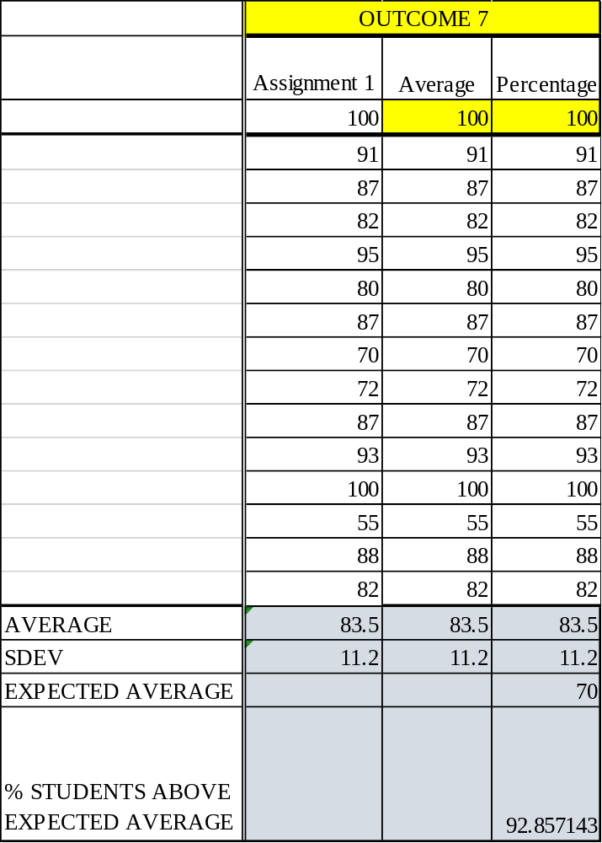

Grade Sheet Showing Student and Class
Performance in Course Outcomes
MCEG 3011-P02 Measurement and Instrumentation Laboratory
FALL 2019 Semester

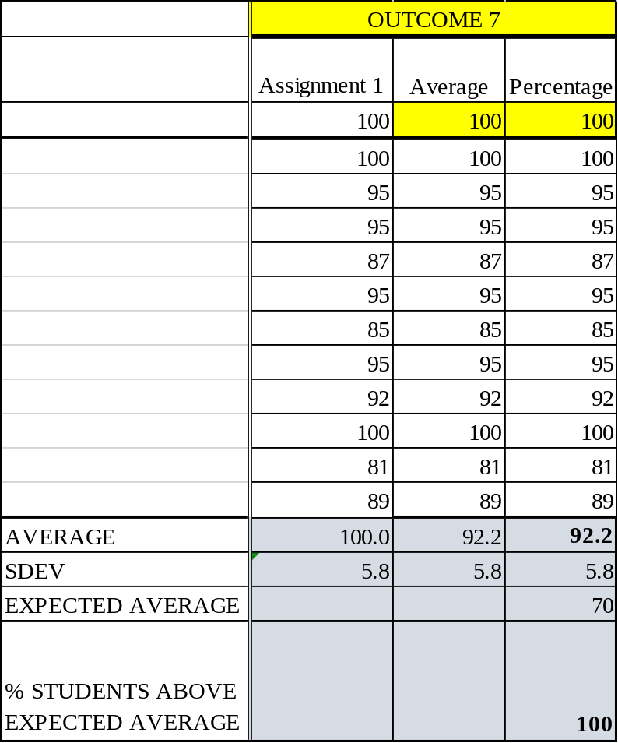
The Class averages for the outcomes shown here should match those listed for the outcomes in the End of Semester assessment Report

OUTCOME SPECIFIC ASSIGNMENTS
USED TO ASSESS OUTCOMES
(Provide at least two assignments used to specifically measure each outcome and justify the suitability of the assignments for the outcome being measured)

ASSIGNMENTS FOR OUTCOME 7

An ability to acquire and apply new knowledge as needed, using appropriate learning strategies.

MECHANICAL ENGINEERING DEPARTMENT OUTCOMES SPECIFIC ASSIGNMENT COVER SHEET
MCEG 3011 MEASUREMENT AND INSTRUMENTATION LABORATORY
FALL 2019

Instructor: Dr. Mingli Han

Title of Assignment

LIFE-LONG LEARNING ASSIGNMENT

Outcome Measured Using this Assignment
Outcome 7
An ability to acquire and apply new knowledge as needed, using appropriate learning strategies

Check the outcome appropriate characteristics related to this assignment

Ability to Acquire new knowledge using the appropriate learning strategies
Requires students to:
Be knowledgeable of and use different learning strategies (Instructor may provide information on different learning strategies
different learning strategies)
Identify and take advantage of learning opportunities available in the library, online resources, seminars, webinars, conferences, workshops and tutorials.
Be aware of the need for and are able to independently acquire additional knowledge and data needed for solving problem using appropriate learning strategies and tools.
Ability to apply new knowledge to solve problems
Requires students to:
Demonstrate appropriate use of the new knowledge to solve problems.

Brief justification of the suitability of assignment for the outcome
Life-long learning assignment 2 tests the students the ability to engage in life-long learning.

Life-long Learning Assignment

What is life-long learning and why?
A simple definition of lifelong learning is that it is “development after formal education: the continuing development of knowledge and skills that people experience after formal education and throughout their lives”.

The basic premise of lifelong learning is that it is not feasible to equip learners at school, college, or university with all the knowledge and skills they need to prosper throughout their lifetimes. Therefore, people will need continually to enhance their knowledge and skills, in order to address immediate problems and to participate in a process of continuous vocational and professional development. The new educational imperative is to empower people to manage their own learning in a variety of contexts throughout their lifetimes.

A life-long learning assignment
- Go to the url: https://www.youtube.com/watch?v=09zfRaLEasY&list=PLZfay8jtbyJt6gkkOgeeapCS_UrsgfuJA&index=1 to have a basic understanding of Arduino. There are series of videos in the topic of Arduino Courses for Absolute Beginners, please go through Tutorial 1 to Tutorial 6 to have an overview of the Arduino hardware and Arduino’s programming environment.

- Go to the following links to have a basic understanding of Simulink:
https://www.mathworks.com/videos/getting-started-with-simulink-part-1-building-and-simulating-a-simple-simulink-model-1508442030520.html , part 1 to part 2.

Simulink and Arduino:
https://www.mathworks.com/videos/programming-arduino-uno-with-simulink-86316.html

- The instructor will introduce Arduino, Arduino’s programming environment, and Simulink in the class, and implement the program in Lab 3.

- A questionnaire and quiz will be given at the end of the class.

MCEG3011 Measurement and Instrumentation Laboratory
Quiz

Name: Grade:

- We use two programming environments for measuring the period of the simple pendulum: Arduino’s IDE and Simulink with Arduino Support. Why do we need to use a programmable timer to measure the period of the simple pendulum?

- What is hardware interrupt mechanism?

- How do you use Arduino’s IDE to create the program?

- How do you use Simulink to create the program?

- After this case study, are you interested to learn more programming to design a different device? If yes, which programming environment will you prefer? Why?

