Course ASSESSMENT REPORT

ROY G. PERRY COLLEGE OF ENGINEERING
MECHANICAL ENGINEERING DEPARTMENT
PRAIRIE VIEW A&M UNIVERSITY

ASSESSMENT REPORT COVER PAGE

MCEG 1021 Introduction to Mechanical Engineering Drawing and Design Lab I

FALL 2020 SEMESTER

NAME OF INSTRUCTOR: Dr. Mingli Han

Revised: 12/17/2020

TABLE OF CONTENTS

- Report Cover Page

- Detailed Course Syllabus

- End of Semester Outcomes Assessment Report

- Grade Sheet Showing Student and Class Performance in Outcomes

- Supporting Outcomes Specific Assignments (Minimum of 2 per outcome except for Project Reports where one is enough)

5.1 An ability to apply engineering design to produce solutions that meet specified needs with consideration of public health, safety, and welfare, as well as global, cultural, social, environmental, and economic factors (outcome 2)

Detailed Course Syllabus
(Distributed to Students at the beginning of the Semester)
ABET outcomes measured using this course should be
explicitly listed in the syllabus

Course Description in ABET Format
MCEG1021 Introduction to Mechanical Engineering Drawing and Design Lab I

1. | Course number and name: | MCEG 1021 Introduction to Mechanical Engineering Drawing and Design Lab I
2. | Credits and contact hours: | 1 credit hours
3. | Instructor’s or course  coordinator’s name: | Dr. Mingli Han
4. | Text book: Title: | Engineering Graphics Essentials
 | Author: | Kirstie Platenberg
 | Publisher, Year & Edition: | Schroff Development Corporation, 2010, 4th Edition
 | - Other Supplemental material | Gary R. Bertoline, Eric N. Wiebe, Fundamentals of Graphics Communication, Fifth edition, McGraw-Hill, 2005.
5. | Specific course information
 | - Brief description of the content of the course (catalog description) | This course will require students to generate a master model and a set of design documents using solid modeling software.
 | - Prerequisites or  Co-requisites | None
 | - *Indicate whether a required, elective, or selected elective (as per definition provided) course in the program | Required
6. | - Specific goals for the course specific outcomes of instruction (e.g. The student will be able to explain the significance of current research about a particular topic.)  Students will be able to : | - Explicitly indicate which of the student outcomes listed in Criterion 3 or any other outcomes are addressed by the course.  The specific goals for the course specific outcomes listed on the left column will address the following student learning outcomes:
 | 1. Create and edit solid models | Outcome 2  An ability to apply engineering design to produce solutions that meet specified needs with consideration of public health, safety, and welfare, as well as global, cultural, social, environmental, and economic factor (including use of the techniques, skills, and modern engineering tools necessary for engineering practice).
 | 2. Create and modify drawings
 | 3. create and modify basic assembly structures
 | 4. open-ended design of student’s choice
7 | Brief list of topics to be covered | 1. Introduction to the engineering drawing, design process, CAD/CAM system concept (1 classes)  2. Engineering technical drawing (2 classes)  3. Introduction to master model concept and Unigraphics software (1 classes)  4. Create and edit solid model solid modeling using Unigraphics (6 classes)  5. Create and modify drawings (2 classes)  6. Assembly of the parts (2 classes)  7. Analysis (1 classes)  8. Report writing (1 class)

Additional Course Syllabus Information

CLASS HOURS | Internet
CLASS ROOM | Internet
OFFICE | S. R. Collins Engineering Building Room 311
OFFICE HOURS | As Posted
TELEPHONE | (936)261-9952

GRADING | The final grade will be computed according to the following weight distribution:  Homework 25%  Projects 40%  Exams 35%  The distribution of grades will be as follows:  A = 90 - 100  B = 80 - 89  C = 70 - 79  D = 60 - 69  F = 0 - 59
COURSE POLICY | Note: The instructor reserves the right to alter it during the semester.  Use of Ecourses (http://ecourses.pvamu.edu)  Ecourses will be used extensively in this class. Lecture slides, assignment, and tutorials will be provided on Ecourses.  Academic Integrity  Academic dishonesty of any sort (plagiarism, cheating, fabrication or facilitation) is prohibited under any circumstance. Any detected actions of dishonesty will cause the failure of the class directly.  Assignments & Due Dates  Homework will be submitted at the beginning of class on the assigned day. Late homework will be charged a 20% penalty for each day late – weekend days do count. Circumstances beyond your control (i.e. illness, weather, etc.) will be considered as required.  Projects  You need to submit all the projects with one hardcopy printed out on papers and one electronic copy on Ecourses.  Attendance  Joining the synchronous sessions is highly encouraged. Viewing the recorded sessions within two days of posting is expected. You should notify the instructor if you can neither attend the synchronous sessions nor review the recorded sessions within two days of posting.  Examinations  No makeup test will be given. You will be expected to complete the exam in the allotted time period. Portions of each exam may be either closed or open book. You will be notified of the exam format at least one week in advance.
IMPORTANT DATES | https://www.pvamu.edu/registrar/academic-calendars/fall-2020-full-term/

Introduction to Mechanical Engineering Drawing and Design Lab I
Tentative Course Schedule

WEEK | Lecture & LAB | SELF EXERCISE (CAST) | REMARKS
1st week | Introduction to the design process, CAD/CAM system concept;  Introduction to engineering drawing and sketching;  Getting started in UG;  Creating a block with a hole | Sphere, Cone
2nd week | Engineering technical drawing (I);  Create primitives: Block, Cylinder, Hole, Slot, Pocket | Pad, Boss
3rd week | Engineering technical drawing (II);  Geometric Elements;  Form features: Extrusion, Sweep, Blend;  Suppress by expression | Form Features – Extrusion, Hollow, Revolve, Sweep, Blend
4th week | Boolean operations;  Overview of project 1
5th week | Sketches | Completion of Project 1
6th week | Expressions  Feature Operations  Boolean Operations | Design projects (any 4 from the CAST tutorials)
7th week | Drafting
8th week | Mid-term Exam
9th week | Concepts of Assembly  Project 3 proposal presentation
10th week | Final Project Proposal Presentation  Project 2  Assembly | Assembly modeling
11th week | Freeform Modeling | Assembly modeling, Completion of Project 2
12th week | Assembly Analysis  Modeling of parts for Project 3
13th week | Final Project Presentation, Review | Completion of Project 3
14th week | Final Exam

How Mechanical Engineering Courses meet Department Objectives & ABET Criterion 3
Specific Objectives of the Mechanical Engineering Program (MCEG Objectives) at Prairie View A&M are to produce graduates who have:

- the techniques and skills necessary for modern mechanical engineering practices, and an ability to function effectively in multi-disciplinary teams.
- an ability in life-long learning skills, a knowledge of contemporary issues, and an ability to communicate effectively.
- an understanding of global and societal context in the aspects of professional and ethical responsibility and the impact of engineering solutions on society.
- the qualifications to be employed by major industries and government agencies in the State of Texas and the nation.
- the qualifications to pursue graduate degrees.

ABET Criterion 3: Program Outcomes and Assessment
Engineering Programs must demonstrate that their graduates have:
- the ability to identify, formulate, and solve complex engineering problems by applying principles of engineering, science, and mathematics;
- the ability to apply engineering design to produce solutions that meet specified needs with consideration of public health, safety, and welfare, as well as global, cultural, social, environmental, and economic factor;
- the ability to communicate effectively with a range of audiences;
- the ability to recognize ethical and professional responsibilities in engineering situations and make informed judgments, which must consider the impact of engineering solutions in global, economic, environmental, and societal contexts;
- the ability to function effectively on a team whose members together provide leadership, create a collaborative and inclusive environment, establish goals, plan tasks, and meet objectives;
- ability to develop and conduct appropriate experimentation, analyze and interpret data, and use engineering judgment to draw conclusions;
- the ability to acquire and apply new knowledge as needed, using appropriate learning strategies.

The table below shows how required Mechanical Engineering courses at Prairie View A&M University contribute to the student’s knowledge and ability to meet ABET criterion 3.

Numerical values – items that the course contents are significantly relevant to ABET Criterion 3 and the instructor will use these items for course assessment. The values represent for “contribution factor” of the specific course toward the assessment of the particular item of ABET Criterion 3. A summation of the values in each column equals to 100.

x – items that the course contents are somewhat relevant to ABET Criterion 3. However, the instructor will not use these items for course assessment.

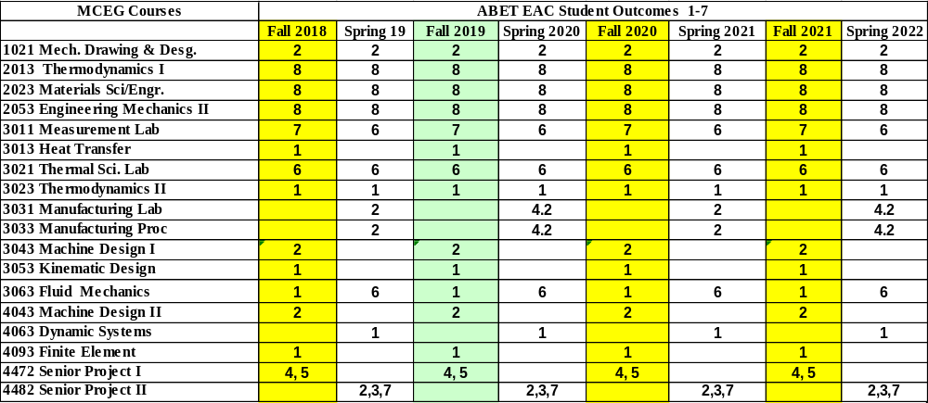

MCEG 1021 Course Objectives and Anticipated Outcomes

Course Objectives

- Introduce the students the concept of the design process, engineering technical drawing, and solid modeling. (1, 4)
Anticipated Outcomes: The students will be able to design a component and system. (ABET outcome 2)

2. Teach students how to use modern solid modeling software to accomplish engineering design tasks. (1, 2, 4)
Anticipated Outcomes: The students will be able to using NX3 to design parts and assembly, write technical project reports and make technical presentations. (ABET outcome 2)
University Rules and Procedures

Academic Misconduct (See Student Planner)
You are expected to practice academic honesty in every aspect of this course and all other courses. Make sure you are familiar with your Student Planner, especially the section on academic misconduct (see University Administrative Guidelines on Academic Integrity). Students who engage in academic misconduct are subject to university disciplinary procedures. As listed in the PVAMU Undergraduate Catalog, Graduate Catalog, and the Student Planner, the following are examples of prohibited conduct. This list is not designed to be all-inclusive or exhaustive. In addition to academic sanctions, any student found to have committed or to have attempted to commit the following academic misconduct may also be subject to disciplinary review and action as outlined in the PVAMU Student Planner.

Forms of Academic Dishonesty:

- Cheating: Deception in which a student misrepresents that he/she has mastered information on an academic exercise that he/she has not learned, giving or receiving aid unauthorized by the instructor on assignments or examinations. Examples: unauthorized use of notes for a test; using a “cheat sheet” on a quiz or exam; any alteration made on a graded test or exam which is then resubmitted to the teacher.

- Plagiarism: Careless or deliberate use of the work or the ideas of another; representation of another’s work, words, ideas, or data as your own without permission or appropriate acknowledgment. Examples: copying another’s paper or answers, failure to identify information or essays from the Internet and submitting or representing it as your own; submitting an assignment which has been partially or wholly done by another and claiming it as yours; not properly acknowledging a source which has been summarized or paraphrased in your work; failure to acknowledge the use of another’s words with quotation marks.

- Multiple Submission: Submission of work from one course to satisfy a requirement in another course without explicit permission. Example: using a paper prepared and graded for credit in one course to fulfill a requirement and receive credit in a different course.

- Conspiracy: Agreeing with one or more persons to commit an act of academic/scholastic dishonesty.

- Fabrication of Information/Forgery: Use or submission of contrived, invented, forged, or altered information in any assignment, laboratory exercise, or test; tampering with or production of a counterfeit document, particularly documents which make up the student’s academic record. Examples: making up a source or citing nonexistent publication or article; representing made up data as real for an experiment in a science laboratory class; forging a change of grade or student withdrawal record; falsifying any document related to a student academic exercise.

Nonacademic Misconduct (See Student Planner)
The University respects the rights of instructors to teach and students to learn. Maintenance of these rights requires campus conditions that do not impede their exercise. Campus behavior that interferes with either (1) the instructor’s ability to conduct the class, or (2) the ability of students to benefit from the instructional program, or (3) the rights of others will not be tolerated. An individual engaging in such disruptive behavior may be subject to disciplinary action. Such incidents will be adjudicated by the Office for Student Conduct under nonacademic procedures.

Sexual Misconduct
Sexual harassment of students and employees at Prairie View A&M University is unacceptable and will not be tolerated. Any member of the university community violating the university’s sexual harassment policy will be subject to disciplinary action. In accordance with the Texas A&M University System guidelines, your instructor is obligated to report to the Office of Title IX Compliance (titleixteam@pvamu.edu) any instance of sexual misconduct involving a student, which includes sexual assault, stalking, dating violence, domestic violence, and sexual harassment, about which the instructor becomes aware during this course through writing, discussion, or personal disclosure. The faculty and staff of PVAMU actively strive to provide a learning, working, and living environment that promotes respect that is free from sexual misconduct, discrimination, and all forms of violence. If students, faculty, or staff would like assistance, or have questions, they may contact the Title IX Coordinator at 936-261-2144 or titleixteam@pvamu.edu. More information can be found at the Title IX Webpage including confidential resources available on campus.

Pregnancy, Pregnancy-related, and Parenting Accommodations
Title IX of the Education Amendments of 1972 prohibits sex discrimination, which includes discrimination based on pregnancy, marital status, or parental status. Students seeking accommodations related to pregnancy, pregnancy-related condition, or parenting (reasonably immediate postpartum period) are encouraged to contact Student Disability Services or the Dean of Students’ Office for additional information and to request accommodations. More information can be found at this webpage.

Non-Discrimination Statement
Prairie View A&M University does not discriminate on the basis of race, color, sex, religion, national origin, age, disability, genetic information, veteran status, sexual orientation or gender identity in its programs and activities. The University is committed to supporting students and complying with the Texas A&M University System non-discrimination policy. It seeks to establish an environment that is free of bias, discrimination, and harassment. If you experience an incident of discrimination or harassment, we encourage you to report it. If you would like to speak with someone who may be able to afford you privacy or confidentiality, there are individuals who can meet with you. The Director of Equal Opportunity & Diversity has been designated to handle inquiries regarding the non-discrimination policies, and can be reached at Harrington Science Building, Suite 109 or by phone 936-261-1744 or 1792.

Class Attendance Policy (See Catalog for Full Attendance Policy)
Prairie View A&M University requires regular class attendance. Attending all classes supports full academic development of each learner whether classes are taught with the instructor physically present or via distance learning technologies such as interactive video and/or internet. Excessive absenteeism, whether excused or unexcused, may result in a student’s course grade being reduced or in assignment of a grade of “F”. Absences are accumulated beginning with the first day of class during regular semesters and summer terms. Each faculty member will include the University’s attendance policy in each course syllabus.
Student Academic Appeals Process
Authority and responsibility for assigning grades to students rests with the faculty. However, in those instances where students believe that miscommunication, errors, or unfairness of any kind may have adversely affected the instructor's assessment of their academic performance, the student has a right to appeal by the procedure listed in the University Catalog and by doing so within thirty days of receiving the grade or experiencing any other problematic academic event that prompted the complaint. Students can file Academic Complaints and/or Grade Appeals at this webpage.

Technical Considerations

Minimum Recommended Hardware and Software:
- Intel PC or Laptop with Windows 10 or later version; Mac with OS High Sierra*
- Smartphone or iPad/Tablet with Wi-Fi*
- High speed Internet access
- 8 GB Memory
- Hard drive with 320 GB storage space
- 15” monitor, 800x600, color or 16 bit
- Sound card w/speakers
- Microphone and recording software
- Keyboard & mouse
- Most current version of Google Chrome, Safari or Firefox

*Smartphone, Google Chrome books and Android tablets may not be supported. iPads are the only tablets supported.

Note: Be sure to enable Java & pop-ups in the Web browser preferences

Participants should have a basic proficiency of the following computer skills:
- Sending and receiving emails
- A working knowledge of the Internet
- Microsoft Word (or a program convertible to Word)
- Acrobat PDF Reader
- Windows or Mac OS
- Video conferencing software

Netiquette (online etiquette)
Students are expected to participate in all discussions and virtual classroom chats as directed. Students are to be respectful and courteous to others on discussions boards. Foul or abusive language will not be tolerated. Do not use ALL CAPS for communicating to others AS IT CAN BE INTERPRETED AS YELLING. Avoid slang terms such as “wassup?” and texting abbreviations such as “u” instead of “you.” Limit and possibly avoid the use of emoticons. Be cautious when using humor or sarcasm as tone is sometimes lost in an email or discussion post and the message might be taken seriously or sound offensive.

Video Conferencing Etiquette
When using Zoom, WebEx or other video conferencing tools, confirm the visible area is tidy, clear of background clutter, inappropriate or offensive posters, and other distractions. Ensure you dress appropriately and avoid using high traffic or noisy areas. Stay muted when you are not speaking and avoid eating/drinking during session. Before class session begins, test audio, video and lighting to alleviate technology issues.
Technical Support
Students should go to the Password Reset Tool if they have password issues. The page will provide instructions for resetting passwords and contact information if login issues persist. For other technical questions regarding eCourses, call the Center for Instructional Innovation and Technology Services (CIITS) at 936-261-3283 or email ciits@pvamu.edu.

Communication Expectations and Standards
Emails or discussion postings will receive a response from the instructor, usually in less than 48 hours. Urgent emails should be marked as such. Check regularly for responses.

Discussion Requirement
Online courses often require minimal to no face-to-face meetings. However, conversations about the readings, lectures, materials, and other aspects of the course can take place in a seminar fashion. This will be accomplished by the use of the discussion board. The exact use of discussion will be determined by the instructor.

It is strongly suggested that students type their discussion postings in a word processing application such as Word and save it to their PC or a removable drive before posting to the discussion board. This is important for two reasons: 1) If for some reason your discussion responses are lost in your online course, you will have another copy; 2) Grammatical errors can be greatly minimized by the use of the spell-and-grammar check functions in word processing applications. Once the post(s) have been typed and corrected in the word processing application, copy and paste to the discussion board.
COVID-19 Campus Safety Measures

To promote public safety and protect students, faculty, and staff during the COVID-19 pandemic, Prairie View A&M University has adopted policies and practices for the Fall 2020 academic term to limit virus transmission. Students must observe the following practices while participating in face-to-face courses and course-related activities (office hours, help sessions, transitioning to and between classes, study spaces, academic services, etc.):

- Self-monitoring - Students should follow CDC recommendations for self-monitoring. Students who have a fever or exhibit symptoms of COVID-19 should participate in class remotely and should not participate in face-to-face instruction.

- Face Coverings - Face coverings (cloth face covering, surgical mask, etc.) must be properly worn in all non-private spaces including classrooms, teaching laboratories, common spaces such as lobbies and hallways, public study spaces, libraries, academic resource and support offices, and outdoor spaces where 6 feet of physical distancing is difficult to reliably maintain.

- Physical Distancing - Physical distancing must be maintained between students, instructors, and others in course and course-related activities.

- Classroom Ingress/Egress - Students must follow marked pathways for entering and exiting classrooms and other teaching spaces. Students should leave classrooms promptly after course activities have concluded, should not congregate in hallways and should maintain 6-foot physical distancing when waiting to enter classrooms and other instructional spaces.

- Face-to-face Class - To attend a face-to-face class, students must wear a face covering (or a face shield if they have an exemption letter). If a student refuses to wear a face covering, the instructor should ask the student to leave and join the class remotely. If the student does not leave the class, the faculty member should report that student to the Office for Student Conduct for adjudication. Additionally, the faculty member may choose to teach that day’s class remotely for all students.

- COVID-19 Guidelines for Student Conduct Adjudication - The mandatory COVID-19 Training/Certification taken by all students serves as the 1st Warning for violation of COVID-19 Guidelines.

  - 1st incident: upon review of Incident Report and finding of responsibility — Conduct Probation

  - 2nd incident: upon review of Incident Report and finding of responsibility — Suspension

  - Consult the Code of Student Conduct in the Student Planner or Student Conduct website for additional information on Conduct Probation and Suspension.

- Personal Illness and Quarantine - Students required to quarantine must participate in courses and course-related activities remotely and must not attend face-to-face course activities. Students should notify their instructors of the quarantine requirement. Students under quarantine are expected to participate in courses and complete graded work unless they have symptoms that are too severe to participate in course activities. Students experiencing personal injury or illness that is too severe for the student to attend class qualify for an excused absence. To receive an excused absence, students must provide appropriate documentation to the Office for Student Conduct, studentconduct@pvamu.edu.

End of Semester
Course Assessment Report

This summary contains the following Information

1. Performance Statistics
- Total number of students in class
- The class average performance (stated as %) in each course outcome assessed in this class and the two previous times course was assessed.
- The acceptable class average for the class in each outcome area as set by your Department. You cannot use any number of your choice
- Percentage of students who scored below the expected average in each outcome.

2. Implementation Summary
- Brief summary of plans implemented during the semester based on last assessment report

3. Perceived Problems
- Instructor’s critical evaluation of perceived problems that affected students’ performance. Realistic problems should be identified throughout the semester and summarized in this section of the report.

4. New Plans for Addressing Problems
- Instructor’s plans for addressing the perceived problems the next time the class is taught. These should be specific enough for another instructor to implement. Most of these should be things that, you, the instructor can implement to help students to improve. Be creative.

5. Overall Trend over last three assessment periods
- Instructor’s summary of overall performance trend for each outcome measured over the last three periods.

5. Were Expectations Met?
- Answer YES if the class average was above the expected average and the stated percentage of students scored at or above the expected average, else answer NO.

END OF SEMESTER COURSE OUTCOME ASSESSMENT REPORT
MCEG 1021-P05 INTRODUCTION TO MECHANICAL ENGINEERING DRAWING AND DESIGN LAB I
FALL 2020 SEMESTER

Report Prepared by: Dr. Mingli Han
Report Date: December 17, 2020

Semester | Analysis Type | Number of Students | Outcome 2  an ability to apply engineering design to produce solutions that meet specified needs with consideration of public health, safety, and welfare, as well as global, cultural, social, environmental, and economic factors
Semester | Analysis Type | Number of Students | Expected Class Average | Expected Percent of students at or above average | Class Average | % Students meeting Expected Average
Fall 2020 | Direct | 13 | 70 | 70 | 77.0 | 84.6
Fall 2019 | Direct | 17 | 70 | 70 | 85.9 | 88.2
Fall 2018 | Direct | 12 | 70 | 70 | 84.6 | 83.3
Fall 2017 | Direct | 16 | 70 | 70 | 91.7 | 93.75
Implementation Summary | Items implemented from previous report or after meeting previous instructor |  | Extra learning tutorial are provided to students for the self-learning after class.  TA sessions are made available to students.
Perceived Problems | Perceived problems are directly related to the PC and the sub items under them |  | More tutorials are needed for students to further their study.  Freshmen needs constant reminder on deadlines.  Students are weak in planning the modeling process of 3D models.  There are limitations in the license borrowing process thus students got problem practicing outside of the classroom
Plans for Addressing Problems | Plans for address specific measures to address PC and their sub areas |  | More types of tutorials including the paper-based tutorials and video-based tutorials could be used in this course.  More examples regarding to the modeling planning could be covered in class lecture.  A smoother license borrowing process should be implemented.
Overall Trend over Periods | Ascertain if there were improvements over previous semesters |  | The class average is lower comparing with last semester.
Were Expectations Met? | Class Average ≥70 and ≥70% of Students Performed at or Above Expected Average. |  | YES

Grade Sheet Showing
Student and Class Performance in Outcomes
The computed semester average in each outcome
as stated in the Assessment report are
highlighted in boldface

Grade Sheet Showing Student and Class
Performance in Course Outcomes
MCEG 1021-Z01 Mechanical Engineering and Drawing I
Fall 2020 Semester

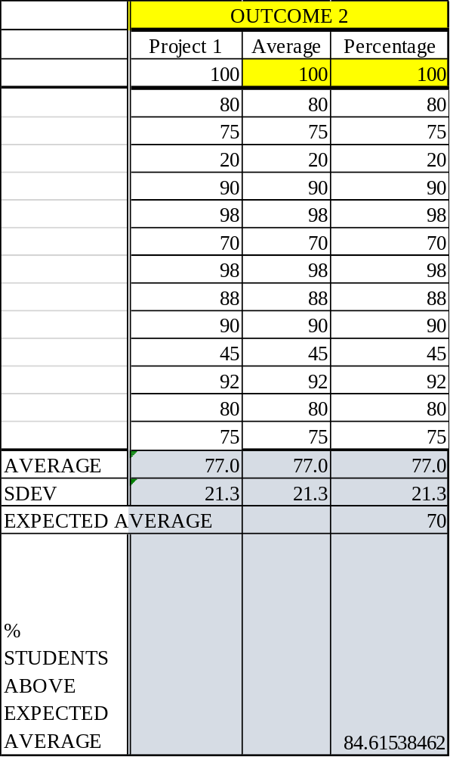

OUTCOME SPECIFIC ASSIGNMENTS
USED TO ASSESS OUTCOMES
(Provide at least two assignments used to specifically measure each outcome and justify the suitability of the assignments for the outcome being measured)

ASSIGNMENTS FOR OUTCOME 2

An ability to apply engineering design to produce solutions that meet specified needs with consideration of public health, safety, and welfare, as well as global, cultural, social, environmental, and economic factors

MECHANICAL ENGINEERING DEPARTMENT
OUTCOMES SPECIFIC ASSIGNMENT COVER SHEET
MCEG 1021 Introduction to Mechanical Engineering Drawing and Design Lab I
FALL 2020
Instructor: Dr. Mingli Han

Title of Assignment
Project 1

Outcome Measured Using this Assignment
Outcome 2
An ability to apply engineering design to produce solutions that meet specified needs with consideration of public health, safety, and welfare, as well as global, cultural, social, environmental, and economic factor

Check the engineering design characteristics related to this assignment
Involves identifying the specific needs to be met by defining/understanding the problem and developing plans for the project to satisfy the need
Involves conducting a review of the literature and performing preliminary design by generating alternative ideas/solutions and applying creativity
Involves performing detailed engineering design leading to specification and fabrication/selection of components for system being designed.
Involves consideration of one or more of the following (Please check those involved in this assignment.)
Public health
Safety and welfare
Global factors
Cultural factors
Social factors
Environmental factors
Economic factors
Involves fabrication and testing of model or prototype

Brief justification of the suitability of assignment for the outcome
This project is designed to test students’ abilities in define the problem and plan the design process. It is also designed to test students’ abilities in detailed design using modern 3D modeling software.

MCEG1021: Mechanical Engineering Drawing I

Fall 2020

Project 1
Assigned on Oct. 12, 2020

This project includes 2 parts. Part I is to design a solid model as shown in page 2. Part II is to create a drafting as shown in page 3.

Due Date:

Part I and Part II is due on Oct 26, 2020.

Requirements:

Part I:
- You need to describe what modeling methods you used to design each part of the model briefly. Hand sketches may be used to describe your design process. (For example, the first step is to create a sketch shown below, then extrude along z-axis. The second step is create another sketch….). You may complete it using either Word document or paper. If it is completed on a paper, you can scan and upload for submission.

- Create the solid model as shown in page 2. Save your NX file. You will use it to finish your project Part II.

Part II:

You need to list your name and student ID on the right bottom corner of your drafting.

Submission:

- You need to upload Three electronic copies on Canvas by the due date:
  - One document describing modeling method
  - One NX file for Part I
  - One NX file for Part II

- You need to submit electronic copy of your model file on Tasktream (http://ecourses.pvamu.edu).

- The NX file names should be Project1_model_lastname.prt for Part I and Project1_drafting_lastname.prt for Part II.

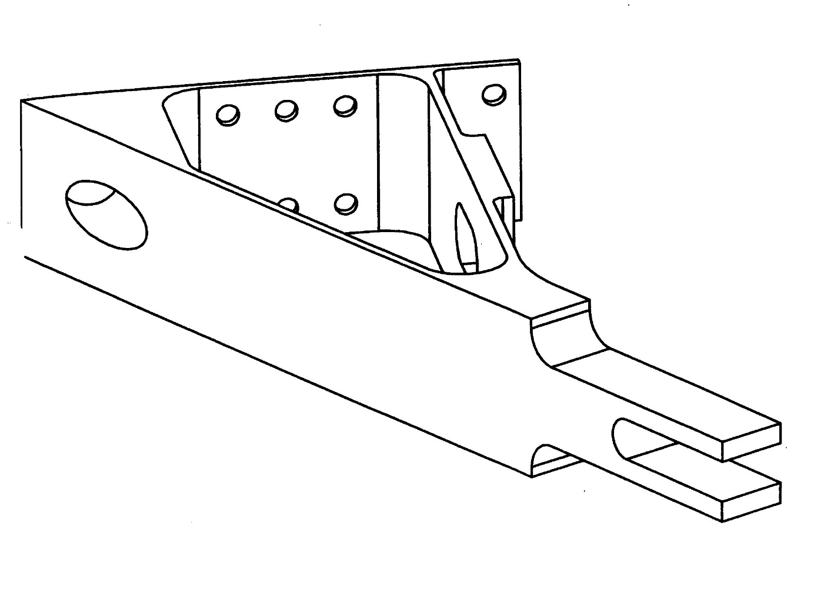
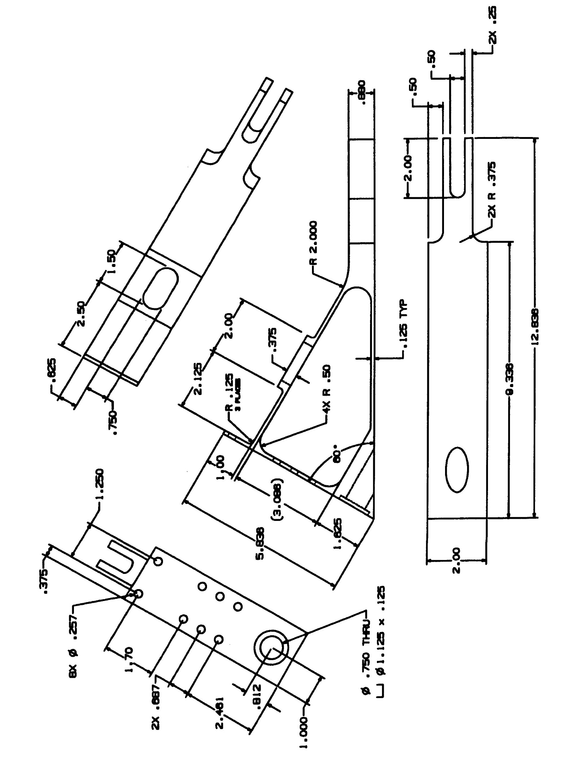
Steven Broussard

75/100
Many missing Features
Missing all dimensions
Not proper alignment
Wrong views

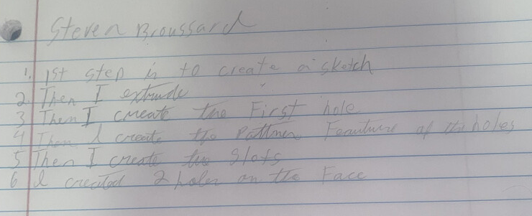

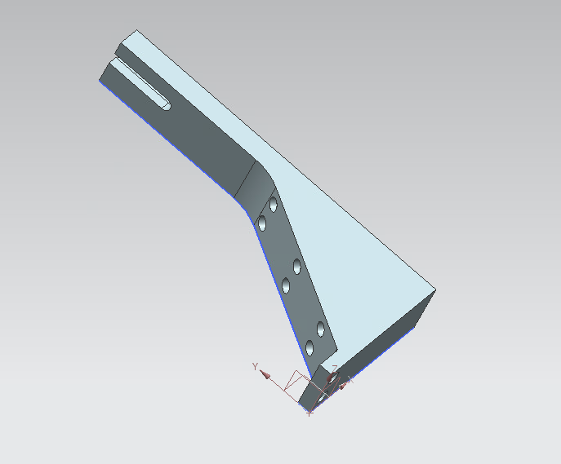
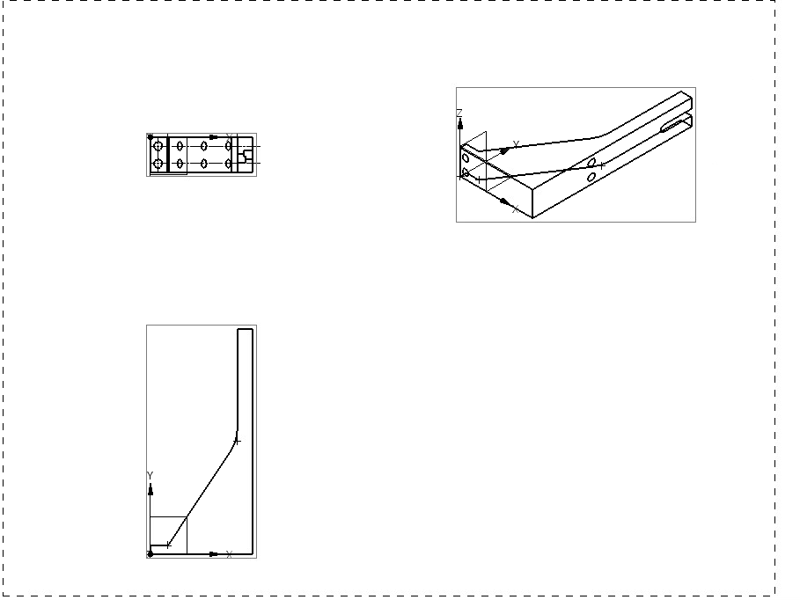

90/100
Angle is off. Missing slot.

