Course ASSESSMENT REPORT

ROY G. PERRY COLLEGE OF ENGINEERING
MECHANICAL ENGINEERING DEPARTMENT
PRAIRIE VIEW A&M UNIVERSITY

ASSESSMENT REPORT COVER PAGE

MCEG 1021 Introduction to Mechanical Engineering Drawing and Design Lab I

FALL 2019 SEMESTER

NAME OF INSTRUCTOR: Dr. Chang Duan

Revised: 12/17/2019

TABLE OF CONTENTS

- Report Cover Page

- Detailed Course Syllabus

- End of Semester Outcomes Assessment Report

- Grade Sheet Showing Student and Class Performance in Outcomes

- Supporting Outcomes Specific Assignments (Minimum of 2 per outcome except for Project Reports where one is enough)

5.1 An ability to apply engineering design to produce solutions that meet specified needs with consideration of public health, safety, and welfare, as well as global, cultural, social, environmental, and economic factors (outcome 2)

Detailed Course Syllabus
(Distributed to Students at the beginning of the Semester)
ABET outcomes measured using this course should be
explicitly listed in the syllabus

Course Description in ABET Format
MCEG1021 Introduction to Mechanical Engineering Drawing and Design Lab I

1. | Course number and name: | MCEG 1021 Introduction to Mechanical Engineering Drawing and Design Lab I
2. | Credits and contact hours: | 1 credit hours
3. | Instructor’s or course  coordinator’s name: | Dr. Chang Duan
4. | Text book: Title: | Engineering Graphics Essentials
 | Author: | Kirstie Platenberg
 | Publisher, Year & Edition: | Schroff Development Corporation, 2010, 4th Edition
 | - Other Supplemental material | Gary R. Bertoline, Eric N. Wiebe, Fundamentals of Graphics Communication, Fifth edition, McGraw-Hill, 2005.
5. | Specific course information
 | - Brief description of the content of the course (catalog description) | This course will require students to generate a master model and a set of design documents using solid modeling software.
 | - Prerequisites or  Co-requisites | None
 | - *Indicate whether a required, elective, or selected elective (as per definition provided) course in the program | Required
6. | - Specific goals for the course specific outcomes of instruction (e.g. The student will be able to explain the significance of current research about a particular topic.)  Students will be able to : | - Explicitly indicate which of the student outcomes listed in Criterion 3 or any other outcomes are addressed by the course.  The specific goals for the course specific outcomes listed on the left column will address the following student learning outcomes:
 | 1. Create and edit solid models | Outcome 2  An ability to apply engineering design to produce solutions that meet specified needs with consideration of public health, safety, and welfare, as well as global, cultural, social, environmental, and economic factor (including use of the techniques, skills, and modern engineering tools necessary for engineering practice).
 | 2. Create and modify drawings
 | 3. create and modify basic assembly structures
 | 4. open-ended design of student’s choice
7 | Brief list of topics to be covered | 1. Introduction to the engineering drawing, design process, CAD/CAM system concept (1 classes)  2. Engineering technical drawing (2 classes)  3. Introduction to master model concept and Unigraphics software (1 classes)  4. Create and edit solid model solid modeling using Unigraphics (6 classes)  5. Create and modify drawings (2 classes)  6. Assembly of the parts (2 classes)  7. Analysis (1 classes)  8. Report writing (1 class)

Additional Course Syllabus Information

CLASS HOURS | Monday 3 – 5:50 PM
CLASS ROOM | C.L. Wilson Engineering Complex Room 204
OFFICE | C.L. Wilson Engineering Complex Room 105H
OFFICE HOURS | As Posted
TELEPHONE | (936)261-9954

GRADING | The final grade will be computed according to the following weight distribution:  Attendance 5%  Homework 15%  Student-centered assignment 15%  Projects 25%  Mid-term exam 20%  Final exam 20%  The distribution of grades will be as follows:  A = 90 - 100  B = 80 - 89  C = 70 - 79  D = 60 - 69  F = 0 - 59
COURSE POLICY | Note: The instructor reserves the right to alter it during the semester.  Use of Ecourses (http://ecourses.pvamu.edu)  Ecourses will be used extensively in this class. Lecture slides, assignment, and tutorials will be provided on Ecourses.  Academic Integrity  Academic dishonesty of any sort (plagiarism, cheating, fabrication or facilitation) is prohibited under any circumstance. Any detected actions of dishonesty will cause the failure of the class directly.  Assignments & Due Dates  Homework will be submitted at the beginning of class on the assigned day. Late homework will be charged a 20% penalty for each day late – weekend days do count. Circumstances beyond your control (i.e. illness, weather, etc.) will be considered as required.  Projects  You need to submit all the projects with one hardcopy printed out on papers and one electronic copy on Ecourses.  Attendance  Class attendance is mandatory. Being late class for more than 15 minutes will count as one absence.  Examinations  No makeup test will be given. You will be expected to complete the exam in the allotted time period. Portions of each exam may be either closed or open book. You will be notified of the exam format at least one week in advance.
IMPORTANT DATES | Last day to withdraw from course(s) without record, 9/11/2019  Withdrawal from courses with record “W” ends, 11/01/2019  Course review day, 12/2-3/2019  Final exam period, 12/4-10/2019

Introduction to Mechanical Engineering Drawing and Design Lab I
Tentative Course Schedule

WEEK | Lecture & LAB | SELF EXERCISE (CAST) | REMARKS
1st week | Introduction to the design process, CAD/CAM system concept;  Introduction to engineering drawing and sketching;  Getting started in UG;  Creating a block with a hole | Sphere, Cone
2nd week | Engineering technical drawing (I);  Create primitives: Block, Cylinder, Hole, Slot, Pocket | Pad, Boss
3rd week | Engineering technical drawing (II);  Geometric Elements;  Form features: Extrusion, Sweep, Blend;  Suppress by expression | Form Features – Extrusion, Hollow, Revolve, Sweep, Blend
4th week | Boolean operations;  Overview of project 1
5th week | Sketches | Completion of Project 1
6th week | Expressions  Feature Operations  Boolean Operations | Design projects (any 4 from the CAST tutorials)
7th week | Drafting
8th week | Mid-term Exam
9th week | Concepts of Assembly  Project 3 proposal presentation
10th week | Final Project Proposal Presentation  Project 2  Assembly | Assembly modeling
11th week | Freeform Modeling | Assembly modeling, Completion of Project 2
12th week | Assembly Analysis  Modeling of parts for Project 3
13th week | Final Project Presentation, Review | Completion of Project 3
14th week | Final Exam

How Mechanical Engineering Courses meet Department Objectives & ABET Criterion 3
Specific Objectives of the Mechanical Engineering Program (MCEG Objectives) at Prairie View A&M are to produce graduates who have:

- the techniques and skills necessary for modern mechanical engineering practices, and an ability to function effectively in multi-disciplinary teams.
- an ability in life-long learning skills, a knowledge of contemporary issues, and an ability to communicate effectively.
- an understanding of global and societal context in the aspects of professional and ethical responsibility and the impact of engineering solutions on society.
- the qualifications to be employed by major industries and government agencies in the State of Texas and the nation.
- the qualifications to pursue graduate degrees.

ABET Criterion 3: Program Outcomes and Assessment
Engineering Programs must demonstrate that their graduates have:
- the ability to identify, formulate, and solve complex engineering problems by applying principles of engineering, science, and mathematics;
- the ability to apply engineering design to produce solutions that meet specified needs with consideration of public health, safety, and welfare, as well as global, cultural, social, environmental, and economic factor;
- the ability to communicate effectively with a range of audiences;
- the ability to recognize ethical and professional responsibilities in engineering situations and make informed judgments, which must consider the impact of engineering solutions in global, economic, environmental, and societal contexts;
- the ability to function effectively on a team whose members together provide leadership, create a collaborative and inclusive environment, establish goals, plan tasks, and meet objectives;
- ability to develop and conduct appropriate experimentation, analyze and interpret data, and use engineering judgment to draw conclusions;
- the ability to acquire and apply new knowledge as needed, using appropriate learning strategies.

The table below shows how required Mechanical Engineering courses at Prairie View A&M University contribute to the student’s knowledge and ability to meet ABET criterion 3.

Numerical values – items that the course contents are significantly relevant to ABET Criterion 3 and the instructor will use these items for course assessment. The values represent for “contribution factor” of the specific course toward the assessment of the particular item of ABET Criterion 3. A summation of the values in each column equals to 100.

x – items that the course contents are somewhat relevant to ABET Criterion 3. However, the instructor will not use these items for course assessment.

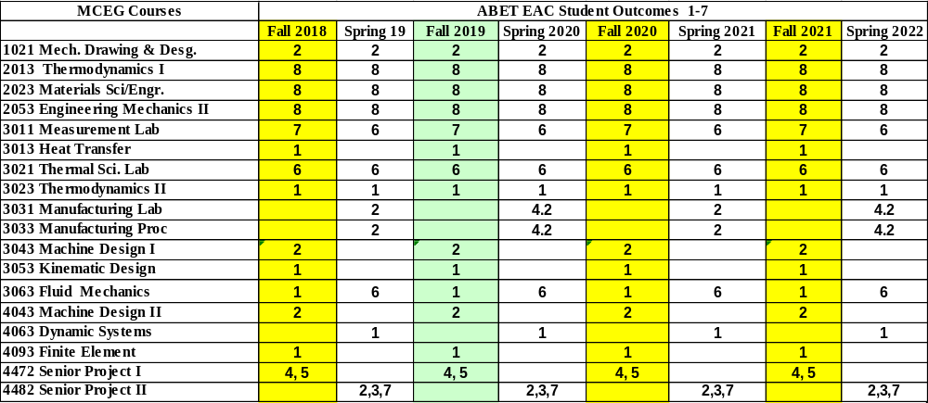

MCEG 1021 Course Objectives and Anticipated Outcomes

Course Objectives

- Introduce the students the concept of the design process, engineering technical drawing, and solid modeling. (1, 4)
Anticipated Outcomes: The students will be able to design a component and system. (ABET outcome 2)

2. Teach students how to use modern solid modeling software to accomplish engineering design tasks. (1, 2, 4)
Anticipated Outcomes: The students will be able to using NX3 to design parts and assembly, write technical project reports and make technical presentations. (ABET outcome 2)
University Rules and Procedures

Disability statement (See Student Handbook):
Students with disabilities, including learning disabilities, who wish to request accommodations in class should register with the Services for Students with Disabilities (SSD) early in the semester so that appropriate arrangements may be made. In accordance with federal laws, a student requesting special accommodations must provide documentation of their disability to the SSD coordinator.

Academic misconduct (See Student Handbook):
You are expected to practice academic honesty in every aspect of this course and all other courses. Make sure you are familiar with your Student Handbook, especially the section on academic misconduct. Students who engage in academic misconduct are subject to university disciplinary procedures.

Forms of academic dishonesty:
- Cheating: deception in which a student misrepresents that he/she has mastered information on an academic exercise that he/she has not mastered; giving or receiving aid unauthorized by the instructor on assignments or examinations.

- Academic misconduct: tampering with grades or taking part in obtaining or distributing any part of a scheduled test.

- Fabrication: use of invented information or falsified research.

- Plagiarism: unacknowledged quotation and/or paraphrase of someone else’s words, ideas, or data as one’s own in work submitted for credit. Failure to identify information or essays from the Internet and submitting them as one’s own work also constitutes plagiarism.

Nonacademic misconduct (See Student Handbook)
The university respects the rights of instructors to teach and students to learn. Maintenance of these rights requires campus conditions that do not impede their exercise. Campus behavior that interferes with either (1) the instructor’s ability to conduct the class, (2) the inability of other students to profit from the instructional program, or (3) campus behavior that interferes with the rights of others will not be tolerated. An individual engaging in such disruptive behavior may be subject to disciplinary action. Such incidents will be adjudicated by the Dean of Students under nonacademic procedures.

Sexual misconduct (See Student Handbook):
Sexual harassment of students and employers at Prairie View A&M University is unacceptable and will not be tolerated. Any member of the university community violating this policy will be subject to disciplinary action.

Attendance Policy:
Prairie View A&M University requires regular class attendance. Excessive absences will result in lowered grades. Excessive absenteeism, whether excused or unexcused, may result in a student’s course grade being reduced or in assignment of a grade of “F”. Absences are accumulated beginning with the first day of class.

Student Academic Appeals Process
Authority and responsibility for assigning grades to students rests with the faculty. However, in those instances where students believe that miscommunication, errors, or unfairness of any kind may have adversely affected the instructor's assessment of their academic performance, the student has a right to appeal by the procedure listed in the Undergraduate Catalog and by doing so within thirty days of receiving the grade or experiencing any other problematic academic event that prompted the complaint.

End of Semester
Course Assessment Report

This summary contains the following Information

1. Performance Statistics
- Total number of students in class
- The class average performance (stated as %) in each course outcome assessed in this class and the two previous times course was assessed.
- The acceptable class average for the class in each outcome area as set by your Department. You cannot use any number of your choice
- Percentage of students who scored below the expected average in each outcome.

2. Implementation Summary
- Brief summary of plans implemented during the semester based on last assessment report

3. Perceived Problems
- Instructor’s critical evaluation of perceived problems that affected students’ performance. Realistic problems should be identified throughout the semester and summarized in this section of the report.

4. New Plans for Addressing Problems
- Instructor’s plans for addressing the perceived problems the next time the class is taught. These should be specific enough for another instructor to implement. Most of these should be things that, you, the instructor can implement to help students to improve. Be creative.

5. Overall Trend over last three assessment periods
- Instructor’s summary of overall performance trend for each outcome measured over the last three periods.

5. Were Expectations Met?
- Answer YES if the class average was above the expected average and the stated percentage of students scored at or above the expected average, else answer NO.

END OF SEMESTER COURSE OUTCOME ASSESSMENT REPORT
MCEG 1021-P02 INTRODUCTION TO MECHANICAL ENGINEERING DRAWING AND DESIGN LAB I
FALL 2019 SEMESTER

Report Prepared by: Dr. Chang Duan
Report Date: December 17, 2019

Semester | Analysis Type | Number of Students | Outcome 2  an ability to apply engineering design to produce solutions that meet specified needs with consideration of public health, safety, and welfare, as well as global, cultural, social, environmental, and economic factors
Semester | Analysis Type | Number of Students | Expected Class Average | Expected Percent of students at or above average | Class Average | % Students meeting Expected Average
Fall 2019 | Direct | 17 | 70 | 70 | 77.3 | 75
Fall 2018 | Direct | 12 | 70 | 70 | 84.6 | 83.3
Fall 2017 | Direct | 16 | 70 | 70 | 91.7 | 93.75
Fall 2016 | Direct | 24 | 75 | 70 | 89.1 | 95.8
Implementation Summary | Items implemented from previous report or after meeting previous instructor |  | Extra learning tutorial are provided to students for the self-learning after class.  TA sessions are made available to students.
Perceived Problems | Perceived problems are directly related to the PC and the sub items under them |  | More tutorials are needed for students to further their study.  Freshmen needs constant reminder on deadlines.  Students are weak in planning the modeling process of 3D models.  There are limitations in the license borrowing process thus students got problem practicing outside of the classroom
Plans for Addressing Problems | Plans for address specific measures to address PC and their sub areas |  | More types of tutorials including the paper-based tutorials and video-based tutorials could be used in this course.  More examples regarding to the modeling planning could be covered in class lecture.  A smoother license borrowing process should be implemented.
Overall Trend over Periods | Ascertain if there were improvements over previous semesters |  | The class average is decreasing comparing with last three years.
Were Expectations Met? | Class Average ≥70 and ≥70% of Students Performed at or Above Expected Average. |  | YES

Grade Sheet Showing
Student and Class Performance in Outcomes
The computed semester average in each outcome
as stated in the Assessment report are
highlighted in boldface

Grade Sheet Showing Student and Class
Performance in Course Outcomes
MCEG 1021-P04 Mechanical Engineering and Drawing I
Fall 2019 Semester

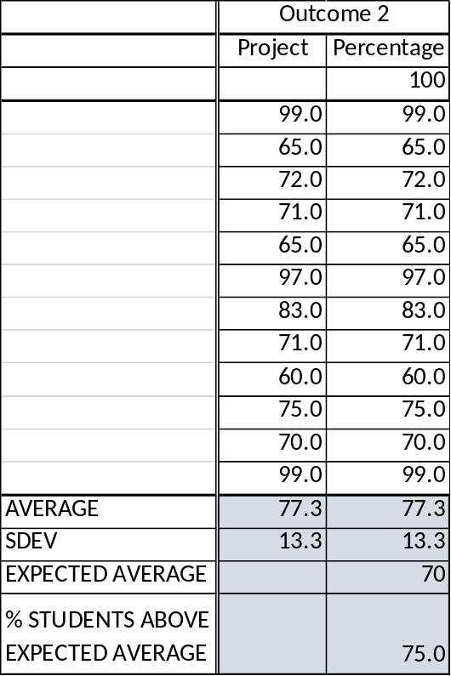

OUTCOME SPECIFIC ASSIGNMENTS
USED TO ASSESS OUTCOMES
(Provide at least two assignments used to specifically measure each outcome and justify the suitability of the assignments for the outcome being measured)

ASSIGNMENTS FOR OUTCOME 2

An ability to apply engineering design to produce solutions that meet specified needs with consideration of public health, safety, and welfare, as well as global, cultural, social, environmental, and economic factors

MECHANICAL ENGINEERING DEPARTMENT
OUTCOMES SPECIFIC ASSIGNMENT COVER SHEET
MCEG 1021 Introduction to Mechanical Engineering Drawing and Design Lab I
FALL 2019
Instructor: Dr. Chang Duan

Title of Assignment
Project 1

Outcome Measured Using this Assignment
Outcome 2
An ability to apply engineering design to produce solutions that meet specified needs with consideration of public health, safety, and welfare, as well as global, cultural, social, environmental, and economic factor

Check the engineering design characteristics related to this assignment
Involves identifying the specific needs to be met by defining/understanding the problem and developing plans for the project to satisfy the need
Involves conducting a review of the literature and performing preliminary design by generating alternative ideas/solutions and applying creativity
Involves performing detailed engineering design leading to specification and fabrication/selection of components for system being designed.
Involves consideration of one or more of the following (Please check those involved in this assignment.)
Public health
Safety and welfare
Global factors
Cultural factors
Social factors
Environmental factors
Economic factors
Involves fabrication and testing of model or prototype

Brief justification of the suitability of assignment for the outcome
This project is designed to test students’ abilities in define the problem and plan the design process. It is also designed to test students’ abilities in detailed design using modern 3D modeling software.

MCEG1021: Mechanical Engineering Drawing I

Fall 2019

Project 1
Assigned on October 21, 2019

This project includes 2 parts. Part I is to design a solid model as shown in page 2. Part II is to create a drafting as shown in page 3.

Due Date:

Part I is due on October 28, 2019.
Part II is due on November 4, 2019.

Requirements:

Part I:
- You need to describe what modeling methods you used to design each part of the model briefly. Hand sketches may be used to describe your design process.

- Save your NX file. You will use it to finish your project Part II.

Part II:

You need to list your name and student ID on the right bottom corner of your drafting.

Submission:

- You need to submit a printout hardcopy in the class on the due date.

- You need to upload electronic copies on Ecourses.

- You need to submit electronic copy of your model file on Tasktream (http://ecourses.pvamu.edu).

- The file names should be Project1_model_lastname.prt for Part I and Project1_drafting_lastname.prt for Part II.

