**How to View ABET Rubric Assessment Data in CANVAS Gradebook**

Faculty can see their own assessment by going to Grades → 1) Clicking on Gradebook and 2) Selecting Learning Mastery Gradebook.  Only the global report will aggregate courses together.

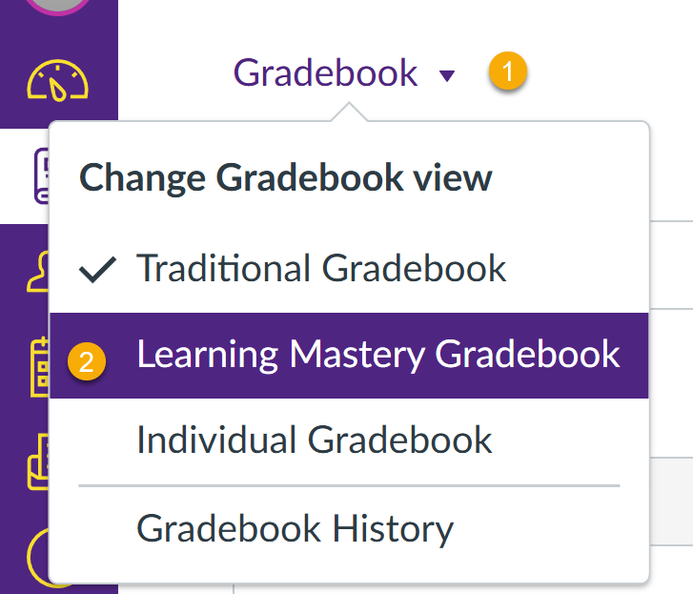

1. If they don’t see the ABET outcomes in their rubrics, they need to email John Starne ([jrstarne@PVAMU.EDU](mailto:jrstarne@PVAMU.EDU) ).