Table 1. END OF SEMESTER COURSE OUTCOME ASSESSMENT REPORT
CHEG 3023 Unit Operations
Fall 2019 SEMESTER

Report Prepared by: Dr. Keisha Antoine Report Date: December 20, 2019

 | Semester |  | Analysis Type |  | Number of Students |  |  | Outcome 2 (old Outcome e)  Ability to apply knowledge of mathematics, science, & engineering |  |  |  |  |  |  | Outcome 7 (old Outcome i)  Ability to recognize the need for and the ability to engage in life long learning
 |  |  |  |  |  |  |  | Expected Average | Expected Percent of students at or above average |  | Class Average |  | % Students Above Expected Average |  | Expected Average |  | Expected Percent of students at or above average |  | Class Average  % |  | % Students Above Expected Average
 |  | Fall 2019 |  | Direct |  | 20 | 75 |  |  | 70 |  | 78 |  | 65 |  | 75 |  | 70 |  | 86 |  | 95
 |  | Fall 2018 |  | Direct |  | 28 | 75 |  |  | 70 |  | 71 |  | 65 |  | 75 |  | 70 |  | 90 |  | 100
 |  | Fall 2017 |  | Direct |  | 35 | 75 |  |  | 70 |  | 68 |  | 58 |  | 75 |  | 70 |  | 86 |  | 100
 |  | Fall 2016 |  | Direct |  | 35 | 75 |  |  | 70 |  | 75 |  | 54 |  | 75 |  | 70 |  | 90 |  | 97
 |  | Fall 2015 |  | Direct |  | 25 | 75 |  |  | 70 |  | 80 |  | 87 |  | 75 |  | 70 |  | 92 |  | 100
 |  | Fall 2014 |  | Direct |  | 24 | 75 |  |  | 70 |  | 75.3 |  | 70 |  | 75 |  | 70 |  | 76 |  | 75.7
 |  | Implementation Summary |  |  |  |  | Review problems were given for each topic and most of them were solved in class. Instructor gave in class activity and group assignments.  Concepts of pressure and Bernouilli equation were taught with the aid of two lab assignments done in groups.  Scheduled office hours were provided to address student issues. |  |  |  |  |  |  |  |  | A group project was given to the students related to practical issues so that they can visualize the problems. Some concepts were challenging for the students to visualize – viscosity, film thickness and choosing the endpoints for use in the Bernouilli equation. The lab assignments and the group work helped to fix a lot of these concepts for them.
 |  | Perceived Problems |  |  |  |  | Students had difficulty conceptualizing the relationship between head and pressure.  Students relied heavily on the professor’s notes and were not inclined to read the text. Unit conversions is still an area of concern, but their ability is improving. |  |  |  |  |  |  |  |  | Students had issues to conceptualize the relationship between head and pressure.  Students rely heavily on the professor’s notes and are not inclined to read the text. Unit conversions is still an area of concern, but their ability is improving.
 |  | Plans for Addressing Problems |  |  |  |  | Tutor and grader help are suggested.  More hands on / laboratory projects related to fluid dynamics can help them to understand better. |  |  |  |  |  |  |  |  | Tutor and grader help are suggested.  More hands on / laboratory projects related to fluid dynamics can help them to understand better.
 |  | Overall Trend over Periods |  |  |  |  | The class average increased and was above target of 75%. The number of students above the average decreased and was below the target of 70%. |  |  |  |  |  |  |  |  | The class average decreased when compared to the previous semester but it still remained above the target of 75%. The number of students above the average decreased slightly when compared to the previous semester but was above the target of 70%.
 |  | Were Expectations Met? |  | Average≥75%?  70% students avg. ≥75%? |  |  | YES |  |  |  |  |  |  |  |  | YES

ABET Outcomes | 2.1: Ability to Define/Understand the Problem and then Plan the Project
Assignment | Q2-10/11/2019 | Project-Pressure group 9/16/2019 | T1-9/30/2019 | T2-Bernouilli Group-10/11/2019 | T3-PBCC Centrifugal-11/20/2019 | Final-12/6/2019 | Composite (2.1)
Class Average per Assignment | 8.3 | 83.3 | 52.6 | 213.0 | 84.5 | 81.0 | 166.1
Maximum Points | 15 | 100 | 100 | 245 | 100 | 105 | 212.3
1 | 13.0 | 81.0 | 55.5 | 234.0 | 95.0 | 99.0 | 185.2
2 | 10.0 | 81.0 | 30.0 | 217.0 | 90.0 | 87.0 | 162.6
3 | 15.0 | 81.0 | 59.0 | 215.0 | 90.0 | 80.0 | 172.7
4 | 3.5 | 81.0 | 93.0 | 234.0 | 85.0 | 86.0 | 191.1
5 | 4.0 | 78.0 | 49.0 | 186.0 | 80.0 | 51.0 | 143.5
6 | 8.0 | 81.0 | 20.0 | 217.0 | 75.0 | 89.0 | 152.7
7 | 9.0 | 93.0 | 100.0 | 217.0 | 95.0 | 94.0 | 194.8
8 | 4.0 | 78.0 | 8.0 | 215.0 | 75.0 | 44.0 | 134.9
9 | 9.5 | 93.0 | 86.5 | 186.0 | 93.0 | 93.0 | 176.0
10 | 6.0 | 81.0 | 55.0 | 215.0 | 93.0 | 97.0 | 174.7
11 | 10.0 | 93.0 | 75.0 | 234.0 | 93.0 | 87.0 | 189.2
12 | 12.0 | 78.0 | 52.5 | 217.0 | 95.0 | 80.0 | 172.1
13 | 15.0 | 78.0 | 90.0 | 186.0 | 65.0 | 99.0 | 168.1
14 | 6.0 | 81.0 | 47.0 | 215.0 | 105.0 | 102.0 | 177.6
15 | 5.0 | 81.0 | 22.5 | 186.0 | 90.0 | 72.0 | 142.5
16 | 13.0 | 81.0 | 56.0 | 186.0 | 75.0 | 101.0 | 158.7
17 | 1.0 | 81.0 | 69.0 | 215.0 | 50.0 | 36.0 | 146.9
18 | 8.5 | 93.0 | 22.0 | 234.0 | 95.0 | 82.0 | 167.3
19 | 10.5 | 93.0 | 33.0 | 234.0 | 75.0 | 88.0 | 165.6
20 | 3.0 | 78.0 | 29.0 | 217.0 | 75.0 | 52.0 | 145.9
 |  |  |  | ABET Outcome 2.1 | Class Average |  | 166.1
 |  |  |  | ABET Outcome 2.1 | Class Std Deviation |  | 17.5
 |  |  |  | ABET Outcome 2.1 | Class Average (%) |  | 78.2
 |  |  |  | ABET Outcome 2.1 | No. of students > Expected Class Average |  | 13
 |  |  |  | ABET Outcome 2.1 | % of Students > Class Average |  | 65

7.1: Acquire new knowledge using the appropriate learning strategies
Project-Pressure group 9/16/2019 | T2-Bernouilli Group-10/11/2019 | T3-PBCC Centrifugal-11/20/2019 | Average (7.1)
83.3 | 213.0 | 84.5 | 126.9
100 | 245 | 100 | 148.3
81.0 | 234.0 | 95.0 | 136.7
81.0 | 217.0 | 90.0 | 129.3
81.0 | 215.0 | 90.0 | 128.7
81.0 | 234.0 | 85.0 | 133.3
78.0 | 186.0 | 80.0 | 114.7
81.0 | 217.0 | 75.0 | 124.3
93.0 | 217.0 | 95.0 | 135.0
78.0 | 215.0 | 75.0 | 122.7
93.0 | 186.0 | 93.0 | 124.0
81.0 | 215.0 | 93.0 | 129.7
93.0 | 234.0 | 93.0 | 140.0
78.0 | 217.0 | 95.0 | 130.0
78.0 | 186.0 | 65.0 | 109.7
81.0 | 215.0 | 105.0 | 133.7
81.0 | 186.0 | 90.0 | 119.0
81.0 | 186.0 | 75.0 | 114.0
81.0 | 215.0 | 50.0 | 115.3
93.0 | 234.0 | 95.0 | 140.7
93.0 | 234.0 | 75.0 | 134.0
78.0 | 217.0 | 75.0 | 123.3
ABET Outcome 7.1 | Class Average |  | 126.9
ABET Outcome 7.1 | Class Std Deviation |  | 9.0
ABET Outcome 7.1 | Class Average (%) |  | 85.6
ABET Outcome 7.1 | No. of students > Expected Class Average |  | 19
ABET Outcome 7.1 | % of Students > Class Average |  | 95

7.2: Apply new knowledge to solve problems.
Project-Pressure group 9/16/2019 | T2-Bernouilli Group-10/11/2019 | T3-PBCC Centrifugal-11/20/2019 | Average (7.2)
83.3 | 213.0 | 84.5 | 126.9
100 | 245 | 100 | 148.3
81.0 | 234.0 | 95.0 | 136.7
81.0 | 217.0 | 90.0 | 129.3
81.0 | 215.0 | 90.0 | 128.7
81.0 | 234.0 | 85.0 | 133.3
78.0 | 186.0 | 80.0 | 114.7
81.0 | 217.0 | 75.0 | 124.3
93.0 | 217.0 | 95.0 | 135.0
78.0 | 215.0 | 75.0 | 122.7
93.0 | 186.0 | 93.0 | 124.0
81.0 | 215.0 | 93.0 | 129.7
93.0 | 234.0 | 93.0 | 140.0
78.0 | 217.0 | 95.0 | 130.0
78.0 | 186.0 | 65.0 | 109.7
81.0 | 215.0 | 105.0 | 133.7
81.0 | 186.0 | 90.0 | 119.0
81.0 | 186.0 | 75.0 | 114.0
81.0 | 215.0 | 50.0 | 115.3
93.0 | 234.0 | 95.0 | 140.7
93.0 | 234.0 | 75.0 | 134.0
78.0 | 217.0 | 75.0 | 123.3
ABET Outcome 7.2 | Class Average |  | 126.9
ABET Outcome 7.2 | Class Std Deviation |  | 9.0
ABET Outcome 7.2 | Class Average (%) |  | 85.6
ABET Outcome 7.2 | No. of students > Class Average |  | 19
ABET Outcome 7.2 | % of Students > Class Average |  | 95

Exercises for Evaluating Outcomes 2 and 7

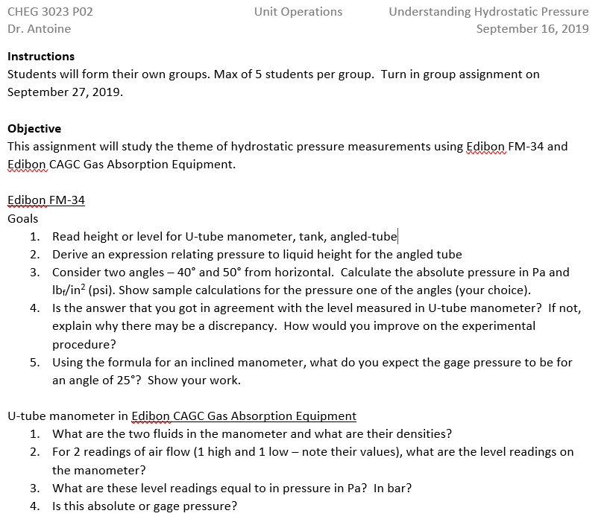

BLANK PAGE
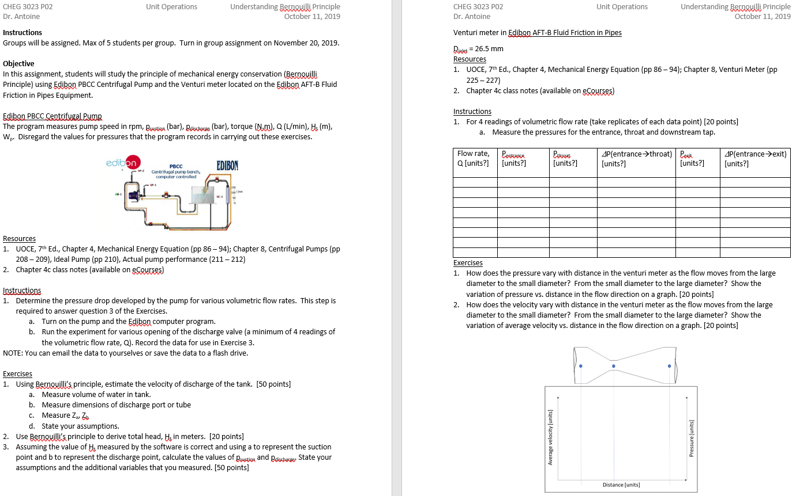

BLANK PAGE
