END OF SEMESTER COURSE OUTCOME ASSESSMENT REPORT
CHEG 2053 P01 MATERIAL AND ENERGY BALANCE: FALL 2019 SEMESTER

Report Prepared by: Dr. KEISHA ANTOINE Report Date: December 20, 2019
Semester |  | Analysis Type |  | Number of Students |  | Outcome D1 (old Outcomes a&e combined)  An ability to identify, formulate, and solve fundamental engineering problems by applying principles of engineering, science, and mathematics. |  |  |  |  | Outcome e  Ability to identify, formulate, and solve engineering problems  Now combined with outcome a in new Outcome D1
 |  |  |  |  |  | Expected Class Average |  | Expected Percent of students at or above average | Class Average | % Students meeting Expected Average | Expected Class Average | Expected Percent of students at or above average | Class Average | % Students meeting Expected Average
Fall 2019 | Direct |  | 13 |  | 75 |  | 70 |  | 54 | 8
Spring 2019 | Direct |  | 25 |  | 75 |  | 70 |  | 83 | 84
Implementation Summary | Items implemented from previous report or after meeting previous instructor |  |  |  | I spent extra contact hours instructing on basics – mathematical manipulations statistics, linear interpolation, calibration; physics and chemistry: pressure, moles, molecular weight balancing equations and stoichiometry. I focused also on fixing these concepts with mass balances for non-reactive and reactive systems.
Perceived Problems | Perceived problems are directly related to the PC and the sub items under them |  |  |  | This semester’s students did not seem especially motivated to perform. They enjoyed doing the group assignment, but individual performance was lacking. Additionally, even though we did several examples in class, most students still struggled to understand the chemical terminology: “distillation column”, “product was recovered”, “5% of x component in the feed was recovered in the overhead”. This suggested that the students did not spend adequate time in self-study or doing the assigned reading and recommended homework.
Plans for Addressing Problems | Plans for address specific measures to address PC and their sub areas |  |  |  | To increase motivation of students to study, I am thinking about making the early parts of the course closed book.
Overall Trend over Periods | Ascertain if there were improvements over previous semesters |  |  |  | The overall performance went down when compared to the previous semester.
Were Expectations Met? | Class Average ≥75% and ≥70% of Students Performed at or Above Expected Average. |  |  |  | NO |  |  |  |  |  | N/A  Transition to new ABET Student Learning Outcomes

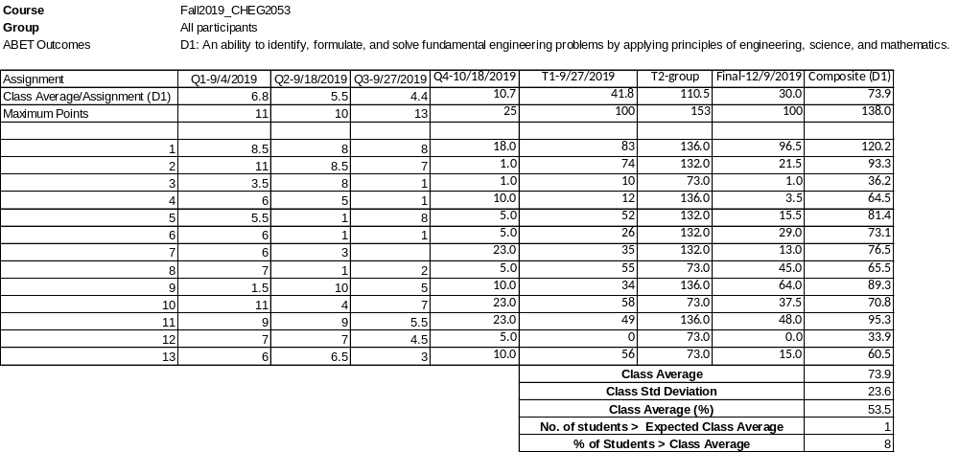

Exercises for Evaluating Outcome D1

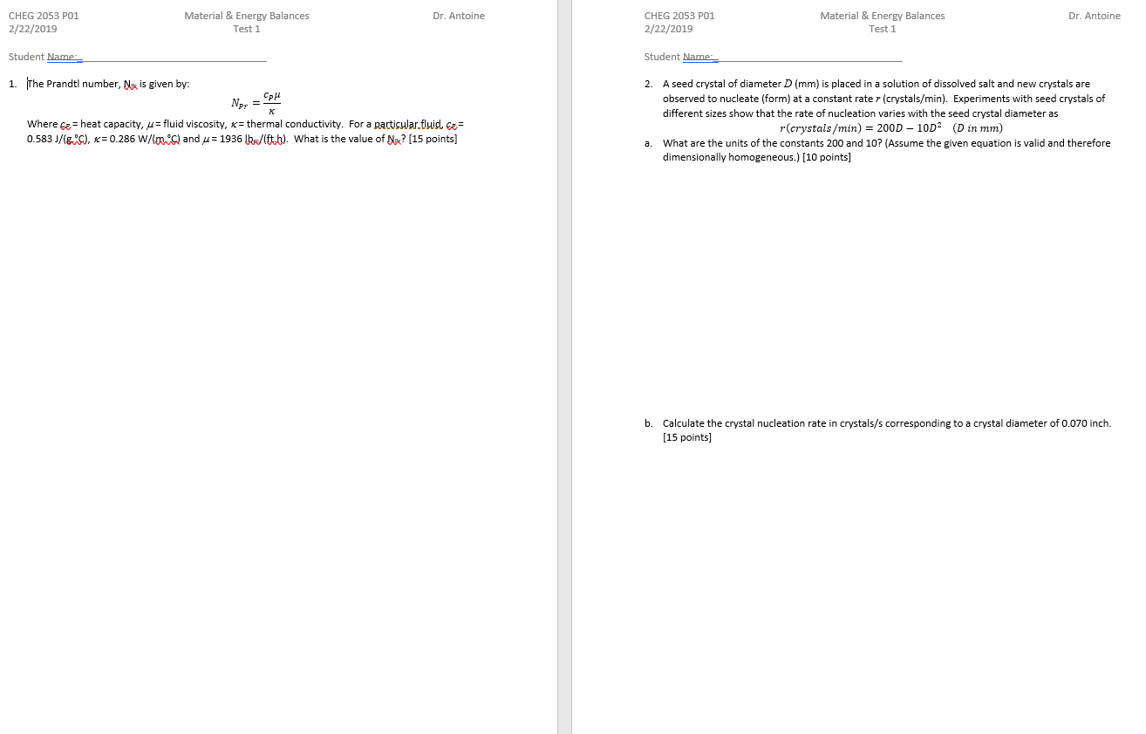

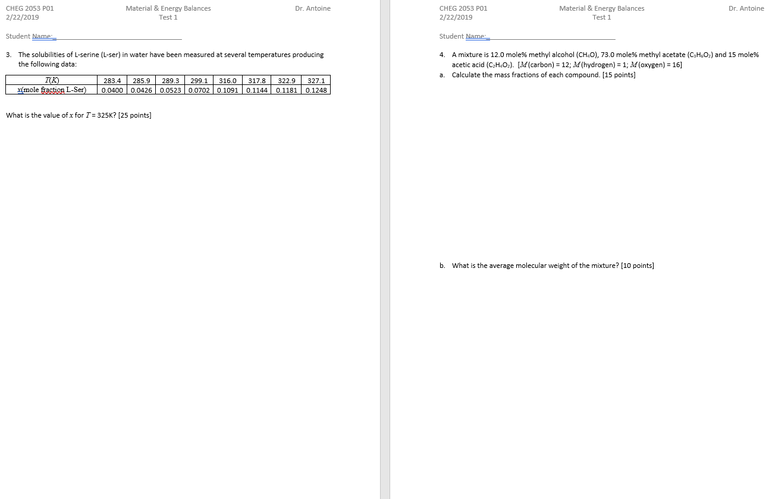

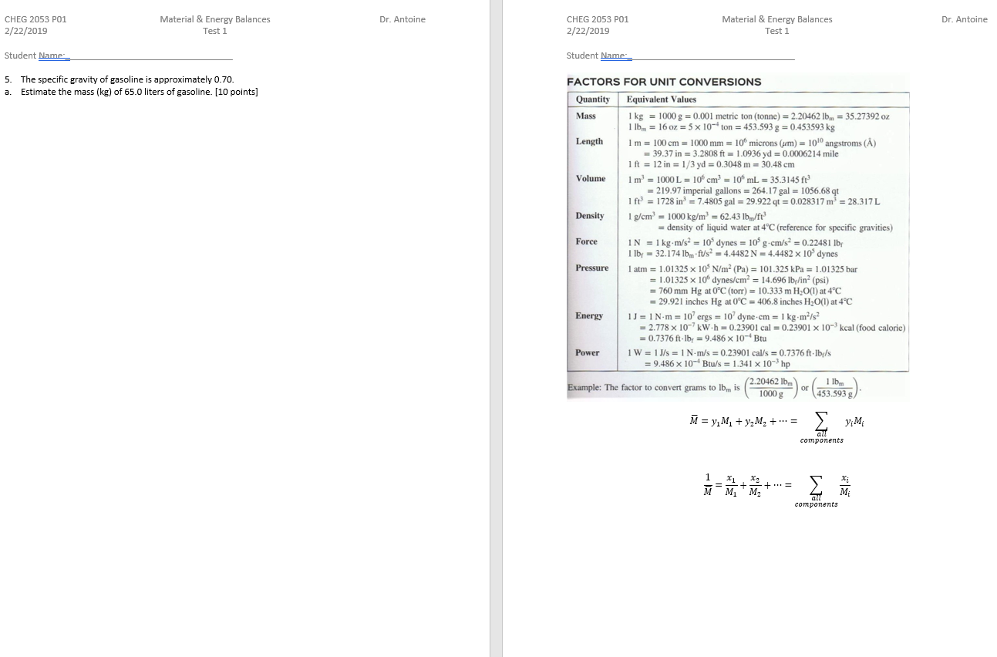

BLANK PAGE

