ROY G. PERRY COLLEGE OF ENGINEERING
CHEMICAL ENGINEERING DEPARTMENT
PRAIRIE VIEW A&M UNIVERSITY

ASSESSMENT REPORT

CHEG 2043 CHEMICAL ENGINEERING THERMODYNAMICS I

FALL 2019 SEMESTER

NAME OF INSTRUCTOR: Dr. Michael Gyamerah

TABLE OF CONTENTS

- Report Cover Page

- Detailed Course Syllabus

- End of Semester Outcomes Assessment Report

- Grade Sheet Showing Student and Class Performance in Outcomes

- Supporting Outcomes Specific Assignments

5.1 Assignments assessing students’ ability to identify, formulate, and solve fundamental engineering problems by applying principles of engineering, science, and mathematics.
(CHEG Students Learning Outcome D1)

Detailed Course Syllabus

Course Description in ABET Format
CHEG 2043 P01 – CHEMICAL ENGINEERING THERMODYNAMICS I

1. | Course number and name: | CHEG 2043-001: Chemical Engineering Thermodynamics I
2. | Credits and contact hours: | 3 credit hours; 3 contact hours
3. | Instructor’s or course  coordinator’s name: | Dr. Michael Gyamerah
4. | Text book: Title: | “Introduction to Chemical Engineering Thermodynamics”
 | Author: | J. M. Smith, H. C. Van Ness and M. M. Abbott, M.T Swihart.
 | Publisher, Year & Edition: | McGraw Hill, New York, 2017, 8th Edition.
 | - Other Supplemental material | 1 “Perry's Chemical Engineers' Handbook”, Edition 8, by Don Green, Robert Perry, Robert H. Perry  2.”Fundamentals of Engineering Thermodynamics,” by M.J Moran, H. N. Shapiro, D. D. Boettner, M. B. Bailey, Wiley, 2014, 8th Edition
5. | Specific course information
 | - Brief description of the content of the course (catalog description) | Introduction to Chemical Engineering Calculations. PVT properties of fluids, equations of state. First and second laws of thermodynamics. Applications to heat effects and flow processes.
 | - Prerequisites | CHEM 1043/CHEM 1034 General Chemistry/Chemistry for Engineers  PHYS 2513 University Physics I
 | - *Indicate whether a required, elective, or selected elective (as per definition provided) course in the program | Required
6. | Specific goals for the course | Students will be able to :
 | - specific outcomes of instruction | - Understanding of the laws of thermodynamics and apply them  - Understand of thermodynamic properties and calculate them  - Make thermodynamic calculations for flow processes, power cycles and refrigerators  - Analyze systems and determine feasibility based on consistency with the 1st and 2nd laws of thermodynamics.
 | - Explicitly indicate which of the student outcomes listed in Criterion 3 or any other outcomes are addressed by the course. | This course addresses the following student learning outcome determined by the department:  Outcome D1  Ability to identify, formulate, and solve fundamental engineering problems in thermodynamics by applying principles of engineering, science, and mathematics.
7 | Brief list of topics to be covered | - Introduction, Dimensions and Units, Fundamental and Secondary Quantities (3 hours)  - State Properties/Functions and Path Functions, Open and Closed systems, Equilibrium, The 1st Law of Thermodynamics, the Phase Rule and Equations for Process Calculations (7 hours)  - The 2nd Law of Thermodynamics, Entropy, Heat Engines and Carnot’s Theorem, and The 3rd Law of Thermodynamics (5 hours)  - PVT Properties of Fluids, Ideal Gas and Virial Equations of State, Cubic Equations and their Applications (7 hours)  - Heat Effects, and Heat Effects of Industrial Reactions (4 hours)  - Thermodynamic Properties of Fluids and Thermodynamic Diagrams (5 hours)  - Application of Thermodynamics to Flow Processes in Ducts, Nozzles, Turbines, Pumps, Compressors and Ejectors (5 hours)

Additional Course Syllabus Information
Office Hours: MWF 10:00 A. M. - 11:30 A.M. & 2:00 P.M. – 3:00 P.M.; F 2:00 P.M. - 4:00 P.M.
Office Location: C.L. Wilson 200A
Course Location: Juvenile Justice Building 257
Class Meeting Days & Times: MWF 12:00-12:50 PM (Lecture); W 5:30-6:20 PM (Recitation)

Table 1 Course Matrix Showing Outcomes covered in Various Courses
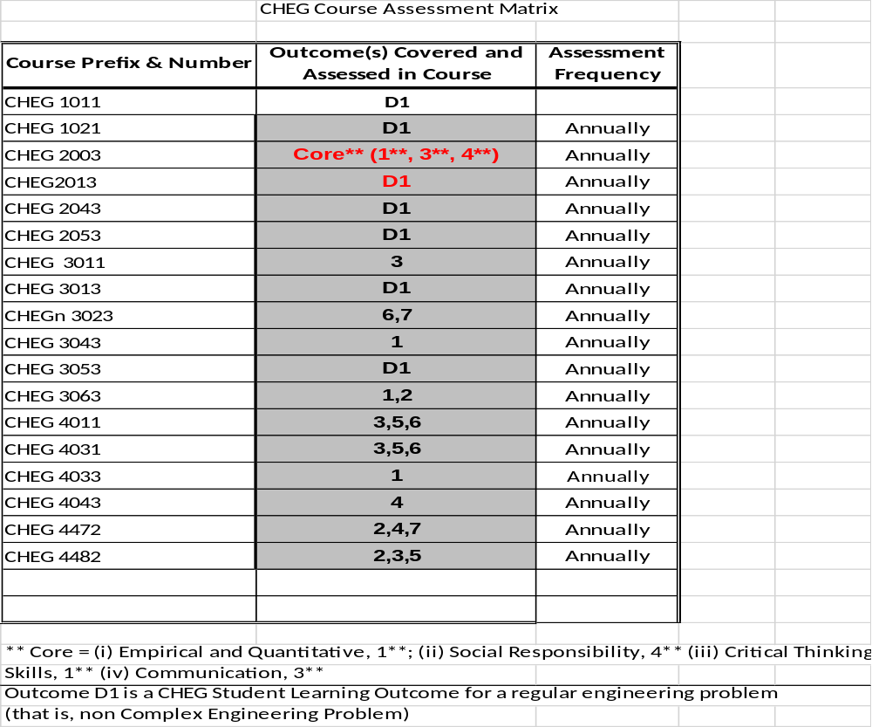
Grading Policy
  Item (Averages) | Weight % |  | Grade | Percentages
  Homework | 10 |  | A  B  C  D  F | 100-90  89-80  79-70  69-60  59 or below
  Exams | 25 |  | A  B  C  D  F | 100-90  89-80  79-70  69-60  59 or below
  Midterm Exam | 25 |  | A  B  C  D  F | 100-90  89-80  79-70  69-60  59 or below
  Final Exam | 40 |  | A  B  C  D  F | 100-90  89-80  79-70  69-60  59 or below
  Total | 100 |  | A  B  C  D  F | 100-90  89-80  79-70  69-60  59 or below
  Item (Averages) | Weight % |  | Grade | Percentages
  Homework | 10 |  | A  B  C  D  F | 100-90  89-80  79-70  69-60  59 or below
  Exams | 25 |  | A  B  C  D  F | 100-90  89-80  79-70  69-60  59 or below
  Midterm Exam | 25 |  | A  B  C  D  F | 100-90  89-80  79-70  69-60  59 or below
  Final Exam | 40 |  | A  B  C  D  F | 100-90  89-80  79-70  69-60  59 or below
  Total | 100 |  | A  B  C  D  F | 100-90  89-80  79-70  69-60  59 or below

TENTATIVE CLASS SCHEDULE

Week | Chapter | Topics
1 | 1: Introduction | Dimensions and Units, Measures of amount or Size, Force, Temperature, Pressure, Work, Energy, Heat
2 | 2: The First Law and Other Basic Concepts | Joule’s Experiments, Internal Energy, The First Law of Thermodynamics, Energy Balance For Closed Systems, Thermodynamic State and State Functions, Equilibrium
3 | 2: The First Law and Other Basic Concepts | The Phase Rule, The Reversible Process, Constant-V and Constant-P Processes, Enthalpy, Heat Capacity, Mass and Energy Balances For Open Systems
4 | 3: Volumetric Properties of Pure Fluids | PVT Behavior of Pure Substances, Virial Equations of State, The Ideal Gas, Application of the Virial Equations
5 | 3: Volumetric Properties of Pure Fluids | Cubic Equations of State, Generalized Correlations for Gases, Generalized Correlations for Liquids
6 | 4: Heat Effects | Sensible Heat Effects, Latent Heats of Pure Substances, Standard Heat of Reaction, Standard Heat of Formation
7 | 4: Heat Effects | Standard Heat of Combustion, Temperature Dependence of  ∆H°, Heat Effects of Industrial Reactions
8 | 5: The Second Law of Thermodynamics | Statements of the Second Law, Heat Engines, Thermodynamic Temperature Scales, Entropy, Entropy Changes of an Ideal Gas, Mathematical Statement of the Second Law
MIDTERM EXAM
9 | 5: The Second Law of Thermodynamics | Entropy Balance for Open Systems, Calculation of Ideal Work, Lost Work, The Third Law of Thermodynamics, Entroy from the Microscopic View Point
10 | 6: Thermodynamic Properties of Fluids | Property Relations for Homogeneous Phases, Residual Properties, Residual Properties by Equations of State, Two- Phase Systems
11 | 6: Thermodynamic Properties of Fluids | Thermodynamic Diagrams, Tables of Thermodynamic Properties, Generalized Property Correlations for Gases
12 | 7: Applications of Thermodynamics to Flow Processes | Duct Flow of Compressible Fluids, Turbines, Compression Processes
13 | 8: Production of Power From Heat | The Steam Power Plant, Internal-Combustion Engines, Jet Engines, Rocket Engines
14 | 9: Refrigeration and Liquefaction | The Carnot Refrigerator, The Vapor-Compression Cycle, The Heat Pump,
15 | Review & Final Exam  Mark your calendar! | December 6, 2019

End of Semester
Course Assessment Report

This summary contains the following Information

1. Performance Statistics
- Total number of students in class
- The class average performance (stated as %) in each course outcome assessed in this class and the two previous times course was assessed.
- The acceptable class average for the class in each outcome area as set by your Department. You cannot use any number of your choice
- Percentage of students who scored below the expected average in each outcome.

2. Implementation Summary
- Brief summary of plans implemented during the semester based on last assessment report

3. Perceived Problems
- Instructor’s critical evaluation of perceived problems that affected students’ performance. Realistic problems should be identified throughout the semester and summarized in this section of the report.

4. New Plans for Addressing Problems
- Instructor’s plans for addressing the perceived problems the next time the class is taught. These should be specific enough for another instructor to implement. Most of these should be things that, you, the instructor can implement to help students to improve. Be creative.

5. Overall Trend over last three assessment periods
- Instructor’s summary of overall performance trend for each outcome measured over the last three periods.

5. Were Expectations Met?
- Answer YES if the class average was above the expected average and the stated percentage of students scored at or above the expected average, else answer NO.

END OF SEMESTER COURSE OUTCOME ASSESSMENT REPORT
CHEG 2043-001 CHEMICAL ENGINEERING THERMODYNAMICS I, FALL 2019 SEMESTER
OUTCOME: CHEG Student Learning Outcome D1: Ability to identify, formulate and solve fundamental engineering problems Report Prepared by: Dr. Michael Gyamerah Report Date: December 20, 2019
Semester | Analysis Type | Number of Students | CHEG Student Learning Outcome D1: Ability to identify, formulate and solve fundamental engineering problems |  |  |  | Outcome e  Ability to identify, formulate, and solve engineering problems
Semester | Analysis Type | Number of Students | Expected Class Average/ | Expected Percent of students at or above average | Class Average | % Students meeting Expected Average | Expected Class Average | Expected Percent of students at or above average | Class Average | % Students meeting Expected Average
Fall 2019 | Direct | 20 | 75 | 70 | 76 | 60
Spring 2019 | Direct | 22 |  |  |  |  | 75 | 70 | 79 | 77
Implementation Summary | Items implemented from previous report or after meeting previous instructor |  | Students were provided with handouts detailing an effective approach to problem solving thermodynamics problems. |  |  |  | Transition to new ABET Student Learning Outcomes
Perceived Problems | Perceived problems are directly related to the PC and the sub items under them |  | Overall student performance was fair in this area, with a class average 1% point above the expected class average. However, 60 % of the students met the expected class average, which was 10 % percentage points below the expected value. Nearly 40 % of the students did not demonstrate the ability to convert word problems to equations and use units correctly, and apply relevant conservation equations as well as effective approach to problem solving. |  |  |  | Transition to new ABET Student Learning Outcomes
Plans for Addressing Problems | Plans for address specific measures to address PC and their sub areas |  | The following will be implemented the next time the course is offered:  Handouts will be prepared for students with a worked example, detailing an effective approach to problem solving prior to the first homework assignment. Coordination with the Physics Department will be carried out to help emphasize the sections in PHYS 2013 that form a strong foundation for CHEG 2043. A diagnostic test covering relevant sections of the pre-requisites will be conducted at the start of the course to ascertain the possible remedies during the teaching of the course. |  |  |  | Transition to new ABET Student Learning Outcomes
Overall Trend over Periods | Ascertain if there were improvements over previous semesters |  | The overall average students' performance in the outcome was 1 % point above the expected average with 60 % of the students meeting the expected course average. The students’ performance was therefore, 10 % points below the expected percentage of students to score at above the expected average. This is the first time this CHEG student learning outcome designated as D1 is being assessed. |  |  |  | Transition to new ABET Student Learning Outcomes
Were Expectations Met? | Class Average ≥75% and ≥70% of Students Performed at or Above Expected Average. |  | NO |  |  |  | Transition to new ABET Student Learning Outcomes

Grade Sheet Showing
Student and Class Performance in Outcomes

Grade Sheet Showing Student and Class Performance in Student Learning Outcomes

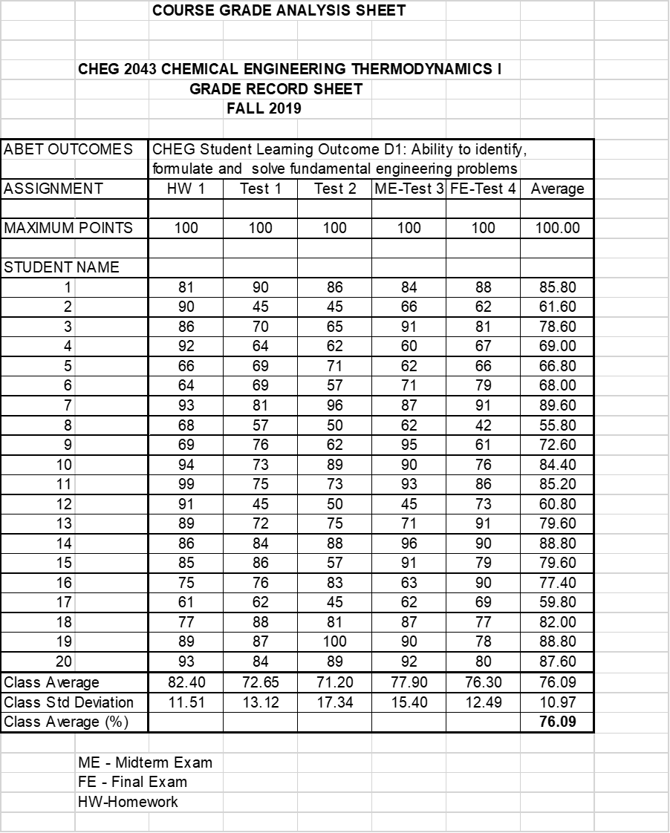

OUTCOME SPECIFIC ASSIGNMENTS
USED TO ASSESS OUTCOMES

ASSIGNMENTS FOR CHEG STUDENT LEARNING OUTCOME D1

An ability to identify, formulate, and solve fundamental engineering problems by applying principles of engineering, science, and mathematics.

CHEMICAL ENGINEERING DEPARTMENT
OUTCOMES SPECIFIC ASSIGNMENT COVER SHEET
CHEMICAL ENGINEERING THERMODYNAMICS I
FALL 2019
Instructor: Dr. Michael Gyamerah

Title of Assignment

Midterm Exam

Outcome Measured Using this Assignment
Outcome: CHEG Student Learning Outcome D1
An ability to identify, formulate, and solve fundamental engineering problems by applying principles of engineering, science, and mathematics.

Check the engineering problem characteristics related to this assignment

Assignment problem
 | involves wide-ranging or conflicting technical issues,
 | has no obvious solution
 | Addresses problems not encompassed by current standards and codes
 | involves diverse groups of stakeholders
 | includes many component parts or sub-problems
 | involves multiple disciplines
 | has significant consequences in a range of contexts
Assignment problem involves the application of the principles of
X | engineering
X | science
X | mathematics

Brief justification of why this assignment is suitable for this outcome

The questions on Midterm Exam test the students’ apply knowledge and application of algebra, science (physics) and engineering to solve fundamental engineering problems involving overall energy balance applied to an incompressible fluid in an open system.

Sample of graded student’s solution

Chemical Engineering Thermodynamics I (Fall 2019): Midterm Exam

October 18, 2019

Answer all questions. You will be graded based on your ability to apply knowledge and application of algebra, science (physics) and engineering to solve fundamental engineering problems. Clarity of presentation would ensure that you do not lose all the points for a calculation if you should make a mistake.

Water at 86 ºF is pumped through a “perfectly” insulated pipe of uniform diameter from a storage tank at a rate of 50 gal min⁻¹. The motor of the pump supplies work at a rate of 15 hp. The water is delivered to a second storage tank at an elevation 45 ft above the first tank.
- What is the temperature of the water delivered to the second tank?
- What is the temperature rise of the water?
Given: The density of water at 86 ºF may be taken as 62.31 lb_{m}/ft³, 1 ft³ is equivalent to 7.48 gallons and 1 hp is equivalent to 42.41 Btu/min. You may assume a value of 1.0Btu/lb_{m} ºF as the Cp of the water in the two storage tanks.

CHEMICAL ENGINEERING DEPARTMENT
OUTCOMES SPECIFIC ASSIGNMENT COVER SHEET
CHEMICAL ENGINEERING THERMODYNAMICS I
FALL 2019
Instructor: Dr. Michael Gyamerah

Title of Assignment

Final Exam

Outcome Measured Using this Assignment
Outcome: CHEG Student Learning Outcome D1
An ability to identify, formulate, and solve fundamental engineering problems by applying principles of engineering, science, and mathematic.

Check the engineering problem characteristics related to this assignment

Assignment problem
 | involves wide-ranging or conflicting technical issues,
 | has no obvious solution
 | Addresses problems not encompassed by current standards and codes
 | involves diverse groups of stakeholders
 | includes many component parts or sub-problems
 | involves multiple disciplines
 | has significant consequences in a range of contexts
Assignment problem involves the application of the principles of
X | engineering
X | science
X | mathematics

Brief justification of why this assignment is suitable for this outcome
The three questions on the Final Exam test the students’ ability to apply knowledge of (1) basic mathematics (algebra) and intermediate mathematics involving differential and integral calculus, (2) PVT properties of pure substances, and (3) thermodynamic systems and processes in identifying, formulating and solving fundamental engineering problems

MECHANICAL ENGINEERING DEPARTMENT

Chemical Engineering Thermodynamics I (Fall 2019): Final Exam

December 6, 2019

Answer all questions. You will be graded based on (1) your ability to apply knowledge of basic mathematics (algebra) and intermediate mathematics involving differential and integral calculus, (2) your ability to apply your knowledge of thermodynamic systems and processes, and (3) your ability to formulate and solve engineering problems. Clarity of presentation would ensure that you do not lose all the points for a calculation if you should make a mistake.

1. (a) Define: (i) Gauge pressure, (ii) Absolute pressure, and
(iii) Write the equation showing the relationship between gauge pressure and absolute pressure.
(b) A water manometer (a tube open to the atmosphere at one end) has a reading of 6.55m of water. The density of water is 996kg/m³, the local acceleration of gravity is 9.807ms⁻², and the barometric pressure (atmospheric pressure) is 101.325x10⁵ N/m²
(i) Calculate the gauge pressure in N/m²
(ii) Calculate the absolute pressure in N/m²
2. Virial coefficients of isopropanol vapor at 200ºC are:
B = -388cm³mol⁻¹ and C = -26000 cm⁶mol⁻². If R = 83.14cm³barmol⁻¹K⁻¹,

Calculate the molar volume V and compressibility factor Z for isopropanol vapor at 200ºC and 10 bar by:
- the virial equation truncated to two terms Z = 1 + PB/RT
- calculate the percentage deviation of Z from ideal gas behavior
You may assume that that if isopropanol were to be an ideal gas PV = RT for a mole of the isopropanol.

3. (a) State the first law of thermodynamic for a closed system, stating clearly what each term in the equation represents.

(b) One mole of an ideal gas with Cp = (7/2)R and Cv = (5/2)R expands from P₁ = 8 bar and T₁ = 600K to P₂ = 1 bar in a mechanically reversible closed-system process. R = 8.314Jmol⁻¹K⁻¹,

For an isothermal process, calculate:
Calculate:
W
Q
∆U and
∆H

