END OF SEMESTER COURSE OUTCOME ASSESSMENT REPORT
CHEG 2013 P01 MATERIAL SCIENCE and ENGINEERING: FALL 2019 SEMESTER

Report Prepared by: Dr. KEISHA ANTOINE Report Date: December 20, 2019
Semester |  | Analysis Type |  | Number of Students |  | Outcome D1 (old Outcomes a&e combined)  An ability to identify, formulate, and solve fundamental engineering problems by applying principles of engineering, science, and mathematics. |  |  |  |  | Outcome e  Ability to identify, formulate, and solve engineering problems  Now combined with outcome a in new Outcome D1
 |  |  |  |  |  | Expected Class Average |  | Expected Percent of students at or above average | Class Average | % Students meeting Expected Average | Expected Class Average | Expected Percent of students at or above average | Class Average | % Students meeting Expected Average
Fall 2019 | Direct |  | 20 |  | 75 |  | 70 |  | 71 | 55
Spring 2019 | Direct |  | 11 |  | 75 |  | 70 |  | 79 | 73
Fall 2018 | Direct |  | 37 |  | 75 |  | 70 |  | 72 | 74 | 75 | 70 | 74 | 70
FALL 2017 | Direct |  | 46 |  | 75 |  | 70 |  | 68 | 38 | 75 | 70 | 67 | 49
SPRING 2017 | Direct |  | 40 |  | 75 |  | 70 |  | 67 | 56 | 75 | 70 | 63 | 49
FALL 2016 | Direct |  | 53 |  | 75 |  | 70 |  | 77 | 60 | 75 | 70 | 81 | 75
SPRING 2016 | Direct |  | 38 |  | 75 |  | 70 |  | 78 | 79 | 75 | 70 | 75 | 82
Fall 2015 | Direct |  | 44 |  | 75 |  | 70 |  | 74 | 70 | 75 | 70 | 75 | 68
Implementation Summary | Items implemented from previous report or after meeting previous instructor |  |  |  | The importance of students’ abilities to apply the knowledge of science in engineering. Students basic concepts on physics and chemistry were tested in the first exam. |  |  |  |  |  | The importance of understanding, formulating and solving engineering problems on stress analysis, diffusion, phase diagram was focused.
Perceived Problems | Perceived problems are directly related to the PC and the sub items under them |  |  |  | Students continue to struggle with applying general knowledge of physics and chemistry in crystal structure, atomic bonds.  Homework is assigned, but not graded, therefore, the students may opt not to do the recommended reading and homework. |  |  |  |  |  | Students were not able to identify or understand the basic concepts of mechanical properties involved thus were unable to solve the problems. Such as force, stress strain. Students very easily get confused with the problem statements and phase diagrams.
Plans for Addressing Problems | Plans for address specific measures to address PC and their sub areas |  |  |  | The instructor spent more contact hours to emphasize general knowledge concepts and to relate them to crystal structure, bonding and their effects on material properties.  Many homework problems are worked in class. The tests are reflective of the homework assigned. Students have begun to pay attention to the homework as a result.  Having a grader for the homework will allow us to accept homework for submission. This may encourage students to do the homework. |  |  |  |  |  | Instructor Focused on the importance on how to identify, formulate, and solve engineering problems. Used More activity problems in class. Giving problem statement and group work to focus on phase diagrams and transformation.
Overall Trend over Periods | Ascertain if there were improvements over previous semesters |  |  |  | Students’ performance fell below expected class average. |  |  |  |  |  | The class average was about 75% .
Were Expectations Met? | Class Average ≥75% and ≥70% of Students Performed at or Above Expected Average. |  |  |  | NO |  |  |  |  |  | N/A  Transition to new ABET Student Learning Outcomes

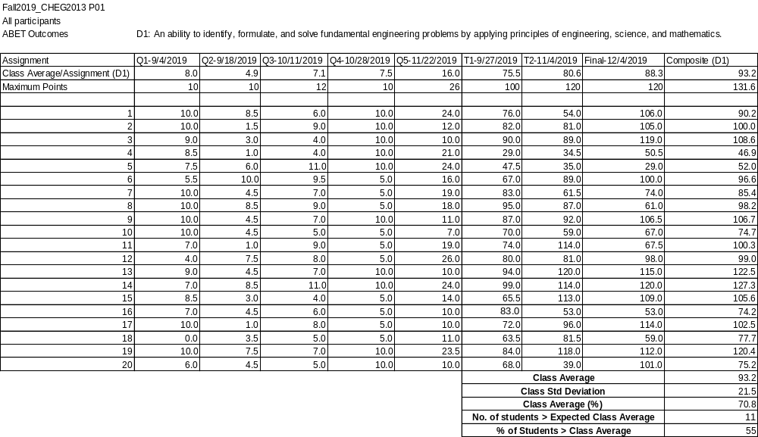

Exercises for Evaluating Outcome D1

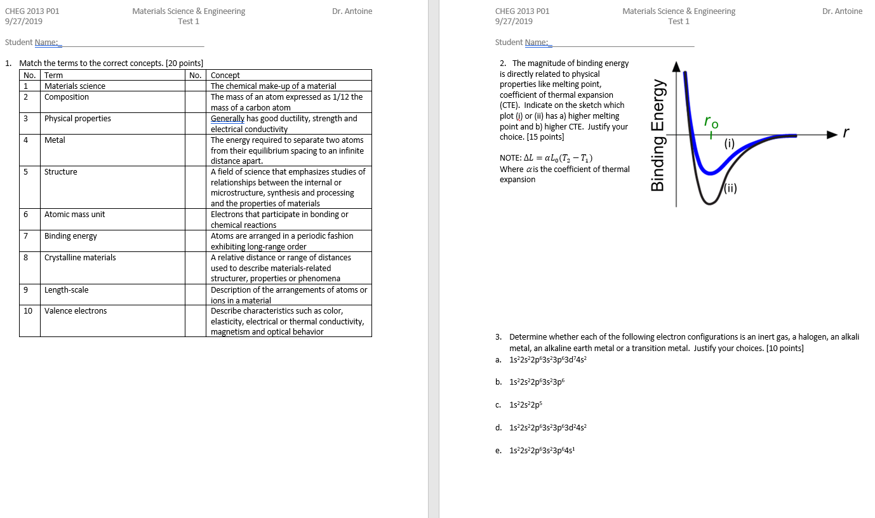

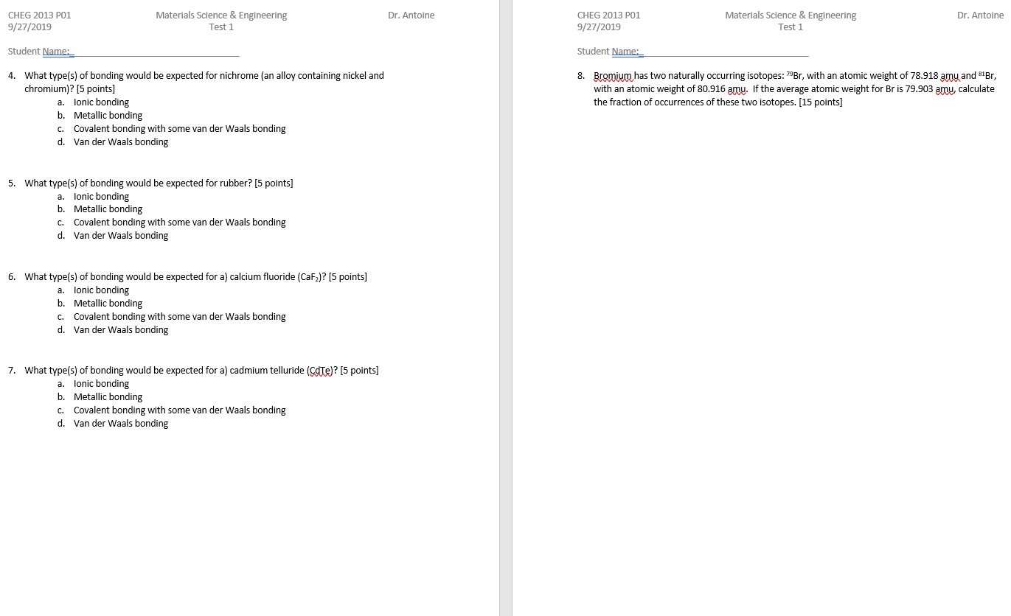

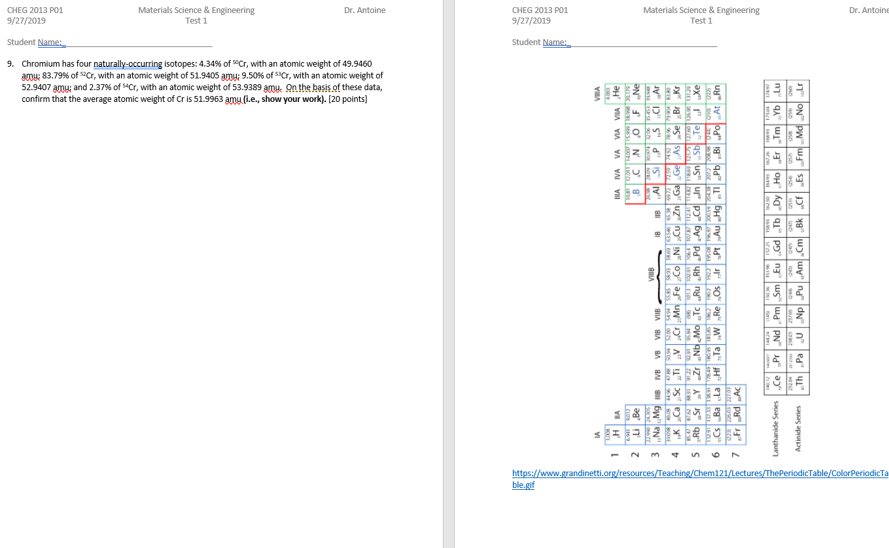
BLANK PAGE

