ASSESSMENT REPORT

ROY G. PERRY COLLEGE OF ENGINEERING
CHEMICAL ENGINEERING DEPARTMENT
PRAIRIE VIEW A&M UNIVERSITY

ASSESSMENT REPORT COVER PAGE

CHEG 1021-P01: INTRO TO CHEG LAB

FALL 2019 SEMESTER

NAME OF INSTRUCTOR: DR. SHEENA M. REEVES

TABLE OF CONTENTS

- Report Cover Page

- Detailed Course Syllabus (ABET + Additional Information)

- End of Semester Outcomes Assessment Report (New Format)

- Grade Sheet Showing Student and Class Performance in Outcomes

- Supporting Outcomes Specific Assignments (Minimum of 2 per outcome except for Project Reports where one is enough)

Course Description in ABET Format
CHEG 1021-P01: Introduction to CHEG Lab
1. | Course number and name: | CHEG 1021-P01: Introduction to CHEG Lab
2. | Credits and contact hours: | 1 credit hours; 3 contact hours
3. | Instructor’s or course  coordinator’s name: | Dr. Sheena M. Reeves
4. | Text book: Title: | N/A
 | Author:
 | Publisher, Year & Edition:
 | - Other Supplemental material | 1. “Spreadsheet Tools for Engineers Using Excel Including Excel 2002” by Byron S. Gottfried, McGraw Hill (Boston, 2003), ISBN 0-07-248068-8  2. “Basic Principles and Calculations in Chemical Engineering” by David Himmelblau, 7th Edition (2003), Prentice Hall, ISBN 978-0-131-40634-6
5. | Specific course information
 | - Brief description of the content of the course (catalog description) | Introduction to the field of engineering, industries, careers, and the curriculum. Basic engineering terms, concepts, calculations problem solving skills, ethics, and computer applications.
 | - Prerequisites or  Co-requisites | Freshman standing in the Chemical Engineering major.
 | - *Indicate whether a required, elective, or selected elective (as per definition provided) course in the program | Required
6. | Specific goals for the course | Students will be able to :
 | - specific outcomes of instruction | 1. identify, sketch, or discuss concepts associated with chemical engineering.  2. formulate fundamental chemical engineering concepts such as mass, mole, composition, density and molecular weight.  3 solve fundamental chemical engineering problems using engineering problem solving strategies and computer applications software.
 | - Explicitly indicate which of the student outcomes listed in Criterion 3 or any other outcomes are addressed by the course. | This course addresses:  Outcome 8  Ability to identify, formulate, and solve fundamental engineering problems by applying principles of engineering, science, and mathematics.
7 | Brief list of topics to be covered | Introduction to Process Controls (3)  Microsoft Excel Basics (6)  Creating/Maintaining a Course Binder (4)  Introduction to Matlab (6)  Ethics in Engineering (3)  Conversions (3)  Preventing Plagiarism Presentation (3)  CHEG Processes (9)  Visio (6)

GRADING POLICY
 |  |  |  |  | Points
Item | Points |  | Grade Scale: | A = | 1000 - 900
Homework | 200 |  |  | B = | 899 - 800
Class Activities/Projects | 250 |  |  | C = | 799 - 700
Midterm | 300 |  |  | D = | 699- 550
Final | 250 |  |  | F = | 549 or below
Complete Course Notebook | Extra 50

A signifies that the student has mastered the subject matter and understands all concepts covered.
B signifies that the student has a good understanding of the subject matter with few exceptions.
C signifies that the student has an adequate understanding of the material and can follow most concepts.
D signifies that the student does not understand important class concepts needed to be successful in future courses.
F signifies that the student has missed significant assignments or does not understand several concepts.
TESTS & TESTING POLICY

- All tests are closed book and closed notes.
- NO MAKE-UP EXAMS WILL BE GIVEN. A missed exam due to an excusable absence will not be added into the students Test Average; instead, only two tests will count for that student. NO EXCEPTIONS!
- No electronic device will be allowed including iPads and eReaders.
- No graphing or programmable calculators are allowed for any test or quiz. Students must purchase a small scientific calculator to use on exams. A cell phone cannot be used as a replacement for a calculator on an exam. Doing so will result in a zero.
- No bathroom breaks are allowed during a test. If a student leaves the room during this time, their exam/quiz will be collected and considered finished by the student.
- Any act of cheating will result in a grade of zero for that student, and the student will be referred to the department head. Such meetings must take place within a week of the violation.
HOMEWORK POLICY & GUIDELINES

- This course involves the usage of computer software. Several individual and group assignments will be given throughout the semester.
- Specific homework assignments will be given throughout the semester as the instructor examines the specific need of the class.
- Students must submit these assignments BEFORE the beginning of class.
- If a student chooses to disobey the university’s honor code and copy the solution manual instead of submitting the student’s own independent work, the student will receive a grade of zero on the assignment and will be referred to the department head. Such meetings must take place within a week of the infraction.
- All homework assignments must be submitted on engineering paper.
- Write only on the front of the paper.
- Staple assignment if it is more than one page.
- Write your name, date, and assignment number on the front page.
- Number your pages! From time-to-time, students staple the pages out of order.
- Homework is due at the beginning of the class period. Late homework assignments will NOT be accepted!

CLASS ACTIVITIES AND PARTICIPATION GRADES
- Students are expected to attend class on a regular basis and are expected to participate in classroom discussions. A student who fails to attend class is risking a poor mark in this area.
- There are zero opportunities to makeup a class activity.
- Students must submit these assignments during a given time frame.

FINAL EXAM PROCEDURES
- The comprehensive final exam is closed book.
- All students are required to take the final exam. No exemptions are given.
- It is the student’s responsibility to arrive on time for the exam with all of the needed materials.
TENTATIVE LECTURE SCHEDULE

Wk | Lecture Topic | Reading Assignment | Graded Assignment
1 | Introduction; Meet and greet; discuss syllabus. | Excel Basics
2 | Microsoft Excel Basics  HOLIDAY: 9/2
3 | Creating/Maintaining a Course Binder;  Using Engineering Paper | Matlab Basics | Homework 1
4 | Introduction to Matlab | Ethics | Homework 2
5 | Ethics in Engineering  (Review Case Studies in Groups) |  | Homework 3
6 | Class Lab Activity #1: Conversions  ( PASCO Mole Set and PASCO Density Set with digital scale)
7 | Preventing Plagiarism Presentation  Case Study Debate #1 | Plagiarism Scenarios
8 |  |  | Midterm Exam
9 | Introduction to Chemical Engineering Processes  Case Study Debate #2 | CHEG Processes
10 |  |  | Homework 4
11 | Class Lab Activity #2: Pressure and Diffusion  (using PASCO tablets, PASCO pressure sensors, beakers, and magnetic stirrers) |  | Homework 5
12 | AIChE Conference  (Groups meet to prepare for presentations)
13 | Group Presentations
14 | Group Presentations  Holiday 11/28
15 | Review for Final: 12/2
 | Final Exam Period Final Exam Period:  TBD |  | Final Exam

UNIVERSITY RULES AND PROCEDURES

Disability statement (See Student Handbook)
Students with disabilities, including learning disabilities, who wish to request accommodations in class should register with the Services for Students with Disabilities (SSD) early in the semester so that appropriate arrangements may be made. In accordance with federal laws, a student requesting special accommodations must provide documentation of their disability to the SSD coordinator.

Academic misconduct (See Student Handbook)
You are expected to practice academic honesty in every aspect of this course and all other courses. Make sure you are familiar with your Student Handbook, especially the section on academic misconduct. Students who engage in academic misconduct are subject to university disciplinary procedures.

Forms of academic dishonesty
- Cheating: deception in which a student misrepresents that he/she has mastered information on an academic exercise that he/she has not mastered; giving or receiving aid unauthorized by the instructor on assignments or examinations.
- Academic misconduct: tampering with grades or taking part in obtaining or distributing any part of a scheduled test.
- Fabrication: use of invented information or falsified research.
- Plagiarism: unacknowledged quotation and/or paraphrase of someone else’s words, ideas, or data as one’s own in work submitted for credit. Failure to identify information or essays from the Internet and submitting them as one’s own work also constitutes plagiarism.

Nonacademic misconduct (See Student Handbook)
The university respects the rights of instructors to teach and students to learn. Maintenance of these rights requires campus conditions that do not impede their exercise. Campus behavior that interferes with either (1) the instructor’s ability to conduct the class, (2) the inability of other students to profit from the instructional program, or (3) campus behavior that interferes with the rights of others will not be tolerated. An individual engaging in such disruptive behavior may be subject to disciplinary action. Such incidents will be adjudicated by the Dean of Students under nonacademic procedures.

Sexual misconduct (See Student Handbook)
Sexual harassment of students and employers at Prairie View A&M University is unacceptable and will not be tolerated. Any member of the university community violating this policy will be subject to disciplinary action.

Attendance Policy
Prairie View A&M University requires regular class attendance. Excessive absences will result in lowered grades. Excessive absenteeism, whether excused or unexcused, may result in a student’s course grade being reduced or in assignment of a grade of “F”. Absences are accumulated beginning with the first day of class.

Student Academic Appeals Process
Authority and responsibility for assigning grades to students rests with the faculty. However, in those instances where students believe that miscommunication, errors, or unfairness of any kind may have adversely affected the instructor's assessment of their academic performance, the student has a right to appeal by the procedure listed in the Undergraduate Catalog and by doing so within thirty days of receiving the grade or experiencing any other problematic academic event that prompted the complaint.

Course Outcome 1: This outcome is the same as program outcome 8.
Students will have an ability to identify, formulate, and solve fundamental engineering problems by applying principles of engineering, science, and mathematics.

The two performance criteria used to assess this outcome consist of
1. Ability to identify, sketch, or discuss concepts associated with chemical engineering.
Students are able to:
- Discuss or present the role of engineers in society, career opportunities, career paths, job environment, and performance expectations.
- Discuss the ethical and professional responsibilities of chemical engineers.
- Describe the different chemical processes and how the processes operate.
- Effectively communicate ideas using both oral and written communications while avoiding dishonesty and plagiarism.
- Prepare a simple report discussing in class experiments.
- Create a process flow diagram, flow chart, or Gantt chart using Visio.

2. Ability to formulate fundamental chemical engineering concepts such as mass, mole, composition, density and molecular weight.
Given a problem, the student is able to:
  - Perform unit conversions given a conversion table.
  - Convert a given value from mass to moles or moles to mass using molecular weight.
  - Write values using the correct number of significant figures.
  - Depict a number using scientific notation.

3. Ability to solve fundamental chemical engineering problems using engineering problem solving strategies and computer applications software.
Given a problem, the student is able to:
  - Input formulas and perform calculations using Excel or Matlab.
  - Calculate mass fractions or mole fractions given mass/mole amounts.
  - Determine an unknown species through a hands-on density calculation based on measured mass and volume.

END OF SEMESTER COURSE OUTCOME ASSESSMENT REPORT
CHEG 1021-P01 INTRO CHEMICAL ENGINEERING LAB: FALL 2019 SEMESTER

Report Prepared by: Dr. Sheena M. Reeves Report Date: December 20, 2019
Semester | Analysis Type | Number of Students | Outcome 8.1  Ability to identify, sketch, or discuss concepts associated with chemical engineering. |  |  |  |  |  | Outcome 8.2  Ability to formulate fundamental chemical engineering concepts such as mass, mole, composition, density and molecular weight. |  |  |  |  |  |  |  | Outcome 8.3  Ability to solve fundamental chemical engineering problems using engineering problem solving strategies and computer applications software. |  |  |  | Outcome 8  Ability to identify, formulate, and solve fundamental engineering problems by applying principles of engineering, science, and mathematics.
Semester | Analysis Type | Number of Students | Expected Class Average |  | Expected Percent of students at or above average | Class Average |  | % Students meeting Expected Average | Expected Class Average |  |  | Expected Percent of students at or above average |  | Class Average |  | % Students meeting Expected Average | Expected Class Average | Expected Percent of students at or above average | Class Average | % Students meeting Expected Average | Expected Class Average | Expected Percent of students at or above average | Class Average | % Students meeting Expected Average
Fall 2019 | Direct | 10 |  | 75 | 70 | 70.4 | 36.4 |  |  | 75 | 70 |  | 70.7 |  | 54.5 |  | 75 | 70 | 69.3 | 54.5 | 75 | 70 | 70.1 | 63.6
Fall 2018 | Direct |  |  | 75 | 70 |  |  |  |  | 75 | 70 |  |  |  |  |  | 75 | 70 |  |  | 75 | 70
Fall 2017 | Direct |  |  | 75 | 70 |  |  |  |  | 75 | 70 |  |  |  |  |  | 75 | 70 |  |  | 75 | 70
Implementation Summary | Items implemented from previous report or after meeting previous instructor |  |  |  |  |  |  |  |  |  |  |  |  |  |  |  |  |  |  |  | N/A
Perceived Problems | Perceived problems are directly related to the PC and the sub items under them |  |  | Lack of participation by half of the students. |  |  |  |  | Students would confuse mass with molecular weight or molar mass. |  |  |  |  |  |  |  | Students did not properly prepare for the final exam and did not recall simple discussions from class. |  |  |  | The biggest issue were the students who did not complete homework assignments and missed a few class days.
Plans for Addressing Problems | Plans for address specific measures to address PC and their sub areas |  |  | The plan for this area is to introduce a lecture on professionalism and how performance in class represents a level of professionalism. |  |  |  |  | The plan for this problem is to introduce more visible examples of mass amount vs. molar mass and to include it in an in-class assignment. |  |  |  |  |  |  |  | The plan for addressing this issue is to incorporate a better exam review time for the Wednesday section of the course. |  |  |  | All plans are mentioned in the sub-outcomes.
Overall Trend over Periods | Ascertain if there were improvements over previous semesters |  |  | This is the first time this sub-outcome was measured. Students performed below expected average. |  |  |  |  | This is the first time this sub-outcome was measured. Students performed below expected average. |  |  |  |  |  |  |  | This is the first time this sub-outcome was measured. Students performed below expected average. |  |  |  | This is the first time this outcome was measured. Students performed below expected average.
Were Expectations Met? | Class Average ≥75% and ≥70% of Students Performed at or Above Expected Average. |  |  | NO |  |  |  |  | NO |  |  |  |  |  |  |  | NO |  |  |  | NO

Grade Sheet Showing Student and Class Performance in Course Outcomes
CHEG 4033-P03: Process Dynamics and Controls, Fall 2019 Semester

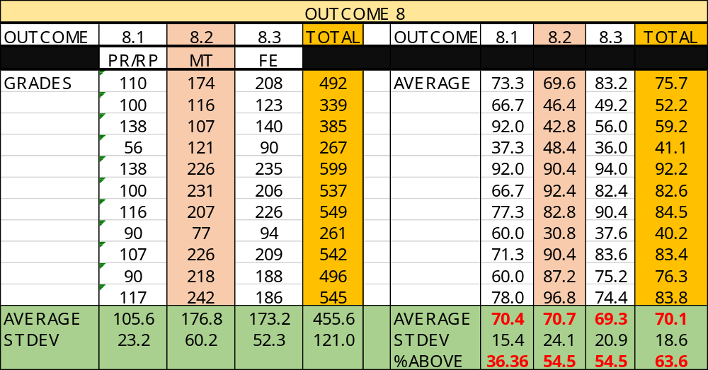

ASSIGNMENTS FOR OUTCOME 8

An ability to identify, formulate, and solve fundamental engineering problems by applying principles of engineering, science, and mathematics.

CHEG 1021-P01: Intro. to CHEG Lab
Process Report Guidelines

- Overall, the report should be at least seven pages in length, double-spaced, 12 pt. Times New Romans font, and contain one inch margins. Upon completion, each group should upload the report as a PDF (no changes in document from computer to computer) to eCourses and submit a bound hardcopy in class on November 19, 2019. Everyone must sign the coversheet and submit a copy for a grade!
- The report should not contain any instances of plagiarism. All thoughts/facts not belonging to group members must be cited within text (Last Name of Author/Editor, Year) and listed in the reference section. Since this report is a technical paper, no direct quotes are allowed. MLA style references.
- The report should be grammatically correct and contain new paragraphs when a new main topic is discussed. The group should refrain from the usage of words such as I, you, me, we, they, it, and us.
- The report should follow the outline of:
  - Coversheet
    - Title, Group members, member signatures, Due date, Course with section number, Instructor
  - Introduction/Background
    - Discuss the compound that is being produced
    - Who created the compound? Why is the compound important?
    - How much of the compound is produced in the US? In the World?
    - What are the economics of the compound?
  - Process Design Discussion
    - Discuss each step of the process including process units and products.
    - Create a Process flow diagram using Microsoft Visio or a similar approved software.
  - Discussion/Conclusions
    - Provide a brief overall summary of what was discussed in the main body of paper.
  - References
    - References should be from credible sources (journal articles, experts, and library books).
    - One source must be a book from the library! Bring the book to class on presentation day.

Prairie View A&M University

The Process of Creating Beer

Jevaun Christie & Cherish Vaughn
November 20, 2019
CHEG 1021- P02
Dr. Sheena M. Reeves
The compound being produced/ Who created the compound
The creation of beer has been known to man for many years. Many might think why beer was invented in the first place. Beer is a topic that doesn’t seem to be talked about a lot but is ingested frequently during the adult population’s leisure time. However, there is a problem with the use of beer within the under age 21 population, but that topic is for another paper. The compound beer is known as one of the most consumed/oldest beverages known to man. Beer has been found to originate in the Western European region, however, there is no specific origin for this intricate compound. Also, it has never been found when the compound was invented. The establishment of beer has presumably emerged alongside the findings of these staple crops. The staple crops consist of wheat, barley, rice, and maize which are key components to making a batch of beer. These key components were initially founded by hunter-gather tribes that began to settle around the staple crop. With the curiosity to find out what potential these staple crops hold, many countries began tampering with these unique crops. The earliest known alcoholic beverage presumably started in China. The concoction is made of rice, honey, and various fruits (Andrews, 2014). The other staple crops such as barley, wheat, etc. were used by other cultures to produce their own style of “beer”. Beer can be made with many staple crops. Beer is an alcoholic based beverage made from fermenting cereal (Denny, 11). The fermented cereal is simply a grass cultivated grain that undergoes a process that makes the crop edible. The fermenting process will be discussed in greater detail later on in the paper.

Why is the compound important?
Many individuals might wonder, what is so special about drinking beer. Humans don’t drink beer in order to just get drunk. In general, alcohol is a depressant meaning that it can disrupt your motor skills, feelings, and eventually your long-term health. So why is beer still around then if it seems to impact the body negatively? It has been found that key components found in beer can reduce “LDL” or bad cholesterol (American Heart Association: Circulation). LDL stands for low-density lipoproteins, which are responsible for transporting fat in the blood throughout the entire body. Having a drink (at a responsible age) can be very beneficial but only at moderation. Beer is a universal beverage that can be shared between various cultures without breaking certain restrictions. In many cultures, alcoholic beverages, mainly beer, are incorporated into cultural festivities to celebrate traditions/ milestone of a person or community has reached. Also, the use of beer can be found in many party scenes. From the clubs to simple kickbacks, the use of the intricate beverage helps many individuals relax before or during the event. Also, the use of alcohol can limit the reaction time and the thought process of the individual ingesting the compound. With this being said, physical alterations and other violent events tend to arise when alcoholic beverages are brought into play. However, it does truly depend on the nature of the human being because not all individuals react the same way to alcohol. With these events occurring, it doesn’t seem to slow down the production of beer across the world.

The production of Beer in the US and in the world
As it pertains to beverages, alcohol especially beer, continues to be the most purchased beverage in the world. The annual consumption for beer around the world varies from 114 billion to 132 billion liters (Denny 1). With these statistics, it might raise the question, which country is responsible for consuming so much beer? Many might assume that America is known for drinking and having a good time. However, according to the statistics Mark Denny pulled from the source: The Kirin Brewing Co., America stands 13th out of the top 20 consuming countries in terms of annual per capita beer consumption by a nation. The nation Czech Republic is 1st followed by Ireland in 2nd, then by Germany in 3rd. These statistics might be alarming but the fact that mass beer production is at an all-time high in the European region might help to contradict the false pretense created by the outsiders. To many surprises, the United States is no longer the leading nation in the consumption beer (Denny 5). As competition in the beer industry increases amongst the nations, the more surprises that begin to be unfolded. Be aware not to associate the consumption value with the monetary value because all beers have their own distinct value. For example, in poorer countries, you might find an increased use of alcoholic beverages but the monetary value it takes to make the product might not be as much as the high-income nations. The richer countries are more likely to import the beer out of lower-income countries because it would cost less to produce a barrel of beer rather than making it in their homeland. In Figure I.2 of Froth! The science of beer, China is ranked 1st, United States 2nd, Germany 3rd, and Brazil 4th in terms of total annual consumption by nation (Denny 5). These countries are also the top 4 producers of beer, USA in 1st, China in 2nd, Germany in 3rd, and Brazil in 4th (Denny 7). The production of beer in a country is proportional to the consumption of beer in a country. However, there are many factors that can affect the proportionality of the beer produced from beer consumed. The availability of resources such as ingredients and machines can drastically affect the production of beer. The number of stores legally able to sell the compound can affect the consumption of beer. Also, the per capita income for a county can both affect the production and consumption of beer. According to the source, British Beer and Pub Association, used by Mark Denny, the United States of America production has gone down from 145,000,000 million barrels in 1991 to 143,500,000 million barrels (7). While this was occurring China production of beer drastically increased from 51,200,000 million barrels in 1991 to a staggering 138,700,000 million barrels (Denny 7). From the statistics above, China is projected to past America in the mass production of beer within the next 50 years.

What are the economics of the compound?
According to Beer Serves America, more than 64,745 Americans are employed by the brewers and beer importers (2). With these new jobs coming in, a substantial amount of growth for other jobs associated with brewers and beer importers began to open. Beer Serves America Report discusses the increase in distribution jobs in the beer industry (2). With the increase in distribution jobs in America, networking with other brewers outside of the United States of America limit is the key potential for expanding globally and making more money. According to Mark Denny, within the United States, 82% of beer is produced by three dominant breweries: Anheuser- Busch (52%), Miller (19%), and Coors (11%) (7). With these statistics, the three dominant breweries are able to earn money from within the country and also can take on the role of importing various alcoholic beverages to foreign countries. With this approach, they can compete globally and maximize their profits while maintaining a stable company in the homeland.
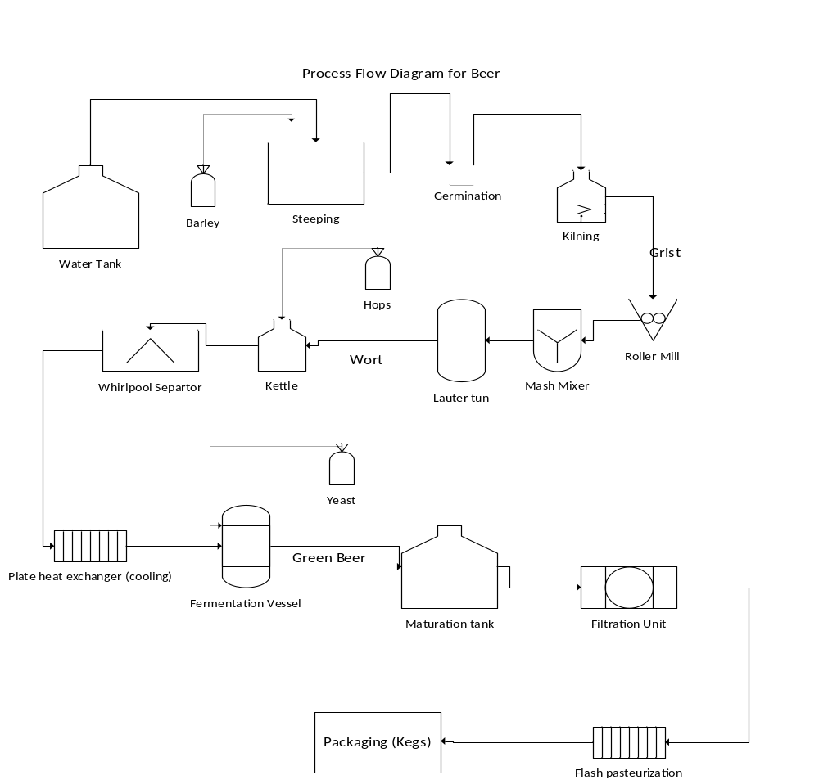

Process Design Discussion
In order for beer to be created, the key ingredients that need to be used are water, choice of staple crop (barley is being used in this demonstration), and yeast. First, water and barley are added to the steeping tank. The steeping tank is used to allow the grains to become fully soaked prepping the grains for germination. Next, since the grains are soaked now, the grains are placed on a tray where they will germinate and release a hormone called Gibberellic acid which is vital for the synthesis of alpha- amylase (Chrispeels & Varner,1967). At the end of the germination process, the kilning tank is used to heat the germinated barley grain, stopping the enzyme activity, creating the color and flavor for the beer. The malt produced is run through the roller mill to be ground up. The ground-up malt is put into the mash mixer with water to extract the natural colors and flavors for the beer. The mash is transferred to the lauter tun vessel to separate wort (the liquid) from the solid part of the mash. The wort is now placed into the kettle and hops are added. The hops are used as a flavor and stabilizing agent for the beer. Without hops, the beer will not taste as good. The mixer is now placed in the whirlpool separator to separate the hop pallets from the wort. Since this wort is extremely hot, we must put the wort to cool down through the plate heat exchanger. The wort is susceptible to bacterial contamination once the temperature drops below 160 degrees Fahrenheit (Henny 99). This is why the wort must be brought below between 68 degrees Fahrenheit and 99 degrees Fahrenheit. Once cooled, the wort is brought into the fermentation vessel where yeast is added. Yeast can take two routes in the fermentation process: convert directly into alcohol and carbon dioxide or directly into the lactic acid (Alba-Lois & Segal-Kischinevzky, 2010). As beer makers, the alcohol route is taken by the industry. Next, the fermented beer is transferred to the maturation tank where it undergoes a second phase in the fermented phase. After the fermentation process is complete, the beer is put through the filtration unit to purify the beer and remove any debris leftover. Next, the beer is flash pasteurized in order to kill all contaminates that was leftover from all the process. The beer is now able to be packaged and shipped to local stores and distribution centers to be sold.
Conclusion
Since beer has been created, it has not failed to please society. The universal use of beer has created an atmosphere for togetherness and excitement when used moderately. With multiple twists to this concoction, many have been able to profit off of the work of another person. Beer continues to be one of the top sold beverages in the world today. With sells raising in both America and the world, there doesn’t seem to be any end in sight. The increase in technology continues to provide many ways of making an intricate batch. From just changing one step in the brewing process, it can drastically alter the taste, texture, and color of beer. With the unique minds of others, there will always be a promising future for processing and producing beer.

Works Cited
Alba-Lois, L. & Segal-Kischinevzky, C. (2010) Beer & Wine Makers. Nature Education 3(9):17.
American Heart Association: Circulation. “The Health Benefits of Beer.” Piedmont Healthcare, www.piedmont.org/living-better/the-health-benefits-of-beer.
Andrews, Evan. “Who Invented Beer?” History.com, A&E Television Networks, 8 Jan. 2014, www.history.com/news/who-invented-beer.
Chrispeels, Maarten & Varner, J. (1967). Gibberellic Acid-Enhanced Synthesis and Release of -Amylase and Ribonuclease by Isolated Barley and Aleurone Layers. Plant physiology. 42. 398-406. 10.1104/pp.42.3.398.
Denny, Mark. Froth!: the Science of Beer. Johns Hopkins University Press, 2009.
FoodTechInfo.com, Energy Solution Center, 16 Jan. 2016, foodtechinfo.com/foodpro/facility_types/311213_malt_beer/.
John Dunham & Associates 32 Court St. A STUDY OF THE U.S. BEER INDUSTRY’S ECONOMIC CONTRIBUTION IN 2016. Beer Serves America, 2017, pp. 1–19, A STUDY OF THE U.S. BEER INDUSTRY’S ECONOMIC CONTRIBUTION IN 2016.



