The Women in Leadership Conference will be held on the Prairie View A&M University campus in Prairie View, Texas on March 6th and 7th, 2024 at the Panther Room located at: 1600 Stadium Dr, Prairie View, TX 77446.

The conference is hosted by the Roy G. Perry College of Engineering. Our goal is to bring women from academia, industry and government who are in leadership roles or aspire to become leaders together and empower them through conversations, stories and leadership strategies.
Price
$350 per adult
$200 early bird registration before March 2, 2024
$10 per student
Table Sponsorship
- Platinum $15,000
- Gold $10,000
- Silver $ 5,000

Registration Link: Women in Leadership Conference at Prairie View A&M University.

Agenda  Wednesday (Pre-Conference)  Day 1: March 6, 2024 |  | Location
5:00 pm | Registration | Panther Room
6:00 pm | Welcome and Opening Remarks  Mistress of Ceremony – Jayhea Mathews, MBA  - Pamela Obiomon, Ph.D. (Welcome)  - Tenisha Tevis, Ph.D. (Opening remarks) | Panther Room
6:15 pm -7:00 pm | Opening Keynote Speaker and Dinner  - Karan Watson, Ph.D., P.E. Emeritus Provost of Texas A&M University | Panther Room
7:00 pm – 8:00 pm | Reception and Networking | Panther Room
Thursday
Day 2: March 7, 2024

8:00 am | Registration and Light Breakfast | Panther Room
9:00 am | Welcome Remarks  - Pamela Obiomon, Ph.D.  Opening Remarks  - Tenisha Tevis, Ph.D. | Panther Room
9:10 – 9:30 am | Morning Keynote Speaker I  - Brigadier General Antionette Gant | Panther Room
9:30 – 9:50 am | Morning Keynote Speaker II  - Annette Moore | Panther Room
9:50 – 10:00 am | Q&A | Panther Room
10:10 – 11:00 am | Panel Session  My Journey to Leadership and How I Found My Voice  - Teta Banks, Ed.D.  - Shirley Holland-Hunt  - Jessica M. Taylor  - Seema Daryanani  - Sitrina Davis  Moderator: Melissa De Witt, M.A. Ed. | Panther Room
11:00 – 11:05 am | Break and Transition to Session | Panther Room
11:05 a.m. – 110 pm | Panel Session  Helping Women in Industry Develop Leadership Skills  - Claudia Walkup  - Arti Venkatesh  - Melissa Tooley, Ph.D., P.E.  - Atieno Obala  - Latonia Knox  Moderator: Patricia Tarry | Panther Room
12:10 – 12:15 pm | Break
12:15 – 1:00 pm | Lunch Keynote Speaker  - Lesia Crumpton-Young, Ph.D., MBA | Panther Room
1:00 – 1:05 pm | Break
1:05 – 2:05 pm | Skills Development Workshop #1:  Personal Brand  - Christi Beard  - Tiffany Songvilay | Panther Room
2:05 – 2:10 am | Break
2:10 – 3:10pm | Panel Session  Helping Women in Academia Develop Leadership Skills  - Camille Gibson, Ph.D., C.R.C  - Karen L. Butler-Purry, Ph.D., P.E.  - Judy Perkins, Ph.D., P.E.  - Ikhlas Sabouni, Ph.D.  - Joyce T. Shiraz, D.SC., P.E.  Moderator: Vera Lewis | Panther Room
3:10 - 3:15 pm | Break
3:20- 4:00 pm | Skills Development Workshop #3:  Self-Care and Mental Health  - Bryant Clayton Jr, Ph.D.  - Rose Yang, Ph.D. | Panther Room
4:00 – 4:20 pm | Closing Keynote - Non-Profit Perspective  - Paula Harris | Panther Room
4:20- 4:40 pm | Closing Keynote - IndustryPerspective  - Debra Curry | Panther Room
4:45 – 5:00 pm | Closing Remarks  - Tenisha Tevis, Ph.D. | Panther Room

Keynote Speakers

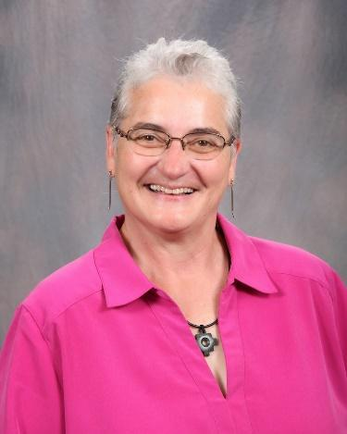
Karan L. Watson, Ph.D., P.E. is a Provost Emeritus and Regents Professor in the Department of Electrical and Computer Engineering and in the Department of Computer Science and Engineering at Texas A&M University.
Watson is a fellow of the Institute of Electrical and Electronic Engineers and the American Society for Engineering Education. Her awards and recognitions include the U.S. President's Award for Mentoring Minorities and Women in Science and Technology, the American Association for the Advancement of Science mentoring award, the IEEE International Undergraduate Teaching Award, the College of Engineering Crawford Teaching Award, and two University-level Distinguished Achievement Awards from The Texas A&M University Association of Former Students—one in Student Relations.
Watson graduated from Wichita Falls High School and then earned a Bachelor of Science in electrical engineering from Texas Tech in 1977. As an undergraduate student, she lettered in track and field and was a student senator. After graduation, she worked as an engineer for AT&T Long Lines and then Hicks and Ragland Consulting Company, before returning to Texas Tech to earn a Master of Science in 1981 and a Doctor of Philosophy in electrical engineering in 1982.
In 1983, she joined the faculty of Texas A&M University. From 1991-1996, she was the associate dean for graduate studies in the Dwight Look College of Engineering. She also served the Look College as associate dean for academic affairs from 1996-2002 and as a member of the Faculty Senate. She was dean of faculties and associate provost of Texas A&M from February 2002 to December 2008.
Watson held the position of interim vice president and associate provost for diversity from 2005 to 2006 and again from December 2008 until July 2009. Watson was appointed provost and executive vice president for academic affairs in March 2011.
She has chaired the graduate committees of 35 doctoral students and more than 60 master's degree students. In the 2003–2004 academic year, she served as a senior fellow of the National Academy of Engineering Center for the Advancement of Scholarship in Engineering Education. Since 1991, she has served as an accreditation evaluator and commissioner and is now on the Board of Directors for ABET, Inc., formerly the Accreditation Board for Engineering and Technology.

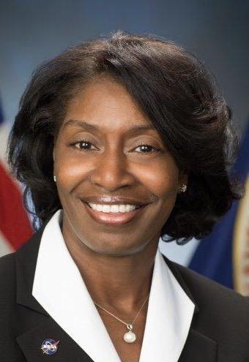

Annette Moore prior to retirement was responsible for the NASA Office of the Chief Information Officer’s Strategy Division with oversight and leadership for managing the OCIO’s business, strategy, and customer engagement efforts. The Strategy Division is composed of three offices that work with all OCIO divisions, service lines, and center organizations, as well as each center OCIO office. Under her leadership the Customer Engagement Office (CEO) was an integrated community of practice focused on supporting customers in all areas of IT policy, processes, and services for enterprise and non-enterprise IT. Under her leadership the Enterprise Business Management Office (EBMO) managed investments and resources; business integration, policy, and audits; IT acquisitions; and workforce strategy and provided a framework and processes for these functions across the organization. Under her leadership the Strategy and; Architecture Office (SAO) was responsible for IT strategy management, integrated roadmaps, reference and future state architectures, and defining, prioritizing,and executing and ensuing activities in support of the Roadmap(s) and strategies toward desired future state.

In her role as the Deputy CIO for Strategy Ms. Moore was also responsible for leading and managing all the NASA Center Chief Information Officers at each of the NASA Field Centers.

She has received the Presidential Rank Award, Meritorious, Delta Sigma Theta, Incorporated –

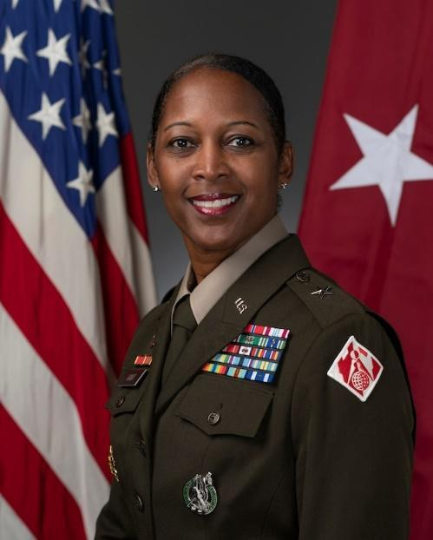

Brig. Gen. Antoinette R. Gant assumed duties as the Chief, Army Enterprise Marketing Office (AEMO), Chicago, Illinois, in September 2023. In this role, she leads the corporate marketing office for the United States Army and is responsible for developing, executing and analyzing national level marketing campaigns in support of the Army’s recruiting mission.
This includes marketing strategy and branding to increase talent acquisition and retention. She leads the team taking Army marketing from the industrial age into the information age by modernizing the prospect’s journey and delivering the Soldiers and Leaders of tomorrow.

A native of Port Gibson, Mississippi, Gant graduated from Prairie View A&M University in Texas as a Distinguished Military Graduate with a Bachelor of Science in Civil Engineering and a commission in the Engineer Regiment. She holds a Master of Science in Engineer Management from Missouri University of Science and Technology, Rolla, Missouri, and a Master of Science in national resource strategy from the Dwight D. Eisenhower School, National Defense University,Washington, DC. She is a certified Project Management Professional.

Gant has served in a variety of command and staff positions for engineering units stateside and abroad. Prior to her current assignment, Gant served as Division Commander, South Pacific Division, U.S. Army Corps of Engineers (USACE),San Francisco, Calif. She led a workforce of more than 2500 military and civilians, overseeing hundreds of construction projects valued at more than $8 billion. She also served as commander of the South Pacific Border District from July2020 to June 2021, as well as commander for both the Albuquerque and Louisville Districts.
Other key USACE positions include military assistant to the Assistant Secretary of the Army-Civil Works, Washington,DC, and chief of operations for the engineer directorate, U.S. Army South, San Antonio, Texas. She also served as the executive officer for Special Troops Battalion and brigade engineer, 4th Brigade Combat Team, 4th Infantry Division, Fort
Carson, Colorado.

Gant has deployed in support of Operation Iraqi Freedom, Operation Enduring Freedom, and Operation Freedom’s Senti-nel (OFS) where she served as the chief, combined joint engineer for the Resolute Support and OFS headquarters, Kabul, Afghanistan, and director for both Public Works and Installation Support directorates, Area Support Group-Kuwait.
A strong advocate for STEM, Gant has developed partnerships with agencies and organizations to promote science,technology, engineering and math initiatives. She has received several national and community awards, to include 2021 Black Engineer of the Year Award (BEYA), Army Stars and Stripes Award recipient, 2020 Women of Color Career Achievement in Government Award, YWCA Women on the Move Award, Women of Influence in Government by Albuquerque Business First, BEYA Special Recognition Award, and Alpha Kappa Alpha Sorority, Inc., South Central Region Visionary Leader and Global Leader Awards. Gant’s military awards and decorations include the Army Distinguished Service Medal, Legion of Merit (3), Defense Meritorious Service Medal, Bronze Star Medal, and Meritorious Service Medal (7). She is also a recipient of the Army Staff Identification Badge, Recruiter Badge, and the Army Engineer Association Silver de Fleury Medal.

Brig. Gen. Gant is married to Leonard Gant of Kansas City, Missouri, and they have two children.

Lesia L. Crumpton-Young, Ph.D., MBA With more than 30 years of experience, President Crumpton-Young is a highly successful transformative leader, who has strategically positioned organizations by implementing transformative initiatives to achieve unprecedented success at an accelerated pace. Currently, Dr. Crumpton-Young serves as President of the Greatness Gurus Corporation and an Executive Consultant. Previously, she served as the 13 th President of Texas Southern University. Also, President Crumpton-Young held the positions of Provost and Senior Vice President for Academic Affairs at Morgan State University (Morgan); Vice President for Research and Institutional Advancement at Tennessee State University(TSU); Program Director at the National Science Foundation(NSF); Associate Provost at Texas A&M University; Associate Dean of Engineering at Mississippi State University(MSU); Professor and Department Head of the Industrial Engineering and Management Systems Department at The University of Central Florida (UCF).

President Crumpton-Young is an accomplished researcher in the areas of modeling Human
Systems under Dynamic conditions with interests that include executive decision-making, human performance modeling and analysis, human reliability analysis and fatigue assessment, and use of virtual reality and computer simulation for workplace design, carpal tunnel syndrome
prevention and control, and workplace design for special populations. President Crumpton-Young is also an expert in human-computer usability and user-centered design. President Crumpton-Young’s research has influenced engineering design, product design, usability, user-centered design, educational research, faculty development, STEM leadership development, facilities design, curriculum reform, mentoring and coaching.

As a distinguished scholar with hundreds of scholarly publications to date, President Crumpton-Young has served as Principal Investigator on numerous innovative research initiatives supported by the National Science Foundation, Department of Defense, National Institute of Health, NASA, and Department of Education. President Crumpton-Young has also worked on many industrial research projects with nearly millions of corporate sponsorship dollars awarded from UPS, IBM, Caterpillar, Intel, Garan Manufacturing,Southwest Airlines, and Lockheed Martin. President Crumpton-Young’s publications include the book entitled,
“Key Productivity and Performance Strategies to Advance Your Career,” co-authoring the book entitled “Company Success in Manufacturing Organizations: A Holistic Systems Approach,” authoring a workbook entitled “Advancing Your Faculty Career” and co-authoring the “You’ve Got The Power!” workbook series dedicated to empowering individuals to unleash their greatness.

President Crumpton-Young received her B.S., M.S., and Ph.D. in Industrial Engineering from Texas A&M University where she was the first African American female to receive a Ph.D. in engineering. President Crumpton-Young is a recipient of the US Presidential Award for Excellence in Science, Mathematics, and Engineering Mentoring and the Houston Business Journal “Women Who Mean Business” award as well as One of Houston’s 50 most Influential Women Award. She has been married for 33 Years and has two daughters.

Debra Curry is a Senior Manager Program Management Office Instrument Operations. Her career is highlighted by progressively responsible positions in program management, systems engineering, aircraft certification, regulatory management, and automotive design. Over the past 20 + years, she’s worked with multiple diverse institutions and organizations globally and demonstrated the ability to create and maintain positive relationships. After graduation she joined Ford Motor Company where she worked both domestically and internationally primarily in truck operations. When an opportunity to return to Texas occurred, she became an aerospace engineer working on military and commercial helicopters at Bell Helicopter. Today, she is a Senior Manager working in the Program Management Office in Instrument Operations at Abbott. She is responsible for leading, directing and developing a team of project managers to ensure that projects are completed on-time, within budget and according to project requirements.
In addition to her work responsibilities, she’s an active member of her community and church. She serves on the Board of Directors for Building Future and Families; an organization that provides health and human services support to foster and adoptive children and their families. She also serves as an officer at her church, St Paul AME Church. As the treasurer of her children’s school Parent Teacher Association (PTA) , she’s responsible for the fiscal responsibility of the organization. She is an active member of Delta Sigma Theta Sorority, where she serves on the social action and membership committee of the North Dallas Suburban Alumnae Chapter of Delta Sigma Theta Sorority, Incorporated. She is the proud mother of 3 children, Jonathan, Alona and Madison.
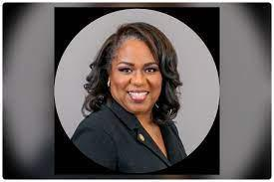
Paula Harris is the Executive Director of the Astros and Senior Vice President, Community Affairs. Harris has over 33 years of experience working in the Houston community, both professionally as an executive with Schlumberger Ltd., and personally with a passion for civic interest and volunteerism.
Harris has extensive connections throughout the Houston community, as she currently serves on the boards of Chart Industries (GTLS), The Vantage Group, Children’s Museum Houston, the Petroleum Club of Houston, the Independent Petroleum Association of America’s Energy Education Center and the Energized for STEM (Science, Technology, Engineering and Math) Charter School. She is a founding member of the Young Women’s College Preparatory Academy, an all-girl’s engineering school serving primarily minority communities in Houston with the goal to graduate girls prepared to attend top engineering universities. Harris has a particular passion for advancing STEM education and career opportunities for all communities, but especially for women and underrepresented minorities.
Previously, she served on the boards of the Houston Independent School District, the Permian Strategic Partnership in Midland, TX, the Space Center Houston and numerous other education and outreach associations. In 2020, Harris received the Women Who Mean Business Lifetime Achievement award from the Houston Business Journal. In 2019, she received the Women on the Move award from Texas Executive Women and the United Nations Global Citizenship Award.
During her 33-plus years in the international oilfield services with Schlumberger Ltd., Harris, educated as a Petroleum Engineer, worked in many roles over three decades with the company. She worked her way up from working on offshore rigs as a Field Engineer to leadership positions such as Director of Community Affairs from 2010-2015, and, most recently as Director of Global Stewardship.
A native Houstonian, Harris graduated with a B.S. in Petroleum Engineering from Texas A&M University and a Master of Education in Technical Instruction and Learning from Abilene Christian. The owner of her own publishing company, Harris has authored, published and distributed four books, including When I Grow Up I Want To Be An Engineer. The book was translated into four languages and over 150,000 copies were distributed globally to schools, museums and non-profits.

__________________________________________________________________
Panelists: My Journey to Leadership and how I found my Voice

Teta V. Banks, Ed.D is a diplomat, human rights advocate, and educator. She holds the position as Chair of the Executive Committee of the World Federation of United Nations Associations(WFUNA). She is also the Vice President of the Council of Organizations (COO) and is the former Chair of the United Nations Association of the United States of America (UNA-USA). Dr. Banks has been a U.S. delegate to the Secretary-General’s U.N. Special Sessions and has served as Honorary Consul General of the Republic of Liberia. She served as an advisor to the Truth and Reconciliation Commission of Liberia.

Dr. Banks has held numerous positions in non-profit organizations, universities, and governmental organizations. She is on the faculty of the Department of Languages and Communications at PVAMU. She has served on the faculties of Howard University, Spelman College, Rutgers University, and Washington University. Dr. Banks served as a Liaison for the White House Initiative on Historically Black Colleges and Universities. She has held the following positions: President of the Consular Corps of Philadelphia, President of the
National Coalition of 100 Black Women -Pennsylvania Chapter and National Board Member, Vice President of The Links, Incorporated- Texas Spring Cypress Chapter and the Penn Towne Chapter, and Executive Director of the King Association -appointed by Mrs. Coretta Scott King..
Dr. Banks is the author of several publications and has presented at UN-sponsored sessions, the UN Security Council, the UN Committee on the Eradication of Racial Discrimination, human rights organizations’ forums, and educational conferences including at National Education Association and Modern Language Association.

She attended Wellesley College, Capella University, Howard University, Oxford University and holds an (Ed.D. in Leadership and Management. She also holds certifications in Human Rights Training from the U.S. Institute of Diplomacy and Human Rights, and the Sustainable Development Goals from University of Copenhagen, Leadership in International Organizations from University of Geneva, and Global Diplomacy from University of London.
She is the recipient of many human rights awards, including “Distinguished Daughter of Liberia”, International Trade Center Humanitarian Award, the Alpha Kappa Alpha Sorority, Incorporated National Education Award, and the Human Rights Award from the US Institute of Diplomacy and Human Rights.

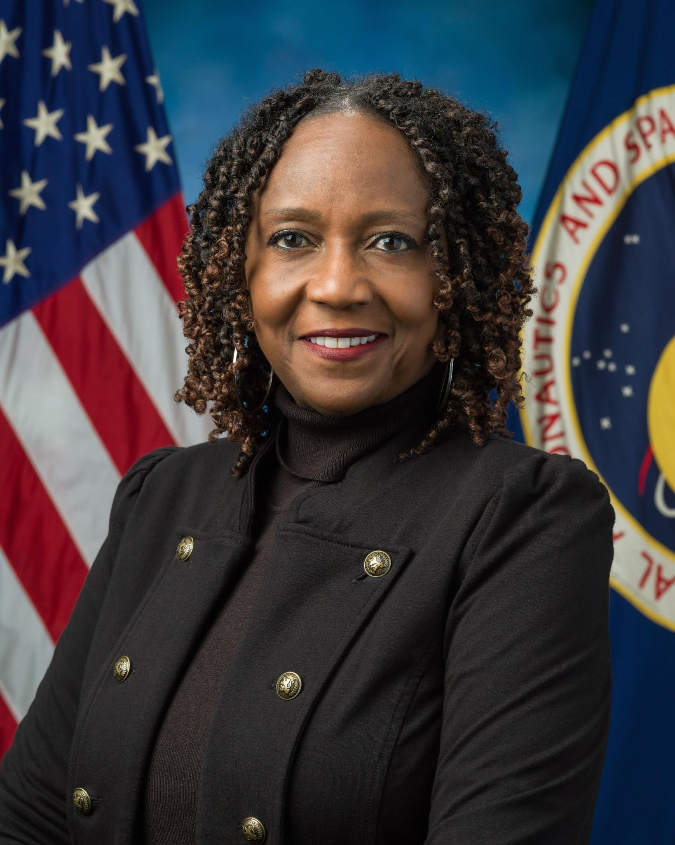

Shirley Holland-Hunt is the Associate Division Chief for the Aeroscience and Flight Mechanics Division at Johnson Space Center. In her current role she leads a team of Engineers that lead the nation in flight mechanics and trajectory design. She also served as Branch Chief for the Material and Processes Branch, which develop, test, and certify all material for space travel. She started her career developing telemetry test software for Laser guided bombs for the department of defense projects. She supported NASA in avionics engineering verification and testing assignments with United Space Alliance, and she later managed the Shuttle Avionics Integration Lab (SAIL) that integrated testing operations for space flight.

She appeared in one of the space agency’s publications for her role as an agreements and technology integration manager and was nominated for NASA’s modern hidden figure.

Jessica M. Taylor is a Global Diversity Business Partner Lead for Google Cloud, where she consults a portfolio of clients on their diversity and inclusion strategies.

She most recently led external engagement initiatives and diversity and inclusion programming at Toyota. Where she was responsible for leading and executing diversity & inclusion strategies and multicultural partnerships across Toyota’s North American operations. Notably, she steered a $4 million-dollar global HBCU strategy and national scholarship & internship repository, partnering with organizations like the United Negro College Fund (UNCF), Thurgood Marshall Foundation and the Rainbow PUSH Coalition to assist students in securing financial support and full-time employment opportunities. To date, Jessica has assisted students gain acceptance to over 45 colleges in 22 states with over 3 million dollars in need and merit based funding. She has led DEI programming and initiatives in education and the public and private sectors.

A strategic thinker, former educator, and policy advocate, Jessica is an emerging voice on the national scene, engaging audiences on the topics of diversity, educational equity, and corporate responsibility. She’s been saluted among leaders as a 2021 Leader in Diversity by the Dallas Business Journal and her work has been featured in Essence, Rollingout Magazine, BounceTV and countless online and print editorials.

As an entrepreneur, Taylor is also the owner of Ezra Coffee Company, a specialty and ethically sourced coffee line that celebrates our collective American history, through flavored and infused blends. She is a member of Alpha Kappa Alpha Sorority Inc., Junior League and 100 Black Women. Jessica holds degrees from Belmont Abbey College and Indiana University.

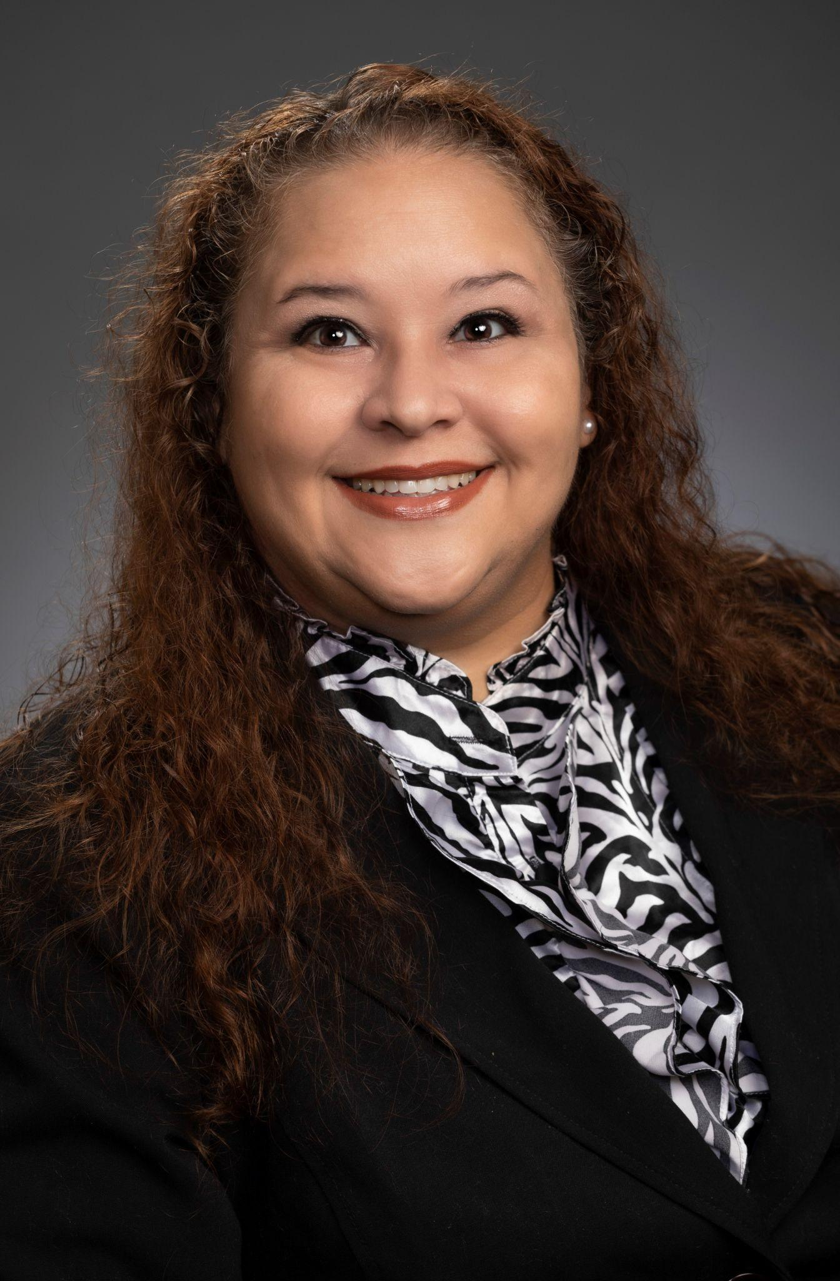

Melissa De Witt, M.A. Ed. is involved in various roles within the Texas A&M University system including serving as the coordinator for Testing Services at Prairie View A&M University from 2012-2017 and as the TSI Coordinator at Texas A&M University-San Antonio from 2017-2020. In 2020, she returned to Prairie View A&M University where she currently serves as a Compliance Officer II in the Office of University Compliance. She is the campus liaison for policies and procedures and Vector training.

Melissa earned a Bachelor of Arts in Communication with a concentration in Public Relations and a minor in Business Administration from the University of Texas at San Antonio. She holds a Master of Science in Education Administration from Prairie View A&M University.

Melissa is currently pursuing her Doctorate in Educational Leadership from the Whitlowe R. Green College of Education at Prairie View A&M University. Her passion is technology, and her dissertation will focus on Generative Artificial Intelligence and its impact on Academic Integrity in Higher Education.

Seema Daryanani brings her commitment to inclusion and belonging to both her professional and personal life. A trained crisis counselor, she has a demonstrated passion helping executives to build conscious competence around equity and inclusion issues, so they have the capacity to create a psychologically safe organization.

She is currently a Global Head of DEI, Core at Google . Prior to that was a DEIB global leader at a SAAS company called Anaplan. Prior to Anaplan, she recruited executive technical talent with a focus on diversity and inclusion at Autodesk and the U.S. Digital Service, a start-up created by the Obama administration that hires technical talent from Silicon Valley to modernize government technology.

She's been actively involved in fighting against human trafficking with Asha Rising & International Sanctuary as an ambassador and Executive Board member for more than a decade. Seema also serves on the board of National Multiple Sclerosis Society and is a mother to two daughters (a 13 year-old and a 10 year-old) with her husband and they live in the Bay Area.

Sitrina Davis is a native Houstonian, is currently a Sr. Process Design Engineer at Shell Deer Park Chemicals. She started her journey as a Chemical Engineer after graduating from the Prairie View A&M. After graduating, Sitrina obtained over 28 years of industry experience from high profile Fortune 500 companies like Monsanto, Foster Wheeler, Dresser Inc, Emerson, Bechtel Oil, Gas & Chemicals, Inc., and BP Americas.

She has focused her career on process safety and is passionate about saving lives and helping to ensure people go home to their family each day, Sitrina set out to learn and excel in
the field of overpressure, relief, and flare systems design. She spent the last 19 years developing her knowledge and is now known as an Industry Expert.

She is the National Vice President of Epsilon Gamma Iota,Inc., a social and service organization. She is the committee chair for the PVAMU College of Engineering Distinguished Alumni Committee, and active committee member of the Houston Livestock
Rodeo. In 2007 she became a member of the Top Ladies of Distinction, where she served as a mentor to several “Top Teens of American” youth. She also volunteers for the PACE Program within the Humble ISD Community Center and plays an integral part by serving as a role model and mentor to pregnant teens. She is also the co-founder of a developing organization entitled, “The Uprising of a Young Queen” that provides workshops and day camps for young girls to discover their love of self.

___________________________________________________________________________
Panel Session A: Helping Women Develop Leadership Skills in Industry

Claudia Walkup Is the Co-Chair of the Women's Employee Network (WEN) and the Director of Digital Transformation at Avanade, she combines her passion for empowering women in tech with her expertise in delivering innovative solutions for the healthcare industry. With over 20 years of experience in IT consulting, she has helped clients across various sectors achieve their business goals by leveraging the power of Microsoft Cloud, automation, Machine Learning, and Artificial Intelligence.
Currently, she is focused on helping healthcare organizations overcome the challenges of aging populations, clinician burnout, patient dissatisfaction, and cost of care, which have been exacerbated by the pandemic. She provides advisory, innovation, design, implementation, and managed services to optimize digital healthcare solutions that accelerate results and create a clear path forward to better outcomes. Outside of work, she enjoys spending time with my three energetic boys and supporting first-generation college students pursuing a career in tech.

Melissa S Tooley, Ph.D., P.E. is an Assistant Agency Director at TTI, which includes managing large federally funded research programs and federal affairs. As part of her activities in federal affairs, she has contributed to the discussion regarding transportation policy and research for the last three transportation reauthorization bills. Her research interests include automated and connected vehicles and transportation policy and planning. Dr. Tooley has been a leader in the University Transportation Center (UTC) community for decades, from being selected as a UTC Student of the Year in 1993 to serving as the first female president of Council of University Transportation Centers. She chaired the UTC Spotlight Conference on Automated and Connected Vehicles and served as the supply chain track chair for another focused on freight. She has served on invited panels at CUTC meetings discussing UTC management topics including diversity, equity and inclusion, marketing, and leadership, among others. She has 17 years of experience as a UTC Director, having served as Director of 3 different UTCs at the University of Arkansas and TTI. She has been involved in an advisory or leadership capacity for 5 additional UTCs at TTI. She currently serves as Deputy Director of the National Center for Infrastructure Transportation, a national UTC led by Prairie View A&M University.

Dr. Tooley is well-connected in the transportation infrastructure construction community, having been an active member of the American Road and Transportation Builders Association (ARTBA) for many years. Her service includes founding the ARTBA Women Leaders Council, and terms on the Executive Committee as an elected Vice-Chairman at Large and Chair of the Research and Education Division. She continues to serve on the Board of Directors and task forces addressing technology and workforce development. Dr. Tooley was awarded the ARTBA Ethel Birchland Lifetime Achievement Award for outstanding leadership and long-term service to the transportation design and construction industry, and is a former recipient of ARTBA’s S.S. Steinberg Award, given for outstanding contributions to transportation education.

Dr. Tooley was recently honored as a Distinguished Alumnus of the College of Engineering at the University of Arkansas. She was an Assistant Professor of Civil Engineering at the University of Arkansas and the University of Florida, and prior to joining academia spent 10 years as a civil engineering consultant on projects involving roadway design, flood control, construction management, forensic engineering and civil infrastructure improvements.

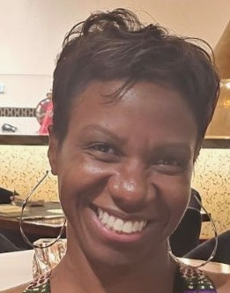

Atieno Obala is a Managing Director responsible for building and cultivating relationships through the implementation of innovative ideas.Her experience spans 25yrs, leading global complex delivery programs. She works with clients across all sectors of Energy, Technology, and Consumer Goods, taking them from ERP adoption to digital transformation. As the first black female Managing Director in Accenture’s Houston Office, Inclusion, Diversity and Equity is at the heart of everything she does. Over the past 10 yrs her focus has been on building lasting partnerships with like-minded organizations to enable talent, increase digital acumen, and generate opportunities for underserved communities.

Atieno is a member of Alpha Kappa Alpha Sorority,Inc. She is passionate about mentoring and an advocate of raising awareness of domestic violence and mental health. Atieno holds a B.S. in Mechanical Engineering from Prairie View A&M University

Latonia Knox is a global business leader who has served in various roles in corporate, public and non-profit organizations for over 20 years. She is a visionary with keen business, multi-cultural & technical acumen that spans a broad, diverse client & sector base.
Latonia is a Director of Diversity, Equity and Inclusion at Google Cloud. She has a Bachelor of Arts Degree in Computer Science from Pace University - Seidenberg School of Computer Science and Information Systems and a Masters Degree in Business Administration and Management from the University of Phoenix.
She is a native of Alexandria, LA. Latonia’s love for community service began in high school where she spent countless hours giving back to her community. She is a wife and a mother of two daughters. She enjoys traveling with family, hanging out with friends, and listening to music while cooking her favorite cajun dishes. She is a member of The Lone Star (TX) Chapter, The Links, Incorporated, the Vice President of the National Society of Black Engineers (NSBE) Austin Professionals and also a member of the Beta Psi Omega Chapter of Alpha Kappa Alpha Sorority, Incorporated.

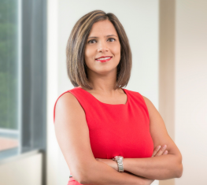
Arti Venkatesh is a Director, Delivery Management at Avanade. She leads the team of Delivery Managers in the Southwest region. She is an innate problem solver and planner at the core, who has built high performing teams. She has developed expertise in leveraging technology and business fundamentals to drive and scale new sources of revenue by repositioning existing services and capabilities to enter new markets. She won Stevie Award for Women in Computing

Arti lives in Houston with her husband and two kids (9 year old daughter and 7 year old son.) In her free time, she enjoys traveling and red wine.

Patricia Tarry, is the IT Digital Portfolio Manager for Chevron. She has over 35 years in Information Technology across diverse industries with more than 20 years in the Oil and Gas industry. She has extensive experience in IT Program and Portfolio Management overseeing multi-million dollar portfolios. Tarry Joined Chevron in 2011 and held various IT leadership roles, gaining recognition as the program manager often solicited to salvage “at-risk” IT projects and programs.

A native of South Carolina, she received both her Bachelors and Masters degrees in Computer Science from the University of South Carolina and Clemson University respectively.
She is a proud member of Delta Sigma Theta Sorority Incorporated and Owner/Founder of Norvani, an all-natural hair and skin care company.

____________________________________________________________________________
Panel Session B: Helping Women Develop Leadership Skills in Academia

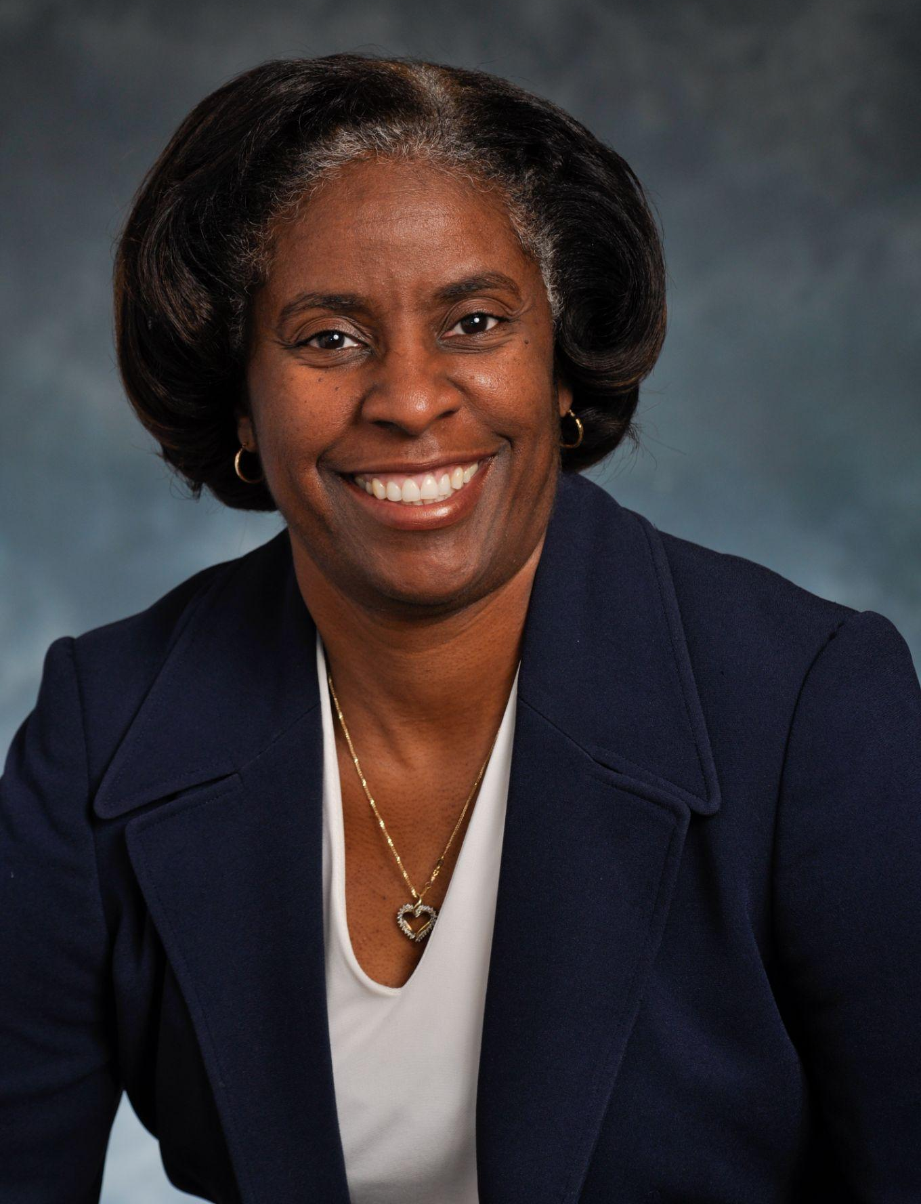

Karen L. Butler-Purry, Ph.D. was awarded a B.S. (summa cum laude) from Southern University in Baton Rouge, a M.S. degree from the University of Texas at Austin, and a Ph.D. from Howard University in Washington, D.C., all in Electrical Engineering. She is the first African-American female to receive a PhD in engineering at Howard University.

During her over 25 years at Texas A&M University, Dr. Butler-Purry has served at all faculty levels, beginning with an initial appointment as visiting assistant professor of electrical engineering in 1994. She currently is a Professor in the Electrical and Computer Engineering Department. Dr. Butler-Purry has vast experiences as an administrator and program leader at Texas A&M. From 2001-2004, she served as Assistant Dean for Graduate Programs in the College of Engineering, served as Associate Department Head in the Electrical and Computer Engineering Department from 2008-2010, and served as Associate Provost for Graduate and Professional Studies from 2010 through 2020 and then in the expanded role of Associate Provost and Dean of the Graduate and Professional School through August 2022. In addition, she served as Interim Vice President for Research from 2017-2018.

Dr. Butler-Purry’s research interests are in the areas of modeling and simulation, protection and control of active electric distribution systems and isolated power systems such as all electric power systems for ships and microgrids, cybersecurity protection, and engineering education. She is a registered professional engineer in the states of LA, TX, and MS. Dr. Butler-Purry has developed a successful research program and led several fellowship and education projects sponsored by the National Science Foundation, National Institutes of Health, and the Department of Education which promote recruitment, retention and advancement of pre-college, undergraduate and graduate students, and faculty in STEM fields, particularly individuals from historically underrepresented populations.

She received the National Science Foundation Faculty Career Award (1995) and the Office of Naval Research Young Investigator Award (1999). Butler-Purry has received numerous teaching and service awards including the 2005 American Association for the Advancement of Science (AAAS) Mentor Award for efforts to mentor students from underrepresented groups and for leadership in promoting PhD careers for them in electrical engineering and computer sciences. She was elevated to Institute of Electrical and Electronics Engineer (IEEE) Fellow status in 2018. Further in 2021, Dr. Butler-Purry received the Council of Graduate Schools Debra Stewart Award for Outstanding Leadership in Graduate Education.

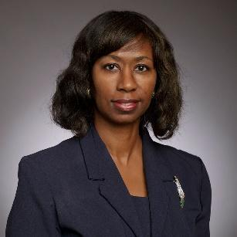

Camille Gibson, Ph.D., C.R.C. is the Interim Dean of the College of Juvenile at Prairie View A&M University and Executive Director of the Texas Juvenile Crime Prevention Center. She has worked in various settings with juveniles as the primary client. She began in higher education teaching at Brooklyn College in Political Science, and concurrently at John Jay College of Criminal Justice in Public Administration. Thereafter, she has served at Prairie View A&amp;M University. She has over 90 publications on topics such as youth interactions with law enforcement, youth gangs, delinquency and schools,sexual abuse, sex trafficking, child abuse, juvenile violence, and student activism. Her books include Juvenile sex offenders: What the public needs to know and Being real: The student-teacher relationship and African American male delinquency. Her professional memberships include the American Society of Criminology and the Academy of Criminal Justice Sciences (previously with elected Board service). She is
a past President of the Southwestern Association of Criminal Justice in which capacity she represented many criminal justice educators in Texas, Oklahoma, Arizona, Arkansas, New Mexico, and Colorado. She is also a recipient of the esteemed Felix Fabian Award and the Niederhoffer Memorial Fellowship. She has offered advice internationally on juvenile justice. She is also the Communications Officer for the Caribbean Crime and Justice Association. She has decades of experience teaching and mentoring leaders in academia.

Joyce T. Shiraz, D.SC., PE is the Dean of the School of Engineering, Architecture and Aviation at Hampton University has a long and distinguished career in higher education and in industry. She leads a skilled team of faculty and staff, to ensure Hampton is a leader in STEM related fields. She has a diverse mix of business and academic experience and has managed projects in each sector with a span of career experience that comprises senior vice president, chief of staff, chair, program director, professor, specialist and engineer. This includes twenty years with Fortune 500 corporations and two decades in higher education leadership. She served in both faculty and staff positions in the University System of Maryland, including senior vice president and chief of staff in the Office of the President, Chair of Information and Technology Systems, Program Director and Professor for Engineering Management, MBA, Management of Information Systems, and Technology Management in the Graduate School at University of Maryland Global Campus. She has design experience in multinational corporations which includes offshore oil platform structures, airplanes, and environmental systems in countries around the world. She is a licensed, professional civil engineer (PE) with a BS in Civil Engineering, Howard University, MS in Environmental Engineering, University of Tennessee, D.SC. in Environmental and Engineering Management, George Washington University, and executive leadership training from the Institute for Educational Management, Harvard University. She currently serves as Chair of the HBCU Council of Engineering Deans.

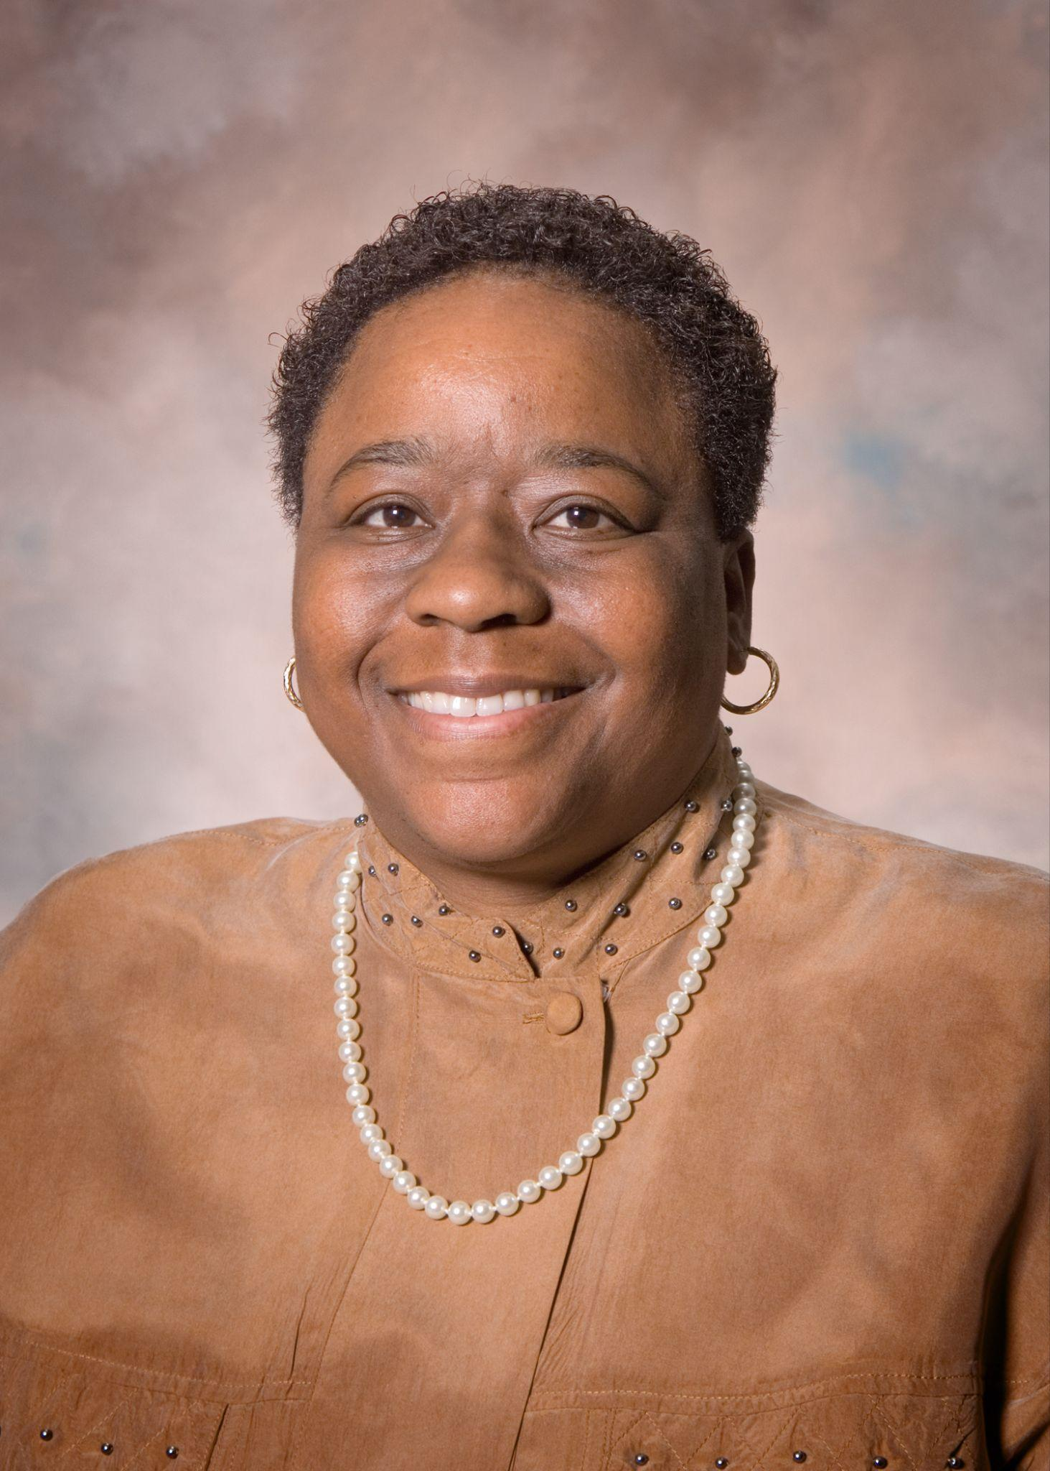

Judy Perkins, Ph.D., PE has served as a civil engineering educator for over three
decades and is the first African American female to graduate with a Ph.D. in Civil & Environmental Engineering from Georgia Institute of Technology. Currently Dr. Judy A. Perkins is a Professor in PVAMU’s Civil & Environmental Engineering Department, a Texas A&M University System Regents Professor, the Google Endowed Professor, and the Director for the National Center for Infrastructure Transformation (NCIT). NCIT is the first HBCU led national US Department of Transportation University Transportation Center.

Dr. Judy Perkins is an active researcher focusing on areas such as asset management, engineering education, hurricane evacuation analysis, logistics, minority outreach, mobility, and the optimization of transportation infrastructure investments. Through her involvement in research, Dr. Perkins, and her colleagues in 2023 received the largest competitive grant ever awarded to PVAMU. The total of the project is $40 million. This is a historic achievement for PVAMU and TAMUS. Dr. Perkins is a retired U.S. Army lieutenant colonel and a licensed professional engineer.

Ikhlas Sabouni, Ph.D. is the Dean and Distinguished Professor of Architecture at Prairie View A&M University (PVAMU). She received a Master's and a Doctorate of Architecture from Rice University in Houston, Texas. At Rice, she won the William Dunlap Darden Award in Architecture for her outstanding doctoral dissertation. At PVAMU, she transformed a small Architecture department into a well-recognized autonomous School of Architecture with three undergraduate and two graduate programs. She led the Architecture Program at PVAMU through four successful reaccreditation visits and chaired several NAAB visits nationally and internationally. Dr. Sabouni received several teaching honors; The Texas Society of Architects (TxA) Edward J. Romieniec, FAIA Award, The American Institute of Architects (AIA) Houston Chapter Educator Award, the Association of Collegiate Schools of Architecture (ACSA) Distinguished Professor, the ACSA Creative Achievement Award, The Prairie View A&M University Distinguished Professor, the Texas A&M University Systems Regents' Professor, and the College of Engineering and Architecture Faculty of the Year three times, to mention a few. She co-chaired two regional ACSA conferences and served on professional honor award juries in architecture, such as the first National AIA Diversity Recognition Program, The ACSA Distinguished Professor Award, the AIA Houston Young Architect Award, and the Texas Society of Architects 25 Years Awad. Dr. Sabouni served on several national, regional, and local boards; Texas Architecture Foundation, American Institute of Architecture Students (AIAS), ACSA, and Tau Sigma Delta Honor Society (TSD). She also served as the secretary, the Vice-Chancellor, and the Chancellor of the ACSA College of Distinguished Professors. Currently, she is serving as President-elect of the National TSD Honor Society.

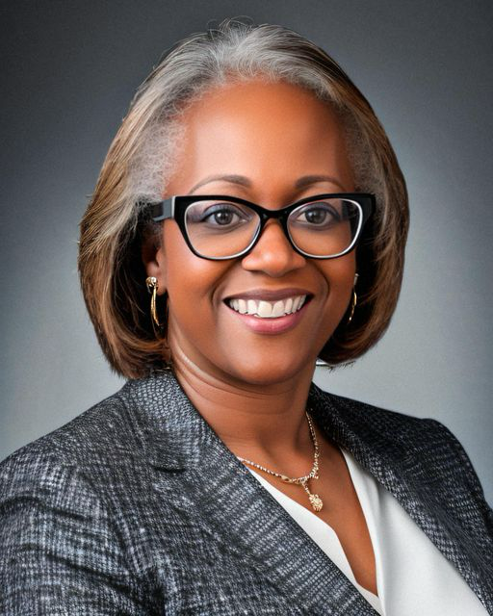

Vera Lewis-Jasper has been an integral part of Galveston College since 2010, initially serving
as the Director of Continuing Education before assuming the role of Dean of Technical and
Professional Education in 2011. In her current capacity, she provides oversight for allied
health, nursing, public safety, and all technical programs, ensuring their excellence and
alignment with industry standards.
Before her tenure at Galveston College, Vera excelled as the Executive Director at Cuyahoga
Community College’s Corporate College. There, she spearheaded the creation of the model
for Global Corporate College, a pioneering workforce initiative adopted by 45 community
colleges nationwide. With over two decades of corporate experience in engineering, sales, and
marketing at esteemed companies like General Electric and Westinghouse Electric, Vera
brings a wealth of practical knowledge to her educational leadership role.

Vera's expertise extends beyond the classroom, as evidenced by her prolific contributions to
publications such as Smart Business Magazine, Cleveland Plain Dealer, and Today’s Campus.
She has authored numerous articles on sales, quality, and process improvement, showcasing
her commitment to advancing both academic and professional spheres.

According to Vera, "The landscape of business and higher education is evolving rapidly, with
both entities recognized as vital components of workforce and community development.
They play crucial roles in stabilizing or enhancing employment opportunities within their
communities while also fostering social and cultural well-being."

Vera holds a Bachelor of Science in Electrical Engineering from Prairie View A&M University
and a Master of Science in Management from Indiana Wesleyan University, reflecting her
dedication to continuous learning and academic achievement.

____________________________________________________________________________
Skills Development Workshop #1: Personal Brand

Tiffany Songvilay is a Product Owner with 20 years’ experience in Modern Workplace. She is a Certified Solutions Architect with a deep understanding of Workplace Experience, the problems, and opportunities it presents, and the solutions and services required to meet client needs. Tiffany’s expertise and passion for change are an integral part of the projects she solutions and delivers. Her industry experience spans across public and financial services, products, and resources.

Christi Beard leads the Global Client Success Programs in the Growth Office at Avanade, a joint venture between Microsoft and Accenture. In this role, she helps drive programs and strategies to optimally lead Avanade client relationships. Christi transitioned to this role from Golin, a global PR and digital communications agency where Avanade was her client for three years, along with Dow, ADP, Texas Instruments, Humana, Walmart, PetSmart and many others. She also held roles leading communications and PR for Vizient and Lennox. Christi has nearly 20+ years of experience in communications, marketing, operations and leadership since graduating from Texas A&M University in 1999 with a B.S. in journalism and minors in English and speech communications.

____________________________________________________________________________
Skills Development Workshop #2: The Role of Women in AI: Inspiring the next Generation

Rubina Ohanian, Ph.D. is a Managing Director with Accenture’s Applied Intelligence out of Atlanta. She manages the data science & ML/AI organization for the US South and leads a team of highly talented data scientists with deep technical skills who solve challenging and hard data and analytics problems. Dr. Ohanian is a passionate and experienced data transformation expert who specializes in advanced analytics solution development and deployment. She has substantial experience working with executives and their complex global organizations to define data driven strategies, deliver growth, innovation, and business value. Dr. Ohanian has over 35 publications in industry and scientific journals and is a frequent speaker at domestic and international conferences for Diversity in Data Science & Technology, Digital Transformation, and Cultivating a Data Culture.

____________________________________________________________________________
Skills Development Workshop #3: Self-Care and Mental Health

Bryant Clayton Jr, Ph.D. is a clinical psychologist practicing in Houston, Texas originally from Indianapolis, Indiana. Dr. Clayton specializes in the practice of psychotherapy and psychological assessment, particularly personality evaluation. As a psychologist, Dr. Clayton evaluates and treats patients who have reported conditions related to depression, anxiety, stress, personality disorder, anger, trauma, identity formation, spirituality, and men's related issues. He received his bachelor’s degree in interdisciplinary studies in 2016 at Indiana State University. He graduated from the University of Indianapolis with a Doctorate in Psychology in 2022. He completed both his internship and post-doctoral fellowship at The Menninger Clinic from 2021 to 2023. His research interests include the study of the effects of personality disorder, particularly narcissistic personality disorder, and spirituality on mental health outcomes. Additionally, Dr. Clayton is an avid mental health advocate through the arts. As a playwright, songwriter, and performing artist, he has written and performed works tailored for audiences struggling with belonging, substance use, identity formation, and relationships.”

Rose Yang, Ph.D. is a member of the Mental Health Equity Committee and the Menninger Lead for DEI, she is a skilled and dedicated clinician and has been engaged in various community education events with a passion for women's health

___________________________________________________________________________

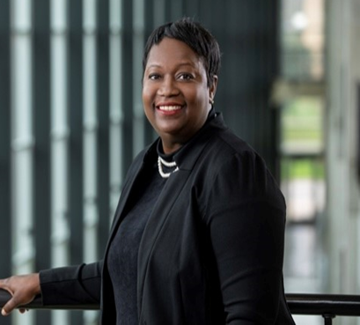

Pamela Holland-Obiomon, Ph.D. ’93 began her role as the first female Dean of the Roy G. Perry College of Engineering in September of 2018. Holland-Obiomon was also the first female graduate from the College of Engineering at Prairie View A&M University to receive a PhD in engineering.

Holland-Obiomon has been a faculty member in the Department of Electrical and Computer Engineering since 2003. In 2013, Obiomon took on the role of department head serving one of the largest programs in the college. Under her guidance, the department was awarded $20 million dollars in grants from the chancellor’s research initiative, which helped aid in the creation of the Computational Biology and Bioengineering Research Center, Cyber Security research center, the Center for Advancing Innovation is Smart Microgrid and Center of Excellence in Research and Education for Big Military Data Intelligence.
As Dean, Holland-Obiomon she developed a number of initiatives that have kept the college on the cutting edge of engineering. She leads 1,247 undergraduate, graduate and doctoral students, 105 faculty, staff and researchers in six academic departments and 12 state-of-the-art laboratories and research centers such as the Center of Excellence in Research and Education for Big Military Data Intelligence (CREDIT), which is nationally recognized for its research in Artificial Intelligence, Machine Learning, and Deep Learning and have been instrumental in helping PVAMU reach its R2 Carnegie classification. Her role is to advance the profile of the College of Engineering at Prairie View A&M University. Her goal is to extend opportunities to students and faculty to be nationally recognized for their scholarly work. She has continued to engage the alumni base and corporate partnerships, using them to help expand opportunities for students.
She earned a B.S. degree in Electrical Engineering from the University of Texas at Arlington, an M.S. in Engineering from Prairie View A&M University, and a Ph.D. in Electrical Engineering from Texas A&M University. Before coming to PVAMU, she taught courses at the Rochester Institute of Technology in Rochester, New York, and she worked in the Shuttle Avionics Integration Laboratory at the Johnson Space Center in Houston, Texas.

Obiomon’ s research is centered on improving machine learning algorithms for reliable sentiment analysis for classification in social networks. She has published more than 55 papers and been principal investigator (PI) or co-PI on more than $20 million in grants from funders such as NSF, DOD and DOE. Additionally, she supervised and served on some 30 master’s and Ph.D. committees and held memberships in IEEE, IEEE Women in Engineering, and Eta Kappa Nu.

Dr. Pamela Holland-Obiomon is from a family of engineers, a native of Hempstead, Texas and is married with four children.

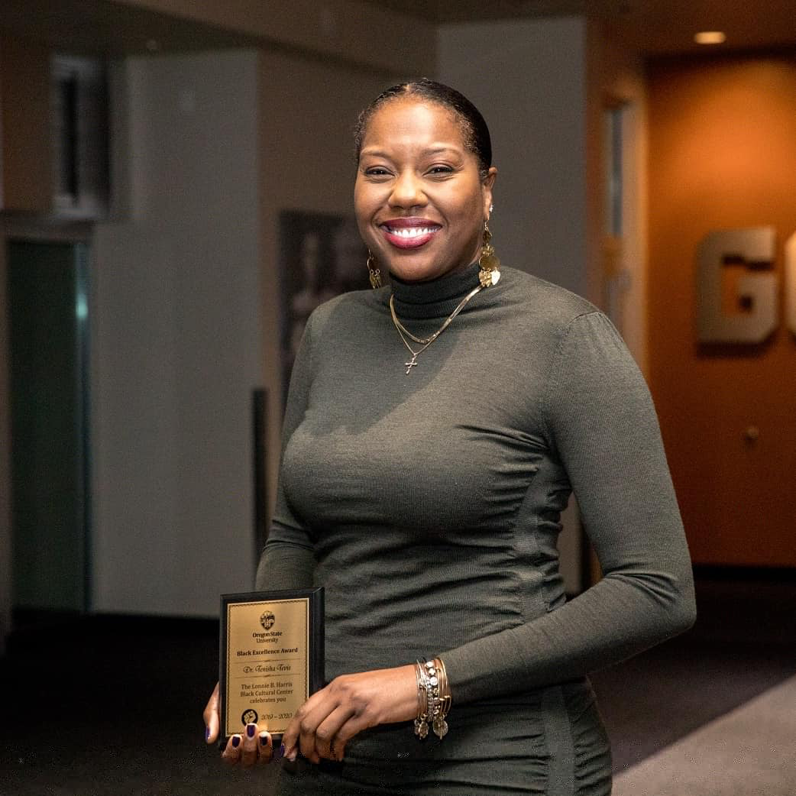

Tenisha Tevis, Ph.D. is an associate professor of Adult and Higher Education in the College of Education at Oregon State University. She earned her Ph.D. in Educational Theory and Policy Studies with a cognate in Higher Education from The Pennsylvania State University. She interrogates postsecondary practices to promote equity and inclusion across the organization. Her research agenda focuses specifically on students’ transition to college, and the confluence of leadership and identity. Tenisha co-edited a book with Zak Foste titled Critical Whiteness Praxis in Higher Education: Considerations for the Pursuit of Racial Justice on Campus. And she recently co-authored a text titled The Gendered Transaction of Whiteness: White Women in Educational Spaces. In her spare time, she enjoys going to the gym, and training to be a spin instructor. Tenisha also enjoys coaching middle school and high school girls’ basketball.

Jayhea Mathews, MBA is Diversity, Equity & Inclusion Program Manager for Google Core. She joined Google in June 2013. In her previous roles at Google she was a Localization Manager for Google Payments, Next Billion Users and Google Education. Prior to that role she also was a Staffing Services Operations Lead, Hardware Staffing Lead, Hardware Recruiter, and a Diversity Sourcer. Before joining Google Jayhea spent 9 years as a College Director of Admissions/Recruiter.

She is a graduate of Prairie View A&M University and holds a Bachelor of Science in Criminal Justice, and also received her MBA from Belhaven University. In her free time she enjoys volunteering within the community, and listening to and creating podcasts! She is a host/co-creator on an internal Google podcast focused on diversity. Also, Jayhea is a Soulcycle, and Barry's Bootcamp junky, enjoys traveling, lover of fashion, and is always happy spending time with family and friends.

