**PRAIRIE VIEW A&M UNIVERSITY**

**DEPARTMENT OF ELECTRICAL AND COMPUTER ENGINEERING**

**PhD PRELIMINARY EXAMS - MICROELECTRONICS**

**SPRING 2016**

**1 (a). (9 points)** Design an op amp circuit with inputs , and  whose output voltage  is given as . Only use resistors between 100  and 100  in your design. ***Draw the designed circuit with element values****.*

**1. (b) (9 points)** For the circuit shown below, if V1 = 2 mV, find V2, V3, V4.

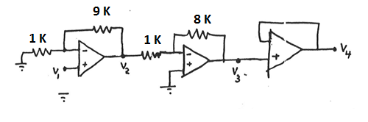

V2 = \_\_\_\_\_\_\_\_\_\_\_\_\_\_\_ V3 = \_\_\_\_\_\_\_\_\_\_\_\_\_\_ V4 = \_\_\_\_\_\_\_\_\_\_\_\_\_\_\_\_\_

**2 (16 points)** (a) In the circuit shown below, VS = 20 V, RS = 1 KΩ, and RL = 4.0 KΩ. If he Zener breakdown voltage is 8 V, find (i) the output voltage, (ii) the current flowing through RS, and (iii) current flowing through the Zener diode.

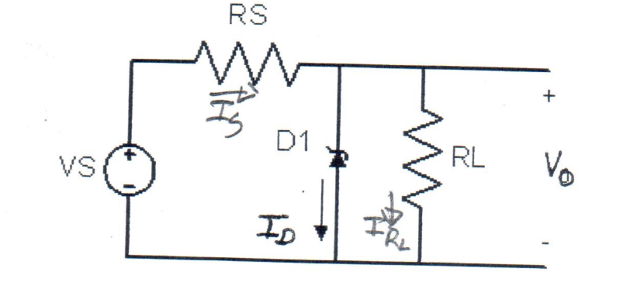

Vo = \_\_\_\_\_\_\_\_,  = \_\_\_\_\_\_\_\_\_\_\_ current through RS = \_\_\_\_\_\_\_\_\_\_\_

**(b)** In the circuit shown above , VS = 5 V, RS = 1 KΩ, and RL = 4.0 KΩ. If he Zener breakdown voltage is 8 V, find the output voltage, Vo.

Vo = \_\_\_\_\_\_\_\_\_

**Problem 3. (16 points)** For the circuit shown below, = 10 mA/V and = 60 KΩ.

(a) Draw the small-signal equivalent circuit

|  |  |
| --- | --- |
| **sedr42021_p04077** | Draw the small signal equivalent circuit here. |

(b) Find the input resistance,,

(c)Determine voltage gain, .

(d) What is the significance of connecting the by-pass capacitor across the 3.0 KΩ resistor?

### PROBLEM 4 (8 Points)

In a p+-n junction, suppose ND is doubled. If everything else remains unchanged, which the of the following increase or decrease? Justify each answer.

|  |  |  |
| --- | --- | --- |
| PROPERTY | INCREASE/ DECREASE | JUSTIFICATION |
| Built-in Potential | Increases  Decreases |  |
| Junction Capacitance | Increases  Decreases |  |
| Breakdown Voltage | Increases  Decreases |  |
| Depletion Width | Increases  Decreases |  |

### PROBLEM 5 (15 Points)

An approximate expression for the variation of the reverse saturation current Is in a p-n junction diode is given by

.

Show that the fractional change in Is is given by

.

Hence determine the fractional change in Is at T=300K for a germanium diode (Eg = 0.663 eV) and a silicon diode (Eg = 1.125 eV).

**PROBLEM 6 (15 Points)**

The junction capacitance of a one-sided n+p GaAs junction at T=300k was measured and had the following values: (*ni = 2x106 cm-3):*

*Cj/A = 1.12x10-8 F/cm2* at *V = -1 V and Cj/A = 6.69x10-9 F/cm2* at *V = -5 V.*

Determine a) Vbi, b) Na, and c) Nd.

**Problem 7 (12 Points)**

The dc state of an ideal MOS-C is characterized by the block charge diagram shown below.



(a) Is the semiconductor p-type or n-type? Explain.

(b) Is this device an n-MOS or a p-MOS? Explain.

(c) Is the device in accumulation, depletion, deep depletion or inversion? Explain.

**USEFUL INFORMATION**







$$C= \frac{ϵA}{W}$$