**PRELIMINARY EXAMINATION – FALL 2017 – MICROELECTRONICS**

**Problem 1 (1+1+3+5 points)**

A student who has not paid much attention in the class draws the following band diagram of a doped Germanium semiconductor (bandgap = 0.68 eV) with an acceptor impurity concentration of 1016/cm3.

|  |  |
| --- | --- |
|  |  |

1. As drawn, is the semiconductor n-type or p-type?
2. With the parameters given, is this representation correct? If not, what type of semiconductor is it?
3. If incorrect, draw the correct band diagram, in the right column of the table above, showing all the relevant energies.
4. Compute the position of the Fermi level.

**Problem 2 (13 points)**

An abrupt silicon p-n junction, 10-2 cm2 in area has NA=2x1014 cm-3 doping on the p-side and ND=2x1015 cm-3 on the n-side. Calculate the depletion capacitance with a reverse bias of 5 V.

**Problem 3 (12 points)**

Draw the band diagram for each of the following cases. Show **all** the relevant energies: Eg, Ei, Ec, Ev, EF.

1. n-type, bandgap = 1.5 eV, EF = 1.2 eV
2. n-type, bandgap = 2.4 eV, EF = 1.8 eV
3. p-type, bandgap = 1.8 eV, EF = 0,6 eV
4. p-type, bandgap = 2.2 eV, EF = 0.9 eV

**Problem 4 (15 points)**

Complete the table below making use of the *C-V* characteristic of an ideal MOS-C and the block charge diagrams included in the figure below. For each of the biasing conditions named in the table, identify (using numbers 1-5) which diagram corresponds to which biasing condition.

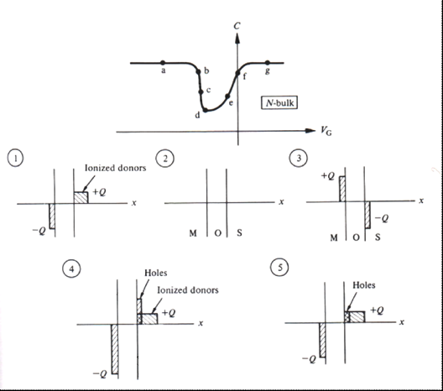

|  |  |
| --- | --- |
| Bias condition | Block charge diagram (1-5) |
| Accumulation |  |
| Depletion |  |
| Inversion |  |
| Flat band |  |
| Depletion/inversion transition |  |